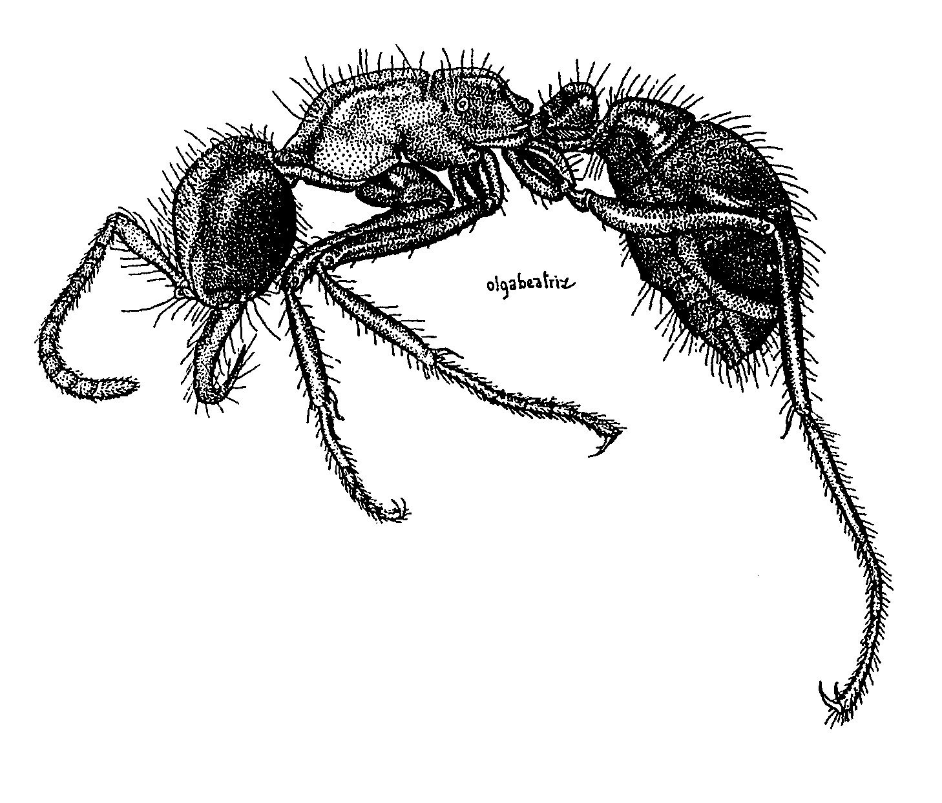Fig. 1. Side view of a major worker of Cheliomyrmex sp. (from Serna, 1999).
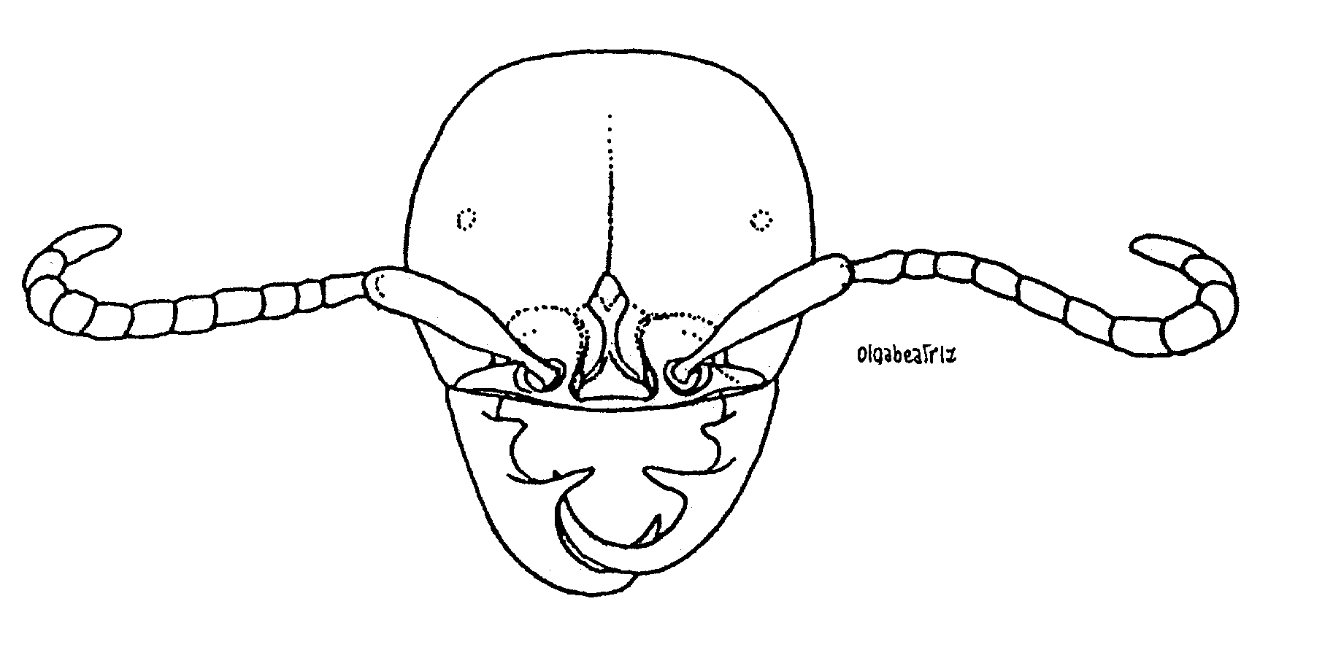Fig. 2. Head of a major worker of Cheliomyrmex sp. (from Serna, 1999).
KEY TO SPECIES OF Cheliomyrmex

Soldiers
1. Body dark brown; head and thorax thickly punctated ................................................. andicolus - Body reddish yellow; head and thorax smooth ............……………………........................ 2
2(1). Sixth flagellar segment broader than long; metapleuron punctated ............................ morosus
- Sixth flagellar segment longer than broad; metapleuron with fine striae ................... megalonyx

Males
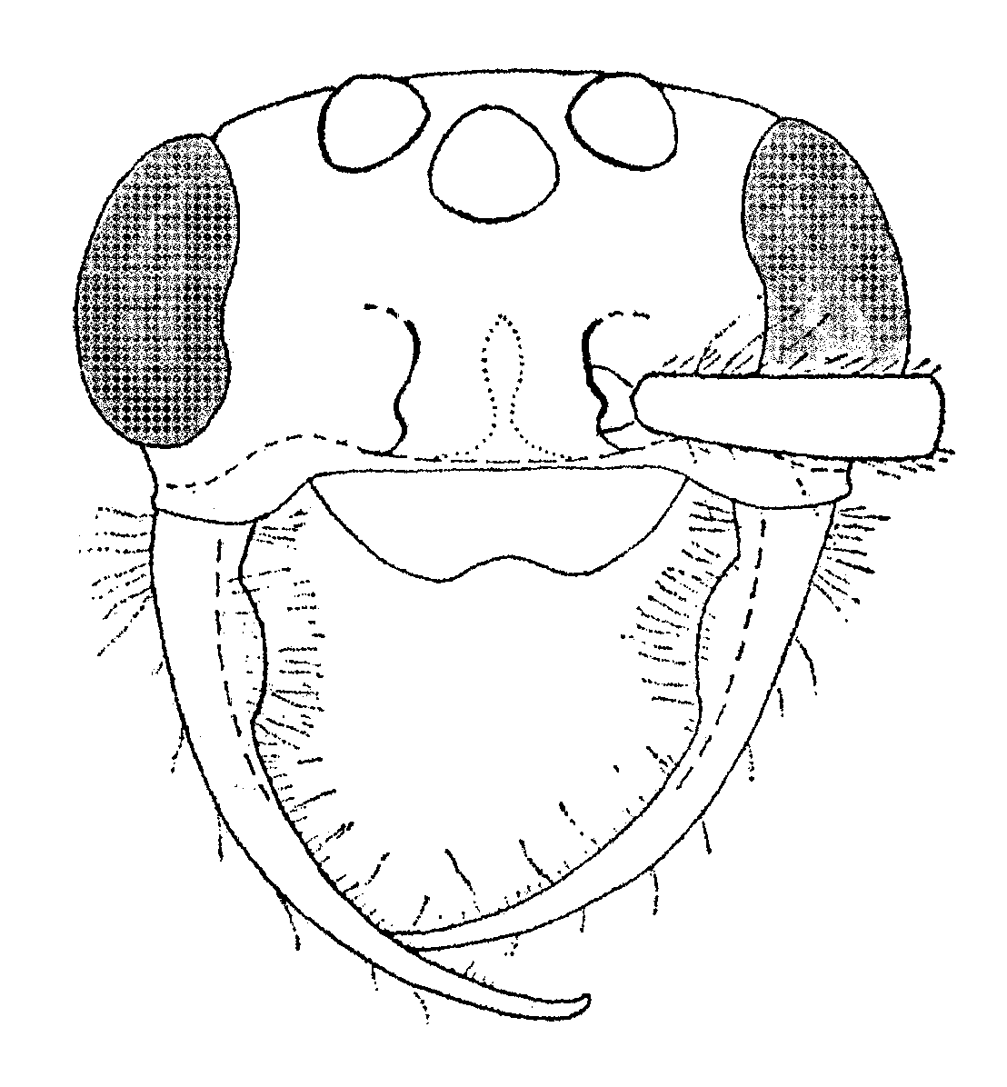 Fig. 3. Head of a male of C. andicolus (from Kempf, 1975).
1. Body black or blackish brown .....….......... 2
- Body reddish brown .....….....................…..3
2(1). Distance from lateral ocellus to compound eye equal to or greater than diameter of lateral ocellus; height of compound eye about equal to length of scape exclusive of basal condyle ......... ……………………….................................. ursinus
- Distance from lateral ocellus to compound eye ½ or less diameter of lateral ocellus; height of compound eye distinctly greater than length of scape exclusive of basal condyle ............................. …………………………………………… morosus
3(1). Metatibia distinctly bent (Pl. 3, Fig. 11), dorsal longitudinal surface distinctly concave ..............……………………………….......... audax
- Metatibia not distinctly bent (Pl. 3, Fig. 12), dorsal longitudinal surface straight .......................... …………………………………………. megalonyx

Literature cited
Kempf, W. 1975.
Serna, F. 1999. Hormigas de la zona de influencia del Proyecto Hidroeléctrico Porec II. Unpublished Master’s Thesis, Universidad Nacional de Colombia, xiv + 250 pp.
Watkins, J.

Modified from Watkins (19xx).

