Key to Species of Octostruma, Based primarily on Workers

1. With fine, but distinct carina arching from eye to eye across the head, separating the convex posterior border from the concave frontal part (Fig. 1) .. 2
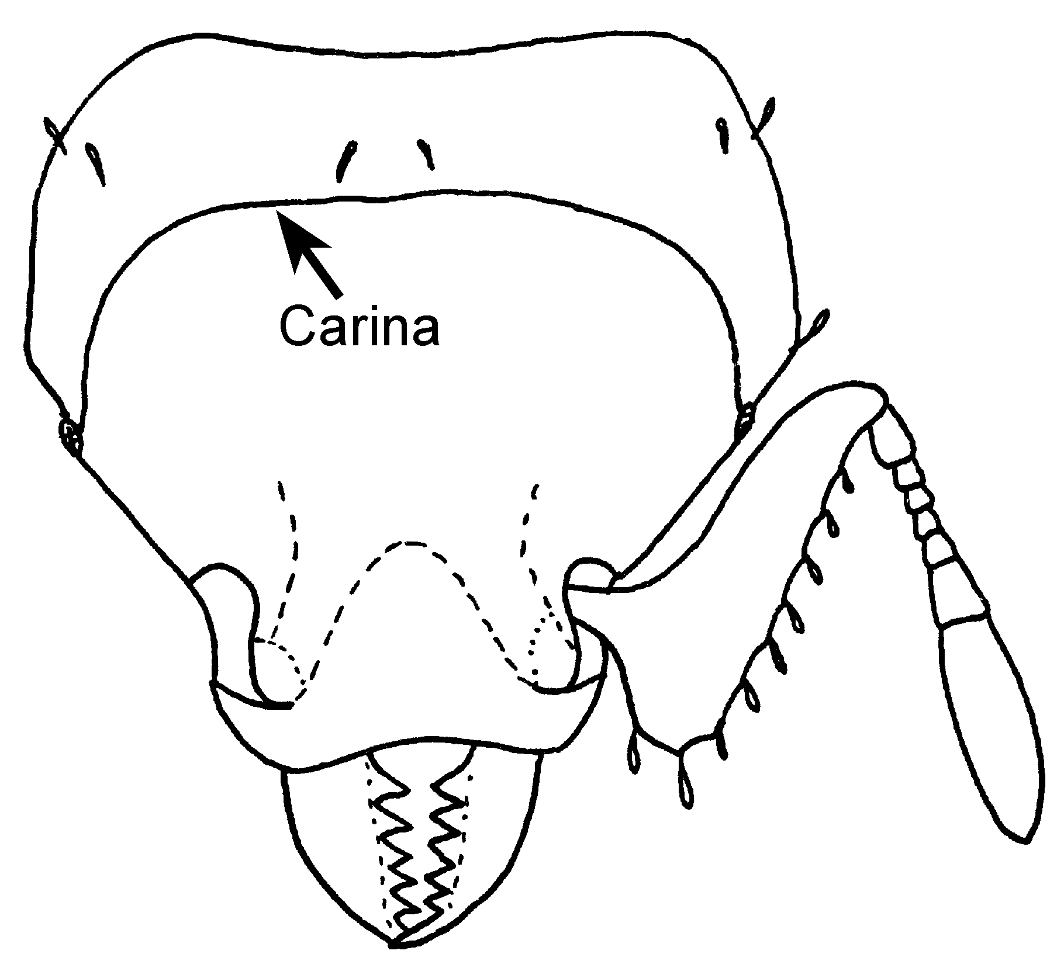
Fig. 1. Head of a worker of Octostruma rugifera (from Brown and Kempf, 1960).
- Head without distinct transverse arched carina across middle of head (although in some samples of O. balzani there is an indistinct suggestion of this carina) ……………………………………………………………………………. 3
2(1). All of dorsum of head and alitrunk uniformly and densely punctulate, opaque (Fig. 21) se. Brazil, Argentina ………………………………………………………….. rugifera (Mayr)
- Dorsum of head vaguely rugose over basic punctation; concave part of the surface indefinitely rugulose, becoming almost smooth and strongly shining where it joins clypeus; pronotum with rugulose oversculpture, more or less transverse (Fig. 20); s. Mexico …………………………………………... rugiferoides Brown & Kempf
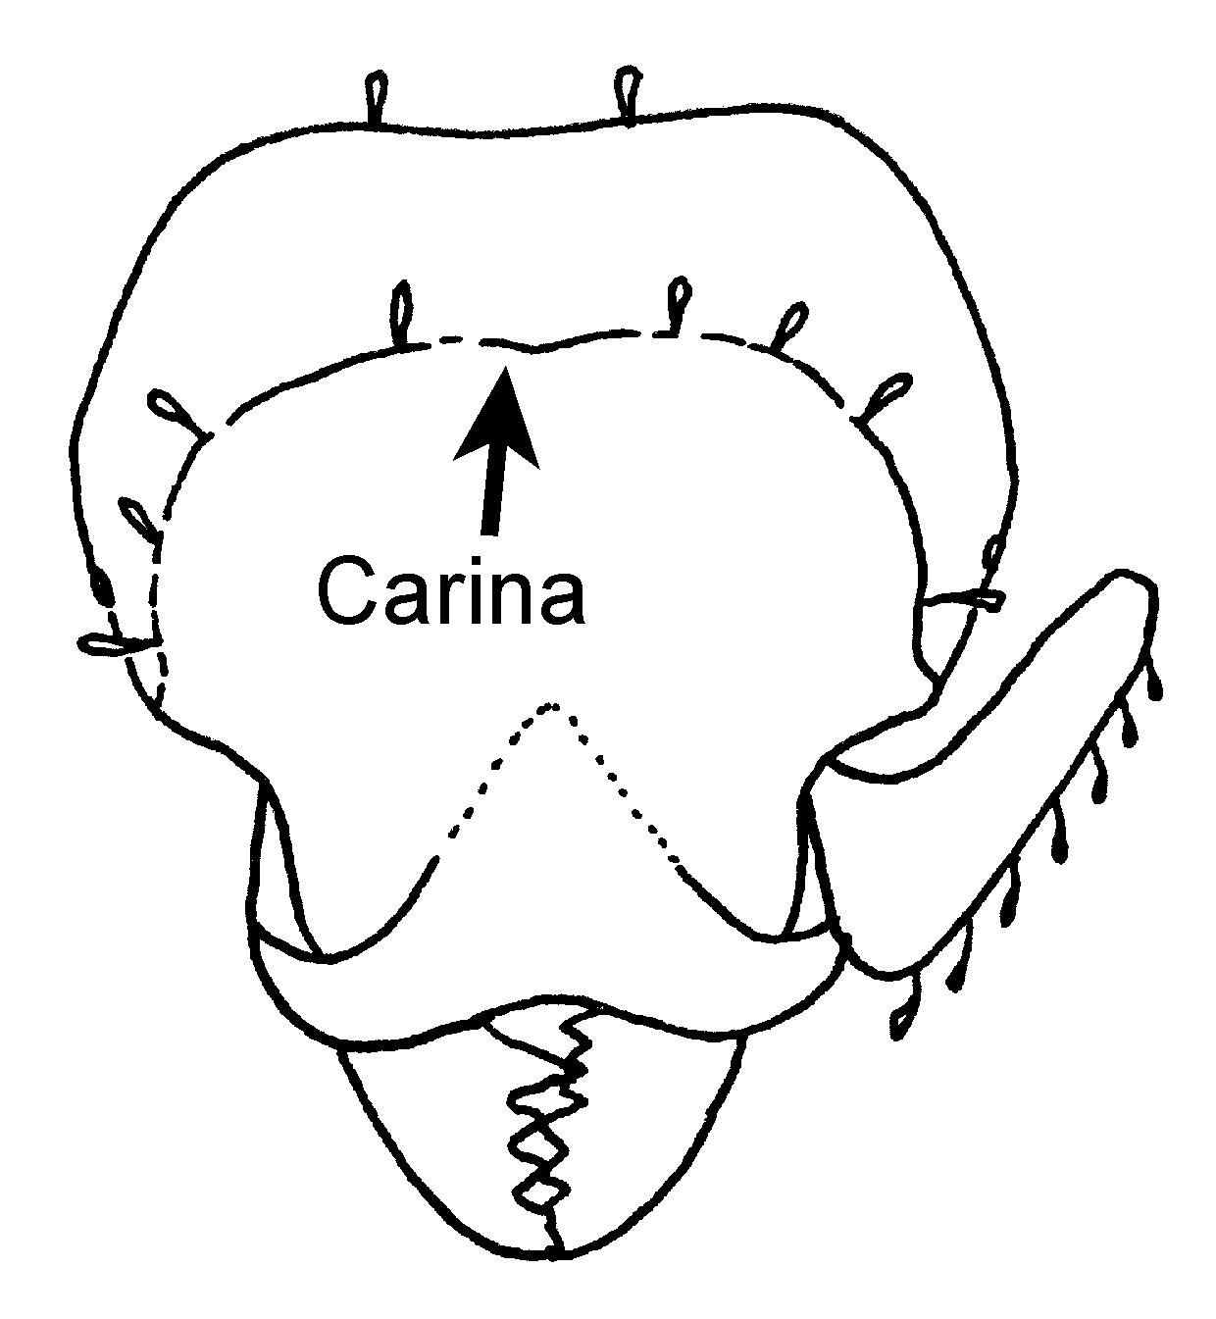
Fig. 2. Head of a worker of Octostruma rugiferoides (from Brown and Kempf, 1960).
3(1). Mesonotum of worker with broad, shallow longitudinal sulcus often extending onto pronotum and propodeum; worker usually and female always with coarse, irregular, longitudinal rugulae covering most of dorsum of head (Fig. 3); widespread ……………………………………………………………… iheringi (Emery)
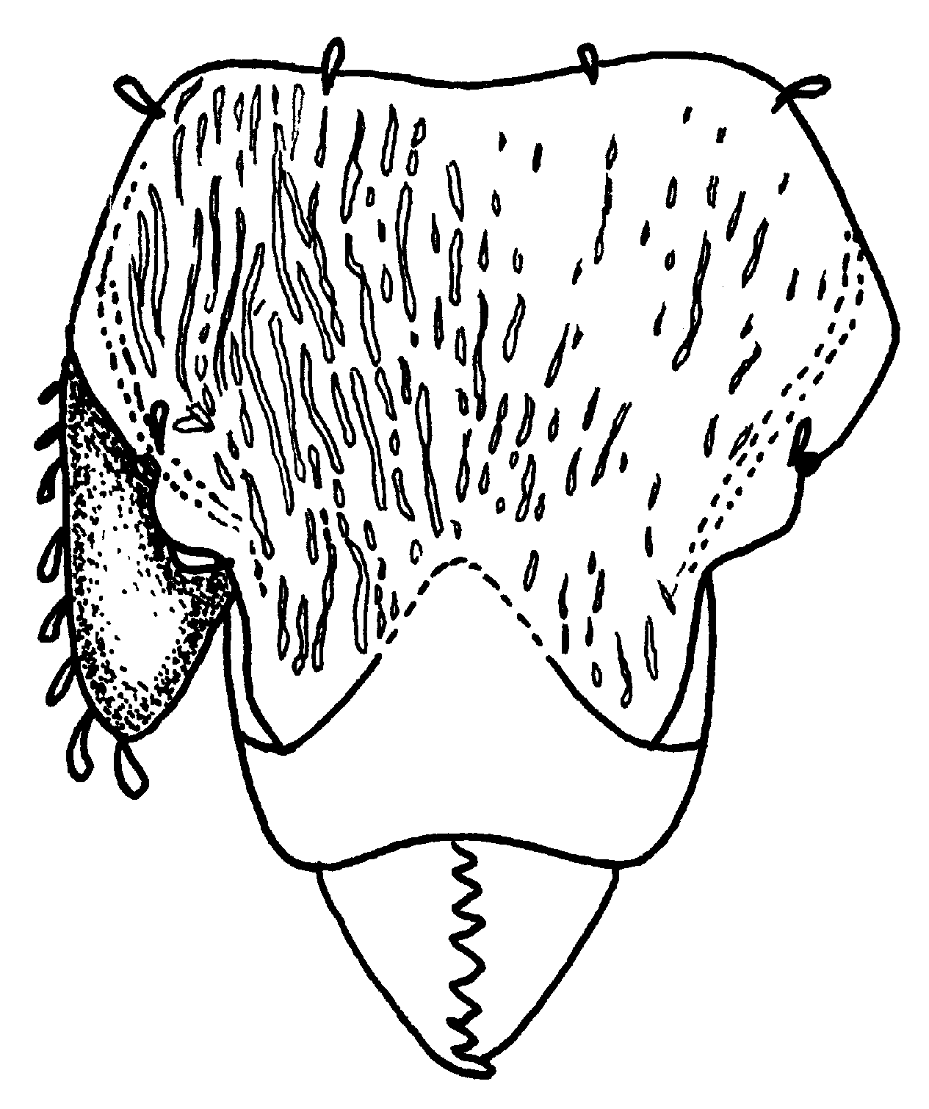
Fig. 3. Head of a worker of Octostruma iheringi (from Brown and Kempf, 1960).
- Mesonotum and pronotum of worker convex or nearly flat, without a trace of longitudinal sulcus; dorsal surface of head never clearly longitudinally costate in worker or female ………………………………………………………………….. 4
4(3). Head proper always slightly longer than broad; size large, combined length of worker head and closed mandibles 1.00 mm or more (possibly slightly less in very small workers); female large gaster over 1.5 mm wide; worker propodeal teeth reduced to a narrow lamellar margin on each side of the declivity, subrectangular above (Figs. 16, 20; Colombia, Peru, Bolivia) …………………………. inca Brown & Kempf
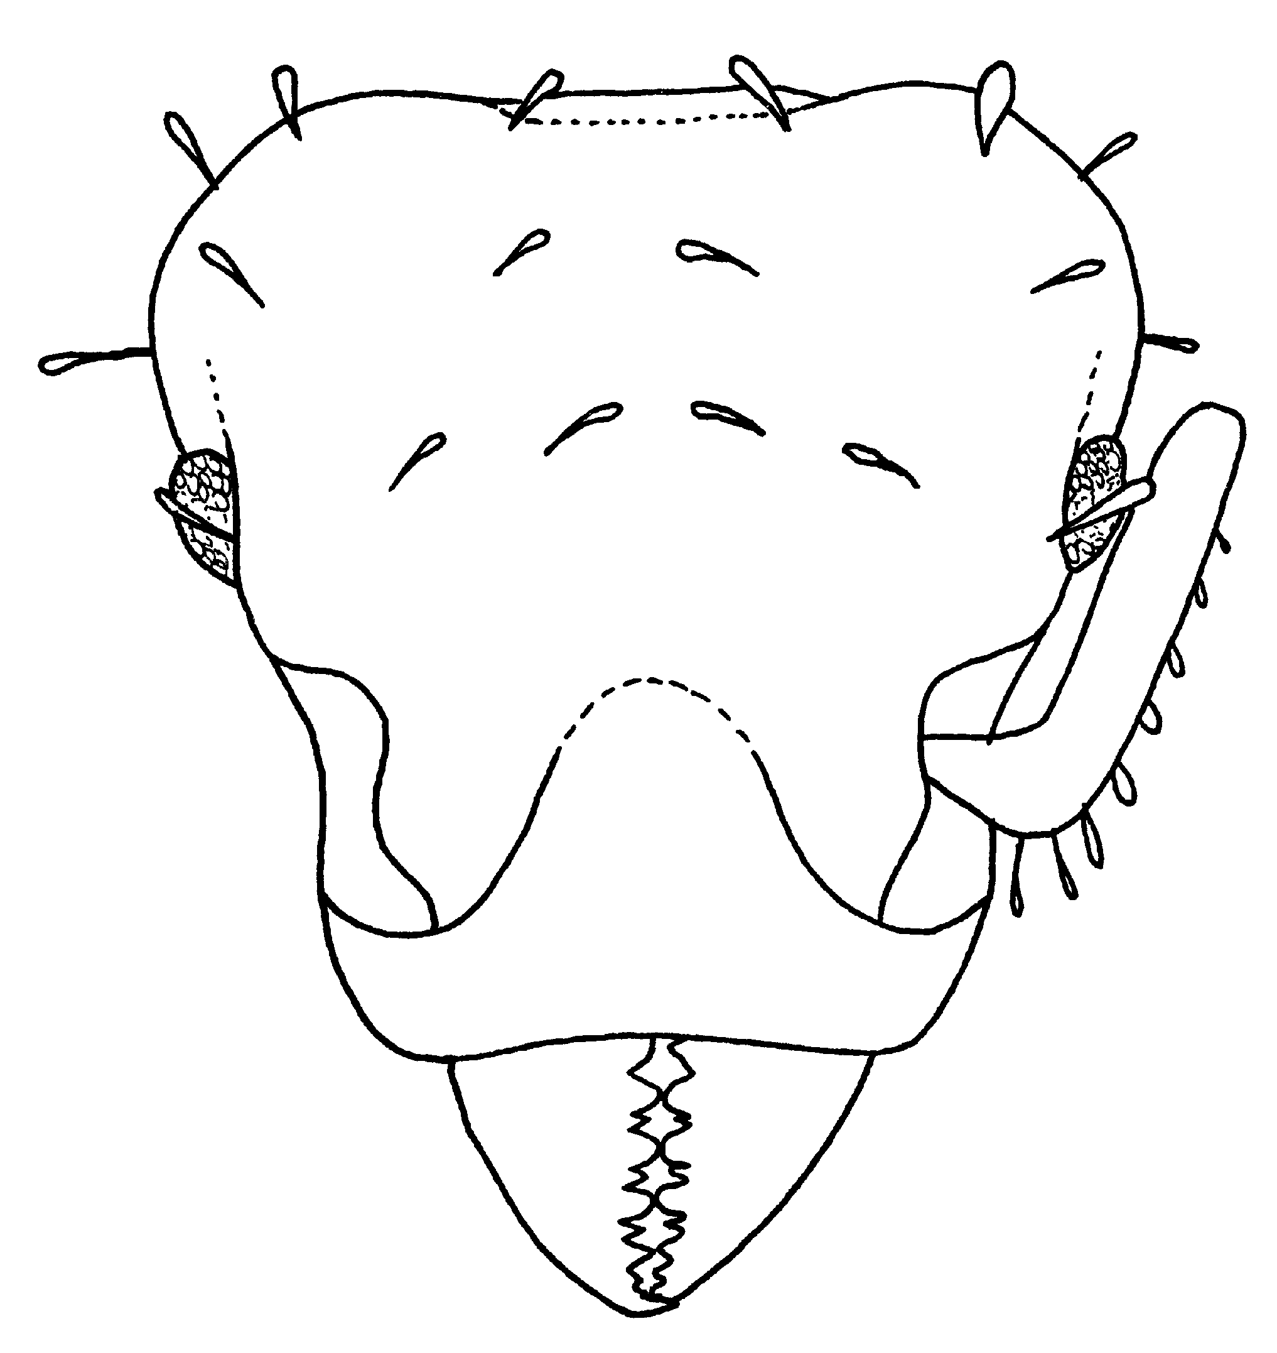
Fig. 4. Head of a worker of Octostruma inca (from Brown and Kempf, 1960).
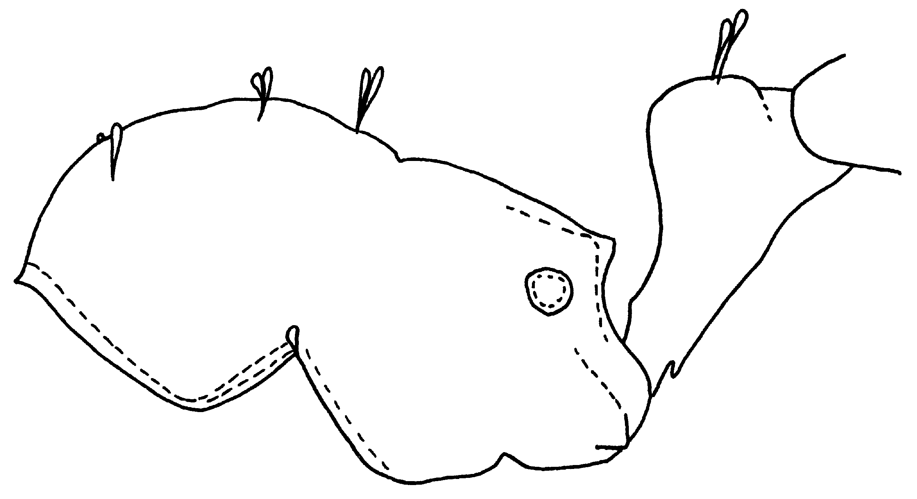
Fig. 5. Mesosoma of a worker of Octostruma inca (from Brown and Kempf, 1960).
- Head proper slightly broader than long and/or size smaller; combined length of head and closed mandibles of worker under 1.00 (in workers from se. Brazil head may be slightly longer than bread but then size is small); female smaller width of gaster under 1.5 mm; worker propodeal teeth well developed, projecting more or less acutely triangular …………………………………………………………………. 5
5(4). Body of worker, including head smooth and very finely and superficially shagreened, but not shining, except weakly on gaster: worker head width usually over 0.80 mm; female gaster width over 1.3 mm; female rugulose-punctate over head, mesosoma and nodes gaster densely punctate (Figs. 15, 23); se. Brazil ………….. petiolata (Mayr)
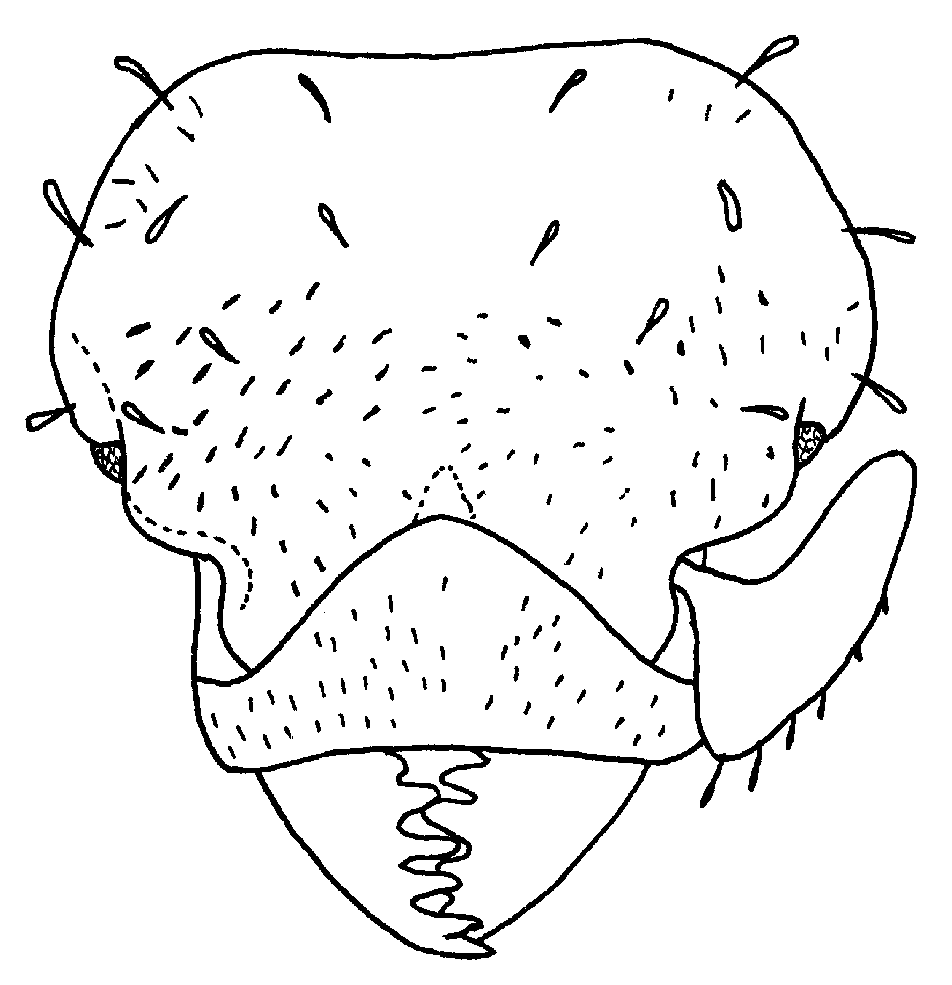
Fig. 6. Head of a worker of Octostruma petiolata (from Brown and Kempf, 1960).
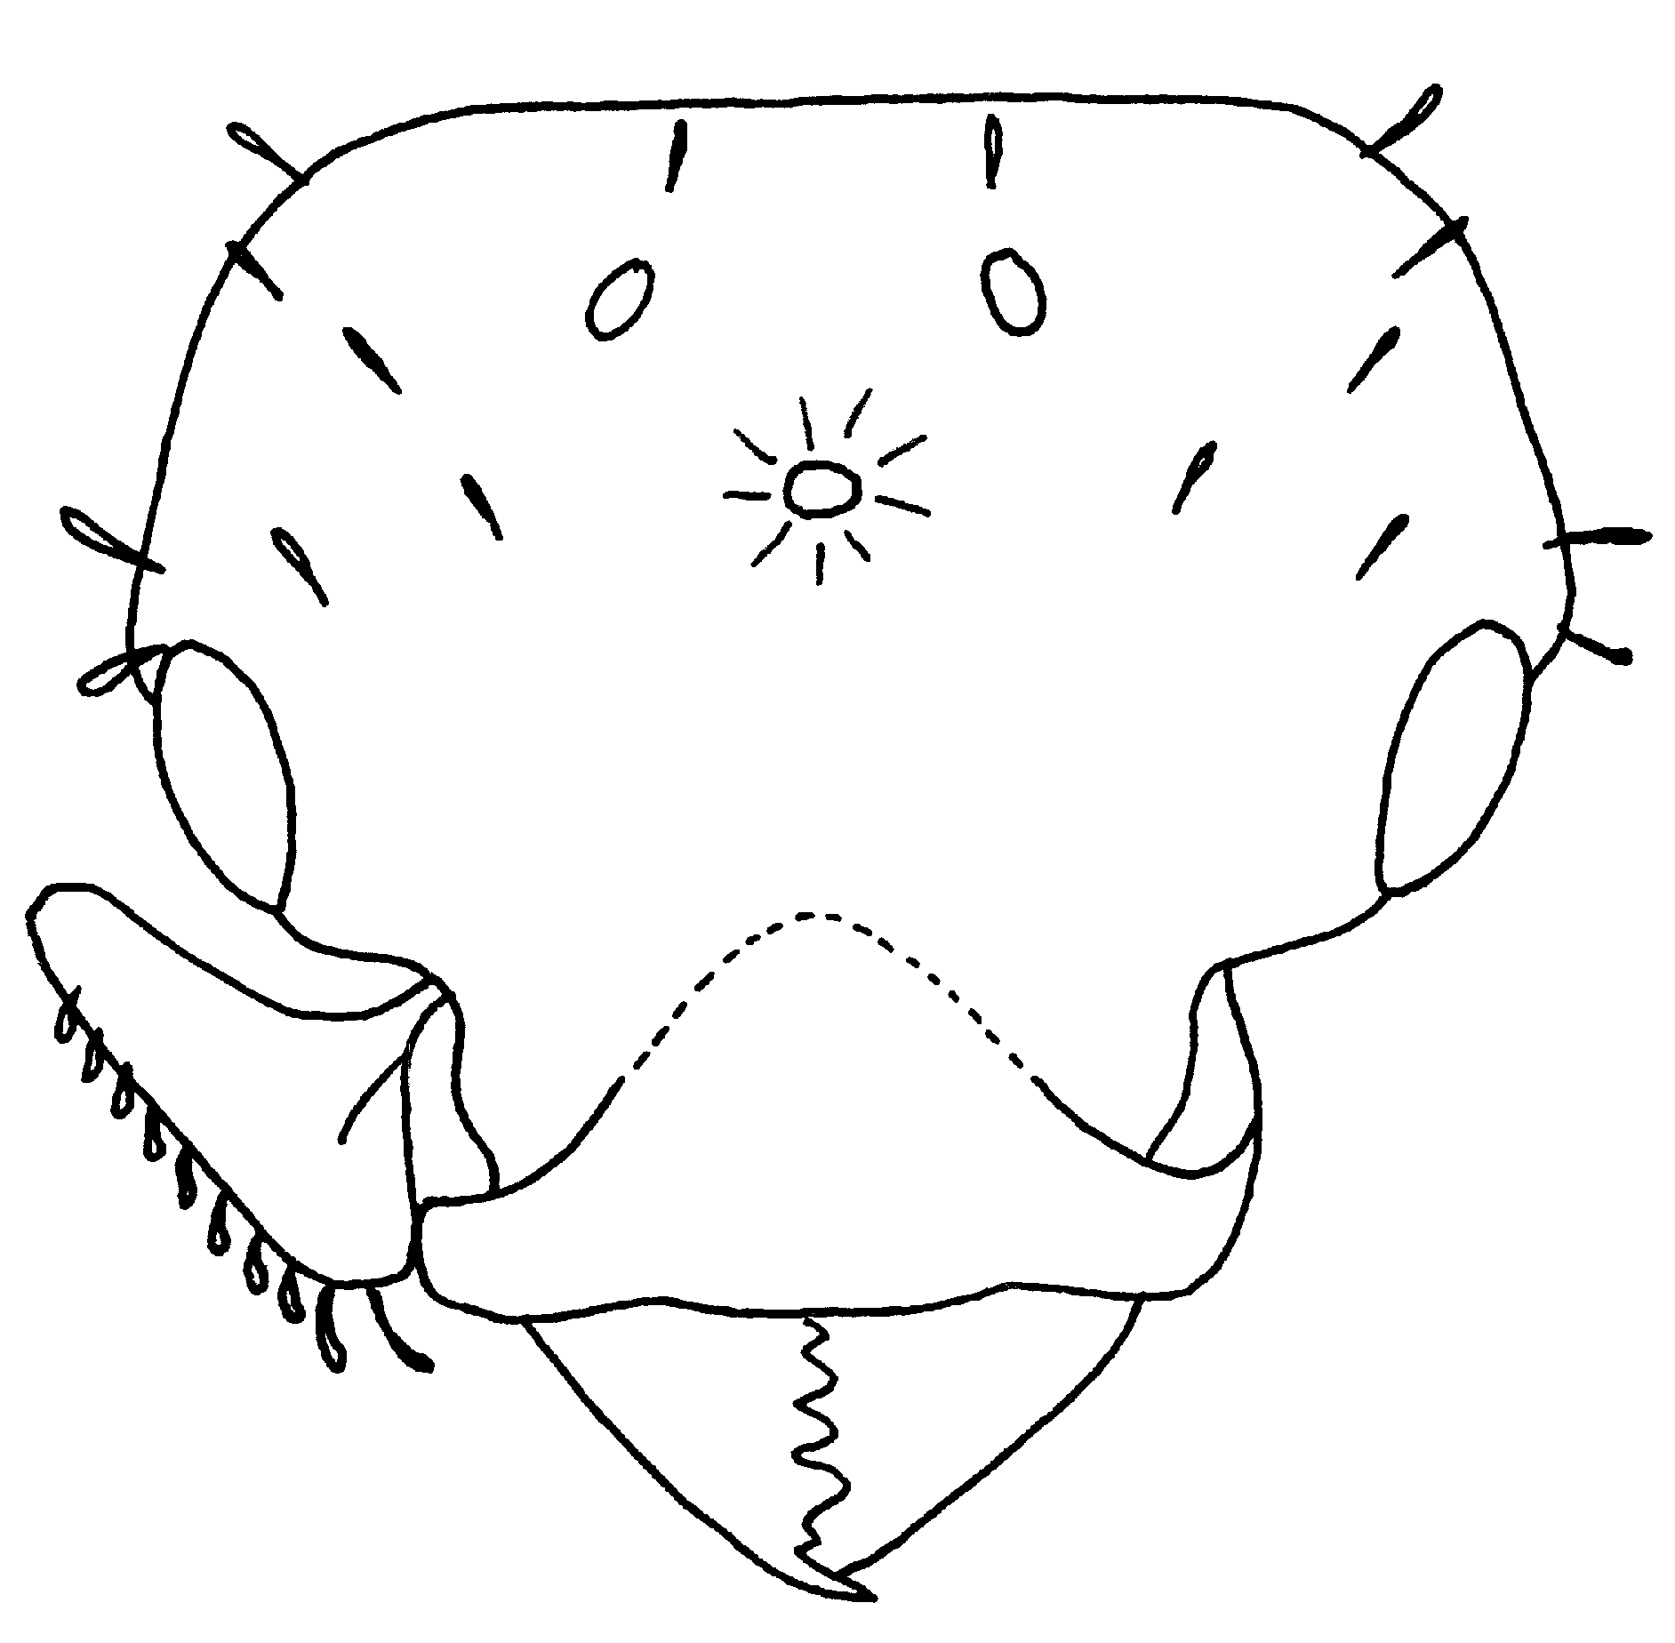
Fig. 7. Head of a female of Octostruma petiolata (from Brown and Kempf, 1960).
- Body of worker and especially head distinctly reticulate-punctate or rugulose-punctate not smooth; worker head width usually under 0.80 mm ………………... 6
6(5). Head of worker shallowly rugulose-punctulate (probably usually between 0.70 and 0.80 mm wide); C. America …………... wheeleri Mann
- Body including head finely and densely reticulate-punctulate; size smaller (HW under
0.75 mm) ………………………………………………………………………….. 7
7(6). Size larger; HW of unique type worker 0.71 mm; lateral lamellar lobe behind eye well developed rounded (Fig. 19); Amazonas and Guianas ……………………... batesi (Emery)
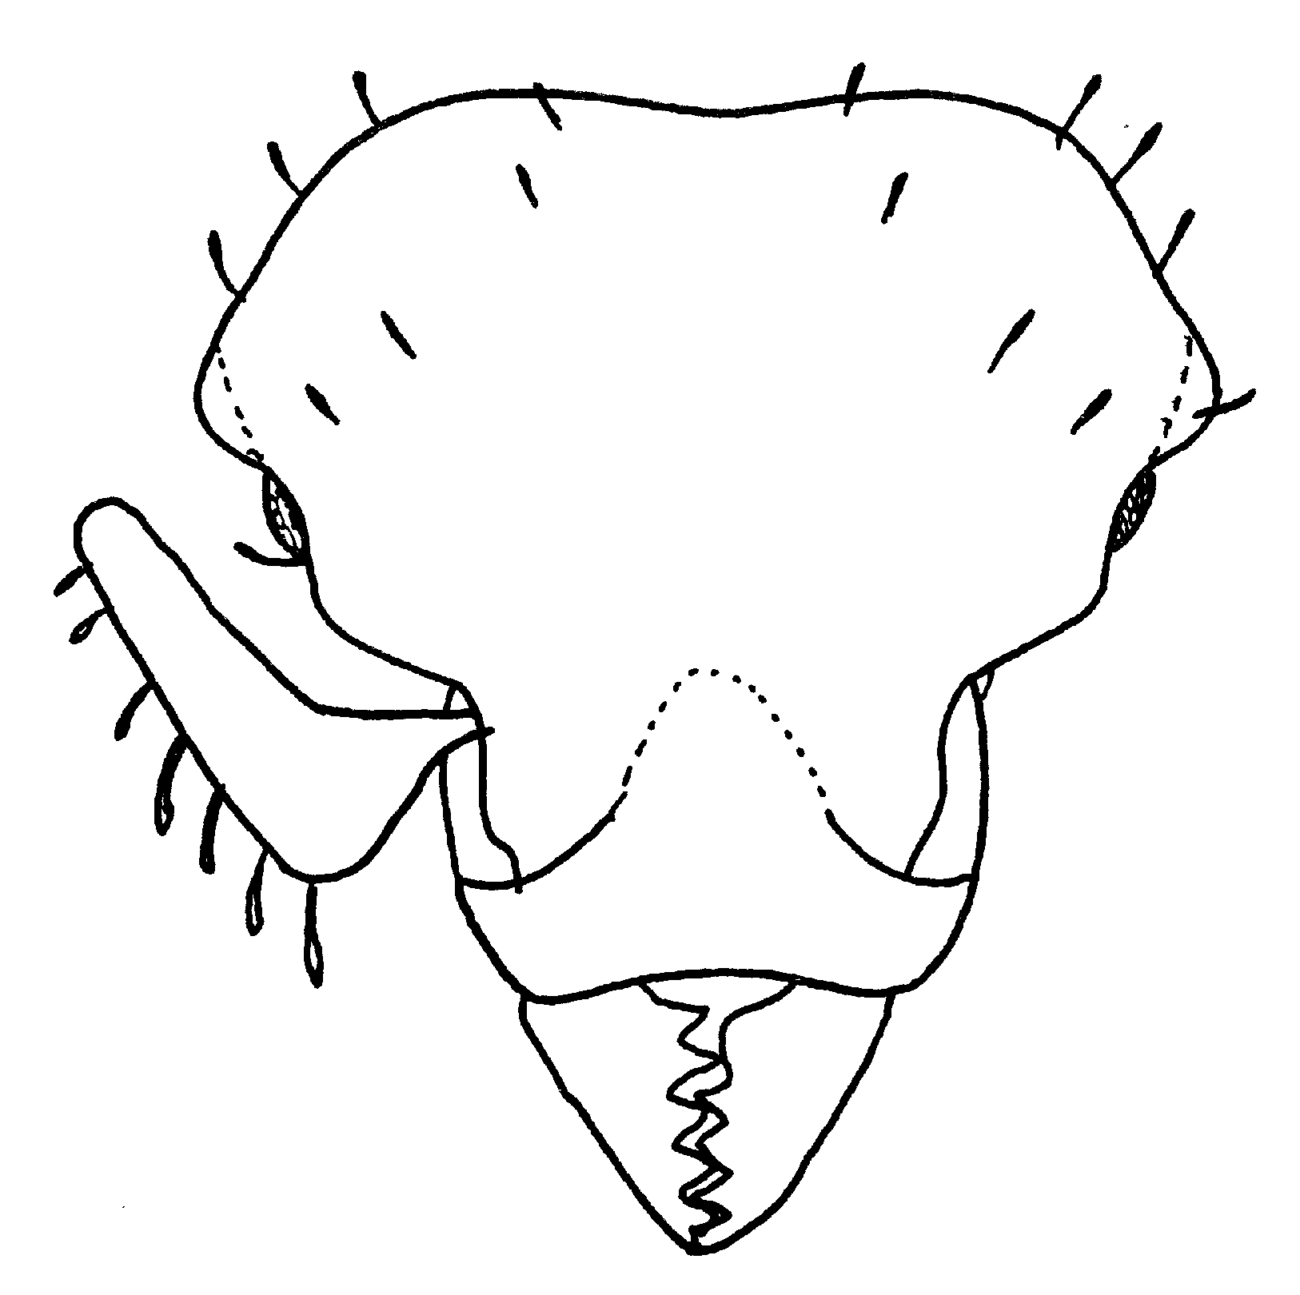
Fig. 8. Head of a worker of Octostruma batesi (from Brown and Kempf, 1960).

- Size smaller worker HW under 0.69 mm (ergatoid female to about 0.70 mm); lateral lobe behind eye reduced to a small obtuse angle or obsolete (Figs. 18, 22, 27, 28); widespread in tropical America ………………………………………………….. 8
8(7). In zone of sympatry (se. Brazil and possibly adjacent areas) basal tooth of mandible narrow and pointed, leaving a notable space between mandible and clypeus at full closure; head averaging more slender (CI 94-103) (Figs. 25, 28) SE Brazil ……...
……………………………………………………. stenognatha Brown & Kempf
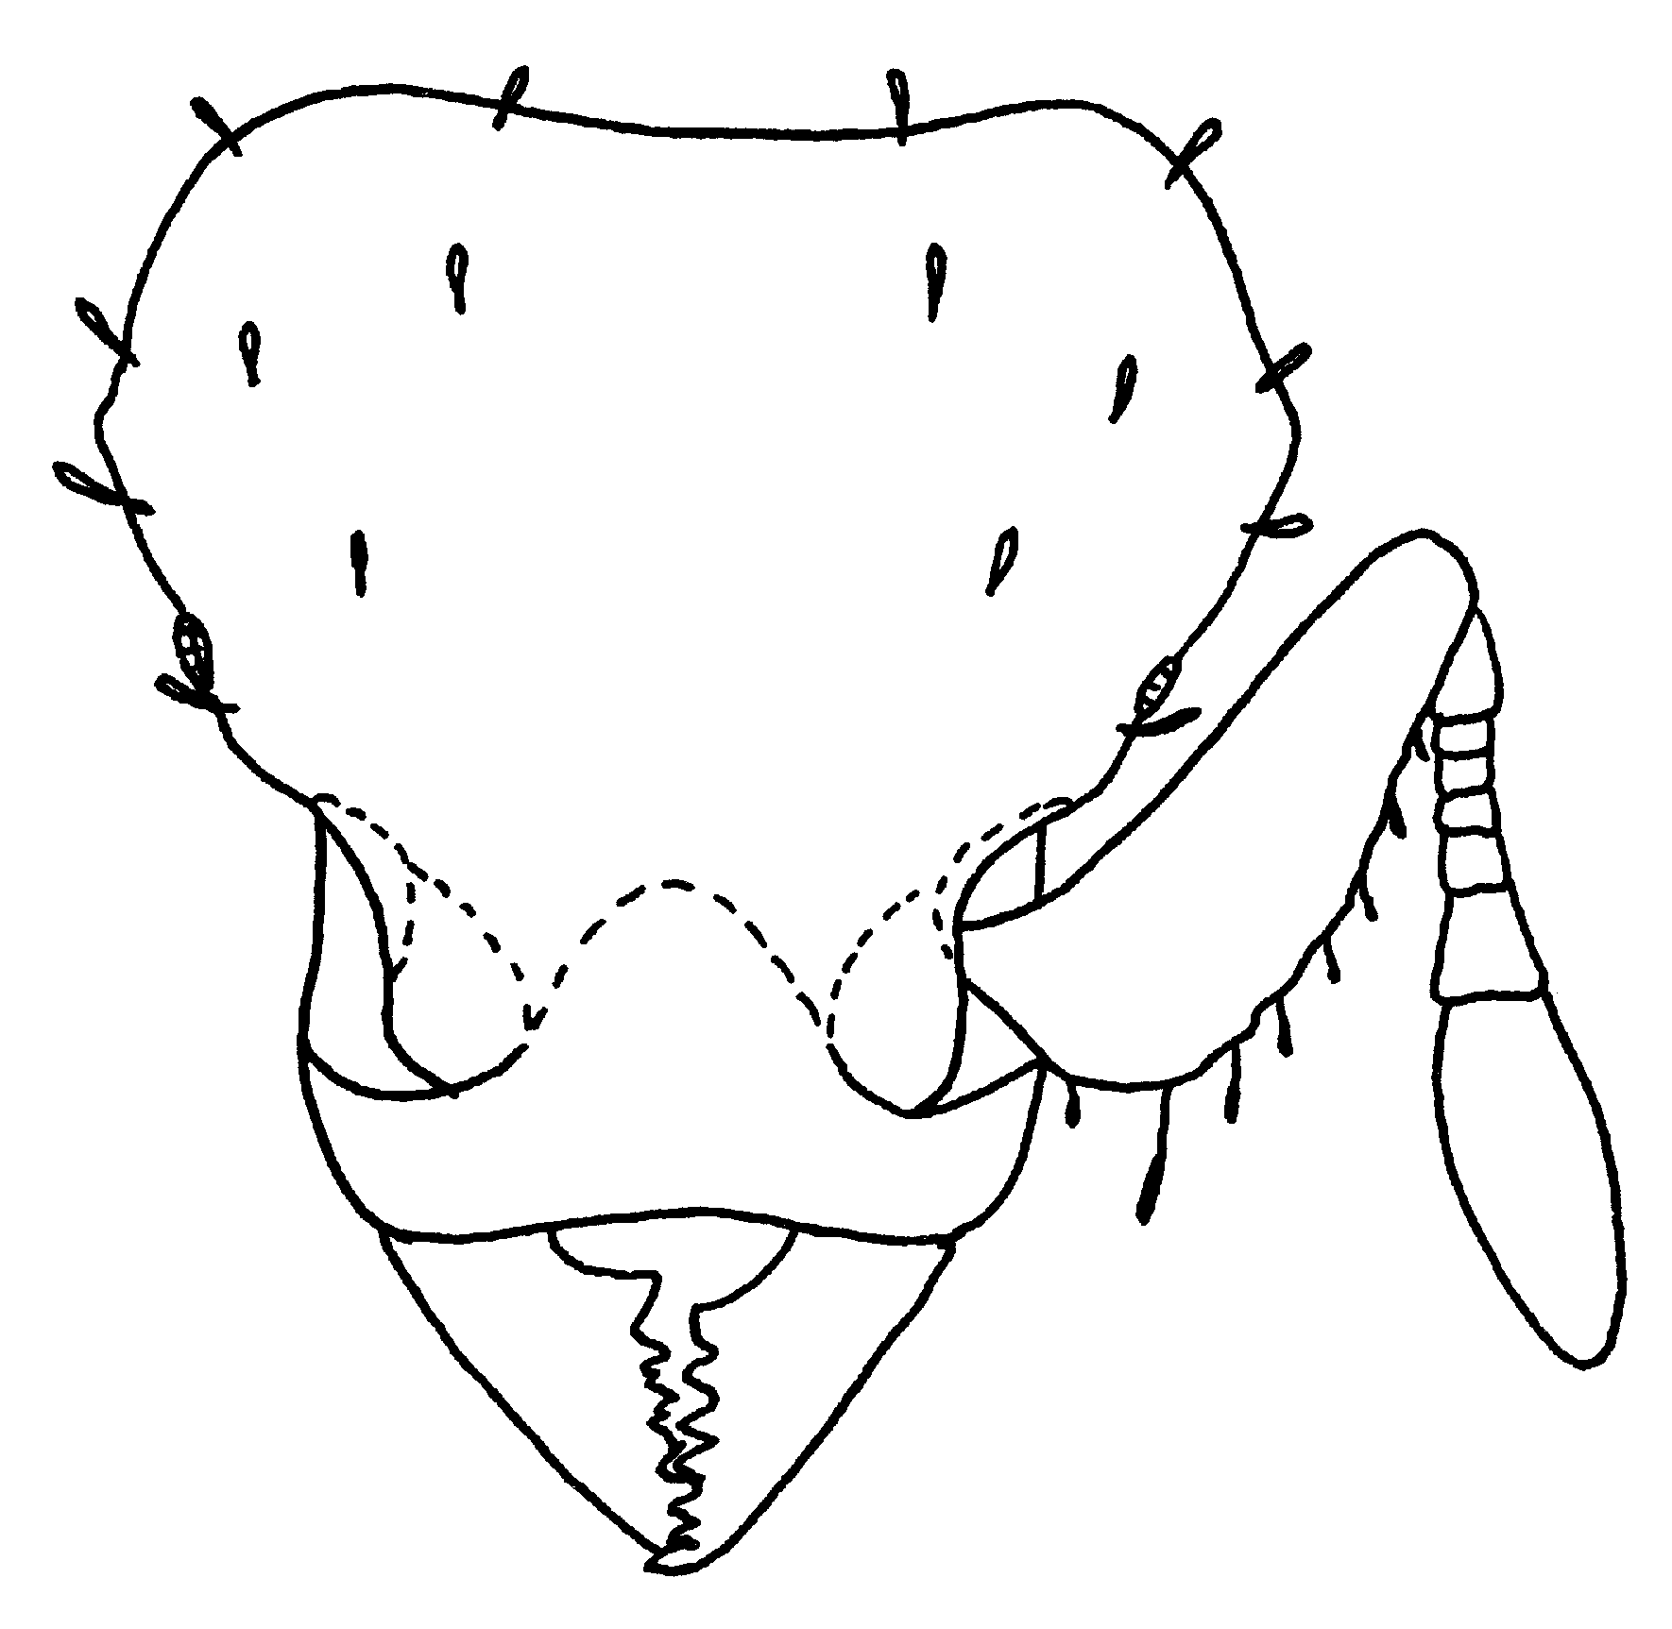
Fig. 9. Head of a worker of Octostruma stenognatha (from Brown and Kempf, 1960).
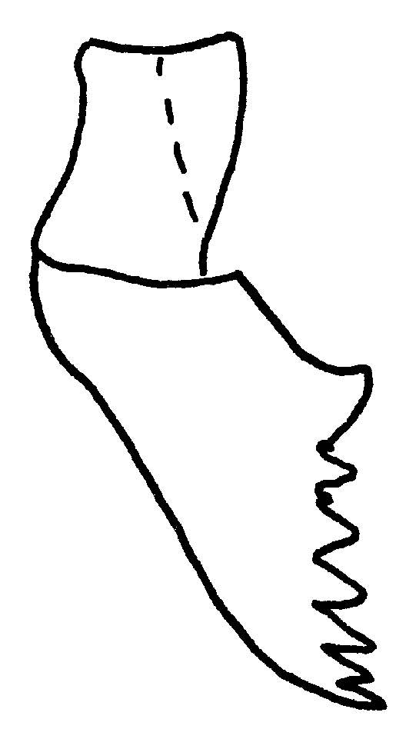
Fig. 10. Mandible of a worker of Octotstuma stenognatha (from Brown and Kempf, 1960). needed???

- Mandibles usually (invariably in se. Brazil) with broad, rounded basal teeth leaving no anteclypeal space at full closure; worker head broader (CI 101-113, usually over 103) (Figs. 18, 22, 24, 26, 27); widespread ………………………. balzani (Emery)
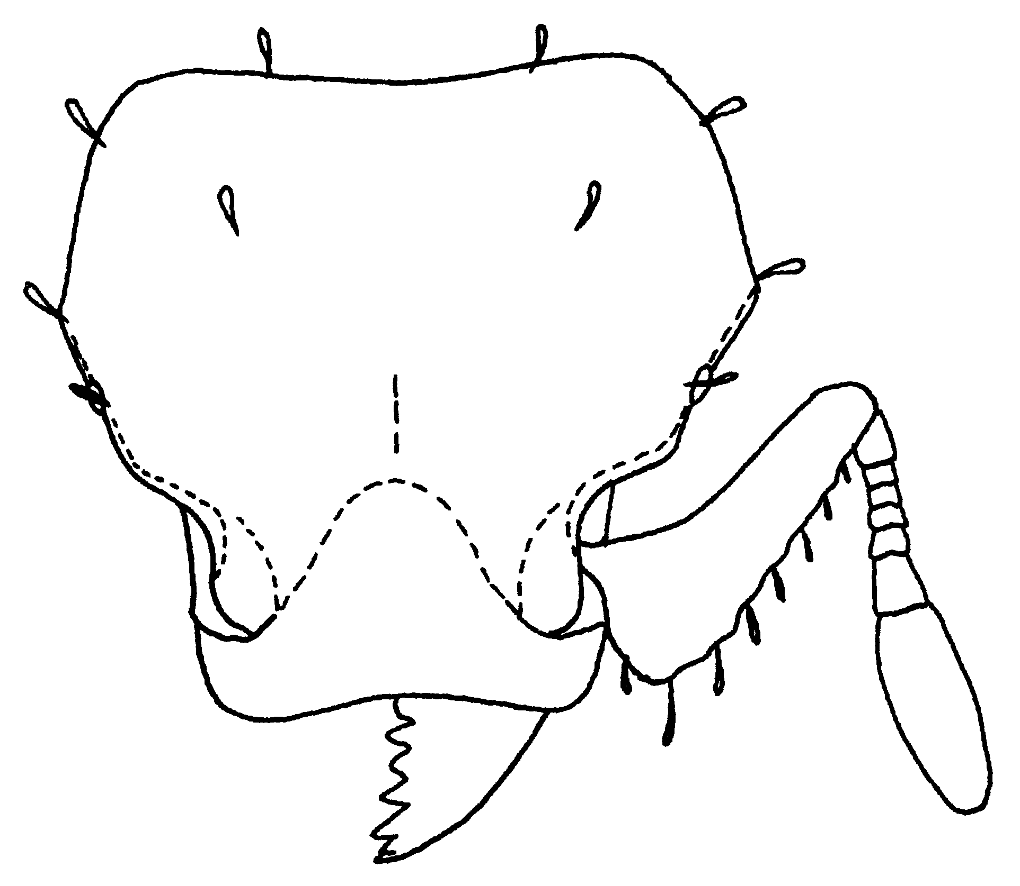
Fig. 11. Head of a worker of Octostruma balzani (from Brown and Kempf, 1960).
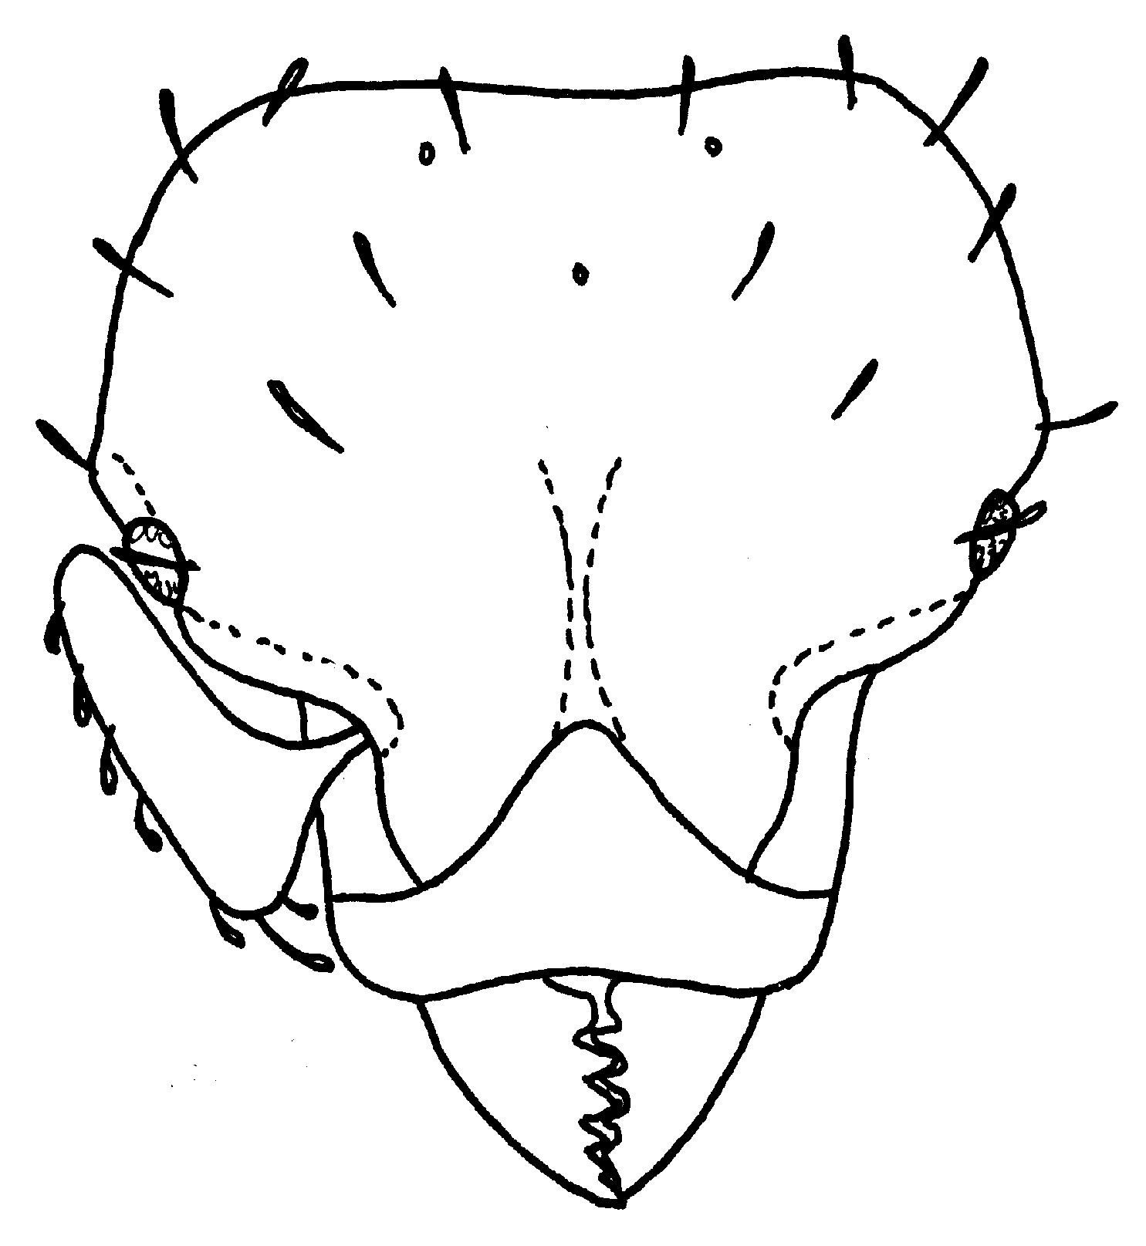
Fig. 12. Head of a ergatoid female of Octostruma balzani (from Brown and Kempf, 1960).

List of species

Octostruma balzani (Emery)

Figs. ; Map

Discussion.
Distribution. Mexico (Puebla, Veracruz, Chiapas) south through Guatemala, Nicaragua, Costa Rica, Panamá, Colombia, Trinidad, Guianas, Brasil and Bolivia.
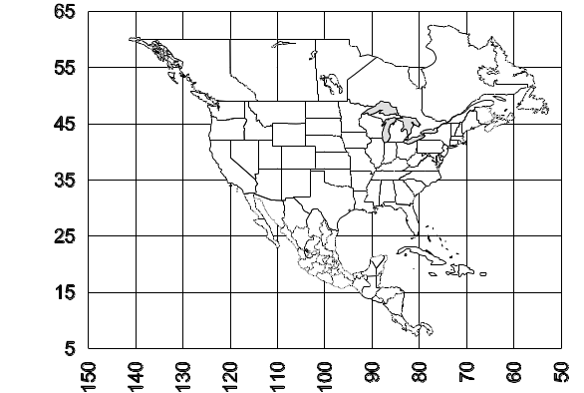 Map 1. Octostruma balzani.
Habitat.
Biology.

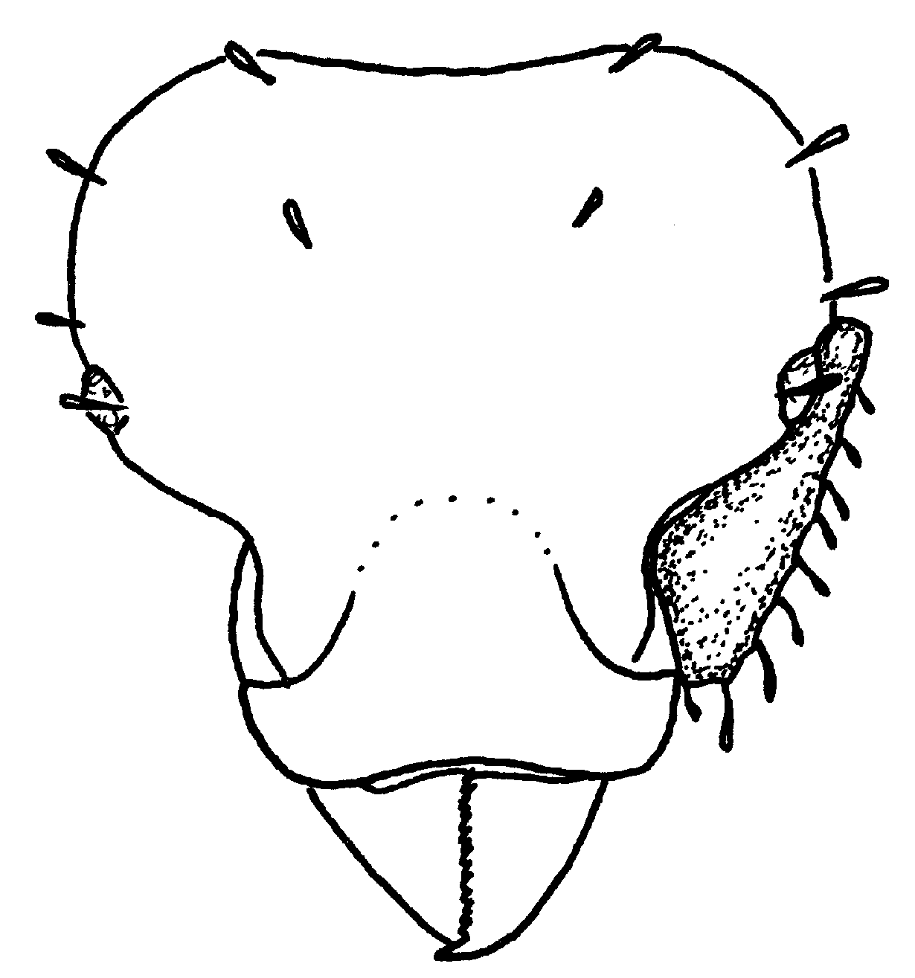
Fig. 13. Head of a worker of Octostruma balzani (from Brown and Kempf, 1960). double check identity, looks wrong.
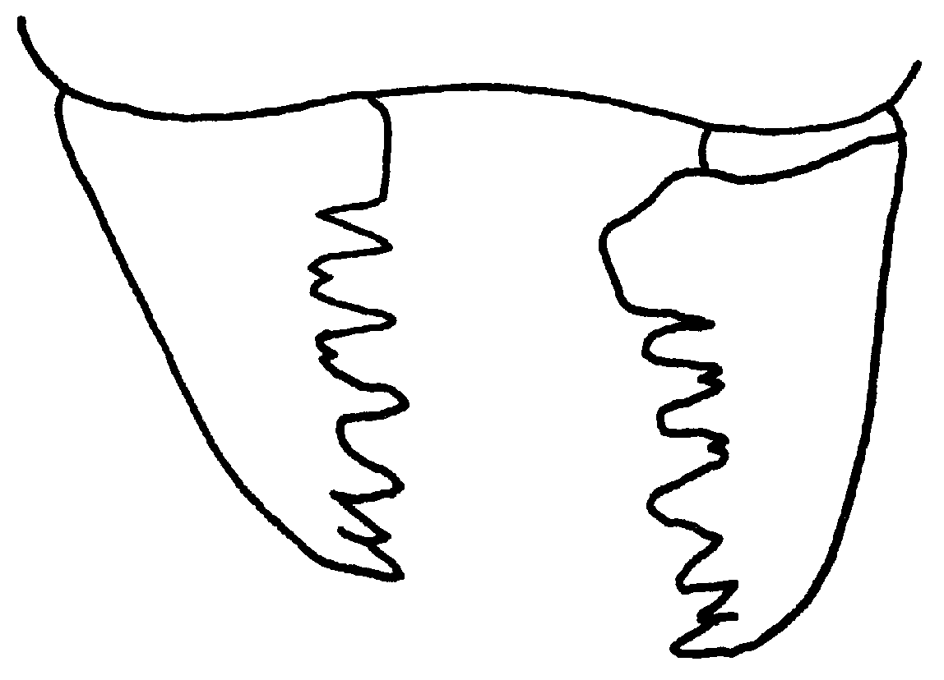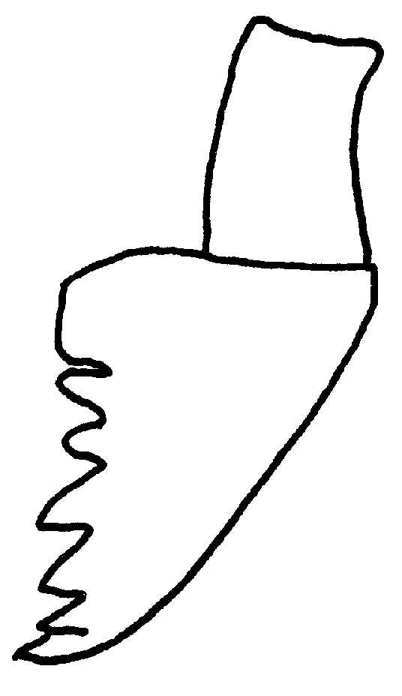
Fig. 14. Mandibles of a worker (left) and female (right) of Octostruma balzani (from Brown and Kempf, 1960).

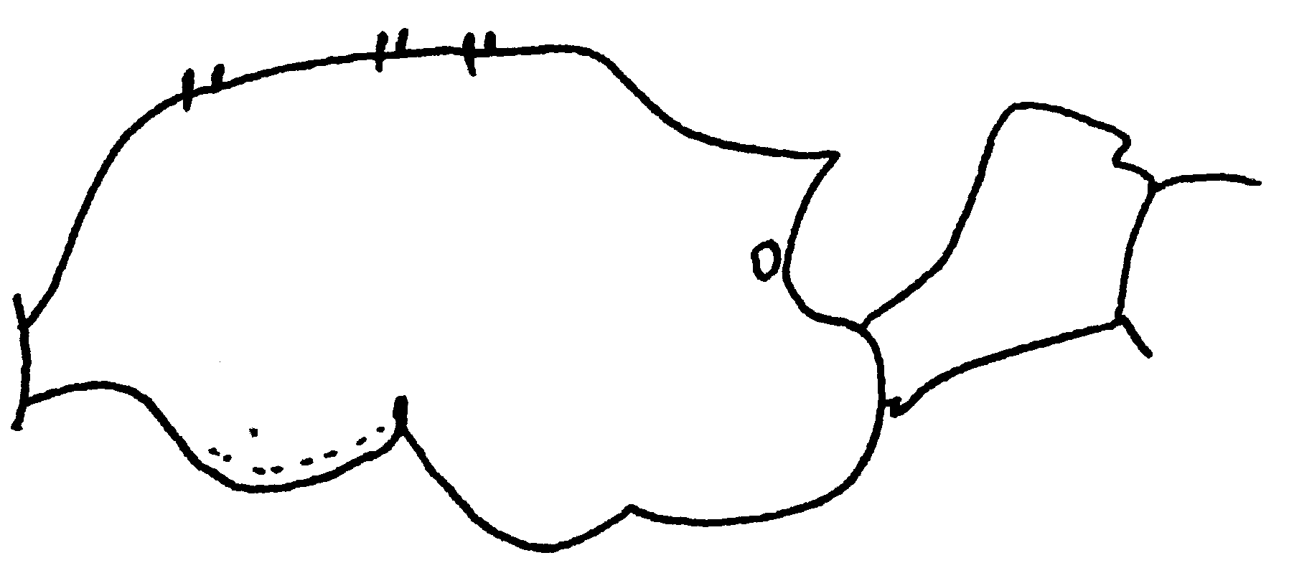
Fig. 15. Mesosoma and petiole of a worker of Octostruma balzani (from Brown and Kempf, 1960).

Octostruma inca

Distribution: Colombia, Peru, Bolivia.

Octostruma iheringi (Emery)
Figs. ; Map

Discussion.
Distribution. Guatemala, Panamá, Jamaica, Colombia, Venezuela, Trinidad, Brasil.
Map 2. Octostruma iheringi.
Habitat.
Biology.

Octostruma rugiferoides Brown and Kempf

Figs. ; Map

Discussion.
Distribution. Mexico (Veracruz, Pueblo Nuevo near Tetzonapa).
Map 3. Octostruma rugiferoides.
Habitat.
Biology.

Octostruma wheeleri Mann

Distribution: Guatemala, Livingston.
Map 1. Octostruma wheeleri.
Literature Cited
Brown, W. and W. Kempf. 1960.

