Genus Eciton
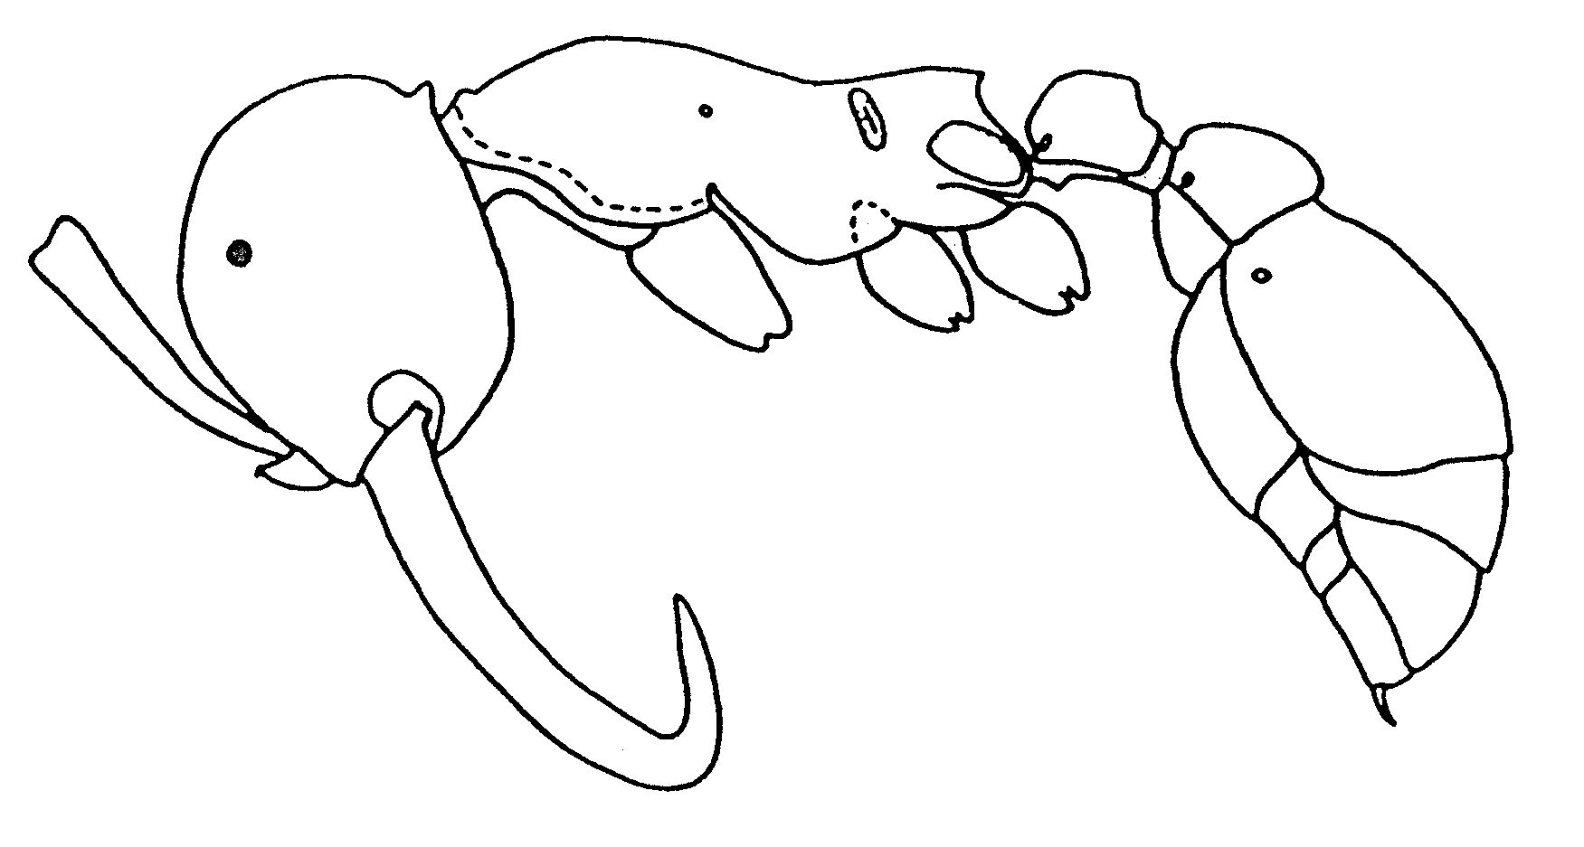Fig. 1. Side view of a worker of Eciton sp. (from Serna, 1999).
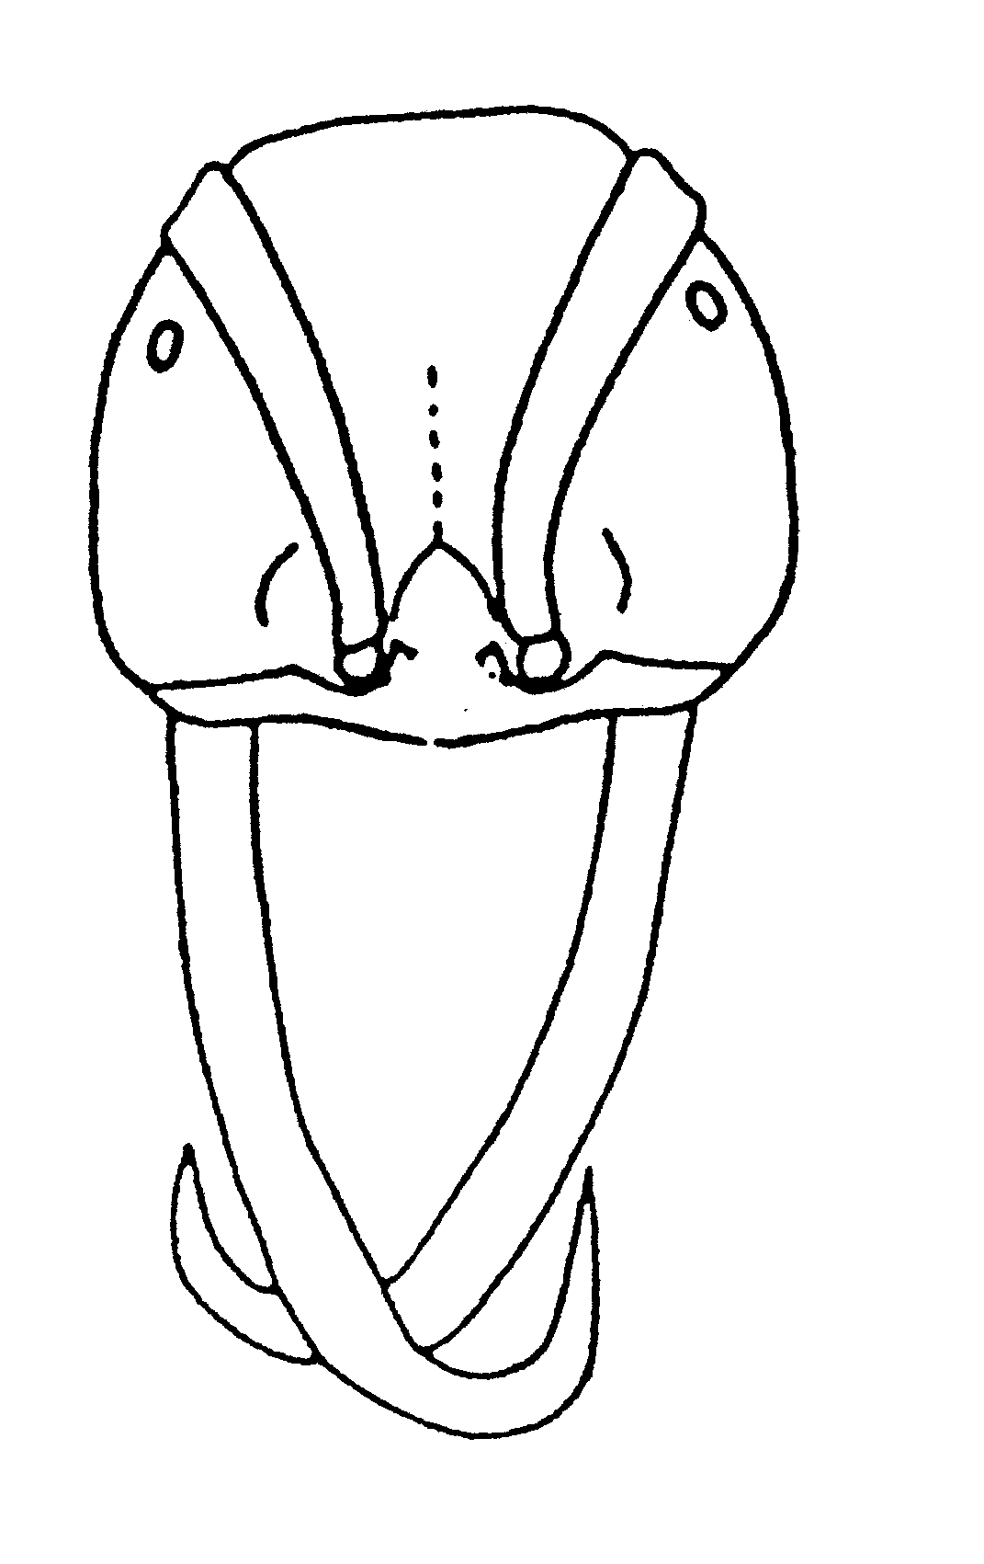 Fig. 2. Head of a major worker of Eciton sp. (from Serna, 1999).
KEY TO SPECIES OF ECITON

Workers
1. Occipital corners without distinct teeth ...................................................................... dulcius
- Occipital corners with sharp teeth .............. 2
2(1). Propodeal teeth fused (Fig. x) ............................................................... mexicanum
- Propodeal teeth separated, or weakly fused with a low carina near base (Fig. x) ....................... 3
3(2). Propodeal teeth spinous (lateral view, Fig. ) .............................................………..…………...... 4
- Propodeal teeth triangular or rounded (Fig. x) .................................…………………....…....... 6
4(3). Head and alitrunk black, gaster yellow to orange; propodeal spine thin and sharp (Fig. x); mandibles of soldiers never hook-shaped ......................................................................... rapax
- Head and alitrunk reddish brown to blackish brown, gaster red dish brown to orange; propodeal spine (Fig. x) broader than in rapax; mandibles of soldiers hook-shaped (Fig. x) ........................…..... 5
5(4). Propodeal teeth about as long as propodeal spiracles (Fig. 5); mandibles (exclusive of recurved tips) of soldiers about as long as width of head (Fig. x) ........................................................ quadriglume
- Propodeal teeth shorter than propodeal spiracles (Fig. x); mandibles (exclusive of recurved tips) of soldiers distinctly longer than width of head .................................……………….............. vagans
6(3). Distinct single median longitudinal keel on sloping surface of propodeum; propodeal spiracle almost perpendicular to dorsal surface (Pl. 4, Fig. 4, 6); strigile of metatibia about 2 times longer than wide; hook-shaped mandible of soldier with large median tooth on inner surface (Fig. x) ............ …………………………………………. lucanoides
- Longitudinal keels on sloping surface of propodeum paired or absent; propodeal spiracle at angle of 70 - 80 degrees from dorsal surface of propodeum (Fig. x); strigile of metatibia at least three times longer than wide; hook-shaped mandible of soldier without distinct tooth on inner surface ..........…………………………….............. 7
7(6). Node of petiole trapezoidal or subquadrate (dorsal view); alitrunks of media and minor workers usually brownish or blackish; head of soldier not distinctly shining ........................……....... burchelli
- Node of petiole elongate rectangular (dorsal view); body concolorous yellowish or light reddish; head of soldier distinctly shining ........................... 8
8(7). Area between propodeal keels narrowed posteriorly (dorsal view); second segment of flagellum slightly longer than twice its greatest width (soldiers); second segment of flagellum longer than apical width of scape (workers) ......... ................................................................... hamatum
- Propodeal keels about parallel (dorsal view); second segment of flagellum slightly shorter than twice its greatest width (soldiers); second segment of flagellum not longer than apical width of scape (workers) ....................................... drepanophorum

Males

1. Greatest width of mandible about equal to or less than distance between antennal bases .....….... 2
- Greatest width of mandible distinctly greater than distance between antennal bases .............…... 8
2(1). Apex of mandible broadly rounded (Fig. x) ..........................………........……................ jansoni
- Apex of mandible pointed or angular ........ 3
3(2). Broadest portion of mandible nearer its base than its apex ................................................…....... 4
- Broadest portion of mandible not nearer its base than its apex ......................……………......... 6
4(3). Outer surface of mandible almost straight along its basal ²_{/3} (Fig. x) ..........…............ burchelli
- Outer surface of mandible distinctly bent or convex along its basal one-third to one-half (Fig. x) ……………………………………………………. 5
5(4). Mandible distinctly longer than height of head; mandible (straight line from apex to inner base) at least 4 times longer than greatest width (Fig. x) ...….................................................. dulcius
- Mandible about as long as height of head or shorter; mandible (straight line from apex to inner base) about 3 times longer than greatest width (Fig. x) .....................………........................ quadriglume
6(3). Gaster without long setae; claw without tooth, (except vagans allognathum) ............. vagans
- Gaster with long setae; claw with tooth ..... 7
7(6). Color brownish; scape without setae; setae on gastric tergites 2 - 4 confined to posterior half of each tergite .......................……................ setigaster
- Color yellowish or light reddish brown; scape with numerous setae; setae of gastral tergites scattered over entire surface. .................... hamatum
8(1). Distal surface of inner triangular projection of mandible almost straight except for curved apical tooth (Fig. x) ........………...................... uncinatum
- Distal surface of inner projection of mandible not straight, but convex or forming a slight corner before flowing into curved apical tooth (Fig. x) .......................……................... mexicanum

Literature Cited
Watkins, J. 1976. The identification and distribution of the New World army ants (Dorylinae: Formicidae). Baylor Univ. Press.

