Key to the species in the Formica rufa group

1. Apex of petiole extremely thick and evenly rounded above so that in profile scale has shape of an inverted letter U (Fig. xx); hairs forming gastral pubescence often erect at base, but reflected at tip, forming little loops or wickets (Fig. xx) ; female 5.5 mm. – 6.5 mm in length, very smooth and shining and with gastral pubescence like that of worker …………………. reflexa Buren
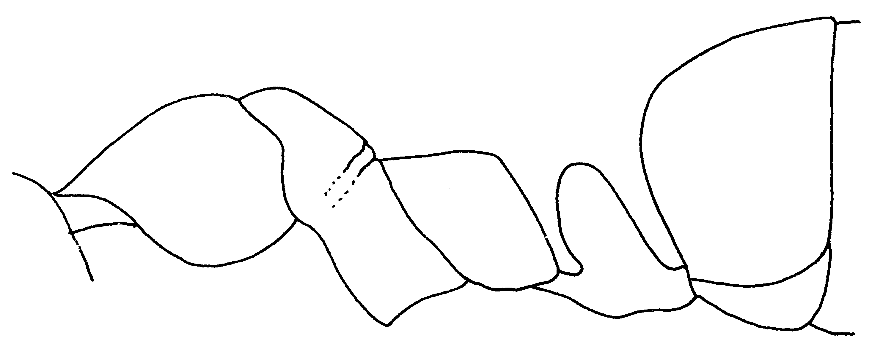Fig. 1. Side view of a paratype worker of F. reflexa.
- Crest of petiole much thinner; in profile anterior face slopes rearward to crest even when latter is blunt (Fig. xx); gastral pubescence usually appressed (Fig. xx), never reflected ………..…… 2
2(1). Antennal scapes covered on all surfaces with numerous, delicate, erect, or suberect hairs (Fig. xx) ………….. 3
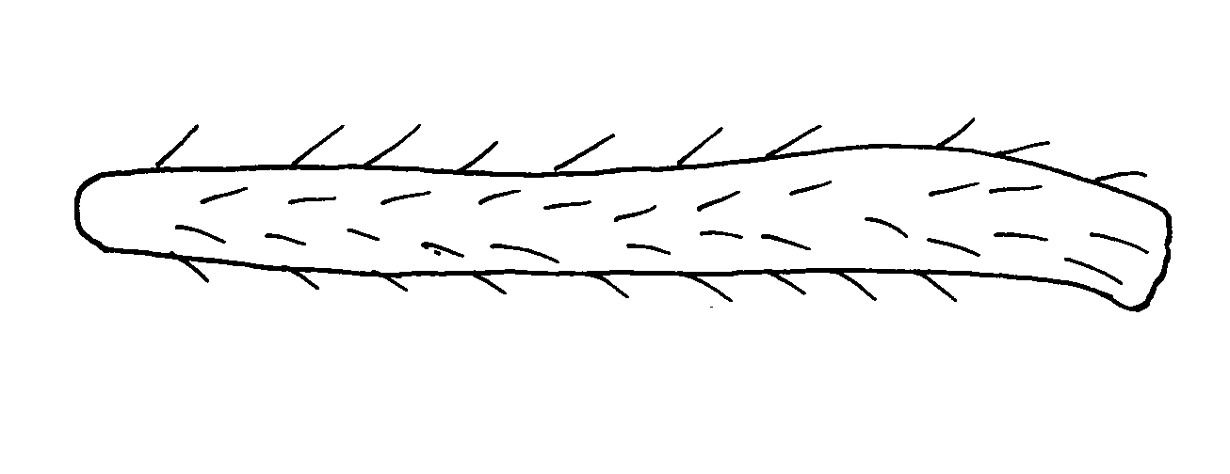Fig. 2. Scape of a worker of F. oreas, showing the suberect hairs.

- Antennal scapes without erect hairs except for those at extreme tip, rarely a few scattered suberect hairs on inner surface near tip ……………..….. 4
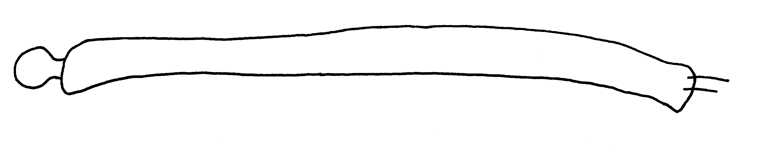Fig. 3. Antennal scape of a worker of F. laeviceps, showing a lack of erect hairs.

3(2). Worker with more than 12 erect hairs seen on scape when viewed in profile; female very smooth and shining, orange in color; with numerous erect, often twisted or tangled hairs on all parts of the body ………...…. oreas Wheeler (= oreas complula Wheeler)
- Worker with fewer than 12 erect and suberect hairs visible on scape, when held in profile; female dull, dark brown or bicolored; with few erect hairs on dorsum of mesosoma ………..….. ………………….. mucescens Wheeler
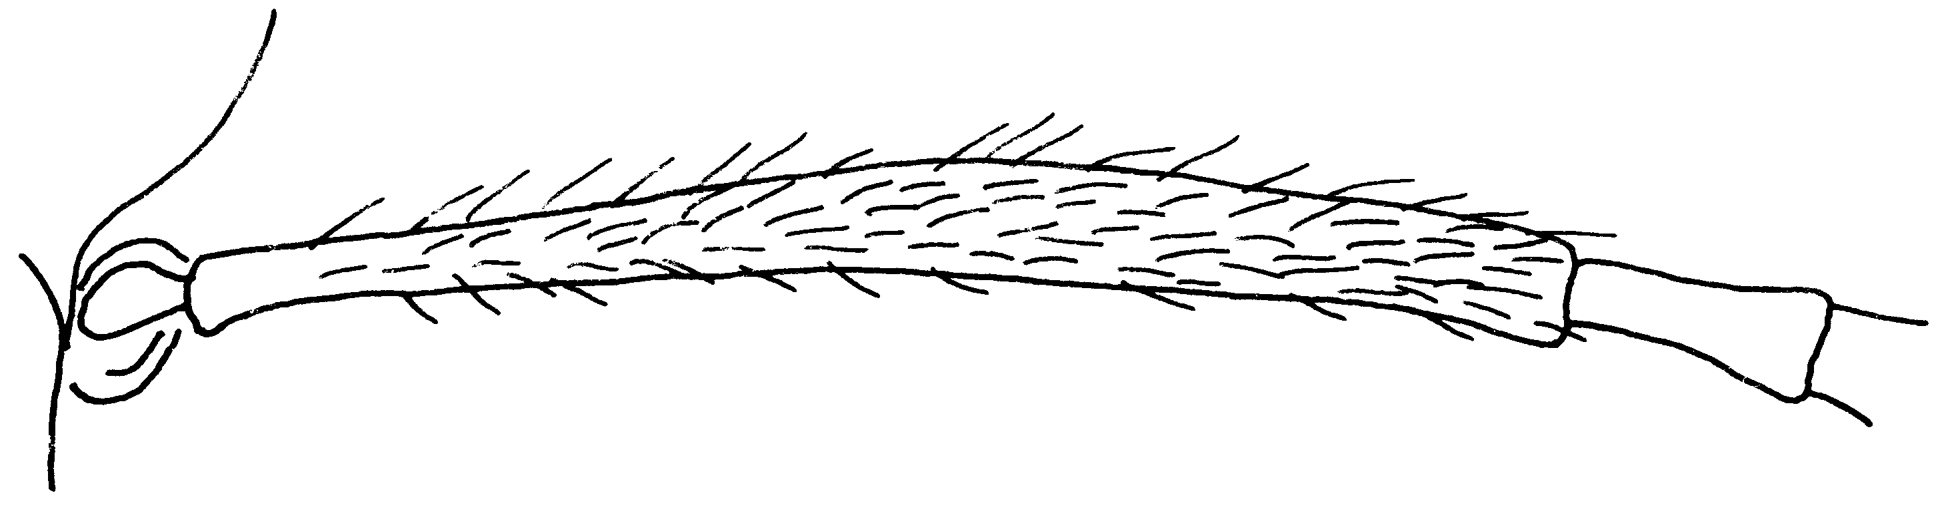Fig. 4. Left scape of a cotype worker of F. mucescens.

4(2). Scale of petiole seen from behind with flat or broadly concave crest, sides in lower half of scale parallel, tapering inward only in lower half of scale, crest blunt in profile (Fig. xx); female sometimes no larger than the largest worker, strongly shining, color dull brown with some yellow markings .………………...… dakotensis Emery
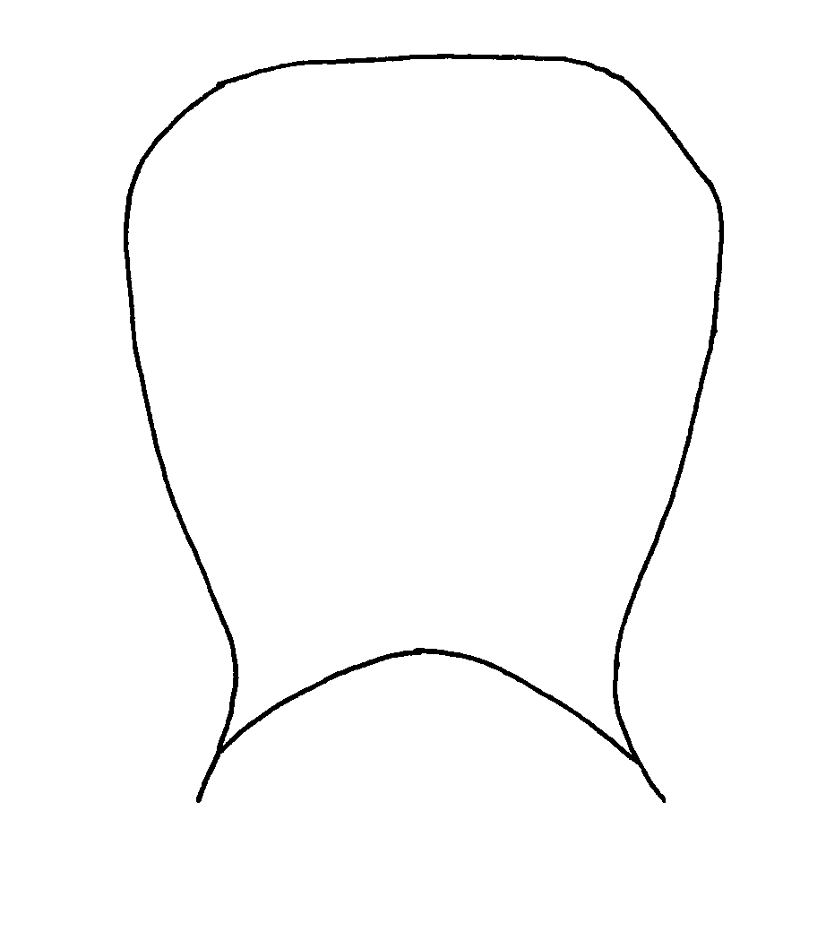
Fig. 5. Petiole of a worker of F. dakotensis as seen from the front.

- Scale of petiole seen from behind with crest convex or angularly produced upward in middle, rarely with small central notch; sides of scale tapering inward evenly from crest to peduncle …………………………… 5
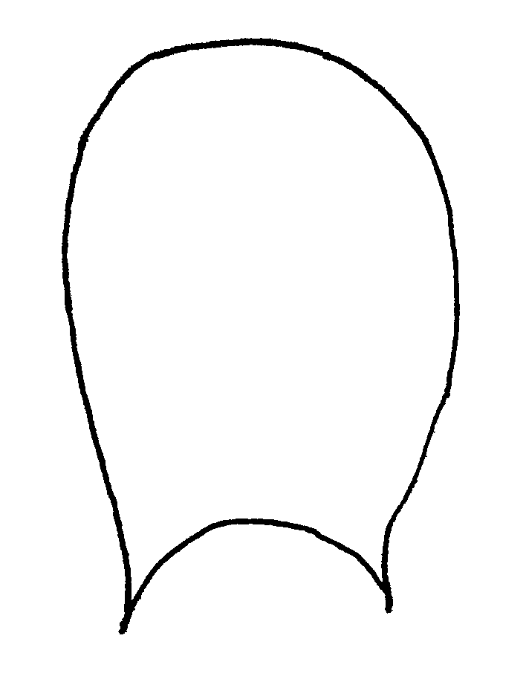
Fig. 6. Petiole of a worker of F. obscuripes as seen from the front.
5(4). Median lobe of clypeus box-like, descending abruptly to clypeal fossae through steep side faces, which make angle with upper face of lobe; clypeal fossae deep, pit-like, anterior edge of clypeus which bounds them in front, sweeping up in even curve to median lobe ……………….………………….. 6 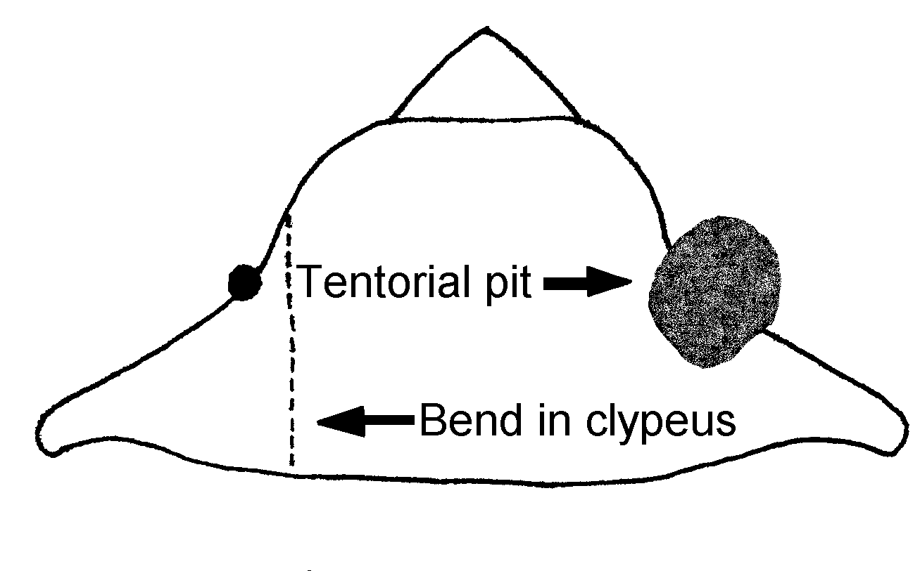
Fig. 7. Clypeus of a worker of F. laeviceps showing the deep, pitlike tentorial pit (depression indicated by dark stippling at point of arrow). The dashed line indicated by the other arrow represents a bend in the clypeus, which makes the middle part of the clypeus protrude into a box-like or rectangular surface.

- Median lobe of clypeus descending to clypeal fossae through even curve, which begins at carina (Fig. xx), clypeal fossae shallow and scarcely pit-like, edge of clypeus in front of fossa very broadly united to base of lobe and not forming distinct curve with it …... 11
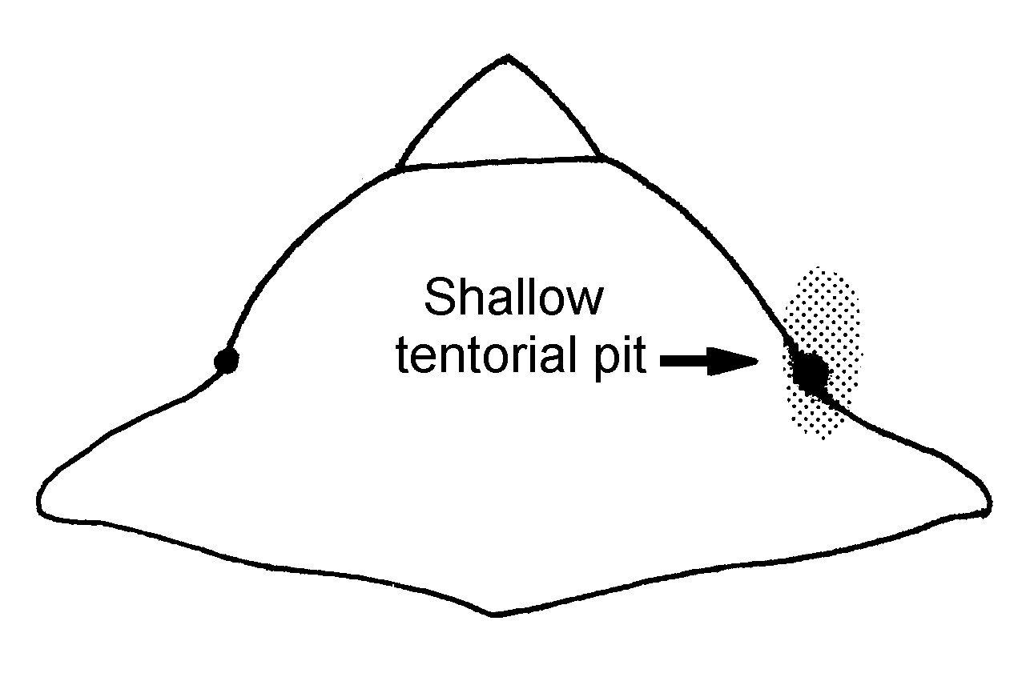Fig. 8. Clypeus of a worker of F. obscuripes, showing the shallow tentorial pit (indicated by arrow and light stippling). Note that this clypeus is not strongly bent, and the surface only weakly convex, without a box-like surface.

6(5). Middle and hind tibiae without erect hairs, except for double row on flexor surface (Fig. xx) ….…… ……………………obscuriventris Mayr (= obscuriventris clivia Creighton)
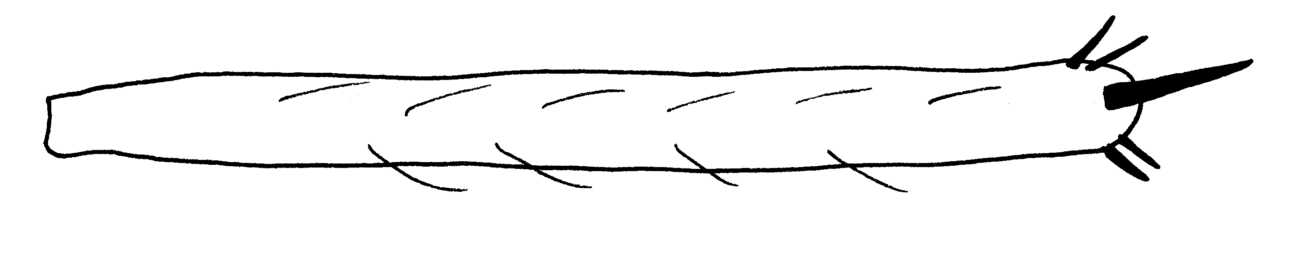Fig. 9. Posterior left tibia of a worker of F. laeviceps.
- Middle and hind tibiae with erect hairs on all surfaces (Fig. xx) .…….... 10
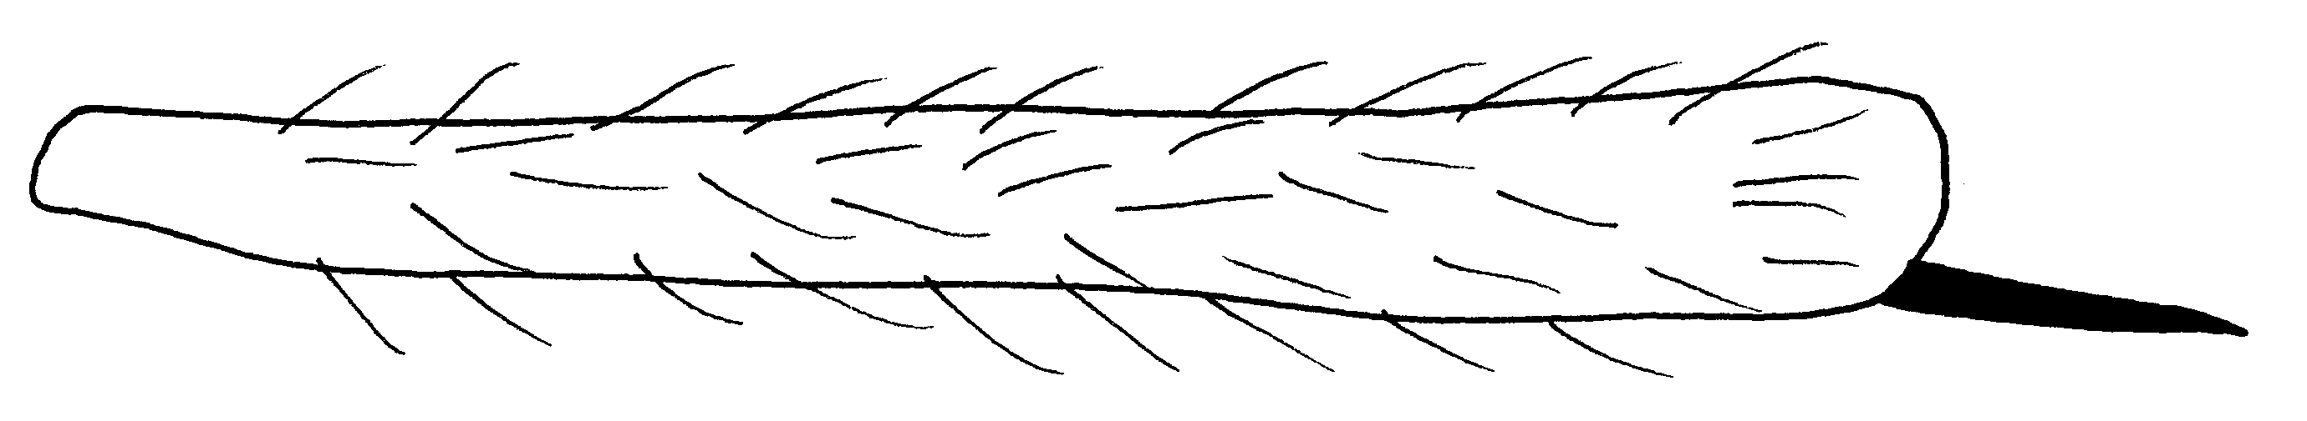Fig. 10. Posterior tibia of a worker of F. obscuriventris clivia, showing numerous erect hairs on all surfaces.

7(6). Erect hairs absent on upper surface of body; gaster with extremely fine, short, scattered pubescence (Fig. xx) , its surface strongly shining; female sometimes no larger than largest worker; virtually hairless and very strongly shining; its clypeus ecarinate ………… …………………...….. fossaceps Buren
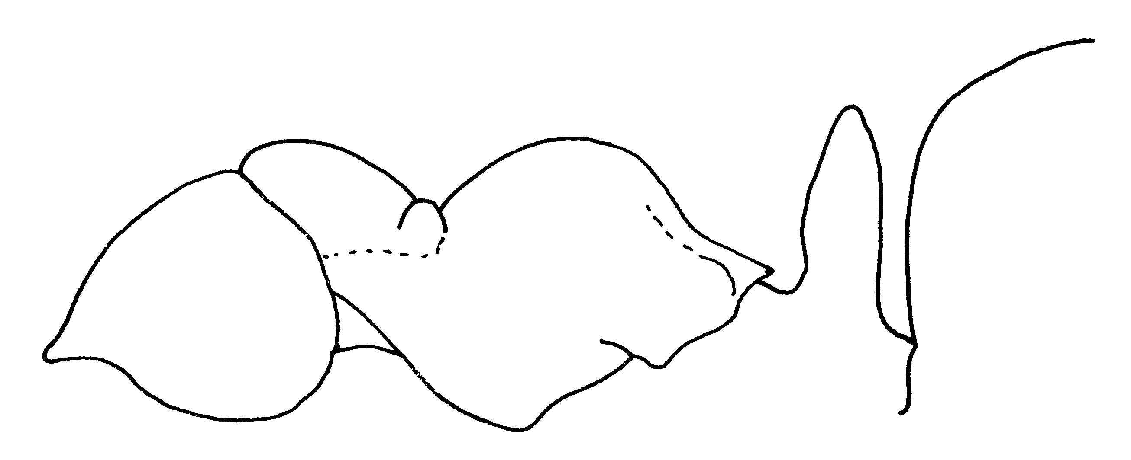Fig. 11. Side view of a paratype worker of F. fossaceps.
- Erect hairs present on dorsum of mesosoma (Fig. xx); pubescence on gaster varies; female variable …..….… 8
Fig. 12. Side view of a worker of F. laeviceps or calviceps.
8(7). Erect hairs abundant on upper surface of body; gaster opaque with rather dense whitish pubescence; female always larger than largest worker; mesosoma less shining than head and gaster; erect hairs present; clypeus ecarinate ……...… laeviceps Creighton (=calviceps Cole, = undescribed species in Hung, 19__).
9 doesn’t exist
10(6). Minor workers extensively infuscated with brown, majors and medias with at least scale of petiole infuscated …………………………….. ………. ??
- Minor workers less deeply infuscated, dirty yellowish brown in color, scale of petiole in majors clear red or yellow …..….... ??

11(5). Erect hairs on middle and hind tibiae usually abundant and covering all surfaces, but at least there are a number of erect hairs in addition to those on flexor surface .……………………… 12
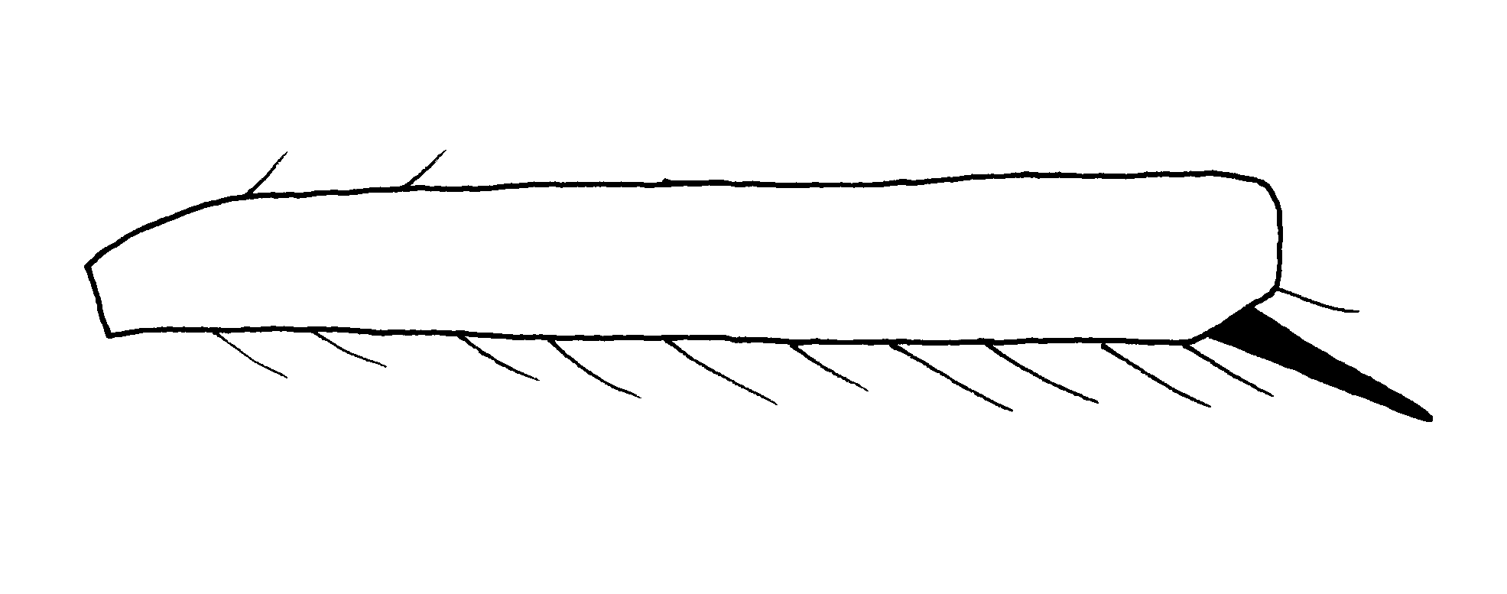Fig. 13. Middle tibia of a worker of F. planipilis as seen from the bront, showing 2 erect hairs in addition to the rows of hairs on the flexor surface.
- Erect hairs on middle and hind tibiae, when present, confined to double row of bristles on flexor surface, rarely 1 or 2 erect hairs elsewhere …………... 14
12(11). Head of major as broad as long or broader than long (mandibles excluded); erect hairs on mesosoma rather unequal in length; cephalic hairs only a little less abundant and not much longer than those on mesosoma …..…… ………………………. obscuripes Forel
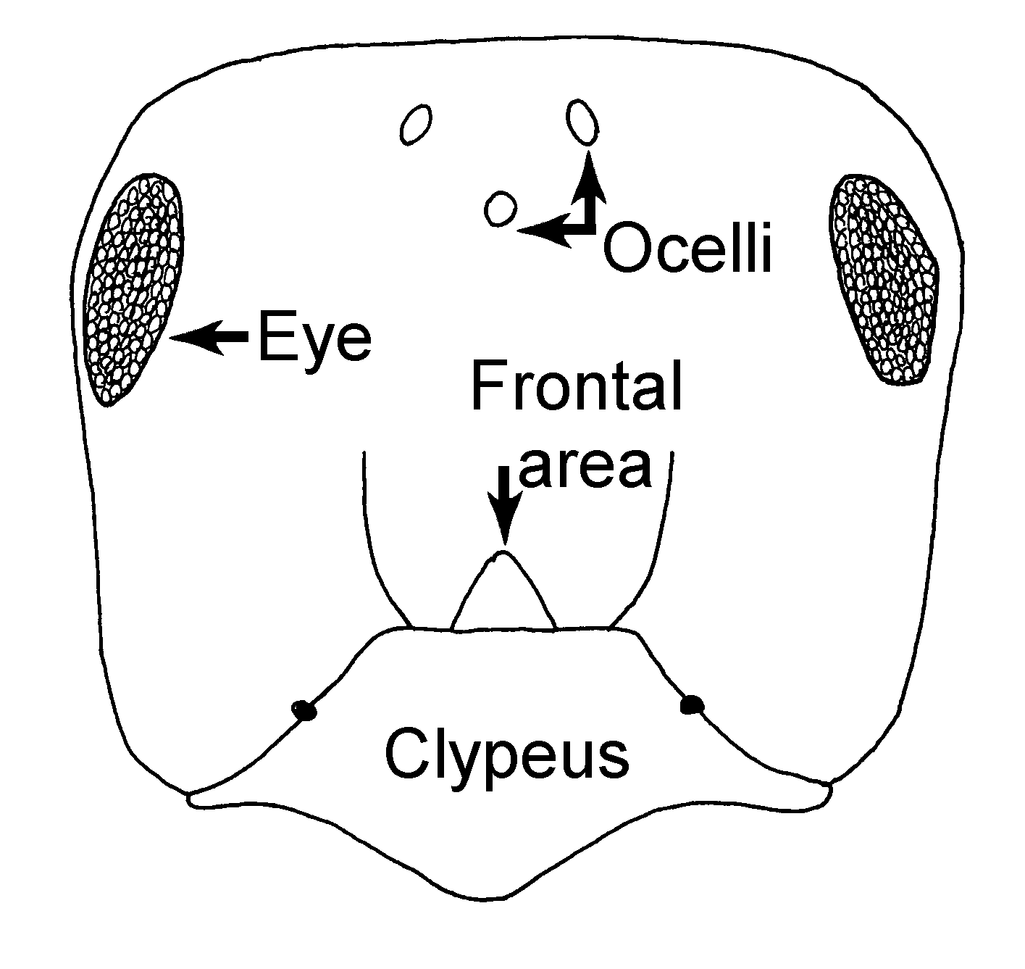Fig. 14. Head of a worker of F. obscuripes.
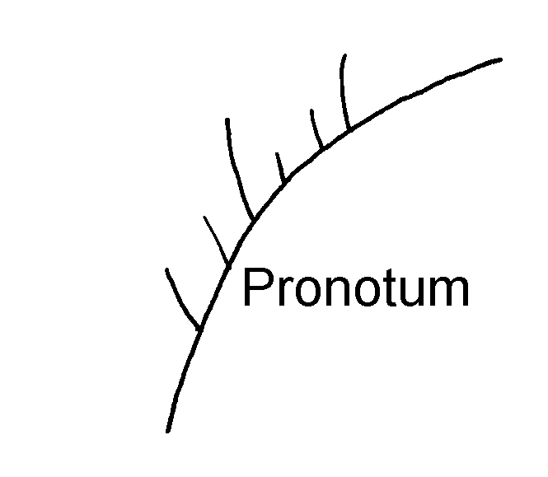
Fig. 15. Hairs on the dorsal surface of the pronotum of a worker of F. obscuripes, showing the hairs of unequal lengths.
- Head of major longer than broad (mandible excluded); erect hairs on mesosoma short and of about equal length; cephalic hairs notable longer and sparser than those on mesosoma …… ………………. coloradensis Creighton
(= planipilis Creighton)

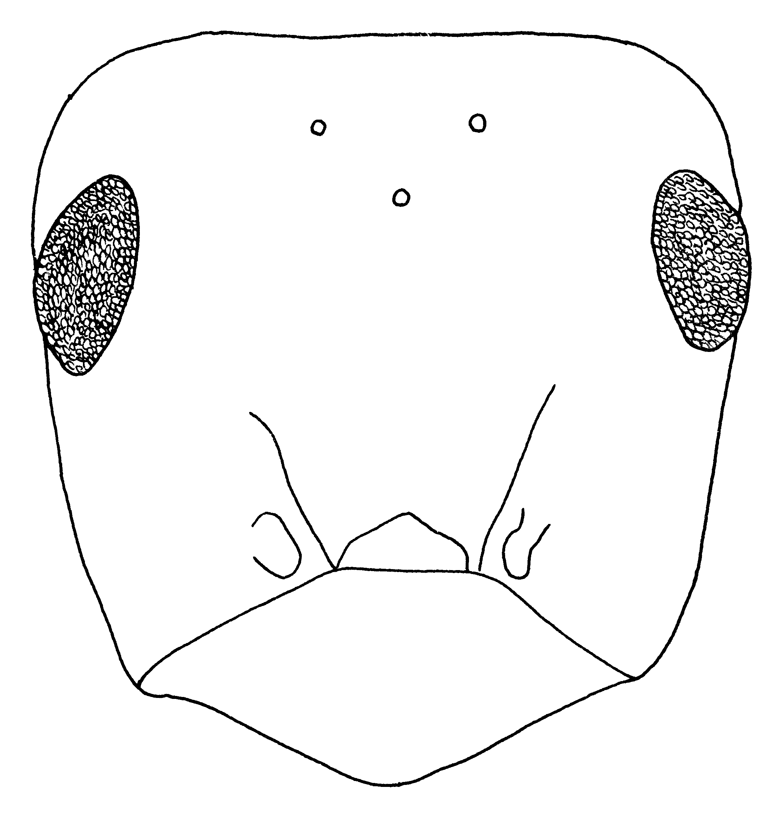Fig. 16. Head of a “type” worker of F. coloradensis.
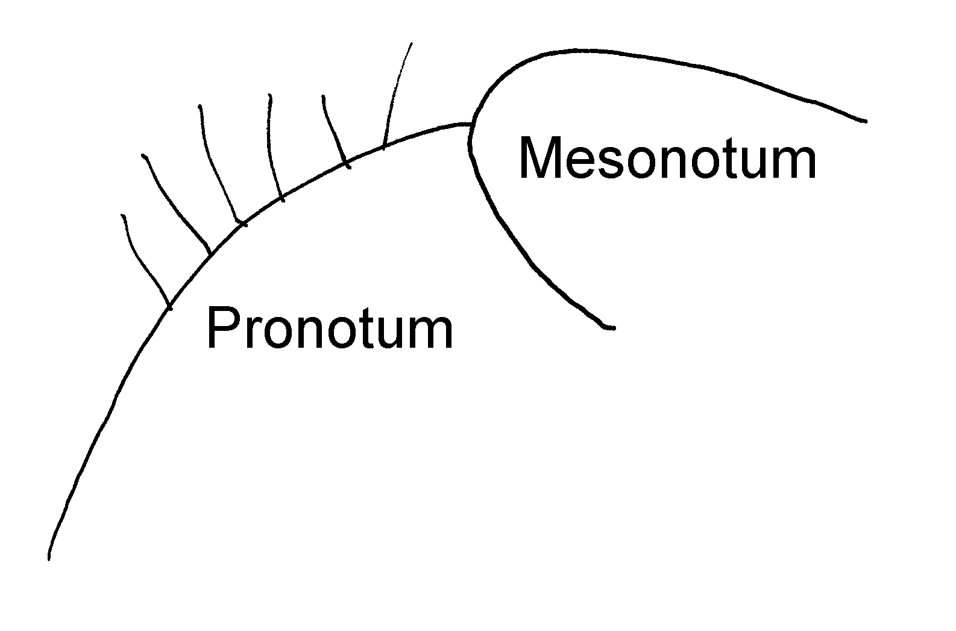
Fig. 17. Hairs on the dorsal surface of the pronotum of a worker of F. planipilis, showing the hairs of approximately equal length.
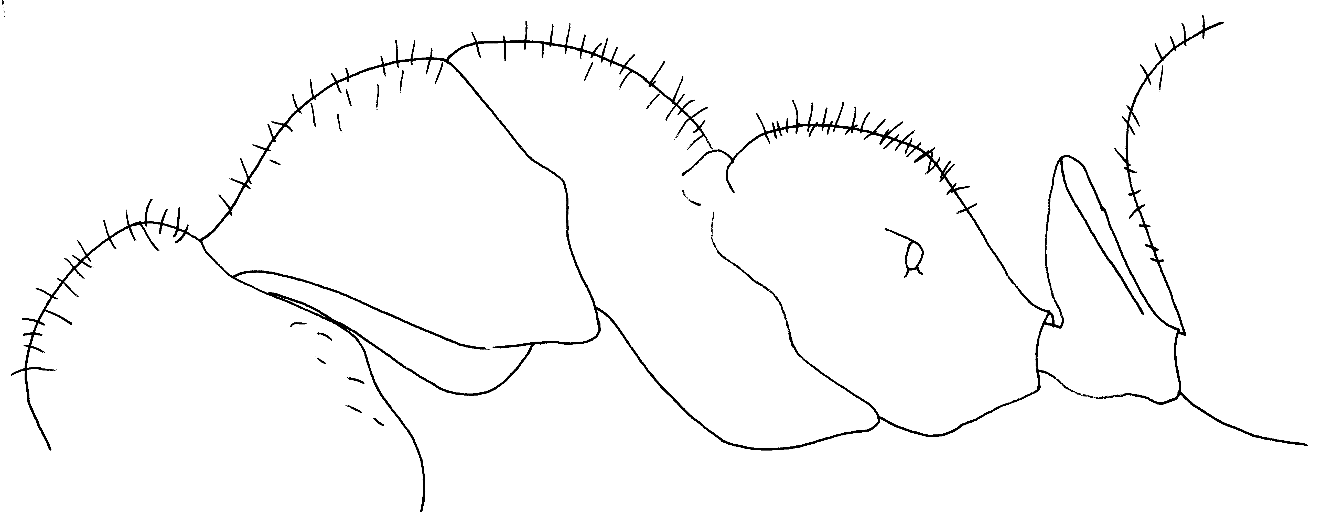Fig. 18. Side view of a “type” worker of F. coloradensis.
13(doesn’t exist).
14(11). Gaster densely clothed with short, erect hairs which are close enough together to give appearance of loose, plush-like investiture when gaster is viewed in profile ...…….…………… 15
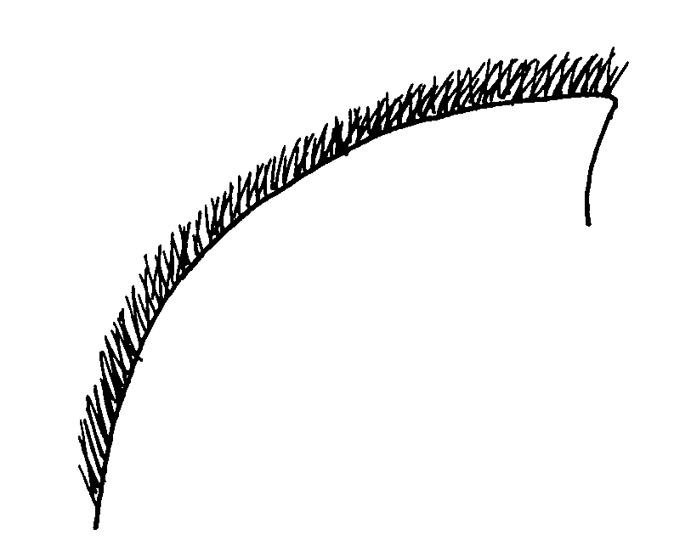
Fig. 19. Hairs on the dorsum of the first tergum of the gaster of a worker of F. ciliata, showing the dense, erect hairs.
- Erect hairs on gaster much more widely spaced and not forming even investiture when gaster is viewed in profile ………...………...……………17
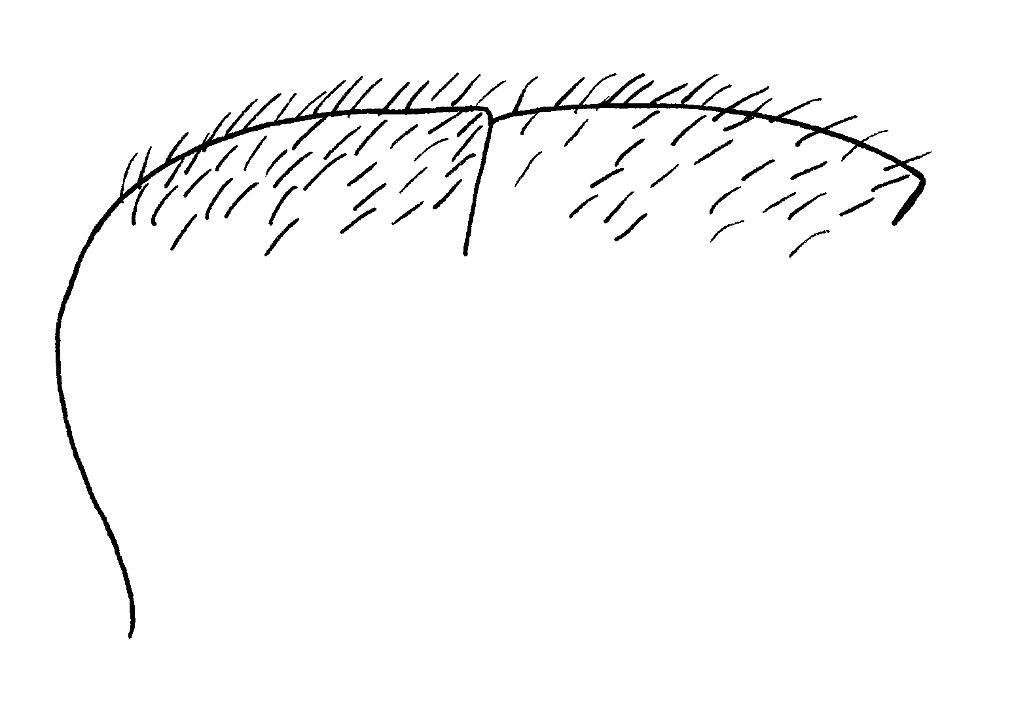Fig. 20. Hairs on the gaster of a worker of F. comata.
15(14). Ventral surface of the head usually without any erect hairs; rarely 1 or 2 suberect hairs present; female yellow with very long, yellow hairs with curled tips present on pronotum, scutellum, fore coxae, mesosternum, propodeum, scale of the petiole and entire gaster …………… ciliata Mayr
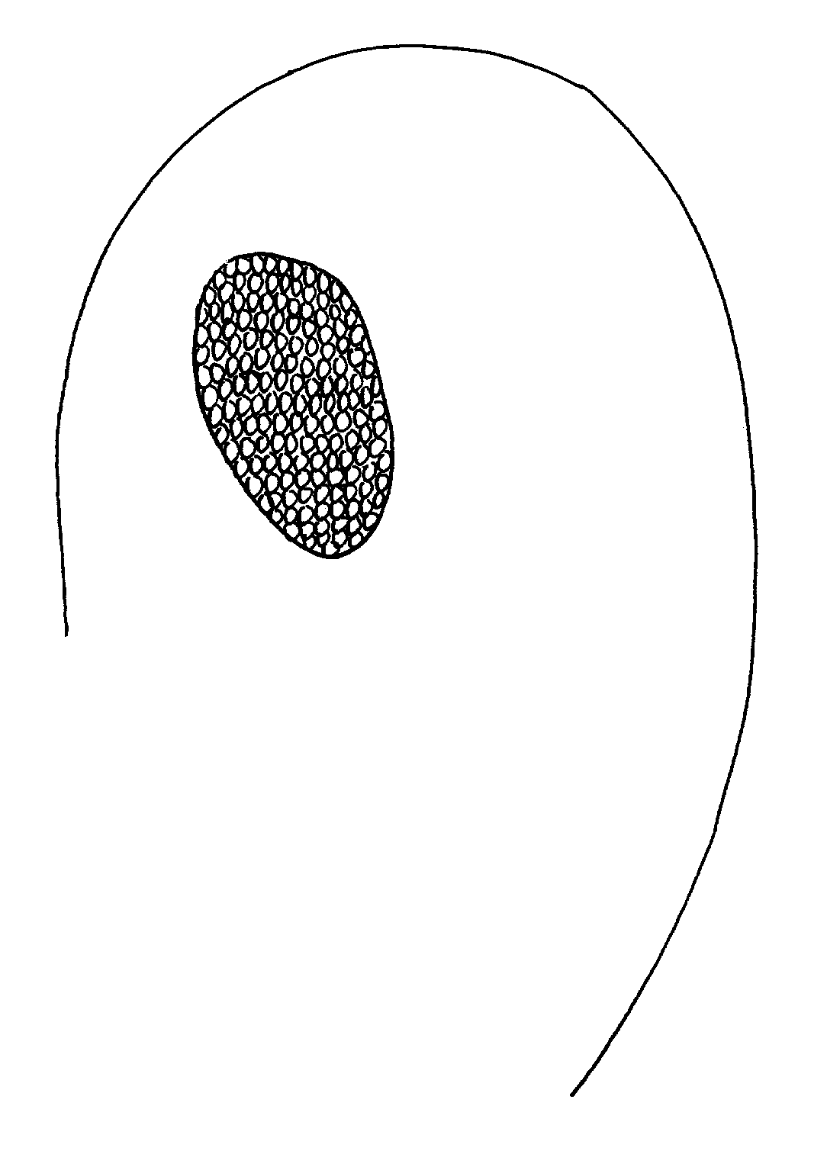
Fig. 21. Head of a worker of F. ciliata, showing the lack of erect hairs on the ventral surface of the head.
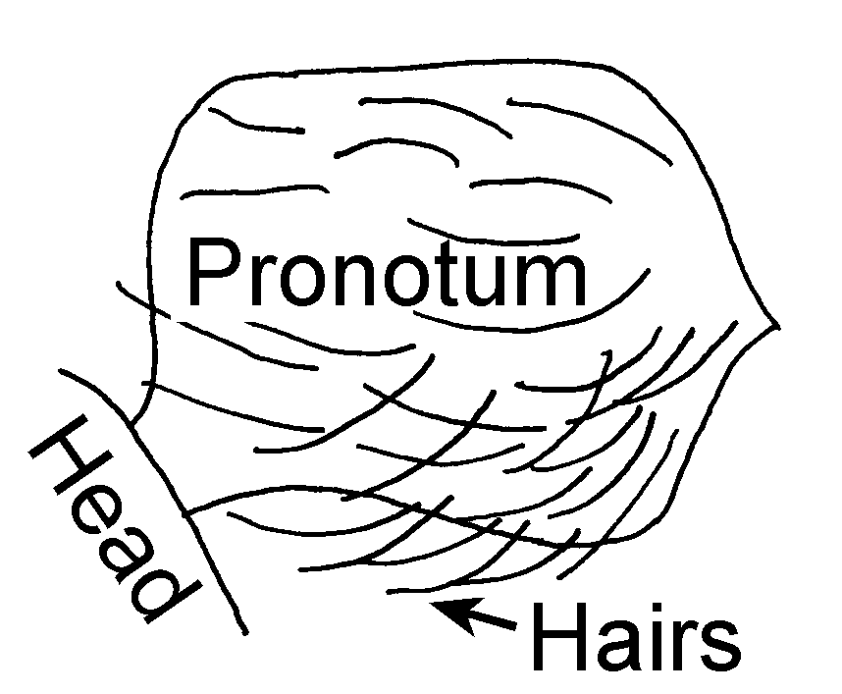
Fig. 22. Pronotum of a female of F. ciliata, showing the long, curled hairs.
- Gula with several erect hairs, usually at least 12 present ………..… 16
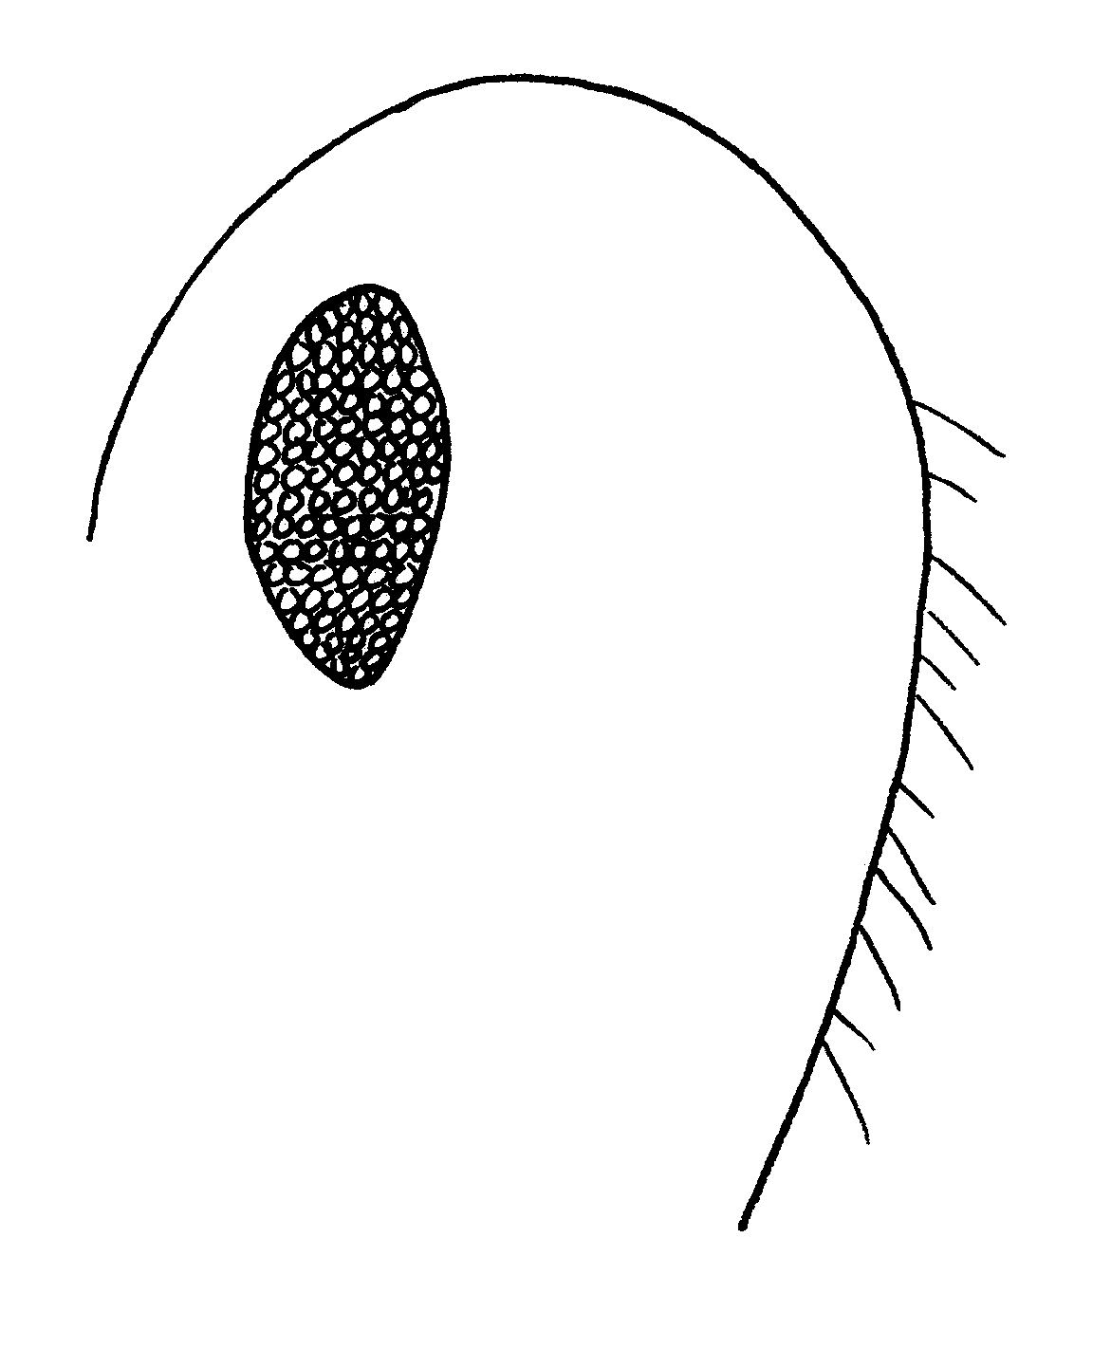
Fig. 23. Side view of the head of a worker of F. comata, showing the numerous hairs on the ventral surface of the head.
16(15). Scape without erect hairs, erect hairs on gaster slightly longer (up to 0.18 mm) (Fig. xx); female without erect or suberect hairs on scape; hairs on pronotum relatively long (); most surfaces of female smooth and shining …………………….… comata Wheeler
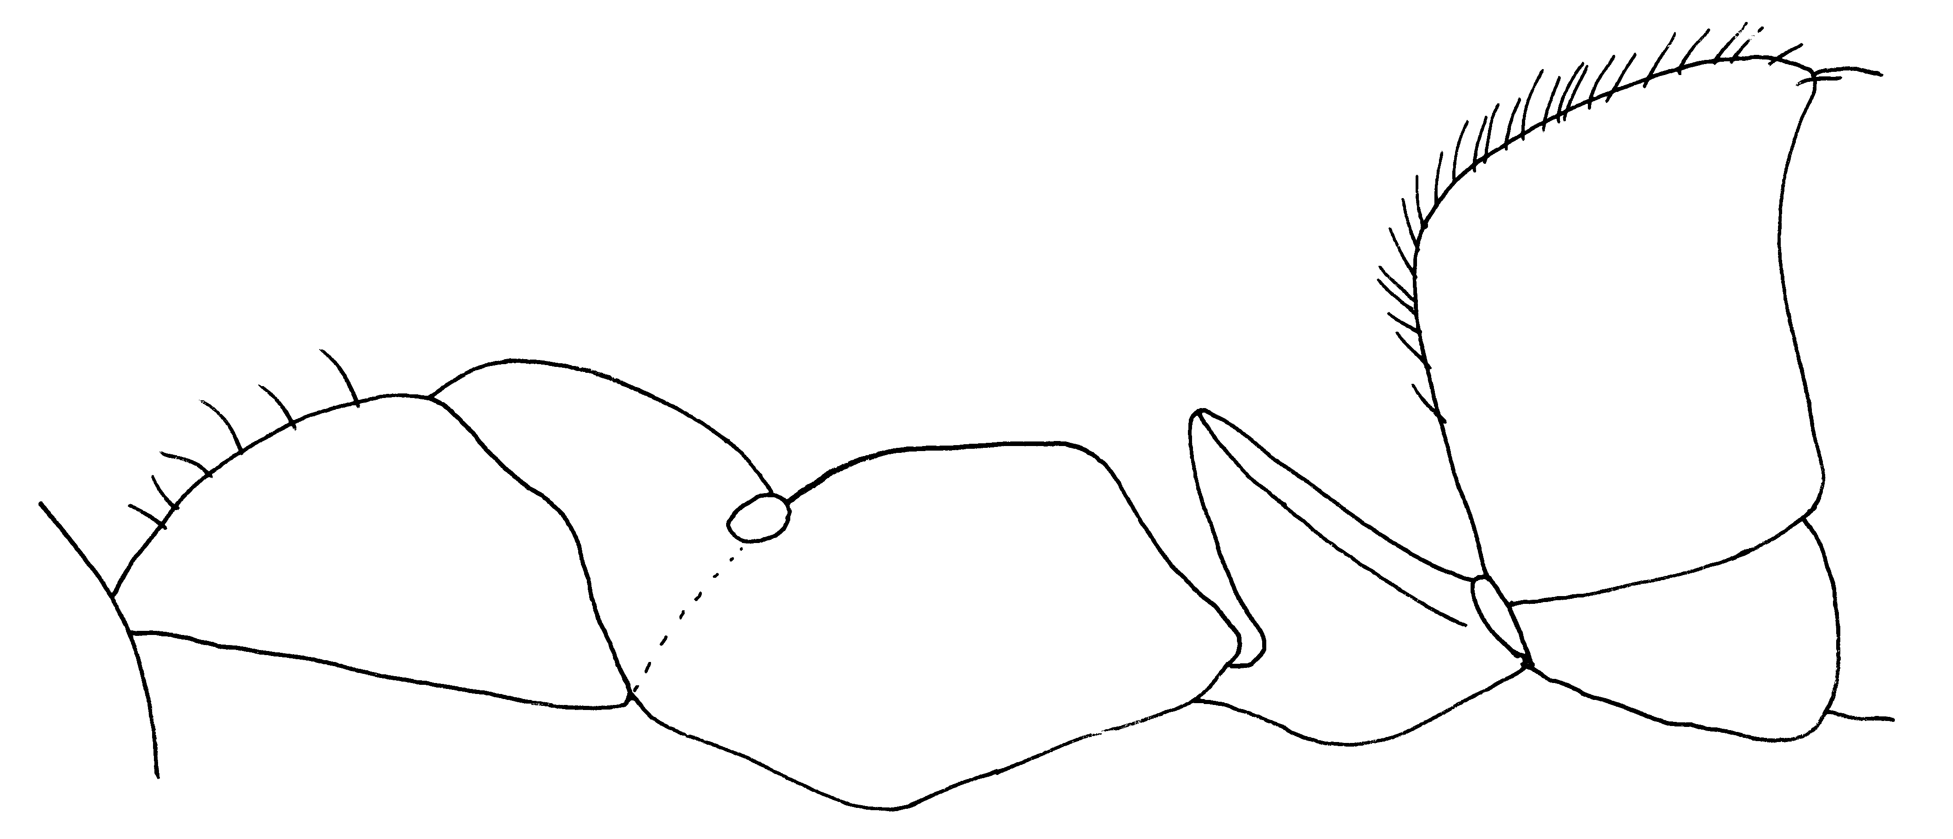Fig. 24. Side view of a cotype worker of F. comata.
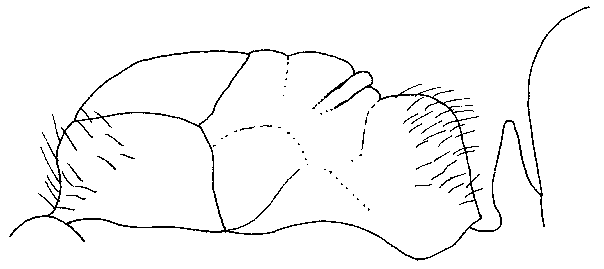Fig. 25. Side view of the type female of F. comata.
- Scape often with erect or suberect hairs, erect hairs on gaster shorter (up to 0.12 mm); female sometimes with erect or suberect hairs on scape; hairs on pronotum short, sparse; all surfaces of female dull …… …………………… musescens Wheeler
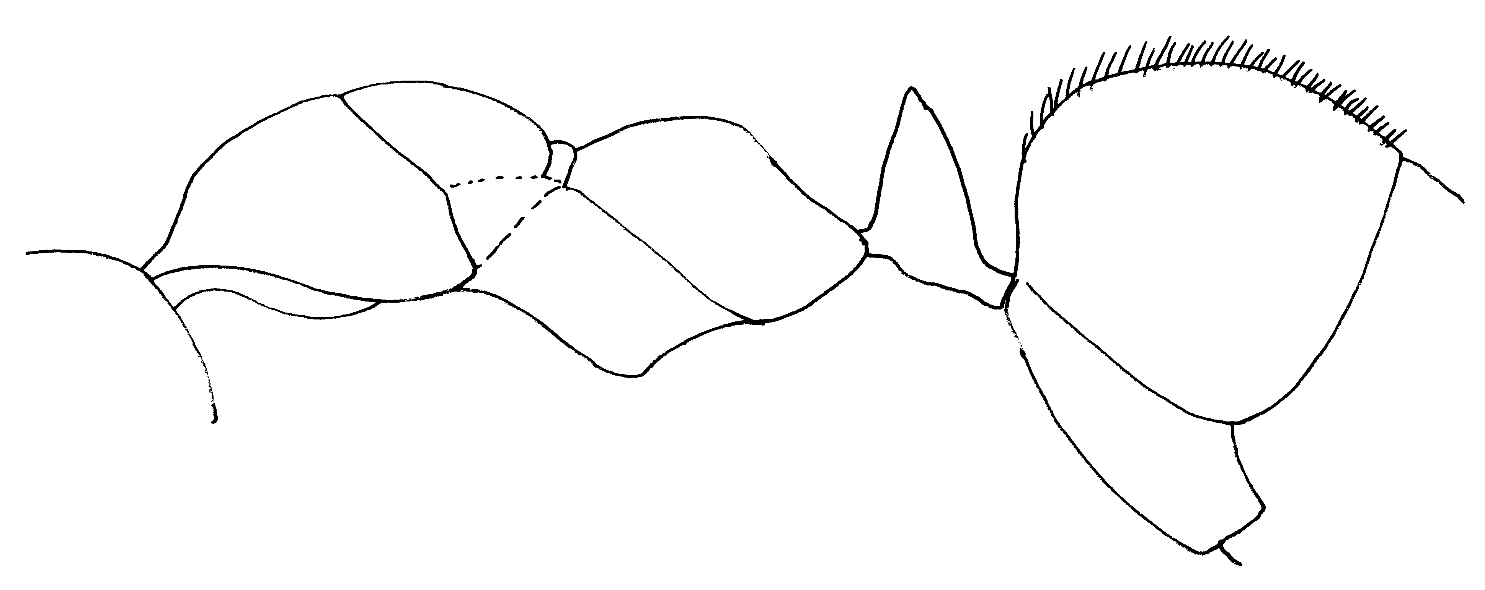Fig. 26. Side view of a cotype worker of F. mucescens, showing the longer, erect hairs on the dorsum of the gaster.

17(14). Row of erect bristles on middle and hind tibiae extending at least ½ length of tibia ……………...…….. 18
- Middle and hind tibiae virtually without erect hairs of any sort, usual row of erect bristles reduced to 3 or 4 hairs close to spur; erect body hairs completely absent, except on clypeus and gaster, female deep yellow, shining; long hairs with curled tips abundant on gaster and crest of petiole, sparse on propodeum, scutellum, pronotum and clypeus………...…criniventris Wheeler
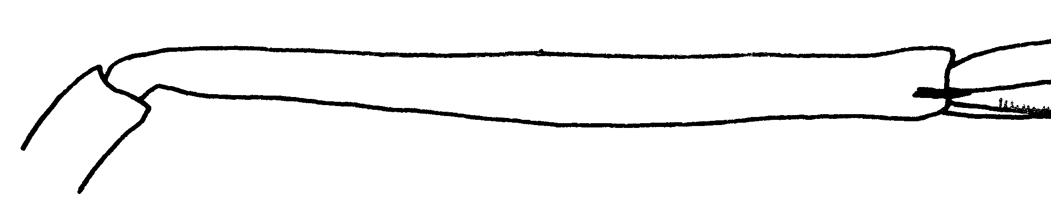Fig. 27. Posterior left tibia of a cotype worker of F. criniventris.
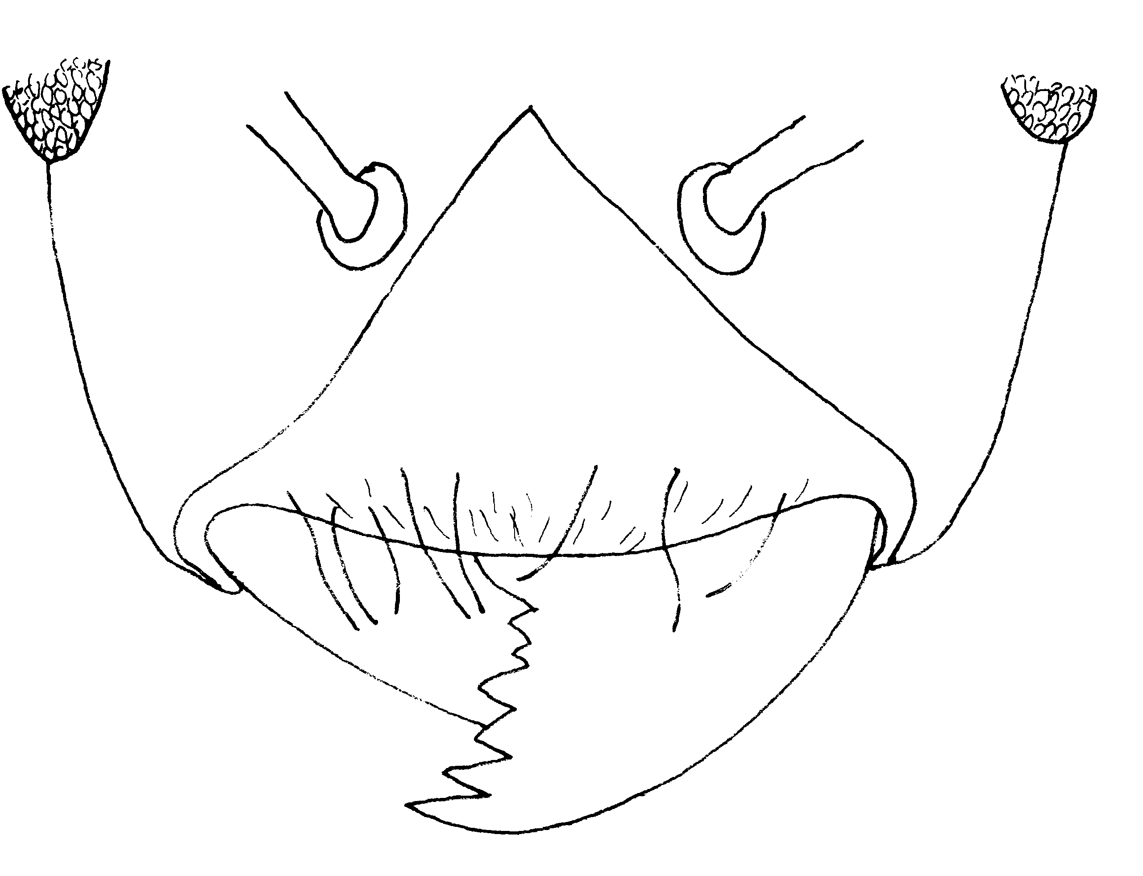Fig. 28. Anterior part of the head of a “type” female of F. criniventris.
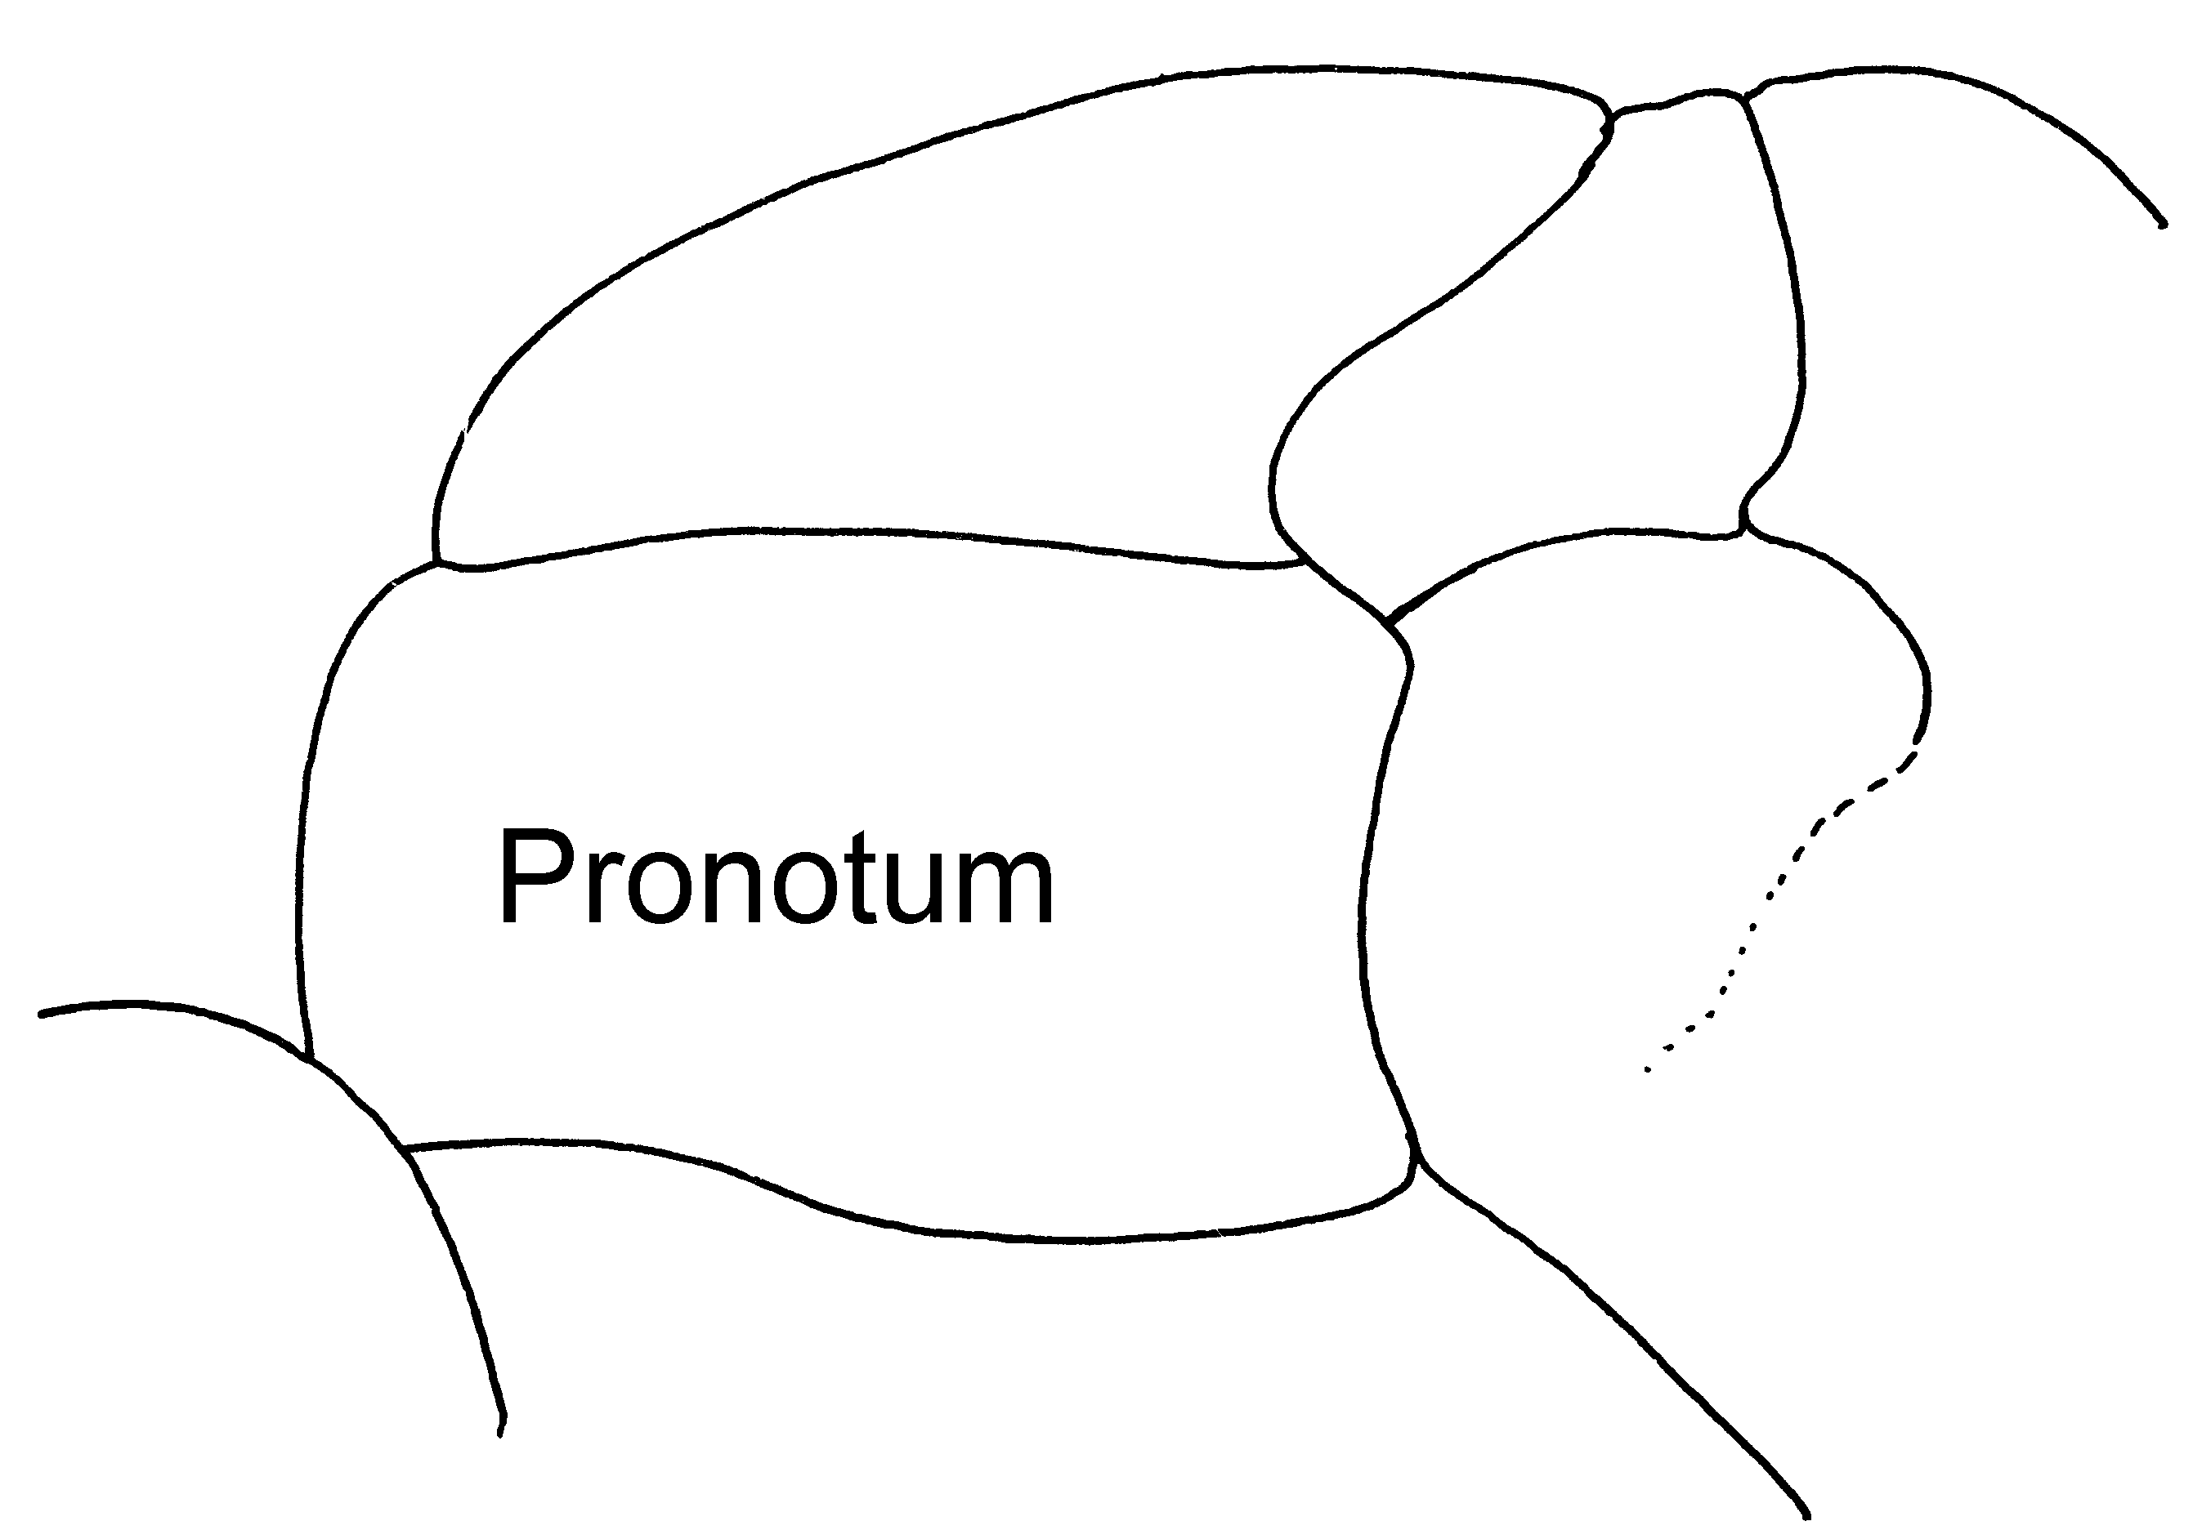Fig. 29. Anterior part of mesosoma of a “type” female of F. criniventris, showing the lack of erect hairs.

18(17). Scale of petiole low and thick from front to back, crest blunt and not extending above level of propodeal spiracle when scale is in vertical position ………………….………………….…19

- Scale of petiole thinner from front to back, higher and with sharper crest, which in majors and medias distinctly exceeds level of spiracle when scale is in vertical position ..…………20
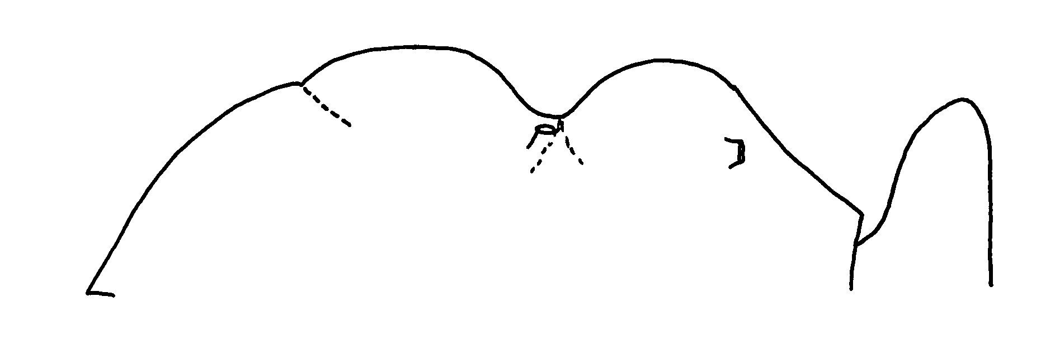Fig. 30. Side view of the mesosoma and petiole of a worker of F. ravida.

19(18). Dorsum of gaster with numerous delicate, erect hairs; cheeks with distinct, coarse, oval punctures between front of eye and insertion of mandible; propodeum of largest workers definitely angulate (Fig. xx); female unknown, but probably aberrant ……………………… ……………………... ferocula Wheeler
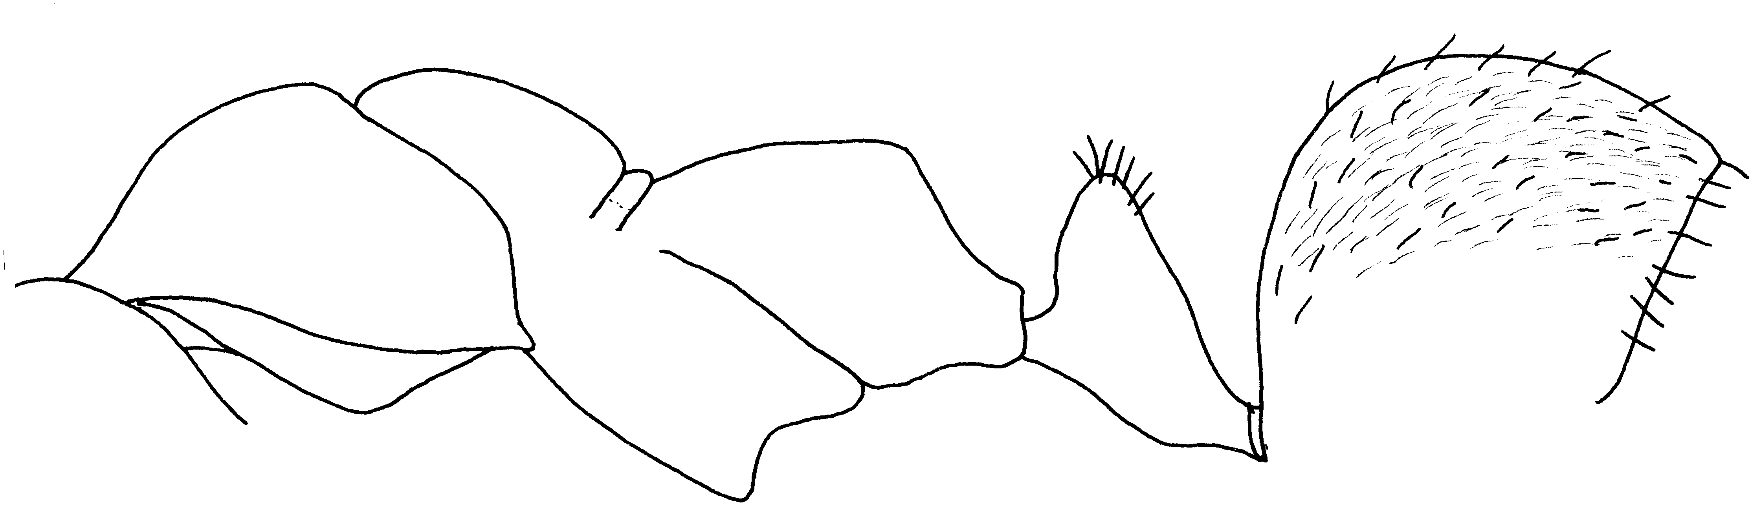Fig. 31. Side view of a syntype worker of F. ferocula showing the numerous, delicate hairs on the gaster.
- Dorsum of gaster with scarcely any erect hairs, few present at base and tip; cheeks densely and finely coriaceous, but without distinct punctures; propodeum of all workers evenly rounded between faces; females golden yellow, gaster banded with brown; long hairs with curled tip abundant on ventral surface of gaster, clypeus, coxae, fore femora and entire mesosoma except the scutum ….. .………prociliata Kennedy and Dennis
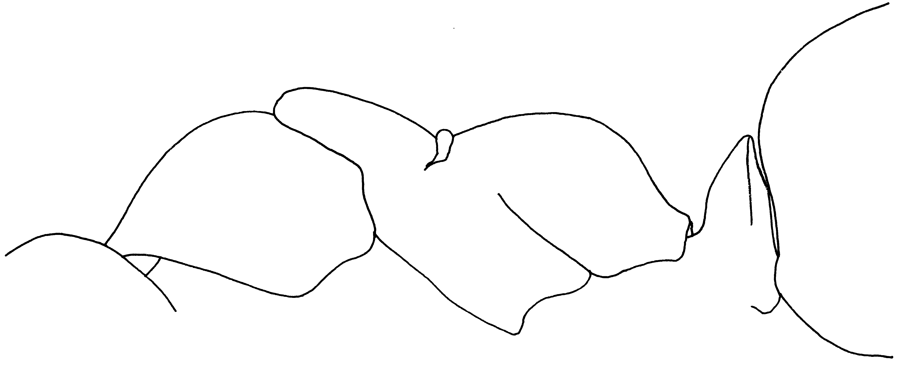Fig. 32. Side view of a worker of F. prociliata, showing a near lack of erect hairs (compared with type by A. Cole).
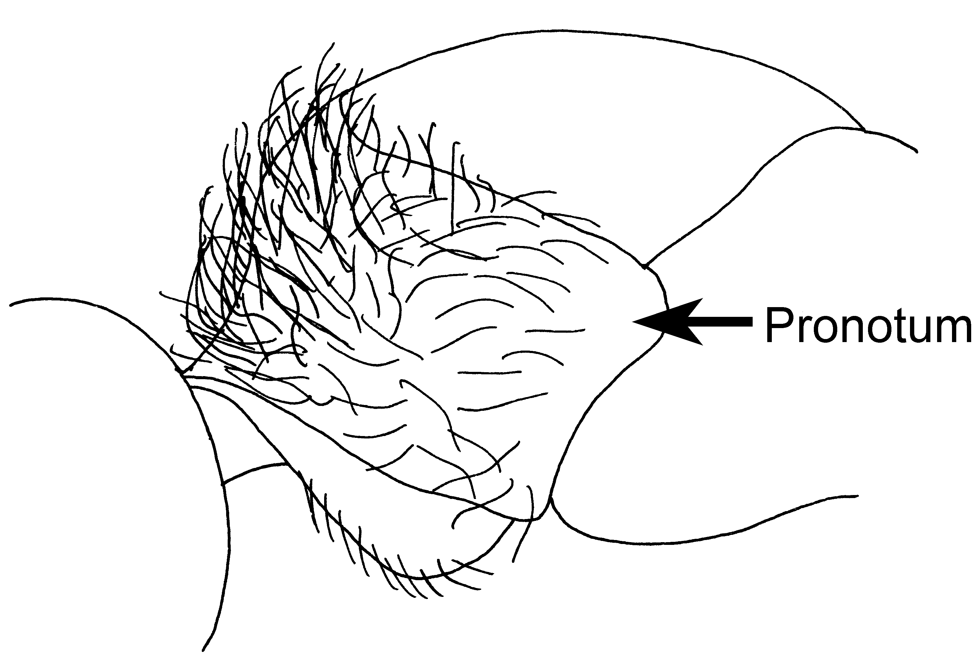Fig. 33. Pronotum of a paratype female of F. prociliata.

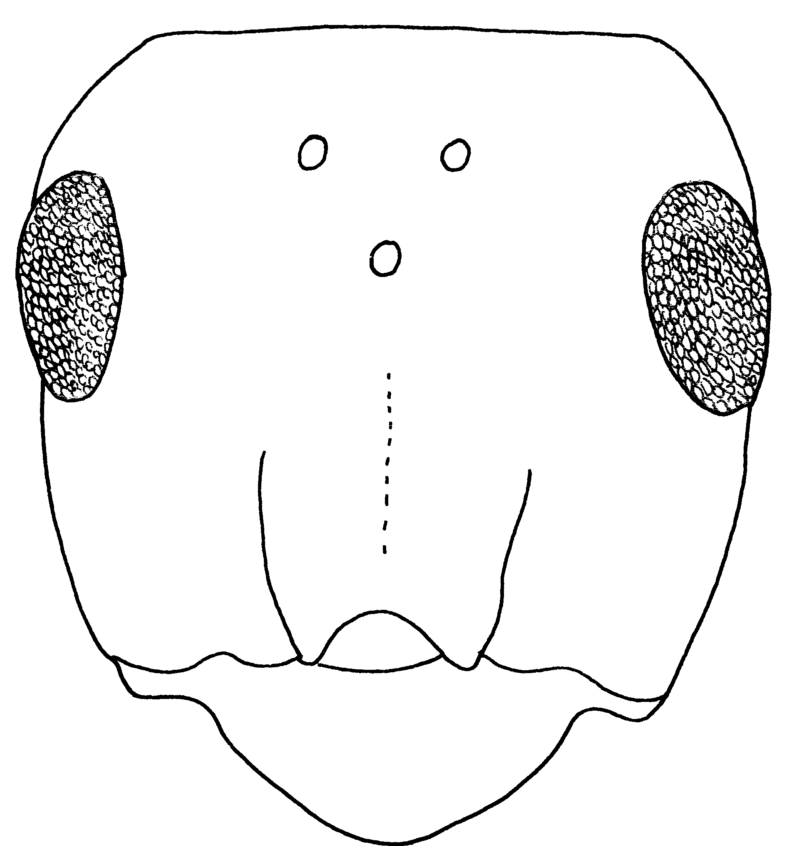Fig. 34. Head of a worker of F. subnitens (compared with type by W. Creighton and A. Cole)
20(18). Clypeus, gula and genae strongly shining ………..… subnitens Creighton
- Clypeus, gula and genae subopaque or completely opaque …... 22
21 doesn’t exist.
22(21). Gula, crest of petiole and dorsum of mesosoma usually without erect hairs, rarely 1 or 2 inconspicuous hairs present ……………….……………………… 23
- Numerous erect hairs present on gula, pronotum, propodeum and crest of petiole at least in considerable part of nest series …...… integroides Wheeler (= propinqua Creighton)
Fig. 35. Side view of a worker of F. integroides.
23(22). Eyes hairy (Fig. xx); gaster opaque with dense gray pubescence; western North America (as far east as Dakota and Colorado) … ……………………… ravida Creighton
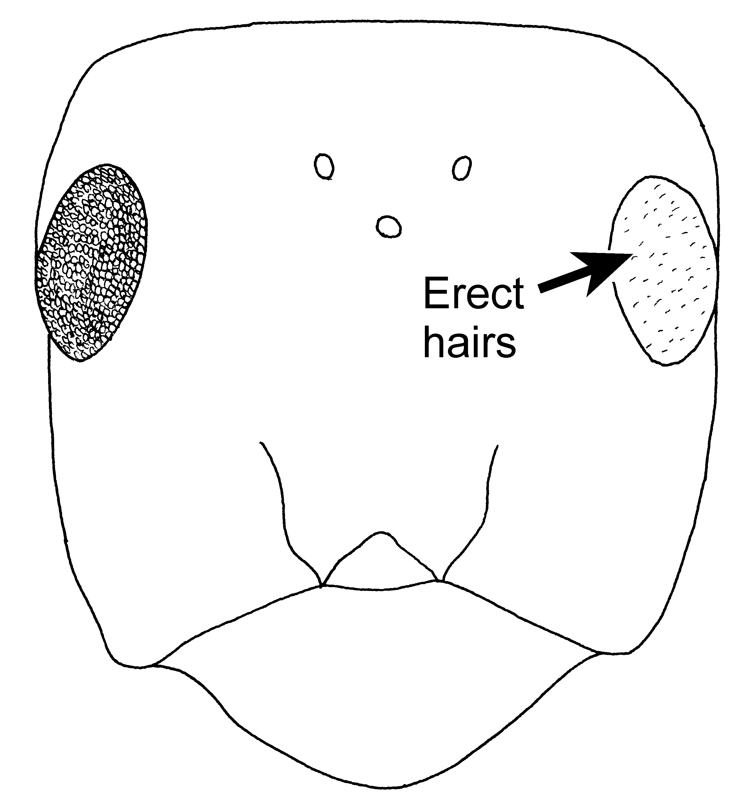Fig. 36. Head of a cotype (F. haemorrhoidalis), worker of F. ravida showing the erect hairs on the eyes.

- Eyes hairless; gaster feebly shining with delicate, dilute pubescence; eastern North America (as far west as Alabama) .………..… integra Nylander
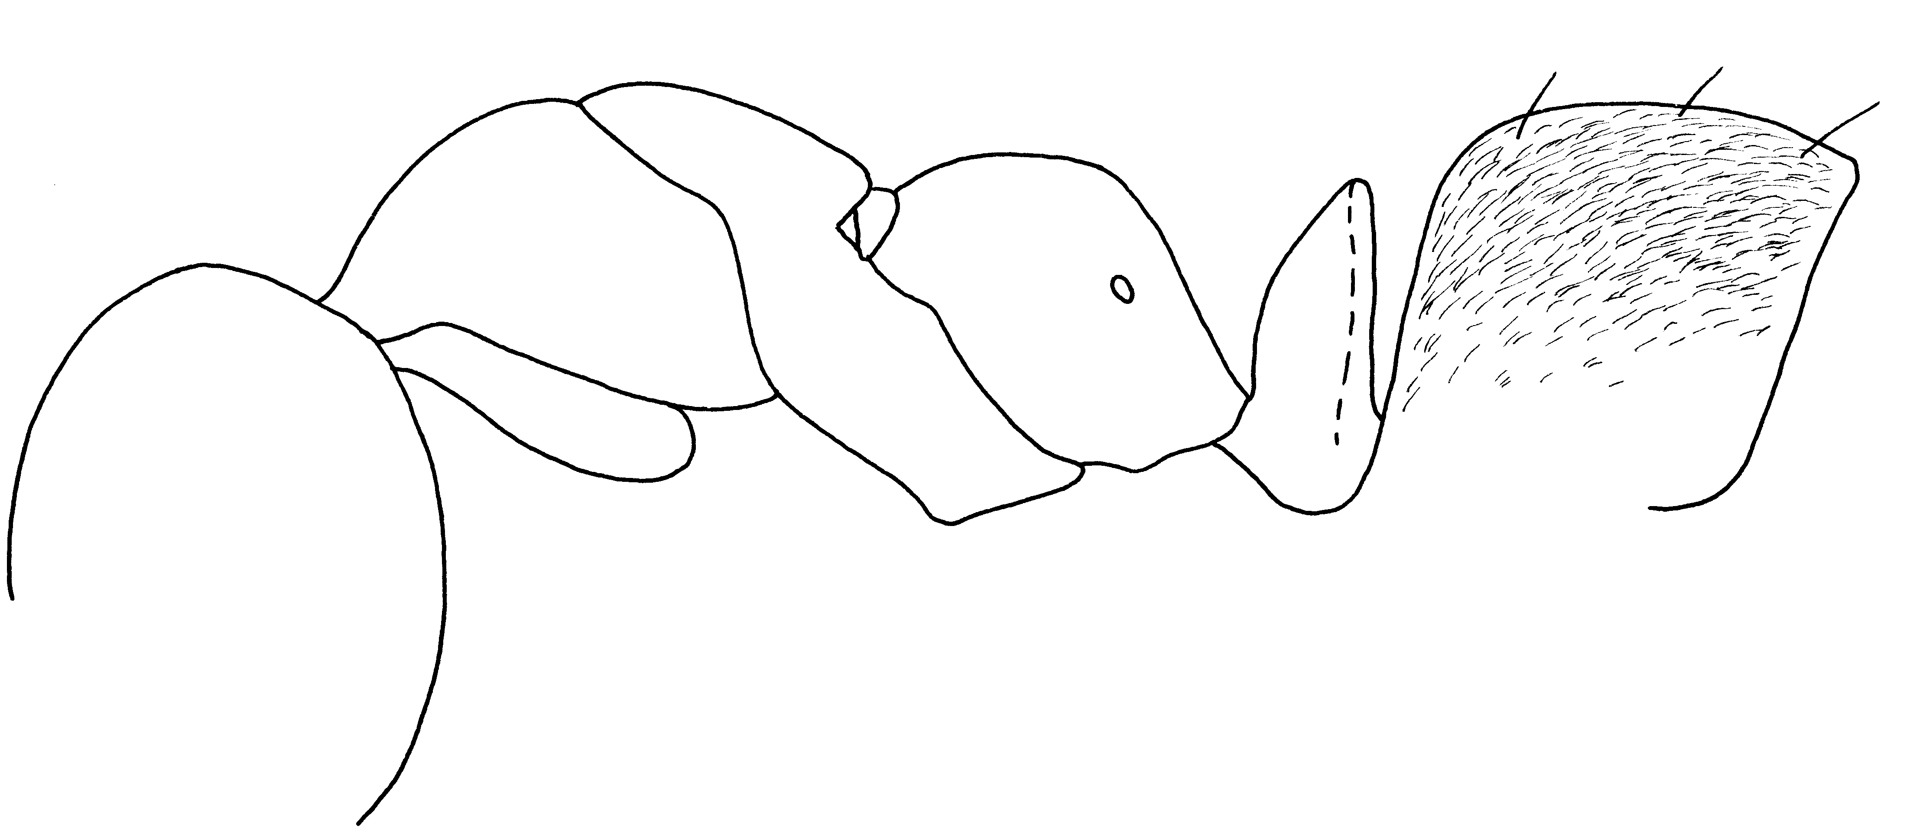Fig. 37. Side view of a worker of F. integra (Rock Point, Suffolk Co., NY).
Fig. 38. Posterior lateral angles of the head of a worker of F. integroides.
List of species:
Formica aterrima Cresson
Figs. ; Map

Discussion:
Distribution:
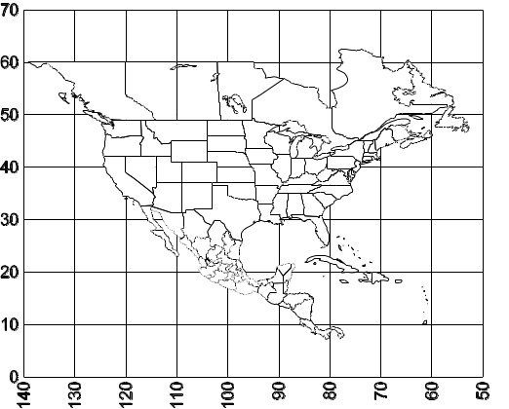
Map 1. Formica aterrima.
Habitat:
Biology:

Formica calviceps Cole (rufa group)
Fig. ; Map

Discussion. The middle and hind tibiae of this species have a double row of erect hairs on the flexor surfaces. Erect hairs are present on the mesonotum near the metanotal suture.
It differs from F. fossaceps by the presence of erect hairs on the mesosoma, and from F. laeviceps in that the hairs on the mesosoma are not abundant. It may be a synonym of F. laeviceps.
Distribution. USA: NM: Union Co., Capulín Volcano National Monument (type locality, Cole, 1954e), Los Alamos Co., Los Alamos (Map).
Habitat. Scrub oak, in dry, grassy areas.
Biology. This ant nests under stones, with the site surrounded by thatching.
Cole, 1954e

Map 2. Formica calviceps.

Formica ciliata Mayr (rufa group)
Figs. ; Map

Discussion. The workers of this species have few erect hairs, which are mostly restricted to the clypeus, pronotum, propodeum and gaster. The scapes are without erect hairs (except at the apex), each tibia has only a few (fewer than 10) erect hairs on the flexor surfaces. The gaster is covered with short, erect hairs, in which the tips are closer than the length of the hairs. The females of this species are unusual as they are covered with long, curled, yellow hairs (Fig. 403), which suggests that it is a temporary social parasite (these types of hairs are typical of parasitic species).
Formica criniventris females have similar hairs, but the workers of this latter species lack the dense, erect hairs on the gaster and are thus easily separated.
Distribution. USA: MT, ND S to NM.
Habitat. Sagebrush, grasslands, disturbed areas (nuclear waste site), pinyon-juniper woodland, deciduous forests, up to ponderosa pine.
Biology. This species has nests thatched with pinyon pine needles and juniper needles, and also nests under logs and stones. The mound may completely lack thatching, and be covered with pebbles. The mound is small and is not much higher than the surrounding soil surface. They are usually found on south facing slopes. This species appears to be polydomous, with individual colonies located 4 - 5 meters apart, although in one instance, 2 adjacent nests were fighting. Brood was found in nests in August, reproductives occurred in nests in July and August, dealate females were collected loose in August.
Wheeler, 1909, 1910a; Gregg, 1963; Wheeler and Wheeler, 1963

Formica coloradensis Creighton (rufa group)
Fig. ; Map

Discussion. The presence of bristly, short, erect hairs scattered over all surfaces of the tibiae, separate this species from most of the others in the rufa group.
The lack of erect hairs on the scapes distinguishes it from F. oreas. Separation of this species from F. obscuriventris is more difficult, as both have scattered erect hairs on the tibiae. The clypeus of this latter species is box-like, protruding, with deep tentorial pits. Formica coloradensis has a less protruding clypeus, with shallow tentorial pits. Once these other species are excluded, we are left with a baffling group, which is nearly impossible to separate. The erect hairs on the mesosoma of the closely related F. obscuripes are unequal in length (Fig. 396), whereas those of F. coloradensis are short and equal in length (Fig. 398). Finally, we separate this species from F. planipilis on the basis of the color of the minor worker, the head and mesosoma of those of F. coloradensis being red, minor workers of F. planipilis are darker (especially the smaller specimens). The legs of all workers are red, whereas the legs of workers of F. planipilis are dark. It is obvious that much work remains to be done on the systematics of the rufa group, as well as the remainder of the genus Formica.
Distribution. USA: ID, UT, CO; NM.
Habitat. Higher elevation forests (1600 - 3500 meters), oak forests, occasionally in meadows or near aspen-spruce forests.
Biology. This ant nests under logs and stumps or stones, or simply in mounds with thatching. Reproductives were found in nests in July, dealate females were collected in July and August.
Wheeler, 1913; Creighton, 1940b; Cole, 1954e; Gregg, 1963

Formica coloradensis Wheeler
Figs. ; Map

Discussion:
Formica planipilis differs from F. coloradensis on the basis of having darker appendages. Comparison of the types shows this difference to be insignificant. Additionally, there is a considerable amount of variability in this species and thus this minor color difference is insignificant, and F. planipilis is proposed as a synonym.
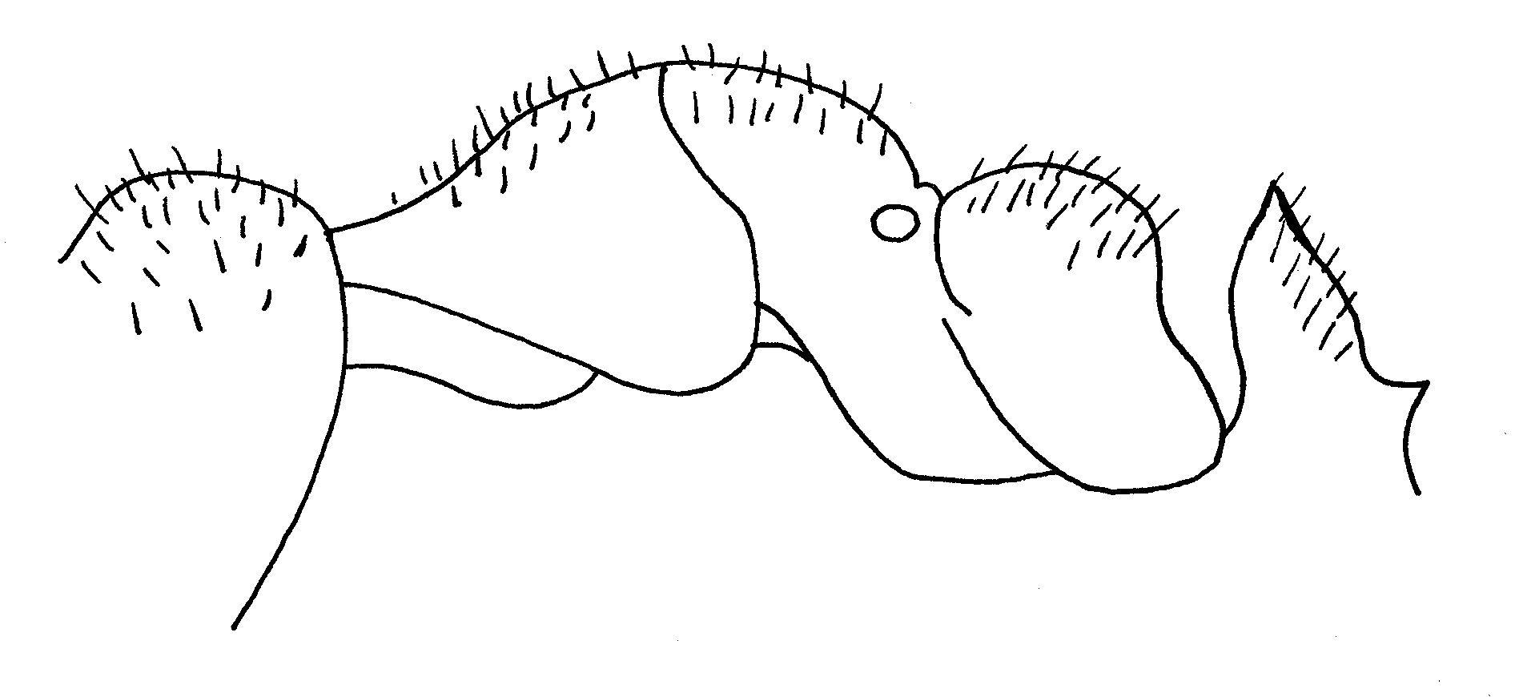Fig. 39. Outline of the posterior part of the head, mesosoma and petiole of a worker of F. coloradensis.
Distribution:
Map 3. Formica coloradensis.
Habitat:
Biology:

Formica comata Wheeler (rufa group)
Figs. ; Map

Discussion. The workers of this species can be recognized by the numerous snort, erect hairs on the underside of the head (Fig. 402), and by the abundant, short, bristly hairs on the dorsum of the gaster (Fig. 404). The dorsum of the gaster is covered with a dense layer of fine, appressed, silver hairs.
It can be separated from the similar F. ciliata by the hairs on the ventral surface of the head, and from F. mucescens by the short length of the hairs on the dorsum of the first tergum of the gaster.
Distribution. USA; NM.
Habitat. Grasslands, Ponderosa pine forest, sagebrush.
Biology. These ants construct thatched nests. Sexuals were found in nests in July.
Formica comata Wheeler
Figs. ; Map

Discussion: The workers of this species can be recognized as the scape is without erect and suberect hairs, the underside of the head has several erect hairs. The dorsum of the gaster is covered with short (up to 0.18 mm), erect hairs.
The female could be confused with that of F. mucescens, but can be separated as there are many long (most more than 0.2 mm in length), erect hairs (Fig. xx). It is also partially to mostly smooth and glossy, whereas the female of F. mucescens is completely dull. The females could also be confused with those of F. ciliata, but differ in that the hairs are sparse, and mostly straight, whereas they are thick and curled in F. ciliata.
Distribution: Colorado.
Map 4. Formica comata.
Habitat:
Biology:

Formica criniventris Wheeler (rufa group)
Fig. ; Map

Discussion. This is an attractive, bicolored ant (head and mesosoma red, gaster black), in which the mid and hind tibiae normally have only 1 or 2 erect or suberect hairs, located near the apices of the tibiae. The scapes are without erect hairs (except at the apex). The clypeal fossa is shallow and the surface of the clypeus is broadly convex. The suberect hairs on the gaster are widely scattered and sparse.
Distribution. USA: MT, ND, south to CO; NM: Santa Fe Co., Santa Fe (Audubon Center).
Habitat. Forested areas, open meadows.
Biology. These ants usually nest under stones and build thatched nests around the stone. It may enslave F. argentea or F. neoclara.
Wheeler, 1913

Formica criniventris Wheeler

Discussion: The worker of this species nearly lacks erect hairs on the head, mesosoma and gaster (the clypeus, mesonotum and gaster may have a few, scattered hairs). The middle and hind tibiae are nearly without erect hairs (few present near tibial spur). The clypeus is convex, but the sides are not separated from the middle region, and thus not forming a box. The gaster is covered with appressed pubescence, which give it a silver sheen.
The females are very distinctive, being a pale yellow color. More surfaces are smooth and glossy, the clypeus is covered with coarse, twisted or curled hairs, as is the gaster, especially posteriorly. The pronotum is without such hairs.
The workers of the species could be confused with F. fossaceps F. ravida?,
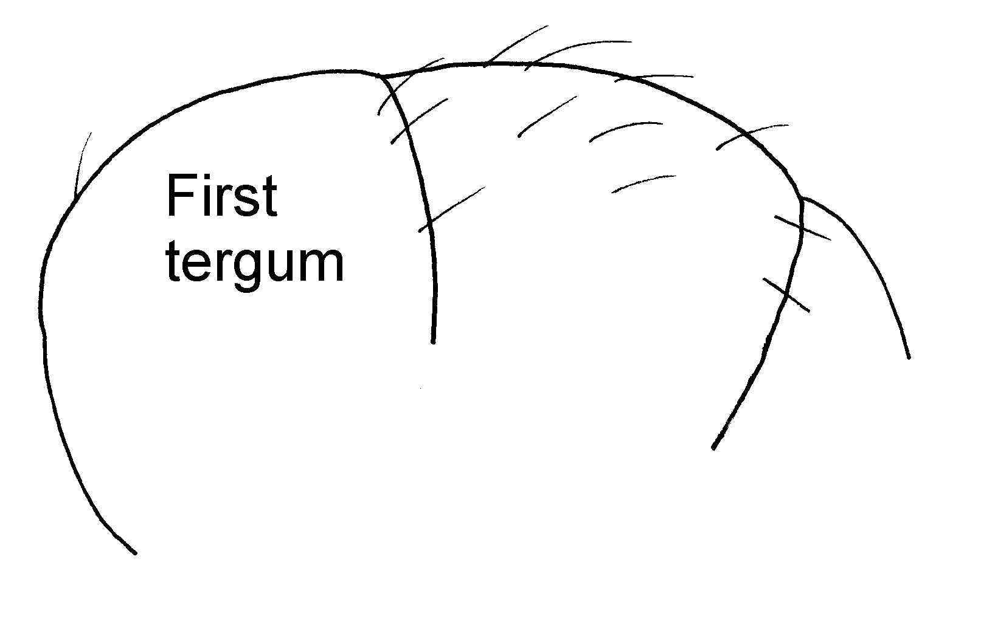
Fig. 40. Dorsal surface of the gaster of a worker of F. criniventris, showing the relatively sparse erect and semierect hairs.

Distribution:
Map 5. Formica criniventris.
Habitat:
Biology:

Formica dakotensis Emery (rufa group)
Fig. ; Map

Discussion. Workers, females (and even males) of this species are easily recognized as the node of the petiole is flat or has a slightly concave apex, as seen from the front or back (Fig. 390). The sides of the node are nearly straight and parallel.
The shape of the petiole separates this species from all other New World species of the rufa group. The palpi are remarkably short. The female is smooth and shining, and smaller than the largest workers.
Distribution. CANADA: Que.; USA: Much of North America; NM: San Miguel Co., Beulah (Wheeler, 1913, as F. dakotensis var. montigena).
Map 6. Formica dakotensis.
Habitat. Grasslands up to ponderosa pine forests.
Biology. This ant nests in mounds, often thatched with detritus, or under stones. It enslaves F. fusca, F. lepida, F. montana, F. nitidiventris, F. subsericea and F. pallidefulva. Like most species of Formica, this species tends aphids.
Wheeler, 1904, 1910a; Abbott, 1926; Brown, 1957b; Gregg, 1963; Wheeler and Wheeler, 1963
Formica ferocula Wheeler
Figs. ; Map

Discussion: The clypeus of workers of this species is broadly convex, not boxlike. The scape lacks erect hairs, the clypeus, most of the mesosoma, dorsum of the petiole, and dorsum of gaster have scattered, thick, erect hairs. The hairs on the middle and posterior tibiae are suberect, but extend along nearly the entire length. The propodeum is angulate between the faces in the larger workers, but is rounded in smaller workers. The female in male are unknown.
The species could be confused with F. prociliata, but differs in that the suberect hairs on the dorsum of the gaster are more numerous, and the propodeum is angulate between the faces. Additionally, the coarse bristles on the tibiae are suberect, not barely raised from the surface as in F. prociliata. Is possible that F. prociliata is a synonym
Distribution: Illinois (Rockford).andif it can
Map 7. Formica ferocula.
Habitat:
Biology:

Formica fossaceps Buren
Figs. ; Map

Discussion: The workers of this species can be recognized as the clypeus is strongly protruding, and the dorsum of the mesosoma and gaster are without erect hairs. Additionally the middle and hind tibia are without erect or suberect hairs (except possibly a hair near the tibial spur).
The female is smooth and polished, and is only slightly larger than the largest worker. The head, mesosoma and gaster are nearly without erect or suberect hairs.
The lack of erect or suberect hairs on the dorsum of the gaster would separate the worker and female of this species from all of the other members of the rufa group, except _____??? Criniventris, ravida?
Distribution:
Map 8. Formica fossaceps.
Habitat:
Biology:

Formica integra Nylander
Figs. ; Map

Discussion:
Distribution: MA, MA, VA, PA, NH, Ont., NY, ALAska, NC, Conn., VT, Maryland, AL, NJ, IO,
Map 9. Formica integra.
Habitat:
Biology:

Formica integroides Emery
Figs. ; Map

Discussion:

Formica propinqua has been separated from F. integroides on the basis of the lack of erect hairs on the posterior lateral corners. Actually the placement of the hairs of F. integroides ranges from the central region of the posterior margin to the sides of the head near the eyes. Among the type series in the MCZC the numbers of hairs in this region range from 1 hair in 3 specimens,. To 3 hairs and 4 hairs in two of the specimens. Thus this is not a consistent character and F. propinqua is apparently a synonym.
Distribution: CA (King’s River Canyon) , BC [Victoria, Kelowna], Immigrant Pass (state?),
Map 10. Formica integroides.
Habitat:
Biology:

Formica laeviceps Creighton (rufa group)
Figs. ; Map

Discussion. Workers can be recognized as lacking erect hairs on the scape (except at apex) and with few erect hairs on the mid and hind tibiae, except for a double row of bristles, each with up to 10 hairs, which extend the entire length of the tibia. The tentorial pits are very deep and pit-like, making the middle part of the clypeus rise up as a rectangle (Fig. 391). The species name suggests that the head is smooth, but it is predominantly rough and only slightly smoother than the average member of the rufa group.
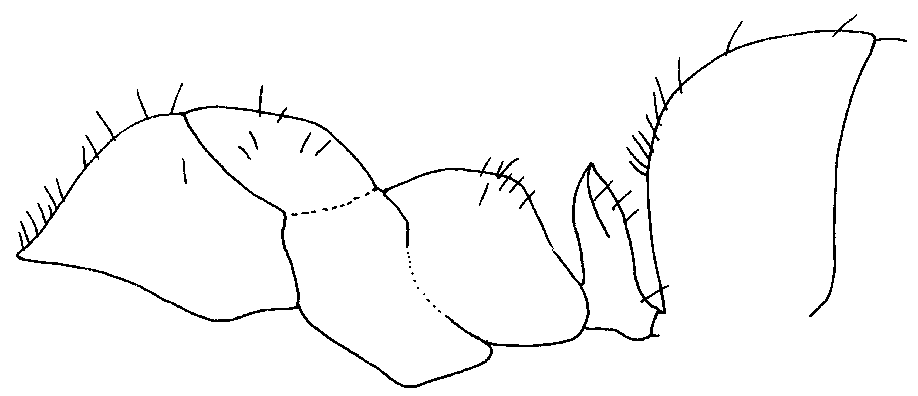Fig. 41. Side view of a worker of a paratype worker of F. laeviceps.

Distribution. USA: CO; NM: Los Alamos Co., east Bandelier (possibly species near laeviceps), Taos Co., Taos (Yerba trailhead).
Map 11. Formica laeviceps.
Habitat. Semiarid sites, grasslands, pinyon-juniper forests, up into mixed conifer habitats (Fagerlund, pers. comm.).
Biology. This ant nests under stones, and occurs in areas with sandy soils and interspersed stones. Foragers were collected on Yucca sp. stalks, tending aphids, on a sunny, east-facing slope.

Formica lugubris Zetterstedt (rufa group)
Figs. ; Map

Discussion:
Distribution:
Map 12. Formica lugubris.
Habitat:
Biology:
Formica mucescens Wheeler (rufa group)
Figs. ; Map

Discussion. This species can be recognized as there are few hairs on the tibiae, where they are restricted to two rows on the flexor surface. The gaster is covered with short, bristly hairs, in which the distance between the tips is less than the lengths of the hairs.
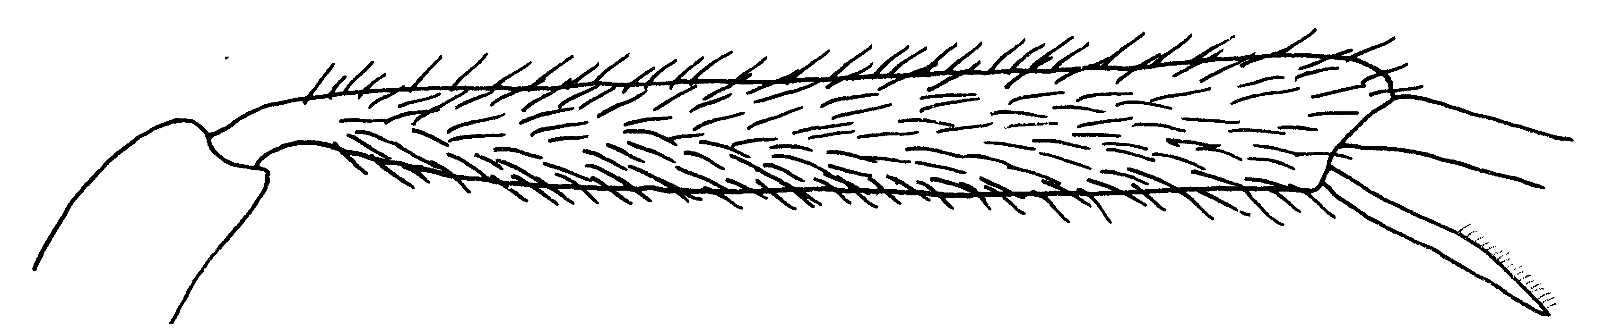Fig. 42. Posterior left tibia of a “type” worker of F. mucescens.

It is similar to F. ciliata, but differs in that the cheek has several erect hairs (usually more than 12 on each), and the female is brown, and without the curved hairs found on the female of F. ciliata. It can be separated from F. comata (which occurs from Montana south to Colorado) as the erect hairs on the gaster are longer (0.12 mm vs. 0.06 mm in length in F. comata).
Distribution. USA: CO and UT.
Habitat. Found in open prairies up to ponderosa pine forests.
Biology. This species nests under stones banked with detritus or in thatched nests.
Gregg, 1963
Formica mucescens Wheeler (rufa group)
Figs. ; Map

Discussion: This species can be recognized as the scape usually has several (up to 12 seen in outline of scape) erect and suberect hairs on the scapes (may be completely absent). The tibia also has several suberect hairs. The dorsum of the mesosoma and gaster have abundant erect hairs, mostly less than 0.1 mm in length.
This species could be confused with F. oreas, but can be separated as the workers are less hairy. Specifically, the scape has fewer than 12 erect and suberect hairs that can be seen in outline, whereas the workers of F. oreas have more than 12 such hairs. The females of the two species are very different, that of F. mucescens has few hairs and is completely dull and dark in color. The female of F. oreas is abundantly hairy, with abundant hair on the head, mesosoma and gaster. The hair is often twisted and matted in the females of the latter species. The females of F. oreas are yellow and glossy.
This species could also be confused with F. comata. It differs in that the worker (and female) usually have at least a few erect or suberect hairs on the scape (scape of F. comata without erect hairs) and the female has few hairs, which are all short (). Creighton (1950) was incorrect when he stated in his key that the hairs on the dorsum of the gaster of the worker of F. mucescens are longer than are those of F. comata. Direct comparison of the types showed that the longest hairs on the gaster of F. mucescens were up to 0.12 mm in length, whereas the similar hairs in F. comata were up to 0.18 mm in length. Unfortunately there was too much variability among specimens and even of the length of hairs within a single species to make this difference of much use.
The female of F. comata is without erect or suberect hairs on the scape, and while the hairs on the dorsum of the mesosoma are not dense, they are much longer. Additionally, the female of F. comata is partially smooth and shiny. It is thus more similar to the female of F. oreas than to the female of F. mucescens.
Distribution:
Map 13. Formica mucescens.
Habitat:
Biology:

Formica obscuripes Forel (rufa group)
Figs. ; Map

Discussion. This species is difficult to separate from F. obscuriventris. Characters to separate it from F. obscuriventris are in the discussion of that species. It is generally less hairy than F. obscuriventris, specifically having fewer than 30 erect hairs on the posterior border of the head (usually fewer than 20), whereas F. obscuriventris usually has more than 30.
Distribution. USA: Much of North America; NM:
Map 14. Formica obscuripes.
Habitat. Prairies, sagebrush, mixed deciduous forest up to pinyon-juniper, ponderosa pine-riparian.
Biology. This species is not common in New Mexico. It nests in thatched mounds or under logs or stones (usually partially covered with thatch). Workers tend aphids. It is polygynous (multiple queens in the nest). This species does not have typical mating flights; instead small numbers leave the nest throughout the season. Dealate females were collected in late June and early July.
Wheeler, 1913 (F. rufa aggerans); Jones, 1929; Cole, 1932; Weber, 1935; Gregg, 1963
Formica obscuriventris obscuriventris Mayr (rufa group)
Figs. ; Map

Discussion. This species is difficult to identify as characterization depends on the structure of the clypeus (see couplet 5 of the rufa group key). The tentorial fossa is deep, with the surrounding area depressed into a pit-like funnel. In addition, the middle of the clypeus is separated from the sides and is shaped somewhat like a rectangular box. If you pass couplet 6, it will key to F. obscuripes, but will differ to some degree in being more hairy. The vertex of the head usually has more than 30 erect hairs, when the top of the head is seen in profile from behind.
Formica obscuripes usually has fewer than 20 hairs on the vertex, and the clypeal fossa will not be deep and funnel shaped. The middle of the clypeus passes gradually into the sides, not forming a rectangular box.
Distribution. USA: All through North America; NM: This subspecies is found in southwestern Colorado and may occur in New Mexico. Mayr (1886) includes NM, as does Wheeler (1913:449), without listing localities.
Habitat. Mixed canyon forest, and open woods into pinyon-oak-cedar woodland.
Biology. This species nests under logs or stones, usually partially covered with thatch. Females were found in nests in April, it may be polygynous, as several dealate females may be found in nest. It enslaves F. subsericea.
Wheeler, 1913; Gregg, 1963
Formica obscuriventris Mayr (rufa group)
Figs. ; Map

Discussion:
Specimens from New Mexico have a few erect and suberect hairs on the scapes, and may represent a new species.
Formica obscuriventris clivia has been separated from F. obscuriventris on the basis of the a darker coloration. Color is variable in this species and the minor differences between the two is insignificant, and thus is is considered a synonym.
Distribution:
Map 15. Formica obscuriventris.
Habitat:
Biology:

Formica obscuriventris clivia Creighton (rufa group)
Fig. ; Map

Discussion. This subspecies can be separated from the typical F. obscuriventris in that the minors are darker, and at least part of the petiole of the majors is somewhat darkened, as compared to workers of F. obscuriventris, in which the minors are yellow-brown in color and the petiole of the majors is clear yellow or red. Obviously the differences in color are of little significance, and this subspecies is probably a synonym.
Distribution. USA: Central North America south to NM.
Map 16. Formica obscuriventris clivia.

Habitat. Meadows up to oak woodlands, ponderosa pine-riparian and spruce aspen forests.
Biology. This ant constructs thatched domes of pine needles, typical of the F. rufa species group, in loam soils. Nests may also be found under stones or logs banked with thatch. Brood was found in nests in June and August, reproductives can be found in nests in August to September; dealate females were also found in August and September. They are very aggressive and attack when the nest is disturbed. Foragers tend aphids on various plants.
Gregg, 1963
Formica oreas oreas Wheeler (rufa group)
Figs. ; Map

Discussion. This species can be separated from most others as the scape is more or less evenly covered with erect hairs, whereas other species have erect hairs only at the tip, with possibly a few others scattered on the scape. It can be separated from others with many erect hairs on the scapes as it has short dense hairs covering the gaster and the gaster is brownish black instead of black.
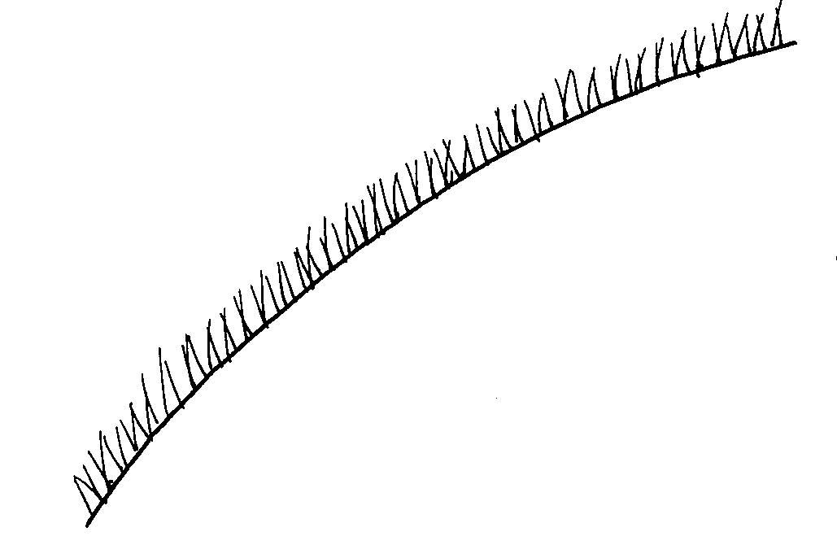
Fig. 43. Hairs on the pronotum of a worker of F. oreas.
Specimens with few or no hairs will key to F. obscuripes, thus it is important to carefully examine all surfaces of scapes of several workers from a series. The subspecies F. oreas comptula is recognized, as the minor workers are darker. It is doubtful that this insignificant difference in color is of any importance.

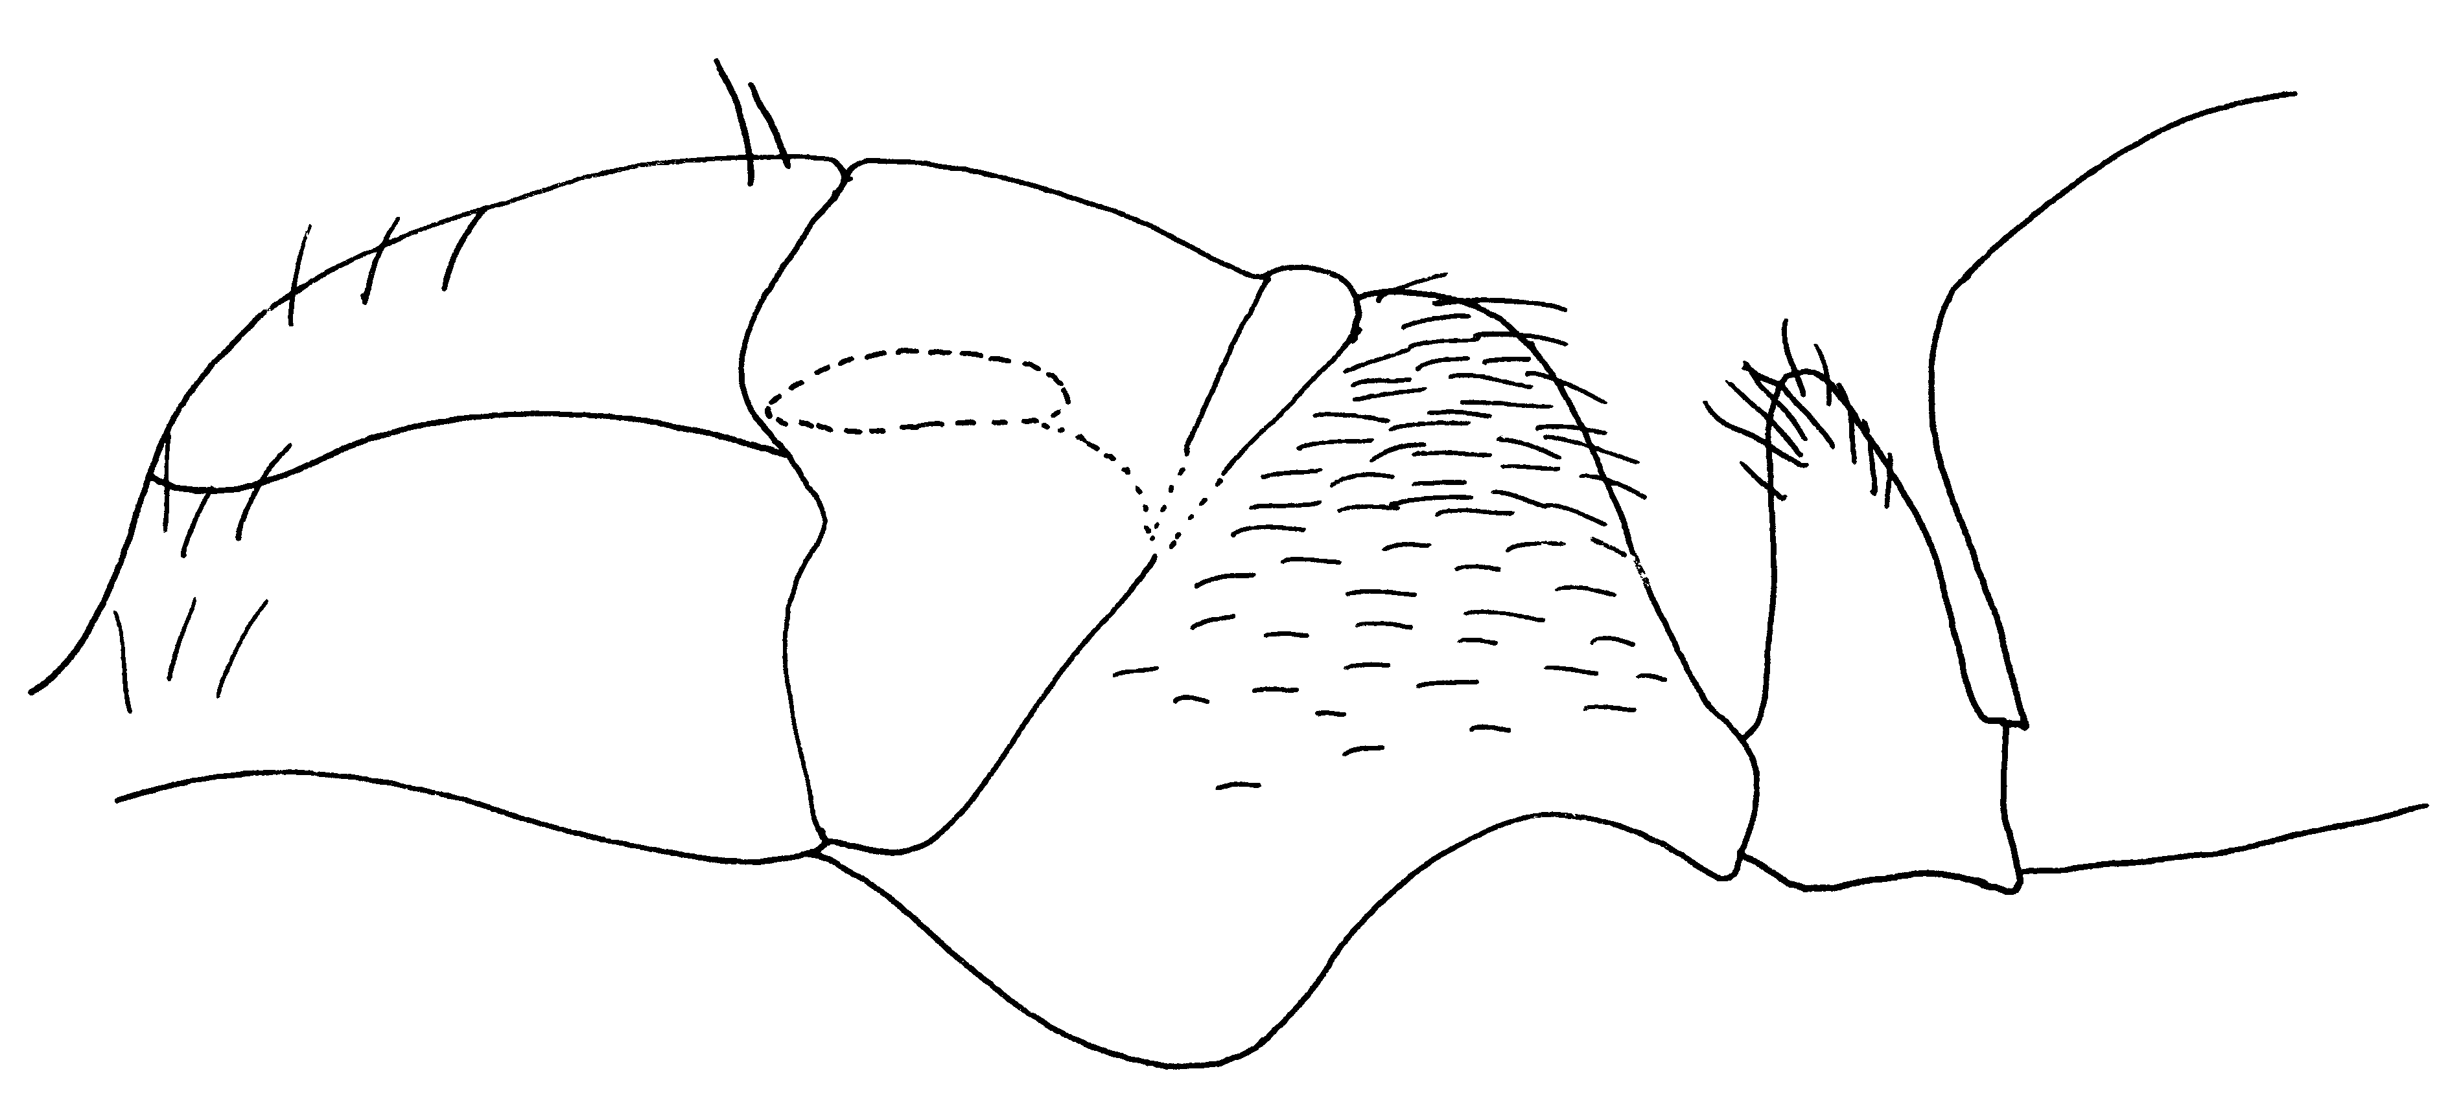Fig. 44. Side view of a cotype female of F. oreas.
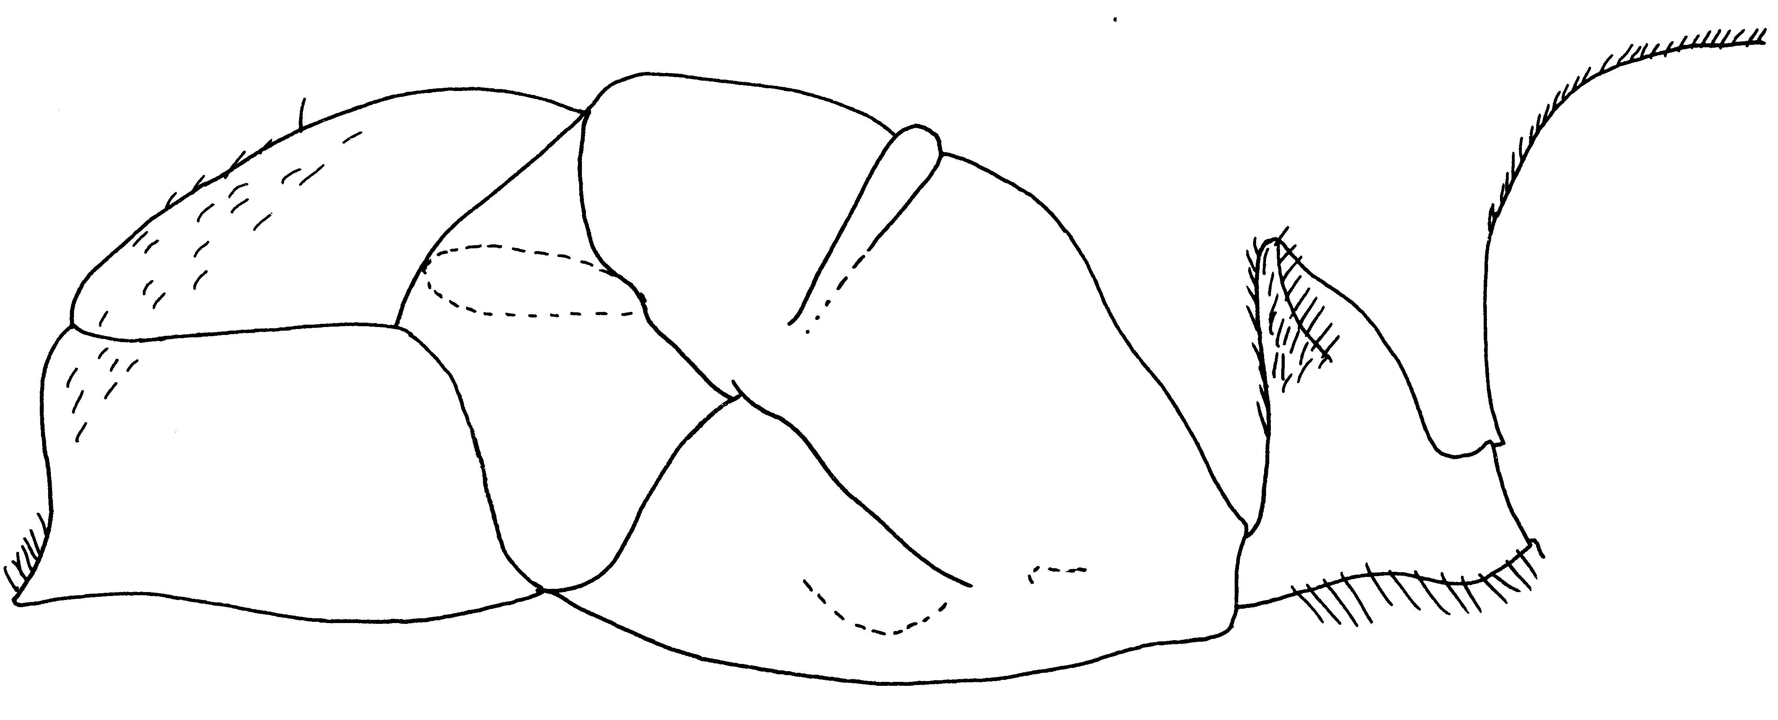Fig. 45. Side view of a cotype female of F. oreas comptula.
Distribution. USA: MT, ID S to NM.
Map 17. Formica oreas.
Habitat. Open woods or meadows up to pine and aspen forests.
Biology. This ant nests under stones or logs, usually covered with detritus or thatching, in areas of fine sand to rocky loam. Occasionally this species constructs mounds solely of thatching. Brood was found in nests in March and August, reproductives occurred in nests June to August. Workers are very aggressive when the nest is disturbed.
Wheeler, 1913; Cole, 1942; Gregg, 1963
Formica oreas comptula Wheeler (rufa group)
Figs. ; Map

Discussion. This is another subspecies, which is based on relatively insignificant color differences. The minor workers of this subspecies are partially dark, whereas minor workers of the typical F. oreas are generally bicolored (head and mesosoma red, gaster black). It will probably be shown to be a synonym of the typical F. oreas.
Distribution. USA: Western North America; NM:
Map 18. Formica oreas comptula.
Habitat. Woodlands and grasslands.
Biology. Nest are found under stones or logs covered with thatching.
Cole 1934b; Wheeler and Wheeler 1963
Formica planipilis Creighton (rufa group)
Figs. 394, 397; Map 209

Discussion. The tentorial pit of this species is shallow. The middle and hind tibiae have a double row of bristles on the flexor surface, but each is with few hairs (fewer than 10 hairs in each row). There are a few scattered hairs on the other surfaces of the tibiae. The head of the major is longer than broad; the erect hairs on the mesosoma are short and of about equal length. The hairs on the head are longer and sparser than those on the mesosoma.
This species differs from the closely related F. coloradensis in that the smaller workers are partially brown, and the legs of workers of all sizes are brownish black. The minor workers of F. coloradensis are clear red with a black gaster. The legs of all sizes of workers of F. coloradensis are not much darker than the mesosoma.
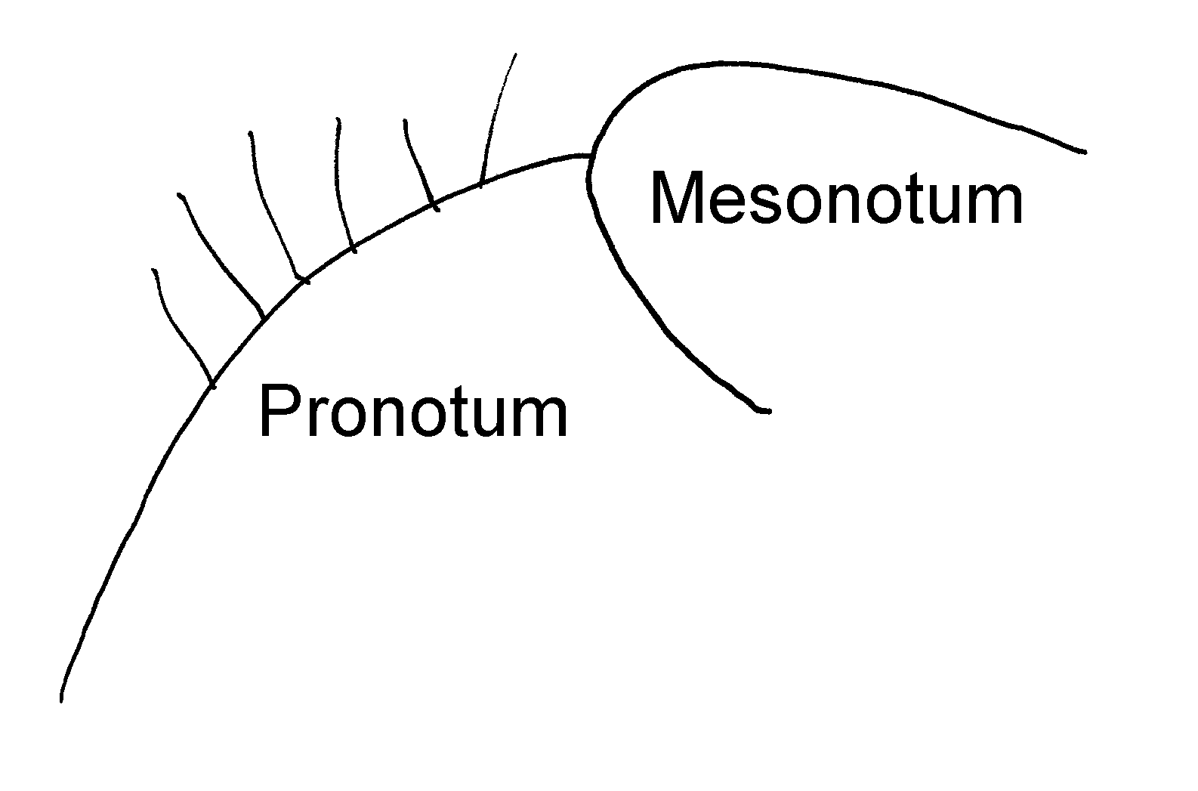Fig. 46. Anterior part of the mesosoma of a worker of F. planipilis.
Distribution. USA: ND, UT, CO, KS, UT, NV, NM.
Map 19. Formica planipilis.
Habitat. Grasslands, open forests, ponderosa pine forests, often found in riparian areas, popular-spruce forests, up to about 3000 meters elevation.
Biology. These ants nest in the soil, usually with some thatching of pine needles, but may also be found nesting in rotten logs and stumps in rocky and gravely soils. Brood and reproductives were found in nests from late June to mid August. Workers forage up into the canopy of pine trees.
Gregg, 1963; Wheeler and Wheeler, 1963; Cole, 1966; DuBois and Danoff-Burg, 1994
Formica prociliata Kennedy and Dennis
Figs. ; Map

Discussion: The workers of this species have a convex clypeus, but it is not boxlike. The scape is without erect hairs, the clypeus, most surfaces of the mesosoma, especially the dorsum, the dorsum of the petiole, and the dorsum of the gaster have erect or suberect hairs. The hairs on the middle and posterior to be a barely raised above the surface, but extend along the entire length.
The female is yellow, with thick, curled, matted hairs on most surfaces of the body, especially the clypeus, the pronotum, the propodeum, and the petiole. The gaster has a few, scattered, erect hairs.
This species could be a synonym of F. ferocula. It differs in the numbers of hairs on the dorsum of the gaster is reduced (usually fewer than three can be seen with the gaster in profile) and the region between the two faces of the propodeum is broadly rounded. Additionally, the coarse bristles on the middle and hind tibiae are only slightly raised from the surface, not suberect as in F. ferocula.
Distribution: Michigan Ohio Iowa
Map 20. Formica prociliata.
Habitat:
Biology:

Formica propinqua Creighton (rufa group)
Figs. ; Map

Discussion. Workers can be recognized by the distribution of erect hairs. The posterior lateral corners and scapes have none (except at apex of scape), the dorsal and ventral surfaces of the head have several (at least 12 on ventral surface of head), the dorsum of the mesosoma has several short, fine erect hairs (most < 0.1 mm in length), the petiole has several similar hairs, and the dorsum of the gaster has several erect hairs which are slightly longer and slightly coarser than those on the pronotum. Most surfaces, including the clypeus, underside of the head and the gena, are dull or only weakly shining. The mid and hind tibiae have a few erect bristles (about 5 on each of the 2 parallel rows), but they extend the entire length of the tibiae.
The dull surfaces separate it from F. subnitens, and the lack of posterior lateral hairs separates it from F. coloradensis, and from F. integroides (which is only found on the West Coast). This species was previously referred to as F. integroides propinqua.
Distribution. USA, NM.
Map 21. Formica propinqua.

Habitat. Forests.
Biology. This species nests next to logs and stumps, in thatched nests.
Gregg, 1963
Formica ravida Creighton (rufa group)
Figs. ; Map

Discussion. The tentorial pits of this species are shallow. The erect bristles on the tibiae are restricted to two rows on the flexor surface, which extend nearly the entire length of the tibiae. The erect hairs on the gaster are scattered, and do not form an even vestiture when viewed in profile, although the gaster is covered with dense, gray, appressed pubescence. The petiole is narrow in profile with a moderately sharp apex. This species was previously referred to as F. haemorrhoidalis.
Distribution. USA: Western North America; NM: although this species commonly occurs in western and southwestern Colorado, we have no records from New Mexico. It would be expected to be found in northwestern New Mexico.
Habitat. Prairies up to pine forests.
Biology. Nests are usually in the form of thatched mounds on the sides of logs and stumps. Incipient nests may be found under stones or logs, but usually some thatching is present. These ants are extremely aggressive. Workers fold the gaster under the body and squirt a stream of formic acid several centimeters. This acid is strong enough to cause blistered skin, after repeated contact with these ants.
Gregg, 1963
Formica ravida Wheeler
Figs. ; Map

Discussion: This species can be recognized as it is nearly without erect hairs, including. It is separated from F. integra on the basis of the erect hairs on the eyes (which are absent in F. integra). There is a range in the number of these hairs, but most specimens have more than five. Two cotypes of F. haemmorhoidalis in the MCZ have very few hairs, which are all poorly developed, the type series of F. ravida have a few more hairs (approximately 6 on each eye). Thus it is not easy to separate the two species, although F. integra apparently never has erect hairs on the eyes.
Distribution: CA, CO, Dakota, Mont, ID, WA,

Map 22. Formica ravida.
Habitat:
Biology:

Formica reflexa Buren
Figs. ; Map

Discussion:
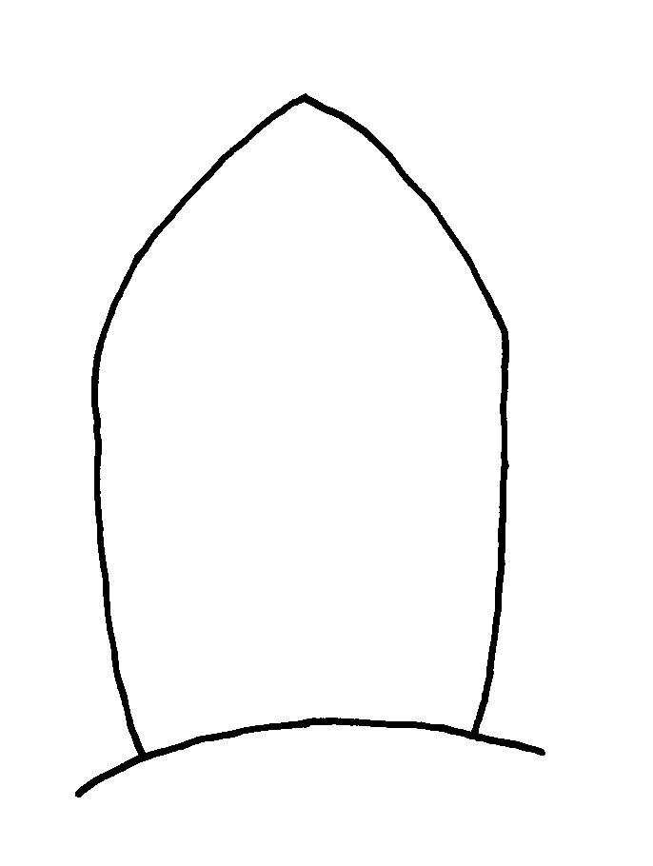
Fig. 47. Petiole of a worker of F. reflexa as seen from the front.

Distribution:
Map 23. Formica reflexa.
Habitat:
Biology:

Formica subfasciata Wheeler
Figs. ; Map

Discussion:
Distribution:
Map 24. Formica subfasciata.
Habitat:
Biology:

Formica subnitens Creighton (rufa group)
Figs. ; Map

Discussion. The middle and hind tibiae of this species have erect hairs in two rows (usually fewer than ten hairs in both rows combined), but do not have erect hairs scattered over the remainder of the surface. The erect hairs extend over nearly the entire length of the tibia. The gaster has few erect hairs on the first tergum (fewer than 10, excluding those along posterior edge of tergum).
This latter characteristic separates it from the closely related F. ravida which has more than 10 hairs on the same surface. The clypeus, cheeks and malar area are often shiny.
Distribution. USA: Western United States; NM: Taos Co., 5 mi. E Taos (Cole, 1954e), 12 mi. E Taos (Cole, 1954e).
Habitat. Grasslands to pinyon cedar forests, willows, and cedars.
Biology. This species nests in thatched mounds, occasionally under stones or logs, usually with some surrounding thatch. They are occasionally found in earthen domes (Cole, 1954e).
Cole, 1954e; Ayre, 1957, 1958a, 1958b, 1959; Gregg, 1963; Wheeler and Wheeler, 1963
Formica subnitens Creighton
Figs. ; Map

Discussion: The worker of this species can be recognized by the relative elongate head, which is narrowed anteriorly. The clypeus is convex, but is not boxlike. The mesosoma has a number of short, coarse, blunt-tipped hairs, the hairs on the gaster are longer, and more pointed, the tibiae have erect and suberect bristles scattered along the entire length, but only present on the flexor surface. The side of the head between the base of the mandibles in the anterior edge of the eye is punctate, but is moderately to strongly shining.
Distribution:
Map 25. Formica subnitens.
Habitat:
Biology:

Literature cited
Creighton, W. 1950. The ants of North America. Bull. Mus. Comp. Zool. 104:1-585 + 57 plates.

Modified from Creighton (1950)

