Revision Of The Thief Ants

of North America

(Hymenoptera: Formicidae: Solenopsis)

by

Isidra Moreno Gonzalez, and William P. Mackay¹

ABSTRACT

The genus Solenopsis includes some of the most common ants, most notably the notorious “fire ants”. It also includes some of the smallest ants, which are commonly known as thief ants. Many species of this group live in nests of other ants, where they steal food and brood of their hosts. They also appear to be effective predators, and may be natural enemies of the founding queens of the imported red fire ants.
This group of ants was originally proposed as the subgenus Diplorhoptrum of Solenopsis by Mayr, in 1855. In 1862, Mayr synonymized the subgenus with Solenopsis, where it remained until 1930. Creighton (1930) revived it from synonymy with Solenopsis, where it remained as a subgenus until 1966, when Ettershank synonymized it again with Solenopsis. In 1968, Baroni-Urbani raised it to the status of a genus, later Kempf (1972) again synonymized it with Solenopsis, where it has remained (Bolton, 1987). This group of ants has been ignored, due to their small size, and the lack of good morphological characters which can be used to separate species.
A number of species and subspecies occur in North America. All of these species would be expected to be predators on the red imported fire ant, and I intend to include species from North America and Central America (total of 28) in my thesis. The following species complexes and species are defined: 1) azteca complex: S. azteca Forel and S. terricola Menozzi; 2) fujax complex: S. krockowi Wheeler, S. pergandei Forel, and S. pilosula Wheeler; 3) minutissima complex: S. depilis new species, S. ocellata new species missing info here???

Introduction

Even though ants are found everywhere, they are seldom noticed unless they disturb us in some way. This group of insects is one of the most successful terrestrial arthropods, and their presence is essential in controlling the insect fauna, turning the soil and channeling energy. Ants are among the “little things that run the world” (Kremen et al., 1993).
Ants are classified in the family Formicidae, and order Hymenoptera. The family Formicidae has been divided into 11 subfamilies, over 297 genera, and more than 8,800 species. It has been estimated that over 20,000 species of ants still remain undescribed (Hölldobler & Wilson, 1990). The classification of ants is a very difficult task because they are small and in most cases it is impossible to differentiate between species without the help of a high quality microscope. Therefore, the classification of very tiny ants can be challenging and can lead to taxonomical misclassification. A good example is the group of thief ants.
The thief ants (fugax group of the genus Solenopsis, was previously considered to be members of the subgenus Diplorhoptrum) are predators on the founding queens of the red imported fire ant Solenopsis invicta, as well as, predators on the brood of this pest species. Unfortunately, very little ecological work has been done on this potentially important group of predators, due to the difficulty in identification and separation of species. I am especially interested in Solenopsis salina, due to its potential as a predator on the founding queens and brood of the red imported fire ant Solenopsis invicta in the El Paso area. The systematics of this group must be done before any serious biological work can be done with these ants. Since thief ants have been found to be effective predators of S. invicta, it is possible that they can be used as biocontrol of this pest. The objective of this research is to provide a revision of those species that are found in North America. This will serve as a basis for future work on the biology of these ants.

Definitions of Abbreviations
Specimens were measured using a micrometer in the ocular of a Wild dissection microscope. The following abbreviations are used (all measurements in mm.).

TL Total length from head to gaster.
HL Head length, anterior margin of medial lobe of clypeus to posterior border.
HW Head width, maximum width excluding eyes (Measured immediately posterior to eyes).
SL Scape length, excluding basal condyle.
CI Cephalic index, HW/HL x 100
SI Scape index, SL/HL x 100
PI Petiolar index, PL/PW x 100

RESULTS AND DISCUSSION

Solenopsis

The genus Solenopsis includes ants in the subfamily Myrmicinae, in which the antenna of the worker has 10 segments, with a 2-segmented club, which is nearly as large as the remainder of the funiculus. There are generally 2 clypeal carinae, and normally at least 2 teeth on the anterior margin of the clypeus. The medial point of the clypeus has single, elongate hair. The mandibles have 4 teeth. The scapes rarely reach the posterior lateral corners. The metanotal suture is impressed, often deeply impressed. The propodeum is rounded between the faces, and is without teeth. The petiole and petiole are well developed, and are usually about equal in size (in profile). Most surfaces are covered with long, erect hairs, including the head, scapes, mesosoma, legs, petiole, postpetiole and gaster. Most surfaces are smooth and polished. These ants are usually golden brown, but color ranges from pale yellow (nearly white), bicolored (head and mesosoma red, gaster black) to concolorous black.
Thief ants possess the above characteristics, but are tiny ants with very small eyes (usually 3 - 4 facets or less, never more than 18). The second and third funicular segments are as broad as long or broader than long. Most species are monomorphic or weakly dimorphic, a few of the South American species (wasmanni species complex) are strongly dimorphic with well-developed soldiers.
Various subgenera have been named, and most are of questionable validity, and several of these have been synonymized (Ettershank, 1966; Trager, 1991). We will only discuss those which occur in North America.
The subgenus Solenopsis currently contains the “fire ants” (geminata complex), as well as a mixture of other ants, including nest parasites (S. daguerrei). The group may be paraphyletic or even polyphyletic (Trager, 1991).
The subgenus Diagyne contains a single species: S. succinea. This is a very unusual species, as the workers completely lack the clypeal carinae, as well as the clypeal teeth. Although other species lack the clypeal teeth (bicolor complex, others have very reduced teeth), the female has a 10-segmented antenna (the females of all other species have an 11-segmented antenna), and the mandibular teeth of the female are very unusual, appearing to be broken (Fig. 8a). Although this species is clearly related to the others in the genus Solenopsis, it is clearly an aberrant form. As the worker could be confused with thief ants, it is included in this revision, although it is probably not closely related. It is not my intention to synonymize Diagyne. Trager (1991) suggested that the workers are not distinguishable at the species-group level from the globularia complex of the subgenus Euophthalma. This seems unlikely, but will have to be reevaluated with a thorough revision of the globularia species complex.
The subgenus Euophthalma includes 2 possibly unrelated groups: the globularia species complex and the nigella species complex. Workers of both of these groups have large eyes (more than 10, usually more than 20 ommatidia), and the second and third antennal segments of the funiculus are usually broader than long, or at most slightly longer than broad. They are monomorphic or feebly polymorphic species. The globularia complex is easily recognized as the postpetiole is greatly swollen (Fig. 12b), and appears to represent a monophyletic taxon. The nigella complex, on the other hand, is difficult to separate from members of the subgenus Solenopsis, as the dimensions of the funicular segments are variable (especially the third segment). Even if this characteristic was consistent, it (and the nearly monomorphic workers) would be little basis for considering them members of a separate subgenus. One of the members, S. huachucana, is actually a synonym of S. aurea (Trager, 1991). Trager (1991) stated that the species outside the globularia (-tenuis) group [the nigella complex] are apparently not differentiable from Bisolenopsis and Synsolenopsis, which he confirms are synonyms of Solenopsis, further supporting the hypothesis that the nigella complex is a synonym of Solenopsis. Except for the Central American species S. picquarti, the remainder of the species in the nigella group are South American. Trager (1991) suggests that the globularia species complex is related to the tenuis group of the thief ants, as they share several synapomorphic features (unspecified by Trager).
The thief ants present an interesting history. The group was originally proposed as the subgenus Diplorhoptrum of Solenopsis by Mayr, in 1855. In 1862, Mayr synonymized the subgenus with Solenopsis, where it remained until 1930. Creighton (1930) revived it from synonymy with Solenopsis, where it remained as a subgenus until 1966, when Ettershank synonymized it again with Solenopsis. In 1968, Baroni-Urbani raised it to the status of a genus, later Kempf (1972) again synonymized it with Solenopsis, where it has remained (Bolton, 1987). This group of ants is very closely related to the fire ants of the genus Solenopsis, and probably cannot be morphologically distinguished from them, but ecologically they are very different. These ants are almost exclusively subterranean, where they specialize in attacking the brood and stored food of other species of ants. Although I use Diplorhoptrum throughout this thesis, it is not my intention to resurrect this subgenus, but only as a matter of convenience. It is beyond the scope of this thesis to analyze the subgeneric structure of the entire genus Solenopsis.
Creighton (1930), first attempted to delineate species complexes in the thief ants, based on “characteristics that are fairly consistent”. Unfortunately he did not include any of the characteristics, stating that they would be presented in a future publication. Unfortunately the publication was never finished, and I have not been able to locate even an unpublished manuscript. I attempted to use his classification of 5 species complexes, but early in the revision it became clear that this was unattainable. Some of his complexes are apparently monophyletic (westwoodi group, actually the fugax complex), the molesta complex, and the azteca complex. The other groups listed (laeviceps group and the basalis-tenuis group) appear to be members of the molesta complex. It has been necessary to recognize 2 additional complexes: the succinea complex and the pygmaea complex. All of the species complexes of thief ants in North America will be defined, and distinguished by keys in this study.

Identification Keys

Key to the subgenera and species complexes of the genus Solenopsis of North America (north of Panamá)

1. Second and usually third segment of funiculus at least 1 ½ times as long as broad (Fig. 1, upper) ...…. geminata species complex (subgenus Solenopsis)
- Second and at least third segment of funiculus only slightly longer than broad, often broader than long (Fig. 1, lower) ..…………….. 2
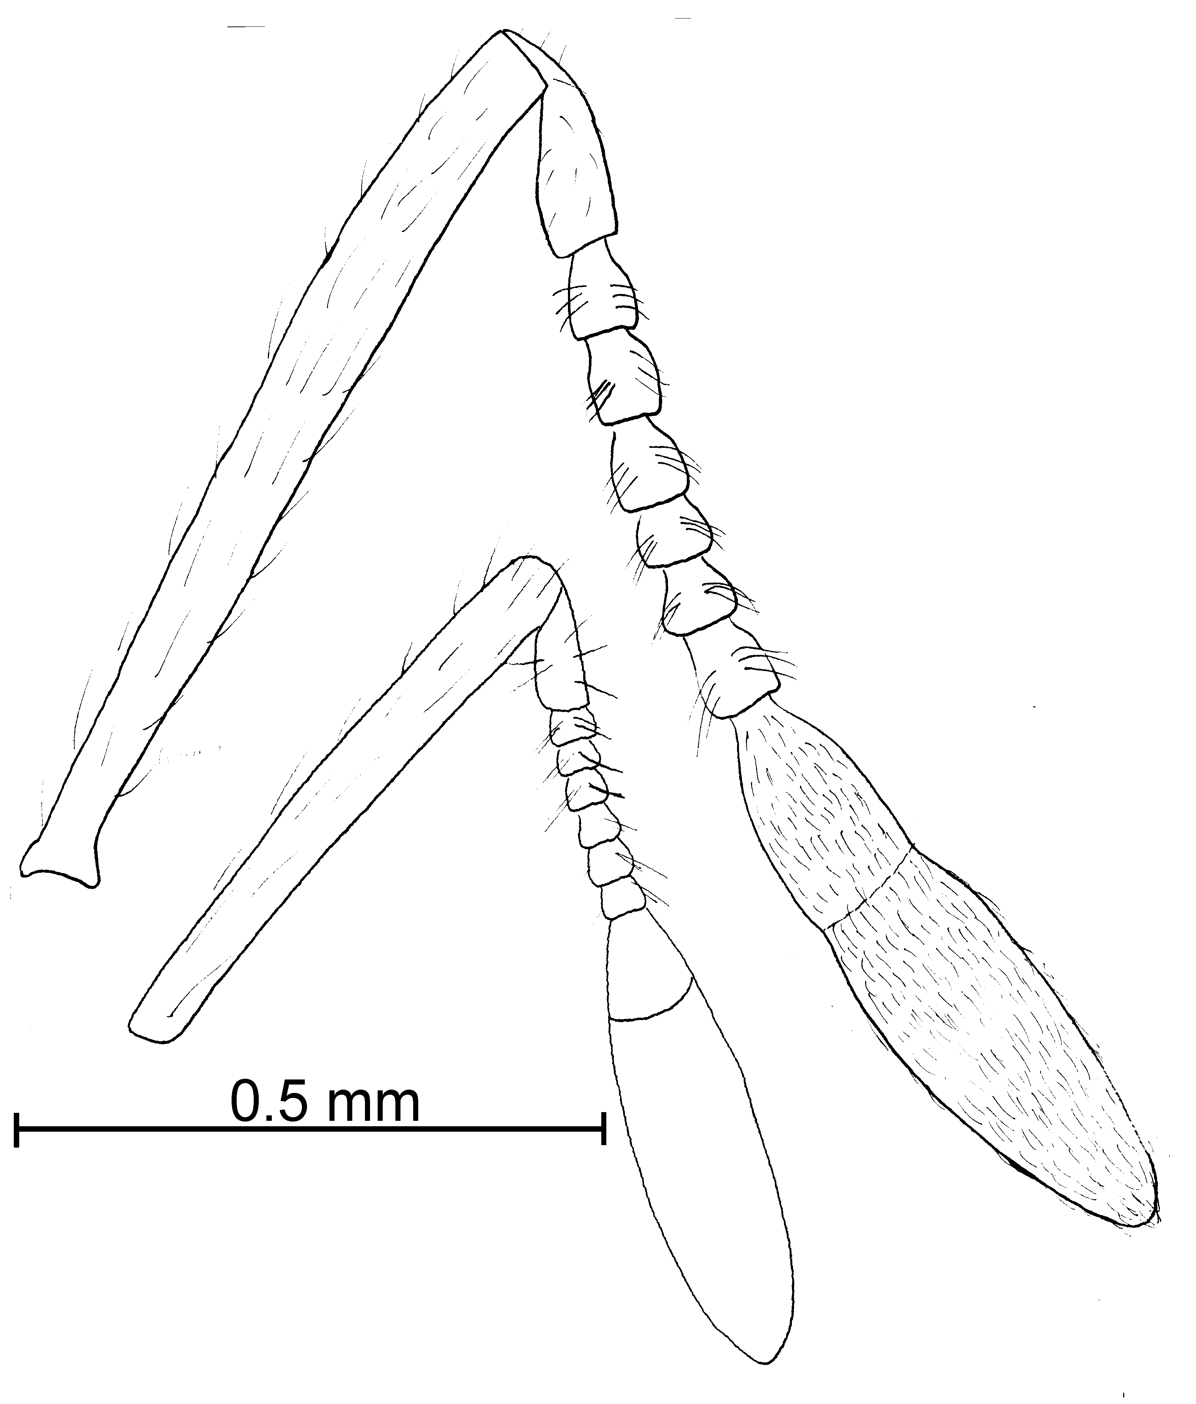
Fig. 1. Antennae of S. geminata (upper) and S. franki idea (lower) showing the relative lengths of the second and third funicular segments.

2(1). Eyes of worker with at least 12 ommatidia (Fig. 2 -13d) .. 3
- Eyes of worker with fewer than 12 ommatidia, usually fewer than 6 (Fig. 3 -13b) ……………… 4

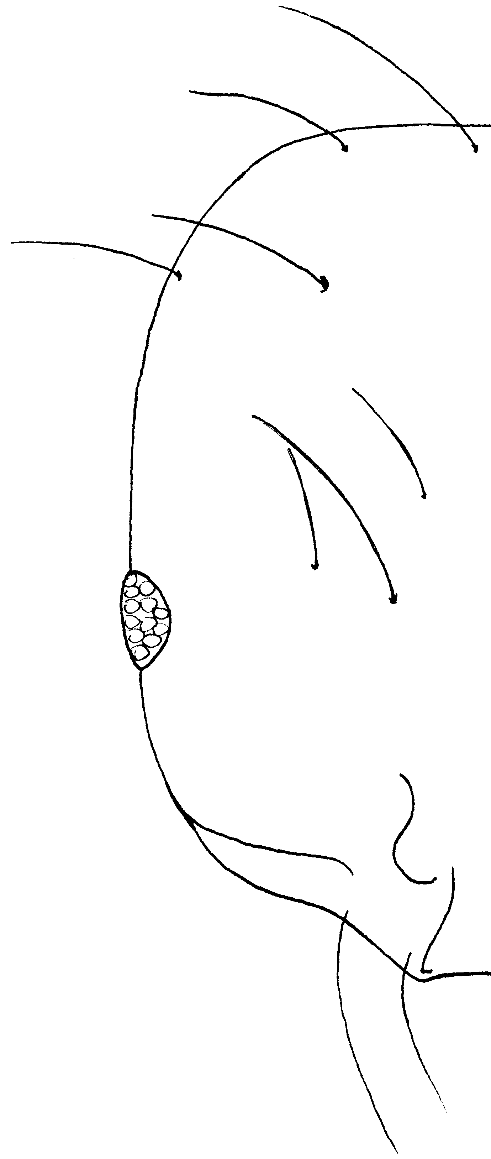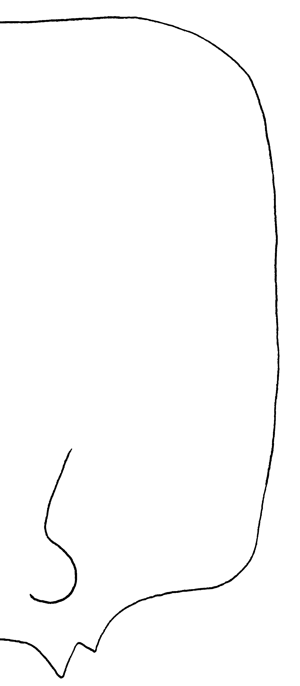
Fig. 2. Heads of workers of S. altinodis (left) and S. krockowi (right).

3(2). Postpetiole greatly dilated (Fig. 13) ……. globularia species complex (subgenus Euophthalma)
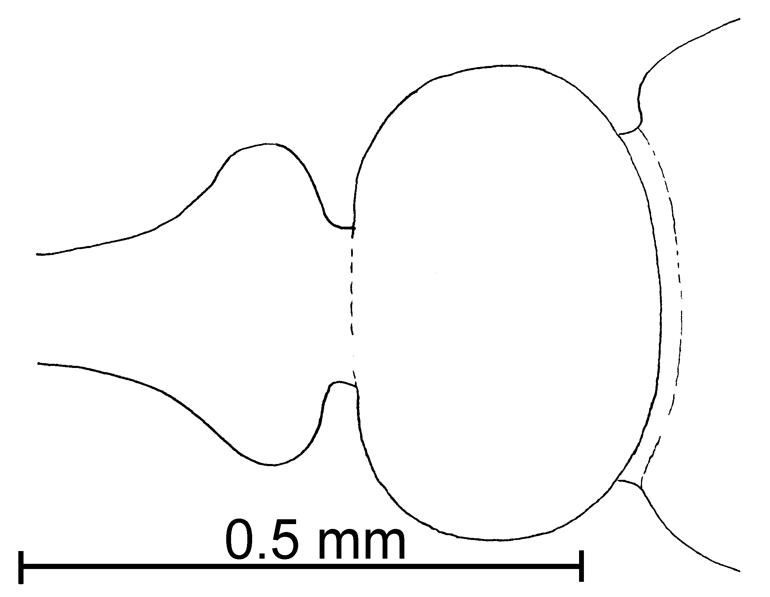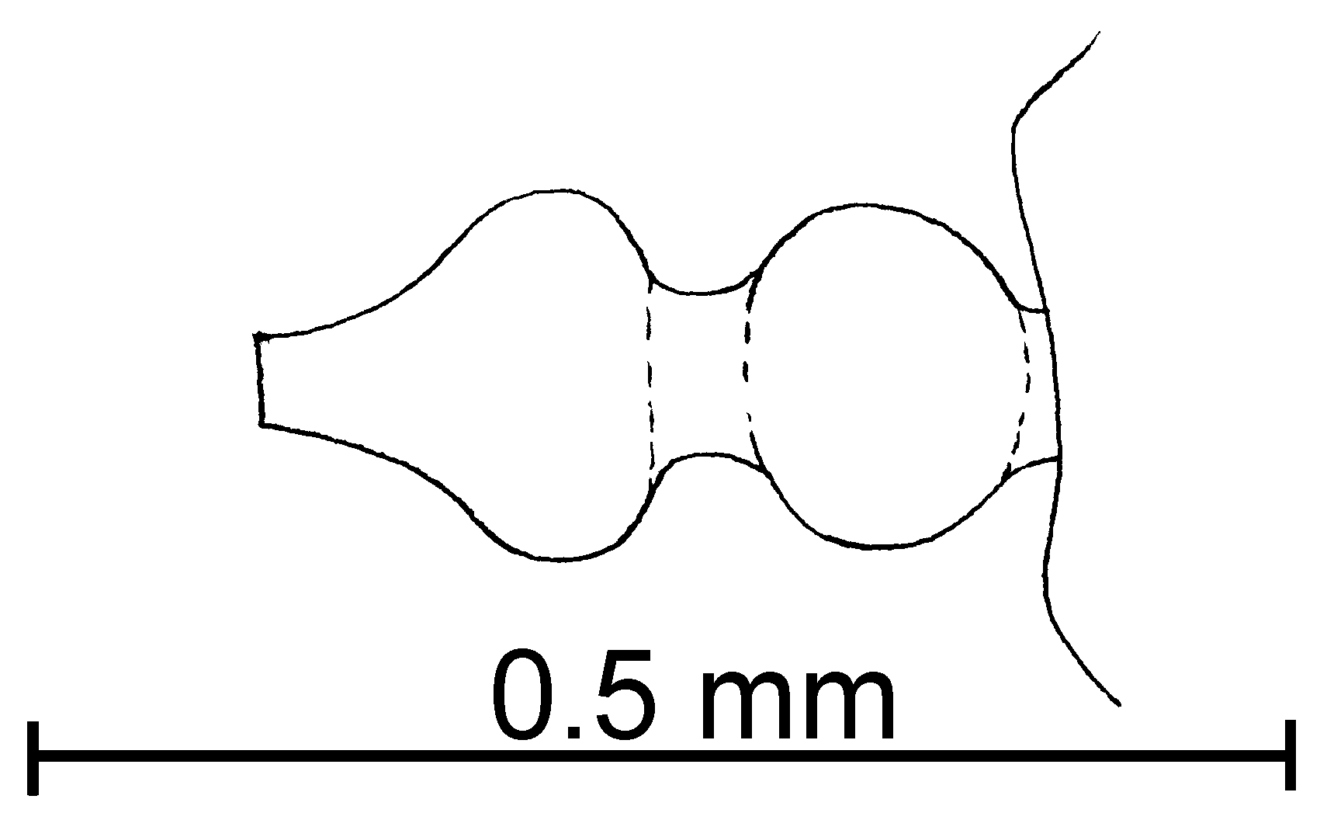
Fig. 3. Petiole and postpetiole of a worker of S. globularia (left) and S. minutissima (right).

- Postpetiole not greatly dilated ……… nigella species complex (subgenus Euophthalma)
4(2). Clypeus of worker lacking carinae and carinal teeth (Fig. 11e); female with 10-segmented antenna (Fig. 8a); Costa Rica, Bahamas and Hispañola ……………... succinea species complex (subgenus Diagyne)
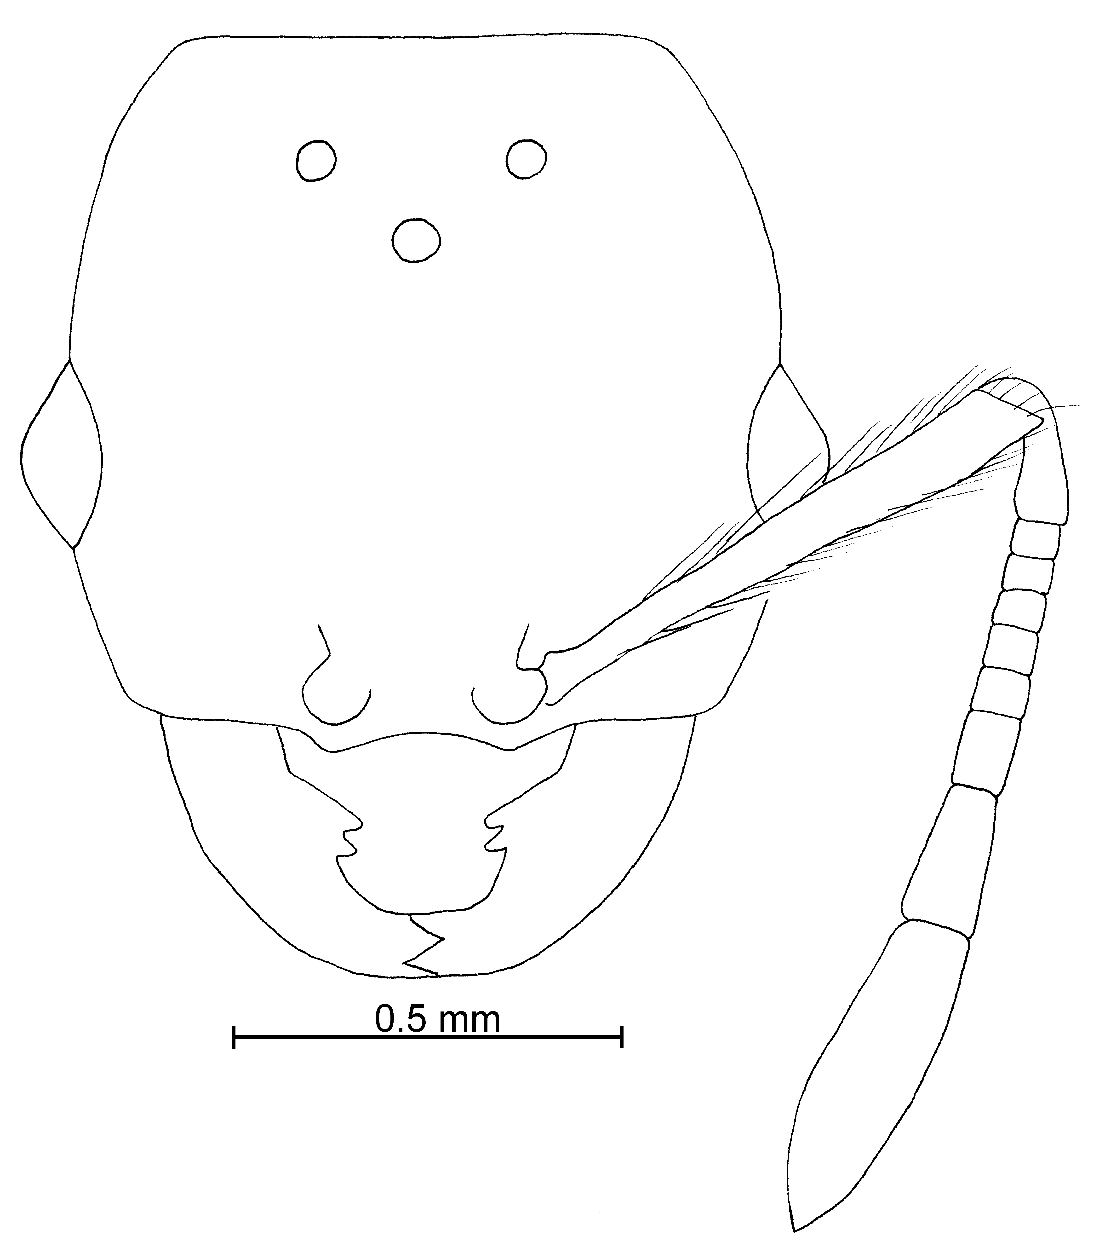
Fig. 4. Head of a paralectotype female of S. succinea.

- Clypeus of worker with 2 carina which diverge anteriorly, clypeal teeth present or absent; female with 11-segmented antenna; widely distributed …….….. 5 (thief ants)

5(6). Eye tiny and difficult to see (Fig. 4c); postpetiole round as seen from above (Fig. 4f); head elongate and usually coarsely punctured (Fig. 5c) ..………….………… ………… pygmaea species complex
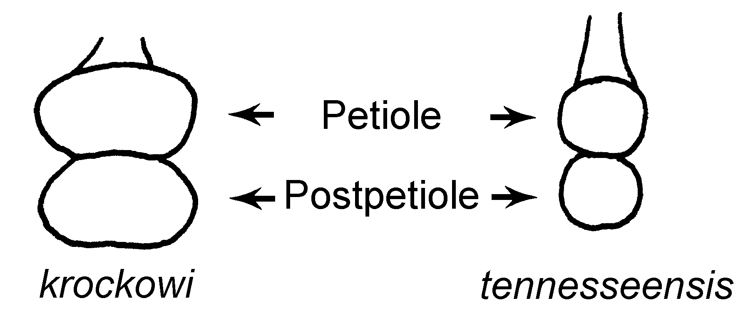
Fig. 5. Petioles and postpetioles of workers of S. krockowi and S. tennesseensis.

- Eye small, but easily seen, usually consisting of about 4 (or more) ommatidia (Fig. 13b); without all of the above characteristics ...... 6
6(5). Minor segments of funiculus short (about 0.07mm - Fig. 2a); and petiole thickened as seen in profile (Fig. 2c) ..…………….......... …….. brevicornis species complex
- Minor segments of funiculus longer (> 0. 70mm - Fig. 13d), if shorter, petiole narrow as seen in profile (Fig. 13f) ...............……...... 7
7(6). Anterior clypeal teeth absent (Fig. 13d), clypeal carina turning mesially at anterior margin of clypeus (Fig. 13d) …………………. ………… bicolor species complex
- Clypeal teeth usually present, if poorly developed, clypeal carinae not as above .........…......... 8
8(7). Punctures on dorsum of head usually small, barely perceptible (60X, Fig. 10h); extralateral clypeal teeth poorly developed (Fig. 10b); head somewhat elongate (CI 83 - 85) (Fig. 10c) ………………... ………….. molesta species complex
- Punctures on head coarse, much wider than hairs arising from them (Fig. 3c); extralateral teeth (Fig. 3d) usually well developed (at least in majority of nest series); head quadrate (CI 85 - 92) (Fig. 3a) ……. ………..….. fugax species complex

bicolor Species Complex

Diagnosis: Workers of this species complex can be recognized by the unusual shape of the clypeus. The clypeal carinae pass forward and at the anterior edge of the clypeus abruptly bend mesially to meet in the middle of the anterior border of the clypeus, where they form an anterior margin. Thus, both sides and the anterior margin of the clypeus are bounded by the same carina. The eyes are relatively large, ranging up to a diameter 0.07 mm, with 10 ommatidia. The petiole is often thickened as seen in profile, and is nearly always wider than the postpetiole, when both are viewed in profile. The postpetiole is often very narrow. Most surfaces of the body covered with relatively long (0.10 mm), erect hairs.
Carebarella alvarengai Kempf (1975) is not a member of this complex nor a member of Solenopsis. It is separated based on the 11-segmented antenna (10 segmented on left side, due to fusion of the second segment being fused with the third), with a 3-segmented club, and the anterior margin of the clypeus has a pair of sharp, lateral teeth.
Three of the ants (S. alvarengai, S. bicolor, and S. condei) in this species complex were considered to be members of the genus Carebarella, separated from Solenopsis from the unusual form of the clypeus. This appears to be weak support for the recognition of a genus, especially when other species in the genus Solenopsis lack (or are poorly developed) lateral clypeal teeth (i. e. S. corticalis, S. hayemi, S. zeteki), and clypei appear to be similar to that of this species complex. Therefore, we synonymize the genus Carebarella with Solenopsis.

Key to the workers of the bicolor species complex

1. Length of minor segments of funiculus about 0.07 mm in length ………………. …………… Species BO1 near bicolor from Bolivia
- Length of minor segments of funiculus at least 0.10 mm in length ……………………………….…… 2
2(1). Petiole relatively widened as seen in profile, about as long (at upper level of anterior peduncle) as height (upper level of peduncle to apex of petiole); bicolored (predominantly red with darker gaster) …………………….. bicolor Emery
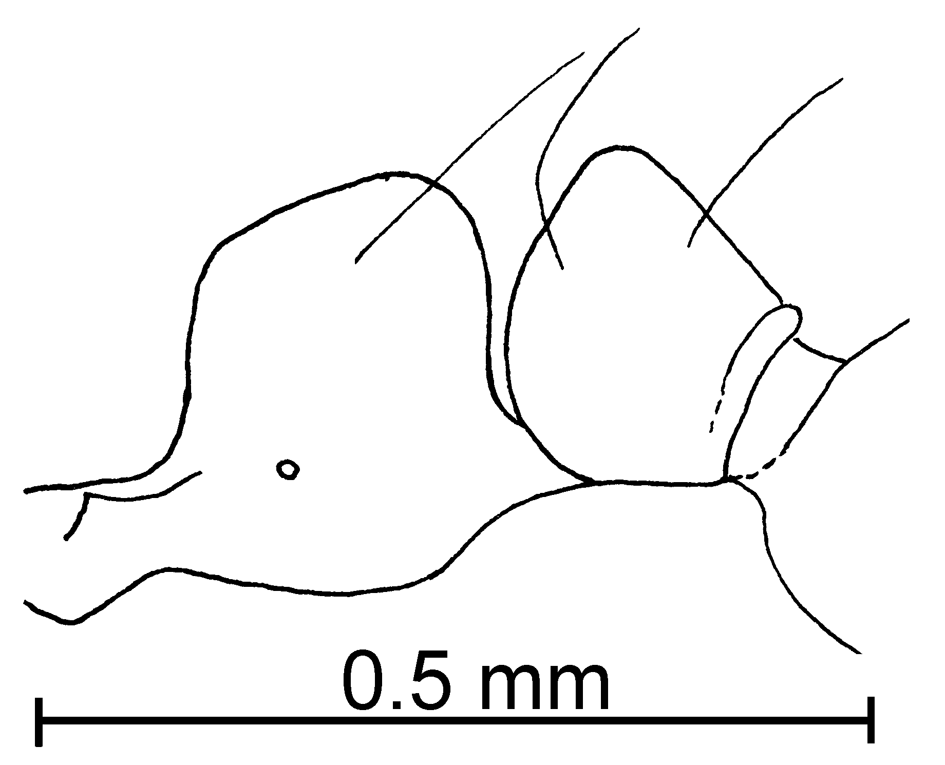
Fig. 6. Petiole and postpetiole of a worker of S. bicolor.
- Petiole thickened as seen in profile, usually longer (at upper level of anterior peduncle) as than height (upper level of peduncle to apex of petiole); medium brown to dark reddish-brown, often with slightly darker gaster ……………...……… 3
3(2). Pale brown, with slightly darker gaster; side of propodeum predominantly smooth and glossy; northern South America (Colombia, Venezuela) ………. altinodis Forel
- Darker reddish brown with black gaster; Central America (Costa Rica) and northern South America (Colombia) ……… new speciesCC1

brevicornis Species Complex

Diagnosis: Workers of this group can be recognized by the short antennal scape and the thickened petiole (as seen in profile, less thickened in S. brevicornis). The minor segments (Fig. 10a) of the funiculus are very short (up to about 0.7 mm). The head is nearly quadrate, the eyes relatively large, (with at least 2 ommatidia). The clypeus is flattened and the extralateral teeth are not developed. The metanotal suture is deeply depressed.

Key to the workers of the brevicornis species complex

1. Mesopleuron completely smooth and glossy (Fig. 2c, possibly roughened region near lower, anterior border); Central and South America, Caribbean region ……..… ……………………...... azteca Forel
- Mesopleuron mostly punctate (Fig. 3d, at least lower half punctate); México to South America ……………………………...…….. 2
2(1). Dark mahogany brown with yellowish appendages; side of petiole mostly smooth and glossy; common in Costa Rica and Panamá …………….…. terricola Menozzi
- Yellow to brown, with concolorous legs; side of petiole usually somewhat sculptured, only moderately smooth and glossy; uncommon; México to Brasil ………… ………………… brevicornis Emery

fugax Species Complex

Diagnosis. Workers of this group have the head wider than long, or only slightly longer than wide, with the posterior border straight. The dorsum of the head is coarsely punctate (punctures larger than the diameter of the hair arising from them). There are usually four teeth on the anterior border of the clypeus. The postpetiole is oval (round in S. pergandei) and slightly wider than the petiole. Often the metanotal suture is deeply depressed. All North American species are yellow, and size varies, although they are relatively large (2.0 - 2.4 mm total length). The females of the species where they are known are very large (> 5 mm, most ~ 7 mm total length). Solenopsis fugax is a European species.
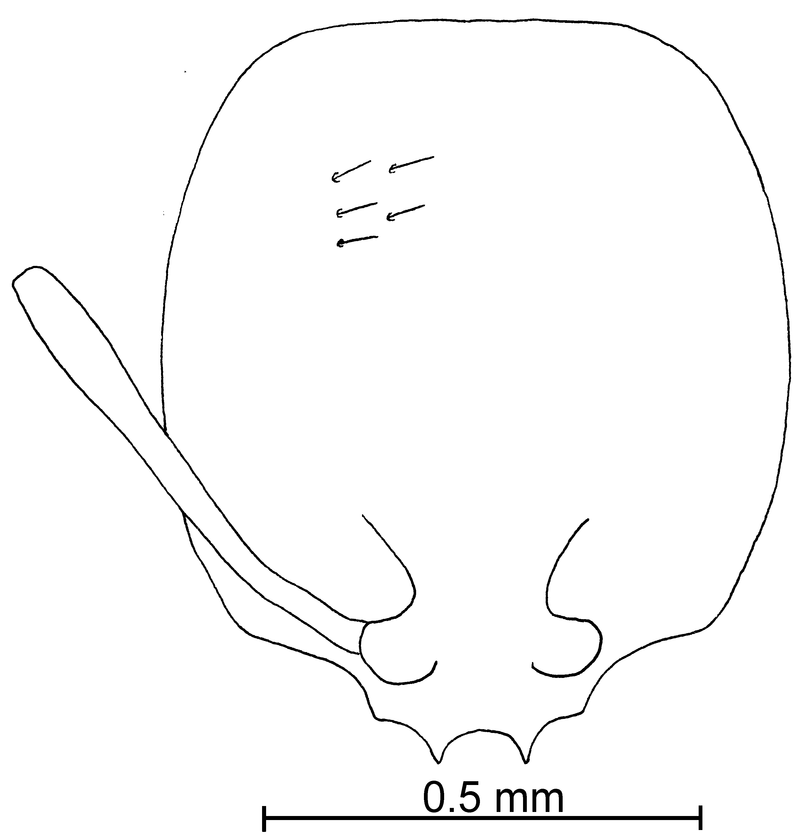
Fig. 7. Head of a worker of S. fugax ().

Key to the workers of the North American species of the fugax species complex

1. Clypeal carinae widely spaced (distance between teeth at anterior margin of clypeus usually ~0.10 mm), strongly diverging anteriorly ….…………… krockowi Wheeler
- Clypeal carinae closely spaced (distance between teeth at anterior margin of clypeus 0.06 - 0.08 mm), weakly diverging or even nearly parallel ………………………… 2a
2a(1). Petiole narrow as seen in profile, width ~ 0.05 at near apex, about same width as greatest diameter of propodeal spiracle (Fig. xx); Costa Rica and Colombia ………………… …………. angustinodis new species
- Petiole not notably narrowed, wider at apex than greatest diameter of propodeal spiracle; widely distributed in North and South America . 2
2(1). Postpetiole circular seen from above (Fig. 3b) … pergandei Forel
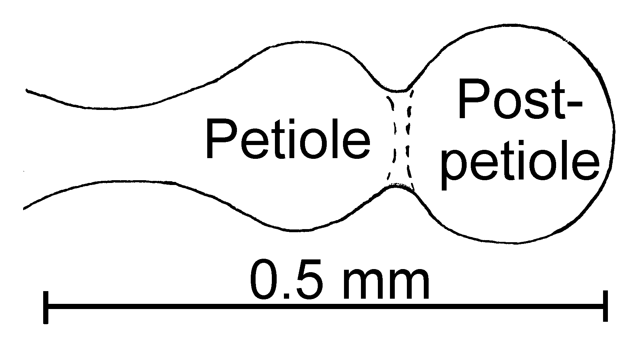
Fig. 8. Petiole and postpetiole of a worker of S. pergandei as seen from above.

- Postpetiole oval-shaped as seen from above (Fig. 9b) ……...... 3
3(2). Dorsum of head mostly covered with rugulae, which meld into the shiny subsurface; petiole somewhat thickened, in form of dome as seen from side; mesosoma mostly smooth and glossy; Colombia ……….……..……. rugiceps Mayr
- Dorsum of head mostly smooth and glossy between punctures, if rugulae are present, mesosoma mostly sculptured and dull; petiole usually narrow as seen in profile, not dome-shaped; USA to South America ……….………….. 4
4(3). Mesosomal hairs of various lengths (0.03-0.15mm); clypeal carinae diverging anteriorly; often dimorphic; México to South America ……………………………………. 5
- Mesosomal hairs same length (0.04mm); clypeal carinae nearly parallel, closely placed; monomorphic; Texas ……………… ………………... pilosula Wheeler
5(4). Relatively large ants (Total Length of major 1.8 - 2.1 mm, TL of minor 1.3 - 1.6 mm); female yellow, large (TL 5.5 - 6.5); Baja California Sur …. johnsoni new species
- Relatively small ants (TL of major 1.3 - 1.5 mm, TL of minor 1.0 - 1.2 mm); female yellow or brown (female of S. westwoodi not seen), small (TL 4.0 - 5.0 mm); New Mexico and mainland México south to South America ….………..…… 6
6(5). Dark brown; Brasil …...…

………………….. westwoodi Forel
- Yellow; North America . 7

7(6). Head of major (specimens with TL of 1.3 - 1.5) with head predominantly coarsely sculptured; female dark brown; mainland México south to Panamá …………………… ………………. vinsoni new species
- Head of worker (minors apparently do not exist) smooth and polished, with scattered punctures; female pale brown; New Mexico … …………….… melina new species

Key to the workers of the South American species of the fugax species complex

1. Petiole narrow as seen in profile, width ~ 0.05 at near apex, about same width as greatest diameter of propodeal spiracle (Fig. xx); Costa Rica and Colombia ………… …………. angustinodis new species
- Petiole not notably narrowed, wider at apex than greatest diameter of propodeal spiracle; widely distributed in North and South America …………………... 3
2(1). Blank

3(2). Dorsum of head mostly covered with rugulae, which meld into the shiny subsurface; petiole somewhat thickened, in form of dome as seen from side; mesosoma mostly smooth and glossy; Colombia …………..…..……. rugiceps Mayr
- Dorsum of head mostly smooth and glossy between punctures, if rugulae are present, mesosoma mostly sculptured and dull; petiole usually narrow as seen in profile, not dome-shaped; USA and northern México …………….. 5
5(4). Clypeus of minor worker with 4 clypeal teeth (2 lateral, 2 extralateral), all 4 teeth about equal in shape and size, clypeus of major with 2 - 4 clypeal teeth .………... 7
- Clypeus of minor and major with 2 well developed lateral teeth, extralateral teeth smaller than lateral teeth ………………..…….. 6
6(5). Head of major (specimens with TL of 1.3 - 1.5) with head predominantly coarsely sculptured; female dark brown; mainland México south to Panamá …………………… ………………. vinsoni new species
- Head of worker (minors apparently do not exist) smooth and polished, with scattered punctures; female pale brown; New Mexico … …………….… melina new species
7(5). Major with 2 well developed lateral teeth, extralateral teeth poorly developed; petiolar peduncle of major and minor poorly developed or absent; Colombia ……………. Species near tetracantha
- Major and minor with 4 teeth on anterior border of clypeus, approximately equal in size or shape; petiolar peduncle of major and minor well developed; southern South America ………………………….. 8
8(7). Head elongate (Cephalic Index of major 80, of minor 71); subpetiolar process pointing nearly anteriorly ……. tetracantha Emery
- Head nearly square shaped (Cephalic Index of major 86, of minor 81); subpetiolar process pointing nearly straight down ……………….. ………………… patagonica Emery

molesta Species Complex

Diagnosis: Most species in this complex are small to medium sized, yellow ants, although a few species are small, black ants. The head is longer than wide, usually somewhat elongate. The sculpturing is fine, with the punctures on the head being tiny and difficult to see, not much larger in diameter than the hairs that arise from them (four exceptions, S. salina, and occasional specimens of S. molesta and S. validiuscula, and S. neomexicana, in which the punctures may be a coarse as is found in members of the fugax group). There are only two clypeal teeth along the anterior border, occasionally two swellings (rarely developed into teeth) are present at the position of the extralateral teeth. The surface of the clypeus is concave, and at a much lower level than the carinae. The postpetiole is oval shaped as seen from above, and about as wide as the petiole.
Workers are very difficult to identify without females. For example, workers of Solenopsis castor, S. corticalis, S. tenuis and S. zeteki are nearly identical. Likewise the workers of S. laeviceps, S. molesta and S. validiuscula are difficult to separate. Workers of a third group, consisting of S. carolinensis, S. maboya, S. pollux, and S. texana are nearly impossible to separate. Unfortunately the workers are often collected without females, especially in series from baits, pitfall traps and litter samples. The differences among the females suggest that they are all valid species, and are usually necessary for accurate identification.

Key to workers of North American (Panamá north to USA) species of the molesta complex

1. Total length of minor segments of funiculus (antennal segments 3 - 8) greater than 0.1 mm in length (usually greater than 0.12 mm) (Fig. 13d) ..........…………..... 2
- Smaller segments of funiculus (Fig. 10a) less than 0.1 mm in total length (rarely longer) ……. 9
2(1). Sides of head nearly straight (Fig. 10c) ....……………... 3
- Sides of head obviously convex (Fig.10g) ......…….……..... 7
3(2). Eye small, maximum diameter 0.03 mm, usually circular in shape (Fig. 10a); primarily tropical ....………………………….…….. 4
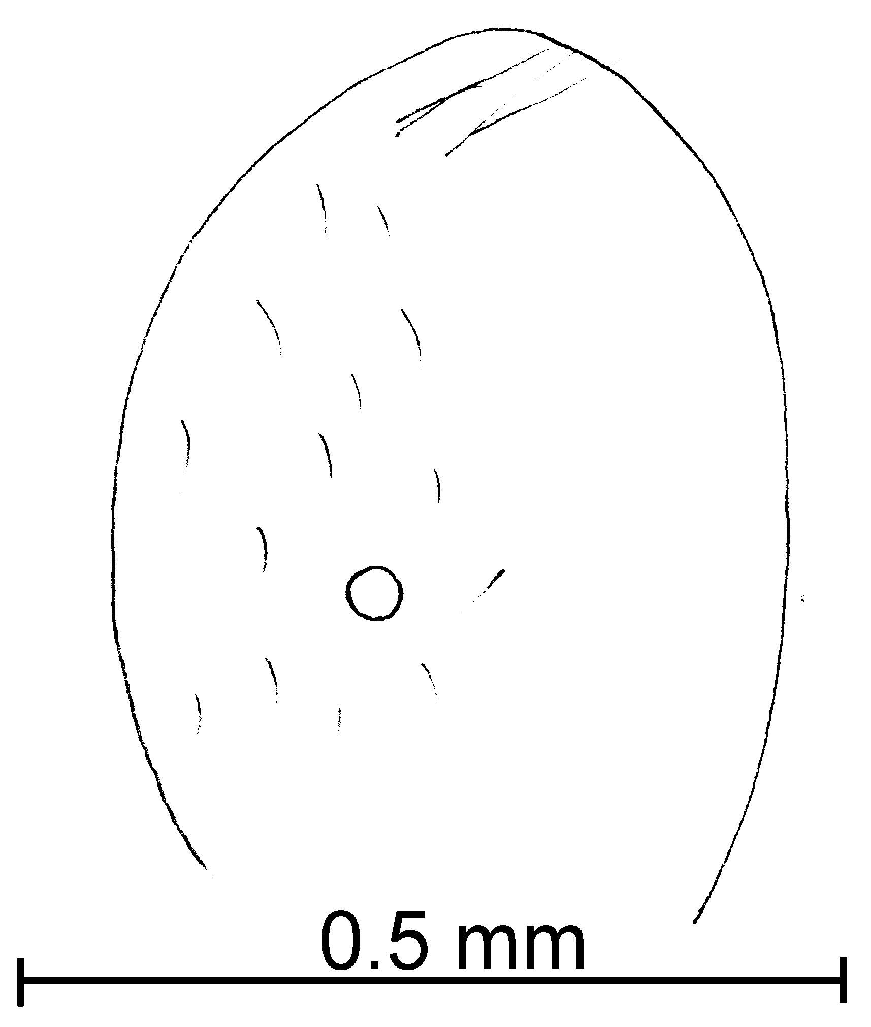
Fig. 9. Head of a worker of S. conjurata as seen from the side.

- Eye elongate, greatest diameter > 0.04 mm; primarily in temperate regions .............................… 5
4(3). Mesopleuron predominately smooth and polished; most hairs on posterior tibia appressed or decumbent (Fig. 10f) ……………. ………………. conjurata Wheeler
- Mesopleuron predominantly striate or rugulose; most hairs on posterior tibia suberect (Fig. 10e) ……………….. striata new species
5(3). Sides of the head of part of the series somewhat curved (convex), petiole of most individuals thickened as seen in profile (Fig. 12d); punctures on head very small, leaving surface of head smooth, polished and glossy; Panamá, Colombia and South America ………………… ………..…………... laeviceps Mayr
- Sides of head of all members of straight; petiole usually narrow as seen in profile (Fig. 10d); punctures on head usually with small diameters (may be large and coarse), but noticeably interrupt smooth surface of head; United States and northern México …………..…....... 6
6(5). Workers and females usually concolorous yellow; cephalic punctures often fine; female (Fig. 6a) large (> 4 mm total length) with large median ocellus (maximum diameter 0.12 mm); northern United States, south and west to CA, east to northeastern México ....………. 6a
- Workers usually brown, head hairy with coarse punctures, female (Fig. 7a) large (> 4 mm total length) predominantly brown with course punctures, median ocellus small (maximum diameter 0.09 mm); California east to Colorado, Arizona and New Mexico, south to Coahuila and Colima … validiuscula Emery

- Workers brown, head with scattered hairs, punctures small; female small < 3 mm total length) with small, medial ocellus; known only from type locality in Victoria, TX …………………. moerens Wheeler
- Workers yellow, head with fine punctures; female dark brown, small (< 4 mm total length), with small median ocellus (0.05 mm); known only from Cochise Co., Arizona …….….. nana new species
6a(6). Cephalic punctures fine, maximum diameter less than 5 times diameter of hair arising from it; female eye relatively large, maximum diameter 0.24 - 0.28 mm; Montana east to New York, south to Nuevo León, west to Baja California …… …………………..…. molesta (Say)
- Cephalic punctures coarse, diameter at least 5 times width of hair arising from it; female eye relatively small, maximum diameter 0.24 mm; New Mexico and Arizona … neomexicana new species
7(2). Predominantly yellow … ………………………….....…..… 7a
- Predominantly brown ...... ….…………………..…….…......... 8
7a(7). Mesopleuron smooth and glossy (possibly sculpture along edges …………….. laeviceps Mayr

- Mesopleuron (at least lower half) covered with longitudinal striae (Fig. xxx) . striata new species
8(7). Clypeal teeth well developed (Fig. 9c); petiole often narrow as seen in profile (Fig. 9d) ……. ...…………………... picea Emery
- Clypeal tooth simple angles, formed as clypeal carina curves laterally to anterior border of clypeus (Fig. 11a); petiole thick as seen in profile (Fig. 11c) ………….….......... …… (stricta complex) hayemi Forel
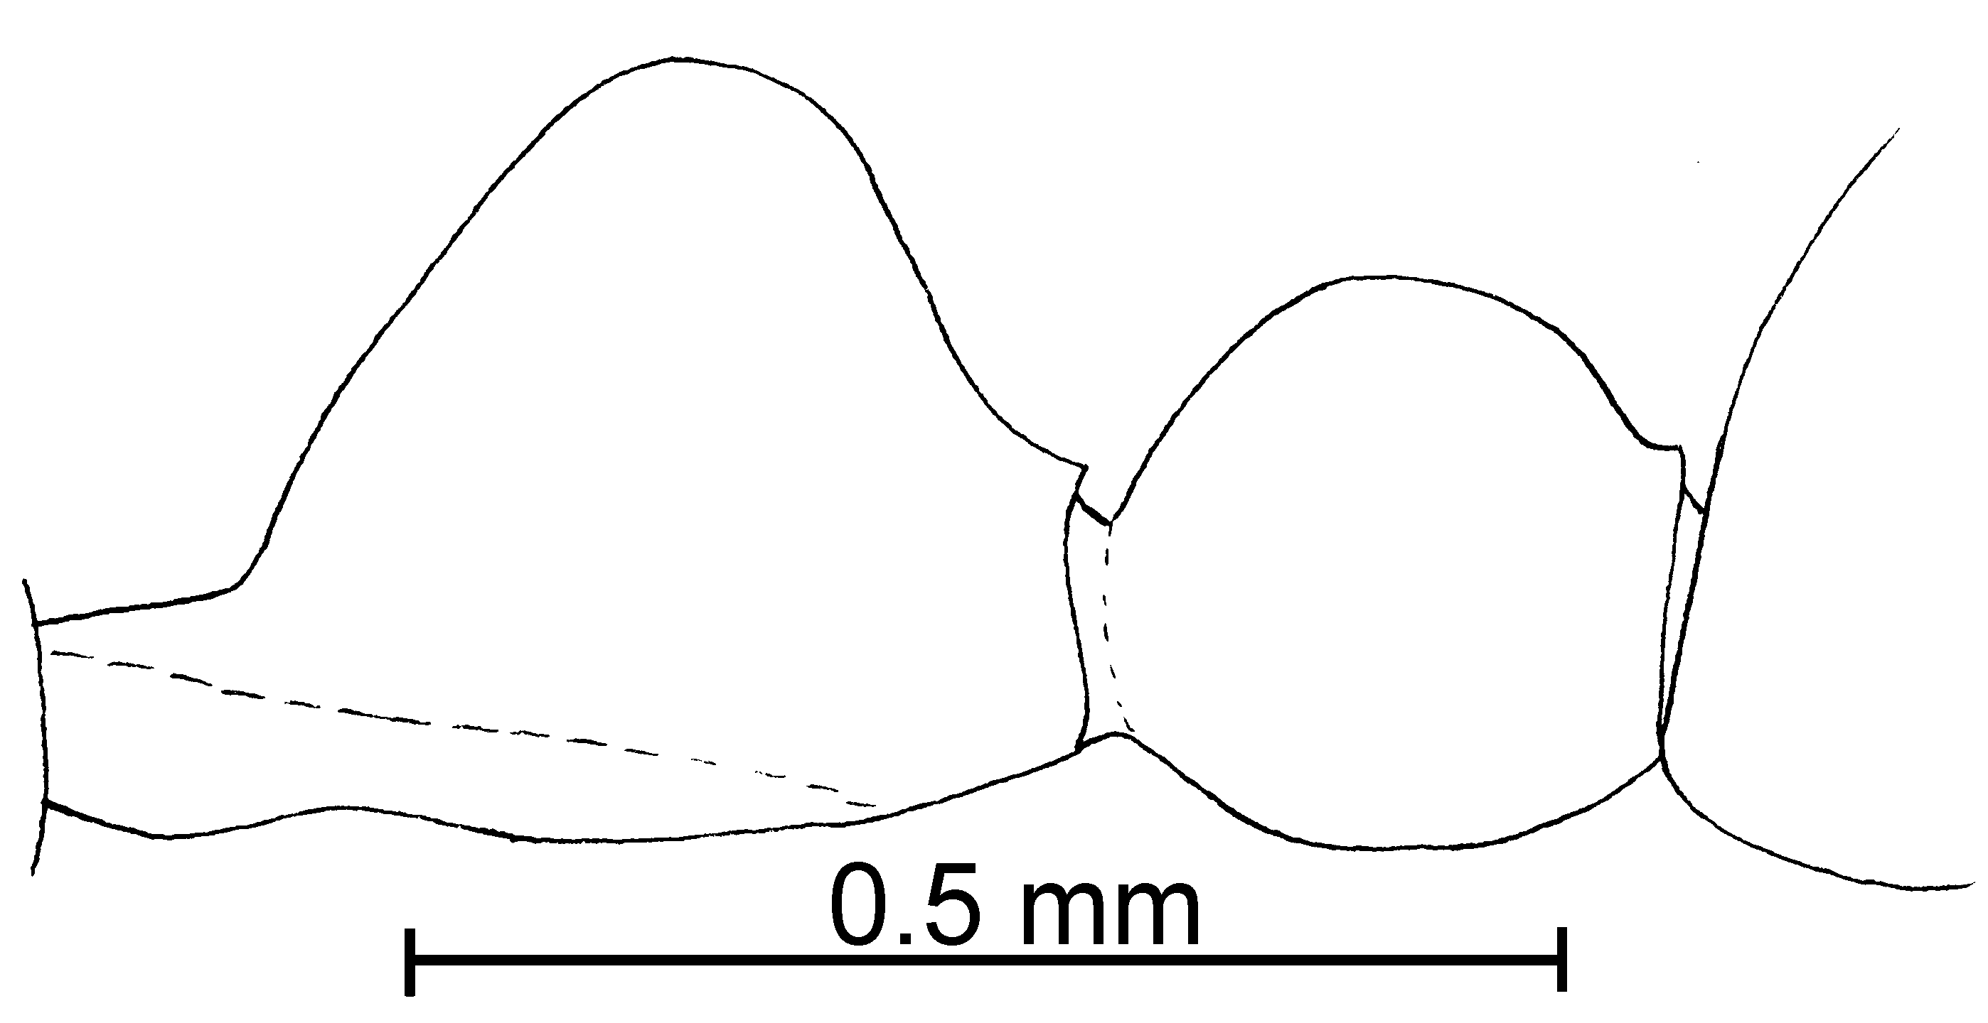
Fig. 10. Petiole and postpetiole of a worker of S. hayemi as seen from the side.

9(1). Worker predominantly brown (may be bicolored with dark brown gaster) ....….…………….. 10
- Worker predominantly yellow ....…………….................. 13
10(9). Scape relatively short (Fig. 10b), scape index ranges from 56 - 59; southeastern United States ..…………….…..…… picta Emery
- Scape relatively long (Fig. 11b), scape length/head length ranges from 69 - 74; Central and South America …………..……... 11
11(10). Usually honey colored or medium brown with legs concolorous with mesosoma; head of worker (Fig. 11d) often relatively short (CI ranges from 82 - 91); lateral clypeal teeth poorly developed (Fig. 11d); female relatively large, head length 0.66 mm, Weber’s length 1.32 mm, maximum eye length 0.18 mm; usually honey colored or medium brown with legs concolorous with mesosoma ..……………............ 12
- Usually dark brown with lighter colored appendages; head (Fig. 11b) often relatively elongate (CI ranges from 77 - 80); lateral clypeal teeth moderately well developed (Fig. 11b); female relatively small, head length 0.44 mm, Weber’s length 0.70 mm, maximum eye length 0.13 mm ……………...... 11a
11a(11). Worker relatively large (total length >1.3mm, with head bent perpendicular to axis of mesosoma, and gaster extended); México and Central America, south to Bolivia ………………………. castor Forel
- Worker relatively small (total length <1.2 mm); Florida …………… nickersoni Thompson
12(11) Lateral clypeal teeth small, but well developed (Fig. 11d); female dark brown ……………… ………………..…….. tenuis Mayr
- Lateral clypeal projections reduced to angles, not toothlike (Fig. 10g); female yellow ……………… ……………….…… corticalis Forel
13(9). Clypeus without distinct teeth along anterior margin, angles are present (Fig. 10h) ………… 14
- Clypeus with distinct teeth along anterior margin, although they may be tiny (look from side) ............…........................……....... 15
14(13). Worker and female pale yellow (gaster slightly darker in female); female (Fig. 7b) with large eye (maximum diameter 0.18 mm, about 1/2 length of side of head), ocelli large (maximum diameter of median ocellus equal to distance to lateral ocellus); México south to Panamá ……....…… zeteki Wheeler
- Worker and female honey colored; female (Fig. 8a) with small eye (maximum diameter 0.16 mm; ocelli small (maximum diameter of median ocellus about 2/3 length of distance to lateral ocellus); southern USA south to Costa Rica …............……. corticalis Forel
15(13). Worker with several erect and suberect hairs on scape (Fig.13b), most over 0.03 mm in length, some up to 0.05 mm; mid and hind tibiae often with numerous erect and suberect hairs (Fig. 10e); female (that of S. andersoni unknown) predominantly yellow or medium brown; eye of female large (maximum diameter 0.20 mm); widely distributed in eastern and southern USA (including Florida), south into México .......……….……...…….. 15
- Worker with several erect and suberect hairs on scape (Fig. xx), most shorter than 0.02 mm in length; middle and posterior tibia with numerous suberect hairs (Fig xx); female dark brown, small (total length ~ 2.5 mm); eye small (maximum diameter ~0.12 mm); Bahamas ……… ………..……….. batyle new species
- Worker often with few or no erect hairs on scape (Fig. 10a), most hairs appressed or nearly appressed, short (up to 0.03 mm); mid and hind tibia with few or no suberect hairs, most hairs appressed; female predominantly dark brown, moderate in size (~ 3 mm); eye smaller (maximum diameter 0.18 mm); Florida ….. abdita Thompson
- Worker with few or no erect hairs on scape (Fig. xx), most hairs appressed of nearly appressed, short (0.02 mm, difficult to measure as are very close to scape); mid and hind tibia with few or no suberect hairs, most hairs appressed; female predominantly dark brown, small in size (~ 2.5 mm); eye smaller (maximum diameter 0.14 mm); México …………….. patriciae new species
15(14). Posterior tibia of worker with numerous erect and suberect hairs (Fig. 10e) on the extensor surface (of majority of nest series); worker usually yellow; female predominantly yellow, large (> 3.75 mm total length), eye of female large (maximum diameter ~ 0.26 mm), maximum length about half length of head as seen from side (Fig. 7b); USA south to Belize …….……........ ………………… carolinensis Forel
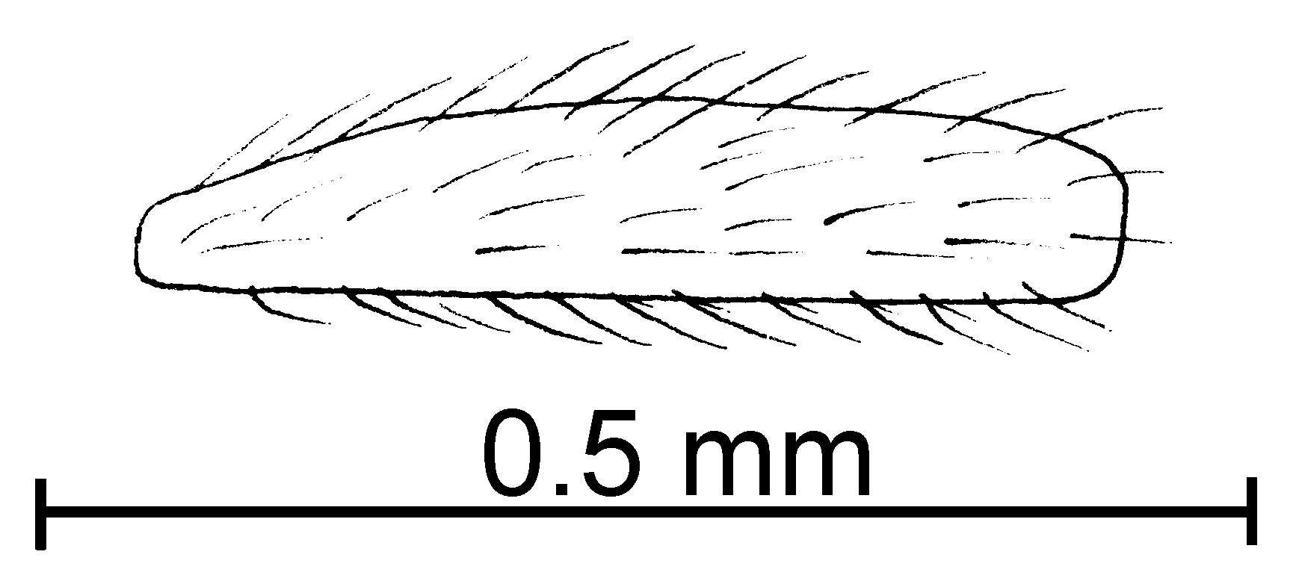
carolinensis
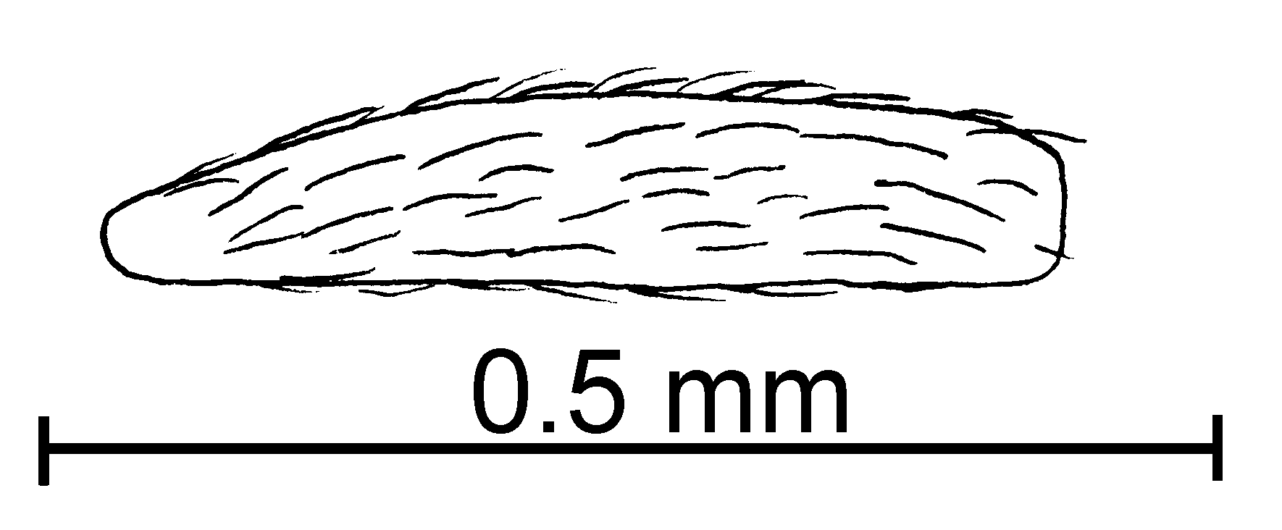
texana
Fig. 11. Posterior left tibiae of workers of S. carolinensis and S. texana.

- Posterior tibia of worker with mostly appressed or decumbent hairs (Fig. 10f) on extensor surface (on majority of nest series, individual workers may vary, even on different tibiae of single worker); worker often somewhat brown; female predominantly brown, small (< 3.5 mm total length, if larger, from Caribbean region), eye of female small (maximum diameter ~ 0.18 mm), about 1/3 total length of head as seen from side (Fig. 8a, if larger, specimen from Caribbean region and predominantly brown) …………….. 16
16(15). Punctures on head fine, not much larger than diameter of hair arising from them (Fig. 10c); female small (less than 3.5 mm total length); extralateral teeth of female poorly developed …………………... 16a
- Punctures on head moderately coarse, much larger than hairs arising from them (Fig. 11f); female larger (greater than 4.5 mm total length), if smaller, extralateral teeth acute and well developed ………. 17
16a(16). Continental areas (USA south to Colombia) and Puerto Rico; eye of female small, maximum diameter about 1/3 of length of side of head) (maximum diameter ~0.17 mm); female relatively small (total length ~ 3 mm) ………….…..… 16b
- Caribbean Islands (Hispaniola south to San Vicente); eye of female larger, about ½ length of side of head (~0.18 mm), female larger (total length ~ 3.25 mm) ……………………….. pollux Forel

16b(16a). United States south to Colombia; total length of worker ~1.5 mm, that of female ~ 3 mm ……… …………………... texana Emery
- Puerto Rico; TL of worker ~ 1 mm, TL of female ~2.5 mm … ………………..…. maboya Snelling
17(16). Clypeal teeth often somewhat curved inward (Fig. 11f), thick, usually with dull tips; female with 2 clypeal teeth (Fig. 9a); commonly collected ................. salina Wheeler

- Clypeal teeth straight, slender, directed anteriorly, with sharp tips; female with 4 sharp, well developed clypeal teeth ………...... …….... quadridentata new species
Key to some of the workers of South American species of the molesta complex

1. Total length of minor segments of funiculus (antennal segments 3 - 8) greater than 0.1 mm in length (usually greater than 0.12 mm) (Fig. 13d) ..........…..……..... 2
- Smaller segments of funiculus (Fig. 10a) less than 0.1 mm in total length (rarely longer) ……… ……………………………………. 9
2(1). Predominantly yellow . 3
- Predominantly brown .... 8
3(2). Lateral clypeal teeth well developed ……………………….. 4
Lateral clypeal teeth represented as small bumps ………. 7
4(3) Extralateral teeth relatively sharp, but much smaller than lateral teeth; common ………….. 5
- Extralateral teeth blunt, modified into broad swollen regions, whose volume is about equal to lateral teeth; rarely collected ……..… 6
5(4). Worker with distance between lateral clypeal teeth > 0.06 mm; apparently monomorphic; common ……….... laeviceps Mayr
- Minor worker (total length ~ 1.5, total length of major ~ 2.2) with distance between lateral clypeal teeth < 0.06 mm; dimorphic; rare …. …………………… Species CO1
6(5). Worker relatively large (total length ~ 2.2 mm) . idae Forel
- Worker length relatively small (total length ~ 1.3 - 1.5 mm) .. ……………. hammari (=hermione)
7(3). Mesopleuron completely smooth and glossy …………………. ……………… clytemnestra Emery
- Mesopleuron (at least lower half) with fine, longitudinal striae …… nr clytemnestra Emery
8(7). Lateral clypeal teeth well developed (Fig. 9c); petiole often narrow as seen in profile (Fig. 9d); México south to Colombia …… 8a
- Lateral clypeal teeth simple angles, formed as clypeal carina curves laterally to anterior border of clypeus (Fig. 11a); petiole thick as seen in profile (Fig. 11c) ……………………..….......... stricta xx ← these two same? → hayemi Forel
8a(8). - Workers relatively larger, total length > 2.00 mm …… 8b
- Workers relatively small, total length < 1.75 mm …….... 8d 8b(8a). Extralateral teeth modified into swollen bump, with volume about equal to volume of lateral teeth ……………………..... franki Forel
- Extralateral teeth absent, or smaller in volume than lateral teeth …………………………….. 8c
8c(8b). Lower mesopleuron smooth and glossy (except small areas adjacent to sutures), if fine striolae present, propodeal spiracle relatively larger (minimum diameter 0.04 mm - see Fig. ); female small (~ 3 mm) .. Species near latastei Emery
- Lower mesopleuron with fine, longitudinal striae; propodeal spiracle small (maximum diameter 0.03 mm - see Fig. ); female large (total length ~ 5 mm) ………… …………………….. latastei Emery
8d(8a). Worker dark brown; mesopleuron with fine, longitudinal striae ……..………….. picea Emery (= parabiotica Weber ???)
- Worker pale brown; mesopleuron mostly smooth and glossy ……….. hammari Mayr
(twice in key)
Fig. 12. Mesosomata and petioles of S. near latastei and S. latastei. needfig 1

9(1). Worker predominantly dark brown (may be bicolored with dark brown gaster) ....………… 10
- Worker predominantly yellow, or pale brown ....……...... 13
10(9). blank

11(10). Lateral clypeal teeth poorly developed, about as large as extralateral teeth; female medium sized, head length 0.54 - 0.56 mm, Weber’s length 0.94 - 0.97 mm, maximum eye length 0.16 - 0.18 mm; worker and female usually honey colored or medium brown with legs concolorous with mesosoma ..……....... helena Emery 12
- Lateral clypeal teeth moderately well developed (Fig. 11b); female relatively small, head length < 0.52 mm, Weber’s length < 0.91 mm, maximum eye length < 0.17 mm; worker and female usually medium brown (or yellow) with concolorous appendages ……………… …………………… hammari Mayr
(twice in key)

12(11). Anterior clypeal teeth small, but well developed (Fig. 11d); female dark brown ………………………………..…….. tenuis Mayr
- Anterior clypeal projections reduced to angles, not toothlike (Fig. 10g); female yellow ……………………… corticalis Forel
13(9). Clypeus without distinct teeth along anterior margin, angles are present (Fig. 10h), which may form poorly defined teeth …….... 14
- Clypeus with distinct teeth along anterior margin, although they may be tiny (look from side) ........ 15
14(13). Worker and female pale yellow (gaster slightly darker in female); female (Fig. 7b) with large eye (maximum diameter 0.18 mm, about 1/2 length of side of head), ocelli large (maximum diameter of median ocellus equal to distance to lateral ocellus); México south to Colombia …….....…… zeteki Wheeler
- Worker and female honey colored; female (Fig. 8a) with small eye (maximum diameter 0.16 mm; ocelli small (maximum diameter of median ocellus about 2/3 length of distance to lateral ocellus); southern USA south to Costa Rica …............……. corticalis Forel
15(13). Worker with several erect and suberect hairs on scape (Fig. 13b), most over 0.03 mm in length, some up to 0.05 mm; mid and hind tibiae often with numerous erect and suberect hairs (Fig. 10e); female (that of S. andersoni unknown) predominantly yellow or medium brown; eye of female large (maximum diameter 0.20 mm); widely distributed in eastern and southern USA (including Florida), south into México .......……….……...…….. 15
- Worker with few or no erect hairs on scape (Fig. 10a), most hairs appressed or nearly appressed, short (up to 0.03 mm); mid and hind tibia with few or no suberect hairs, most hairs appressed; female predominantly dark brown; eye smaller (maximum diameter 0.18 mm); Florida .…………....………………………... abdita Thompson
15(14). Posterior tibia of worker with numerous erect and suberect hairs (Fig. 10e) on the extensor surface (of majority of nest series); worker usually yellow; female predominantly yellow, large (> 3.75 mm total length), eye of female large, maximum length about half length of head as seen from side (Fig. 7b); USA south to Colombia ...……… ……………....... carolinensis Forel
- Posterior tibia of worker with mostly appressed or decumbent hairs (Fig. 10f) on extensor surface (on majority of nest series, individual workers may vary, even on different tibiae of single worker); worker often somewhat brown; female predominantly brown, small (< 3.5 mm total length, if larger, from Caribbean region), eye of female small, about 1/3 total length of head as seen from side (Fig. 8a, if larger, specimen from Caribbean region and predominantly brown) …………….. 16
16(15). Punctures on head fine, not much larger than diameter of hair arising from them (Fig. 10c); female small (less than 3.5 mm total length); extralateral teeth of female poorly developed ………………...…... 16a
- Punctures on head moderately coarse, much larger than hairs arising from them (Fig. 11f); female larger (greater than 4.5 mm total length), if smaller, extralateral teeth acute and well developed ……. 17
16a(16). Continental areas (USA south to Colombia) and Puerto Rico; eye of female small, maximum diameter about 1/3 of length of side of head) (maximum diameter ~1.3 mm); female relatively small (total length ~ 3 mm) ……………..… 16b
- Caribbean Islands (Hispaniola south to San Vicente); eye of female larger, about ½ length of side of head (~1.7 mm), female larger (total length ~ 3.25 mm) ……………………………….. pollux Forel

16b(16a). United States south to Colombia; total length of worker ~1.5 mm, that of female ~ 3 mm ……… …………………... texana Emery
- Puerto Rico; TL of worker ~ 1 mm, TL of female ~2.5 mm …………………………………………………..…. maboya Snelling
17(16). Clypeal teeth often somewhat curved inward (Fig.11f), thick, usually with dull tips; female with 2 clypeal teeth (Fig.9a); commonly collected ...........................................................……. salina Wheeler
- Clypeal teeth straight, slender, directed anteriorly, with sharp tips; female with 4 sharp, well developed clypeal teeth ………...... ……………………………...………….... quadridentata new species

pygmaea Species Complex

Diagnosis. The pygmaea group is a monophyletic group in which workers are characterized by being extremely small (1.20 - 1.45 mm total length), with very small and poorly developed eyes, having elongated heads, very course punctures and very well developed clypeal teeth. The metanotal suture is only weekly impressed, and the postpetiole is circular or nearly circular as seen from above. The legs are relatively short and stocky, and usually covered with relatively coarse, erect or suberect hairs. Solenopsis minutissima is a Brasilian species, but it is very similar to the species in North America. It has an elongate head, coarse punctures and poorly developed eyes. The mesosoma is narrower and shorter than North American species, and is usually not very hairy (gaster also not very hairy).

Key to workers of the pygmaea species complex

1. Very hairy, with more than 20 hairs (Fig. 4g) on outline of pronotum (as seen with mesosoma in profile) ….....………….….....….… 2
- Hairs absent or with not more than 10 hairs on outline of pronotum (in profile of mesosoma) .…………...………………….….... 4
2(1). Pronotal hairs of various lengths (Fig. 4g), minor segments of funiculus 0.07 - 0.09 mm in total length ...…………………....…. 2a
- Pronotal hairs all short and of same length (Fig. 4h), minor segments of funiculus 0.06 mm in total length ...........………………...…… 3
2a(2). Southern and eastern United States, south to Colombia; hairs on dorsum of gaster sparse (fewer than 20), of various lengths, up to 0.05 mm in length ………… …..……….…. tennesseensis Smith
- Caribbean Islands and eastern México; hairs on dorsum of first tergum short (up to 0.04 mm, most less than 0.03 mm), all approximately same length, abundant (more than 20) ….. pygmaea Forel
3(2). Head thick as seen in profile (0.25 mm from dorsal to ventral surface, Fig. 4e); USA (Florida and Texas) ...……… tonsa Thompson
- Head slender (0.18 mm from dorsal to ventral surface, Fig. 4c) southern USA south to south to Colombia and Venezuela ………… ....... subterranea Mackay & Vinson
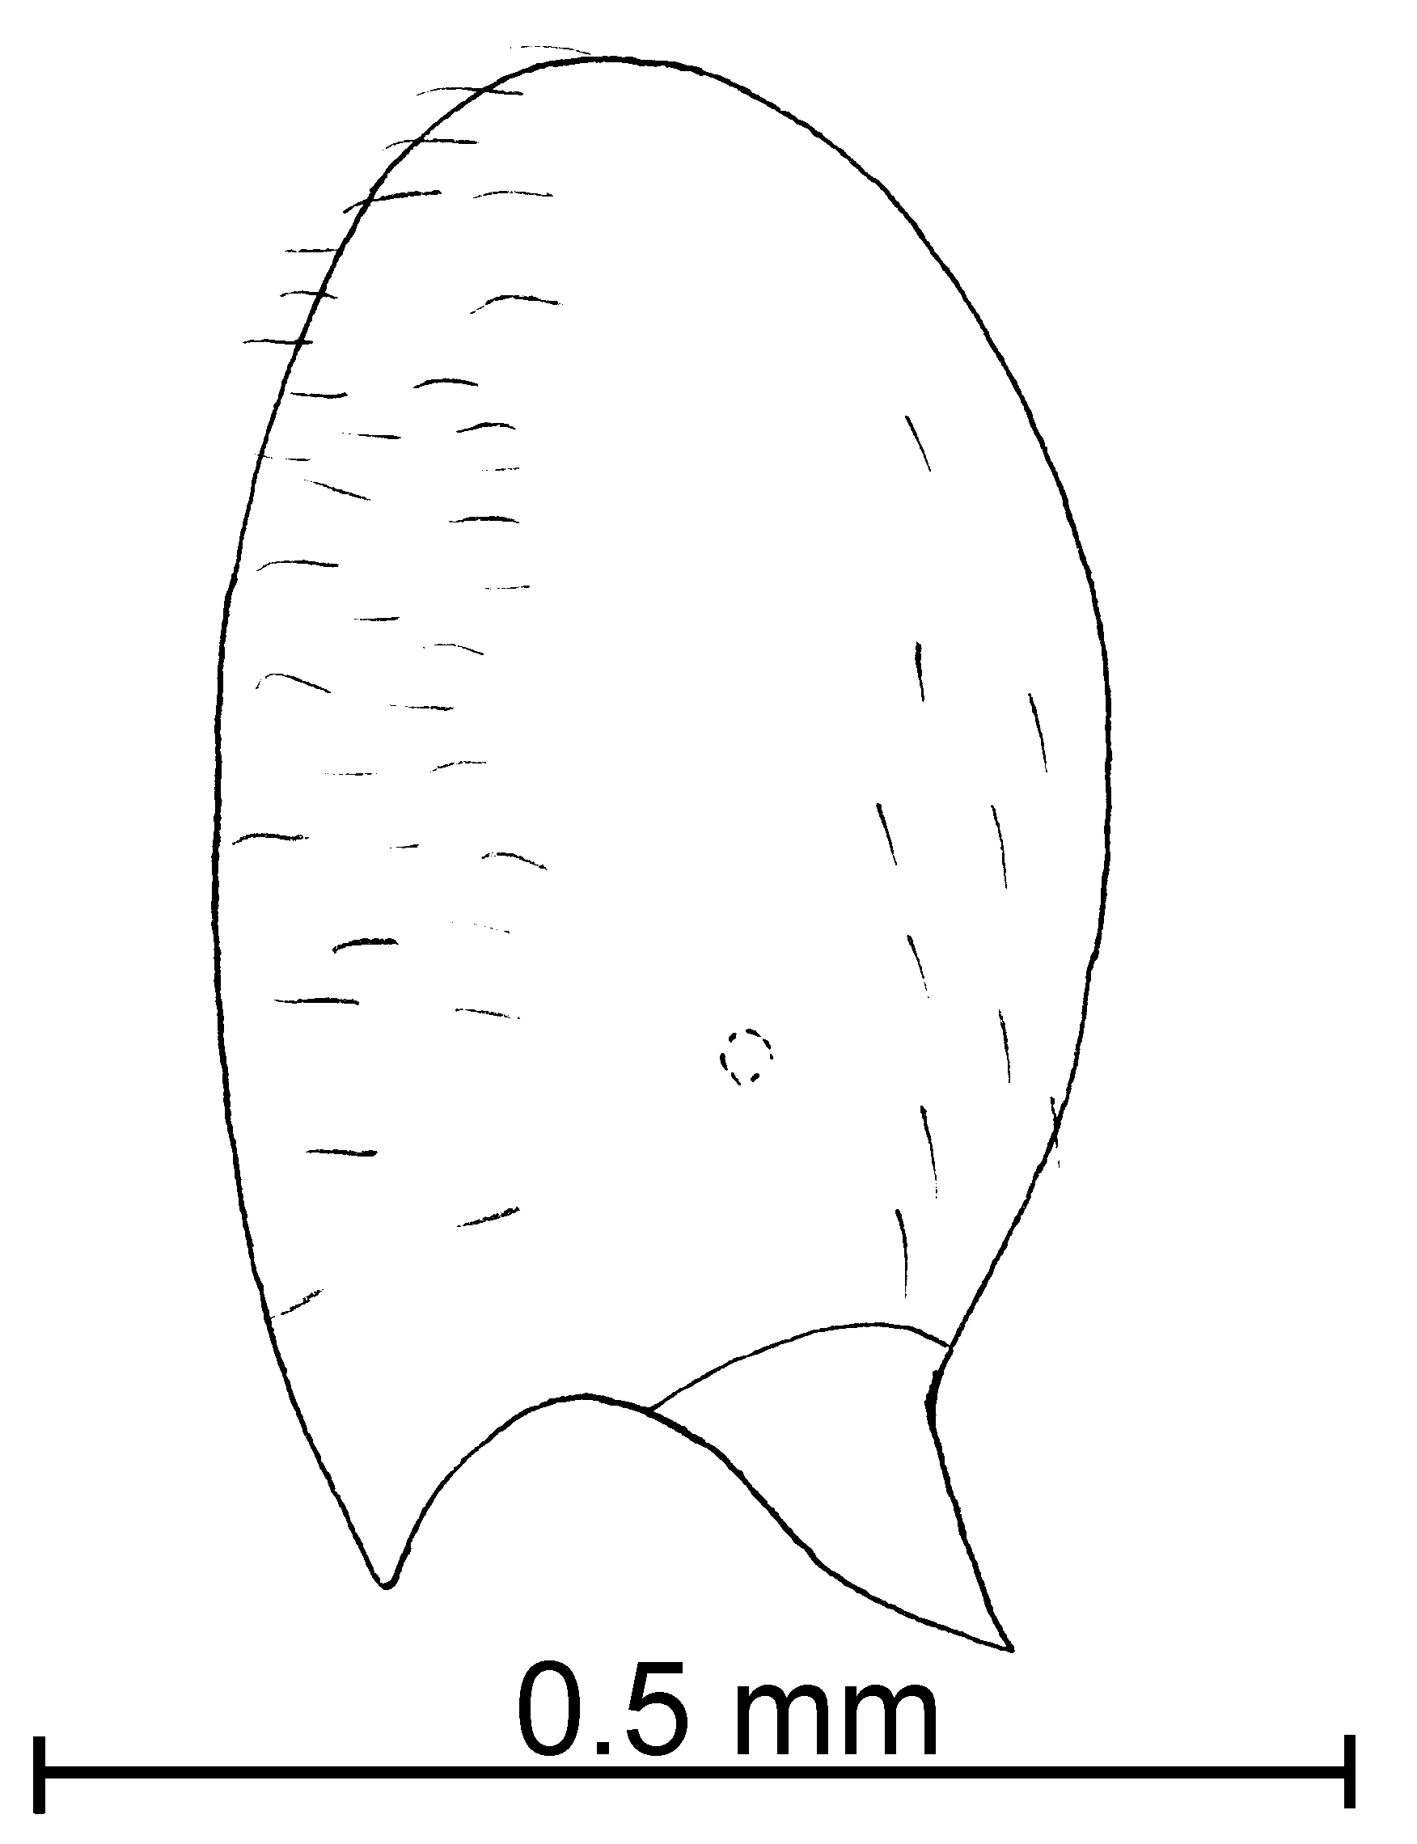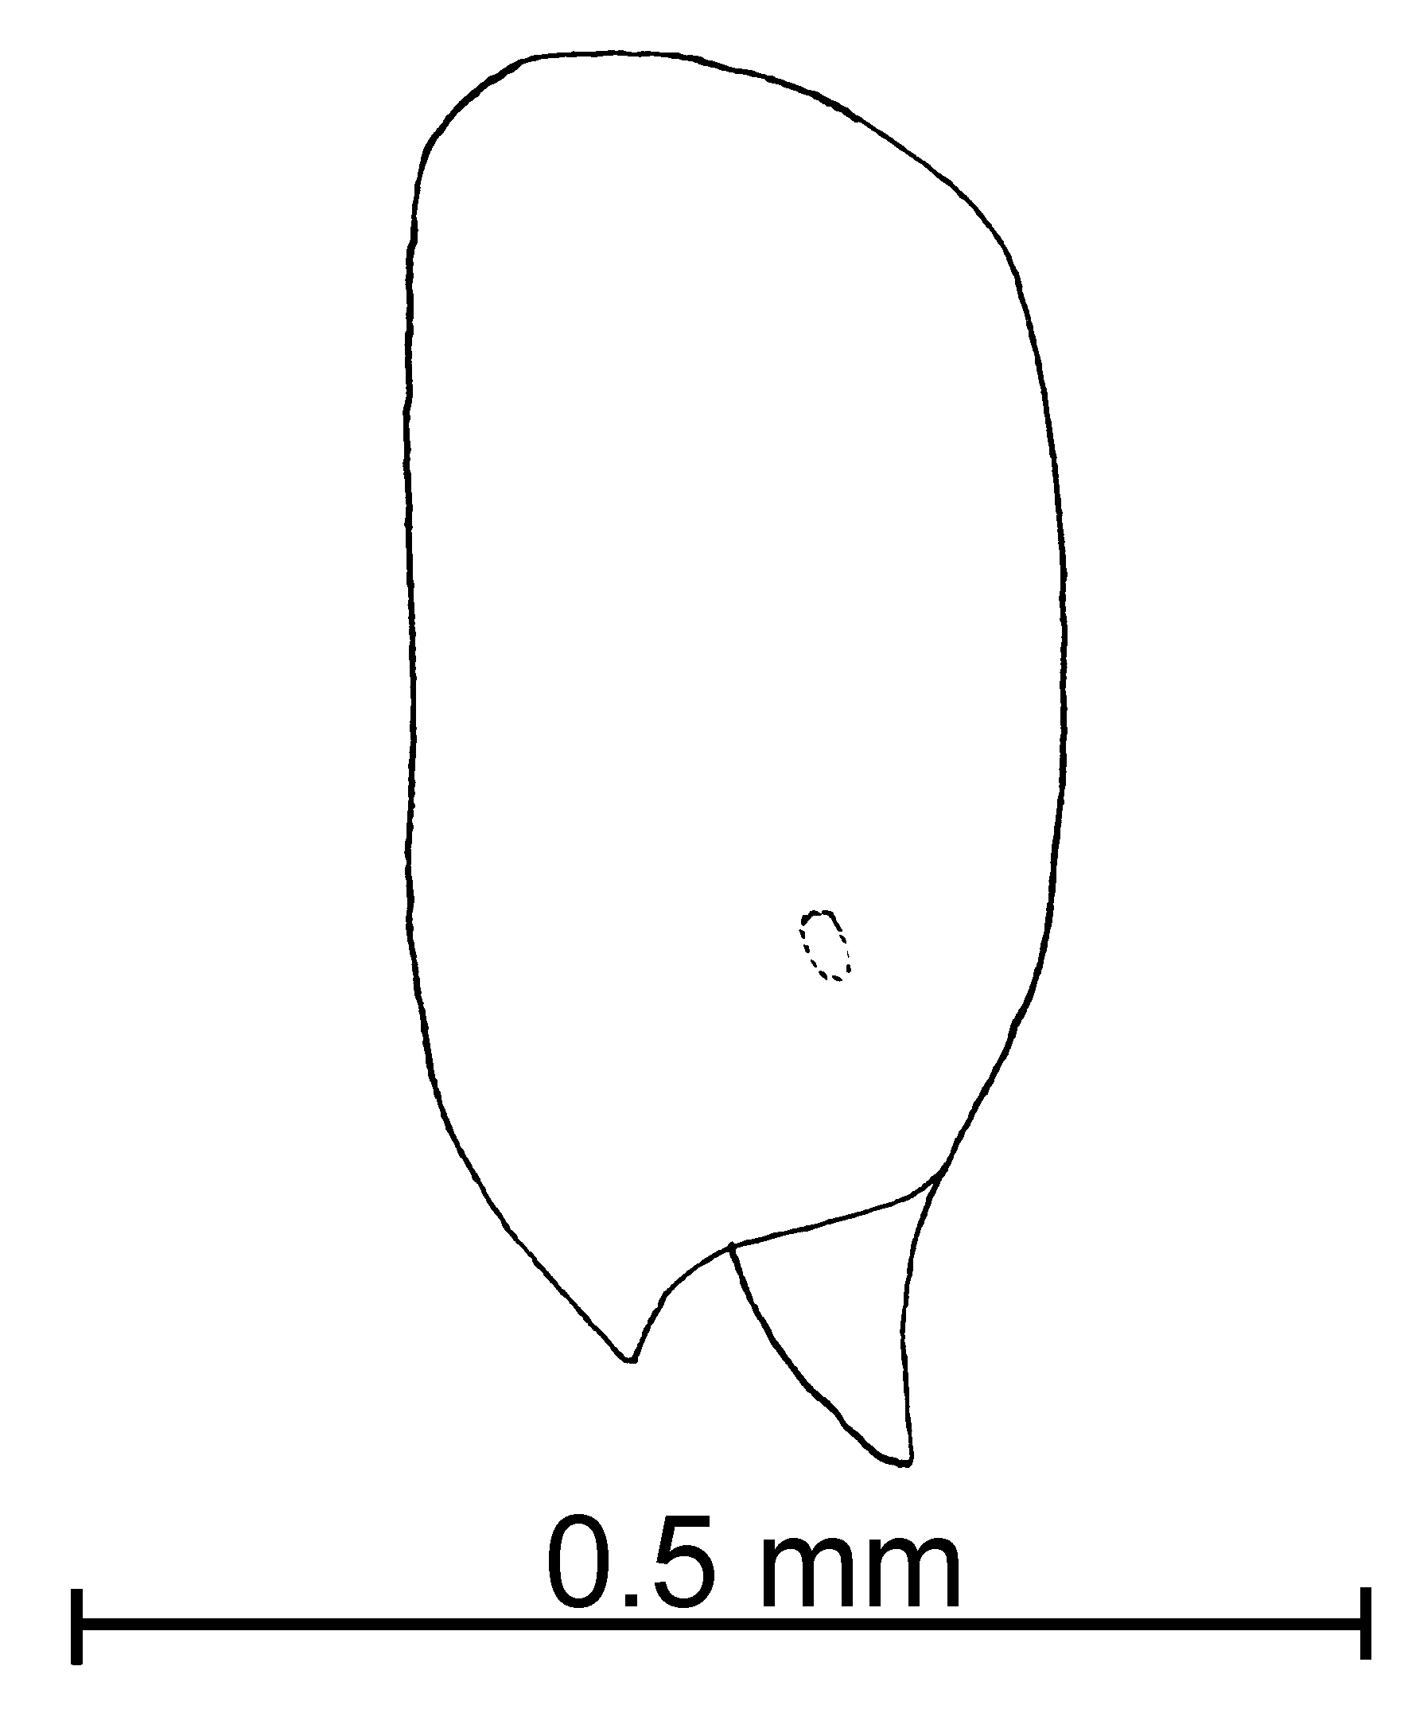
tonsa subterranea
Fig. 13. Heads of workers of S. tonsa (left) and S. subterranea (right) as seen from the side.

4(1). Eyes poorly defined or nearly absent (Fig. 4b) .................. 5
- Eyes present, with at least one ommatidium (Fig. 4a) ............ 6
5(4). Pronotum without hairs; central Texas …. depilis new species
- Pronotum with more than 4 hairs; widely distributed …. 5a
5a(5). Dorsum of first gastral tergum with more than 20 erect or suberect hairs; Colombia ………..… ………… species near minutissima
- Dorsum of first tergum with fewer than 20 erect or suberect hairs; southern New Mexico and Brasil ...….……………………… 5b
5b(5a). Southern New Mexico, head greatly elongate, ~0.4 mm in length ……….. pulleni new species
- Brasil; head not greatly elongate, 0.35 mm in length ……… …………….… minutissima Emery
6(4). First tergum of gaster in profile with fewer than 20 erect hairs of varying lengths (many over 0.05 mm), southern USA and northern México ………………………...… 7
- First tergum of gaster in profile with more than 20 hairs, all equal in length (about 0.02 mm in length); Veracruz ……………….…. ……………….. isopilis new species
7(6). Head larger (HL 0.40 - 0.43 mm); scape relatively longer (SL 0.24 - 0.26 mm, SI 58 - 62); Arizona and Louisiana ..………….… ………………. ocellata new species
- Head smaller (HL 0.35 - 0.39 mm); scape relatively shorter (SL 0.20 - 0.21 mm, SI 50 - 54); New Mexico .…………………..… ……………... whitfordi new species
stricta Species Complex

Diagnosis: The workers are moderately large in size (total length 1.6 - 2.25 mm), with relatively large eyes (0.03 - 0.04 mm maximum diameter). The lateral clypeal teeth are poorly developed or even absent, with the clypeal carina passing anteriorly, abruptly bending and forming the lateral anterior border of the clypeus. The metanotal suture is deeply impressed, the propodeum is broadly rounded, with no indication of a separation into a dorsal and posterior face. The petiole is much larger and wider the workers in the other complexes, with the width (at the level of the dorsum of the anterior peduncle) greater than the height (from dorsum of anterior peduncle to apex).

Key to workers of New World species of the stricta complex

1. Worker relatively small (Weber’s length 0.6 mm); México south to Panamá ………………. ………….. species near hayemi A
- Worker relatively large (Weber’s length > 0.75); México, Costa Rica and Panamá, Perú, Bolivia and Brasil …………………. 2
2(1). Propodeum swollen, reaching a level approximately as high as pronotum when viewed in profile ……………………………… ……………. species near hayemi B
- Propodeum not notably swollen, level much lower than pronotum when seen in profile … 3
3(2). Deep reddish-brown, with black gaster; Costa Rica …………. ……………………… hayemi Forel
- Pale brown to medium brown, with slightly darker gaster; México south to Bolivia …………… …………………..… stricta Emery

Descriptions of Solenopsis Species
`` Solenopsis abdita Thompson

molesta species complex

Solenopsis abdita Thompson, 1989:275, Figs. 1-4, , USA, Florida, Ft. Lauderdale

Diagnosis: This is a small, yellow species, with the shortest funicular segments being less than 0.06 mm in total length. The hairs on the posterior tibia are mostly appressed. This species is difficult to separate from S. texana, unless females are available (they are black, vs. the yellow females of S. texana). The scapes of the workers are shorter (0.22 - 0.23 mm, head length 0.37 - 0.40 mm), and the petiole is relatively wider than in S. texana (0.09 mm, postpetiole width 0.10 - 0.11 mm). This species is known only from Florida, whereas S. texana apparently does not occur in Florida, thus there should be little confusion between the two allopatric species. Confusion with S. carolinensis is also likely, but the shorter scape and the wider petiole will also distinguish this species from C. carolinensis. If females are available, they are easily separated by the darker color and the smaller eye. The workers can often be separated by the appressed hairs on the posterior tibiae, which are mostly semierect in S. carolinensis.
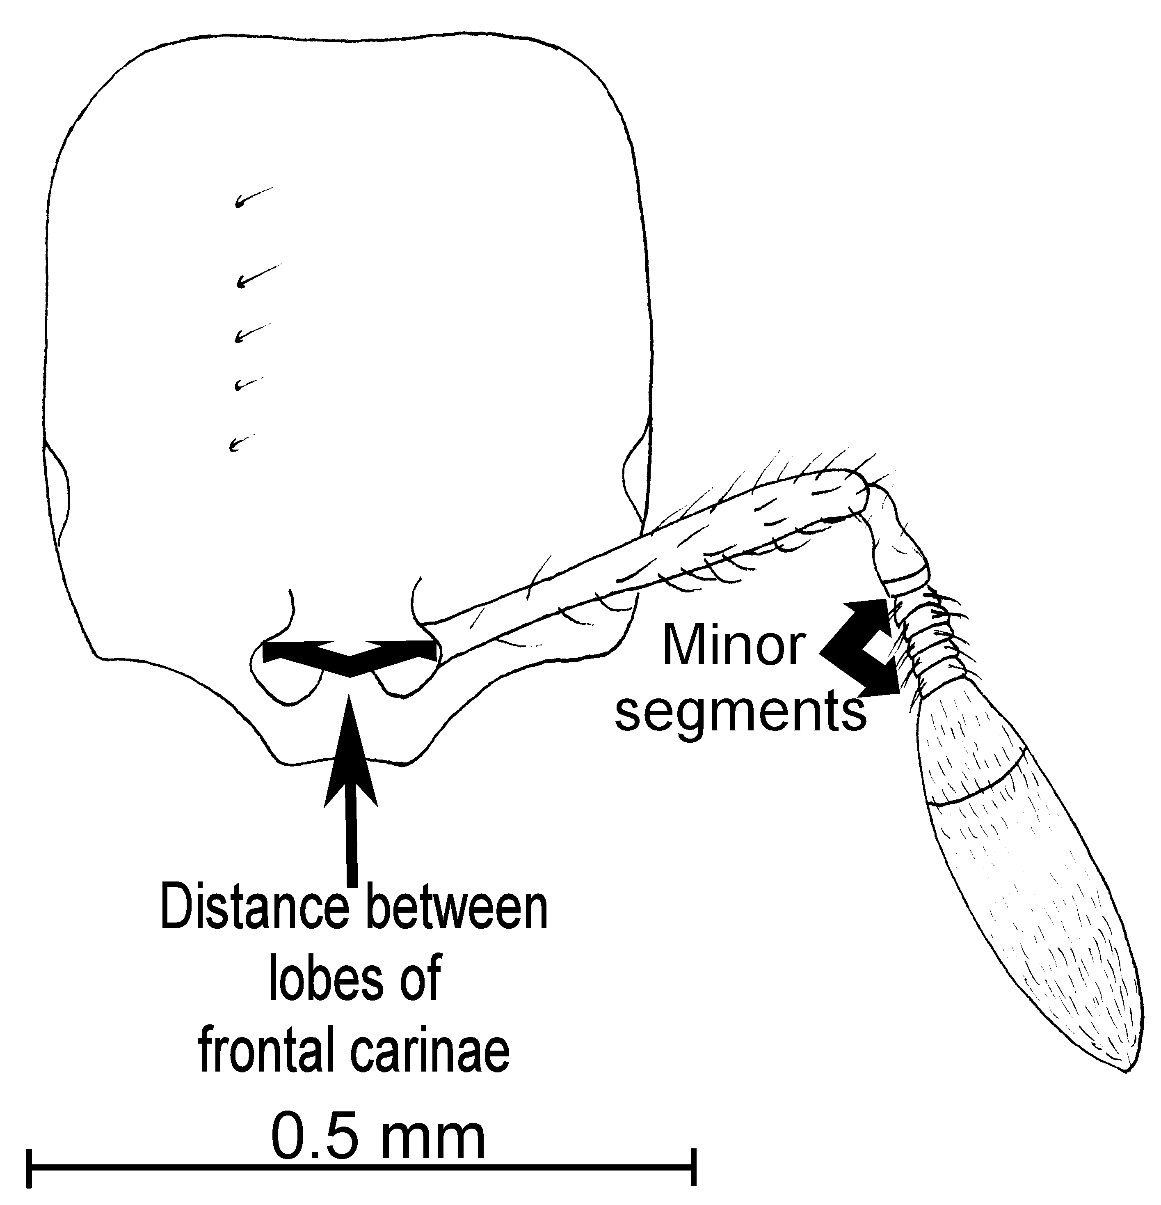
Fig. 14. Head of a worker of S. abdita.
Distribution: USA (Florida).
Map 1. Solenopsis abdita in North America.
Types: Holotype worker, several worker, female and male paratypes (numbers not specified, deposited in FSCA, MCZC, LACM – none found), 26-iv-1984, Ft. Lauderdale, Broward Co., Florida (Thompson, 1980).
Material examined: USA: Florida, Beach Co., Corbett Wildlife Area, 16-vi-2001, M. Deyrup (5 , 3 alate , 1  Deyrup Collection), Citrus Co., without locality, 18-vii-1985, J. Trager (2 , 1  CWEM), Hernando Co., 13 mi. N of Brooksville, 17-vi-1990, M. Deyrup (12 , 4  CWEM, MCZC), Lake Co., Alexander Springs, hard wood hammock, 22-vii-1968, W. L. Brown (2 , 2  MCZC).
Biology: Solenopsis abdita is common in Gainesville, Florida (Thompson, 1980). This species nests in rotten wood in pine oak forests. Pine wetlands, litter from tree base.
`` Solenopsis altinodis Forel

bicolor species complex

Solenopsis altinodis Forel, 1912:10, , Venezuela, Zig-Zag

Diagnosis: This species can be easily recognized the shape of the petiole. It is approximately as long from the point of the dorsum of the anterior peduncle as it is tall from the same point to the apex. The anterior edge is rounded, and lower than the posterior edge. When the petiole is viewed from above can be seen to be laterally compressed, being narrower anteriorly. The eye is relatively large (maximum diameter 0.06 mm, about 10 ommatidia), the minor segments of the funiculus are relatively long (0.12 mm). The clypeal teeth are absent; the clypeal carinae extends anteriorly and then abruptly turns inward, passing along the anterior margin of the clypeus. The mesosoma is deeply impressed at the metanotal suture, and the area between the two faces of the propodeum are nearly angulate, the two faces are approximately equal in length. The entire body is covered with coarse, erect hairs, which are approximately 0.1 mm in length.
Fig. 15. Petiole and postpetiole of a _________ worker of S. altinodis.
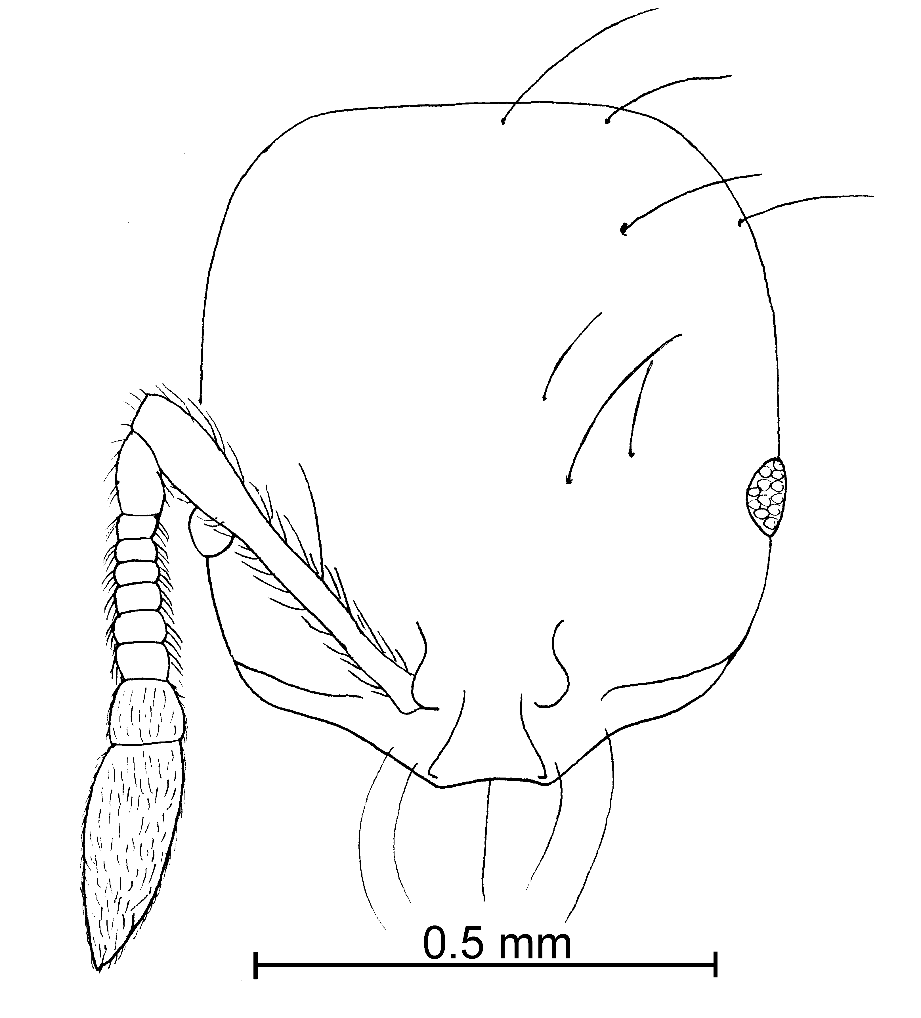
Fig. 16. Head of a __________ worker of S. altinodis.
Distribution: Colombia, Venezuela, Guiana.
Map 2. Solenopsis altinodis in South America.
Type series: Lectotype worker (MHNG), 5 paralectotype workers (MHNG), S. altinodis Forel, Zig Zag, Venezuela (Forel).
Material examined: Type series and GUIANA: Kartabo, vii, viii-1920, W. Wheeler (7  CWEM).
Biology: .
`` Solenopsis angustinodis Mackay & Moreno, new species
new species 1

fugax species complex

Diagnosis:
Measurements: Worker TL mm, HL mm, HW mm, SL mm, Indices: CI, SI.
Female and male: Unknown.
Description:
Distribution: Costa Rica (Guanacaste) and Colombia (Risaralda).

Type series: Holotype worker (MCZC), 5 paratype workers (CWEM, IAVH, MCZC), Colombia: Risaralda, La Virginia Carmelita, 950m, 21-v-1997, P. Chacón MYR-12.
Material examined: Type series and COSTA RICA: Guanacaste, Loma Barbudal, 3-vi-1989, S. Vinson # 12099 (1  CWEM), others???
Map 3. Solenopsis angustinodis in North America.
Biology: The type series was collected in dry forest. The specimens from Costa Rica were collected in pitfall traps.
`` Solenopsis azteca Forel
azteca species complex

Solenopsis azteca Forel, 1893:390 , Saint Vincent
Solenopsis azteca var. pallida Wheeler, 1908:131 , Puerto Rico, Coamo Springs new synonym

Diagnosis: The workers are small specimens (1.37 - 1.45 mm total length), the head of the worker is nearly quadrate, punctures are small, about the same diameter as the hairs that originate from them, the area between punctures is smooth and shiny, color ranges from light yellow to light brown. It has relatively large black eyes with at least four ommatidia. The clypeus is flat, with poorly defined lateral and extralateral teeth. The metanotal suture is well depressed. The petiole is wide as seen in profile. Hairs vary in length, including those on the gaster, the scape has a few erect and suberect, long hairs. The antenna is short, especially the minor segments of the funiculus (0.06 mm).
It can be separated from S. terricola and S. picta (which also have short antennal scapes) on the basis of color (S. azteca is yellow to pale brown, S. terricola and S. picta are black with black or pale legs).
Wheeler recognized the yellow specimens as the subspecies pallida. Color in this species ranges from yellow to brown, with intermediates of all colors occurring. Pale yellow specimens can be found in Puerto Rico (type series), Jamaica, Guatemala and Colombia. These lighter colored specimens are of little importance, and this subspecies is synonymized.
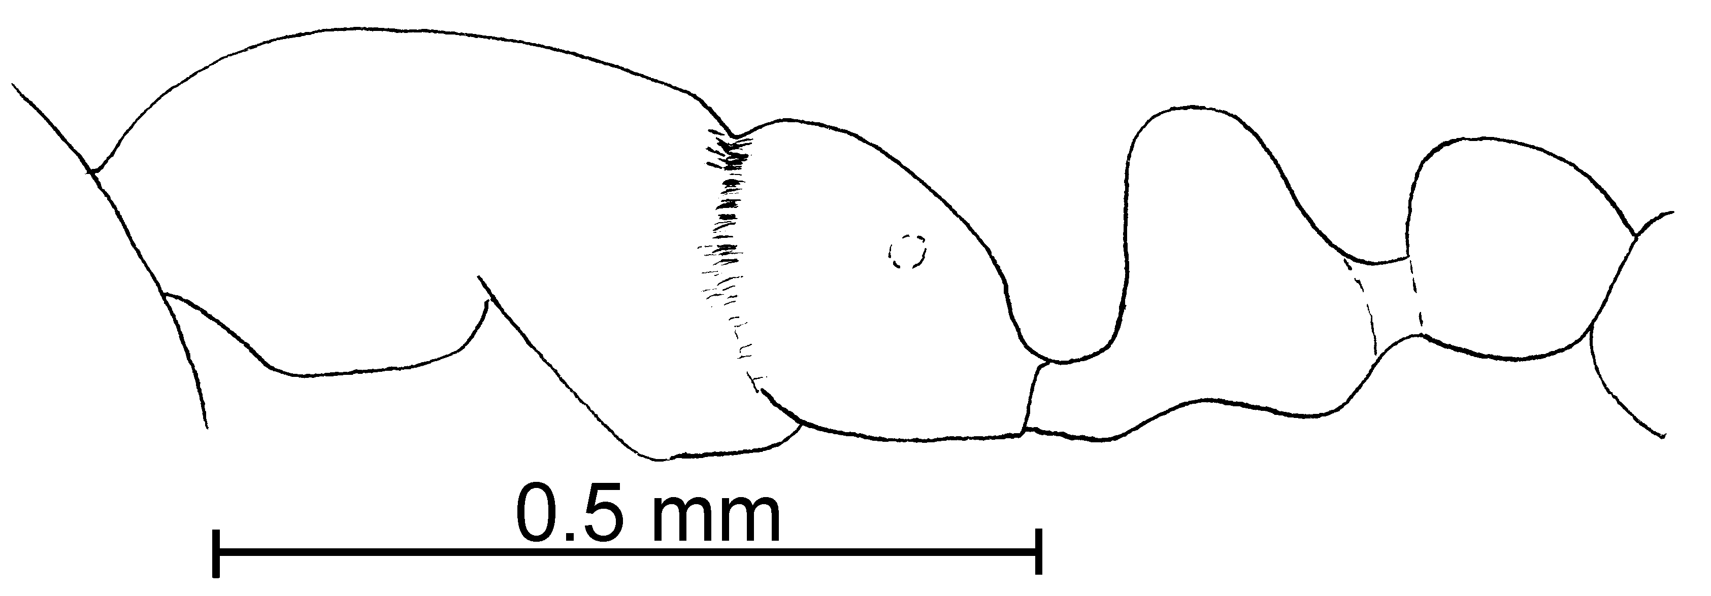
Fig. 17. Mesosoma, and pedicel of a ______ worker of S. azteca.
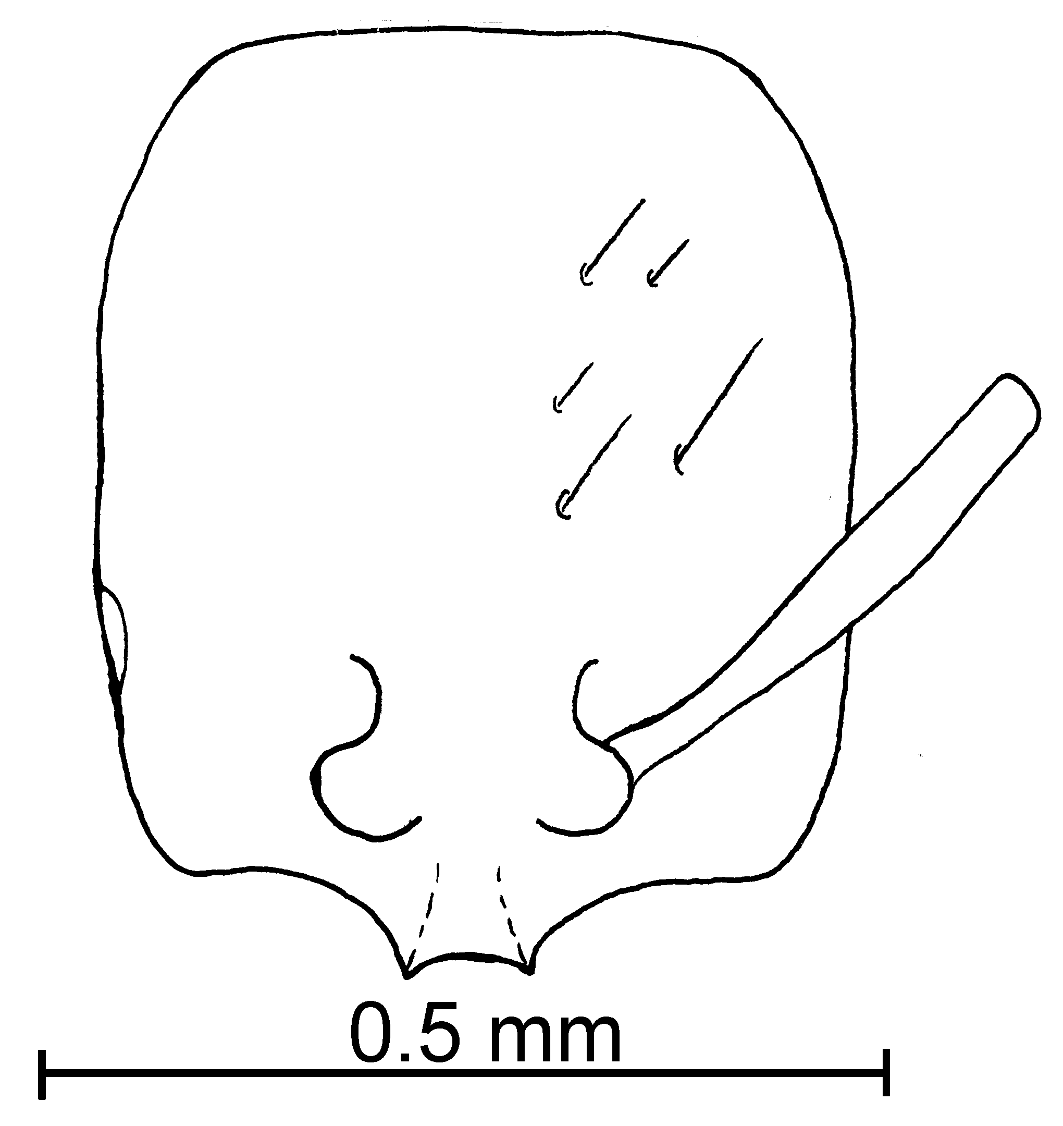
Fig. 18. Head of a ______________ worker of S. azteca.
Distribution: Colombia (Risaralda), Honduras south to Caribbean Region (Jamaica, Puerto Rico, Antilles, St. Vicente) (see Map 2).
Map 4. Solenopsis azteca in North America.
Types: Lectotype worker, 5 paralectotypes workers [here designated], Solenopsis azteca type worker, San Vicente (MHNG).
Twenty five cotype workers, Cosmo Springs, Porto [sic] Rico, W. M. Wheeler; Type # 9248 (MCZC).
Material examined: COLOMBIA: Cauca, Isla Gorgona, 16-i-1990, M. Baena # GACD-01 (2 , 1 alate  CWEM), same locality, 2-x-1990, same collector, GGHI-5 (1  CWEM); Risaralda, La Virginia, A. Claras, 1225m, 18-vi-1997, P. Chacón # MYR-10 (66  CWEM). GUATEMALA: Quirigua, 13-i-1912, W. Wheeler (3  MCZC) JAMAICA: Mandeville, Wight (20  MCZC), without locality, Wright (10  and 1  MCZC). PANAMA: Canal Zone, Barro Colorado Island, A. Emerson (3 , 1  MCZ). PUERTO RICO, Rio Grande El Verde Field Station., 29-vii-1988, G. Camilo (16  CWEM). VENEZUELA: Aragua, Parque Nacional H. Pittier, Rancho Grande, 19-x-1988, W. Mackay # 11239-5 (1  CWEM); Bolívar, Canaima, 16-x-1998, W. Mackay #’s 11194-2, 4, 11219-2, 11223-2 (17  CWEM).
Biology: These ants are found in litter in dry forests, and nest with the termite Amitermes medius. Specimens are most commonly collected in litter samples or in pitfall traps. The specimen from the Parque Nacional H. Pittier was collected at a Vienna sausage surface bait together with a specimen of Solenopsis sp. RG15 (apparently a new species near S. brevicornis, see S. brevicornis discussion).
`` Solenopsis batyle Mackay & Moreno, new species
new species 2

molesta species complex

Diagnosis: The workers are small, yellow specimens, which have abundant suberect hairs on the scape and tibiae. They are very similar to S. texana, S. pollux, S. carolinensis, S. maboya, and S. abdita. These species are not known from the Bahamas, which may allow identification of the workers without the presence of the females. The abundant suberect hairs on the scapes and tibiae, would often separate it from those with few or no suberect hairs (S. abdita, S. texana, S. pollux). The worker is larger than that of S. maboya (total length ~1.25 mm in S. batyle, vs. ~ 1 mm in S. maboya). Separation from S. carolinensis is difficult.
Measurements: Worker TL mm, HL mm, HW mm, SL mm, Indices: CI, SI.
Female TL mm, HL mm, HW mm, SL mm, Indices: CI, SI.
Male - Unknown.
Description:
Distribution: Known only from the type locality in the Bahamas.
Map 5. Solenopsis batyle in North America.
Type series: Holotype female (MCZC), 1 paratype female (), 10 paratype workers (), BAHAMAS, NORTH ANDROS IS.; FORFAR FIELD STATION; 10-X-1996; M. DEYRUP, L. DAVIS.
Material examined: Type series.
Etymology: From Greek, batyle, meaning female dwarf, describing the small size of the female of this species.
Biology: The type series was collected in a grass tussock, in a marshy area near a road.
`` Solenopsis bicolor Emery
bicolor species complex

Carebarella bicolor Emery, 1906:138, , Argentina, Misiones, Santa Ana; Borgmeier, 1948:465, 
Carabarella bicolor var. punctatotugosa Emery, 1906:139, Fig. 18 (Kempf, 1969:281)

Diagnosis:
Distribution:
Type series: Holotype worker (MCZC), paratype workers (.
Material examined: Type series and BELIZE: . PERU: Tambopata, 15 k NE Puerto Maldonado, 200 , 6-xii-1989, S. Cover & J. Tobin # CA-102
Map 6. Solenopsis bicolor in South America.

Biology: .
`` Solenopsis brevicornis Emery
brevicornis species complex

Solenopsis brevicornis Emery, 1888:256, ; Wasmann, 1915:est 5, Fig 4, 

Diagnosis: The worker can be recognized by the short scape, short minor segments of the funiculus (~0.07 mm), punctures at least on the lower mesopleuron, and the side of the petiole is moderately roughened in most specimens and only moderately or weakly shining. It is concolorous yellow or concolorous brown, including the legs, which are concolorous with the mesosoma.
It appears similar to S. azteca (the color of the two species is identical) but can be separated by the punctures on the side of the mesopleuron (completely smooth and polished in S. azteca, or with weak sculpture along the lower, anterior border of mesopleuron). Solenopsis terricola is dark, mahogany brown, with yellow antennae and legs, which easily separates it from the concolorous S. brevicornis. Both of the latter species have the mesopleuron at least partially punctated, but the side of the petiole of S. terricola is mostly smooth and glossy.
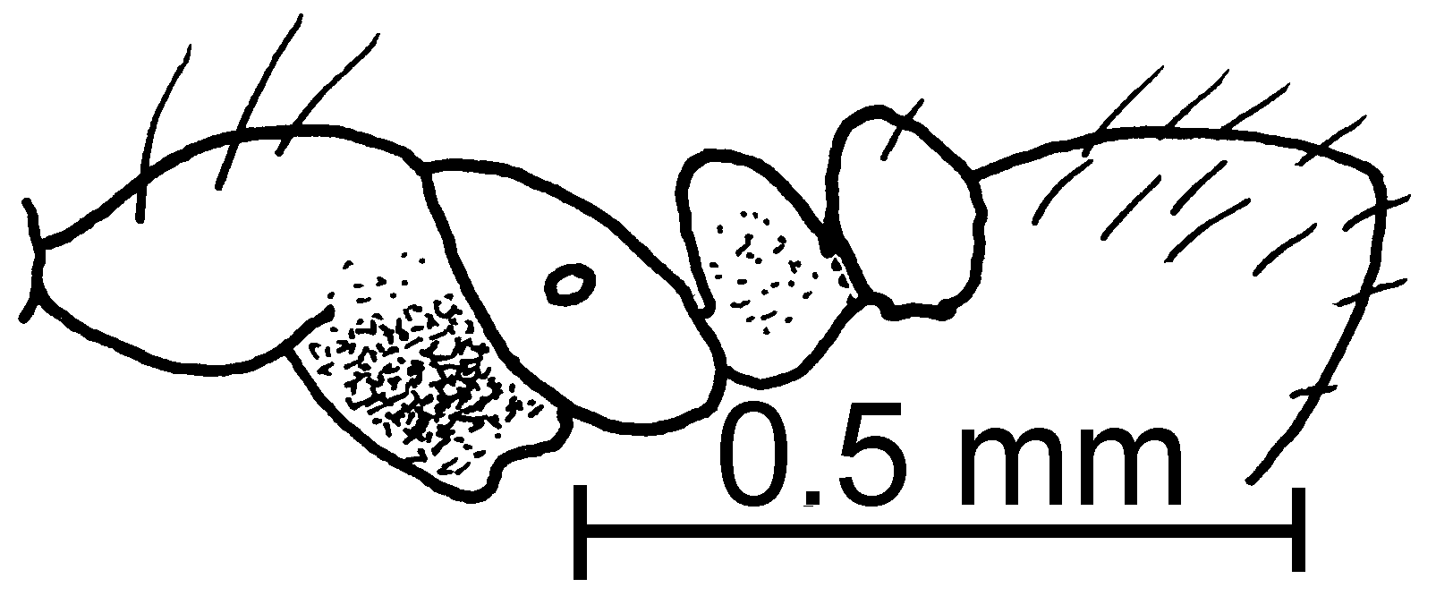
Fig. 19. Mesosoma of the lectotype worker of S. brevicornis.
It is very closely related to an apparently undescribed species from Venezuela (species RG 15). This undescribed species differs in that the entire petiole is densely and coarsely punctated, with the posterior lateral face having poorly defined rugulae.
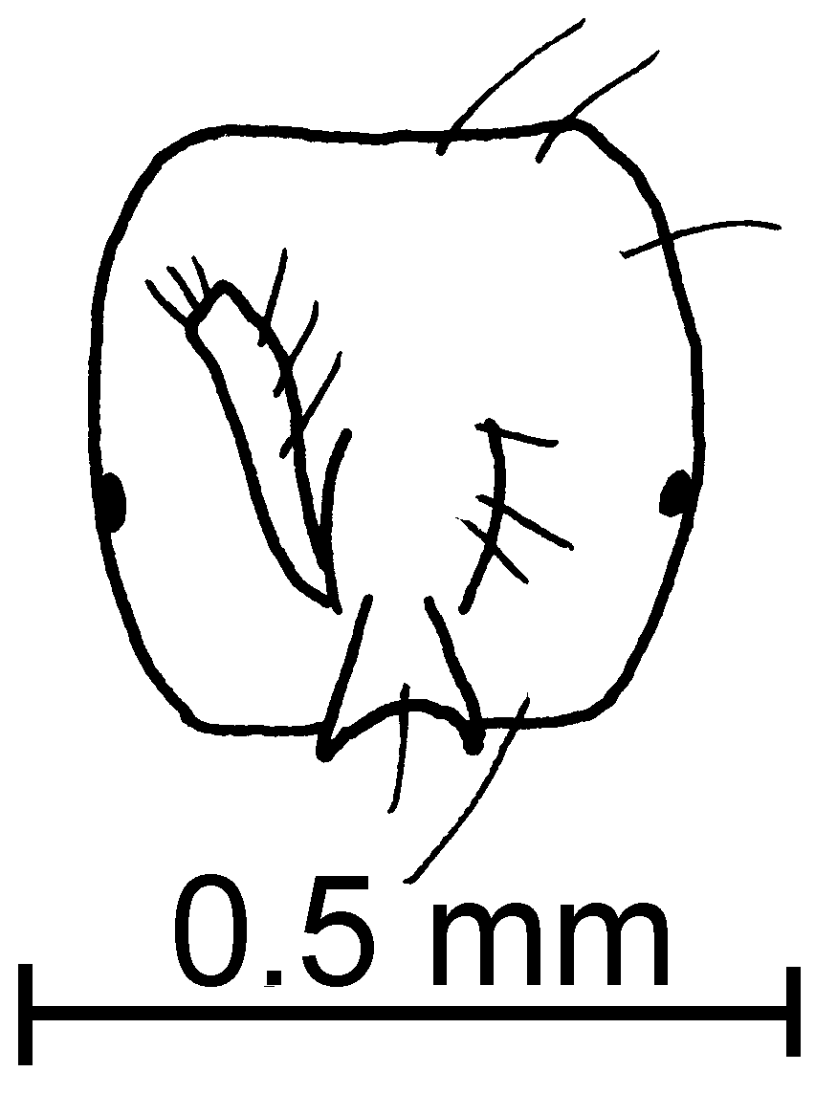
Fig. 20. Head of the lectotype worker of S. brevicornis.
Distribution: México south to Brasil.
Map 7. Solenopsis brevicornis in North America.
Map 8. Solenopsis brevicornis in South America.
Types: Lectotype worker [here designated], Solenopsis brevicornis Em. n. sp., Rio Grande, Ihering ((MCSN), female not found.
Material examined: COLOMBIA: Cauca, Isla Gorgona, 2-i-1990, M. Baena # GGHI-8 (38  CWEM). COSTA RICA: Guanacaste, Pitilla Field Station, 1000m, 14-ii-1996, R. Anderson # 17679 (1  CWEM); Puntarenas, Oso Peninsula, Fundación Neotrópica, 23-vi-1997, R. Anderson #’s 18686, 18687 (1  CWEM), Las Cruces, 4 k S San Vito, 19-vi-1998, R. Anderson # 18662 (1  CWEM). MEXICO: Chiapas, 10 k S Palenque, 31-v-1988, W&E Mackay # 10633 (6  CWEM). PANAMA: Cerro Campana, 950m, 5-vi-1995, R. Anderson # 17836 (3  CWEM).
Biology: ???
`` Solenopsis carolinensis Forel
molesta species complex

Solenopsis texana carolinensis Forel, 1901: 345 (w.q.m.)

Diagnosis: Workers are small, yellow specimens in which the length of the minor funicular segments total to less than 0.10 mm in length. The hairs on the posterior tibia are usually semierect. The female is yellow, with a large eye (maximum diameter 0.21 - 0.25 mm).
It could be confused with S. texana and with S. abdita. Often the workers of these two species have appressed hairs on the posterior tibia, whereas they are often semierect in S. carolinensis. If females are available, they are easily identified due to the large diameter of the eye. It can be separated from S. abdita by the longer scapes (scape length of two type workers 0.23 and 0.26 mm, head length 0.37 and 0.38 mm), and the relatively narrower petiole (petiolar width of two type workers 0.19 and 0.20 mm, postpetiolar width 0.25 and 0.26 mm, petiolar index 76 and 77). Forel (1901) separated S. texana race truncorum from S. texana race carolinensis by the lighter color, smaller size, shorter scapes and a narrower petiole. Direct comparison and measurement of 2 workers of each of the type series of both demonstrates that they are both approximately the same shade of yellow (probably no fading occurred, even after more than 100 years), the sizes are approximately equal (see measurements below, the S. truncorum types are actually slightly larger), the scapes are actually slightly longer (scape length of S. truncorum ranges from 0.26 - 0.28, head length 0.42, SI 63 - 66), and the petiole is equal in length (0.19 - 0.20 mm, postpetiolar length 0.25 mm, petiolar index 76- 81. The females are apparently identical, although only the female from the type series of S. truncorum was available (compared with monotype C. carolinensis females. Thus it appears that S. truncorum is a synonym of S. carolinensis. All of the literature records for S. truncorum should be considered to be S. validiuscula.
Fig. 21. Posterior left tibia of a worker of S. carolinensis (50 X).
This species is difficult to separate from S. zeteki. It is usually slightly larger, but can be approximately equal in size. The lateral clypeal teeth of S. carolinensis are well developed, and the extralateral processes are developed at least into an angle. The lateral teeth are usually absent in S. zeteki, but may be developed into small angles. The extralateral angles of S. zeteki are absent or developed into a wide, slightly expanded area. Specimens from Colombia are somewhat intermediate between the two, but have much more developed lateral clypeal teeth and are assumed to be S. carolinensis.
Distribution: USA (Arkansas, N. Carolina, Tennessee, Texas, Virginia) (Map 3). The specimens from Central and South America are not associated with females, and may be misidentified.
Types: Lectotype worker, 5 paralectotype workers [here designated], S. carolinensis worker, Faisons, North Caroline cotype #201786 (USNM).
Solenopsis texanus truncorum lectotype female (MHNG), 1 paralectotype female, 6 paralectotype workers (MHNG), S. texana Em  r. truncorum type Forel, Faisons N.C. du tronc 28.VII.
Map 9. Solenopsis abdita in North America.
Material examined: BELISE: Orange Walk, Rio Bravo Conservation Area, 30-iv-1996, # 17703 (1  CWEM). COSTA RICA: Guanacaste, Cacao Field Station, 1000m, 12-ii-1996, R. Anderson # 17733 (1  CWEM), Loma Barbudal, 3-vi-1989, S. Vinson # 12216 (3  CWEM), Parque Nacional Santa Rosa, 4-v-1995, R. Anderson # 17717 (2  CWEM). MEXICO: Chiapas, 24 k SW Cintalpa, 710m, 2-vi-1998, W. Mackay # 10717E, C, 10718B, C, D, 17020E, G, 10723H, 10726A (27  CWEM), Nuevo León, Parque Mont. Chipinque, 29-ix-1990, J. Garcia Pérez # 83 (3  CWEM); Tabasco, 10 k N Cárdenas, 10m, 28-v-1998, W. Mackay # 10521 (2  CWEM), Veracruz, Reserva Ecológica La Mancha, various dates, P. Rojas (16  Rojas Collection) atm. PANAMA: Chiriquí, Bocas del Toro, Continental Divide, 9-vi-1995, R. Anderson # 17841 (2  CWEM), Fortuna hydrological trail, 1100m, 9-vi-1995, R. Anderson # 17785 (1  CWEM), 20.4 k N San Félix, 950m, 8-vi-1995, R. Anderson # 17767 (2  CWEM). UNITED STATES: Arkansas, Cross Co., Village Creek State Park, 14-vii-1988, R. Anderson (2  CWEM), Pike Co., Center of Diamonds, 13-viii-1988, R. Anderson. (22 , 25 , 1 ); Tennessee, Lawrence Co., David Crockett State Park, 15-vi-1998, Mackay family #18374 (20  CWEM), Lincoln Co., Stump Shoals, Elk River at Hwy. 64, 11-vi-1998, Mackay family # 18231 (12  CWEM), McMinn Co., Rest Area 7K SW Athens, 12-vi-1998, W. Mackay #’s 18256, 275, 284 (21  CWEM); Texas, Brazos Co., Allen Site, 03-vii-1999, K. Helms #’s 85-88 (4  CWEM), Peach Creek, 22-vii-1987, W. Mackay # 9349 (2  CWEM), 10 k N Kurten, 5-viii-1987, W. Mackay #’s 9654, 658, 659, 660, 661, 663 (14  CWEM), Koppe’s Bridge, 15-i-1989, R. Anderson (3  CWEM), Brewster Co., Big Bend Nat. Park, 14-iii-1988, W. Mackay #10131 (29  CWEM), Burnet Co., Inks Lake State Park, 3-v-1988, R. Anderson (23  CWEM), Cameron Co., Sable Palm Grove, 12-x-1988, R. Anderson (24  CWEM), Hidalgo Co., Anzalduas County Park, 15-x-1988, R. Anderson (38  CWEM), Sabine Co., 14.5 km. E Hemphill 8-iii-1989, R Anderson # 12761 (3  CWEM), San Patricio Co., Welder Wildlife Refuge, 18-iv-1989, R. Anderson (5  CWEM), Walker Co., Ellis Prison Unit, 22-vii-1980, Johnson Taylor (11  CWEM); Virginia, Richmond Co., 28-ii-1938, W. F. Turner #T-926 (3  USNM).
Biology: These ants are found in mixed wood leaf litter and also nest under stones. It occurs in temperate ______________, to tropical old growth dry forest to wet mountain cloud forest. Foragers are attracted to Vienna sausage baits (surface and subsurface) in a variety of habits, including slashed and burned tropical forest.
`` Solenopsis castor Forel
molesta species complex

Solenopsis castor Forel, 1893:391 (w. f.)

Diagnosis: This is a small (1.0 - 1.2 mm total length), medium brown (Caribbean) to dark brown (México and Central America), shiny species, in which the appendages are usually lighter colored than the remainder of the ant. The funicular segments are short, the scape is long, coming to nearly the first funicular segment of reaching the posterior lateral corner. Most surfaces are covered with long (0.05 - 0.10 mm), erect hairs. They are superficially similar to S. terricola, but can be easily separated by the longer scape, the smooth and polished mesopleuron, and the slender, completely polished petiole. Solenopsis tenuis is similar, but is usually very pale concolorous brown. The narrow funicular segments and the dark color would differentiate this from most of the other thief ants. Direct comparison of types of workers of S. castor and S. nickersoni show no differences. Thompson (1982) described S. nickersoni on the basis of the worker. She (1989) later described the female on the bases of specimens that were not associated with workers, but were selected by a process of elimination (Thompson, 1980, 1989). Unfortunately these do not appear to be true females of S. nickersoni, as all of the other females of the molesta complex are small and most are light in color. Central American specimens seem to be different from types, in color (darker brown) and density of hair, especially on the first tergum of gaster.
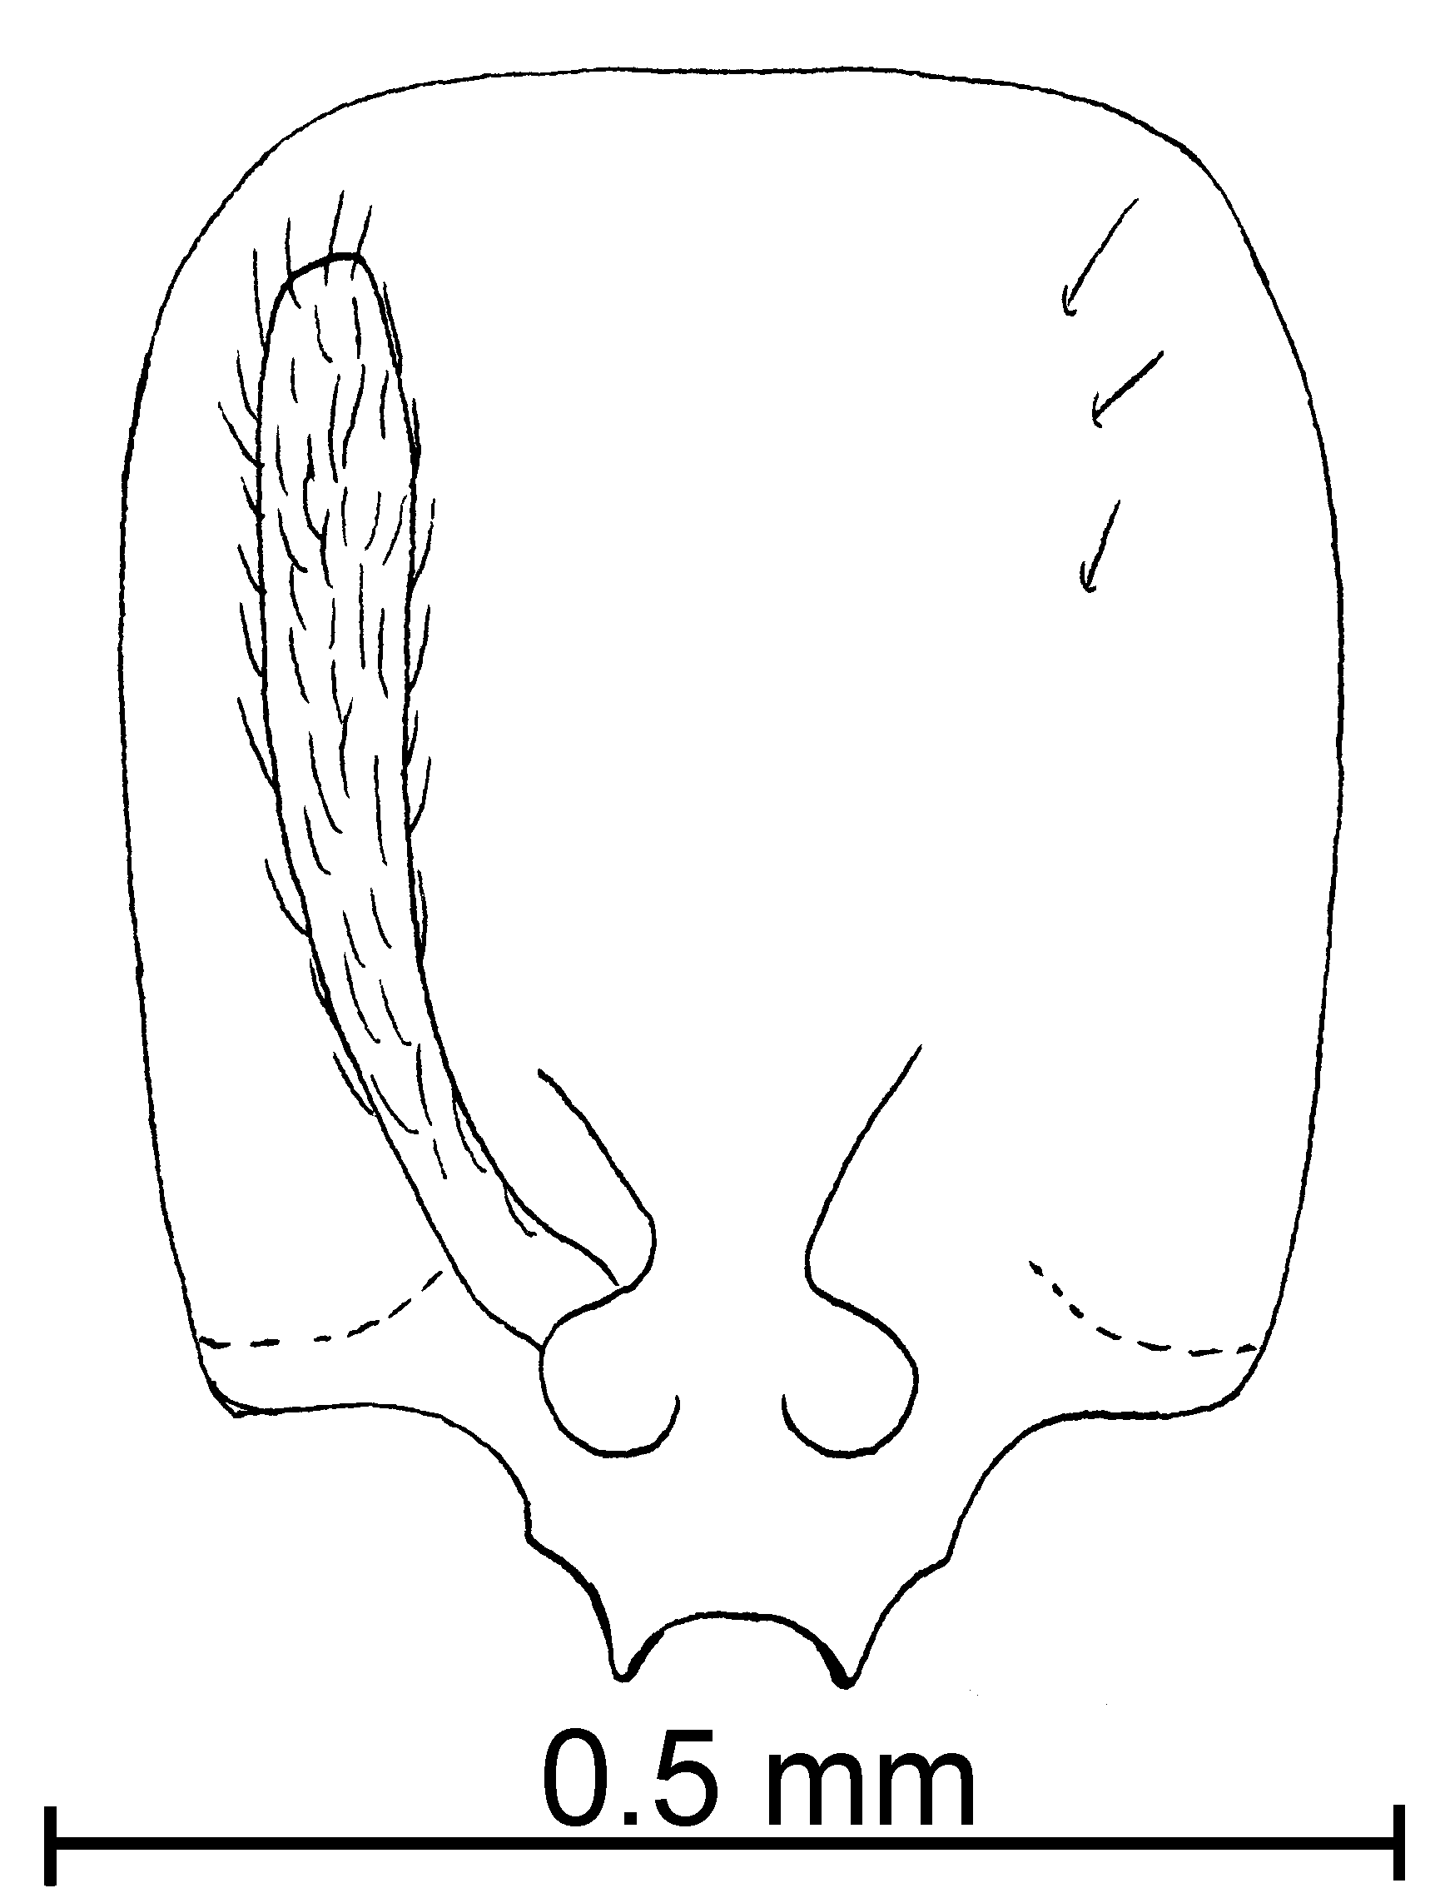
Fig. 22. Head of a _____________ worker of S. castor.
Solenopsis nickersoni workers differ in being slightly smaller, and pale in color similar to Caribbean specimens. It will continue to be considered to be a separate species until females associated with workers can be found, and compared with females of S. castor. It is probably a synonym.
It is easy to confuse workers of S. castor with workers of S. picea. The minor segments are usually shorter than 0.1 mm in total length (usually greater than 0.12 mm in S. picea, and they are usually dark mahogany brown with yellow legs (S. picea is usually medium brown with the legs nearly concolorous with the mesosoma).
The females of S. castor are relatively small (total length about 3 mm) versus the larger females of S. picea (usually greater than 4 mm total length). The females could be confused with those of S. tenuis. The punctures on the head are usually sparse and small in both species, although the punctures of S. castor are slightly larger. The eyes of S. castor are oblong in shape, with the anterior border convex and curved, the posterior border is nearly straight. The eye of S. tenuis is nearly circular in shape, with the posterior border being as rounded as the anterior border.
Distribution: USA (Florida) south to Panama (Chiriquí). Caribbean (Antilles St. Vincent, Grenada, Dominica) and Bolivia (see Map 4).
Map 10. Solenopsis castor in North America.
Map 11. Solenopsis castor in South America.
Types: Lectotype worker, 4 paralectotype workers, 1 paralectotype female [here designated] S. castor worker Forel type, St. Vincent (MHNG).
Solenopsis nickersoni, 9 paratype workers, FL: Alachua Co., Gainesville Airport, 7-x-79, C. R. Thompson, tuna trap, # 53 (MCZC) [seen].
Material Examined: COSTA RICA: Guanacaste, Cacao Field Station, 1350 - 1400m, 12,13,15, 20-ii-1996, #’s 17665, 17673, 17681, 17690, 81-2 J, 17725, 17728, 17731 (7 , 2  CWEM), Estación Maritza, 875m, 10°58’N 85°30’W, 13-ii-1996, R. Anderson # 17736, 17678 (7 , 1 dealate  CWEM), Pitilla Field Station, 600m, 2-v-1995, 14-ii-1996, #’s 17671, 17722, 17737, 17739, 17741 (9 , 1  CWEM), same locality, 1175m, 14-ii-1996, R. Anderson # 17739 (3  CWEM), Rincón La Vieja, Las Pailas, 400m, 10, 18-ii-1996, R. Anderson # 17675, 17677, 17686, 17747 (20 , 7 dealate  CWEM), Loma Barbudal, ii-1990, S. Vinson (1  CWEM); Puntarenas, Osa Peninsula., Fundación Neotrópica, 23-vi-1997, R. Anderson # 18687 (1  CWEM); San Jose, Pan. Hwy. Km. 117, 15-vi-1998, R. Anderson #’s 18657, 60, 63, 65, 78, 80, 83-89 (29 , 6  CWEM). MEXICO: Colima, 19 k NE Comala, 1-viii-1988, R. Anderson # 88-19 (2 alate  CWEM). NICARAGUA: Sinotega Los Pinares, 25-vi-986 PANAMA: Chiriquí, Bocas del Toro, Continental Divide, 9-vi-1995, R. Anderson, #’s 40-48, 17841 (196 , 5  CWEM), 5.7 k NE Boquete, 1500m, 19-vi-1995, R. Anderson # 17765, 17766 (4  CWEM), Fortuna area, Finca La Suisse, 12-vi-1995, R. Anderson # 17775 (22 , 4 dealate  CWEM), 20.4 k N San Félix, 950m, 8-vi-1995, R. Anderson, 17767 (3  CWEM); Cerro Campana, 05-vi-1995, R Anderson #18833 (2  CWEM), Fortuna Hydrological Trail, 1100 m, 9-vi-1995, R. Anderson #’s 17785, 87-91, 93-97 (124 , 9  CWEM), same locality, La Fortuna, Finca La Suisse, 10-11-vi-1995, R. Anderson #’s 17822-32, 39 (166 , 29  CWEM), same locality, Volcán, Hartman’s Finca, 14-16-vi-1995, R. Anderson #’s 17801, 02, 05, 13-15 (19 , 2  CWEM), _______________________ Pipeline Road, Rio Frijolito, 18-v-1995, R. Anderson # 17848 (1 alate  CWEM).
Biology: These ants nest on soil and also under stones.
`` Solenopsis clytemnestra Emery
Figs. Maps

molesta species complex

Diagnosis: The workers of this species are moderate sized, yellow ants, with a total length of 1.5 - 4 mm. The clypeal teeth of the worker of this species are poorly developed, represented as simple angles, the carinae are also poorly developed, but present. The head is moderately elongate (total length 0.48 - 0.52 mm), and the width is 0.39 - 0.41 mm. The length of scape is 0.29 - 0.34 mm the length of the minor segments is 0.13 - 0.15 mm. The eyes are small, but well-defined, with about 5 - 7 ommatidia, and a maximum diameter of 0.05 mm. The metanotal suture is deeply impressed, the propodeal spiracle is very large (0.04 - 0.05 mm maximum diameter). The scape has many suberect hairs, the dorsum of the head, dorsum of the mesosoma, petiole and gaster have several erect hairs. The head has small diameter punctures, which are not much larger in hairs than the diameters of the hairs arising from them. Most surfaces are smooth and glossy, including the mesopleuron and much of the side of the propodeum (lower surfaces with fine striae).
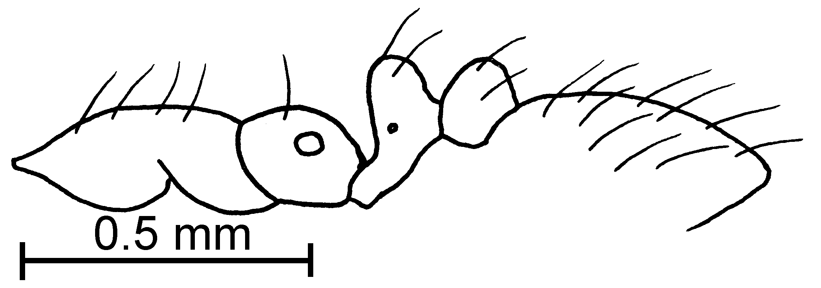Fig. 23. Mesosoma, pedicel and first gastral tergite of the lectotype worker of S. clytemnestra.
The small clypeal teeth distinguish this species from most other species in the genus. It could be confused with S. zeteki but can be separated by its larger size (total length of S. zeteki up to 1.2 mm).
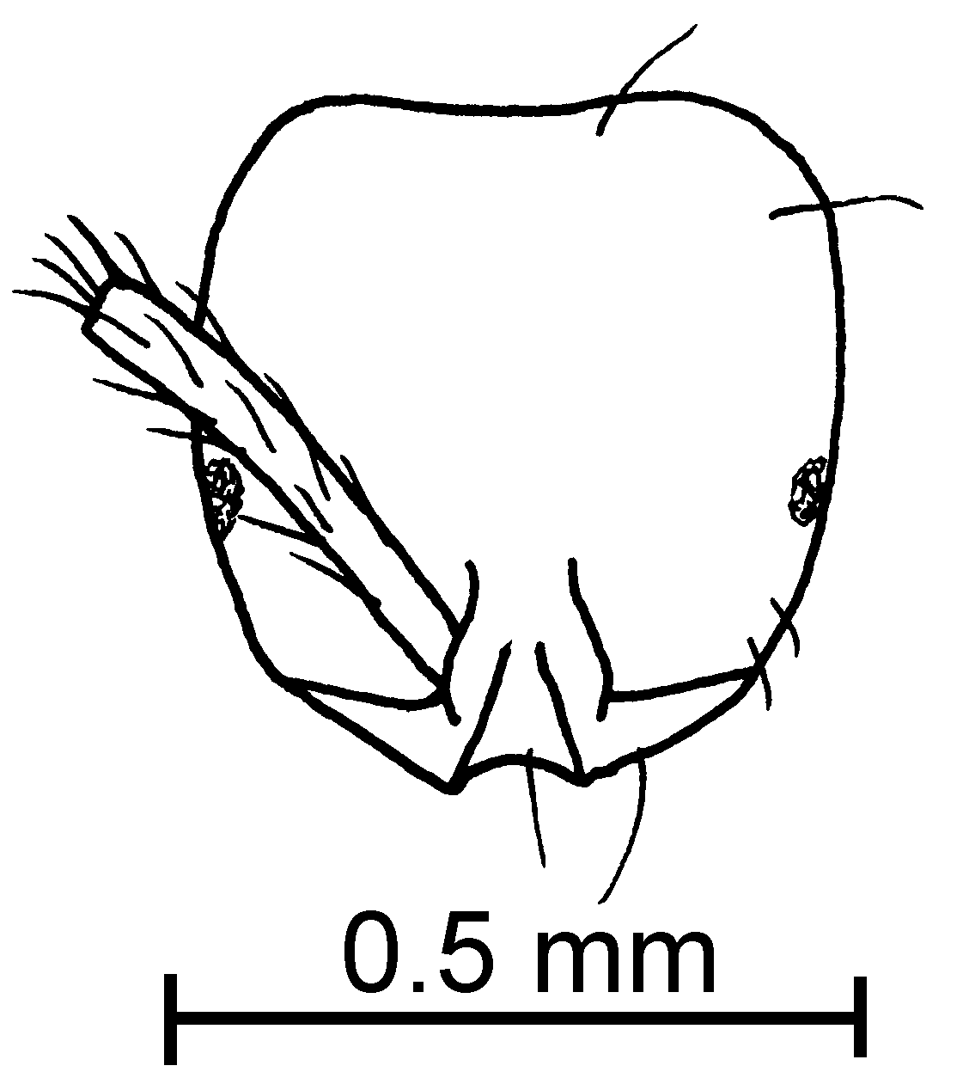
Fig. 24. Head of the lectotype worker of S. clytemnestra.
Our specimens nr clytemnestra are identical to the types except most of the mesopleuron (at least lower half) is covered with fine striae, and most of side of propodeum with similar striae. These surfaces are smooth and glossy in the types of clytemnestra.
Distribution: (From Kempf, 1972) Brasil (Rio Grande do Sul), Paraguay, Argentina (Entre Rios, Buenos Aires, Rio Negro).
Map 12. Solenopsis clytemnestra in South America.
Type series: Lectotype worker (MCSN), one paralectotype worker [here designated] (MCSN), Rio Grande, Ihering.
Material examined: Type series and
Biology: Workers were collected in litter samples.
`` Solenopsis conjurata Wheeler

molesta species complex

Solenopsis conjurata Wheeler, 1925: 178. (w.)
Solenopsis species PACI-2 Mackay et al., 1991
Map 13. Solenopsis conjurata.
Diagnosis: This is a small, yellow species that has small, circular eyes (occasionally the eyes are weakly elongate, but are always less than 0.03 mm in length). They are only moderately hairy, without suberect hairs on the posterior tibia (most are appressed or decumbent). The smaller segments of the funiculus are at least 0.12 mm in total length. This is the only species of thief ant in the molesta group with small, usually perfectly round eyes. This would separate it from similar species, such as S. molesta.
Fig. 25. Side of the head of a _____________ worker of S. conjugata.
Distribution: Mexico (Chiapas and Nuevo Leon), and Panamá (Canal Zone). (see Map 5).
Map 14. Solenopsis abdita in North America.
Types: Lectotype worker 7 paralectotype workers [here designated], S. conjurata, Wheeler worker cotype #23232 Panama, Colorado Island (MCZC). PANAMA, Canal Zone, Colorado Island, 29-vii-1924, W. M. Wheeler cotype #782 (8  MCZC).
Material examined: COSTA RICA: Guanacaste, Cacao Field Station, 1700m, 20-ii-1996, R. Johnson # 17684 (1  CWEM). MEXICO: Baja California: Sierra San Borja, 9.9 mi N San Borja, 1970’, 28°52.54’N 113°47.48’W, 11-iii-1998, R. Johnson # BC 1316 (11  Johnson collection); Baja California Sur, west base Mesa Tecolote @ N of P. Abreojos, 27°0’N 113°27’W, 16-ii-1993, R. Johnson # BCS 131 (15 , 1 dealate  Johnson collection), Rancho Santa Gertrudis, 1300’, 23°32’N 110°4’W, 2-ii-1996, R. Johnson # BCS 1202 (11  Johnson collection), 8.3 mi W San Ignacio, 27°17’30”N 113°3’30”W, 16-ii-1993, R. Johnson #’s BCS 116, 117 (34 , 1 dealate  Johnson collection); Chiapas, 10K S Palenque, 30-31-v-1988, W. Mackay #’s 10565, 630 (24  CWEM); Nuevo Leon, El Salto (Zaragosa), 10-vi-1988, W. Mackay #’s 11011-6, 011-8, 015-10 (30  CWEM). USA:
Biology: They nest under ground; and they were collected in subterranean traps.
`` Solenopsis corticalis Forel
molesta species complex

Solenopsis corticalis Forel, 1881:13 (w.f.)
Solenopsis Species PACI-2, Mackay et al., 1991

Diagnosis: The worker of this species is small and pale, and the minor funicular segments are less than 0.12 mm in total length. It is easily recognized as the anterior lateral angles on the anterior border of the clypeus are rounded or in larger workers simply angulate, and not developed into teeth. The eyes are somewhat elongate, with the maximum diameter being greater than 0.03 mm. It is a brownish-honey color. These characters will separate it from nearly all of the other species in the molesta group, except for S. zeteki. The female can be separated from the female of the latter species as the eye is small (maximum diameter about 0.16 mm, vs. 0.18 mm or larger in S. zeteki). Unfortunately, the workers of the two species are nearly identical, apparently differing only in color. Workers of S. corticalis are brownish-honey in color, whereas workers of S. zeteki are yellow in color. This species could be easily confused with S. tenuis. It can be separated as S. tenuis is darker brown in color and the clypeal teeth are developed, although they are small. Series consisting of only workers cannot always be correctly identified. The females are easily separated, with those of S. corticalis being yellow, those of S. tenuis being dark brown.
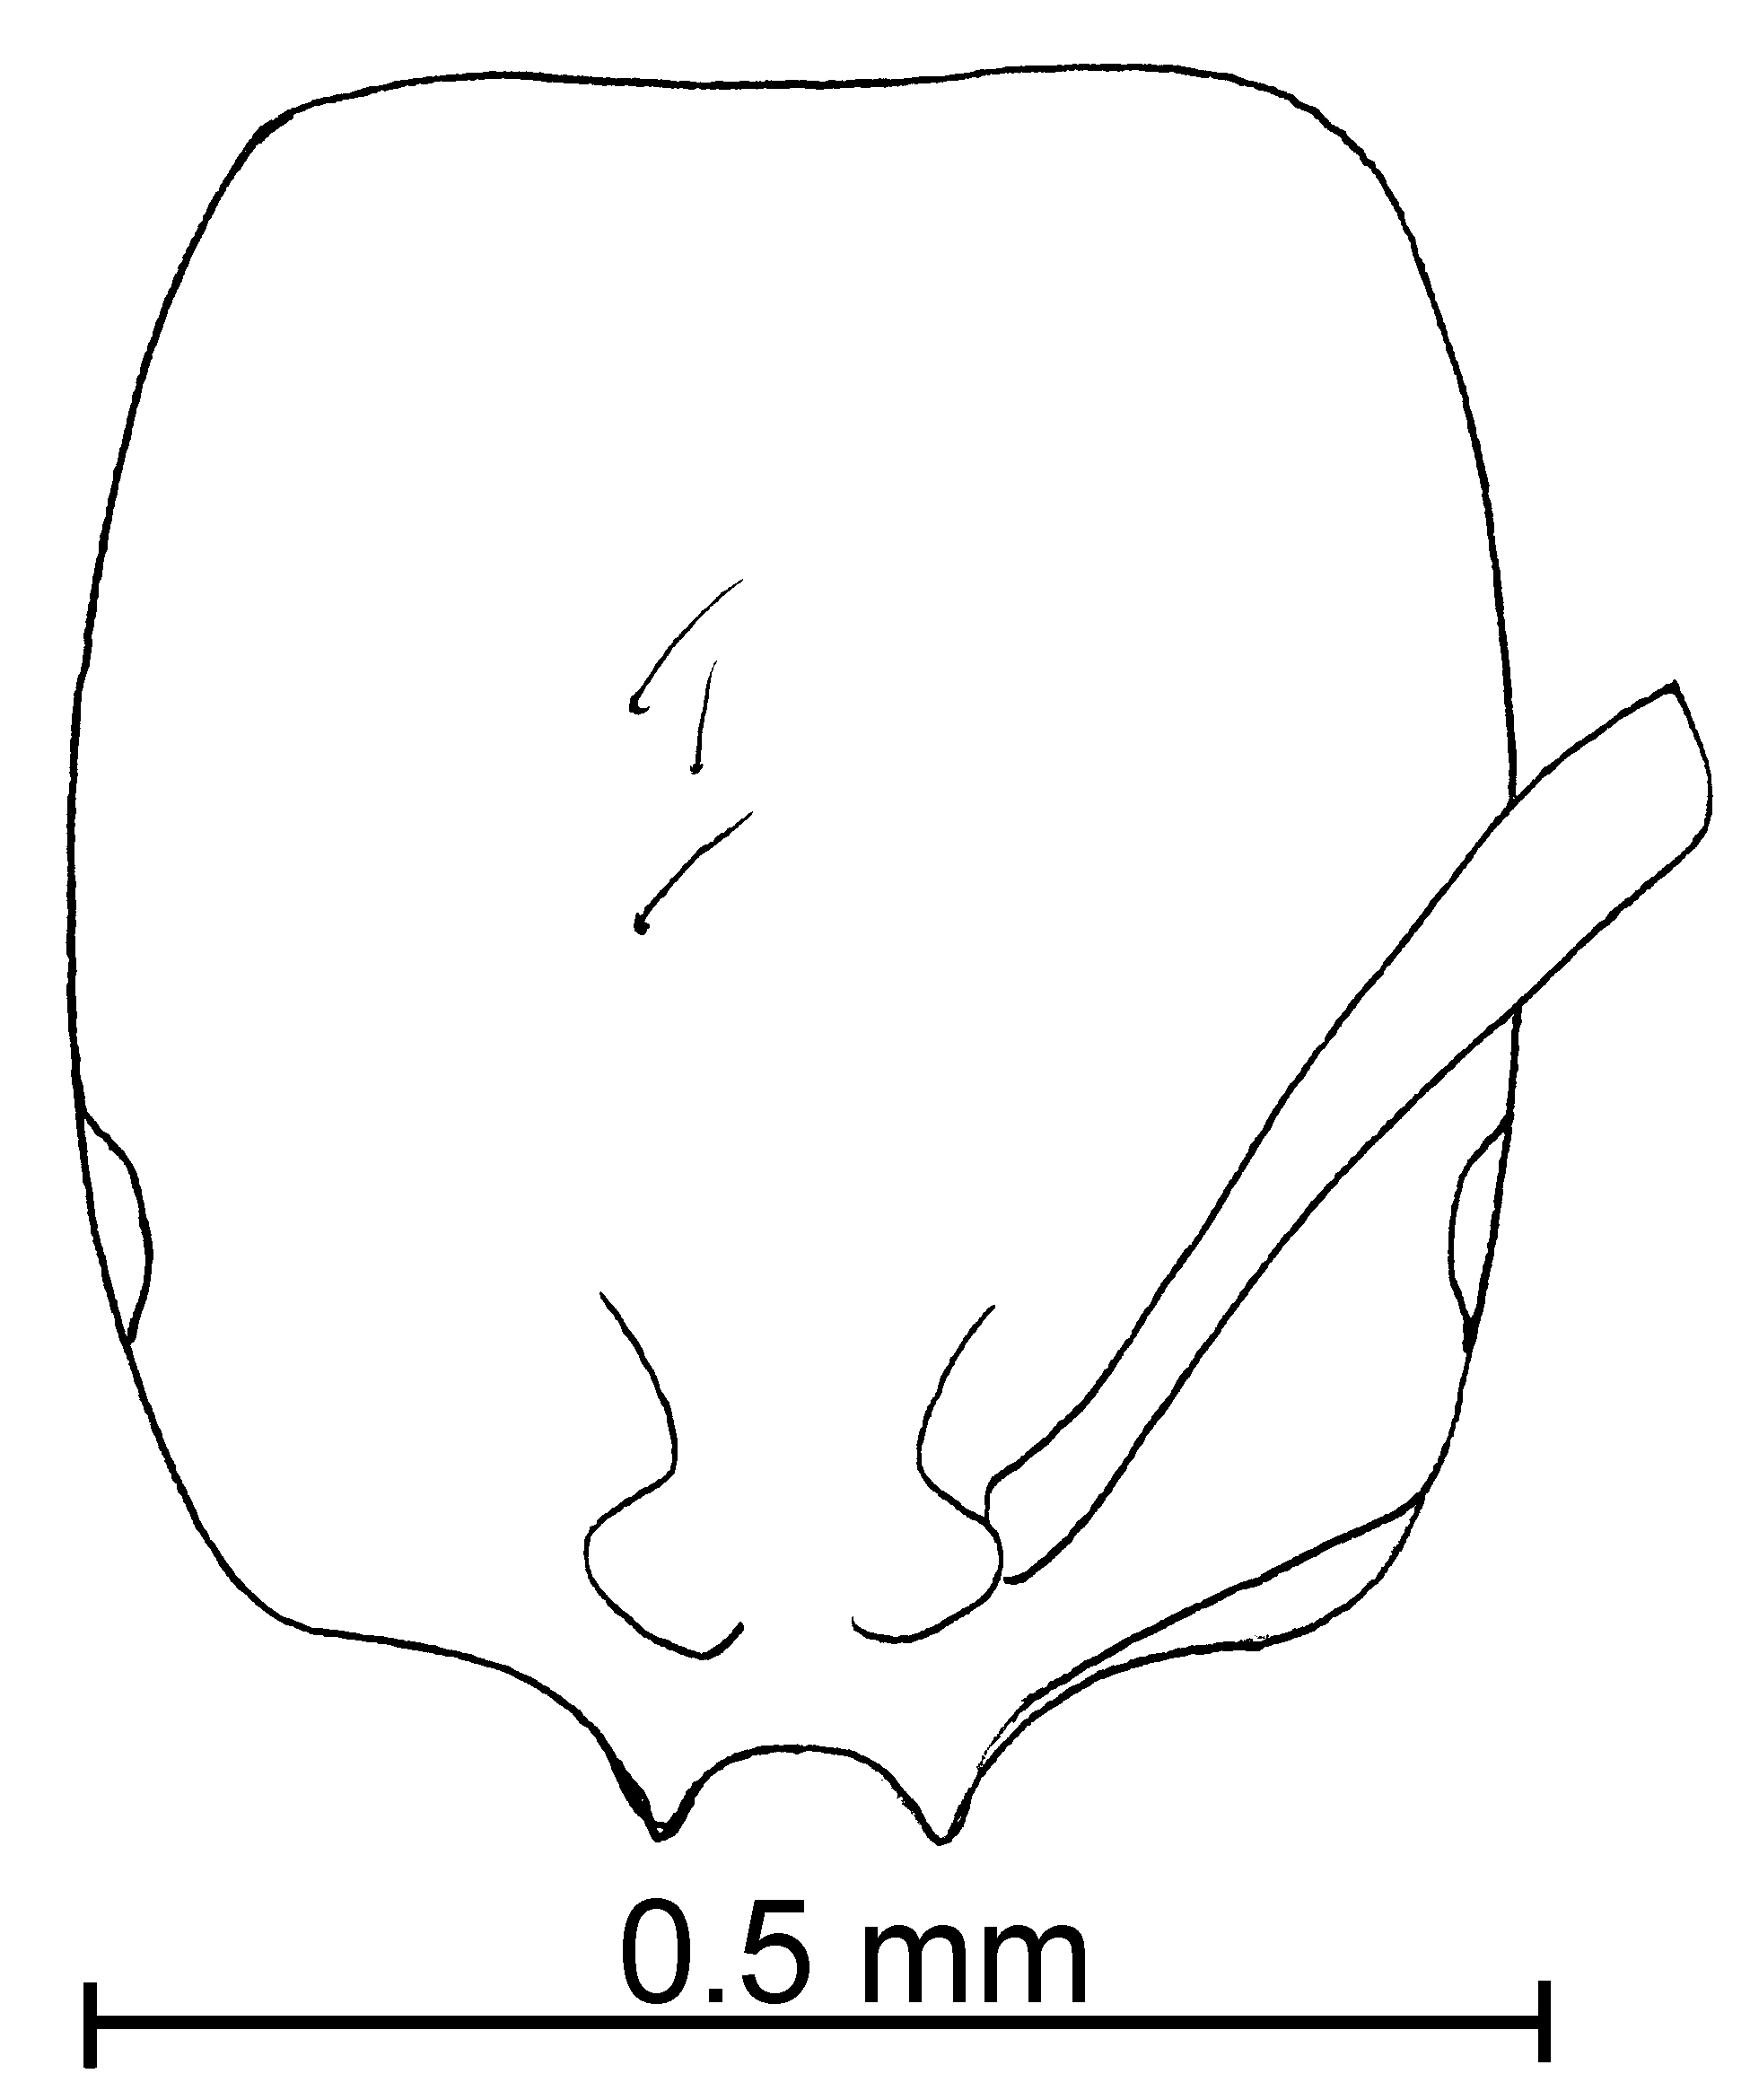
Fig. 26. Head of a _____________ worker of S. corticalis.
Distribution: Mexico (Chiapas, Tabasco, Veracruz) south to Panama (Canal Zone, Chiriquí), Caribbean Region (Puerto Rico and Cuba) (see Map 6).
Map 15. Solenopsis abdita in North America.
Types: Lectotype female, and 6 paralectotype workers [here designated], S. corticalis worker Forel type, St. Thomas (MHNG)
Material examined: COSTA RICA: Guanacaste, Loma Barbudal, 3-vi-1989, ii-1990, S. Vinson #’s 12143, 12047, 12242, 13227, 13232 (12  CWEM), Maritza Field Station, 3-v-1995, R. Anderson #17716 (4  CWEM), Puntarenas 4k S. Las Cruces, 19-vi-1998 #18680 (2  CWEM), same locality, 5k SW Estación Biológico Las Cruces, 22-vi-1998 #18665 ( 6  CWEM). MEXICO: Chiapas, 10k S Palenque, 30-31-v-1988, W. Mackay #’s 10606, 637 (3  CWEM), same locality, 24K Cintalpa, 02-vi-1988, W. Mackay #’s 10723H, 726B, H, 726F, 17J, 18G, 637 (31  CWEM); Tabasco, 5K N Cárdenas, 28-v-1988, W. Mackay #’s 10496, 501, 519 (10  CWEM); Veracruz, 6.5 K N Tierra Blanca, 28-v-1988, W Mackay #’s 10454, 55, 57, 58, 59, 60, 63, 66, 72, 97, 83, 86, 85, 10496, 10832 (90  CWEM), Tontoyuca, 08-vi-1988, W. Mackay # 10894 (10 , 18 , 2  CWEM). NICARAGUA: Izapa, Nobarasca, 16-vi-1986, J. Palacios, (6  CWEM). PANAMA: Chiriquí, Bocas del Toro, Continental Divide, 9-vi-1995, R. Anderson #’s 17844, 45 (8  CWEM), same locality, La Fortuna, Finca La Suisse, 10-vi-1995, R. Anderson #17789, 823 (12  CWEM), same locality, 11-vi-1995, #’s 17827, 30 (7  CWEM), La Fortuna, Hydrological Trail, 1100m , 09-vi-1995, R. Anderson #17785 (2  CWEM).
Biology: They nest in logs stumps, forest litter and also in the soil.

`` Solenopsis hammari
Solenopsis hammari Mayr, 1903:400, , Brasil, São Paulo, São Paulo, Serra da Cantareira
Solenopsis helena hermione Wheeler, 1921d:157  Guiana: Kartabo new synonymy

molesta species complex

Diagnosis: Workers are small specimens (total length ~ 1.4 mm), but with the minor segments of the antenna being 0.12 mm in length. The head is relatively elongated, with the sides nearly straight. The eye is small (0.04 mm maximum diameter) and apparently composed of 3 - 4 ommatidia. The propodeal spiracle is smaller than the eye (maximum diameter 0.03 mm). Color of the worker and the female ranges from pale brown to yellow.
This species can be separated from S. helena is it is larger (female medium sized, head length 0.54 - 0.56 mm, Weber’s length 0.94 - 0.97 mm,) maximum eye length 0.16 - 0.18 mm). It can be separated from S. idae in that is it is smaller (total length of worker ~ 1.3 - 1.5 mm, vs. ~ 2.2 mm in S. idae). It could be easily confused with the darker S. picta, but can be separated on the basis of color (much lighter in color than S. picea) and by having a smaller propodeal spiracle (propodeal spiracle of S. picea is larger in diameter than the diameter of the eye.)
Solenopsis helena hermione (both workers and females) differs only in being yellow, instead of the apparently “normal” pale brown color of this species.

Fig. 27. Mesosoma, pedicel and first gastral tergum of the lectotype worker of S. hammari (X).
Fig. 28. Head of the lectotype worker of S. xx (X).

Fig. 29. Propodeum and pedicel of the paralectotype female of S. xx (X).
Fig. 30. Head of the paralectotype female of S. xx (X).

Distribution: BRASIL: São Paulo (type se.ies), GUIANA: Kartabo (type series). JAMAICA?
Map 16. Solenopsis hammari in South America.
Type series: Solenopsis hammari: lectotype worker (MCZC), Cantarera, b. San Paulo, Coll. G. Mayr; S. Hammari, G. Mayr, Type (MCZC).
Solenopsis helena hermione: lectotype worker, 4 paralectotype workers, 1 paralectotype female (MCZC).
Material examined: Type series and
Biology: Wheeler (1921) reported that numerous specimens of S. helena hermione were collected from several colonies found in petioles of young Tachigalias along the Cuyuni trail at Kartabo. He also stated that it nests in hollow twigs of various other plants.

`` Solenopsis hayemi Forel ***here

molesta species complex
Solenopsis hayemi Forel, 1908:45 (w.)

Diagnosis: This is a large (total length), bicolored dark reddish-brown and black species (head and mesosoma red, gaster black). It has moderate sized eyes with at least two ommatidia. Its hair is fine, and dispersed all over the body, including the gaster. The second segment of the club is extremely long and it has few or no hairs. It has a small bump between the poorly developed, widely spaced lateral clypeal teeth (Fig. 11a). The metanotal suture is very depressed. The petiole is very wide laterally and petiole and postpetiole are about the same height.
Fig. 31. Petiole and postpetiole of a __________ worker of S. hayemi.
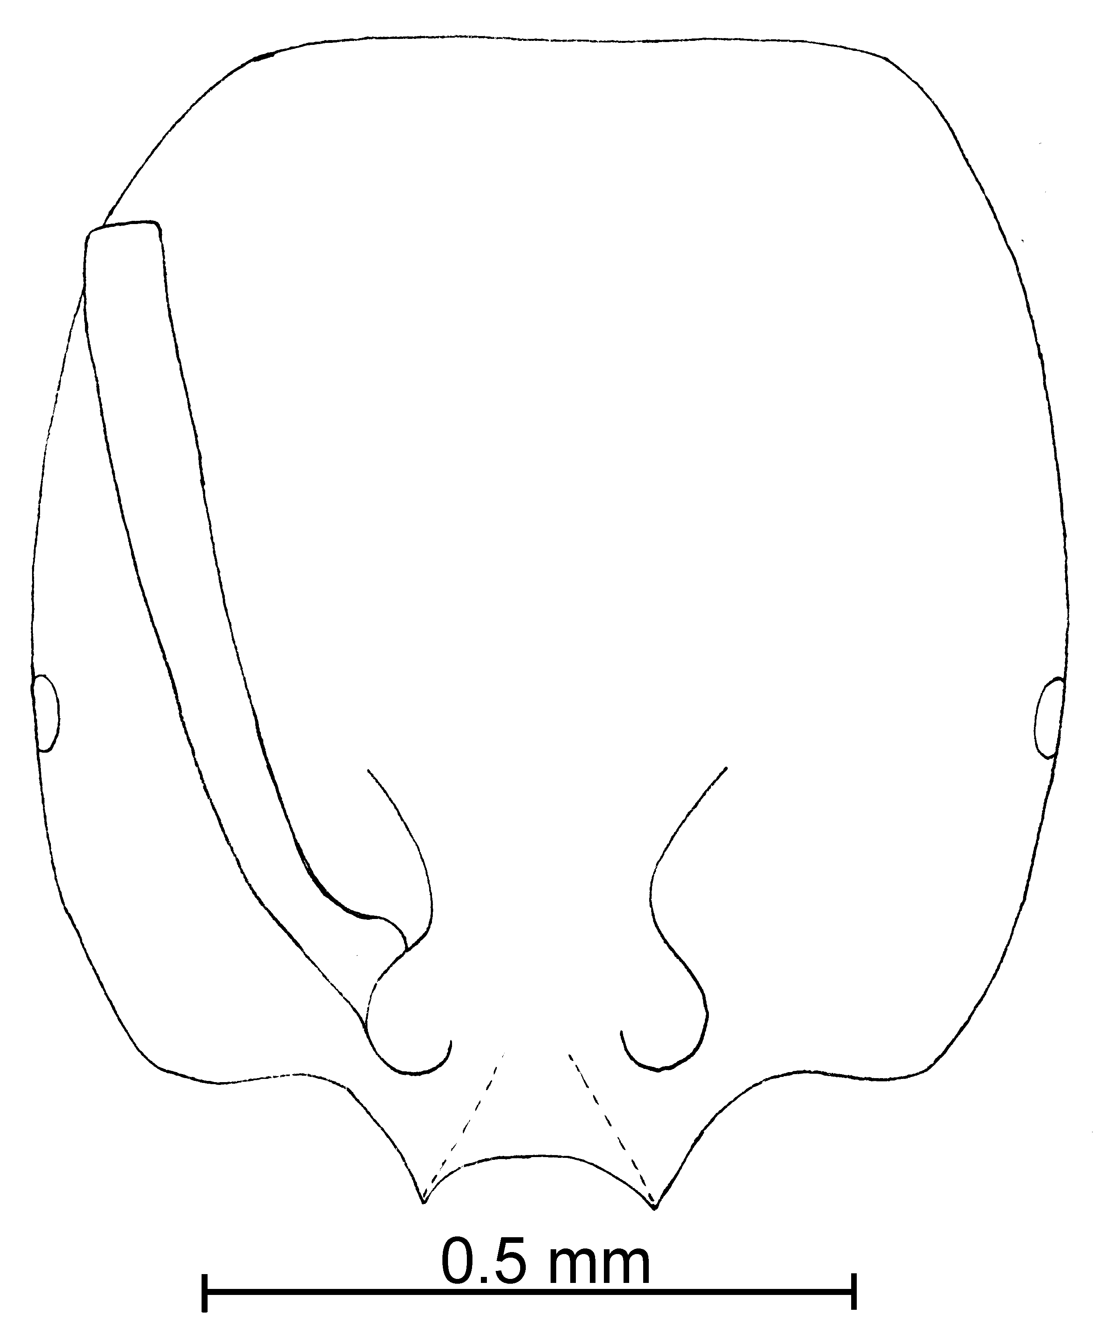
Fig. 32. Head of a ________ worker of S. hayemi.
Distribution: Mexico (Chiapas and Veracruz) south to Costa Rica (El Hiquito, San Mateo) (see Map 7).
Map 17. Solenopsis hayemi in North America.
Types: Lectotype worker [here designated], S hayemi Forel, worker Cotype Costa Rica, El Hiquito, S. Matto, Broffey cotype #22615 (MCZC).
Material examined: MEXICO, Chiapas 10 Km. S Palenque, 31-v-1988, W. Mackay #’s 10605, 10635, 10642 (sp B near hayemi?, 9  CWEM); Veracruz, 13 Km. WNW El Potrero, 16-xii-1948, W. Mackay #17381 (8  CASC).
Biology: These ants nest under ground.
`` Solenopsis helena,

xx species complex

Diagnosis:
Measurements: Worker TL mm, HL mm, HW mm, SL mm, Indices: CI, SI.
Fig. 33. Mesosoma and pedicel of the lectotype worker of S. helena.
Fig. 34. Head of the lectotype worker of S. helena.
Female TL mm, HL mm, HW mm, SL mm, Indices: CI, SI.
Male TL mm, HL mm, HW mm, SL mm, Indices: CI, SI.
Description:
Distribution:
Map 18. Solenopsis helena in North America.
Map 19. Solenopsis helena in South America.

Type series: Holotype worker (MCZC), paratype workers (.
Material examined: Type series and
Biology: .
`` Solenopsis depilis Moreno & Mackay, new species
new species 3

pygmaea species complex

Diagnosis of worker: This is a milky, light yellow colored specimen, its eyes are very transparent, poorly visible, about the color of the remainder of the ant. The lateral teeth of the clypeus are well developed and the extralateral bumps only slightly developed. It is nearly completely without hairs.
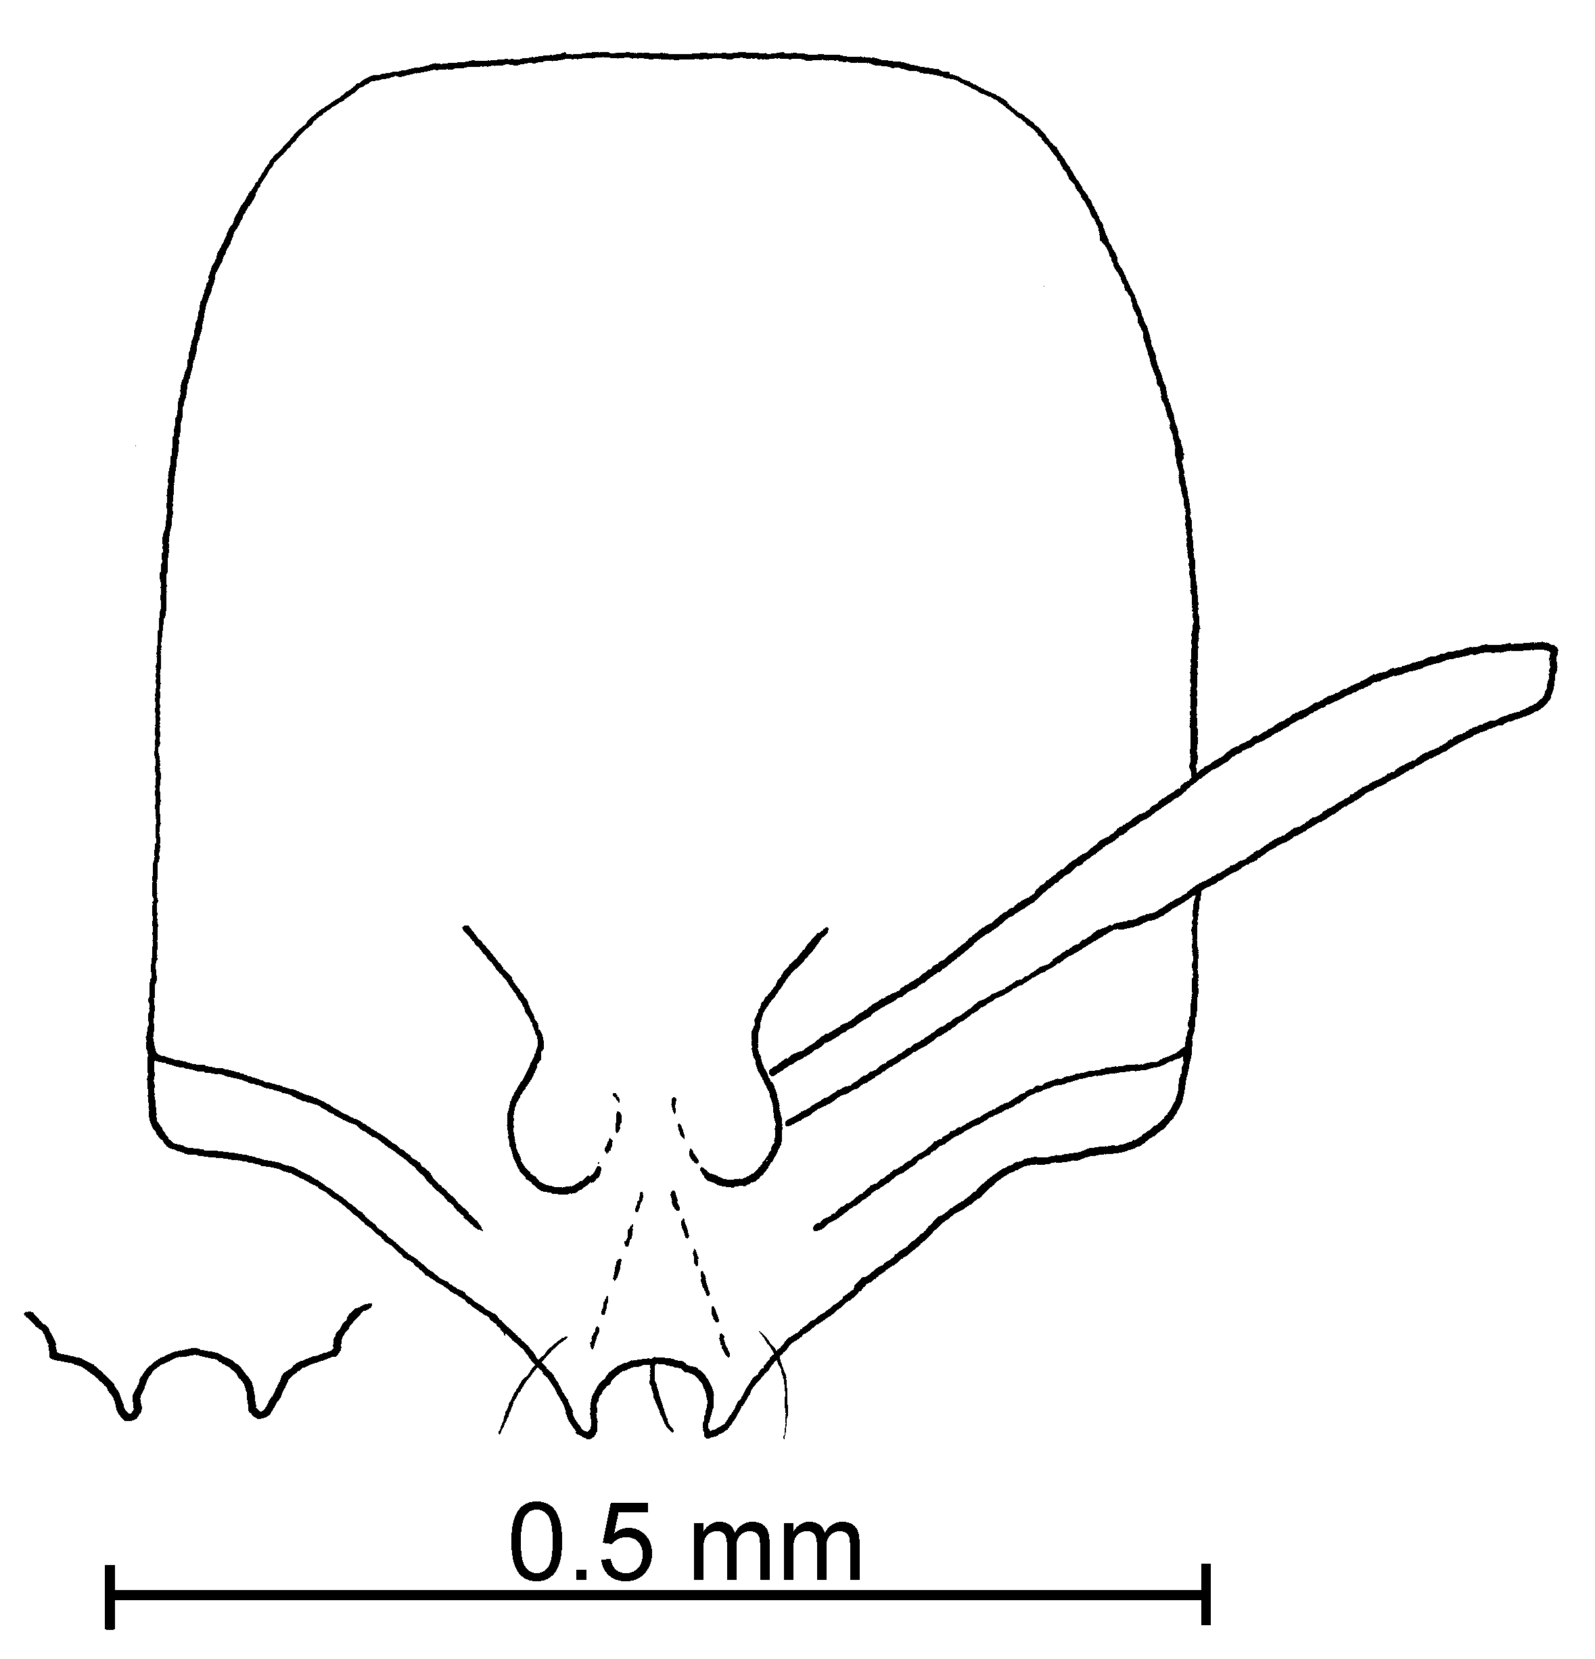
Fig. 35. Side of the head of the holotype worker of S. debilis. The inset shows the anterior edge of the clypeus as seen in a direct view.
Measurements: TL 1.22 - 1.27 mm, HL 0.34 - 0.40m, HW 0.32- 0.33 mm, SL 0.25 - 0.28 mm. Indices: CI 94 - 82, SI 70 - 73.
Description: Head elongate, dorsal and ventral surfaces convex, sides of head straight, posterior border rounded; lateral clypeal teeth very well developed, medial tooth absent, extralateral bumps poorly developed, scape extends slightly more than two thirds length of head; eye barely visible, same color as cuticle, ommatidia not evident; antennae very slender, including club; mesosoma and petiole as in other members of minutissima complex.
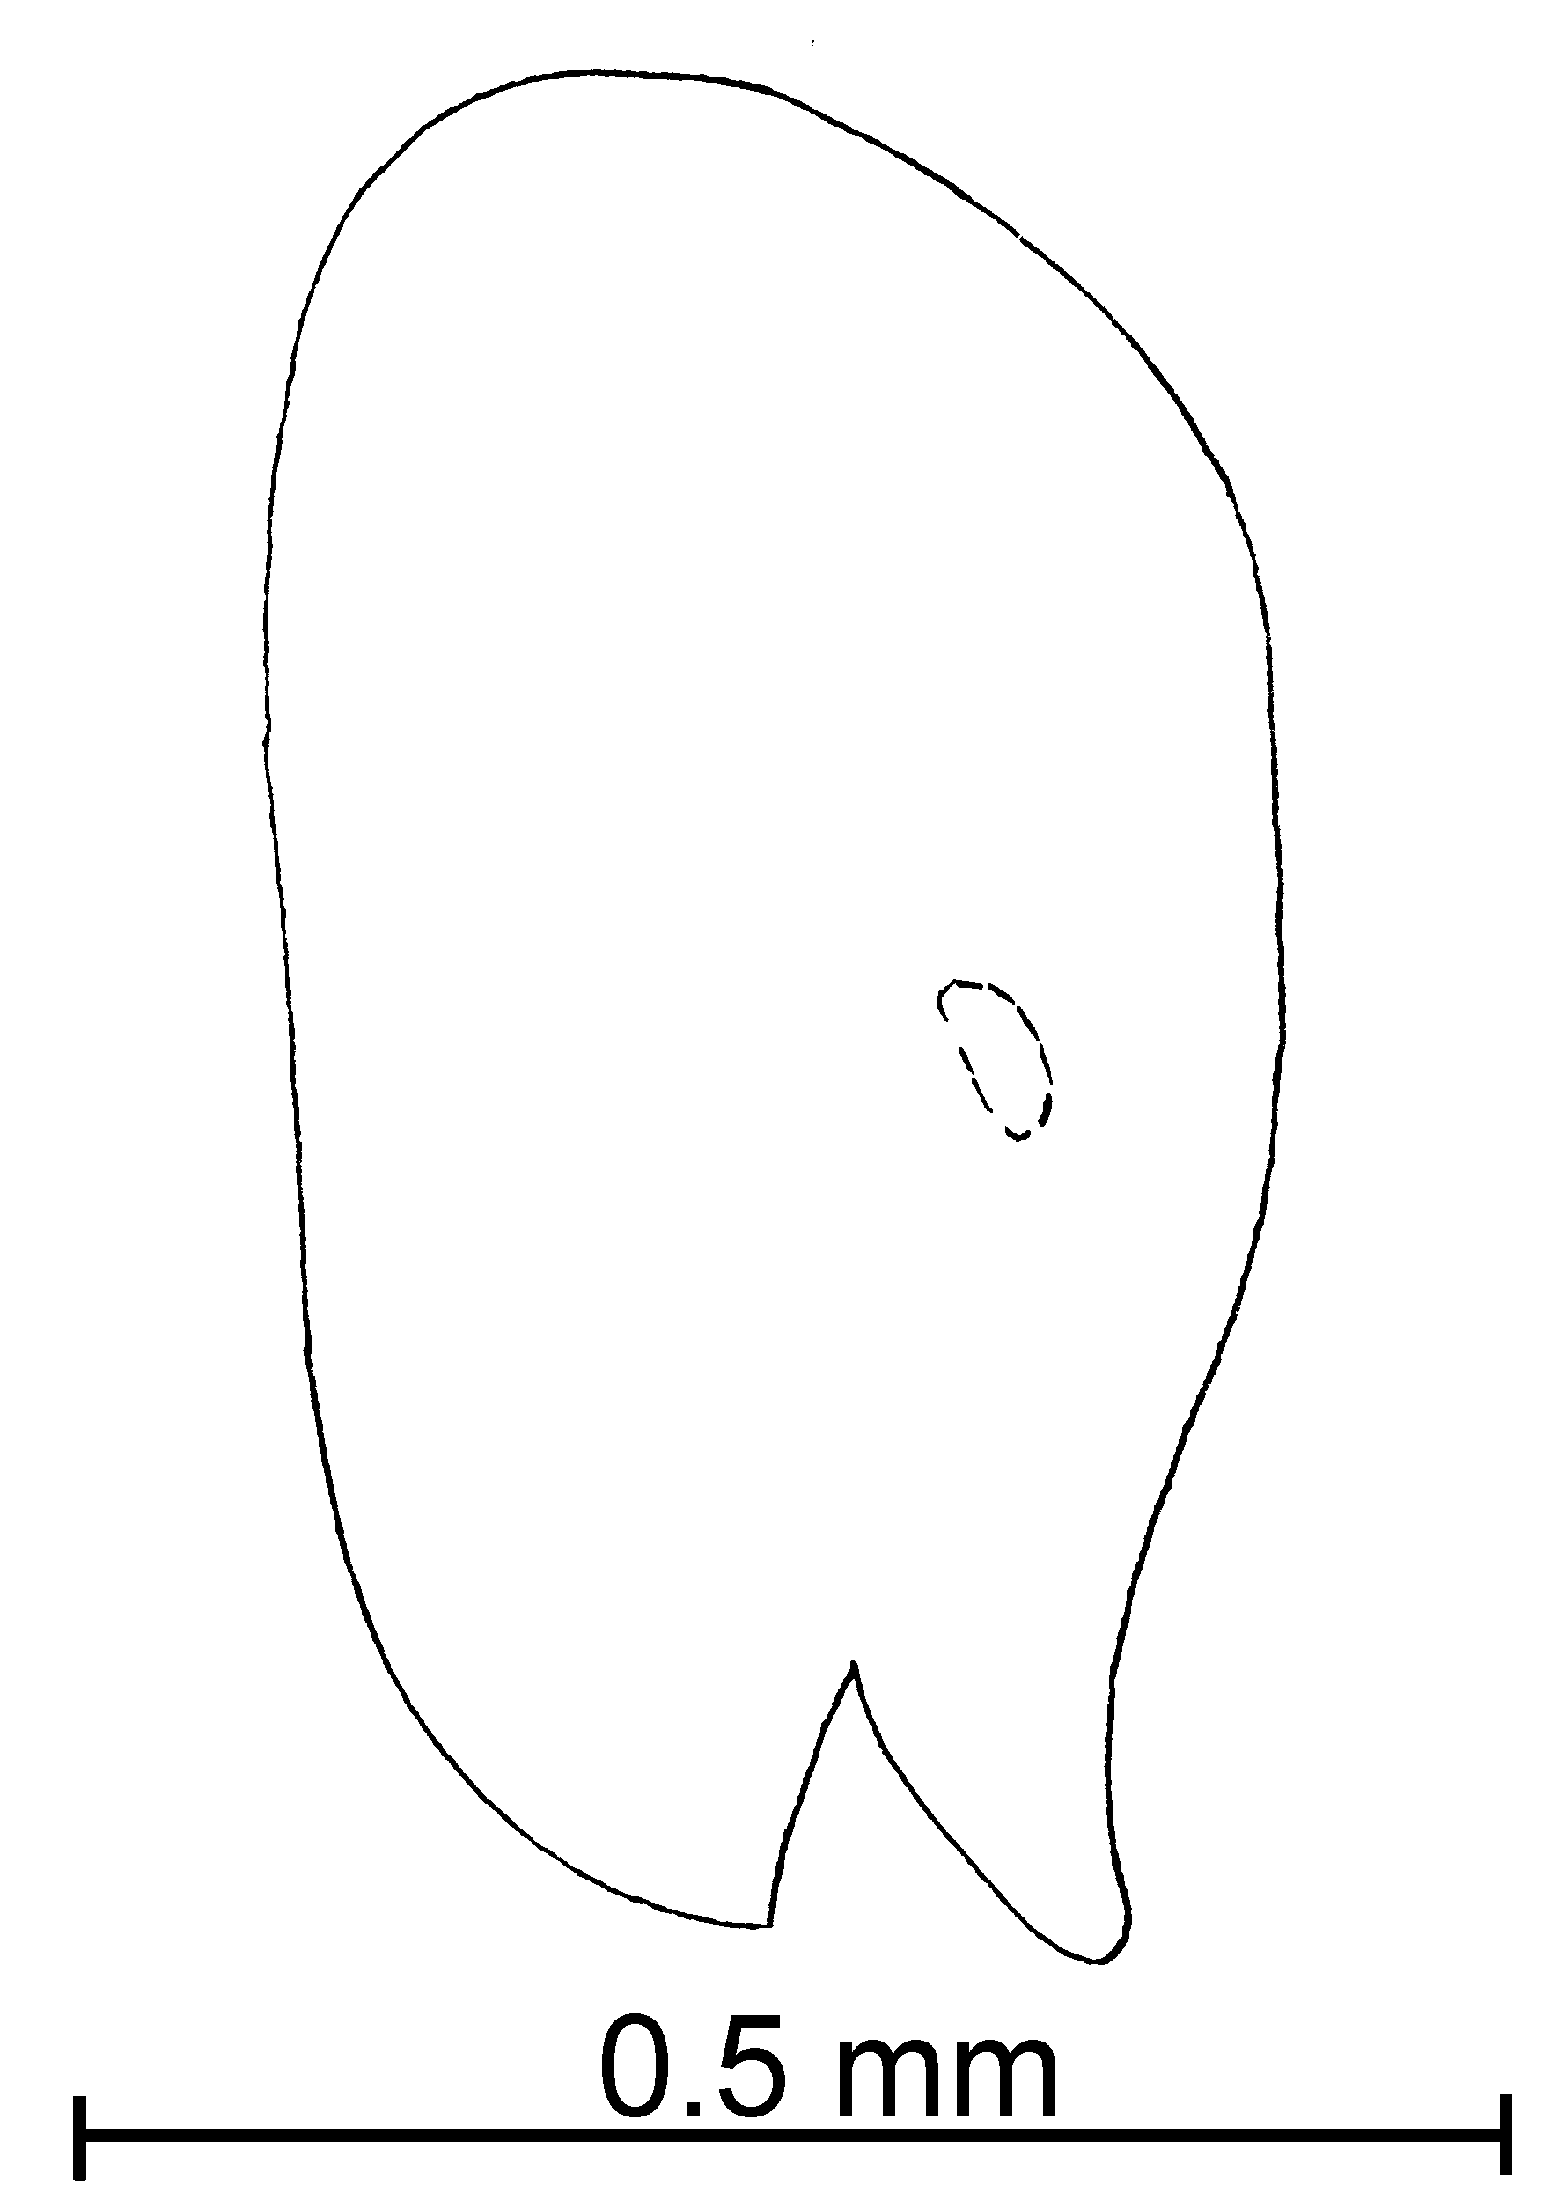
Fig. 36. Side of the head of the holotype worker of S. debilis.
Head with coarse punctures and with no hairs at all. Hairs absent on whole body including gaster. Head, mesosoma, and gaster light yellow, antennae and legs milky white in color.
Female and Male: Unknown.
Distribution: Known only from the type locality (see Map 8).
Map 20. Solenopsis debilis in North America.
Type Series: Holotype worker (MCZC), 4 paratype workers (CWEM, Pullen collection), USA Texas, Bandera Co., W. Bandera, 30-viii-1963, B. Pullen.
Etymology: From Latin, depilis, meaning without hair.
Material examined: Type series.
Biology: Unknown.
`` Solenopsis franki Forel
molesta species complex

Diagnosis:
Measurements: Worker TL mm, HL mm, HW mm, SL mm, Indices: CI, SI.
Fig. 37. Mesosoma, pedicel and first gastral tergum of the lectotype worker of S. xx (X).
Female TL mm, HL mm, HW mm, SL mm, Indices: CI, SI.
Male TL mm, HL mm, HW mm, SL mm, Indices: CI, SI.
Fig. 38. Head of the lectotype worker of S. xx (X).

Description:
Fig. 39. Propodeum and pedicel of the paralectotype female of S. xx (X).
Fig. 40. Head of the paralectotype female of S. xx (X).

Distribution:
Map 21. Solenopsis franki in South America.
Type series: Holotype worker (MCZC), paratype workers (.
Material examined: Type series and
Biology: .
`` Solenopsis idae Forel

molesta species complex

Diagnosis: This is a small, yellow species, which can be characterized as having a thickened petiole (when viewed profile), and by having only a few, erect, long (up to 0.15 mm) hairs on the mesosoma. The medial clypeal teeth are poorly developed the lateral teeth are present only is swollen regions along the anterior margin of the clypeus. The eyes are small, consisting of only three or four ommatidia, the sides of the head are convex and rounded, the posterior border of a head is nearly straight. The antennal scape reaches approximately three-fourths the distance to the posterior lateral corner.
Forel (1908) lists the total length of this species as being 2 - 2.4 mm. Measurement of 5 of the cotypes (one cotype is missing the head) shows the largest to have a total length of 2.25 mm (smallest 1.75 mm) , and the mean length to be 1.94 mm ± 0.24 SD. Specimens (N = 6) from Colombia have a mean total length of 2.10 ± 0.14 (range 1.90 mm - 2.25 mm). The head length of the type series is
The specimens from Colombia differ in being medium brown and in having slightly smaller eyes (0.48 mm greatest diameter).

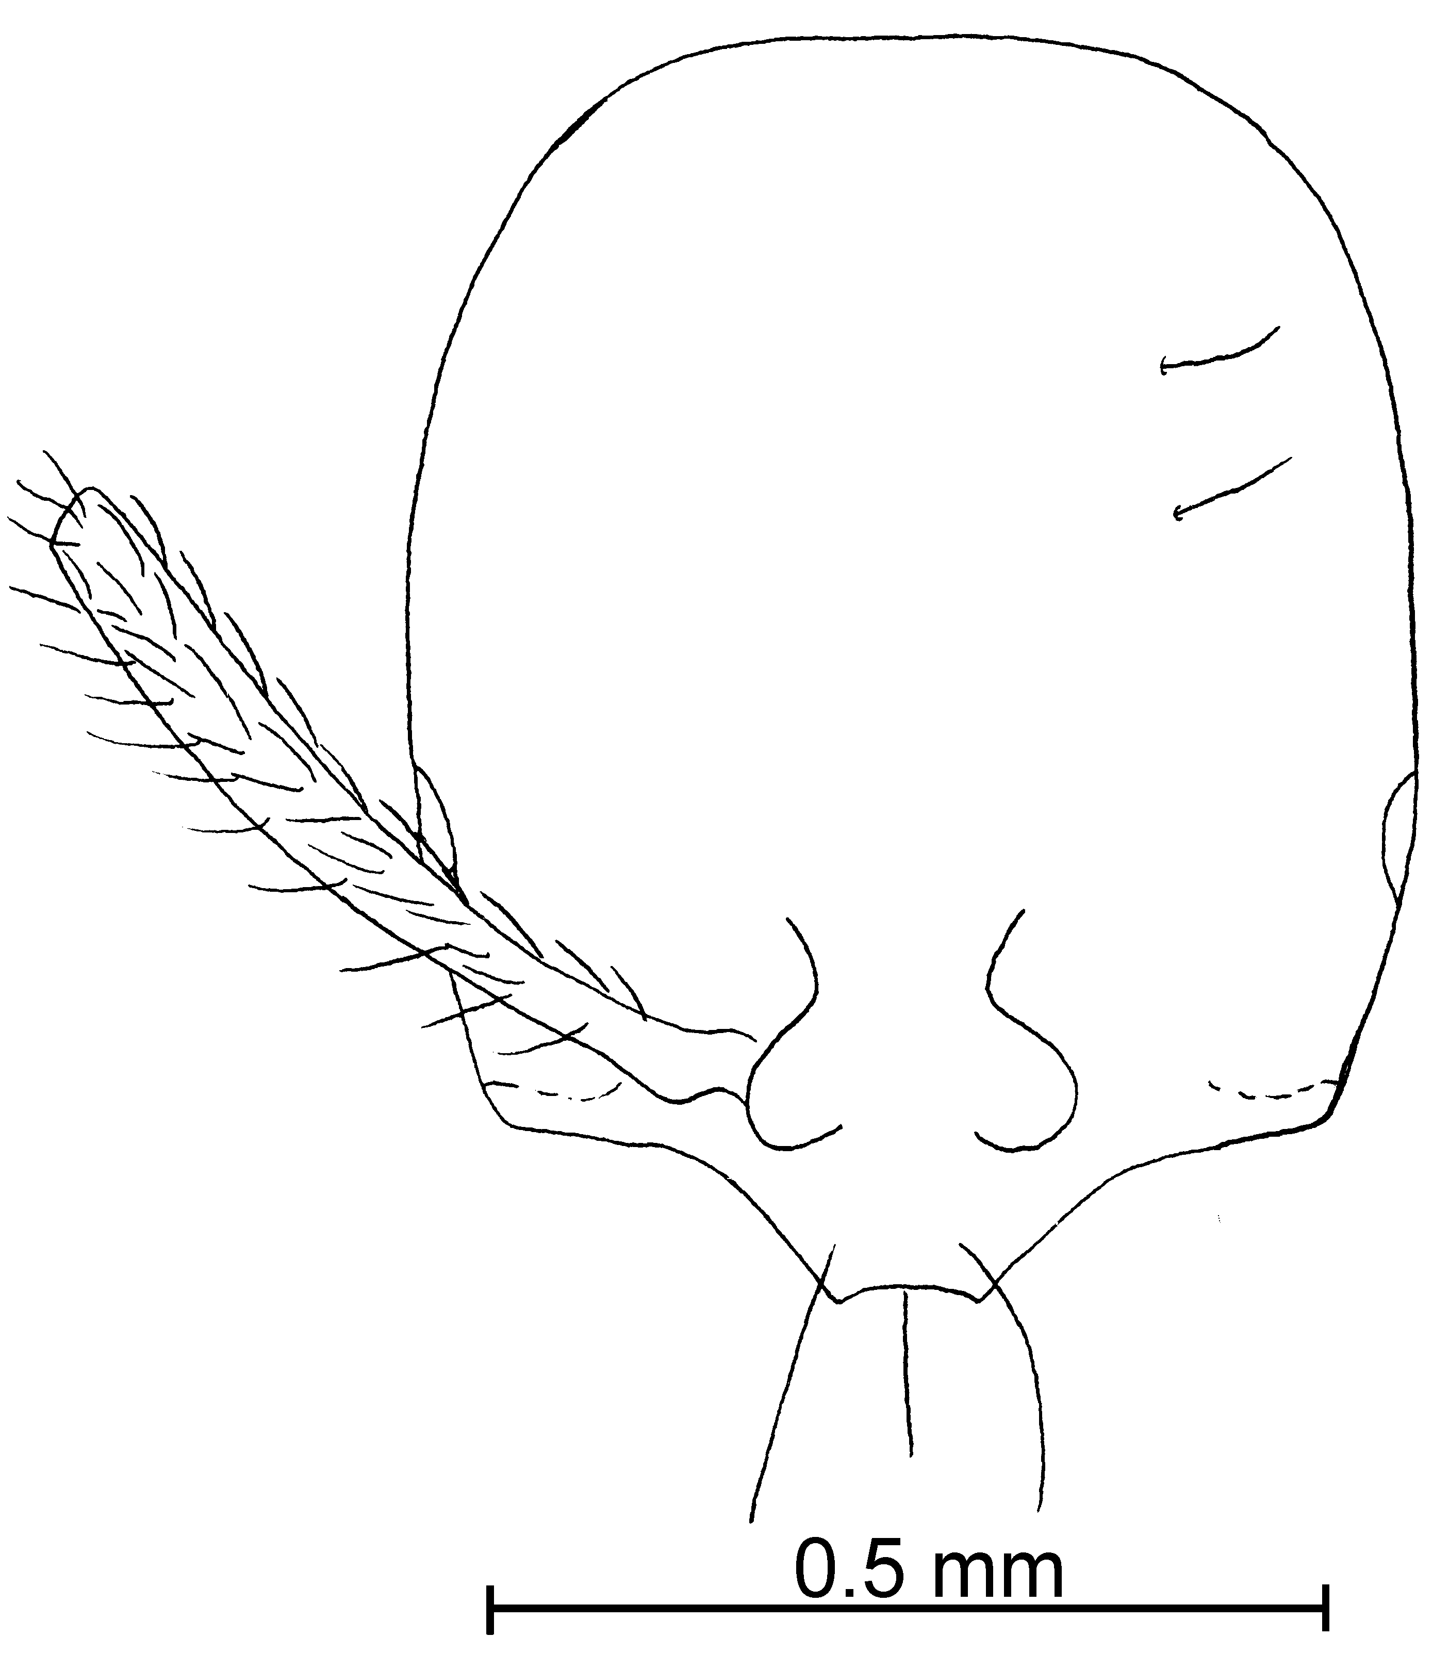
Fig. 41. Head of the lectotype worker of S. idae.
Distribution:
Map 22. Solenopsis idae in South America.
Type series: Lectotype worker (MHNG), 5 paratype workers (MHNG), S. Franki  Forel r. Idea Forel Type Sao Paulo (v. Ihering); #5578.
Map 23. Solenopsis xx.
Material examined: Type series and
Biology: .
`` Solenopsis isopilis Mackay & Moreno, new species
new species 4

pygmaea species complex

Diagnosis: The workers of this species are small and yellowish-brown, with an elongate head, which is covered with coarse punctures. The erect hairs on the dorsum of the head, and dorsum of the gaster are about equal in length and are usually very dense, especially on the dorsum of the gaster. The eye is small, and the same color as a remainder of the head, but is well defined, although individual ommatidia cannot be distinguished. The minor segments of the funiculus are short, only slightly longer than the shortest segment of the antennal club.
The erect hairs of equal lengths on the dorsum of the gaster would separate this species from most of the others (including S. whitfordi), except for S. minutissima, S. pygmaea and S. subterranea. It can be easily separated from S. pygmaea and S. subterranea by having few erect hairs on the dorsum of the propodeum (when viewed in profile). The well-defined eyes would separate it from S. minutissima.
Measurements: Worker TL 0.96 - 1.12 mm, HL 0.31 - 0.32 mm, HW 0.22 - 0.23 mm, SL 0.17 - 0.18 mm, Indices: CI, 67 - 73 SI 52 - 58.
Description: Clypeal carinae and lateral teeth well-developed; head elongate posterior margin slightly concave; scape extends slightly less than half distance to posterior lateral corners; eye small (maximum diameter 0.02 mm) but well-defined; minor segments of funiculus 0.04 - 0.05 mm in length.
Erect hairs on dorsum of head abundant (0.02 mm in length), nearly equal in length, pronotum with approximately 10 erect hairs (0.03 mm in length), hairs on remainder of mesosoma, petiole, and postpetiole similar, erect hairs on dorsum of gaster approximately equal in length (0.02 mm).
All surfaces with a glossy, head with scattered, of course punctures, remainder of a hand without such punctures.
Concolorous yellow brown.
Female and male: Unknown.
Distribution: Known only from the type locality.
Map 24. Solenopsis isopilis in North America.
Type series: Holotype worker (Instituto de Ecología), and 15 paratype workers (CWEM, LACM, MCZC, USNM), MEXICO: Veracruz; Res. Ecol. “La Mancha”, junio 1991; Col. P. Rojas.
Etymology: From Greek, isos, meaning equal, and pilos meaning hair, referring to the numerous hairs on the gaster, which are equal in length.
Material examined: Type series.
Biology: The type series was collected in a selva mediana subperennifolia (medium, sub perennial rain forest) in a subterranean trap at 0 meters elevation.
`` Solenopsis johnsoni Moreno & Mackay, new species
new species 5

fugax species complex

Diagnosis: These ants are light yellow in color and are characterized by square like head shape having very hairy body with various of length including gaster. The lateral clypeus teeth are very well developed and the extralateral teeth are present but not as well developed. The scapes are relatively long (0.37 in the major, 0.30 mm in the minor), the minor segments of the antenna are relatively long (0.16 in the major, 0.12 in the minor).
Measurements: TL 1.6-2.5 mm, HL 0.45 - 0.60 mm, HW 0.33 - 0.57 mm, SL 0.28- 0.41 mm. Indices: CI 76 - 95, SI 62 - 68.
Description: Head slightly longer than wide, sides of head straight, posterior border slightly concave in workers, in soldiers it is straight; lateral clypeal teeth very well developed, medial tooth absent, extra lateral teeth not well developed, scape extends slightly more than ²/₃ length of head; small, brown eye, at least three ommatidia lower mesopleural region slightly striated, oval petiole and postpetiole.
Hairs of various lengths (~ 0.03 - 0.15 mm), erect and semierect hairs on head, about 20 on any line drawn from the posterior border to the posterior base of clypeus, antenna very hairy, scape with few suberect hairs, pronotum with ~ 10 erect hairs projecting above outline, as seen in profile, mesonotum with ~ 4 erect hairs (0.12mm) above profile, ~ 4 on propodeum, ~6 on outline of petiole, ~ 7 on outline of postpetiole, gaster with erected hairs, ~10 erect hairs on outline of first tergum. All hairs are pointing in different directions.
Head many hairs (~ 18 along line from posterior border to border of clypeus), coarse punctures, larger than hairs that originate from them, punctures on mesosoma and gaster less coarse, surfaces between punctures not smooth.
Concolorous pale yellow.
Female: Solid dark yellow color, large, very hairy and with very course punctures, hairs same length (0.15mm) throughout body. It has medium sized eyes (maximum diameter 0.12 mm) and very small ocellus (0.09 mm).
Distribution: Mexico (Baja California Sur) (see Map 9).
Map 25. Solenopsis johnsoni in North America.
Type series: Types. Holotype worker (MCZC), 12 paratype workers (Johnson’s Collection). MEXICO: Baja California Sur, 0.4 mi Sierra San Francisco, 26-i-1995, R Johnson #BCS 1201.
Etymology: Named to honor Robert Johnson, who collected the type series, as well as a large number of other interesting species.
Material examined: Type series
Biology: Solenopsis johnsoni nest under stones.
`` Solenopsis krockowi Wheeler
fugax species complex

Solenopsis krockowi Wheeler, 1908:438, pl. 26, Fig. 28, 29 (f. m.)

Diagnosis: This is a relatively large, deep yellow colored species, with coarse punctures on the head. The head is slightly longer than wide, but somewhat square in shape. The clypeal teeth are widely spaced, with a distance of about 0.10 mm between the teeth. The extralateral teeth are often well developed. The cephalic hairs are short, with an area in the central portion of the head free of hairs. The hairs on the remainder of the body, including petiole and postpetiole, are a mixture of long (0.07 mm) and short (0.04 mm) hairs. The clypeus is straight between the teeth and wide, the lateral and extralateral clypeal teeth are very well developed. It has large eyes, with 3 - 4 ommatidia, the metanotal suture is depressed. It has a large, extended process peduncle, the postpetiole is oval shaped as seen from above. The females (paralectotype) is a very large (TL 7.75 mm), orange specimen, with small eyes (maximum diameter 0.35 mm).
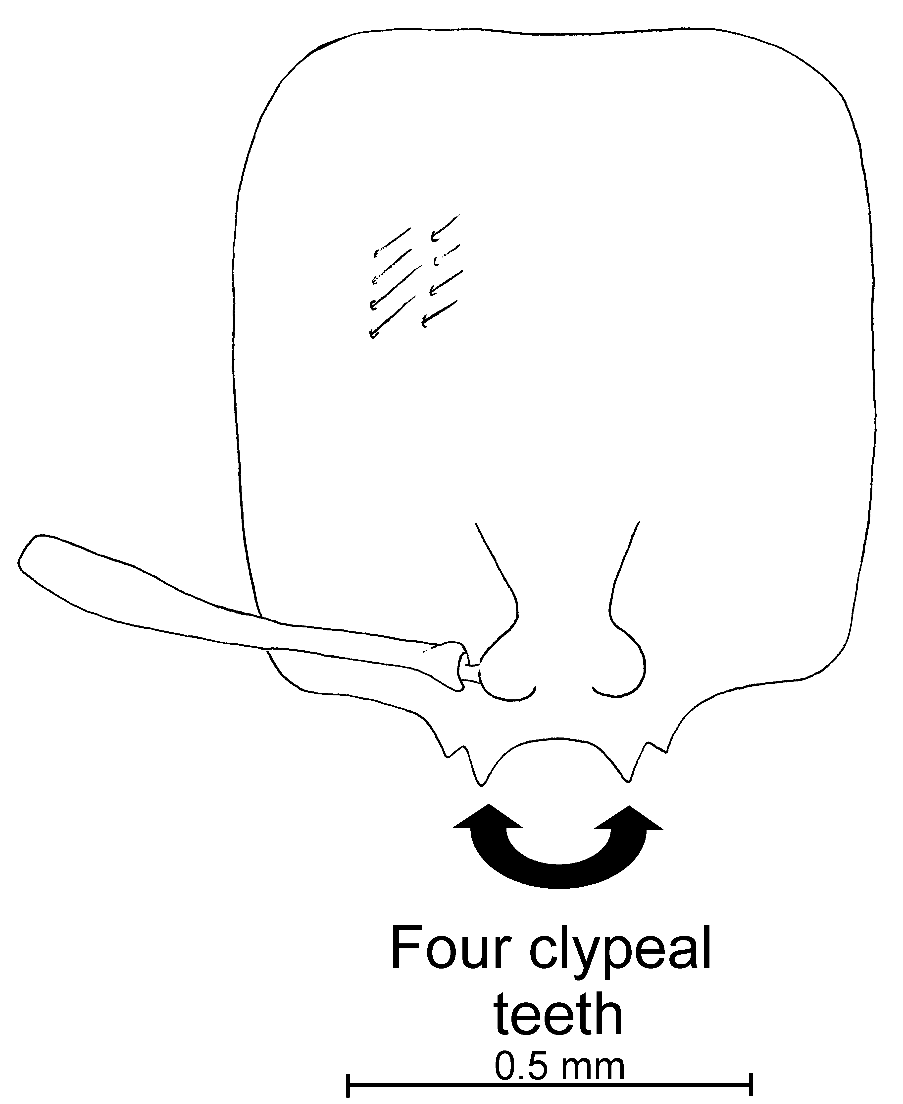
Fig. 42. Head of the __________ worker of S. krockowi .
This species could be confused with S. molesta, but is easily separated by the square-shaped heads, with strongly convex sides. The punctures on the head are very coarse, whereas they are very fine in S. molesta. It can be separated from S. pergandei on the basis of the oval shaped postpetiole. The widely diverging clypeal carinae separate it from S. pilosula, in which the carinae are nearly parallel and closely placed. The widely spaced clypeal carinae and monomorphism separate it from S. johnsoni and S. vinsoni.
Distribution: USA (Arizona and New Mexico) (see Map 10).
Map 26. Solenopsis krockowi in North America.
Types: Lectotype worker, 6 paralectotype workers and 1 paralectotype female [here designated], Wheeler, type, New Mexico, Sacramento Mts., Box Canon, 06-vii-1906, Von Krockow type #1-13 20907 (MCZC).
Material examined: MEXICO: San Luis Potosí, Matehuala, 10-vi-1988, W. Mackay #’s 10960-7, 10968-5, -7, 10970-1, 10972-2, -3, -4, -5, -6, 10974-3, -10 10978-3 (61  CWEM). USA: Arizona, Cochise Co., Chiricahua Mts., 4.0 mi WNW Jct. ESR42B, 15-vii-1992, S. P. Cover #’s 5550, 3251 (2  MCZC), Santa Cruz Co., Cobre Ridge, 3.8mi W. Ruby on FSR 39, 23-viii-2000, S. P. Cover #5991 (12  MCZC); New Mexico, type series, and Doña Ana Co., Las Cruces, 29-iii-1983, 20-v-1984, W. Mackay (7  CWEM), 15 mi N Las Cruces, 11-vii-1983, 11-ix-1983, 5-x-1983, 3-xi-1983, W. Mackay #’s 1121, 1311, 1321, 2112, 2122, 3112, 3311, 3312, 3321 (54  CWEM), 40 k NNE Las Cruces, 29-iii-10983, W. Mackay # 3312 (1  CWEM), 45 k NE Las Cruces, 19-iv-1984, W. Mackay # ‘s LTWEN, 1311, 2122, 2211, 3212 (11  CWEM).
Map 27. Solenopsis krockowi.
Biology: This species nests under stones, in sparse mesquite scrub on rocky slopes. Specimens were collected in a variety of leaf litter, ranging from desert scrub (creosotebush) to cottonwood tree leaves.
`` Solenopsis laeviceps Mayr

molesta species complex

Solenopsis laeviceps Mayr, 1870: 406 (w.)

Diagnosis: Workers are yellow (rarely pale brown with yellow legs, or with brown markings), with a thickened petiole as seen in profile (Fig. 12e). The sides of the head are convex and rounded, and the head is somewhat narrowed posteriorly. Rarely the sides of the head are nearly straight. The smaller segments of the funiculus are at least 0.12 mm in length, usually about 0.15 mm. The clypeal teeth are well developed, and somewhat curved inwards (usually). The lateral teeth are poorly developed. The mesopleuron is nearly completely smooth and glossy. This character separates it from S. striata in which the mesopleuron is nearly completely striolate. Additionally, the petiole is thick as seen in profile, whereas the petiole of S. striata is slender and high when viewed in profile.
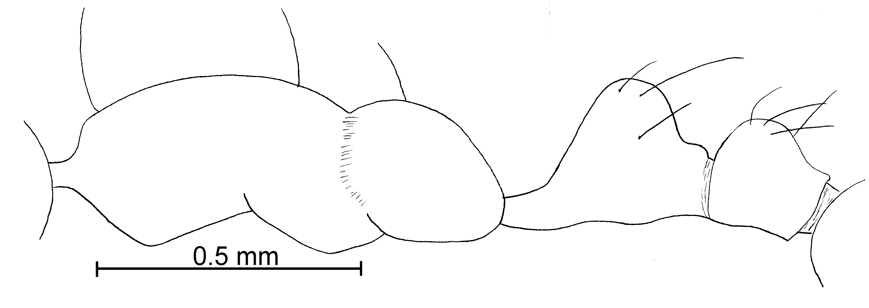
Fig. 43. Mesosoma and pedicel of a ________-worker of S. laeviceps.
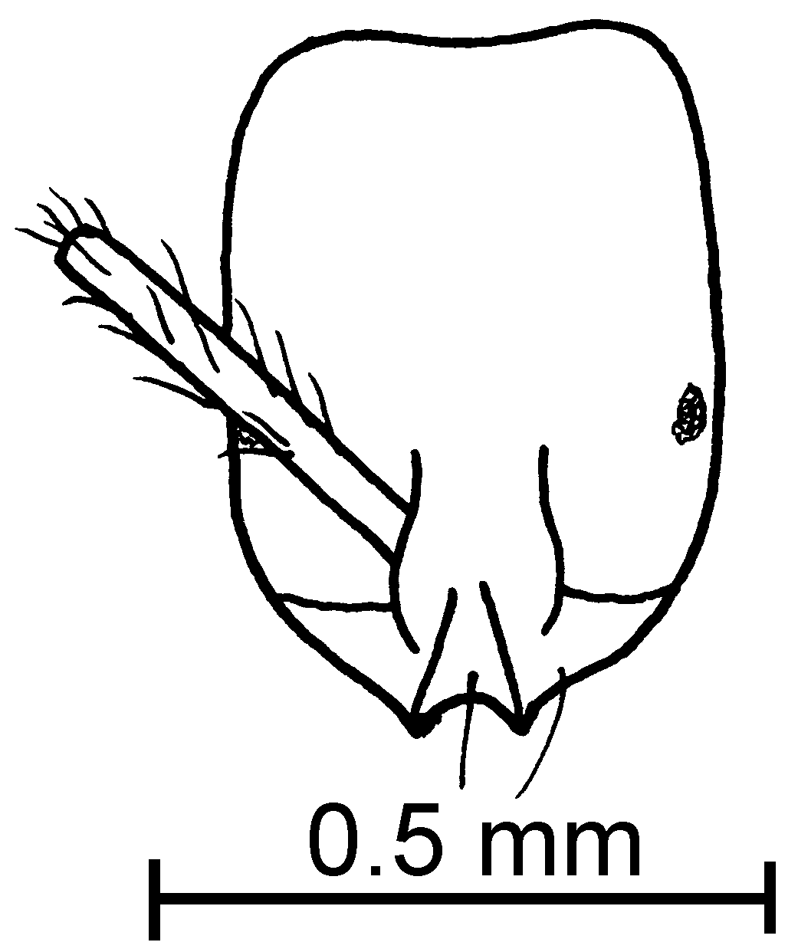
Fig. 44. Head of the lectotype worker of S laeviceps.
Distribution: Costa Rica (Guanacaste) south to Colombia (Cauca, Valle and Valle del Cauca); Caribbean Region (Bahamas). Bahamas, Brasil: SP, PA; Colombia (Cauca, Valle and Valle del Cauca), Costa Rica (Guanacaste), Panama (Bocas del Toro and Chiriquí) Brasil (São Paulo, Pará); (see Map 11).
Map 28. Solenopsis bicolor in North America.
Map 29. Solenopsis laeviceps in North America.
Type series: Lectotype worker, 11 paralectotype workers [here designated], S. laeviceps Mayr worker, type Colombia (NHMW),
Material examined: BELISE: Orange Walk, Rio Bravo Conservation Area, 30-iv-1996 # 17703 (2  CWEM). BRASIL: Santa Catarina, Hečko, (17  NHMW, labeled as types). COLOMBIA: Valle del Cauca, Bosque Yotoco, 23-vi-1989, W. P. Mackay #11654, 87 (4  CWEM), Isla Gorgona, 23-x-1989, M. Baena #’s GAP-Hii6, GAP-IA2 (8  CWEM); Medio Calima Site, 24-vi-1989, W. Mackay #11789 (4  CWEM), Cauca, Isla Gorgona, M Baena #GG-10 (5  CWEM). COSTA RICA: Guanacaste, Loma Barbudal, 3-vi-1989, S. Vinson #’s 12029, 12037 (2  CWEM), Maritza Field Station, 3-v-1995, R Anderson #’s 17715, 17716 (3  CWEM); Puntarenas, Las Cruces, 4 k S San Vito, 19-vi-1996, R. Anderson # 16660 (2  CWEM). PANAMA: Chiriquí, Bocas del Toro, 9-vi-1995, R. Anderson #’s 17840, 17841, 17842, 17843, 17847 (63  CWEM), 20.4 k N San Felix, 950m, 08-vi-1995, R Anderson #’s 17767, 81, 83, 84, 89, 98, 17822 (44 , 3  CWEM), Bocas del Toro, Continental Divide, 9-vi-1995, R. Anderson #’s 17843, 845 (19  CWEM), same locality, La Fortuna, Hydrological Trail, 1100m, 9-vi-95, R Anderson #17785 (11  CWEM), same locality, La Fortuna, Finca La Suisse, 10-vi-1995, R. Anderson #’s 17785, 88, 89, 95 (8  CWEM).
Map 30. Solenopsis laeviceps.
Map 31. Solenopsis laeviceps in South America.
Biology: Specimens were collected in wet mountains, in cloud forest litter.
`` Solenopsis latastei Emery

molesta species complex

Solenopsis latastei var. hoffmanni Forel, 1912:7 , __________ (Snelling and Hunt, 1976:87)

Map 32. Distribution of Solenopsis laeviceps in South America.

Diagnosis:

Forel (1912) separated variety Hoffmanni on the basis of more developed clypeal teeth and the shorter scapes. Direct comparison of the types (workers and females) show that the clypeal teeth, as all other characters are identical. We agree with Snelling and Hunt on their synomization.
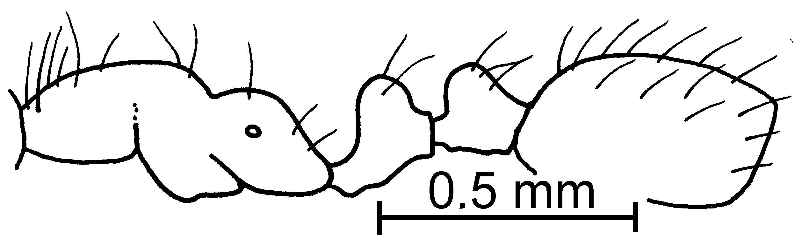
Fig. 45. Mesosoma of the lectotype worker of S. latastei.
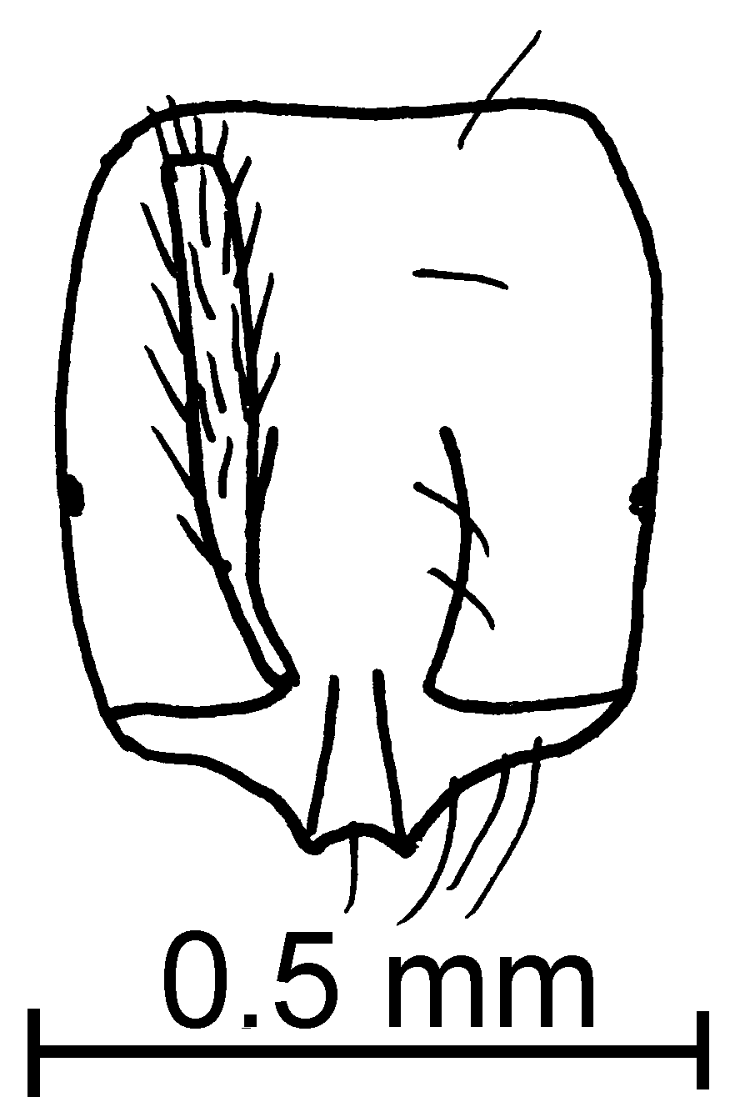
Fig. 46. Head of the lectotype worker of S. latastei.
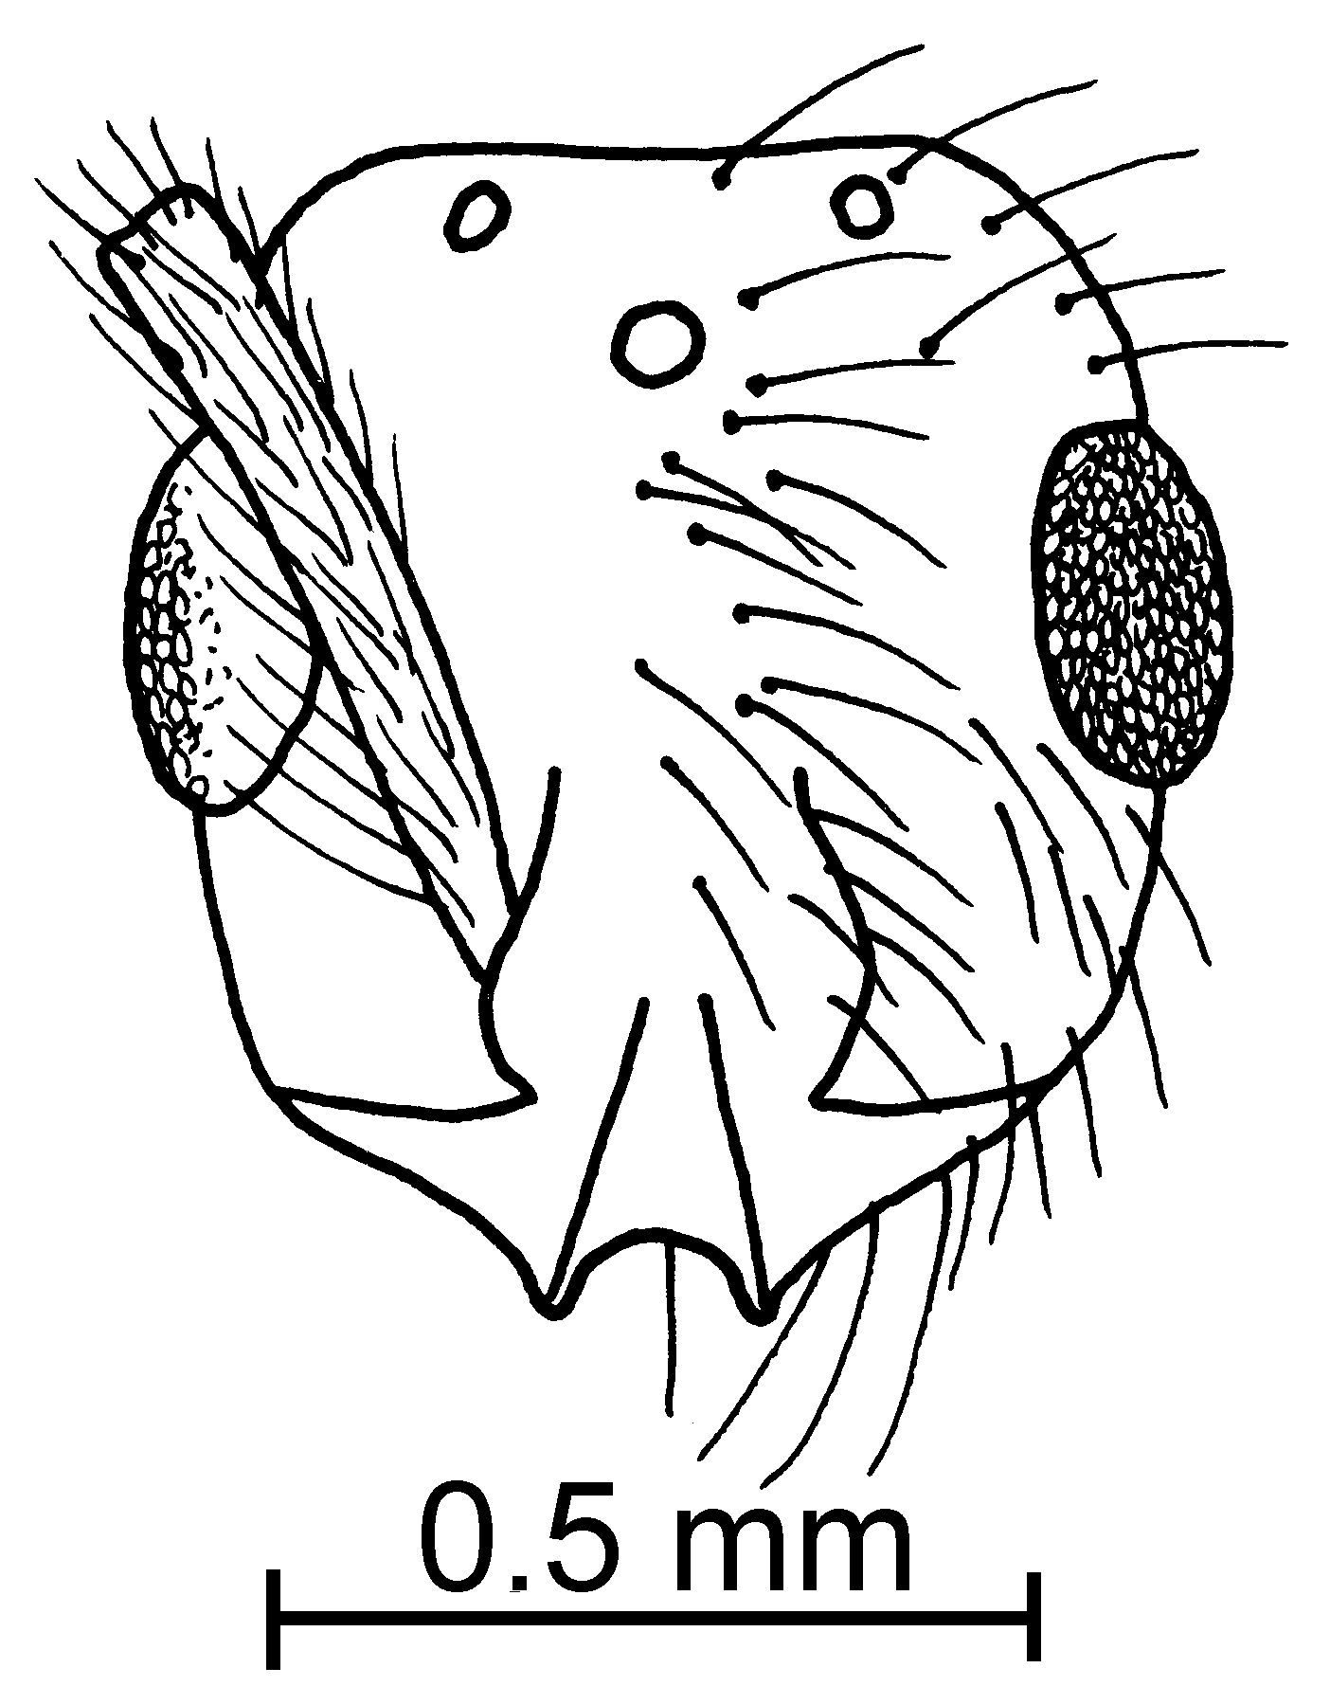
Fig. 47. Head of a paralectotype female of S. latastei.
Measurements: Worker TL mm, HL mm, HW mm, SL mm, Indices: CI, SI.
Female TL mm, HL mm, HW mm, SL mm, Indices: CI, SI.
Male TL mm, HL mm, HW mm, SL mm, Indices: CI, SI.
Description:
Distribution: Chile (Forel 1912), Valparaiso (Forel 1912), Buenos Aires (Forel, 1912)
Map 33. Solenopsis latastei in South America.
Type series: Lectotype worker (MCZC), 1 paralectotype workers (), 2 paralectotype females.
Map 34. Solenopsis latastei.
Solenopsis latastei var. hoffmanni Forel, 1 cotype worker, 1 cotype female (MCZC) [without locality data], Type # 29399. synonym
Material examined: Type series and
Biology: .
`` Solenopsis maboya Snelling
molesta species complex

Diagnosis:
Measurements: Worker TL mm, HL mm, HW mm, SL mm, Indices: CI, SI.
Description:
Distribution:
Map 35. Solenopsis maboya in North America.
Type series: Holotype worker (MCZC), paratype workers (.
Material examined: Type series and
Biology: .
`` Solenopsis melina Mackay & Moreno, new species
new species 6

fugax species complex

Diagnosis:
Measurements: Worker TL 1.34 - 1.44 mm, HL 0.46 - 0.47 mm, HW 0.37 - 0.38 mm, SL 0.32 - 0.34 mm, Indices: CI 79 - 84, SI 71 - 72.
Female TL 4.44 mm, HL 0.68 - 0.71 mm, HW 0.55 - 0.58 mm, SL 0.40 - 0.41 mm, EL 0.18 - 0.19 mm. Indices: CI 81, SI 58.
Male Unknown.
Description:
Distribution: Known only from the area near White Sands National Monument, New Mexico.
Map 36. Solenopsis melina in North America.
Type series: Holotype worker (MCZC), 9 paratype workers (CWEM, LACM, MCZC, USNM), N. M., Otero Co., White Sands National Monument, 31-v-1992, 25-vii-1992, W. Mackay #’s 15945, 16054, 16059.
Etymology: From Latin, melinus, meaning honey-colored, referring to the color of the worker and female of this species.
Material examined: Type series and USA: New Mexico, Otero Co., Lake Lucero, 25-vii-1992, W. Mackay (2  CWEM, MCZC)
Biology: ???.
`` Solenopsis minutissima Emery
pygmaea species complex

Diagnosis:
This species can easily be confused with S. subterranea, which both have short hairs which are about the same length, on the pronotum, and on dorsum of the gaster. It can be separated as the eyes are poorly developed, and nearly absent (present and well-defined on S. subterranea).
Fig. 48. Petiole and postpetiole of the ________ worker of S. minutissima.
Measurements: Worker TL mm, HL mm, HW mm, SL mm, Indices: CI, SI.
Description:
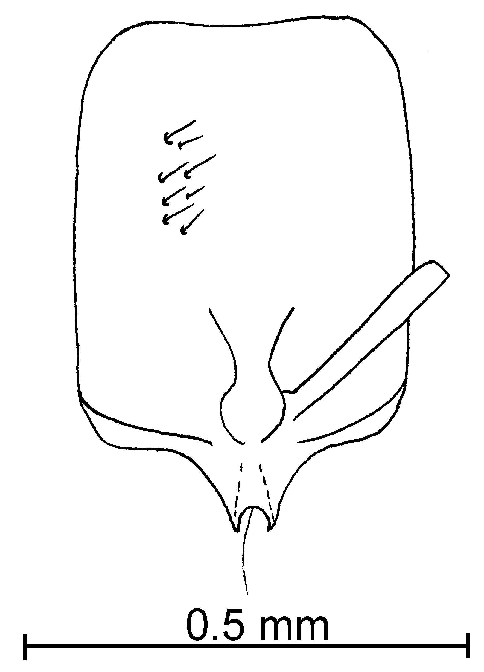
Fig. 49. Head of the ____________ worker of S. minutissima.
Distribution:
Map 37. Solenopsis minutissima in South America.
Type series: Holotype worker (MCZC), paratype workers (.
Material examined: Type series and
Biology: .

`` Solenopsis moerens Wheeler

xx species complex

Diagnosis:
Measurements: Worker TL mm, HL mm, HW mm, SL mm, Indices: CI, SI.
Fig. 50. Mesosoma, pedicel and first gastral tergum of the lectotype worker of S. xx (X).
Female TL mm, HL mm, HW mm, SL mm, Indices: CI, SI.
Male TL mm, HL mm, HW mm, SL mm, Indices: CI, SI.
Fig. 51. Head of the lectotype worker of S. xx (X).

Description:
Fig. 52. Propodeum and pedicel of the paralectotype female of S. xx (X).
Fig. 53. Head of the paralectotype female of S. xx (X).

Distribution: Known only from the type locality.
Map 38. Solenopsis moerens in North America.
Type series: Lectotype worker (MCZC), paratype workers (MCZC), paratype females (MCZC).
Material examined: Type series and
Biology: .

`` Solenopsis molesta (Say)
molesta species complex

Solenopsis molesta (Say), 1836: 293 (q.)

Diagnosis: This is a small, yellow species (may be pale brown), in which the dorsum of the head has sparse, scattered, punctures with a diameter only slightly larger than the hairs arising from them. Only two clypeal teeth are well developed, the extralateral teeth are only small bumps. The smaller segments of the funiculus are about 0.12 mm in total length, rarely shorter.
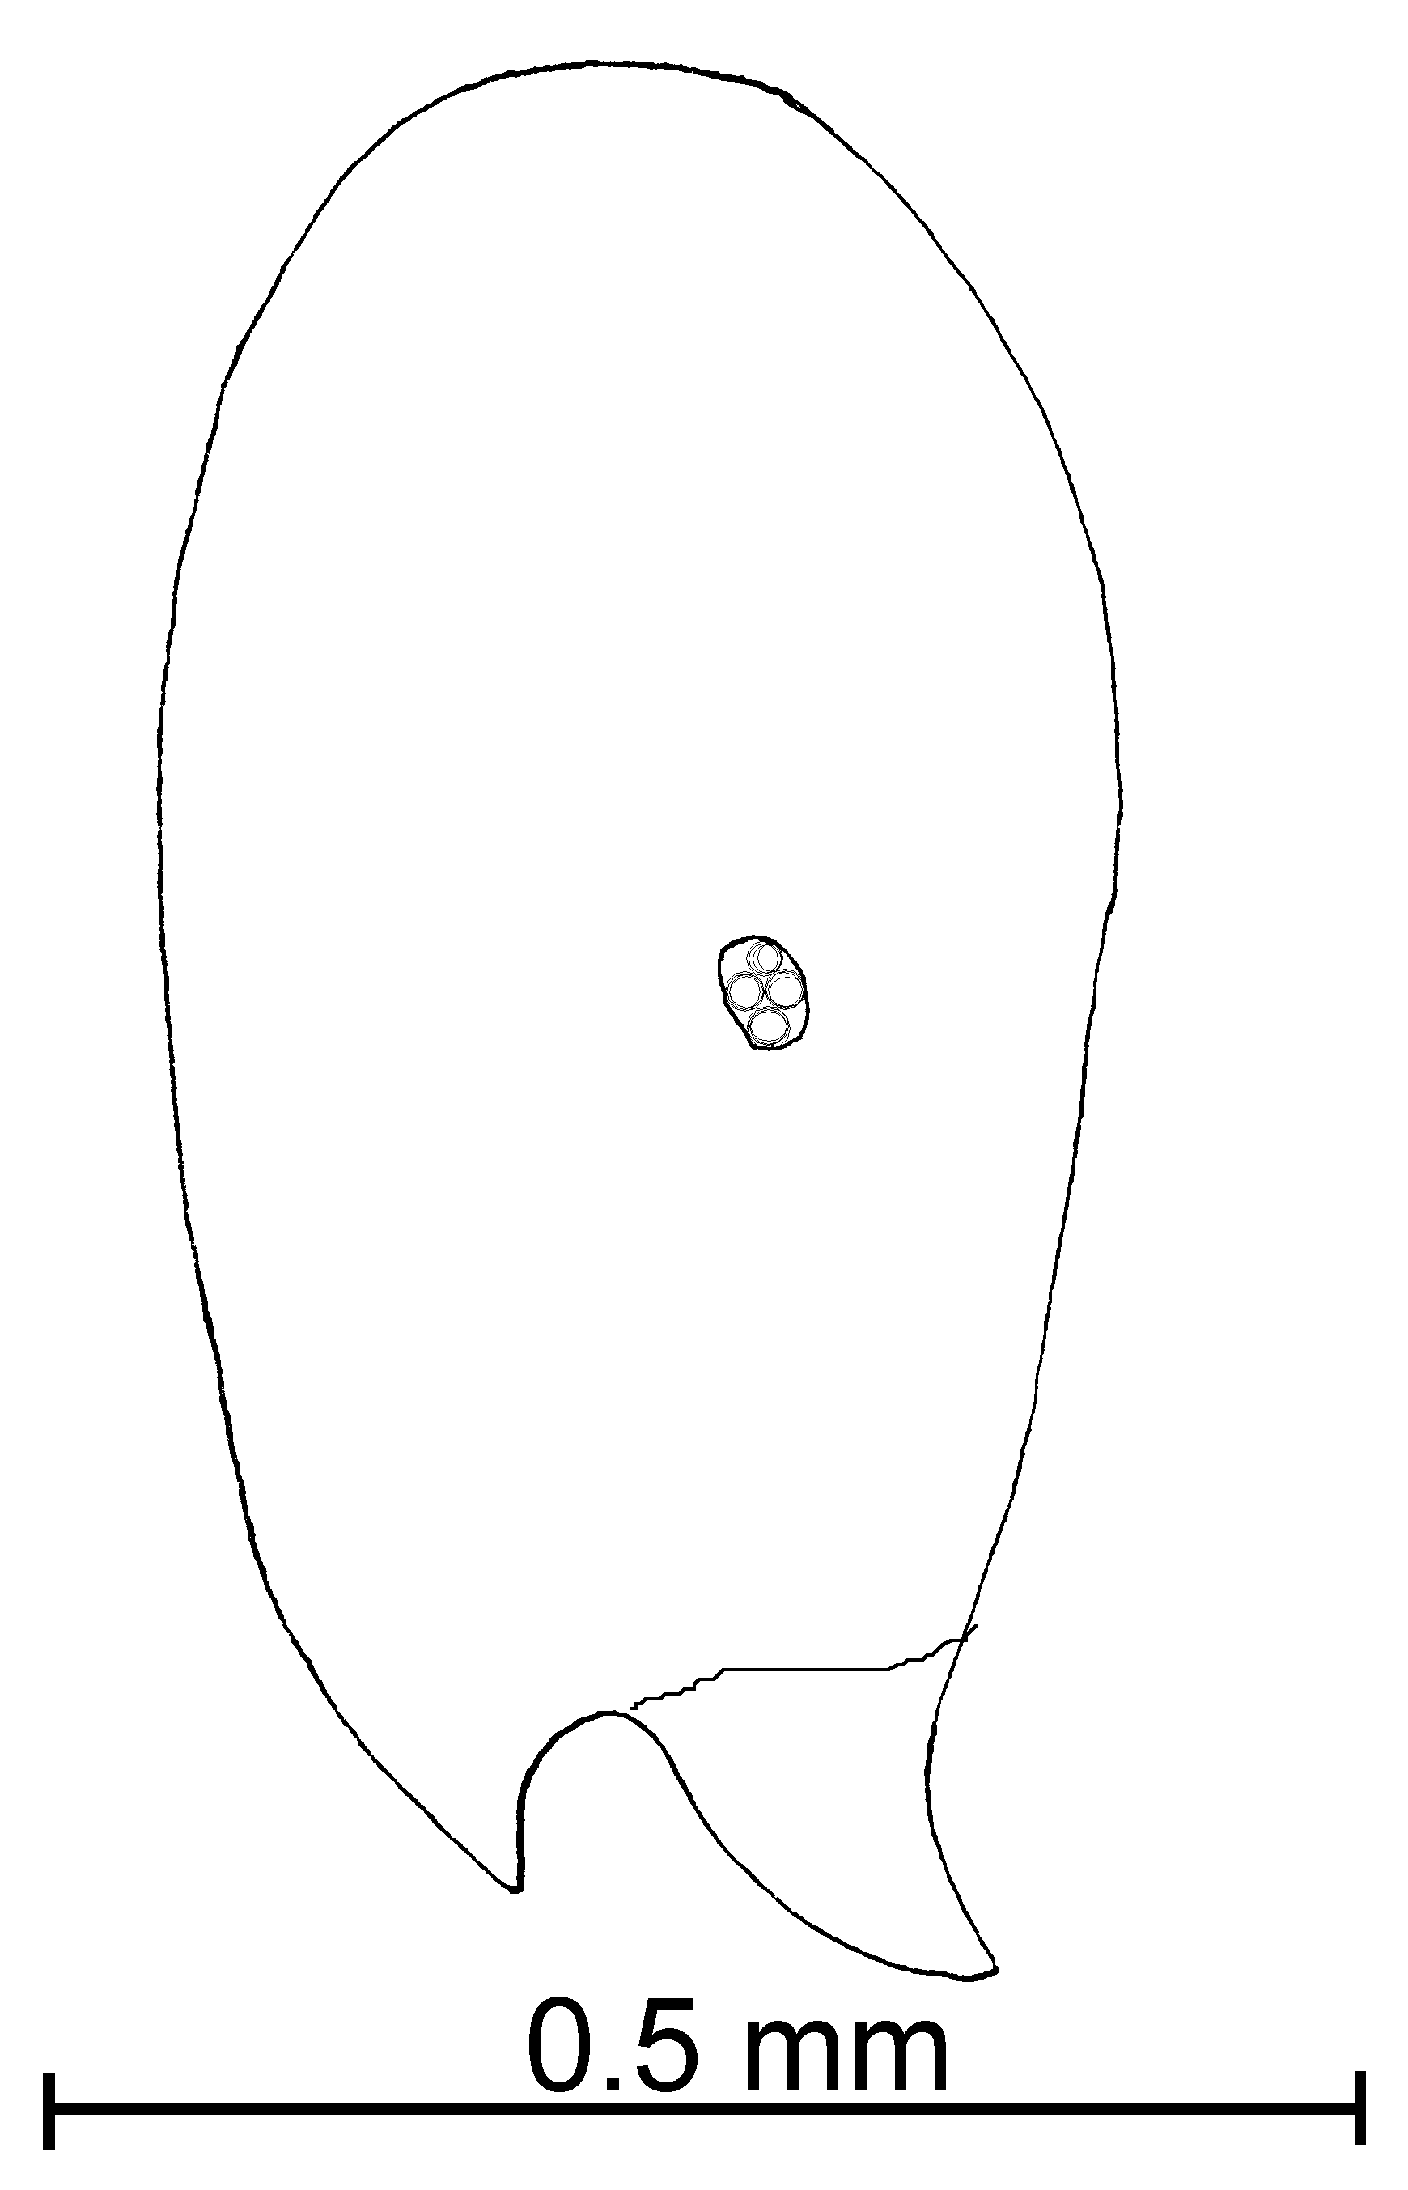
Fig. 54. Side of the head of a worker of S. molesta ().
This is a common species that can be separated from S. texana and related species (S. carolinensis, S. abdita, etc.,) by the longer length of the smallest segments of the funiculus. It is related to S. krockowi and its relatives, but can be separated as the punctures on the head are much smaller in diameter and the smaller segments of the funiculus are rarely greater than 0.12 mm in total length. It is difficult to separate this species from S. validiuscula. The workers of S. molesta are usually yellow or pale brown, those of S. validiuscula are usually dark brown, but there is a considerable amount of variation in color. Solenopsis molesta workers are often smaller (total length 1.5 – 1.7 mm), those of S. validiuscula larger (total length 1.8 – 2.0 mm), although the sizes of the workers overlap. The cephalic punctures of S. validiuscula are nearly always moderately coarse, much larger than the hairs which arise from them, the punctures are often finer in S. molesta, often difficult to see, and not much larger in diameter than the hairs which arise from them. Females are always yellow, or at most with some parts pale brown. The females of S validiuscula are always dark brown. The median ocellus of the female is large in diameter, the maximum diameter nearly equal to the distance to a lateral ocellus. The median ocellus of S. validiuscula has a maximum diameter which is clearly less than the distance to a lateral ocellus. The male of S. molesta is pale brown, that of S. validiuscula is dark brown. The pedicel (first segment of funiculus) of the male of S. molesta is large, the maximum length is nearly as long as the scape. The pedicel of S. validiuscula is about 2/3 the length of the scape. The two species are nearly identical, but based on these characters, it appears that they are both valid species.
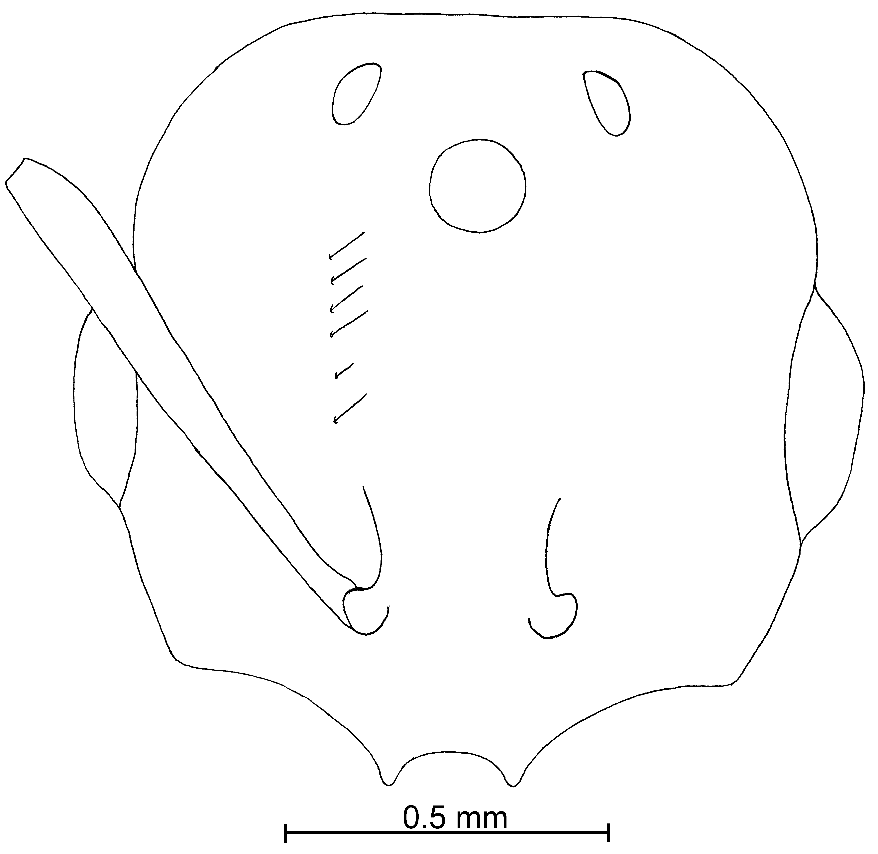
Fig. 55. Head of a female of S. molesta (50 X).
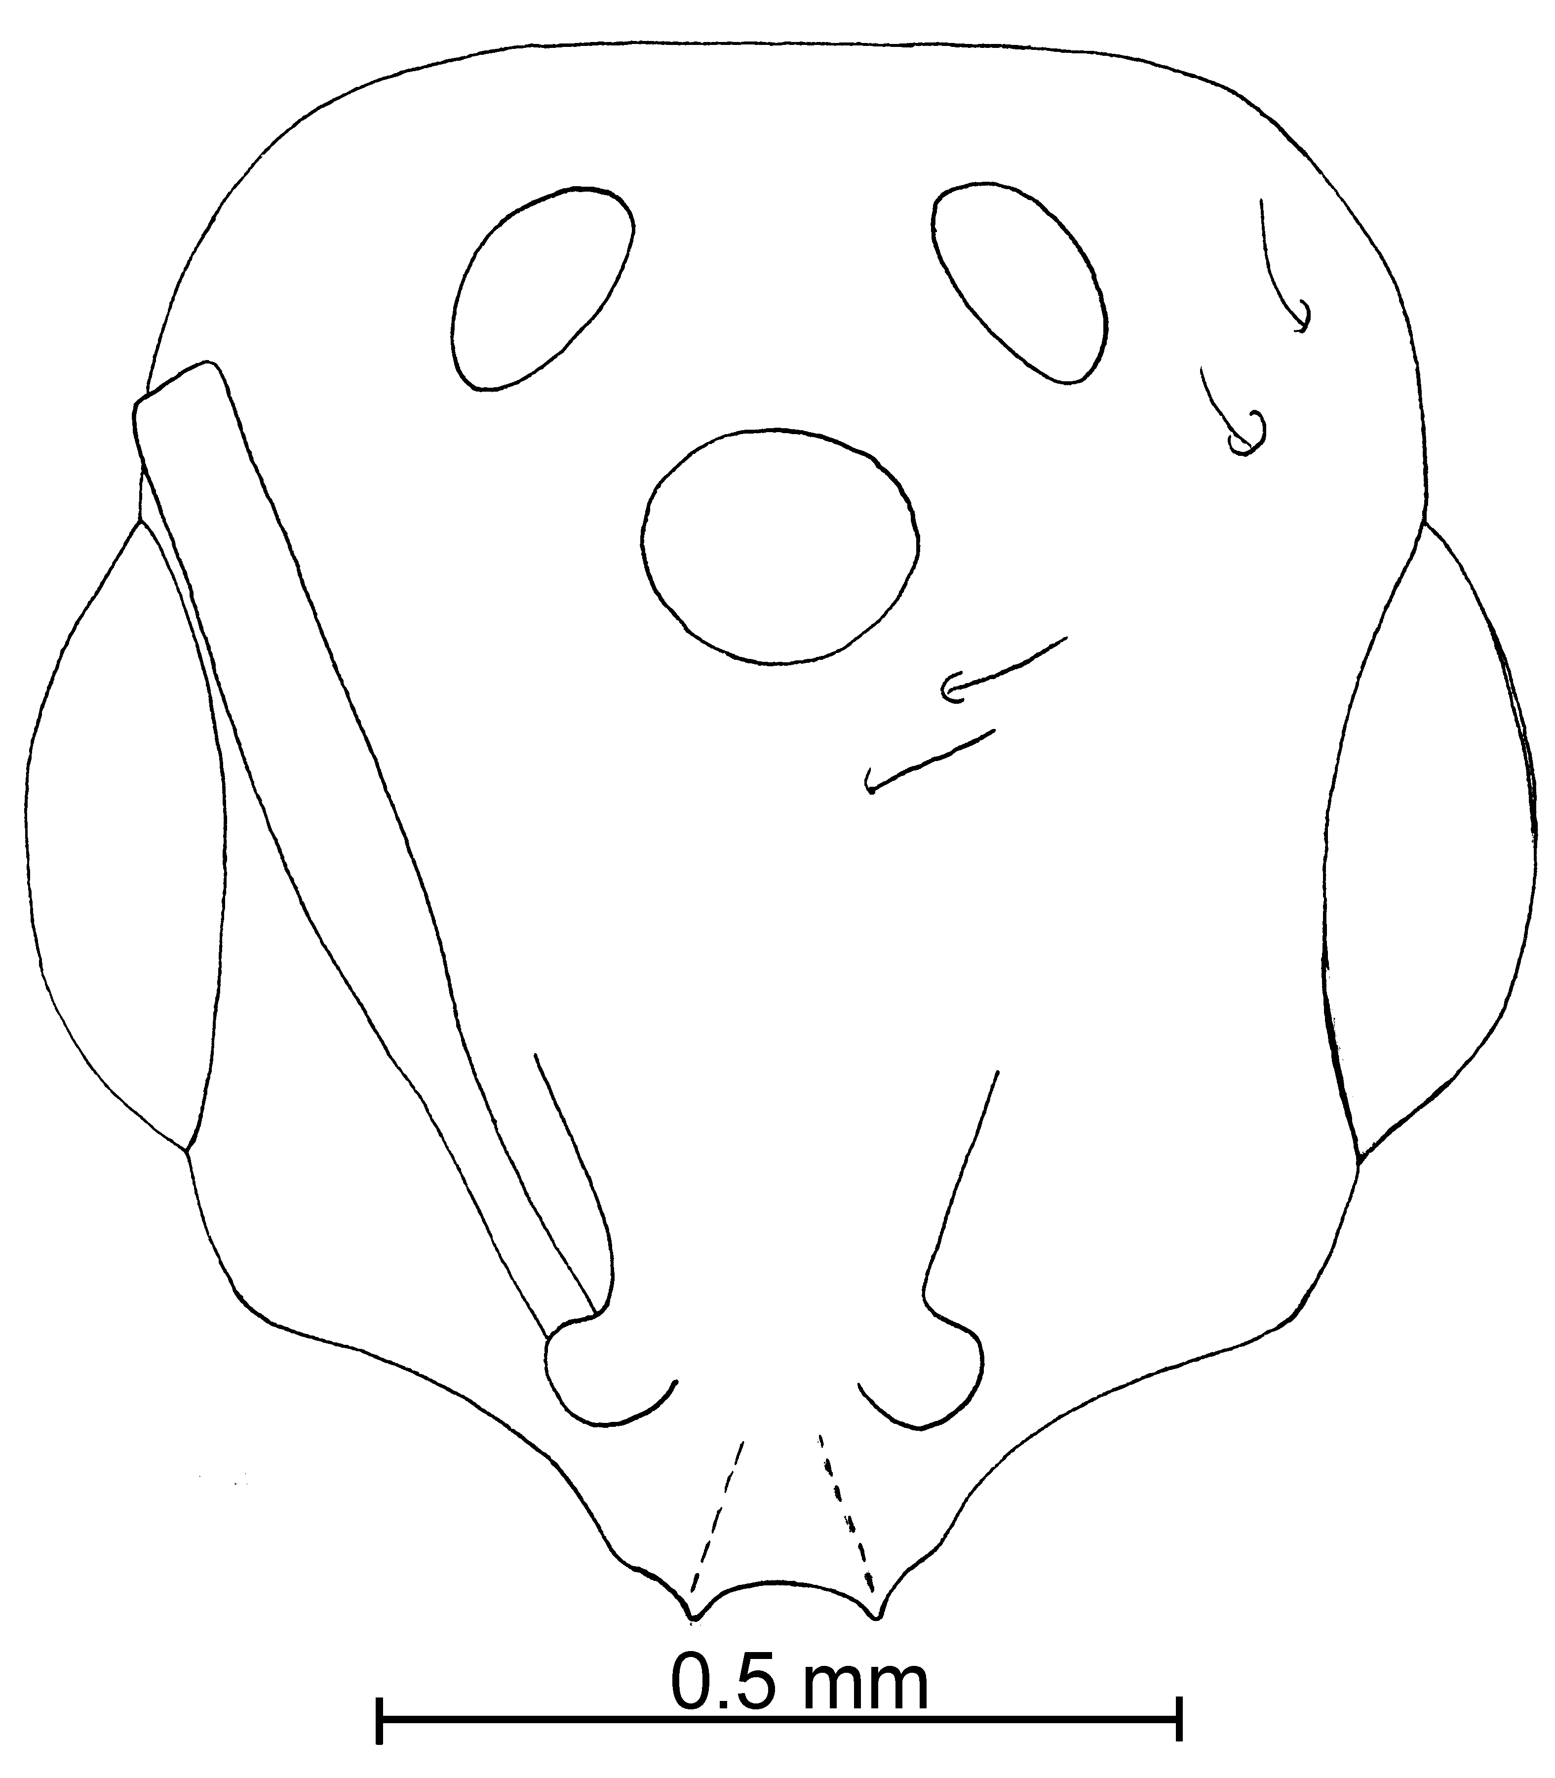
Fig. 56. Head of  truncorum.
It is difficult to separate the workers S. molesta from S. nana. Solenopsis nana is consistently smaller, with the total length ranging from 1.2 - 1.3 mm. The females are easily separated as they are much larger than those of S. nana (total length of S. molesta ranging from 4 - 5.5 mm, the female of S. nana has a total length of slightly over 3 mm). The female of S. molesta is yellow or pale brown, that of S. nana is black. Solenopsis nana is known only from SE Arizona.
Some specimens from southern Arizona and throughout New Mexico differ from the “typical” S. molesta in that the workers have larger diameter cephalic punctures, and the females are darker in color. It is possible that they are a new species, but appear to be impossible to reliably separate from S. molesta. The cephalic punctures of the workers appear to vary in diameter, and the color of the female is usually yellow or yellowish brown, but to also vary considerably.
Distribution: USA: (Arkansas, Illinois, Iowa, Michigan, New York, Virginia, and Washington) (see Map 12).
Map 39. Solenopsis molesta in North America.
Types: None known to exist.(type locality: Indiana).
Material examined: MEXICO: Baja California, Sierra Juárez, 9.5 mi S Laguna Hanson, 31°56.25’N115°58.07’W, 15-v-2000, R. Johnson # 1997 (12  Johnson Collection), Nuevo León, 146 k N Monterrey, 19-v-1988, W. Mackay # 10233 (1  CWEM), El Salto (Zaragosa), 1415m, 11-vi-1988, W. Mackay #’s 11010-9, -10 (8  CWEM) San Luis Potosí, Ciudad Valles, 9-vi-1998, W. Mackay #’s 10940-1, -7 (2  CWEM). USA: Arizona, Apache Co., Apache National Forest, 5 mi E Hwy 180 on USFS Road 249, 8630’, 11-ix-1994, R. Johnson # AZ 549 (3  Johnson Collection), Cochise Co., Chiricahua Mts., , upper Cave Creek, 6000 - 7500’, 11-viii-1967, V. Roth (3  CWEM), Portal, 11-vi-1977, V. Roth (2  CWEM); Arkansas, Cross Co., Village Creek State Park, 14-viii-1988, R. Anderson (13  CWEM), Pulaski Co., Pinnacle Mountain State Park, 13-iii-1989, R. Anderson # 12766 (1  CWEM) Washington Co., 20-viii-1959, R. Redfern (68  USNM), Hutchinson Co., without locality 9-viii-1943, G. Rexwood #45-6455 (25 , 3  USNM); California, Riverside Co., Riverside, 30-v-1960, C. Musgrove (1 , 1 alate , 1  CWEM), same locality, 14-v-1963, C. Musgrove (1 , 1  CWEM), San Diego Co., Point Loma, San Diego, L. Leonard (1  CWEM); Illinois, without county, La Rue, 19-iv-1944, Ross Sanderson (4  USNM # 2017865); Iowa, Story Co., Ames, 06-v-1940, Wm. F. Buren (4  USNM), county # 64 [?], 27-viii-1945, R. King (1  CWEM); Louisiana, Calcasieu Parrish, Sam Houston Jones State Park, 17-viii-1987, W. Mackay # 9723-2 (2  CWEM); Michigan, Saint Joseph Co., Sturgis, C. W. Sabrosky (9  USNM); Mississippi, Oktibbeha Co., 4 k NE Starkville, 27-viii-1987, W. Mackay # 9927 (8  CWEM); Montana, Fallon Co., 10 mi W Willard, 20-viii-1971, W. Mackay (7  CWEM); New Mexico, Doña Ana Co., Las Cruces, 20-v-1984, W. Mackay # (54 CWEM), 15 mi N Las Cruces, 5-x-1983, W. Mackay #’s 1112, 1121, 1122, 1321, 2112, 3111, 3321 (10  CWEM), 45 k NE Las Cruces, 19-iv-1984, W&E Mackay # 2211, 3112, 3212 (6  CWEM), Grant Co., 2 mi NW Luna, 16-iv-1980, W&E Mackay # 3879 (2  CWEM), Los Alamos Co., Rio Grande, 1680m, 1-vii-1986, W. Mackay # 7938 (18 , 10 alate, 14  CWEM), Socorro Co., Magdalena Mts., 17 k SSE Magdalena, 2063m (GPS), 4-viii-1994, W. Mackay #’s 16762, 16763, 16772, 16773, 16776, 16780 (14 , 8 dealate  CWEM); New York, Rockland Co., Nyack, 22-viii-1989, M. Deyrup (4  CWEM), Tompkins Co., Berger Beach, 13-v-1906, Krockow (22  USNM), Ithaca, 12-18-viii-1928, Eidmannlegit (2  USNM), South Lansing, 21-viii-1971, A. Francoeur # 02143 (2  CWEM); Tennessee, McMinn Co. 7 k SW Athens (rest area), 12-vi-1998, Mackay family # 18271 (13  CWEM); Texas, Bastrop Co., Buescher State Park, 3-v-1998, R. Anderson (5  CWEM), Blanco Co., Pedernales Falls, 3-v-1988, R. Anderson (1  CWEM), Brazos Co., Brazos Site, 30°35.2’N 96°23.2’W, 26-vii-1999, K. Helms Voucher # 5 (1  CWEM), 10 k N Kurten, 5-v-1987, W. Mackay #9138 (44  CWEM), same locality, 18-vi-1987, W. Mackay #’s 9251, 9252, 9253, 9254, 9257, 9259, 9264 (26  CWEM), same locality, 5-viii-1987, W&E Mackay #’s 9558, 9563, 9568, 9569, 9605, 9626, 9631, 9638, 9643, 9644, 9646, 9647, 9648, 9663, 9671, 9672 (64  CWEM), Peach Creek, 22-vii-1987, W. Mackay # 9346 (1  CWEM), Brewster Co., Big Bend National Park, Pine Canyon, 6-ix-1988, R. Anderson (11  CWEM), Cameron Co., Sabal Palm Grove, 12-14-x-1988, R. Anderson (3  CWEM), El Paso Co., El Paso, Chamizal National Monument, numerous dates during 1998-2001 (numerous  CWEM), El Paso, 7-vii-1995, W. Mackay # 17139 (1 alate  CWEM), Jim Wells Co., Alice, 30-vii-1987, W. Mackay # 9530 (5  CWEM), Houston Co., Big Slough Wilderness, 9-v-198, R. Anderson # 12759 (2  CWEM), Hudspeth Co., 25 k SW Van Horn, many dates, W. Mackay #’s 14083, 14391, 14535, 14689, 14691, 14838, 14911, 14935, 14936 (27  cwem), Jeff Davis Co., 3.4 mi NE Fort Davis, 10-ix-1988, R. Anderson (4  CWEM), Rusk Co., 30 k NE Nacogdoches, 3-vi-1990, W. Mackay #’s 13406, 13419 (14  CWEM), Sabine Co., 14.5 k E Hemphill, 11-v-1988, R. Anderson # 12763 (9  CWEM), same locality, 8-iii-1989, R. Anderson (8  CWEM), Walker Co., Huntsville State Park, 14-iv-1988, R. Anderson # 12762 (64  CWEM); Virginia, Albemarle Co., Charlottesville, K. M. King #4P-42 (1  USNM), Lantz Mt., 13-vi-1939, J. E. Graf, #39 (4  USNM), Pine Crest, 22-v-1938, M. R. Smith, (15  USNM); Washington D. C., 09-xii-1938, L. Russell (6  USNM), same locality, 15-xi-1944, M. Wadsworth, (3  USNM).
Biology: This species has been collected in subterranean baits. S. molesta nests under ground, and is polygynous, with up to 5 females in a single nest.
`` Solenopsis nana Mackay & Moreno, new species
new species 7

molesta species complex

Diagnosis: Workers are small, yellow specimens that appear to be identical to S. molesta, except they are slightly smaller than the typical S. molesta. The females are completely different from those of S. molesta, being much smaller and dark brown.
Measurements: Worker TL 1.20 - 1.28 mm, HL 0.43 - 0.44 mm, HW 0.31 - 0.35 mm, SL 0.28 - 0.30 mm, Indices: CI 72 - 78, SI 64 - 68.
Female TL 3.18 mm, HL 0.55 mm, HW 0.51 mm, SL 0.37 mm, EL 0.20 mm, Indices: CI 92, SI 67.
Male TL 2.41 mm, HL 0.36 mm, HW 0.40 mm, SL 0.08 mm, EL 0.19 mm, Indices: CI 110, SI 23.
Description: worker: lateral clypeal teeth well-developed, extralateral teeth represented by simply swollen regions, clypeal carinae well defined; head elongate, sides nearly straight, posterior border concaved; scape extends about ¾ lengths of distance to posterior lateral corners; eye small (maximum diameter 0.04 mm); mesosoma deeply impressed at metanotal suture; ventral process on anterior peduncle of petiole formed into small angle.
Scapes with numerous, erect and suberect hairs (0.02 mm) head with erect hairs (0.06 mm) mesosoma with several erect hairs (up to 0.1 mm) hairs on petiole, postpetiole, and gaster similar to those on dorsum of mesosoma; hairs on tibiae decumbent or appressed. Punctures on head tiny, slightly larger than hairs arising from them, remainder of body smooth and polished. Yellowish-brown, funiculus and gaster slightly darker.
Female: clypeal carinae and lateral teeth well-developed, extralateral teeth poorly developed sides of head rounded, posterior border concave eyes large, ocelli small (maximum diameter of median ocellus 0.08 mm) diameter about ½ length of distance to lateral ocellus; scape extending more than ¾ length to posterior lateral corners; ventral anterior peduncular process poorly developed, consisting of an elongate process.
Pilosity as in worker, except hairs slightly longer (hairs on scape up to 0.1 mm, those on head to 0.13 mm, hairs on dorsum of mesosoma dense, up to 0.12 mm, hairs on petiole, postpetiole, and gaster similar to those on mesosoma. Punctures on head very coarse, diameters about 5 times width of hair arising from them; scutum with punctures similar to those on head, most other surfaces smooth and glossy, sides of propodeum with parallel striae, petiole and postpetiole finely striate, with scattered punctures. Dark brown, head and gaster slightly darker.
Male: clypeal carinae developed, lateral clypeal teeth poorly developed; eyes large, occupying nearly one-half of sides of head; maximum diameter of median ocellus 0.07 mm, about equal to distance to lateral ocellus; is sub-peduncular process very small, dorsum of petiole low and rounded, apex of postpetiole flattened. Scape with few decumbent hairs, hairs on dorsum of head long (to 0.07 mm) hairs on dorsum of mesosoma abundant (to 0.1 mm), hairs on petiole, postpetiole, and gaster similar to those on mesosoma. Punctures on head and scutum small, remainder of ant smooth and glossy, except sides of propodeum, which are finally striated; dark brown, with pale brown appendages.
Distribution: Known only from the type locality in Arizona.
Map 40. Solenopsis nana in North America.
Type series: Holotype female (MCZC), 3 paratype workers (MCZC, CWEM, Deyrup collection) and 1 paratype male (MCZC), AZ, COCHISE CO.; 3 MI W OF PORTAL; SUNNY FLAT; 5 AUGUST 2001, MARK DEYRUP; Solenopsis sp. B.
Material examined: Type series.
Etymology: From Latin, nanus meaning dwarf, referring to the small size of the female.
Biology: The type series was collected in a riparian forest, under a rock.
`` Solenopsis nickersoni Thompson
Solenopsis (Diplorhoptrum) nickersoni Thompson, 1982:468, Fig. 1 (w.); Thompson, 1989:281 (f.)

molesta species complex

Diagnosis: This is a small, medium brown ant with pale yellow legs. It is essentially identical to S. castor, differing only in being slightly smaller. It will continue to be considered to be a valid species until the true female can be compared with the female of S. castor. It can be easily separated at the present time, as it occurs in Florida, whereas S. castor is not found in Florida, and occurs in México south to Bolivia.
It would be unlikely that this species would be confused with any others in Florida, based on the color.
Distribution: Known only from Florida.
Map 41. Solenopsis nickersoni in North America.
Type series: Holotype worker (MCZC), paratype workers (.
Material examined: Type series and UNITED STATES: Florida, Brevard Co., Indian River City, 1-iii-2001, M. Deyrup & S. Cover (15  Deyrup Collection), Highlands Co., Lake Placid, 13-ix-1988, 17-ii-1990, M. Deyrup.
Biology: .
`` Solenopsis ocellata Moreno & Mackay, new species
new species 8

pygmaea species complex

Diagnosis: These ants are light yellow in color and are characterized by small eyes with at least one ommatidium. The lateral clypeus teeth are very well developed and the extralateral teeth are present but not as well developed. The body is not very hairy including the gaster, the hairs vary in length.
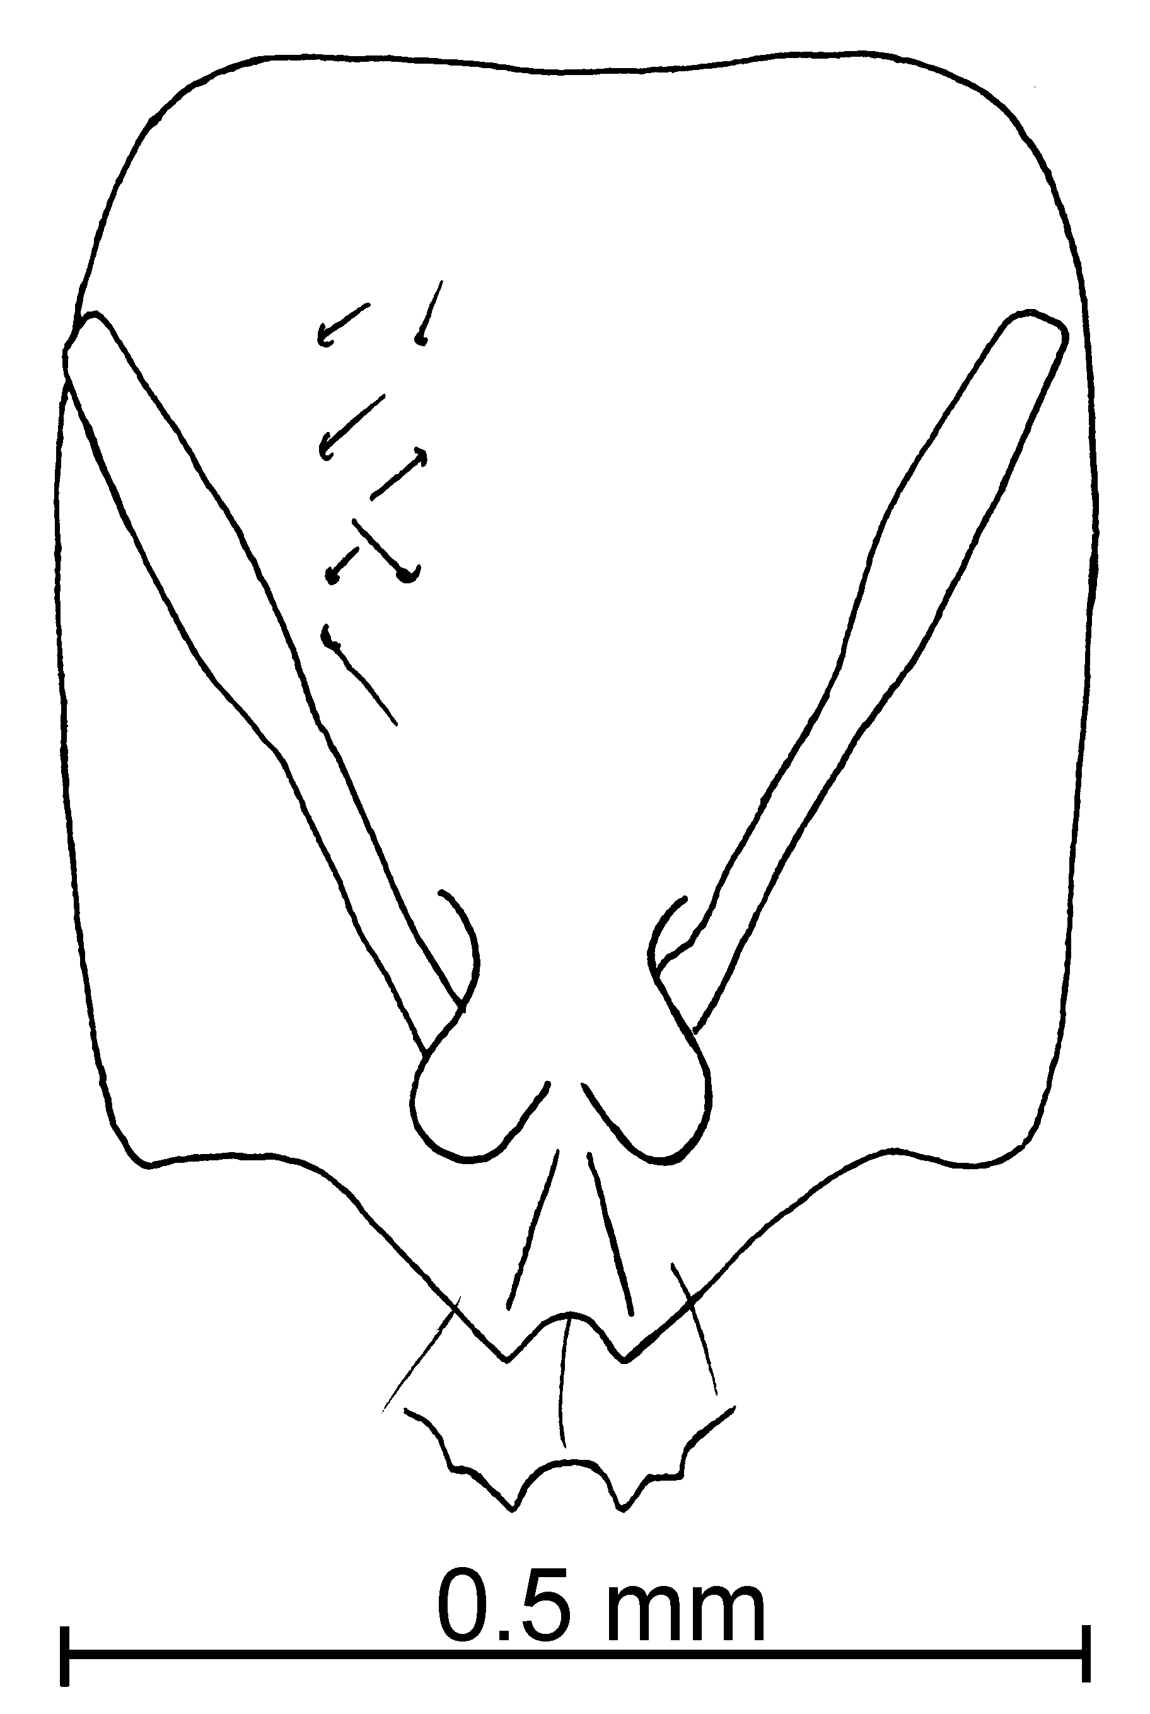
Fig. 57. Head of the holotype worker of S. ocellata. The inset shows the anterior border of the clypeus as seen in direct view.
Measurements: TL 1.20 - 1.30 mm, HL 0.40 - 0.43 mm, HW 0.30 - 0.34 mm, SL 0.24 - 0.26 mm. Indices: CI 71 - 81, SI 58 - 62.
Description: Head elongate, sides of head straight, posterior border concave; lateral clypeal teeth very well developed, medial tooth absent, extra lateral teeth well developed, scape extends slightly more than ²/₃ length of head; very small, light brown eye, with least one ommatidium; lower mesopleural region finely striated, petiole and postpetiole as in other members of the complex.
Hairs of various lengths (~ 0.03 mm), erect and semierect hairs on head, about 20 on any line drawn from the posterior border to the posterior base of clypeus, antenna very hairy, especially club, scape with few suberect hairs, pronotum with ~ 10 erect hairs projecting above outline, as seen in profile, mesonotum with ~ 3 erect hairs (0.06 mm) above profile, ~ 6 on propodeum, ~6 on outline of petiole, ~ 7 on outline of postpetiole, gaster with erect hairs, ~13 erect hairs on outline of first tergum. All hairs pointing in several directions.
Map 42. Solenopsis ocellata.
Head with few (~ 11 along line from posterior border to border of clypeus), coarse punctures, larger than hairs that originate from them, punctures on mesosoma and gaster less coarse, surfaces between punctures not smooth or glossy.
Concolorous pale yellow.
Female and male: Unknown.
Distribution: USA (Arizona and Louisiana).
Map 43. Solenopsis ocellata in North America.
Type series: Holotype worker (MCZC), 6 paratype workers (CWEM, Johnson’s Collection); UNITED STATES: Arizona, Stoneman Lake Rd @ 0.9 mi E I-17, 12-ix-1997, 5800’ R Johnson #AZ1115 (7  R. Johnson collection).
Material examined: Type locality and Louisiana, Iberia Co., New Iberia, 19-viii-1987, W. P. Mackay #9787 (12  CWEM).
Etymology: From Latin, ocellatus, meaning having small eyes, referring to the tiny eyes of this species.
Biology: Solenopsis ocellata was collected in subterranean baits, in pine/juniper forests habitats. They nest under stones.
`` Solenopsis patriciae Mackay & Moreno, new species
new species 9

molesta species complex

Diagnosis: The worker of this species is a small, yellow ant, in which most of hairs on the scapes and tibiae are appressed. The clypeal carinae are well-developed and the lateral teeth are sharp, and well formed. The head is elongate, and the scapes reach approximately two-thirds the length to the posterior lateral corner. The eyes are small (maximum diameter 0.04 mm). The female is a small, black specimen with small eyes.
The workers apparently can not be separated from those of S. texana. It could be separated from the other similar species by the appressed hairs on the scapes and tibiae. The female is distinctive, and easily separated from the brown or yellowish-brown female of S. texana, which is also larger (total length > 3 mm). This species is also very similar to S. batyle from the Bahamas, but the workers can be separated by the appressed hairs on the appendages (erect and suberect in S. batyle).
Measurements: Worker TL mm, HL mm, HW mm, SL mm, Indices: CI, SI.
Female TL mm, HL mm, HW mm, SL mm, Indices: CI, SI.
Male TL mm, HL mm, HW mm, SL mm, Indices: CI, SI.
Description:
Distribution: Known only from the type locality in southern México.
Map 44. Solenopsis patriciae in North America.
Type series: Holotype female (Instituto de Ecología), 3 paratype workers (CWEM, Instituto de Ecología, MCZC), MEXICO, Tabasco; Campo Experimental COLPOS; Cárdenas, 22-viii-2000, Col. P. Rojas; Formicidae BSIE-1187.
Material examined: Type series.
Biology: The type series was collected in a berlese sample of leaf litter in “selva de Canacohite”.
`` Solenopsis pergandei Forel
fugax species complex

Solenopsis pergandei Forel, 1901: 45, p. 343 (w.q.m.)
Solenopsis (Diplorhoptrum) pergandei M. R. Smith, 1947: 37 (3), p. 568, pl. 9, Fig. 36 (w.)
Solenopsis puncticeps Mackay and Vinson, 1989: 91 (2), pp.175-178 (w.) new synonymy.

Diagnosis: The worker is a light yellow, medium size specimen. Its head is nearly quadrate, it has small, round eyes, with at least two ommatidia. The clypeus is very narrow, the lateral and extralateral clypeal teeth are very well developed. It has very coarse punctures on the head, hairs scattered across the head, but with the center line free of hairs. The entire body is densely hairy, with all hairs about the same length. The postpetiole is perfectly round when viewed from above (Fig. 3b). The metanotal suture is very depressed, the propodeal spiracle is large and close to the suture.
Fig. 58. Petiole and postpetiole of a worker of S. pergandei ().
This species is unlikely to be confused with any others in North America, based on the coarse punctures on the head, combined with the perfectly round postpetiole. The members of the pygmaea group, also have coarse punctures on the head, as well as circular postpetioles, but have elongate heads. Solenopsis pergandei has a quadrate shaped head, which makes it easily separated from the pygmaea group. The shape of the petiole (moderately thickened as seen in profile) suggests a close relationship of this species with S. pilosula. It can be separated by the circular postpetiole (widened in S. pilosula) and the clypeal carinae are not parallel (nearly parallel in S. pilosula).
Solenopsis puncticeps differs from the “normal” S. pergandei in having coarser punctures on the dorsum of the head, but is very similar to the condition of the types, and is proposed as a synonym.
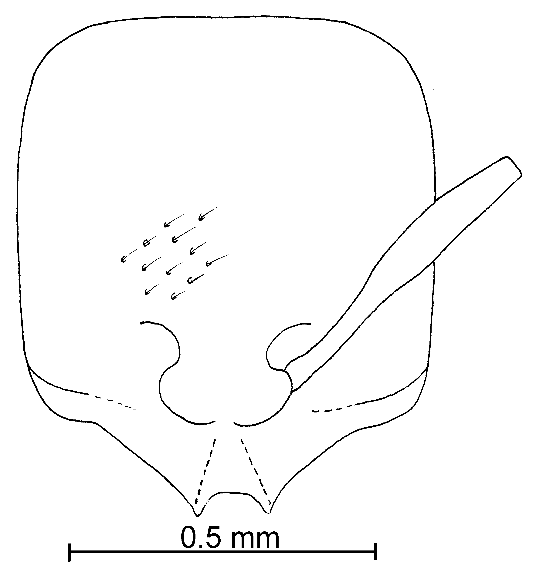
Fig. 59. Head of a worker of S. pergandei ().
Distribution: USA (North Carolina).
Map 45. Solenopsis pergandei in North America.
Type series: Lectotype worker (MHNG), 5 paralectotype workers, 2 paralectotype females, 3 paralectotype males (MHNG), S. Pergandei Forel,  type, Faisons, N. C. do terre, Forel.
Material examined: USA: Alabama, Equality, L. Morpheme (1  CWEM); Florida, Alachua Co., without locality, 28-vii-1985, J. Trager (3 , 1 alate  CWEM), Walton Co., De Funiak Springs, 9-vii-1989, M. Deyrup (4 CWEM); Mississippi, Ackerman, 2-i-1930, M. Smith # 2 (2  CWEM), _______ Biloxi, M. Smith (1  CWEM); New Mexico, 40 k NNE Las Cruces, 29-iii-1983, W. Mackay # 2221 (1  CWEM); North Carolina, Faisons, 28-vi-1899, A. Forel (6 , 2 , 3  MHNG); Texas, Brazos Co., 10 k N Kurten, 5-v-1987, W. Mackay # 9149 (27  CWEM, paratypes of S. puncticeps), Rusk Co., 30 k NE Nacogdoches, 3-vi-1990, W. Mackay # 13404 (11 CWEM).
Biology: This species prefers compact soil, arid sites, areas such as lawns and woods trails (Thompson, 1980).
`` Solenopsis picea Emery

molesta species complex

Solenopsis picea Emery, 1896:89 (w. q.)

Diagnosis: This is a dark brown (somewhat bicolored with the gaster darker than the remainder of the ant), medium sized species (total length 1.75 mm). The head is somewhat square-shaped, the punctures are very fine and the hairs are very short (0.03 mm). The lateral clypeal teeth are poorly well developed. It has relatively large, black eyes, with 3 - 5 ommatidia. Its metanotal suture is very well depressed. The minor segments of the antennae are slender and long (0.12 mm). The hairs on the scape are very short. The petiole is noticeable longer (0.18 mm) than postpetiole (0.13 mm).
Map 46. Solenopsis picea.
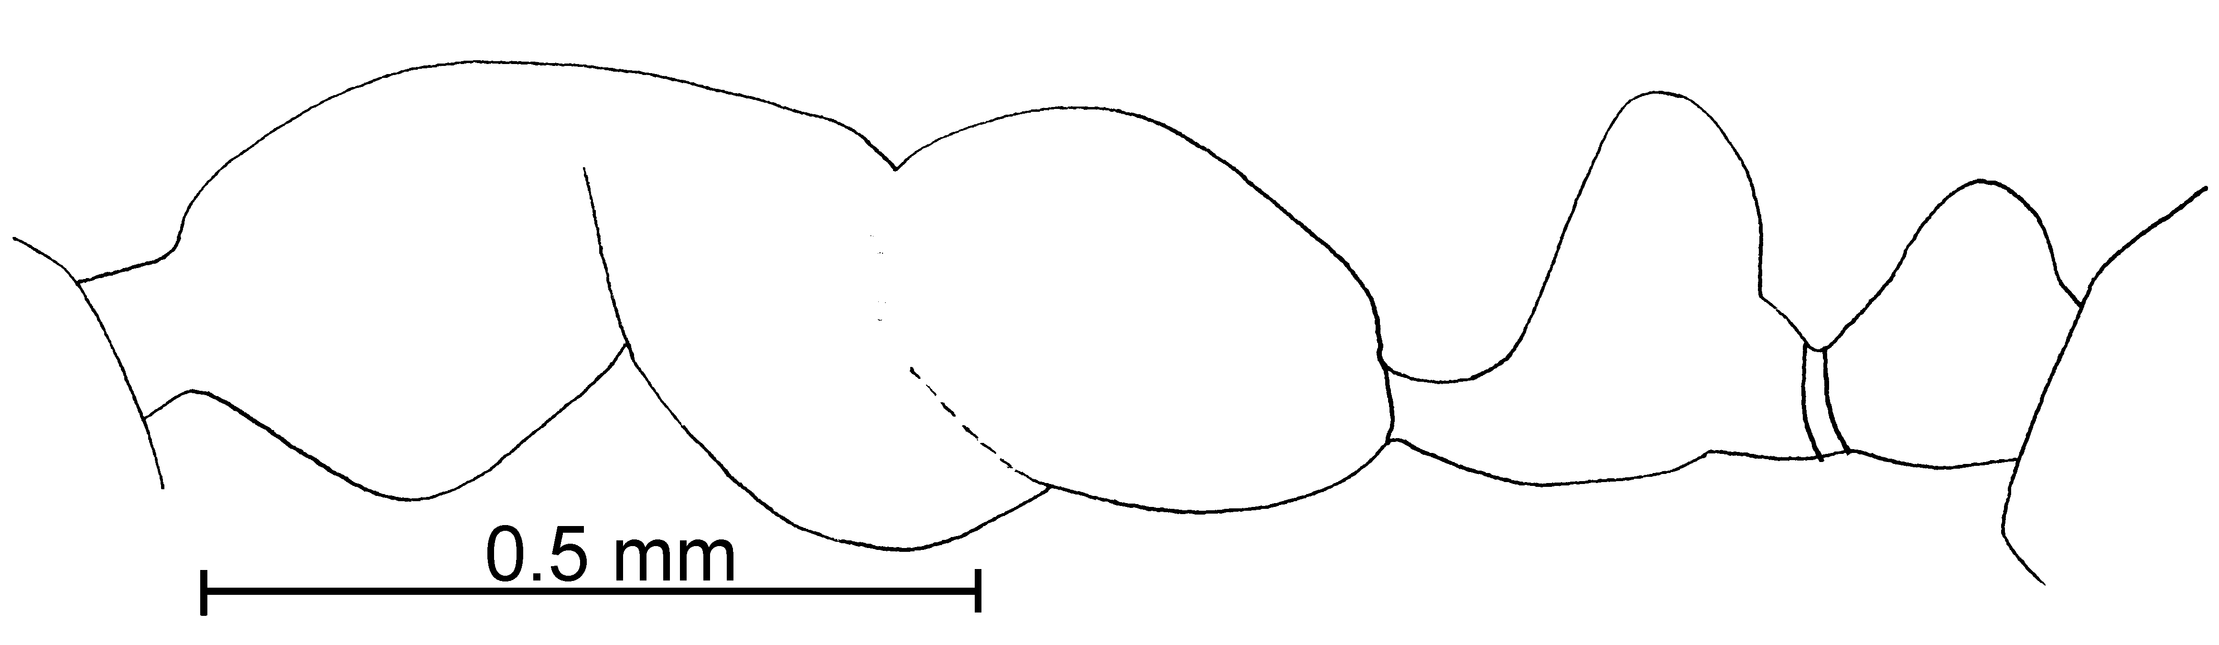
Fig. 60. Mesosoma and pedicel of the lectotype worker of S. picea (50 X).
It is possible that this species will be shown to be a synonym of S. basalis. It differs in being darker (S. basalis is mostly medium brown, with the gaster only slighter darker than the remainder of the ant). Otherwise the workers appear identical. Workers are easily confused with those of S. castor. The are not as dark mahogany brown as is S. castor, and the minor segments of the antennae are longer, nearly always greater in length than 0.12 mm (nearly always less than 0.12 mm in S. castor). If females are available, these 2 species are easily separated, as the females of S. picea are large (Total length > 4 mm), compared to the much smaller females of S. castor (TL up to 3 mm).
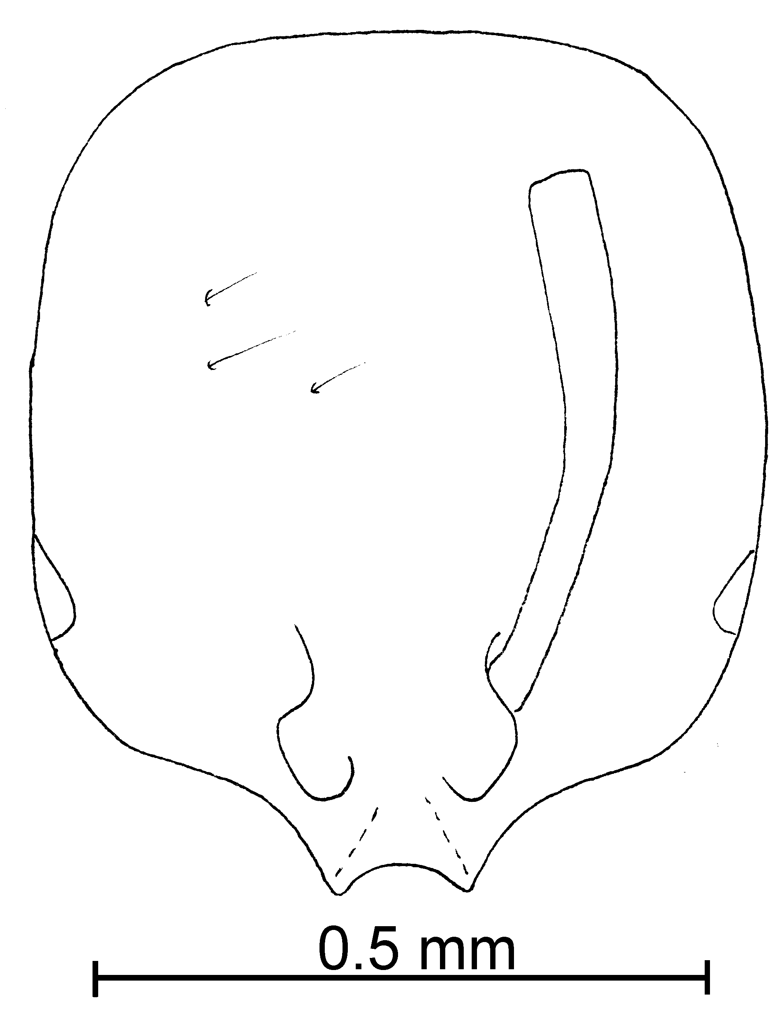
Fig. 61. Head of the lectotype worker of S. picea.
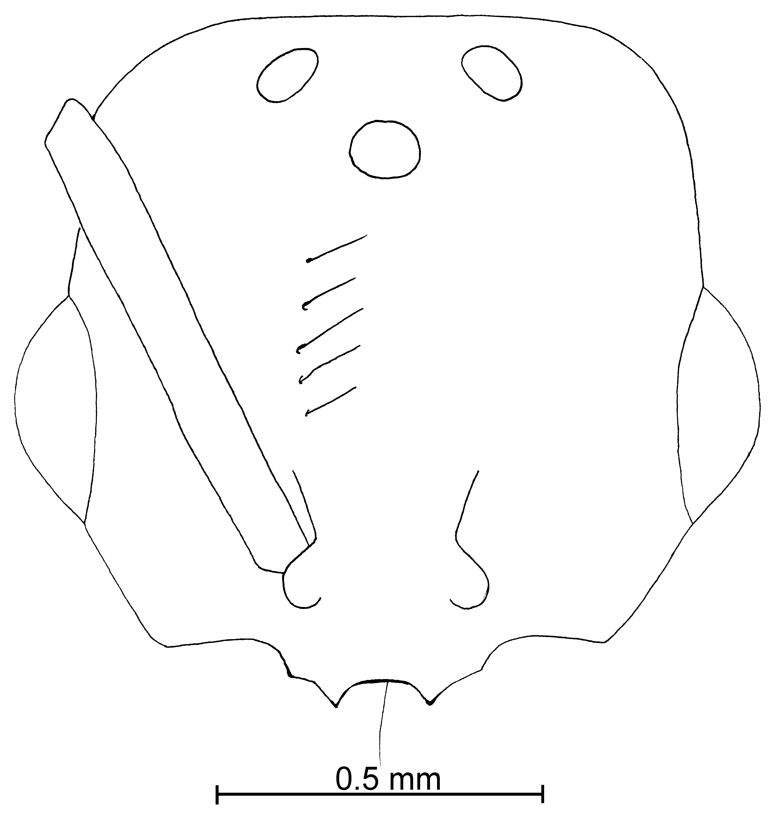
Fig. 62. Head of a paralectotype female of S. picea.
Distribution: Mexico (Veracruz and Hidalgo) south to Panama (Chiriquí); Argentina; Caribbean Region (Cuba, Puerto Rico).
Map 47. Solenopsis picea in North America.
Map 48. Solenopsis picea in South America.
Type: Lectotype worker, 1 paralectotype worker and 1 paralectotype female [here designated], S. picea worker Emery type, Costa Rica, Jimenez (MCSN).
Material examined: COLOMBIA: Risaralda, La Virginia Miralindo, 1900m, 4-ix-1997, L. Osorio #’s MYR-12, MYR-74 (5  CWEM). Costa RICA: Guanacaste, Cacao Field Station, 1100 - 1200m, 15-ii-1996, 20-ii-1996, R. Anderson #’s 17664, 17673, 17682, 17687, 17690, 17693, 17731, 17739 (17  CWEM), Estación Maritza, 800 - 950m, 10°58’N 85°30’W, 3-4-v-1995, 13-ii-1996, R. Anderson #’s 17667, 17711, 17715 (3  JTLC), Parque Nacional Santa Rosa, 300m, 10°52’N 85°36’W, 4-v-1995, R. Anderson # 17717 (1  CWEM), Rincón de La Vieja, Las Pailas, 1400m, 18-ii-1996, R. Anderson # 17676 (3  CWEM).; San José, Cerros de Escaza, 13-v-1997, R. Anderson (1  CWEM). MEXICO: Veracruz, 2k NE Orizaba, 27-v-1988, W. Mackay #10426 (3 , 3 , 1  CWEM). PANAMA: Chiriquí, 2 k NE Buquete, 1400m, 17-vi-1993, R. Anderson # 17791 (3  CWEM), Bocas del Toro, Continental Divide, 9-vi-1995, #’s 17842, 17847 (4  CWEM), Fortuna Hydrological Trail, 1100m, 09-vi-1995, #17785 (2  CWEM), Fortuna area, Finca La Suisse, 10-vi-1993, 12-vi-1995, R. Anderson #’s 17776, 17777, 17778, 17780, 17781, 17824 (16  CWEM), 20.4 k N San Félix, 950m, 8-vi-1995, R. Anderson # 17768 (1  CWEM).
Biology: These species nest under stones and in soil.
`` Solenopsis picta Emery
molesta species complex

Solenopsis picta Emery, 1895. 8:278. (w.)

Diagnosis: This is a small, dark reddish brown, nearly black ant (1.7 mm) total length. The head is slightly longer than wide, and the body is not very hairy. The hairs are erect and suberect and vary in length. The minor funicular segments are quiet long (0.11 mm), lateral clypeal teeth are widely separated, but poorly developed. The eyes are almond shaped, with 4 - 5 ommatidia.
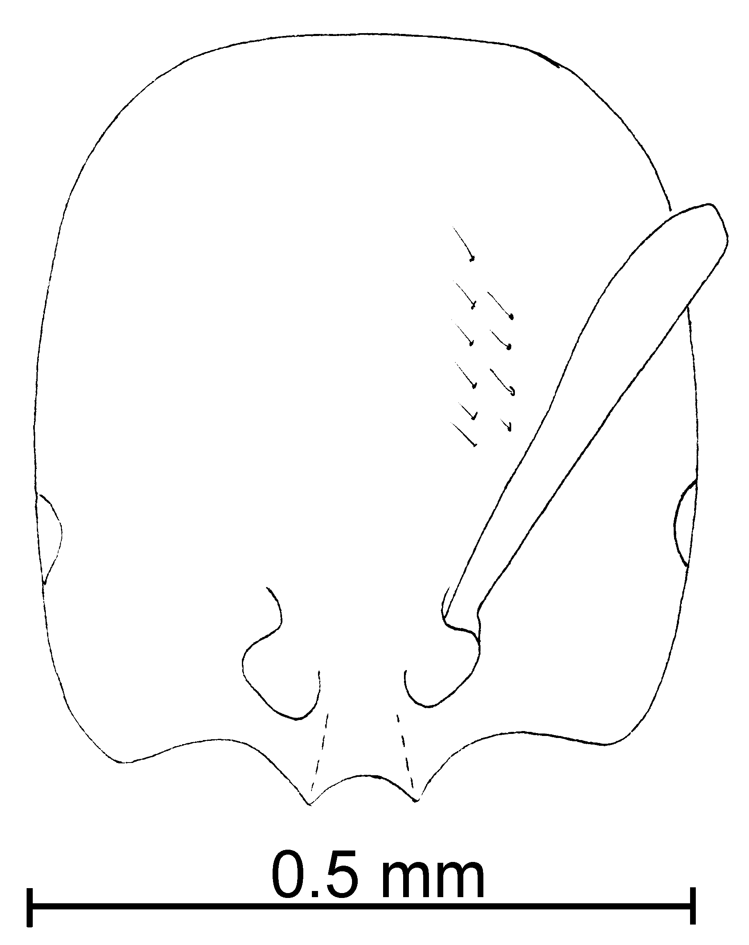
Fig. 63. Head of the _________ worker of S. picta.
Distribution: USA (Florida, Louisiana).
Map 49. Solenopsis picta in North America.
Types: Lectotype worker [here designated], S. picta worker Emery type Florida (MCSN).
Material examined: USA: Louisiana, Calcasieu Parish, Sam Houston Jones South Park. 17-viii-1987, W. Mackay #’s 9735, 9729-9, 9729-10, 9729-B1, 979-B2 (44  and 1  CWEM), St. Mary Parish, Morgan City, 29-viii-1987, W. Mackay # 9814-216 (13  CWEM).
Biology: These ants nest in hollow twigs and dead wood in Florida and the southeastern states (Thompson, 1980).
`` Solenopsis pilosula Wheeler
fugax species complex

Solenopsis pilosula Wheeler, W.M. 1908. 24: 426, pl. 26, figs. 26-27, (w. m.)

Diagnosis: The workers are dark yellow, medium sized specimens. The head is longer that wide, subquadrate, the clypeus is very narrow, the lateral and extralateral clypeal teeth are very well developed, but thickened and blunt. The frontal carinae are nearly parallel. The eyes are small, with 3 - 4 ommatidia. The head is covered with hairs and very course punctures, but centerline is free of hairs. The hairs are of equal lengths on the head, but are various lengths on the remainder of the body, including the petiole and postpetiole. The metanotal suture is very depressed. The propodeal spiracle is large and near the suture. The mesopleuron is striated. The end of the propodeum makes an angle. The mesonotum is very narrow when viewed from above. The petiole is thickened when viewed in profile.
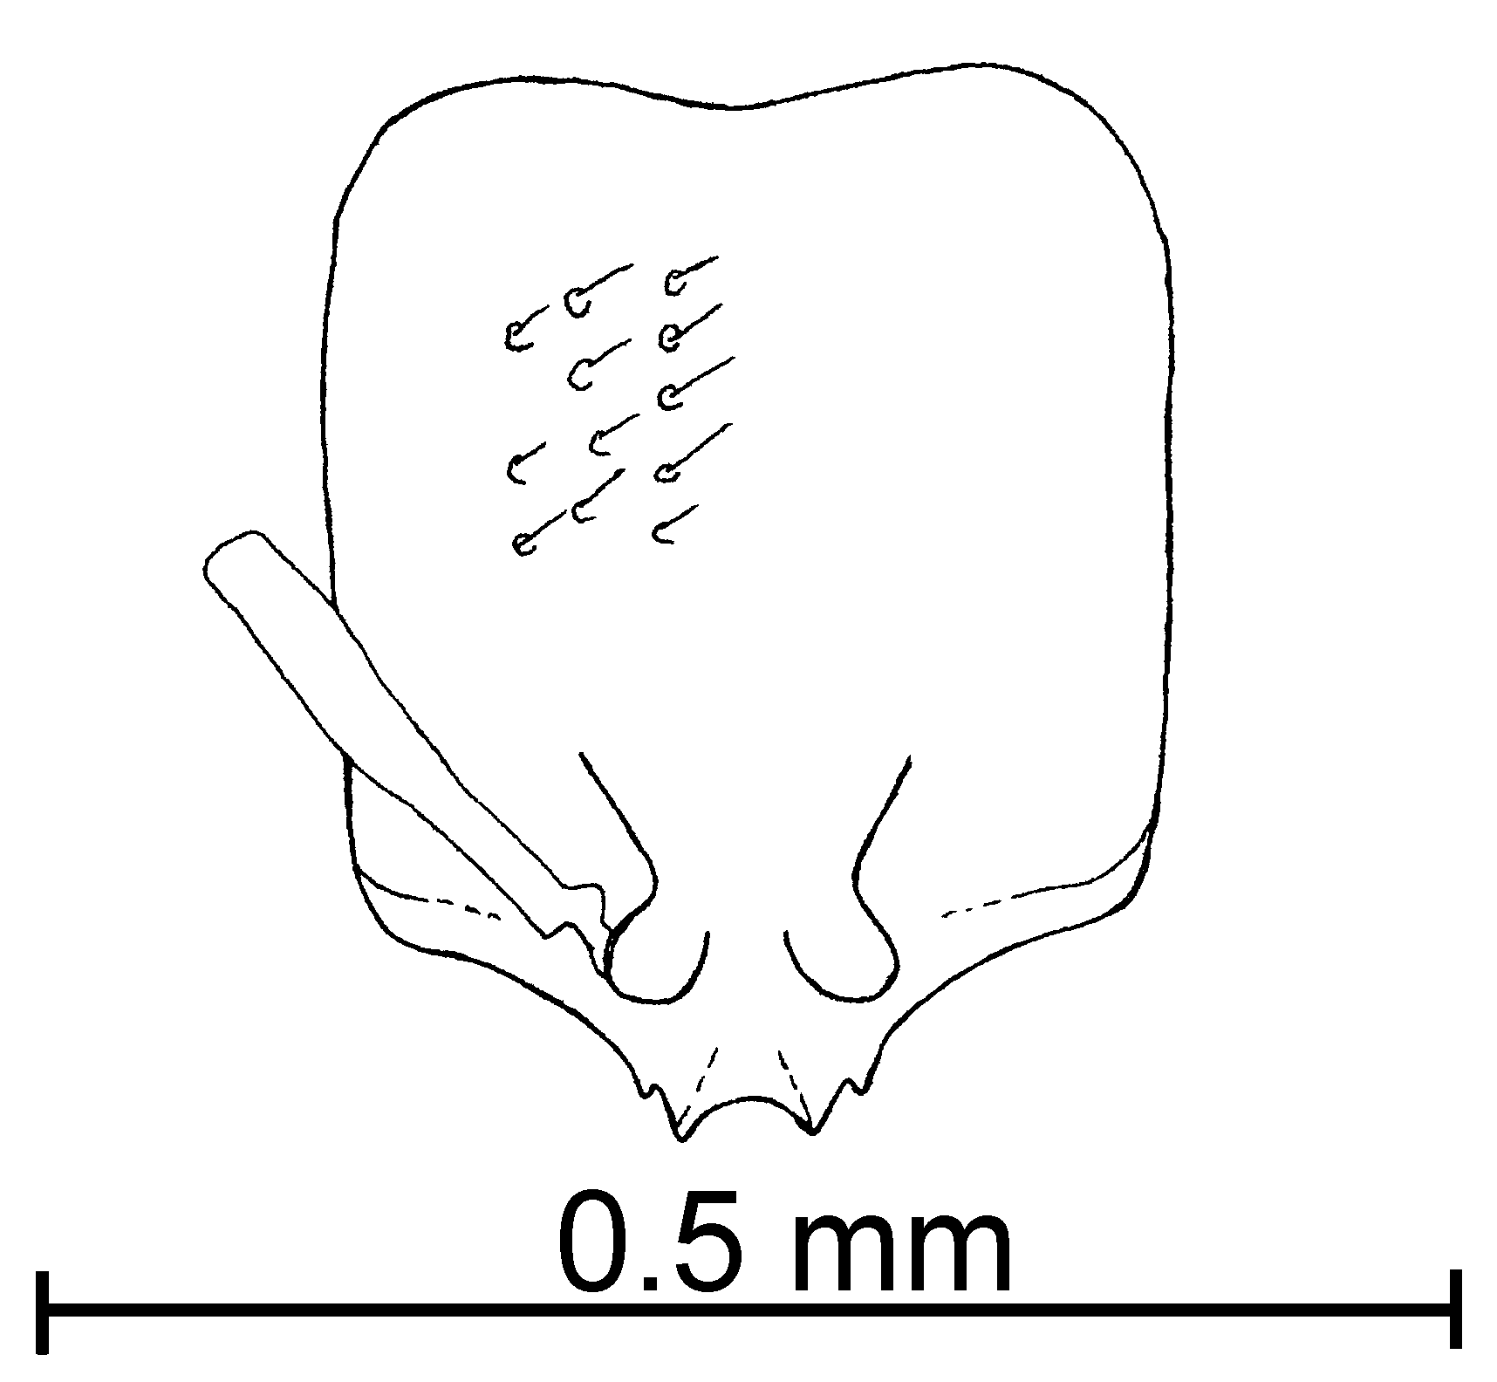
Fig. 64. Head of the ________ worker of S. pilosula.
Female (undescribed): Large dark yellow specimen 4.75 mm Total Length; head subquadrate with sparse course punctures, width 0.92 mm, length 0.84 mm, scape 0.58 mm, ocellus very small (maximal diameter of median ocellus 0.07 mm); head with depression from the carina to the posterior region; eyes relatively large with a maximal diameter 0.25 mm; lateral and extralateral clypeal teeth are poorly developed, lateral teeth blunt.
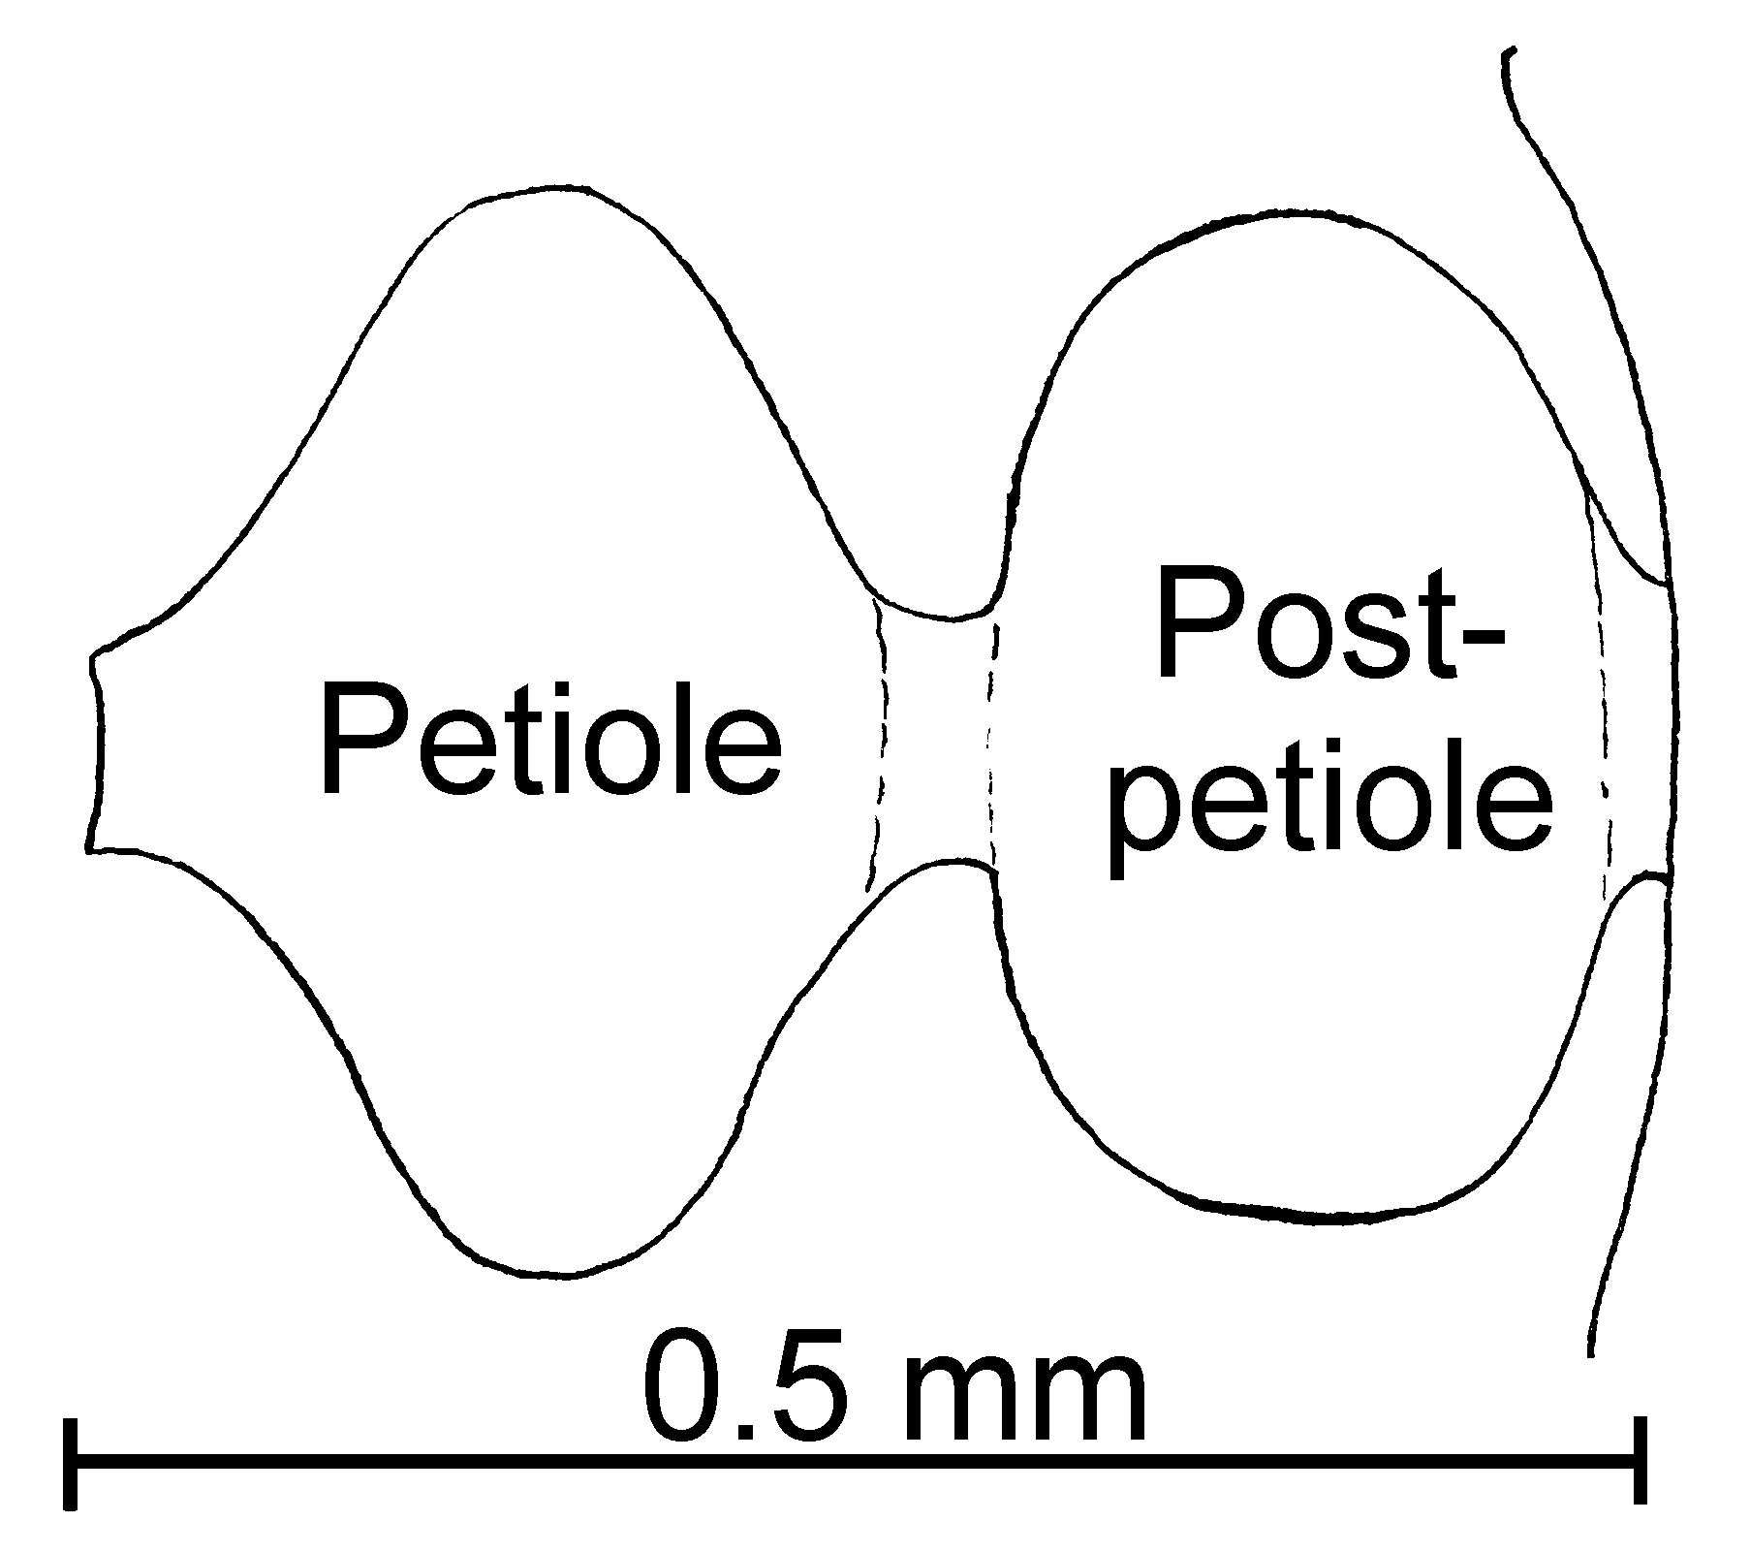
Fig. 65. Petiole and postpetiole of a worker of S. pilosula as seen from above.
Distribution: Eastern Texas, USA (see Map 17).
Map 50. Solenopsis pilosula in North America.
Type: Lectotype worker, 2 paralectotype workers, 3 paralectotype males [here designated], Texas, Alice Co., 16-vi-1903, cotype#1-6 20909 (MCZC).
Material examined: USA, Texas, Ector Co., Odessa, 30-i-1971, B. Pullen (5 , 1  CWEM).
Biology: They nest in the soil and their mating season occurs in July (Wheeler, 1908).
`` Solenopsis pollux Forel
molesta species complex

note: if these are not pollux, they are a new species andersoni. They differ from carolinensis in being smaller.

Diagnosis: This is a small (1.2 - 1.4 mm total length), pale brown species with well developed medial teeth on the anterior border of the clypeus.
Measurements: Worker TL mm, HL mm, HW mm, SL mm, Indices: CI, SI.
Description:
Distribution:
Map 51. Solenopsis pollux in North America.
Type series: Holotype worker (MCZC), paratype workers (.

Double check ids: not in index Material examined: Type series and COSTA RICA: Guanacaste, Estación Maritza, 800m, 10°58’N 85°30’W, 3-v-1995, A. Anderson # 17715, 17716 (4  CWEM), Loma Barbudal, 3-vi-1989, S. Vinson #’s 12069, 12070, 12077, 12078, 12080, 12083, 12088, 12105, 12106, 12111, 12029, 12151, 12204, 12268, 12273, 12283, 12285, 12297 (67  CWEM), same locality, ii-1990, S. Vinson #’s 13058, 13059, 13062, 13065, 13124, 13127, 13128, 13129, 13130, 13134, 13135, 13137, 13139, 13141, 13162, 13169, 13177 (50  CWEM), Estación Maritza, 600m, 10°58’N 85°30’W, 3-v-1995, R. Anderson # 17714 (21  CWEM), same locality, 950m, 13-xi-1995, R. Anderson (1  CWEM), Parque Nacional Santa Rosa, 300m, 10°52’N 85°36’W, 11-15-viii-1985, R. Anderson #’s 17717, 17718, 17719 (18  CWEM), . PANAMÁ: Cerro Campana, 950m, 5-vi-1995, R. Anderson # 17833, 17834 (2  CWEM),
Biology: Workers were collected in litter samples.
`` Solenopsis pulleni Moreno & Mackay, new species
new species 10

pygmaea species complex

Diagnosis: This species can be easily recognized by the greatly elongate and coarsely punctate head. It is very transparent, with the eyes the same color as the integument, making them difficult to see. The clypeus has well-developed lateral teeth. It is not very hairy, with very short, fine hair of equal length.
Measurements: TL 1.37 - 1.45 mm, HL 0.38 - 0.41 mm, HW 0.27 - 0.29 mm, SL 0.21 - 0.22 mm, Indices: CI 71, SI 54 - 55.
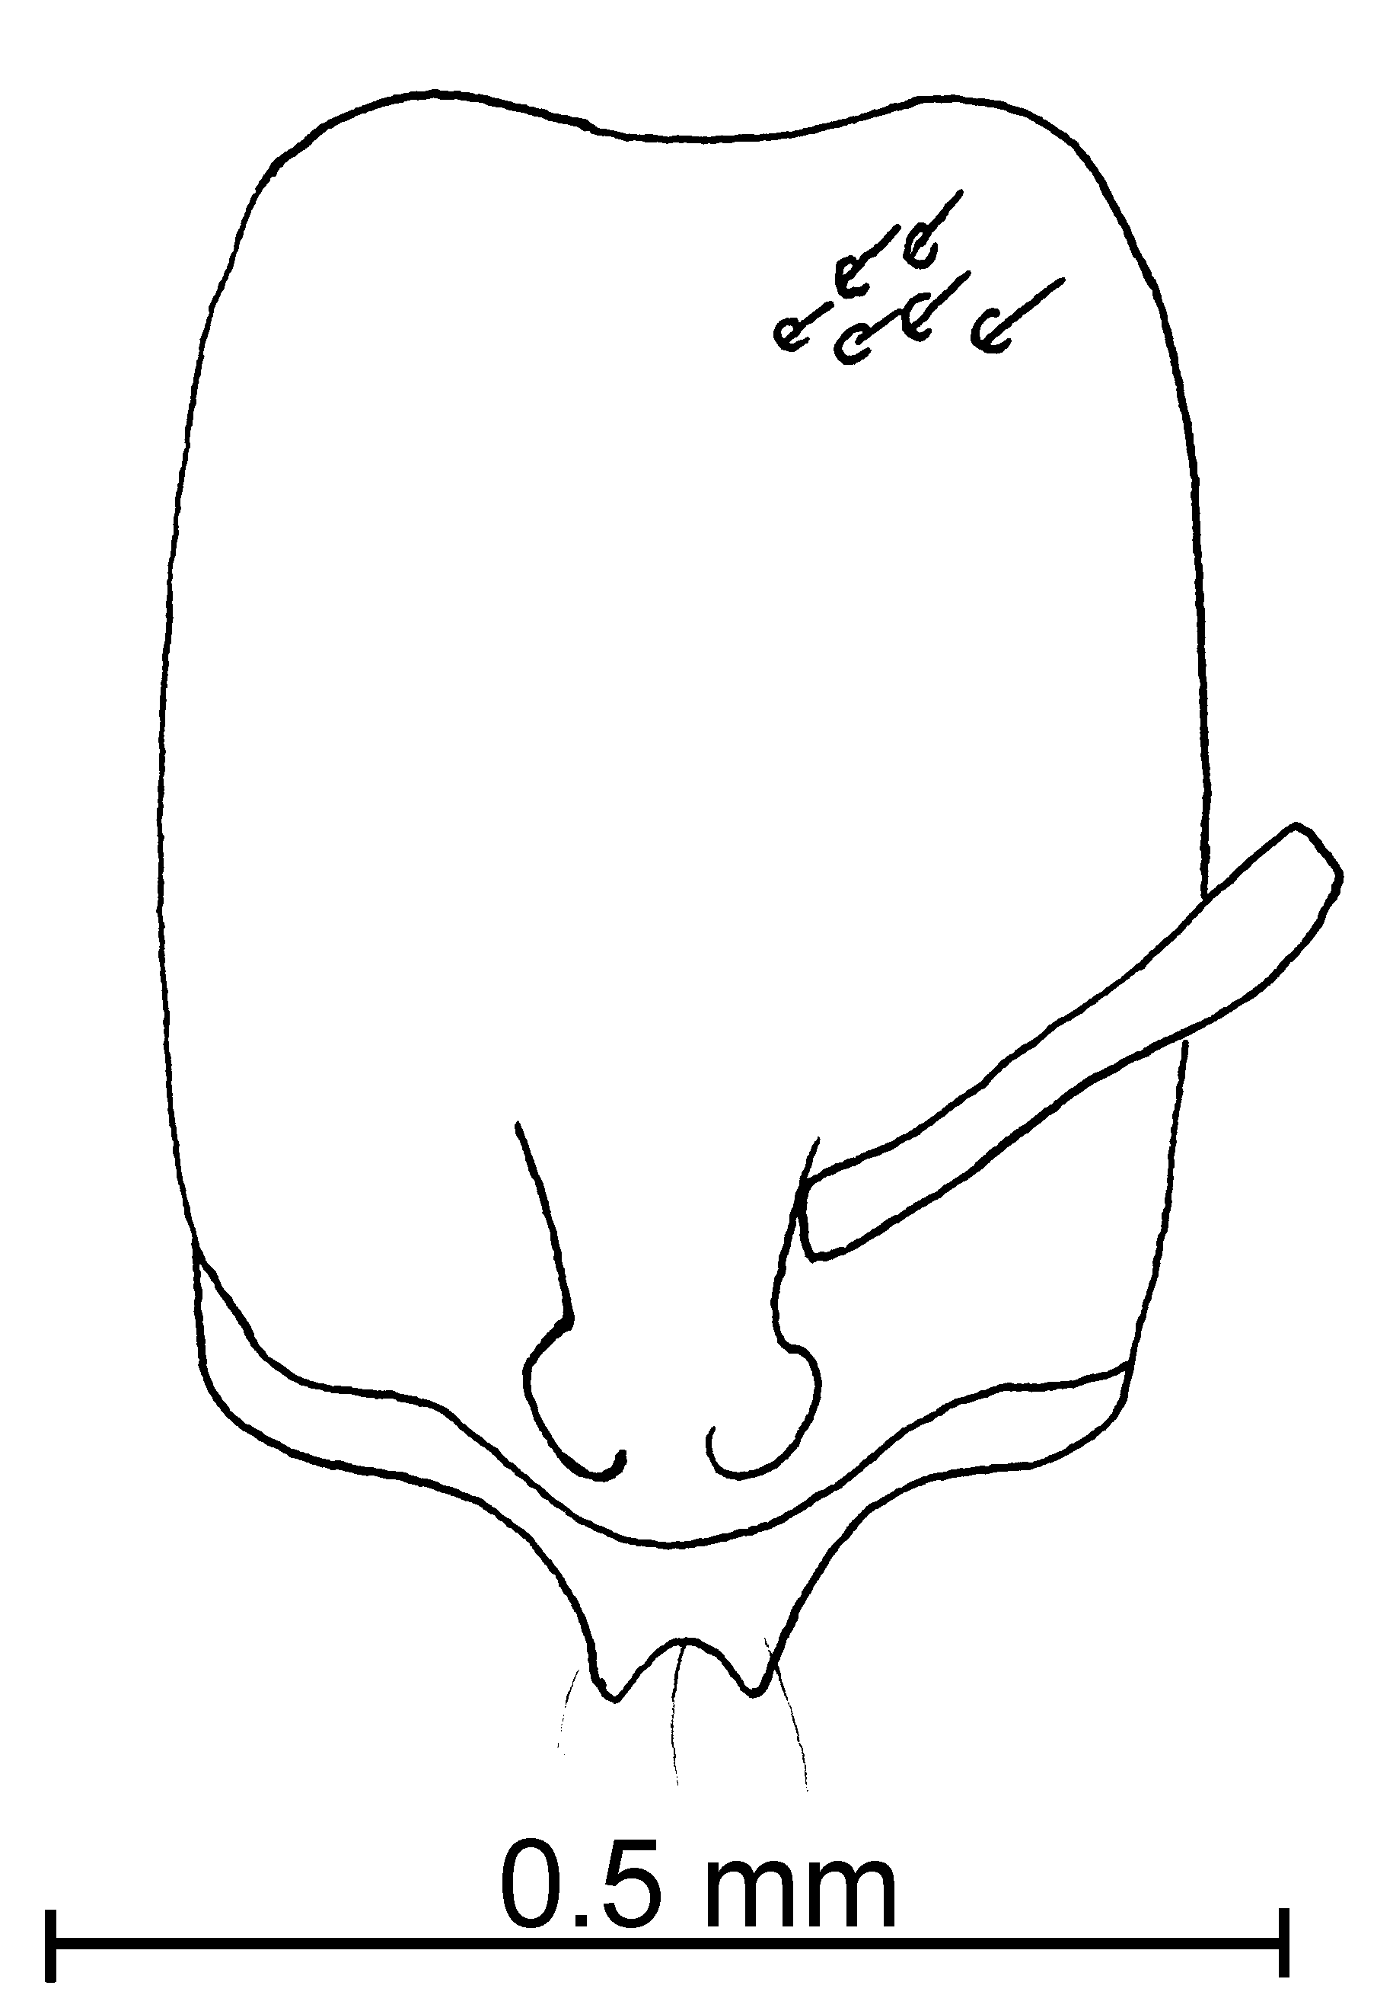
Fig. 66. Head of the holotype worker of S. pulleni.
Description: Head very elongate, dorsal and ventral surfaces flat, sides of head straight, posterior border deeply concave; lateral clypeal teeth very well developed, medial tooth absent, extra lateral bumps poorly developed; usually scape extends slightly more than half length of head; eye barely visible, same color as cuticle, ommatidia not evident; mesosoma and petiole as in other members of the complex.
Map 52. Solenopsis pulleni.
Short (~ 0.02 mm), erect hairs sparse on head, about 10 on any line drawn from the posterior border to the posterior base of clypeus, antenna not very hairy, especially club, scape with few suberect hairs, pronotum with ~ 8 erect hairs projecting above outline, as seen in profile, mesonotum with ~ 3 erect hairs (0.03 mm) above profile, ~ 2 on propodeum, 3 on outline of petiole, ~ 6 on outline of postpetiole, gaster with scattered, fine hairs, ~10 erect hairs on outline of first tergum.
Head with abundant (~ 13 along line from posterior border to border of clypeus), coarse punctures, much larger than hairs that originate from them, many without, punctures on mesosoma and gaster similar, surfaces between punctures smooth and glossy.
Concolorous yellow.
Female and Male: Unknown.
Distribution: Known only from the type locality.
Map 53. Solenopsis pulleni in North America.
Type series: : Holotype worker (MCZC), 15 paratype workers (AMNH, CASC, CWEM, IAVH, LACM, MCZC, MPEG, MZSP, USNM), USA: New Mexico, Doña Ana Co., Jornada Playa, 8-x-1986, B. Pullen #10.
Etymology: Named to honor Barry Pullen, who collected the type series, as well as several other, interesting ants.
Material examined: Type series.
Biology: Unknown.
`` Solenopsis pygmaea Forel
pygmaea species complex

Solenopsis pygmaea Forel, 1901:345 (originally misspelled as pygmaca; justified emendation pygmaea by Forel, 1915:354).; replacement name for exigua Forel, 1893:395 (junior secondary homonym of exigua Buckley, 1867:342).

Diagnosis: The workers are small, pale yellow ants, in which the shortest segments of the funiculus are 0.07 - 0.09 mm in total length. The clypeal teeth are very well developed. The pronotum has abundant erect hairs, which are of different lengths. The hairs on the posterior tibiae are usually slightly raised from the surface. The punctures on the head are moderately large, larger than the hairs that arise from them. The hairs on the first tergum of the gaster are similar to those on the pronotum, but tend to be nearly the same length. The hairs on the remaining terga are longer and coarser.
Map 54. Solenopsis. fix dots??
The female is large (about 5 mm total length). It is medium brown with a lighter brown gaster (due in part to the lighter intersegmental membranes of the distended gaster). The eye is relatively small (maximum diameter 0.19 mm), extending about 1/3 of the length of the side of the head. The dorsum of the head is covered with coarse punctures. The scapes and tibiae are covered with suberect hairs.
The workers of this species are nearly identical to those of S. tennesseensis, differing in being slightly smaller more abundantly covered with erect hairs. The hairs on the dorsum of the first tergum are all short (up to 0.03 mm, few up to 0.04 mm), abundant (more than 20), and approximately equal in length. The similar hairs of S. tennesseensis are longer (many 0.05 mm), sparse (fewer than 20) and are somewhat unequal in length. The synonymy of S. tennesseensis is not proposed as the females of the latter species are unknown.
The specimens from México appear to be identical to specimens from Puerto Rico, but are not associated with females, and may actually be another species.
Distribution: Caribbean.
Map 55. Solenopsis pygmaea in North America.
Material examined: Types and MEXICO: Tabasco, Campo Experimental COLPOS, Cárdenas, 22-viii-2000, P. Rojas # BSIE-1186 (8  Instituto de Ecología). UNITED STATES: Puerto Rico, ____________ Co., Cayey, 8-vi-1991, J. Torres # 600 (3  CWEM); Guaynabo, Barrio Sonadora, 3-vi-1991, J. Torres # 593 (2 , 1 alate  CWEM).
Biology: Solenopsis pygmaea. In the soil in Selva Avacohite
`` Solenopsis quadridentata Moreno & Mackay, new species
new species 11

molesta species complex

Diagnosis: The workers are small, pale yellow ants, in which the shortest segments of the funiculus are usually less more than 0.10 mm in total length. The clypeal teeth are very well developed, The extralateral bumps are poorly developed. The hairs on the posterior tibiae are usually appressed or decumbent. The punctures on the head are moderately large, larger than the hairs that arise from them.
Measurements: TL 1.4-1.5mm, HL 0.40 - 0.45mm, HW 0.25 - 0.27 mm, SL 0.28- 0.30mm. Indices: CI 60 - 62, SI 67-70.
Description: Head longer than wide, sides of head straight, posterior border slightly concave, lateral clypeal teeth very well developed, medial tooth absent, extra lateral teeth poorly developed, scape extends slightly more than ²/₃ length of head; small, brown eye, at least two ommatidia, oval petiole and postpetiole.
Hairs of various lengths (~ 0.02 - 0.09 mm), erect and semierect hairs on head, about 13 on any line drawn from the posterior border to the posterior base of clypeus, antenna very hairy, scape with few suberect hairs, pronotum with ~ 7 erect hairs projecting above outline, as seen in profile, mesonotum with ~2 erect hairs (0.07 mm) above profile, ~ 4 on propodeum, ~ 4 on outline of petiole, ~ 4 on outline of postpetiole, gaster with erected hairs, ~13 erect hairs on outline of first tergum. All hairs are pointing in different directions.
Head many hairs (~ 13 along line from posterior border to border of clypeus), coarse punctures, larger than hairs that originate from them, punctures on mesosoma and gaster less coarse, surfaces between punctures not smooth.
Concolorous pale yellow.
Female: A dark brown color and slender body specimen, very hairy and it has very course punctures, It has medium eyes size (maximum diameter 0.18 mm) and very small ocellus (0.08 mm). Its lateral and extralateral clypeus teeth are sharp and very well developed.
Distribution: USA (New Mexico).
Map 56. Solenopsis quadridentata in North America.
Types. Holotype worker (MCZC), 6 paratype 5?? workers and 1 female (CWEM, MCZC). USA: New Mexico, Socorro Co., Magdalena Mt. 17.0K Magdalena, 04-viii-1994, W. Mackay #16774.
Etymology: From Latin, quattuor, meaning four, and dentis, for tooth, referring to the four teeth on the anterior margin of the clypeus of the female of this species.
Material examined: Type series
ARKANSAS: Pike Co., Center of Diamonds, 13-viii-1988, R. Anderson (1  CWEM).
Biology: Solenopsis quadridentata nest under ground.
`` Solenopsis rugiceps Mayr

fugax species complex

Solenopsis rugiceps Mayr, 1870:406, worker, Colombia [without locality]

Diagnosis: The coarsely sculptured head of the worker easily separates this species from all others that may be found in North America. The rugulae cover much of the anterior part of the head, the posterior part of the head may be moderately smooth and glossy. The four teeth on the anterior border of the clypeus are very well developed, the extra lateral teeth are nearly as large as the medial pair of teeth. Furthermore, the petiole is broad when viewed in profile (Fig. ).
Distribution: Colombia.
Map 57. Solenopsis rugiceps in South America.
Types: Lectotype worker [here designated], … Colombia [without locality] ().
Material examined: Type series and COLOMBIA: Valle del Cauca, Bosque Yotoco, 1575m, 23-vi-1989, W. Mackay #’s 11542, 11549, 11550, 11573 (42  CWEM)
Biology: Workers were collected in surface and subterranean baits containing Vienna sausage, in an old-growth tropical rain forest.
`` Solenopsis salina Wheeler
molesta species complex

Solenopsis salina Wheeler, 1908. 24: 427, pl. 26, figs, 24-25 (q.).

Diagnosis: The workers are small, yellow ants (or pale brown, sometimes with darker brown areas), in which the total length of the shortest segments of the funiculus is usually less than 0.10 mm. The clypeal teeth are often bent inward, and are thick and usually blunt at the tips. The extralateral bumps are poorly developed. The hairs on the posterior tibiae are usually appressed or decumbent. The punctures on the head are moderately large, much larger than the hairs that arise from them.
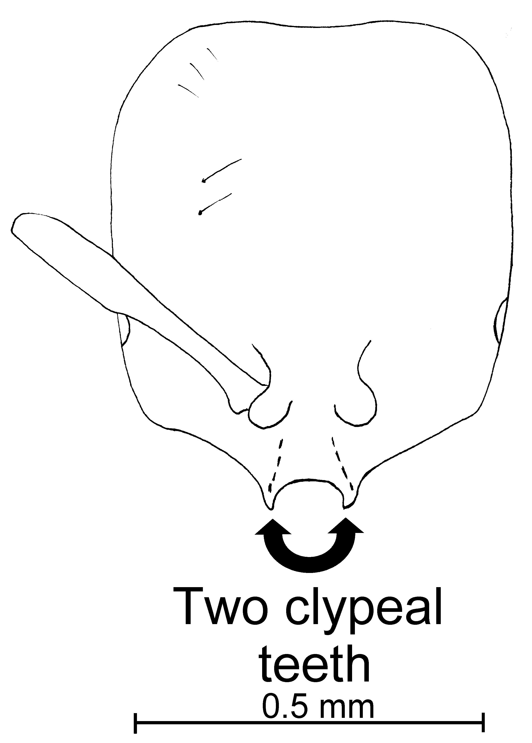
Fig. 67. Head of a ____________ worker of S. salina.
The blunt, inwardly curved clypeal teeth of the worker (not always in this form in all specimens of a series) will often separate this species from the closely related S. texana (straight, thick, blunt teeth, rarely bent inward) and S. quadridentata (straight, slender, sharp clypeal teeth). The punctures on the head are moderately large and obvious, which also separates this species from S. texana (where the punctures small and difficult to see). The appressed or decumbent hairs on the posterior tibiae (as well as the larger punctures on the head) will separate it from S. carolinensis. Larger workers (rare) could be confused with S. molesta, but the combination of the bent clypeal teeth (teeth may also be curved inward in S. molesta) and the larger punctures on the head should separate this species from S. molesta. It can be separated from members of the fugax group as the cephalic punctures are much finer and the extra lateral clypeal bumps are poorly developed.
Distribution: USA (Louisiana, Mississippi, New Mexico and Texas).
Map 58. Solenopsis salina in North America.
Types: We were unable to locate any types of S. salina; they were apparently borrowed by Thompson in 1989, and not yet returned (S. Cover, pers. comm.).
Material examined: USA: Louisiana, Calcasieu Co., Sam Houston Jones St. Park, 17-viii-1987, W. Mackay #’s 9702-7 (1  CWEM), Iberia Co., New Iberia, 19-viii-1987, W. Mackay # 9785 (6  CWEM); Mississippi, Hancock Co., Waveland, 24-viii-1987, W. Mackay #19850 (1  CWEM) Oktibbeha Co. 4 k NE Starkville, 27-viii-1987, W. Mackay #’s 9928, 9933, 9936, 9937, 9955 (28  CWEM); New Mexico, Catrón Co., 37 k N Apache Creek, 24-iii-1994, W. Mackay # 16581 (41 , 1  CWEM), Otero Co., Bates Peak Turnoff, N side of Rd. 41.4 Km. NW Sitting Bull Falls, 01-ix-1997, W & E Mackay #’s 17588, 611, 636, 637 (54  CWEM); Texas, Brazos Co., College Station, Foster Lane, 17-vi-1987, W. Mackay #’s 19214, 220-22, 226, 228, 230, 233, 234, 236, 238, 240, 246 (46  CWEM), same locality, 5-v-1987, W&E Mackay #’s 9196, 9197, 9200 (9  CWEM), 10 K N Kurten, 5-v-1987, W. Mackay #’s 9108, 98, 99, 9201 (14  CWEM), same locality, 18-vi-1987, W. Mackay #’s 19255, 256, 258, 265, 272, 287, 621, 682, (20  CWEM), Peach Creek, 22-vii-1987, W. Mackay #’s 9355(2), 56B, 57B, 58A(3), 58B, 59(2), (39  CWEM), same locality, 5-viii-1987, W. Mackay # 9661 (2  CWEM), Lick Creek Park, College Station, 03-vii-1999, K. Helms #’s 53-56, 58, 65-67, 69, 70-75, 79, 80, 81 (10  CWEM), Anderson Site, K. Helms #’s 29, 30, 35-37, 39 (6  CWEM), Brazos Site, 01-vii-1999, K. Helms # 10 (1  CWEM), Brooks Co., 13 k S Falfurrias, 38-vii-1987, C. Pinder # 9440 (3  CWEM), El Paso Co., El Paso, Chamizal National Monument, numerous dates during 1998-2001 (numerous  CWEM), Hardin Co., Votaw, 16-viii-1987, W. Mackay # 9699 (2  CWEM), Real Co., 13 k S Leakey, 15-iii-1990, W. Mackay # 13380 (1  CWEM), Rusk Co., 30 k NE Nacogdoches, 3-vi-1990, W. Mackay # 13400 (16  CWEM).
Biology: These ants nest under large stones on grass and underground.
`` Solenopsis striata Mackay & Moreno, new species
new species 12

molesta species complex

Diagnosis: The striated mesopleuron will separate this species from all others in the molesta species complex, including the closely related S. laeviceps, in which the mesopleuron is nearly completely smooth and shining. The eye is small, with the maximum diameter ranging in size from 0.04 - 0.05 mm.
Measurements: Worker TL 1.51 - 1.86 mm, HL 0.46 - 0.53 mm, HW 0.40 - 0.46 mm, SL 0.31 - 0.35 mm, Indices: CI 86 - 87, SI 66 - 68.
Description. Head subquadrate, slightly longer than broad, sides of head convex, posterior border straight; lateral clypeal teeth well developed, extra lateral teeth developed as only slightly swollen area; scape nearly reaching posterior lateral corner; metanotal suture deeply depressed.
Erect and suberect hairs abundant on most surfaces, including scapes and tibiae.
Punctures on head small, only slightly larger in diameter than hairs arising from them, all surfaces smooth and glossy, except for mesopleuron, which is longitudinally striate (at least lower half).
Concolorous yellow.
Female and male: Unknown.
Distribution: Costa Rica and Panamá.
Map 59. Solenopsis striata in North America.
Type series: Holotype worker (MCZC), 61 paratype workers, COSTA RICA, Guanacaste, Pitilla Field Station, 600 - 1175m, 2-v-1996, 14-ii-1998, R. Anderson #’s 17679, 17691, 17692, 17694, 17715, 17721, 17722, 17741, (AMNH, CASC, CWEM, IAVH, LACM, MCZC, MPEG, MZSP, USNM).
Etymology: From Latin, stria for furrow, referring to the sculpture on the lower mesopleuron.
Material examined: Type series and COSTA RICA: Guanacaste, Cacao Field Station, 1000m, 12-15-ii-1996, R. Anderson #’s 17733, 17765 (2  CWEM), Maritza Field Station, 800 - 950m, 13-17-ii-1996, R. Anderson #’s 17667, 17668, 17734 (24 , 1  CWEM), same locality, 3-v-1995, R. Anderson # 17715 (7  CWEM); Puntarenas, Cerro Helado, 24-vi-1997, R. Anderson # 18699 (1  CWEM), Osa Fundación Neotropical, 23-vi-1997, R. Anderson # 18687 (3  CWEM); San José, 68 k ___ Boquillos ???, 10-ii-1996, R. Anderson # 17750 (1  CWEM). PANAMA: Chiriquí, Bocas del Toro, 9-vi-1995, R. Anderson #’s 17840, 17841, 17843, 17845 (11  CWEM), Fortuna area, Finca La Suissa, 10-12-vi-1995, Anderson # 17775, 17839 (21  CWEM), Fortuna Hydrological Trail, 1100m 9-vi-1995, R. Anderson # 17785 (5  CWEM), 20 k N San Félix, 950m, 8-vi-1995, R. Anderson #’s 17767, 17768 (66  CWEM); ______________ Cerro Campana, 900 - 950m, 5-vi-1995, R. Anderson # 17756 (7  CWEM)
Biology: Workers were collected in litter samples.
`` Solenopsis subterranea Mackay and Vinson
pygmaea species complex

Solenopsis (Diplorhoptrum) subterranea Mackay and Vinson 1989. 91(2):175-178, Figs. 1-4, worker

Diagnosis: Workers of this species are easily recognized as having an elongate head, which is densely, coarsely and evenly punctate (except for a narrow, central strip without sculpture). The eyes are very small and round, with at least one ommatidium. The head and mesosoma are covered with a short (0.02 mm), vestiture, in which all hairs are about equal in length. The length of minor segments of the funiculus is 0.06 mm.
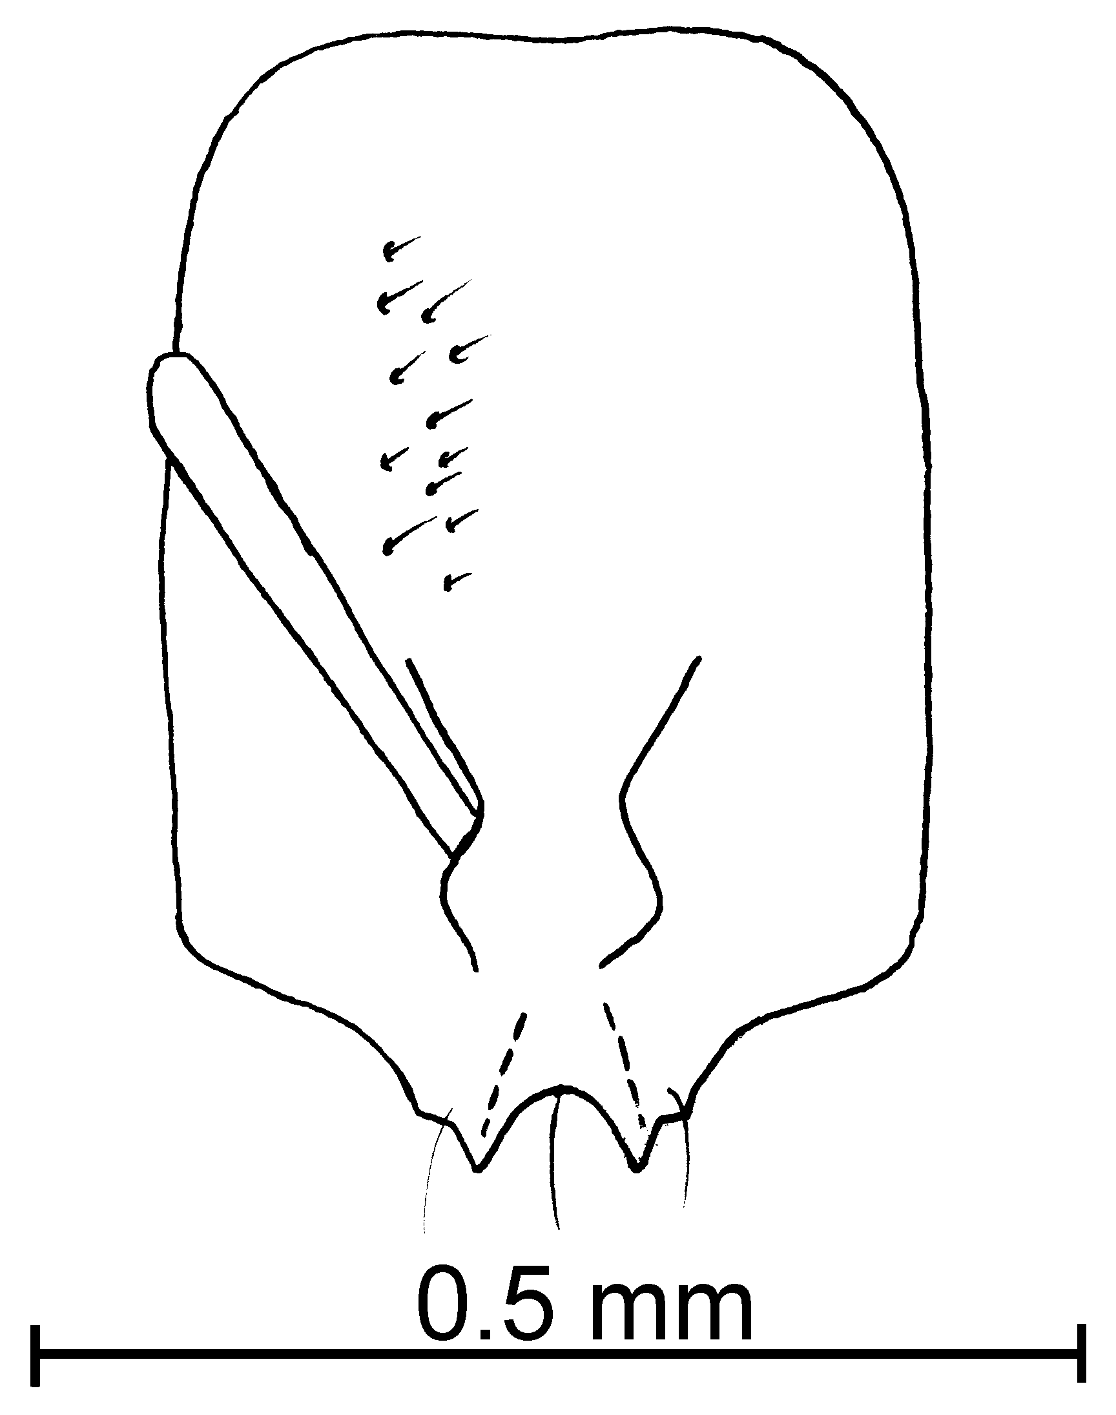
Fig. 68. Head of a paratype worker of S. subterranea as seen from the front and from the side.
The vestiture of short hairs on the head and mesosoma would easily separate this species from all other species in the United States in the pygmaea complex, except S. tonsa. It can be separated from the latter species as the head is slender as seen in profile (compare Figs. 4c and 4e). It could be easily confused with the Mexican species S. isopilis and the South American S. minutissima, which both have short hairs on the pronotum and gaster, which are all about equal in length. It can be separated from S. minutissima the eyes are small, but well-defined (poorly defined, nearly absent in S. minutissima). It can be separated from S. isopilis by being more hairy, with more than 20 erect hairs on the outline of the pronotum when seen in profile.
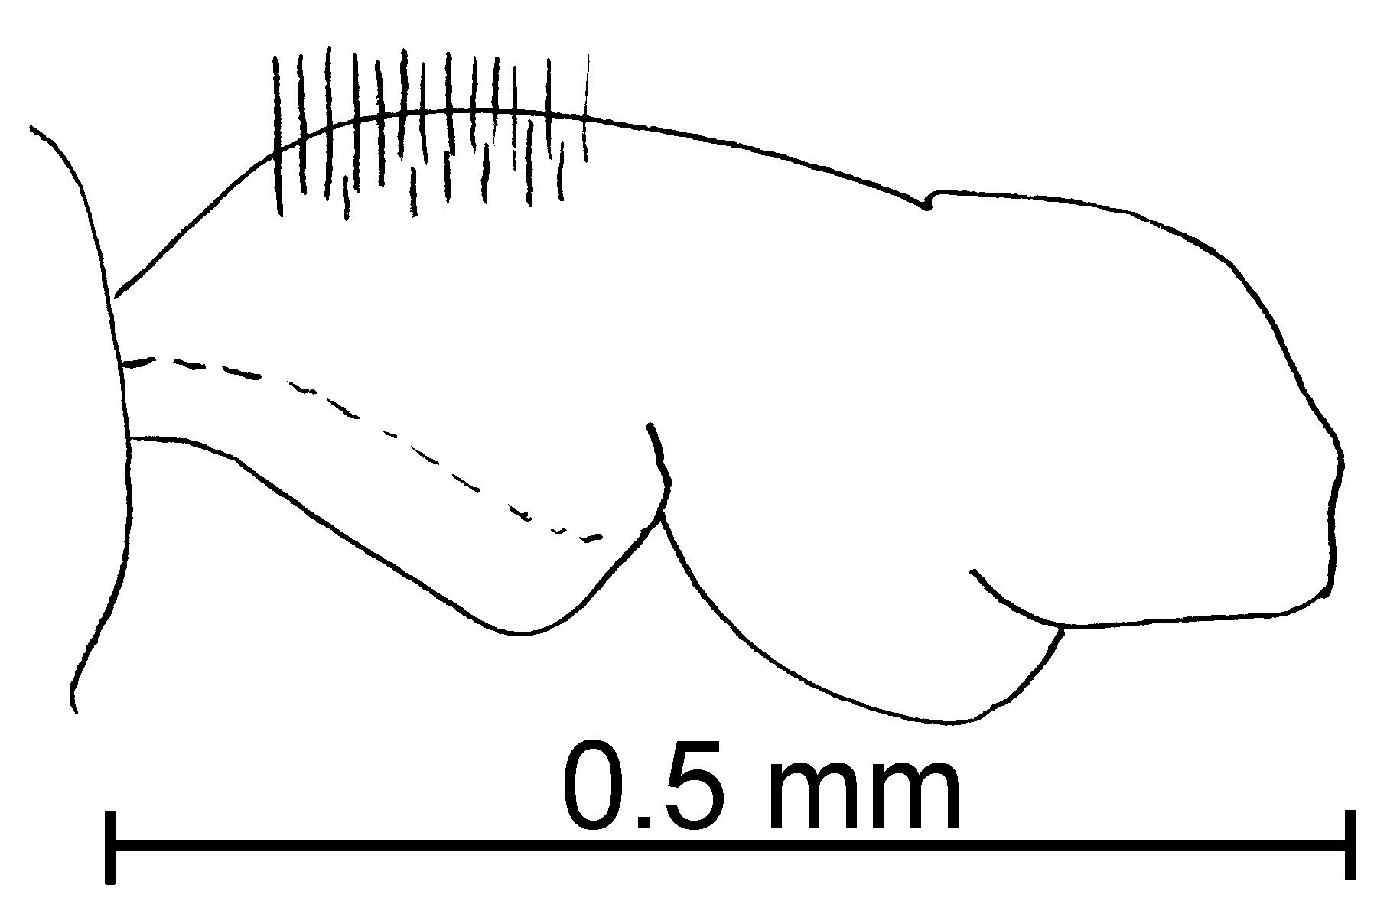
Fig. 69. Mesosoma of a paratype worker of S. subterranea.
Distribution: Costa Rica, Colombia (Cauca), Mexico (Chiapas and Tabasco), USA (Louisiana and Texas) and Venezuela (Distrito Federal).
Map 60. Solenopsis subterranea in North America.
Map 61. Solenopsis subterranea in South America.
Types: USA, Texas, Brazos Co., 10 k N Kurten, Holotype and 20 paratypes are deposited in the MCZC, additional 180 paratypes are deposited in the USNM, AMNH, CASC, CWEM, LACM, BMNH, UNAM, FMNH, FSCA, MZSP, MACN, UNC, MVIC, Insect Collection of Texas A&M (Mackay and Vinson, 1989)
Material examined: COLOMBIA: Cauca, Isla Gorgona, 2-x-1989, M. Baena # GGHI-5 (24  CWEM), same locality, 2-i-90, #GG-Hi-9 (28  CWEM), same locality, 2-ii-90 #’s GY-Hi8, GY-Hi4 (5  CWEM), same locality, 10-xi-89 # GY-Gii2 (26  CWEM). COSTA RICA, Guanacaste, Loma Barbudal, 3-vi-1989, S. B. Vinson #’s 12076, 081, 082, 177 (17  CWEM), same locality, ii-1990 S. B. Vinson #’s 13064, 125, 160, 161 (20  CWEM). MEXICO, Chiapas, 10 k S Palenque, 30-v-1988, W. Mackay #’s 1056, 63, (21  CWEM), same locality, 31-v-1988 #1065 (95  CWEM), Rancho Sagrado Corazón (Municipio Cintalpa), 2-vi-1988, W Mackay #’s 10718, 24 (31  CWEM; Tabasco, 10 k N Cárdenas, 28-v-1988, W. Mackay #1050 (17  CWEM). USA, Louisiana, Calcasieu Parish, Sam Houston Jones St. Park, 17-viii-1987, W&E Mackay #9724-1 (1  CWEM); Texas, Brazos Co., N side of Ferrill Creek Rd., 3.94 K E of turnoff from Farm Road 2038 North, 5-viii-1987, W. Mackay #9636 (201  CWEM); Cameron Co. Anzalduas Park 15-x-1988, R. Anderson (5  CWEM). VENEZUELA: Distrito Federal, Caracas, Instituto de Estudios Avansados, 10-x-1988, W Mackay #11136-10, (36  CWEM).
Biology: These specimens were captured in pit fall traps at 10 cm. in depth (Mackay and Vinson 1989).
`` Solenopsis succinea Emery
succinea species complex

Solenopsis succinea Emery, 1890:52 (w.q.m.)

Diagnosis: The workers are relatively large specimens (2.25 mm total length), nearly as long as the female (3 mm total length) and male (2.5 mm total length). The head is somehow square, the round eyes have at least two ommatidia. It is not very hairy, including the gaster. The antennae, including the segments of the funiculus (0.19 mm total length), is long. The clypeus is straight between the teeth, the lateral and extralateral clypeal teeth are not well developed. The metanotal suture is very depressed and the propodeal spiracle large and round. The petiole and postpetiole are wide (Fig. 8b). The lack of clypeal carinae and its large size, together with the 10-segmented antenna of the female, suggest that this species is not closely related to the other thief ants, and it is included here only for identification purposes.
Map 62. Solenopsis succinea.
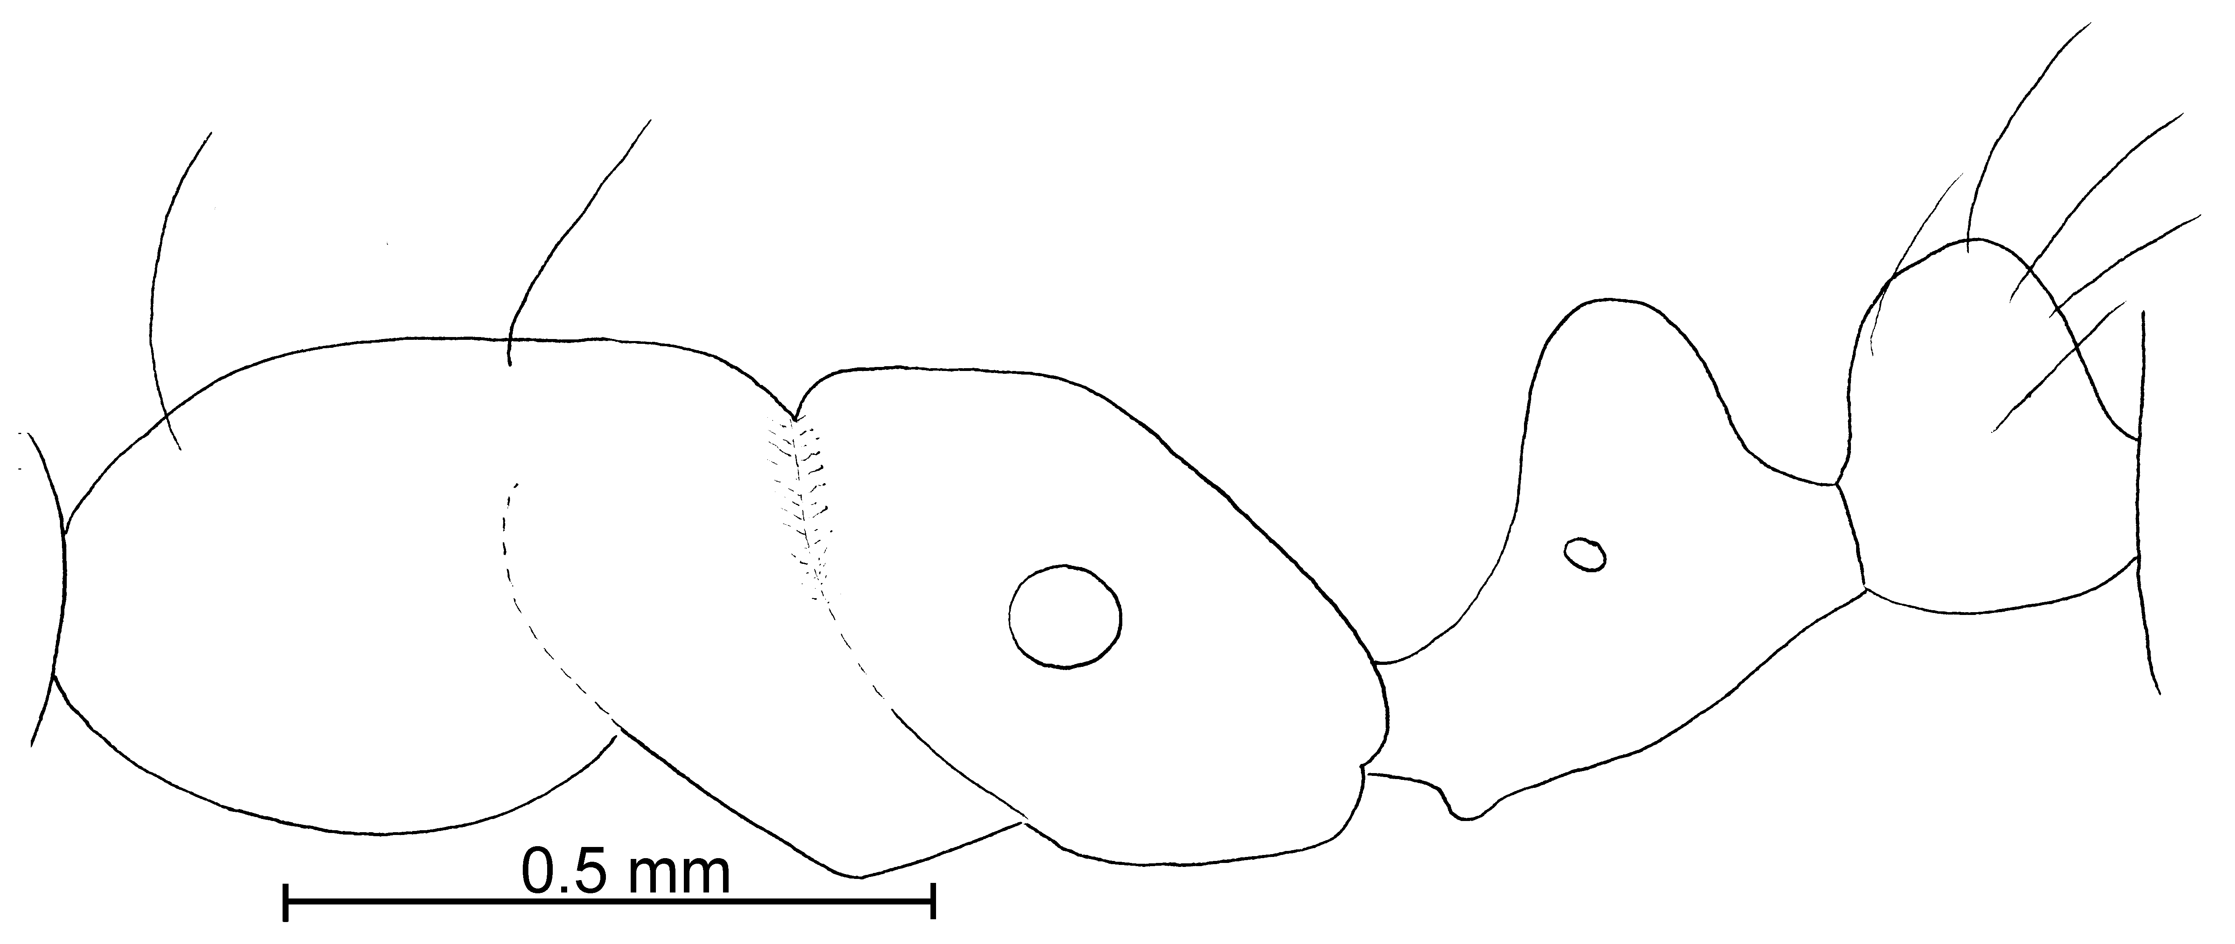
Fig. 70. Mesosoma of a _________ worker of S. succinea.
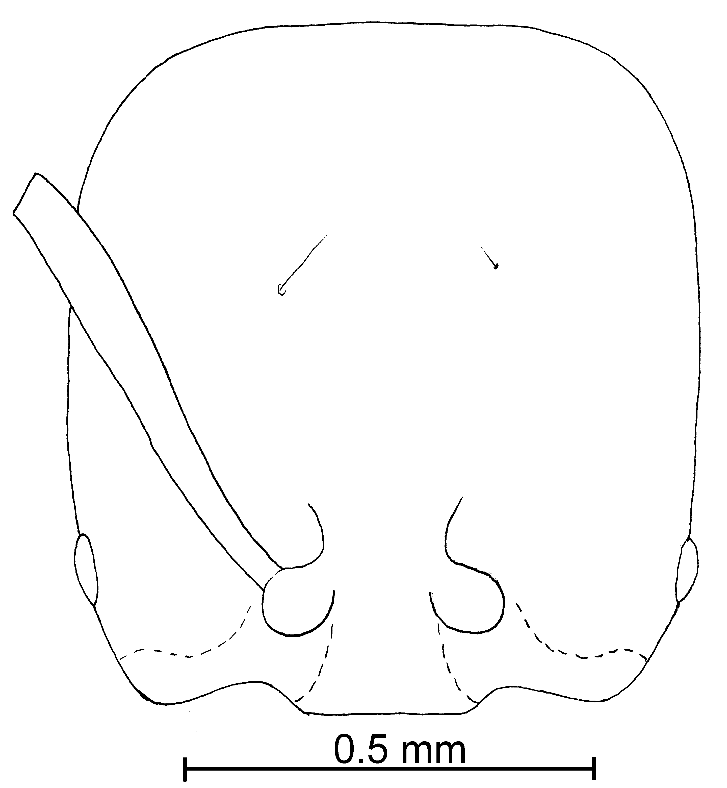
Fig. 71. Head of a _________ worker of S. succinea.
Fig. 72. Head of a ___________ female of S. succinea (50 X).
Distribution: Costa Rica, Haiti (see Map 22).
Map 63. Solenopsis succinea in North America.
Type series: Lectotype worker, 1 paralectotype worker, 1 paralectotype female and 1 paralectotype male [here designated], S. succinea worker, female and male Emery Costa Rica: Jimenez (MCSN).
Material examined: Type series.
Biology: Unknown.

`` Solenopsis tennesseensis Smith
pygmaea species complex

Solenopsis tennesseensis M.R. Smith. 1951:814 (w.)
Solenopsis longiceps M. R. Smith. 1942:210 (w.)

Diagnosis: The head is much longer (0.40 - 0 41 mm) than wide (0.28 - 0.30 mm), flat, and the mandibles are very hairy. The clypeus has very well developed, lateral teeth, and extralateral teeth are present but not very well developed. This ant is very hairy, the hairs on the head are the same length. The minor segments of the funiculus are usually about 0.09 mm in total length. The eyes are very small, round and light brown, and do not appear to have ommatidia. The propodeal spiracle is barely visible. The peduncle is not developed. The gaster is flat, elongate and hairy. The hairs on the dorsum of the first tergum are scattered, and of various lengths (the longest hairs are about 0.05 mm). The length and form of the gastral hairs would separate this species form similar species that have shorter hairs (), in which all the hairs are approximately the same length (S. pygmaea, S. minutissima, and those with short minor funicular segments such as S. subterranea).
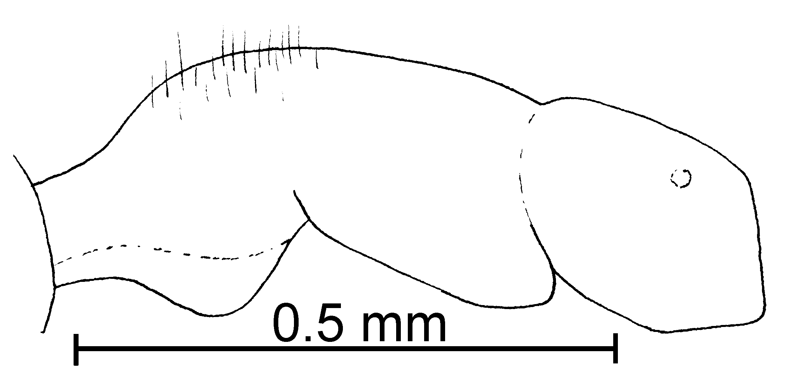
Fig. 73. Mesosoma of the _______________ worker of S. tennesseensis.
The workers of S. tennesseensis are difficult to distinguish from the workers of S. pygmaea, differing in being slightly larger and slightly less hairy. It could be a synonym of S. pygmaea, but will not be proposed as a synonym as the females may be different (the female of S. tennesseensis is unknown), and thus the two species are separated geographically in the key.
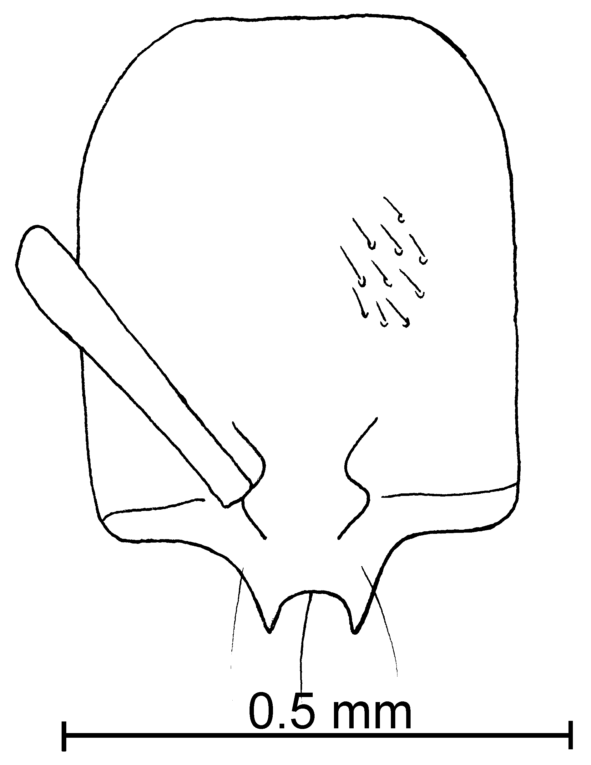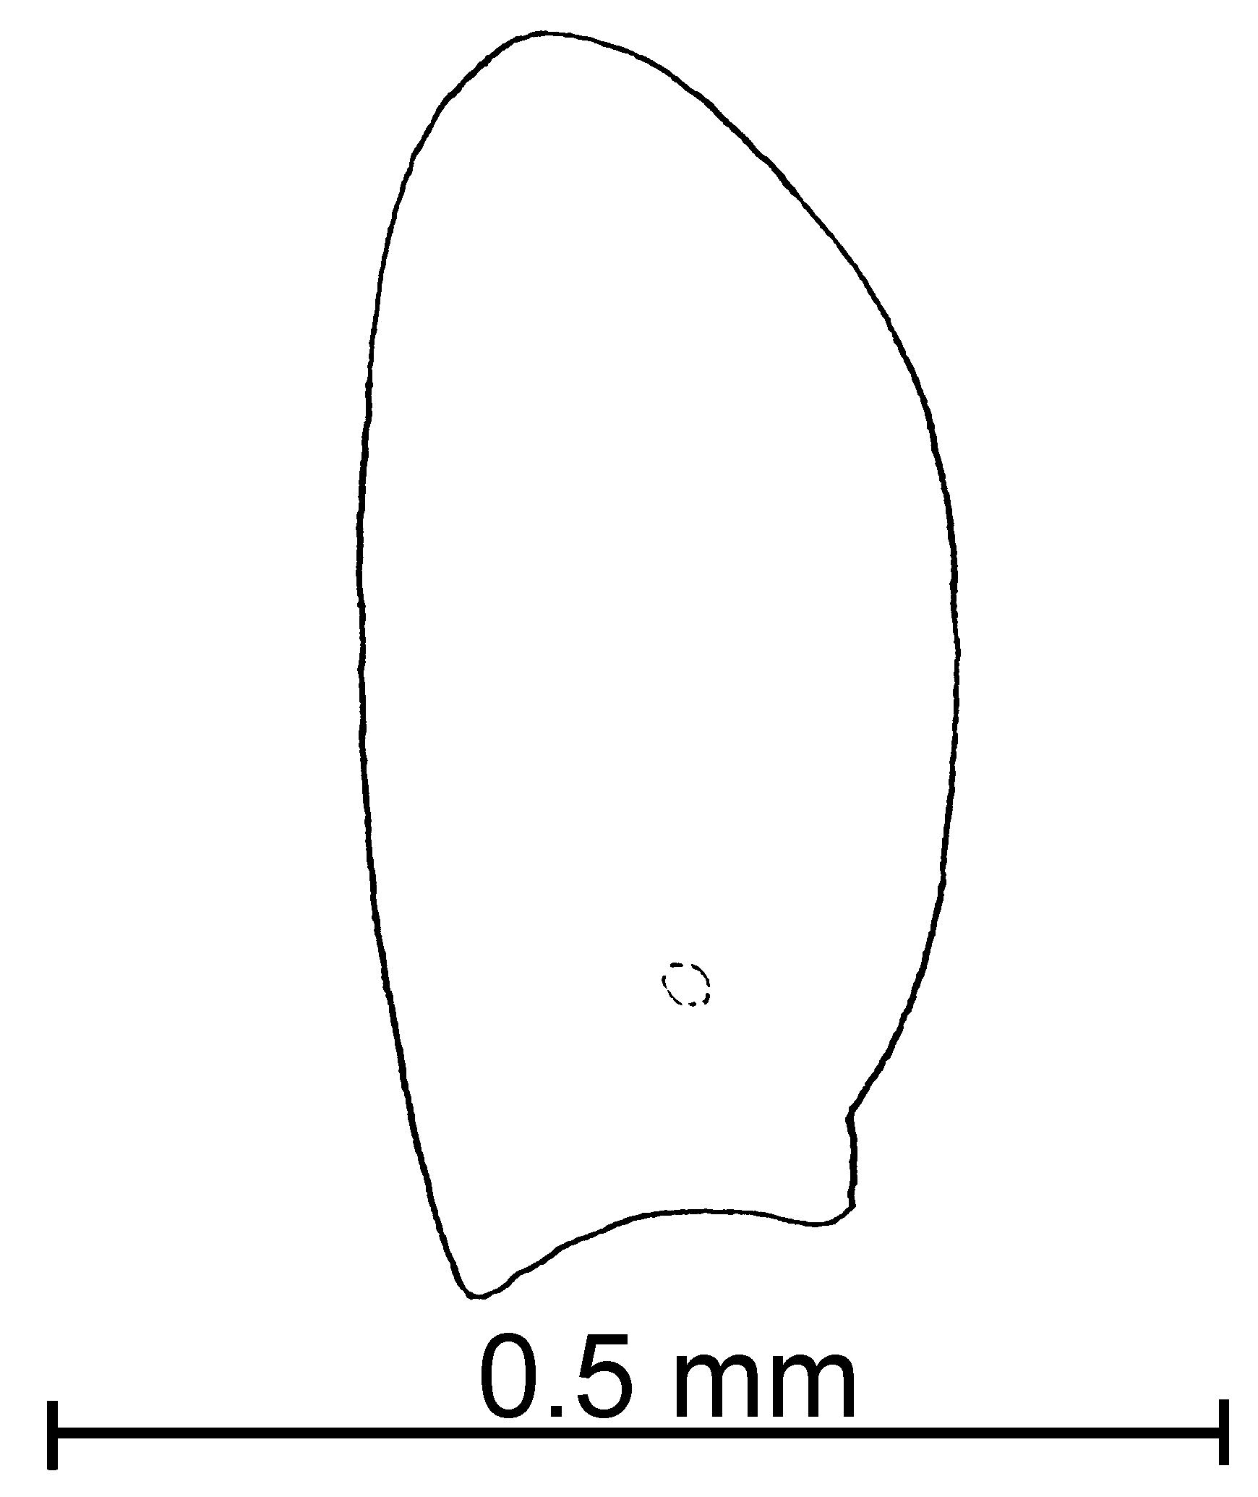
Fig. 74. Head of a _________________ worker of S. tennesseensis as seen from the front and from the side.
Distribution: USA (Tennessee and Texas) south to Colombia (Valle and Valle del Cauca).
Map 64. Solenopsis tennesseensis in North America.

Map 65. Solenopsis tennesseensis in South America.
Types: Lectotype worker, 5 paralectotypes workers [here designated], S. tennesseensis worker, Tennessee, Hamilton Co., Smith paratype #563441 (MCZC) and #28092 (USNM).
Material examined: COLOMBIA: Valle, Loboguerrero, 26-vi-1989, F. Fernández #’s 11938,944,974, 976, 977, 982, 12014-5 (79  CWEM), Valle del Cauca, Bosque Yotoco, 23-v-1989, W. Mackay #11676 (2  CWEM). MEXICO: San Luis Potosí, Cuidad Valles, 9-vi-1998, W. Mackay # 10940-9 (3  CWEM), Tabasco, 10 k N Cárdenas, 28-v-1988, W. Mackay #’s 10504, 10506, 10508, 10510 10511, 10512, 10514 (65  CWEM). USA: Florida, Dixie Co., 4 mi N Cross City, 7-vii-1990, M. Deyrup (4  Deyrup Collection), Highlands Co., Archbold Biological Station, Lake Placid, 4-viii-1983, M. Deyrup (1  Deyrup Collection, not associated with ), Polk Co., Davenport, 11-iv-1990, M. Deyrup (4  Deyrup Collection); Texas, Brazos Co., Van of Riet Site, 21-vii-1999, K. Helms #’s 1-2, 97 (3  CWEM), Allen Site, #’s 89, 90, 91 (3  CWEM), Coulter Airfield, #’s 25-27 (3  CWEM), Brazos Site, #7, 24 (2  CWEM), Riverside Campus (TAMU), #’s 3-4 (2  CWEM), El Paso Co., El Paso, Chamizal National Monument, numerous dates during 1998-2001 (numerous  CWEM).
Biology: These ants nest in the soil and under stones. Male collected in malaise trap. Hardwood forest near swamp. Hardwood swamp forest.
`` Solenopsis tenuis Mayr
tenuis species complex

Solenopsis tenuis Mayr, 1877: 874 (w.q.)
Solenopsis tenuis Forel, 1913: 222 (m.)

Diagnosis: This is a small, slender, pale brown or medium brown species, in which the head is nearly square, and has relatively large, black eyes. The minor funicular segments are shorter than 0.12 mm in total length (these segments of the workers of the type series are about 0.10 mm in total length, occasionally workers have even shorter funicular segments, about 0.08 mm in total length, and are considered to be S. tenuis, although they may represent an undescribed species). The lateral clypeal teeth are not very developed and it is straight between the teeth. It has scattered hair all over the body. The antennae, including the scape, are long, and have long and erect hairs. The apex of the petiole is slightly acute and higher than postpetiole (in profile). The side of the propodeum is finely striated. The metanotal suture is deep and widely depressed.
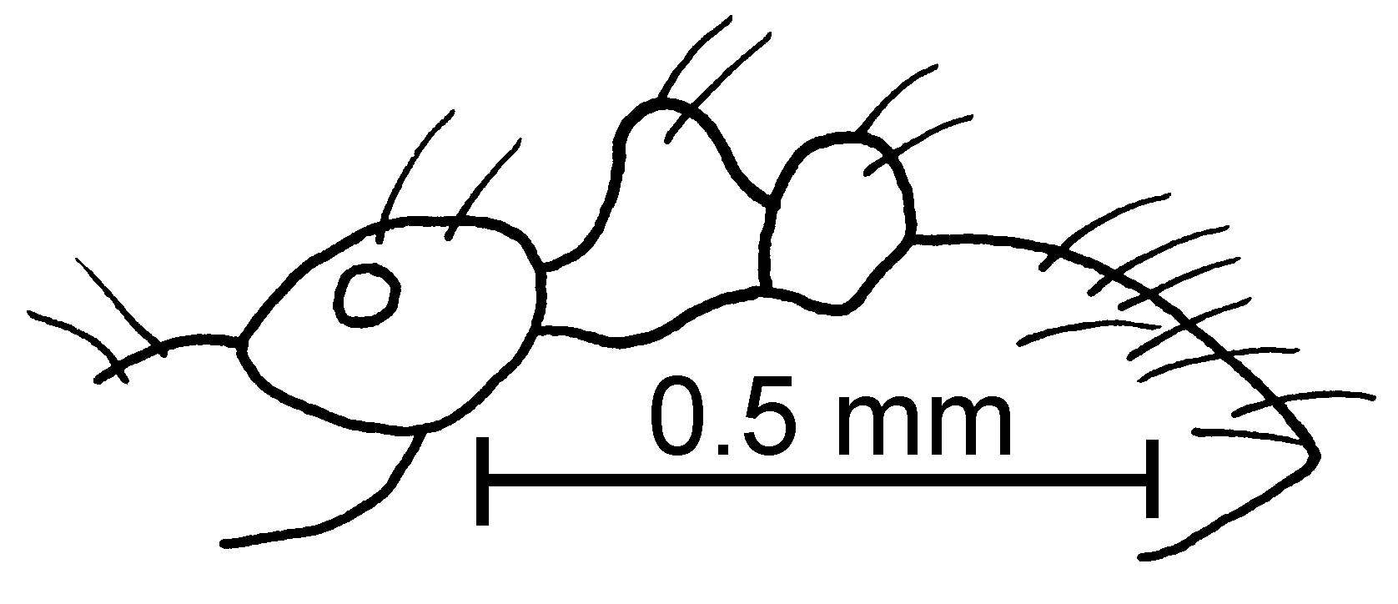Fig. 75. Mesosoma, petiole, postpetiole and first gastral tergite of the lectotype worker of S. tenuis.

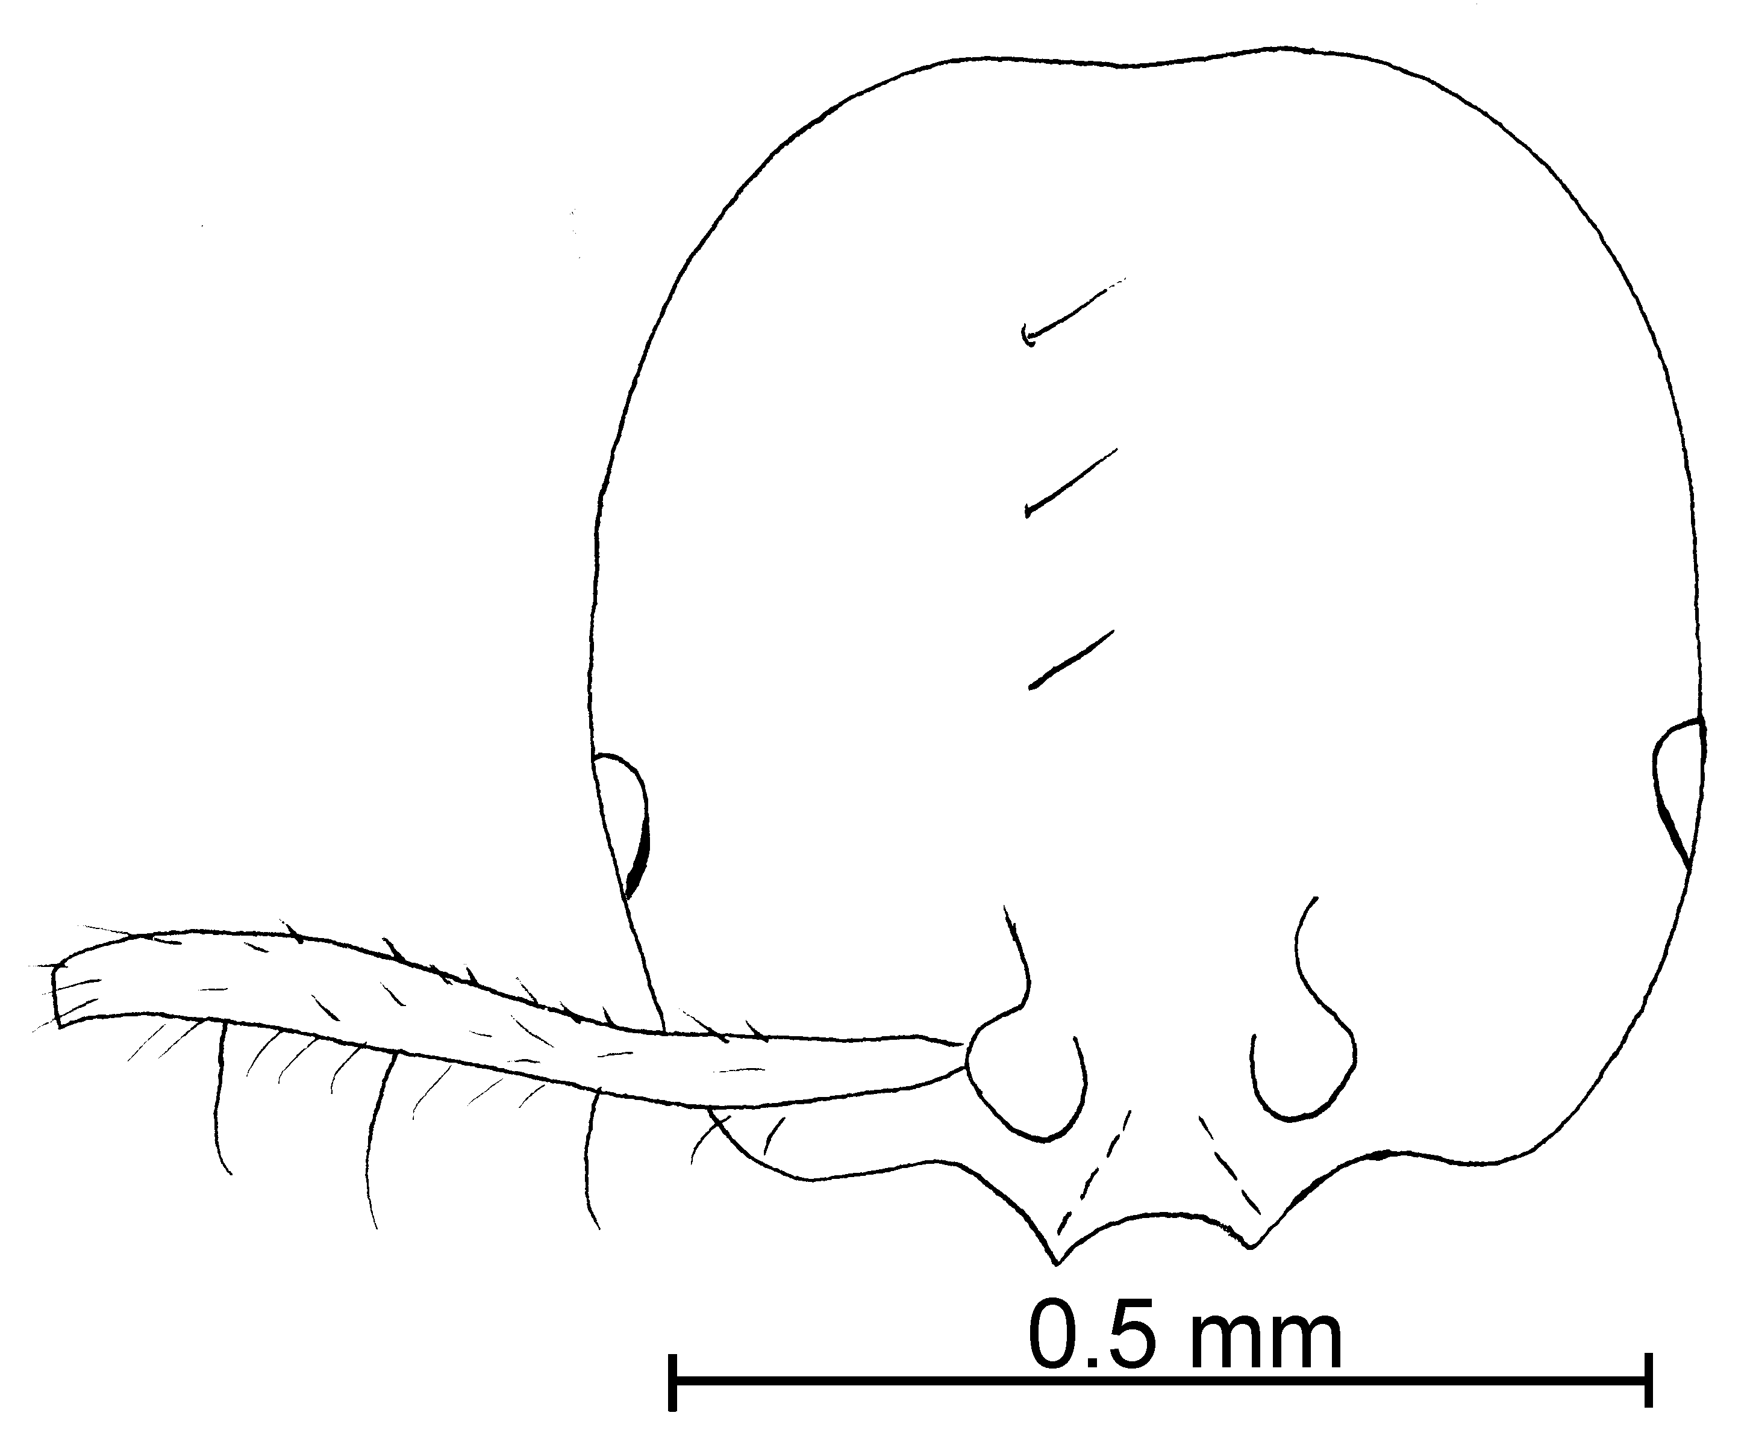
Fig. 76. Head of a _______________ worker of S. tenuis (50 X).
The workers can be separated from S. picta by the longer scapes. Workers could be confused with S. corticalis, but are often darker and the clypeal teeth are more developed, although they are small. Workers can be easily confused with S. picea, but the minor segments of the funiculus are shorter (usually > 0.12 mm in S. picea). Series consisting of only workers cannot always be correctly identified. The females are easily separated, with those of S. corticalis being yellow, those of S. tenuis being dark brown. The eye is relatively large, occupying about ½ of the length of the side of the head. The eye is nearly circular in shape. The head is nearly completely smooth and shiny, with a few, scattered, insignificant punctures. It is difficult to separate from C. castor, but where the distributions overlap (Central America), it is usually medium brown with concolorous legs, whereas S. castor in this area is nearly black, with yellowish-brown legs.
Distribution: Mexico (Nuevo Leon and San Luis Potosi) south to and Panama (Chiriquí); Brasil.
Map 66. Solenopsis tenuis in North America.

Map 67. Solenopsis tenuis in South America.
Types: Lectotype worker, 5 paralectotype workers and 2 paralectotype females [here designated], S. tenuis worker, Mayr Brazil, Amazonia (NHMW). Three paralectotype males (MHNG),
Material examined: BELISE: Orange Walk, Rio Bravo Conservation Area, 30-iv-1996 # 17703 (2  CWEM). COLOMBIA: Cauca, Isla Gorgona, 23-x-1989, M. Baena # GAP-Eii6 (5  CWEM); Huila, 4 k NE Rivera, 30-xii-1986, W. Mackay # (2  CWEM), Valle del Cauca, Bosque Yotoco, 1575m, 23-vi-1989, W. Mackay # 11627 (1  CWEM), COSTA RICA: Guanacaste, Cacao Field Station, 1150m, 15-ii-1996, R. Anderson # 17670 (3  CWEM), Loma Barbudal, 3-vi-1989, ii-1990, S. Vinson #’s 12296, 13079, 13171 (4  CWEM), Maritza Field Station, 13-i-1996, R. Anderson #’s 17667, 17668, 17670 (10  CWEM), same locality, 03-v-1995, R. Anderson #17714 (2  CWEM), same locality, 17-ii-1996, R. Anderson # 17734 (1  CWEM), Pitilla Field Station 14-xi-1996, R. Anderson (2  CWEM); Puntarenas, Osa Peninsula, Fundación Neotropical, 23-vi-1997, R. Anderson # 18687 (7  CWEM), same locality, Cerro Helado, 17 k NE Rincón, 24-vi-1997, R. Anderson # 18689 (5  CWEM). MEXICO: Colima, 19 k NE Comala, 1219m, 1-viii-1988, R. Anderson # 88-19 (1  CWEM); Nuevo Leon, El Salto (Zaragosa), 10-11-vi-1988, W. Mackay #’s 11011-3, 11011-4, 11015-5 (49  CWEM), San Luis Potosi, 13 k N Tamazunchale, 08-vi-1988, W. Mackay #10930 (1  CWEM); Tabasco, 10 k N Cárdenas, 10m, 28-v-1988, W. Mackay # 10497 (1  CWEM). PANAMA: Chiriquí, Bocas del Toro, 9-vi-1995, R. Anderson # 17841 (1  CWEM), Fortuna Hydrological trail. 1100M 09-vi-1995, R. Anderson #’s 17785, 786, (7  CWEM), La Fortuna, Finca La Suisse 10-vi-1995, R. Anderson #’s 17789-70 (3  CWEM). VENEZUELA: Aragua, Parque Nacional Pittier, Rancho Grande, 19-x-1988, W. Mackay # 11232-5 (1  CWEM),
Biology: They nest under ground; they were collected in subterranean traps.
`` Solenopsis terricola Menozzi
azteca species complex

Solenopsis terricola Menozzi, 1931: 267 (w.)
Diagnosis: Workers are small (1.5 mm - 1.6 mm total length) , bicolored specimens. The head, mesosoma and gaster are dark brown to black, legs and antennae are yellow. The head is quadrate, the sides of head straight, it does not have a concave posterior margin; it has large, black eyes, with at least 5 ommatidia. The clypeus is straight between the teeth, the lateral clypeal teeth are poorly developed, the medial tooth is absent. The scape extends slightly more than half-length of the head. It has a punctate mesopleuron and a wide petiole (Fig. 2d) which is at least partially punctate. Short (~ 0.02 mm), suberect, and the long (0.05 mm), erect hairs are sparse on head, about 6 short and 2 long (adjacent to the occipital region) on any line drawn from the posterior border to the posterior base of clypeus, the antennae are hairy, the scape has a few suberect hairs, the pronotum has ~ 1 suberect erect hairs (0.06 mm) projecting above outline as seen in profile, the mesonotum is with ~ 2 erect hairs (0.01 mm) above profile, ~ 1 is located on the propodeum, and ~2 on the outline of the petiole, 2 on the outline of postpetiole, the gaster has scattered, fine hairs, ~6 erect hairs on the outline of the first tergum. The head has several small punctures (~ 8 along any line from the posterior border to the posterior border of clypeus), about equal in diameter to the hairs that originate from them, the surfaces between the punctures are smooth and shiny.
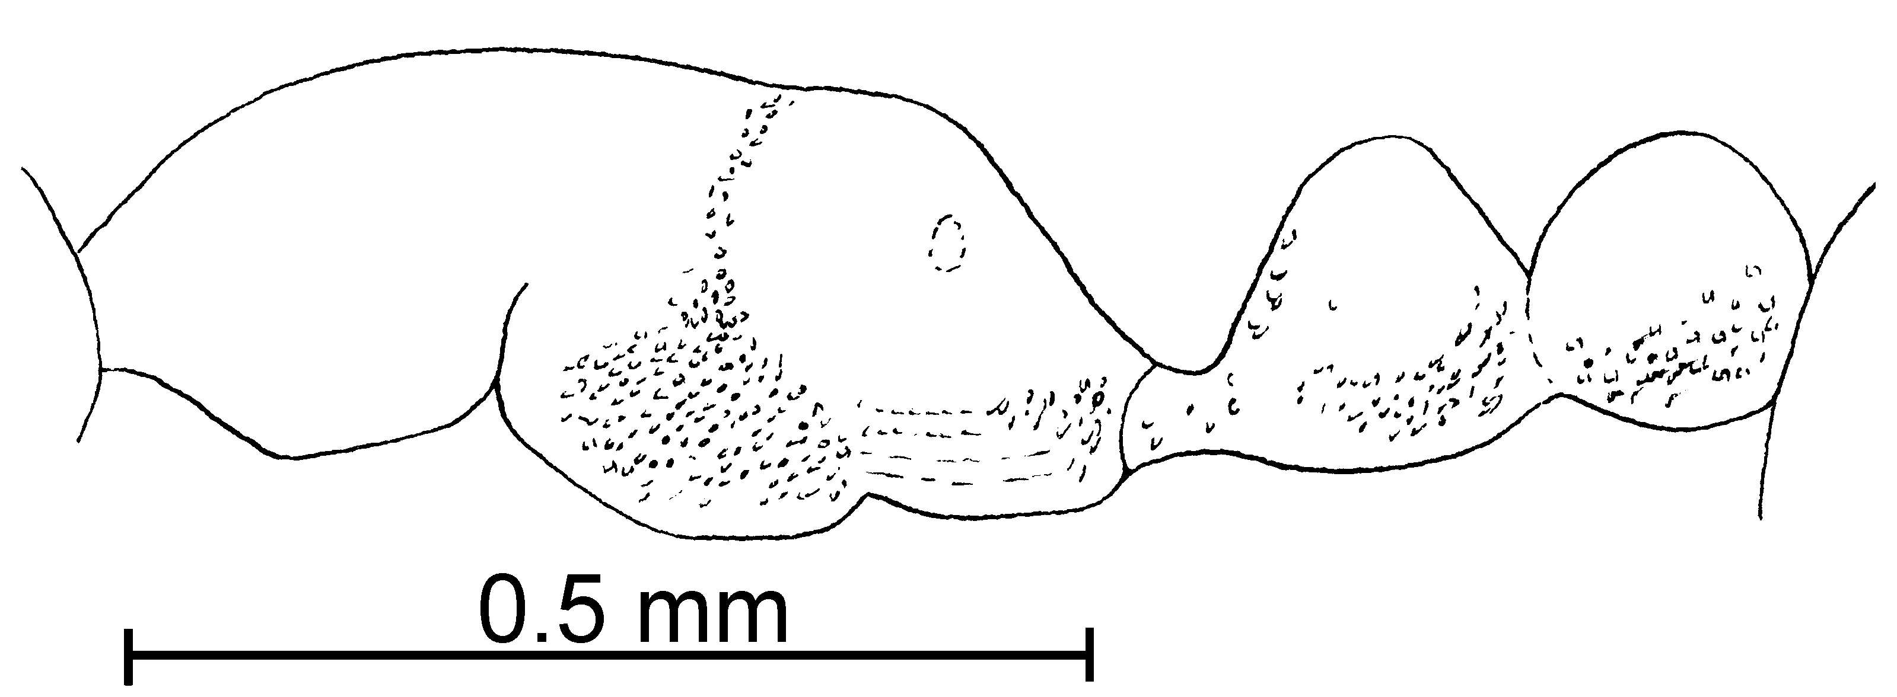
Fig. 77. Mesosoma of the lectotype worker of S. terricola.
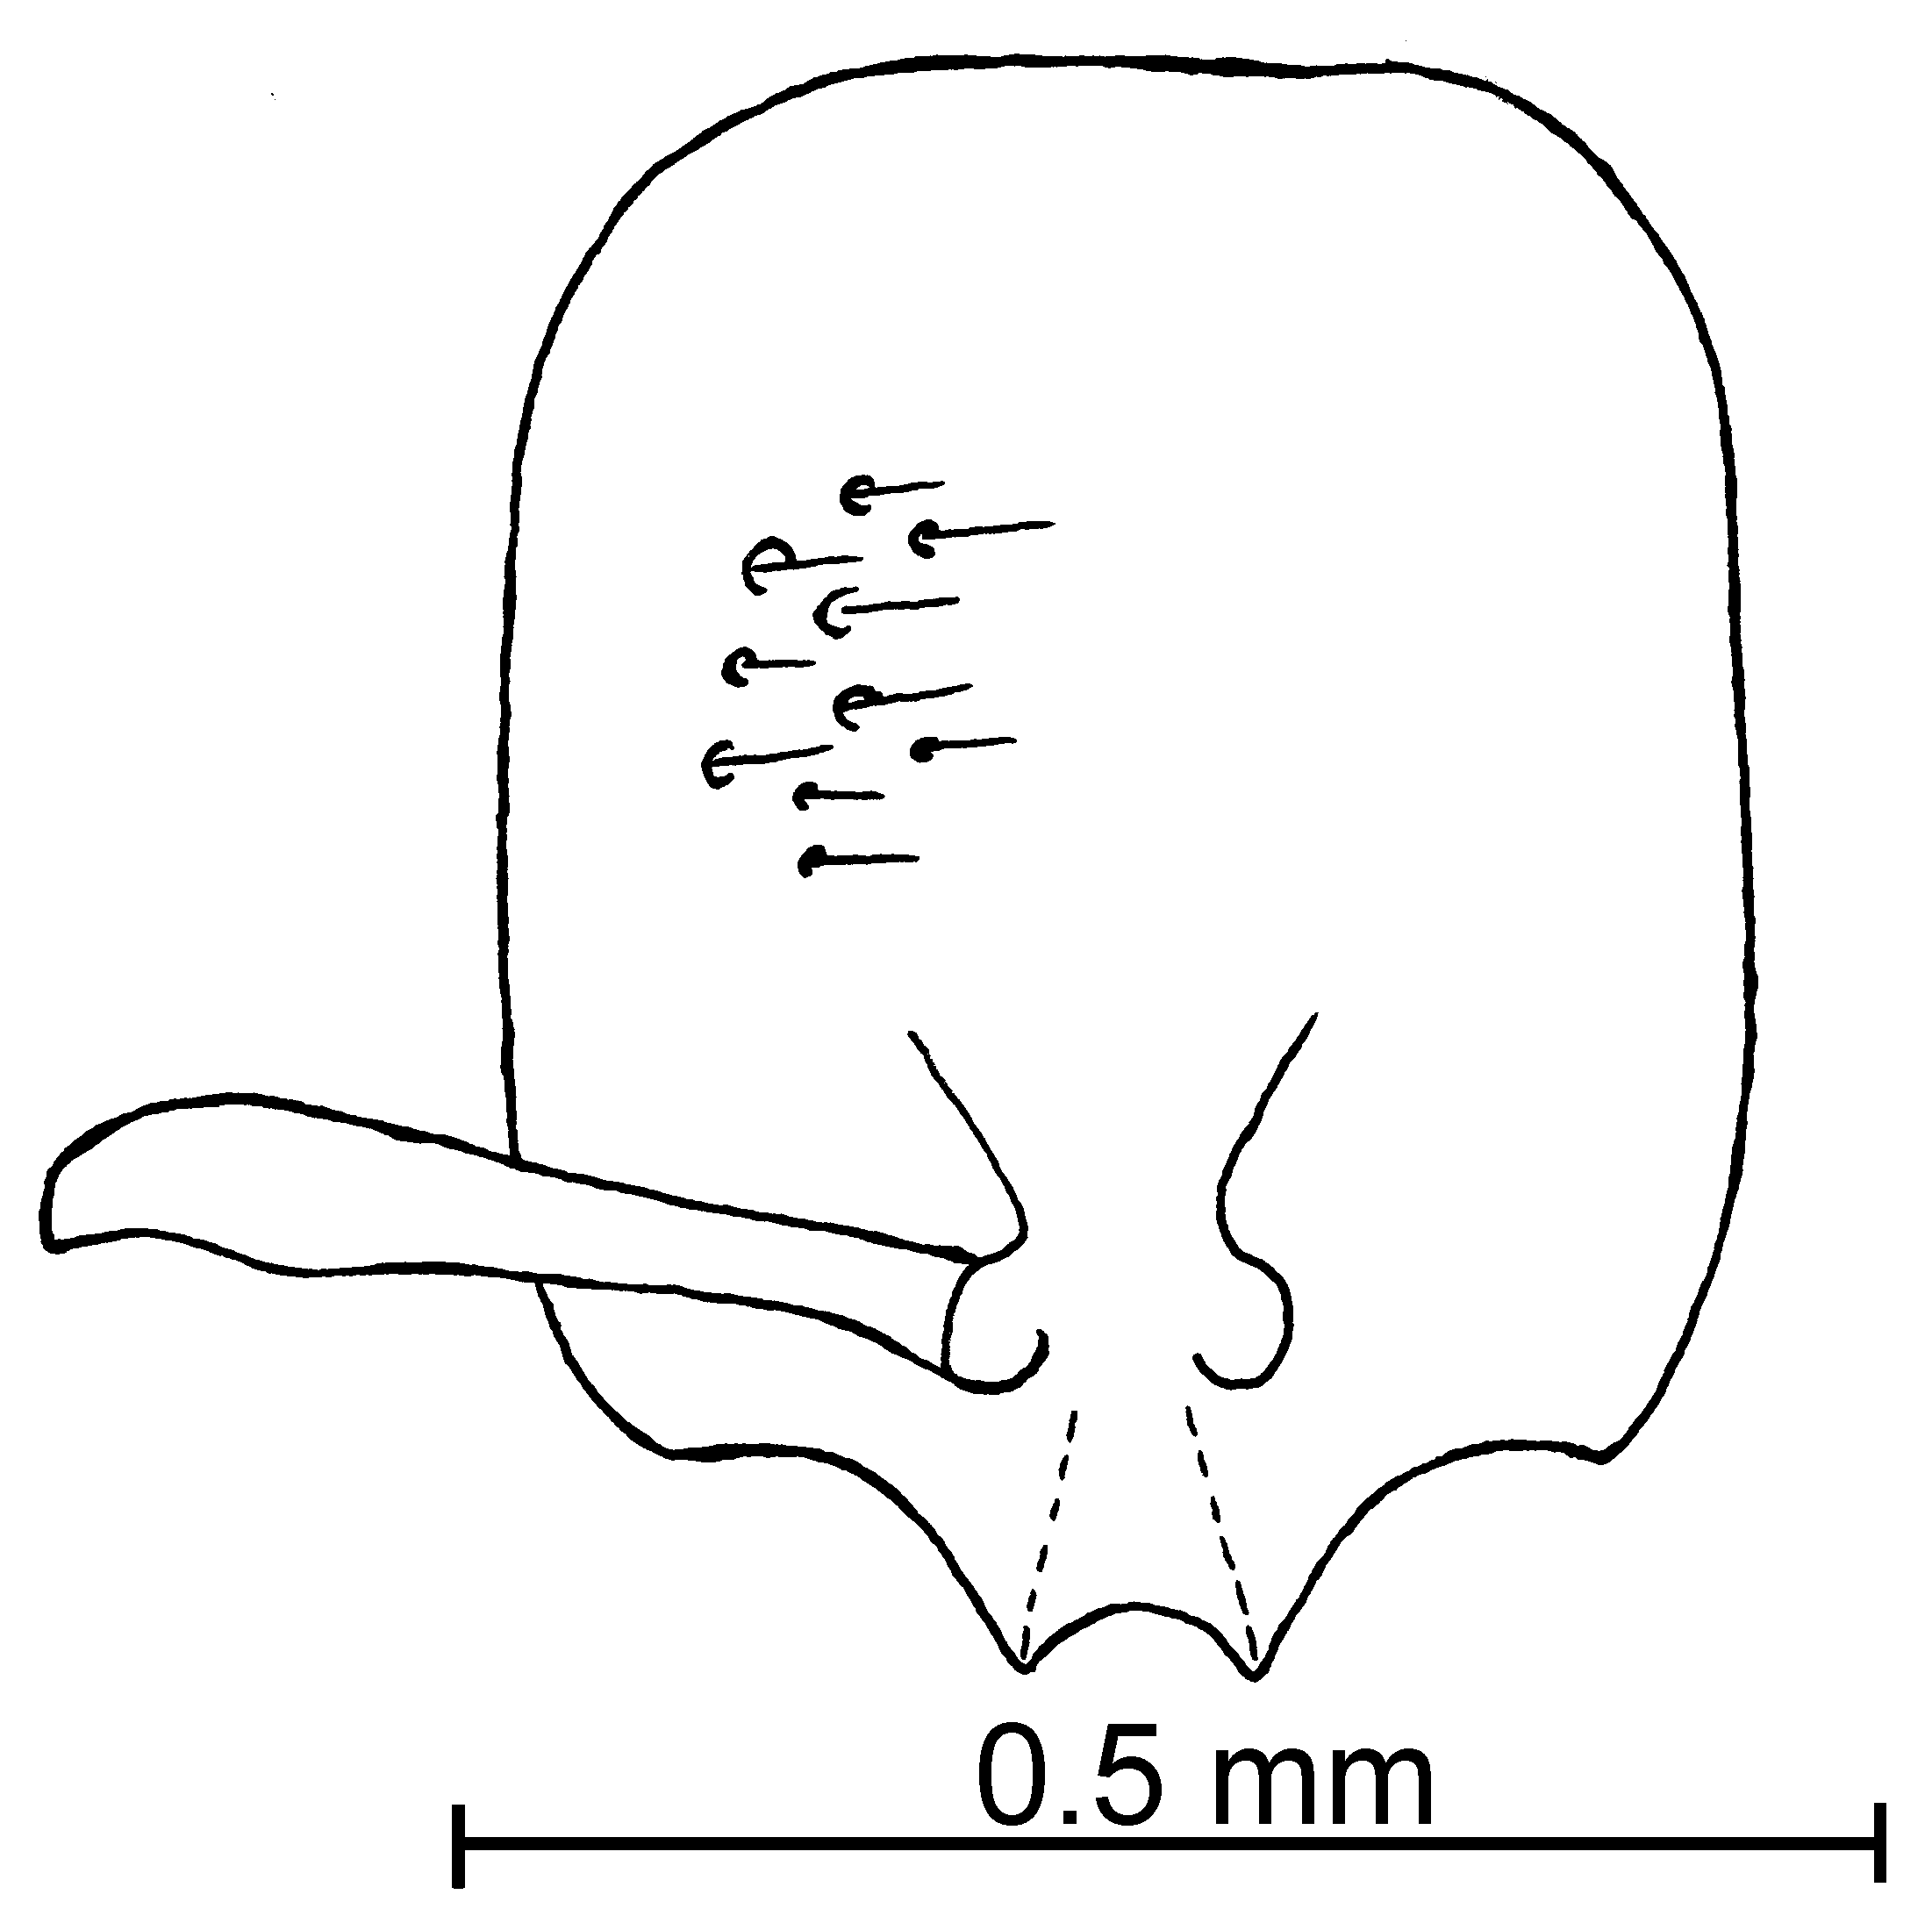
Fig. 78. Head of the lectotype worker of S. terricola.
Distribution: Costa Rica (Guanacaste), Panama (Cerro Campana) (see Map 25).
Map 68. Solenopsis terricola in North America.
Types: Lectotype worker, 2 paralectotypes workers [here designated], S. terricola type worker, Menozzi, Costa Rica: Puente de las Mulas (UDSB).
Material examined: COSTA RICA: Guanacaste, Cocoa Fields Station, 1100-1200 m, 4-v-1995, R. Anderson #17710 (15  CWEM), same locality, 1350-4000 m #’s 17690, 726 (1 , 2  CWEM), same locality, 1150 m, 15-ii-1996, #’s 17670, 73 (5  CWEM), Same locality, Maritza Field St. 13-15-ii-96, R. Anderson #’s 17667, 68, 70 (35  CWEM), same locality, 800m, 03-v-1995, R. Anderson # 17714, 15, 16 (16  CWEM), same locality, 04-v-1995, #’s 17711, 13, 14, 22 (22 , 2  CWEM), same locality, 850-875m, 13-v-1996, #’s 17663, 66, 678, 730, 34, 35, 36, 37 (69 , 2  CWEM), Pitilla Field Station, 600 m 02-v-1995, R. Anderson #’s 17720, 21, 22, 23 (24  CWEM), same locality, 1000 m, 14-ii-1996, #’s 17679, 692, 694, 733, 741 (90  CWEM); Puntarenas, Cerro Helado, 17 k NE Rincón, 24-vi-1997, 8°45’30”N 83°25’0”W, 24-vi-1997, R. Anderson # 18689 (7 , 1 dealate  CWEM), Neotropical Foundation, 23-vi-1997, R. Anderson # 18687 (3  CWEM). PANAMA, Cerro Campana 950 m, 5-vi-1995, R. Anderson #’s 17833, 17836 (13  CWEM).
Map 69. Solenopsis terricola.
Biology: Specimens were found in leaf litter in a montane hardwood forest.
`` Solenopsis texana Forel
molesta species complex

Solenopsis pollux var. texana Emery, 1895. 8, p 278 (w.)
Solenopsis texana Forel, 1901. 45, p. 345 (w.)
Solenopsis rosella Kennedy, 1983: 70, p.232, pl. 19, figs. 1-11 (w. f. m.)

Diagnosis: Workers of this species are small, pale yellow to medium brown, with the smaller segments of the funiculus being shorter than 0.10 mm in total length, less than the greatest width between the frontal lobes. The medial clypeal teeth are usually developed only into small, blunt angles. The hairs on the posterior tibia are mostly appressed. It is necessary to have a female as part of the series, in order to identify this species. The female is small, medium brown to yellowish-brown, with small eyes (0.18 mm in greatest diameter). If one has females of a series, they are easily recognized by the color and the size of the eye. Without females, identification is very difficult, as workers are easily confused with those of S. carolinensis and S. abdita. They are most difficult to separate from S. carolinensis, and the distributions of the two species overlap. The posterior tibial hairs are mostly appressed, whereas they are mostly suberect in S. carolinensis, although there is considerable variability in this characteristic. If a large series is available, nearly all will have the hairs on the posterior tibia appressed or decumbent. It is not unusual to have a few specimens with the hairs suberect, or even a specimen with the hairs on one posterior tibia appressed, and on the other suberect. If more than half of the specimens have suberect hairs on the posterior tibia, the series is probably S. carolinensis. Thus it is often impossible to provide correct identifications, although they are definitely separate species, as the females are so different. Separation from S. abdita is easier, as S. texana apparently does not occur in Florida, the only state where S. abdita has been reported. They can also be separated as S. texana has a relatively longer scape (scape length of two type specimens, 0.26 mm, head lengths 0.40 and 0.42 mm) and a relatively narrower petiole (petiole width of two type specimens 0.19 and 0.22 mm as seen from above, compared to the postpetiolar widths of 0.25 and 0.26 mm). This species is also difficult to separate from S. salina. The punctures on the dorsum of the head are tiny, barely noticeable, and the clypeal teeth are usually straight (usually poorly developed). The punctures on the dorsum of the head of S. salina are very obvious, moderately coarse, and the clypeal teeth are often bent inward. This species could be confused with S. molesta. Solenopsis texana are slightly smaller, with the length of the minor segments of the funiculus being less than 0.10 mm (these segments of S. molesta are usually about 0.12 mm), and the clypeal teeth are poorly developed (well developed in most S. molesta). Dark brown specimens of S. texana with yellow appendages could be easily confused with S. castor. They differ in that the appendages are darker and the specimens are larger (total length about 2 mm, vs. 1.8 mm in S. castor).
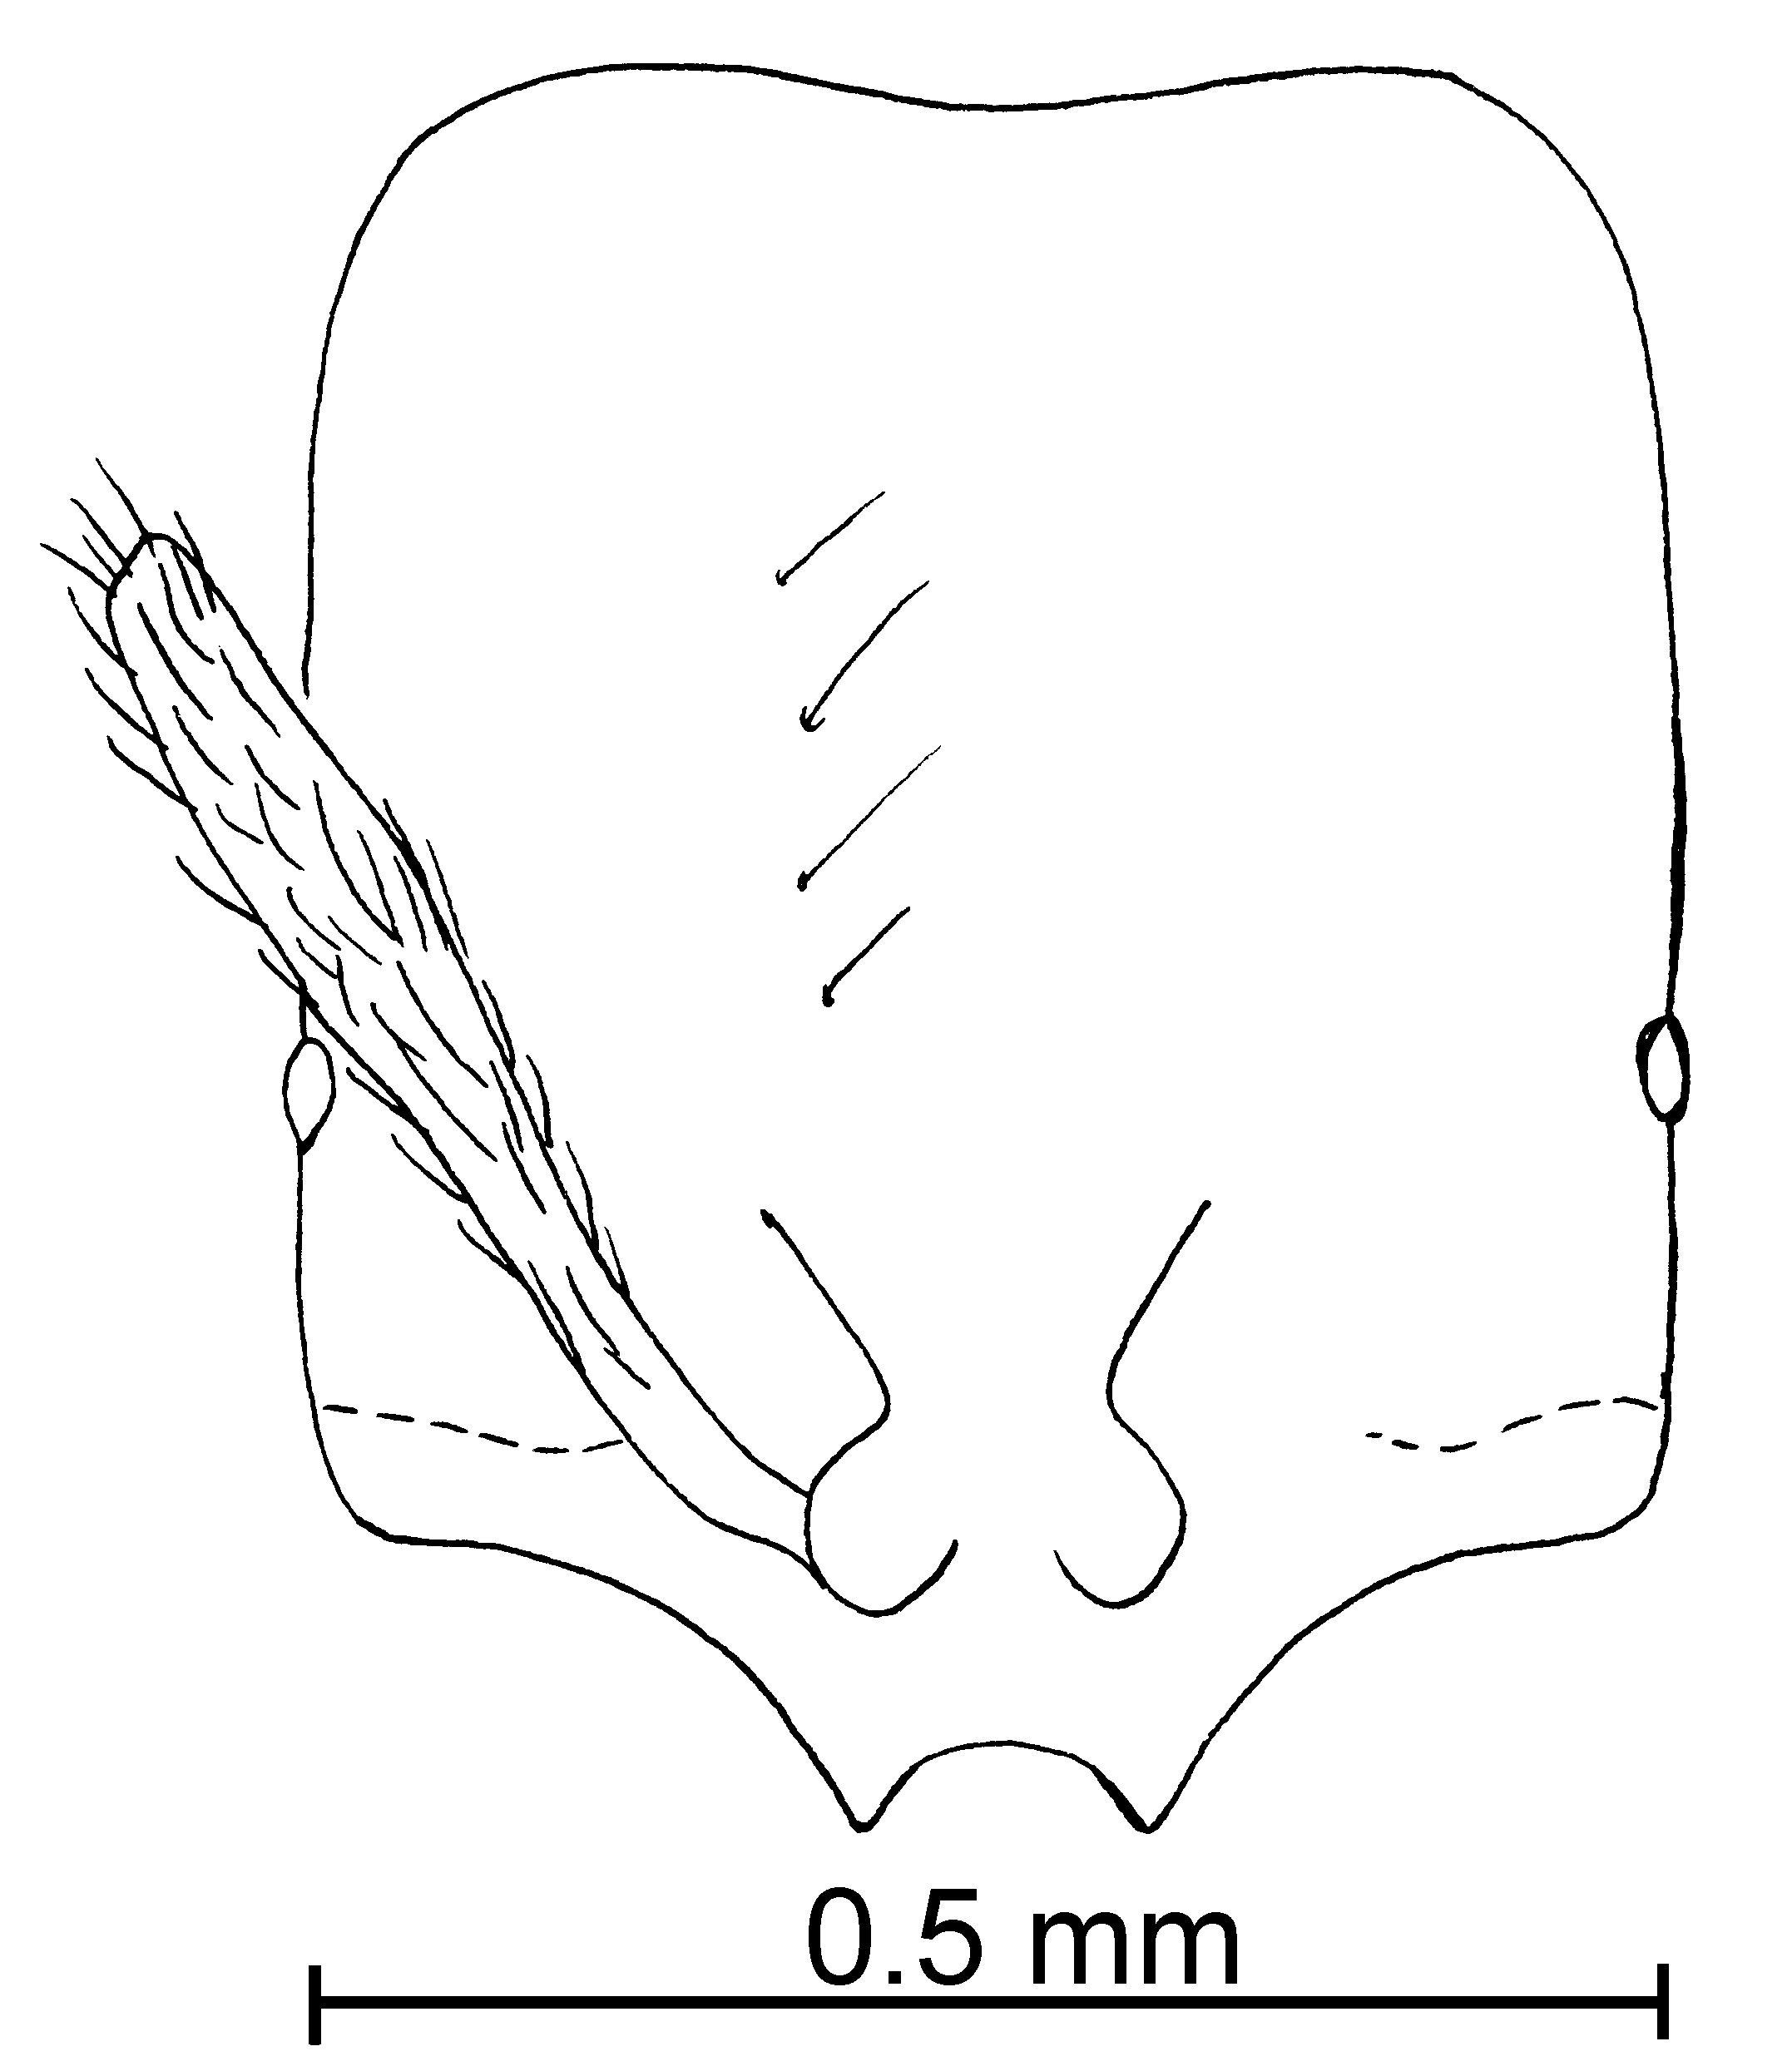
Fig. 79. Head of the ____________ worker of S. texana.
Fig. 80. Posterior left tibia of the ______________ worker of S. texana.
Distribution: USA (Arkansas, Louisiana, Mississippi, New Mexico, Tennessee, Texas, and Virginia) south into Eastern Mexico (Coahuila, Nuevo Leon, San Luis Potosí, Tabasco and Tamaulipas), Costa Rica (Guanacaste), Panamá () and Colombia (Cauca).
Map 70. Solenopsis texana in North America.
Map 71. Solenopsis texana in South America.
Types: Lectotype worker, 3 paralectotype workers [here designated], S. pollux var. texana worker, Emery, Texas, cotype #164 (MHNG) and 1 paralectotype worker (MHNW).

Material examined: COLOMBIA: Bolívar, Zambrano 110m, # 395 (1  CWEM); Cauca, Isla Gorgona, 2-i-1990, M. Baena # GG-Hi9 (4  CWEM). COSTA RICA: Guanacaste, Cocoa Field Station, 1100-1200m, 4-v-1995, R. Anderson # 17710 (1  CWEM), Loma Barbudal, 3-vi-1989, S. Vinson #’s 12127, 12155, 12177, 12193, 12194, 12220, 12222, 12223, 12224, 12292 (30  CWEM), same locality, ii-1990, S. Vinson #’s 13053, 13057, 13096, 13098, 13099, 13123, 13180 (26  CWEM), Estación Maritza, 600m, 10°58’N 85°30’W, 3-4-v-1995, R. Anderson #’s 17711, 17715, 17716 (3  CWEM), Parque Nacional Santa Rosa, 300m, 10°52’N 85°36’W, 4-v-1995, R. Anderson # 17719 (4  CWEM), Pitilla Field Station, 1000m, 14-ii-1996, R. Anderson # 17692 (1  CWEM). MEXICO: Coahuila, 8 k S Saltillo, 22-vii-1988, Francisco Perez D. #40 (7  CWEM); Nuevo Leon, El Salto (Zaragosa), 11-vi-1988, W. Mackay #’s 11010-8 (10  CWEM); San Luis Potosí, Ciudad Valles, 9-vi-1988, W. Mackay #’s 10939-2, 5, 7, 9 (27  CWEM), Matehuala, 10-vi-1988, W. Mackay #’s 10968-4 (9  CWEM); Tabasco, 10 k N Cárdenas, 10m, 28-v-1988, W. Mackay # 10520 (4  CWEM); Tamaulipas, Gomez Farias, 25-ix-1987, W. Mackay #10077 (1  CWEM). PANAMA: Cerro Campana, 950m, 5-vi-1996, R. Anderson # 17833 ( 1  CWEM). UNITED STATES: Alabama, Marion Co., Haleyville, 7-vi-1998, Mackay family # 18123 (1 , 1  CWEM); Arkansas, Cross Co., Village Creek State Park, 14-vii-1988, R Anderson (1  CWEM), Pulaski Co., Pinnacle Mountain State Park, 13-iii-1989, R. Anderson #12765 (6  CWEM); Florida, Levy Co., 10 mi S Bronson, 31-I-2001, M. Deyrup (12 , 3 dealate  Deyrup collection CWEM); Louisiana, Calcasieu Parish, Sam Houston Jones State Park, 17-viii-1987, W. Mackay #’s 9702, 11, 13, 16, 18, 19, 22-28, 38-45 (153  CWEM), Iberia Parish, New Iberia, 19-viii-1987, W. Mackay #’s 9739, 9754, 56, 58, 61, 67, 80, 83, 84, 86 (61  CWEM), St. Mary Parish, Morgan City, 20-viii-1987, W. Mackay #9817 (1  CWEM); Mississippi, Oktibbeha Co., 4 k NE Starkville, 27-viii-1987, W. Mackay #9938-47 (45  CWEM); New Mexico, Taos Co., 20-vi-1993, D. Fagerlund (1  CWEM); Tennessee, Hamilton Co., 28-29-xi-1940, #T-15656 (21  USNM), Chattanooga, Lookout Mt., 11-vi-1998, Mackay family # 18252 (14  CWEM); Texas, Bandera Co., Lost Maples State Natural Area, 28-30-iv-1988, R. Anderson (9  CWEM), Brazos Co., Brazos Site, 03-vii-1999, K. Helms #’s 8, 9, 11, 12, 14, 15, 16, 18, 19, 20, 21, 22, 17, 23, (15  CWEM), Deer Lick Creek, 16-vii-1987, W. Mackay #’s 9320, 329 (3  CWEM), same locality, K. Helms 08-vii-1999, #’s 57, 60, 61, 62, 64, (5  CWEM), same locality, 03-vii-1999, K. Helms #’s 63, 68, 76-78, 82-84, 93-96, (12  CWEM), Anderson Site, 3-vii-1999, K. Helms #’s 13, 31-34, 38, 40-42, 44-50, 52, 59 (19  CWEM), Peach Creek, 22-vii-1987, W. Mackay # 9356F (1  CWEM), 10 k N Kurten, 5-viii-1987, W. Mackay #’s 9558, 563, 580, 624, 625, 661, 633, 642, 659, 660, 669, 670, 679, 680, 681, 682, 687 (56  CWEM), College Station, Foster Lane, 17-vi- 1987, W. Mackay #’s 19218, 227, 235, 239 (6  CWEM), Brewster Co., Big Bend National Park, Cattail Falls, 6-iv-198, R Anderson. (10  CWEM), Brooks Co., 13 k S Falfurrias, 28-vii-1987, W. Mackay # 9443 (1 dealate  CWEM), Cameron Co., Sabal Palm Grove, 12-14-x-1988, R. Anderson (20  CWEM), Gonzalez Co., Palmetto State Park, 17-18-iv-1989, R. Anderson #12754 (22  CWEM), Hidalgo Co., Anzalduas Co. Park, 15-16-x-1988, R. Anderson (18  CWEM), Bentsen Rio Grande Park, 19-viii-1981, A. Hook # 2981 (4  USNM), Houston Co., Big Slough Wilderness Area, 9-v-1988, R. Anderson #’s 12759-60 (334 , 1  CWEM), Sabine Co., 14.5 k E Hemphill, 8-iii-1989, R. Anderson (50 , 2 dealate  CWEM), same locality, 14 k E Hemphill 11-v-1988, R. Anderson #12764 (109  CWEM), 3K. (3  CWEM), same locality, 11-v-1988, R. Anderson #12763 (28  CWEM), San Patricio Co., Welder Wildlife Refuge, 18-19-iv-1989, R. Anderson (9  CWEM), Tyler Co., Big Thicket Natural Preserve, 12-v-1988, 8-iii-1989, R. Anderson # 12756, 57 (3 , 1 dealate  CWEM), Spurger, 24-iv-1988, R. Anderson #12761 (8  CWEM), Walker Co., Huntsville State Park, 23-iv-1989, W. Mackay #11400 (64  CWEM), same locality, 14-iv-1988, R. Anderson # 12762 (52  CWEM); Virginia, Rockingham Co., without locality 08-v-199, R. Youngman # DGN-2-1991 (4  USNM).
Biology: Solenopsis texana nests under ground in forested areas, especially under stones; most specimens were collected in pitfall traps or in litter extractions. Tropical specimens were collected in wet transitional tropical forests to montane hardwood cloud forest in leaf litter. In cypress swamp
`` Solenopsis tonsa Thompson
pygmaea species complex

Solenopsis tonsa Thompson, 1989: 272, figs. 29-32 (w. q. m.)

Diagnosis: Workers of this species are easily recognized as having an elongate and ventrally concave head, which is densely hairy, coarsely and evenly punctate (except for a narrow, central strip without sculpture). The eyes are very small and circular, with at least one ommatidium. The head, mesosoma and gaster are covered with short (0.02 mm), vestiture, in which all hairs are equal in length. The total length of the minor segments of the funiculus is 0.06 mm.
Fig. 81. Side view of the head of a worker of S. tonsa ().
We were not able to locate the types in any of the museums where they were reported deposited by Thompson (1989), as they were borrowed by Thompson in 1989 (S. Cover and M. Deyrup, pers. comm.). A series of specimens from Texas was identified as S. tonsa, based on Thompson’s description and figures. It could only be confused with S. subterranea, in having both the body heavily covered with hairs, which are all of about equal lengths, and in having the centerline of the head free of hairs. Additionally, the defining character that separates them is the convex ventral surface of the head head shape of S. tonsa (compare Figs. 4a & 4c ), which makes the head thickened as seen in profile.
Distribution: USA, Florida, and Texas.
Map 72. Solenopsis tonsa in North America.
Type series: Florida, type locality.
Material examined: Texas, Rusk Co. 30K Nacogdoches, 3 June 1990, W. Mackay #’s 13405, 407 (40  CWEM).
`` Solenopsis validiuscula Emery
molesta species complex

Solenopsis validiuscula Emery, 1895. Vol. 8, p. 278 (q.).
Solenopsis validiuscula Wheeler, 1908. 24:430 (w.)
Solenopsis truncorum Forel, 1901, Vol. 45, p. 346 (w. q.).

Diagnosis: These are relatively large, dark brown (usually, but may be pale in color, or even yellow) ants with moderately coarse punctures on the dorsal surface of the head. The females are easily recognized as dark brown ants with a small median ocellus (0.08 mm) maximum diameter, and relatively large eyes (0.24 mm). They are easily confused with S. molesta, but can often be separated on the basis of color (S. molesta are usually yellow), and size (S. molesta are often smaller, 1.5 – 1.7 mm total length), and S. molesta usually has tiny punctures and fined hairs on the dorsal surface of the head (usually). Unfortunately there is considerable variability in all three of these characters, and without females, identification is difficult. This species does not appear to be a synonym of S. molesta, as the females are distinctly different, both in the sizes of the ocelli and the color. This species has been listed as S. truncorum throughout the literature, based on the misidentification of this species by Creighton (1950). Actually S. truncorum is considered to be a synonym of S. carolinensis; it is pale yellow, not dark brown as it has been described in the literature. It is also a relatively small ant, approximately the same size as S. molesta. The female of S. truncorum is identical to that of S. carolinensis, and has much larger eyes (maximum diameter about 0.25 mm) than the female of S. validiuscula.
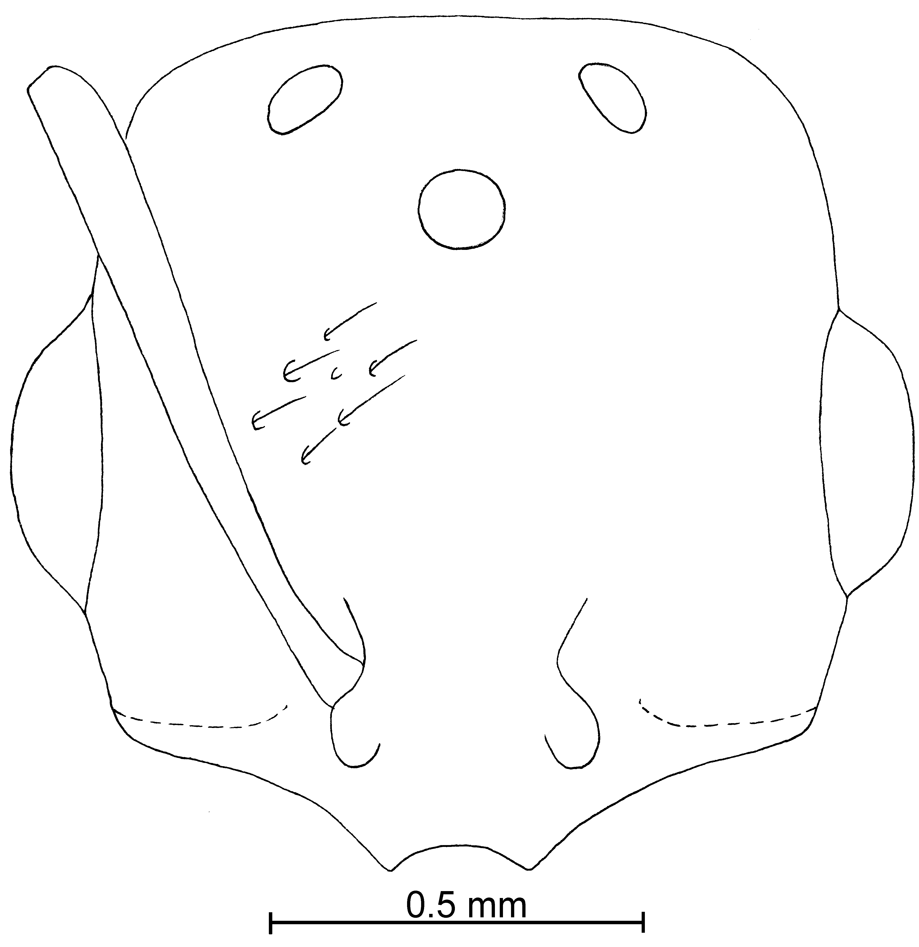
Fig. 82. Head of a female of S. validiuscula (50 X).
Distribution: USA (Arizona and California).
Map 73. Solenopsis validiuscula in North America.
Types: None in this country
Material examined: MEXICO: Coahuila, 55 k SE Arteaga, 24-ix-1987, W. Mackay # 10021 (18  CWEM); Colima, 19 k NE Comala, 1219m, 1-viii-1988, R. Anderson # 88-19 (7  CWEM). USA: Arizona, Apache Co., Apache National Forest, 1.7 mi NE Hannagan Meadow, 8950’, 11-ix-1994, R. Johnson #’s AZ 550, AZ 580 (21  Johnson Collection)), same locality, 5 mi E HWY 180 on USFS Rd 249, 8630’, 11-ix-1994, R. Anderson # AZ 549 (9  Johnson Collection), Coconino Co., Coco. Nat’l For, Blue Ridge Rd @ 1 mi S. Buck Springs, 15-v-1995, R. Johnson #AZ 665 (12  Johnson collection), same locality, Blue Ridge, Rim & Buck Springs Rd., 7800’, 34°24’N 111°10’W, 15-v-1995, R. Anderson # ‘s AZ 652, AZ 655 (12  Johnson Collection), San Francisco Peak, 8000’, 35°17.57”N 111°42.38’W, 11-ix-1997, R. Johnson # AZ 1186 (7  Johnson Collection), Cochise Co., Chiricahua Mts., 7000 - 9000’ 27-vi-1970 (3  CWEM), Chiricahua Mts., ½ mi W SWRS 23-vii-1994, R. Johnson #AZ 508 (24  Johnson collection), same locality, 9-vii-1993, R. Johnson #AZ 250 (15  Johnson collection), Gila Co., Pine Mts., USFS Rd. 651 @ 2.2 mi. S. Sulphide del Rey Pound, 6-12-iv-1997, R. Johnson #’s AZ 964, 967 (17 , 1  Johnson collection), Rd. 580@ 0.5 mi S Madera Peak. 16-vii-1997, R. Johnson #AZ 1204 (14 , 1  Johnson collection), 615C @ Pinal Peak, 15-iv-2000, R. Johnson #AZ 1928, 30 (18  Johnson collection), Maricopa Co., Tempe1190’, 13-vi-1996, R. Johnson # AZ 752 (18  Johnson collection), Santa Cruz Co., Pajarito Mnts. Sycamore Canyon Trailhead, 28-vii.1996, R. Johnson #AZ 1209 (17  Johnson collection), Yavapai Co. Prescott National Forest Bradshaw Mts. Walker Rd. @ 6.8 mi S Hwy 69, 17-vii-1998, R. Johnson #1459-62 (22 , 13  and 11  Johnson collection); Colorado, Boulder Co., 3 mi E Nederland, 17-viii-1982, W&E Mackay #’s 6417, 6419, 6430, 6432 (1 , 18 alate , 17  CWEM); New Mexico, Bernalillo Co., Albuquerque, 20-viii-1962, B. Pullen (9 , 2 alate , 1  CWEM), Colfax Co., 16 k E Eagle Nest, 9-viii-1986, W&E Mackay #’s 8593, 8598 (14 , 9 alate , 5  CWEM),41 k E Eagle Nest, 9-viii-1986, W&E Mackay # 8613 (7 , 3 alate , 1  CWEM), Grant Co., 77 k E Silver City, 25-vii-1986, W&E Mackay # 8326 (5  CWEM), 88 k E Silver City, 24-vii-1986, W&E Mackay # 8312 (3  CWEM), Los Alamos Co., Los Alamos, 30-vi-1986, W&E Mackay # IIB (2  CWEM), 4 k N Los Alamos, 19-viii-1986, W&E Mackay #’s 8739, 8754 (11 , 1 dealate  CWEM), 8k N Los Alamos, 19-viii-1986, W&E Mackay # 8776 (6 , 3 , 3  CWEM), Rio Grande, 1680m, W&E Mackay (22 , 1 dealate , 1 alate , 1  CWEM), Mora Co., Coyote Creek State Park, 6-vii-1986, W&E Mackay # 8157 (4  CWEM), 2 k E Wagon Mound, W&E Mackay # 8747 ( 1 alate  CWEM), Rio Arriba Co., 7 k S Cebolla, 2-viii-1986, W&E Mackay #’s 8456, 8466 (5  CWEM), Sandoval Co., Bandelier National Monument, 21-viii-1986, W&E Mackay # 8803 (2  CWEM), 4 k W Cuba, 16-viii-1986, W&E Mackay # 8684 (9  CWEM), 11 k E Cuba, 16-viii-1986, W&E Mackay # (4  CWEM), San Miguel Co., 20 k NW Las Vegas, 6-vii-1986, W&E Mackay # 8104 (1  CWEM), Santa Fe Co., Santa Fe, 5-vii-1986, W&E Mackay # 8077 (6  CWEM), Taos Co., 14 k SE Tres Piedras, 29-vi-1986, W&E Mackay #’s 8013, 8014 (8  CWEM), 6 k SW Tres Piedras, 28-vi-1986, W&E Mackay # 8003 (3  CWEM), 20 k S Taos, 9-viii-1986, W&E Mackay # 8564 (6  CWEM).
Biology: These ants nest under stones in pine/oak forests. They are most common in ponderosa pine forests.
`` Solenopsis vinsoni Mackay & Moreno, new species
new species 13

fugax species complex

Diagnosis: This is a dimorphic species in which the majors are slightly larger than the minors (see dimensions in key). The majors can be recognized as the extra lateral teeth are moderately developed, but are much smaller than the pair of medial teeth. The punctures on the head are coarse, greater in diameter than the hairs that arise from them. The dorsum of the head is also nearly covered with poorly defined rugulae. The scapes are relatively long (0.26 in the major, 0.22 mm in the minor), the minor segments of the antenna are relatively long (0.11 in the major, 0.08 in the minor). The eye of the major is relatively large (0.06 mm greatest diameter), almost as long as the distance from the anterior border to the insertions of the mandibles. The top of the mesosoma is mostly covered with punctures and poorly defined rugulae, the side of the pronotum is moderately smooth and shining, the mesopleuron smooth and glossy (slight sculpturing along anterior edge), the lower half of the propodeum is longitudinally striated, the upper half mostly smooth and glossy. The petiole and postpetiole are both sculptured with punctures and very fine rugulae.
The minor worker is completely different from the major worker. The extra lateral teeth are poorly developed, the head is mostly smooth and glossy, with scattered, coarse punctures (much larger in diameter than the width of the hairs arising from them). The eye is relatively small (maximum diameter about 0.03 mm), much smaller than the distance from the anterior border to the insertions of the mandibles. The mesosoma, petiole and postpetiole are mostly smooth and moderately to strongly shining. Both the majors and the minors are yellow or pale brownish-yellow.
The major worker could be confused with S. rugiceps. It can be easily separated by the sculptured mesosoma, petiole and postpetiole (predominantly smooth and glossy in S. rugiceps). Additionally the metanotal suture is weakly depressed (strongly depressed in S. rugiceps). Although the sculpturing of the head is similar in the two species, they do not appear to be closely related.
The minor workers will key to the fugax species complex. They are unlikely to be confused with any of the other species in the complex, due to their relatively small size, and the presence of hairs of various lengths on the mesosoma.
Measurements: major worker TL 1.3 - 1.6 mm, HL 0.47 - 0.52 mm, HW 0.40 - 0.44 mm, SL 0.26 mm, Indices: CI 85 - 86, SI. 50 - 55; minor worker TL 1.0 - 1.2 mm, HL 0.35 - 0.38 mm, HW 0.32 - 0.35 mm, SL 0.22 - 0.23 mm, Indices: CI 84 - 100, SI. 59 - 62.
Description: see diagnosis above.
Distribution: México (Tabasco) south to Colombia (Valle del Cauca).
Map 74. Solenopsis vinsoni in North America.
Map 75. Solenopsis vinsoni in South America.
Type series: Holotype major worker (MCZC), 3 paratype major workers, 54 paratype minor workers (AMNH, CASC, CWEM, IAVH, LACM, MCZC, MPEG, MZSP, USNM), COSTA RICA, Guanacaste Prov., Loma Barbudal, 3-vi-1989, S. B. Vinson # 12039.
Material examined: Type series and
Biology: Workers were collected in litter samples.
`` Solenopsis westwoodi Forel
Solenopsis westwoodi Forel, 1894b:100 , Brasil (without locality).

fugax species complex

Diagnosis: The worker of this species is a small (lectotype: 1.32 total length, HL 0.42 mm, HW 0.35 mm, WL 0.46), medium brown ant. The head is coarsely punctate, the mesopleuron is mostly smooth and glossy. The scape and head have numerous erect hairs, as does the mesosoma, the pedicel and gaster, the hairs are several different lengths.
It would be unlikely to confuse this species with any other South American species of the fugax complex, as they head is predominately smooth and shining, with many scattered, coarse punctures, and the hairs on the mesosoma are of different lengths. It is also a medium dark brown ant, which is unusual for the fugax species complex.
Fig. 83. Mesosoma, pedicel and first gastral tergum of the lectotype worker of S. westwoodi (X).
Fig. 84. Head of the lectotype worker of S. westwoodi (X).

Fig. 85. Propodeum and pedicel of the paralectotype female of S. westwoodi (X).
Fig. 86. Head of the paralectotype female of S. westwoodi (X).
Distribution: Brasil.
Map 76. Solenopsis westwoodi in South America.
Type series: Lectotype worker (MHNG), Typus; punctaticeps m, Brasilien; Sp. S. Westwoodi Forel; S. Westwoodi Forel nec. punctaticeps Mayr.
Material examined: Type series and BRASIL: Blumenau, M. Witte # 144 (3  MCZC).
Biology: .
`` Solenopsis whitfordi Moreno & Mackay, new species
new species 14

pygmaea species complex
Diagnosis: This is a small, pale, concolorous yellow species, with round eyes, which are clear to light brown, but defined. The lateral clypeal teeth are well developed and the extralateral teeth are usually poorly developed. Erect hairs are sparse and fine.
Measurements: TL 1.34 - 1.36 mm, HL 0.35 - 0.39 mm, HW 0.26 - 0.29 mm, SL 0.20 - 0.21 mm, Indices: CI 70-79, SI 50 - 54.
Description: Head elongate, thick in profile (~ 0.18 mm dorsally-ventrally) dorsal and ventral surfaces flat, sides of head straight, posterior border slightly concave; lateral clypeal teeth well developed, medial tooth absent, extralateral bumps poorly developed, scape extends slightly more than half length of head; eye clearly visible, usually light brown, one ommatidium; mesosoma very straight in profile, petiole as in other members of the complex.
Short (~ 0.03 mm), erect hairs sparse on head, about 20 on any line drawn from the posterior border to the posterior margin of clypeus, antennae very hairy, including club, scape with few suberect hairs, pronotum with ~ 9 semierect hairs projecting above outline, pointing in various directions, mesonotum with ~ 2 erect hairs (0.03 mm) above profile, ~ 1 on propodeum, ~5 on outline of petiole, ~ 5 on outline of postpetiole, gaster with scattered fine hairs, ~9 semierect hairs (0.04 mm) on outline of first tergum.
Head with abundant (~ 9 along line from posterior border to border of clypeus) coarse punctures, larger than hairs that originate from them, punctures on mesosoma and gaster similar, surfaces between punctures smooth and glossy. Predominately yellow, darker mandibles.
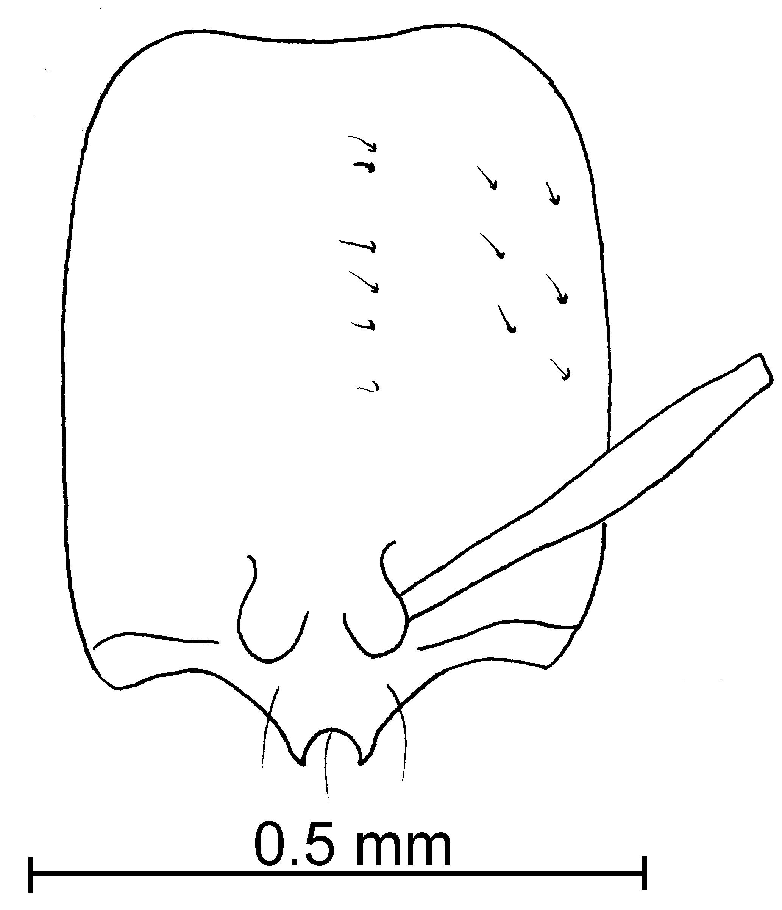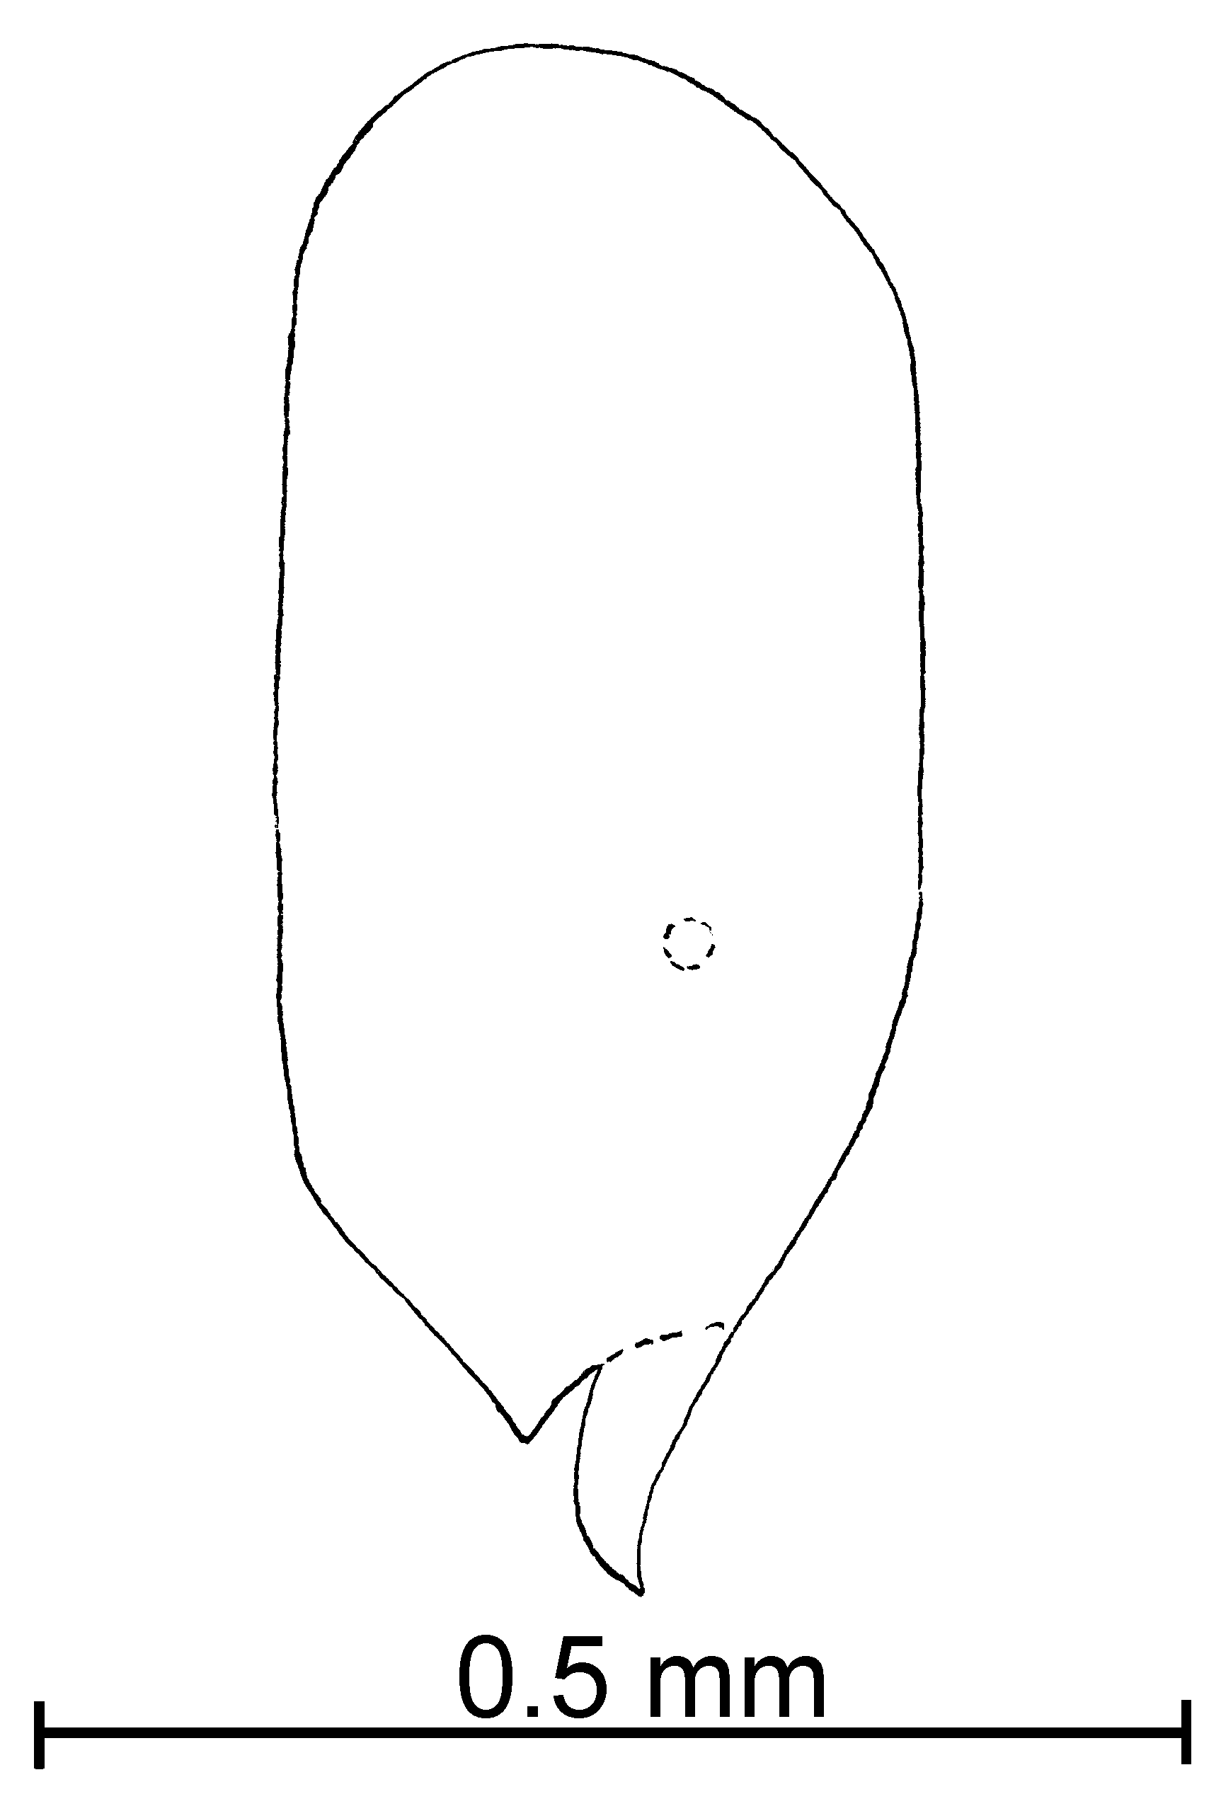Fig. 87. Head of the holotype worker of S. whitfordi as seen as seen from the front and from the side.
Female and Male: Unknown.
Distribution: Known only from the type locality.
Map 77. Solenopsis whitfordi in North America.
Type series: Holotype worker (MCZC), 3 paratype workers (CWEM, MCZC). UNITED STATE: New Mexico, Dona Ana Co., Jornada Range, 15 m N of Las Cruces, 5-x-1983, W. Mackay #1312 (3  CWEM), same locality, 11-ix-1983, W. Mackay #1112 (2  CWEM).
Map 78. Solenopsis whitfordi.
Etymology: This species is named to honor or our close friend and colleague, Walter G. Whitford, who has published a number of the papers on the ants of the southwest.
Material examined: Type series.
Biology: Specimens were collected from an extraction of soil in a creosotebush shrubland area.
`` Solenopsis zeteki Wheeler
molesta species complex

Solenopsis zeteki Wheeler, 1942:201, (w .)
Solenopsis torresi Snelling, 200?:?? new synonymy

Diagnosis: The workers of this species are pale yellow, small ants in which the clypeal teeth are reduced to blunt angles. The eyes are relatively large (greater than 0.03 mm in diameter), and oval-shaped. The minor funicular segments are shorter than 0.10 mm in total length. Erect hairs are sparse. The color, short funiculus and the poorly developed clypeal teeth would separate this species from all of the others except S. corticalis. The female of S. zeteki has a large eye (0.23 mm maximum diameter), which covers about ½ of the side of the head (the eye is much smaller in the female of S. corticalis, with the maximum of 0.15mm). Unfortunately, the workers of the two species are essentially identical, although the workers of S. zeteki are usually pale yellow, whereas the workers of S. corticalis are usually a more brownish, honey color. This species could be confused with S. andersoni, but can be separated as the clypeal teeth in S. andersoni are developed into definite, elongate teeth. The small clypeal teeth could cause confusion of this species with S. clytemnestra. It can be easily separated due to its small size (up to 1.2 mm total length, compared with 4 mm total length in S. clytemnestra).
Specimens from México are identical to those of the type series, except for being slightly darker. Although there are no associated females, they will be considered to be S. zeteki.
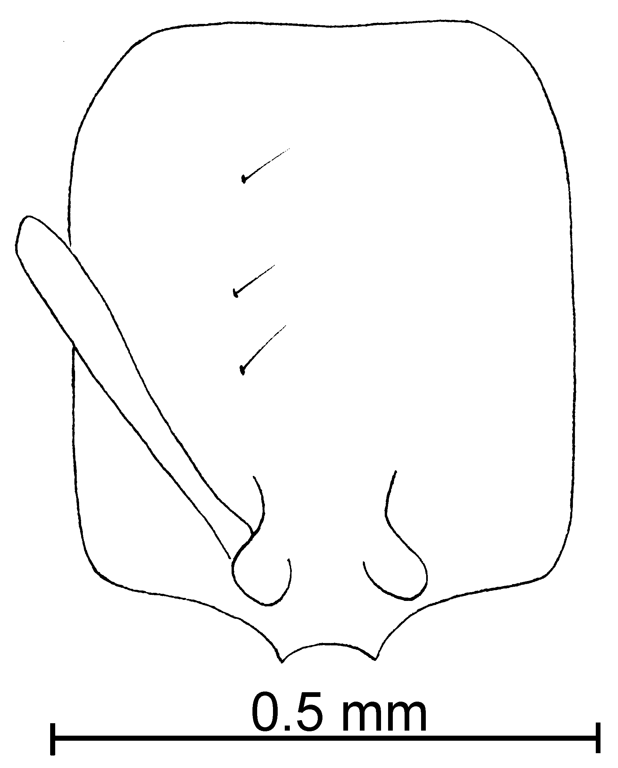
Fig. 88. Head of the ____________ worker of S. zeteki.
This species is difficult to separate from S. carolinensis. It is usually slightly smaller, but can be approximately equal in size. The lateral clypeal teeth of S. carolinensis are well developed, and the extralateral processes are developed at least into an angle. The lateral teeth are usually absent in S. zeteki, but may be developed into small angles. The extralateral angles of S. zeteki are absent or developed into a wide, slightly expanded area. Specimens from Colombia are somewhat intermediate between the two, in having small, extralateral teeth, but have much less developed lateral clypeal teeth and are assumed to be S. zeteki.
Distribution: México (Veracruz) south to Panamá (Canal Zone).
Map 79. Solenopsis zeteki in North America.
Types: Lectotype worker, 19 paralectotype workers and 4 paralectotype females [here designated], Panama type # 26289 (MZCZ).

Material examined: COLOMBIA: Bolívar, Zambrano, 110m, viii-1992, Many Roit (81  CWEM), Valle, Loboguerrero, 26-vi-1989, F. Fernández #’s 11970, 11971, 11978, 11980, 11985, 11994, 12001, 12009, 12011 (83  CWEM), Valle del Cauca, Buga, El Vintula Forest, 1000m, 17-xii-1994, R. Aldana # 17193 (8  CWEM). COSTA RICA: Guanacaste, Loma Barbudal, 3-vi-1989, S. Vinson # 12306 (11  CWEM), same locality, ii-1990, S. Vinson #’s 13135, 13066, 13088, 13091, 13097, 13120 (18  CWEM). COSTA RICA: Guanacaste, Loma Barbudal, 3-vi-1989, ii-1990, S. Vinson #’s 12072, 12142, 13152, 13177, 13180, 13195, 13186, 13187, 13188, 13189, 13200, 13202, 13203, 13210, 13218, 13219, 13232 (40  CWEM). MEXICO: Veracruz, Rio Metlac nr El Fortín, 17-xii-1948, E. Ross # 17236 (1  CASC), 6.5 k N Tierra Blanca, 28-v-1988, W. Mackay #10443, 446-9, 451-4 (88  CWEM); NICARAGUA: Leon, Frasco, 20-ix-1988, J. M. Maes (8  CWEM).
Biology: This specimens nest on loose vegetation and they are also collected in bait traps.

Conclusions
Based on the results of this research study, the following taxonomic classification for Diplorhoptrum is suggested: the species under the minutissima complex are the least related to the succinea complex; the species in the fugax and the molesta complexes are the most closely related; and the azteca complex is more closely related to the succinea than to the minutissima or the fugax and the molesta complexes (Table 1).
Table 1. Revised taxonomic classification of Diplorhoptrum.
azteca
Creighton (1930) divided Diplorhoptrum into 5 complexes: the westwoodi complex (includes the species now in the fugax complex); the minutissima complex was not included; the laeviceps complex, the molesta complex, and the basalis-tenuis complex were separated; and the succinea complex was classified as the subgenus Diagyne of Solenopsis.

Diplorhoptrum has been rearranged (see Table 2). The azteca complex remains added. The westwoodi complex was incorporated into the fugax complex. The laeviceps, and basalis-tenius complexes were placed under the molesta complex.

Literature Cited

Baroni Urbani, C. 1968. Uber die eigenartige Morphologie der mannlichen Genitalien des Genus Diplorhoptrum Mayr und die taxonomishen Schlussfolgerungen. Zeitschrift fur Morphologia der Tiere. 63:63-74.
Bolton, B. 1987. A new review of the Solenopsis genus-group and revision of Afrotropical Monomorium Mayr. Bulletin of the British Museum (Natural History) (Entomology). 54:263-452.
Creighton, W.S. 1930. The New World species of the genus Solenopsis. Proceeding of the America Academy of Arts and Sciences. 66:39-151.
Emery, C. 1890. Voyage de M.E. Simon au Venezuela (Decembre1887-Avril 1888). Annales de la Societe Entomolgique de France. (6) 10: 55-76.
Emery, C. 1896. Sur les fourmis du genre Macromicha Roger. Bullerin de la Societe Entomologique de France. 1986: 102-103.
Emery, C. 1905. In Mantero, G. Materialiper una fauna dell' Archipelago Toscano. Isola del Giglio. Annali del Museo Civico di Storia Natural di Genova. (3) 1 [41]:449-454.
Ettershank, G. 1966. A generic revision of the World Myrmicinae related to Solenopsis and Pheidologeton. Australian Journal of Zoology. 14: 73-171.
Forel, A. 1881. Die Ameisen der Nitlle St. Thomas. Mittheilingen des Munchener Entomologischen Vereins. 5: 1-16.
Forel, A. 1893. Sur la clasification de la famille des formicides, avec remarques synonymiques. Annales de la Societe Entomologique de Belgique. 37: 161-167.
Forel, A. 1901. Les formicides de l'Empire des Indes et de ceylan. Part 8. Sous famille Dolylinae. Journal of the Bombay natural History Society. 13: 462-477. Forel, A. 1908. Fourmis de Ceylan et d'Egypte, recoltees par le Prof. E. Bugnion. Bulletin de la Societe Vaudoise des Sciences Naturelles. 44:1-22.
Holldobler, B. and E. O. Wilson. 1990. The ANTS. The Belknap Press of Harvard University Press. Cambridge, Massachusetts. pp. 1-3.
Kempf, W.W. 1970. Levantamento das formigas da Mata Amazonica, nos arredores de Belem do Para Brasil. Studia Entomologica (N.S.). 13:321-334.
Kempf, W.W. 1972. Catalogo abreviado das formigas da Regiao Neotropical. Studia Entomologica (N.S.). 15: 3-344.
Kremen, C., R. K. Colwell, T. . Erwin, D. d. Murphy, R. F. Noss, and M. A. Sanjayan. 1993. Terrestrial Arthropod Assemblages: Their Use in Conservation Planning. Conservation Biology. 7:796-808.
Mackay, W. P. and S. B. Vinson. 1989. Two new ants of the genus Solenopsis (Diplorhoptrum) from eastern Texas (Hymenoptera: Formicidae). Proc. Entomol. Soc. Wash. 91: 175-178.
Mayr, G. 1855. Formicina austriaca. Beschreibung der dkisherim osterreochischen Kaiserstaate aufgefundenen Ameisen nebst Hunzufugung jener in Deutschland,in der Schwartz und in Italien vorkommenden Ameisen. Verhandlungen des Zoologisch-Botanishen Vereins in Wien. 5: 273-478.
Mayr, G. 1862. Myrmecologische Studien. Verhandlungen des Zoologisch-Botanishen Gesellschaft in Wien. 12: 649-776.
Mayr, G. 1877. In Fedchenko, A.P. Puteshestive v Turkestan, 2 (5). Formicidae. Izvestiya Imperatorskago Obshchestva Lyubitelei Estestvoznaniya, Antropologii i Entnografii . 26: 1-20.
Menozzi, C. 1931. Spedizione del Barone Raimondo Franchetti in Dancalia. Hymenoptera-Formicidae. Annali del Museo Civico di Storia Naturale di Genova. 55: 154-156.
Smith, M. R. 1942. A new, apparently parasitic ant. Proceedings of the Entomological Society of Washington. 44: 59-61.
Smith, M.R. 1947. Ants of the genus Cryptocerus F. in the Unites States. Proceedings of the Entomological Society of Washington. 49: 29-40.
Thompson, C.R. 1980. Solenopsis (Diplorhoptrum) (Hymenoptera: Formicidae) of Florida. Dissertation, University of Florida.
Thompson K. 1989 The thief ants , Solenopsis molesta group, of Florida (Hymenoptera: Formicidae), Florida Entomologist 72: 268-289.
Wheeler, W.M. 1904. Three new genera of inquiline ants from Utah and Colorado. Bulletin of the America Museum of Natural History. 20: 1-17.
Wheeler, W.M. 1908. The Ants of Puerto Rico and the Virgin Islands. Bulletin of the America Museum of Natural History. 24: 117-158.
Wheeler, W.M. 1925. Neotropical ants in the collection of the Royal Museum of Stockholm. Arkiv for Zoologi. 17 (A 8): 1-55.
Wheeler, W.M. 1942. Studies of Neotropical ant-plants and their ants. Bulletin of the Museum of Coperative Zoology at Harvard College. 90:1-262.

Appendix

Index

abdita, 16
altinodis, 17
Amitermes medius, 19
angustinodis, 18
Argentina
Buenos Aires
clytemnestra, 25
Entre Rios
clytemnestra, 25
Rio Negro
clytemnestra, 25
azteca, 18
Bahamas
batyle, 20
batyle, 19
Belise
carolinensis, 22
laeviceps, 32
tenuis, 52
Belize
bicolor, 20
bicolor Complex, 5
Brasil
Rio Grande do Sul
clytemnestra, 25
brevicornis, 20
brevicornis Complex, 6
carolinensis, 21
castor, 23
clytemnestra, 24
Colombia
altinodis, 18
Bolivar
texana, 55
zeteki, 61
Cauca
subterranea, 50
Cauca
azteca, 19
brevicornis, 21
laeviceps, 32
texana, 55
Risaralda
angustinodis, 18
azteca, 19
picea, 42
Valle
tennesseensis, 52
zeteki, 61
Valle del Cauca
laeviceps, 32
rugiceps, 47
tennesseensis, 52
vinsoni, 59
zeteki, 61
conjurata, 25
corticalis, 26
Costa Rica
Guanacaste
angustinodis, 18
brevicornis, 21
carolinensis, 22
castor, 24
conjurata, 25
corticalis, 26
laeviceps, 32
picea, 42
striata, 49
subterranea, 50
tenuis, 53
terricola, 53
vinsoni, 59
zeteki, 61
hayemi, 27
Puntarenas
brevicornis, 21
castor, 24
corticalis, 26
laeviceps, 32
striata, 49
terricola, 54
San Jose
castor, 24
picea, 42
striata, 49
succinea, 51
Cuba
corticalis, 26
depilis, 27
fugax Complex, 6
Guiana
altinodis, 18
hayemi, 27
Hispanola
succinea, 51
isopilis, 29
Jamaica
azteca, 19
johnsoni, 30
Key to the bicolor species complex, 5
Key to the brevicornis species complex, 6
Key to the molesta species complex, North America, 9
Key to the molesta species complex, South America, 11
Key to the pygmaea species complex, 14
Key to the species complexes, 4
Key to the stricta species complex, 16
krockowi, 30
laeviceps, 31
longiceps, 51
melina, 34
Mexico
Baja California
conjurata, 25
molesta, 36
Baja California Sur
conjurata, 25
johnsoni, 30
Chiapas
brevicornis, 21
carolinensis, 22
conjurata, 25
corticalis, 26
hayemi, 27
subterranea, 50
Coahuila
texana, 55
validiuscula, 57
Colima
castor, 24
validiuscula, 57
Nuevo Leon
carolinensis, 22
conjurata, 26
molesta, 36
tenuis, 53
texana, 55
San Luis Potosi
krockowi, 31
molesta, 36
tennesseensis, 52
tenuis, 53
texana, 55
Tabasco
carolinensis, 22
corticalis, 26
patriciae, 40
pygmaea, 46
subterranea, 50
tennesseensis, 52
texana, 55
vinsoni, 59
Tamaulipas
texana, 55
Veracruz
carolinensis, 22
corticalis, 26
hayemi, 27
isopilis, 29
picea, 42
zeteki, 61
molesta, 35
molesta Complex, 8
nana, 37
Nicaragua
castor, 24
corticalis, 26
Leon
zeteki, 61
nickersoni, 38
ocellata, 39
Panama
Bocas del Toro
laeviceps, 32
brevicornis, 21
Canal Zone
azteca, 19
conjurata, 25
Cerro Campana
terricola, 54
Chiriqui
carolinensis, 22
castor, 24
corticalis, 27
laeviceps, 32
picea, 42
striata, 49
tenuis, 53
texana, 55
Paraguay
clytemnestra, 25
patriciae, 39
pergandei, 40
Peru
Tambopata
bicolor, 20
picea, 41
picta, 42
pilosula, 43
pollux, 44
Puerto Rico
azteca, 19
corticalis, 26
maboya, 33
pygmaea, 46
pulleni, 44
puncticeps, 40
pygmaea, 45
pygmaea Complex, 14
quadridentata, 46
rosella, 54
rugiceps, 46
salina, 47
striata, 48
stricta Complex, 16
subterranea, 49
succinea, 50
tennesseensis, 51
tenuis, 52
terricola, 53
texana, 54
tonsa, 56
torresi, 60
truncorum, 57
United States
Alabama
pergandei, 41
texana, 55
Arizona
krockowi, 31
molesta, 36
nana, 38
ocellata, 39
validiuscula, 57
Arkansas
carolinensis, 22
molesta, 36
quadridentata, 46
texana, 55
California
molesta, 36
Colorado
validiuscula, 58
Florida
abdita, 17
nickersoni, 38
pergandei, 41
picta, 43
tennesseensis, 52
texana, 55
tonsa, 56
Illinois
molesta, 36
Iowa
molesta, 36
Louisiana
molesta, 36
ocellata, 39
picta, 43
salina, 48
subterranea, 50
texana, 55
Michigan
molesta, 36
Mississippi
molesta, 36
pergandei, 41
salina, 48
texana, 55
Montana
molesta, 36
New Mexico
validiuscula, 58
New Mexico
krockowi, 31
melina, 34
molesta, 36
pergandei, 41
pulleni, 45
quadridentata, 46
salina, 48
texana, 55
whitfordi, 60
New York
molesta, 36
North Carolina
pergandei, 41
Tennessee
carolinensis, 22
molesta, 36
texana, 55
Texas
carolinensis, 22
depilis, 28
molesta, 36
pergandei, 41
pilosula, 43
salina, 48
subterranea, 50
tennesseensis, 52
texana, 55
tonsa, 57
Virgina
molesta, 37
Virginia
carolinensis, 22
texana, 56
Washington D. C.
molesta, 37
validiuscula, 57
Venezuela
altinodis, 17
Aragua
azteca, 19
Bolívar
azteca, 19
Distrito Federal
subterranea, 50
vinsoni, 58
whitfordi, 59
zeteki, 60

`` Solenopsis xx Mackay & Moreno, new species
new species 15

xx species complex

Diagnosis:
Measurements: Worker TL mm, HL mm, HW mm, SL mm, Indices: CI, SI.
Fig. 89. Mesosoma, pedicel and first gastral tergum of the lectotype worker of S. xx (X).
Female TL mm, HL mm, HW mm, SL mm, Indices: CI, SI.
Male TL mm, HL mm, HW mm, SL mm, Indices: CI, SI.
Fig. 90. Head of the lectotype worker of S. xx (X).

Description:
Fig. 91. Propodeum and pedicel of the paralectotype female of S. xx (X).
Fig. 92. Head of the paralectotype female of S. xx (X).

Distribution:

Map 80. Solenopsis xx in North America.
Map 81. Solenopsis xx in South America.

Type series: Holotype worker (MCZC), paratype workers (.
Material examined: Type series and
Biology: .



Department of Biological Sciences, The University of Texas, El Paso 79968

