***An Economic Argument for Drug Legalization***

***Jagadish Thimiri, Ramya Burugu, Neale Smith, Eric Smith***

This is a working paper. Please obtain permission from the lead author (Eric Smith) at [esmith2@utep.edu](mailto:esmith2@utep.edu) before making any use of this paper. Copyright 2017 is retained by the authors.

***Abstract***

Drug-related violence and corruption demonstrate that the U.S. War on Drugs is a serious problem. Young people are enticed into the illicit drug markets because of the policy-induced, artificially high drug prices. A review of the literature on the relationship between drugs and violence is presented. Economic theory and systems engineering are applied to drug policy, demonstrating that confiscation does not restrict supply but actually strengthens drug cartels. Conclusions are drawn from research and arguments.

**Keywords** — Drugs, Cartels, Demand and Supply, Supply Chain, Drug Policy, Legalization, System Engineering, System Dynamics

***Section 0: Introduction***

**0.1 Importance**

In order to starve cartels and traffickers of drug profits, and to remove the pervasive Americas-wide temptation for everyday people to become involved in illegalized activities, as well as the trend for governments to become hyper-militarized and corrupted, economic analysis points to the legalization of drugs. Legalization would radically reduce violence and save the lives of new entrants, lured by a psychologically overlooked personal risk premium.

**0.2 Audience**

The target audiences for this proposal are the American and Mexican people and governments. We believe that this working paper will help to justify policies leading to the legalization of illegalized drugs, and to a significant decrease in crime.

**0.3 Sections in this Paper**

This paper pursues a systems thinking approach to address the endemic nature of the War on Drugs.

Section 1 introduces Systems Engineering, while Section 2 describes the use of the System Dynamics methodology to describe the web of interactions present in the War on Drugs. Section 3 describes Feedback Thinking and the Systemic Enablers that perpetuate and feed illicit drug activities. Section 4 reviews and extends basic Economics theory in order to illustrate the fact that economic drivers provide perennial energy to the flow of contraband drugs. Section 5 notes that the population of drug smugglers is culled for fitness. Section 5 also notes that government agencies have for decades been in the position to conclude that the war on drugs is unwinnable, but have failed to officially recognize such, because their self-interests lie in a perpetual war.

Section 6 introduces the possibility that responsible drug regulation controls drug use and limits the harsh consequences of criminalization. Section 7 concludes with an appeal for the salvation of our inter-American human populations. Appendices provide some supporting data.

***Section 1: Systems Engineering***

**1.1 Systems Engineering (SE)**

“Systems engineering constitutes an interdisciplinary approach and a means to enable the realization of a successful system by an orderly process” [Blanchard Benjamin S, 2008, p.1].

**1.2 Why Systems Engineering?**

One approach of systems engineering is to break a complex system into simple systems, without leaving out any entities, i.e., decomposing a complex problem into simple problems which are solvable, and then considering synthesis and emergence.

**1.3 Systems Engineering Across Domains**

According to SE Vision 2025, “Systems engineering is being adapted to support many application domains in both common and industry-unique ways. Embracing the diversity of practice while leveraging practices that deal with common system challenges enriches the discipline” [INCOSE SE Vision 2025, 2014, p. 17].

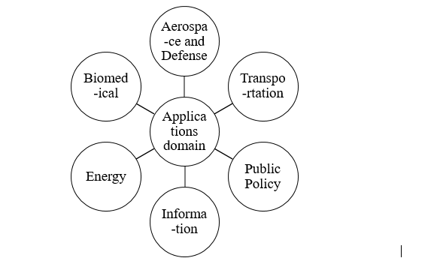

**Figure 1**: Systems Engineering practiced across different domains [Based on INCOSE SE Vision 2025, 2014, p.17]

From Figure 1, we can see that systems engineering can be applied to the domain of Public Policy. One technique of systems engineering that can be applied is System Dynamics (SD). System Dynamics can be used to analyze the current problem situation and solution approaches to arrive at an improvement to public policy.

***Section 2: System Dynamics (SD)***

**2.1 System Dynamics**

System Dynamics is a powerful approach (that can be computer-aided) for framing complex problems characterized by interdependence, mutual interaction, information feedback, and circular causality.

The cartel problem is described in this section from a systems-thinking perspective, as described by McGee et al., who conducted a holistic assessment begun by identifying different domains of cartel operations. The domains were separated and each domain was examined to identify the relationships and the casual factors contributing to the problem situation. The domains identified are the Cartel Domain, Economic Domain, and Systemic Enablers.

System Dynamics is approached by defining the problem dynamically. Modeling begins by mapping nodes and arcs, as illustrated in the figure below.



**Figure 2**: System Dynamics Example (www.advancedepidemiology.org)

Figure 2 demonstrates the positive feedback to the Work life created by expansion of other activities, such as Exploration. The activities in the work domain are interlinked in such a way that each activity supplies the other activities with resources for their operation. For example, Interest leads to increase in Work, which in turn leads to an increase in Results, which leads to Success, and from Work which leads to increase in Boredom, which leads to an increase in Exploration, which in turn leads to Interest in other things, which in turn increases Guilt and leads to an increase in Work. Note also that Interest in other things leads to negative feedback in Work.

System Dynamics is used to gain an integrated view of the major forces that can affect key outcomes over long stretches of time. An integrated, strategic view is necessary when various variables have multiple consequences depending on their application. System dynamics can be applied to complex social, managerial, and economic systems.

**2.2 Feedback Thinking**

The feedback concept is at the conceptual heart of the system dynamics approach. Information feedback loops and circular causality diagrams are used to conceptualize the structure of a complex system and communicate model-based insights. The system dynamics approach to model interconnected system parts strives to demonstrate the behavior of a system as a consequence of the system’s structure.

***Section 3: Complete System Dynamics Model***

**3.1 Problem Statement in System Dynamics**

The cartel problem is approached in this paper from a systems thinking perspective, a holistic assessment begun by identifying different domains of cartel operations. The domains can be separated and each domain is examined to identify the relationships and the casual factors contributing to the problem situation. The domains identified are Cartel Domain, Economic Domain, and Systemic Enablers.

**3.2 Cartel Domain**

The activities and factors of the cartel domain are drug trafficking, drug profits, contraband revenues, arms purchases, arms smuggling, cash smuggling, kidnapping, extortion and human smuggling. These activities are shown in Figure 3 below.



**Figure 3**: Illicit Cartel Activities

[Mcgee, Joel, Edson, *Mexico’s Cartel Problem: A Systems Thinking Perspective*, p .4]

Figure 3 demonstrates the positive feedback to cartel profits created by the expansion of criminal activities. The activities in the cartel domain are interlinked in such a way that each activity supplies the other activities with resources for their operation, and which in turn makes the cartel a powerful and complex enterprise. For example, drug trafficking leads to increases in drug profits, which in turn leads to increases in contraband revenue, which leads to arms purchases, and which in turn leads to arms smuggling. Also cash smuggling leads to money laundering, which in turn leads to an increase in cartel strength.

The War on Drugs has caused cartel related violence to increase, creating a challenge for socio-political stability in Mexico. Currently, the U.S. government focuses on law enforcement measures to interdict drugs in the cartel supply lines. According to a 2010 GAO [GAO-11-73] report, approximately $18 to $39 billion dollars of drug sale dollars are smuggled into Mexico each year. Cartel operations have expanded into human trafficking, weapons smuggling, kidnapping and extortion. Figure 3 demonstrates how positive feedback among criminal activities increases cartel profits.

**3.3 Economic Domain and the Cartel Domain**

The activities identified in the economic domain are economic growth, unemployment, income, black market share, and incentives for organized crime activities. Economic activities and factors are shown in Figure 4 below.



**Figure 4:** Economic Domain and Cartels

[Mcgee, Joel, Edson, *Mexico’s Cartel Problem: A Systems Thinking Perspective*, p .4]

From Figure 4, the relation between the cartel domain and socio-economic domain is shown. From the economic domain, it can be seen that it leads to unemployment, reduction in income, increase in incentives for organized crimes activities in black market share. The economic domain increases the strength of the cartel domain by playing a significant role in illegal immigration through human trafficking activities. The poor socio-economic conditions in Mexico, lead to high illegal immigration and human trafficking from Mexico to the USA.

**3.3 Systemic Enablers and the Cartel Domain**

Systemic enablers include the failure to penalize, failure to prosecute, failure to arrest, and prison escapes. Cartels bribe public officials and government personnel, leading to corruption of prison officials, corruption of crime prosecutors, corruption of police, corruption of military officers, corruption of public officials, and to the corruption of customs and border agencies, which leads to the failure of drug interdiction.



**Figure 5**: Systemic Enablers of Cartels

[Mcgee, Joel, Edson, *Mexico’s Cartel Problem: A Systems Thinking Perspective*, p .5]

From Figure 5, it can be seen that Corruption plays an important role in cartel activities. Because cartels are powerful and wealthy enterprises, cartels can bribe military officers, public officials and customs and border agencies, which allows the cartels to function without any problem, and which in turn strengthens the cartel domain. Figure 6 takes a closer look at influences among factors and types of corruption.



**Figure 6**: Influences among types and factors of corruption [Mcgee, Joel, Edson, Mexico’s Cartel Problem: A Systems Thinking Perspective, p .5]

From Figure 6, it is clear that the cartels pose a significant challenge to the national security of the US. The current efforts, which rely purely on law enforcement activities such as interdiction, are failing to produce the desired results expected by the government, namely, to the prevent consumption and trading of illegal drugs.

Figure 7 demonstrates the current situation and shows that the current system functions as a failed state because the government is focusing on the short term solution (interdiction) and not the long-term solution which is to bring a reform in the judicial system.

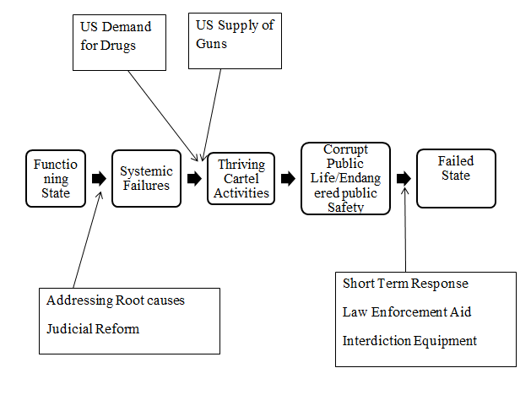

**Figure 7**: Solutions at the root causes vesus solution at the symptoms [Mcgee, Joel, Edson, *Mexico’s Cartel Problem: A Systems Thinking Perspective*, p .8]

This System Dynamics approach provides a useful analytical framework to understand markets for illegal drugs and deficiencies in the approaches of the governments of the US and Mexico. On the conceptual side, while there are many positive (+) signs (worsening the situation among negative factors) in the system dynamics diagrams, the conceptual solution provided in this paper will lead to negative (-) signs (improvement in the situation by reducing negative factors) in the system dynamics diagrams.

***Section 4: Economic Theory***

**4.1 Basics of Supply and Demand**

Supply and Demand are two of the most fundamental concepts of economics and they are the theoretical backbone of a competitive market function analysis.

**4.2 Demand Point**

Demand refers to the quantity of a product that is desired by buyers, at a given price.

**4.3 Supply Point**

Supply refers to the quantities of a product that are supplied into the market at different prices.

**4.4 Demand Relationship**

The correlation between the price and the quantity demanded is known as the demand relationship.

**4.5 Supply Relationship**

The correlation between price and quantity of goods supplied is known as the supply relationship. The allocation of goods in market is based on the principles of supply and demand. Changes in the supply curve deal with changes in quantity of the product supplied, allowing supply curves to tell us how much is being sold and at what price.

**4.6 Law of Demand**

The law of demand states that the higher the price of a good, all other factors remaining equal, the lower the quantity demanded. As a result, people will naturally avoid buying a product at a very high price. The demand curve is a downward slope as shown in Figure 8.



**Figure 8**: Demand Curve showing Demand Relationship [Investopedia.com, 2003]

In Figure 8, the points on the demand curve show a correlation between quantity demanded and price. Q1 < Q2 < Q3 and P1 > P2 > P3. At point A, the quantity demanded will be Q1 and the price will be P1. At point B, the quantity demanded will be Q2 and the price will be P2. At point C, the quantity demanded will be Q3 and the price will be P3. Figure 8 shows the negative relationship between price and quantity demanded. The higher the price of good, the lower the quantity demanded, and the lower the price, the more the goods will be in demand.

**4.7 Law of Supply**

The law of supply states that the higher the price of a good, the higher the quantity supplied. The supply curve is an upward slope as shown in Figure 9.



**Figure 9:** Supply Curve showing Supply Relationship [Investopedia.com,2003]

Figure 9, the points on the demand curve show a correlation between quantity supplied and price. Q1 < Q2 < Q3 and P1 > P2 > P3. At point A, the quantity supplied will be Q1 and the price will be P1. At point B, the quantity supplied will be Q2 and the price will be P2. At point C, the quantity supplied will be Q3 and the price will be P3. Figure 9 shows the positive relationship between price and quantity demanded. The higher the price of a good, the higher the quantity of goods will be supplied.

**4.8 Equilibrium**

Supply and demand are at equilibrium where the supply function and demand function intersect. At equilibrium, the allocation of goods is efficient, since the amount of goods supplied is exactly the amount of goods demanded.



**Figure 10**: Supply and Demand in Equilibrium

[Investopedia.com,2003]

As shown in Figure 10, equilibrium occurs at the intersection of the demand and supply curve, which shows allocative efficiency.

**4.9 Excess Supply**

When the price is set too high, by a government price floor at P1, for example, excess supply will be created and there will be allocative inefficiency.



**Figure 11**: Excess Supply [Investopedia.com, 2003]

From Figure 11, Q2 is number of goods supplied by producers at price P1, while only Q1 goods were in demand. Since Q1 < Q2, excess goods are supplied, compare to the goods in demand.

**4.10 Excess Demand**

When the price is set too low, by a government price ceiling at P1, for example, excess demand will be created and there will be allocative inefficiency.

**Figure 12**: Excess Demand



[Investopedia.com, 2003]

In Figure 12, Q1 is number of goods supplied by producers at price P1 and Q2 goods are in demand. Since Q1 < Q2, there is a shortage of goods supplied.

**4.11 Elasticity and Inelasticity:**

The degree to which a demand or supply curve reacts to a change in price is the curve's elasticity. Elasticity of the supply or demand curves can be determined using the equation below:

Elasticity = ( %_change_in_quantity

**/** %_change_in_price)

If elasticity is greater than or equal to one, the supply or demand relationship (curve) is considered to be elastic. If it is less than one, the curve is said to be inelastic.

**Figure 13**: Elastic Demand



The relatively flat curve in Figure 13 shows elasticity of demand.

Elasticity = ( %_change_in_quantity

**/** %_change_in_price)

= ((Q1-Q2)/Q1)/ ((P1-P2)/P1) ≥1

= One or greater than one is considered elastic demand

**Figure 14**: Inelastic Demand



From Figure 14, the relatively upright demand curve illustrates inelastic demand.

Inelasticity = ( %_change_in_quantity

**/** %_change_in_price)

= ((Q1-Q2)/Q1)/ ((P1-P2)/P1)<1

= less than one is considered inelastic demand

**Figure 15**: Elastic Supply



From Figure 15, the relatively flat curve means that the good has an elastic supply.

Elasticity = ( %_change_in_quantity

**/** %_change_in_price)

= ((Q1-Q2)/Q1)/ ((P1-P2)/P1) ≥1

= One or greater that one is considered elastic supply

**Figure 16**: Inelastic Supply



From Figure 16, the upright supply curve is considered inelastic supply.

Elasticity = ( %_change_in_quantity

**/** %_change_in_price)

= ((Q2-Q1)/Q2)/ ((P2-P1)/P2)< 1

= less than one is considered inelastic supply.

**4.12 Producer Surplus**

Producer surplus is what producer firms receive by getting more for their product than the minimum they were willing to accept, as shown in Figure 17.

**4.13 Consumer Surplus**

Consumer surplus is the difference between what consumers are willing to pay relative to market price. If consumer is willing to pay more than the required price of the goods than consumer surplus occurs which is shown in Figure 17.



**Figure 17**: Producer and Consumer Surplus [Wikipedia.com,2015]

**4.14 Deadweight Loss**

A deadweight loss is a loss of economic efficiency. Deadweight loss can occur when equilibrium for a good or service is not achieved or is not achievable. Adding consumer and producer loss gives the Dead Weight Loss.

Causes of deadweight loss can include monopoly pricing, price ceiling as shown in Figure 18.

**Figure 18**: Deadweight Loss [Wikipedia.com, 2015]



Figure 18 shows that a price ceiling produces a net surplus to consumers and a net deficit to producers. A price floor, in contrast, is created by the War on Drugs.



**Figure 19**: Producers gain by interdiction

Figure 19 demonstrates from the concept of dead weight loss.

Before interdiction:

Consumer surplus= S+T+Q

and the

Producer surplus= U+R.

After interdiction, the

Consumer surplus = S

and the

Producer Surplus = U+T.

Thus, the

Net gain after interdiction for producers = T - R. This demonstrates that interdiction is beneficial to the drug traffickers.

**4.15 Straight-line Demand and Supply Curves**:

Straight-line demand and supply curves are expressed in two straight lines that intersect. All supply and demand curves in reality are indeed curves, but can be extrapolated so that they appear to be straight lines. The x-y axis will help us discretize related trends and make theoretical predictions or simulations.

Figure 20 shows:

* The different price levels
* Straight line demand curve
* Supply curves are flat and elastic.
* Prices are described at seizure levels

Notice:

1: In this Figure 20, the supply curve is flat and elastic.

2: Demand line is an approximation.

3: Supply and demand lines intersect at right angles

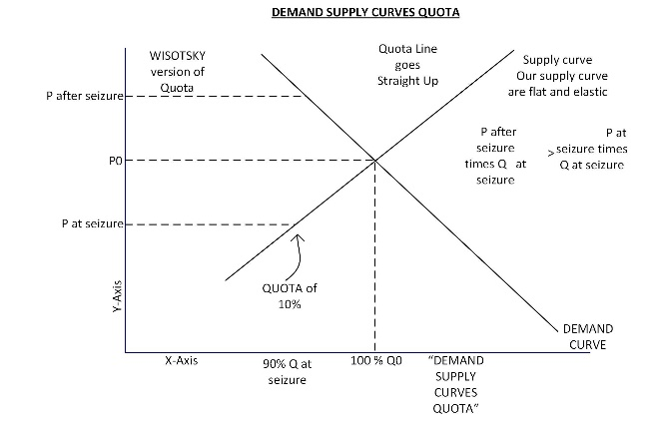

**Figure 20**: Straight Line Demand & Supply Curves

**4.16 Geographical Demand curve: NEW**

*This paper introduces the new concept of a Geographically-based Demand Curve. A geographical demand curve explains the increase or rise in the consumption of drugs from Columbia to the USA border.* We can notice how the growth in usage or demand for the product has increased over its geographic trajectory from production area to predominant consumption area.

Notice from Figure 21 below how the demand of drugs from one country to another has increased dramatically. This graph shows the increase in the demand curve in geographical terms. Figure 21 shows:

* The Demand Curve starts out horizontal at the south region of Bogota, and then goes up to 90% at the U.S. border.
* The curve fits the claim of the DEA, that they confiscate 10% of the cocaine smuggled between the Mexico and U.S. border [Davenport-Hines, 2004]
* Demand Curve starts off flat at the south of Bogota, while spiking in the U.S.
* Demand Curve is a Power Curve.



**Figure 21**: Geographical Demand Curve

**4.17 Flat Supply Curves: NEW**

*This paper introduces the new concept of relatively flat supply curves within national boundaries, with a jump to a different supply curve as drugs are smuggled into the next country.* Figure 22 shows:

* How the Supply Curve remains flat in the U.S. This is why Drug Gangs rarely fight in the U.S.
* Every geographic region along the supply route has a relatively flat supply curve, which shows the relatively uniform price within a given country.
* There is a discrete jump and change of supply curve as drugs are transported across important barrier borders.

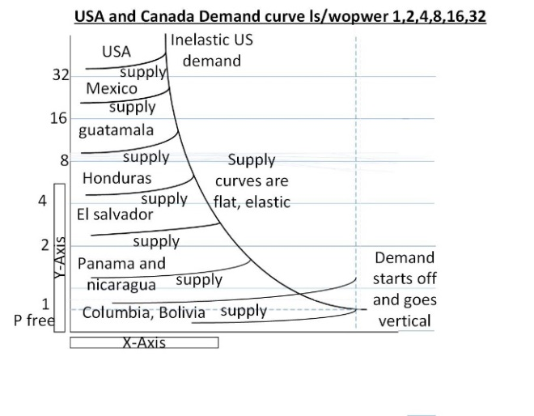

**Figure 22**: Flat Supply Curves

**4.18 Angles and Inventory Value Gain**: **NEW**

Inventory value gain is a type of windfall profit. Value gain in product inventory is derived from price appreciation, or price re-valuation.

*Examining a supply and demand chart, it can be seen that confiscation will result in reduced supply, some deadweight loss to the consumer, but very often an inventory value gain for the producer. This means that drug smugglers with product in the supply line gain a windfall profit from confiscations of other product in the supply line.* See Figure 23.



**Figure 23**: Gain Producer Surplus after Confiscation

Figure 24 shows an expanded, angle-based analysis of inventory value gain for producers/smugglers.

* From these angles are calculated the increase in the value of Cocaine after Seizure in the Supply. Sine(alpha) minus Sine(beta) expresses inventory value gain.

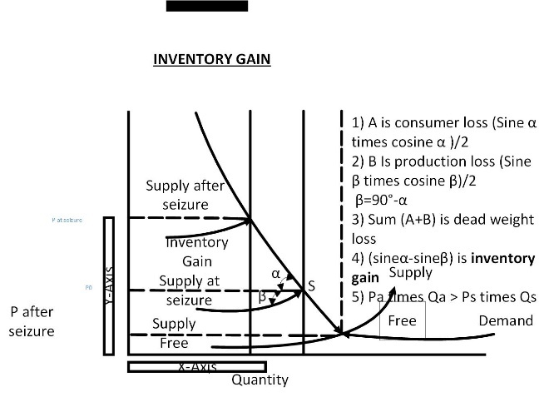

**Figure 24**: Angles and inventory value grain

***Section 5: Insights from Economics***

**5.1 Analysis of Drug Trade**

Richard Davidson, in his book “The Pursuit of Oblivion,” [2004, p.23] criticized the efficacy of the War on Drugs by pointing out that, only “10–15% of illicit heroin and 30% of illicit cocaine is intercepted. Drug traffickers have gross profit margins of up to 300%. At least 75% of illicit drug shipments would have to be intercepted before the traffickers' profits were hurt.”

The U.S. Drug Enforcement Agency (DEA), in charge of the Drug War, reports that during the course of one year, that is, in collaboration with its allies, intercepts, confiscates and destroys 10% [Davenport-Hines, 2004] of the illegal drugs from the inventory in the supply chain, from South of Bogota up to the cities in the United States, Boston, Chicago and Washington D.C.

This annual interception is considered for the purpose of this paper as occurring in one single day, as this has a physical and immediate crime-stopping impact far beyond an interdiction spread over one year (365 days).

An initial and optimistic view of interdiction predicts that, upon on annual interdiction of approximately 10% of supply quantity [Davenport-Hines, 2004], the value of the illegal drug remaining as inventory in the supply chain decreases (practically nothing); while a more detailed analysis demonstrates that the value of the illegal drug remaining in the supply chain actually increases: counter intuitive! This is because, for those suppliers lucky enough to have no interdicted product, the selling price of their product spontaneously increases by approximately two times.

“One of the major problems with supply reduction efforts (source control, interdiction, and domestic enforcement) is that “suppliers simply produce for the market what they would have produced anyway, plus enough extra to cover anticipated government seizure” [Rydell and Everingham, 1994, p. 6].

“To achieve a one percent reduction in U.S. cocaine consumption, the United States could spend an additional $34 million on drug treatment programs, or 23 times as much — $783 million — on efforts to eradicate the supply at the source” [Rydell and Everingham, 1994, p. 6].

“Interdiction efforts intercept 10-15% of the heroin and 30% of the cocaine. Drug traffickers earn gross profit margins of up to 300%. At least 75% of international drug shipments would need to be intercepted to substantially reduce the profitability of drug trafficking” [Associated Press, “U.N. Estimates Drug Business Equal to 8 Percent of World Trade,” (1997, June 26)].

**5.2 Assumptions for the analysis of Drug Trade**

The basics of the supply-and-demand approach provide a useful analytical framework to understand markets for illegal drugs. Conceptually, after some analysis, we will draw to a conclusion about drug legalization. The economic approach is flexible enough to capture many of the special features of the illegal drug markets, and provides important insights.

**Figure 25:** Value of drug in the supply before and after interdiction [Wisotsky, 1990]



Figure 25, demonstrating that an interdiction of 10% / 15 % results in an increase in value of the inventory in the supply chain and counter intuitively a corresponding increase in production. Contrary to current political rhetoric, interdiction of illegalized drugs may actually result in an increase of value of the drug inventory in the supply chain. The area of rectangle P1*Q1 is the value of a drug inventories in the supply chain before interdiction. After interdiction, the total value of the drugs still in the possession of traffickers, P2*Q2, has actually increased.

Consequently, the interdiction serves more as increased demand rather than as a penalty or a deterrent. The sudden jolt of an annual interdiction in one day never takes place. The 10 % interdiction occurs over the course of one year.

**5.3 Positive Feedback: NEW**



**Figure 26**: Positive Feedback

Figure 26 shows a *new concept for the drug interdiction debate, namely, that positive feedback is introduced every time a confiscation occurs.*

From Figure 26, before interdiction the quantity demanded is Q0 at price P0, after interdiction the quantity demanded is Q1 and sold at higher price P1. At this point Q1 and P1 there is an impact on supply curve making the quantity demanded as Q2 and price P2 which implies more quantity is demanded and sold at lower price, which implies interdiction has no effect.

The equilibrium is a small rectangle vibrating the original intersection. If cocaine is considered as a currency based on a physical commodity, interdiction serves to moderate the inflation that devalues fiat currencies over time; that is cocaine becomes a perpetual renewing store of value.

**5.4 Impact on Traffickers**

The interdiction also systematically and relentlessly eliminates the smaller and less competent drug transporters who become more influential, intelligent, more ingenious, and greatly more capitalized and needless to say, more skilled in bribery and brutality, vastly more capable of enforcement.

The price support system imposed by the strategy of interdiction foments the criminal activities of hard core addicts, of criminal gangs dedicated to kidnapping and extortion and of course, the corruption of national armies, national police and government officials.

**5.5 U.S. Government Involvement**

The analysis also brings up the very nasty conclusion that the U.S. Spy Organizations, CIA, FBI, DEA, with plenty of computer geeks, analysts and experienced field agents have directly experienced the futility of interdiction in the Drug War for some 42 years and to preserve their jurisdictions have never forcefully argued and convinced the authorities in the Presidency and in U.S. Congress about the patent futility of the War on Drugs. In fact, these agencies perpetually ask for budget increases.

We don’t know how accurate the DEA statistics are: because as a major player in the game the DEA has its own agenda.

**5.6 Fragmentation of Government**

Columbia was once famous for two Cartels, Medellin and Cali; this Dual Monopoly has broken down in to some 300 smaller organizations which has made detection much more difficult and facilitates multiple possible sources of bribery and corruption.

The Envigado in Medellin has emerged as an informal brokerage for buyers and sellers: curiously the Envigado does not make war on the DEA of the United States: rather it acts as a protection agency for DEA agents. If there were a real war, DEA agents would be falling dead at the rate of 20 or 30 a month. Mexico is following the fragmentation mode, with many small organizations in rural, urban, and border areas. Paradoxically the United States subsidizes this fragmentation with programs such as operation Merida (1.5 billion dollars) and periodic injections of free cash. At a recent meeting in Washington D.C. President Obama gave financial support to each of the Presidents of Guatemala, Honduras and El Salvador, as walking-about money. This occurs whenever these presidents become squeamish about the violence and corruption provoked in their countries by the U.S drug policy.

***Section 6: Policy Reform and De-Criminalization***

**6.1 Why Should We Legalize?**

The criminalization of drug use harms young people and sponsors massive levels of violence and corruption, and fails to curb youth delinquency.

**6.2 Drug Policy Alliance (DPA)**

Throughout our research we’ll take several primary sources that provide multiple angles of perspective to further a more complete argument with breadth and depth on the issue. For example, the Drug Policy Alliance discusses the legalization of drugs, as well as their position on the current war on drugs. Let’s begin by taking on their perspective and dissecting their arguments to get a general perspective of the issue.

**6.3 Mission and Vision**

The Drug Policy Alliance holds a vision of a society which uses and follows the regulation of drugs, in which people won’t be punished for what they consume.

The mission is to lead those policies and attitudes that will scale down the negative effects of both drug consumption and restrictions. This will be done to promote the sovereignty of individuals over their bodies and mind.

**6.4 Reducing the Role of Criminalization**

More than half a million U.S. citizens are currently being held in jails or prisons for violations of drug laws, and a great majority of these people are either African American or Hispanic. Billions of tax payers’ dollars are spent annually in order to keep those prosecuted in incarceration. DPA stands by the fact that people should not be punished for what they put into their own bodies, but should be for crimes that hurt others. Those who abuse drugs are in need of help, and it has been proven that compassion and rehabilitation are far more effective than punishment.

**6.5 Responsible Marijuana Regulation**

Marijuana prohibition has resulted in more than 20 million arrests since 1965, depriving responsible people of educational opportunities, jobs, housing, and most importantly their freedom. American criminal drug laws are unique in the fact that – no other laws are enforced so broadly and harshly; despite being deemed unnecessary by a substantial portion of the population. DPA marijuana policy reform efforts focus on making marijuana legally available for medical purposes, reducing criminal penalties, and arrests for possession, with an ultimate goal of ending marijuana prohibition in the United States.

**6.6 Empowering Youth, Parents and Educators**

Effective drug education for youth will move beyond the inaccurate fear-based messages, and zero-tolerance policies being funded by tax payers’, that have proven to be ineffective. By providing honest reality-based information, we can offer a dialogue that is grounded in trust. National surveys constantly indicate that over half of the teenage population has experimented with drugs, or misused prescription medication.

International Drug Policy Alliance: The Drug Policy Alliance also hosts the International Drug Policy Reform Conference: it’s a premier global gathering on drug policy reform. This three-day event features roundtable discussions, trainings and community-organized meetings on reducing the stigma of people who use drugs, treating drug use as a health rather than criminal justice issue, building support for marijuana legalization, presenting current drug research and discussing post-prohibition models for drug regulation.

Dr. Ethan Nadelmann describes the drug policy as a movement for liberty and freedom and he calls it freedom for everything, i.e.; freedom for racism, freedom for liberty and etc.

There are also few victories of the drug policy alliance which it has achieved through its mission and project works. Some of them are marijuana legalization in few states and harm reduction, criminal justice reform, reforming marijuana laws, fighting injustice, protecting youth, defending liberty, making economic growth, and global reform.

**Table 1: Drug facts 2014**

|  |  |
| --- | --- |
| Amount spent annually for the war on drugs | $51,000,000,000 |
| Number of arrests for only possession of marijuana | 83% of total drugs arrest 1,297,384 |
| Incarceration rate  *Highest in the world | 1 out of every 111 adults |
| Portion African Americans incarcerated | 57% |
| Overdoses | 47,055 |
| Number of students that have lost Financial aid due to drug Conviction | 200,000+ |

Source: Drug Polity Alliance, http://www.drugpolicy.org/drug-war-statistics

**6.7 Drug laws:**

There are several drug laws and criminal justice all over the world. One should be aware of such laws which helps in eliminating harm and also promote justice, liberty, harm reduction, protecting youth, economic sense, and also global reform.

If one losses their job or financial aid because of criminal charges, and if you are charged tax policies and your money is wasted on policies that don't work, the drug war has affected you.

  The overwhelming majority of drug violation arrests are for possession of a controlled substance, which means that the criminal justice system and law enforcement are punishing mostly non-violent drug users and not people belonging to certain organizations.

  Criminal drug charges can permanently effect elimination of education and job opportunities, and people of different country are now and the frequently arrested for drug violations. More people in the criminal justice system also means more tax is being unnecessarily charged for every citizen of America.

**6.8 Drug laws all over the world:**

Drug laws vary from country to country and continent to continent.

Many nations such as the United States and United Kingdom have drug laws which mainly concentrate on criminal justice rather than a health-oriented approach. In Mexico the war on drugs has become highly violent. In Afghanistan, lucrative opium trade has greatly impacted the country.

All these factors concern legalization of drugs to which led in reduction of drug war in Mexico, and Afghanistan in opium trade to medical use. All the nations following such the drug laws will have increasingly credibility in avoiding the war on drugs.

Uruguay is the first country to make legalization of marijuana in late 2013.

In 2001, Portugal legalized all drugs, and has since experience less crime and less drug addiction. [Institute on Drugs and Drug Addiction, 2012, pp 23-24]

**6.9 Impact**

Marijuana prohibition has shifted public opinion in favour of reforming federal and state laws. Why? We waste billions of dollars criminalizing small crime marijuana users. Although white people use marijuana at nearly the same rate minorities do, minorities often are the ones criminalized. Illegal marijuana markets form organized crime, drug cartels and gangs due to needs for met demand.

Marijuana can be used as a medicine in some forms; however, patients are often unable to access the necessary organic forms. Legalizing marijuana would allow law enforcement agencies to focus on real crime and bring in new sources of tax revenue. [1].

The Drug Policy Alliance (DPA) works to reach unique goals by:

* Eliminating criminal penalties for the adult use and personal cultivation of marijuana
* The creation of a legal regulatory market for the responsible production and distribution of marijuana to adults
* The establishment of laws that provide and protect access to medical marijuana

DPA works to reduce marijuana ­related arrests and associated penalties by drafting and promoting state and federal marijuana laws. We also manage state based ballot initiative campaigns and provide resources and expertise to patients, activists, journalists, litigators, and elected officials.

***Section 7: Conclusion***

**Conclusion**

The basics of supply-and-demand and system dynamics approach provided a conceptual framework to understand and capture the features of interdiction in illegal drug markets, and provided important insights.

In order to starve cartels and traffickers of drug profits, and to remove the pervasive Americas-wide temptation for everyday people to become involved with illegalized activities, as well as the trend for governments to become hyper-militarized and corrupted, economic analysis points to the legalization of drugs.

Legalization would radically reduce violence and save the lives of new entrants, lured by a personal risk premium that is psychologically overlooked.

Legalization would leave the hard core addicts in place and would increase drug use in the general population due to lower prices; this would have to be dealt with as a medical and social problem. Legalization would reduce or eliminate criminal behavior and corruption in national armies, national police and national governments. Legalization would radically reduce violence and save lives, particularly in Mexico and Central America.

Admittedly, legalization would leave the hard-core addicts in place and would increase drug use in the general population due to lower prices; however, treatment would proceed as a medical and social problem. Legalization would reduce or eliminate criminal behavior and corruption in national police, national armies, and national governments. Legalization would radically reduce violence and save lives, particularly in Mexico and Central America.

**Appendix: Data Sources**

Below are the results of national survey on drug use and health in the year 2005, showing estimates of the US population aged 12 and above who admit to using substances:

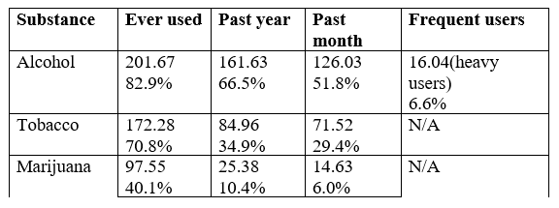

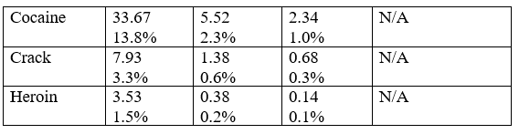

Source: Substance Abuse and Mental Health Services Administration (SAMHSA), 2013.

Price of a Kilogram of Cocaine

|  |  |
| --- | --- |
| Mexico | U.S. |
| $15,000 USD | $35,000 USD |

Source: El Proceso magazine, no. 1999

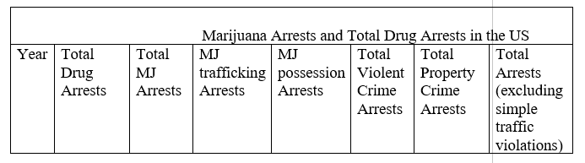

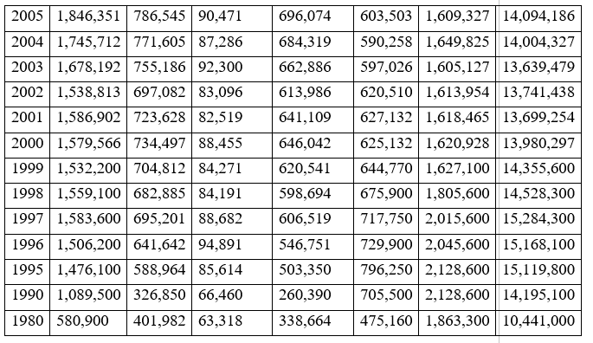

Source: DrugWarFacts.org, 2006

**Portugal Drug data after legalization:**

The data below shows that after legalization of illegal drugs in the year 2001 the consumption of drugs has gone down which is shown below:

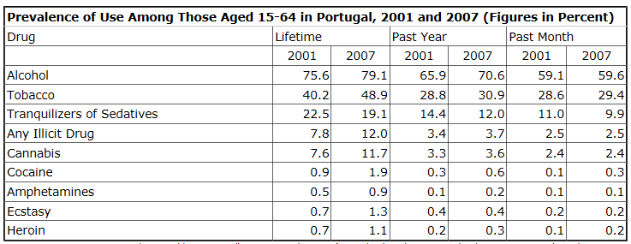

Source: Institute on Drugs and Drug Addiction, I.P., "2012 National Report (2011 data) to the EMCDDA by the Reitox National Focal Point: PORTUGAL: New Development, Trends and in-depth information on selected issues" (Lisbon, Portugal: 2012), Table 1, pp 23-24.

**References**

Associated Press, “U.N. Estimates Drug Business Equal to 8 Percent of World Trade,” June 26, 1997

Blanchard, Benjamin; *System Engineering Management*, 4th edition, Wiley, 2008

Blumstein, Alfred. "Youth violence, guns, and the illicit-drug industry." The Journal of Criminal Law and Criminology (1973-) 86.1 (1995): 10-36

Clayton, Gary; Economics Principles and Practices, 1st edition, Glencoe/McGraw-Hill, 2007

Davenport-Hines, Richard, The Pursuit of Oblivion: A Global History of Narcotics, Norton, ISBN-13: 978-0393325454, 2004

Dead Weight Loss (n.d). Retrieved from, <https://en.wikipedia.org/wiki/Deadweight_loss>

Drug Policy Alliance, [www.drugpolicy.org](http://www.drugpolicy.org)

DrugWarFacts.org, retrieved 2016, <http://www.drugwarfacts.org/cms/Crime#sthash.skSJ61v5.dpbs>

El Proceso magazine, no. 1999, Comunicación e Información S.A. de C.V., Ciudad de México

Heinle, Kimberly, Octavio Rodríguez Ferreira, and David A. Shirk. "Drug violence in Mexico," University of San Diego, 2014

GAO Report-11-73, Moving Illegal Proceeds: Challenges Exist in the Federal Government’s Effort to Stem Cross-Border Currency Smuggling, 2010

Grayson, George; Mexico Narco –Violence and a Failed State, Transaction Publishers, 2009

INCOSE SE Vision 2025, International Council on Systems Engineering, 2014

Institute on Drugs and Drug Addiction, I.P., "2012 National Report (2011 data) to the EMCDDA by the Reitox National Focal Point: PORTUGAL: New Development, Trends and in-depth information on selected issues" (Lisbon, Portugal: 2012), Table 1, pp 23-24.

Introduction to System Dynamics, retrieved 2015, System Dynamics Society website: <http://www.systemdynamics.org/>

Mcgee, Sibel; Joel, Michael; Edson, Robert; *Mexico’s Cartel Problem: A Systems Thinking Perspective*, Applied Systems Thinking Institute, Analytic Services, Inc., 2900 S, Quincy Street, Suite 800, Arlington, VA 22206

Neimeier, H. (1990), A System Dynamics Model of the Standards Development Process, Military Communications Conference, 1990, MILCOM '90, Conference Record, A New Era. 1990 IEEE, 2, 662-666 <http://dx.doi.org/10.1109/MILCOM.1990.117497>

Parker, Robert Nash; Auerhahn, Kathleen; "Alcohol, Drugs, and Violence," Annual Review of Sociology (1998): 291-311.

Payan, Tony; The Three U.S.-Mexico Border Wars: Drugs, Immigration, and Homeland Security, Praeger publishers, 2006

Payan, Tony; Staudt, Kathleen; Kruszewski, Anthony; A War that Can’t be Won, University of Arizona Press, 2013

Payan, Tony; Cops, Soldiers, and Diplomats: Explaining Agency Behavior in the War on Drugs, Lexington Books, 2007

Rodrigues, A.; Bowers, J.; The Role of System Dynamics in Project Management, International Journal of Project Management, 14(4), 1996, 213-220

Rydell, C.P. and Everingham, S.S., Controlling Cocaine, prepared for the Office of National Drug Control Policy and the United States Army (Santa Monica, CA: Drug Policy Research Center, RAND, 1994), p. 6

Substance Abuse and Mental Health Services Administration (SAMHSA), National Survey on Drug Use and Health (NSDUH), 2013

Supply and Demand Basics, retrieved in 2003 from: <http://www.investopedia.com/university/economics/economics3.asp>

System Dynamics, retrieved in 2015 from Systems Thinking World website: <http://www.systemswiki.org/index.php?title=System_Dynamics>

Wisotsky, Steven; Beyond the War on Drugs, Prometheus Books, 1990

Wisotsky, Steven; Breaking the Impasse in the War on Drugs, Greenwood Press, 1986

**Vitas**

**Jagadish Thimiri Mallikarjan** earned his Masters of Science in Systems Engineering degree from the University of Texas at El Paso in the Industrial, Manufacturing and Systems Engineering Department. He earned his Bachelor of Science degree in Electronics and Communication Engineering at the Anna University, India in 2012. He has worked on a number of projects in the fields of electronics and communication engineering.

**Ramya Burugu** is a graduate student in the Computer Science program at the University of Texas at El Paso.

**Neale Smith** is an electrical engineer who worked on U.S. – Mexico border for 60 years. B.S. Physics, California Institute of Technology. M.S. Electrical Engineering, Arizona State University. Advanced Paralegal Certificate.

**Eric Smith** is an associate professor in the Industrial, Manufacturing and Systems Engineering Department at the University of Texas at El Paso. His interests include requirements engineering, system dynamics, decision analysis, and international policy.