Acanthostichus

William P. Mackay
Department of Biological Sciences
The University of Texas
El Paso, TX 79968 USA

The genus Acanthostichus is a member of the subfamily Cerapachyinae, which is a monophyletic group and should be considered distinct from subfamily Ponerinae (Bolton 1990a, 1990b, Baroni Urbani at al. 1992). Acanthostichus can be defined by two synapomorphies in the workers and females: the presence of a metatibial gland (Bolton 1990b), and the malar groove present below the eye (brown, 1975). The functions of these two structures are unknown, and the groove has apparently been secondary lost in the female of A. quadratus. Males also possess the malar groove, although it is difficult to see in some species as the distance between the base of the mandible and the eye may be very short.
There are few differences among species; the mesosoma and gaster are nearly identical in most species. The shape and sculpture of the petiole are important for the identification of workers. The form of the subpetiolar process is also very important. Many characters associated with the head are useless. The shape of the scape and the form of the anterior margin of clypeus are important in some species. Identifications depend on very careful measurements, especially of the petiole and the scape. Without access to a good reference collection, identifications may be impossible.
This is a difficult genus. Fortunately it presently contains only twenty three species, and has been recently revised (Mackay, 1996). New species continue to be collected (Mackay, 2003).
Members of this genus are rarely collected. They are probably common, but due to their below ground activity and secretive habits, they are seldom seen. Many species are known from a single series or even a single specimen. Due to the scarcity of material, it is difficult to judge the variability that may occur within a single species, and some species may be synonyms. On the other hand, some of the species may actually be species complexes. Many species seem to have restricted distributions (possibly due to the paucity of collections?), thus locality is often important for identifications, and distributions are included in the keys.
Mixed species are common in series, especially collections of males, which are often taken at lights. This makes identifications impossible, unless such mixed series are detected. The key to the males may be easier to use than the worker key, but a number of males that appear different may key to the same couplet (suggesting there are undescribed species).
HL Head length, anterior of median lobe of clypeus (disreguarding median clypeal tooth, if present) to occiput.
HW Head width, maximum excluding eyes. (Measured
immediately posterior to eyes in males.)
EL Eye length, maximum dimension.
SL Scape length, excluding basal condyle.
SW Maximum scape width.
WL Weber's length, anterior border of pronotum to posterior border of lobe of metapleural gland.
PW Maximum width of node of petiole.
PL Maximum length of petiolar node (to the posterior edge of petiole).
CI Cephalic Index, HW/HL X 100
OI Ocular index, EL/HL X 100 (note HL used instead of HW).
SI Scape index, SL/HL X 100 (note HL used instead of HW).
FI Femoral index, FL/FW X 100.

Acanthostichus

Typhlopone F. Smith, 1858:111 worker (serratulus)
Acanthostichus Mayr, 1887:549, worker, male, type A. serratulus (monobasic). Wheeler, 1934 (key to species); Kusnezov, 1962 (key to species); Kempf, 1964 (taxonomic notes); Brown, 1975:41-42 (taxonomic discussion).
Ctenopyga Ashmead, 1906:29-30, female, male, (townsendi), (Mackay, 1993) Acanthostichus (Ctenopyga): Emery, 1911:13.

Description.
Worker: Clypeus with broad1y concave medial anterior border, lateral teeth present in many species; frontal carinae usually not covering insertions of antennae; scapes short, antenna with 12 segments; maxillary palps 2 segmented, labial pa1ps 3 segmented; smooth, glossy and shining throughout (unless otherwise mentioned), except for the dorsum of petiole and sides of mesosoma and petiole, which are usually at least light1y sculptured; few erect, simple hairs scattered over most of body surface; mandible without teeth (in most species), except for apical angle or tooth; malar groove present, extending from base of mandible posteriorly to area below eye: eye usually very small (relatively large in A. texanus), but present, consisting of single (or few) ommatidium; metatibial glands present; claws simple; postpetiole (third abdominal segment) separated from remainder of gaster; pygidium with numerous large, upward1y directed teeth (Fig. 2); small to moderate sized ants, often polymorphic. Almost invariably reddish-brown to dark brown.
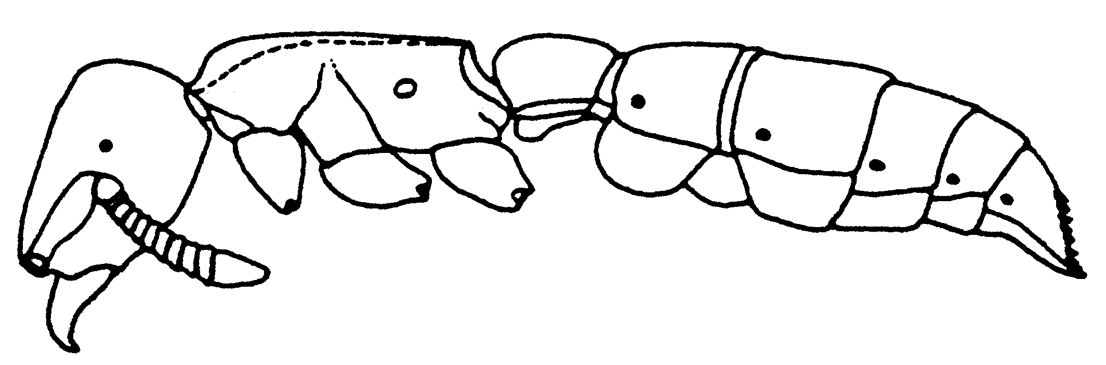Fig. 1. Side view of a worker of A. sanchezorum.
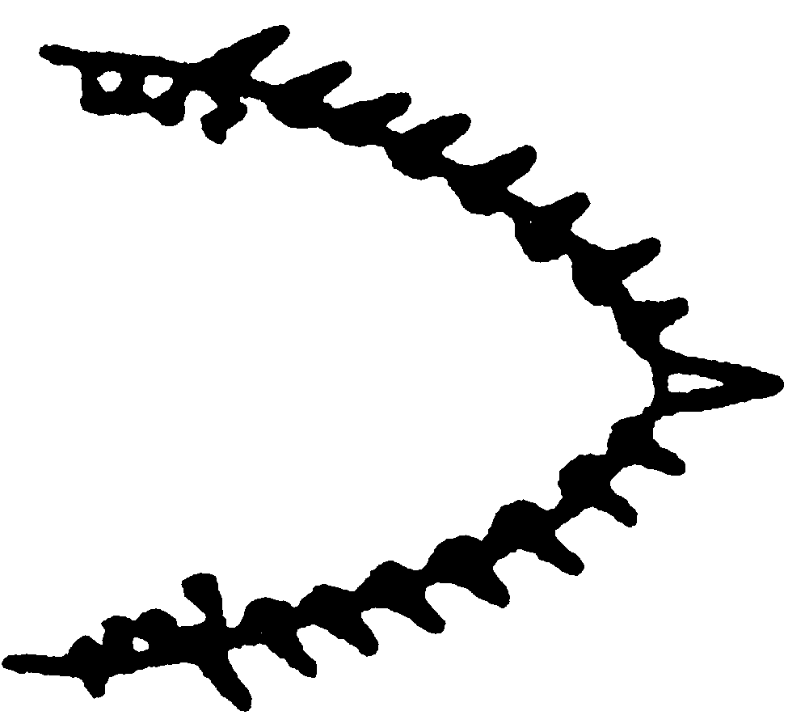
Fig. 2. Pygidium of a worker of A. sanchezorum, as seen from above, showing the thick teeth.
Female: Only known from five species (A. emmae, A. brevicornis, A. laticomis, A. quadratus, and A. texanus). That of A. texanus very similar to worker in size and form; ocelli well developed; winged. The unknown worker of A. emmae is probably similar to the female. The females of the other three species (A. quadratus, A. brevicornis, and A. laticornis) are subdichthadiiform (possess ???ocelli, have large eyes, lacking flight sclerites, see Bolton 1990b), much larger than worker; wingless; petiole much wider than long; covered with long, flexuous hairs. The malar groove (Fig. 53) is present in three of these species (A. emmae, A. texanus and A. laticornis brevicornis???), but absent in the fourth (A. quadratus - Fig. 50). The pygidium toothed in A. emmae and A. texanus (Fig. 53), but not in A. laticomis and A. quadratus brevicornis??? (Fig. 50). Mandibles with or without teeth. A key is not provided as females of few species are known and few would be collected without the presence of workers.
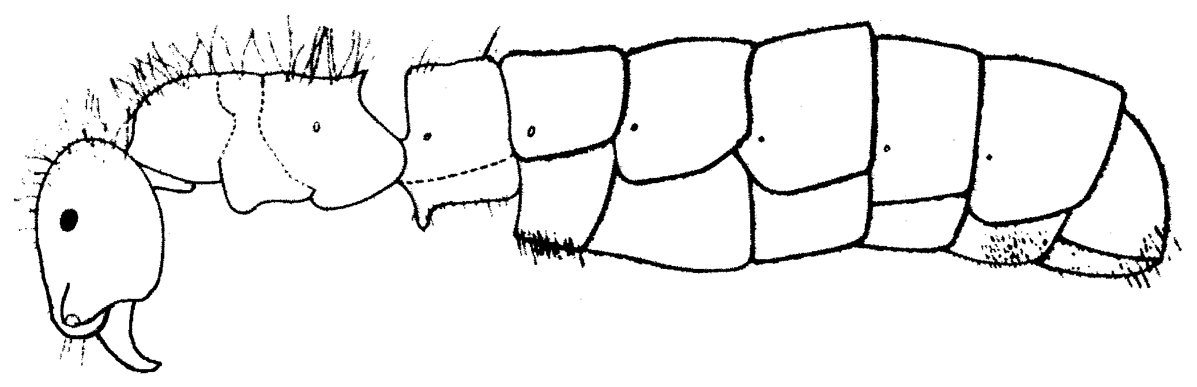Fig. 3. Side view of a female of A. quadratus.
Male: The males of most species are very similar and difficult to distinguish. Therefore, descriptions are limited to characteristics which can be used to separate species. I am providing a key which may be of little use for identifying some species. Size variable within a species, with no constant size differences between species. The males of many, species are unknown. The following characteristics fit most species. HL 0.73 - 1.16, HW 0.80 - 1.18, SL 0.18 - 0.38, SW 0.10 - 0.18, EL 0.39 - 0.58. WL 1.60 - 2.45, PW 0.33 - 0.68, PL 0.43 - 0.48, SI 24 - 35, CI 99 - 115. PI 70 - 131. Mandible light1y punctate, usually without teeth on masticatory border (except apical angle), scapes short, often in shape of “drum stick” (Fig. 65), insertion of scapes completely exposed; frontal carinae closely placed, malar groove (between anterior edge of eye and mandible) well developed, although difficult to see in some species due to short distance between eye and base of mandible: eyes very large, covering most of sides of head; three ocelli large, we1l developed; antenna with 12 segments (Fig. 60) (13 in A. texanus - Fig. 62), those of funiculus difficult to count due to roughened sculpture and numerous small setae; scutum elongate and together with remainder of mesothorax, cause fore and mid coxae to be widely spaced; shape of petiolar node variable between species, seems to bear no relationship to corresponding shape of node of worker of same species; subpetiolar process poor1y developed; with two lateral "felt" lines of fine hair on underside of petiole (poor1y developed in A. texanus); femora not incrassate; pygidial teeth poorly developed or absent: aedeagus well developed, usually elongate, toothed, with well developed apical tooth; volsella also well developed, usually with ventrally directed, apical tooth, which is often twisted laterally; stipites absent; paramere relatively small, usually smaller than volsella: hypopygium forklike with two teeth (Figs. 77 & 78). Partially or primarily shining, concolorous dark brown, with scattered erect hairs on most or all bodily surfaces unless otherwise indicated.
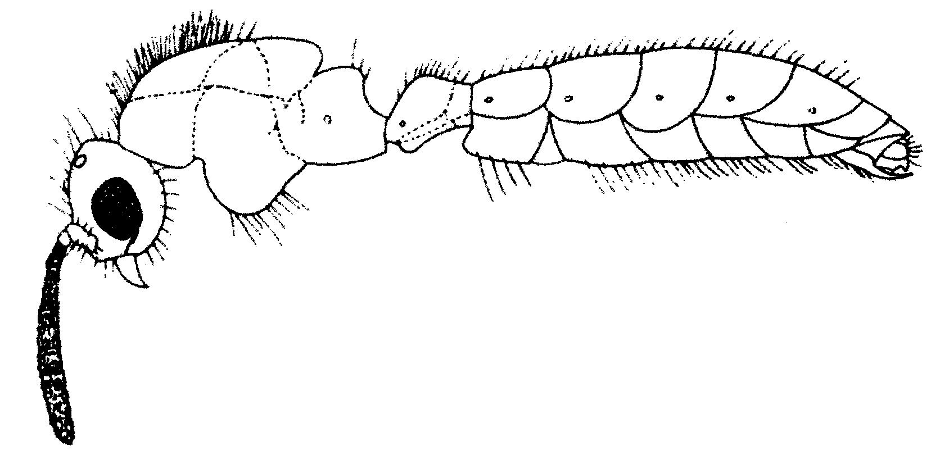Fig. 4. Side view of a male of A. fuscipennis. The wings are not shown
***here proofreading
Key for species identification of workers:

1. Subpetiolar process large, well developed (Fig. 1), apex usually sharply angulate (occasionally truncate – see Fig. 26) (specimens of A. texanus from Texas and Mexico, and a fossil taxon from Dominican Republic often have large, rounded lobes which are not angulate, have relatively large eyes in A. texanus - go to couplet 1l), top of petiole usually sculptured; anterior edge of scape usually concave (Fig. 7); femur never notably swollen (Fig. 49); relatively common species .........................………….…. 2
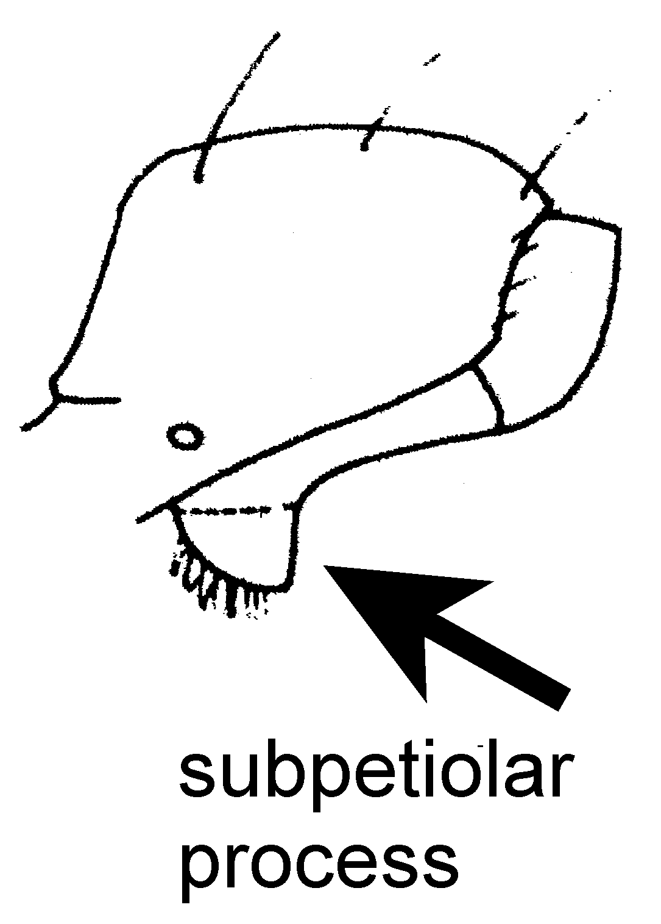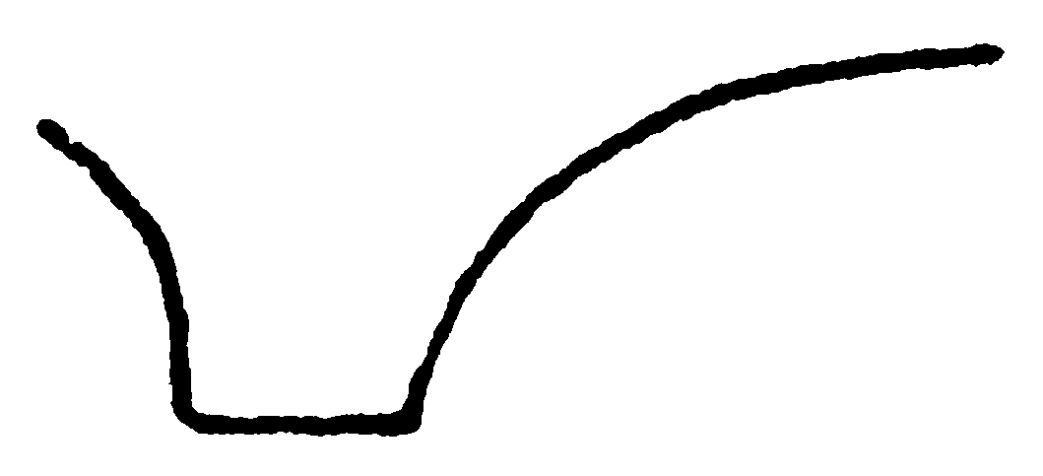
A. texanus A. truncatus
Fig. 5. Side view of the petiole of a worker of A. texanus and subpetiolar process of a worker of A. truncatus (From Mackay, 1996). fig 26
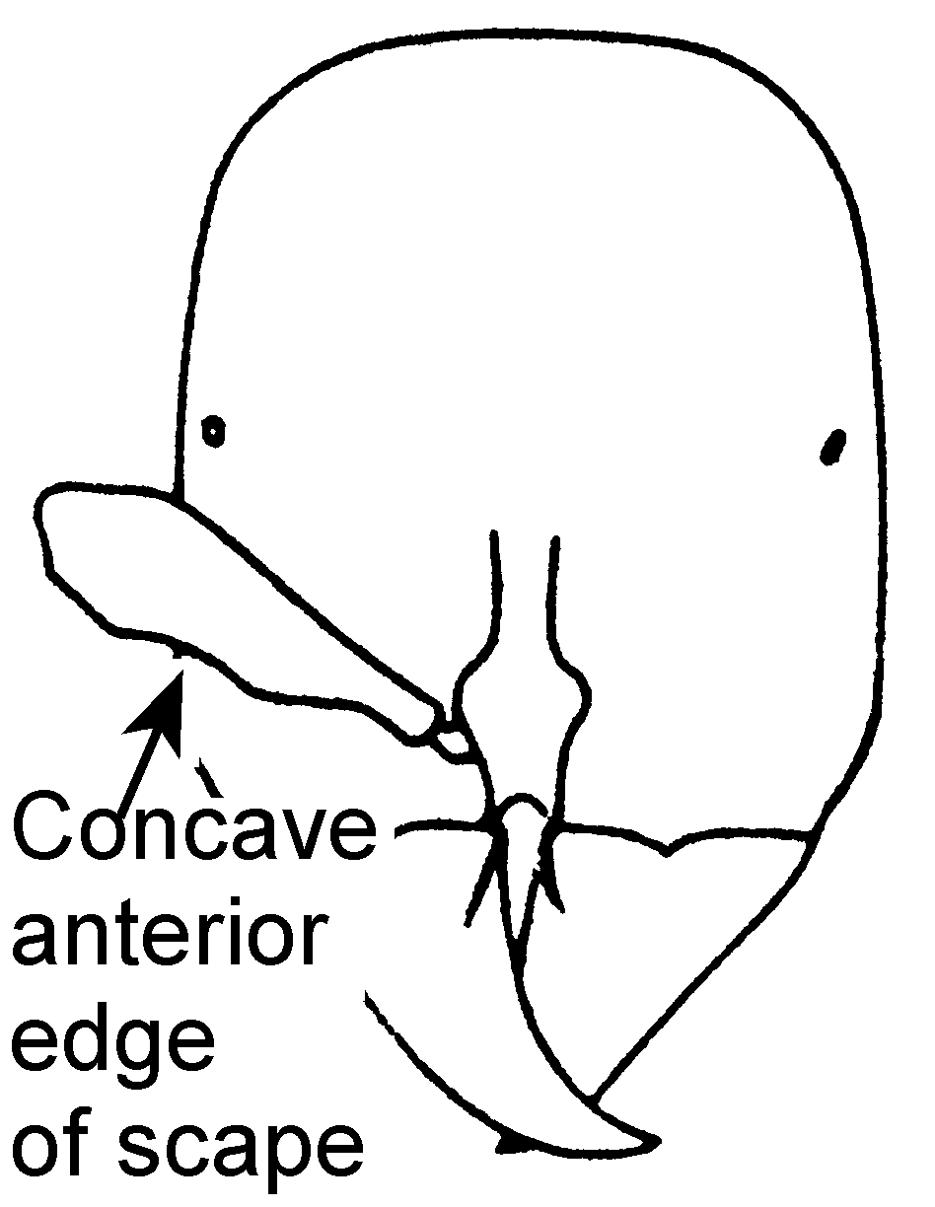
Fig. 6. Head of a worker of A. bentoni (From Mackay, 1996). 7
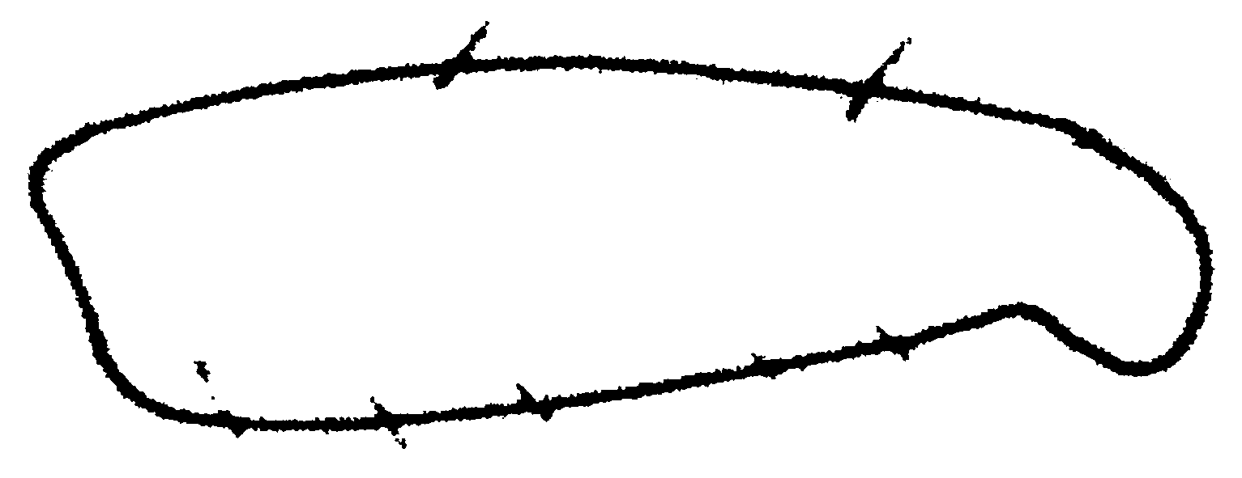
Fig. 7. Posterior left femur of a worker of A. serratulus (From Mackay, 1996).49

- Subpetiolar process consisting of small, rounded lobe (Fig. 1) usually not sharply angulate or truncate, (occasionally angulate posteriorly), dorsum of petiole usually smooth and glossy; anterior edge of scape usually convex (Fig. 6) (slight1y concave in A. quirozi and probably A. skwarrae); hind femur often swollen (Fig. 44); rarely collected species (brevicornis species complex) ……………………… 13
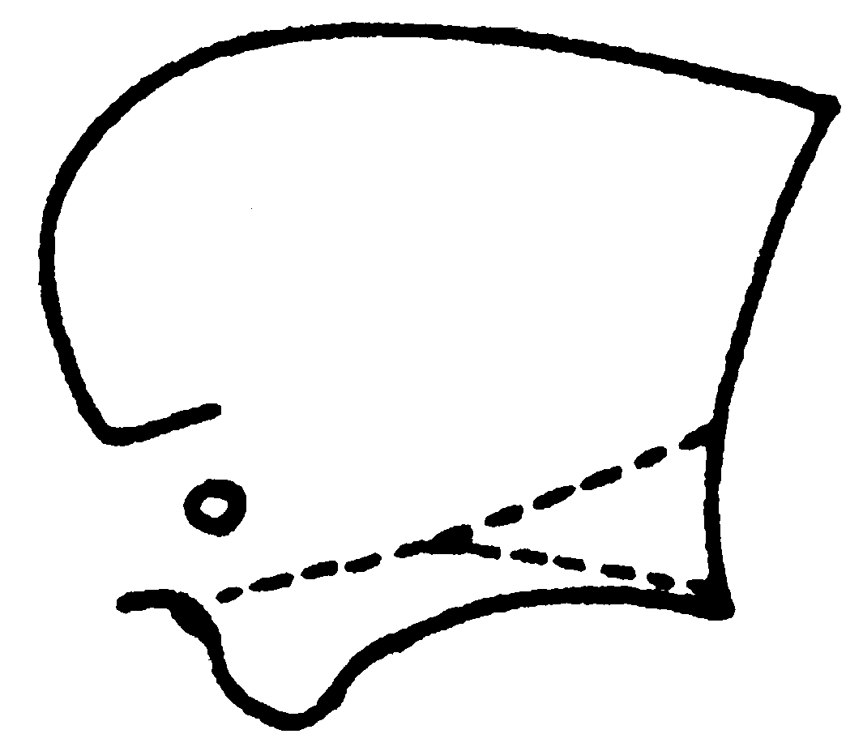
Fig. 8. Side view of the petiole of a worker of A. brevicornis. 1
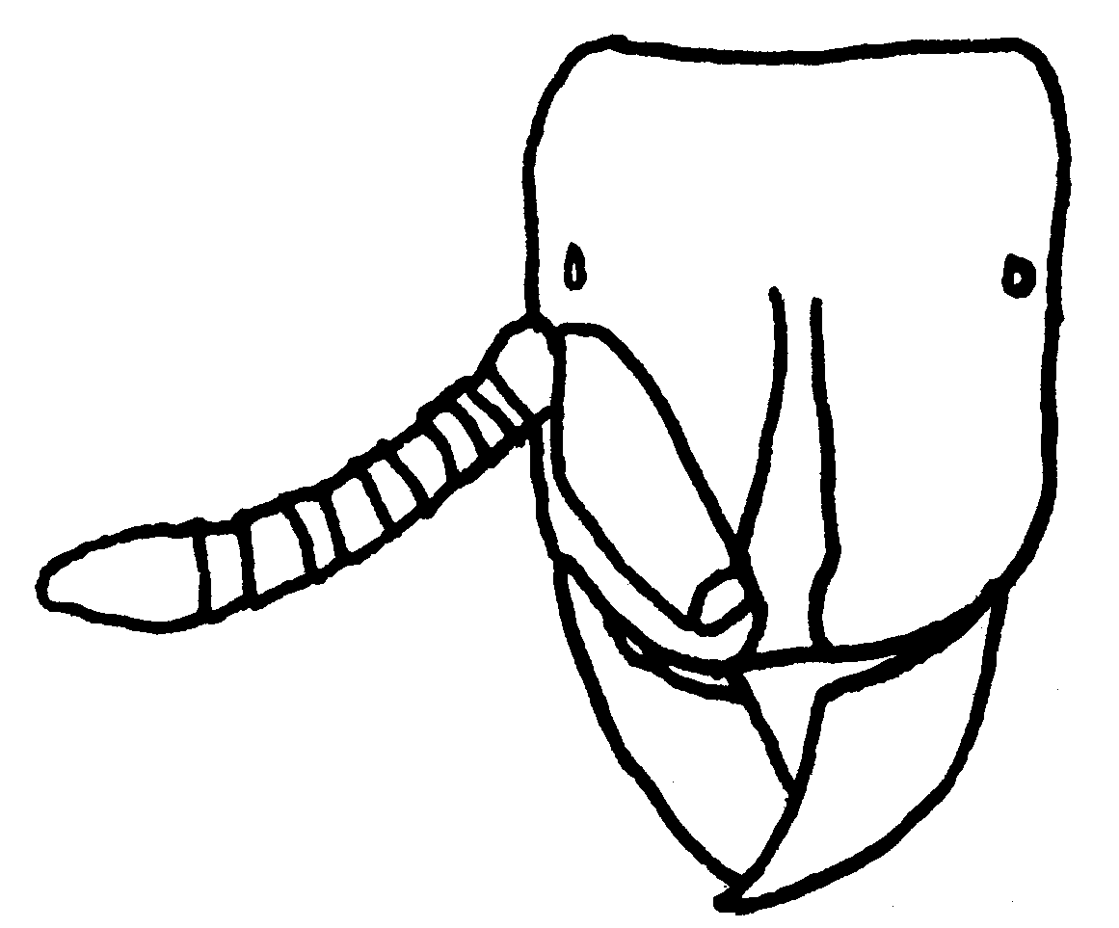
Fig. 9. Head of a worker of A. sanchezorum.
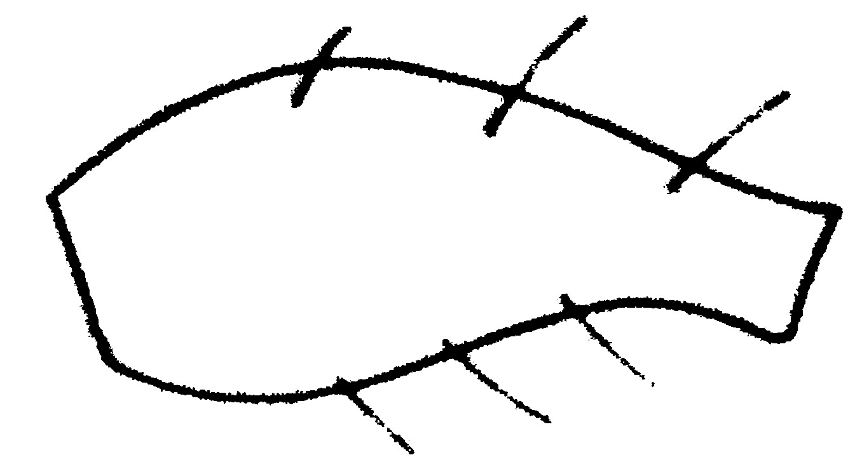
Fig. 10. Posterior left femur of a worker of A. kirbyi .

2(1). Anterior edge of scape concave, with angle near apex (Fig. 7); relatively common; South America (serratulus species complex) ................………………...….…………... 3
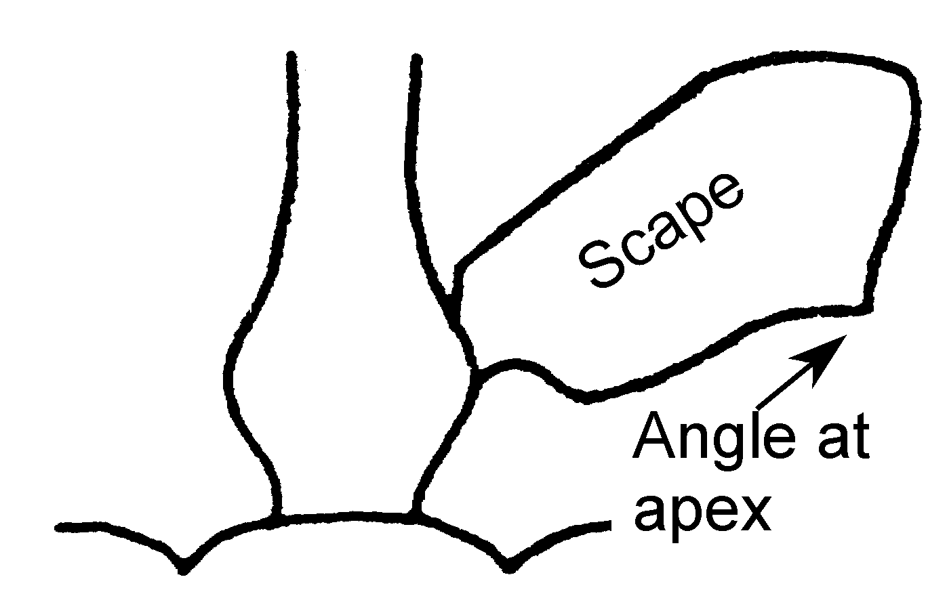
Fig. 11. Scape of a worker of A. laticornis.

- Anterior edge of scape convex (or straight), without well defined angle at apex (Fig 16); North America (including Mexico) or fossil from Dominican Republic; rarely collected …………………………………………..…... 11
3(2). SL/SW < 2.40 (mean = 2. 19); angle on anterior edge of scape very large (Fig. 4) … ………………………………. laticornis Forel
- SL/SW > 2.25 (usually > 2.5); angle on scape: moderately well developed (Figs. 7) …. 4
4(3). Dorsum of petiole completely glossy and strongly shining, occasionally with small, elongate depressions; scape relatively long (mean SL/SW = 2.94, range = 2.80 - 3.08); Venezuela …………………………… laevigatus Mackay
- Dorsum of petiole roughened and sculptured, if somewhat shining, then long, longitudinal troughs or depressions are located near lateral edges, sides parallel (Fig. 37) or posterior half wider than anterior half (Fig. 24); scapes usually shorter, widely distributed in South America ...…………………………...… 5
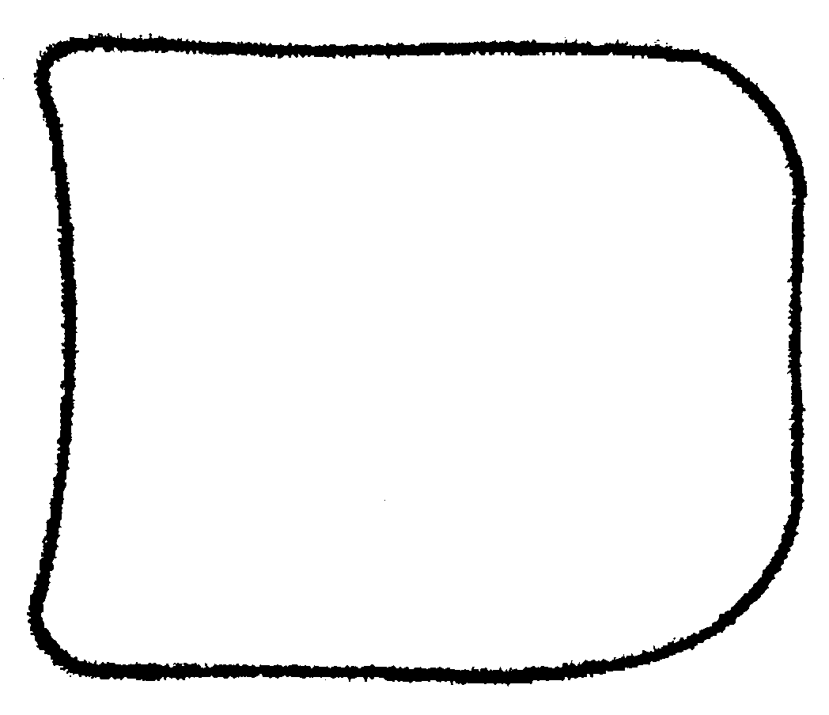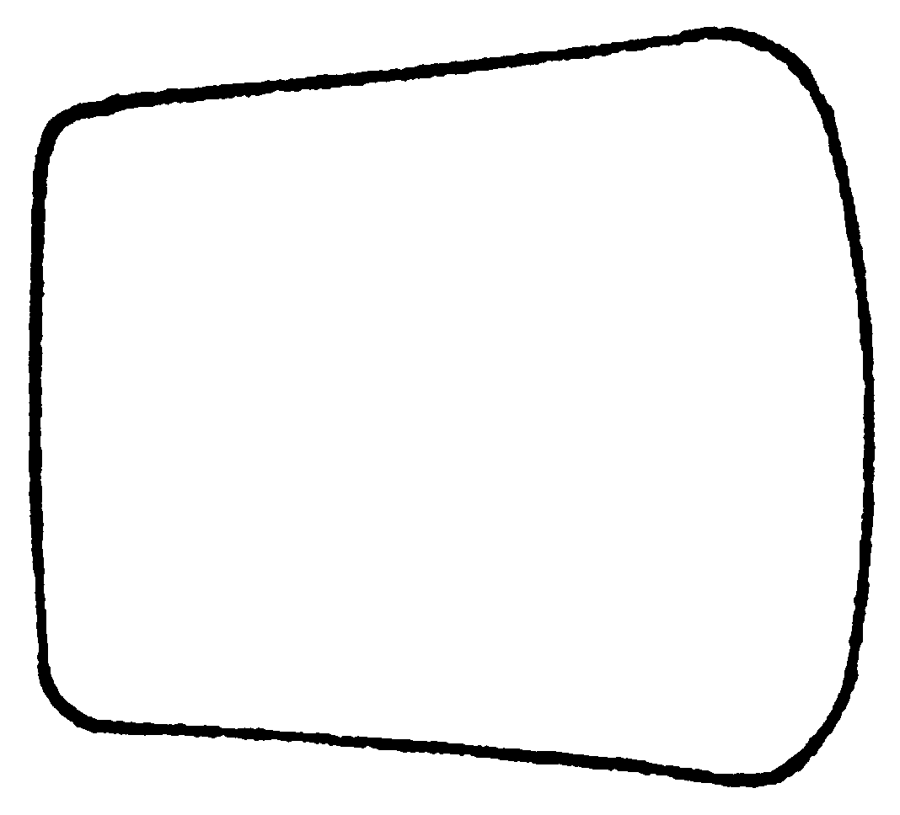
A. serratulus A. kirbyi
Fig. 12. Petioles of a workers of A. serratulus and A. kirbyi, as seen from above.

5(4). Petiole elongate, PI > 110 (PL/PW * 100). if less, lateral clypeal teeth poorly developed; posterior half of petiole usually wider than anterior half (Fig. 24) …………………. 6
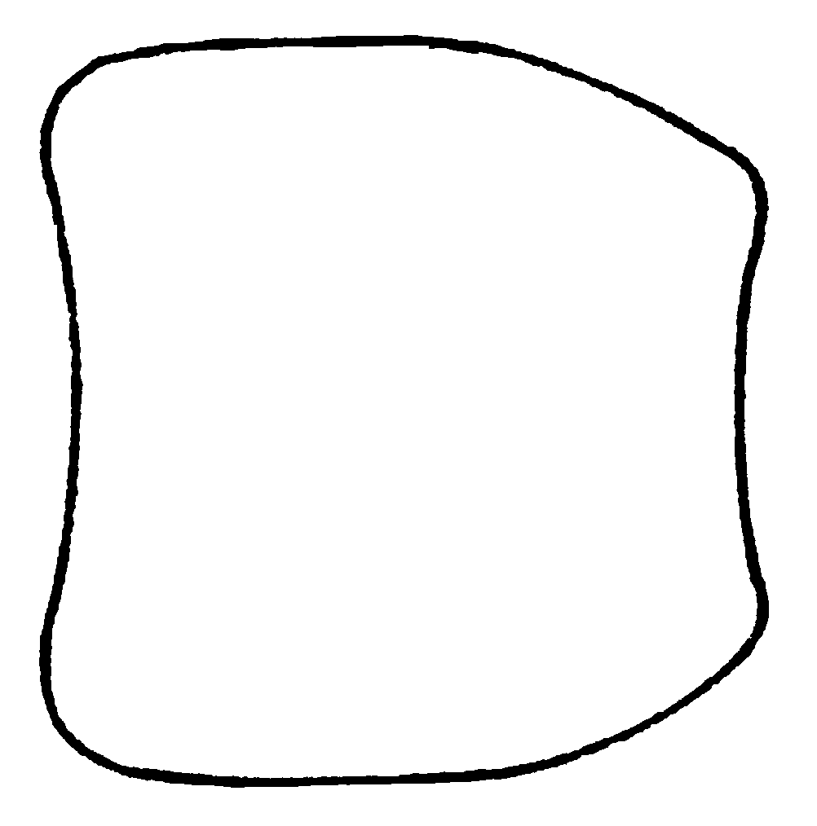
Fig. 13. Petiole of a worker of A. quadratus. 32

- Petiole quadrate or subquadrate (Fig. 32), PI < 110; sides of petiole usually parallel (or only slightly narrowed anteriorly) …...…….…. 9
6(5). Subpetiolar process strongly truncate (Fig. 26); Colombia …….… truncatus Mackay
- Subpetiolar process not truncate, usually with posteriorly directed toothlike process (Fig. 25); widely distributed, including Colombia ………………………………………….. 7
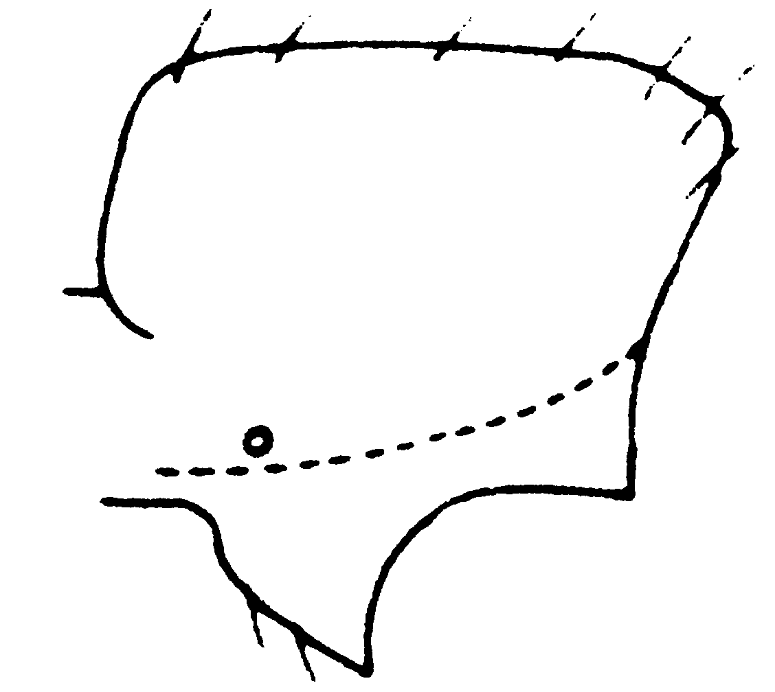
Fig. 14. Petiole of a worker of A. kirbyi as seen from the side.

7(6). Carinae on sides of petiole well developed, or at least sides of petiole meet at right angle; lateral clypeal teeth usually poorly developed (Fig. 13); dorsum of petiole lightly punctate and usually with well developed, longitudinal troughs; rarely collected .……… 8
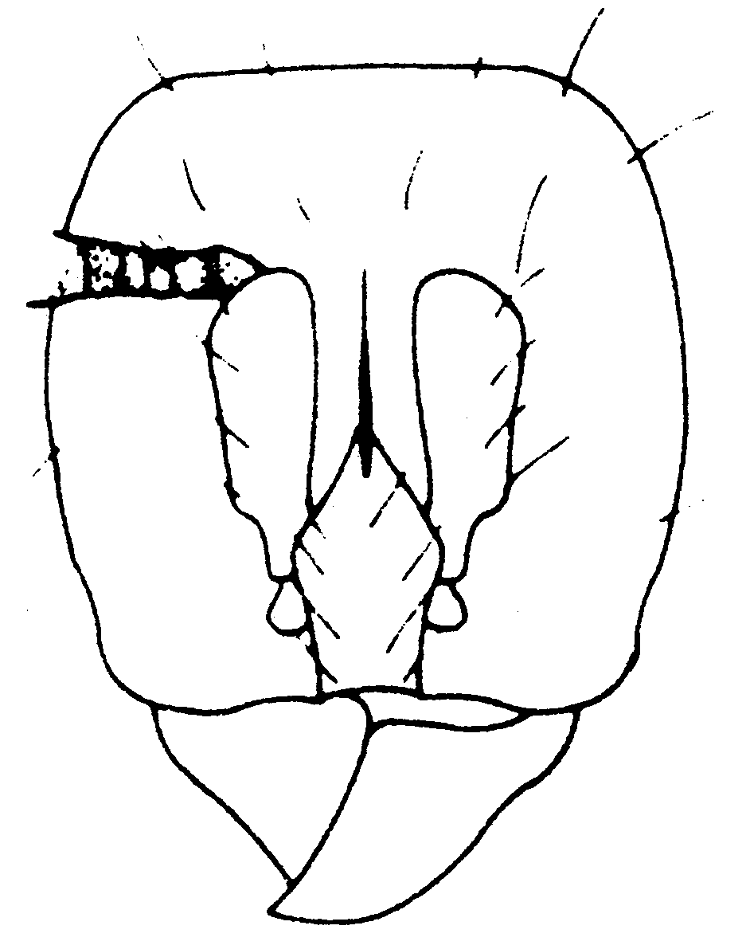
Fig. 15. Head of a worker of A. quadratus.

- Lateral edges of petiole rounded, with little or no evidence of carinae; lateral clypeal teeth well developed (Fig. 10), especially in larger workers; dorsum of petiole moderately punctate, longitudinal troughs poor1y developed or absent; widely distributed, common species ……….… ……………………………….… kirbyi Emery
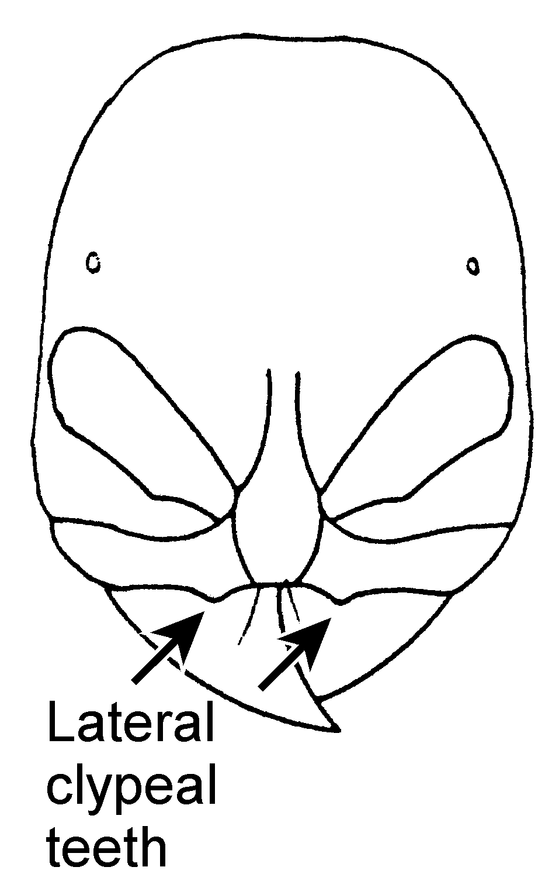
Fig. 16. Head of a worker of A. kirbyi.

8(7). Anterior face of petiole strongly concave (Fig. 21) most1y smooth and shining ………… ……………………….. concavinodis MacKay
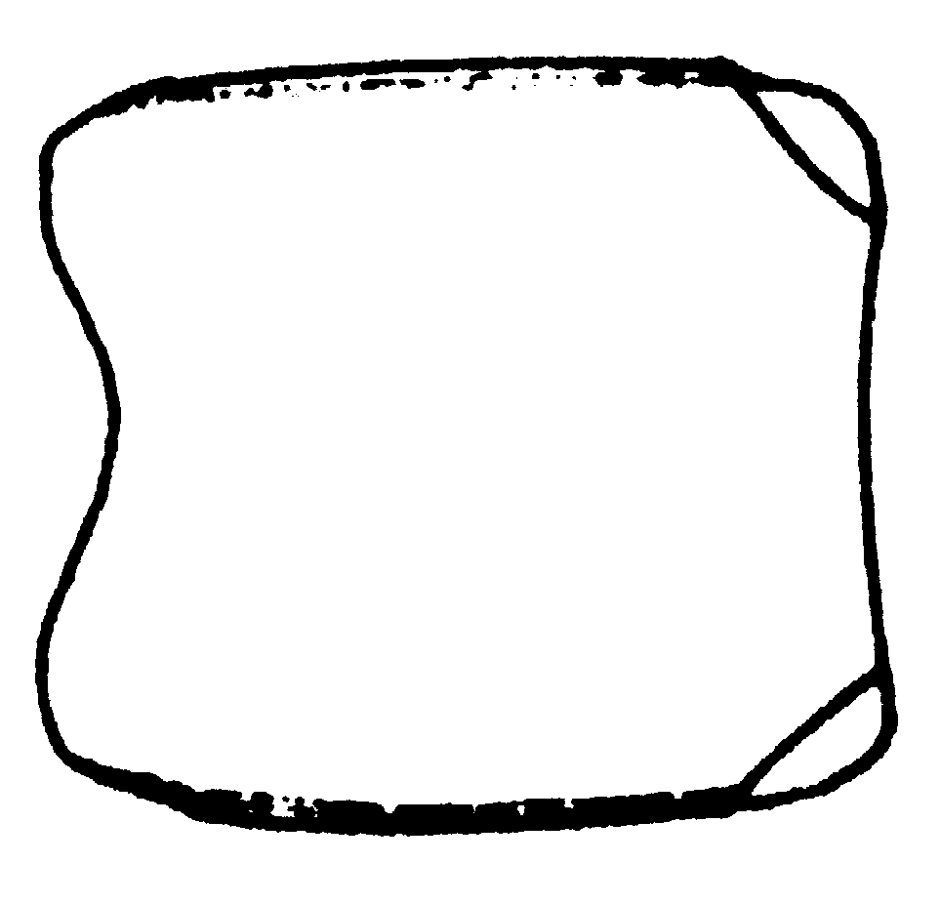
A. concavinodis A. serratulus
Fig. 17. Petioles of workers of A concavinodis and A. serratulus as seen from above.

- Anterior face of petiole not strongly concave (Fig. 37) although may be somewhat concave, dorsum of petiole roughened ...……… ………………………..….. serratulus (Smith)
9(5). Carinae on sides of petiole usually developed, dorsum of petiole light1y punctate with well developed lateral longitudinal troughs; medial lobe of clypeus excised (Fig. 13), often with blunt tooth; scape usually short (SL/SW range 2.45 - 3.07); relatively common (Ecuador to Argentina) (and the rarely collected A. flexuosus Mackay from southern Brasil) ………….…… …………………………..… quadratus Emery
- Lateral petiole broadly rounded, if well developed carinae present, medial lobe of clypeus excised and usually without tooth (Fig. 13); dorsum of petiole longitudinally striate, without longitudinal troughs; scape normally longer (SL/SW range = 2.53 - 3.29); rarely collected 10
10(9). Anterior medial border of clypeus with blunt tooth (Fig. 11); Venezuela ……

……………………….. lattkei Mackay
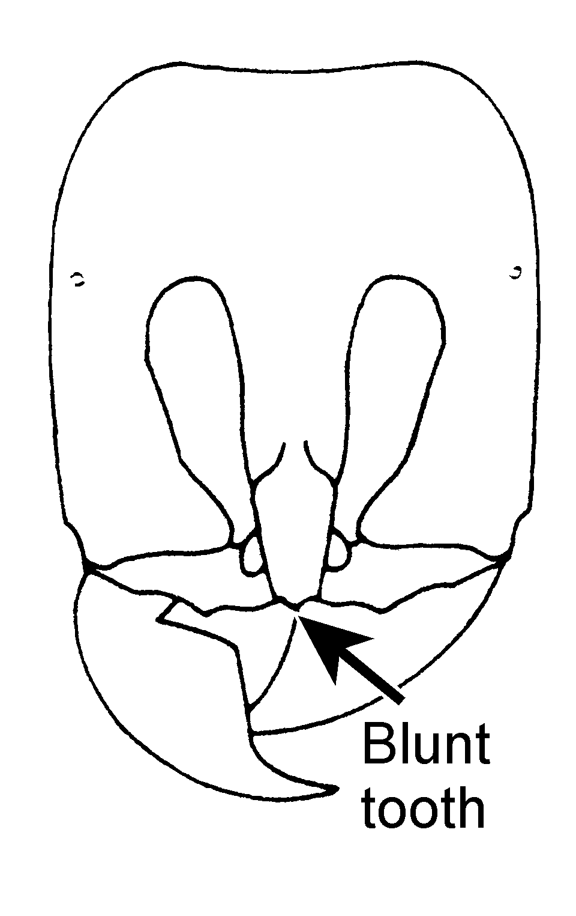
Fig. 18. Head of worker of A. lattkei.

- Anterior medial border of clypeus strongly concave, without tooth (Fig. 7); Brasil ……………………………….. bentoni Mackay
11(2). Maximum eye diameter often nearly as long as length of second and third funicular segments combined (Fig. 16) (usually more than 1/2 length); subpetiolar lobe of petiole with posterior angle or is large, broadly rounded lobe (Fig. 42): dorsum of petiole smooth and glossy; extreme southern Texas and eastern Mexico (texanus species complex) ............ texanus Forel
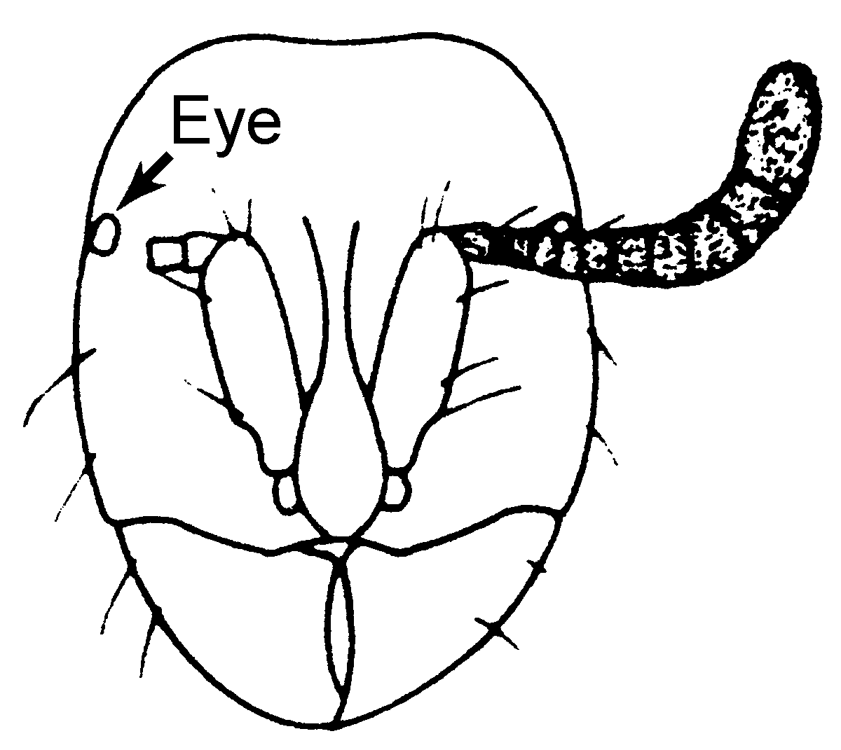
Fig. 19. Head of a worker of A. texanus.

- Maximum eye diameter equal to or smaller than length of second funicular segment (Fig. 6) …………..…………………..... 12
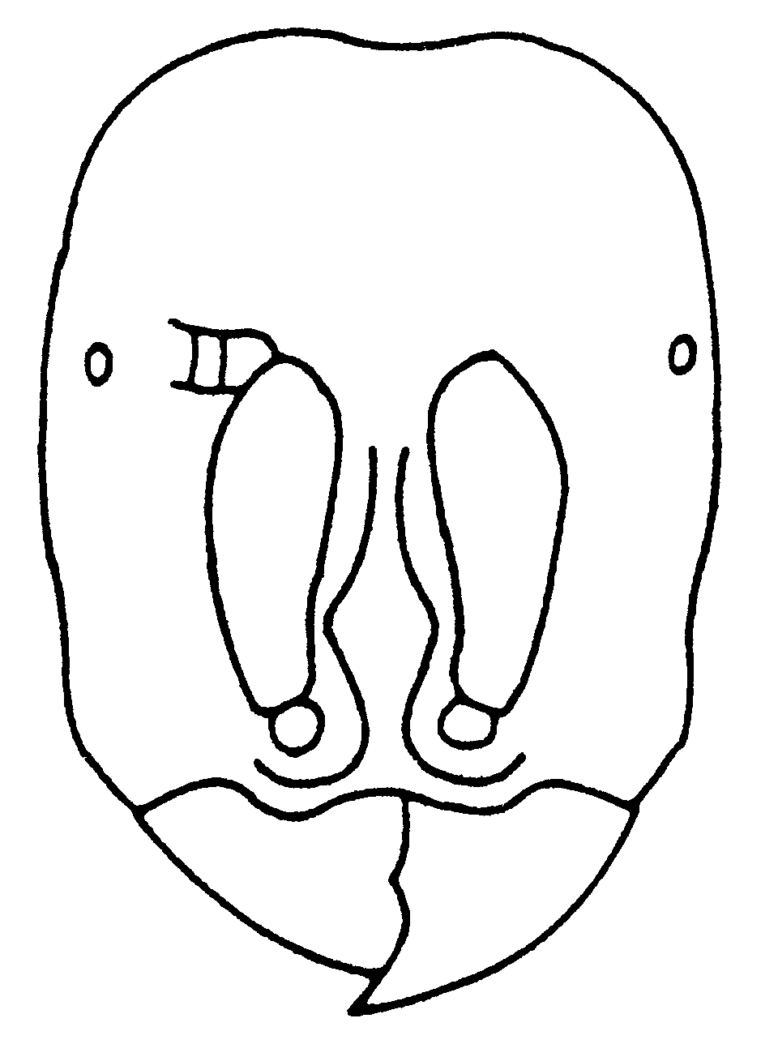
Fig. 20. Head of a worker of A. arizonensis.

12(1l). Subpetiolar process with ventrally directed, sharp tooth (Fig. 31); dorsum. of petiole and scape heavily punctate; .New Mexico (brevicornis species complex, in part) ………. ……………………….. punctiscapus MacKay
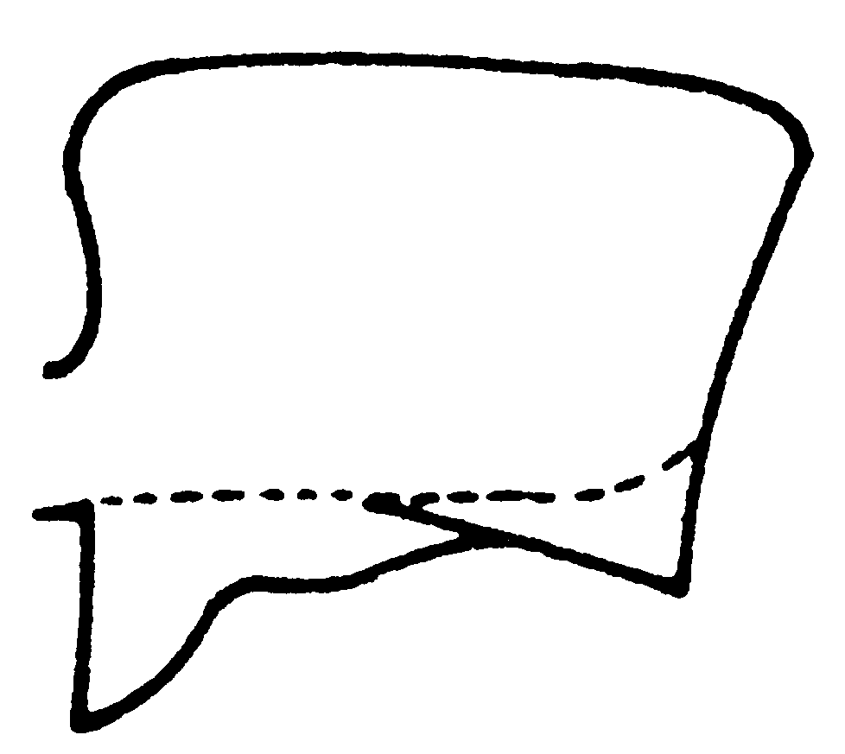
Fig. 21. Petiole of a worker of A. punctiscapus as seen from the side.

- Subpetiolar process without ventrally directed tooth; fossil taxon from Dominican Republic …….…………………………….. species A
13(1). Dorsum of petiole densely punctate; subpetiolar process poor1y developed (Fig. 18); Arizona ………………… arizonesnsis Mackay
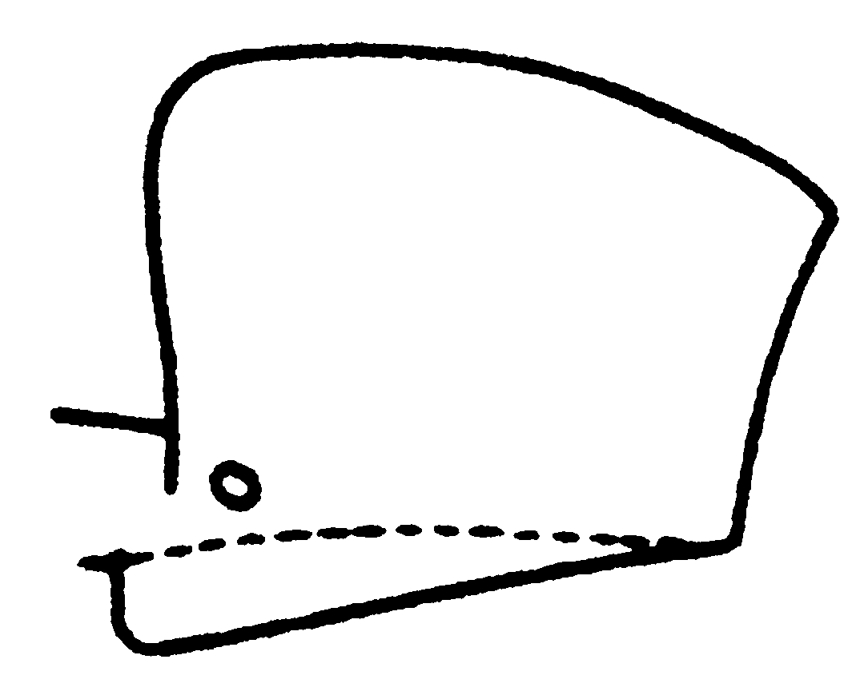
Fig. 22. Petiole of a worker of A. arizonensis as seen from the side.

- Dorsum of petiole smooth and shining; subpetiolar process consisting of broad1y rounded lobe which may be angulate anterior1y (Fig. 40) …………………………… ..…….. 14
14(13). Petiole somewhat wider posteriorly than anterior1y (Fig. 39), much longer than broad (PI ≥ 129); Mexico (Vera Cruz) and Paraguay ..…………...… 15
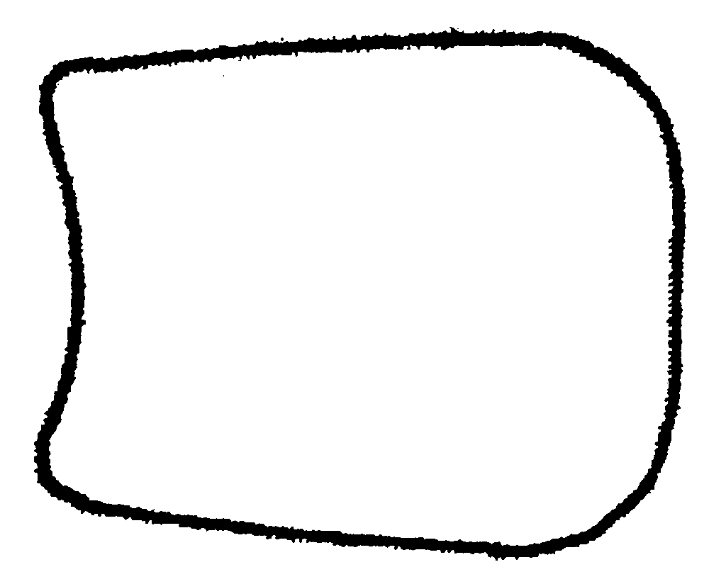
Fig. 23. Petiole of aworker of A. skwarrae as seen from above.

- Sides of petiole parallel or slight1y wider posteriorly (Fig. 36); petiole usually only slighly longer than broad (103 > PI > 135); South America ..……………………………………. 17
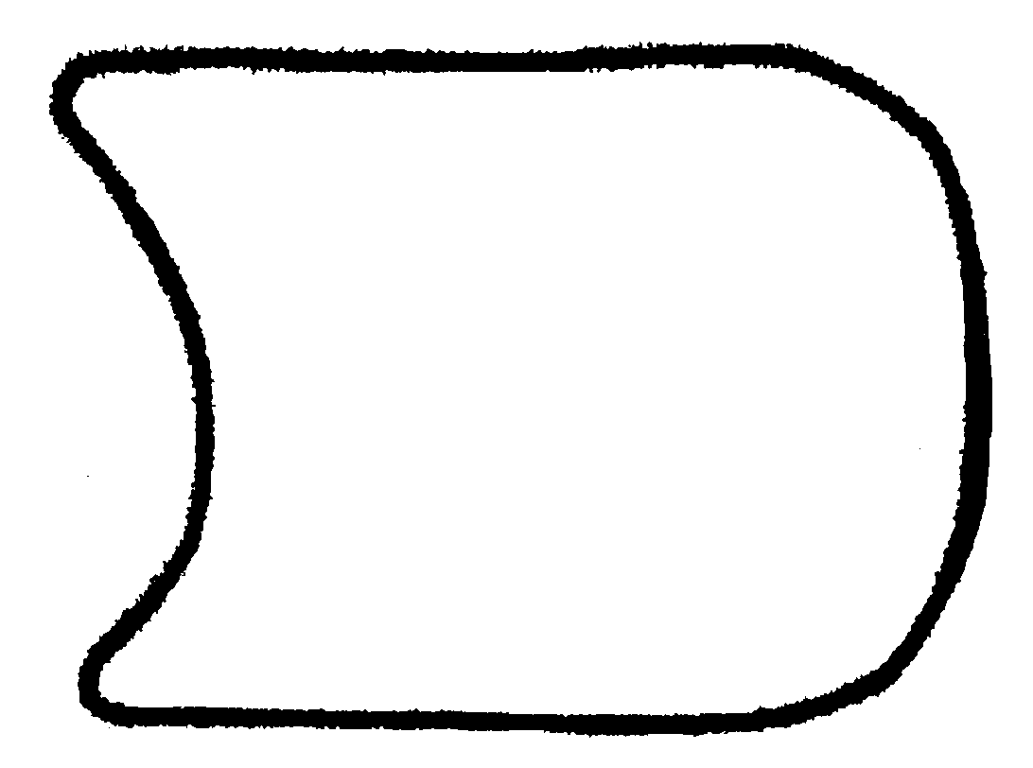
Fig. 24. Petiole of a worker of A. sanchezorum as seen from above.

15(14). Paraguay; sides of petiole separated from dorsal surface by abrupt bend, which nearly forms carina …. longinodis Mackay
- México; sides of petiole evenly rounded into dorsal face ….. 16
16(15). Pronotum with fewer than 5 erect hairs; petiole with less than 6 erect hairs; gaster essentially without erect hairs .…………… ………………….……….… skwarrae Wheeler
- Pronotum with 6 or more long, pointed, erect hairs (0.1 - 0.2-mm) …… quirozi Mackay
17(14). Propodeal spiracle located on upper half (Fig. 1); petiole usually only slightly longer than broad (103 < PI < 112) ..……………….. 18
Propodeal spiracle located at midline or below; petiole usually somewhat longer than broad (108 < PI < 135) .……………… brevicornis Emery
18(17). Outer surface of scape completely convex; dorsum of petiole very glossy and strongly shining; Argentina and Brazil ………… ……………………… femoralis Kusnezov
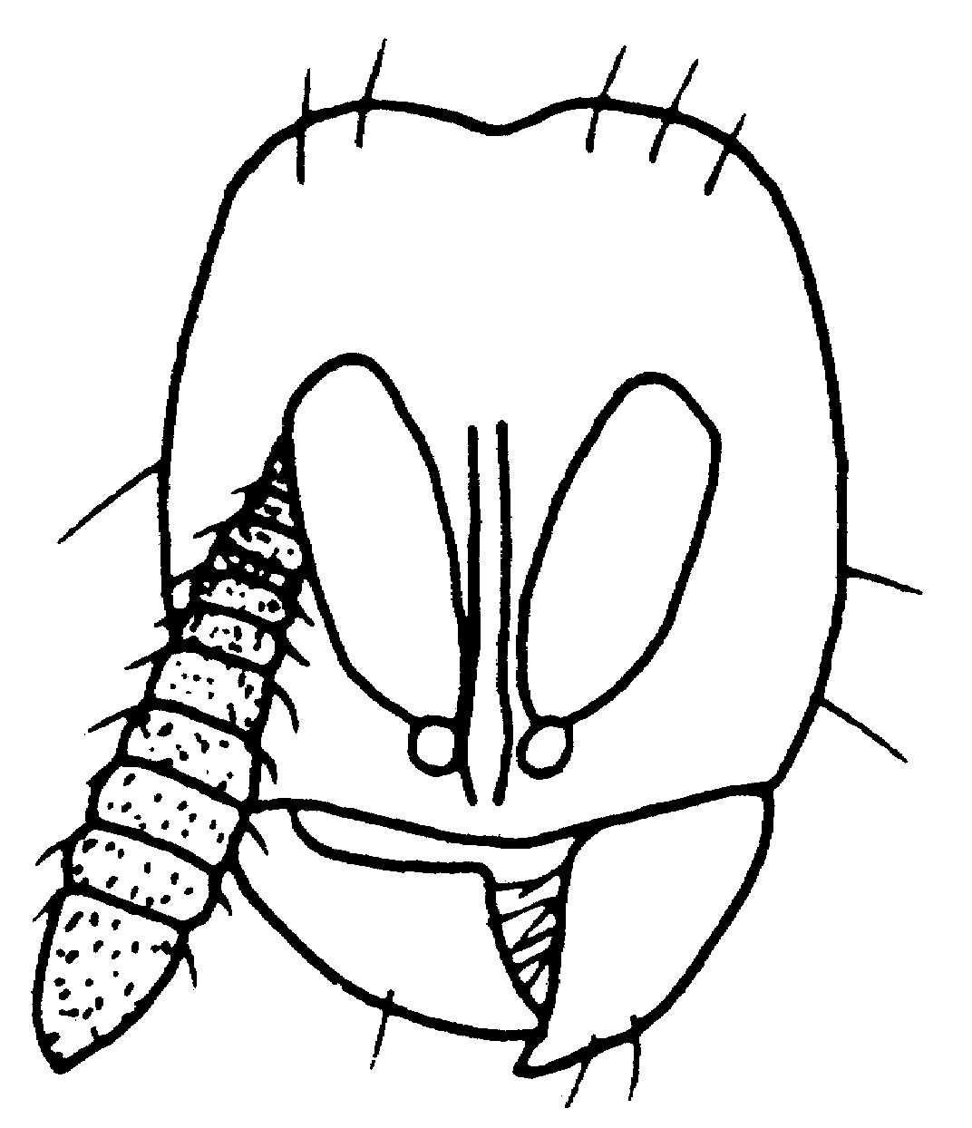
Fig. 25. Head of aworker of A. femoralis.

- Outer surface of scape angulate near apex (Fig. 14); dorsum of petiole smooth. but not strongly shining; Colombia ………… …….………………. sanchezorum Mackay
Key for species identification of males*:

1. Teeth of subgenital plate thickened (Fig. 77); northeastern Mexico and extreme southeastern Texas (and probably unknown male of A. emmae Mackay) ………… texanus Forel
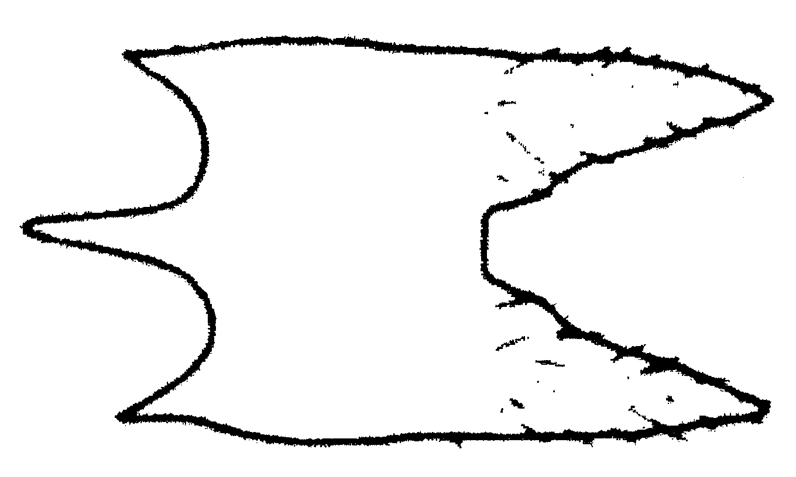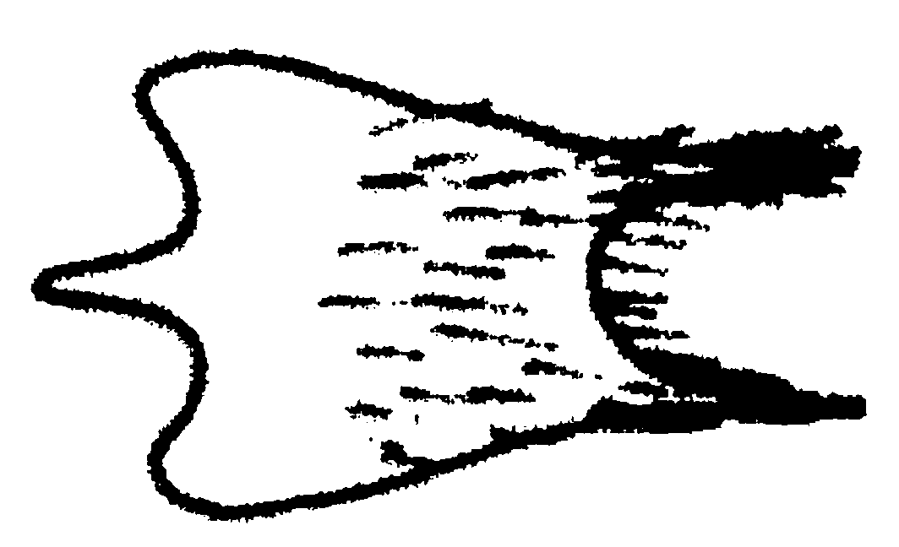
A. texanus A. brevicornis
Fig. 26. subgenital plates of males of A. texanus and A. brevicornis.

- Teeth of subgenital plate elongate and spiniform (Fig. 78); primarily South America ………………………………………..……... 2
2(1). Petiole (from above) subquadrate. or at least usually broader than long (Fig. 70), often wider anteriorly than posteriorly .... 3
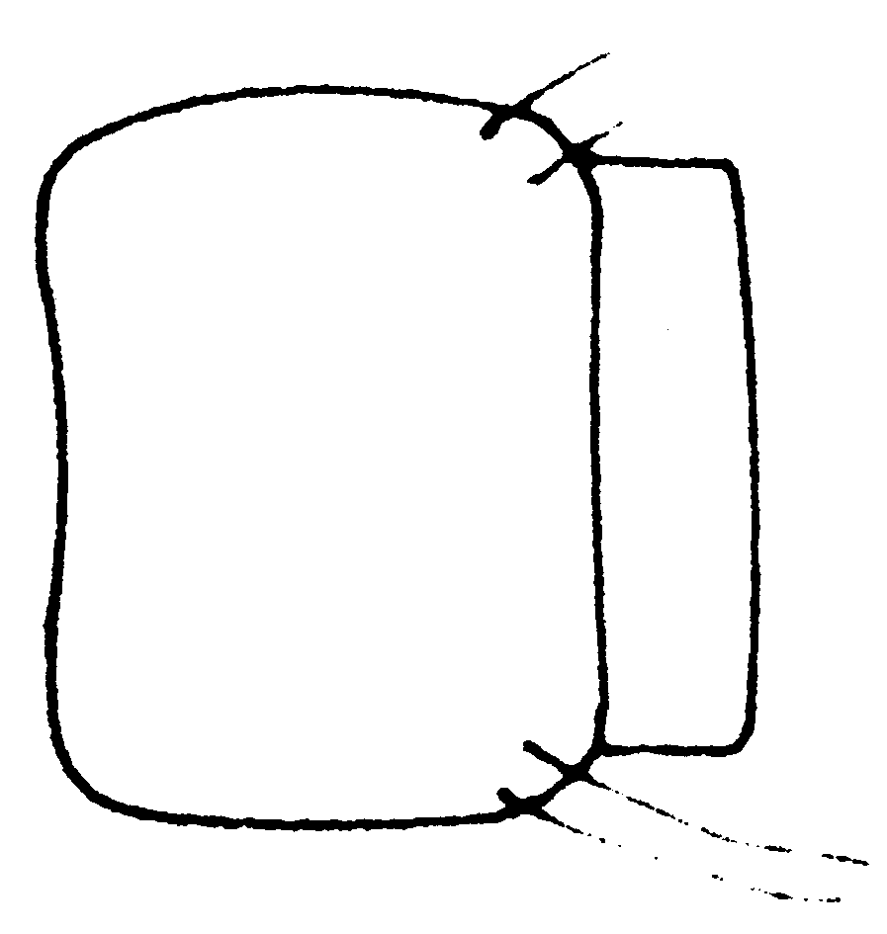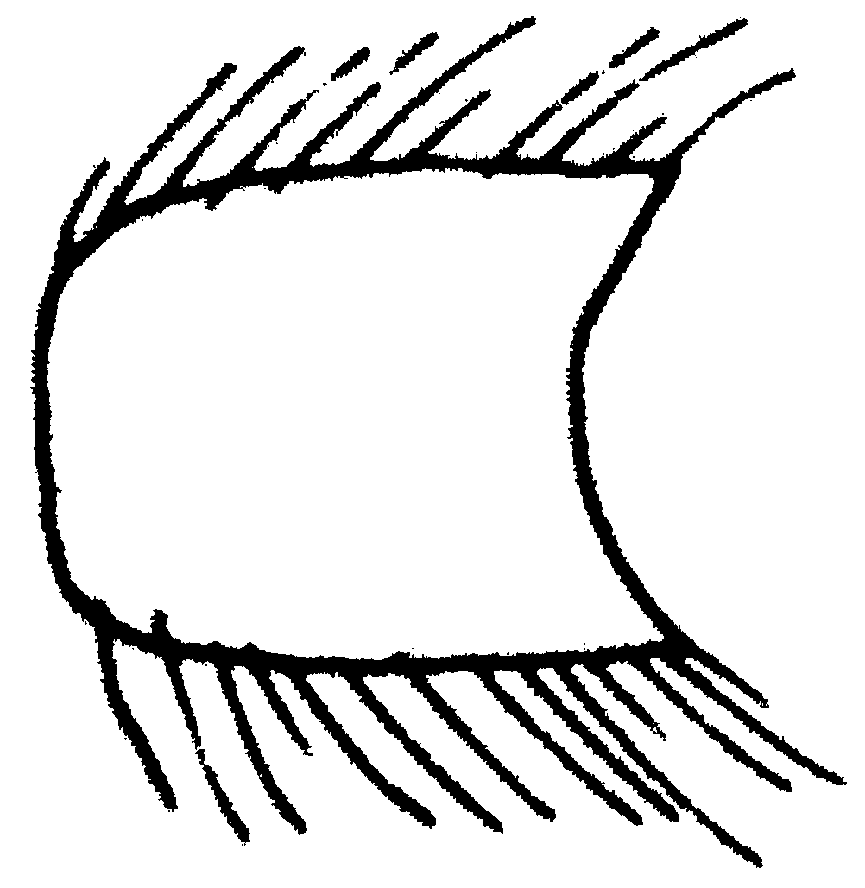
A. fuscipennis A. laticornis
Fig. 27. Petioles of males of A. fuscipennis and A. laticornis as seen from above.

- Petiole much longer than broad (Fig. 71) ........……………………………………… 5
3(2). Petiole with paired, oblique, strongly constricted regions extending from nearly top of node posteriorly along side of node (Fig . 69) …………………. femoralis Kusnezov
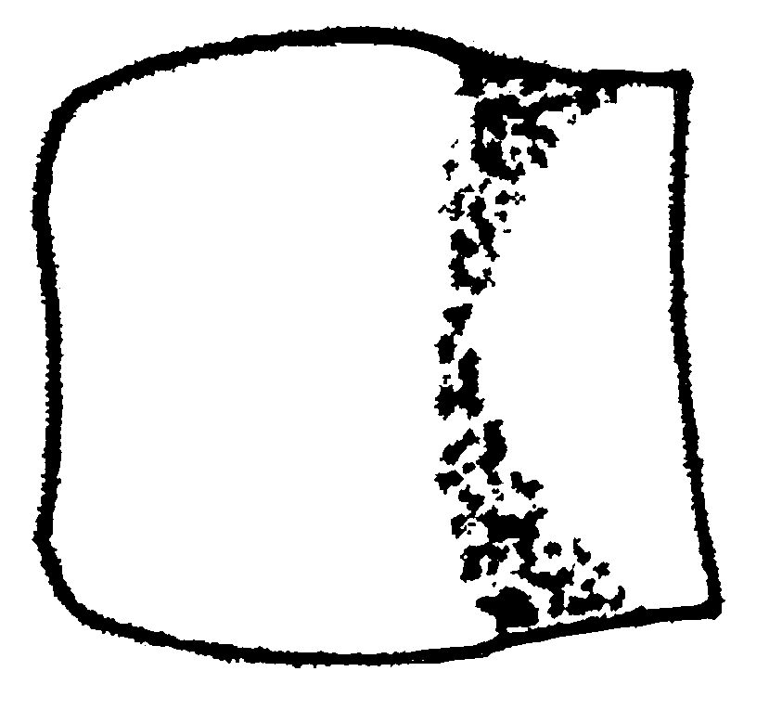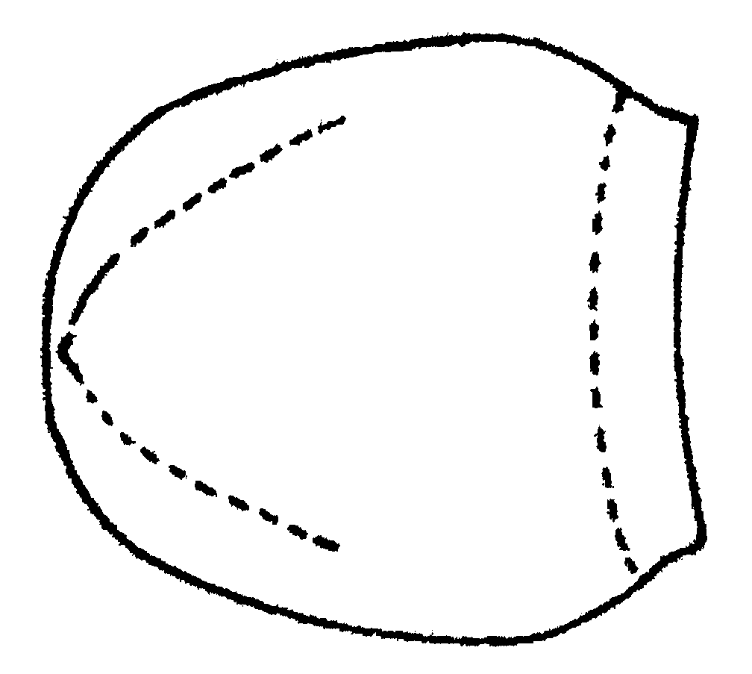
A. femoralis A. quadratus
Fig. 28. Petiole of a males of A. femoralis and A. quadratus as seen from above.

- Sides of petiole without strongly constricted regions ………………………. 4
4(3). Body (especially propodeum and petiole) usually with shiny blue or purplish reflections; node of petiole rounded anteriorly (Figs. 59, 70); widely distributed, commonly collected ….. fuscipennis Emery
- Body without bluish reflections, node of petiole truncate anteriorly (Figs. 67, 68); rarely collected (Brasil) ……….… brevinodis Mackay
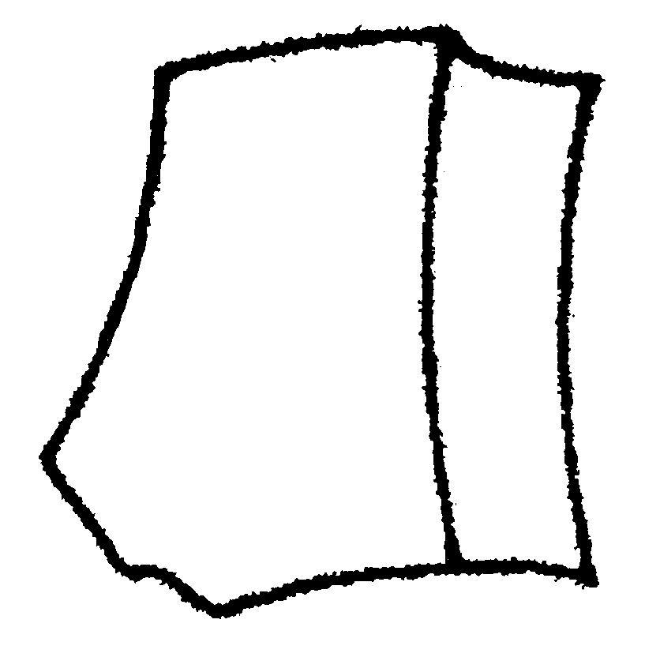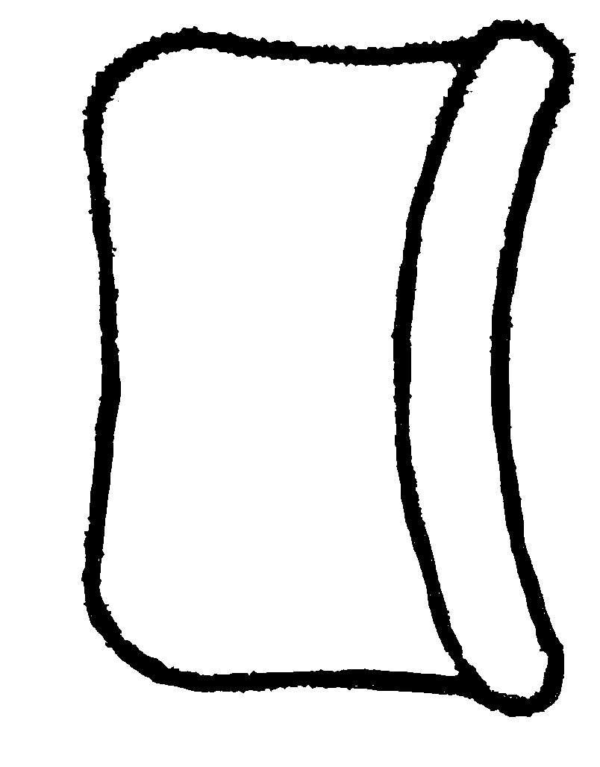Fig. 29. Petiole of a male of A.brevinodis as seen from the side and from above.

5(2). Head and alitrunk with numerous, long, flexuous hairs, at least some on alitrunk about 2/3 times as long as maximum diameter of eye (Fig. 6 l); southern Brasil, rarely collected …………… ……………………………... flexuous Mackay
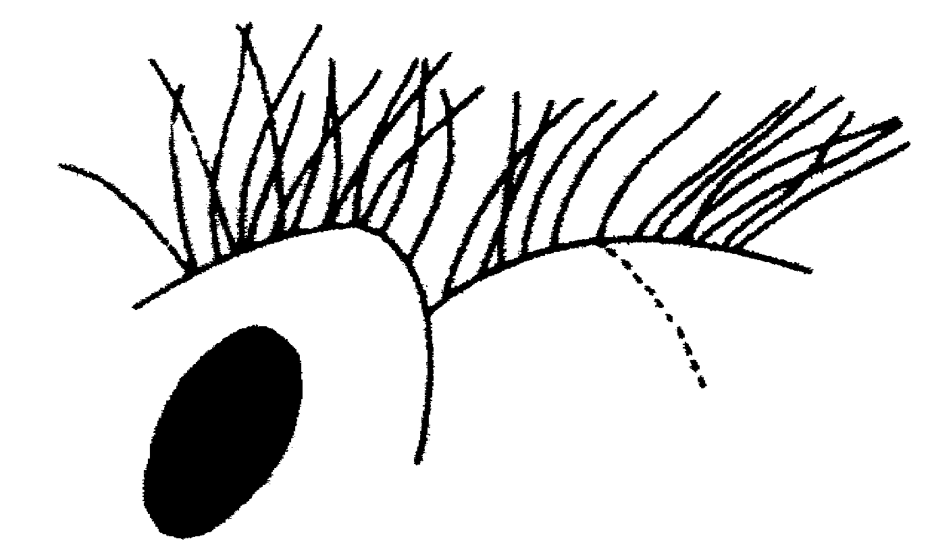
Fig. 30. Head and mesosoma of a male of A. flexuous as seen from the side.

- Head and alitrunk with shorter, scattered, mostly straight hairs, most less than 1/2 length of maximum diameter of eye (Fig. 59); commonly collected ………….. 6
6(5). Small (WL < 1.90 mm): volume of first segment of funiculus about 1/2 volume of scape (Fig. 63); without bluish reflections …………… ……….………………… brevicornis Emery
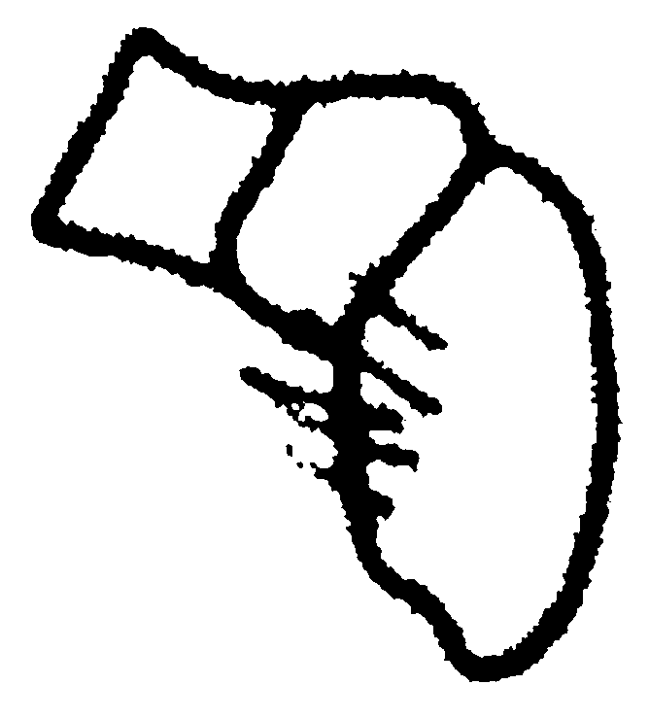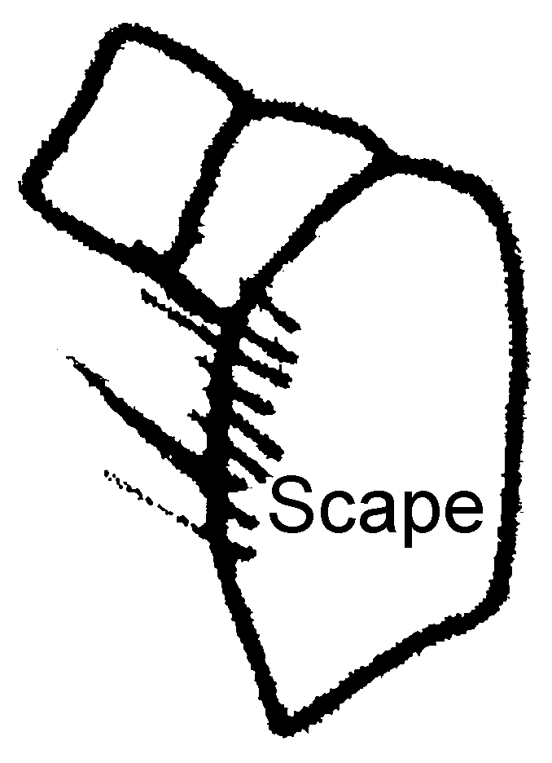 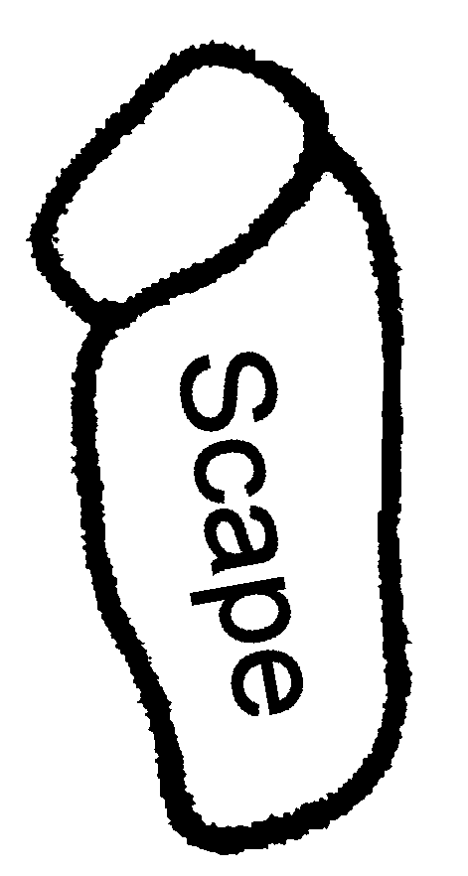 A. brevicornis A. laticornis A. serratulus
Fig. 31. Scape and first 2 segments of the funiculus of males of A.brevicornis and A.laticornis.

- Usually larger (WL > 1.90 mm); if smaller, volume of first segment of funiculus about 1/4 or less volume of scape (Fig. 64), body usually with bluish reflections, at least on pronotum and head .………………… 7
7(6). Apices of volsellae not strongly curved outward (Fig. 82); dorsum of petiole with long, lateral, depressed areas; usually light yellowish-brown .…………………………….. 8
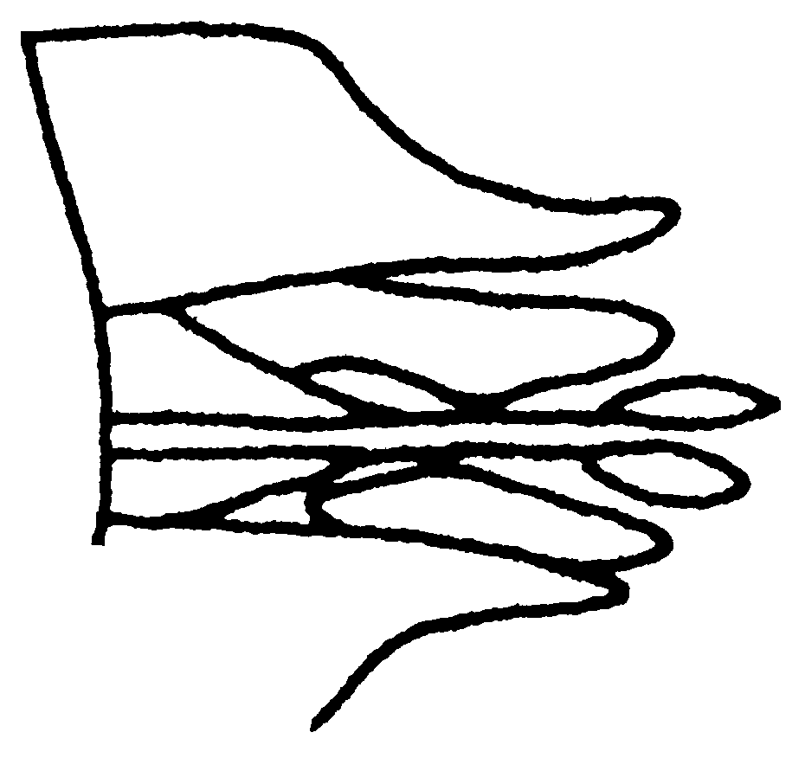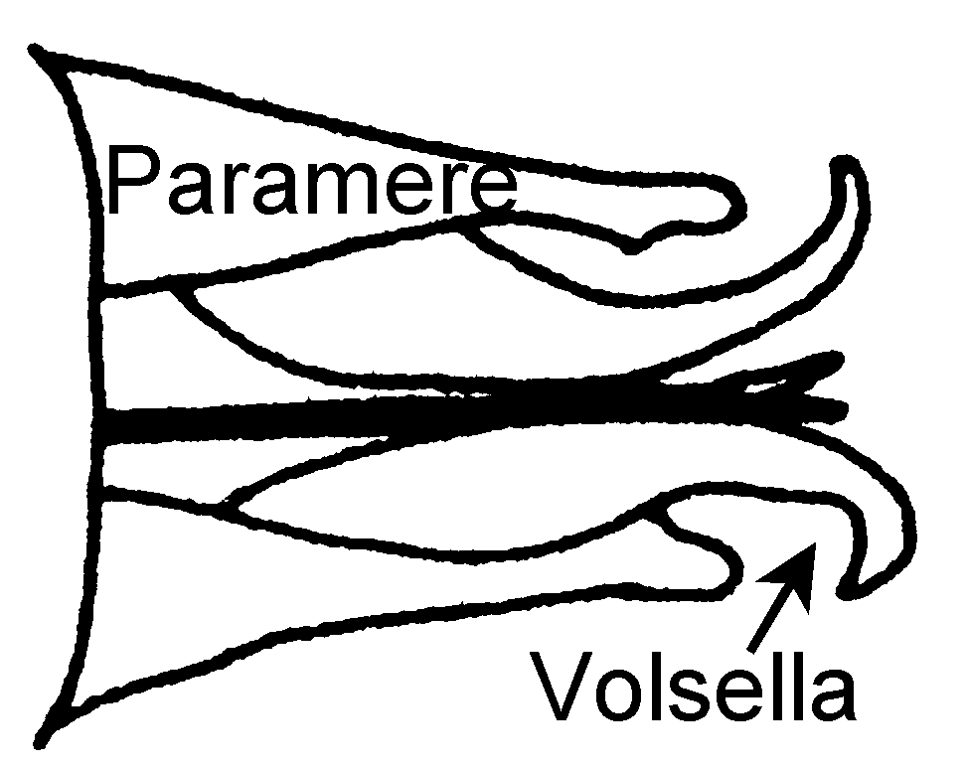
A. kirbyi A. quadratus
Fig. 32. Genitalia of males of A. kirbyi and A. quadratus as seen from below

- Apices of volsellae strongly curved away from midline of body (Fig.83); dorsum of petiole without depressed areas (except possibly at anterior of node – Fig. 72); concolorous dark brown .…………………………..………….. 9
8(7). Anterior edge of petiolar node truncate, edge straight and perpendicular to long axis of petiole (as seen from above) …… kirbyi Emery
- Anterior edge of petiolar node pointed, petiole in shape of bullet (as seen from above) …………..…………………. serratulus Emery
9(7). Scape not noticeably thickened (Fig. 65, SW/SL > 0.6), somewhat “drumstick” shaped; dorsal face of propedeum smooth and glossy, descending face finely leather-like ….… …………………………….. quadratus Emery
- Scape very broad (Fig. 64, SW/SL > 0.6), not “drumstick” shaped; dorsal face of propedeum usually leather like, descending face with transverse costulae …….… laticornis Forel
CHARACTERISTICS OF THE SPECIES COMPLEXES

brevicornis species complex
Head elongate; frontal carinae closely placed, exposing basal condyle and base of scape; anterior face of scape convex, rarely slightly concave and with angle near apex present or absent; masticatory border of mandible without teeth, (except at apex) or with a single tooth (A. punctiscapus and A. arizonesis); lateral and medical clypeal teeth not developed; petiole often somewhat elongate, wider posteriorly than anteriorly, usually with strongly concave anterior face, subpetiolar process consisting of a broadly rounded lobe, rudimentary in A. arizonensis and consisting of a ventrally directed, sharp tooth in A. punctiscapus. The femur is often incrassate, at least in the larger workers. Not strongly polymorphic as in members of the serratulus species complex. The females of this species complex are unknown. The males can be distinguished from those of the other species complexes as the petiole is subquadrate at least in tow species) and the teeth of the subgenital process are long and thin.
Members include A. arizonensis, A. brevicornis, A. brevinodis, A. femoralis, A. fuscipennis, A. punctiscapus, A. quirozi, A. sanchezorum, A. skwarrae and possibly a fossil species currently being described by Ms. Mara de Andrade.

serratulus species complex
Frontal carinae wide, covering at least part of the basal condyle and often part of the base of scape; anterior face of scape concave with well defined angle near apex masticatory border of mandible without teeth, or occasionally with several small denticles; petiole usually subquadrate (or slightly longer than broad) with weakly concave anterior face; subpetiolar process consisting of a large lobe which is sharply angulate (with a posteriorly directed tooth) or truncate ventrally; femur is never incrassate (except occasionally in smaller workers); workers are strongly polymorphic, smallest workers often bearing little resemblance to larger workers, and appearing in some ways similar to those of the brevicornis species complex. The females of two of the species are subdichthadiiform, the others are unknown. The males of this species complex can be distinguished as the petiole is elongated, much longer than broad.
Members include A. bentoni, A. concavinodis, A. flexuous, A. kirbyi, A. laevigatus, A. laticornis, A. quadratus, A. serratulus and A. truncatus.

texanus species complex
Large species with relatively well developed eyes; no median tooth on mandibles; hind femora not incrassated; petiole elongated, wider posteriorly; ventral process of petiole angulate posteriorly. Acanthostichus texanus and A. emmae are the only known members of the complex and are the only species known to have winged females. The male of A. texanusis similar to that of other species in most respects, although the genitalia are quite different (see discussion of A. texanus). Species A, a fossil taxon, is presently being described by Ms. Maria L. de Andrade and may possibly be related to A. texanus. It has rudimentary eyes and a median tooth on the mandibles.

Acanthostichus arizonensis Mackay
Diagnosis: This is an easily distinguished species, as the densely punctate petiolar node will distinguish it from all other species, except A. punctiscapus. It can be separated from this latter species in that the scape is predominantly smooth and glossy (not heavily punctate as in A. punctiscapus). The mandible has a blunt tooth on medial masticatory border (Fig. ), which may be essentially worn away; the lateral clypeal angles are well formed. The outer edge of scape is convex; the eye consists of four or five poorly defined ommatidia; the vertex is concave. The petiole is slightly longer than broad, wider posteriorly (Fig. ), and the subpetiolar process poorly defined.
Fig. 33. Head of a worker of A. arizonensis.
Sparse erect hairs (most less than 0.1 mm, some as long as 0.25 mm) are scattered on all body surfaces. The mandibles, scape, head and mesosoma are smooth and glossy, with scattered punctures. The dorsum of the petiole and most terga of gaster are covered with dense punctures. The female and male are unknown.
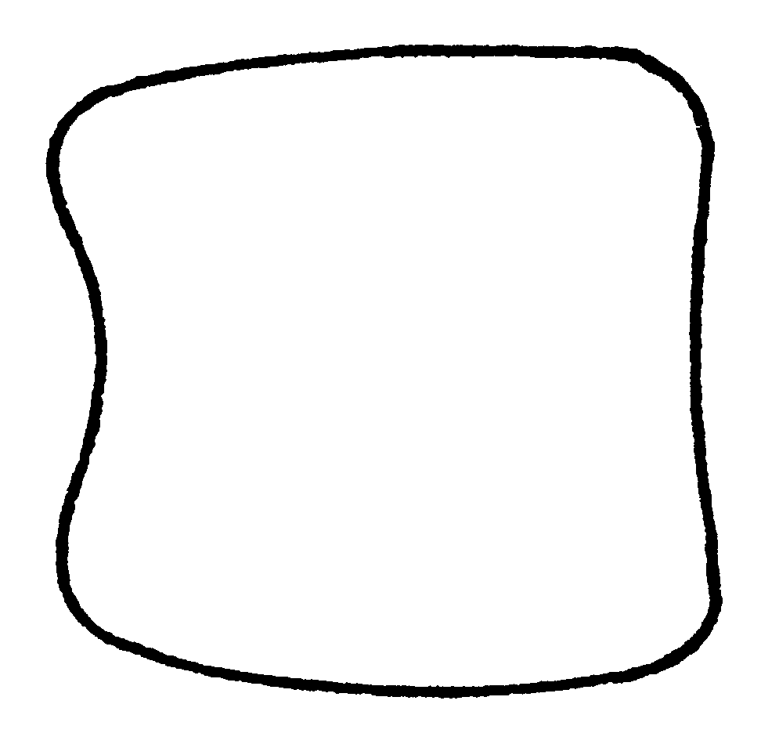
Fig. 34. Petiole of a worker of A. arizonensis as seen from above.
Distribution: USA: S. E. Arizona, Cochise Co. Chiricahua Mountains, 8 mi. S. Apache, 8.1 mi. SE Sunnyside, Pima Co., Baboquivari Mountains, Forestry Cabin, Santa Rita Range, 7 mi. SE Sahuarita.
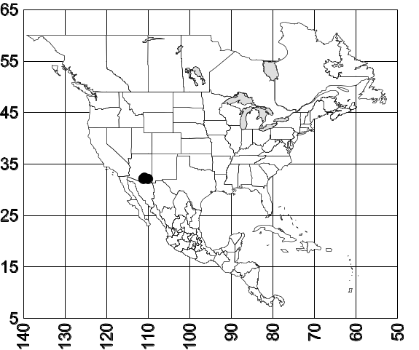 Map 1. Acanthostichus arizonensis.
Biology: The type series was associated with termites (Heterotermes aureus) in an experimental plot. This speci nests nder stones from 1070 - 1780m up to oak-juniper forests.

Acanthostichus emmae Mackay
Diagnosis: The sides of the head are nearly straight, and nearly parallel. The eyes are large (eye length of holotype 0.28 mm), and reach the sides of the head. The ocelli are large, with the diameter of the median ocellus (0.08 mm) equal to the distance to the lateral ocellus. The subpetiolar process is well developed, but blunt. The petiolar node is wider posteriorly, with the maximum width almost equal to the length.
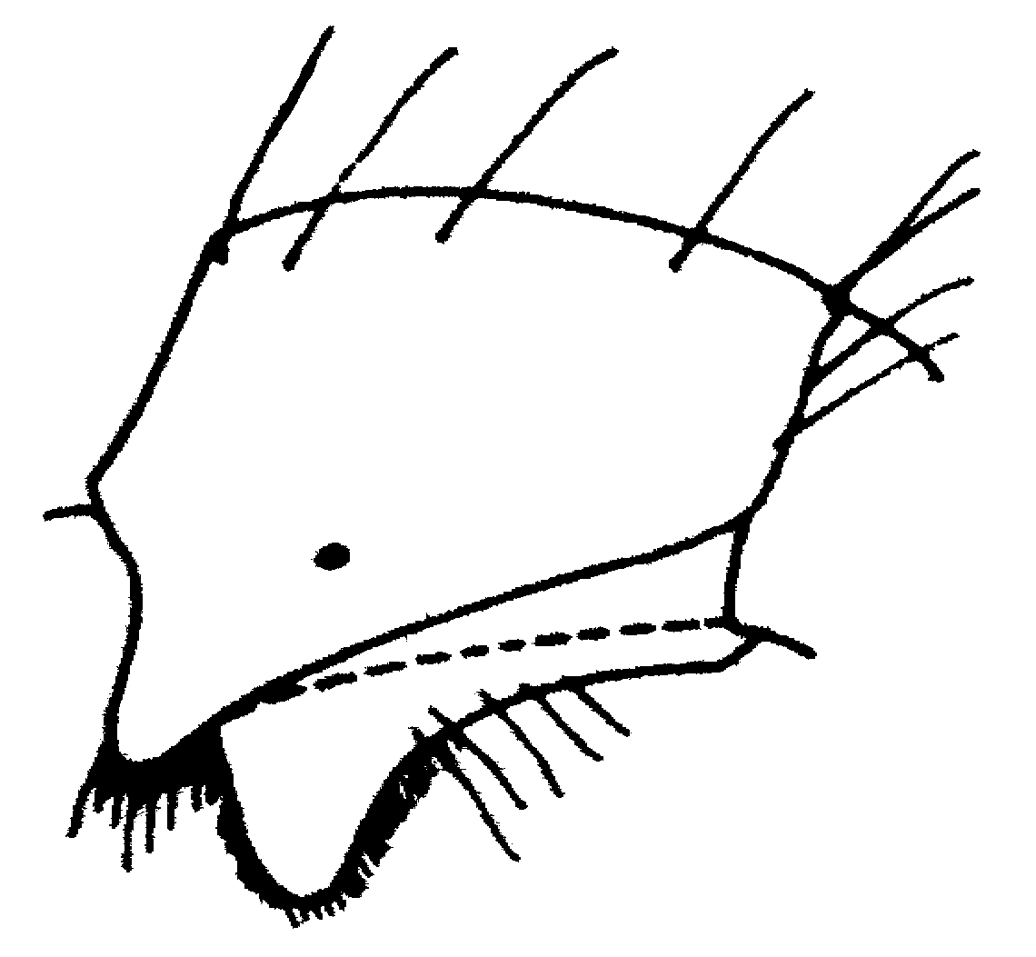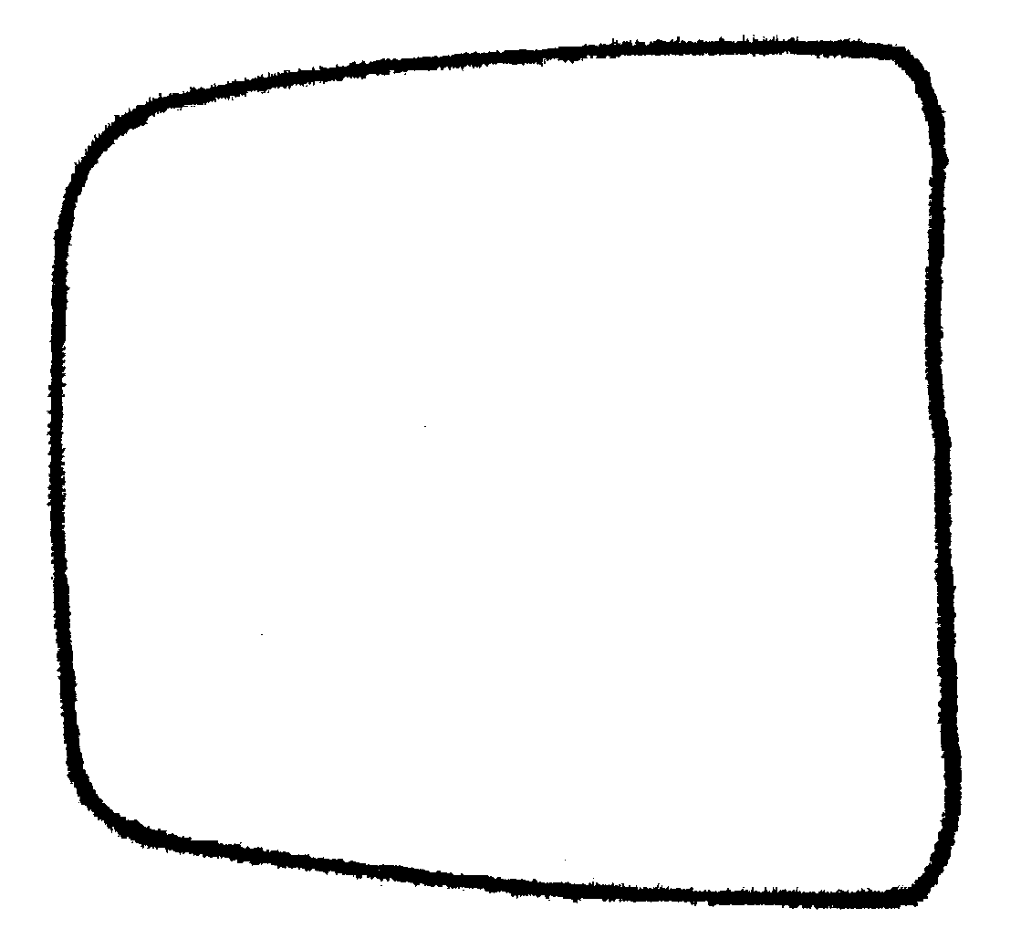
Map 2. Petiole of a female of A. emmae as seen from the sidea and from above.
The body is covered with long hairs, especially the dorsum of the head and mesosoma. The gaster has abundant long hairs. The erect hairs along the anterior edge of the scape are nearly twice as long as the width of the scape. It is ferrugineous red with yellow blotches on the base of the first gastral tergum.
This species is similar to A. texana, probably the only species with which it could be confused (the females are unknown for A. skwarae and A. quirozi, which occur in the same general area). It differs from A. texanus as the petiole is less eongate as seen from abve (compare Figs xx & xx). The subpetiolar process is more rounded and the ocelli are larger. The worker is unknown, and would be expected to be similar to that of A. texanus, but the petiole should be nearly square (viewed from above). The eyes should be relatively large as in workers of A. texanus. The male is also unknown, but would be expected to have broad teeth on the subgenital plate.
Distribution: MEXICO: Oaxaca, Tehuantepec.
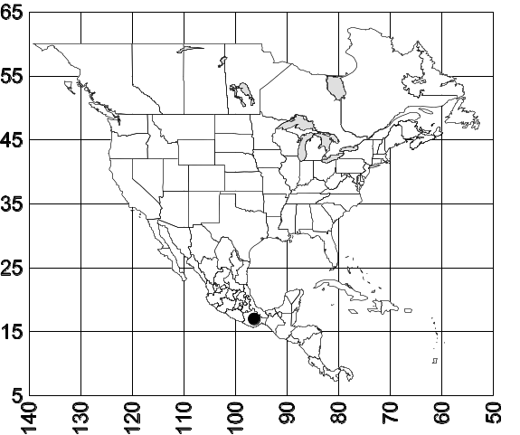 Map 3. Acanthostichus emmae.

Acanthostichus fuscipennis Emery
A. fuscipennis Emery, 1895:752, male, Plate 17, Fig. 13 (lectotype specimen in illustration, here designated). Brazil: Pará, Belém; Borgmeier, 1923:51; Kusnezov, 1962:132, incorrectly synonymized with Acanthostichus quadratus.

Worker: Unknown
Female: Unknown
Discussion. There has been considerable confusion regarding this species as it was based on a mixed species series. Due to the mixed series, Emery concluded that A. fuscipennis was closely related to A. serratulus (which is incorrect). As a result of this, many males in collections were identified by myrmecologists as A. fuscipennis.
The males of this species are among the most distinct and easily recognized in the genus, based on the shape of the petiole. The node of the petiole (as seen from above and with the anterior face hidden from view) is broader than long (elongate in most other known species) and narrowed posteriorly, with a suture which passes over the posterior edge of the petiole (Fig. ). The node of the petiole is smooth, shining, and broadly rounded anteriorly. Most specimens have bluish or purpleish reflections on most of the body parts, especially the head in pronotum. This characteristic must be used with caution, as others, such as A. serratulus (Brasil and Argentina), A. kirbyi (Perú south to Argentina) and A. laticornis (southern South America), also have bluish reflections, but the petioles in the species or elongate. Specimens of A. fuscipennis without bluish reflections can be recognized by the shape of the petiole (described above). In addition, the aedeagus is elongate with small, widely spaced teeth (which are occasionally absent). The ventrally directed teeth are well developed on both the aedeagus and the volsella.
There seems to be a reasonable amount of variation in this species, even in specimens collected at the same locality. We tentatively conclude that all of these specimens are A. fuscipennis, although this may be incorrect. Unfortunately it is impossible to link this species to workers of any other species; thus the workers of A. fuscipennis are unknown at this time.
Distribution. Colombia south to Brasil. The distribution of this common, widely distributed species may extend into Central America:
Biology. Males are commonly collected in light traps, from January to October.

Acanthostichus punctiscapus Mackay
Diagnosis: This species is easily recognized and can be separated from all others in the genus by the densely punctate surfaces (on the mandibles, scapes, head, dorsum of mesosoma, petiole and gaster), especially on the scapes. No other species in the genus has such punctures. The mandible has a small tooth on the medial masticatory border (Fig. xx). The petiole is strongly narrowed anteriorly, with a large, ventrally directed tooth (Fig. ).
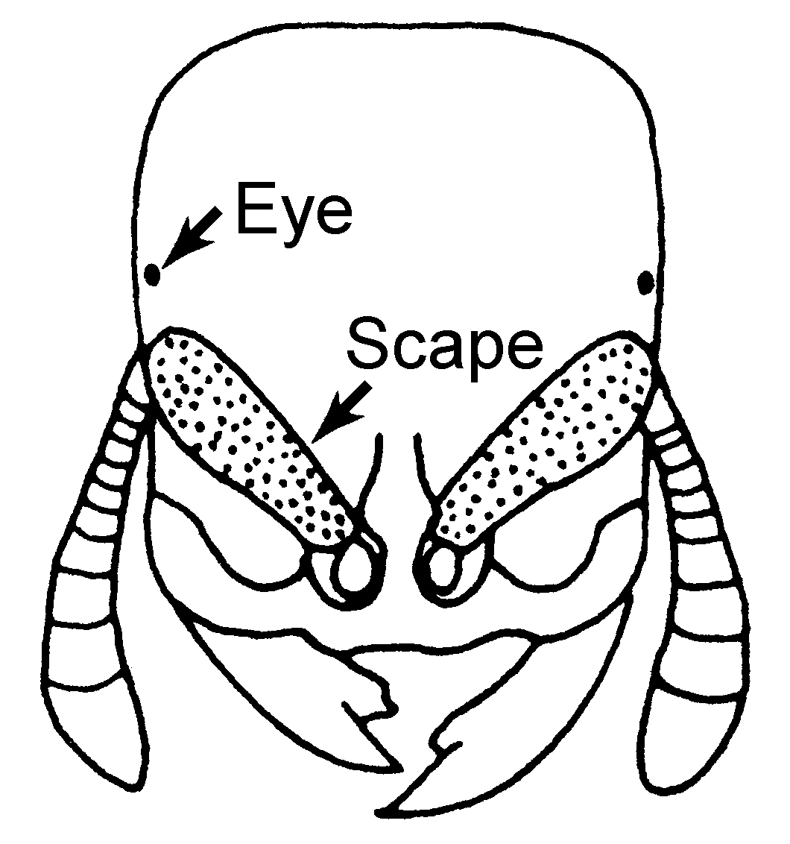Fig. 35. Head of a worker of A. punctiscapus.
This species can be easily separated from A. arizonensis by the punctures on the scapes (surface smooth and polished in A. arizonensis). The female and male are unknown, but the female could probably be recognized as having punctures on the scapes. The males undoubedly have slender teeth on the subgenital plate.
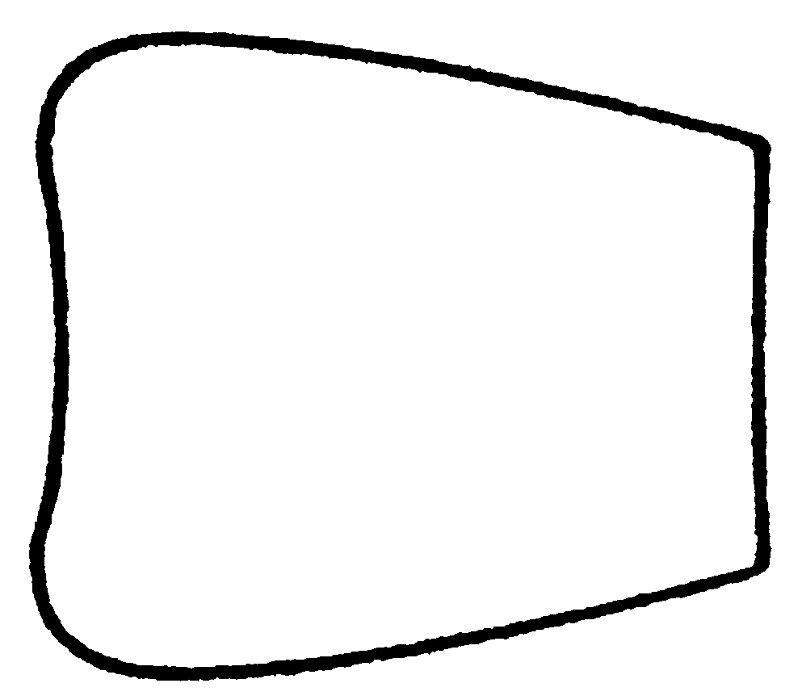
Fig. 36. Petiole of a worker of A. punctiscapus as seen from above.
Distribution. USA, New Mexico, Doña Ana Co., Jornada LTER [National Science Foundation Long Term Ecological Research] Site, 45 Km NE Las Cruces, 1.6 Km W of College Ranch Headquarters.
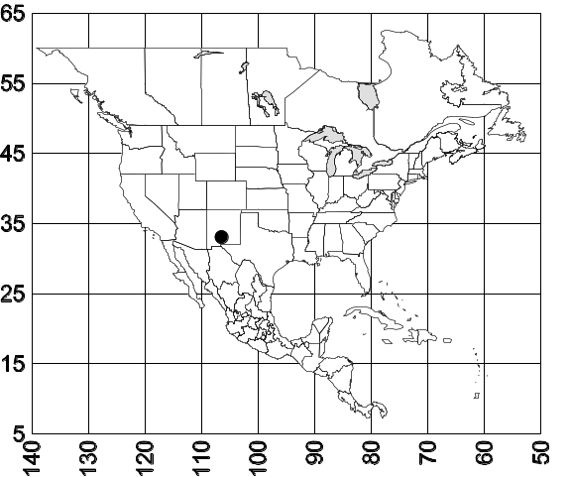 Map 4. Acanthostichus punctascapus.
Biology. The typ seres was collected in a nest of the ant Pogonomyrmex desertorum Wheeler at a depth of 70 cm, located in a Larrea tridentata (creosote bush) Chihuahuan desert scrub. Most of the colony was maintained in a laboratory colony for a few days, and specimens were preserved after they had died. Additional specimens were not collected, although an extensive search of the area was conducted. I operated a light trap within thirty meters of the site where they were collected, twice weekly throughout the remainder of the summer and fall of 1985 and during the spring to fall in 1986, without collecting any males. Numerous Cerapachys davisi males were collected in the trap in addition to reproductives of several other ant species.

Acanthostichus quirozi Mackay
Acanthostichus quirozi Mackay, 1996:164-165, worker, Mexico: Veracruz, Tuxtlas

Discussion. This species is closely related to A. skwarrae. The petioles are almost identical in shape, and are both smooth and highly polished. The two species are easily separated, as A. skwarrae has no erect hairs on the dorsum of the petiole. In addition, A. skwarrae has possibly as many as 10 erect hairs on the dorsum of the mesosoma, the longest of which is 0.1 mm in length. The gaster of A. skwarrae is almost without hair, except for the area near the pygidium. The longest hair on the gaster is about 0.05 mm in length. Thus, these two species appear to be very similar, but A. quirozi can be easily distinguished by the longer and much more abundant erect hairs.
It would not be likely to confuse this species with any of the other species, based on the shape and sculpture of the petiole. The unknown workers of A. emmae should have a subquadrate petiole, and larger eyes, and thus be distinguishable from this species.
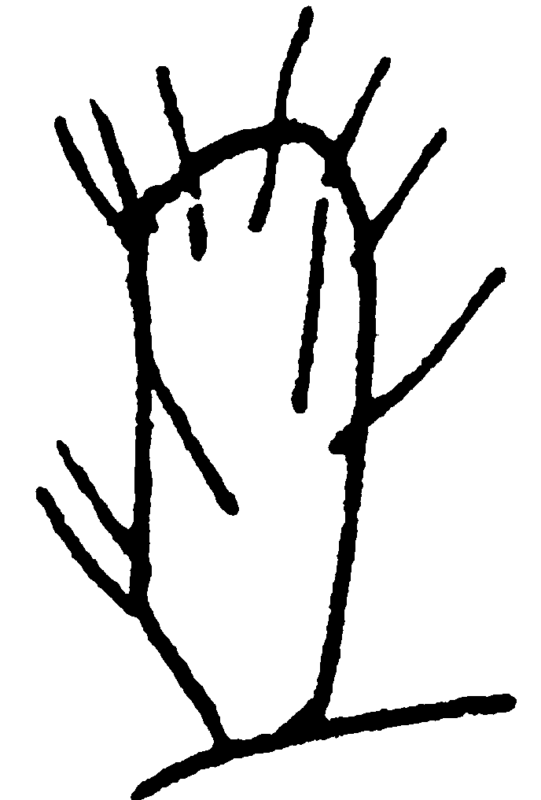
Fig. 37. Antennal scape of a worker of A. quirozi
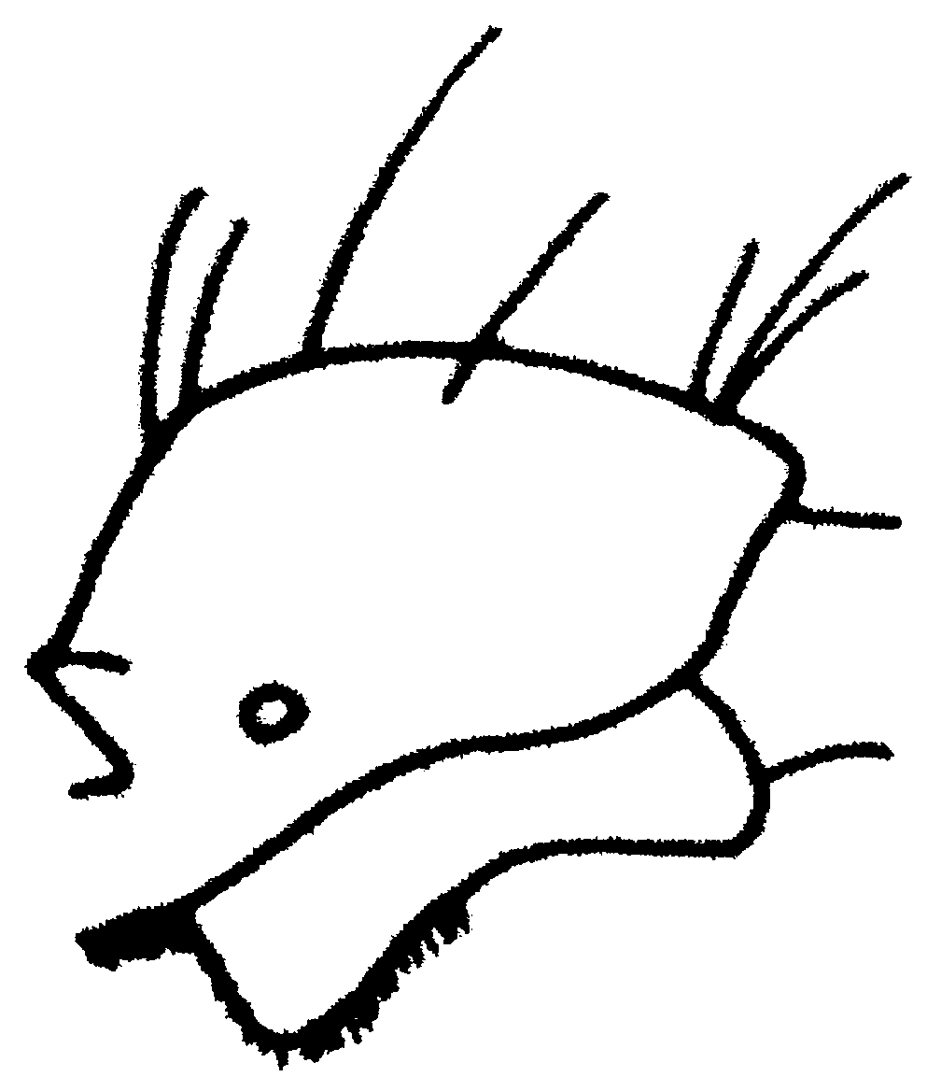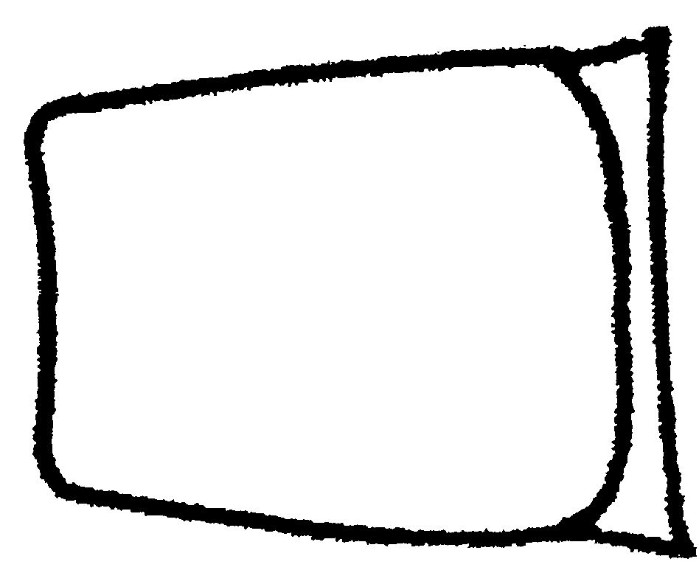
Fig. 38. Petiole of a worker of A. quirozi as seen from the side and from above.
Distribution: MEXICO: Veracruz, Tuxtlas.
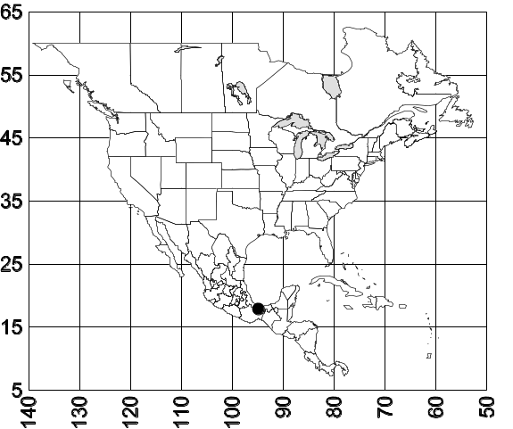 Map 5. Acanthostichus quirozi.
Biology. Unknown.
Acanthostichus skwarrae Wheeler
Acanthostichus skwarrae Wheeler, 1934:161, worker, Mexico: Veracruz, Tamarindo; Kusnezov, 1962:133, (comparison with other species).

Female: Unknown.
Male: Unknown.
Discussion: Acanthostichus skwarrae is presently represented by a poorly preserved, headless lectotype worker. Fortunately good distinguishing characteristics are present on the specimen, which allow recognition of the taxon as a valid species. It is obviously a member of the brevicornis species complex, as the petiole is elongate (PL = 0.44, PW = 0.35) and wider posteriorly (Fig. ). It is strongly concave anteriorly and the subpetiolar process is formed into a large, rounded lobe (Fig. ). The hind femur is moderately thickened (FL = 0.58, FW = 0.26 mm). It is easily separated from most other species in the complex by the shape of the petiole (wider posteriorly than anteriorly), the large subpetiolar process (Fig. ) and the smooth dorsum of the petiole. It is closely related to A. quirozi, differing as it has very few erect hairs on the surfaces.
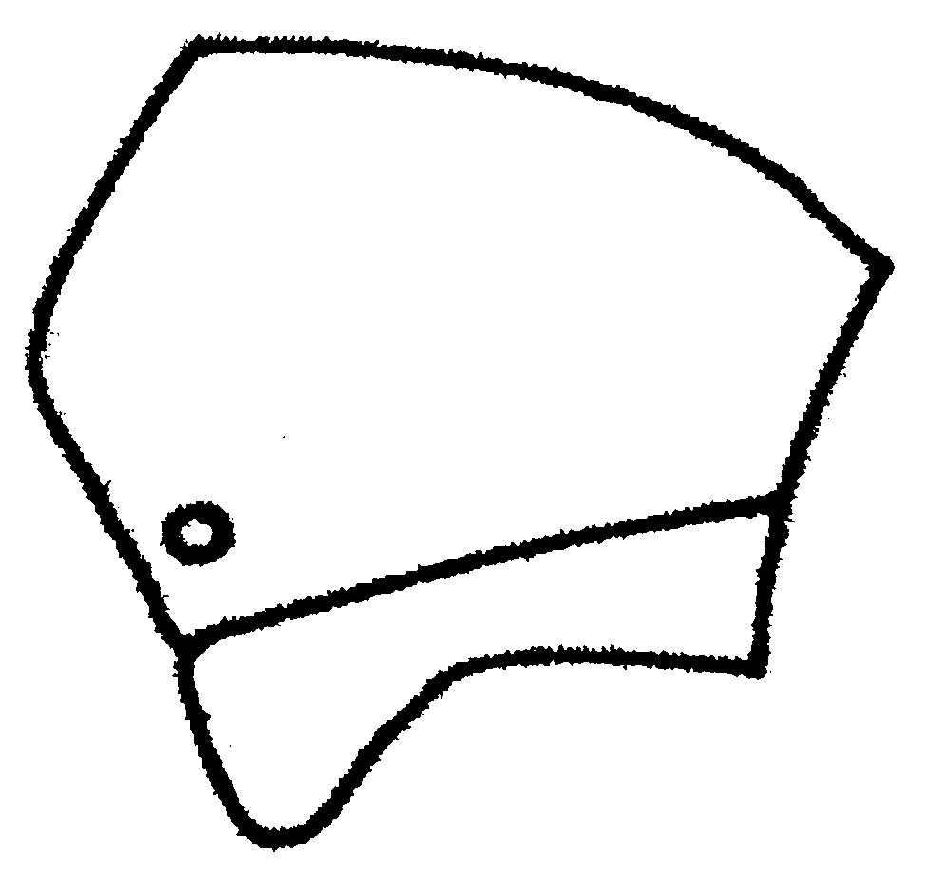
Fig. 39. Petiole of a worker of A. skwarrae as seen from the side and from above.
Distribution: MEXICO: Veracruz, Tamarindo.
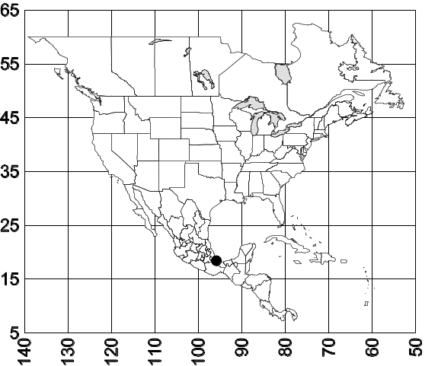 Map 6. Acanthostichus skwarrae.
Biology: A single worker was found loose on the ground (Wheeler, 1934).
***here making changes from original.
Acanthostichus texanus Foarel

Acanthostichus texanus Forel, 1904:168, dealate female, Brownsville (Nat. Hist. Mus. Genova) [not seen, presumably lost, see Smith, 1955); M. Smith, 1942:62, characterization of male, 1947:526, dealate female (presumably lost), Fig. 4; Kusnezov, 1962:133.
Ctenopyga townsendi Ashmead, 1906:29, female, male [one male lost?] synonymy by Smith, 1955:49. Emery, 1913:14; Smith, 1943:283, 288-290, Fig. 4,J (pygidium of male).
Worker: HL 0.96 - 1.06, HW 0.83 - 0.94, SL 0.43 - 0.48, SW 0.15 - 0.16, EL 0.05 - 0.08, WL 1.39 - 1.56, FL 0.65 - 0.70, FW 0.28 - 0.33, PW 0.38 - 0.48, PL 0.49 - 0.54, SI 44 - 45, CI 86 - 88, PI 113 - 130, FI 2.15 - 2.36, SL/SW 2.83 - 2.92.

details***
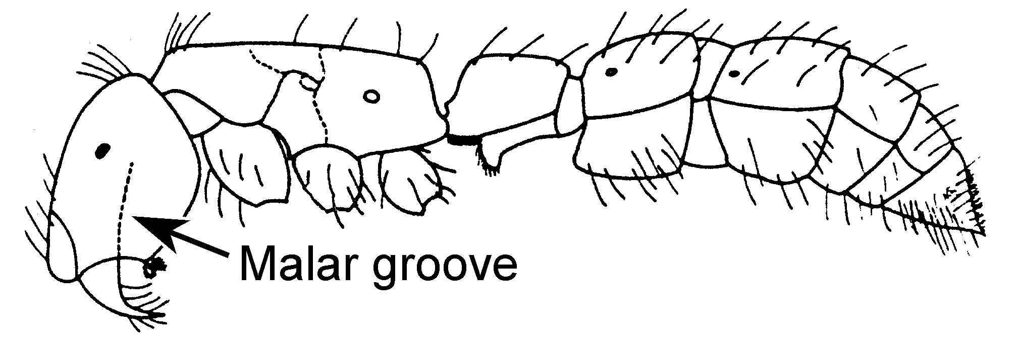
Fig. 40. Side view of a worker of A. texanus.
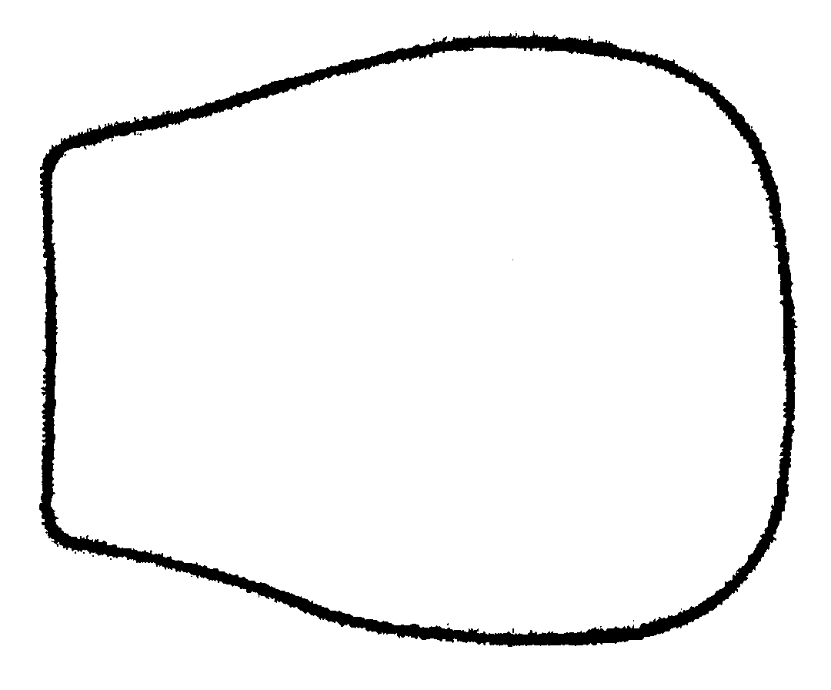
Fig. 41. Petiole of a worker of A. texanus as seen from above.

Female: HL 0.95 - 1.24, HW 0.84 - 1.03, SL 0.43 - 0.51, SW 0.15 - 0.19, EL 0.23 - 0.29, WL 1.65 - 1.88, PW 0.40 - 0.60, PL 0.53 - 0.64, SI 41 -45, CI 83 - 88, PI 106 - 131, SL/SW 2.73 - 2.83.
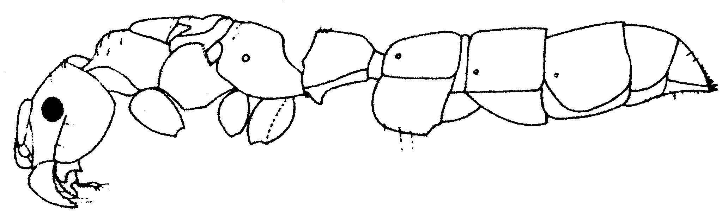
Fig. 42. Side view of a female of A. texanus.
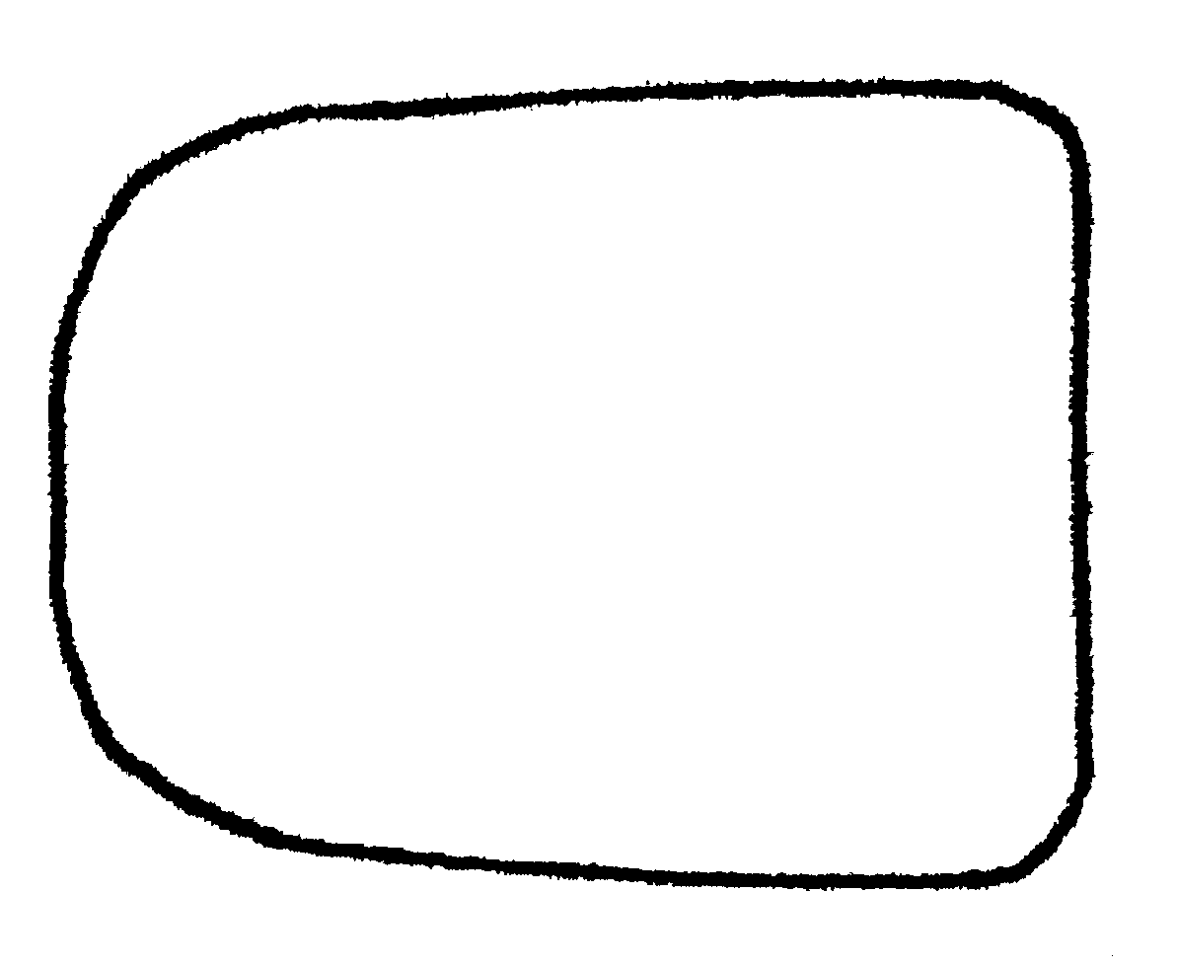
Fig. 43. Petiole of a female of A. texanus as seen from above.
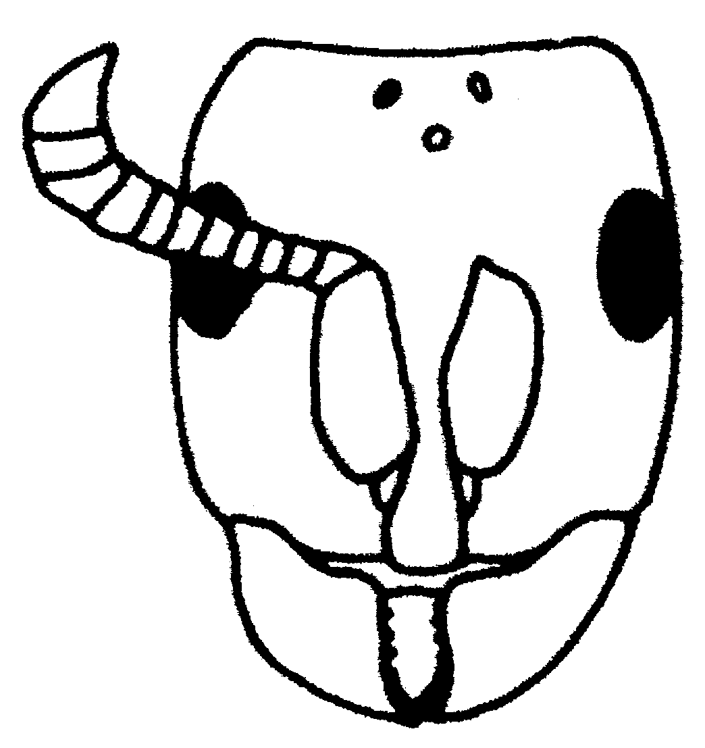
Fig. 44. Head of a female of A. texanus.

details***

Male:
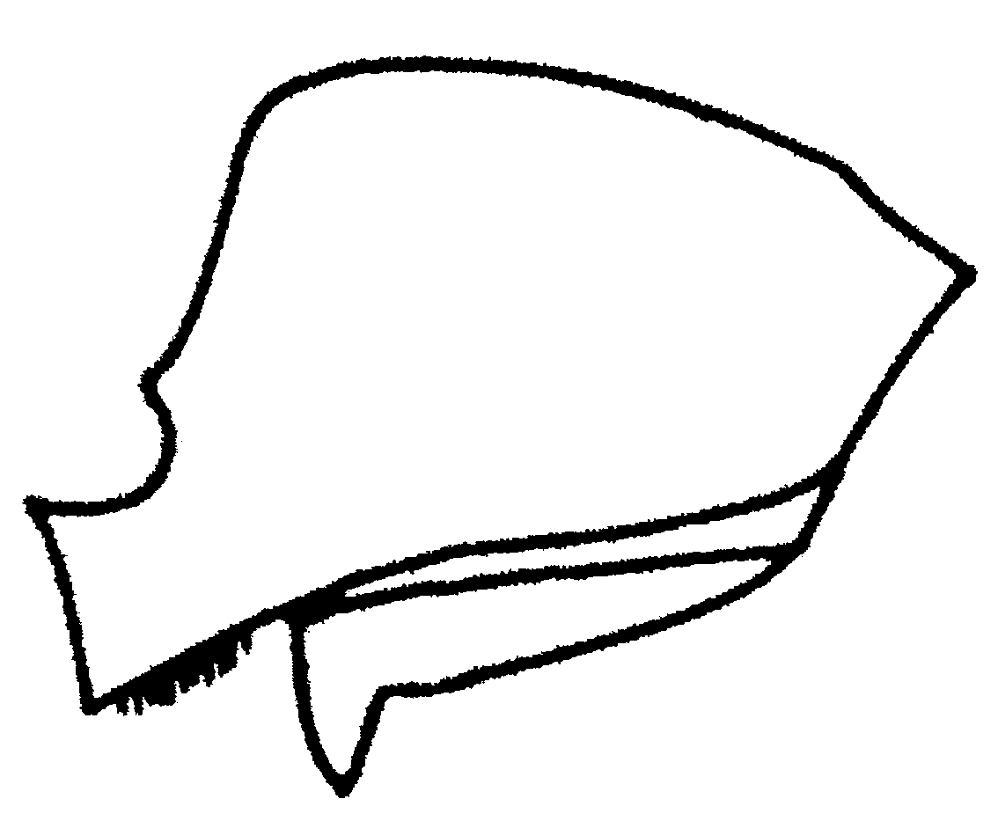
Fig. 45. Petiole of a male of A. texanus.
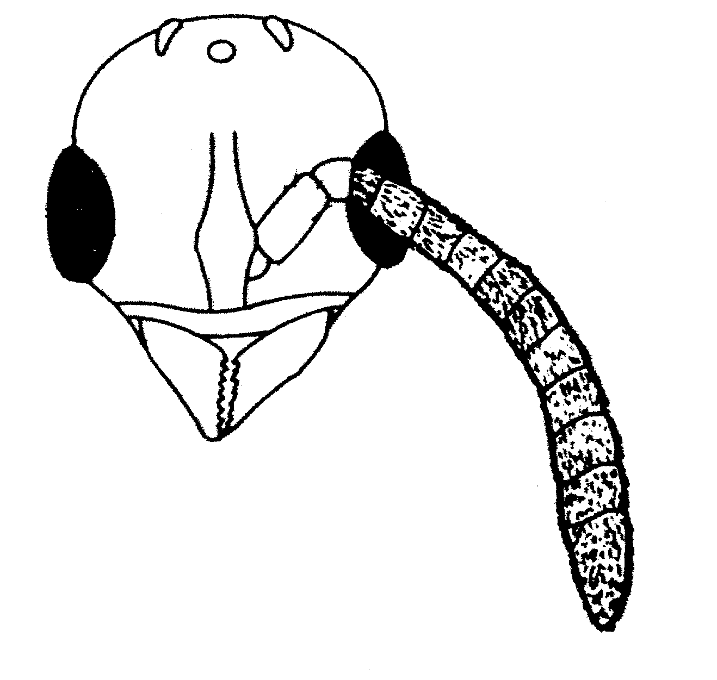
Fig. 46. Head of a male of A. texanus.
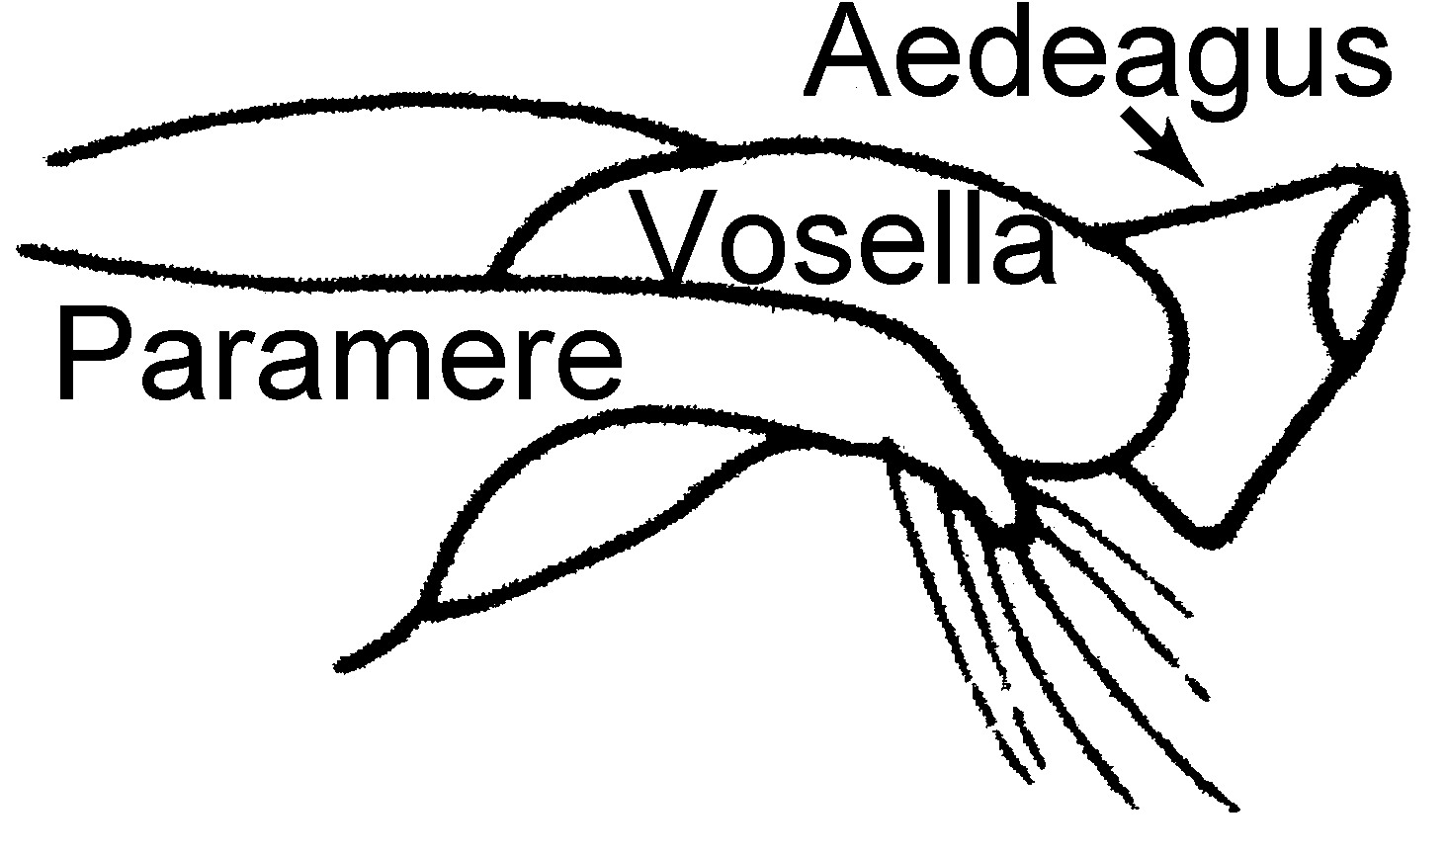
Fig. 47. Genitalia of a male of A. texanus.
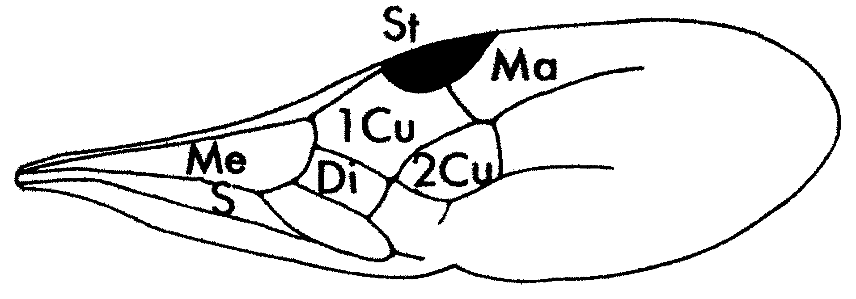
Fig. 48. Forewing of a male of A. texanus.

details***

Discussion: All three castes of this species are easily distinguished from those of the other species. The workers have well developed eyes (Fig. ) and the top of the petiole is smooth and strongly shining (found in few other species). The female is easily distinguished as it is the only known in the genus to have wings. They are not subdictadiiform ***spelling? as they are in other species. They are very similar to the workers, both in size and form. The top of the petiole is smooth and the petiole is elongate. The male is very similar to those of other species in the genus, except for the genitalia, which are very distinct. The teeth of the subgenital plate are thickened. The internal genitalia are completely different (Fig. ). Add details later***
The males were not associated with workers, but these three castes are probably all members of the same species. All three castes are quite different from those of other species, it seems to be the only species form the area around Monterrey Mexico, and the petioles of the three castes are polished and shining. I feel there is no doubt they are conspecific.

Distribution: USA: Texas, _______________, Brownsville, Cameroon Co., 10 miles W. Boca Chica, Starr Co., Rio Grande City, Victoria Co., Victoria, Hidalgo Co., Hidalgo. MEXICO: Nuevo León, Bustamante, Monterrey, San Niocolás de Los Garza; unknown state, La Puerta (apparently northern México, and not the state of Chihuahua, see Mackay, 1996).
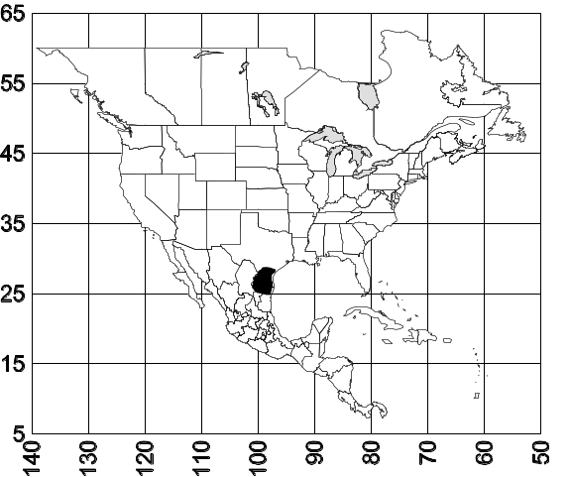 Map 7. Acanthostichus texanus.
Biology: This species is primarily subterranean, and preys on termites (Gnathamitermes tubiformans) and can be collected when they prey on termites under cow manure. Workers are most commonly collected in the autumn - winter (Oct. - Dec.). The two males were collected in May and November at 13:30.

REFERENCES

Ashmead ,1906.

Bolton, B. 1990. Abdominal characters and status of the
cerapachyine ants (Hymenoptera, Formicidae). J. Natur.
Hist. 24:53-68.
Borgmeier, T. 1923.

Brown, W. L. 1975. Contributions toward a reclassification
of the Formicidae. V. Ponerinae, tribes Platythyreini,
Cerapachyini, Cylindromyrmecini, Acanthostichini, and
Aenictogitini. Search Agriculture 5:1-116.
Bruch, C. 1924. Una nueva ponerina <<Acanthostichus
Ramosmexiae>> n. spec. Physis 7:260-261.
Bruch, C. 1925. Macho, larva y ninfa de <<Acanthostichus
Ramosmexiae>> Bruch. Physis 8:110-114 + 1 plate.
Bruch, C. 1934. La hembra dictadiforme de Acanthostichus laticornis For. v. obscuridens Sants. (Hymenoptera
Formicidae) Rev. Soc. Entomol. Argent. 6:3-8 + 2
plates.
Bruch, C. and V. Lopes. 1937. Géneros y especies nuevos de
un estafilínido mirmecófilo (Col. Staph. Aleocharinae).
Rev. de Entomología 7:353-356.
Emery, C. 1894. Studi sulle formiche della fauna
neotropica. VI-XVI. Bull. Soc. Entomol. Ital.
26:137-242 + 4 plates. ref ok??***

Emery, C. 1895. Die Gattung Dorylus Fab. und die
systematische Eintheilung der Formiciden.
Zool. Jahrb. Syst. 8:685-778 + 4 plates.
Emery, C. 1899.

Emery, C. 1911.

Emery, C. 1913.

Forel, A. 1904. 168

Gallardo, A. 1918.

Kempf, W. W. 1964. A próposito de um estudo sôbre as
formigas do género Acanthostichus Mayr
(Hymenoptera, Formicidae). Pap. Avuls. Zool.
Sa~o Paulo 16:263-266.
Kusnezov, N. 1962. El género Acanthostichus Mayr
(Hymenoptera, Formicidae). Acta Zool.
Lilloana 18:121-138.
Luederwaldt, H. 1926. Observaçoes biologicas sôbre formigas
brasileiras especialmente do estado de Sa~o Paulo. Rev.
Museu Paulista 14:185-304 + 5 plates.
MacKay, W. P. 1985. Acanthostichus sanchezorum
(Hymenoptera: Formicidae) una nueva especie de
hormiga en Colombia. Sociobiology 11:127-131.
Mann, W. M. 1916 The ants of Brazil. Bull. Mus. Comp. Zool.
Harvard 60:399-490 + 7 Figs.
Mayr, 1884.

Mayr, 1887.

Mayr, 1895.

Santschi, F. 1916. Formicides sudaméricains nouveaux ou peu
connus. Physis 2:365-399. ref ok??***

Santschi, F. 1933.

Santschi, F. 1934.

Smith, F. 1858. Catalogue of hymenopterous insects in the collection of the British Museum. Part VI. Formicidae.
London. 216 pp. + 14 plates.
Smith, M. R. 1942. The males of two North American
cerapachyine ants. Proc. Entomol. Soc. Wash.
44:62-64.
Smith, M. R. 1943. 283

Smith, M. R. 1955. Acanthostichus (Ctenopyga) townsendi
(Ashm.), a synonym of Acanthostichus texanus Forel
(Hymenoptera: Formicidae). Bull. Brooklyn Entomol.
Soc. 50:48-50.
Wheeler, G. C. 1950. Ant larvae of the subfamily Cerapachyinae. Psyche 57:102-113.
Wheeler, G. V and J. Wheeler. 1964. The ant larvae of the subfamily Cerapachyinae: supplement. Proc. Entomol.
Soc. Wash. 66:65-71.
Wheeler, W. M. 1934.
Wheeler, 1942. Studies of neotropical ant-plants and their ants. Bull. Mus. Comp. Zool. 90:1-262. right ref??***

