Key to the workers of the Neotropical Species of Anochetus
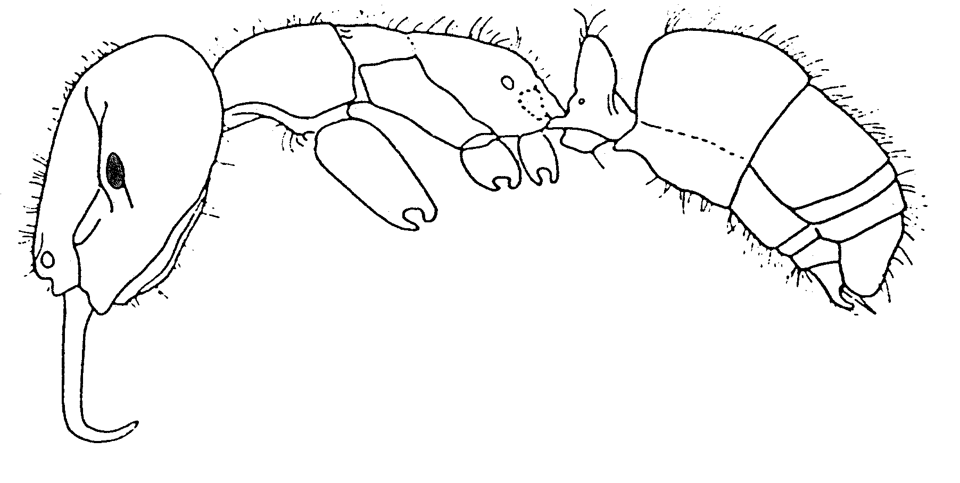
Fig. 1. Side view of a worker of Anochetus sp. (from Serna, 1999).
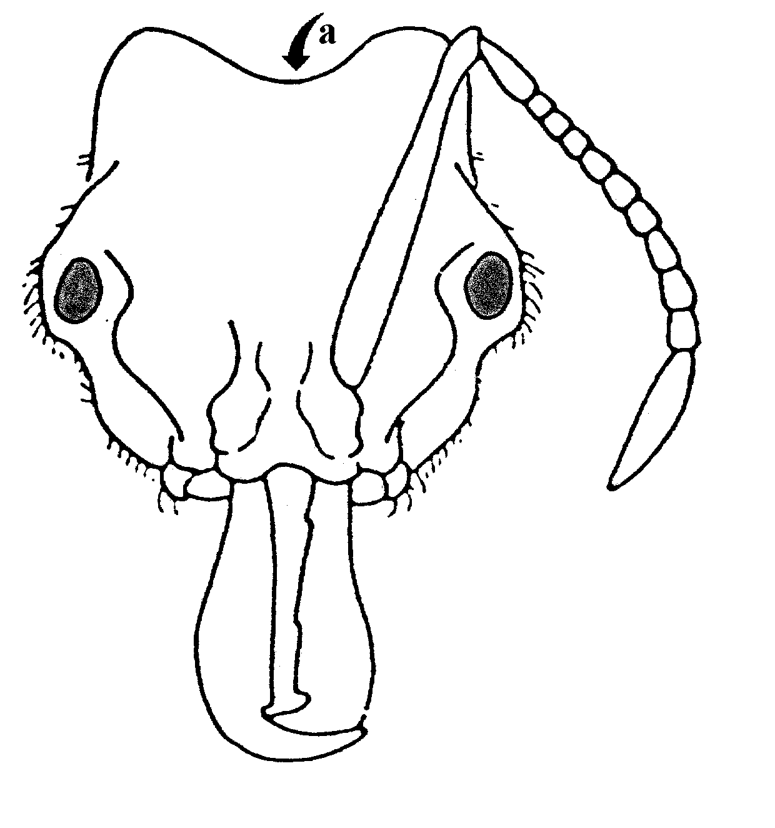
Fig. 2. Head of a worker of Acanthostichus sp. (from Serna, 1999). The letter "a" indicates the rounded nuchal carina.
1. Large species with long mandibles, combined length of head and closed mandibles > 2.2mm; medial borders of mandibles with 2 or more prominent, serially arranged teeth (in addition to the 3 teeth at apex, fig. 9) .. 2
- Species either with HL + ML < 2.2 mm, or else medial borders of mandibles without prominent teeth proximal to the single preapical tooth or angle (Fig. xx) ……………………… 10
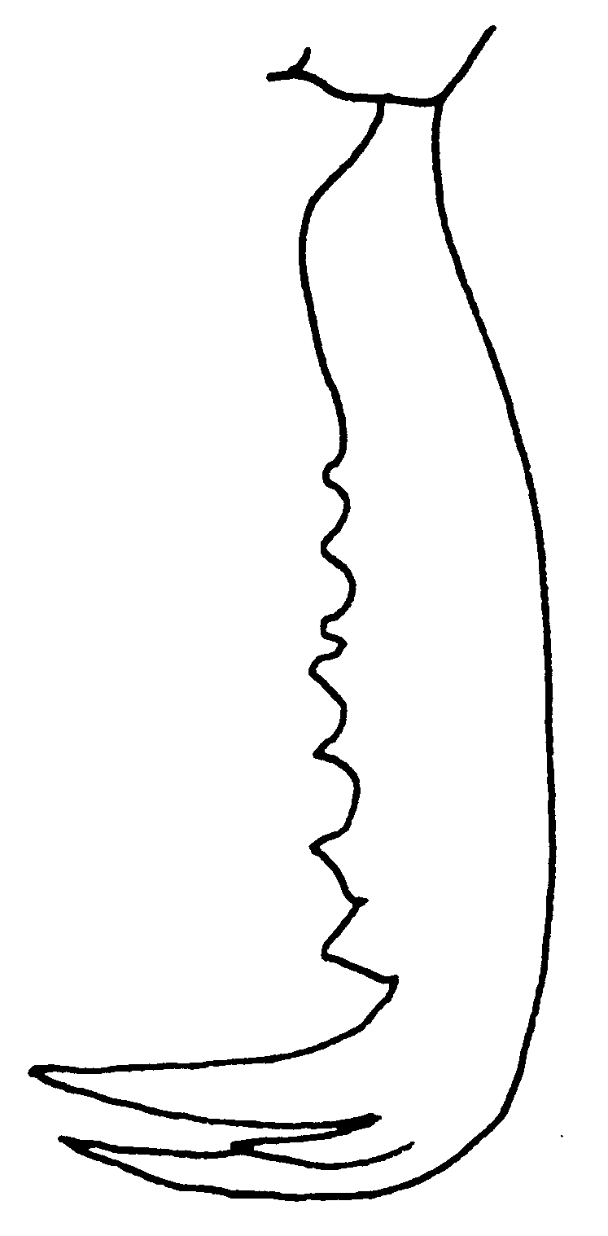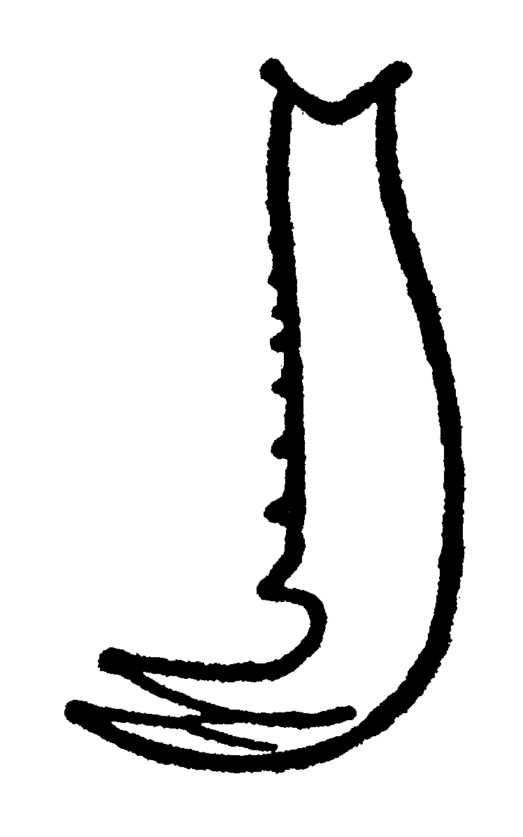
Fig. 3. Mandible of a worker of A. simoni (left, Ecuador) and of a worker of A. inermis (right) (right modified from Brown, 1978).
2(1). Mandibles with >10 preapical teeth and denticles (Fig. xx) ….……… 3
- Mandibles with < 10 preapical teeth and denticles (Fig. xx) ………..... 6
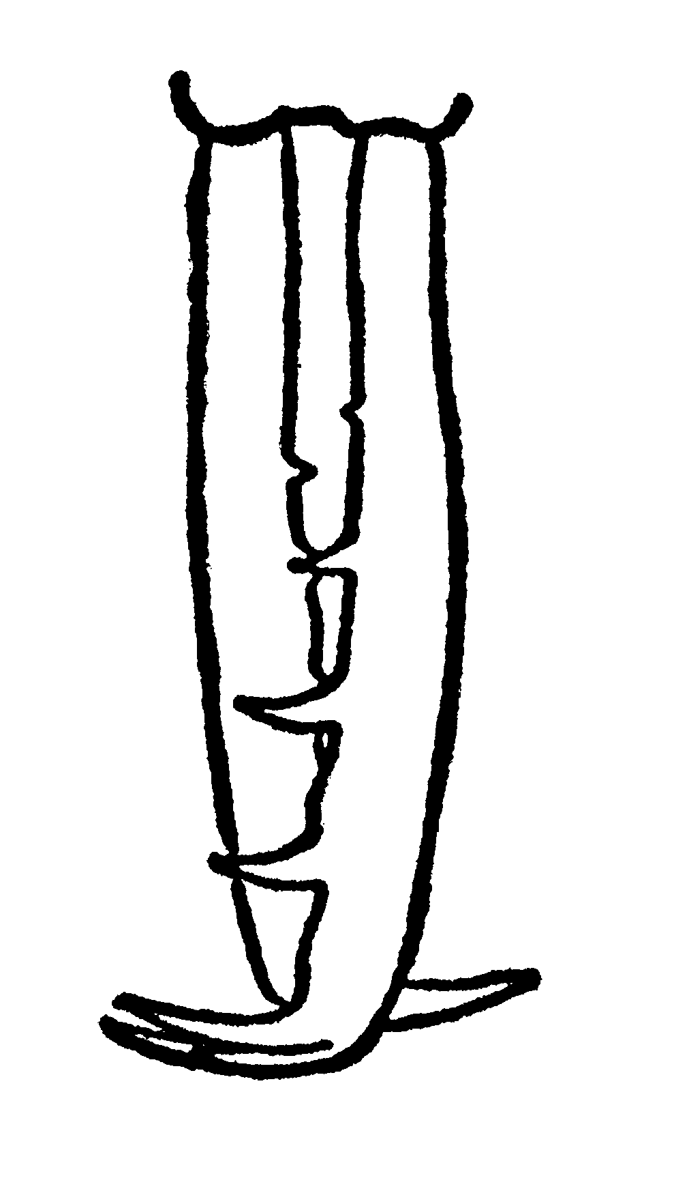
Fig. 4.Mandibles of A. horridus (from Brown, 1978).
3(2). Petiolar node low, the anterior slope as seen from side view rising at an angle of only 30º to the main axis of the petiole; petiolar apex forming blunt double point that strongly overhangs receding posterior face of the node; first gastric segment (postpetiole) bell-shaped as seen from the side or from above, both dorsal and ventral faces concave in outline for much of their lengths, but the segment abruptly and strongly constricted just before its caudal margin ………. 3a
- Petiolar node high, main anterior slope rising at an angle of ca. 45º; petiolar apex more or less acutely double-pointed, the points directed dorsad, and not overhanging posterior face of node, which is vertical and usually convex as seen from the side; first gastral segment evenly convex above and laterally as seen from side or from above, ventral surface straight or nearly so; caudal margin only slightly and gradually constricted …………… 4
3a. Propodeal teeth poorly developed; apex of petiole terminating in blunt angles; N Peru; Maranon Valley, ca. 1500 m ……………….…………………… inca
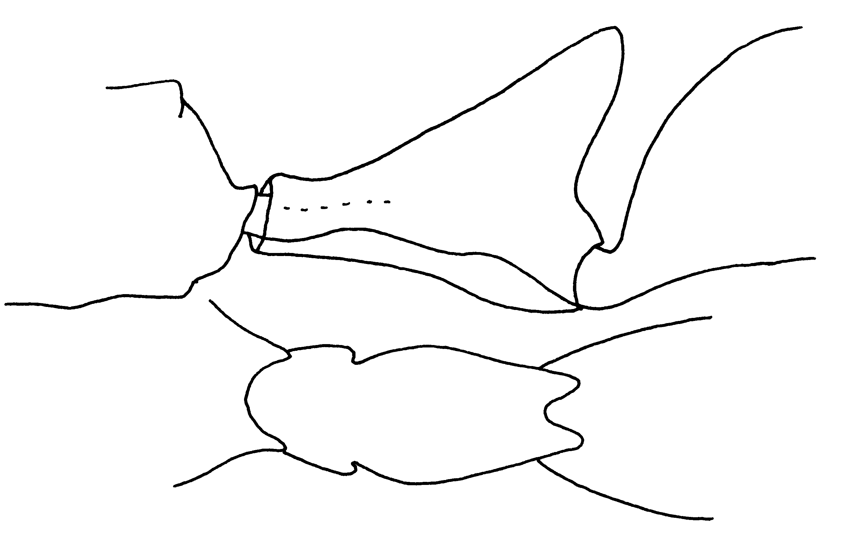Fig. 5. Petiole of a cotype worker of A. inca, as seen from the side and from above.
- Propodeal spines well developed; apex of petiole forming two, sharp teeth; Department of Valle, Colombia ….. ………………………… elegans Lattke
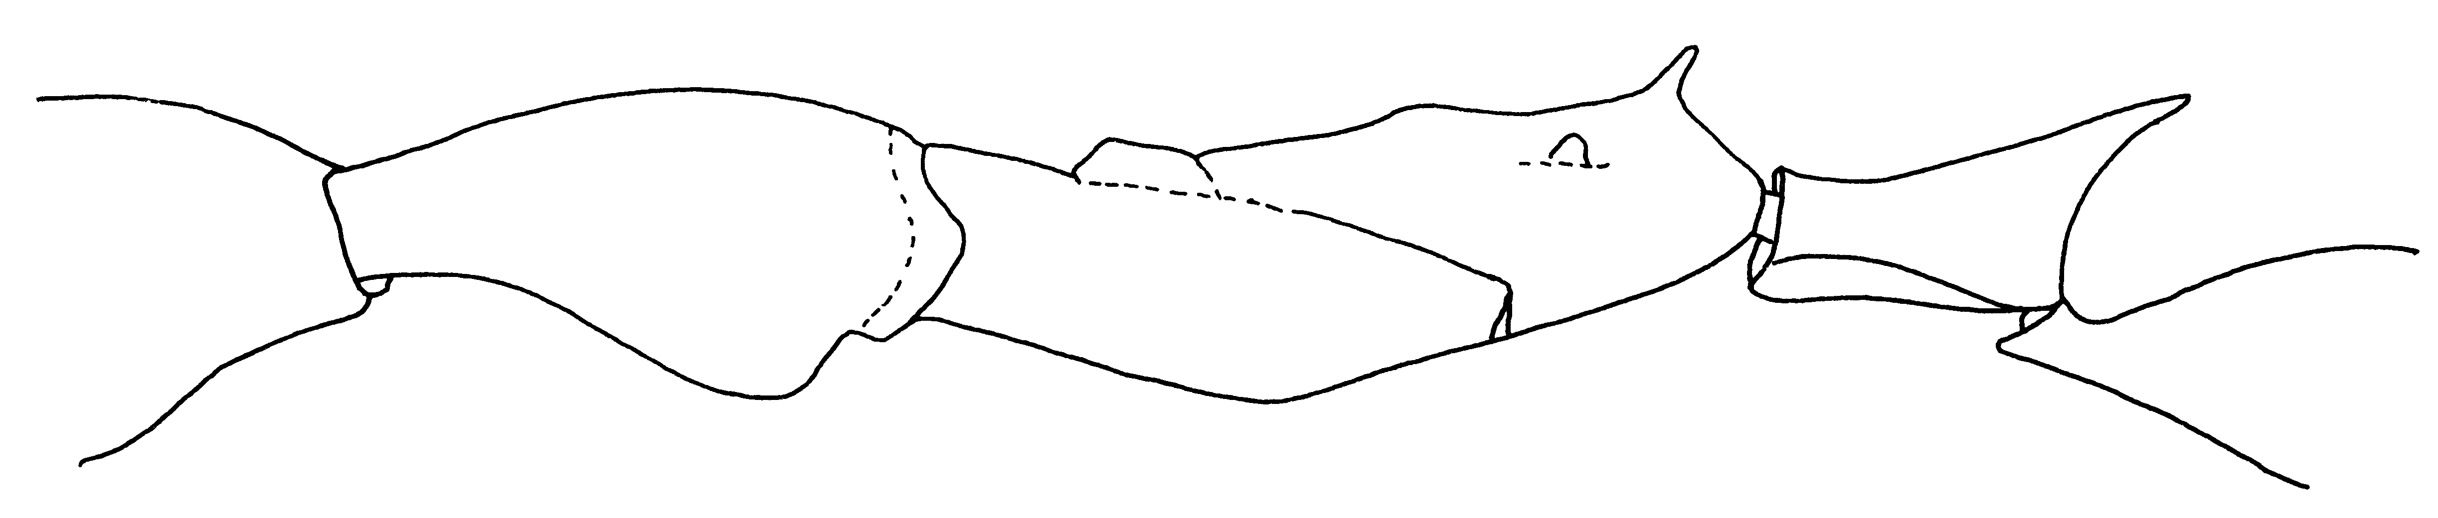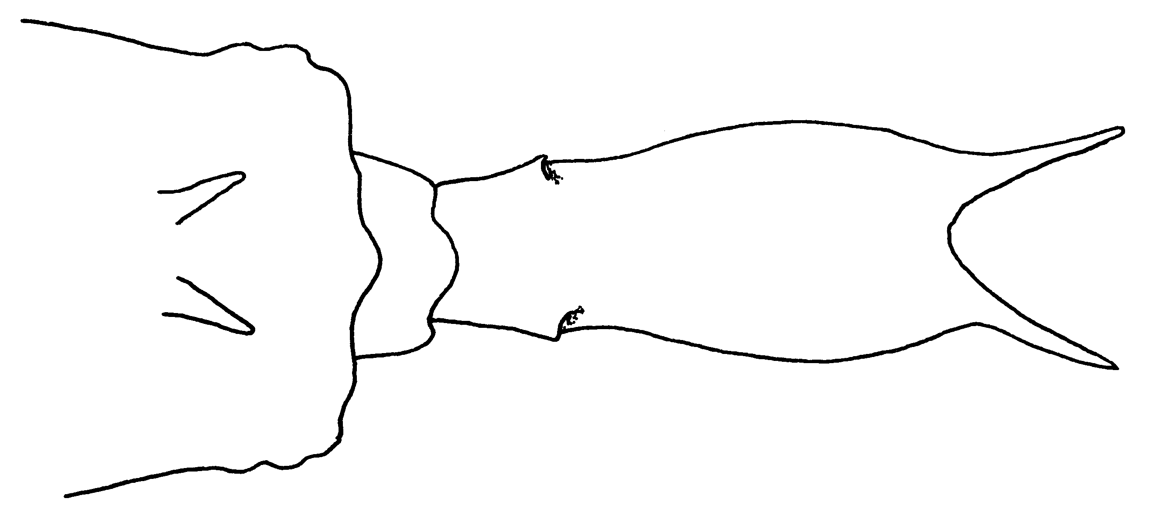
Fig. 6. Mesosoma and petiole of a paratype worker of A. elegans, as seen from the side (upper) and the petiole from above (lower).
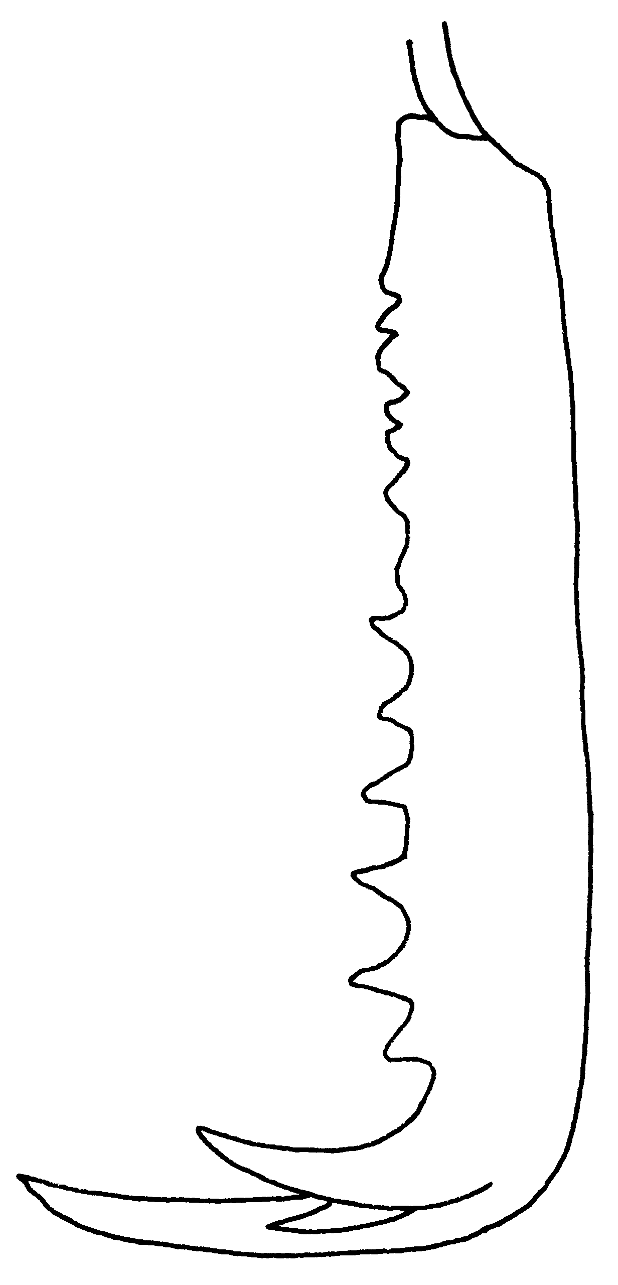
Fig. 7. Mandible of a paratype worker of A. elegans.
4(3). Smaller species (head length + mandible length < 2.80 mm); pronotum very finely and densely punctate, opaque, without striation (SE Brasil: N Espirito Santo) …………….…… oriens
- Larger species (HL + ML > 2.80 mm); pronotum with fine or coarse striation, or its disc sometimes partly or largely smooth and shining (emarginatus superspecies) …………………..…….. 5
5(4). Yellow, trunk ferruginous yellow; most of vertex, disc of pronotum and upper front half of petiolar node smooth and shining; petiolar teeth short and not very sharp (aedeagus of male genitalia as in fig.); W. Indies: St. Vincent, Grenada …..……… testaceus
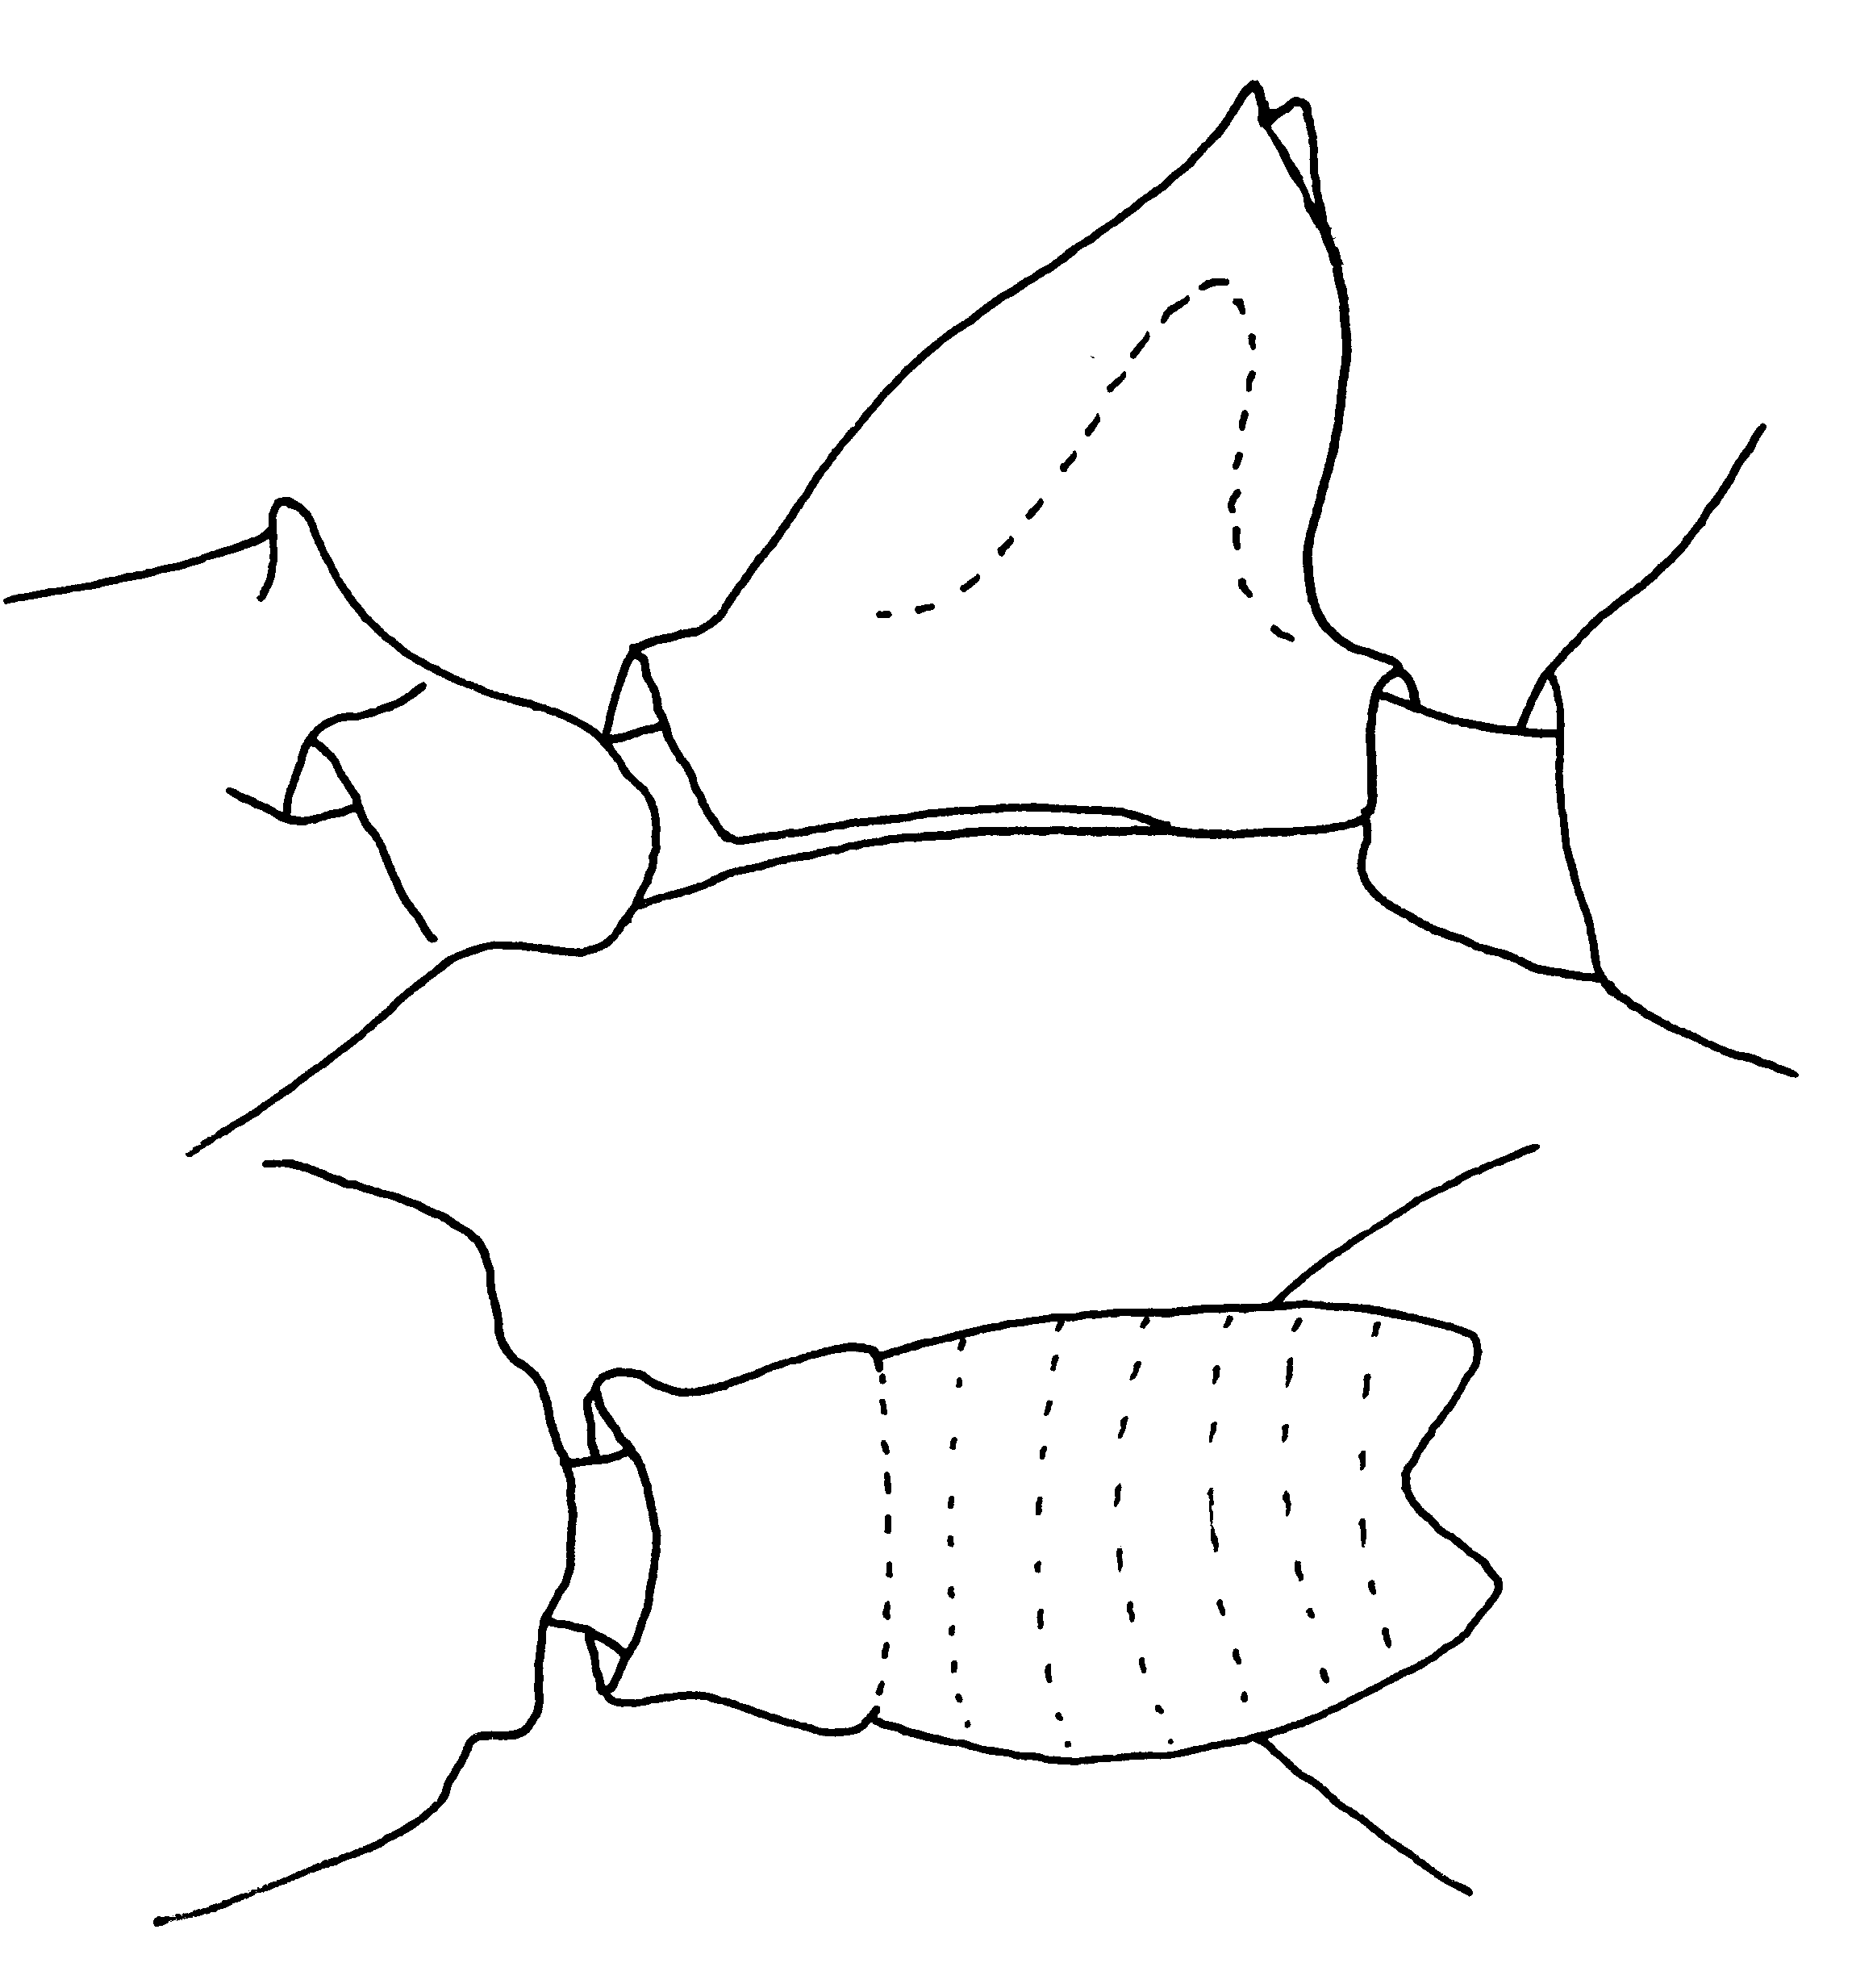
Fig. 8. Propodeum and petiole of a worker of A. testaceus (Grand Etang, Grenada) as seen from the side (upper) and from above (lower).
- Trunk, petiole and node ferruginous to piceous, head and legs paler, yellowish; pronotum varying from transversely rugose or striate to largely smooth and shining, but upper front face of petiolar node usually rugulose and opaque; petiolar teeth short (male genitalia as in fig. 74; Amazon Basin N to N. Colombia and Trinidad ……………..…….……… emarginatus
- Body dark reddish-brown, including head (corners of head slightly paler), legs brownish-yellow; frontal area, front and sides of pronotal disc, and upper front face of petiolar node finely striolate, sericeous; posterior center of pronotal disc smooth and shining; petiolar teeth long (L 0.1mm or more) and sharp (Costa Rica: Atlantic lowlands) ……..……………. striatulus
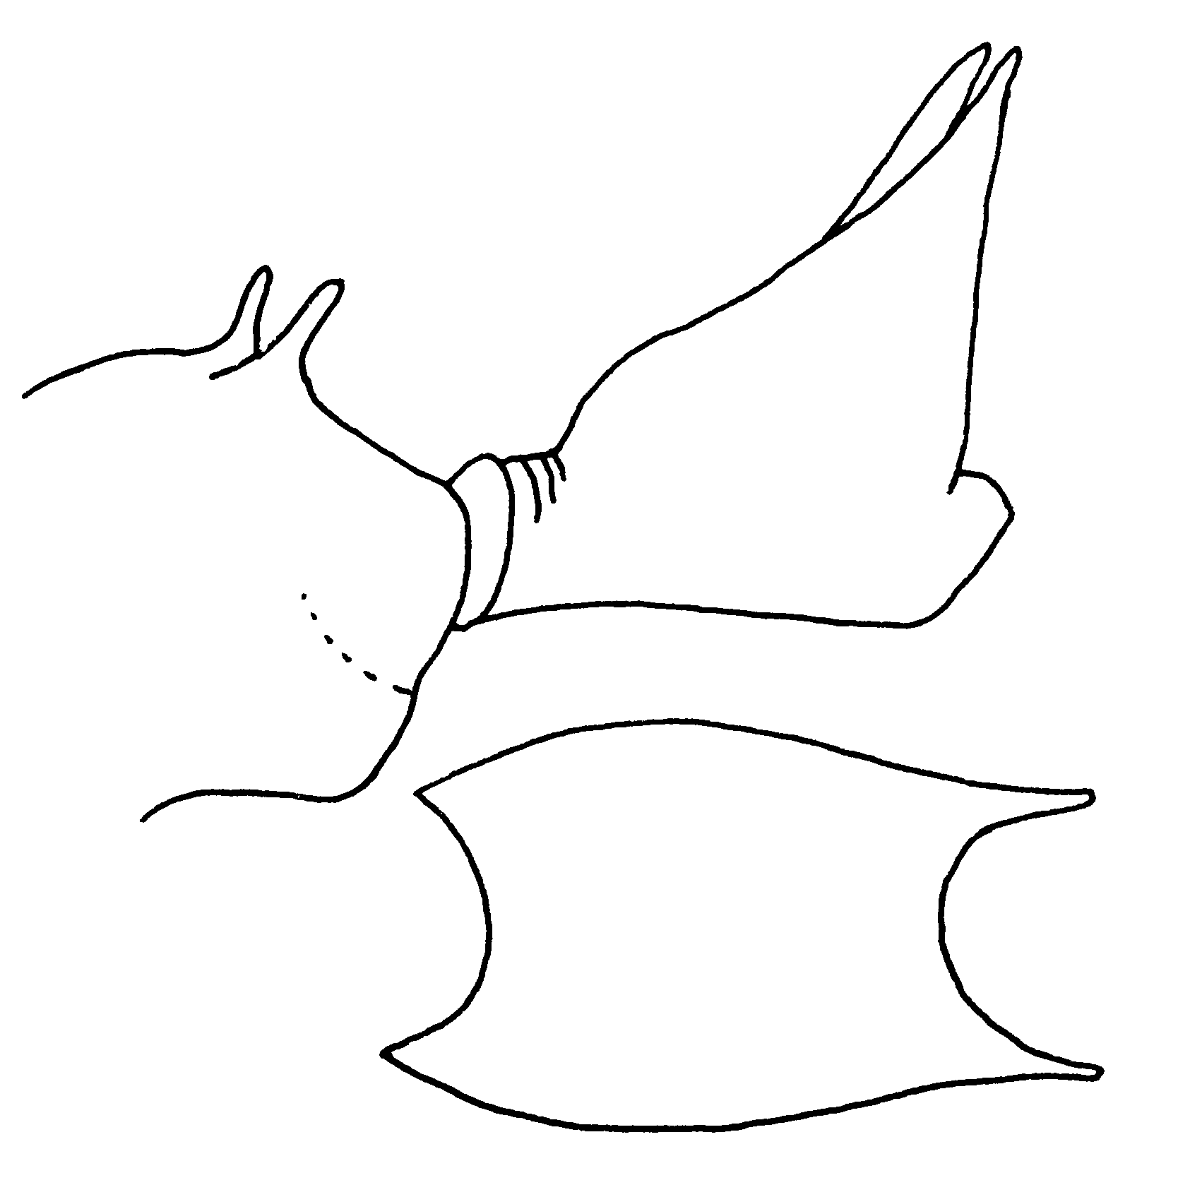
Fig. 9. Propodeum and petiole of a worker of A. striatulus as seen from the side (upper) and above (below).

- Body light ferruginous; pronotum striate at least over front half; sculpture and petiolar teeth varying with locality (locally in C. America, Bahamas) ………………...……. micans
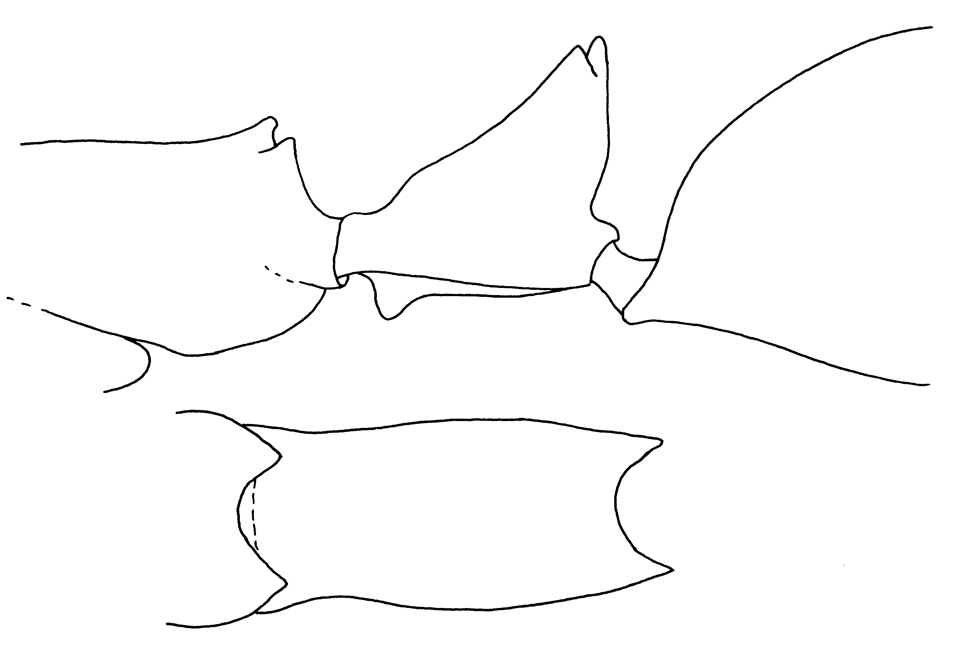Fig. 10. Mesosoma and petiole (side view and top view) of a worker of A. micans from Belize.
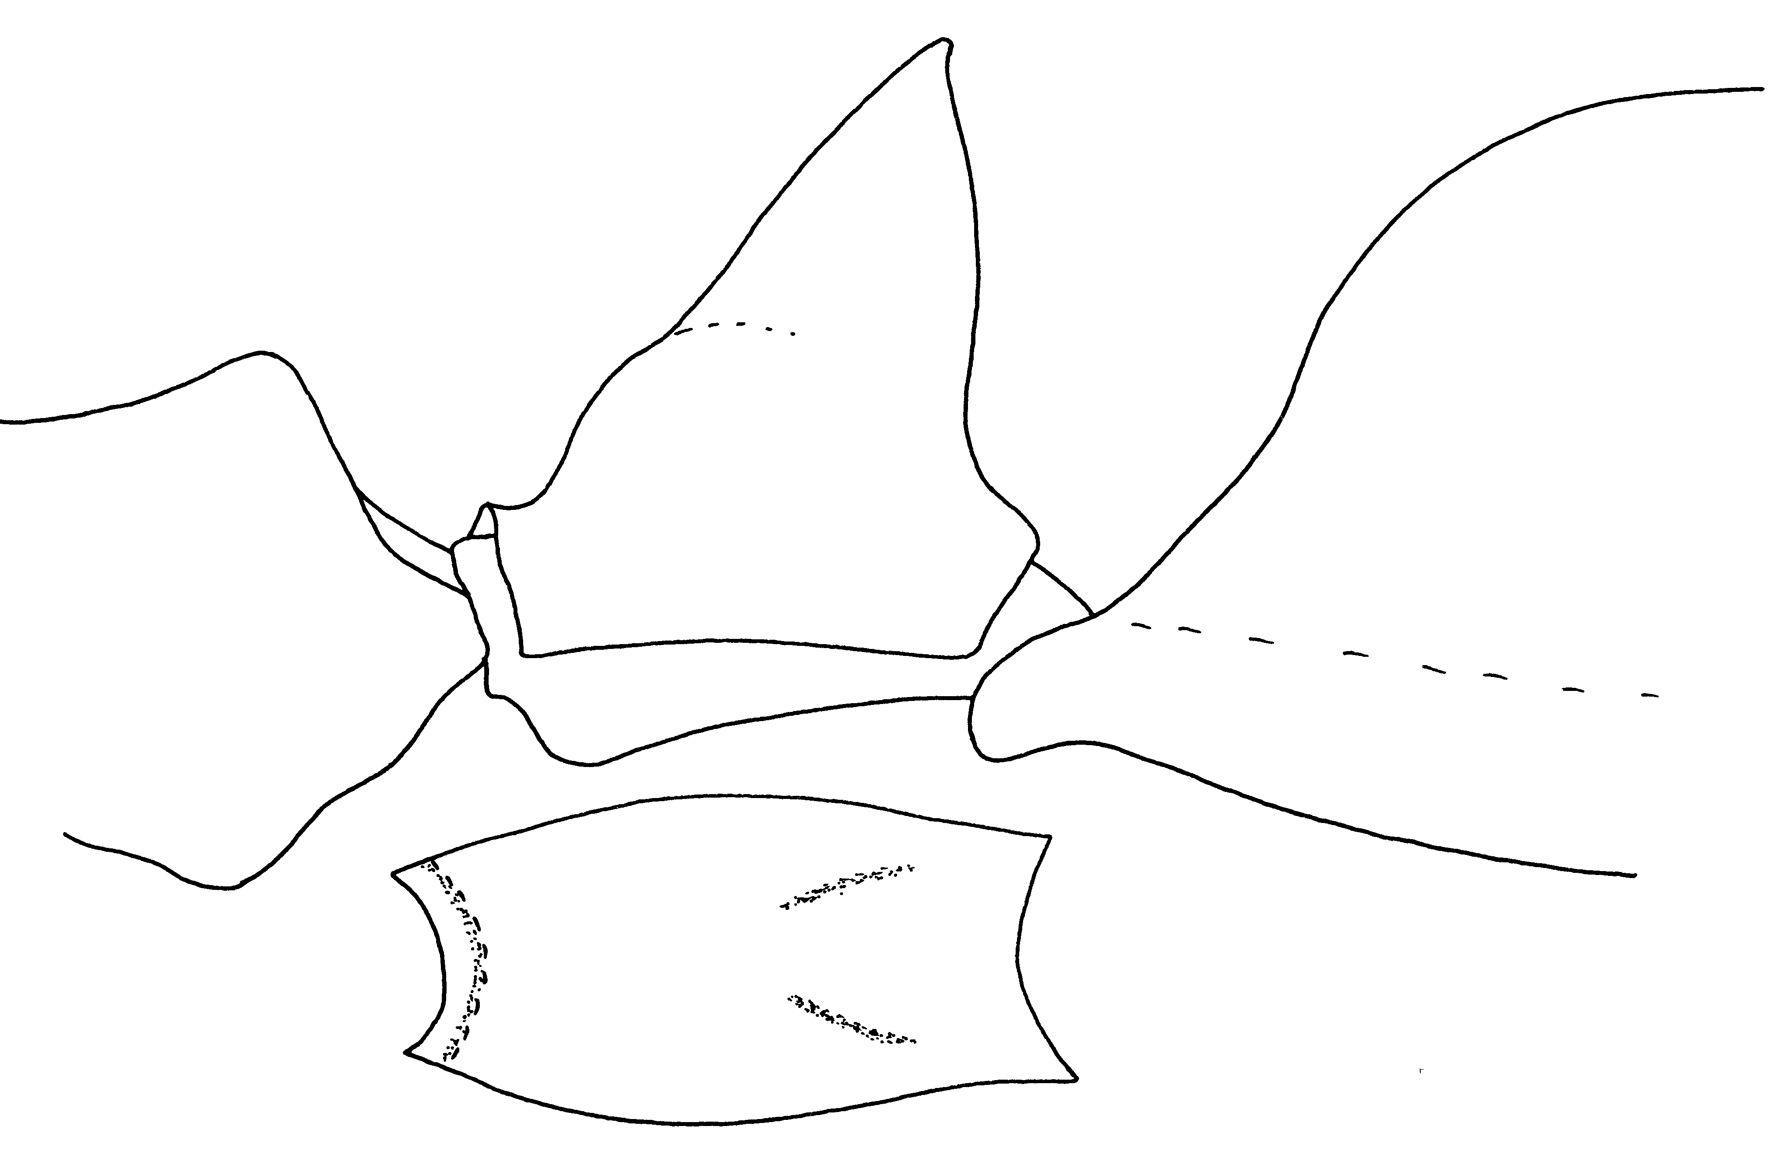Fig. 11. Mesosoma and petiole (side view and top view) of a worker of A. micans from Nassau, Bahamas.
6(2). Mesial borders of mandibles each with 7-9 teeth and denticles (excluding apical trio; W. Indies) (haytianus superspecies) ………………………… 7
- Mesial borders of mandibles each with 3-5 teeth and denticles (excluding apical trio; Amazon-Orinoco Basins) .. 9
7(6). Propodeal teeth small but well developed, acute, erect (Fig. ; Puerto Rico, including Culebra Island) ……… …….……………….…………... kempfi
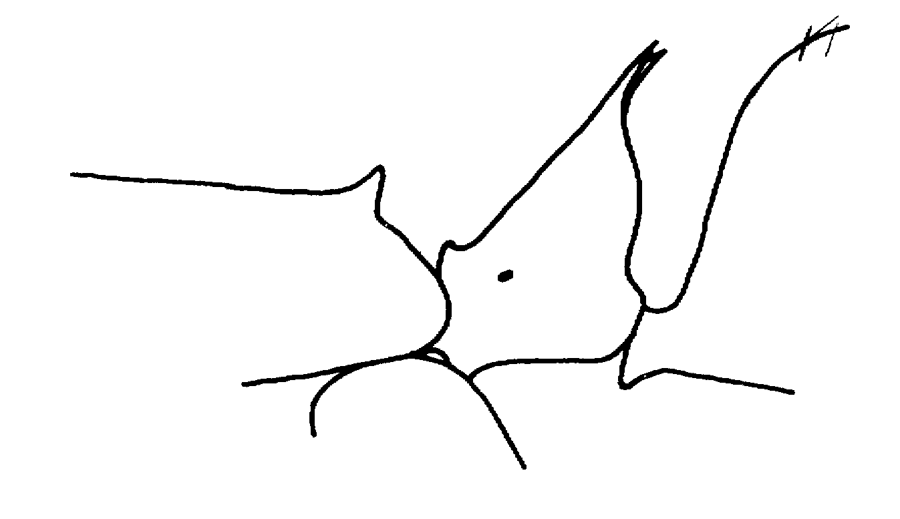
Fig. 12. Propodeum and petiole of a worker of A. kempfi (from Brown, 1978).
- Propodeal teeth absent, or at most low, inconspicuous and obtuse (Hispaniola) ……………………..….... 8
8(7). Mandibles longer, MI > 61; paired teeth of petiolar apex very long (L > 0.2 mm) and slender (Haiti: La Hotte Massif, 1000+ m) ……...….. longispina
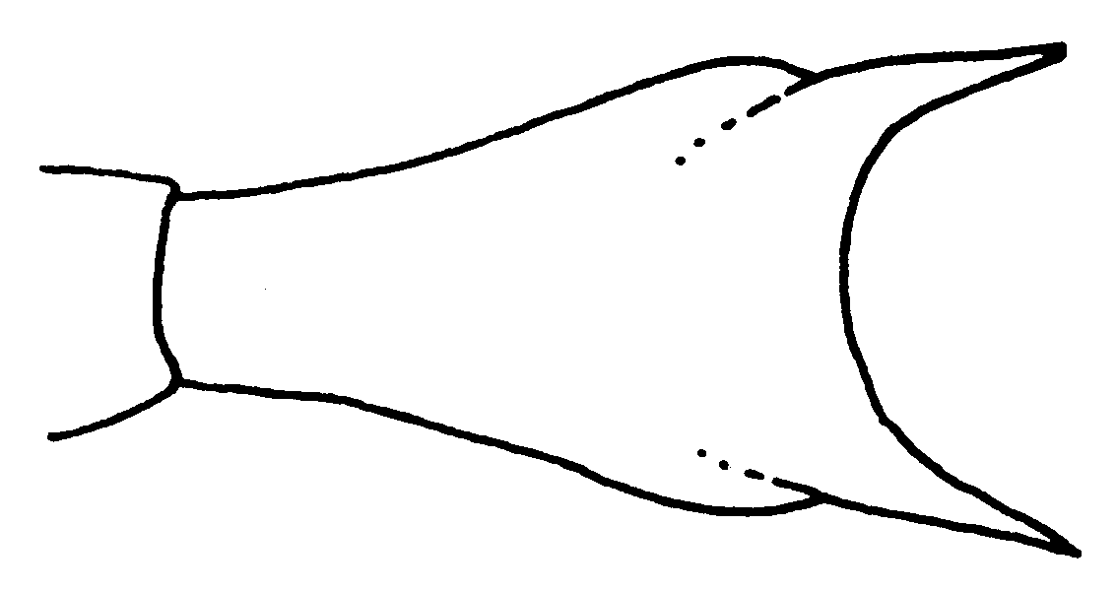
Fig. 13. Petiole of a cotype worker of A. longspina, as seen from above.
- Mandibles shorter, MI < 61; petiolar teeth shorter, L not over 0.15 mm (E Central Haiti) …...… haytianus
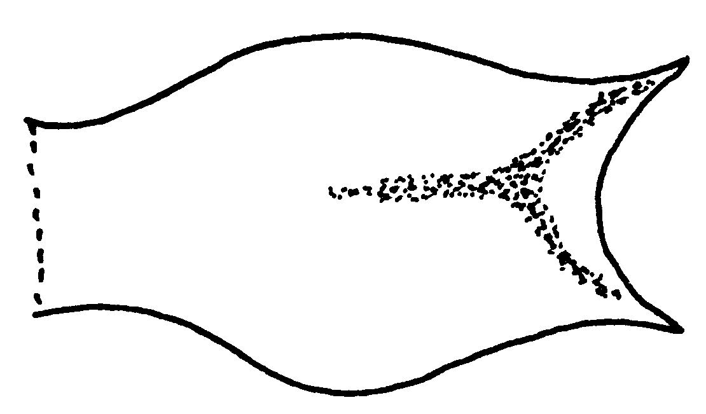
Fig. 14. Petiole of a cotype worker of A. haytianusI as seen from above.
9(6). Six teeth present on preapical mandibular border, apical 4 teeth about equal in size (Fig. xx) . vallensis Lattke
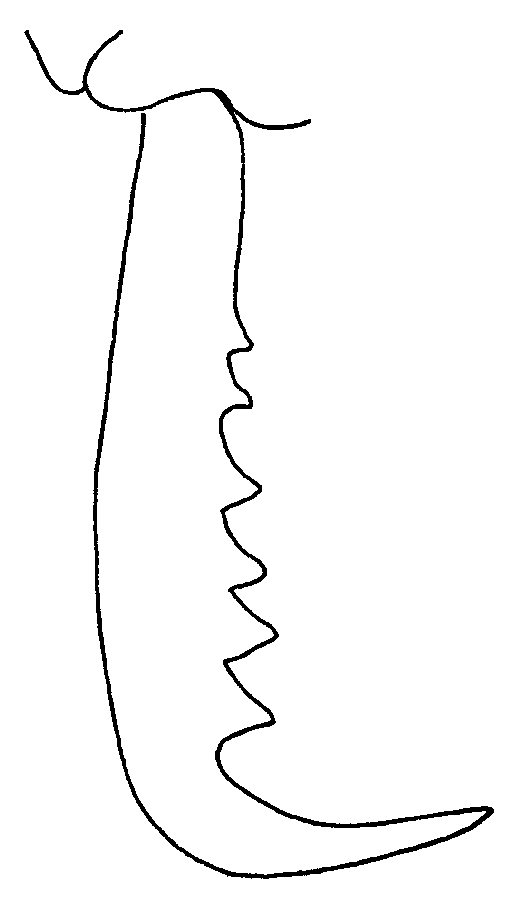
Fig. 15. Mandible of a paratype worker of A. vallensis.
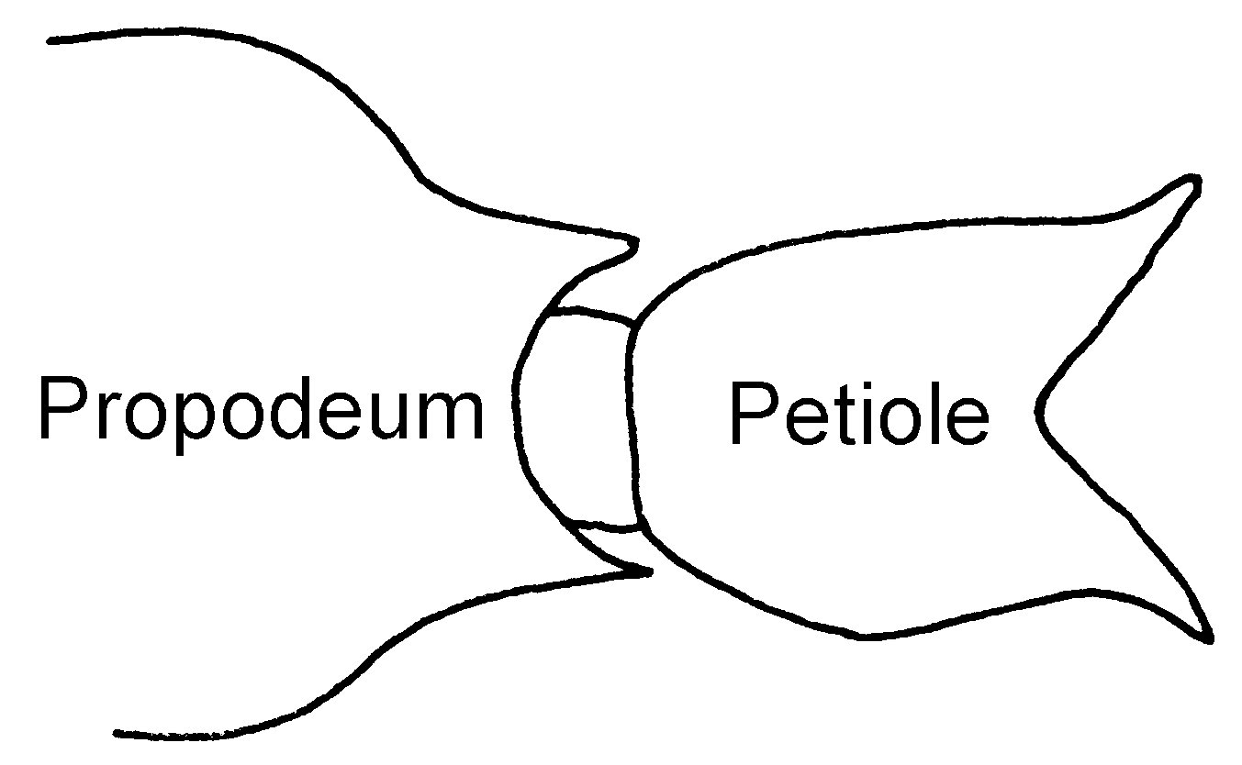
Fig. 16. Petiole of a paratype worker of A. vallensis, as seen from above.
- Fewer than 6 teeth on preapical border ……………. 9a
9a. Three of the teeth on each inner preapical mandibular border large and spiniform when unbroken (Brasil: Pará, Amazonas) …… horridus Kempf
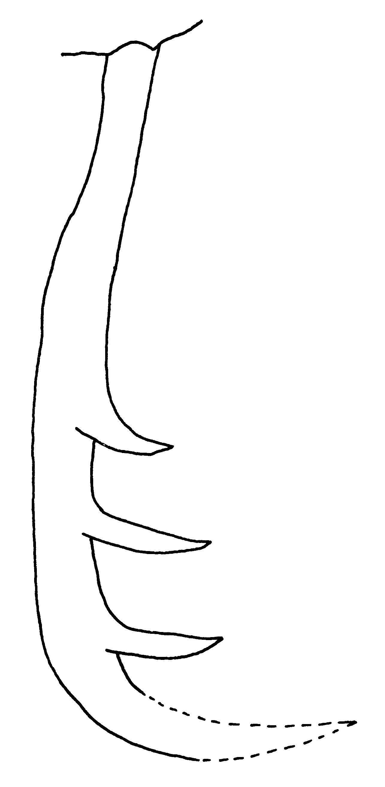
Fig. 17. Mandible of a worker of A. horridus (Brasil).
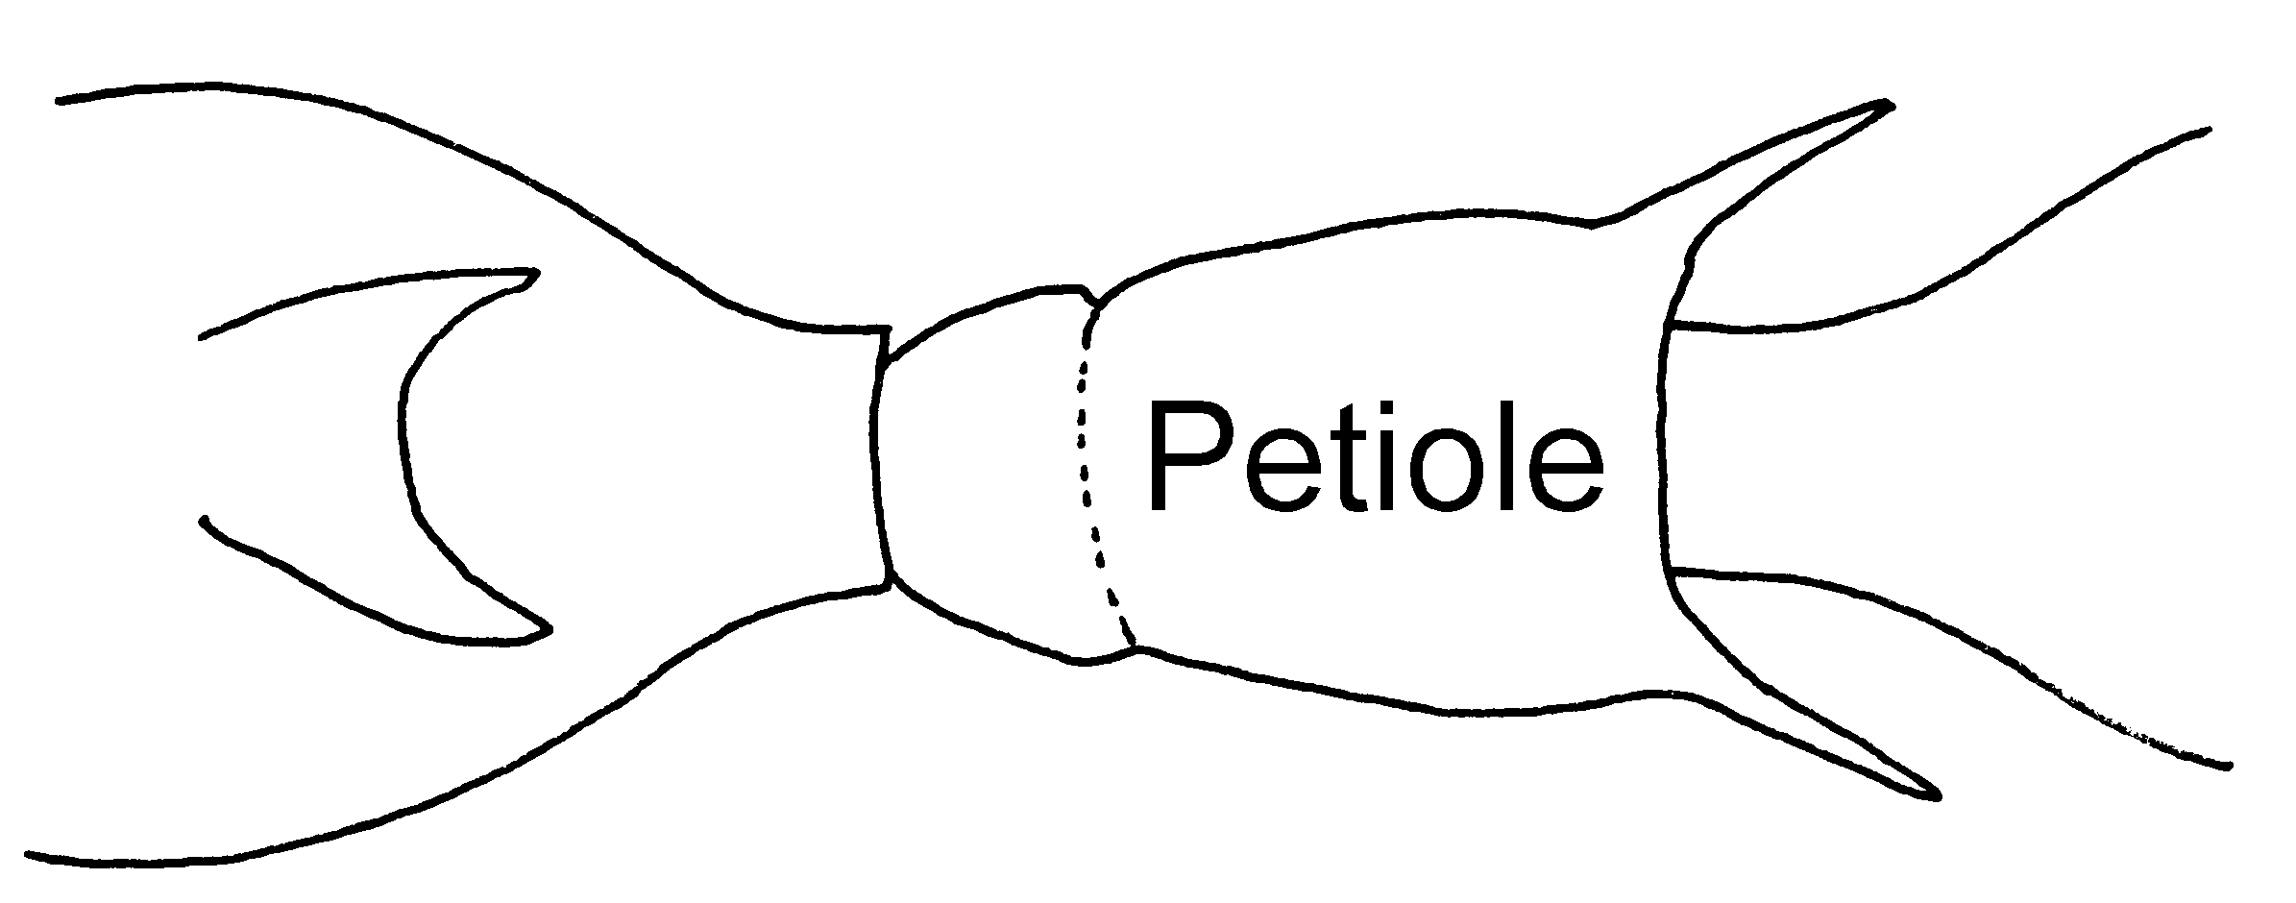Fig. 18. Petiole of a worker of A. horridus, as seen from above (Brasil).
- Two of the teeth on each inner preapical mandibular border large and spiniform when unbroken (Brasil: NE Mato Grosso) ……………………....... vexator
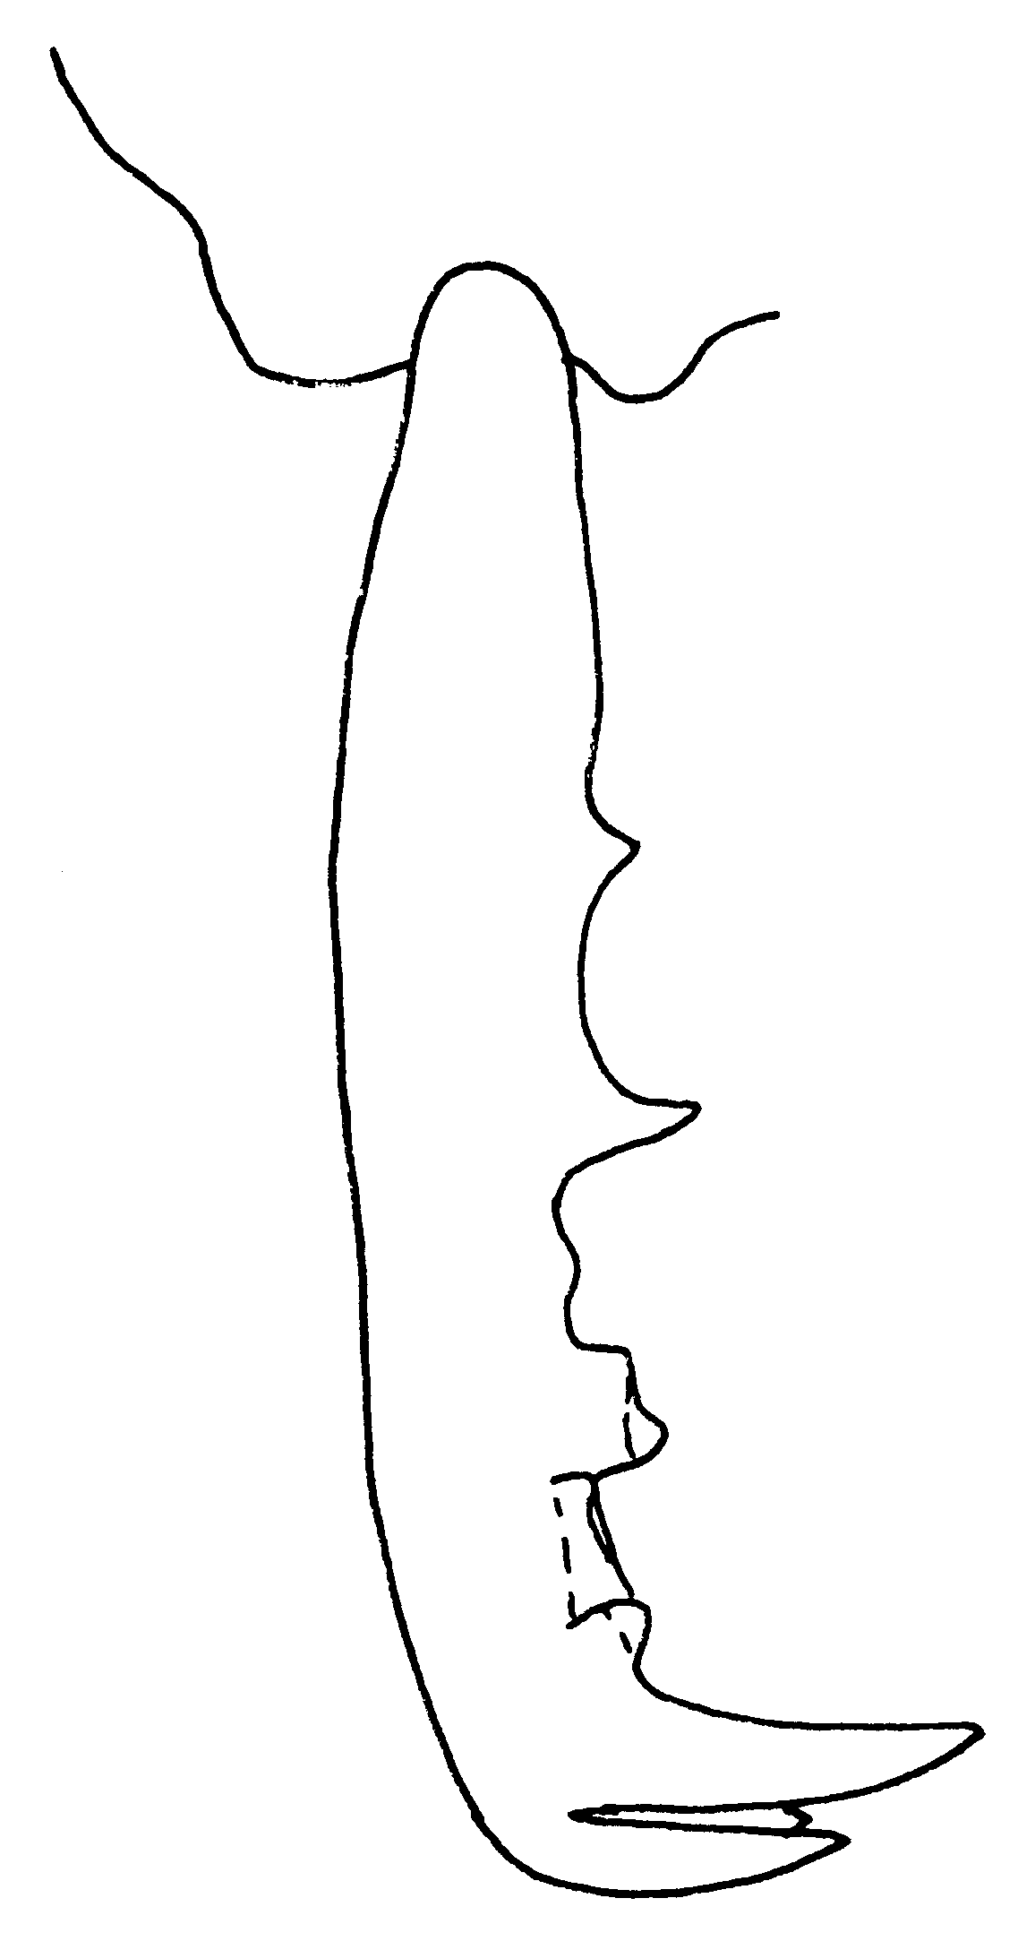
Fig. 19. Mandible of a paratype worker of A. vexator.
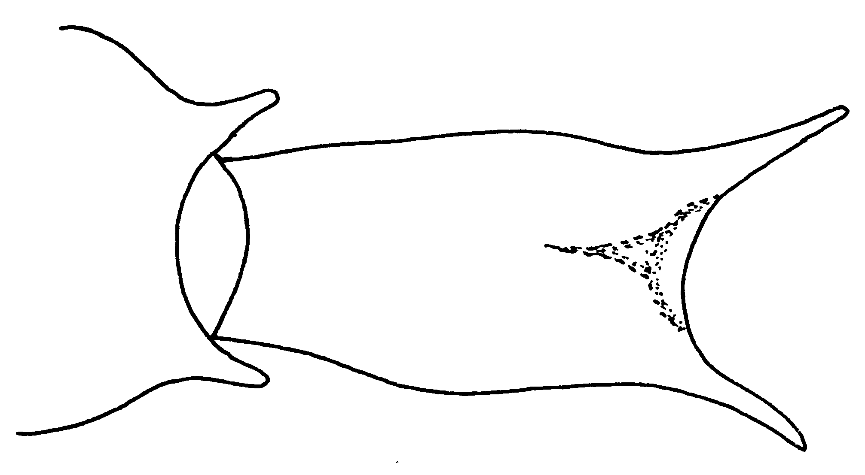
Fig. 20. Petiole of a paratype worker of A. vexator as seen from above.
10(1). Petiolar node as seen from front or rear with apical margin rounded, slightly flattened, or weakly emarginate in the middle, but in this case, the free corners are always broadly rounded (altisquamis group) ………………… 11
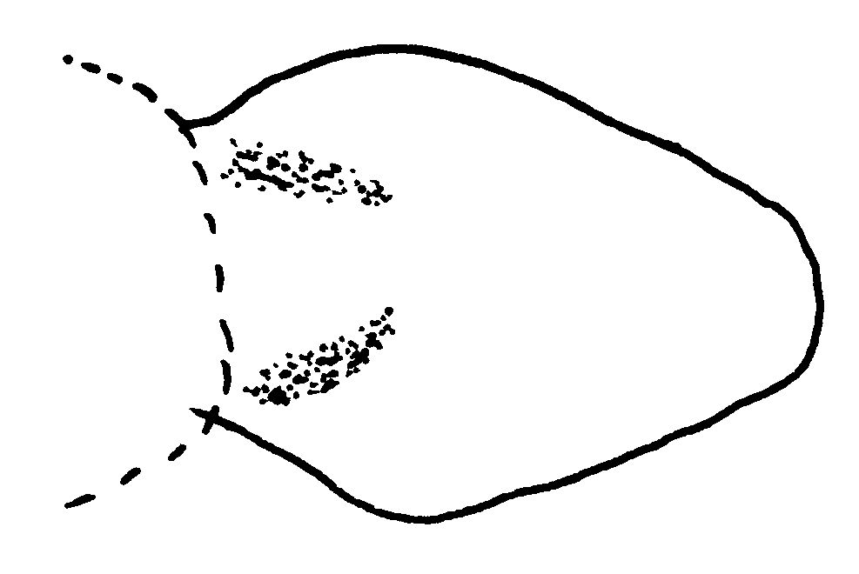
Fig. 21. Petiole of a worker of A. altisquamis (Tucumán, Argentina).

- Petiolar node as seen from front or rear with apical margin distinctly concave, the 2 free corners forming angles or produced as teeth (figs. 43, 44) …………………………………….… 12
11(10). Pronotum smooth only in the middle of the disc, its sides striolate and scarcely shining; size larger, HW > 1.3 mm; vertex mostly striolate and vaguely roughened, with inconspicuous punctulae in the narrow posterior smoother zone (S Brasil, N Argentina) …………………….……… altisquamis
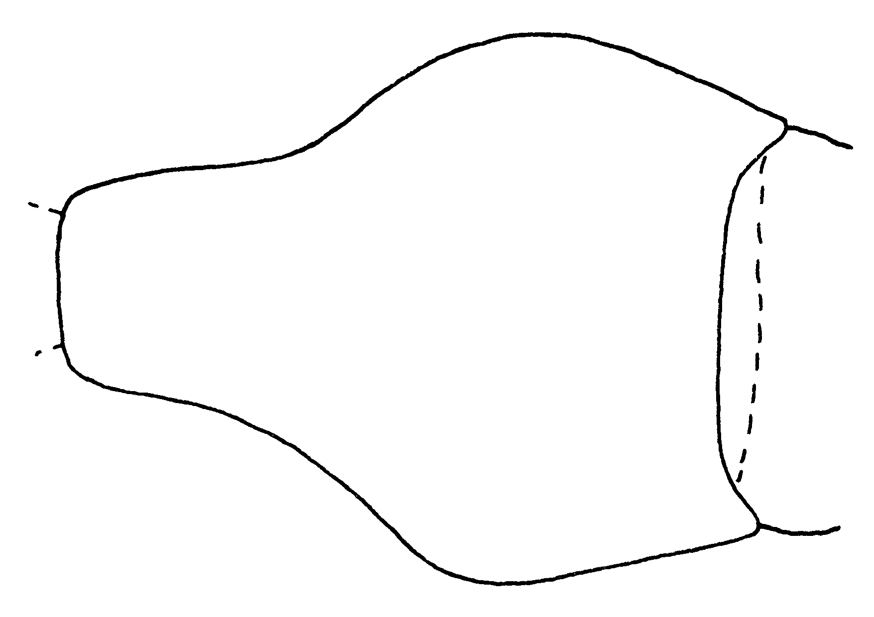
Fig. 22. Pronotum of a worker of A. altisquamis (Tucuman, Argentina). Add sculpture???
- Pronotum smooth and shining on disc and sides, with spaced punctures; head width <1.3 mm; vertex mostly smooth and shining, thickly sown with separate, conspicuous punctures (SE Mexico) …………...……… orchidicola
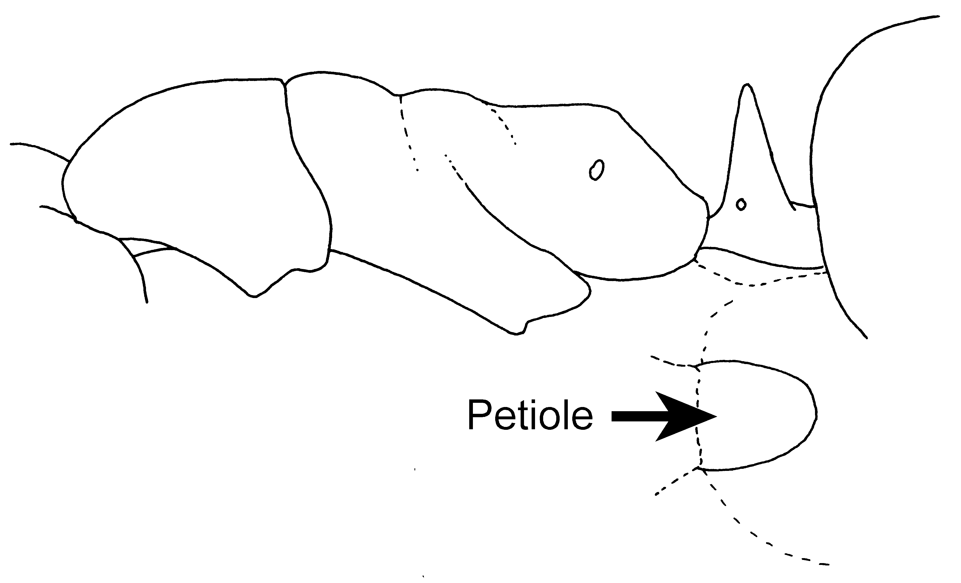Fig. 23. Mesosoma and petiole of a worker of A. orchidicola as seen from the side, and the petiole as seen from above.
12(10). Small species, combined length of head and closed mandibles (head length + mandible length) < 1.75 mm; second segment of antennal funiculus less than twice as long as broad (mayri complex) …………………………… 13
- Larger species (HL + Ml > 1.75 mm); second segment of antennal funiculus at least twice as long as broad ……………..………………………... 14
Some specimens in the intermediate size range, HL + ML 1.60-1.75 mm, may possibly belong in couplet 14. (coastal mts. of SE Brasil) ……………………………………………. problem specimens, inermis group
13(12). Head and trunk very finely striolate, sericeous-opaque (pronotum sometimes densely punctulate rather than striolate but still opaque), mesopleuron completely sculptured; eyes usually 0.13-0.16 mm in greatest diameter; color usually uniform reddish- or yellowish-brown, rarely somewhat infuscated (SE and C Brasil S to N Central Argentina) ………..… neglectus
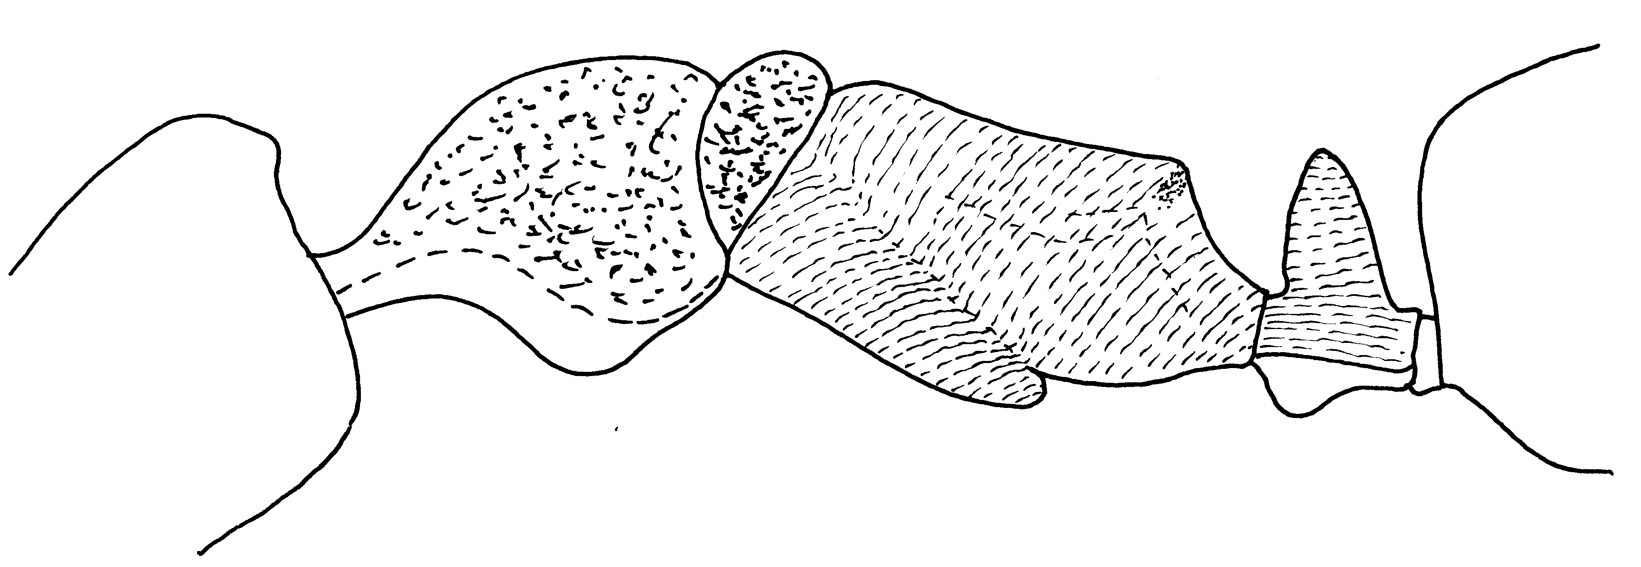Fig. 24. Mesosoma and petiole of a worker of A. neglectus (Cavaru, PE, Brasil?).
- Sculpture and color variable; head striate for varying distances; pronotum striate or smooth, in part or entirely; eyes usually 0.09-0.13 mm in greatest diameter; male terminalia as in figs. 70 and 71 (S Mexico and W. Indies S through Amazon Basin to Bolivia; W of Andes to S Ecuador) ……...…. mayri
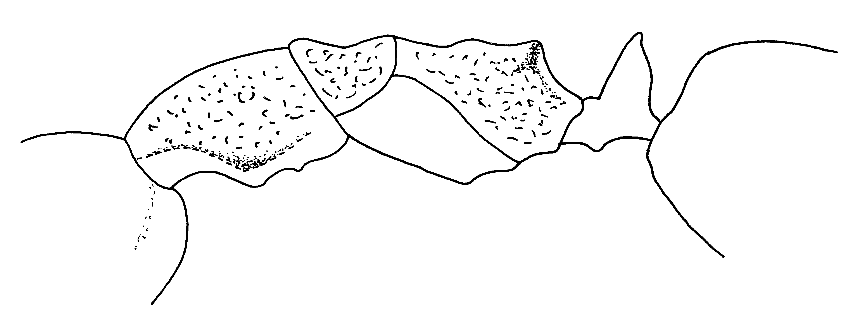Fig. 25. Mesosoma and petiole of a worker of A. mayri (Honduras).
14(12). Modest-sized species, head width < 1.20 mm; pronotum smooth or variously sculptured, but not coarsely rugose; petiolar teeth undeveloped or shorter, rarely longer than as shown in (Fig. ) …………..………………….. 15
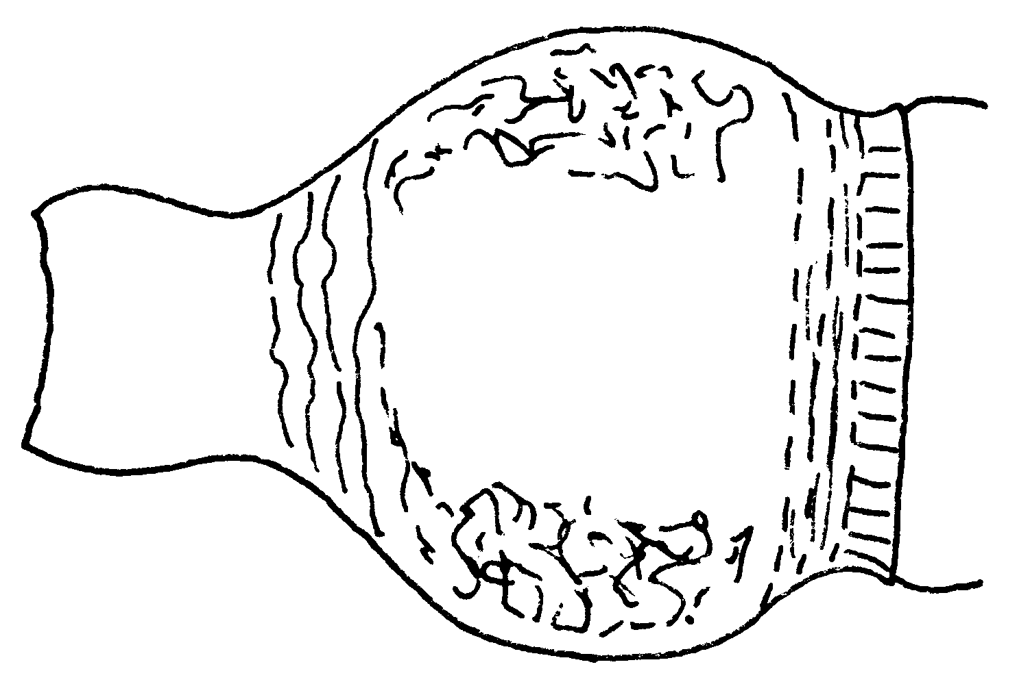
Fig. 26. Pronotum of a worker of A. minans (Río Toro, Costa Rica).
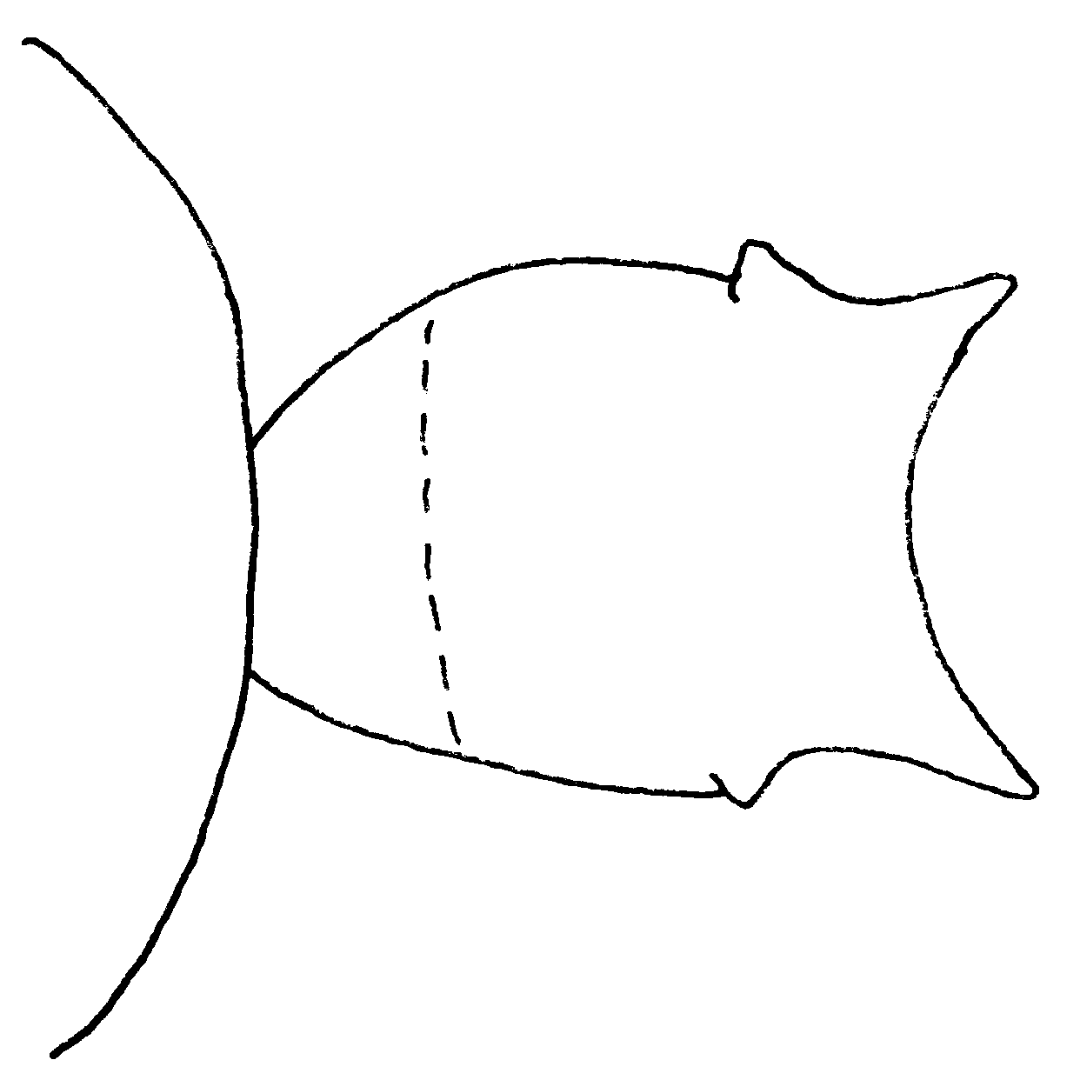
Fig. 27. Petiole of a worker of A. minans (Río Toro, Costa Rica) as seen from above.
- Larger species, HW > 1.2 mm; pronotum coarsely reticulate-rugose; petiolar teeth long, acute and strongly diverging (hylean S. America) ………… ………………………….…. bispinosus
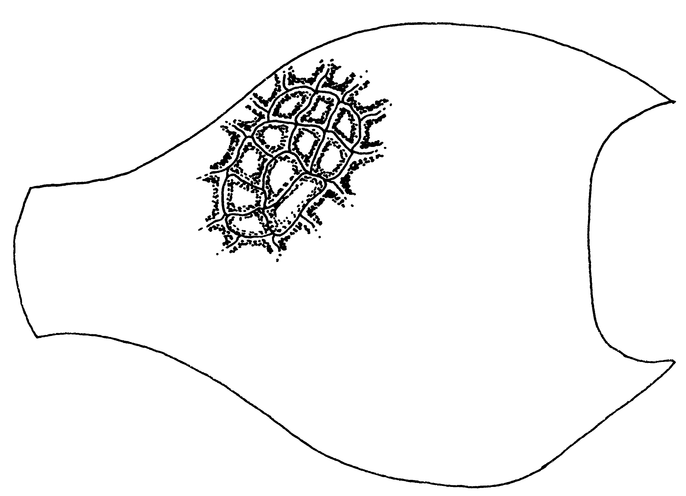Fig. 28. Pronotum of a worker of A. bispinosus (Buenaventura, Colombia), as seen from above. Only a small section of the sculpture is shown.
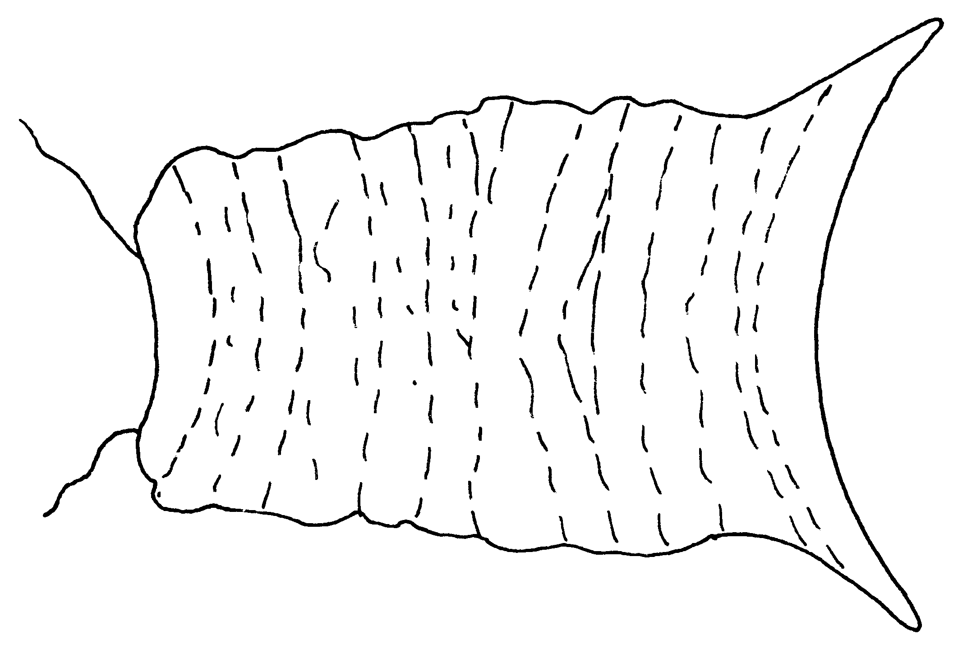
Fig. 29. Petiole of a worker of A. bispinosus (Buenaventura, Colombia), as seen from above.
15(14). Compound eyes < 0.08 mm greatest diameter (Central America) …….…………………………... minans
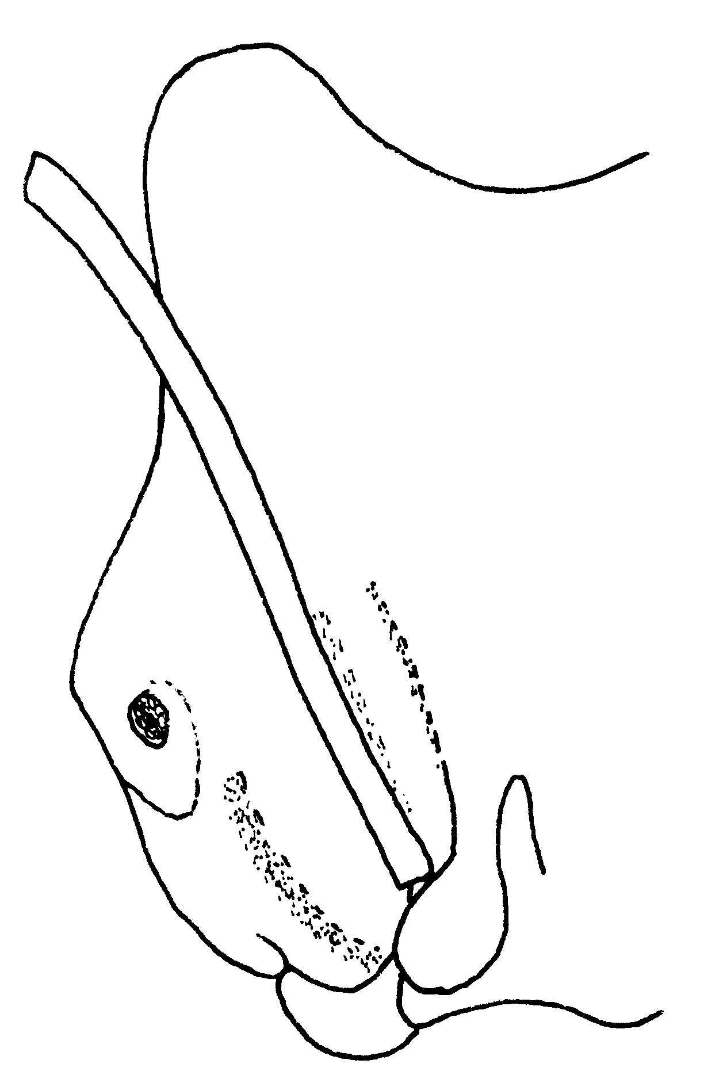
Fig. 30. Right half of the head of a worker of A. minans (Río Toro, Costa Rica).
- Eyes > 0.08 mm greatest diameter (inermis group) …………….16
16(15). Dorsum of head and most or all of trunk finely and densely punctulate and matt; pronotum with a single pair of long standing hairs (one or both of which may be missing); color uniform light brownish-yellow (Fig. xx) ….… 17
- Head of trunk with varied sculpture: striate, costulate or rugulose, and partly smooth; pronotum with more than 4 standing hairs; color variable, often variegated (Fig. ) …..…… …….18
17(16). Inner mandibular borders each with a single margin bearing a series of coarse teeth (Fig. xx); teeth at apex of petiolar node strong and acute, like those shown in Fig. (N Venezuela, SW to Ecuador, in forest) ….………………….…… simoni
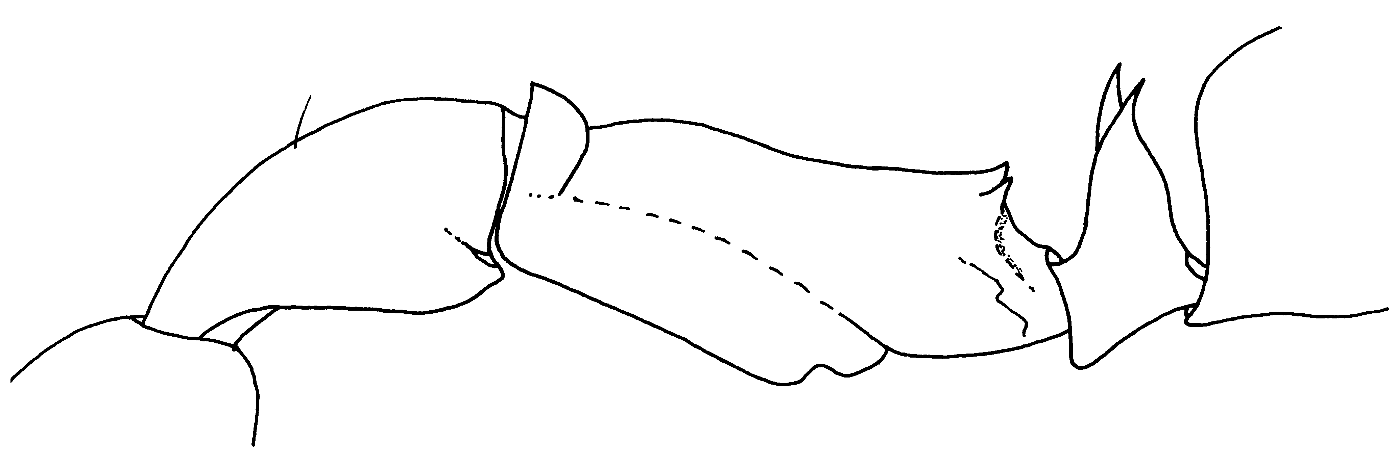
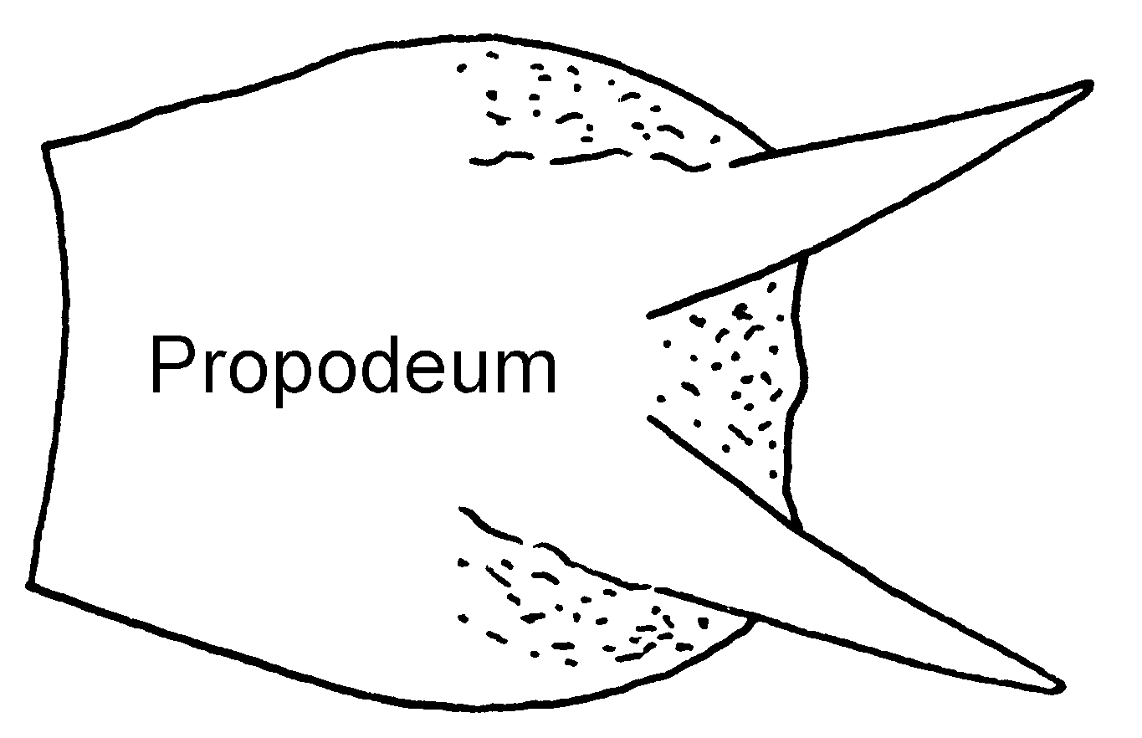
Fig. 31. Mesosoma of a worker of A. simoni (Ecuador). Petiole or propodeum?
- Inner mandibular borders each with 2 margins; dorsal margin unarmed except for the preapical angle; ventral margin with variably distinct denticles, or unarmed (Fig. xx); corners of apical margin of petiole not acutely dentiform (Fig. 4 N S. America, Trinidad, sporadic in Lesser Antilles, mainly in savanna or thin woodlands) ..……………... inermis
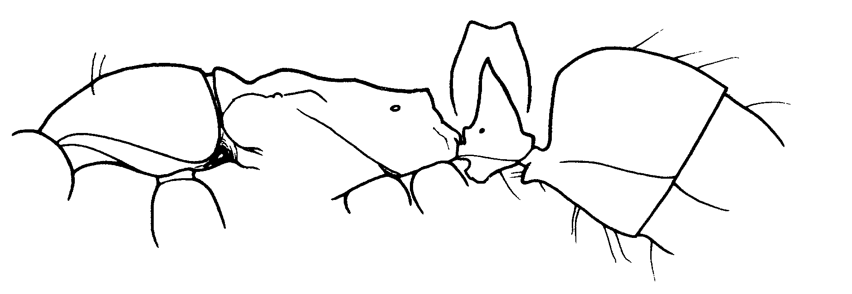
Fig. 32. Mesosoma, petiole (inset shows petiole from front) and gaster of a worker of A. inermis (from Brown, 1978).
18(16). Mesonotum and propodeum with several to many standing (mostly inclined) hairs; mandibles (Fig. 7) only slightly broadened apicad, their ventral inner margins usually unarmed (Hylea to Bolivia) ………..…….……… targionii

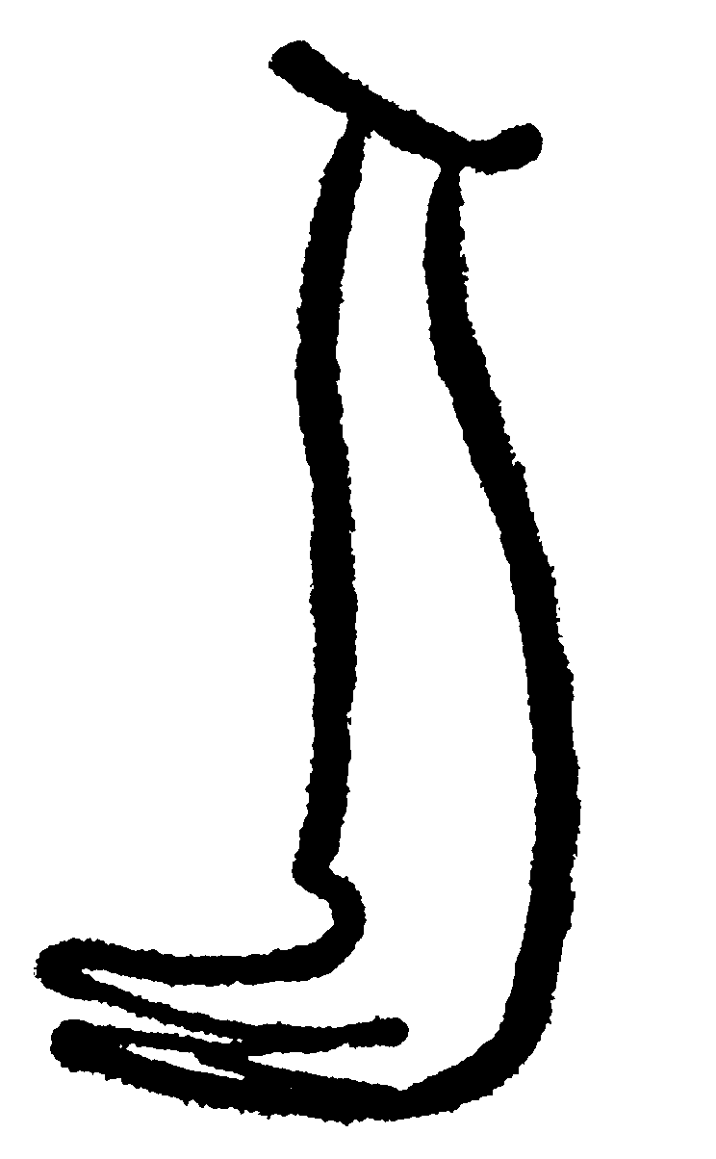
Fig. 33.Mandible of a worker of A. targioni (from Brown, 1978).
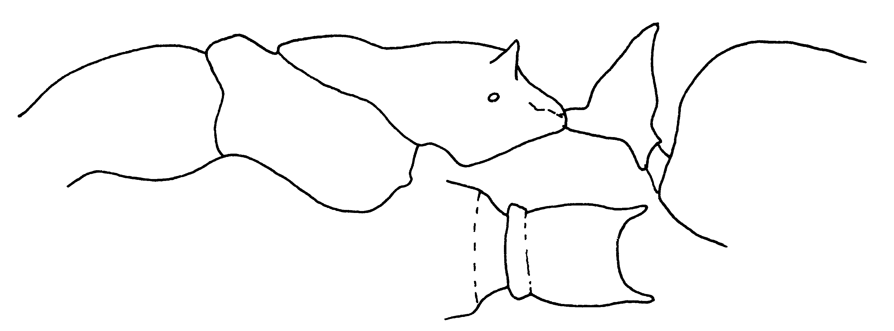Fig. 34. Mesosoma and petiole of a worker of A. targionii as seen from the side, and the petiole as seen from above.
- Mesonotum and propodeum with at most 1 or 2 standing hairs; mandibles broadened apicad (Fig. 8), their inner margins with or without low teeth or denticles (N S. America, Panama) …… …………………………...….. diegensis
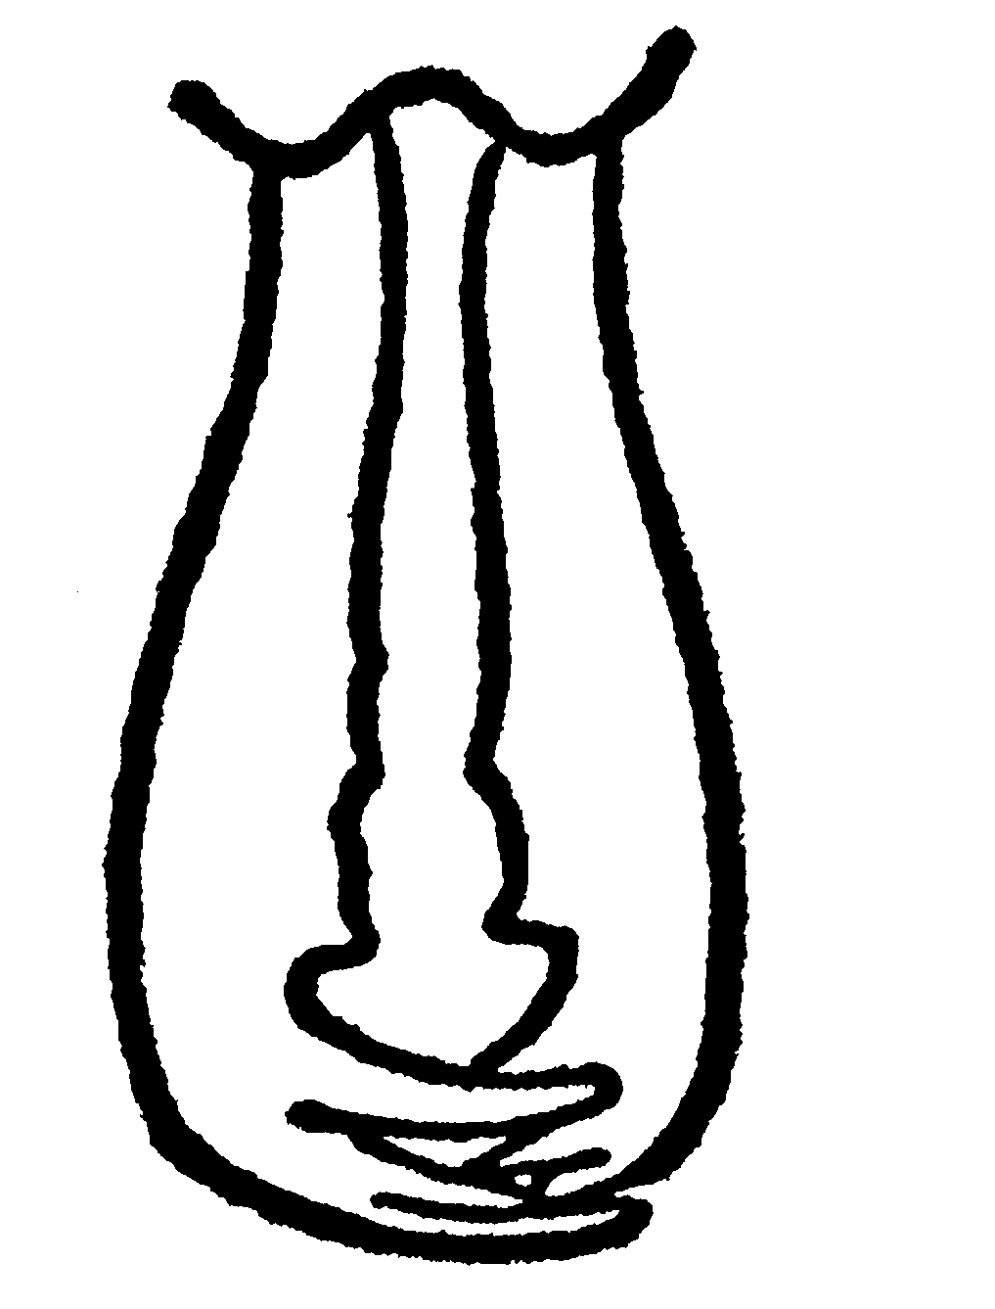
Fig. 35. Mandibles of a worker of A. diegensis (from Brown, 1978).
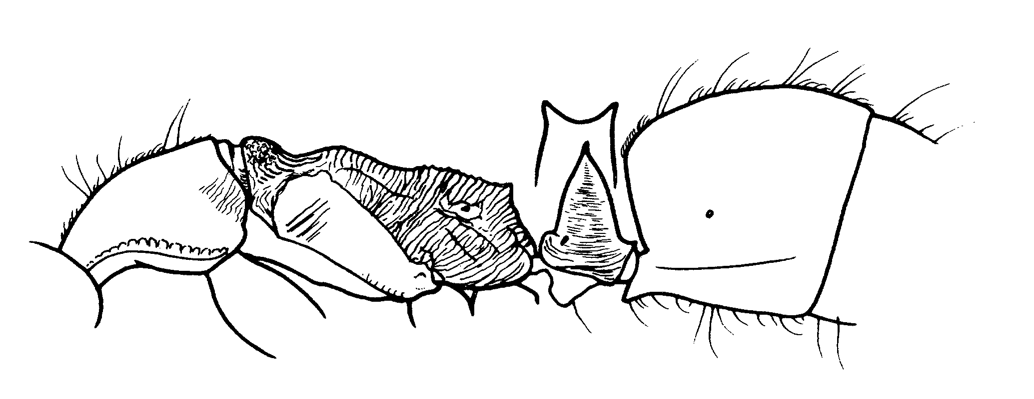
Fig. 36. Mesosoma, petiole (from front in inset) and gaster of a worker of A. diegensis (from Brown, 1978).
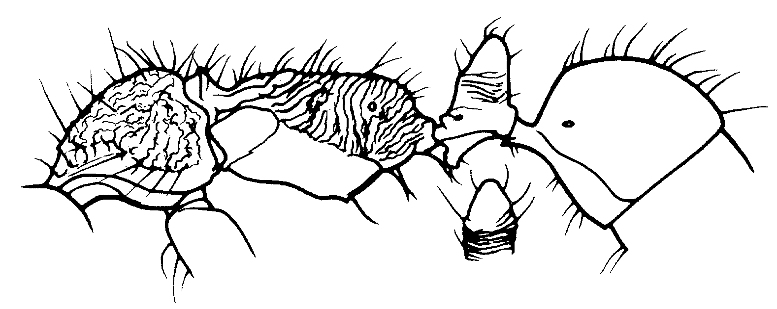
rugosus is this in New World?

Anochetus diegensis Forel have

Figs. ; Map

Discussion. The preapical border of the mandible is without teeth, although fine serrations or denticles may be present. The apex of mandible has 3 teeth. The scape extends to the posterior lateral corner. The pronotum has a pair of large hairs at the shoulder, and additionally approximately six hairs scattered across the surface, the mesonotum in the propodeum are without hairs, or 1 - 2 hairs may be present. The propodeal spines are developed into thick angles, the spines on the petiole are long and semiacute. The dorsum of the head is sculptured, although parts may be smooth and glossy, the sides of the head are smooth and glossy, the mesosoma is finely sculptured, with rugulae and striolae, most of the mesopleuron is smooth and glossy, as is the sides of the pronotum. The dorsum of the gaster is smooth and glossy, although some fine sculpture may be found on the anterior one-third of the gaster.
The pattern of hairs on the dorsum of the mesosoma would separate this species from most others. It could be confused with A. targionii (South American), but the mesosomal hair pattern would separate the two species.
Distribution. BRASIL: Pará, BRITISH GUIANA:, COLOMBIA: Antioquia, Guajira, Magdalena, Meta ECUADOR: Napo, Puerto Misahuallí, PANAMA: Canal Zone (Barro Colorado Island), PERU: Puerto Maldonado, SURINAME: TRINIDAD: VENEZUELA: Bolívar, Carabobo, Guarica, Miranda.
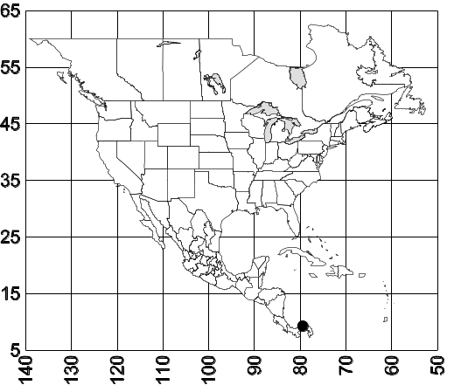 Map 1. Anochetus diegensis.
Habitat. Lowland forest. Shady creek bed. 260m, tierra firma forest. Edge of small gap.
Biology. Foraging in litter.

Anochetus emarginatus (Fabricius) have

Figs. ; Map

Discussion. This is a large ant (total length 6 mm) , yellowish, or reddish brown to dark brown, in which the medial margin of the mandible has more than 10 teeth and denticles. The scape extends approximately three funicular segments past posterior lateral corner. The mesosoma is mostly sculptured (with striate, rugae, or granulate), although the center of the dorsum of the propodeum may be smooth and glossy. The mesopleural tooth is well-developed, and extends laterally perpendicular to the axis of the body when seen from above. The propodeal spines are small, but well-developed. The teeth on the petiole are also small, but acute. The dorsum of gaster is smooth and glossy.
the large size worker of this species would separated from most of the others in the genus. The large number of teeth on the medial border of clypeus of the mandible with distinguish it from many of the other large species. The anterior face of the petiole forms and approximately 50° angle with the plane of the ventral surface of the petiole, and is convex. This character would separate it from two others (A. inca, A. elegans) in which the anterior face petiole forms a many 20 - 30° angle. The fine striation on the dorsal surface of the pronotum would separate it from the Brasilian A. oriens, in which the dorsum of the propodeum lacks striation. The relatively short (> 0.1 mm), apically rounded petiolar teeth would distinguish this species from the Caribbean A. testaceus, in which the petiolar teeth are longer than 0.1 mm. Finally, the rugose and opaque upper front the petiolar node would separate this species from the Costa Rican A. striatulus, in which this part of the node is finely striolae.
Distribution. Colombia (Vichada, Meta), Trinidad, and the Amazon Basin, unknown from North America, but may be found there.
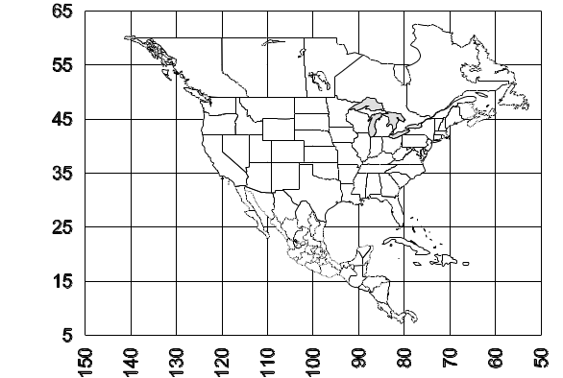 Map 2. Anochetus emarginatus.
Habitat. 73-191, 846, 657, 851,
Biology.

Anochetus kempfi Brown have

Figs. ; Map

Discussion. The workers of this pale brown species are relatively large (total length about 6 mm). The mandibles have approximately 6 - 7 teeth along the medial border, in addition to the three well-developed teeth at the apex. The eyes extend well past the sides of the head and the scapes extend about two funicular segments past the posterior lateral corner. The mesosoma is elongate, with the dorsum being approximately in the same plane. The propodeal spines are small, but well-developed, and are pointed vertically. The spines on the petiole are very elongated and sharp.
The entire dorsum of the head is finely striated, the pronotum is transversely striated and the dorsum of the propodeum is covered with transverse rugulae. The side of the pronotum is longitudinally striate, with the striate directed upwards towards the posterior, much of the mesopleuron is smooth and shiny, but the remainder has transverse striae, the side of the propodeum is mostly covered with transverse striae. The petiole is finely sculptured and mostly shining, the gaster is strongly shining.
The relatively large size of this ant would separate it from many of the other species. The number of teeth on the medial border of the mandible would separate it from other Caribbean species, such as A. testaceus and A. emarginatus. The small, vertically directed spines on the propodeum would distinguish this species from Caribbean (Hispaniola) A. haytianus and H. longispina.
Distribution. Puerto Rico (Arecibo), ???
Map 3. Anochetus kempfi.
Habitat. ???
Biology. ???

Anochetus mayri Emery

Figs. ; Map

Discussion. The workers are relatively small (about 4 mm total length), dark brown ants, with slightly lighter colored appendages. The mandibles have three well-developed, apical teeth, but the medial borders are without teeth and rarely with tiny denticles. The scapes extend nearly to the posterior lateral corners. The eyes are small (maximal length 0.15 mm) The propodeal spines form only small angles, the petiolar teeth are poorly developed (length about 0.04 mm).
Most of the dorsal surface of the head is striate, the dorsum of the mesosoma has mostly transverse striae or rugulae, although the central region of the dorsum of the pronotum is usually relatively smooth and glossy. The side of the pronotum is mostly longitudinally striate, the side of the propodeum is obliquely rugulose, and nearly the entire mesopleuron is smooth and glossy.
This small species is difficult separate from many of the other small Anochetus. It can be separated from A. altisquamis and A. orchidicola by the petiolar teeth, which are lacking in the latter two species. The glossy mesopleuron would separate it from the widely distributed South America A. neglectus, in which the mesopleuron is completely sculptured. Its relatively small size would distinguish it from A. bispinosus and allies.
Distribution. Southern Mexico (Tabasco, Chiapas) south through Costa Rica (Puntarenas), Panamá (Chiriquí, Panamá), Colombia (Meta) south to Bolivia, Caribbean.
Map 4. Anochetus mayri.
Habitat. Coffee and cacao plantations, Oak forest, riparian oak forest, bamboo forest to upper montane, wet cloud forest, up two 1500 m.
Biology. Most specimens are collected in leaf litter. An alate female was collected in May in Panamá. # 10521, 10583

Anochetus micans Brown

Figs. ; Map

Discussion. This is a relatively large (total length of worker about 7 mm), medium brown species. The medial border of the mandibles has more than 10 small teeth or denticles, in addition to the three, well-developed apical teeth. The eyes are large (maximum diameter 0.36 mm) and the scapes extend at least two funicular segments past the posterior lateral corner. The propodeal spines and petiolar spines are poorly developed, and consist of simple angles. The apex of the petiole is concave, as seen from the front.
Much of the head is covered with longitudinal striae, but the posterior corners are smooth and glossy. The dorsum of the pronotum has many transverse striae, but the central region may be shiny, and relatively smooth, the side of the pronotum is longitudinally striate. The mesonotum has transverse striae, the mesopleuron is covered with transverse striae, most of the propodeum is covered with transverse rugulae. The posterior face of the propodeum is smooth and glossy, with transverse rugulae. Much of the petiole is transversely (anterior face) or longitudinally (side) striate, but much of the surface is smooth and glossy, especially the region near the apex, and the posterior face. The gaster is smooth and glossy.
Erect hairs are sparse on most surfaces, but are present on the mandibles, a few hairs are present on the dorsum of the head, and hairs are present on most surfaces of the gaster, except for the first tergum.
The large numbers of teeth and denticles on the medial border of the mandible (> 10) would separate this species from most other Mexican and Central American species, except for A. striatulus and possibly the South American A. emarginatus. The pale brown, or light ferruginous brown color would separate it from the darker reddish-brown A. striatulus. Additionally, the petiolar teeth are very short (< 0.1 mm in length), as contrasted with the longer petiolar teeth of A. striatulus (> 0.1 mm in length). It can be distinguished from the South American (including northern Colombia, and may extend into Central America) A. emarginatus as the dorsum of the pronotum is finely sculptured (roughly sculptured with transverse striae, and of mostly dull in A. emarginatus) and in the region near the apex of the front face the petiole is smooth and glossy (entire front face of petiole roughly sculptured in A. emarginatus).
Distribution. Mexico (Chiapas Oaxaca Quintana Roo), Belize.
Map 5. Anochetus micans.
Habitat. ???
Biology. Number 10728, number 10755, number 10720B, number 10720 E, A

Anochetus minans Mann don’t have

Figs. ; Map

Discussion. ???
Distribution.
Map 6. Anochetus minans.
Habitat. ???
Biology.

Anochetus orchidicola Brown have

Figs. ; Map

Discussion. The worker is a small, yellowish-brown specimen, in which the preapical margin of the mandible is without teeth, there are 3 well-developed teeth at the apex. The scape is relatively short, and fails to reach the posterior lateral corner by about 2½ funicular segments. The dorsum of the propodeum is concave, the propodeum lacks spines, the petiole is slender when viewed in profile, with the front and rear faces being straight or slightly concave. The apex of the petiole is rounded, without a spine. The dorsum of the head is sculptured with striae or punctures, the sides of the head are weakly to moderately shining, the dorsum of the mesosoma is transversely striolate (except the dorsum of the pronotum, which is mostly smooth and glossy), the sides of the mesosoma, especially the mesopleuron are smooth and glossy, the dorsum of the gaster is smooth and glossy.
The lack of preapical teeth would separate this species for most of the others. The relatively smooth and glossy pronotum would separate this species from A. altisquamis, which occurs in Brazil and Argentina. Thus it is not likely that this species would be confused with any others in North America.
Distribution. COSTA RICA: Puntarenas (11k SW Estación Biológica La Selva). PANAMA: Bocas del Toro (Sendero Divisa).
Map 7. Anochetus orchidicola.
Habitat. Wet cloud forest.
Biology. Most specimens were collected in leaf litter.

Anochetus striatulus Emery don’t have

Figs. ; Map

Discussion. ???
Distribution. Costa Rica.
Map 8. Anochetus striatulus.
Habitat. ???
Biology.

Literature Cited
Brown, W. 1978. Contributions toward a reclassification of the Formicidae, Part VI: Ponerinae, tribe Ponerini, subtribe Odontomachiti; Section B: Genus Anochetus and bibliography. Stud. Entomol.20: 549-638
Lattke, J. 1986. Two new species of neotropical Anochetus Mayr (Hymenoptera : Formicidae). Insectes Soc. 33:352-358.
Serna, F. 1999. Hormigas de la zona de influencia del Proyecto Hidroeléctrico Porec II. Unpublished Master’s Thesis, Universidad Nacional de Colombia, xiv + 250 pp.

Species | have | discussion | comparison | distribution | map | habitat | biology | Comments
diegensis | yes | yes | yes | yes | yes | yes | yes
emarginatus | yes | yes | yes | no | no | no | no
kempfi | yes | yes | yes | no | no | no | no
mayri | yes | yes | yes | yes | no | yes | yes
micans | yes | yes | yes | yes | no | no | no
minans | no | no | no | no | no | no | no | Describe at mcz
orchidicola | Yes? | yes | yes | yes | yes | yes | yes | Check at mcz
striatulus | no | no | no | no | no | no | no | Look for at mcz
New species |  | no |  | no | no | no | no
New species |  | no |  | no | no | no | no
New species |  | no |  | no | no | no | no
 |  | no |  | no | no | no | no
 |  | no |  | no | no | no | no
 |  | no |  | no | no | no | no

Illustrations needed: Anochetus
# | Fig.# | Species | Specimen | View | Status | Comments
1 |  | New species | holotype | head |  | Need description also
2 |  | New species | holotype | meso
3 |  | New species | holotype | head
4 |  | New species | holotype | meso
5 |  | New species | holotype | head
6 |  | New species | holotype | meso
7
8
9
10
11
12
13
14
15
16
17
18
19
20
21
22
23
24
25
26
27
28
29
30
31
32
33
34
35
36

based on Brown (1978).

