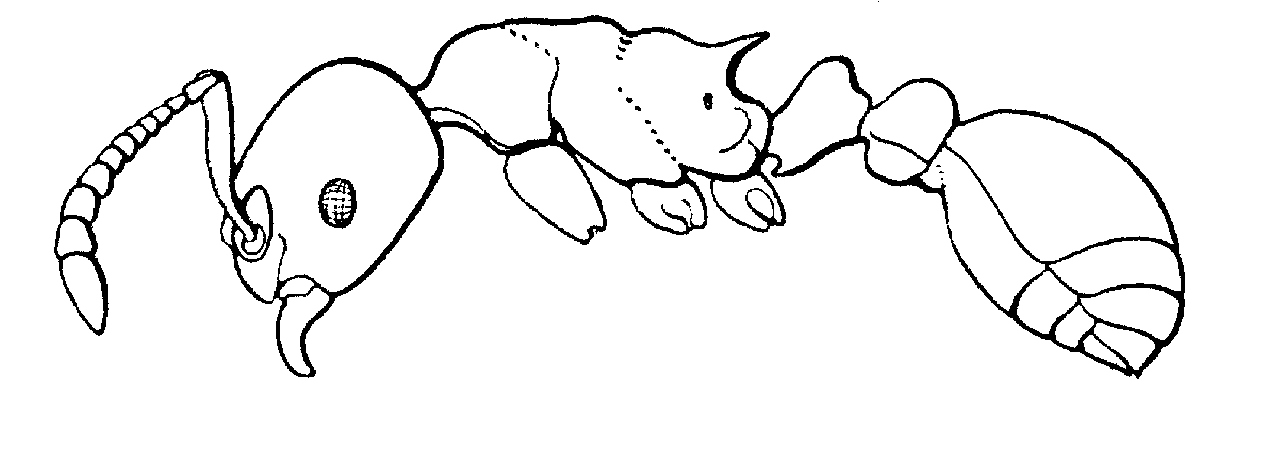
Fig. 1. Side view of a worker of M. brevinodis (from Creighton, 1950).
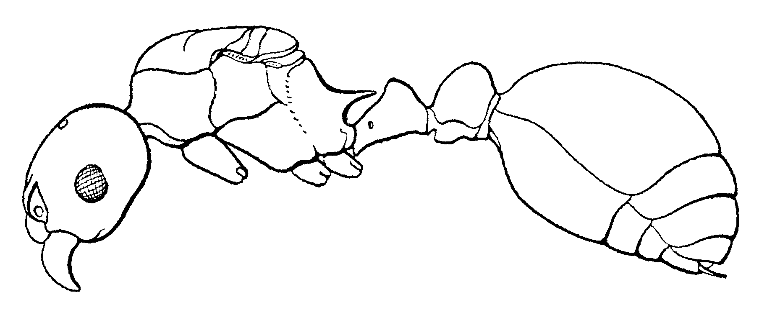Fig. 2. Side view of a female of M. brevinodis (from Creighton, 1950).
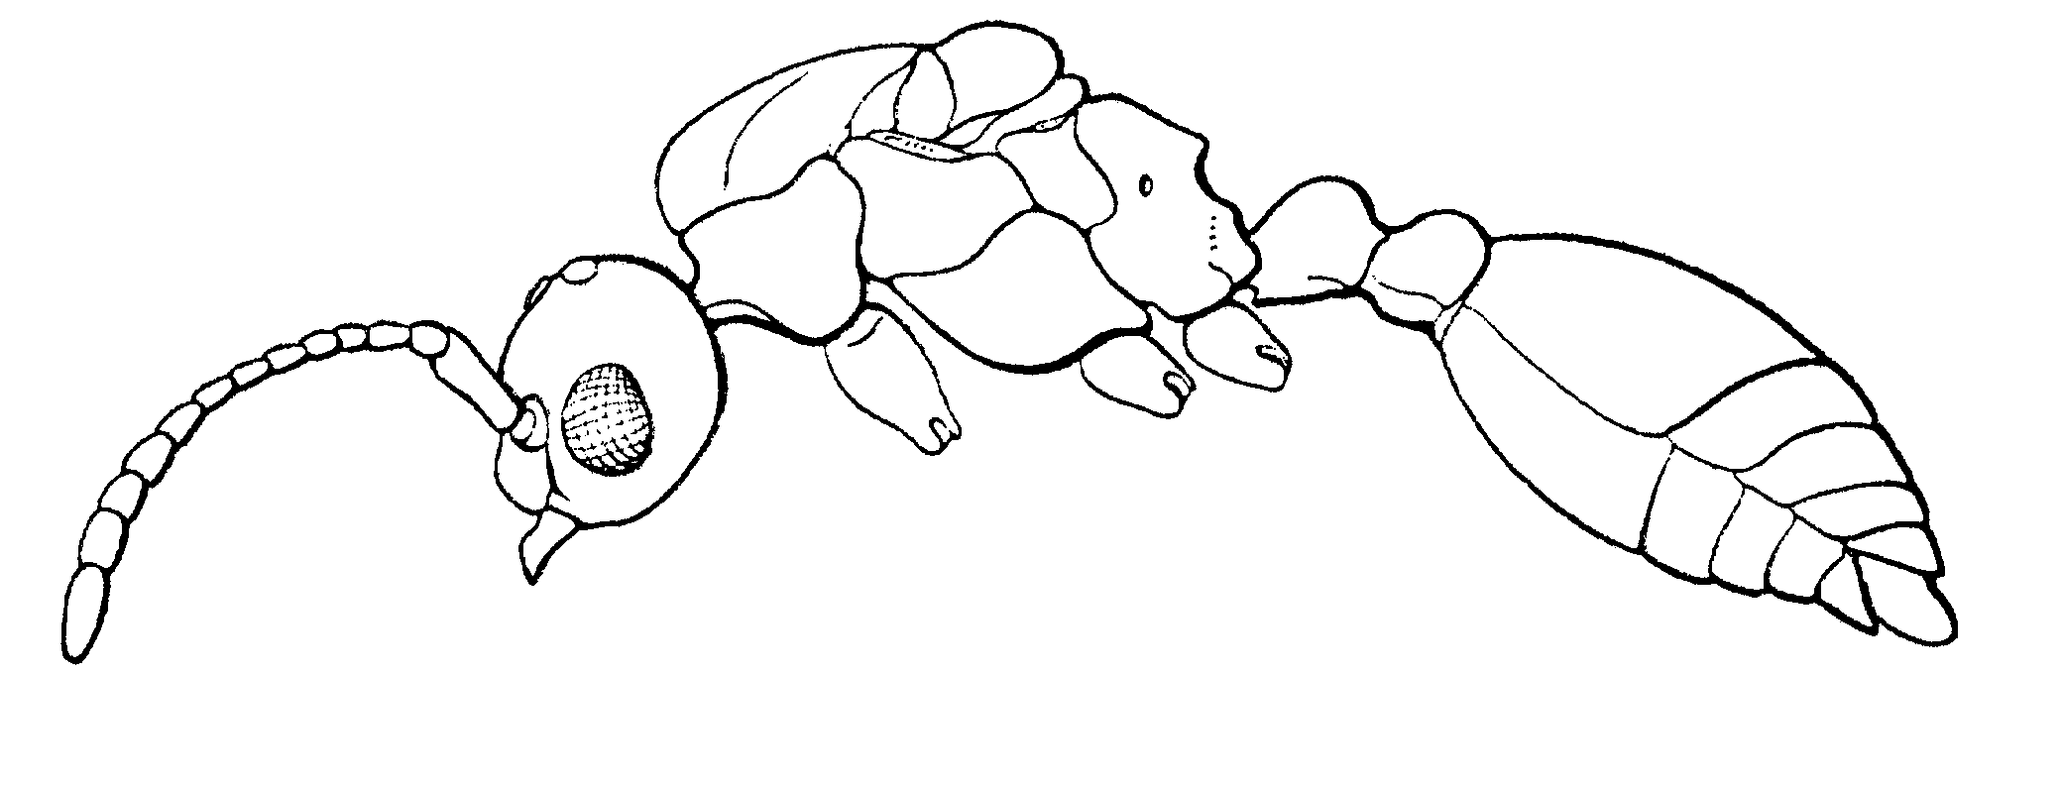Fig. 3. Side view of a male of M. brevinodis (from Creighton, 1950).
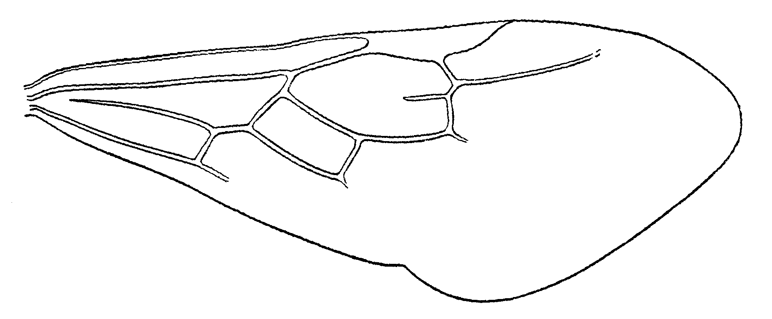Fig. 4. Forewing of a female of M. brevinodis (from Creighton, 1950).
Key to North American species of Myrmica
brevinodis not in key

1. Node of petiole high, distinctly set off from anterior and posterior peduncles and angular at crest; ventral surface of petiole with distinct, obtusely angular impression formed by the junction of the anterior and posterior peduncles; Arizona .......... wheeleri
- Node of petiole not distinctly set off from anterior and posterior peduncles or, if so, it is low and much rounded above; ventral surface of petiole straight or very feebly convex ........................................ 2

2(1). Outer edge of frontal lobe feebly convex throughout most of its length and fusing with head without marked posterior incision; frontal area distinct, not crossed by rugae, usually smooth and strongly shining; Que. Maine, Mass, RI ......................... rubra (and subsp. neolaevinodis
- Outer edge of frontal lobe strongly convex or angular in front, or deeply incised behind, or both; frontal area obscured by rugae, never completely smooth and shining (except in M. punctiventris) ...................... 3

3(2). Frontal lobes narrow, scarcely or not at all projecting above antennal fossae; insertions of antennae exposed when head is viewed from above; Tenn, Miss, Ill.........spatulata
- Frontal lobes strongly projecting out over antennal fossae; insertions of antennae hidden when head is viewed from above … 4

4(3). Antennal scape evenly bent at base, upper surface never forming right angle at bend (sometimes about 80°); lamina, if present, forming low, inconspicuous ridge at side of bend ....................................... 5
- Antennal scape suddenly bent at base, upper surface forming right angle; lamina always present, of varying shapes (Figs.) .............................................15

5(4). Frontal area mostly smooth and glossy with 1 or 2 rugae; lateral portion of clypeus raised into carina which forms abrupt, semi-circular boundary at front of antennal fossa (as in Tetramorium) (Fig.) .......................... rugiventris
- Frontal area roughly sculptured, with several rugae; clypeus not as above ............................................... 6

6(5). Basal face of propodum abruptly depressed below level of mesonotum; gaster with numerous coarse punctures with diameters at least 5X diameter of hairs arising from them .................... 7
- Basal face of propodium forming descending slope at about level of mesonotum, which is separated from mesonotum only by impression at metanotal suture; gaster with fine punctures, whose diameter is less than 3X diameters of hairs ...........................................................8

7(6). Antennal scapes surpassing occipital margin by an amount equal to their greatest thickness; propodeal spines about 1½ X as long as distance which separates their bases and slightly deflected downward; color piceous brown; length 4.0-4.7 mm; antennal scape of male as long as following 6 segments together; Mass. to Georgia to Iowa, Nebr, Ark., TX ........................... punctiventris
- Antennal scapes barely surpassing occipital margin; propodeal spines only slightly longer than distance which separates bases, not deflected downward; color brownish yellow; length 3.5-4.0 mm; antennal scape of male as long as following two segments together; Mass. to S.C., West to Ohio, Okla., Miss .......................... pinetorum

8(6). Gaster with longitudinal striae extending about ²_{/3} length of first gastral tergum, sparsely, but distinctly; punctate; inquiline in nest of M. striolagaster; Texas (Davis Mts.) ...................................... colax
- Gaster without longitudinal striae .......................... 9

9(8). Lateral margins of frontal lobes strongly angular, thick and slightly, but definitely deflected downward; antennal scapes of male not longer than 3 following segments together and straight at base) .............. 10
- Lateral margins of frontal lobes rounded, thin and moderately to strongly elevated; antennal scape of male varies in length ......................................................13
*** note contridiction in length of antennal scape in 9 and 10

10(9). Antennal scape of male slightly bent at base and as long as following 4 or 5 segments together; common ...........11
(brevisp/discont/mex)
- Antennal scape of male straight at base and shorter than following 3 segments; New Mexico; rarely collected ................................ species B

11(10). Postpetiole with shining dorsal area that is largely free from rugae; average size of workers 3.5 mm; Alaska, Quebec ... ................................................... alaskensis
- Postpetiole ordinarily covered with rugae, rarely with dorsal area free from rugae, but in such cases this area is not shining; average size of workers at least 4.5 mm; Labrador South to NJ, West to Rocky Mtns., Wyo, NM ......... 12

12(11). Sculpture fine, color reddish-brown over most of body and appendages ........................................ incompleta
- Sculpture of head and mesosoma coarse; color dark brownish-black to black, legs, mesosoma and antennae lighter ..........
....................................................whymperi

13(9). Color often orange-yellow, but variable; propodeal spines slightly less than one-half as long as distance which separates tips; ND, Nebrs. to NM, west to Atla., ID ................................. brevispinosa
- Color dark brown; propodeal spines more than ½ as long as distance which separates tips .....14

14(13). Antennal scape of male approximately as long as 5 funicular segments (Fig.); area between lateral ocellus and eye of male mostly punctate; New Foundland to Mts. of CO, WY, NM .................................................. discontinua
- Antennal scape of male approximately as long as 7 funicular segments (Fig.); area between lateral ocellus and eye mostly with reticulate rugae; eastern Mexico (NL, Coahuila south to VC) .................................... mexicana Wheeler

15(4). Bend of antennal scape with large, thick, lobose lamina that extends backward along basal third of scape; Que., Mich. to Man, N.D. Colo ....................................16
- Bend of antennal scape with small transverse lamina or with thin lamina which surrounds bend like collar and does not extend backward along basal third of scape .........17

16(15). Separate monticola and nearctica (see Francoeur)

17(15). Scape covered with longitudinal rugae; gaster with longitudinal striae on first tergum, obvious at least near point of attachment of post petiole (gradient exists with less developed striae in western populations); gaster with coarse punctures with diameters about 5X diameter of hairs; AZ (Chiricahua mts.), NM (entire state), West TX, Chih. (entire state), CO ..................................... striolagaster
- Scape usually with fine sculpture, mostly punctate; gaster without striae and with punctures whose diameter is less than 3X diameter of hairs ................................ 18

18(17). Ventral surface of postpetiole seen in profile flat or nearly so and not forming anterior projection; antennal scapes of male as long or longer than following 4 segments together and straight at base; Que, Maine to N.C., Tenn. to Manitoba, Colo., Utah, AZ ......... americana
- Ventral surface of postpetiole seen in profile convex or forming prominent anterior projection that thrusts forward under anterior peduncle; antennal scapes of male bent at base, or if straight they are distinctly shorter than above .................................................19

19(18). Lamina of antennal scape forming high, semicircular welt that surrounds scape at bend; antennal scape of male bent at base and usually shorter, never longer, than 3 following segments taken together ................... 20
- Lamina of antennal scape not forming high, semicircular welt; antennal scape of male straight at base or if bent, its length is equal to following 5 segments together) .................................................. 22

20(19). Area of scape immediately distal to flange with carina (Fig.), which often joins flange (Fig.); scape of male about equal in length to first 3 segments of funiculus; widely distributed ............................... 21
- Area of scape immediately distal to flange without carina or with carina very weakly developed; scape of male greater in length than following 7 segments; NM ................. spA

21(20). Lamina of antennal scape under-cut on inner face, edge forms distinct hook (Fig. ); CO, NM, AZ, UT ................ hamulata
- Lamina of antennal scape without hook on inner face; Iowa ....................... hamulata subsp. trullicornis

22(19). Lamina of antennal scape small and diagonally transverse on upper surface of scape, but continued as prominent transparent flange along inner surface of that part of scape that lies below bend; antennal scape of male straight at base and as long as 3 following segments taken together); New Foundland to GA, west to Man., ID, CO, AZ ....................................... latifrons
- Lamina not forming prominent median flange as above or if small median flange is present, lamina not transverse on the upper surface of scape ...................... 23

23(22). Propodal spines slightly, but distinctly bent downward (spines on single ant may be different); mesosoma reddish-yellow, head and gaster piceous; antennal scape of male straight at base and as long as following 3 segments together); MT, WY, UT, AZ, to BC, NV, OR .............. tahoensis
- Propodal spines straight; color not as above; antennal scape of male bent at base and at least as long as following 5 segments together) .................... 24

24(23). Antennal lamina encircling bend of scape in form of spoon-like or saucer-like flange; antennal scape of male abruptly bent at base with upper surface distinctly angulate at bend; propodal spines of male well-developed, propodeum with prominent rugae; CO, NM, UT, AZ, N to Alaska ..................................... lobifrons
- Antennal lamina small, transverse, forming angular tooth-like projection on inner side of bend; antennal scape of male gradually bent at base and not forming distinct angle at bend; propodal spines of male reduced to rounded angles, rugae of propodeum very feeble or lacking); New Foundland, S to Tenn., Ohio to Rocky Mts., CO, NM, UT, AZ ....... ................................................. fracticornis

