(3 , 3  ; , 2 

Genus Odontomachus
This genus is easily recognized by the elongated head, which is widened in the vicinity of the eyes (Fig. 1), and by the elongated mandible with three apical teeth (rarely two). The nuchal carina, which separates the dorsal from the posterior surfaces of the head, converges into a V at the midline, which would separate this genus from closely related Anochetus, in which the nuchal carina forms a broad, uninterrupted curve across the posterior dorsal extremity of the head.
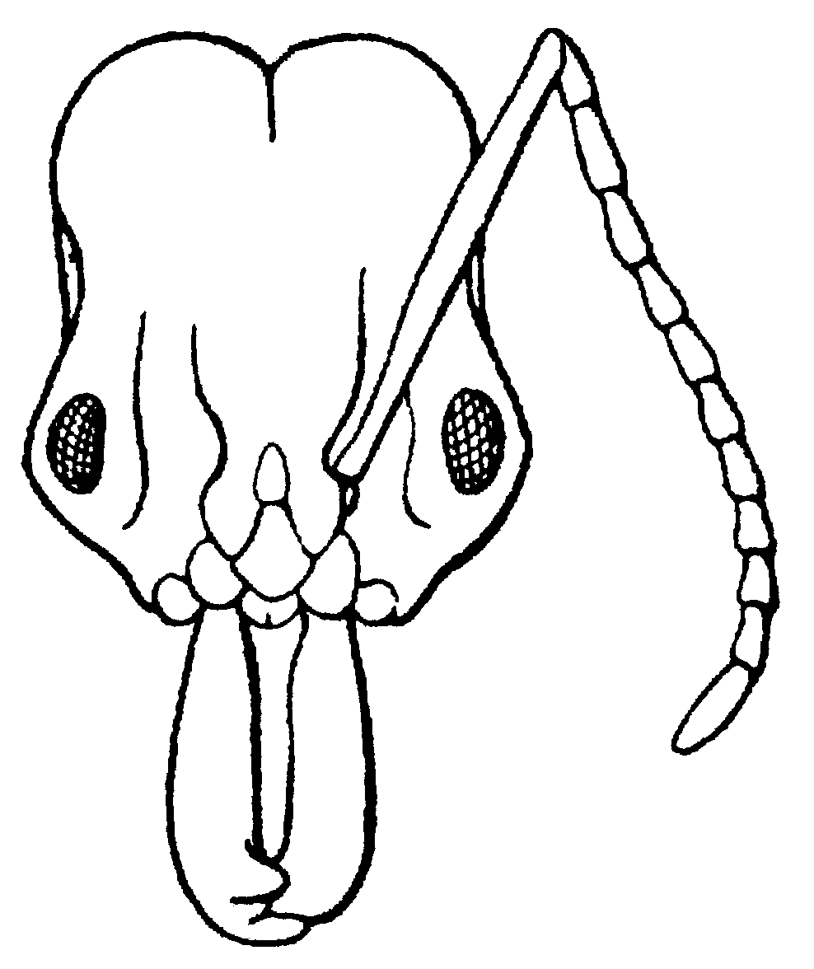 Fig. 1. Head of a worker of O. clarus (from Creighton, 1950). Label nuchal carina. This
The head has a deeply depressed region posterior to the insertion of the antenna (Fig. xx), as well as a depressed area on the side of the head about half way along the length of the head. The mesosoma is usually depressed at the metanotal suture, and the propodeum is without spines. The apex of the petiole forms a spine, which may be long and sharp. The gaster is not constricted between the postpetiole and the remaining segments (first and second segments of the gaster).
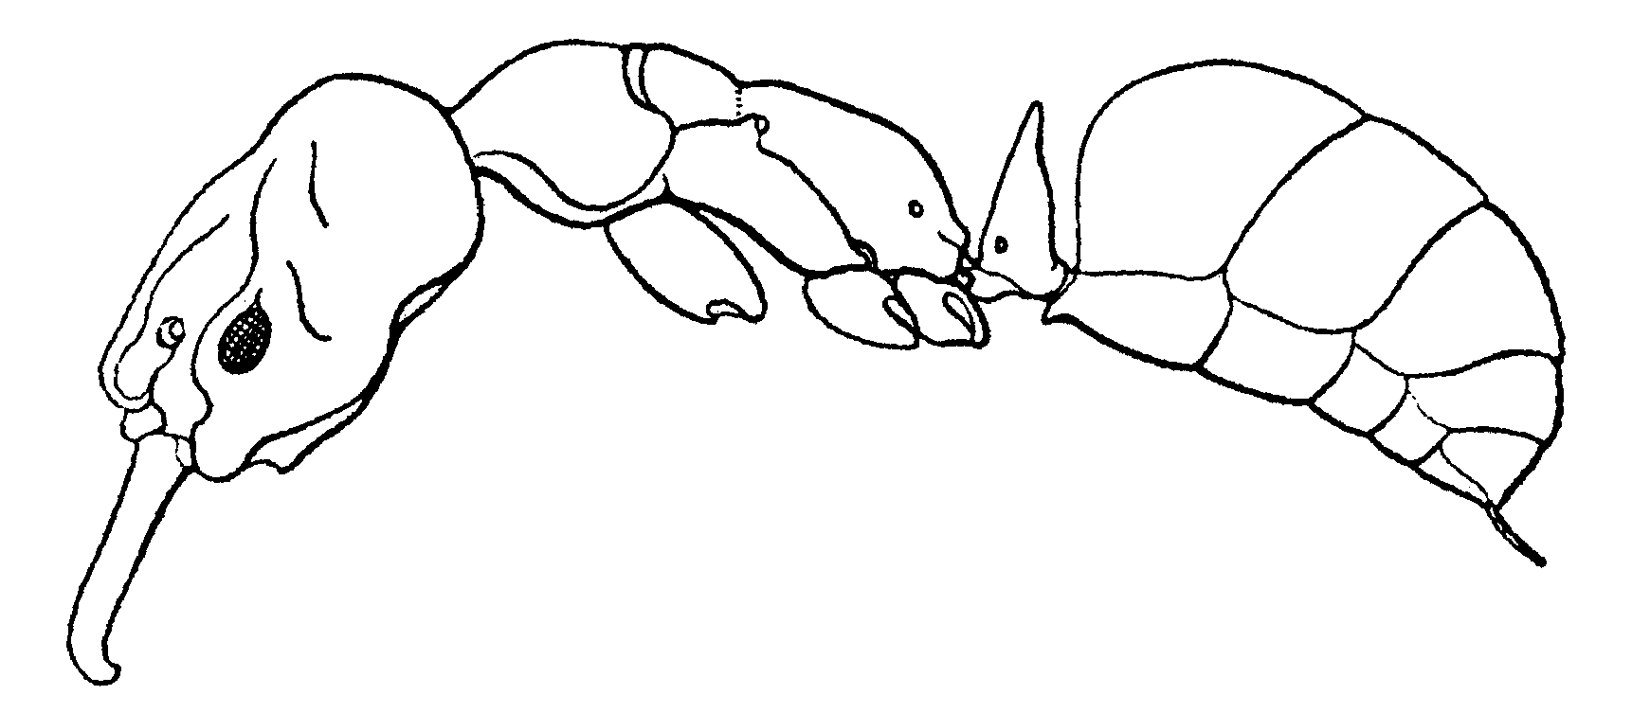
Fig. 2. Side view of a worker of O. clarus (from Creighton, 1950). Label postpetiole
Erect hairs are sparse, with a few scattered on the dorsum and ventral surfaces of the head, the mandibles, the pronotum, and all surfaces of the gaster. Most hairs on the tibiae are appressed, or only slightly raised from the surface. The hairs on the petiole are suberect to erect, but are generally very short (0.1 mm).
The mandibles are generally finely sculptured, the anterior half of the head is covered with fine striae, which may extend to the area near the posterior border of the head. The striae on the pronotum are usually slightly coarser than those on the head, and are transverse across the neck, and transverse near the posterior border, but are longitudinal on most of the disc of the pronotum, and may formed concentric circles. The striae on the side of the pronotum are usually obliquely (posteriorly) vertical. The striae on the mesonotum are similar, except in nearly all cases (with the exception of O. yucatecus) they are transverse. The mesopleuron is often smooth and glossy, with a few, poorly defined striae near the anterior border, but in some species may be completely sculptured. The side of the propodeum has vertically oblique striae, which are transverse over the dorsum of the propodeum, and are horizontal on the posterior face of the propodeum. The petiole is often finely sculptured and at least partially smooth and shiny, but may have transverse or horizontal striae. The dorsum of the postpetiole (first segment of the gaster) ranges from being smooth and glossy, to covered with striae or punctures, and completely dull. The remainder of the gaster of a given species is often sculptured in a similar way to the dorsum of the postpetiole.
Most species are dark reddish-brown, but bicolored (head and mesosoma red, gaster black) species are also common, and some specimens are yellow or yellowish-brown.
The female is similar to the worker, with the elongated mandibles, and the petiole terminating in a spine.
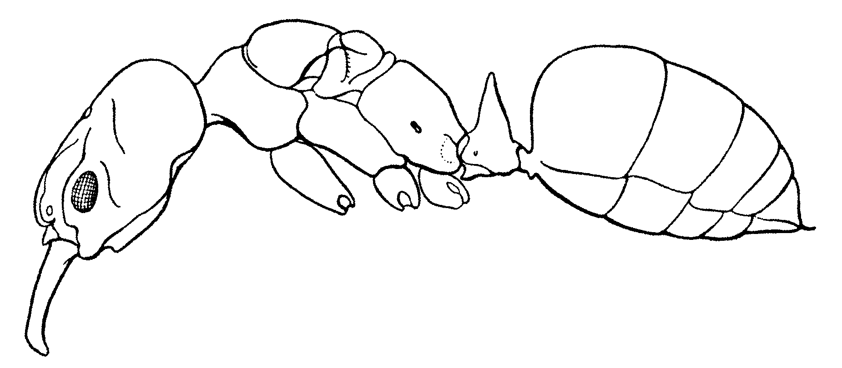
Fig. 3. Side view of a female of O. clarus (from Creighton, 1950).
The male is usually a smaller, darker specimen (usually black), without elongated mandibles, and usually lacks the spine on the petiole. They can be usually recognized, as pygidium is forms a slender, down curve spine (Fig. 4). The petiole is often triangular shaped, which may separate males of Odontomachus from those of Pachycondyla.
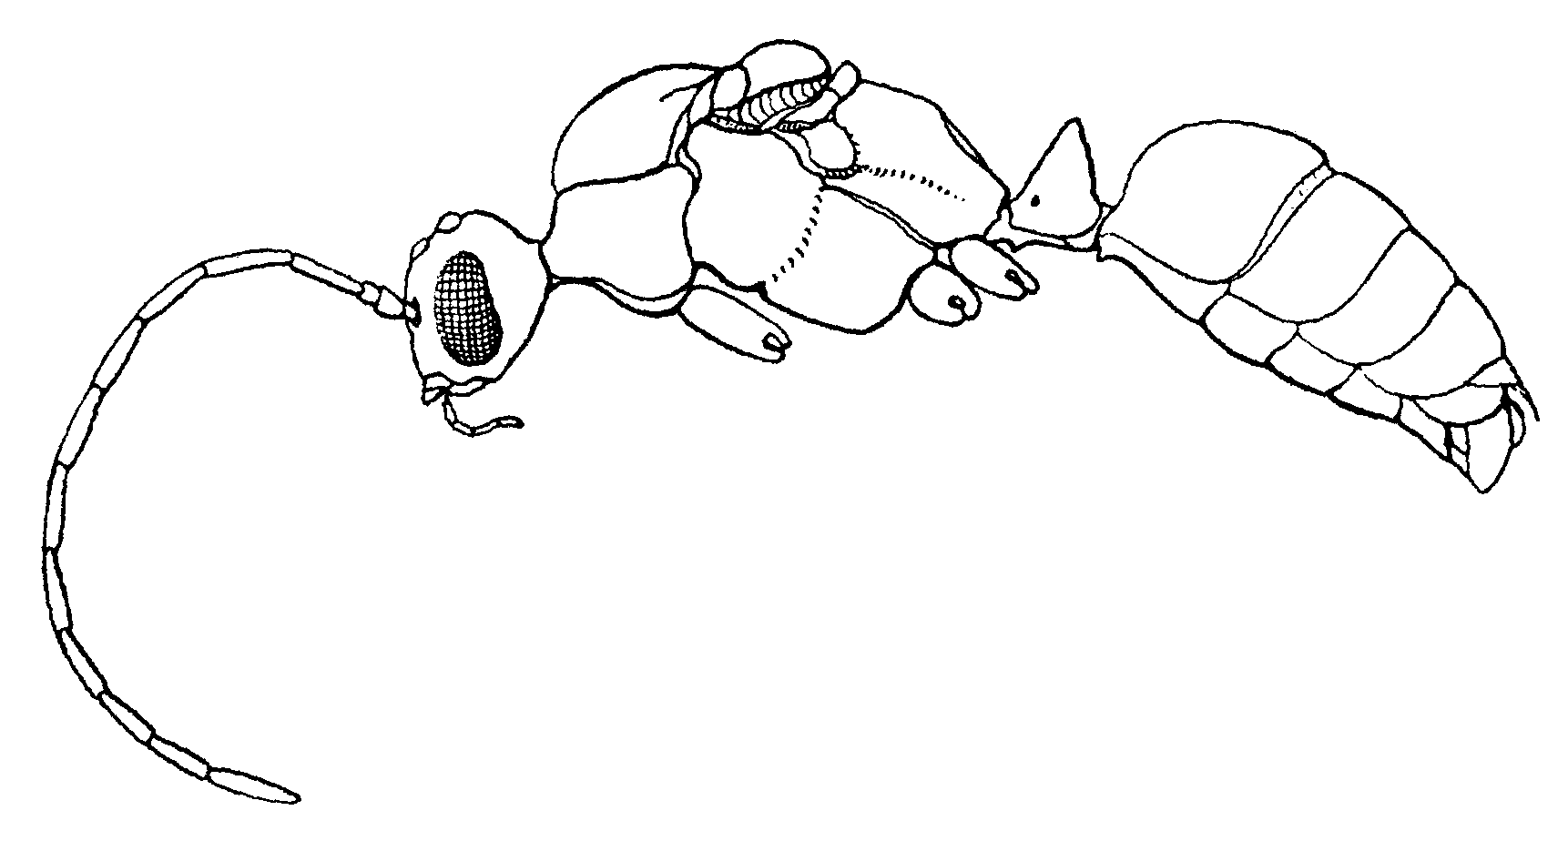
Fig. 4. Side view of a male of O. clarus (from Creighton, 1950). Label spine
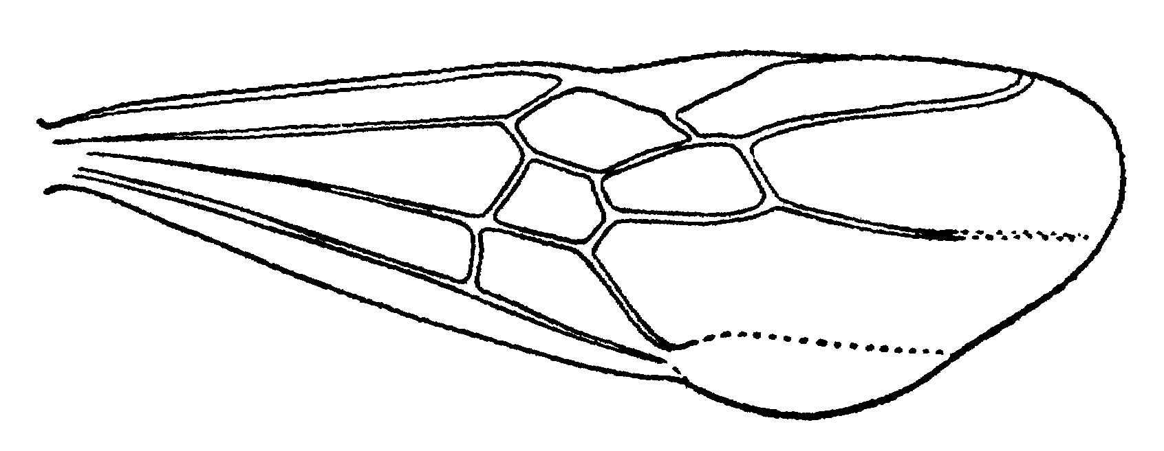
Fig. 5. Forewing of a female of O. clarus (from Creighton, 1950).
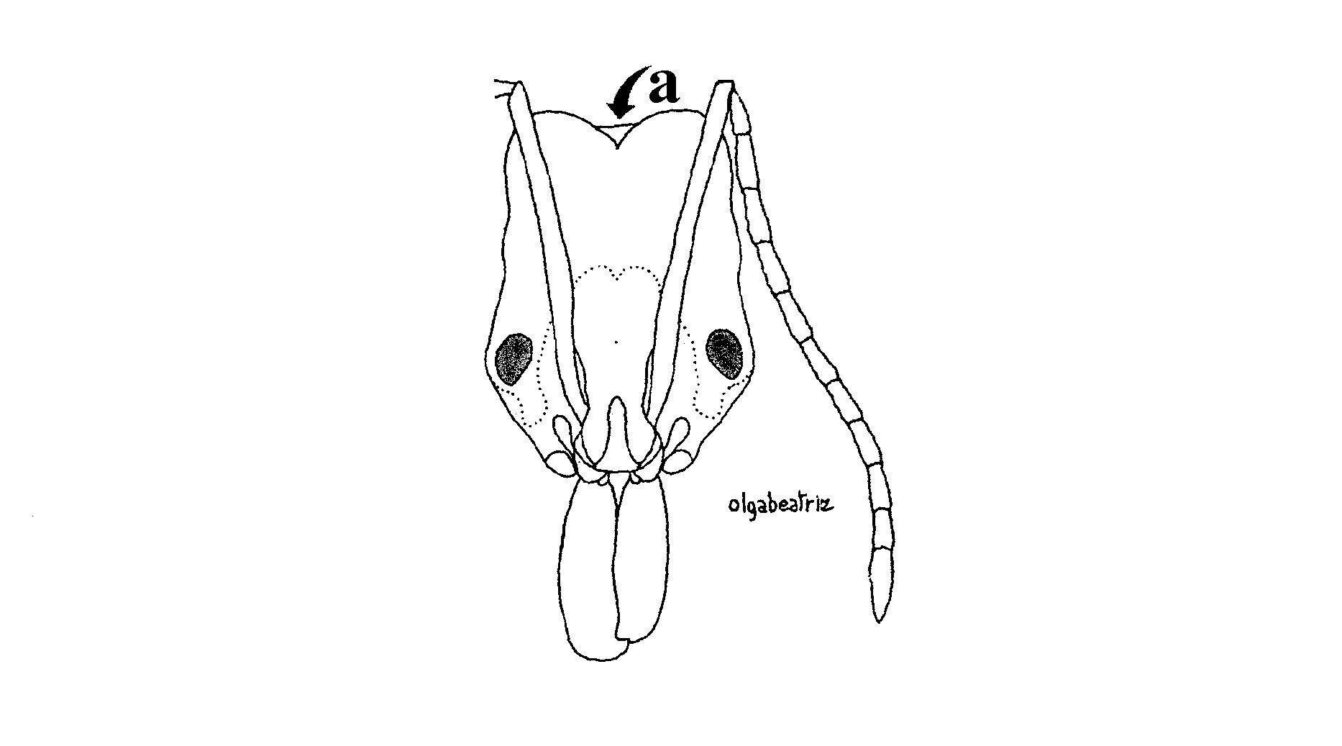
Fig. 6. Head of a worker of O. erythrocephalus (from Serna, 199_).

Barth (1960) and Brown (1976) described the snap-trap mechanism of the mandibles and capture of prey. The mandibles are locked into the open position (180°), but are subject to tremendous force from the powerful adductor muscles which fill the massive cranium, and by the distortion of a sclerotized, spoon-shaped part of the adductor tendon which works as a powerful spring. The foragers are usually cautious and hesitant in the attack of a prey. They make a sudden attack and recoil movement, snapping the mandible shut in the process. The mandibles do sudden, severe damage to prey, and the rapid retreat avoids damage, either chemical or mechanical, to the ant. A few seconds later, the ant coaches the prey, subdues it and carries it back to the nest.

Species complexes

Brown (1976) recognized the following species complexes:

bradleyi species complex

The palpal formula is 4, 4.
Species in this complex include O. bradleyi.

cornutus species complex
This complex includes only a single species, which has a tooth like projection anterior to the eye, and thus is very easily recognized.
Palpal formula???
Species in this complex include O. cornutus.

haematodus species complex

The palpal formula is 4, 3.
Species in this complex include O. affinis, O. allolabis, O. bauri, O. biolleyi, O. biumbonatus, O. brunneus, O. caelatus, O. chelifer, O. clarus, O. erythrocephalus, O. haematodus, O. insularis, O. laticeps, O. mayi, O. minutus, O. opaciventris, O. panamensis, O. scalptus, O. spissus and O. yucatecus.

hastatus species complex
The worker of this species complex can be characterized as being long, slender ants. The mandibles have a long serious of denticles, which extend along the entire masticatory margin. The posterior half of the dorsum of the head is smooth and glossy, and the mesosoma is strongly depressed in the metanotal region. The propodeal spines slender, with a long, sharp spine. The palpal formula is 4, 4.
The female is similar, although the mesosoma is slightly more massive, due to the presence of wings in flight muscles.
Two species, O. hastatus, and O. mormo are included in this complex (Brown considered O. mormo to be in its own complex).

Key to New World Species of Odontomachus
Workers

1. Dorsal surface of head distinctly striate to or nearly to the nuchal carina; common ……….…………..… 2
Fig. 7. Head of a worker of O. yucatecus. need fig 1

- Posterior third to half of dorsal surface of head smooth and shining, or nearly so; rarely collected ………. 17
Fig. 8. Head of a worker of O. hastatus. need fig 2

2(1). Disc (dorsal surface) of first gastric segment predominantly smooth, punctulate, leather-like, or reticulate; striation absent, or if present, mixed with other sculpture and distinct only on ½ (anterior or posterior) of the disc ……. 3
- Disc of postpetiole (first gastral tergite) distinctly and evenly striate over its entire surface, at least as seen from dorsal view ………..……...…... 15
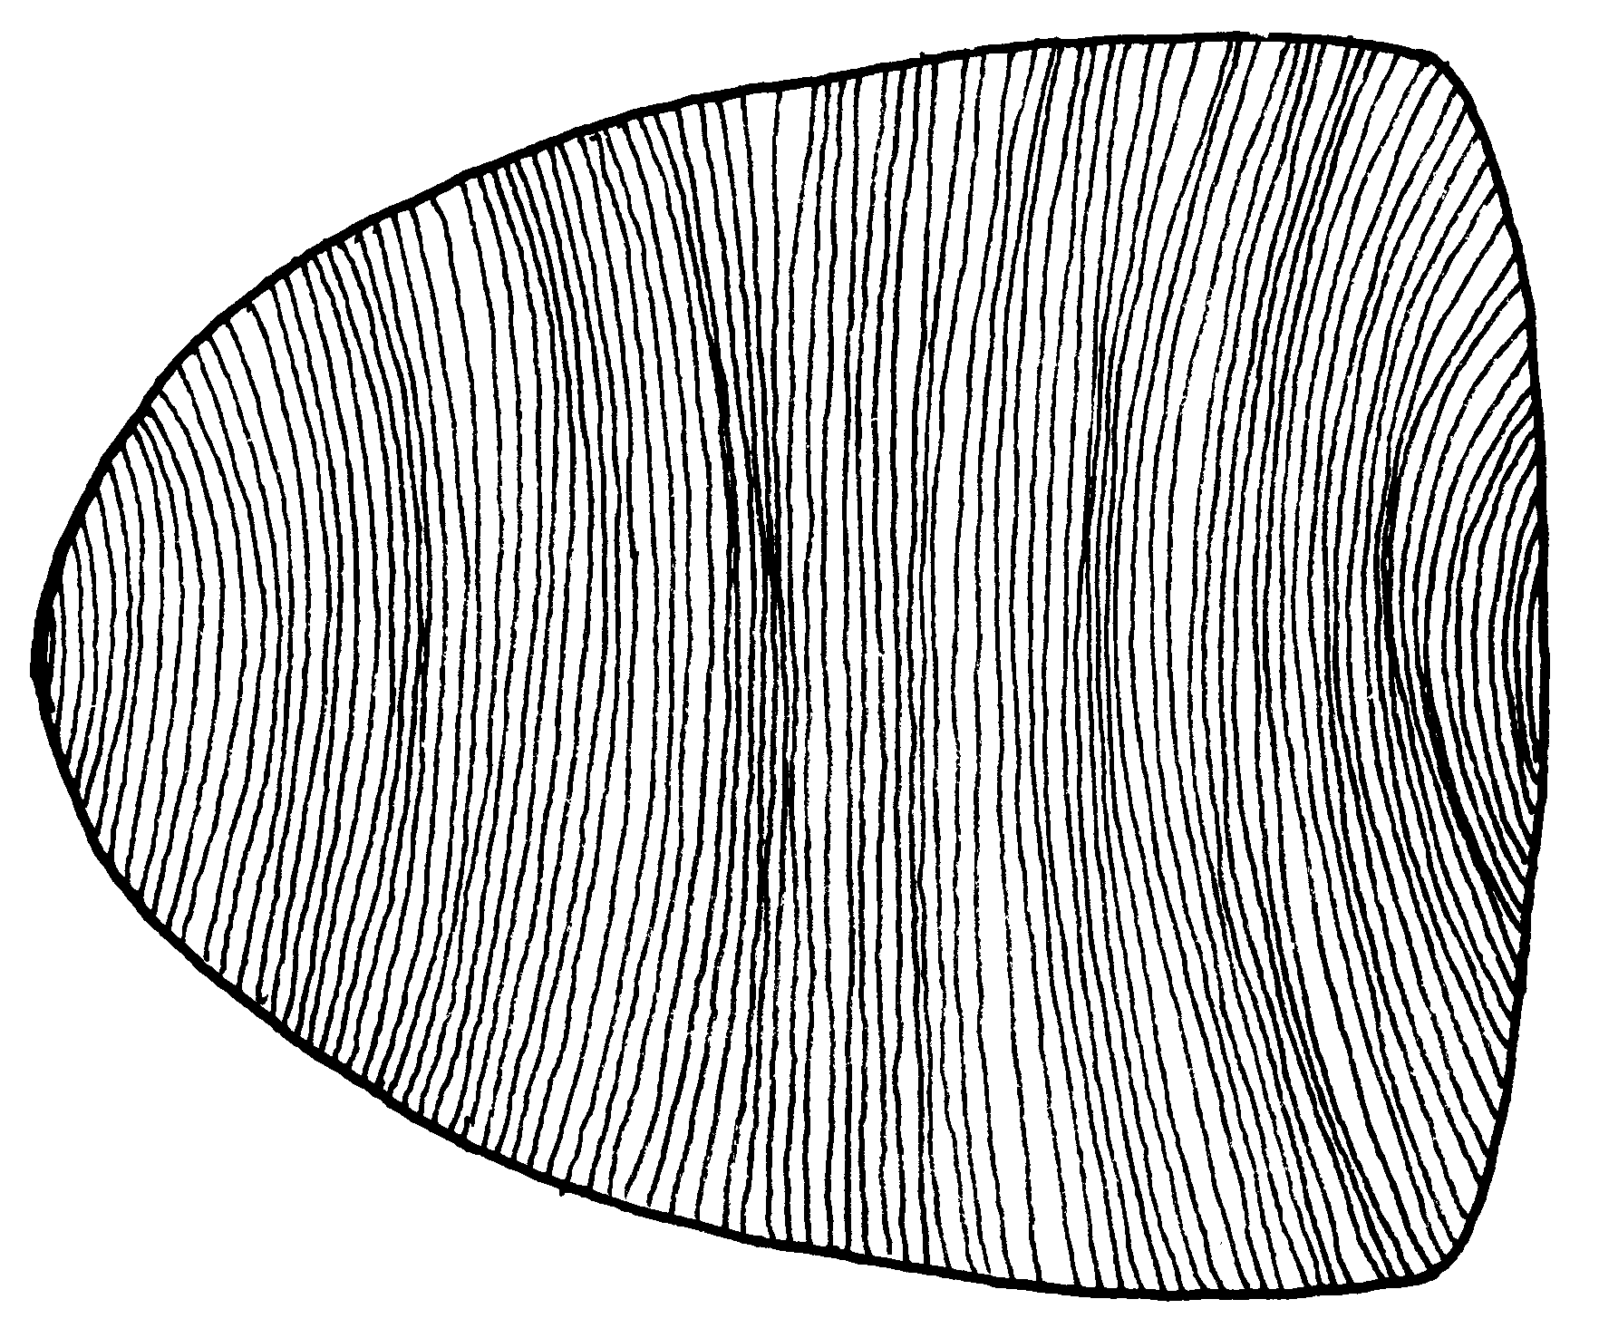
Fig. 9. Dorsum of the postpetiole of a worker of O. chelifer.

3(2). Mesonotum longitudinally striate ………………………………. 3a
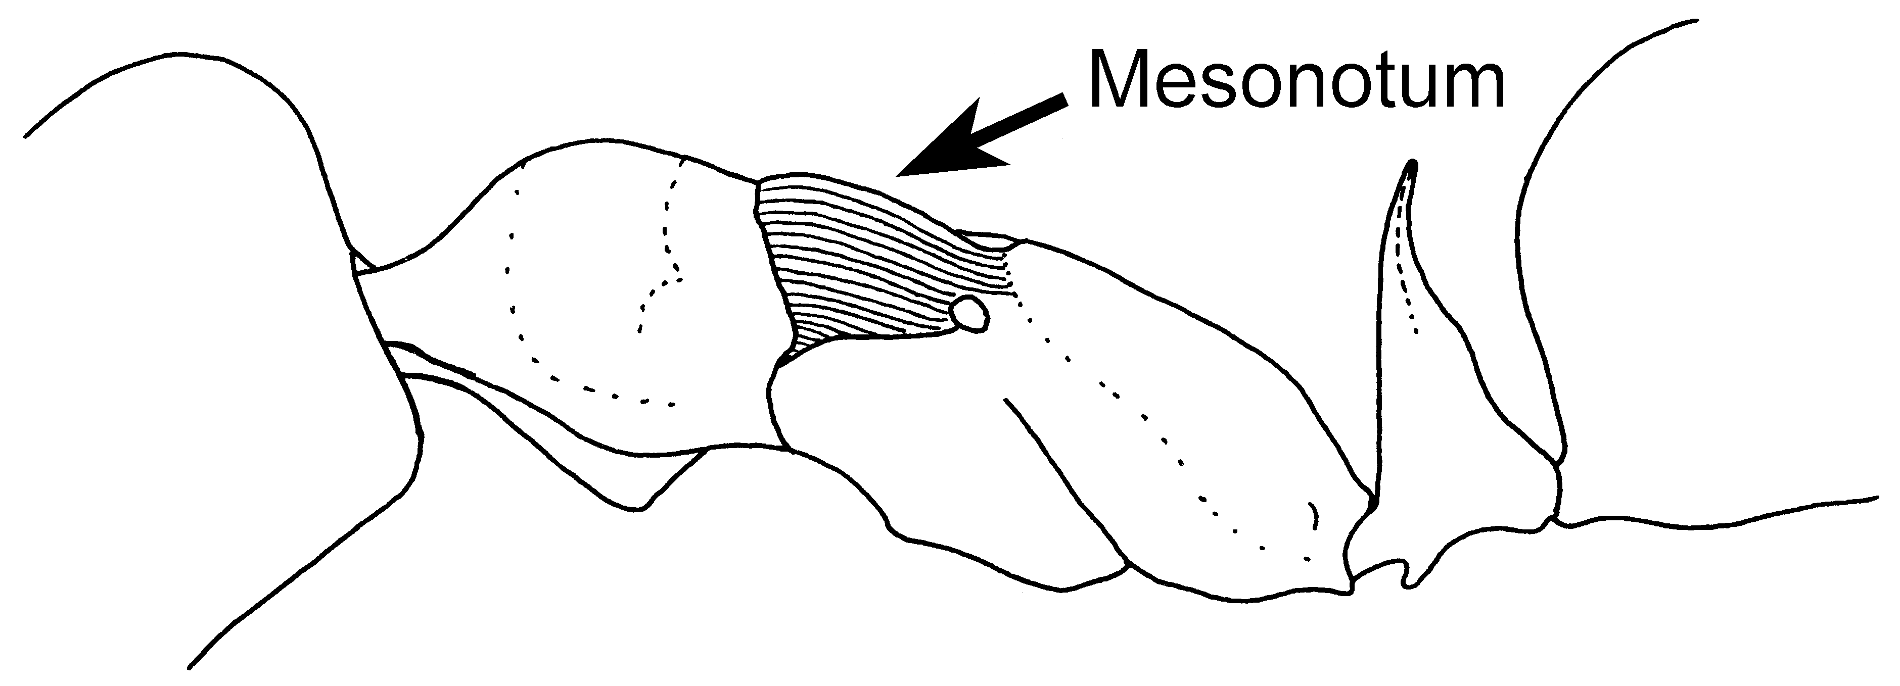
Fig. 10. Mesosoma and petiole of a paratype worker of O. yucatecus, showing the longitudinally striated mesonotum.

- Mesonotum prevailingly transversely striate …………………... 4
3a(3). First tergum of gaster predominantly smooth and glossy; Yucatan Peninsula to Vera Cruz and Guatemala) …………………….... yucatecus Brown
- First tergum with fairly distinct striation over anterior half; Ecuador and Guyana ……. scalptus Brown
4(3). Head more or less bright red (frontal area often infuscate), contrasting with blackish-brown body and yellow legs; size medium( fig. 2); anterior face of petiole convex; Costa Rica to Ecuador W of Andes .. erythrocephalus Emery
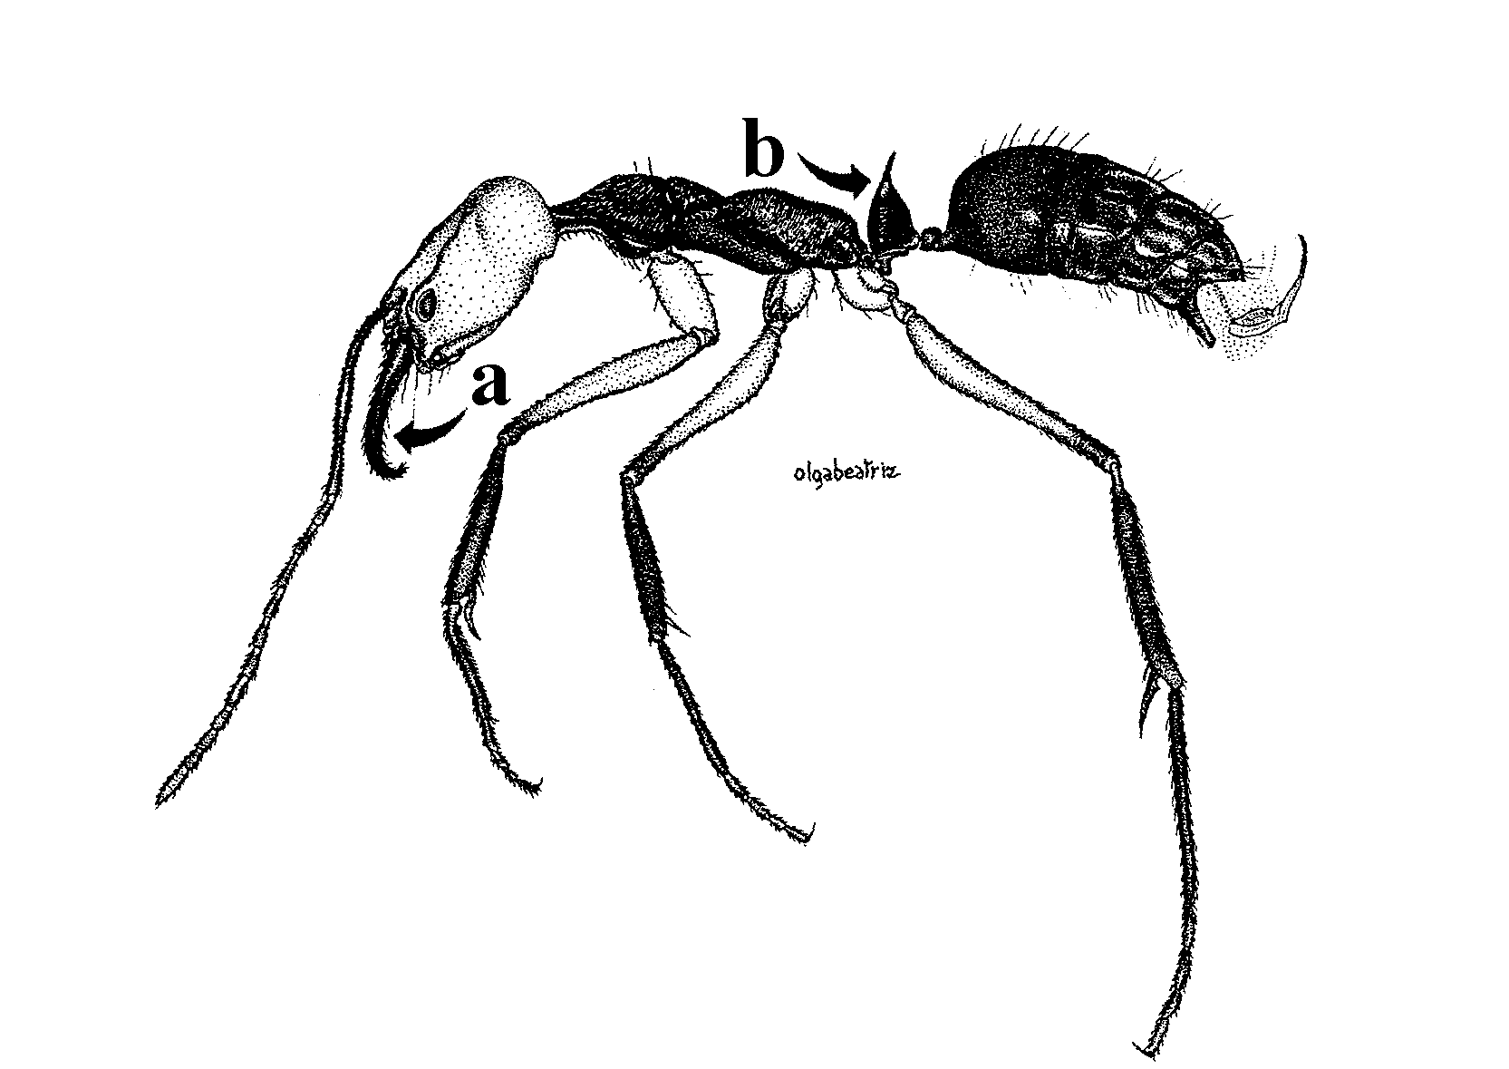Fig. 11. Side view of a worker of O. erythrocephalus (from Serna, 199_).

- Color combination otherwise; if head is distinctly red, then mesosoma is red also, or legs are dark; or anterior face of petiole straight or concave …….… 5
5(4). Sternum immediately in front of and between metathoracic coxae produced as a slender, acute pair of teeth or spines (Fig. 7); disc of first gastric segment densely and finely shagreened and pubescent, usually opaque; body brown, legs yellow to brown; forests of cis-Adean continental S America from Orinoco Delta to Tucumán, Argentina ………………..… ……………… haematodus (Linnaeus)
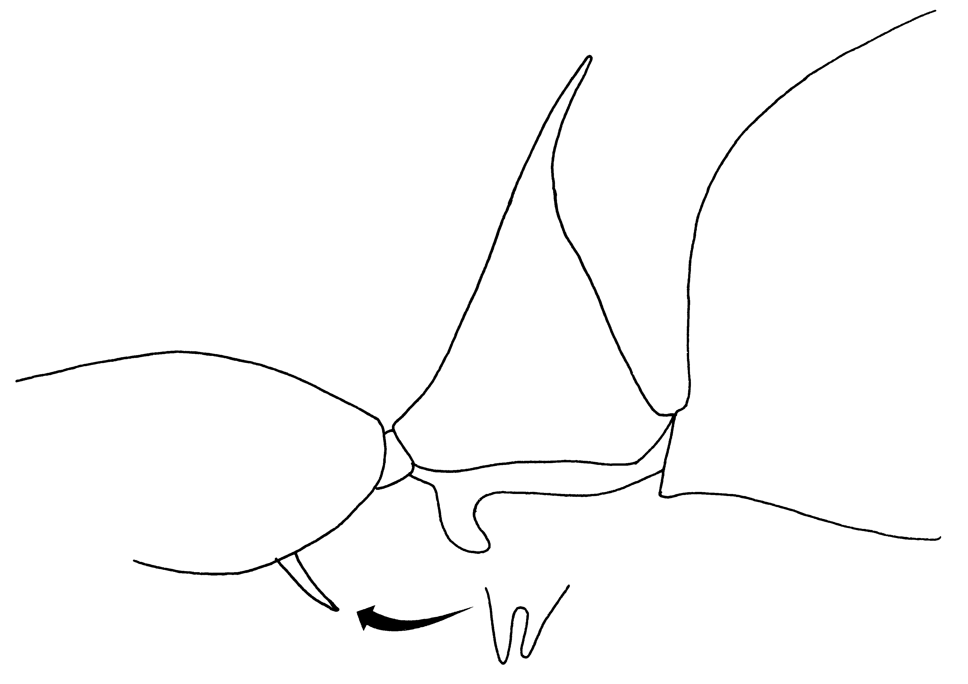
Fig. 12. Propodeum and petiole of a worker of O. haematodes, showing the pair of teeth on the sternum as seen from the side and from behind (inset). It is usually necessary to remove the posterior leg to see the pair of teeth.

- Sternum in front of metathoracic coxae with a low transverse ridge, sometimes notched in the middle or bilobed, but not produced as acute, paired teeth (Figs. ); gaster smooth or variously sculptured; color varying, but legs usually dark in samples from continental S America) …………………… 6
Fig. 13. Metasternal teeth of a worker of O. opaciventris. need fig 3

6(5). Disc of first gastric tergite very finely, densely and regularly punctulate throughout; opaque or nearly so; longest hairs of gastric dorsum 0.6 mm or more in length; large, black or dark brown hairs species (Costa Rica to Colombia) …………… opaciventris Forel
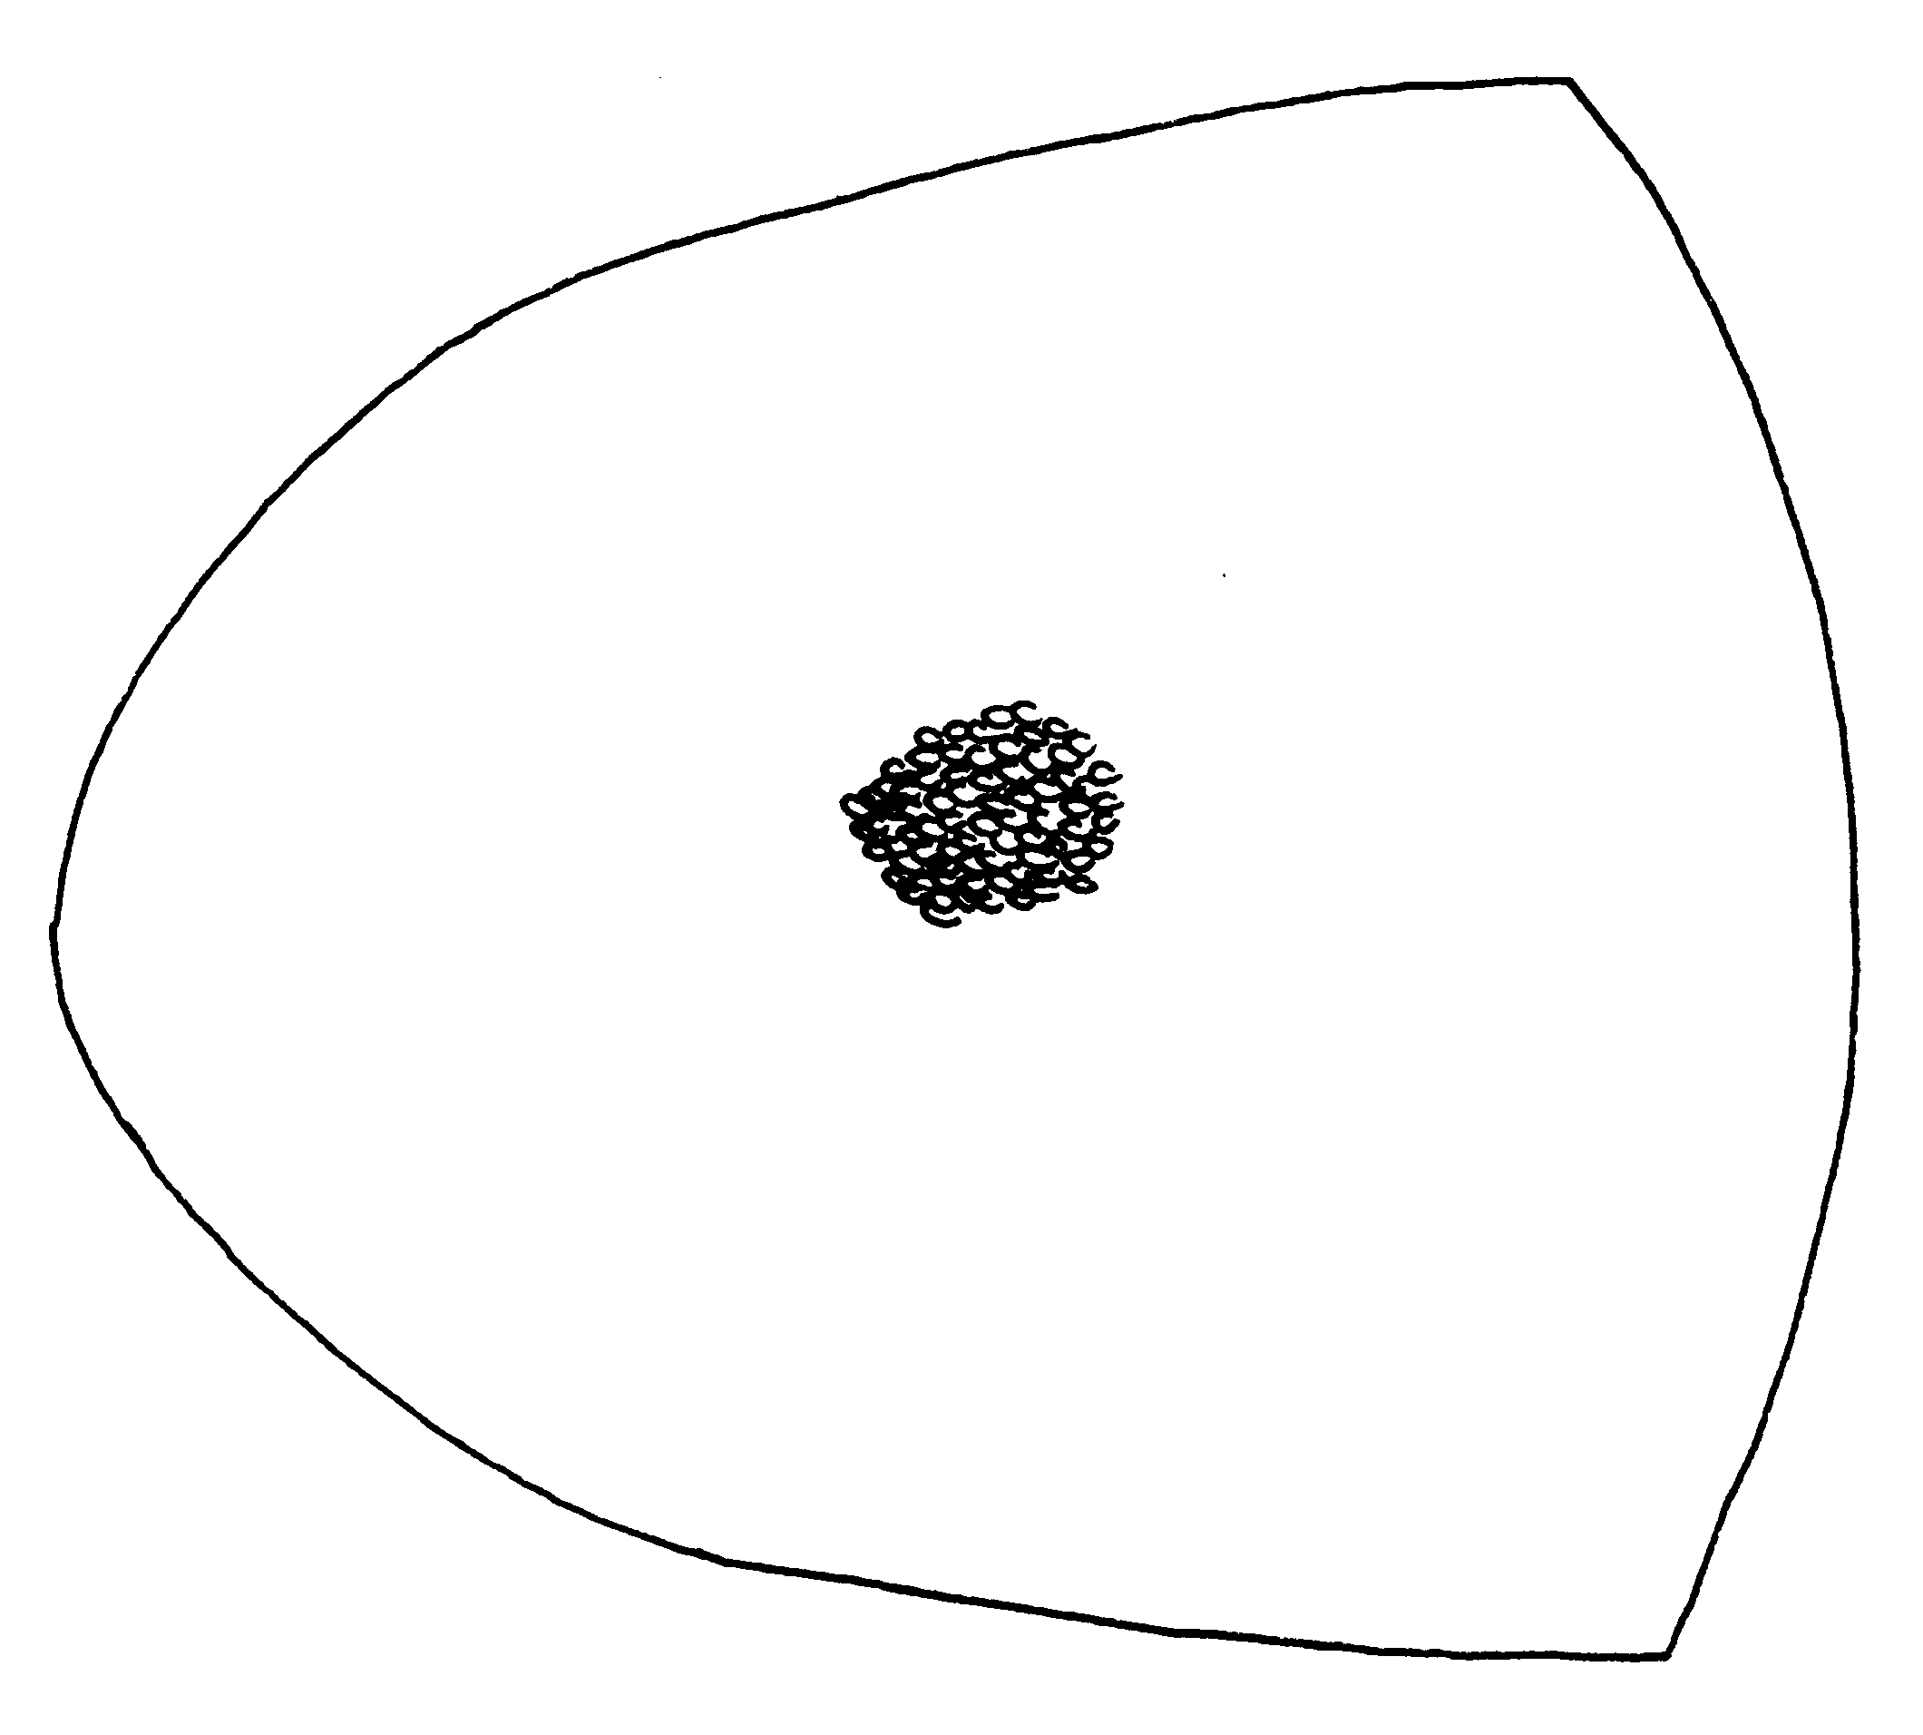
Fig. 14. Disc of first gastral tergite of a paratype worker of O. opaciventris. Only a small part of the sculpture is shown.
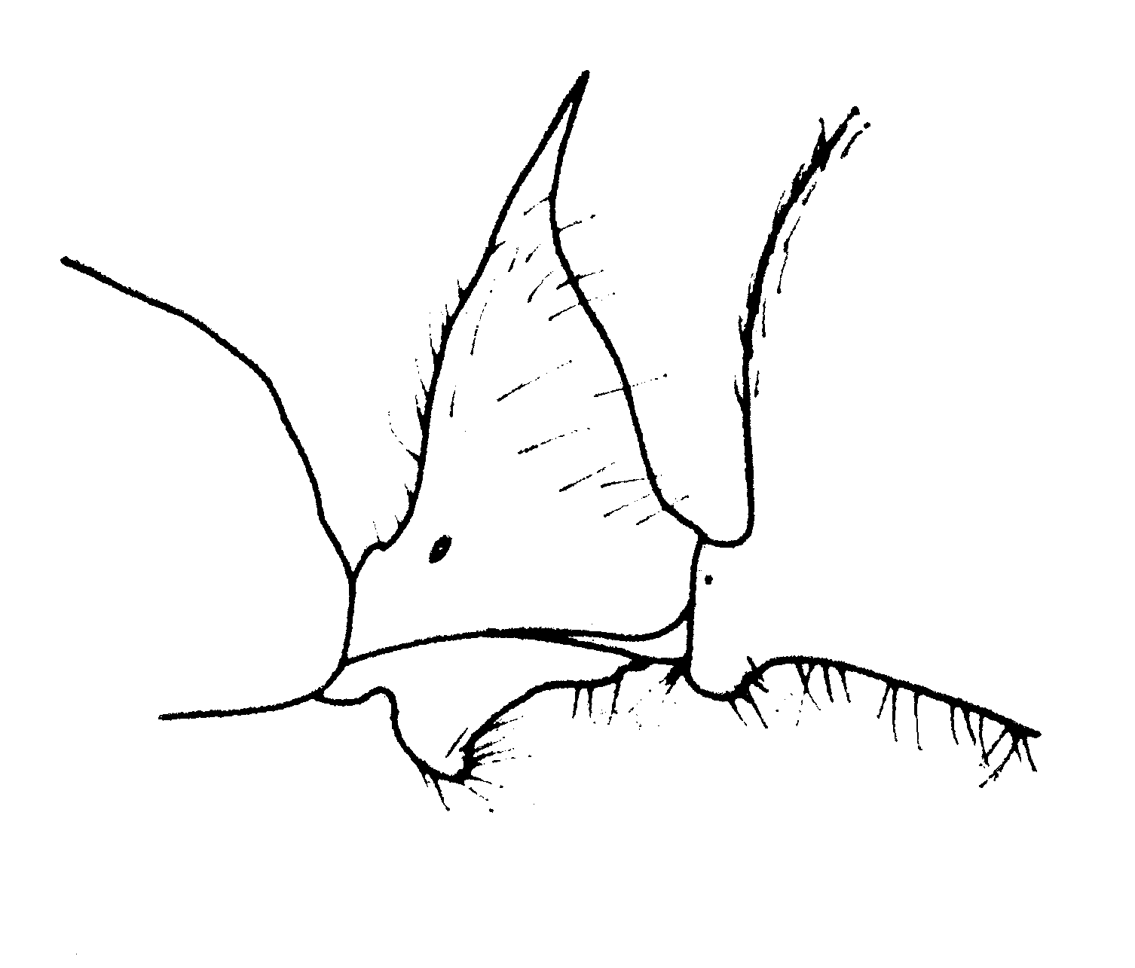
Fig. 15. Petiole of a worker of O. opaciventris (from Brown, 1976).

- Disc of first gastric segment otherwise sculptured; shining or, if densely punctulate and opaque, then at least the posterior part becoming longitudinally striate (Fig. xx); longest hairs of gastric dorsum <0.6 mm long ……...7
7(6). Disc of first gastric tergite very densely punctulate, opaque, longitudinally striae over a posterior portion of variable extent (Plate 1,D); small species, light to dark brown in color (S Mexico to S Brasil and Bolivia, forests) ……………………..…. meinerti Forel
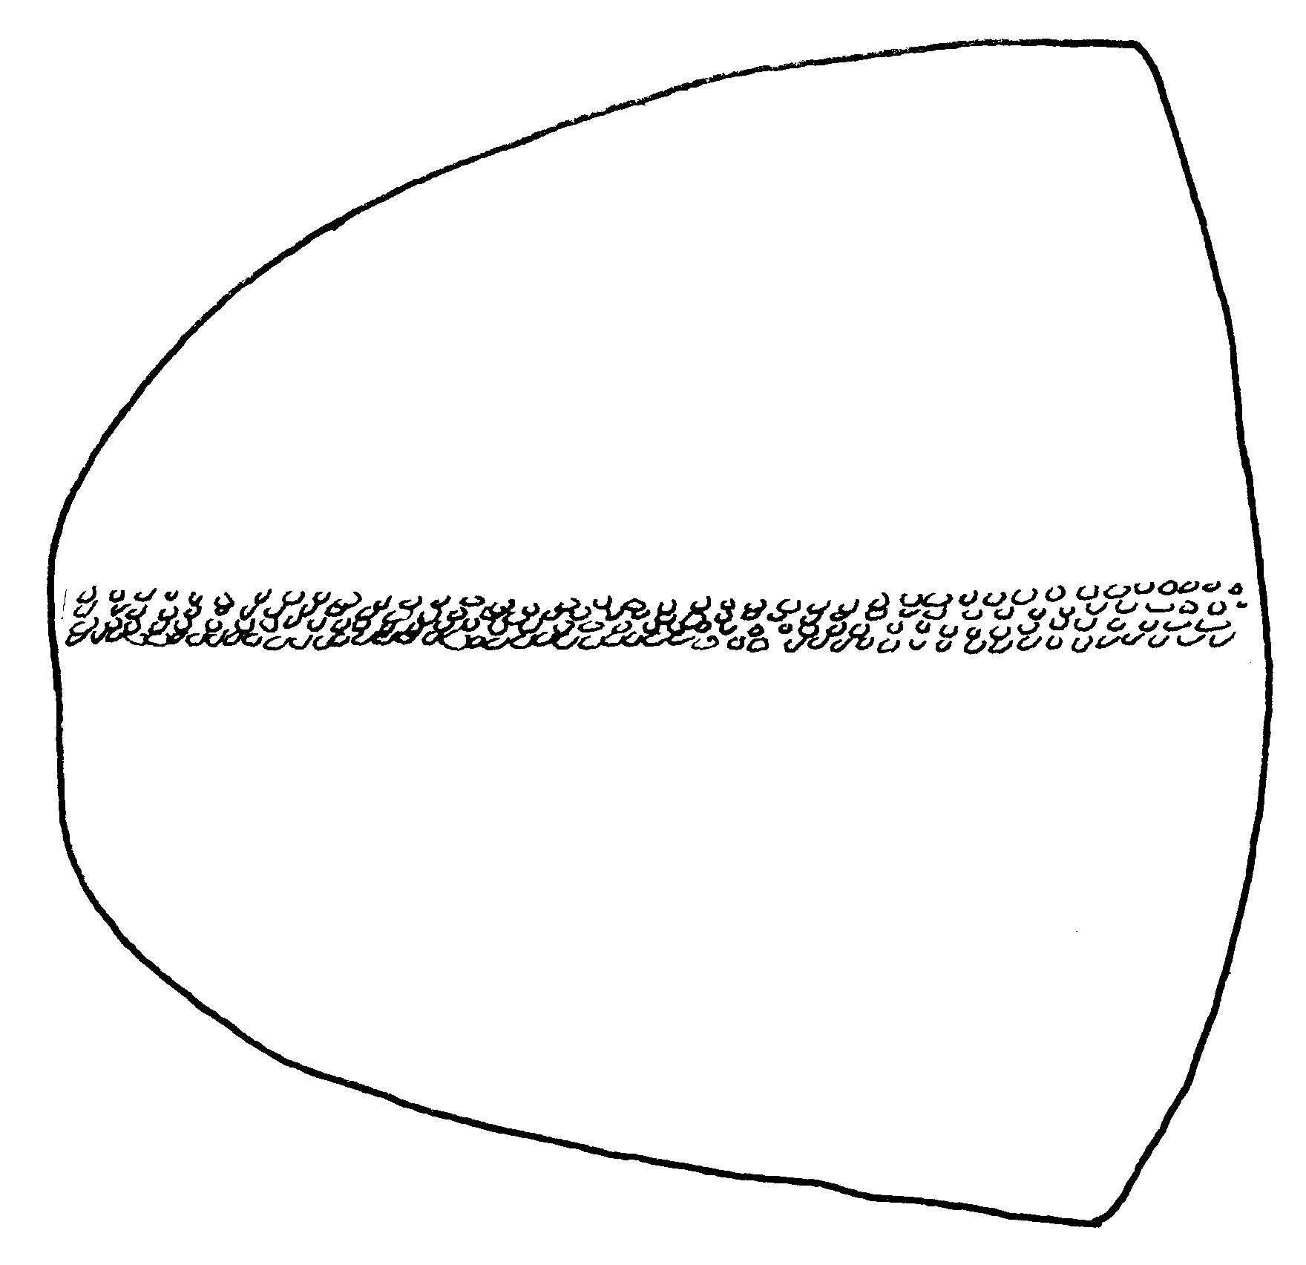
Fig. 16. Disc of first gastral tergite (postpetiole) of a worker of O. meinerti (Distrito Federal, Brasil). Only a small part of the sculpture is shown.

- Disc of first gastric segment prevailing shining though its surface sometimes leather-like, shagreened, or even with traces of striation in the posterior portion ………………………….. 8
8(7). Head, mesosoma and petiole nearly or quite concolorous light red or dull yellow; legs yellowish, gaster light brown to blackish ……………….... 9
- Head, mesosoma and petiole dark reddish brown or brown to nearly black, legs variable in color, often dark …………………………………….. 11
9(8). Apex of petiole narrowed to a long, slender, posteriorly directed spine (Cuba, Bahamas, local on Hispaniola) … ……….… insularis Guérin-Méneville
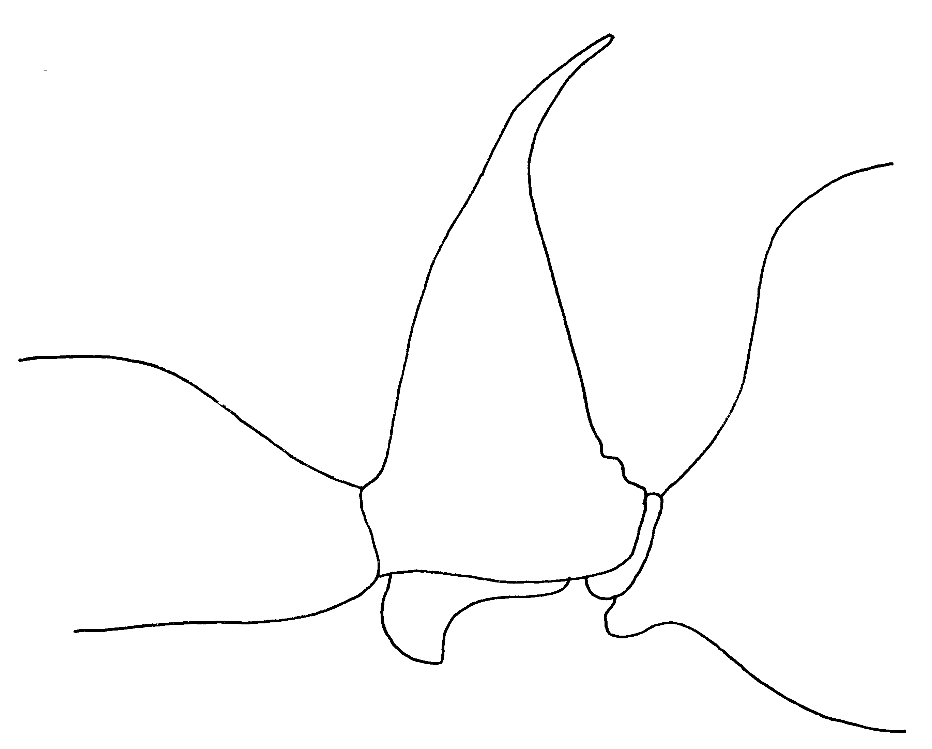
Fig. 17. Petiole of a worker of O. insularis.

- Petiole conical or subconical in side view; apex acute or even dentate, but not drawn out into a long, slender spine (Fig. 18) ……….………….…. 10
10(9). Posterior face of petiole at least feebly concave or sulcate mesad (Fig. 1); compound eye usually shorter than maximum W of a mandible (without teeth), rarely slightly longer; sides of head in side view reticulate-punctulate (Mexico N to S Arizona and C Texas) ……………………..… clarus Roger
- Posterior face of petiole convex in both directions; compound eye distinctly longer than maximum W of a mandible (without teeth); sides of head, especially the part posterior to extracular furrow, finely, densely and distinctly reticulate-punctulate dull (México and Costa Rica, possibly in mangroves) …. ………………………..... biolleyi Forel
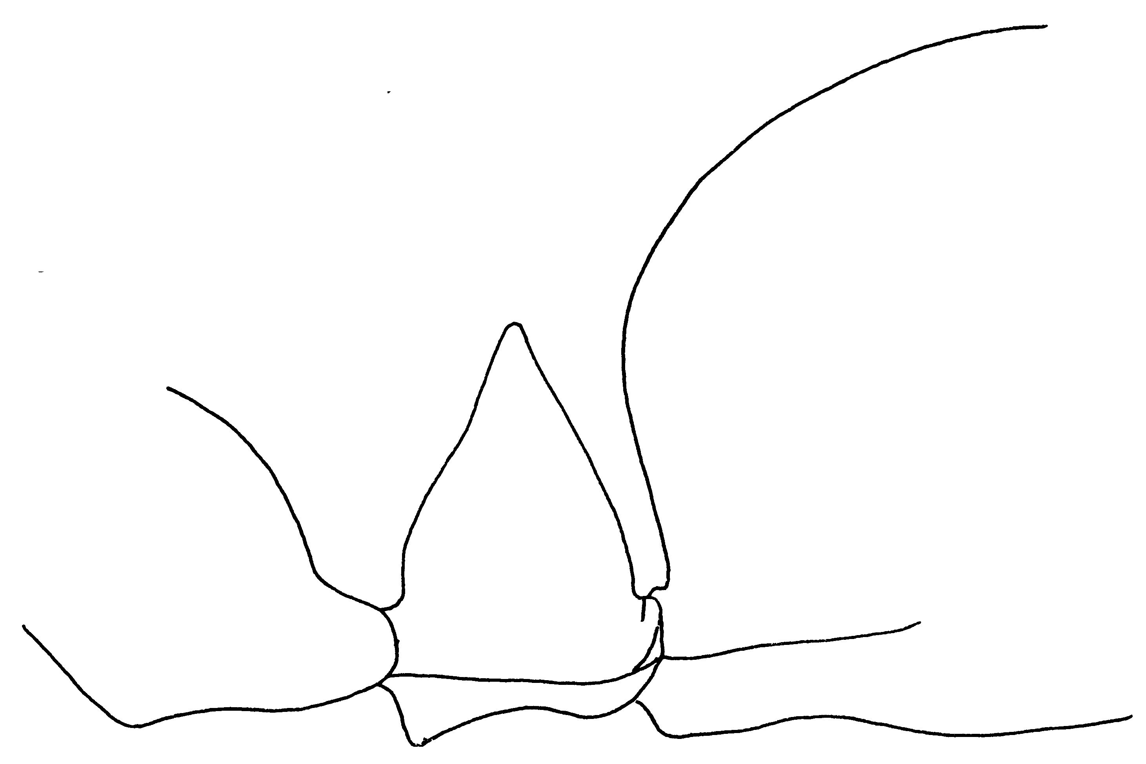
Fig. 18. Petiole of a paratype worker of O. biolleyi.

11(8). Node of petiole with a pair of prominent posterolateral tumosities at about mid-height (Fig. xx); apex as seen from side abruptly narrowed to an axially erect, acute tooth (Fig. 18); all surfaces of node smooth or nearly so above basal leather-like part; Amazon Basin, Guyanas, SE Brasil; forest ................... ……………… biumbonatus Brown
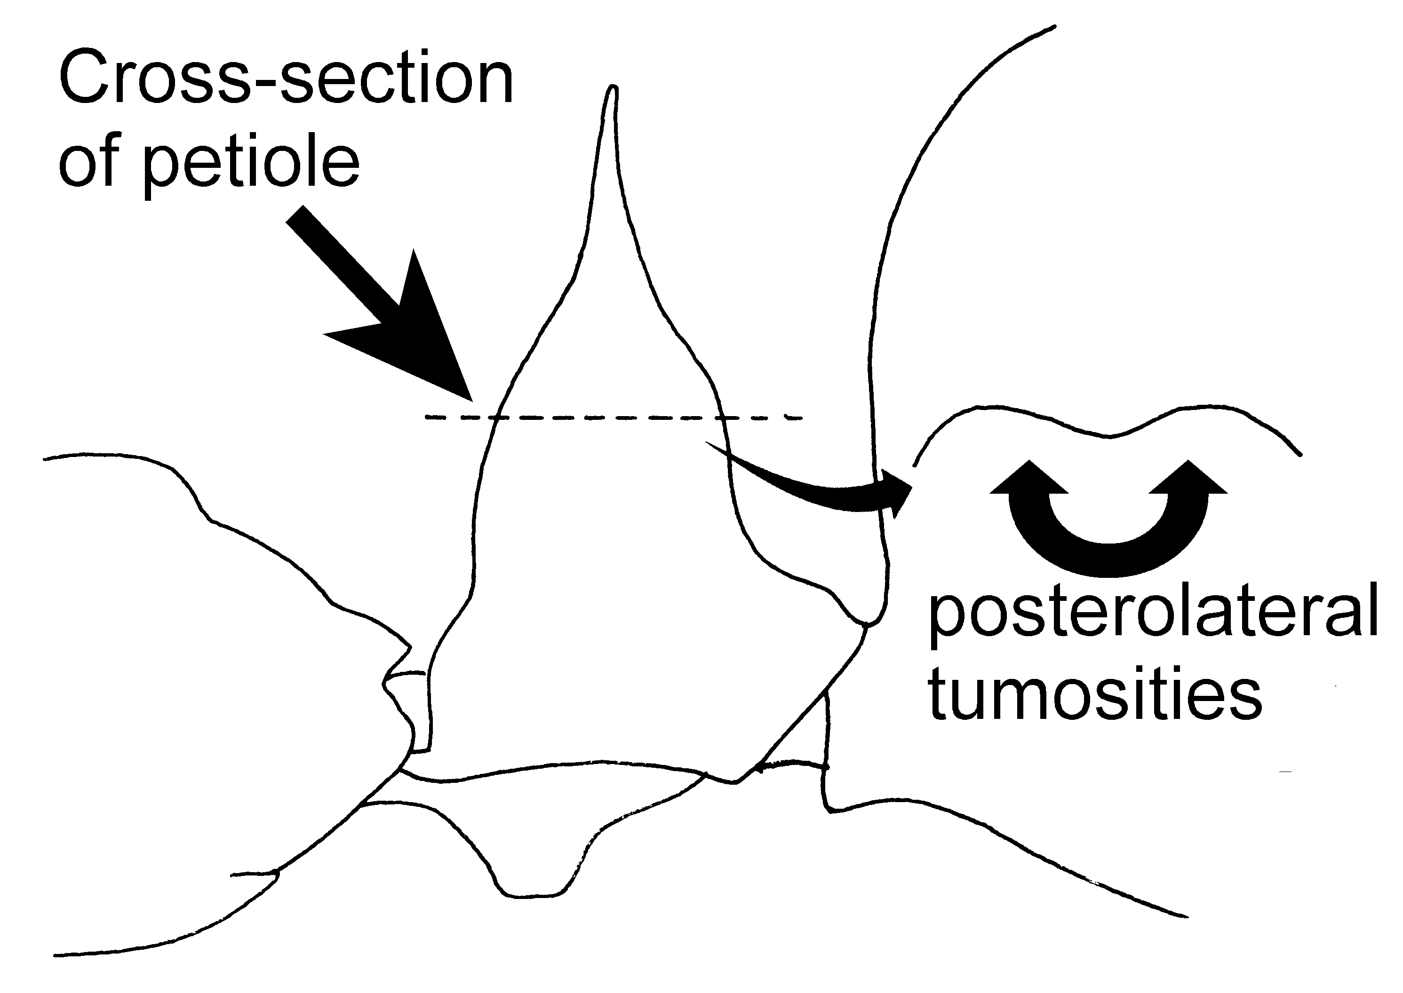
Fig. 19. Petiole of a worker of O. biumbonatus (compared with a paratype). The inset shows the shape of the posterior surface of a cross-section of the petiole, showing the paired posteriorlateral tumosities.

- Node of petiole without paired posterolateral tumosities (Fig. 19); or, if moderate swellings are present, the node is distinctly sculptured with horizontal reticulostriation or costation, or apical spine or tooth inclined caudad from nodal axis (Fig. 19) ………………..………….. 12
12(11). Antennal scape length > 2.15 mm, or of less than that (in minim workers from incipient nests), then the petiolar node is dome-shaped as seen from the side, with distinctly convex outline front and rear up to root of apical spine (Fig. 24) ……………………….………….... 13
- Antennal scape length < 2.15 mm; petiolar node not dome-shaped as seen from the side (Figs.; ); widespread in American tropics N to U.S.: Georgia; Cuba and Bermuda) …………………… …………………….. brunneus (Patton)
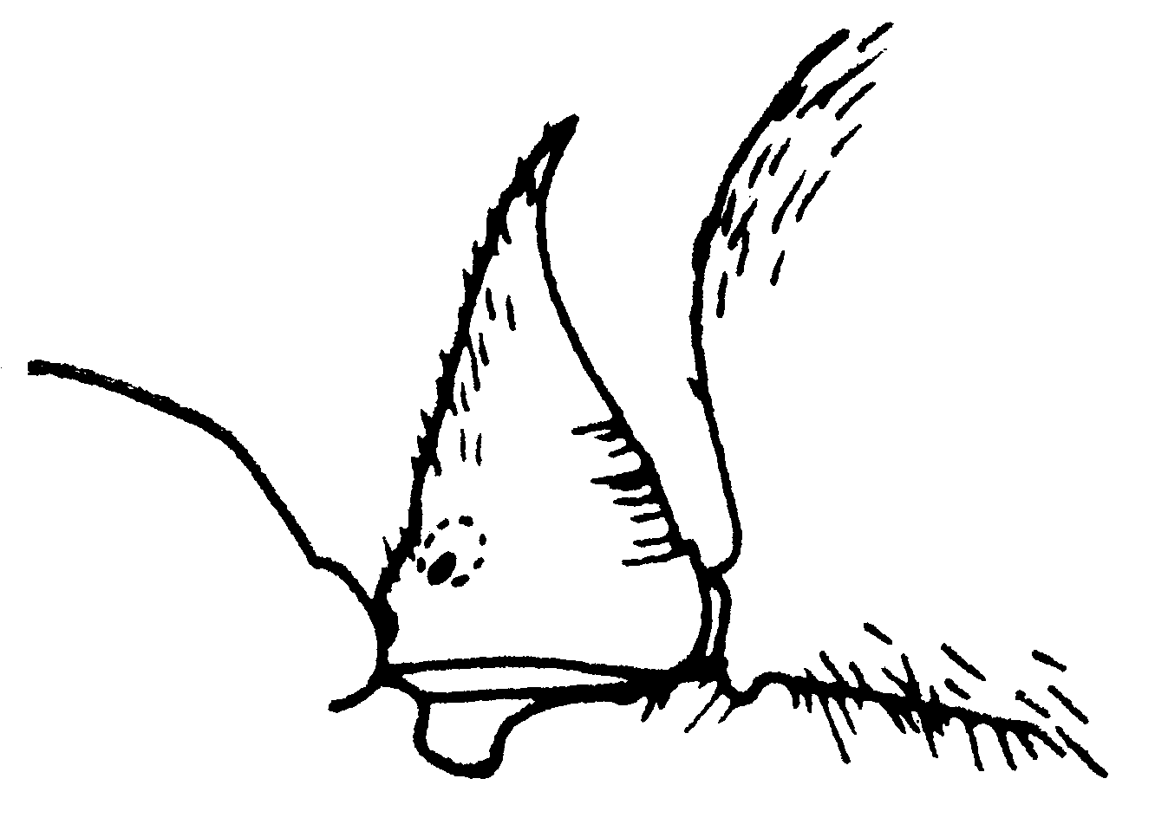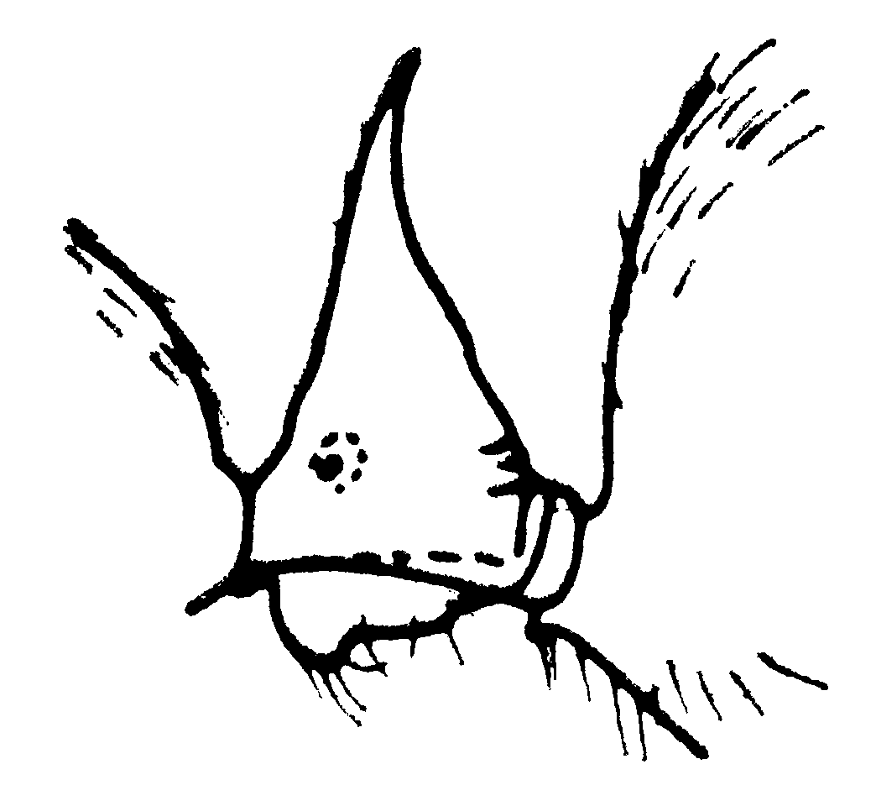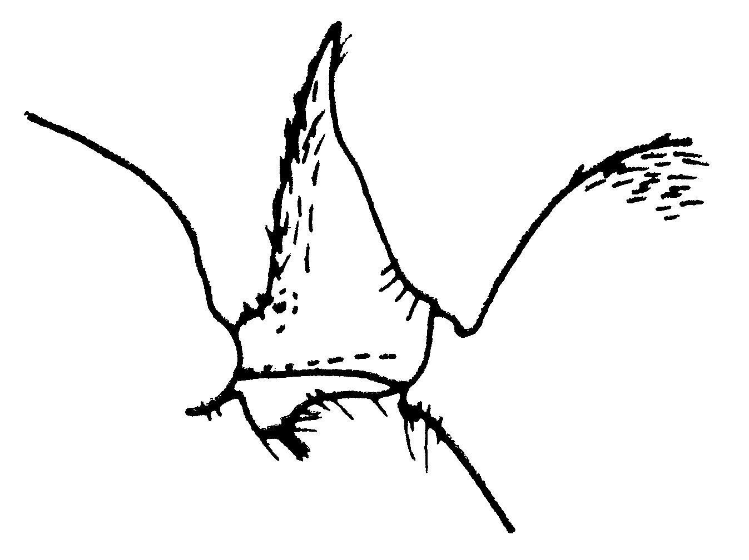
Fig. 20. Petioles of a workers of O. brunneus from Brasil (left) from Ecuador (middle) and from Georgia (right) (from Brown, 1976).

13(12). Anterior face of petiolar node as seen from the side rising steeply from anterior margin, then passing through an obtuse angle into a long section concave in outline to the root of the apical spine (Fig. 20); labial palpi 4-merous; E central Peruvian and Ecuadorian Andes) …. ………………………. bradleyi Brown
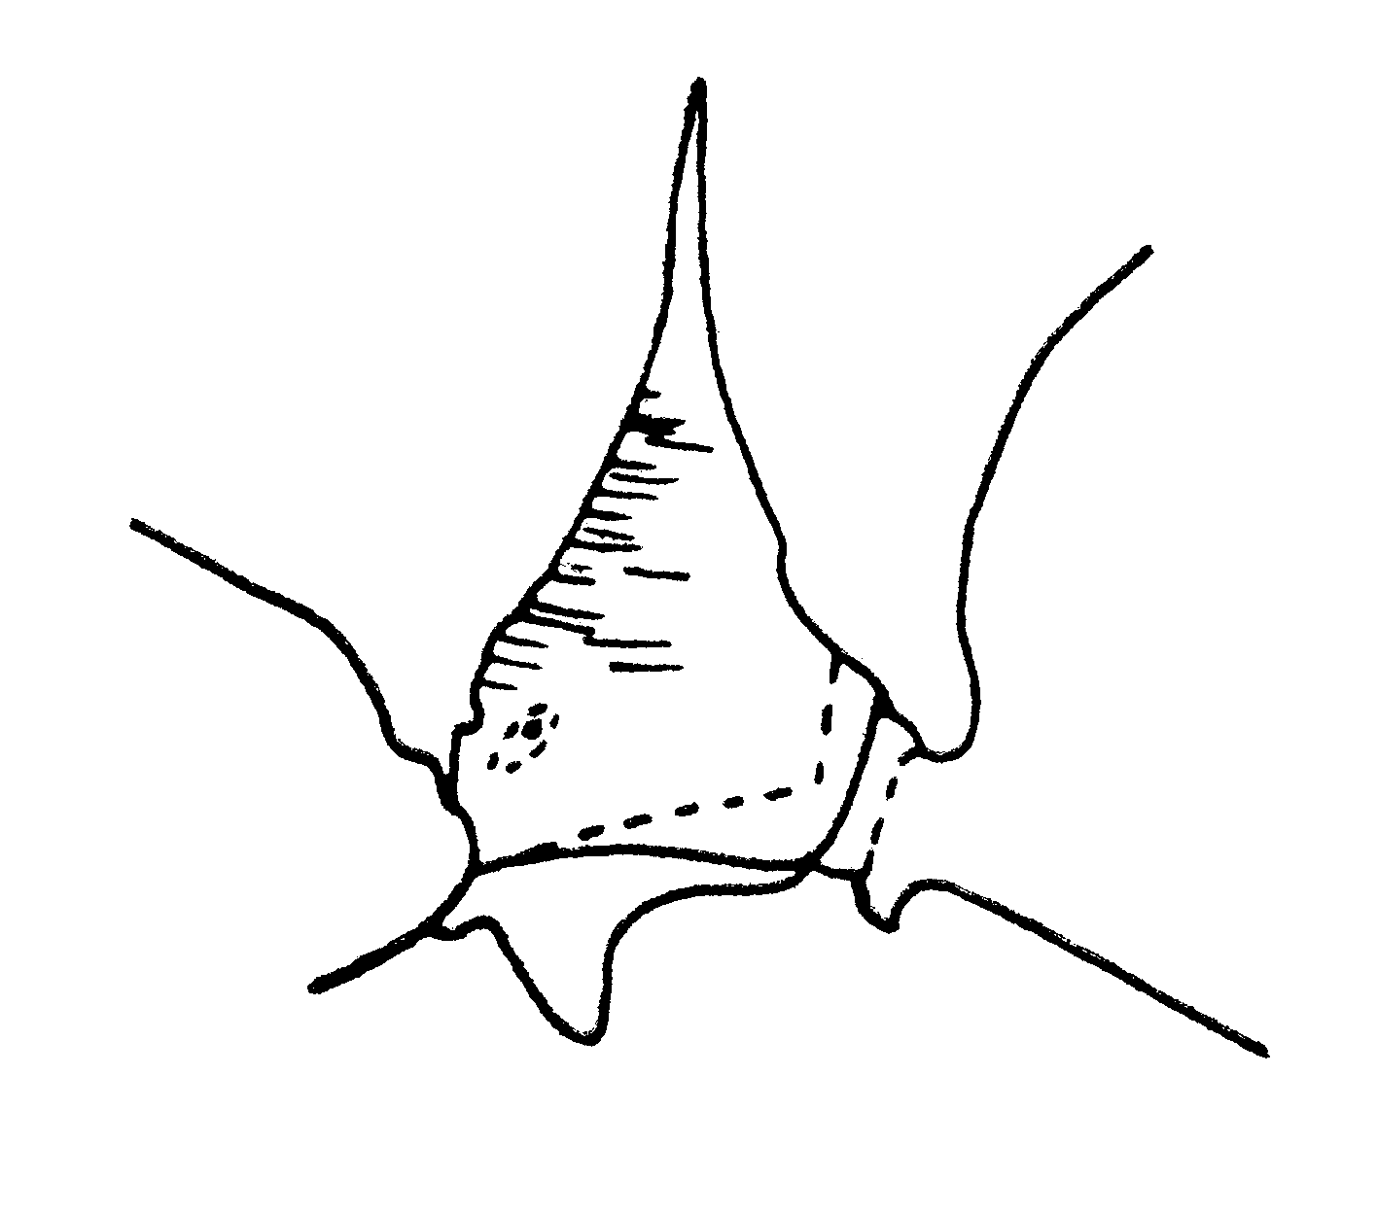
Fig. 21. Petiole of a worker of O. bradleyi (from Brown, 1976).

- Anterior face of petiolar node otherwise formed, either convex (Fig. 22), concave (Fig. 24) or straight (Fig. 23) from base upward for ½ to ²/₃ the distance to the root of the apical tooth or spine; labial palpi 3-merous …...… 14
14(13). Petiolar node as seen from the side dome-shaped, with at least the anterior outline convex from near base to root of apical tooth (Fig. 24); tropical S and C America, Galapagos, W. Indies except Cuba and Bahamas …………… ………………….……… bauri Emery

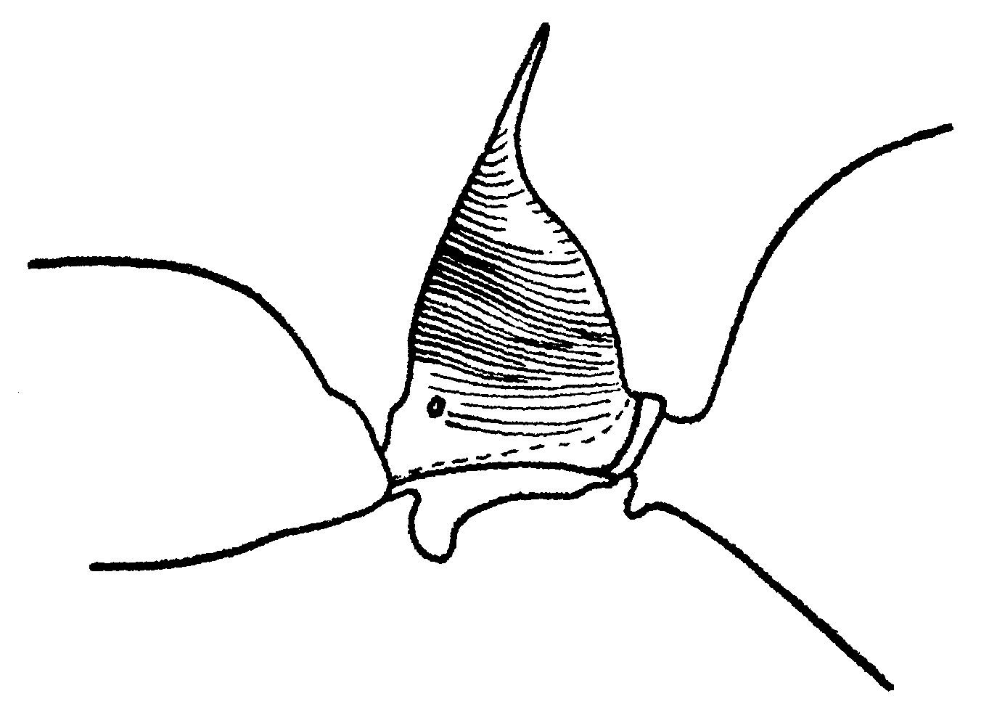
Fig. 22. Petiole of a worker of O. bauri (from Brown, 1976).

- Petiolar node as seen from side gradually tapered dorsad, with basal half of ²_{/3} of anterior outline concave or straight (Fig. 23); grades into form with gaster longitudinally striate above; see couplet 16 (Panama to NE Mexico) ………….…….. laticeps Roger (in part)
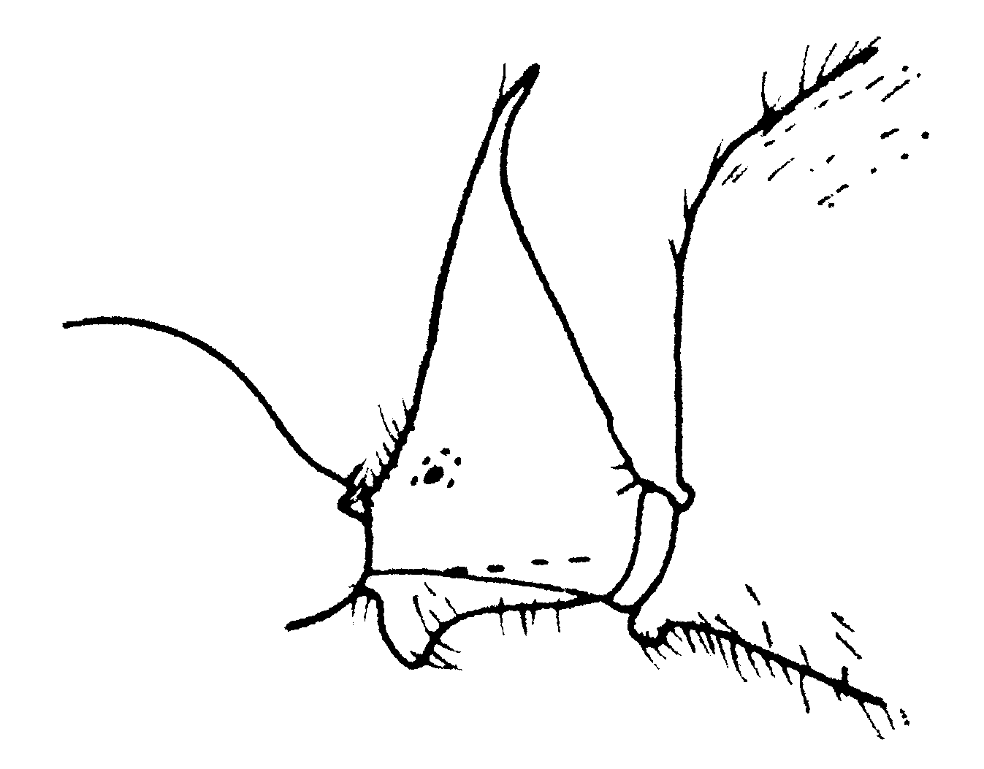
Fig. 23. Petiole of a worker of O. laticeps (from Brown, 1976).

15(2). Striation of gastric dorsum curved-transverse; large, slender species; S Mexico to N Argentina; Trinidad; forest ……………..… chelifer (Latreille)
Fig. 24. Dorsum of the postpetiole (first gastral tergite) of a worker of O. chelifer.

- Striation of gastric dorsum longitudinal ………………………… 16
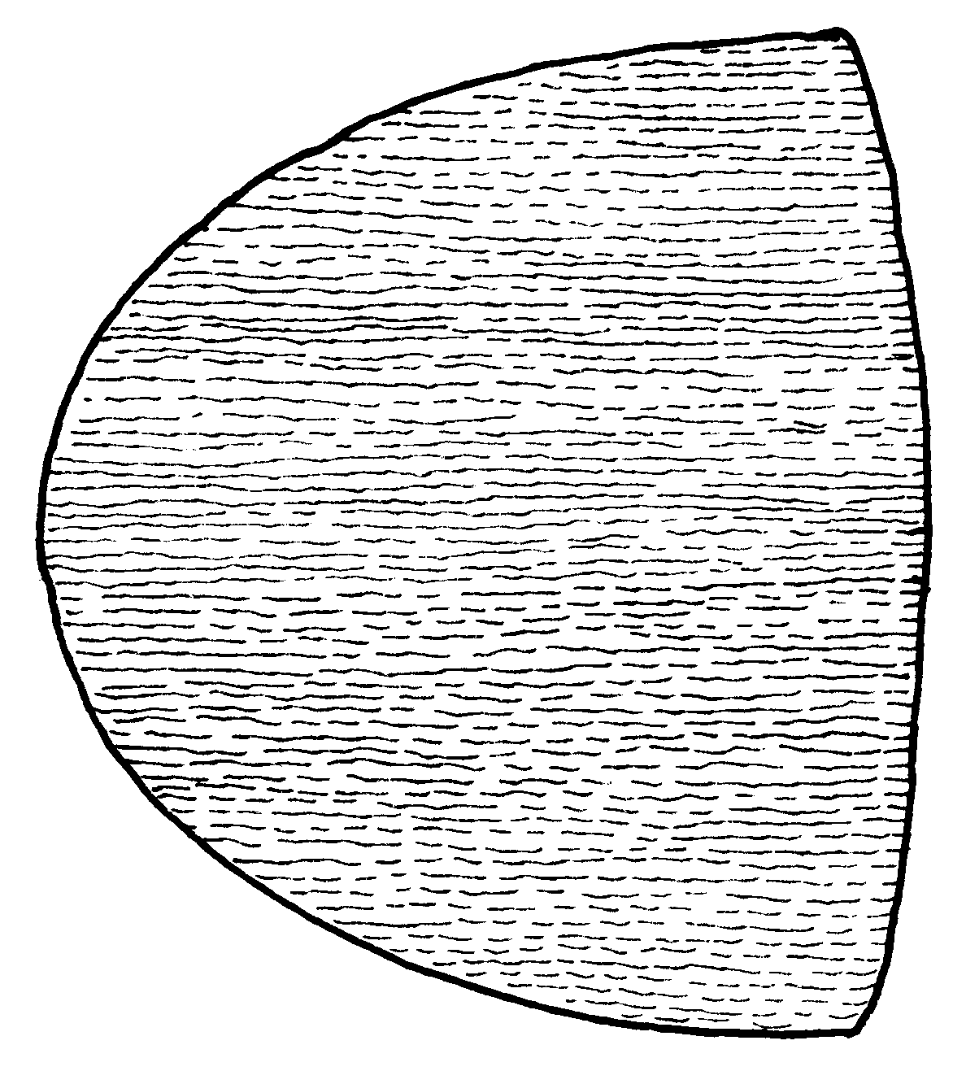
Fig. 25. Dorsum of the postpetiole of a female of O. laticeps.

16(15). Mesonotum strongly convex, but broadly sulcate and longitudinally striate on at least the anterior half near midline (Fig. 26); appressed pubescence of gastric dorsum nearly obsolete, its individual hairs minute, separated from one another by an average distance of their own length or more (Fig. 23); Amazon Basin, Guyanas, forest ……… ……………………….. caelatus Brown
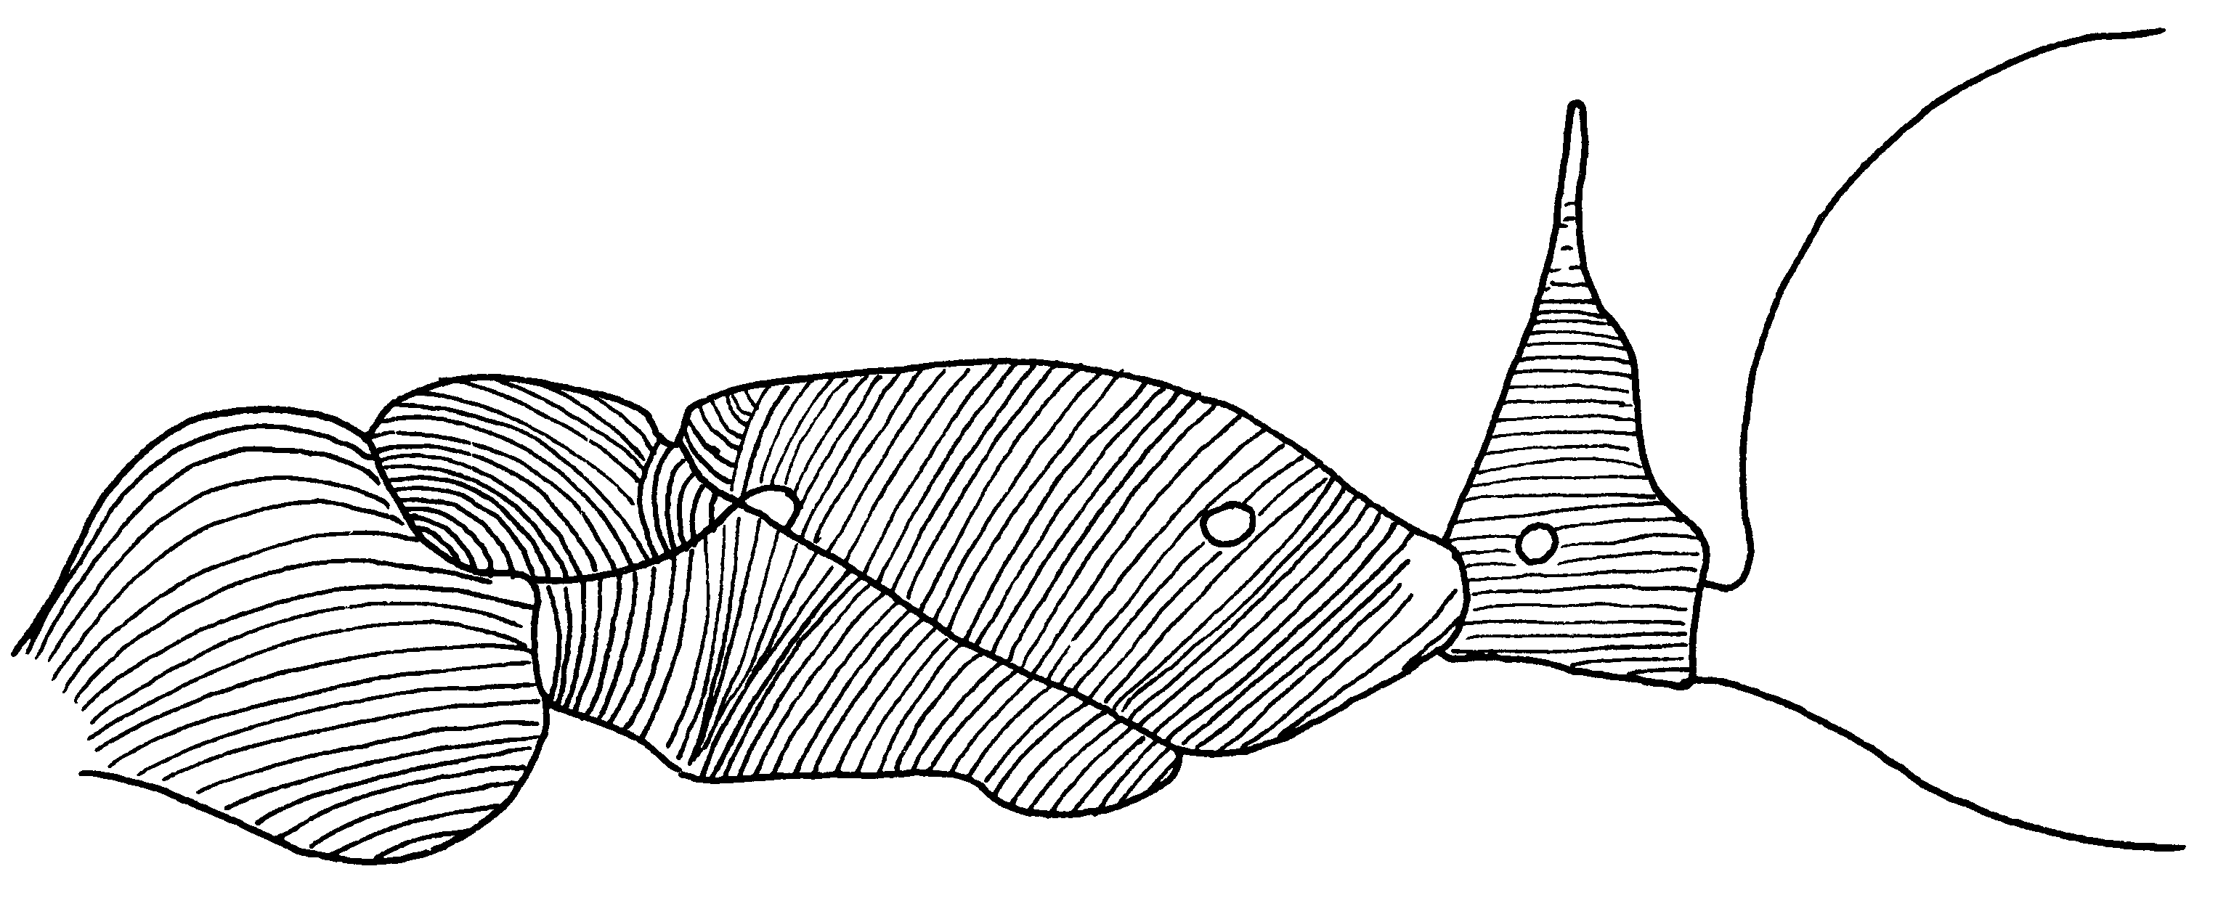
Fig. 26. Mesosoma and petiole of a paratype worker of O. caelatus.

- Mesonotum gently but evenly convex, transversely striate; reclinate pubescence of gastric dorsum abundant and conspicuous, its individual hairs 2 or more times longer than the average space between them; grades into form with smooth gastric dorsum; see couplet 14; NE Mexico to Panamá ……….. …………….… laticeps Roger (in part)
Fig. 27. Mesosoma of a worker of O. laticeps. need fig 4

17(1). Ocular prominences each produced anterolaterally into a stout, acute, oblique, toothlike process (W Ecuador) …………..…………….. cornutus Stitz
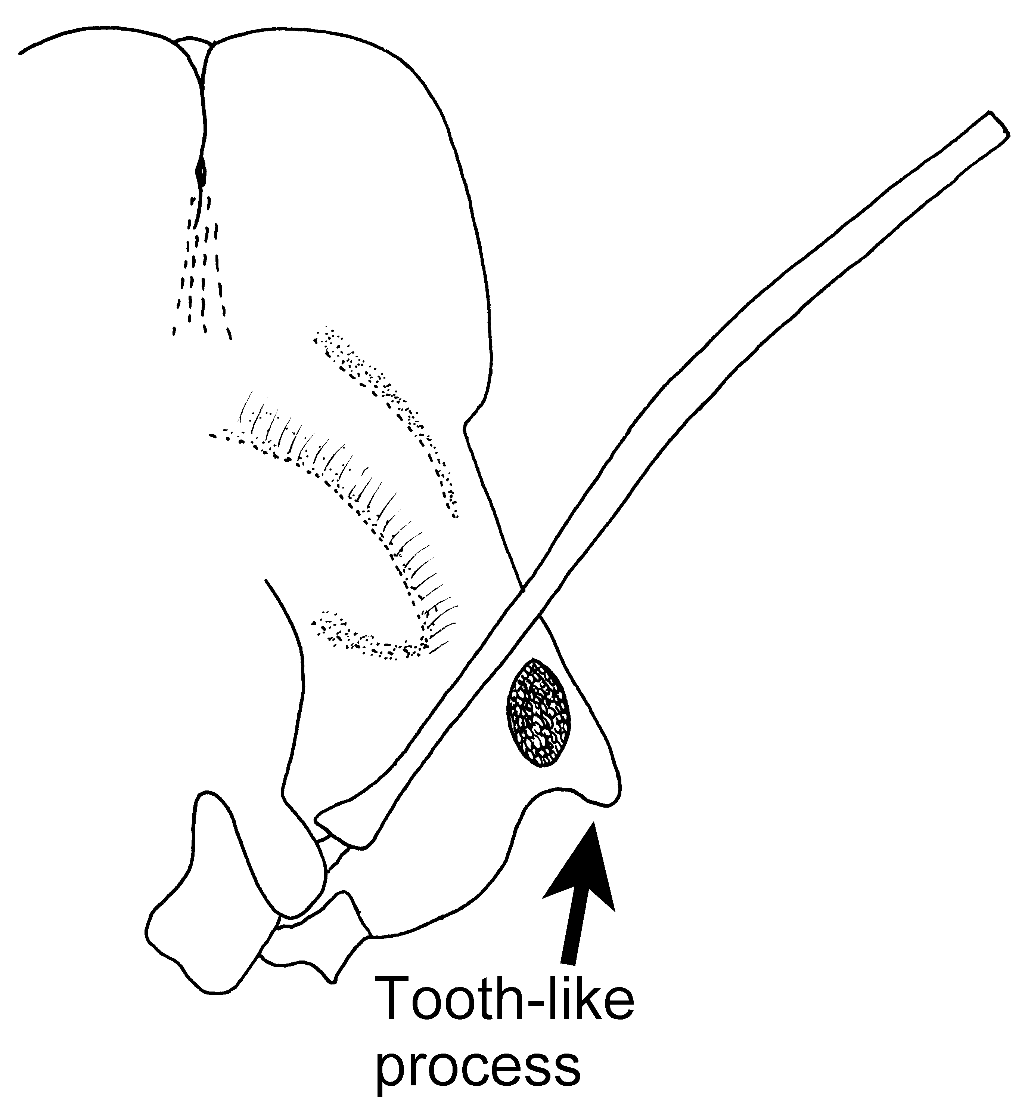
Fig. 28. Left half of the head of a worker of O. corrnutus (Chocó, Colombia), showing the tooth-like ocular prominence.

- Ocular prominences bluntly rounded, as usual …………….…….. 18
18(17). Antennal scapes very short, not reaching posterior border of head in full-face view; very small species with broad head; Mato Grosso …… spissus Kempf
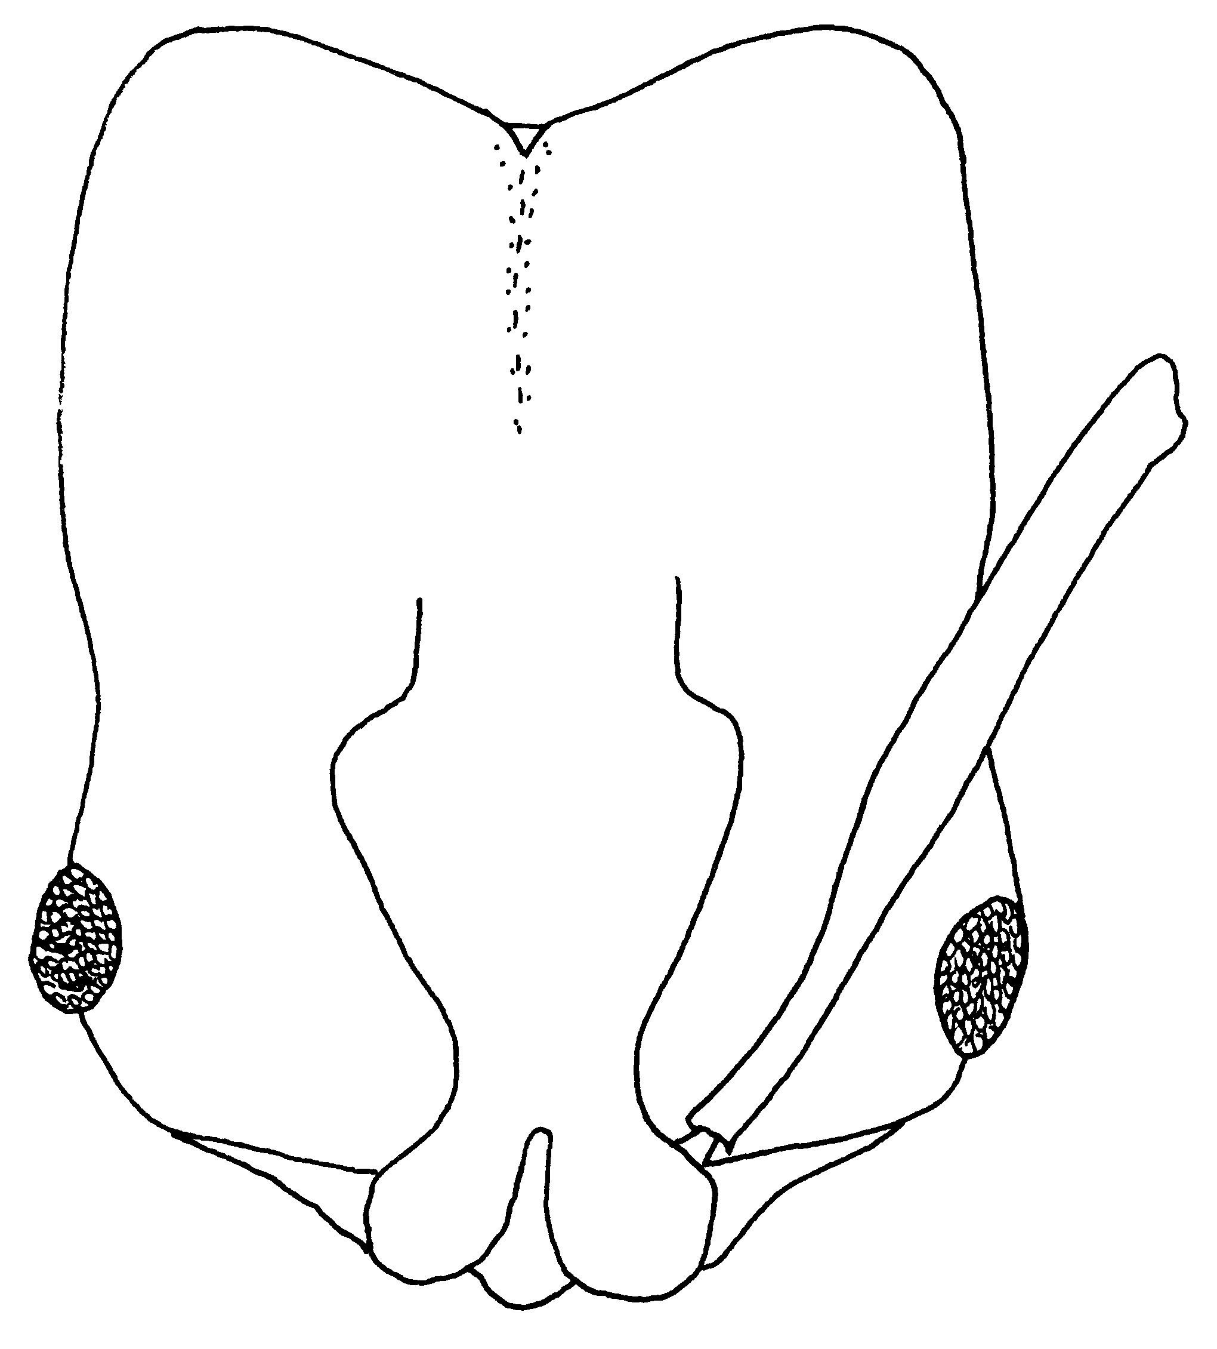
Fig. 29. Head of a worker of O. spissus.
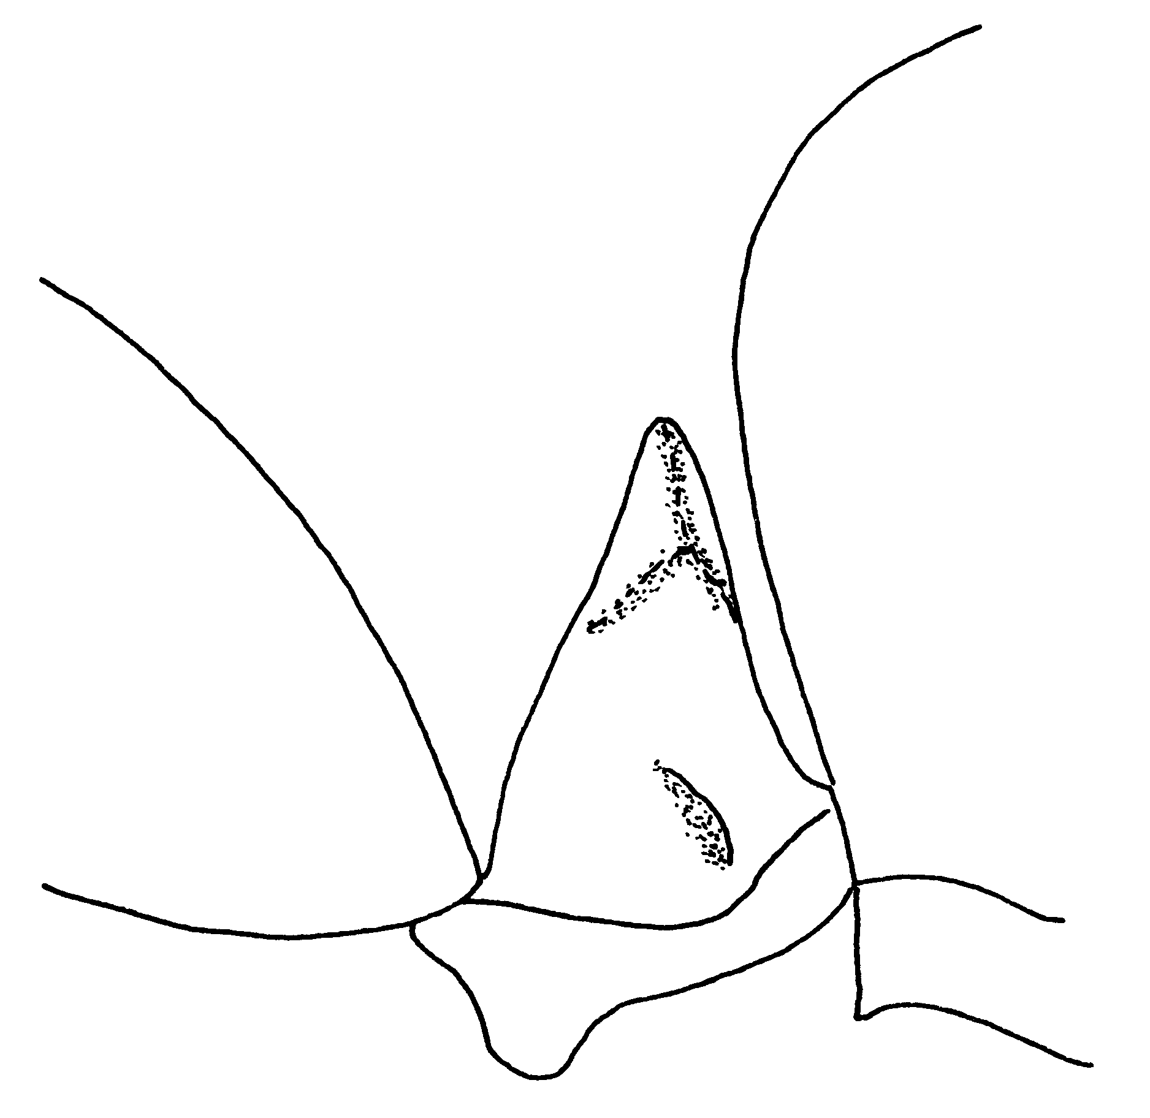
Fig. 30, Petiole of a worker of O. spissus.

- Antennal scapes surpassing posterior border of head viewed full-face ………………………………………. 19
19(18). Antennal scapes (Fig. 33) at least slightly longer than head (SL > HL); slender species, vertex narrow (CI usually under 55) ………………….. 20
- Antennal scapes shorter than head (SL < HL); more robust species vertex broader (CI > 55) …………… 22
20(19). Apex of mandible with only 2 large teeth (intercalary tooth lacking); size small (HL < 2.3 mm; worker characters deduced from queen; W Amazon Basin) …………….... allolabis Kempf
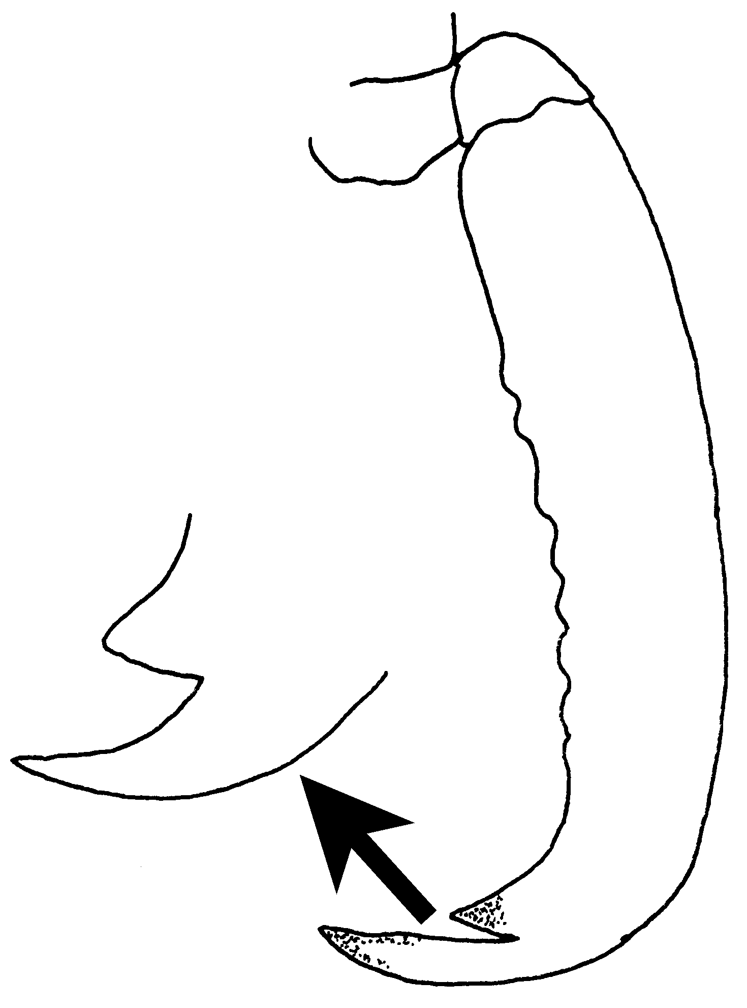
Fig. 31.Mandible of a paratype female of O. allolabis. The inset shows a direct view of the two teeth of the mandible.
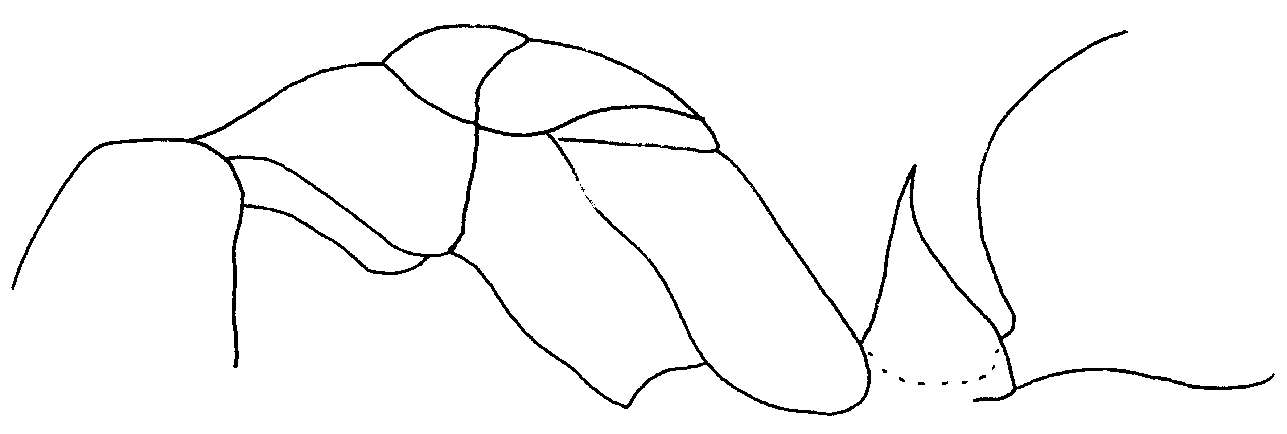
Fig. 32. Mesosoma and petiole of a paratype female of O. allolabis.

- Apex of mandible with the usual 3 large teeth, including the intercalary tooth; size larger (HL > 2.4 mm) .. ……………………………………... 21
21(20). Size very large (HL of holotype worker 4.34 mm); head and body virtually hairless except for a few long hairs on posterior half and underside of gaster; petiolar node as in Fig. 34; Ecuador, and Colombia, W base of Andes .. ………………………… mormo Brown
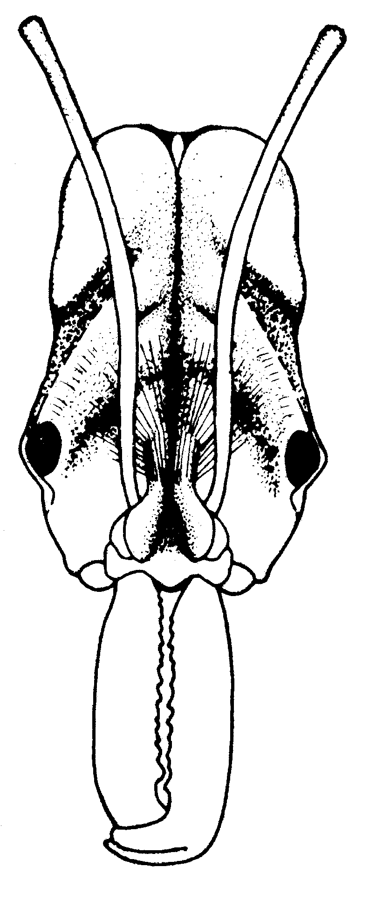
Fig. 33. Head of a worker of O. mormo (from Brown, 1976).
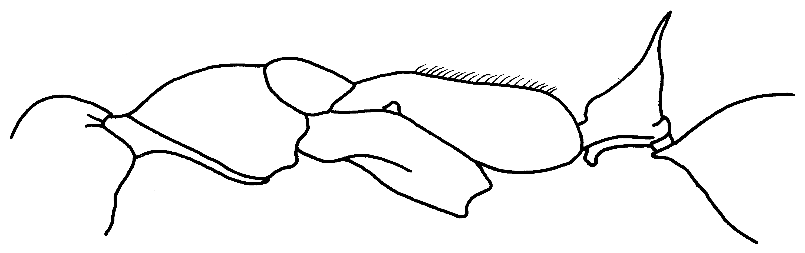
Fig. 34. Mesosoma and petiole of the holotype worker of O. mormo.
- Size not so large (HL < 3.8 mm); head, mesosoma, petiole and gaster with abundant fine standing hairs (Fig. 31); petiolar node pedunculate anteriorly (Fig. 35); S Mexico to Bolivia ………….... …………………… hastatus (Fabricius)
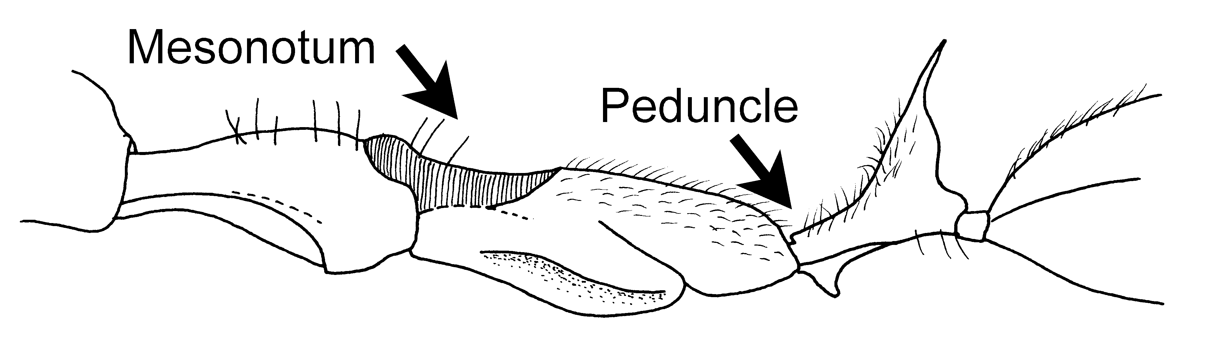
Fig. 35. Mesosoma and petiole of a worker of O. hastatus.

22(19). Mesepisternum with a prominent, narrowly-rounded anteroventral lobe projecting conspicuously on each side when mesosoma is viewed from above (Fig. 36); medium-sized species; Amazon Basin, Guyanas; forest ……… …………………….……… mayi Mann
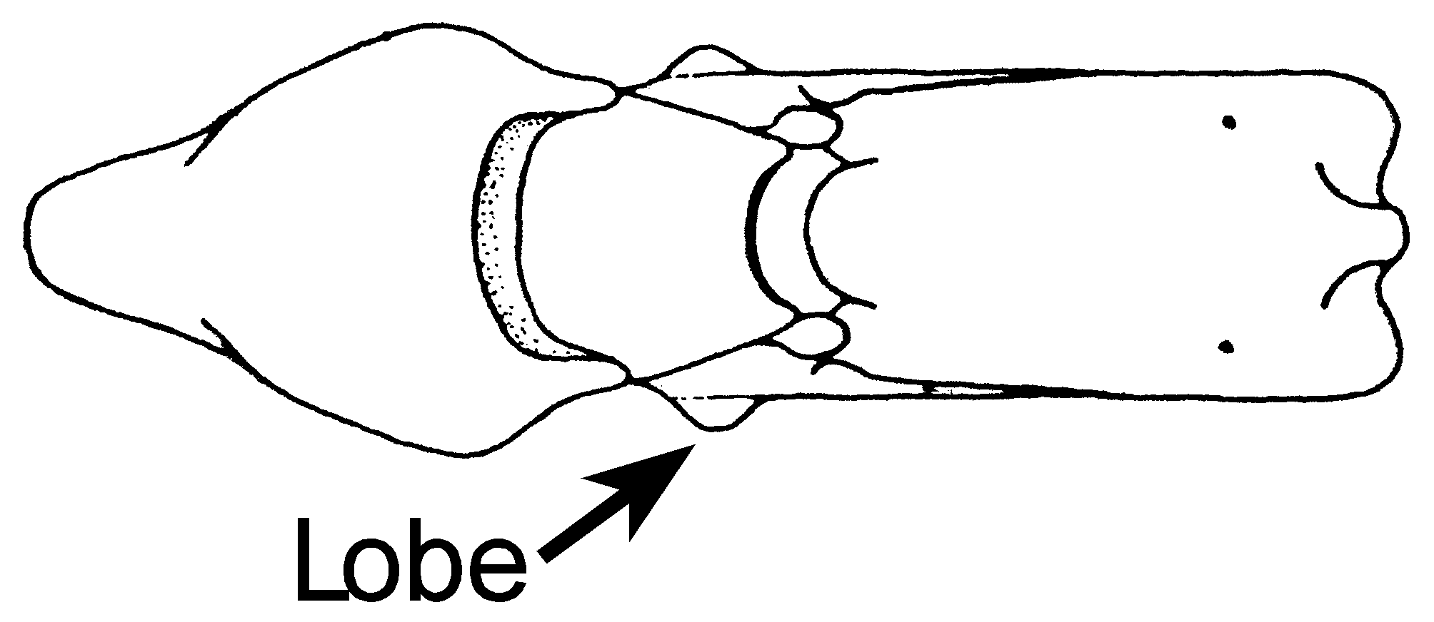
Fig. 36. Dorsal view of the mesosoma of a worker of O. mayi (from Brown, 1976).

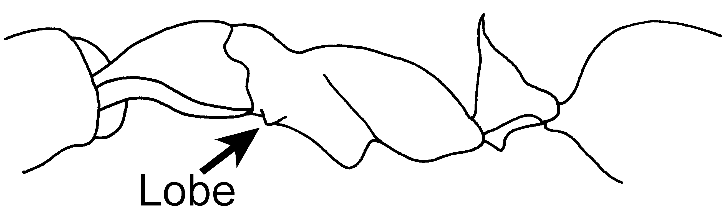
Fig. 37. Mesosoma and petiole of a cotype worker of O. mayi, showing the anteroventral lobe.

- Mesopleuron with at most a low, inconspicuous convexity on its anteroventral margin (Fig. 38); size averaging either larger or smaller than mayi …. …………………………….……….... 23
23(22). Large species (HL > 2.8 mm); SE Brasil) .. affinis Guérin-Méneville
- Small species (HL < 2.8 mm); Panama, Costa Rica ………….………... ……………………. panamensis Forel
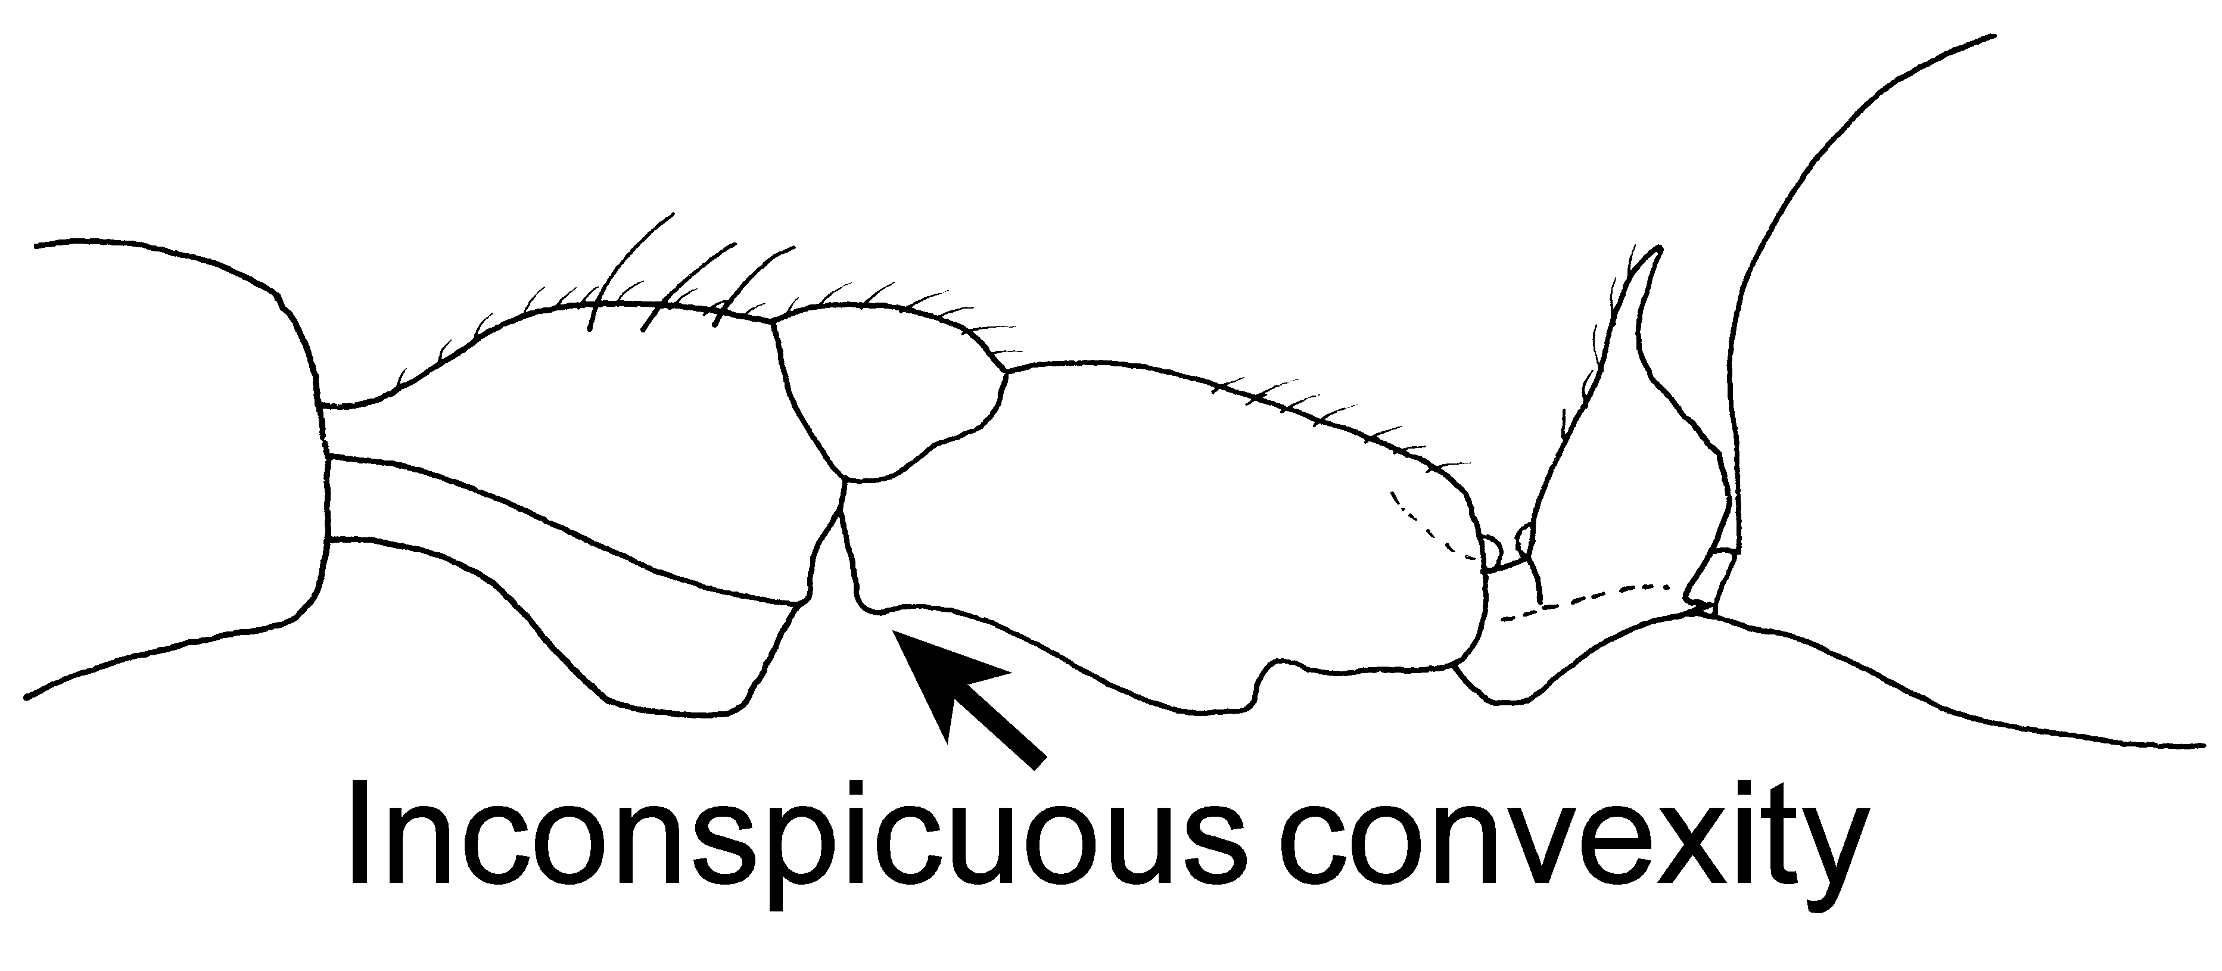
Fig. 38. Mesosoma and petiole of a “type” worker of O. panamensis.
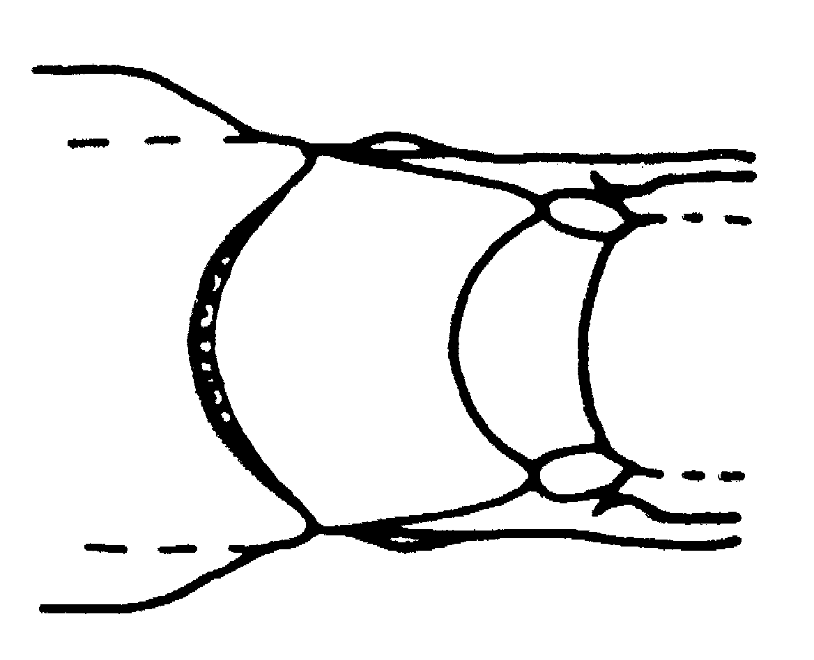
Fig. 39. Top of the middle part of the mesosoma of a worker of O. panamensis, showing the reduced mesopleural lobes (from Brown, 1976).

Odontomachus bauri Emery
Figs. 22 (petiole); Map 1

Discussion. The workers are moderate sized (total length about 9 mm), dark reddish-brown ants, in which the antennal scape extends about first funicular segment past posterior lateral corner. Both the anterior and posterior faces of the petiole are noticeably convex, and terminate in a well-developed spine (length about 0.35 mm). The metasternal process is poorly developed, the anterior portion consists of a tiny, elongate flange, the posterior part consists of a transverse carina, with a pair of tiny, ventral bumps.
The striate on the dorsum of the head extend nearly to the posterior border, with the area around the nuchal carina being smooth and glossy. The neck of the pronotum has transverse striae, most of the striate on the dorsum of the pronotum are longitudinal, those on the side of pronotum are nearly vertical, the striate on the mesonotum are transverse, as are those on the dorsum of the propodeum, those on the side of the propodeum are nearly vertical, the mesopleuron is nearly completely smooth and glossy, with a few, fine striae on the anteriormost part. All faces of the petiole are covered with fine, striate, which circle the node. The dorsum of the postpetiole is very finely coriaceous, and smooth and glossy, the second tergum of the gaster is slightly more coarsely sculptured.
This species has the normal pattern of hairs for the genus.
The female is similar, approximately the same length, and differs in possessing ocelli, having longitudinal striae on the scutum, and a punctate, moderately glossy scutellum, and in having the anterior face of the petiole being nearly straight.
It can be separated from O. biumbonatus and O. brunneus as the anterior part of the metasternal process is only weakly developed into a small, longitudinal flange, not into a definite lobe as in the other two species. It differs from O. bradleyi in having the anterior face of the petiole (at least in worker) being convex, not concave as in O. bradleyi. Finally, it can be separated from O. laticeps by the convex anterior face of the petiole, which is straight or even slightly concave in O. laticeps. The striate on the side of the petiole are very well-developed in O. bauri, and only weakly developed in O. laticeps. The metasternal lobe of O. laticeps is moderately developed. This species is similar to O. scalptus from Ecuador, Guyana, and Surinam, differing in having the striae on the mesonotum being transverse, instead of longitudinal, as in O. scalptus.
Distribution. COSTA RICA: Guanacaste (Loma Barbudal). COLOMBIA: Huila,
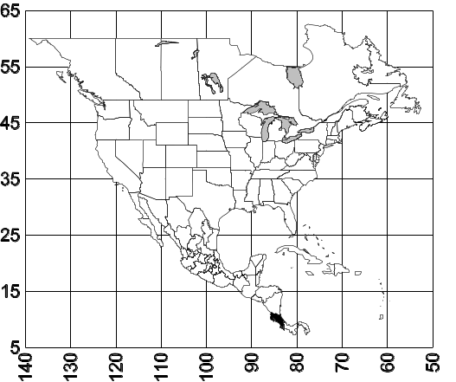Map 1. Odontomachus bauri.
Habitat. ???
Biology. ???
Odontomachus biolleyi Forel
Figs. 18 (petiole); Map

Discussion. The worker is moderate sized (total length 7 mm), reddish-brown ant. The scapes nearly reach or slightly surpass the posterior lateral corners, the anterior and posterior faces of the petiole are at least slightly convex, and the spine is relatively long (0.25 mm). The metasternal process consists of a broad, blunt lobe, followed by a transverse flange, which appears to be a triangular shaped process when viewed in profile (Fig. xx).
The entire dorsum of the head is covered with fine striae, the striae on the pronotum are coarser, and are transverse on the neck, form concentric circles on the dorsum and are longitudinal on the highest point. The striate on the mesonotum are transverse, and slightly more coarse striae are located on the dorsum of the propodeum. Nearly the entire mesopleuron is smooth and glossy, with only a few, fine striae on the anteriormost part, the gaster is only finely sculptured and polished.
The female is similar to the worker, except striae on the scutum are longitudinal and scutellum is mostly smooth and glossy. The anterior face of the petiole is distinctly concave, the posterior face slightly convex, and petiole terminates in a sharp spine, similar to that of the worker.
This species is very similar in size, color, and general form to O. clarus. It can be easily separated, as O. clarus lacks the metasternal process, and petiolar spine is slightly less developed than it is in O. biolleyi.
Distribution. MÉXICO: Veracruz (La Mancha, 6.5 k N Tierra Blanca, CWEM); COSTA RICA; COLOMBIA: Chocó (Río Sucio [La Balsa 7°2’26”N 77°20’16W, 50-80m, IAVH]), Valle del Cauca (Dagua).
Map 2. Odontomachus biolleyi.
Habitat. ???
Biology. 1047
Odontomachus brunneus (Patton)
Figs. 20 (petioles); Map

Discussion. The workers are dark brown, moderate sized (total length about 8 mm) specimens. The anterior face of the petiole is convex, and terminates in a well-developed (length about 0.3 mm), the posterior face is also convex, the metasternal process is weakly developed into two, small lobes, the posterior lobe is partially developed into a carina.
The striae on the dorsal surface of the head nearly reach the posterior border, with the region near the nuchal carina being slightly punctate and moderately shining. The striae on the neck of the pronotum are transverse, as are those along the posterior margin, the striae in the center form concentric circles, those on the side are obliquely vertical. The striae on the mesonotum are transverse, those on the dorsum of the propodeum are transverse and slightly more coarse, those on the side of the propodeum are obliquely vertical, nearly the entire mesopleuron is smooth and glossy. The dorsum of the gaster is mostly smooth and polished.
A few erect hairs are present on the dorsal and ventral surfaces of the head, the pronotum, the petiole, and all surfaces of the gaster.
The female is similar, except slightly larger (total length about 9 mm), with well developed ocelli, the striae on the scutum are longitudinal, the scutellum is finely punctate. The anterior face of the petiole is nearly straight, the posterior face is convex.
The development of the metasternal process could cause confusion with O. biolleyi. This process is much more developed in O. biolleyi, than it is in O. brunneus (compare figs. X &X). Additionally, O. biolleyi is reddish-brown, and O. brunneus is black. It can be separated from the very similar O. biumbonatus as the metasternal process of O. biumbonatus is barely developed. The concave convex anterior face of the petiole (at least in the worker) would easily separate this species from O. bradleyi.
Distribution. United States: Georgia, south to American tropics (Brasil); Cuba, Bermuda, Puerto Rico.
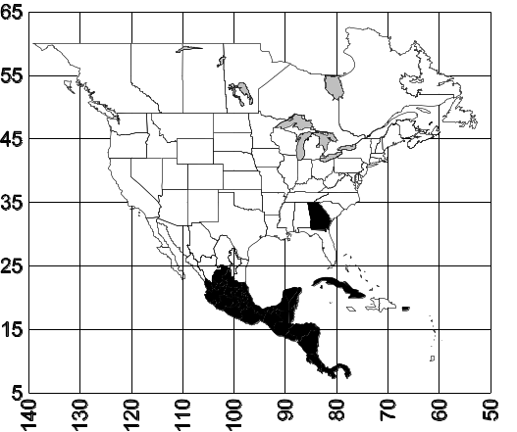 Map 3. Odontomachus brunneus.
Habitat. ???
Biology. 12705
Odontomachus chelifer (Latreille)
Figs. 24 dorsum of petiole, NEED; Map

Discussion. These are among the larger of the species of Odontomachus (total length about 12 - 15 mm), dark brown to bicolored (head and gaster dark brown, mesosoma and petiole lighter brown). The anterior face of the petiole is straight, or slightly convex, the posterior face is convex.
The entire dorsum of the head, with the exception of the region near the nuchal carina, is covered with fine striae, as is the dorsum of the pronotum (predominately transverse), the dorsum of the mesonotum, and the dorsum of the propodeum. Most of the mesopleuron is smooth and glossy. The petiole is covered with fine, oblique striae. The dorsum of the postpetiole (first segment of the gaster) is completely covered with transverse, fine striae, which form semicircles posteriorly. The sculpture on the ventral surface of the postpetiole, and much of the sides, is very fine, nearly smooth, but only weakly shining. The sculpture on the second tergum is similar.
The female is large (total length 16 mm), dark brown or black, similar to the worker, with the first tergum (as well as the second) of the gaster transversely striate.
The transversely striated first and second tergum of the gasters of the worker and the female would separate this species from all of the other species of Odontomachus.
Distribution. Mexico (Veracruz), Honduras, Costa Rica, Panamá, south to Paraguay.
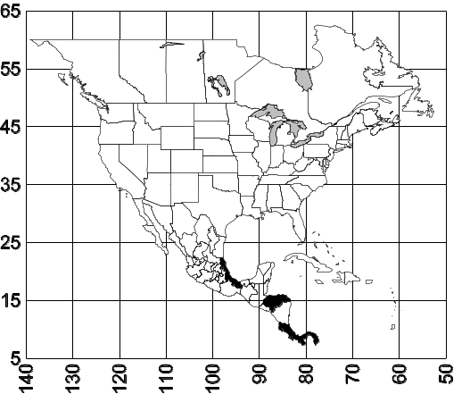 Map 4. Odontomachus chelifer.
Habitat. ???
Biology.
Odontomachus clarus Roger
Figs. 1 (head), 2 (side view), 3 (side view of female), 4 (side view of male); Map 5

Discussion. Workers are moderately sized (total length 8 mm), generally bicolored (red with a black gaster) ants. The mandibles have three well-developed teeth at the apex, but the remainder of the mandible is without teeth, although bumps may be present. The scape nearly reaches the posterior lateral corner of the head. The anterior face of the petiole is straight, or even slightly concave, the posterior face is slightly convex, and the petiolar spine is relatively short (0.1 mm).
A few erect hairs are present on the mandibles, the dorsal and ventral surfaces of the head, the pronotum, the petiole, and all surfaces of the gaster.
Most of the dorsum of the head is covered with fine striae, although the region near the posterior corners may be smooth and glossy. The striae on the pronotum are very similar, and pass transversely across the neck, form concentric circles on the dorsum of the mesosoma, and are longitudinal at the highest point. The striae on the mesonotum are transverse, as are those on the propodeum; the side of the propodeum has obliquely transverse striae. The mesopleuron is nearly completely smooth and glossy. The petiole is smooth and glossy, although sculpture may be present on the lower anterior face, as well is occasionally on the sides. The gaster is mostly smooth and glossy.
The female is similar to the major worker in most aspects, except the mesosoma is swollen muscles and designed for flight.
The male is a small, dark brown specimen, with lighter appendages, and a lighter colored gaster.
This species is easily recognized, as it is the only one which occurs in the southwestern United States and northern Mexico. It can be separated from the other similar species on the basis of color, as O. brunneus and O. laticeps are both dark brown. There is no metasternal process, which would separated from similar colored, Central and South American O. biolleyi, which has a bilobed process (Fig. xx).
Distribution. United States: west Texas, Arizona; Mexico (Chihuahua, Guanajuato, Hidalgo, México, Morelos).
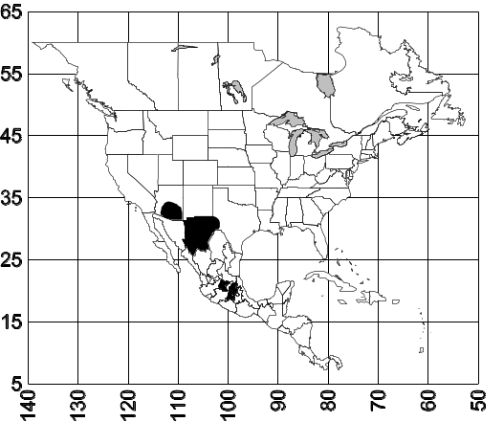 Map 5. Odontomachus clarus.
Habitat. This species is most common in riparian areas within dry, desert scrub communities.
Biology. Nests are located in the soil, often under a stone.
Odontomachus erythrocephalus Emery
Figs. 6 (head), 11 (side view); Map 6

Odontomachus haematodes race erythrocephalus Emery, 1890:44 ; Forel 1914:9 

Discussion. The worker is a moderately sized (total length about 9 mm), black specimen, with dark brown mandibles, and a reddish-brown head and legs, which strongly contrast with remainder of the ant. The scape extends slightly past the posterior lateral corner home. The anterior and posterior faces of the petiole are convex, and the spine is relatively long (0.3 mm) and acute.
The striae on the dorsum of the head extend to the posterior margin, the side of the head and ventral surface are smooth and glossy. The striae on the pronotum are more coarse than those on the head, and pass transversely across the anterior part of the pronotum, but are longitudinal on the central dorsal region, and are obliquely longitudinal on the sides. The striae on the mesonotum are transverse, as are those on the dorsum of the propodeum. Nearly the entire mesopleuron is smooth and shiny, with some very fine striae on the uppermost part, the striae on the side of the propodeum are obliquely longitudinal and pass transversely on the dorsal face propodeum. All surfaces of the petiole are covered with fine striae, which are transverse on the anterior and posterior faces or longitudinal on the side of petiole. The entire gaster is smooth and glossy.
The female is larger than the worker (total length about 10 mm), and similar in color. The striae on the scutum are longitudinal, those on the scutellum are barely obvious. The anterior face of the petiole is straight or slightly concave, the posterior face is convex. The pilosity and sculpture are similar to that of the worker.
The workers and females are nearly always easily recognized, due to the bright red head, and the black mesosoma, petiole, and gaster. The glossy dorsal surface of the gaster would separate this from many similar species, such as O. haematodus, O. opaciventris, and O. minutus. Odontomachus clarus is similar, but the head and mesosoma are generally red, the legs are often yellowish-brown, and the gaster is black, a color combination never found in O. erythrocephalus. Darker specimens could be confused with O. biolleyi. They can be separated, as they lack the bilobed process on the metasternum, which is found in O. biolleyi.
Distribution. Nicaragua??? (???), Costa Rica (???), Panamá (???) and Colombia (Santander, Boyacá, Cundinamarca, Valle del Cauca, Tolima); Ecuador (Esmeraldas).
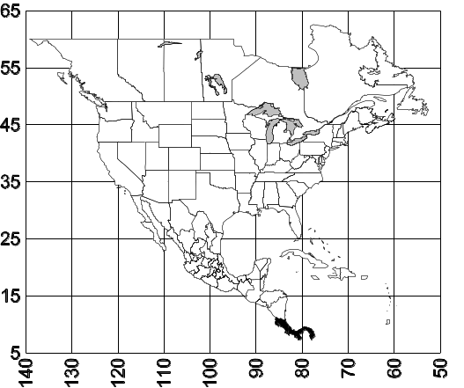 Map 6. Odontomachus erythrocephalus.
Habitat. ???
Biology. 74-373, 578, 575, 1094, 1117, 7214, C.-14, 11745, 11778, 11780, 11817, 11535, 11732, 11815
Odontomachus hastatus (Fabricius)
Figs. 35 (side view); Map 7

Discussion. This is a moderately large (total length 13 mm), medium brown, slender (Fig. xx) species. The mandibles are elongate, with three well-developed teeth at the apex, and a series of denticles along the masticatory border. The head is narrowed posteriorly, and the scape extend ¼ - ⅓ times its length past the posterior lateral corner. The mesonotum is strongly concave, and the dorsal face of the propodeum is straight. The anterior face of the petiole is straight, or slightly concave, the posterior face is straight, or slightly convex.
Erect hairs are present on the dorsum and ventral surface of the head, the scape has tiny (0.03 mm) bristly hairs on the shaft, the pronotum, mesonotum, propodeum, petiole, and all surfaces of the gaster have elongate (0.1 mm - 0.4 mm), erect, golden, or silver hairs.
The anterior half of the head is partially covered with longitudinal striae, the posterior half of the head is glossy. The striae on the pronotum are all transverse (vertical on the sides), those on the neck are slightly coarser. The striae on the mesonotum and dorsum of the propodeum are transverse, those on the side propodeum are vertical, the mesopleuron is covered with vertical striae, and is only weakly shining. The petiole is mostly smooth and glossy, with a few poorly defined striae. The gaster is smooth and glossy.
the female is similar, with similar mandibles. The head is also narrowed anterior posteriorly, and the scape extends well past the posterior lateral corner. The dorsal face of the propodeum is straight, or even slightly concave, the anterior face of the petiole is concave, the posterior face convex. Erect hairs are abundant as they are in that worker.
This species is easily recognized, as there are only two species in Central America in which the posterior half of the head is smooth and glossy. The other species O. panamensis, is much smaller, with the head length being less than 3 mm (> 3 mm in O. hastatus). It can be distinguished from South American species, such as O. mormo from Colombia and Ecuador, by the presence of erect hairs on the dorsum dorsal face of the propodeum (lacking in O. mormo), from O. mayi from the Amazon Basin in lacking the anterior ventral lobes on the side of the mesopleuron (present in O. mayi), and from O. affinis from southeastern Brasil, in having scapes which extend well past the posterior lateral corners.
Distribution. Costa Rica, Panamá, Colombia (Casanare, Valle del Cauca, Meta, Amazonas) south to Brasil.
Map 7. Odontomachus hastatus.
Habitat. ???
Biology.
Odontomachus insularis Guérin-Méneville
Figs. 17 (petiole); Map 8

Discussion. The worker is a moderate sized (total length about 8 mm), ferruginous red ant, with a dark brown gaster. The anterior border of the petiole is straight or slightly convex, and terminating in a posteriorly directed, acute spine (length 0.35 mm), the posterior face is convex.
Erect hairs are sparse, with a few on the mandibles, the dorsum of the head, the ventral surface of head, the pronotum, and all surfaces of the gaster.
The fine striae on the dorsum of the head extend nearly to posterior border of the head. The pronotum is covered with slightly more coarse striae, which are transverse on the neck, formed concentric circles on the dorsum, and longitudinal striae on the highest point, the striae on the side of the pronotum are obliquely longitudinal. The striae on the mesonotum are fine, and transverse, those on the dorsum of the propodeum are coarser and transverse, with the striae on the side of the propodeum are nearly vertical. The petiole is mostly smooth and shiny, as is the gaster.
This species is similar to O. clarus, in size, color, in general habitus. It can be separated as the petiolar spine is strongly differentiated from the remainder of the petiole (seen from the front, see Fig. xx), with the spine bent posteriorly (seen from the side). It can be distinguished from other similar species, such as O. biolleyi and O. biumbonatus, by the shape of the petiole. As it is found only on the Caribbean Islands, it should not be confused with the mainland species.

Fig. 40. Petiolar spine of a worker of O. insularis as seen from the front (left) and from the side (right).

Distribution. Cuba, Bahamas, Hispaniola.
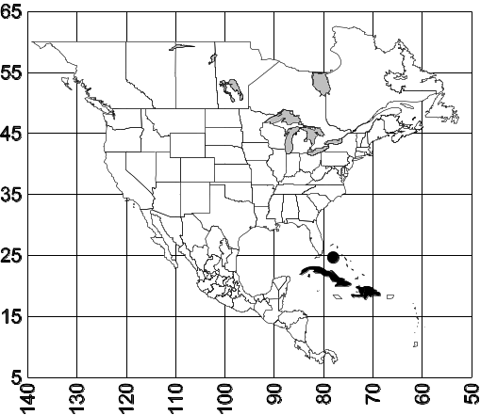 Map 8. Odontomachus insularis.
Habitat. ???
Biology. ???
Odontomachus laticeps Roger
Figs. 23 (petiole), 27 (mesosoma) NEED; Map 9

Discussion. The workers are medium sized (total length 12 mm), dark reddish-brown or black ants. The antennal scape extends slightly past the posterior lateral corner of the head. The anterior face of the petiole is straight or slightly concave, the posterior face is straight or slightly convex. The metasternal process consists of a anterior lobe, and a small, transverse carina posteriorly, which can be barely seen in profile.
The striae of the head extend to the posterior border or very near the posterior border, the striae on the mesosoma are more coarse, and are mostly longitudinal on the pronotum (except for the transverse striae on the neck), transverse on the mesonotum, transverse on the dorsum of the propodeum, and obliquely vertical on the side. Nearly the entire mesopleuron is smooth and polished, except for a few striae on the anteriormost part. The petiole is nearly smooth and glossy, with a little evidence of striae. The dorsum the first tergum of the gaster is nearly smooth and glossy, with a little evidence of longitudinal striae.
The female is similar, and is often smaller than the worker. The striae on the dorsum of the gaster are usually more defined.
Odontomachus laticeps can usually be separated from similar species, by the straight, or slightly concave anterior face of the petiole. The mostly longitudinal striae on the dorsum the pronotum will separate it from the widespread O. brunneus, in which the striae are partially transverse. The common, widely distributed O. bauri is similar in color and size, but can be easily separated due to the convex anterior face of the petiole. The Peruvian O. bradleyi, has a four segmented labial palp, whereas O. laticeps has a three segmented labial palp. Finally, it can be distinguished from the much larger O. chelifer by the sculpturing of the gaster, which has predominantly transverse striae in O. chelifer.
Distribution. Mexico (Veracruz), Guatemala, Honduras, Costa Rica south to Brasil.
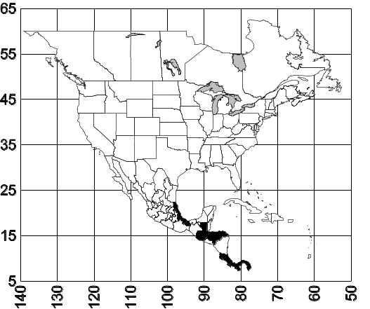 Map 9. Odontomachus laticeps.
Habitat.
Biology.
Odontomachus meinerti Forel
Figs. 16 (top of postpetiole), NEED mesosoma; Map 10

Odontomachus haematodes race meinerti Forel, 1905:156 
Odontomachus haematoda minuta Luederwaldt, 1918:36,  [first available use of Odontomachus haematodes pubescens var. minuta Emery, 1894:146, unavailable name] (Bolton, 1995:296)

Discussion. ???
Distribution. México (Vera Cruz), Costa Rica, south to Paraguay.
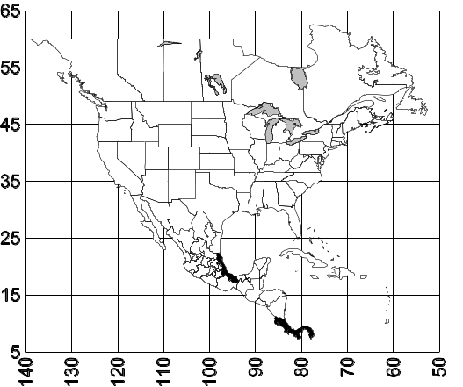 Map 10. Odontomachus meinerti.
Habitat. ???
Biology.

Odontomachus minutus Emery
Figs. D M, H ; Map

Discussion. The worker of this species is a relatively small (total length 6-7 mm total length), reddish-brown ant. The scape slightly surpasses the posterior lateral corner of the head. The mesosoma is depressed at the metanotal suture. The anterior face of the petiole is nearly straight, or slightly concave, the posterior face is slightly convex, the spine is relatively short (0.2 mm)
The dorsum of the head is finely striate nearly to the posterior border with the region adjacent to the nuchal carina being smooth and glossy. The striae on the neck of the propodeum are transverse, those on the dorsum are more coarse and longitudinal, with the striae on the side of the pronotum being obliquely longitudinal. The striae on the mesonotum are transverse, as are the striae on the dorsum of the propodeum, with those on the side of the propodeum being obliquely transverse. Nearly the entire mesopleuron is smooth and glossy. The petiole is smooth and glossy, the dorsum of the postpetiole is densely punctate and dull, as is the tergum of the first segment the gaster.
Erect hairs are abundant on the mandibles, scattered on the dorsum of the head, present on the ventral surface of the head, the pronotum, and all surfaces of the gaster.
The female is similar to the worker, with striae covering most of the posterior half of the head. The striae on scutum are longitudinal, those on the scutellum are nearly absent but are apparently longitudinal. The entire mesopleuron is smooth and glossy. The anterior face of the petiole is weakly concave, with the posterior face being only slightly convex. The sculpturing, and pilosity are similar to that of the worker.
The densely punctate gaster would separate this species from other small species which have glossy gasters, such as O. biolleyi and O. clarus. The coarse sculpturing of the gaster could cause in with O. opaciventris. It can be easily separated, as is much smaller than the large (total length 11 millimeters) O. opaciventris.
Distribution. MEXICO: Tabasco? (Córdoba) COSTA RICA: Guanacaste (Maritza Field Station), Puntarenas (Fundación Neotropical, Cerro Helado, Las Cruces Biological Station) ; COLOMBIA: Valle Del Cauca (Medio Calima), VENEZUELA, BOLIVIA.
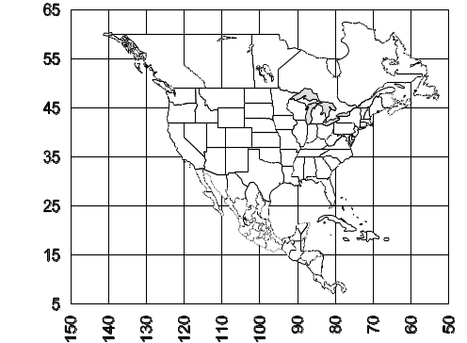
Map 11. Odontomachus minutus.
Habitat. Lowland rain forest, Ridge forest to montane hardwood forest.
Biology. 11138-9, 11147, 11519, 11823, 17715, 186 89, 18687, 18662, 17716, 18686, 18687, 18 526, 18647, 18525, 17709, 17715, 17716,
Odontomachus opaciventris Forel
Figs. 13 (metasternal teeth NEED, 14 (top of postpetiole), 15 (petiole); Map 11

Discussion. The worker is a moderate to large (total length ranges from 10 - 13 mm) dark brown or black ant. The scape extends about the first funicular segment past the posterior lateral corner. The metanotal region is deeply depressed below the adjacent level of the mesosoma. Both the anterior and posterior faces of the petiole are convex, and the spine is relatively long (0.3 mm)
The striae on the head extend to the posterior border, the longitudinal striae on the side of pronotum extend transversely across the anterior region, the striae on the dorsum are mostly longitudinal. The striae on the mesonotum are transverse, and the striae on the propodeum are obliquely longitudinal on the side and transverse on the dorsum. The mesopleuron is smooth and glossy, with a few poorly developed striae on the dorsal most part. Much of the petiole is smooth and glossy, with a few, poorly defined striae on the sides. The dorsum of the postpetiole is completely and densely punctate and only weakly shining, the sculpture on the first segment of the gaster has similar sculpture, the remainder of the gaster has finer sculpture.
Erect hairs are scattered on the mandibles, dorsum of the head, pronotum, petiole, and all surfaces of the gaster.
The dull, punctate dorsal surface of the gaster would separate this species from many dark species which have a relatively shiny or weakly sculptured gaster, such as O. bauri, O. brunneus, O. biumbonatus and O. laticeps. It could be confused with O. minutus, in which the dorsum of the gaster is also densely punctate, but can be easily separated as it is much larger (total length of his about 7 mm).
Distribution. Mexico: Chiapas (???), Tabasco(???), Guatemala (???), Costa Rica (???), Panamá (???), Colombia (Valle del Cauca, Meta), south to Brasil.
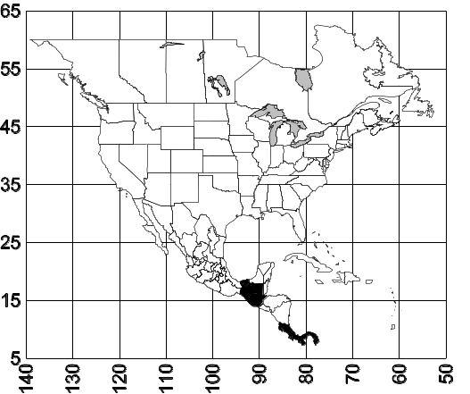 Map 12. Odontomachus opaciventris.
Habitat.
Biology. 1082
Odontomachus panamensis Forel
Figs. 38 (mesosoma and petiole), 39 (top of mesosoma); Map 12 need head

Discussion. ???
Odontomachus panamensis forms a subgroup with two other species (Brown, 1976): O. affinis and O. mayi, neither of which occurs in North America. It can be separated from O. affinis (SE Brasil) by a smaller size and lighter color. It lacks the anterior ventral lobes of the mesoepisternum, which characterize O. mayi (Fig. xx).
Distribution. Costa Rica, Panama, south to Brasil.
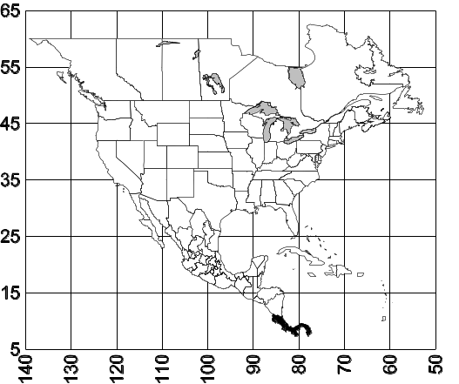 Map 13. Odontomachus panamensis.
Habitat. Tropical forests.
Biology. Unknown.
Odontomachus yucatecus Brown
Figs. 10 (mesosoma and petiole); Map 13

Discussion. The worker is a moderate sized (total length about 8 mm), reddish-brown to dark brown specimen. The apex of the mandibles have three, well-developed teeth, there are normally no teeth on the medial border, although a small tooth may be located on the medial border near the apex. The scape extends slightly past the posterior lateral corner. The mesosoma is depressed at the promesonotal suture, and in the region of the metanotal suture. The propodeal spiracle is small and nearly circular. The anterior border of the petiole is nearly straight, the posterior face is convex, and the petiolar spine is long (length about 0.5 mm) and acute.
The dorsum of the head is finely striate, including the entire posterior half of the head. The region anterior to the eyes and the ventral surface of the head are glossy and shining. The pronotum is longitudinally striate, with the striae being much more coarse than those on the dorsum of the head. The striae on the mesonotum are longitudinal, those on the upper half of the mesopleuron are also longitudinal, the lower half of the mesopleuron is smooth and glossy. The striae on the side of the propodeum are obliquely longitudinal and transverse across the dorsum of propodeum. The sides and most of the anterior face are longitudinally striate, with the striae passing across the posterior face. The entire gaster is smooth and glossy.
Erect hairs are present on the mandibles, scattered across the dorsum of the head, on the ventral surface of the head, the pronotum, the petiole, and all surfaces of the gaster.
The female is similar to the worker, with striae extending to the posterior margin of the head, the scape extends slightly past posterior border. The mesosoma is similar to that of the worker, with longitudinal striae present on the scutum and scutellum. The anterior face of the petiole is straight or even concave, the posterior face is slightly convex. The pilosity and sculpture are similar to that of the worker.
The worker can be easily recognized by the longitudinal striae on the mesonotum, which are transverse in all of the other North American species.
Distribution. México: Veracruz (???), Campeche (???), Yucatan (???), Chiapas (10 k S Palenque) Belize, Guatemala.
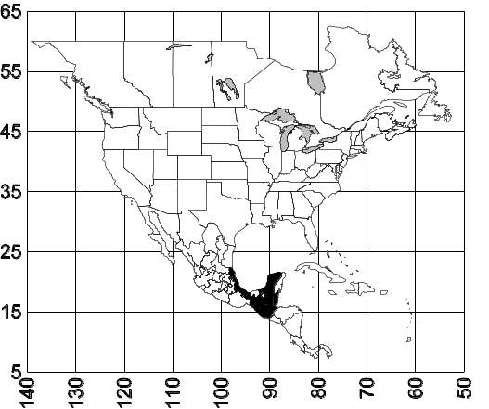 Map 14. Odontomachus yucatecus.
Habitat. Tropical rain forest, as well as disturbed tropical areas.
Biology. Nests are located in logs and stumps, as well as in the soil. A dealate female was collected in a pitfall trap in May.

Literature Cited

Brown, W. L. 1976.Contributions toward a reclassification of the Formicidae. Part VI. Ponerinae, Tribe Ponerini, Subtribe Odontomachiti. Section A. Introduction, subtribal characters, Genus Odontomachus. Studia Entomologica 19:67-171.

11/11/03 15 pages 11/12 17 pp. 12/01 19 pp

# | Species | have | discussion | comparison | distribution | map | habitat | biology | comments
1 | bauri | yes | yes | yes | no | no | no | no | no
2 | biolleyi | yes | yes | yes | yes | no | no | no | no
3 | brunneus | yes | yes | yes | no | no | no | no | no
4 | chelifer | yes | yes | yes | no | no | no | no | no
5 | clarus | yes | yes | yes | no | yes | yes | yes | no
6 | erythrocephalus | yes | yes | yes | yes | no | yes | yes | no
7 | hastatus | yes | yes | yes | yes | no | no | no | no
8 | insularis | yes | yes | yes | yes | yes | no | no | no
9 | laticeps | yes | yes | yes | no | no | no | no | no
10 | meinerti | no | no | no | no | no | no | no | MCZ
# | Species | have | discussion | comparison | distribution | map | habitat | biology | comments
11 | opaciventris | yes | yes | yes | yes | yes | no | no | no
12 | panamensis | no | no | no | no | no | no | no | MCZ
13 | yucatecus | yes | yes | yes | yes | yes | yes | yes | no
14 | minutus
15
16
17
18
19

Illustrations needed:
# | Fig.# | Species | Specimen | View | Status | Comments
1 | 7 | yucatecus |  | head
2 | 8 | hastatus |  | head
3 | 13 | opaciventris |  | mesos |  | Metasternal teeth
4 | 24 | chelifer |  | gaster |  | Top showing striae
5 | 27 | laticeps |  | mesos |  | Side + petiole
6 |  | panamensis |  | head
7 | 40 | insularis |  | Petiolar spine |  | Seen from front
8
9
1 0
11
12
13
14
15
16
17
18
19
20
21
22
23
24
25
26
27
28
29
30
31
32
33
34
35
36
37
38
39
40
41
42
43
44

Modified from Brown, 1976

