Soft Path to Water Guide
The University of Texas at El Paso Center for Environmental Resource Management
Holguin, Nayeli

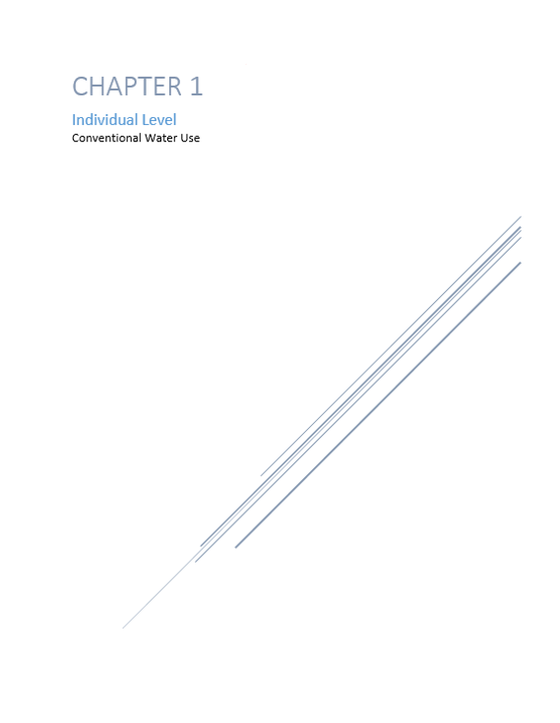

Water Treatment: Household
We begin this chapter with how to treat water at the household level. The technology we will be talking out is called point of use filters. We will specifically be talking about under the sink reverse osmosis filters. The average cost is $150-300 this is the initial cost of purchasing a unit. There can be other cost associated such as an installation fee if someone else installs it and the replacement cost of the cartridges that last around six month to a year. Some of the benefits of using one of these is that it saves about $350 per year from water bottle savings, as well as that it saves about 170 gallons per year per family. Here in this guide a family means four people living in a house.

Water Reuse
Next, we have reusing water from different points and activities in the home. This is also called grey water. You can reuse water from doing laundry by placing the water pipe in a large bucket. The average cost is $5 per 5-gallon bucket. You can use this water for toilet flushing, and for watering plants. You can save about 12,000 gallons a year per family. Water can also be reused from cooking or washing fruits and vegetables. The average cost is $3 per six in bowl. This water can be used for watering plants, for toilet flushing, and for compost. You can save about 16,000 gallons a year per family. You can also reuse shower water. You can place a bucket in the shower and collect the water that first comes out while you set the temperature of you can try to collect all the water from your shower. The average cost is $5 per 5-gallon bucket. You can use the water for toilet flushing and for watering plants as well. You can save about 29,200 gallons a year per family if you collect the water from a full shower.
Water Conservation: Indoors, Restroom
In this section, we talk about many ways to conserve water in the home by room and by indoor and outdoor use as well. We will start with the restroom where most of the indoor water use is. One of the things you can do is install a Water Sense toilet. These toilets use less water per flush while still being effective. They cost around $100-400 for the unit only. There could be installation cost or other cost associated. Having one of these can save about $110 per year per family. It can save about 14,160 gallons of water per year per family. Another option is to install a universal water-saving toilet kit with dual flush valve. This tool allows you to turn your regular toilet into a dual flush toilet that is usually about $100-$170 for a fraction of the cost. Having this allows you to have the option to have a quick flush or a full flush. These units are about $30-45 per unit. They save about 19,400 gallons per year per family. Another action you can take to save water is to place a two-liter filled with rocks in the toilet tank for low flow. Some people use brinks instead of the bottle but the brick will dissolve with the years and could cause damage to the toilet tank. The cost is about $3-5 per unit. You can save about 3,650 gallons per year per family. Another thing you can do is use food coloring in the toilet tank once a year. If the color comes out without flushing, there is a leak. It cost $2-4 for one-four bottle packs. You can save about 2,550 gallons a year per family if a leak is fixed. A further action you can take is to place aerators on faucets. These help reduce the gallons per minute used each time you use the sink. They cost about $1-5 per unit and can save about 3,150 gallons per year. Something else you can do is turn off the water when you brush your teeth, this cost nothing to do and can save you about 3,000 gallons per year per family. Similarly, you can use a cup of water to rinse your razor instead of opening the faucet each time. This also cost nothing to do and you can save about 3,400 gallons per year for two people. There are various ways you can save water when talking about showering. You could install a water sense showerhead that uses less gallons per minute in the shower than a regular showerhead. These cost about $5-30 and can save about 11,680 gallons per year per family. You can also save water in the shower by taking a two-minute shower. Some songs are dedicated for the use of two-minute showers and can be found in different sites online such as 2minuteshowersongs.co.za. It cost nothing to do and can save about 21,900 gallons a year per family. Additionally, you can save shower water by not washing your hair as much and using dry shampoo. You can buy dry shampoo at many stores or you can make your own using items such as essential oil, cocoa, cornstarch and cinnamon. It cost about $1-8 and can save about 1,000 gallons a year for two people.
Water Conservation: Indoors, Kitchen
This section talk about the various ways you can conserve water in the kitchen. You can start by keeping a pitcher of drinking water in the fridge instead of running the tap. This cost nothing and can save about 12,840 gallons a year per family. You could also cook food in as little water possible. This also cost nothing and can save about 960 gallons a year per family. Another thing you could do is keep hydrated but only use one glass a day, this does not cost any money and it can save about 12,840 gallons per year per family. You can also save water by soaking pots and pans rather than scrubbing them with the water running. This does not cost anything to do and can save about 3,190 gallons per year per family. Additionally you can save water by not using water to defrost. This is free to do and can save about 9,240 gallons per year per family.
Water Conservation: Outdoors
This section talks about the different ways you can conserve water outdoors. One of the things you can do is use a broom instead of a hose to clean the driveway. This does not cost anything to do and you can save about 150 gallons per year if done once a year. You could use leftover drinking water or unsweet tea to water plants, this is free to use and can save about 3,200 gallons per year per family. Another way to save water is to replace old hose washers. It may not seem like a few drops is a lot but it does add up. It only cost $1-3 varying on package sizes. You can save about 2,550 gallons per year per hose. You can also apply water only as fast as soil can absorb it, using an upside down bottle. You can use a plastic or glass bottle. It cost about $1-3 per unit glass or plastic bottle. You can save about 10,290 gallons per year for multiple plants.
Something else you can do to save water is to wash your car with a bucket instead of a hose. There is an average cost of $5 per 5-gallon bucket. This practice lets you save about 7,650 gallons per year per car. Another thing you could do to save water is to use a raised bed garden. Having a raised bed garden allows the water to be contained in the proper area and you do not water any unnecessary areas. It cost about $10-45 per unit, for different materials such as wood or plastic. You can save about 450 gallons per year. Using minimum fertilizer can also save water. It does not cost anything to do and the savings vary by use. Planting in blocks instead of rows can also save water by using less water by square foot. Using this practice is free and the water saving benefits vary by kind of soil, depth, and plant kind. This practice can give high yields and increased shading. Pruning properly can also save water with an average cost of $70 for various tools. The water saving benefits vary by plant type and pruning does not waste water on dead plant members. Another way to conserve water is to water at night or in the morning so that the water you use does not evaporate. It is free to do and the water benefits vary by temperature, wind, humidity, soil moisture and type of plant. You can also use mulch made of various materials like compost, leaf litter, wood chips, and newspaper. Mulch insulates the soil, keep weeds out, keeps roots moist and prevent soil compaction. The water benefits vary by use. It cost about $20-60 for a compost bin, about $3-40 for woodchips, and about $1-2 for newspaper. You can also save water by using tools that are more efficient such as drip irrigation and soaker hoses. Drip irrigation is a system of small hoses that you can makes holes in to water in the precise desired areas. They cost about $20-45 for different drip systems. They use about 30 – 50% less water than conventional watering methods. They can save about 58,650 gallons a year. This practice discourages weeds, and helps control fungal diseases. Soaker hoses are porous hoses that let small amounts of water go out of them in droplets or more. They cost about $10- 30 for different sized hoses. The water benefits vary by use but they let you have consistent soil moisture and minimize plant disease.
Water Conservation: Outdoors, Xeriscaping
This section talks about Xeriscaping, which is the practice of designing landscapes to reduce supplemental watering. It involves choosing plants that are appropriate to their site and arranges them in efficient, water-saving ways. First, we will talk about using drought-tolerant plants. The cost vary by nursery and by seed or mature plant about $10-50 each. The water benefits vary plant type and area. You can also group plants with similar water needs or do companion planting. This does not cost anything do to do. The water saving benefits also vary by plant type and area but could possibly have higher yields. Additionally, you can use native plants, plant and trees that are originally from that area and are well adapted to the soil and climate conditions. The cost vary by nursery, by seed or mature plant and by region. The conservation benefits also vary by plant type and area.
Rainwater Harvesting
This section talks about rainwater harvesting which is an innovative alternative water supply approach. It can take active or passive forms. Passive is where runoff is slowed or diverted to allow it to soak into the soil and active is where runoff is stored for later use in items like barrels or tanks. A way to store rainwater for later use is through rain barrels and rain chains. The chains help channel the rain into the barrel similar to a gutter for a tank set up. It cost about $60- 80 per barrel. The cost of the rain chains varies by material used, $2 per ft. for zinc plated chains. The water benefits vary by catchment area, capacity of barrel and average rain in the area. Just 0.1” of rain on a 1,000 ft2 will give you 62.3 gallons (1,000 ft2. x .623 x 0.1” = 62.3 gal) enough to overflow the average barrel size. The passive form of rainwater harvesting is rain gardens where the rain is allowed to soak into the soil and feeds the plants there. It cost about $85 for various tools to create the garden; it is set up to take advantage of the rainwater. Having a raingarden protects from flooding, recharges local aquifers, and reduces pollutants in the area. The active form of rainwater harvesting is using items like tanks that are connected to gutters to collect and store water for future use. Here we talk about rainwater harvesting systems that go around a home. These systems cost about $500- 1000 for various materials not including tanks.Tanks maybe be donated from different sources. The water benefits vary by catchment area, capacity of tanks and average rain. These systems may reduce water hauling by up to 50%. You can capture 5,084-11,893 gallons of rain depending on the area you live in (based on a 1,000 ft^2 roof).

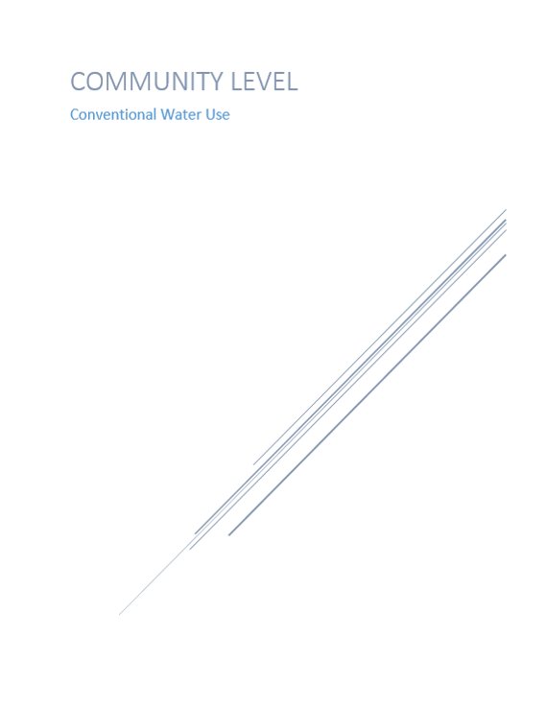

Rainwater Harvesting: Multiple Homes
The community level approach to conventional water use would be through active rainwater harvesting. This would involve having a system that goes around the whole home like in the previous section but this time connecting the systems of many homes that are close by to maximize the water collection. These systems cost about $500- 1000, per home, for various materials not including tanks. Cost may be lower if the families buy the material in bulk or in large quantities. Tanks maybe be donated from different sources. The water benefits vary by catchment area, capacity of tanks and average rain. These systems may reduce water hauling by up to 50%. You can capture 5,084-11,893 gallons of rain a year depending on the area you live in (based on a 1,000 ft^2 roof).

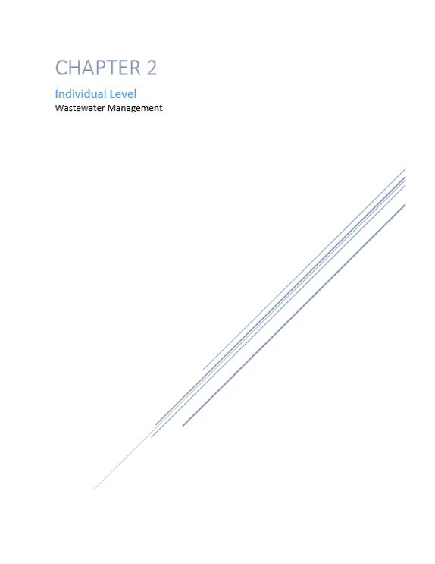

Toilet Alternatives
We begin this chapter with managing wastewater through toilet alternatives like ecological toilets. These toilets work similarly to pit latrines. This is a type of toilet that collects human feces in a hole in the ground. It cost about $650 for various building materials and an average of $9 per metric ton of sand or gravel to maintain. A family of five will save about 39 million gallons of water a year from not transporting the waste. The next toilet alternative is a composting toilet. A composting toilet is a type of toilet that treats human feces by a biological process called composting. This process decomposes organic material and turns the waste into compost which produces soil conditioner. Compost is rich in nutrients. It cost about $960 per unit only but you need to have an absorbent material such as coco coir to maintain it. Coco coir is about $6-10 for 5 kg or 11 pounds. Two people using the unit full time can run up to 3 weeks before needing to clean out. You can save an average of 27,440 gallons a year per family. This is a small sized compost toilet. There are larger compost toilets that cost $895 per unit that also needs an absorbent material like coco coir. The advantages of having a composting toilet are that they are waterless, self- contained, odorless, easy to maintain and ready to install. The larger composting toilet has a higher capacity; it is good for two months before needing to be emptied based on full time usage by two adults. It is also easy to source extra containers or spare parts for the larger one.
Septic Tank Alternatives
This section talks about a new technology that can be used in place of septic tanks. The system is called Biodigestor and Rotoplas produces it. This system takes the homes wastewater and completes a primary treatment of the water. It avoids the contamination of groundwater. It is a self-cleaning system where opening a valve lets out all the wastewater sludge making maintenance cost much lower. It also does not need mechanical equipment or electricity to be maintained. It only need to be cleaned out once a year. The one-piece system avoids leaks, odor, cracking and has a high resistance to impact and corrosion. The system converts the sludge into a thin layer of dust that is great compost that can be used on landscapes. The system allows you to use the treated water for certain purposes. The unit cost between $345-440 per 600 liters system for five people. There are different sizes available from 1,300 to 14,000 liters. The unit has a service life of 35 years and a five-year warranty. This item is only available for purchase in Mexico.
Modular Sewage Treatment Unit: Active Water Solutions
This section talks about the Modular Sewage Treatment Unit by Active Water Solutions. A system that is flexible, modular and scalable. It uses a small amount of energy usually only needing 20 amps. It is easy to maintain. The system uses tanks that can be organized in different ways to accommodate for different spaces. This standalone system can be linked together to service over 500 people. Odor is contained and you can reuse the quality effluent (treated water) for different activities. The cost of the system is dependent of the amount of users.

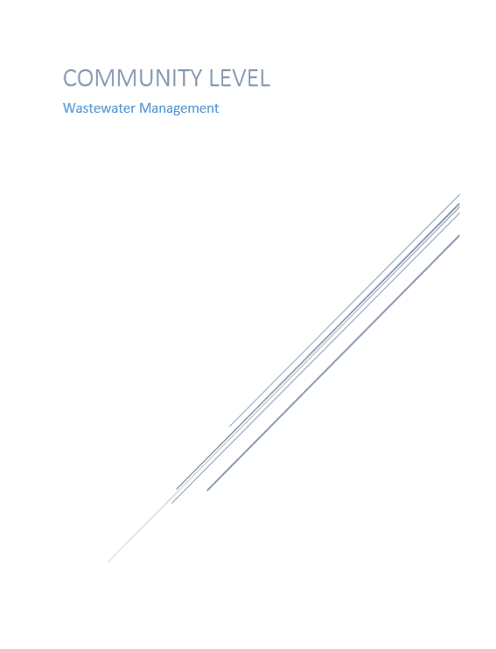

Small Wastewater Treatment Plants: Above or Below Ground Unit
In this portion, we will be discussing small wastewater treatment plants that have systems that can be placed above ground or below ground. These do many of the jobs of a regular wastewater treatment plant but in a more cost efficient way and with less space required. One of these systems is a self-contained system from the company Active Water Solutions, LLC (AWS). The treatment unit is simple to operate and maintain. It is a gravity flow system with minimal moving parts. It is ideally suited for communities ranging from 100 to 1,500 people and can produce water for reuse. Multiple units can be installed for higher capacities. The cost is dependent of the amount of users. Leasing and financing available. Built to last over 30 years.
Septic Tank Alternative
The septic tank alternatives discussed here are similar to the ones stated before but they have a higher capacity. Here we will talk about a technology that was mentioned before in the individual level of wastewater management, the Biodigestor from Rotoplas. This is the same technology with the same structure and benefits except this is a much larger unit capable of servicing more people. It cost an average of $6,390 for 14,000 liters for 116 people. This unit is also only available for purchase in Mexico. The next technology is a group of products that do the same job but that differ in capacity. The One2clean, One2clean plus (two tank); One2clean plus XXL are also septic tank alternatives. They have a 12 hour cycle time. They have a low energy consumption of 75 kWh and minimal maintenance cost. They are also self-cleaning containers with a maintenance interval of 1-2 years. These units have a capacity up to 70 people depending on the system. There is a 15-year warranty for the tank(s). This technology cost about $2,200- $4,800 per unit. The next items are also the same just with different capacities. The Klaro E Professional and the Klaro E Professional with multiple tanks have a capacity of up to 14 people for a single tank and up to 50 for multiple tanks. This system can be retrofitted in existing tanks and has a six hour cycle time. It is a self-cleaning container with a maintenance interval of 1-2 years. It includes lifters for easy removal for maintenance without the use of tools. This unit has a low energy consumption of 43 kWh. It cost about $3,100-$8000 per unit. The Klaro L, XL, XXL System work the same as the Klaro E Professional except that it has a larger capacity of 60-300 people. This system may not be retrofitted. It has a maintenance interval of two-four times per year. There is a 15-year warranty for the tanks. The system cost about $13,600 and above depending on the amount of users. Both the One2clean and the Klaro E Professional are made of recycled material. The moving bed system is also a septic tank alternative. It works without electric control, pumps, and magnetic valves. It has a maintenance interval two-four times per year. It has a capacity for 20-200 people. It cost about $8,000 to $24,000 and comes with a 15-year warranty for the tanks.
Small Wastewater Treatment Plants: Below Ground
Next, we will discuss small wastewater treatment plants that have systems that go below ground. These, like the past system above, do many of the jobs of a regular wastewater treatment plant but in a more cost efficient way and with less space required. One of these systems is Amphidrome and F.R Mahony and Associates manufacture it. The Amphidrome process is an advanced biological treatment for wastewater. The treatment it uses is fixed film Sequencing Batch Reactor and it has proven to work in the state of New Jersey in the Pinelands Commission. It is approved there permanently for use on a minimum 1.0-acre lot. The average cost is about $20,000 for the unit only. It comes with a five-year warranty. The next technology is Bioclere it is manufactured by Aquapoint, Inc. The Bioclere system uses an attached growth trickling filter method for wastewater treatment. The treatment process is modified trickling filter. This technology has proven to work in New Jersey as well and has the same approval. The average cost is about $18,000 for the unit only. This also comes with a five-year warranty. Another technology is FAST (Fixed Activated Sludge Treatment) and Bio-Microbics, Inc. produces it. This system is a pre-engineered modular system designed to treat wastewater. The treatment process is the acronym the system is named after. The technology has proven to work in the same area but with a minimum 1.4-acre lot approval. The average cost is about $18,000 for the unit only and has a five-year warranty as well. The following technologies are part of the pilot program as of August 2018 in in the New Jersey Pinelands Commission. BioBarrier is a system that is manufactured by Bio-Microbics Inc. The BioBarrier MBR is a membrane bioreactor. The system consists of a tank with three compartments. The average cost is $19,000 for the unit only. It is currently authorized for use on minimum 1.7-acre lots based on interim performance. The SeptiTech system is a product of SeptiTech LLC. The SeptiTech wastewater treatment system is a two-stage treatment technology. The system operates without a fan or compressor. The treatment process used is modified trickling filter. The average cost is $19,000 for the unit only. This technology is also currently authorized for use on minimum 1.7-acre lots based on interim performance.

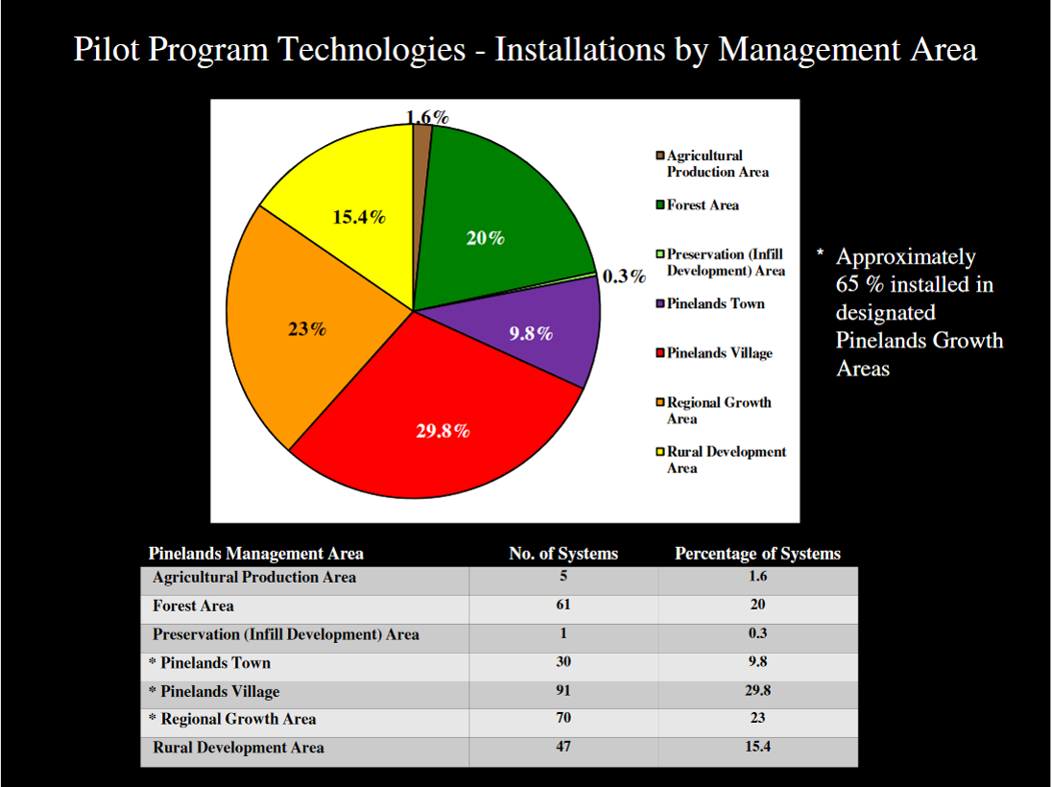

Pilot program technologies-installation by management area in New Jersey Pinelands

Funding resources
• Funding Sources by State https://efcnetwork.org/funding-sources-by-state/
• North American Development Bank Grant http://www.nadbank.org/~nadborg/index.php?acc=contest&tpl=beif
• North American Development Bank Grant http://www.nadbank.org/~nadborg/index.php?acc=contest&tpl=cap
• North American Development Bank Financial Services http://www.nadbank.org/~nadborg/index.php?acc=contest&tpl=jtap_financial
• North American Development Bank Lending http://www.nadbank.org/~nadborg/index.php?acc=contest&tpl=loan
• North American Development Bank Loan-Certification and financing http://www.becc.org/funding- programs/infrastructure-funding/nadb-loan
• Technical Assistance Program http://www.nadbank.org/~nadborg/index.php?acc=contest&tpl=jtap_studies
• Funding for colonias projects https://www.hudexchange.info/programs/cdbg-colonias/
• Office of Colonia Initiatives: Colonias Self-Help Centers Program and Texas Bootstrap Loan Program http://www.tdhca.state.tx.us/oci/index.htm
Technical Resources
- ARCSA Resource Guide http://www.arcsaresource.com/
- Technical Assistance Program: http://www.nadbank.org/~nadborg/index.php?acc=contest&tpl=jtap_studies
- Office of Colonia Initiatives: Colonias Self-Help Centers Program: http://www.tdhca.state.tx.us/oci/index.htm

Educational Resources
• Product Gallery: http://waterfootprint.org/en/resources/interactive-tools/product-gallery/
• Personal Water Foot Print Calculator: http://waterfootprint.org/en/resources/interactive- tools/personal-water-footprint-calculator/
• Personal Calculator Extended: http://waterfootprint.org/en/resources/interactive-tools/personal-water-
footprint-calculator/personal-calculator-extended/
• How to Calculate the Water Foot Print of any Food: https://get-green-now.com/wp-
content/uploads/2017/05/PDFHowtoCalculatetheWaterFootprintofanyFood.pdf
• Rainwater Harvesting- Activities for Youth Education: https://www.agrilifebookstore.org/v/vspfiles/downloadables/EBN-009.pdf
• Texas Well Owner Manual: http://twon.tamu.edu/fact-sheets/
• Abandoned Well Plugging: https://abandonedwell.tamu.edu/class-materials-and-resources/
• On-Site Sewage Facilities (OSSF): https://ossf.tamu.edu/
• Parent/Student Water Conservation Checklist: https://water.ca.gov/-/media/DWR- Website/Divisions/Education- Materials/Worksheets/Files/Checklist.pdf?la=en&hash=16DEDDF72B9FE9013D474D4A9FCFC7882998A2 E1
• Water and Me Kids Activity Book: https://water.ca.gov/-/media/DWR-Website/Divisions/Education- Materials/Activity- Books/Files/WATERandME.pdf?la=en&hash=1C511CA304D70F9402529E1C3E949AE0627998C9
• I am Ready Flood Preparedness Activity Book: https://water.ca.gov/-/media/DWR- Website/Divisions/Education-Materials/Activity-Books/Files/Flood-Preparedness-Activity- Book_English.pdf?la=en&hash=E0869862D0D3B9E41111E65986846D928D7DD7E9
• The American Rainwater Catchment System Association: https://www.arcsa.org/
• Water footprint of crop and animal products: a comparison: http://waterfootprint.org/en/water-footprint/product- water-footprint/water-footprint-crop-and-animal-products/
• Water Resources for Educators: https://www.watercalculator.org/education/water-resources-for-educators/
• United States Department of Agriculture Educational Material: https://www.nal.usda.gov/waic/educational-materials
• United States Coast Guard various water topics: https://water.usgs.gov/education.html
• EPA water topics: https://www.epa.gov/environmental-topics/water-topics
• Water Education Foundation: Water Issues: https://www.watereducation.org/topic-list-water-issues

