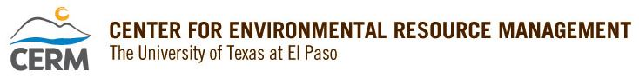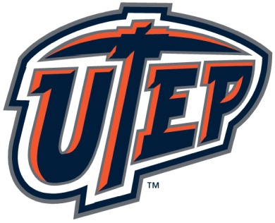

Presents:
A BROWN BAG SEMINAR IN THE
WATER RESOURCES SEMINAR SERIES

“Lessons Learned in the U.S.-Mexico Transboundary Aquifer Assessment”

by

Jacob D. Petersen-Perlman, Research Analyst
&
Elia M. Tapia, Senior Research Specialist
University of Arizona Water Resources Research Center
Tucson, AZ

12:00 – 1:00 pm
Friday, April 12
Rm 701, Kelly Hall
UTEP Campus

ABSTRACT
The Transboundary Aquifer Assessment Program (TAAP) is a joint effort between Mexico and the U.S. to assess shared aquifers. Under this program, scientists from each country have collaborated on binational studies of aquifers in the U.S.-Mexico border region. This scientific coordination and dialogue have been based on the “Joint Report of the Principal Engineers Regarding the Joint Cooperative Process United States-Mexico”, which has served as the framework to implement binational studies. This presentation will focus on the evolution of cooperation over binational aquifers shared between the U.S. and Mexico and the lessons learned from the cooperative process. The history of the University of Arizona’s section of the TAAP will be discussed, including its efforts towards the completion of the Binational Study of the Transboundary San Pedro Aquifer. The presentation will also discuss current and future efforts of the University of Arizona TAAP program.

SHORT BIOS
Jacob Petersen-Perlman
Jacob Petersen-Perlman is a Research Analyst at the Water Resources Research Center. He has worked on the Transboundary Aquifer Assessment Program (TAAP) and issues of groundwater governance and management at the WRRC. Prior to joining the WRRC, Dr. Petersen-Perlman served as a post-doctoral scholar through the Ken Alberman Fellowship in Water, Society, and Geopolitics at Hebrew University of Jerusalem, Israel. He earned his Ph. D. in Geography at Oregon State University, his M.S. in Geography at the University of Montana, and his B.S. in Meteorology at Iowa State University. His research areas of interest include transboundary water conflict and cooperation, water security, and water governance.

Selected Publications
- Petersen-Perlman, J.D., S.B. Megdal, A.K. Gerlak, M. Wireman, A.A. Zuniga-Teran, & R.G. Varady. 2018. Critical Issues Affecting Groundwater Quality Governance and Management in the United States. Water 10(6): 735. DOI: 10.3390/w10060735.
- Petersen-Perlman, J.D., & I. Fischhendler. 2018. The Weakness of the Strong: Re-examining Power in Transboundary Water Dynamics. International Environmental Agreements: Politics, Law and Economics 18(2): 275-294. DOI: 10.1007/s10784-018-9387-z.
- De Stefano, L., J.D. Petersen-Perlman, E. Sproles, J. Eynard, & A.T. Wolf. 2017. Assessment of Transboundary River Basins for Potential Hydro-political Tensions. Global Environmental Change 45(July): 35-46. DOI: 10.1016/j.gloenvcha.2017.04.008.
- Petersen-Perlman, J.D., J.C. Veilleux, & A.T. Wolf. 2017. International Water Conflict and Cooperation: Challenges and Opportunities. Water International 42(2): 105-120. DOI: 10.1080/02508060.2017.1276041.
- Petersen-Perlman, J.D., & A.T. Wolf. 2015. Getting to the First Handshake: Enhancing Security by Initiating Cooperation in Transboundary River Basins. Journal of the American Water Resources Association (JAWRA) 51(6): 1688-1707. DOI: 10.1111/17521688.12348.

Elia M. Tapia
Elia M. Tapia is a Senior Research Specialist at the University of Arizona Water Resources Research Center. She is a Ph.D. candidate in Arid Lands Resource Sciences and is pursuing a minor in Hydrology.
She holds M.S. and B.S. degrees in Geological Sciences from Universidad de Sonora, Hermosillo, Mexico, and a B.S. degree in Geological Sciences from Michigan Technological University through their Exchange Program. She has been a consultant with ORTOPLAN Engineering and ERAH Environmental Hydrologic and Risk Studies in Hermosillo, Mexico. She has participated in projects such as the Transboundary Aquifer Assessment Program (TAAP) and the Water Research and Planning Innovations for Dryland Systems Program (Water RAPIDS). Her research areas include climate change, stakeholder engagement, and water resources management in transboundary settings, particularly in the Santa Cruz Aquifer.

Selected Publications
2018 | Callegary, J.B., Megdal, S.B., Tapia, E.M., Minjárez-Sosa, I., Petersen-Perlman, J.D., Monreal, R., Gray, F., Grijalva-Noriega, F. “Findings and lessons learned from the assessment of the Mexico-United States transboundary San Pedro and Santa Cruz aquifers: The utility of social science in applied hydrologic research.” Journal of Hydrology: Regional Studies.
2017 | Mott Lacroix, K. E., Tapia, Elia M., Springer, A. “Environmental Flows in the Desert Rivers of the United States and Mexico: Synthesis of Available Data and Gap Analysis.” Journal of Arid Environments 140: 67–78. doi:10.1016/j.jaridenv.2017.01.011.
2016 | Callegary, J.B., Minjárez Sosa, I., Tapia, E.M., dos Santos, P., Monreal Saavedra, R., Grijalva Noriega, F.J., Huth, A.K., Gray, F., Scott, C.A., Megdal, S.B., Oroz Ramos, L.A., Rangel Medina, M., Leenhouts, J.M., 2016, The Binational Study of the Transboundary San Pedro Aquifer: International Boundary and Water Commission, 170 p
2014 | Tapia, Elia M., Minjarez, J.I., Minjarez, C.M., Espinoza, I.G., Use of Stella Software for the Modelling of Climate Change Impacts on Water Balance for the Rio Yaqui Basin, Sonora, Mexico. European Scientific Journal. Vol. 20, No. 14.

