INDUSTRIAL, MANUFACTURING, & SYSTEMS ENGINEERING

CAPSTONE PROJECT /INTERNSHIP
SUMMARY
Joel Aguirre, Nayef Almutairi, Jesus Marquez

Type of Capstone (research, teaching, practical application): Practical Application

Capstone Project Title: Improving Productivity through reduction of reworks & Line Balancing in the SWBDs area at Schneider Electric.

Year and semester: Fall, 2018

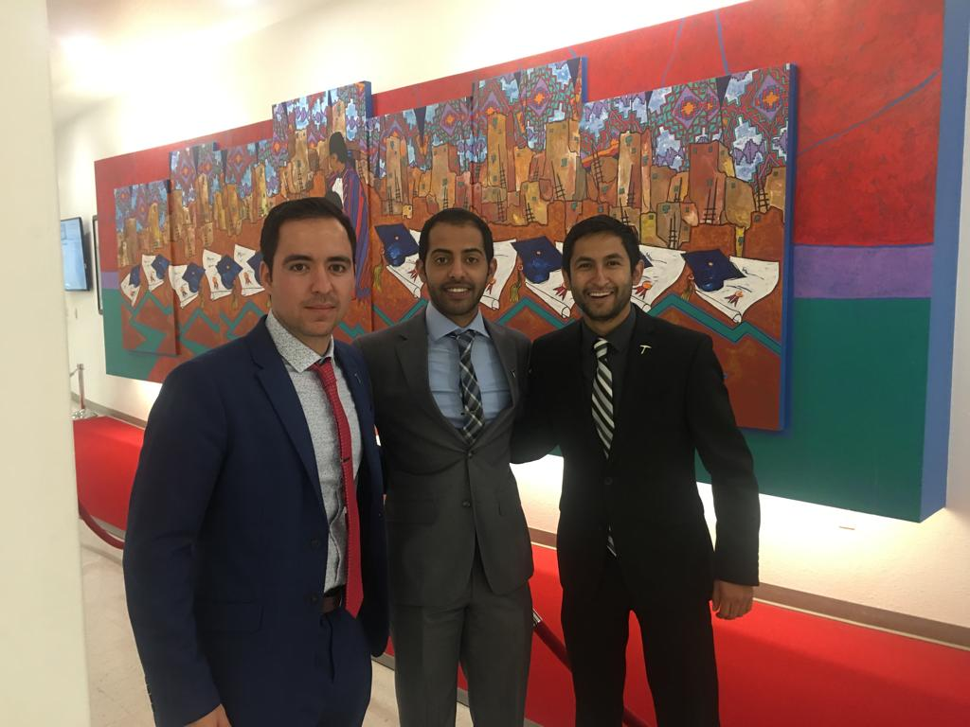

INTRODUCTION
Schneider Electric is leading the Digital Transformation of Energy Management and Automation in Homes, Buildings, Data Centers, Infrastructure and Industries. El Paso, TX plant manufactures products within an ETO (Engineered to Order) environment or costumed products, therefore standardization is very difficult since every product is different from the others. For 2019 it is expected a substantial growth and working on improving productivity within manufacturing and increase daily output is a key driver for our success. After reviewing the situation, we found two major factors that can take us to the desired productivity which are reworks and line balancing. Reworks – We have a very low FPY (First Pass Yield) and the time consumed on reworks is significantly affecting daily output. On average we have almost 3 defects per unit and a reduction of defects would make a very significant change in our operational performance. 2019. Line Balance – Due to our type of manufacturing line balancing is not easy and would need some deep understanding on the way we operate and to define a strategic process to optimize the workforce while getting the most output possible and make recommendations as of the best way to allocate people by the mix of products being manufactured. Since there was no concrete information we could use to do analysis and design solutions, we were able to do observations (time studies), interviews and statistical analysis (Pareto chart, Pivot tables, and pie graphs) to define real causes of delays and therefore design solutions. Using this information, we will able to identify the root causes of reworks and provide possible solutions to the company. After some of the proposed solutions were introduced to our manager he decided to take actions on some of the problems identified and see why the problem was caused.

PROJECT OUTCOMES
Our project consists in two main objectives the first one was to decrease our DPU (Defects per Unit) from 2.8 to 2 and increase our FPY(First pass yield) from 25% to 35%. For our second problem of the project was to only make a recommendation for line balancing. The first thing we have to do is to get familiarized with the products produced at the factory, once we know about what types of products and how many they have we started to analyzed the data provided by the quality control department. We used it to define in which station was the reworks causing more problems as well as to identifying what was the main root of a rework. After we identify that the main issues were occurring in the mechanical line, we started to look at the main problems and we got the number of reworks a stations produce during the past months, also we identify the problems that the stations were making and we identify that missing parts was the most common issue causing reworks along all stations. The station that produces more reworks was Frames and the reason was that they have not been placing some parts in the unit. We started to focus only in this station and make sure why they do not put those parts and we found that the warehouse was not providing the sufficient amount of parts that the mechanical lines need to be able to satisfy the demand. Once we told that to our supervisor we create a form that the leads and workers need to fill out if that issue happened again just to have records that the issue was happening.

Our recommendations to Schneider was to increase the number of bins that the water spider needs to have, this was with the intention to meet the demand of most commonly parts causing reworks. Also, we proposed to place a poster with the most commonly miss parts in each station that way the employees will see constantly the poster and will start to memorize the parts and try to remember to place them or report if the warehouse is not supplying enough. For the line balancing, we develop a matrix to the leads that will be used in the mechanical lines to rearrange they employees through the stations depending in the work schedule. depending on that the leads will see which station will be a delay and can move a unit to overflow to keep the line in a continuous flow.

INDUSTRIAL ENGINEERING PROGRAM ASSESSMENT
At the beginning of the project, there were several challenges encountered. Schneider Electric El Paso manufactures industrial switchboards that are used in big buildings such as hospitals, schools, stadiums, etc. They work as Engineering to Order, which means the client provides the specification of each switchboard needed and this cause that every single unit will be different from each other. This is one challenge that we face because since every single unit is different we could not be familiarized with the products they offer easily. Also, we found that some of the parts that were most critical causing reworks were not because they forgot to place them in the unit, but the warehouse was not supplying enough in order to satisfy the daily demand. In the end, the challenge became welcome since now it gave all of us an idea of how the real world of industrial engineering was really about. Sometimes you will have the data needed, and sometimes you will not and you need to find a way to get that data to improve your project.

