(3 , 3  ; , 2 
GENUS MYRMECOSYSTUS
(Key: Snelling, 1976)

This is a common, easily recognized genus in New Mexico. One character is sufficient to distinguish it from all others: the long maxillary palps in which the fourth segment is especially long (Fig. 433). It could be confused with Formica, but the fourth segment of the maxillary palp of Formica is not elongate. The maxillary palp is similar to that of Dorymyrmex, but this dolichoderine has a pyramid on the propodeum, which is very different than the type of propodeum in Myrmecocystus. All of the species have a psammophore or basket of long hairs on the underside of the head.
This is the genus of “honey pot” ants in which repletes fill their crops with liquids and hang inside the nests, serving as storage structures. These “honey pots” are consumed in Mexico. This genus is common in New Mexico, especially in arid and semiarid regions. These ants nest in the soil and often have a well developed mound (5 - 20 cms dia.) with a surprisingly large (up to 2 - 3 cm diameter) entrance hole (Fig. 434), which allows rapid escape when the nest is attacked by army ants. The genus is distributed in the southwestern section of the United States and in northern Mexico. Cole (1954c) discusses the genus in New Mexico. Identification to species is difficult unless a series has a good representation of major workers
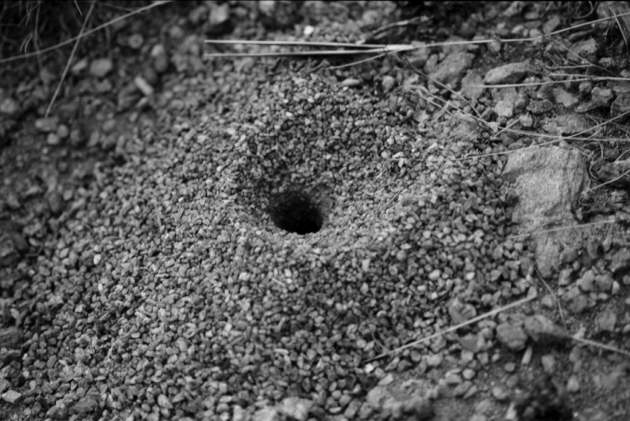 Fig. 434. Nest of Myrmecocystus sp., showing the large entrance hole.

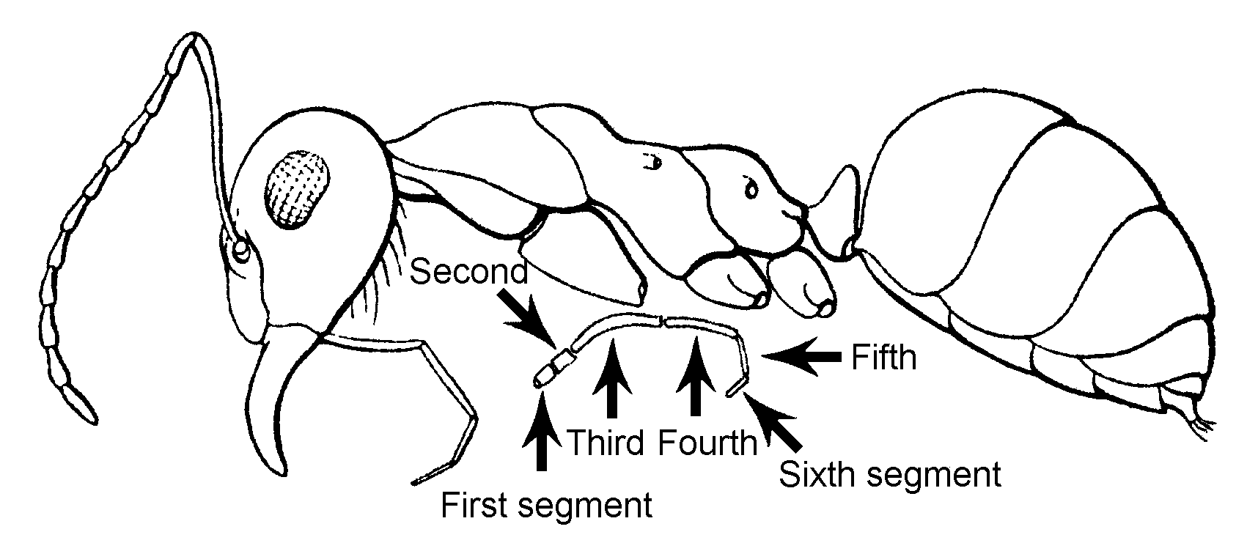Fig. 1. Side view of a worker of M. mexicanus (from Creighton, 1950).
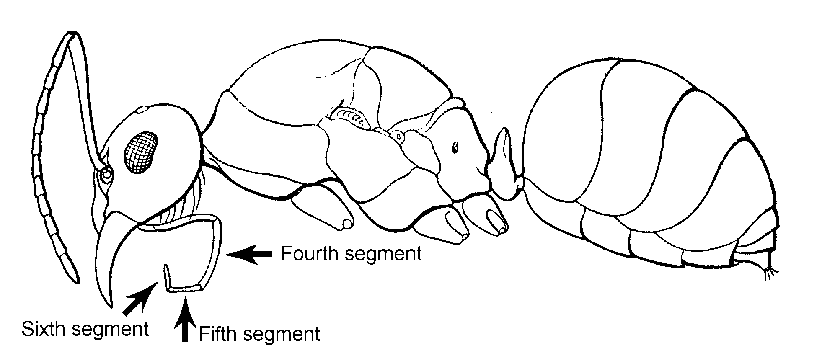Fig. 2. Side view of a female of M. mexicanus (from Creighton, 1950).
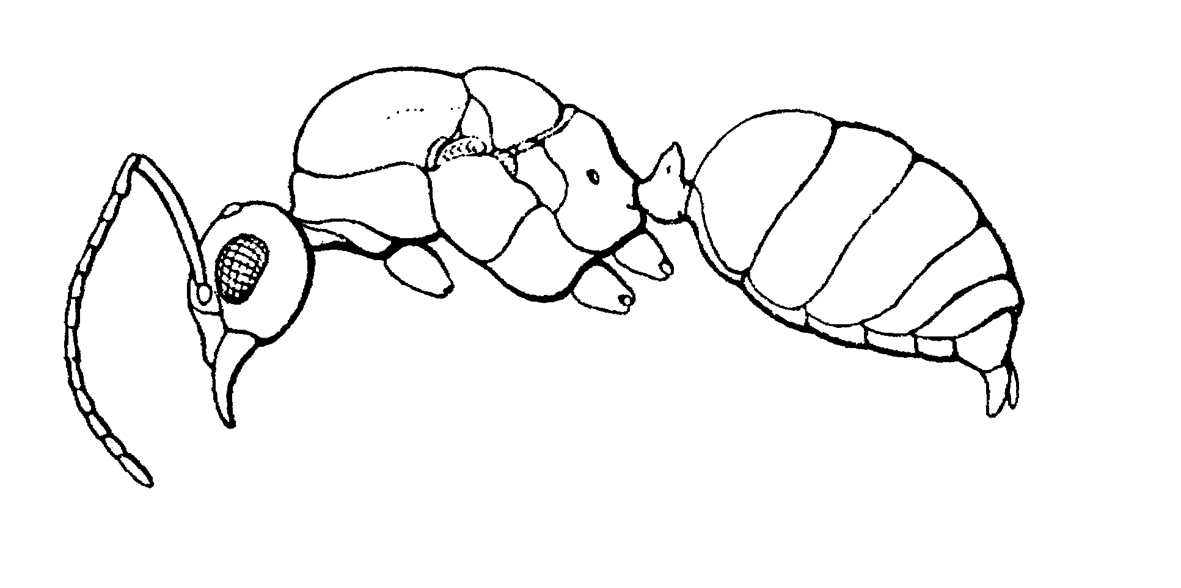Fig. 3. Side view of a male of M. mexicanus (from Creighton, 1950).
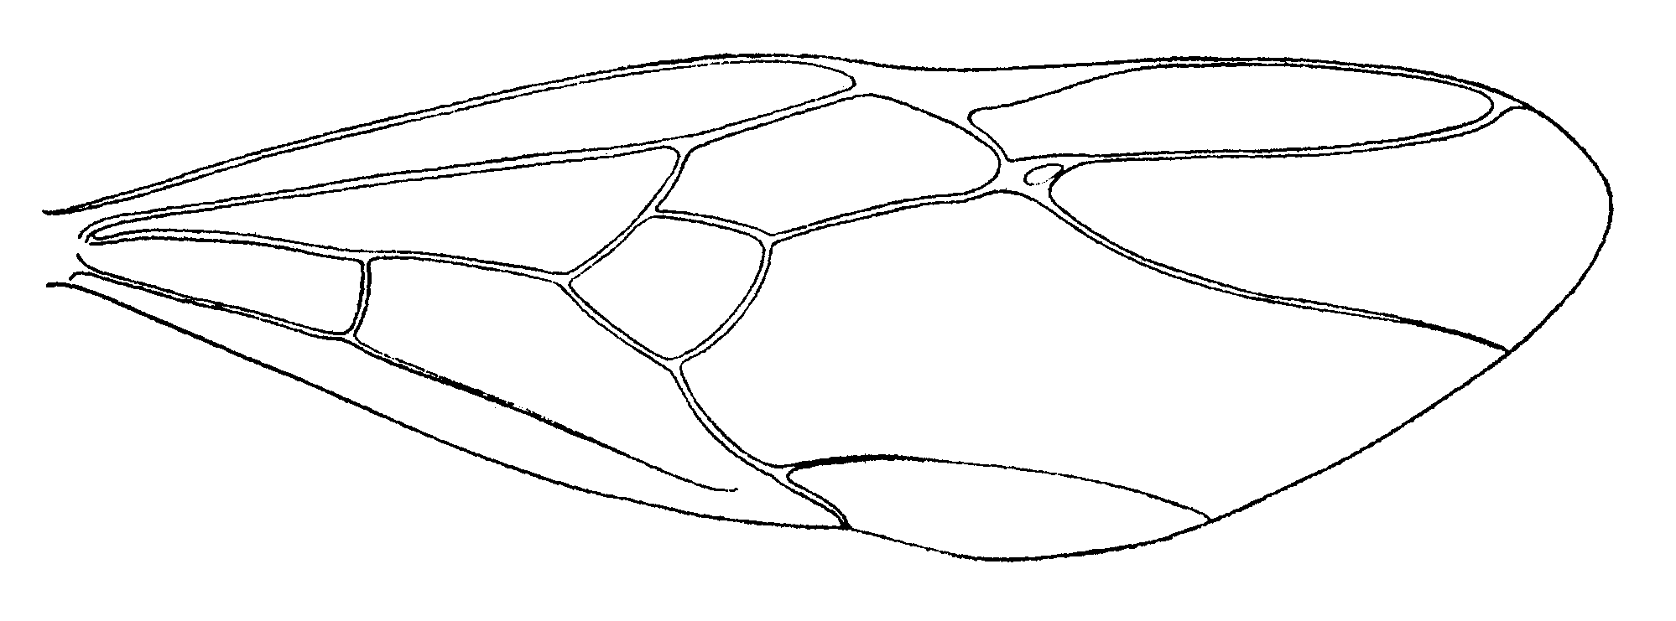Fig. 4, Forewing of a female of M. mexicanus (from Creighton, 1950)
.
KEY TO SUBGENERA

KEY TO WORKERS :

1. Integument either: (a) bicolorous, head and thorax ferruginous, gaster black; (b) concolorous ferruginous or orange; (c) concolorous blackish or dark brown; mandibles six or seven toothed; eye small, maximum diameter less than to slightly exceeding length of first flagellomere; ocelli present, sometimes obscure in small individuals; diurnal, matinal or crepuscular ..........................2

- Integument light yellow or brownish yellow; mandibles eight to ten toothed; eye large, maximum diameter much exceeding length of first flagellomere; ocelli absent or much reduced; nocturnal ....................Subgenus Myrmecocystus
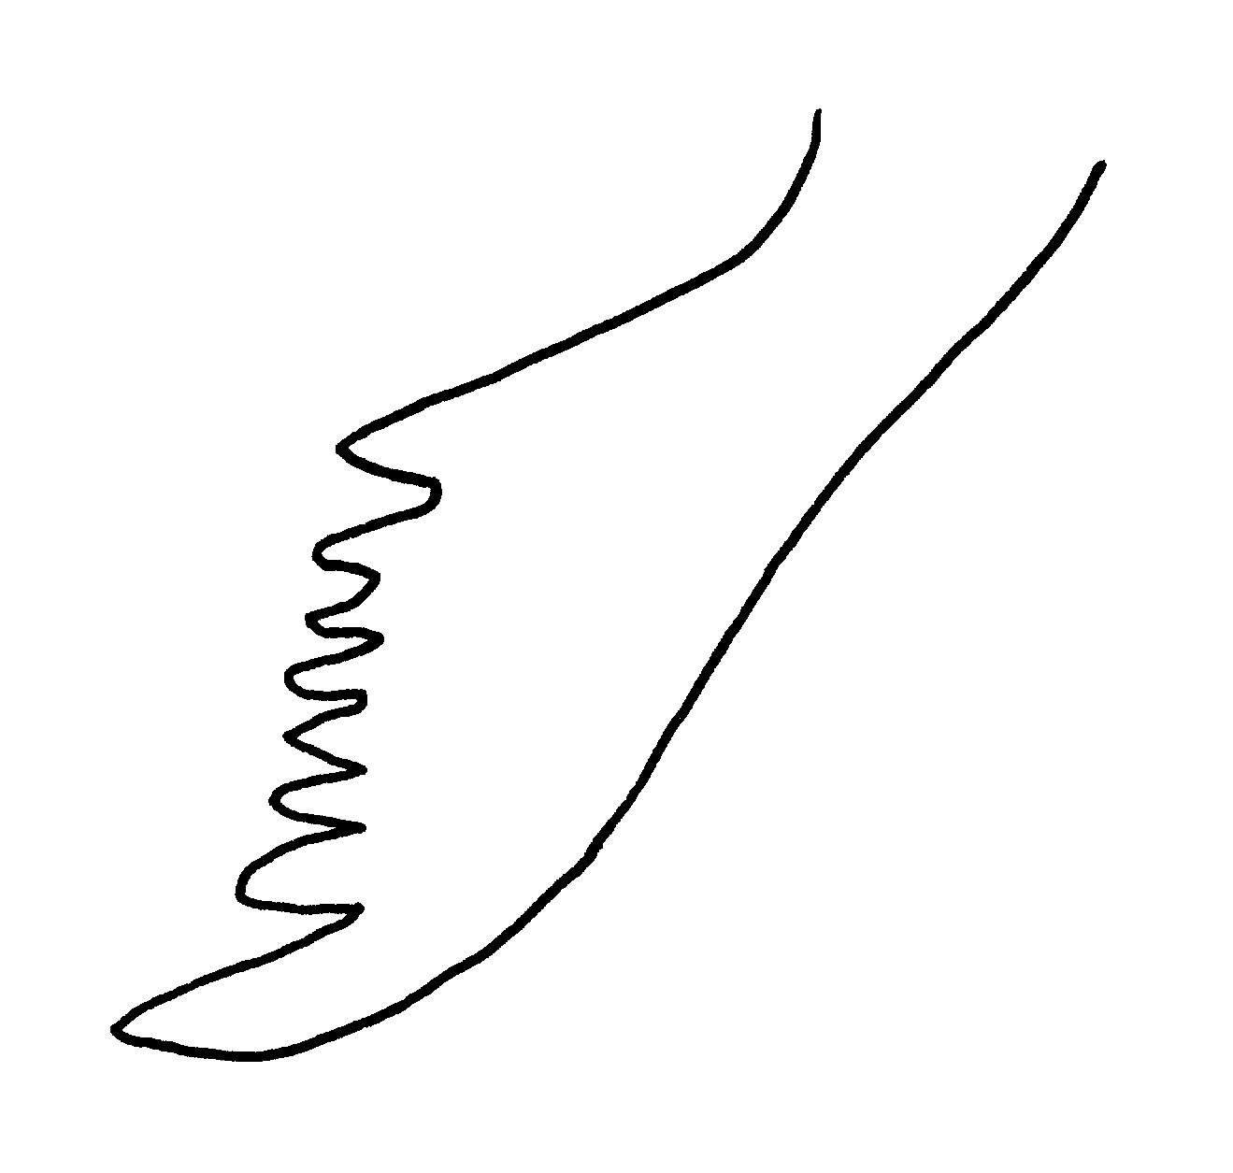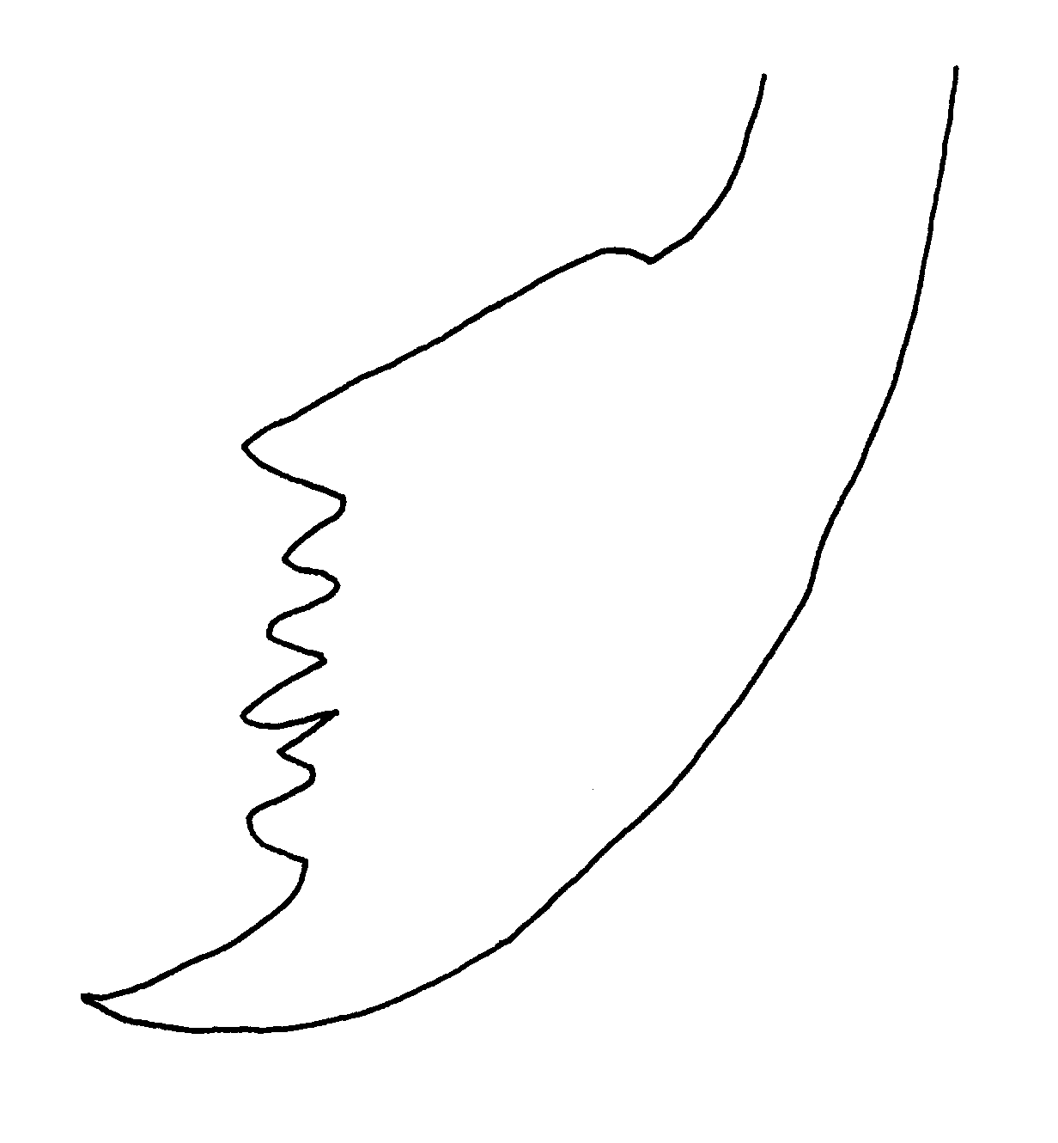
navajoa depilis
Fig. 5. Mandibles of workers of M. navajoa and M. depilis.

2(1). Small (HL not exceeding 1.26 mm), uniformily blackish or dark brown, usually with anterior one-third of head paler; erect hairs very reduced on head and thorax (two exceptions); pubescence sparse on head; usually is crepuscular or matinal .......Subgenus.. Eremnocystus

- Larger (HL exceeding 0.83 mm), either bicolorous or ferruginous; usually abundantly hairy, erect hairs numerous on head and thorax, appressed pubescence usually dense on third tergum; diurnal ……………………... ………………...Subgenus Endiodioctes

KEY TO FEMALES ¹:

1. Integument either (a) uniformly blackish or dark brown or (b) mainly ferruginous on head and thorax, latter often with black markings, gaster ferruginous or black; mandible seven-toothed .............................. .......... ......2

- Uniformly yellowish, thorax and gaster often with brownish infuscations; mandible eight or nine-toothed; wing membranes without short, erect hairs, marginal fringe present/absent ......................Subgenus Myrmecocystus

2(1). Integument uniformly blackish or dark brown, anterior ¹/₃ of head sometimes lighter; small species, HL exceeding 1.63 mm; wing membrane with numerous short, erect white hairs................Subgenus Eremnocystus

- Integument of head and thorax largely ferruginous, gaster blackish (except in M..wheeleri); larger species, HL exceeding 1.43 mm; wing membrane without short, erect, white hairs ..........................Subgenus Endiodioctes

KEY TO MALES¹:

1. Integument either (a) uniformly blackish or dark brown or (b) mainly ferruginous on head and thorax, latter often with black markings, gaster ferruginous or black; mandible seven-toothed ............................................... 2

- Uniformly yellowish, thorax and gaster often with brownish infuscations; mandible 8 or 9 toothed; wing membranes without short, erect hairs, marginal fringe present/absent ......................Subgenus Myrmecocystus

2(1). Integument uniformly blackish or dark brown, anterior one-third of head sometimes lighter; small species, HL not exceeding 1.63 mm; wing membrane with numerous short, erect, white hairs ..............…......Subgenus Eremnocystus

- Integument of head and thorax largely ferruginous, gaster blackish (except in M..wheeleri); larger species, HL exceeding 1.43 mm; wing membrane without short, erect, white hairs ..........................Subgenus Endiodioctes

KEY TO SPECIES OF SUBGENUS ENDIODIOCTES

KEY TO WORKERS¹:

1. Abundantly hairy species: 20+ erect hairs on malar area in frontal view; scape, femora and tibiae with numerous suberect to erect hairs on all surfaces; first three (usually four) terga with dense pubescence (except intonsus); HW of major usually in excess of 1.7 mm.... ....2

- Less hairy species: fewer than 20 erect hairs on malar area in frontal view, usually fewer than 6; scape and femora often sparsely hairy; third tergum often sparsely pubescent; HW of major less than 1.7 mm .........................................6
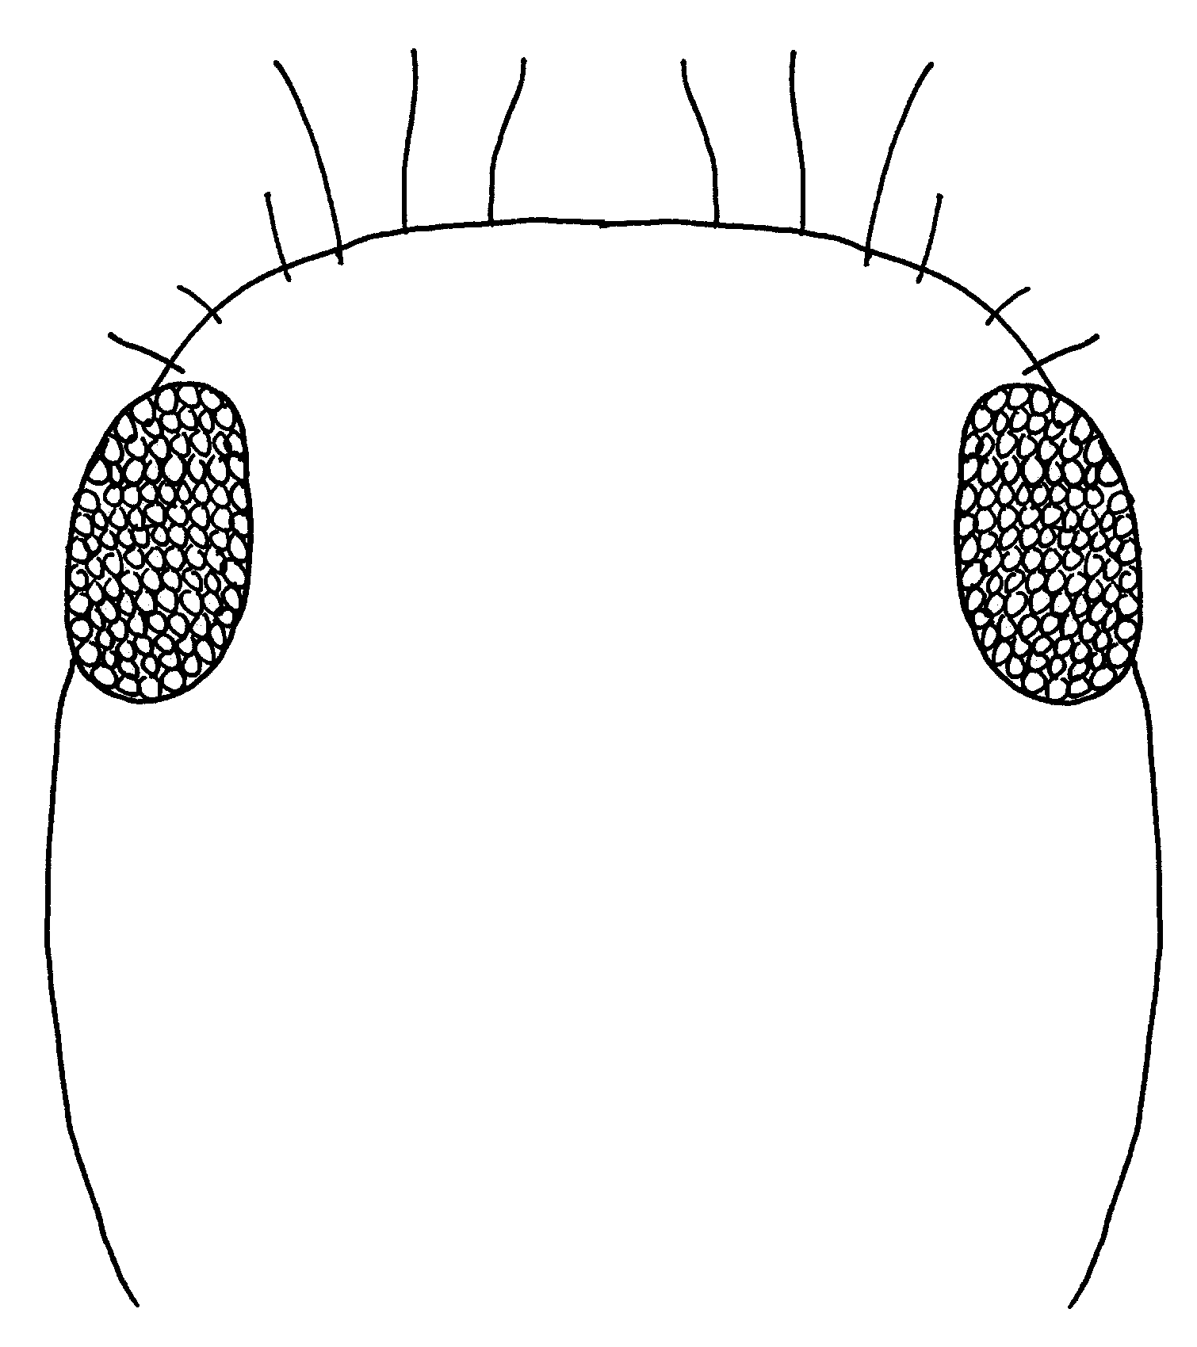 Fig. 6. Outline of the head of a worker of M.depilis.

2(1). Longest occipital hairs usually shorter than EL; longest pronotal hairs as long as or (usually) shorter than EL; longest discal hairs on second tergum less than EL; head of major often strongly orbiculate ...............................3

- Longest occipital, pronotal and discal hairs of second tergum exceeding EL; head of major not orbiculate ....................................… melliger Forel

3(2). Third tergum, and usually fourth as well, densely pubescent; pronotal hairs variable but often more than 0.5 X MOD; HW of major in excess of 1.7 mm; head of major orbiculate or not .............4

- Third and fourth terga with scattered pubescence only; pronotal hairs stiff, uniform, less than 0.5 X MOD; HW of major less than 1.7 mm; head of major orbiculate ...................intonsus Snelling

4(3). Longest hair on pronotal dorsum and disc of second tergum no more than 0.5 X MOD, usually less; head of major orbiculate or not ...................................5
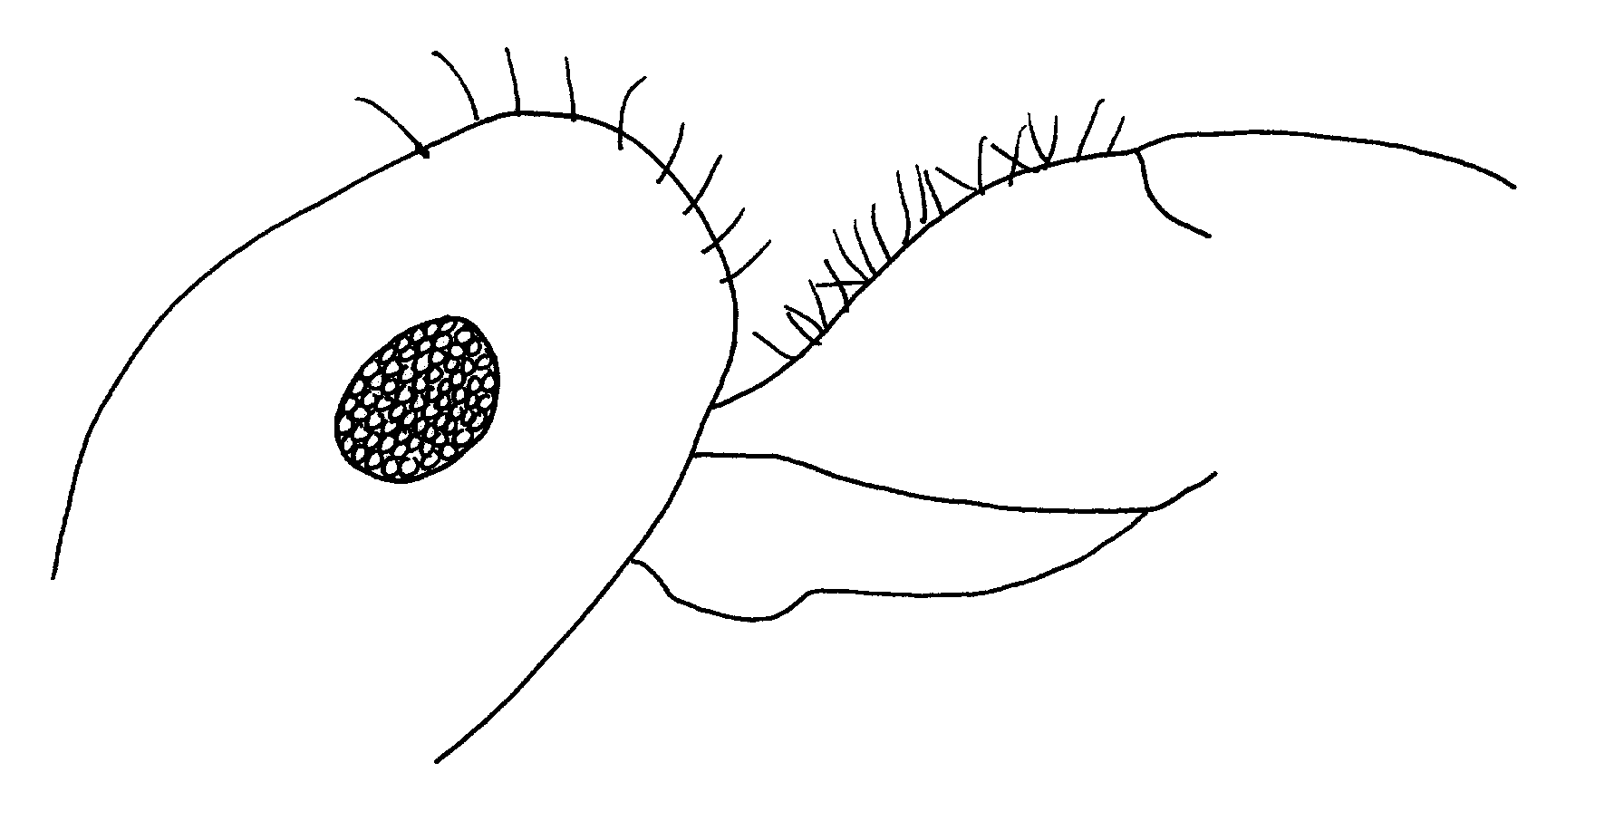
Fig. 7. Head and pronotum of a worker of M. placodops, as seen from the side.

- Longest hairs on pronotal dorsum and disc of second tergum at least 0.6 X MOD, usually about 0.75 X MOD; head of major with margins, in frontal view, nearly parallel .............mendax Wheeler
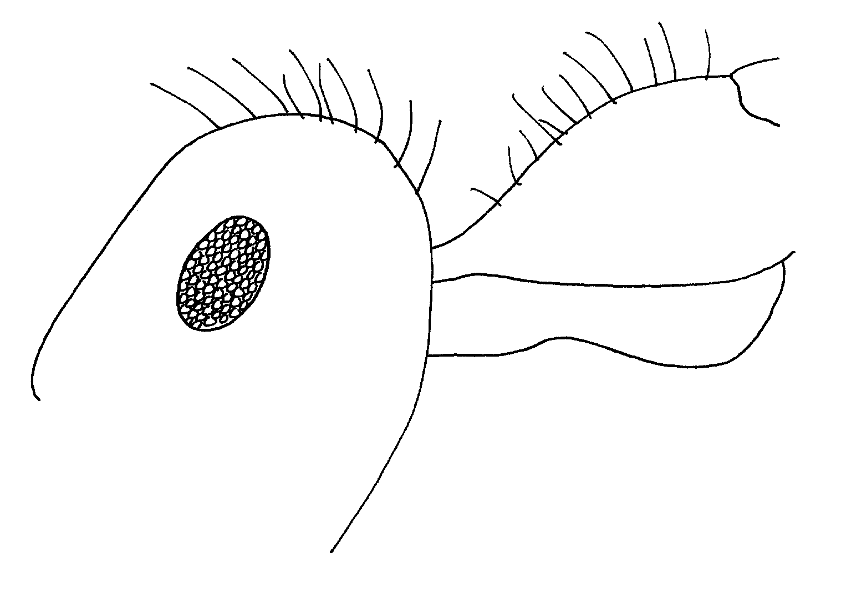
Fig. 8. Head and pronotum of a worker of M. mendax, as seen from the side.

5(4). Frontal lobes shiny, closely, sharply punctate, punctures round or weakly ovoid; frons usually with distinct, coarse punctures greater in diameter than hairs arising from them; head of major not, or weakly, orbiculate; California, Baja Calififornia) .......semirufus Emery

- Frontal lobes dull, irregularly, weakly punctate, punctures often elongate; frons weakly punctate, if at all, punctures, when present not exceeding diameter of their hairs; head of major strongly orbiculate (Texas to Arizona) … ……………………… ..placodops Forel
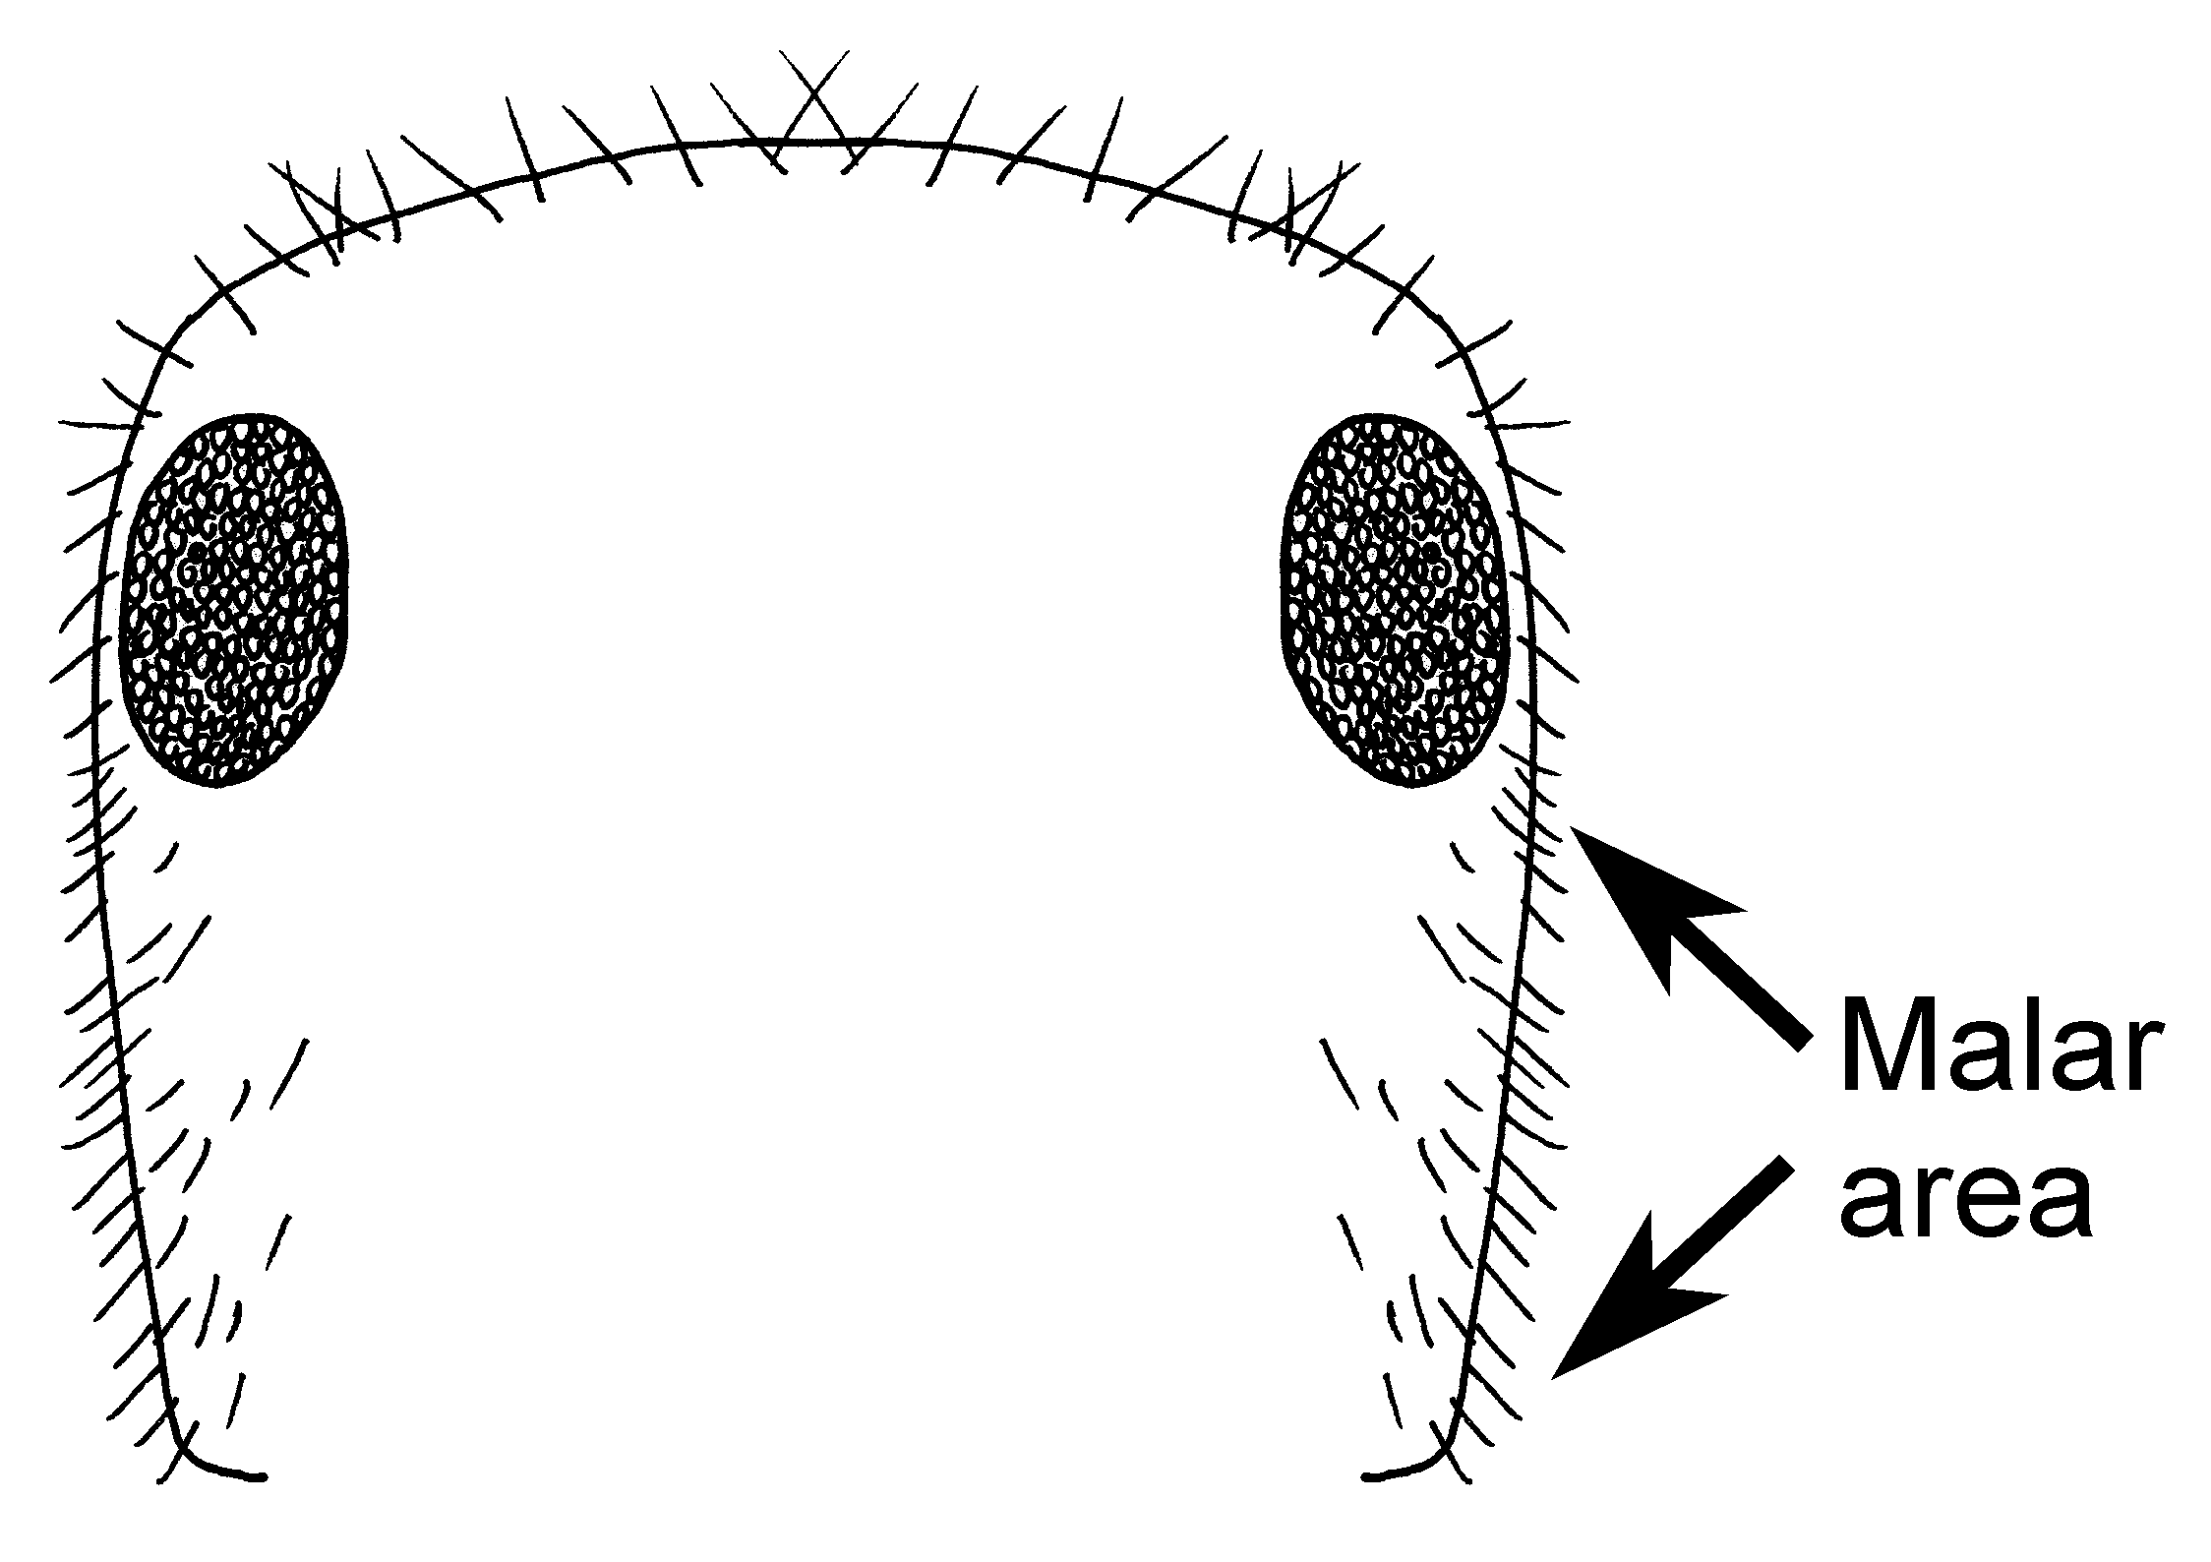 Fig. 9. Outline of the head of a worker of M. placodops.

6(1). Malar area in frontal view, with 6 or more erect hairs evenly distributed between eye and base of mandible ........7

- Malar area in frontal view with not more than four erect hairs, these confined to lower half, near base of mandible ........................................... 11

7(6). First 3 terga uniformly, densely pubescent; clypeus moderately shiny to polished, lightly tessellate to smooth; frontal lobes shiny, sparsely to closely punctate; HW variable ..........................8

- Third tergum apubescent or at least conspicuously less pubescent than first two; clypeus slightly shiny, distinctly tessellate; frontal lobes slightly shiny, distinctly tessellate, with scattered coarse punctures and dense micropunctures; HW of majors 1.03-1.63 mm ............................….. intonsus Snelling

8(7). Tergum IV conspicuously pubescent in specimens with PW in excess of 1.0 mm; erect hairs present over at least half of distance between inner eye margin and antennal socket; punctures of frontal lobes and frons of variable size and irregularly distributed ..........…………..................................10

- Tergum IV with pubescence, when present, very widely scattered; erect hairs present only adjacent to inner eye margin, not extending more than 0.25 of distance between eye and antennal socket; punctures of frontal lobes and frons uniformly minute, evenly distributed .................….......................9

9(8). Longest pronotal hairs more than 0.5 X MOD; malar area usually with 12-16 erect hairs; vertex usually conspicuously, though finely, punctate toward sides ................... romainei Cole

- Longest pronotal hairs less than 0.5 X MOD; malar area usually with fewer than 12 erect; vertex without punctures at sides ..... flaviceps Wheeler

10(8). Longest occipital hairs 0.75 - 0.96 X MOD; longest pronotal hairs at least 0.6 X MOD; petiole, in profile, thickly cuneate, length, at lower margin of spiracle, exceeding height from spiracle to summit ............ koso Snelling

- Longest occipital hairs 0.59-0.65 X MOD; longest pronotal hairs less than 0.5 X MOD; petiole in profile, higher than thick, measured as above ………… ……………………… semirufus Emery

11(6). Longest occipital hairs at least equal to MOD in majors......................12

- Longest occipital hairs no more than 0.6 X MOD usually about 0.5......15

12(9). Longest pronotal hairs about equal to EL, always exceeding MOD; hind femur with numerous suberect hairs on dorsal surface.................................13

- Longest pronotal hairs less than MOD; hind femur with only very short, subappressed hairs on dorsal surface................................................14

13(12). Hairs on dorsal face of hind femur less than half as long as longest hairs on disc of second tergum; CI commonly over 89; head, thorax and legs distinctly brown .……........depilis Forel

- Hairs on dorsal face of hind femur at least half as long as longest hairs on disc of second tergum; CI less than 89 in 90% of specimens; head, thorax and legs ferruginous ……………. ............................... nequazcatl Snelling

14(12). Hairs on dorsal face of hind femur appressed and subappressed; frontal lobes and frons finely, closely and uniformly punctate; mandible septemdentate; abdomen usually wholly orange-ferruginous .....wheeleri Snelling

- Hairs on dorsal face of hind femur suberect, conspicuous; frontal lobes finely and very irregularly punctate, with large impunctate areas; mandible octodentate; abdomen usually black, often with basal two or three terga extensively yellowish ...kathjuli Snelling

15(11).Tergum III with little or no pubescence ............................ ............16

- Tergum III with dense pubescence ................flaviceps Wheeler

16(15). Pubescence very sparse on face; head often subpolished and shiny; side of head of large worker often convex; head, thorax and legs brownish ……….. ..........…………….... mimicus Wheeler

- Pubescence abundant on face; head usually distinctly tessellate, not notably shiny; side of head straight in frontal view; head and legs ferruginous (top of head maybe slightly brownish) ...................................... kennedyi Cole

FEMALES (SUBGENUS ENDIODIOCTES)¹:

1. Penultimate segment of maxillary palp more than twice wider in basal third as at apex, the remaining segments very broad; gaster ferruginous ......................2

- Penultimate segment of maxillary palp slender, more or less parallel-sided, never more than 1.5 X wider in basal third than at apex, remaining segments slender; gaster brownish or blackish .....3

2(1). Punctures of frontal lobes separated by puncture diameter or more; scutellum with median area punctate, interspaces mostly about 1 to 2 times a puncture diameter; longest scutal hairs exceeding EL …...........kathjuli Snelling

- Punctures of frontal lobes uniformly dense, separated by less than a puncture diameter; scutellum, along midline, impunctate or very sparsely punctate, interspaces mostly three to five times a puncture diameter longest scutal hairs less than EL ............. .................................. wheeleri Snelling

3(1). Parapsis closely, uniformly punctate; malar area with abundant standing hairs; HW usually in excess of 2.0 mm ...... ..........................................4

- Parapsis with punctures usually of two sizes and variably spaced, never uniformly dense; malar area usually with no or few standing hairs; HW usually less than 1.9 mm ................................ ........8

4(3). Smaller species, HW less than 1.9 mm; if more, malar area with fewer than 10 erect hairs; disc of mesoscutum finely, sparsely punctate, usually broadly impunctuate in center .................. ........5

- Larger species, HW more than 2.0 mm; if as little as 1.9, malar area with at least 15 erect hairs; disc of mesoscutum closely, coarsely punctate, often with median impunctate area ......6

5(4). Malar area with fewer than 10 erect hairs, those present usually restricted to area mandibular base; frons, on either side of midline, convexly raised, impunctate or nearly so ...romainei Cole
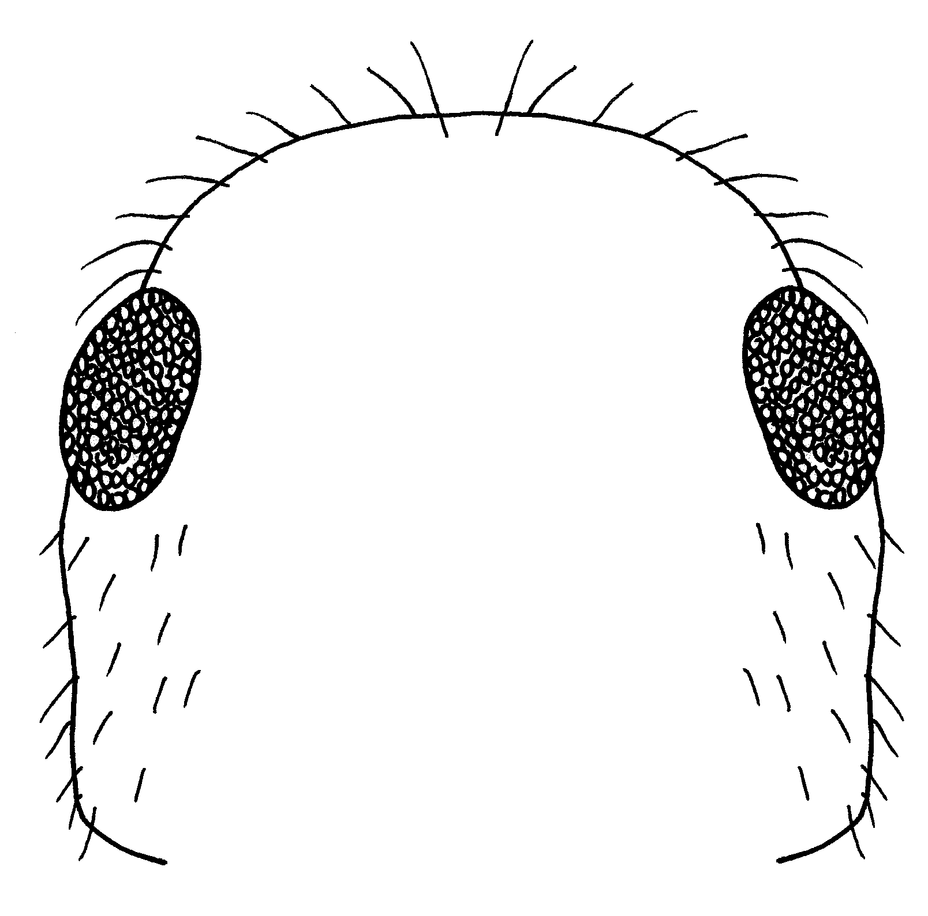
Fig. 10. Outline of the head of a worker of M. romainei.

- Malar area with more than 10 erect hairs, evenly distributed along entire length; frons not notably raised on either side of midline, uniformly, though sparsely, punctate ...............depilis Forel

6(4). Longest occipital hairs 0.5-1.0 X MOD, usually in excess of 0.7; longest mesoscutal hairs at least 0.5 X MOD, usually more; longest scutellar hairs at least 0.9 X MOD; scutal punctuation variable; HW less than 2.3 mm .............7 - Longest occipital and scutal hairs 0.6 or less, X MOD; longest scutellar hairs 0.8, or less, X MOD; scutum with large anteromedian impunctate area; HW 2.3 mm .........................placodops Forel

7(6). Mesoscotum uniformily punctate, sometimes with small anteromedian impunctate area ..........mendax Wheeler

- Mesoscotum with median impunctate area extending nearly entire length of disc ..................melliger Forel

8(3). Median area of first two terga very sparsely punctate ..........................9

- Median area of first two terga uniformly, densely micropunctate .......11

9(8). Median area of third and fourth terga nearly impunctate, similar to first two terga; scutellum very sparsely punctate; HW less than 1.9 mm ..........10

- Median area of third and fourth terga nearly impunctate; scutellum abundantly, finely punctate; HW 2.0 mm or more ......................semirufus Emery

10(9). Frontal lobes closely micropunctate and with scattered coarse punctures; hairs along inner eye margin about as long as on scape; inner face of fore femur with numerous erect hairs along entire length, hairs about as long as those of scape ...................koso Snelling

- Frontal lobes sparsely, coarsely punctate; hairs inconspicuous or absent along inner eye margin; when present, shorter than those of scape .………….. ……………………....flaviceps Wheeler

11(8). Face between eye and frontal lobe, with punctures irregularly distributed, with large impunctate areas; vertex usually with conspicuous areas of sparse punctuation between ocellus and eye .....................................................12

- Face, between eye and frontal lobe, uniformly punctate, interspaces usually no more than twice a puncture diameter; vertex with numerous evenly distributed punctures …...kennedyi Cole

12(11). Longest hairs of mesoscutum, pleura and second tergum less than MOD, often less than 0.5 X MOD …… ……………………....mimicus Wheeler

- Longest hairs of mesoscutum equal to EL, longest of pleura slightly exceeding MOD, longest of second tergum about equal to MOD ………… ……...……….…... nequazcatl Snelling

MALES (SUBGENUS ENDIODIOCTES)¹:

1. Lower margin of ventral lobe of aedeagus strongly convex in profile, teeth small ……………………….…... 2

- Lower margin of ventral lobe of aedeagus concave or straight in profile, teeth coarse (Fig..195) ....……................ ....................…........... wheeleri Snelling

2(1). Disc of second tergum moderately to slightly shiny, uniformly micropunctate and pubescent, first and third terga usually similar; mesoscutum dull, densely, uniformly tessellate ......... 3

- Discs of first two or three terga polished, impunctate and apubescent, at least in middle; mesoscutum wholly, or in part, polished and shiny ....................... 5

3(2). Posterior margin of hind wing with fringe hairs along basal half, at least; if fewer, longest occipital hairs less than 0.5 X MOD; HW often less than 0.90 mm ...……………………………........ 4

- Posterior margin of hind wing without fringe hairs; longest occipital hairs at least 0.60, usually 0.75 or more, X MOD; HW in excess of 0.90 mm ....... ...................................... melliger Forel, mendax Wheeler, placodops Forel

4(3). Longest occipital and mesoscutal hairs exceeding MOD; frontal lobes shiny; side of dorsum of first tergum smooth, shiny, with scattered coarse punctures; HW 0.80 - 0.87 mm .............. ................................... kathjuli Wheeler

- Longest occipital and mesoscutal hairs less than MOD, usually less than 0.5 X MOD; entire face dull, closely tessellate; dorsum of first tergum uniformly, closely micropunctate; HW 0.83-0.97 mm ............ semirufus Emery

5(2). Posterior margin of hind wing without fringe hairs ............................. 6

- Posterior margin of hind wing with fringe hairs ...................................8

6(5). Longest occipital hairs not less than 0.75 X MOD; second and third terga with or without conspicuous pubescence laterad ...............................7

- Longest occipital hairs not exceeding 0.50 X MOD; second and third terga at sides apubescent or very sparsely pubescent .......... kennedyi Cole

7(6). Longest occipital and mesoscutal hairs about equal to MOD; first three terga with little or no pubescence laterad ............................... nequazcatl Snelling

- Longest occipital and mesoscutal hairs no more than 0.75 X MOD; first 3 terga often conspicuously pubescent laterad (esp..Mexican.populations) ......... …………………………… depilis Forel

8(5). Longest occipital and mesoscutal hairs no more than 0.5 X MOD ........... 9

- Longest occipital and mesoscutal hairs at least 0.75 X MOD, often equal to MOD ........................... koso Snelling

9(8). First three terga without conspicuous appressed pubescence or with apubescent median areas of first and second segments larger than lateral, pubescent areas ……………………….. …mimicus Wheeler and romainei Cole

- First tergum largely apubescent, second and third with numerous appressed hairs over a larger area than median, apubescent area .…………........ …………………….. flaviceps Wheeler

KEY TO SPECIES OF SUBGENUS MYRMECOCYSTUS S. STR.

KEY TO WORKERS¹:

1. Dorsal surface of propodeum strongly, angularly projected upward over posterior ²/₃; erect hairs very sparse, with few or none on outer face of hind tibia; upper eye margin little below upper margin of head …….…………………. 2

- Dorsal surface of propodeum either flat or evenly convex; body often abundantly hairy; upper eye margin usually well below upper margin of head ……………………………………..… 3

2(1). With at least two erect pronotal hairs as long as apical breadth of scape; first tergum with a few erect hairs on disc; hind tibia with a few erect hairs on outer face beyond basal third ………... ……………..………..... ewarti Snelling

- Erect pronotal hairs, when present, shorter than apical breadth of scape; first tergum without erect discal hairs; hind tibia without erect hairs on outer face beyond basal third ……… ……………..…… pyramicus M. Smith

3(1). Fully erect hairs conspicuous on thoracic dorsum, discs of first and second terga and on scape and tibiae ………... 4

- No erect hairs on thoracic dorsum, discs of first and second terga, scape or tibiae …… christineae Snelling

4(3). Head, pronotum and gaster with abundant appressed pubescence; mid and hind tibiae usually with numerous erect hairs along apical half of outer face; upper eye margin often distinctly below occipital corner; if metanotal suture impressed, HL exceeds 1.3 mm …..….. 5
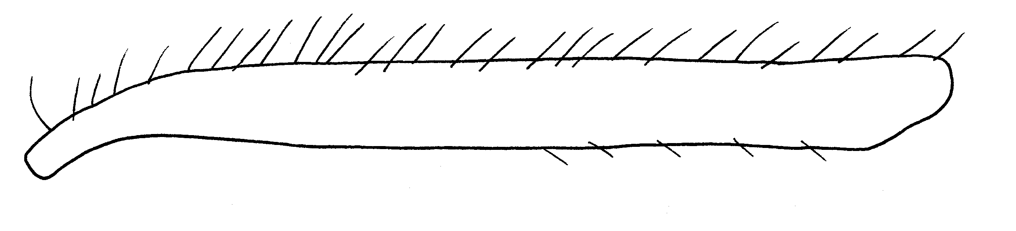
Fig. 11. Mid tibia of a worker of M. mexicanus, as seen from the front.

- Head, pronotum and gaster shiny, with little or no appressed pubescence; mid and hind tibiae with not more than 3 or 4 erect hairs beyond basal third of outer face, usually none; upper eye margin coincident with occipital corner; metanotal suture deeply impressed and dorsal face of propodeum convex ……………………..… navajo Wheeler
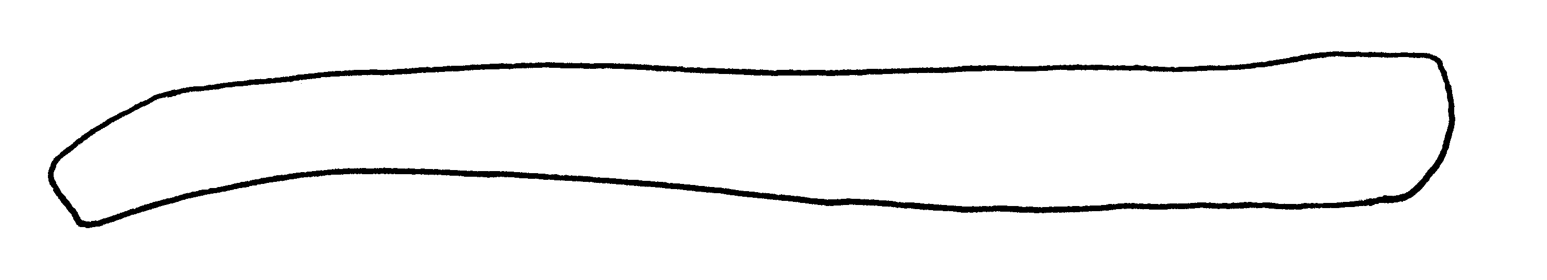
Fig. 12. Mid tibia of a worker of M. navajoa, as seen from the front.

5(4). Large, highly polymorphic species, HL 1.0-2.0 mm or more, usually in excess of 1.3 mm; metanotal suture usually impressed and propodeum as long as high or longer, juncture of dorsal and posterior faces broadly rounded .... 6

- Smaller, moderately polymorphic species, HL 0.8-1.4 mm; metanotal suture not impressed; propodeum higher than long, juncture of dorsal and posterior faces abruptly rounded, often subangulate ……….… testaceus Emery

6(5). Eye with numerous erect hairs which are longer than diameter of ocular facets; mandible with 8 or 9 teeth; color uniformly brownish, gaster a little darker ……….………... melanoticus Wheeler

- Eye with erect hairs, when present, very diffuse, length less than diameter of ocular facets; mandible with 9 or 10 teeth; color usually distinctly yellow, but may be extensively brownish in southern populations ……………..… ………………….. mexicanus Wesmael

KEY TO FEMALES (SUBGENUS MYRMECOCYSTUS)¹

1. Fifth segment of maxillary palp broadest in middle, narrowed basally and apically; hind femur without erect hairs on dorsal surface; hind tibia with hairs decumbent, never fully erect ...……..... 2

- Fifth segment of maxillary palp broadest well basad of middle, gradually narrowed toward apex or parallel sided; hind femur with erect hairs on dorsal surface; hind tibia with abundant fully erect and suberect hairs ……………... 5

2(1). Antennal scape with decumbent or appressed hairs only except a few erect hairs at tip; ocelli normal, OD less than 0.12 mm ……………...……….....3

- Antennal scape with conspicuous coarse erect and suberect hairs; ocelli large, OD greater than 0.15 mm ……… ……………………….. navajo Wheeler

3(2). Fourth segment of maxillary palp gradually widened from base to apex; fine punctures of parapsis abundant and uniformly spaced (Figs..17, 18); side of frontal lobe shiny between close, fine punctures …………………………….. 4

- Fourth segment of maxillary palp distinctly clavate (Fig..xx); fine punctures of parapsis very irregularly spaced (Fig..16); side of frontal lobe dull and roughened between fine punctures which are at least partially obscured …...... …………………… christineae Snelling

4(3). Fine punctures of parapsis conspicuously coarser than those of disc of mesoscutum (Fig..xx); first tergum with fewer than 6 erect hairs on disc, often none; interocellar distance about equal to ocellocular distance ………..……….... pyramicus M..Smith

- Fine punctures of parapsis not obviously coarser than those of disc of mesoscutum (Fig. xx); first tergum with at least 12 erect to suberect hairs on disc; interocellar distance less than ocellocular distance ……..………… ewarti Snelling

5(1). Thorax and gaster brown, legs usually yellowish; HW usually less than 1.85 mm; penultimate segment of maxillary palp slender, parallel-sided …. ……………………..... testaceus Emery

- Thorax and gaster light brownish yellow to yellow, legs concolorous with thorax; HW 1.90 mm or more; usually more than 2.0 mm; penultimate segment of maxillary palp distinctly broadest basad …………… mexicanus Wesmael

MALES (SUBGENUS MYRMECOCYSTUS)¹

1. Scape and tibia without conspicuous standing hairs; hind wing with fringe hairs on posterior margin ... 2

- Scape always and tibia usually with conspicuous standing hairs; posterior margin of hind wing variable . 4

2(1). Forewing with conspicuous fringe hairs along apical margin; HL less than 0.80 mm …………...……………….... 3

- Forewing without fringe hairs along apical margin; HL in excess of 0.90 mm ………...…… pyramicus M. Smith

3(2). Mesopleuron shiny, indistinctly, or not at all, shagreened; forewing usually with discoidal cell ……………. ………………………….ewarti Snelling

- Mesopleuron slightly shiny, distinctly shagreened; forewing without discoidal cell …….. christineae Snelling

4(1). Occipital hairs shorter than maximum diameter of lateral ocellus; posterior and/or apical margins of hind wing with at least a few long fringe hairs ………………………………..…….... 5

- Many occipital hairs longer than maximum diameter of lateral ocellus; hind wing without fringe hairs ……… …………..…………... testaceus Emery

5(4). Small species, HW less than 0.8 mm; scape with scattered erect hairs, tibia with numerous decumbent hairs; apical margin of forewing without fringe hairs ……….………… navajo Wheeler

- Large species, HW greater than 0.9 mm; scape and tibia usually with abundant erect or suberect hairs; if erect hairs reduced or absent, apical margin of forewing with at least vestiges of fringe …………………………...… mexicanus Wesmael and melanoticus Wheeler

WORKERS (SUBGENUS EREMNOCYSTUS)¹

1. Antennal scape and dorsum of propodeum without fully erect hairs … 2

- Antennal scape, usually, and dorsum of propodeum, always, with some fully erect hairs (propodeal hairs may be short and inconspicuous in M..perimeces; this species has an unusually elongate head, CI 70-81) ……………………………………….. 3

2(1). Pronotum and mesonotum with at least eight conspicuous, fully erect white hairs; petiolar scale strongly compressed in profile, crest distinctly notched …..………... lugubris Wheeler

- Pronotum and mesonotum each with no more than two fully erect hairs; petiolar scale not notably compressed, crest slightly concave or flat, but not conspicuosly notched ……………....….. ……………………. creightoni Snelling

3(1). Scape and/or tibiae, usually both, with conspicuous fully erect hairs; or, head moderately broad, CI 89 or more ………………………...……………... 4

- Scape and tibia without erect hairs and head unusually elongate, CI 70 - 81 ……………..… perimeces Snelling

4(3). Scape with conspicuous erect or semierect hairs; femora and tibiae with abundant erect hairs, some present on dorsal femoral surfaces; petiolar scale variable, but often compressed with summit distinctly notched …………… 5

- Scale with no erect hairs, except at apex; femora and tibiae with few erect hairs, none on dorsal femoral surface; petiolar scale thick in profile, crest flat or slightly convex ………... yuma Wheeler

5(4). Scape with scattered erect and numerous suberect to subdecumbent hairs; malar area with fewer than 6 erect hairs in frontal view; if more, pubescence of second tergum much less dense than that of first …………………..……..… 6

- Scape with numerous fully erect hairs; malar area with 10+ erect hairs in frontal view and second tergum fully as densely pubescent as first ……….… …………………… hammettensis Cole

6(5). Pubescence of second tergum as dense as that of first ……………...….. 7

- Pubescence of second tergum much sparser than that of first ………... …………………….. arenarius Snelling

7(6). Appressed pubescence abundant on frons and third tergum; petiolar scale thick, at level of spiracle distinctly more than twice the length of the spiracle, crest flat or convex …….. colei Snelling

-Appressed pubescence sparse on frons and third tergum; petiolar scale thin, at spiracle less than twice the length of spiracle, crest conspicuously notched ………..………….. tenuinodis Snelling

FEMALES (SUBGENUS EREMNOCYSTUS)¹

1. Mesoscutum, finely, densely and uniformly punctate …………………... 2

- Mesoscutal punctation not uniform, punctures often two sizes, with a large median impunctate area or with widely scattered punctures or with impunctate disc and median longitudinal punctate zone ………………………... 3

2(1). Punctures subcontiguous on side of clypeus, very coarse, distinctly coarser than those of upper half of mesopleuron; occiput distinctly shiny, with scattered fine punctures; mid and hind femora without fully erect hairs except a few along lower side ….. creightoni Snelling

- Punctures on side of clypeus distinctly separated, no coarser than on upper half of mesopleuron; occiput slightly shiny, densely shagreened, with fine obscure punctures; mid and hind femora with conspicuous fully erect hairs on all surfaces ………….. colei Snelling

3(1). Fourth segment of maxillary palp elongate-clavate, conspicuously broader at apex than at base; parapsis sparsely punctate, punctures irregular in size and spacing, but mostly separated by two or more puncture diameters ………….… 4

- Fourth segment of maxillary palp not clavate, about as broad in basal third as in apical third; parapsis with punctures uniform in size and spacing ………...... 6

4(3). Summit of first gastric tergum and much of discs of second and third shiny and polished, very nearly impunctate; scutellum with extensive nearly impunctate areas on either side of middle ……………...……………….... 5

- Summit of first gastric tergum and entire discs of second and third terga shiny between fine and evenly spaced piligerous punctures; scutellum with sparse, evenly spaced minute punctures …………………… tenuinodis Snelling

5(4). Fifth segment of maxillary palp uniformly broad, not conspicuously narrowed over apical one-half; forewing with numerous fringe hairs along costal margin …….……… hammettensis Cole

- Fifth segment of maxillary palp conspicuously narrowed over apical one-half (Fig.4); forewing without fringe hairs on costal margin …………….. ……………………. arenarius Snelling

6(3). Face with abundant fine punctures between eyes and frontal lobes; clypeus shiny, polished; appressed gastric pubescence whitish; mesopleural hairs about as long as those of mesoscutum …...……… yuma Wheeler

- Face sparsely punctate between eye and frontal lobe; clypeus dull, densely sculptured; appressed gastric pubescence brownish; mesopleural hairs conspicuously longer than those of mesoscutum, little shorter than those of scutellum ……..…... perimeces Snelling

Key to New Mexico Myrmecocystus workers (Modified from Snelling, 1976)
1. Mandible with 8 - 10 teeth (Fig. 435, left); light yellow or brownish-yellow, entire ant basically same color; primarily nocturnal ...……………............. 2
- Mandible with 6 or 7 teeth (Fig. 435, right); workers are either 1) bicolored, head brownish-red, mesosoma and gaster blackish; or 2) uniformly black or dark brown, anterior part of head may be lighter; primarily diurnal; ................................ 3
2(1). Head, pronotum and gaster shining, with little or no appressed pubescence; mid and hind tibiae with not more than 3 or 4 erect hairs beyond basal third of outer face, usually none (Fig. 436) ............................................... navajo Wheeler
- Head, pronotum and gaster with abundant appressed pubescence; mid and hind tibiae usually with numerous erect hairs along the apical half of outer face (Fig. 437) ..................... mexicanus Wesmael
3(1). Bicolored, head reddish, mesosoma dark, often mixed with red, gaster black; common ...……………………………………………...... 4
- Essentially entire ant dark brown or black; not recorded from NM ………………………………………... (previous subgenus Eremnocystus)
4(3). Twenty or more hairs on malar area in full face view (Fig. 438); first 3 (usually 4) terga (upper surfaces of segments of gaster) with dense pubescence ......………………………………………………………....... 5
- Fewer than 20 erect hairs on malar area (Fig. 439); usually fewer than 6; third tergum often with sparse or no pubescence ........7
5(4). Longest posterior lateral and pronotal hairs (Fig. 440) usually shorter than eye length (EL), longest hairs on second tergum shorter than EL ...............6
- Longest posterior lateral, pronotal and gastral hairs exceeding length of eye; not recorded from New Mexico (TX, SO, CH) ..... melliger Forel
6(5). Longest hairs on pronotal dorsum (Fig. 440) and disc of second tergum no more than half minimum eye diameter ....... ……………… placodops Forel
- Longest hairs on pronotal dorsum and disc of second tergum at least 0.6 X minimum eye diameter (Fig. 441), usually about 0.75 X minimum eye diameter ....... ………………. mendax Wheeler
7(4). Malar area (Fig. 439) with 6 or more (usually 12 - 16) erect hairs; third tergum with dense pubescence, not differing from second tergum .... romainei Snelling
- Malar area usually with not more than 4 erect hairs (Figs. 442 & 443); third tergum with less pubescence than second tergum .... 8

8(7). Longest posterior lateral hairs of head at least equal to minimum eye diameter in majors (Fig. 442) .…………........... …….................…........ depilis Forel
- Longest posterior lateral hairs no more than 0.6 X minimum eye diameter (Fig. 443) , usually about 0.5 X minimum diameter of eye ........…………………........ mimicus Wheeler
Myrmecocystus christineae Snelling
Figs.; Map

Myrmecocystus (Myrmecocystus) christineae Snelling, 1982b: 80, fig. 7-12, 14, 16, 20, 22, 24 (w.q.m.) U.S.A.

Discussion.

Distribution.
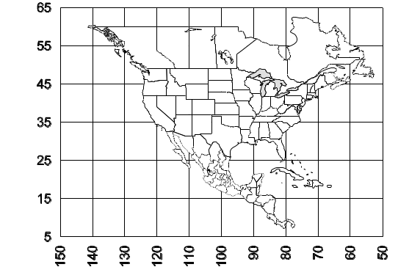
Map 1. Distribution of M. christineae.

Habitat.

Biology.

Myrmecocystus colei Snelling
Figs.; Map

Myrmecocystus (Eremnocystus) colei Snelling 1976:94, , Figs. 203-211, 255-258. U.S.A.

Discussion.

Distribution.
Map 2. Distribution of M. colei.

Habitat.

Biology.

Myrmecocystus creightoni Snelling
Figs.; Map

Myrmecocystus creightoni Snelling, 1971a: 6, , Fig. 2 U.S.A. See also Snelling 1976: 98.

Discussion.

Distribution.
Map 3. Distribution of M. creightoni.

Habitat.

Biology.

Myrmecocystus depilis Forel
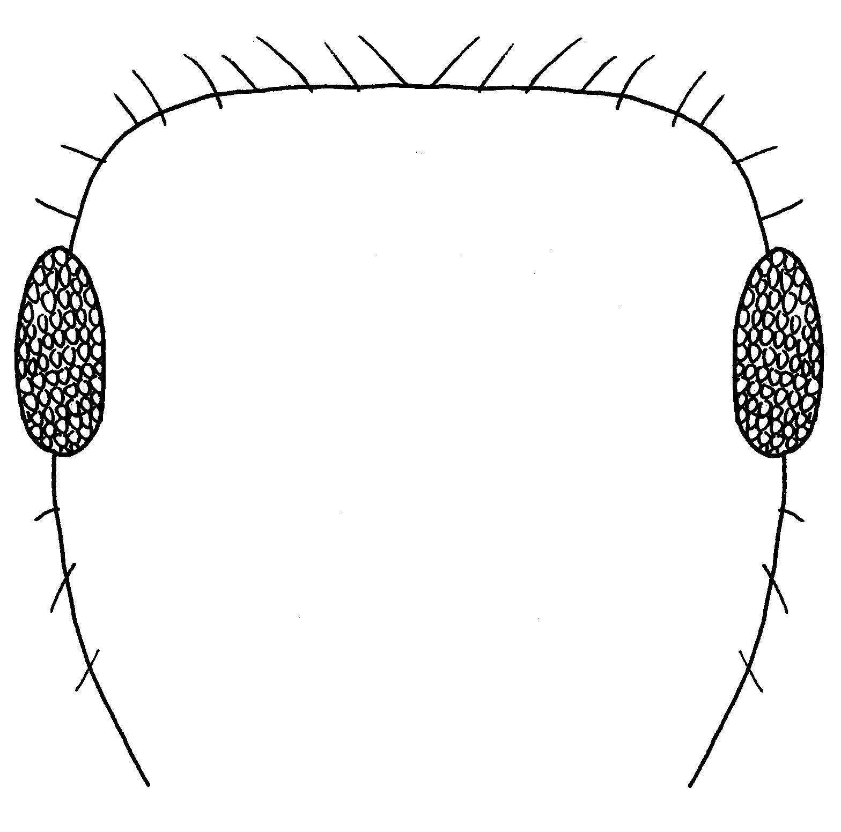 Fig. 443. Outline of the malar area of a worker of M. mimicus.

Figs.; Map
Myrmecocystus melliger var. depilis Forel, 1901c: 135 , MEXICO. Snelling, 1976:52  . Raised to species: Snelling in Hunt and Snelling, 1975:22.

Discussion. This species can usually be distinguished from the others in the genus as the malar area has few or no erect hairs (frontal view), the gaster is blackish, the head and mesosoma are extensively infuscated, and some of the pronotal hairs are longer than the length of the eye in the large workers. Larger workers have abundant pubescence on the disc of the third tergum, medias and minor workers have scattered pubescence on the same surface.
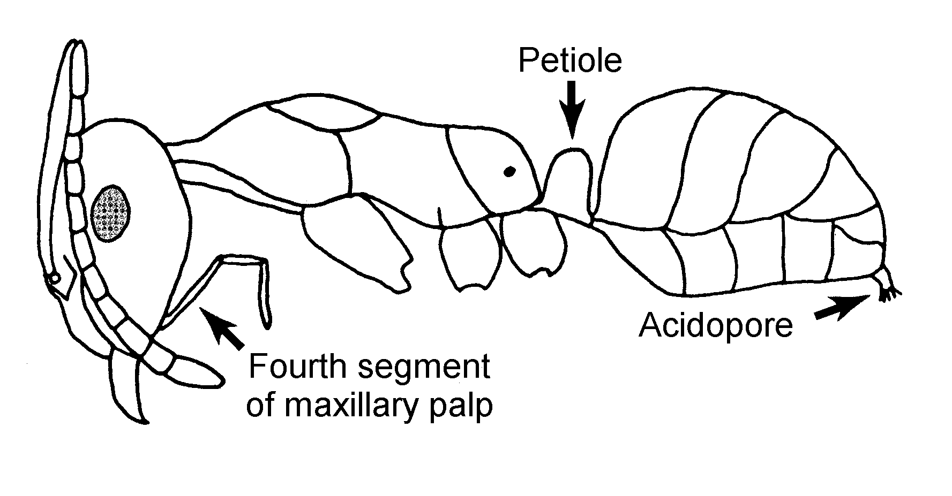
Fig. 13. Side view of a worker of M. depilis.

The smaller workers of this species are easily confused with similar workers of M. mimicus. They may be separated as the minor workers of M. depilis possess hairs of variable length on the pronotal dorsum, a few of which are as long as three times that of the shortest hairs, those of M. mimicus are uniform in length. The majors and media workers of M. depilis always possess long, slender, flexuous hairs on the pronotum, some of which equal or exceed the length of the eye. In addition, the third gastral tergum usually has conspicuous appressed pubescence, except in the smallest workers.
Distribution. USA: NV, AZ, TX; NM: Doña Ana Co., Eddy Co., Grant Co., Hidalgo Co., Lea Co., Luna Co., Otero Co., Sierra Co., Socorro Co.; MEXICO: Sonora, Chihuahua, Coahuila, Nuevo León, Durango, Zacatecas, San Luis Potosí, Jalisco.
Habitat. In most arid habitats (creosote bush scrub, mesquite woodlands, weedy areas), except grasslands.
Biology. Nests are found in sandy soil. It tends aphids and coccids and collects dead insects as well as preys on living arthropods, and collects nectar from flowers of Opuntia rastrera, Parthenium incanum and Euphorbia albomarginata. This species forages individually or in groups. The scarabaeid beetles Cremastocheilus stathamae and C. constricticollis are found in the nests.
Snelling, 1976; Rojas and Fragoso, 1994, 2000

Myrmecocystus ewarti Snelling
Figs.; Map

Myrmecocystus ewarti Snelling, 1971a:2, , Fig. 1 U.S.A. See also: Snelling, 1976:129.

Discussion.

Distribution.
Map 4. Distribution of M. ewarti.

Habitat.

Biology.

Myrmecocystus flaviceps Wheeler
Figs.; Map

Myrmecocystus yuma var. flaviceps Wheeler, W. M. 1912d: 177 (w.) U.S.A. Snelling, 1976: 84 ; Raised to species: Creighton, 1950a: 443.

Discussion.

Distribution.
Map 5. Distribution of M. flaviceps.

Habitat.

Biology.

Myrmecocystus hammettensis Cole
Figs.; Map

Myrmecocystus hammettensis Cole, 1938b:678 , U.S.A. See also: Snelling 1976:101.

Discussion.

Distribution.
Map 6. Distribution of M. hammettensis.

Habitat.

Biology.

Myrmecocystus intonsus Snelling
Figs.; Map

Myrmecocystus (Endiodioctes) intonsus Snelling, 1976: 30, , Figs. 70-72, MEXICO
Discussion.

Distribution.
Map 7. Distribution of M. xx.

Habitat.

Biology.

Myrmecocystus kathjuli Snelling
Figs.; Map

Myrmecocystus (Endiodioctes) kathjuli Snelling, 1976: 59, , Figs. 92-99, 160, 172, 185, 193 U.S.A.

Discussion.

Distribution.
Map 8. Distribution of M. kathjuli.

Habitat.

Biology.

Myrmecocystus kennedyi Snelling
Figs.; Map

Myrmecocystus kennedyi Snelling, 1969a:6, , U.S.A. [First available use of Myrmecocystus melliger subsp. semirufus var. kennedyi Cole, 1936b: 119; unavailable name.] See also: Snelling, 1976: 62.

Discussion.

Distribution.
Map 9. Distribution of M. kennedyi.

Habitat.

Biology.

Myrmecocystus koso Snelling
Figs.; Map

Myrmecocystus (Endiodioctes) koso Snelling, 1976:74, , Figs. 127-135, 164, 176, 199, 200 U.S.A

Discussion.

Distribution.
Map 10. Distribution of M. koso.

Habitat.

Biology.

Myrmecocystus lugubris Wheeler
Figs.; Map

Myrmecocystus lugubris Wheeler, W.M. 1909f:98 , U.S.A. Wheeler and Wheeler, 1968:213, larva; See also: Creighton, 1956: 1; Snelling, 1976: 104

Discussion.

Distribution.
Map 11. Distribution of M. lugubris.

Habitat.

Biology.

Myrmecocystus melanoticus Wheeler
Figs.; Map

Myrmecocystus mexicanus var. melanoticus Wheeler, 1914b:57, , MEXJCO. Raised to species: Snelling 1976:116.

Discussion.

Distribution.
Map 12. Distribution of M. melanoticus.

Habitat.

Biology.

Myrmecocystus melliger Forel
Myrmecocystus melliger Fore1, 1886f:201 , MEXICO. Wheeler, 1912d:174 , Wheeler and Wheeler, 1968:211, larva. Senior synonym of M. comatus: Snelling, 1969a:4. See also: Snelling, 1976:31

Discussion. The worker has numerous erect hairs on the malar area (between the base of the mandible and the eye), the longest hairs on the posterior border of head, pronotum and dorsum of second gastral tergum exceed the eye length; the longest pronotal hairs are flexuous and somewhat curled at the tip.
The long-haired Myrmecocystus from New Mexico are apparently all M. mendax to which it is closely related (Snelling 1976). The largest workers of M. mendax have a head width less than 1.5 mm and the hairs on the pronotal hairs are usually evenly curved along their lengths. This species has been referred to as M. comatus.
Distribution. USA: TX; west Texas and Chihuahua, MEXICO: throughout the northern half. Cole (1954c) reports M. comatus from New Mexico.
Habitat. Semi arid mountain habitats, oak juniper, pinyon juniper woodlands.
Biology. This species nests in the soil and is apparently predaceous.
Snelling, 1976
Myrmecocystus mendax Wheeler

Figs.; Map

Myrmecocystus melliger subsp. mendax Wheeler, 1908d: 351, , Fig. 4, U.S.A. Raised to species: Creighton, 1950a: 445. Senior synonym of M. orbiceps: Snelling, 1976: 35.

Discussion. This ant can be recognized by the numerous hairs on the malar area; the long hairs on pronotum and dorsum of second tergum of large workers are at least 60% of the length of the longest diameter of the eye; the longest hairs on pronotum are evenly curled and not simply curled at the tip.
Distribution. USA: NV, CA, AZ, CO, TX; NM: Bernalillo Co., , Catron Co., Colfax Co., Doña Ana Co., Grant Co., Guadalupe Co., Lincoln Co., Los Alamos Co., Luna Co., McKinley Co., Otero Co., Quay Co., Rio Arriba Co.,, Sandoval Co., , San Juan Co., , San Miguel Co., Santa Fe Co., Socorro Co., Torrance Co., Union Co., , Valencia Co.,; MEXICO: Sonora, Chihuahua.
Habitat. Arid grasslands and desert shrublands up to pinyon juniper woodlands.
Biology. Nests are found in the soil or under stones. Flights occur in the afternoon after a rain. This species is carnivorous (insects) and feeds on dead insects. Workers also collect honeydew and nectar. Foraging occurs during the day. The ant cricket Myrmecophila nebrascensis occurs within the nest.
Wheeler, 1910a; Cole, 1942,1954c; Gregg, 1963 (as M. comatus); Snelling, 1976

Myrmecocystus mexicanus Wesmael
Fig.; Map

Myrmecocystus mexicanus Wesmael, 1838:770, , MEXICO. Wheeler and Wheeler, 1968:213, larva. Junior synonym of melliger: Forel, 1886f:201; Mayr, 1886d: 424. Revived from synonymy: Wheeler, 1908d: 356. Senior synonym of hortusdeorum: Snelling, 1976:120.

Discussion. This is a pale yellow ant with black eyes. The head length of the largest workers exceeds 1.3 mm, the eyes have few or no short, erect hairs, the propodeal dorsum is evenly convex and abundantly hairy and the metanotal suture is usually distinctly impressed.
This species can be easily confused with M. navajo, see discussion of the latter species.
Distribution. USA: NV, CA, UT, CO, AZ, TX; NM: Catron Co., Colfax Co., Doña Ana Co., Grant Co., Hidalgo Co., Lea Co., Los Alamos Co., Luna Co., McKinley Co., Otero Co., San Juan Co., Santa Fe Co., San Miguel Co., Sierra Co., Socorro Co., , Taos Co., Torrance Co., MEXICO: Chihuahua, Coahuila, San Luis Potosí, Durango, Guanajuato, Baja California.
Habitat. Typical creosotebush desert scrub, sagebrush, oak woodland up to pinyon-juniper. This is one of the most common species of Myrmecocystus in New Mexico.
Biology. The nest of this species is usually a crater surrounded by pebbles or coarse gravel. The nest entrance consists of a single, large diameter (over 2 cm) tunnel. The foragers are active just before dusk, and throughout the night, until after dawn. It also forages on cool, overcast days. Workers forage individually, collecting nectar and excretions of Homoptera. Although they collect dead arthropods, they are apparently not predaceous. Flights occur late in the afternoon just before dusk. A myrmecophilous scarabaeid beetle appears to be an obligate predator on the larvae of this species.
Snelling, 1976
Myrmecocystus mimicus Wheeler
Figs.; Map

Myrmecocystus melliger subsp. mimicus Wheeler, 1908d:353, , USA: Wheeler and Wheeler, 1968:213, larva. Raised to species: Creighton, 1950a: 446. Senior synonym of lomaensis, and material of the unavailable name jesuita referred here: Creighton, 1950a:446; Snelling, 1976:54

Discussion. The malar area of this species has fewer than ten erect hairs, usually only on the lower half, the frons and vertex are smooth, shiny and with little or no pubescence, the third tergum of the gaster with only sparse pubescence, and the pronotal hairs are short, stiff and blunt. Specimens from three localities in New Mexico (Roosevelt Co., 1 k E Oasis, Socorro Co., Magdalena Mts. [Water Canyon], and 33°48’32.2”N 107°22’57.2”W) have dense pubescence on the third tergum of the gaster, and may be M. flaviceps Wheeler. They are indicated by squares on the M. mimicus map.
Distribution. USA: CA, NV, UT, AZ, CO, KS, OK, TX; NM: Bernalillo Co., Catron Co., Chaves Co., Doña Ana Co., Eddy Co., Grant Co., Guadalupe Co., Hidalgo Co., Los Alamos Co., Luna Co., Otero Co., Rio Arriba Co., Roosevelt Co., Sandoval Co., San Miguel Co., Santa Fe Co., Sierra Co., Socorro Co., Taos Co., Torrance Co.,; MEXICO: Chihuahua, Durango, Coahuila, San Luis Potosí, Guanajuato, Morelos, Sonora, Baja California.
Habitat. Desert grasslands (fluff grass, grama grass), weedy areas, through creosote bush scrub, mesquite woodlands, sagebrush, oak forest to pinyon juniper woodland.
Biology. Nests range from a hole hidden at the base of a desert plant to a normal crater surrounded by pebbles or a mound as is found in other species in the genus. Foraging occurs during the day with the workers scavenging on dead arthropods or preying on living insects and feeding on nectar in flowers. This species also tends aphids. Workers are timid and rapid. Mating flights occur late in the afternoon after a significant rain event, although flights may occur in the morning. Several queens may start a single nest, although this is apparently uncommon.
Cole, 1934a, 1966; Mallis, 1941; Wheeler and Wheeler, 1973; Hölldobler, 1976; Snelling, 1976
Myrmecocystus navajo Wheeler
Figs.; Map

Myrmecocystus mexicanus subsp. navajo Wheeler, 1908d: 360, Fig. 11, , U.S.A. Snelling, 1976: 126 . Raised to species: Creighton, 1950a:449.

Discussion. The dorsum of the propodeum is evenly convex with abundant erect hairs, appressed pubescence is sparse on the head, mesosoma and gaster, and the hind tibia has few or no erect hairs on the outer face.
Workers are similar to those of M. mexicanus, but differs in being smaller, having sparser cephalic pubescence, and lack the erect hairs on the extensor surfaces of the extensor surfaces of the femora and tibiae. The node of the petiole of M. navajo workers is usually thinner and with fewer erect hairs than that of M. mexicanus. Often workers of the two species cannot be separated.
Distribution. USA: NV, CA, UT, CO, KS, AZ, TX; NM: Bernalillo Co., Doña Ana Co., Grant Co., Los Alamos Co., Otero Co., Santa Fe Co.,; MEXICO: Chihuahua, Sonora, San Luis Potosí.
Habitat. Chihuahuan Desert, sagebrush and grasslands up to oak and pinyon juniper woodlands.
Biology. These ants nest in the soil with the entrance surrounded by a low mound of soil. Wheeler (1908) reports that the colonies are small, 100 - 150 workers, although this estimate is probably low as was suggested by Snelling (1976). Larvae occurred in nests in March. Foraging occurs primarily at night, with the workers tending Homoptera and feeding on flower nectar. Dead arthropods are also collected.
Cole, 1942; Gregg, 1963; Wheeler and Wheeler, 1973; Snelling, 1976; DuBois and Danoff-Burg, 1994

Myrmecocystus nequazcatl Snelling
Figs.; Map

Myrmecocystus nequazcatl Snelling, 1976:67, , Figs. 109-116, 162, 174, 186, 194, MEX-ICO

Discussion.

Distribution.
Map 13. Distribution of M. xx.

Habitat.

Biology.

Myrmecocystus perimeces Snelling
Figs.; Map

Myrmecocystus perimeces Snelling, 1976: 106, , Figs. 234-240, MEXICO.

Discussion.

Distribution.
Map 14. Distribution of M. perimeces.

Habitat.

Biology.

Myrmecocystus placodops Forel
Figs.; Map

Myrmecocystus melliger var. placodops Forel, 1908b:70, , MEXICO. Snelling, 1976:42 . Raised to species: Snelling, 1969a:6.

Discussion. The longest hairs on the pronotum and dorsum of second segment of gaster are less than half the maximum diameter of eye, those on the pronotum are abruptly tapered at the tip; the malar area has numerous erect hairs. The head of the larger workers is orbiculate in shape.
Only the largest workers can be separated from those of M. mendax, the smaller workers of the two species are indistinguishable. The sexual forms of the two species cannot be separated using morphological characters.
Distribution. USA: AZ, TX; NM: Bernalillo Co., Catron Co., Doña Ana Co., Los Alamos Co., Roosevelt Co., San Juan Co., Socorro Co., Taos Co., Torrance Co., Union Co.; MEXICO: Sonora, Chihuahua, Durango, Nuevo León, Tamaulipas.
Habitat. Sagebrush (Rio Grande). Found in most habitats in arid environments, except grasslands. This ant is most abundant in the Rio Grande Valley and plains of western Texas, ranging from grasslands and shrub grassland to mesquite savannas and creosotebush/tarbush grassland.

Biology. This is a diurnal species, which feeds on small arthropods and visits flowers to obtain nectar. They nest in the soil in open areas, usually in rocky soil, with the maximum depth being 4.8 m. There are as many as 1500 repletes in a single nest.
Creighton and Crandall, 1954; Snelling, 1976; Rojas-Fernández and Fragoso, 1994, 2000
Myrmecocystus pyramicus M. Smith
Figs.; Map

Myrmecocystus pyramicus Smith, 1951c:91, , Figs. 1-3, USA: Cole, 1957b: 129 . See also: Snelling, 1976:132

Discussion.

Distribution.
Map 15. Distribution of M. pyramicus.

Habitat.

Biology.

Myrmecocystus romainei Snelling
Figs.; Map

Myrmecocystus romainei Snelling, in Hunt and Snelling, 1975: 22 , U.S.A. [First available use of Myrmecocystus melliger subsp. semirufus var. romainei Cole, 1936b: 120; unavailable name.] Snelling, 1976:78 

Discussion. In this species, the malar area (front view) has 5 - 17 hairs extending beyond the margin, the head width is less than 1.55 mm, the frons and vertex are finely and closely punctate and the longest posterior lateral hair is less than half the maximum eye diameter.
Distribution. USA: Throughout the southwest; NM: Bernalillo Co., Doña Ana Co., Grant Co., Guadalupe Co., Lincoln Co., McKinley Co., Otero Co., Rio Arriba Co., Sandoval Co., Santa Fe Co., Sierra Co., Socorro Co., Valencia Co.; MEXICO: Chihuahua, Nuevo León.
Habitat. Numerous habitats, ranging from grasslands through creosotebush scrub up to pinyon juniper woodlands.
Biology. These ants have irregular craters, with a diameter up to 20 cms. This species can nest in loose, sandy soils, but prefers the more stable interdunal areas at White Sands National Monument. Cole (1954c) reports that the population at White Sands National Monument had brilliant blue gasters, that disappeared after the specimens were preserved. We have not seen this in any of this species that we have collected.
Cole, 1954c (as M. semirufa, in part); Gregg, 1963 (as M. semirufus in part); Snelling, 1976
Myrmecocystus semirufus Emery
Figs.; Map

Myrmecocystus melliger var. semirufus Emery, 1893i:667 , U.S.A. Wheeler and Wheeler, 1968:213, larva; Snelling, 1976: 46 . Subspecies of M. melliger: Wheeler, 1908d:355. Raised to species: Creighton, 1950a:449

Discussion.

Distribution.
Map 16. Distribution of M. semirufus.

Habitat.

Biology.

Myrmecocystus snellingi Bolton
Myrmecocystus snellingi Buren, 1995:274-275. Replacement name for arenarius Snelling, 1982b:71. U.S.A., Figs. 1-6, 13, 15, 19, 21, 23 (.) [Junior primary homonym of arenaria Finzi, 1940: 164.]

Figs.; Map

Discussion.

Distribution.
Map 17. Distribution of M. snellingi.

Habitat.

Biology.

Myrmecocystus tenuinodis Snelling
Figs.; Map

Myrmecocystus (Eremnocystus) tenuinodis Snelling, 1976:107, , Figs. 241-247 U.S.A.

Discussion.

Distribution.
Map 18. Distribution of M. tenuinodis.

Habitat.

Biology.

Myrmecocystus testaceus Emery
Figs.; Map

Myrmecocystus melliger var. testaceus Emery, 1893i:667, , U.S.A. Snelling 1976:136 . Junior synonym of M. semirufus: Creighton, 1950a:449. Revived from synonymy, raised to species, and senior synonym of M. mojave: Snelling, 1969a:6. Senior synonym of M. idahoensis: Snelling, 1976:135.

Discussion.

Distribution.
Map 19. Distribution of M. testaceus.

Habitat.

Biology.

Myrmecocystus wheeleri Snelling
Figs.; Map

Myrmecocystus wheeleri Snelling, 197la:11, , Fig. 3, U.S.A. See also: Snelling, 1976:70

Discussion.

Distribution.
Map 20. Distribution of M. wheeleri.

Habitat.

Biology.
Myrmecocystus yuma Wheeler
Figs.; Map

Myrmecocystus yuma Wheeler, 1912d: 176, , U.S.A. Snelling 1976: 110, . Junior synonym of M. lugubris: Creighton, 1956:1. Revived from synonymy: Snelling, in Hunt and Snelling, 1975:23.

Discussion.

Distribution.
Map 21. Distribution of M. yuma.

Habitat.

Biology.
Literature cited
Snelling, R. 1976. A revision of the honey ants, genus Myrmecocystus (Hymenoptera: Formicidae). Nat. Hist. Mus. Los Angel. Cty. Sci. Bull. 24:1-163.
Snelling, R. 1982. A revision of the honey ants, genus Myrmecocystus, first supplement (Hymenoptera: Formicidae). Bull. South. Calif. Acad. Sci. 81:69-86

Modified from Snelling (19__)

