, ,  ,

Genus Pachycondyla

The genus Pachycondyla was described by Frederick Smith 1858 for group of medium to large ants, belonging to subfamily Ponerinae. Later, Roger (1863) and Mayr (1863), and others considered this genus to be heterogeneous and broke out several new genera, including Neoponera Emery (1901), Mesoponera Emery (1901) and Termitopone Wheeler (1936). Brown (1972) considered these genera to be synonyms of Pachycondyla.
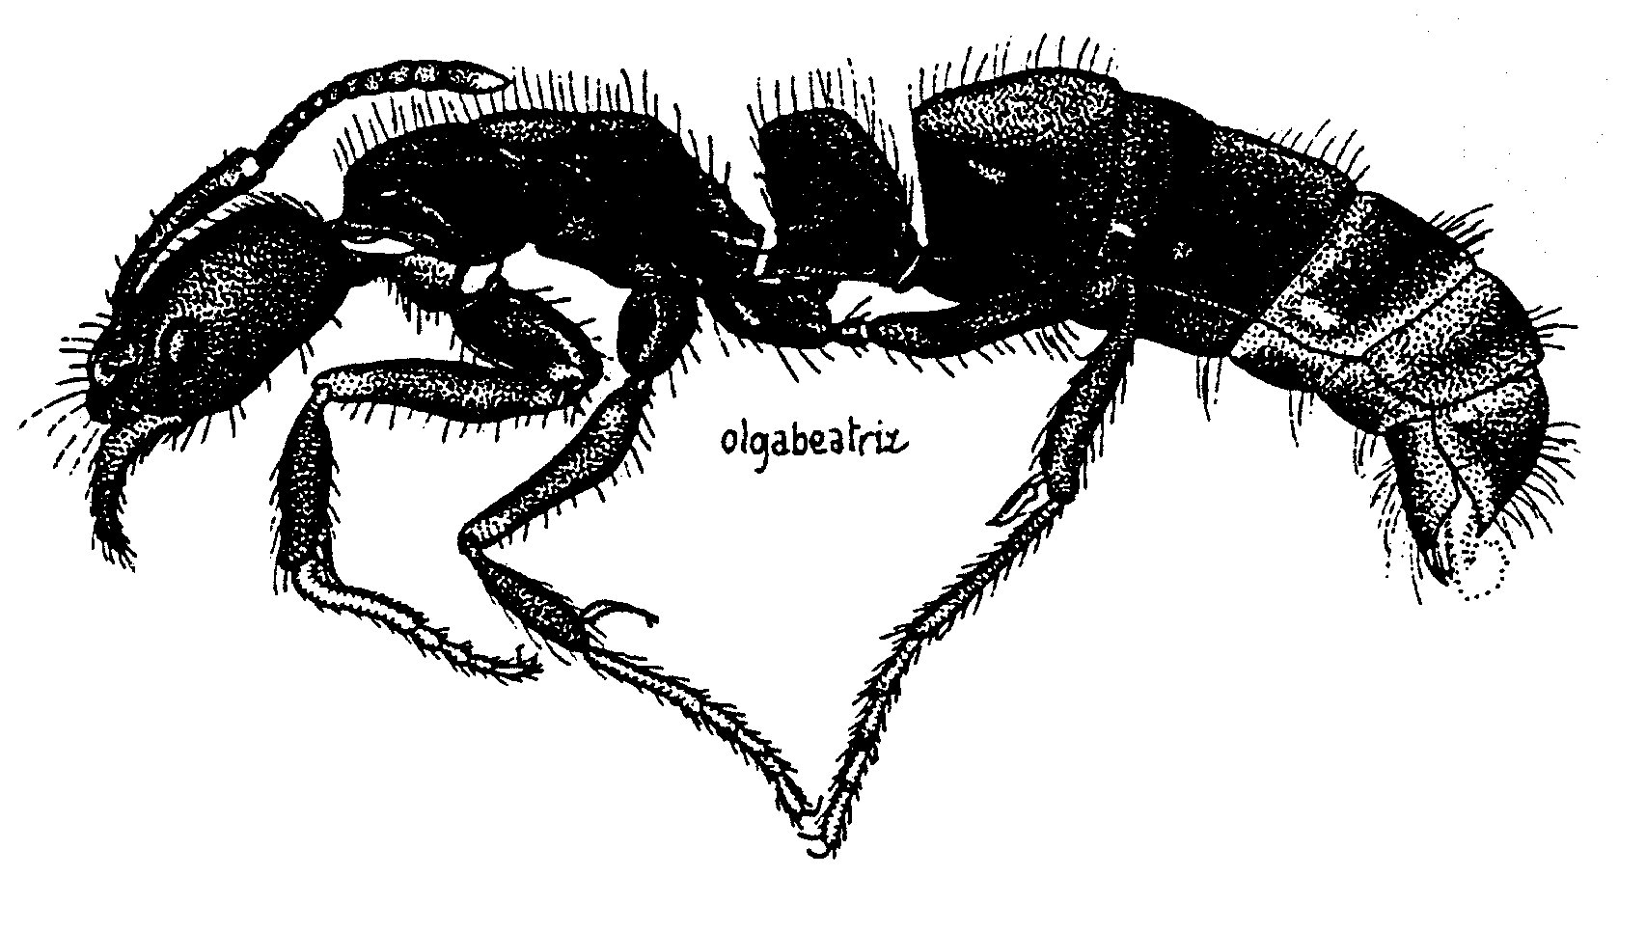
Fig. 1. Side view of a worker of the genus Pachycondyla (from Serna, 1999).
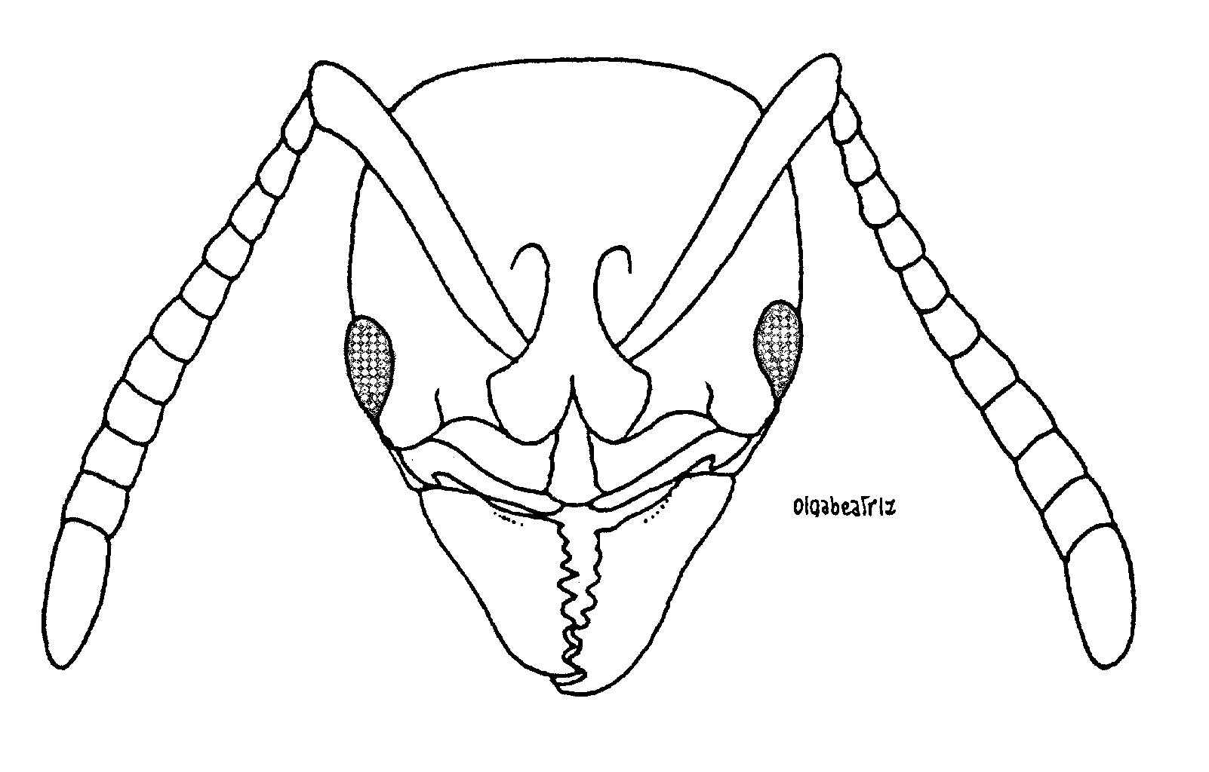
Fig. 2. Head of a worker of Pachycondyla sp. (from Serna, 1999).
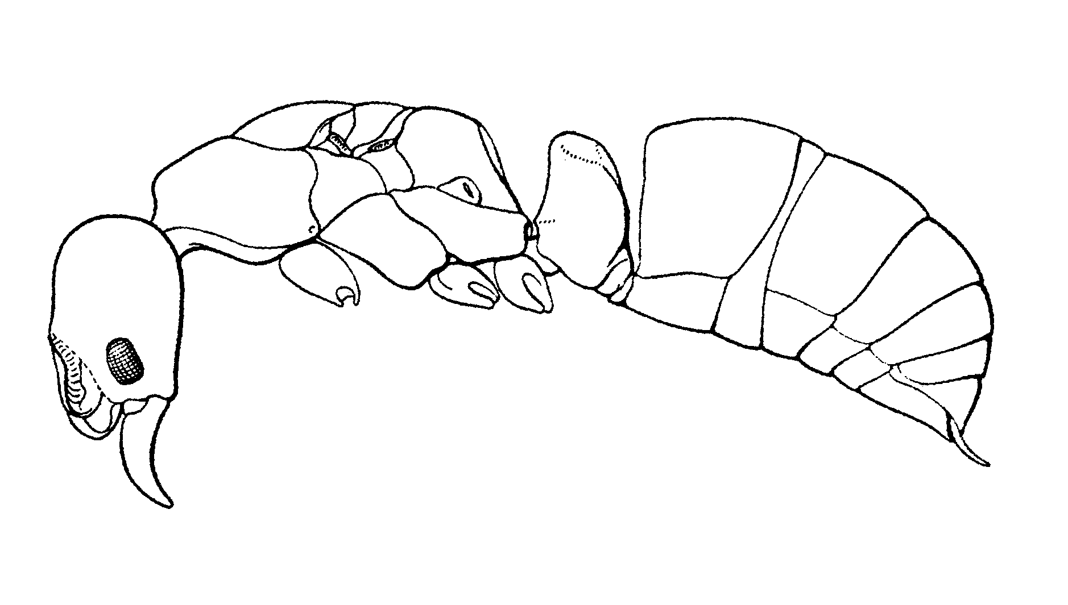Fig. 3. Side view of a female of Pachycondyla harpax (from Creighton, 1950).

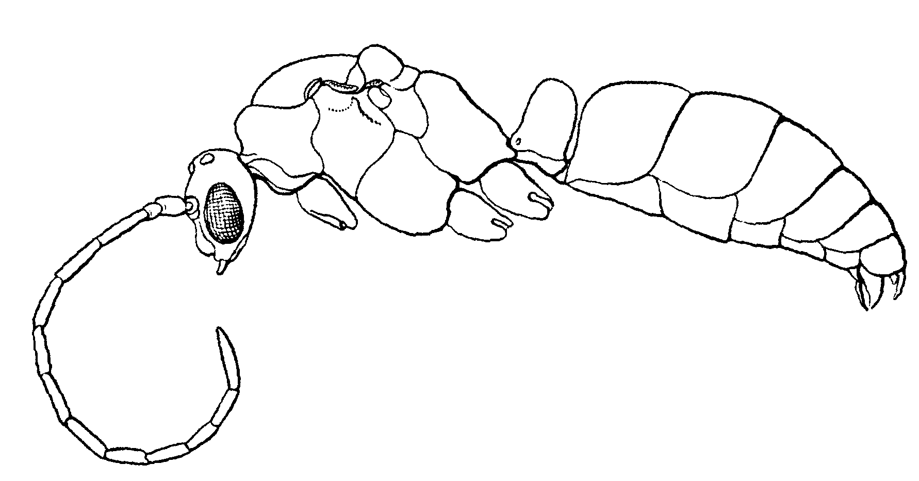
Fig. 4. Side view of a male of Pachycondlya harpax (from Creighton, 1950).
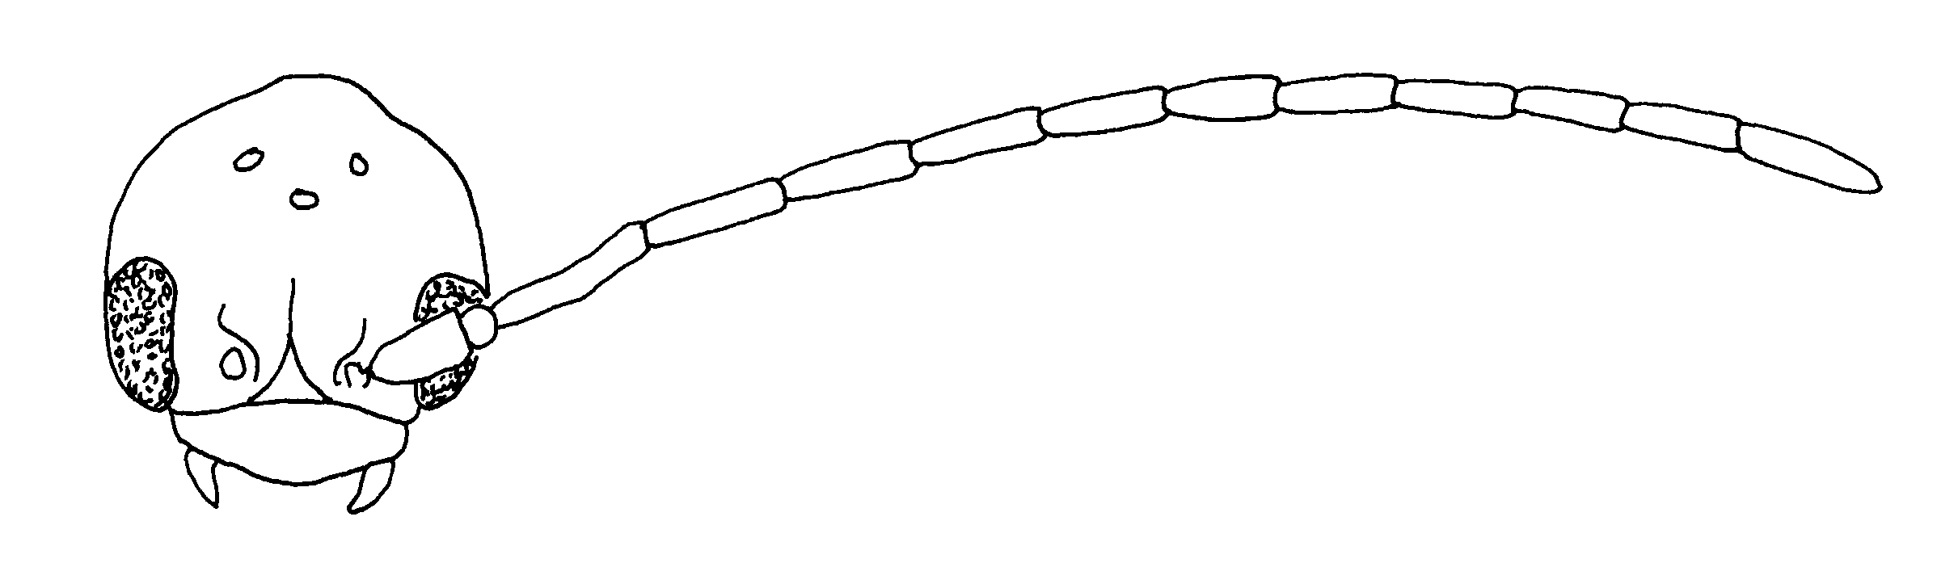
Fig. 5. Head of a male of P. marginata (from ).

The manuscript names in this file are part of a conditional proposal (sensu Article 15 of the 1985 ICZN), and thus not made available here. Their appearance here or in any duplication of this file does not constitute publication (sensu Article 8 of the 1985 ICZN). Please do not use any of the names of the new species, as that would invalidate them.

The following species are not included in the key:
Pachycondyla agilis (Forel)
Pachycondyla azteca Forel
Pachycondyla bakeri Mann= striatinodis
Pachycondyla cauta (Mann)
Pachycondyla cognata (Emery)
Pachycondyla foetida (Linnaeus) in MCZC
Pachycondyla gilberti (Kempf)
Pachycondyla goyana (Borgmeier)
Pachycondyla insignis (Brown)
Pachycondyla leveillei (Emery)
Pachycondyla lunaris (Emery)
Pachycondyla lydiae (Santschi)
Pachycondyla obsoleta (Menozzi)
Pachycondyla ralla (Brown)
Pachycondyla succedanea (Roger)

Key to the species complexes, based on workers:

1. Propodeal spiracle circular or oval-elongate …………… 2
- Propodeal spiracle slit-shaped ………………………………… c
2(1). Mandible with fewer than 8 teeth ……………………. 3
- Mandible with more than 8 teeth ……………………… x
3(2). Middle tibia with coarse, conical setae (Fig. xx) . gilva species complex
- Middle tibia without conical setae, although long, fine setae are present ……………… stigma species complex
4(3). mmm

Species complexes

apicalis species complex

Workers of this species complex have large, elongated mandibles, with more than 10 teeth. The anterior border of the clypeus is broadly convex, and the medial area has several fine, longitudinal striae. The eyes are large, located approximately in the middle of the head, and the maximum diameter is about ⅓ the length of the head. The carina anterior to the eye is well-developed and sharp. The scape extends about ⅓ length past posterior lateral corner. The mesosoma is elongated, and depressed at the metanotal suture. The pronotal shoulder is swollen, but does not form a carina. The region between the faces the propodeum is broadly rounded, and the propodeal spiracle is slit-shaped. The petiole is broad when viewed in profile, with both the anterior and posterior faces being convex and rounded, and meeting at about the midpoint of the dorsal surface of petiole. The dorsum of the mesosoma normally is without erect hairs. The
Members of the apicalis species complex include P. apicalis, and P. obscuricornis. They are usually easily separated, as much of the funiculus of P. apicalis is yellow, whereas it is brown or reddish-brown in P. obscuricornis. Additionally, the posterior lateral edges of the petiole are rounded in P. apicalis, but nearly form carinae in P. obscuricornis.

arhuaca species complex = constricta

constricta species complex

The workers of this species complex are small (up to 11 mm total length). The anterior border of the clypeus is broadly convex, and may even be pointed. The region posterior to the medial point may be slightly depressed. There is no carina anterior to the eye, and the eye is relatively small (maximum length about ¼ of the head length). The pronotal shoulder may be swollen, but does not form a carina. The mesosoma has a well-developed metanotal suture on the dorsum, and may be strongly depressed below the remainder of the mesosoma. The petiole is relatively narrow as seen in profile, with the anterior face being nearly vertical and straight, the posterior face curves broadly and meets the anterior face near the anterior border. The posterior lateral margins of the petiole are moderately sharp. Erect hairs are abundant on most surfaces, including the head, the dorsum of the mesosoma, the dorsum of the petiole, and all surfaces of the gaster.
This species complex could be confused with ???
Members include P. arhuaca, P. becculata and P. constricta. Pachycondyla becculata easily recognized, as there is a sharp point at the medial border (Fig. xx). The mesosoma of P. constricta is strongly depressed at the metanotal suture (Fig. xx), but is only weakly depressed at that point in P. arhuaca (Fig. xx).

crassinoda species complex

The workers of this species complex lack a carina anterior to the eye (may be slightly developed near anterior border of head), usually have relatively large eyes (about 1/5 the length to side of the head), have a swollen region on the pronotal shoulder, which may be developed into a carina, usually have a poorly developed metanotal suture on the dorsum of the mesosoma, the propodeal spiracle is slit-shaped, the petiole is thick when viewed in profile, and the anterior face of the petiole meets the dorsal face at a right angle.
This species complex is closely related to the villosa species complex, but can be distinguished by the lack of the carina anterior to the eye (which is present in the villosa species complex).
Members include P. aenescens, P. carbonaria, P. crassinoda, P. emiliae, P. harpax, P. impressa, and P. procidua and P. striata.

crenata species complex

Workers of this species complex are relatively small ants (total length < 10 mm). The anterior margin of the clypeus is convex, and usually forms a medial angle or even a spine. The carinae in front anterior to the eye is developed, and is very sharp and well marked in some of the species. The scapes extend about ⅓ length past posterior lateral corner and are covered with numerous, erect or nearly erect hairs. The eye is large, covering about ⅓ of the length to side of the head. The pronotal shoulder is strongly developed into a sharp carina, which overhangs the side of the pronotum. The metanotal suture is poorly marked, and barely breaks the cuticle on the dorsum of the mesosoma. The propodeal spiracle is slit-shaped and elongated. The petiole is thick when viewed in profile, usually somewhat cuboidal-shaped, although the posterior face may curve anteriorly, and meet the vertical anterior face near the anterior border of the top of the petiole.
Erect hairs are on most surfaces, including the mandibles, dorsum and ventral surfaces of the head, scapes, posterior margin, dorsum of the mesosoma, dorsum of the petiole, and all surfaces of the gaster, the hairs on the tibiae are mostly suberect and bristly.
These ants are dark, brown, nearly black, the appendages are often lighter brown or may even be yellowish.
The females have the same characteristics as the workers, with the convex anterior margin of the clypeus, the well-developed carina anterior to the eye, the large eyes, the well-developed carina on the pronotal shoulder, and the thick petiole. Erect hairs are on all surfaces mentioned.
The male???
Members include P. carinulata, P. crenata, P. goeldii, P. striatinodis and P. unidentata.

fauvelii species complex

This species complex is closely related to the apicalis species complex, differing in lacking a carina anterior to the eye.
Members include P. fauvelii and P. eleonorae.

ferruginea species complex

Workers of this species complex are relatively small (total length up to 7 mm), with small eyes (maximum diameter of the 0.25 mm). There is no carina anterior to the eye. The pronotal shoulder is slightly swollen, but does not form a carina. The mesosoma is not depressed at the metanotal suture, which is barely indicated on the dorsum. The propodeal spiracle is circular-shaped. The posterior border face of the petiole is broadly rounded, and meets the anterior vertical anterior face near the anterior point of the apex of the petiole.
Erect hairs are relatively sparse and short (most hairs < 0.25 mm), but present on the dorsum of the head, the scape, the ventral surface of the head, the dorsum of the mesosoma, the dorsum of the petiole, and all surfaces of the gaster, the hairs on the tibiae are very short (0.1 mm) and nearly erect
Normally, these are ferruginous red ants, with slightly lighter appendages, but may be black with lighter brown appendages.
Members include P. ferruginea, P. pergandei and P. near ferruginea.

gilva species complex

This is a well defined complex that was previously composed of the genera Wadeura and Cryptopone. The workers of the two genera are nearly identical (differ significantly only in the form of the mandibles), and there was little justification for the recognition of the genus Wadeura. Brown (19 x x) considered Wadeura to be a synonym of Pachycondyla, and as it is nearly identical to Cryptopone, this latter genus will also be considered to be a synonym, although there is probably justification for considering Cryptopone (= Wadeura) to be a valid genus. Two worker characteristics define this complex: the extensor surface of the middle tibia is covered with a series of conical setae, that are usually much coarser than the surrounding hairs (rarely poorly developed), and the posterior part of the mesopleuron and anterior half of the propodeum is depressed laterally, for the reception of the middle femur. It appears that the femur is braced in this depression, when the conical setae are used for excavation of soil.
This complex could be confused with the stigma species complex. Members can be easily separated by the conical setae on the middle tibia, which are lacking in P. stigma. The many similarities suggest that the complexes are closely related, and that P. stigma is somewhat intermediate between this species complex in the remainder of this species in Pachycondyla. One apparently major structural difference between the two complexes, is that the depressed area on the side of mesosoma of the gilva species complex appears designed for the reception of the middle femur, whereas it appears to be designed for the reception of the posterior femur in the stigma species complex.
Members include ???

laevigata species complex

These ants were previously considered to be members of the genus Termitopone. Workers range from moderate sized (total length 10 mm) to large (total length 17 mm). They can be distinguished from most of the other species in Pachycondyla, as being shiny black, with some striae on the dorsum of the head, and on the side of the propodeum. The carina is generally lacking anterior to the eye, but a swollen region may be present which forms a poorly developed carina. The anterior border of the clypeus is convex and may be slightly angulate medially, the eyes are moderately large, covering about ¼ - ⅓ of the length of the side of the head.
The pronotal shoulder is swollen, but does not form a carina, the metanotal suture breaks the sculpture and is slightly depressed on the dorsum of the mesosoma. The petiole is thick when viewed in profile, with the anterior and posterior faces are nearly parallel.
Erect hairs are moderately abundant on most surfaces, including the dorsum of the head, scapes, the ventral surface of the head, the dorsum of the mesosoma, dorsum of the petiole, and all surfaces of the gaster. The tibiae are covered with suberect hairs.
Most surfaces, except parts of the dorsum of the head and the side propodeum, are smooth and glossy.
These ants are generally black, with lighter brown appendages.
Members include P. commutata, P. laevigata and P. marginata. Pachycondyla commutata can be separated from the other two in being much larger, with the total length of the worker being greater than 15 mm. The other two species (total length of the worker < 12 mm) can be easily separated, as P. marginata has a carina, which extends nearly the entire length of the dorsal face of the mandible, which is not present in P. laevigata.
These shiny, glossy ants are not likely to be confused with any of the other New World Pachycondyla species, except P. carbonaria (crassinodis species complex), in which the surface is moderately shining. This latter species can be separated from members of the laevigata species complex, as the anterior medial border of the clypeus is notched and depressed. In addition, the dorsum of the head of P. carbonaria lacks longitudinal striae.

stigma species complex

Workers and females of this species complex are easily recognized by the 6 or 7 mandibular teeth. The eyes are tiny (maximum diameter < 1/10 the length of the head) the pronotal shoulder lacks a carina, the mesosoma is slightly depressed at the metanotal suture, the side of the propodeum is depressed, apparently as an area to brace the femur of the posterior legs, the propodeal spiracle is nearly circular, the region between the faces of the propodeum is angulate, and nearly forms a vertical carina with the posterior face, the petiole is relatively narrow as seen in profile, and narrowed toward the apex, and the anterior face of the postpetiole is rounded with the dorsal face.
This species complex could be confused with the gilva species complex, based on the reduced number of mandibular teeth, the relatively small eyes, the rounded pronotal shoulder, the depressed area on the side of the propodeum, and the shape of the petiole, which is narrowed toward the apex. It can be easily separated, as it lacks the conical coarse setae on the middle leg (relatively long, coarse setae, up to 0.15 mm in length are present). The similarities of the two species complexes suggest a close relationship, and that P. stigma appears to be somewhat intermediate between the gilva species complex and the remainder of the genus.
Members include P. stigma.

` species complex

The workers of this species complex have a well-developed carina anterior to the eye, have relatively large eyes (maximum diameter is at least ¼ the length of the side of the head), a well-developed, sharp carina on the pronotal shoulder, the metanotal suture is well marked on the dorsum of the mesosoma, and depressed below the adjacent level of the mesosoma, have a slit-shaped propodeal spiracle, a relatively thick petiole as seen in profile, and the anterior face of the propodeum is vertical, and forms a nearly right angle with the dorsal face.
This species complex is closely related to the crassinoda species complex, but differs in having a carina anterior to the eye, and having very sharp carina on the pronotum shoulder.
Members include P. holcotyla and P. villosa and
Key to New World Pachycondyla, based on workers

1. Extensor surface of mid tibiae with stiff, conical setae over at least ½ of their length (Fig. xx), worker yellowish or orange in color; eyes absent or very tiny and indistinct in worker (formerly Wadeura and Cryptopone) .......…………..... 2

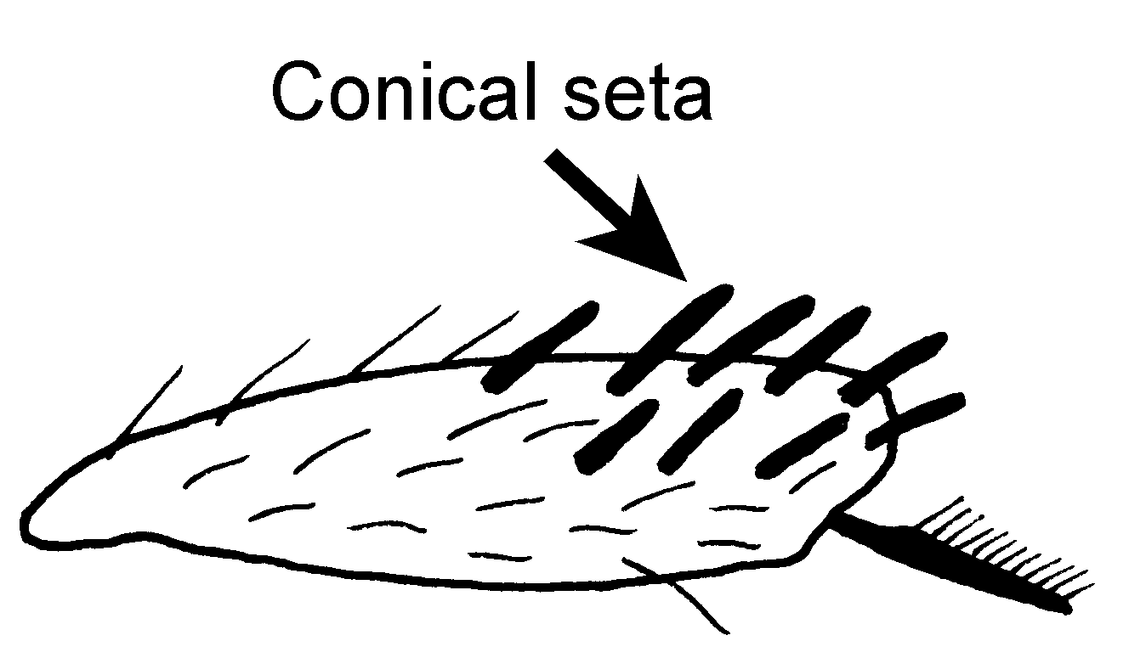

Fig. 6. Mid tibia of P. guianensis, showing the conical setae (Costa Rica).

- Extensor surfaces of mid tibiae without stiff conical setae, except possibly for few at apex (Fig. xx), though long, fine erect setae may occur; mature workers reddish to black in color, with eyes large or small, but always distinct and multifaceted .………..... 3
2(1). Mandibles sublinear, oblique masticatory border nearly continuous with basal border (Fig. ), tooth at mid length of mandible noticeably longer than others (Fig. xx); petiolar node as seen from side subtriangular, tapered markedly to narrowly rounded apex; Central America to southern Brasil …... ……………………………….……….. 2a

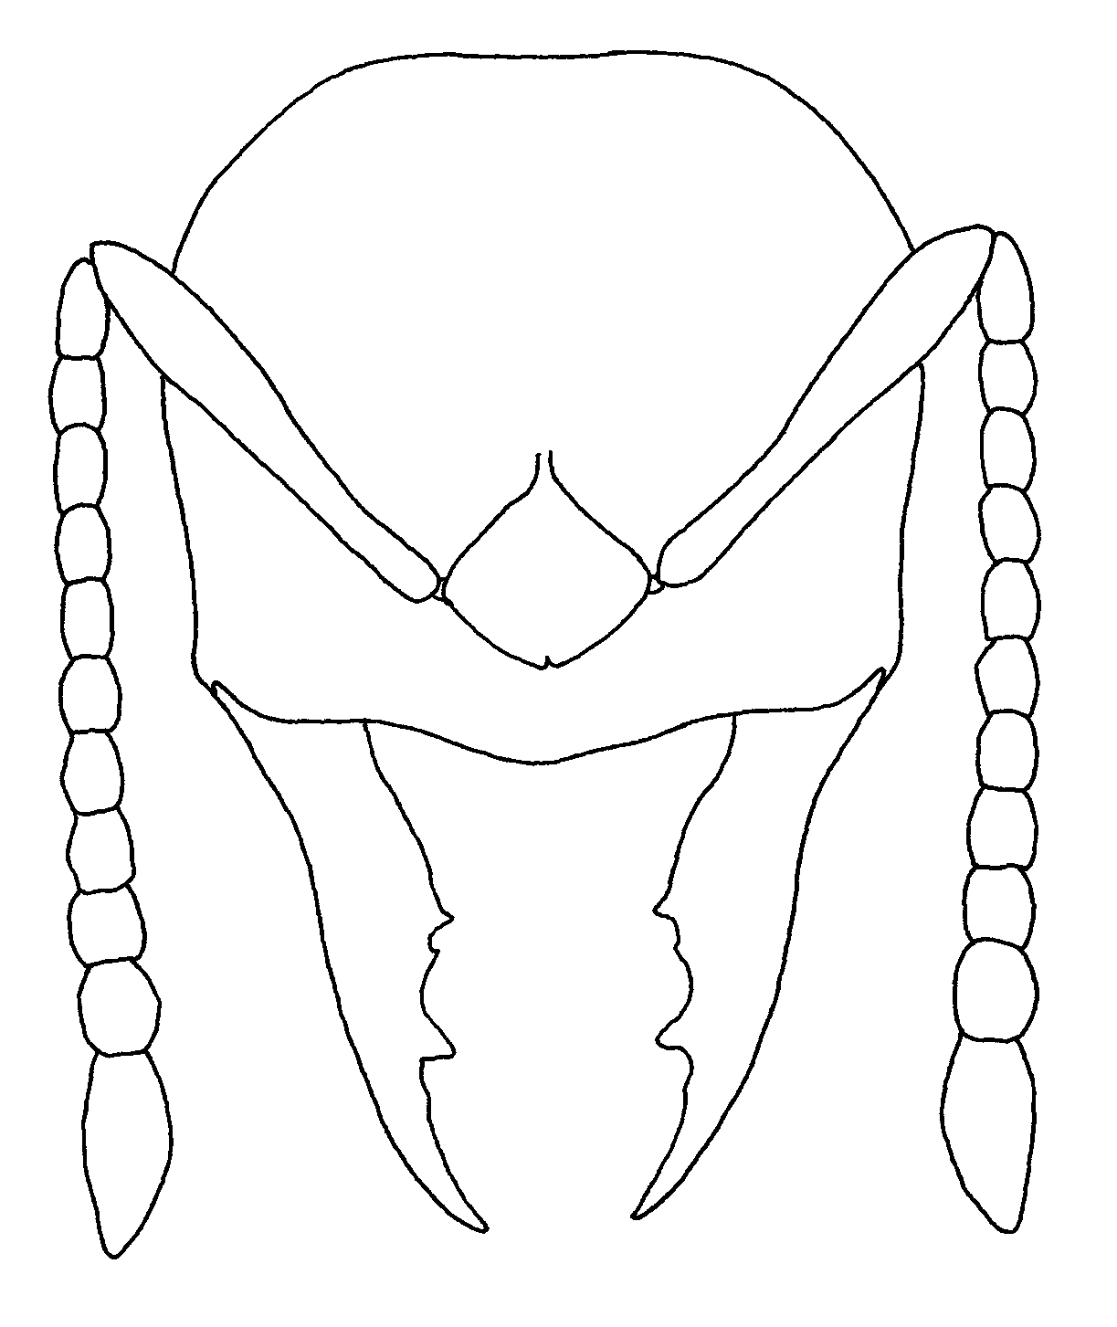
Fig. 7. Head of a worker of P. guianensis (from Weber, 1939).
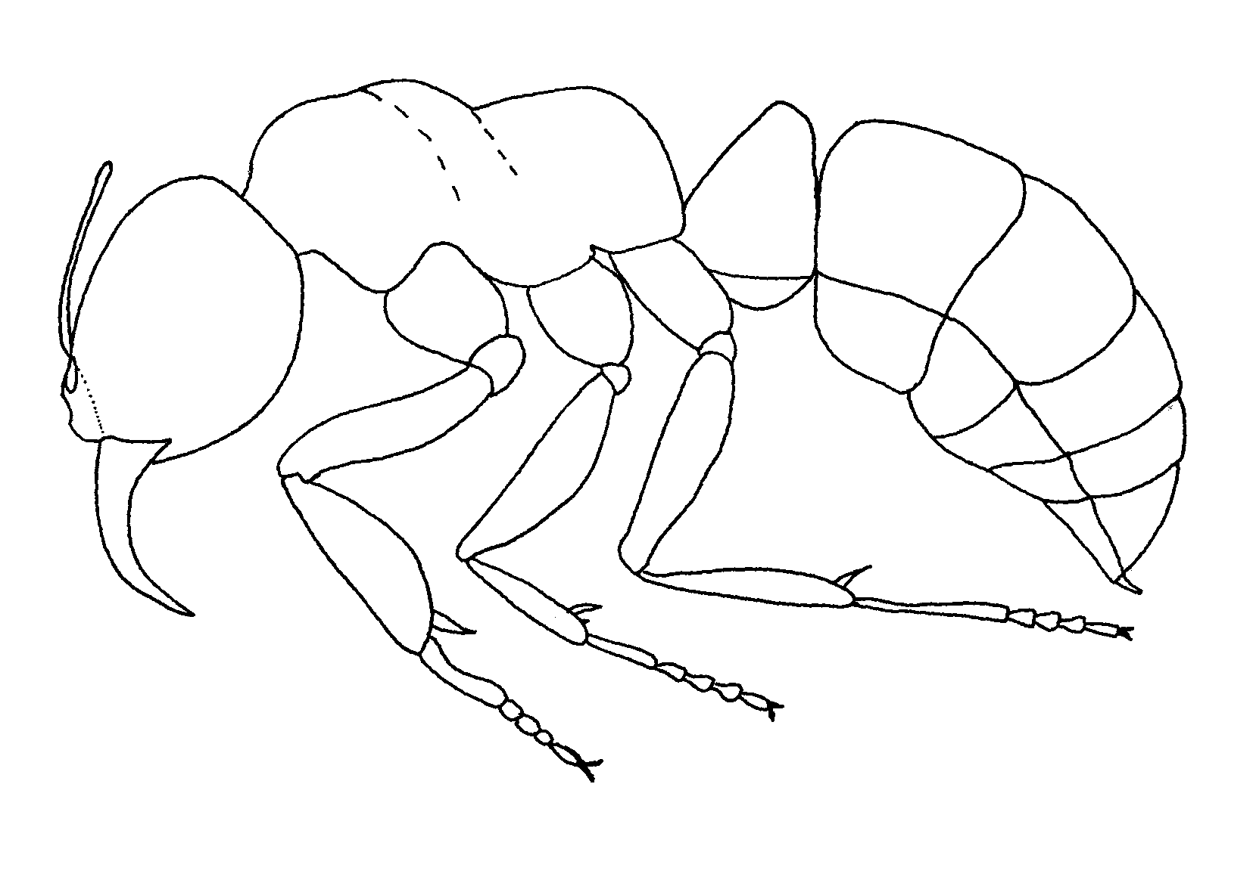
Fig. 8.Side view of a worker of P. guianensis (from Weber, 1939).

- Mandibles triangular, basal and masticatory borders meeting at distinct angle, all mandibular teeth approximately equal in length; node as seen from side subcuboidal, feebly tapered dorsad ……………….…. 2b
2a(). Second funicular segment as long not longer than third; Central America to southern Brasil ………………….... guianensis (Weber)
- Second segment of funiculus longer than third; Panamá …………….. …………………….. haskinsi (Weber)
2b(). Dorsal face of petiole broadly convex, nearly equal in length to posterior face; Amazonia ……………….. …………………. holmgreni (Wheeler)
- Dorsal face narrowly convex, much shorter than posterior face (Fig. xx); North America (including Central America) …………………………………... 2c
2c(). Gastral tergum with many erect hairs (Fig. xx); United States ……….….. …………………………… gilva (Roger)
- Gastral tergum with few or no erect hairs (Fig. xx); tropical México south to Nicaragua …………………... …………………... guatemalensis (Forel)
3(1). Dorsal surface of trunk and petiolar node without standing pilosity ... ……………………………………….. 4
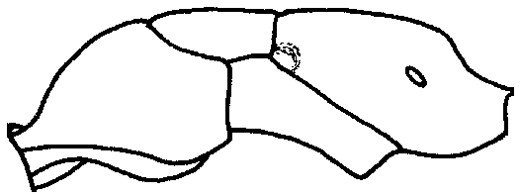
Fig. 9. Mesosoma of a worker of P. obscuricornis (Tingo Maria, Perú), showing the lack of erect hairs on the dorsum.

- Dorsal surface of trunk, and usually also of petiolar node with standing pilosity ………………….….. 7
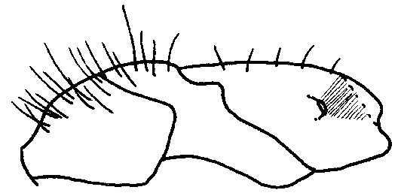
Fig. 10. Mesosoma of a worker of P. xx???, showing the erect hairs on the dorsum.
4(3). Pronotal disc strongly and regularly striate; stout species with node (Fig. xx); dorsal surface of head behind compound eyes with large oval patch of appressed golden pubescence on each side of vertex, in clean specimens resembling pair of huge eyes; Goias State, Brasil ....... magnifica Borgmeier
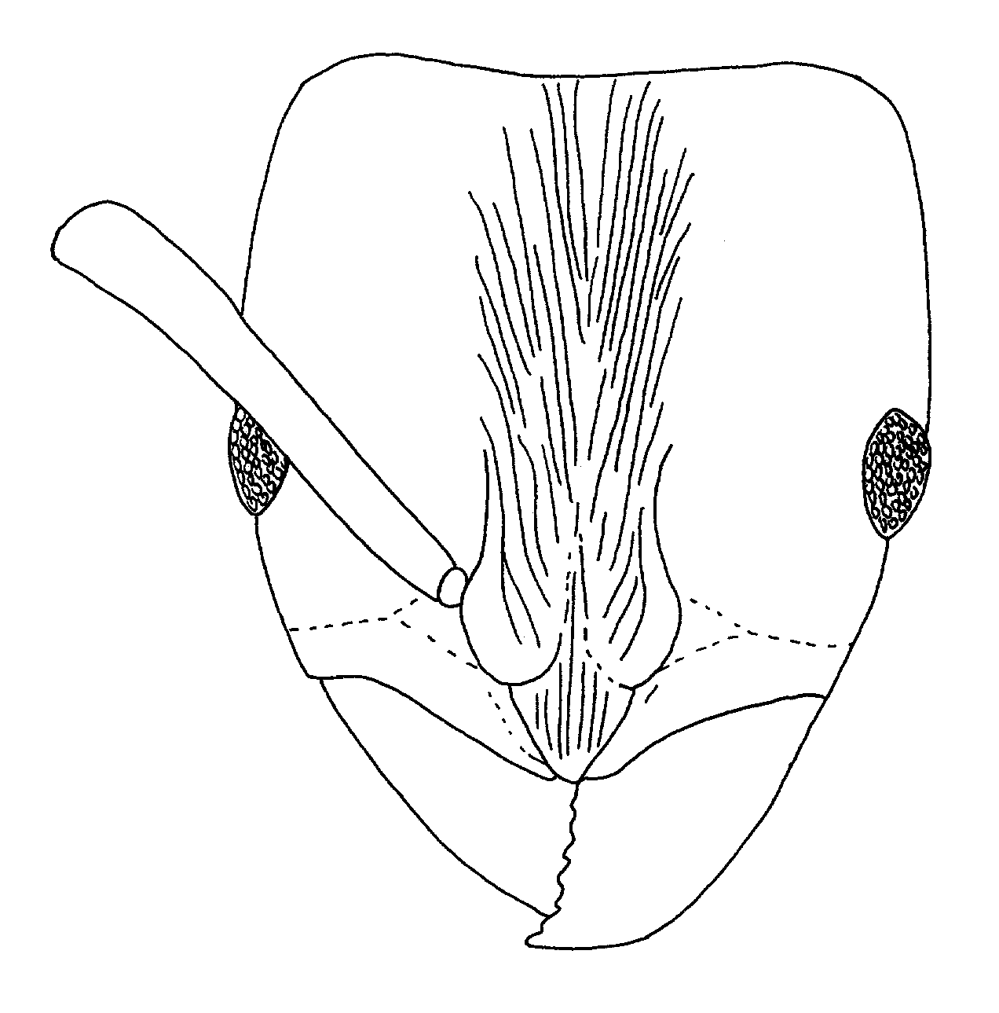
Fig. 11. Head of a worker of P. magnifica (from Kempf, 1961).

- Pronotum not striate; slender forms with nodes (Figs. xx) or no "false eye" pubescence patches on head ........ 5

5(4). Eyes very large and convex, longer than apical antennomere; apex of node curving gradually into posterior face .....................…………………...... 6
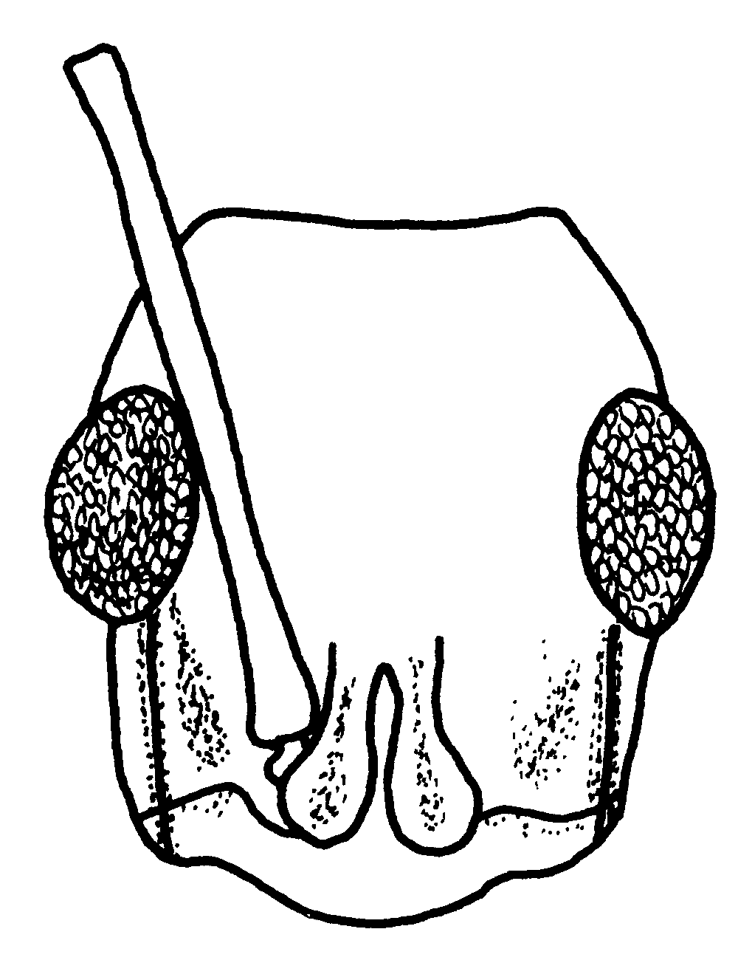
Fig. 12. head of a worker of P. apicalis (Serapaqui River, Costa Rica).

- Eyes shorter than first antennomere; apex of node meeting its vertical posterior face at abrupt angle (Fig. xx); southeastern Brasil, northern Venezuela ........….... bucki (Borgmeier)
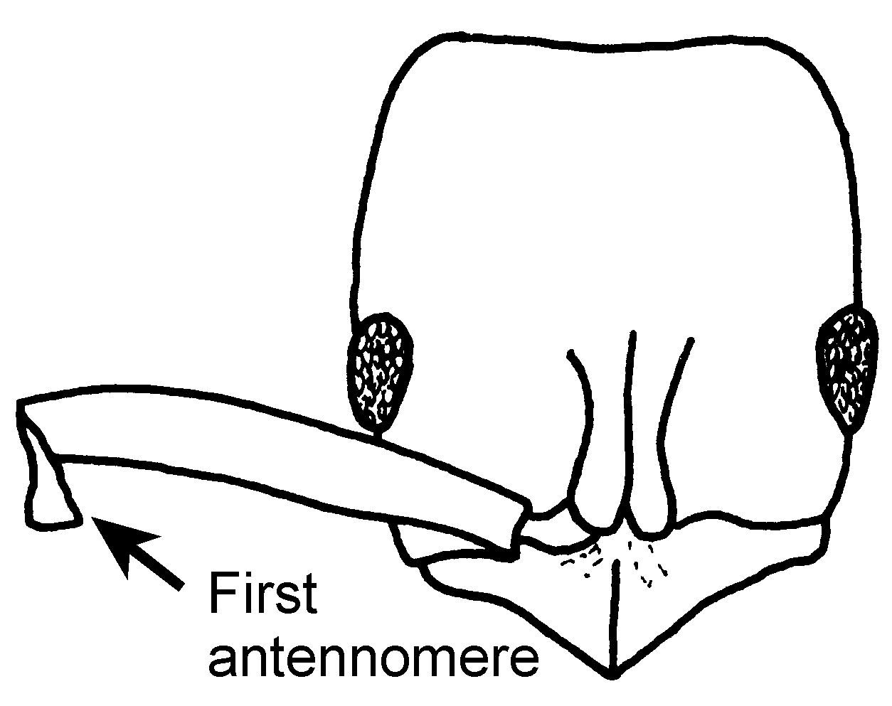
Fig. 13.Head of a cotype worker of P. bucki (São Paulo).
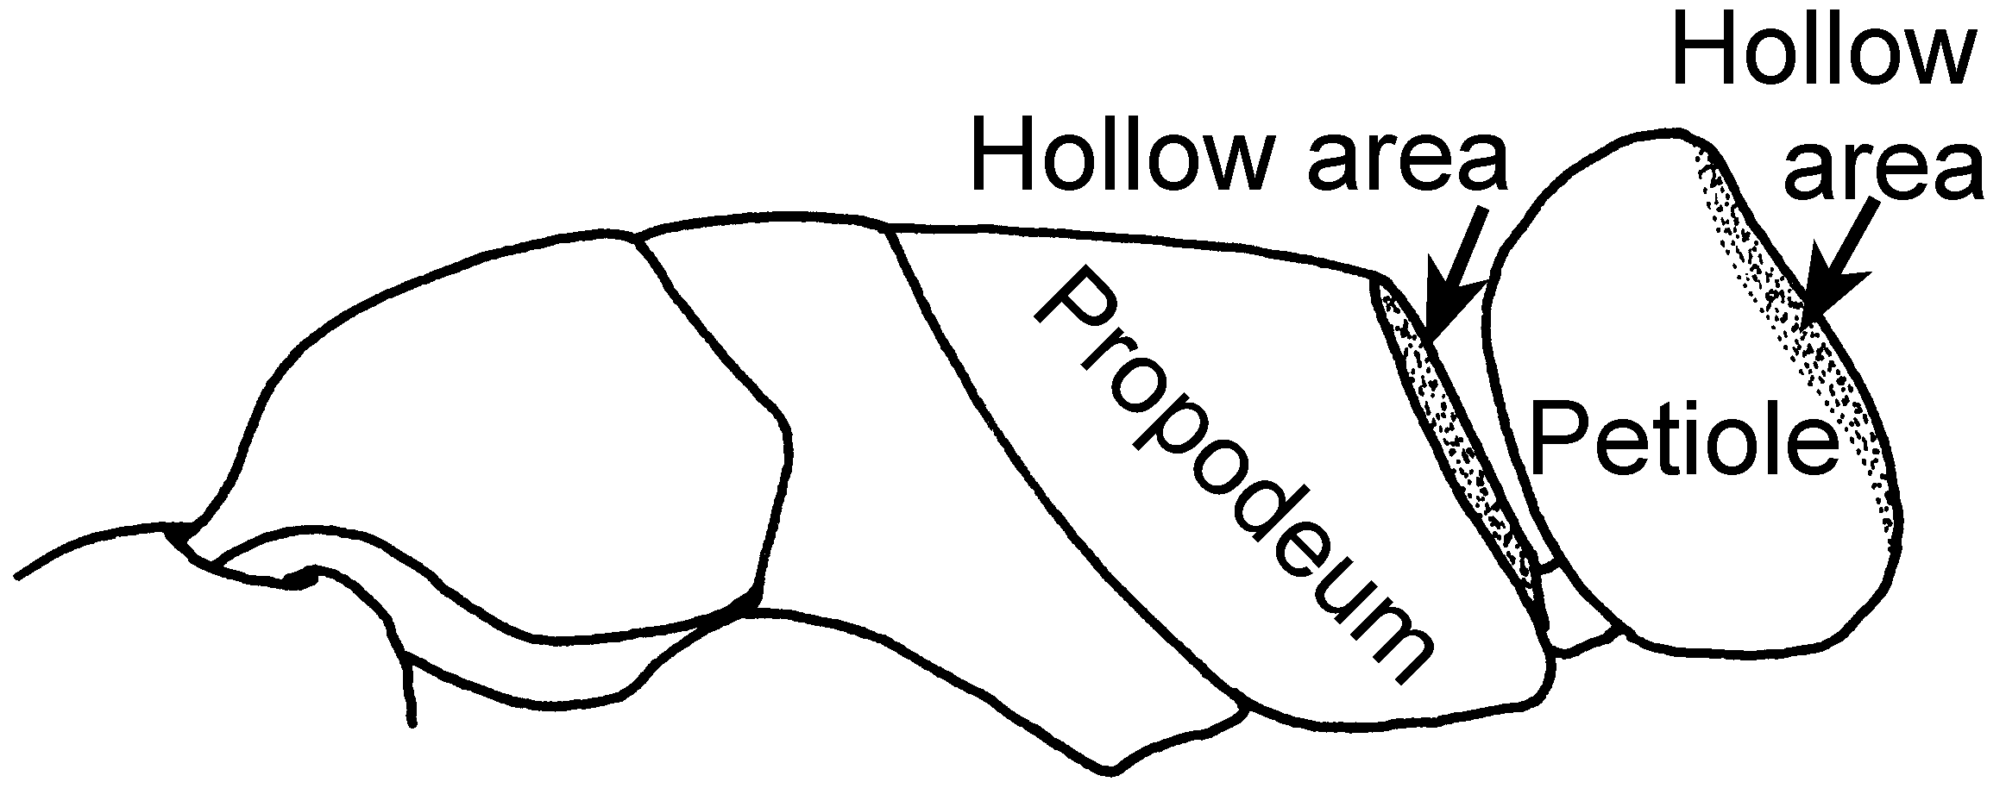
Fig. 14. Mesosoma and petiole of a cotype worker of P. bucki (São Paulo).

6(5). Apical 5 - 6 antennomeres conspicuously yellow; head width including eyes 2.2 - 2.9 mm; posterior lateral margins of node blunt, not raised in relief; S México to N Argentina forest; see couplet 42) ............... apicalis (Latreille)
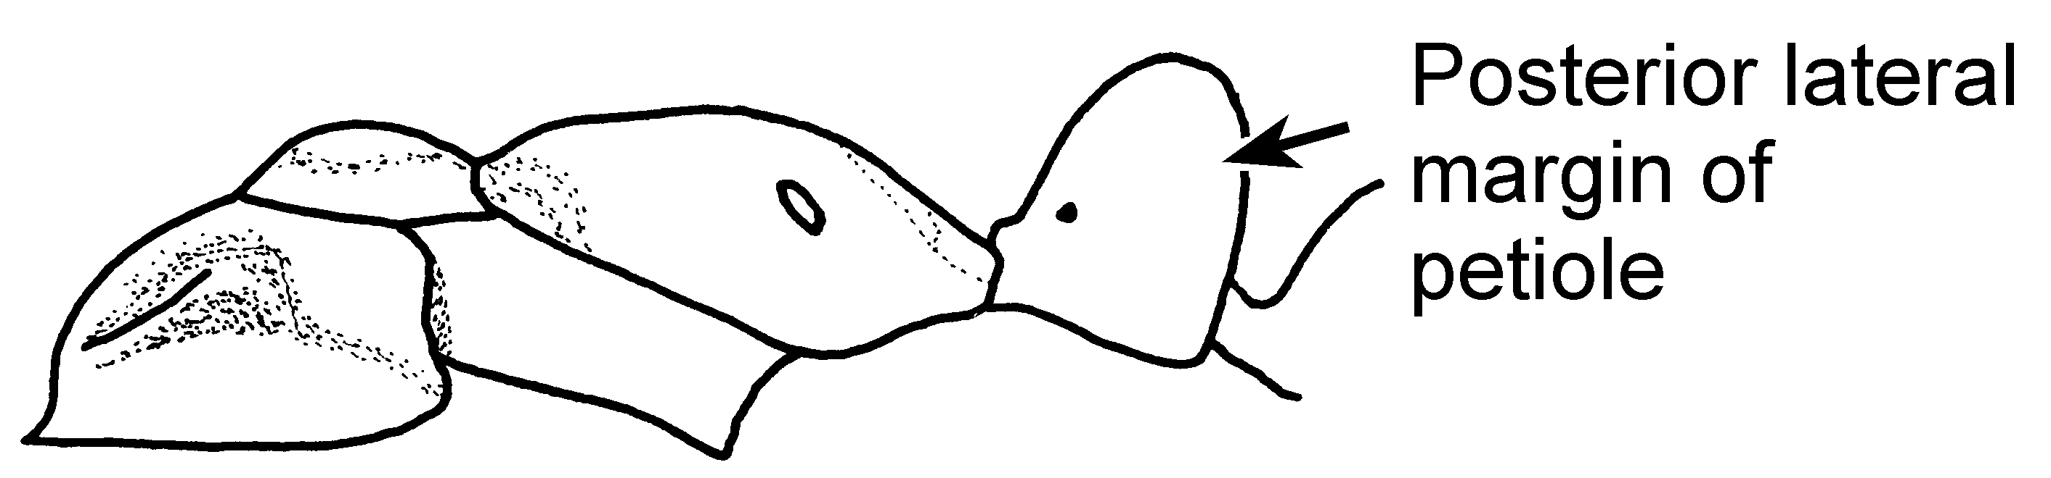Fig. 15. Mesosoma and petiole of a worker of P. apicalis as seen from the side (Serapaqui River, Costa Rica).

- Apical 5 - 6 antennomeres brown, though terminal may shade into yellowish towards its extremity; head width, including eyes, 1.6 - 2.3 mm; posterior lateral margins of petiolar node raised in relief; Mexico to northern Argentina; forest, cerrado, scrub .…... …………………. obscuricornis Emery
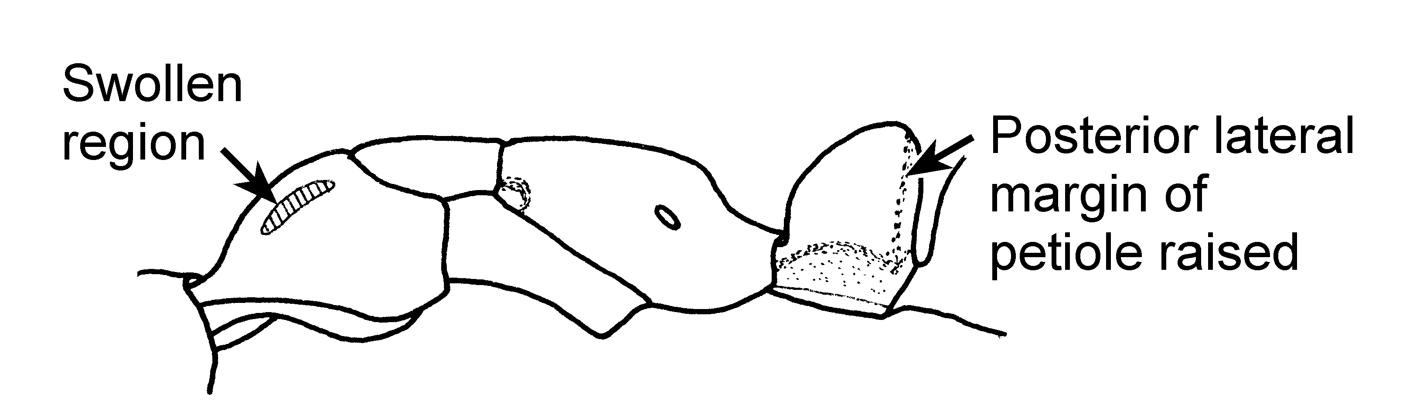Fig. 16. Petiole of a worker of P. obscuricornis as seen from the side (43 mi E Tingo Maria, Perú).
7(3). Gastral apex on each side of sting with stout, triangular upcurved tooth, not to be confused with when these are exerted (large black species with cuboidal node; widespread in Neotropical forests …………………….. ………………… crassinoda (Latreille)
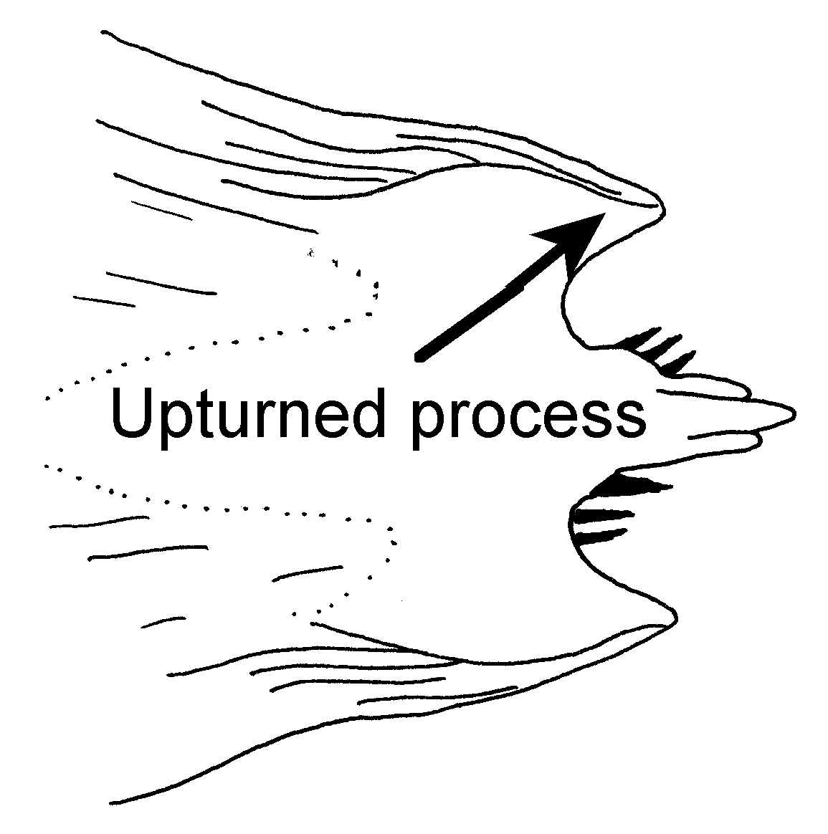
Fig. 17. Pygidium (gastral apex) of a worker of P. crassinoda showing the two upturned processes (modified from Kempf, 1961).

- Gastral apex not produced as pair of stout teeth, although in few species, some setae bordering gastral apex may be spinuliform ………………...... 8
8(7). Mandible usually with 6 teeth, rarely with partially developed seventh tooth; pronotal disc without distinct lateral margins and densely and finely punctulate; relatively small (> 5 mm total length); Florida to northern Argentina, common in rotten wood .................................. …………………….. stigma (Fabricius)

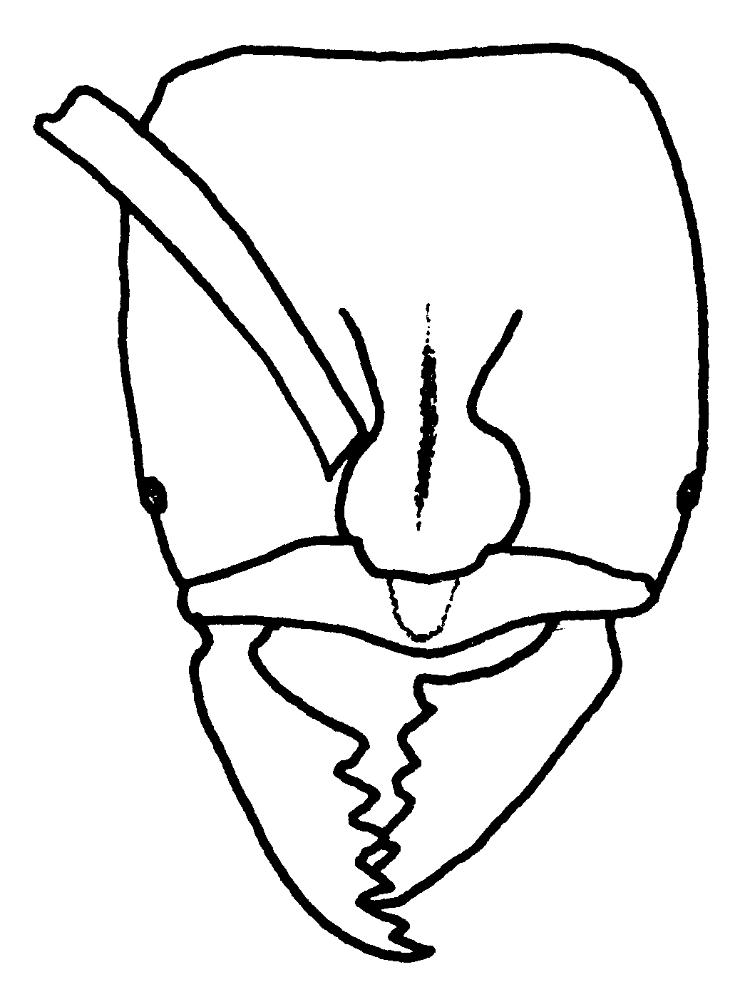
Fig. 18. Head of a worker of P. stigma (near Telas, Honduras).

- Mandibles usually with 8 or more teeth and/or denticles; in rare cases with as few as 5 - 7 teeth, either pronotal margins are distinct, pronotal disc is smooth and shining, or size is larger (< 9 mm total length) .………………..... 9
9(8). Opening of propodeal spiracle, viewed perpendicularly, small, round or elliptical (Figs. xx), usually little more elongate in queens than in workers of same species; small and medium-size species .................………………....... 10
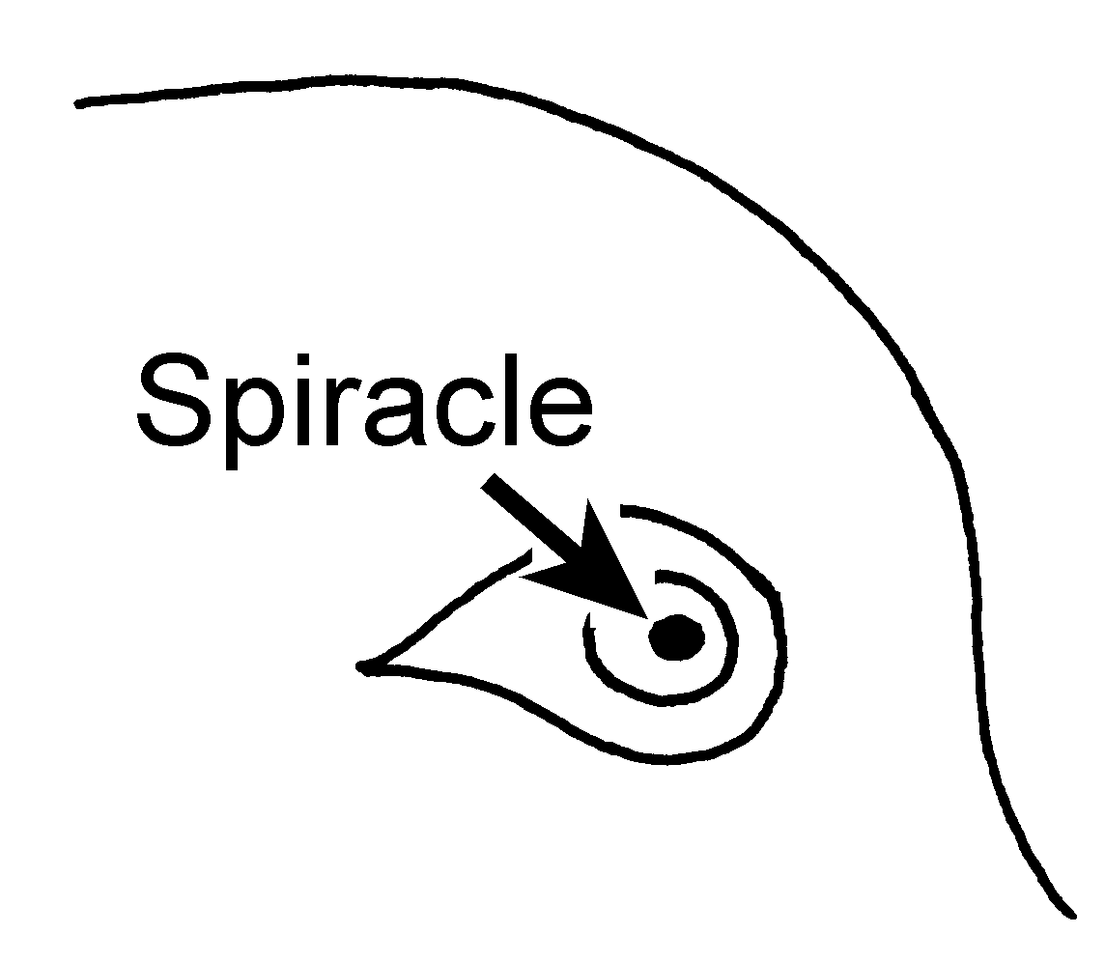 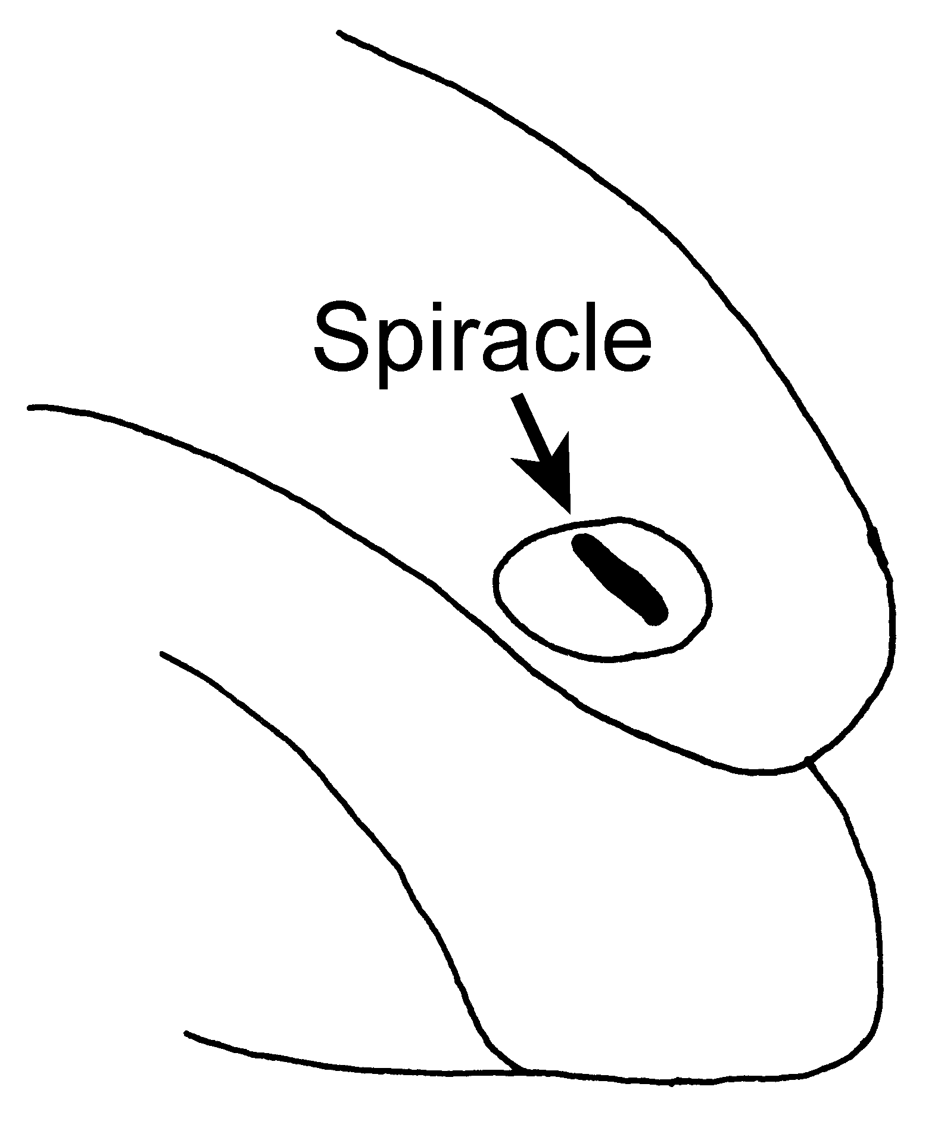
ferruginea harpax
Fig. 19. Round spiracle (P. ferruginea) and elongate spiracle (P. harpax).
- Opening of propodeal spiracle viewed perpendicularly slit-shaped, more than twice as long as wide (Figs. xx); mostly medium- and large-sized species ......…………………………..……...... 18
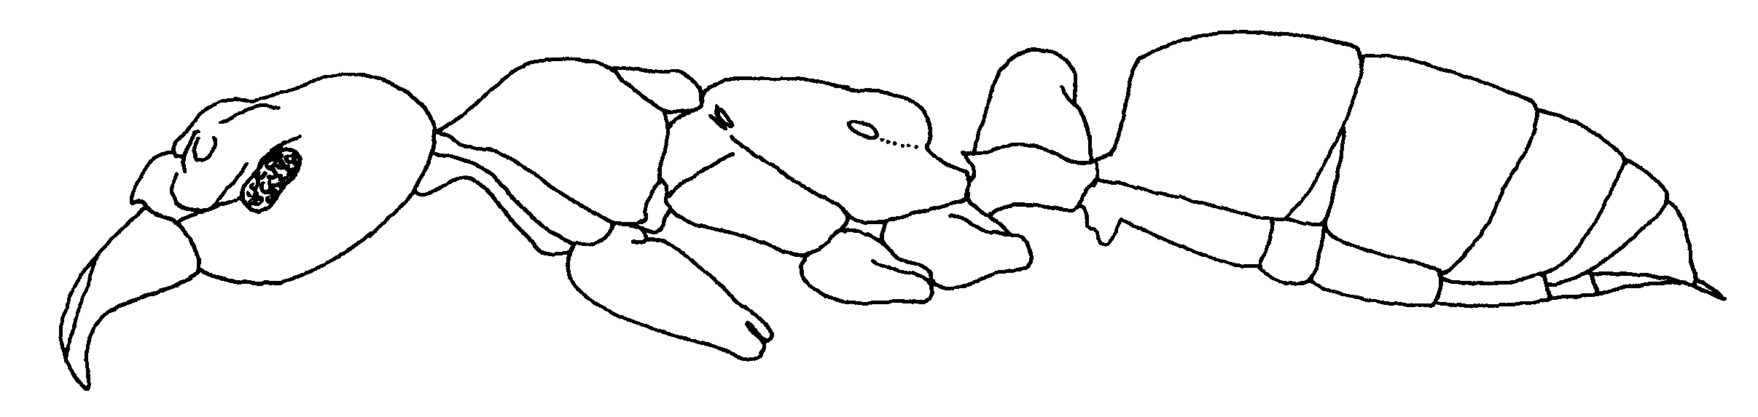
Fig. 20.Side view of a worker of P. commutata.

10(9). Pronotal disc with lateral margins or carinae (Fig. xx) ....……....... 11
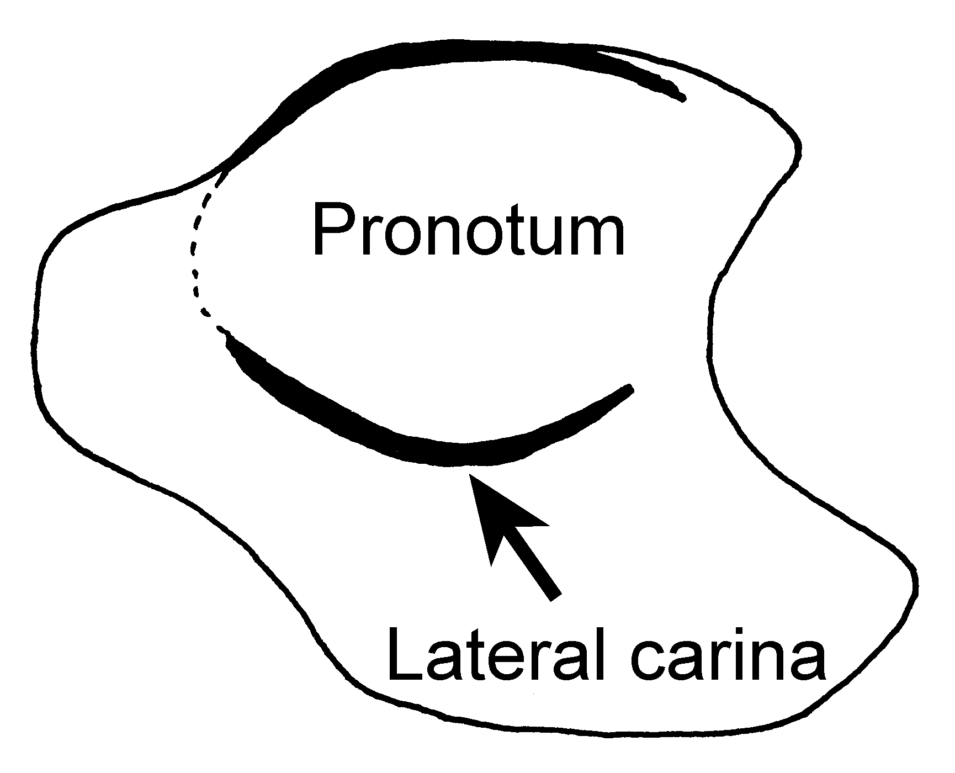
Fig. 21. Pronotum of a worker of P. arhuaca, as seen in an oblique side view (Huila, Colombia).
- Pronotal dorsum rounded into sides, without margins ................ 15 see couplet 14
11(10). Node as seen from side acutely tapered to narrowly rounded apex (Fig. xx) .....………...………………….…... 12
- Node of petiole as seen from side less strongly tapered, apex broadly rounded or obliquely truncate, forming dorsal more or less separate from posterior face (Figs.xx); Espirito Santo, Brasil ....................…..…........... venusta Forel
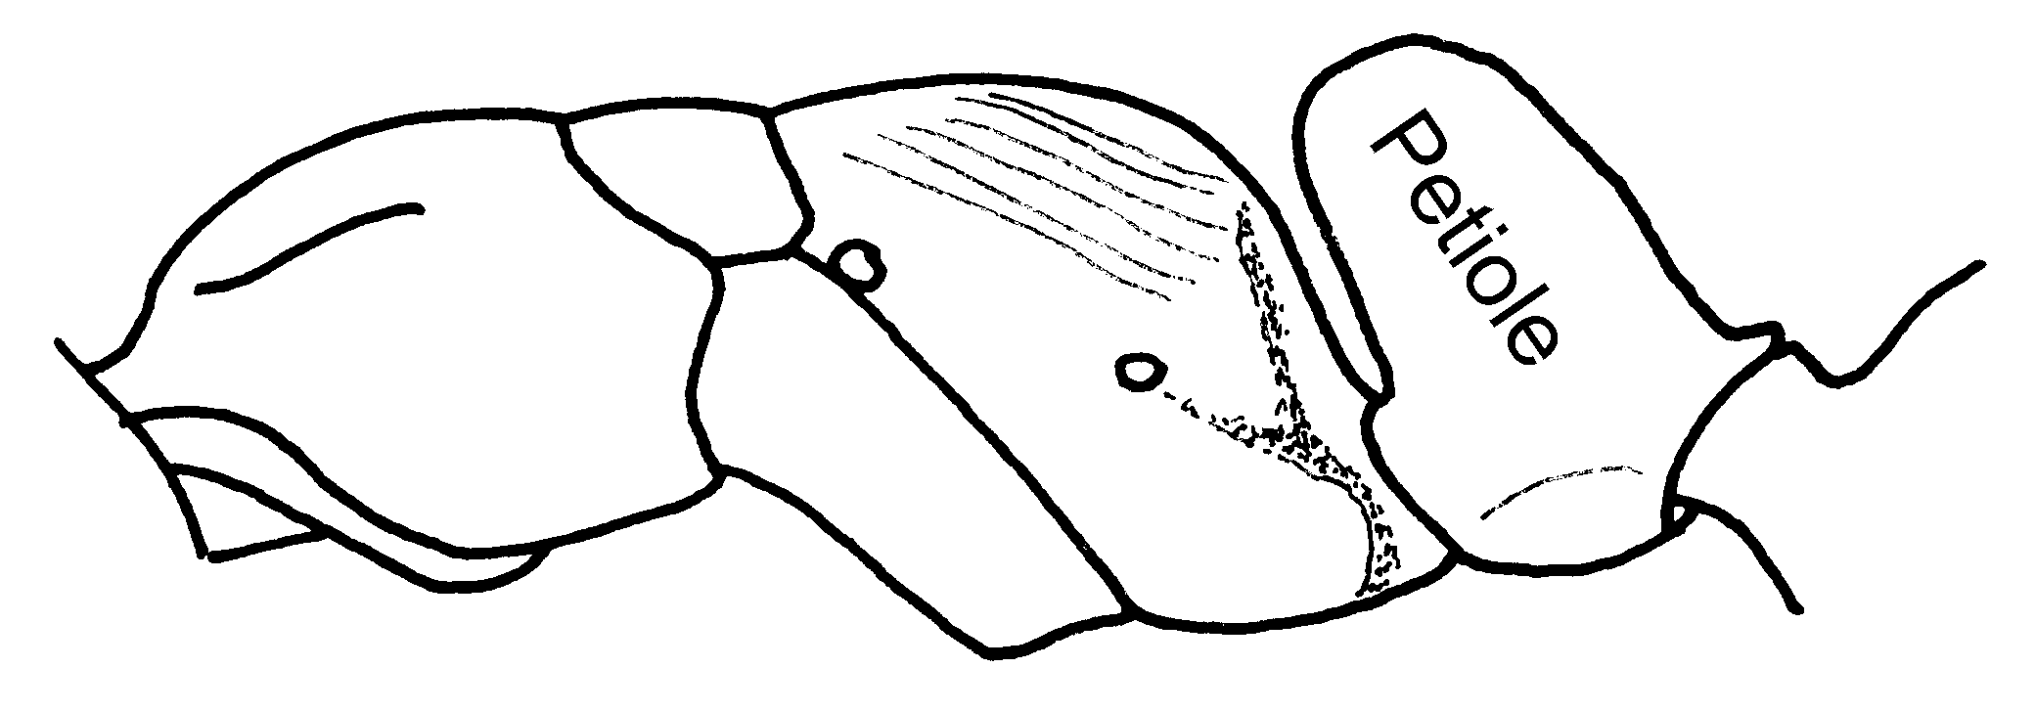Fig. 22. Mesosoma of a worker of P. venusta (Espírito Santo, Brasil).
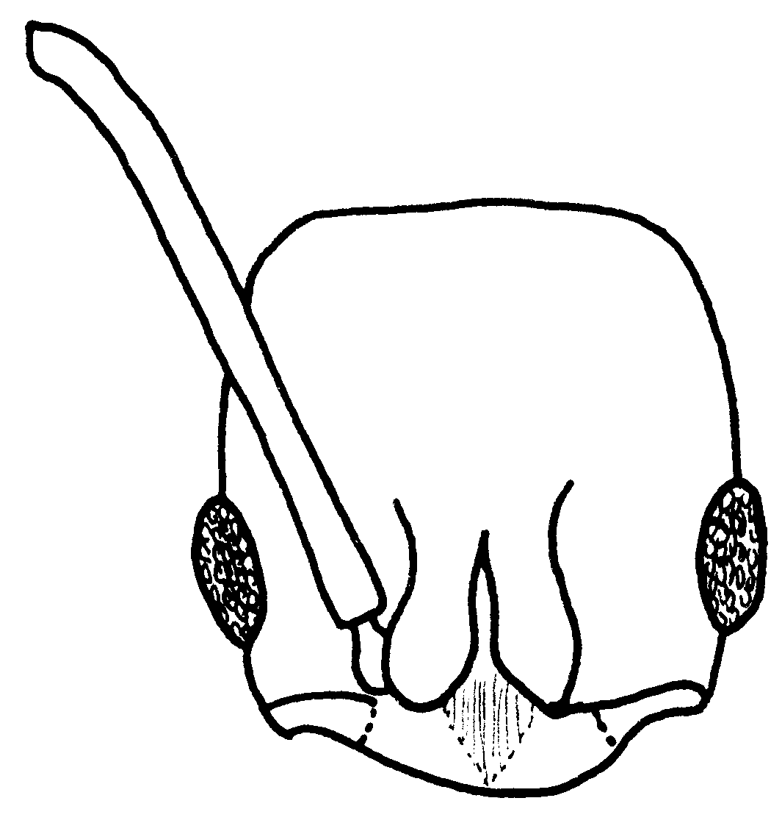
Fig. 23. Head of a worker of P. venusta (Espírito Santo, Brasil).

12(11). Smaller species, maximum width of queen head about 1.25 mm; stridulatory file wanting on middle of acrotergite of gastral segment II; eye of worker not longer than about 0.2 mm (Fig. xx); Amazonia to Panama, rain forest litter and rotten wood ..........….... ……………………….. arhuaca (Forel)
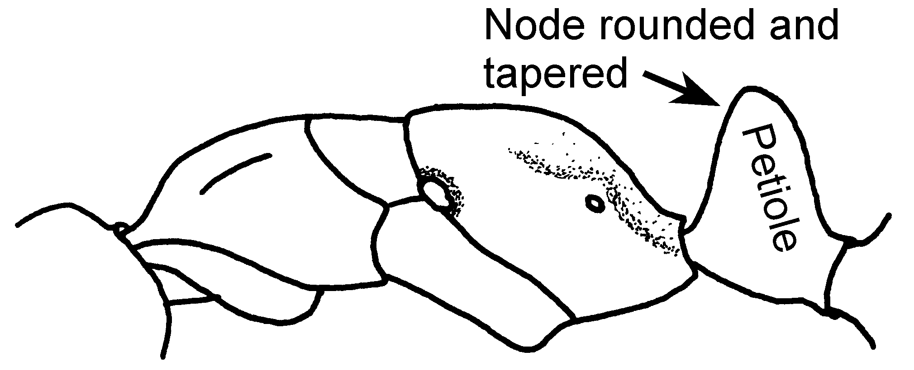Fig. 24. Mesosoma and petiole of a worker of P. arhuaca (Antioquia, Colombia).

- Larger species, head width of worker > 1.4 mm; stridulatory file present on middle of acrotergite of gastral segment II; eye of worker > 0.28 mm long ....………………………..... 13

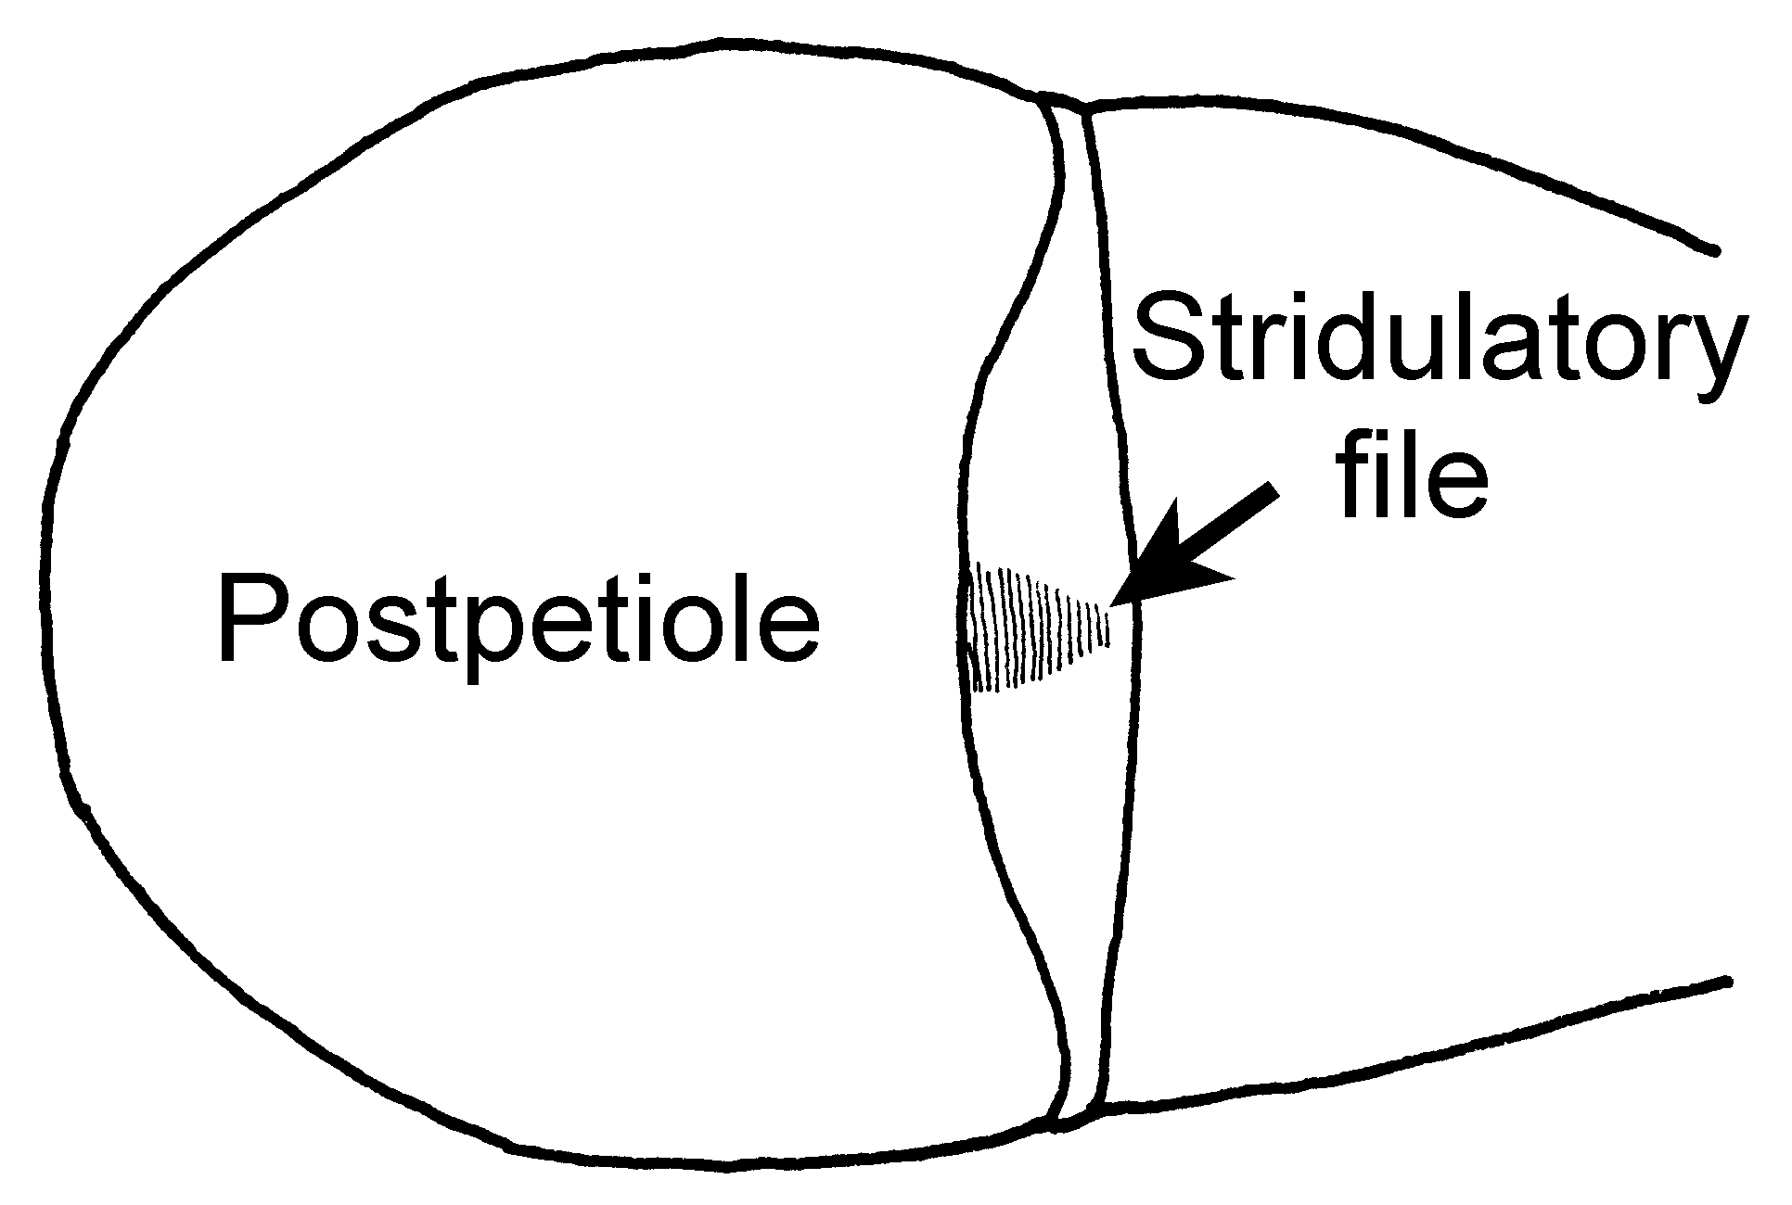
Fig. 25. Dorsum of the anterior part of the gaster of a worker of P. emiliae showing the stridulatory file.

13(12). Petiolar node very wide, about as wide as pronotal disc, its posterior face very smooth and shining, with few scattered punctures and extremely sparse appressed pubescence (Fig. xx); Mts. of southeastern Brasil .........................….. …………...... metanotalis Luederwaldt
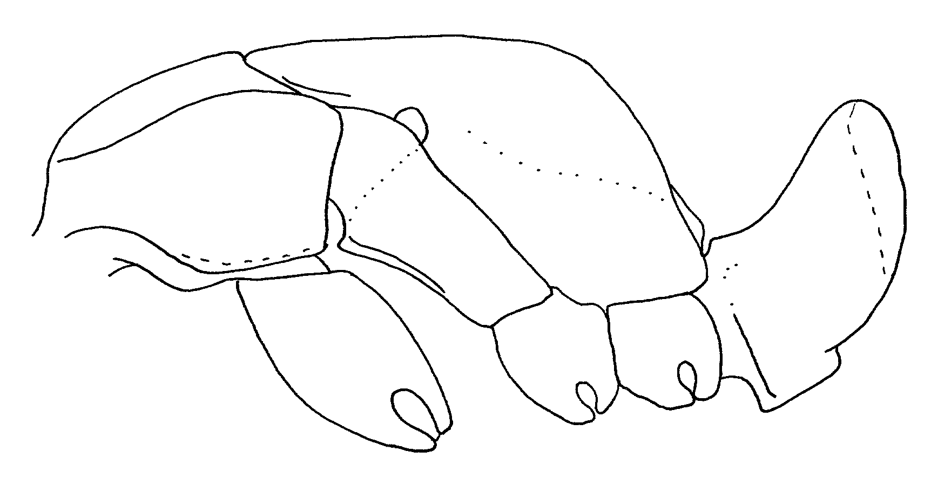
Fig. 26. Petiolar node of a worker of P. metanotalis (from Kempf, 1961).
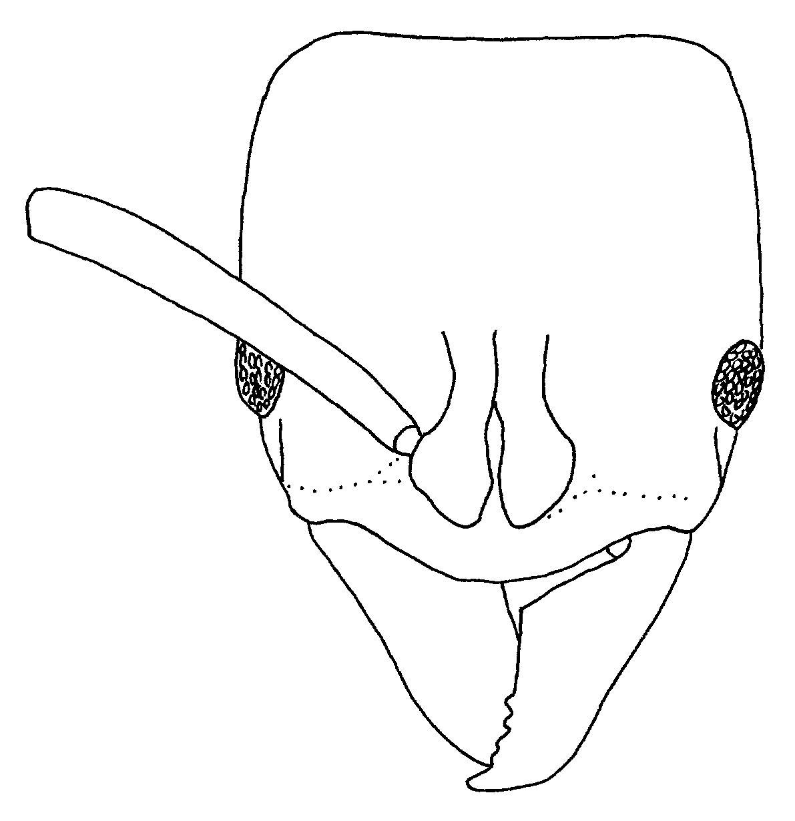
Fig. 27. Head of a worker of P. metanotalis (from Kempf, 1961).

- Node of petiole only about 0.85X width of pronotal disc, its posterior face densely punctulate and with dense reclinate pubescence (Fig. ); northern Venezuela .. ....………..…………….. emiliae (Forel)
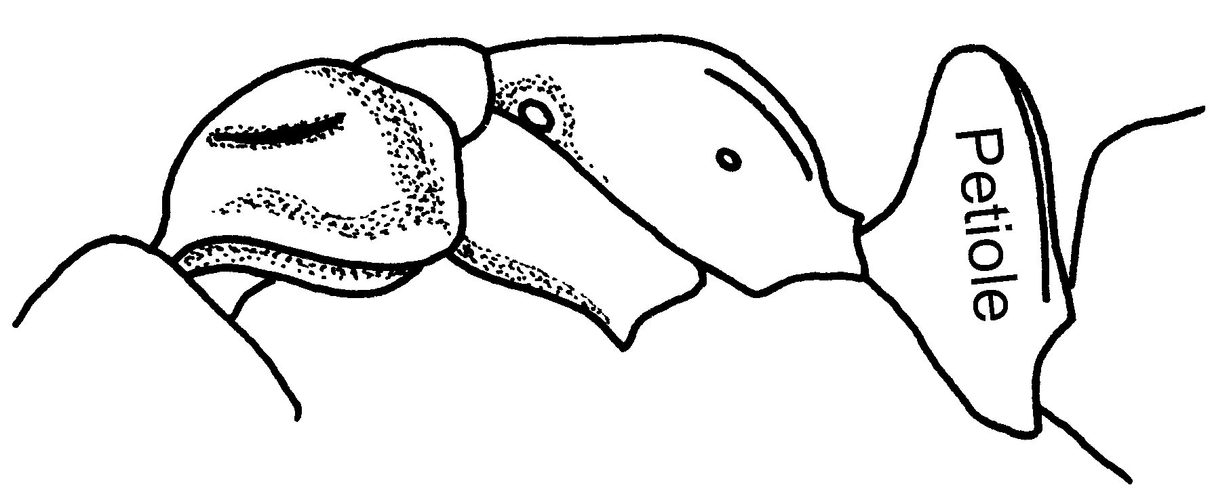Fig. 28. Mesosoma and petiole of a worker of A. emiliae (Rancho Grande, Venezuela).
14(10?).Clypeus armed with conspicuous slender median tooth that projects well beyond free margin (Fig. xx); Peru to Colombia, Andes, 1000 - 2000+ m ...……………......... becculata
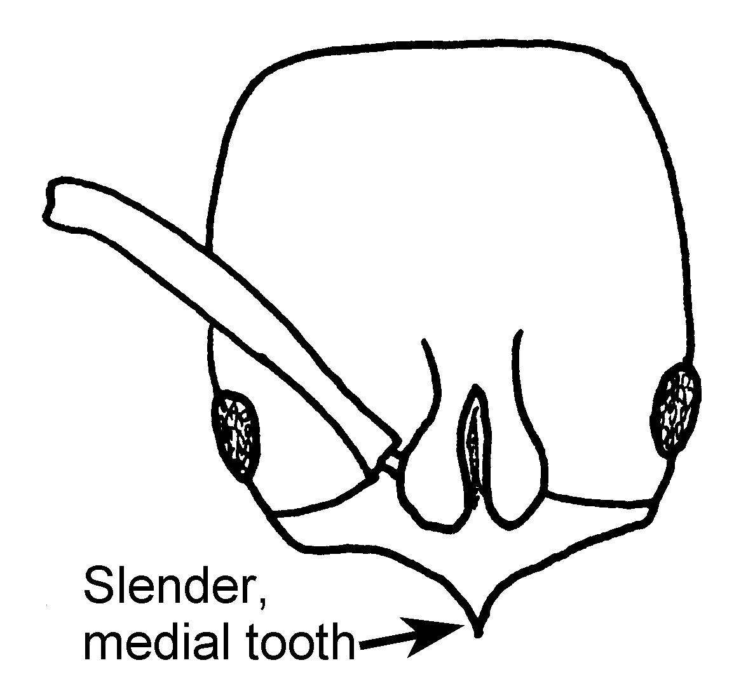
Fig. 29. Head of the holotype worker of P. becculata (Pichincha, Ecuador).
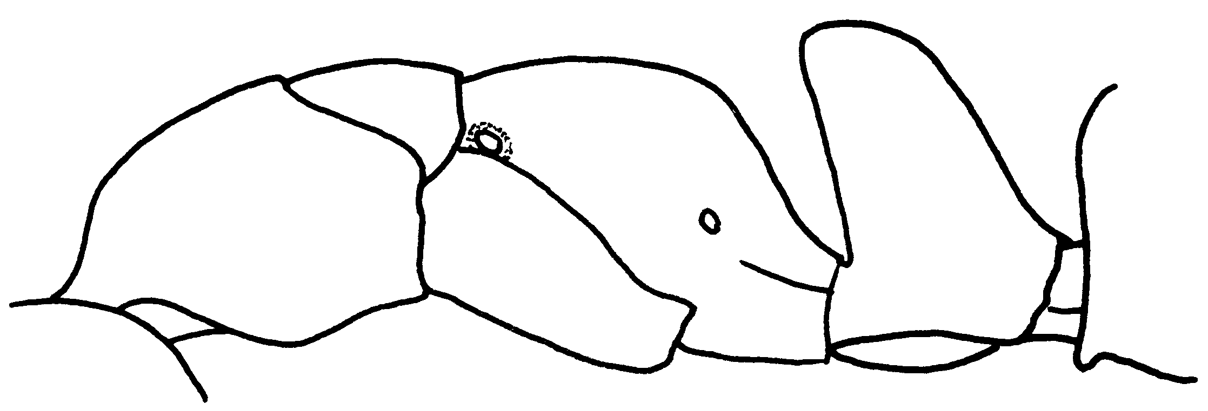
Fig. 30. Mesosoma, petiole the holotype worker of P. becculata (Pichincha, Ecuador).
- Clypeus unarmed, middle of its free border straight, convex, or emarginate ..…... 15 see also couplet 10
15(14). Worker: tibia of middle leg shorter than maximum width of pronotum .…………………………….......... 16
- Worker: tibia of middle leg longer than maximum width of pronotum ..………………...….............................. 17
16(15). Node as seen from side narrowly subtriangular, with anterior and posterior slopes about equal in length and feebly convex or straight (Fig. xx); worker metanotal groove deeply impressed and breaking dorsal profile; fully pigmented worker black with brown or black appendages; (Fig. xx); Central America to Bolivia ………….... pergandei (Forel)
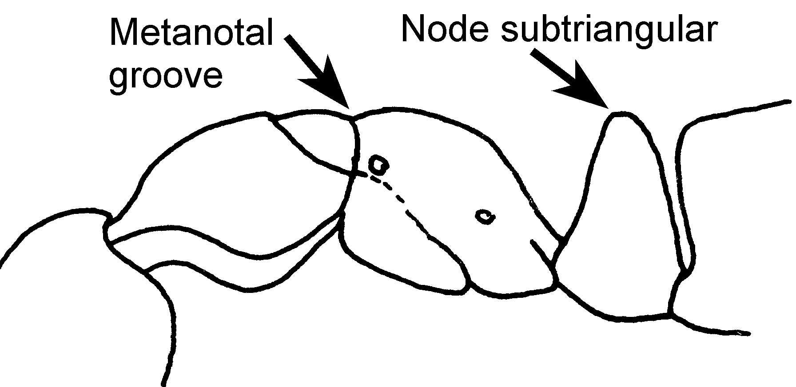Fig. 31. Mesosoma of a worker of P. pergandei (Aragua, Venezuela).

- Petiole as seen from side nearly rectangular in shape, possibly slightly narrowed at apex; worker metanotal groove fine and shallow, scarcely breaking convex dorsal profile of trunk in side view; worker red to black; S Mexico to SE Brasil ………………………..………. 16a
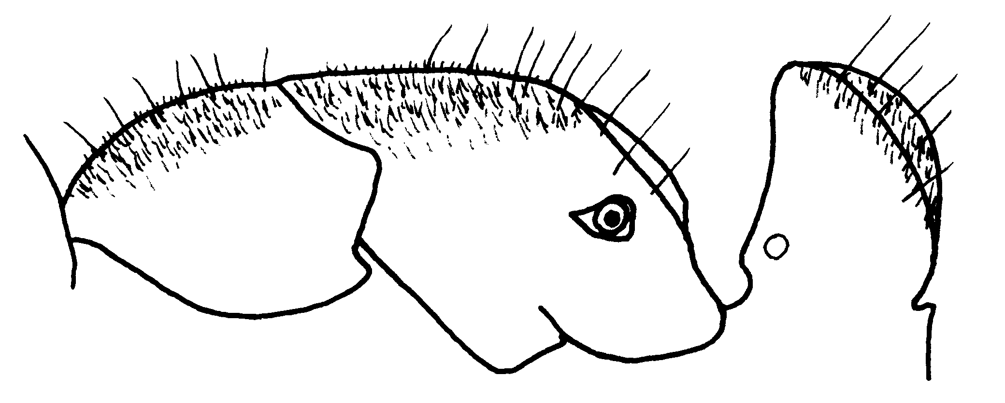 Fig. 32. Mesosoma of a worker of P. ferruginea.

16a(). Petiole with straight or feebly concave anterior slope and rounded summit merging into convex posterior slope (Fig. xx); apex much broader than long (> 2.5X) as seen from above....…... ……..……….. ferruginea (F. Smith)
- Petiole nearly rectangular-shaped, sometimes slightly wider near apex (seen from side, Fig. xx), apex not as wide (< 2.0X) as seen from above
……. New species near ferruginea
17(15). Size smaller, head width of worker and queen, including eyes, < 1.4 mm; node as seen from side narrowly subtriangular with feebly convex anterior and posterior slopes (anterior slope straight to faintly concave in queen) meeting at narrowly rounded apex; worker metanotal groove set in deep impression separating mesonotal and propodeal convexities; mandibles finely striolate, sericeous-opaque, with only apical third smooth; southern Mexico to northern Argentina, forest, in rotten wood .............. …………….………. constricta (Mayr)
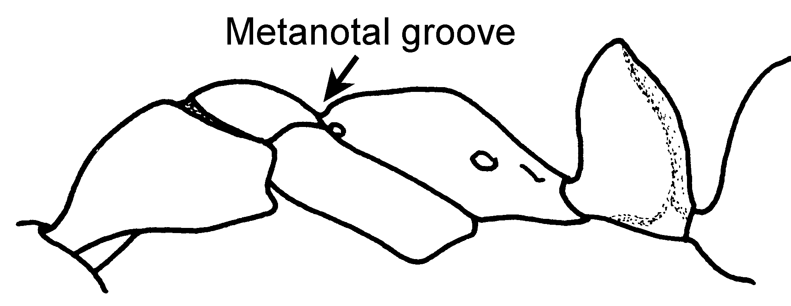

Fig. 33. Mesosoma of a worker of P. constricta (Atlántida, Honduras).

- Size larger, head with eyes > 1.5 mm; node thick, subtruncate above, with nearly vertical anterior and posterior slopes (Fig. xx); metanotal groove shallow, separating convex mesonotum from nearly straight propodeal dorsum, which lies at slightly lower level (Fig. xx); mandibles smooth and shining, with spaced punctures (Fig. xx); W Colombia, Panamá; rocky-walled ravines in rain forest ………...... rupinicola n. sp.
18(9). Mandibles exceptionally long and slender, about as long as head; petiole longer than high, rising and thickening gradually to rounded node caudad; widespread, but rare and local in tropical S. America ……………...... rostrata Emery

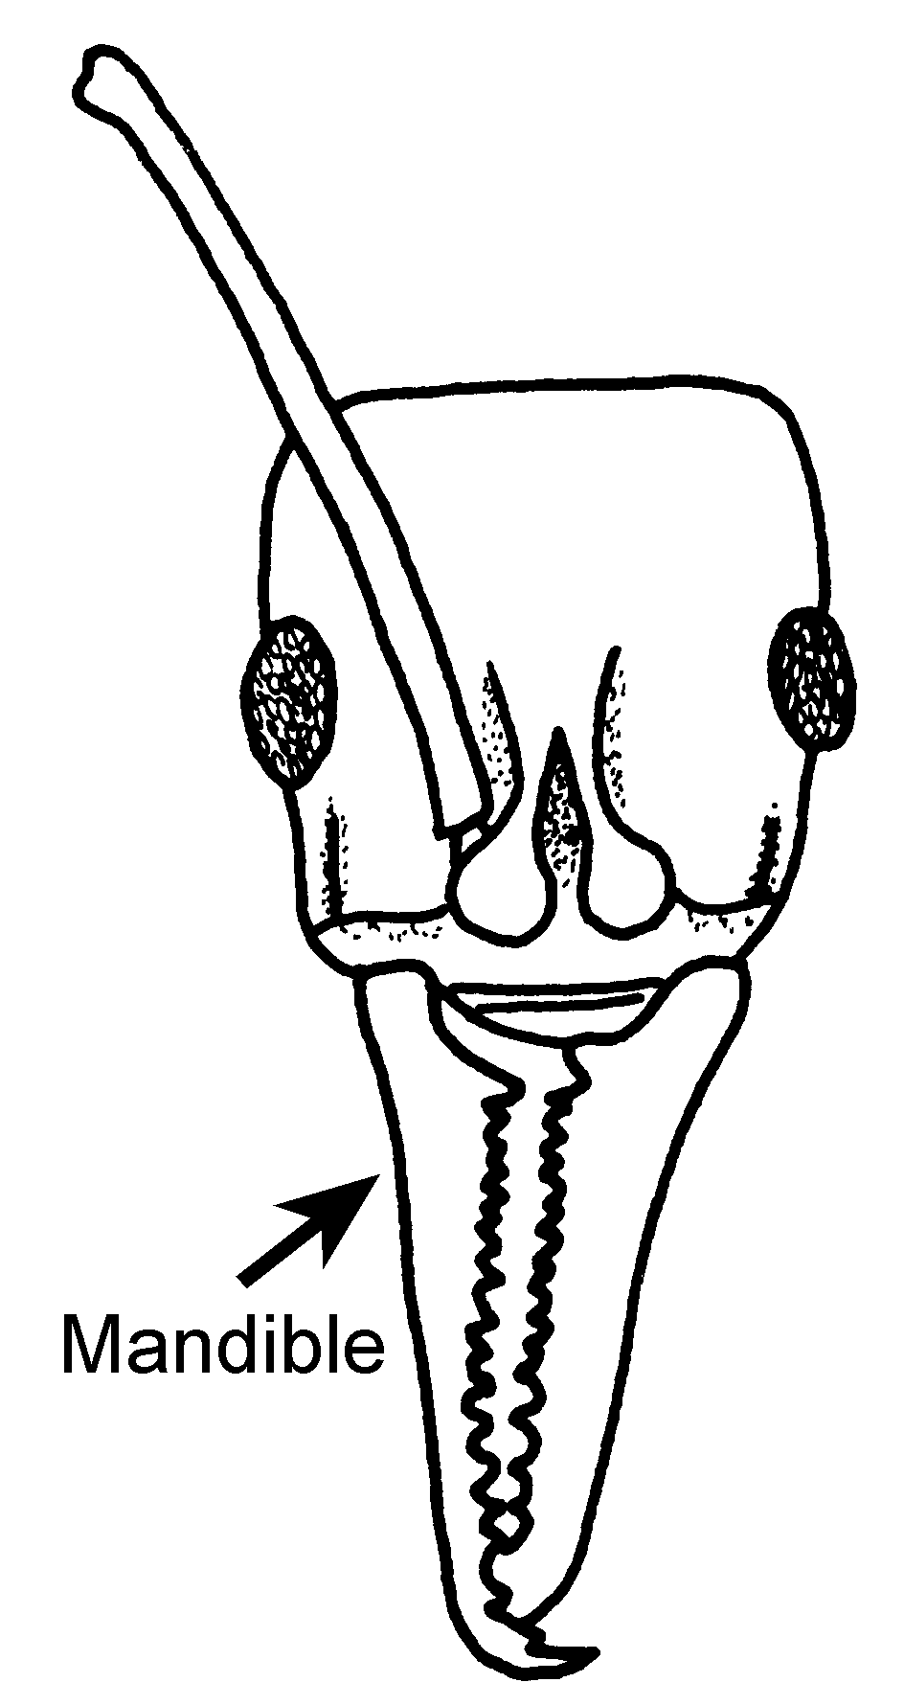
Fig. 34. Head of a worker of P. rastrata (Leticia, Colombia).
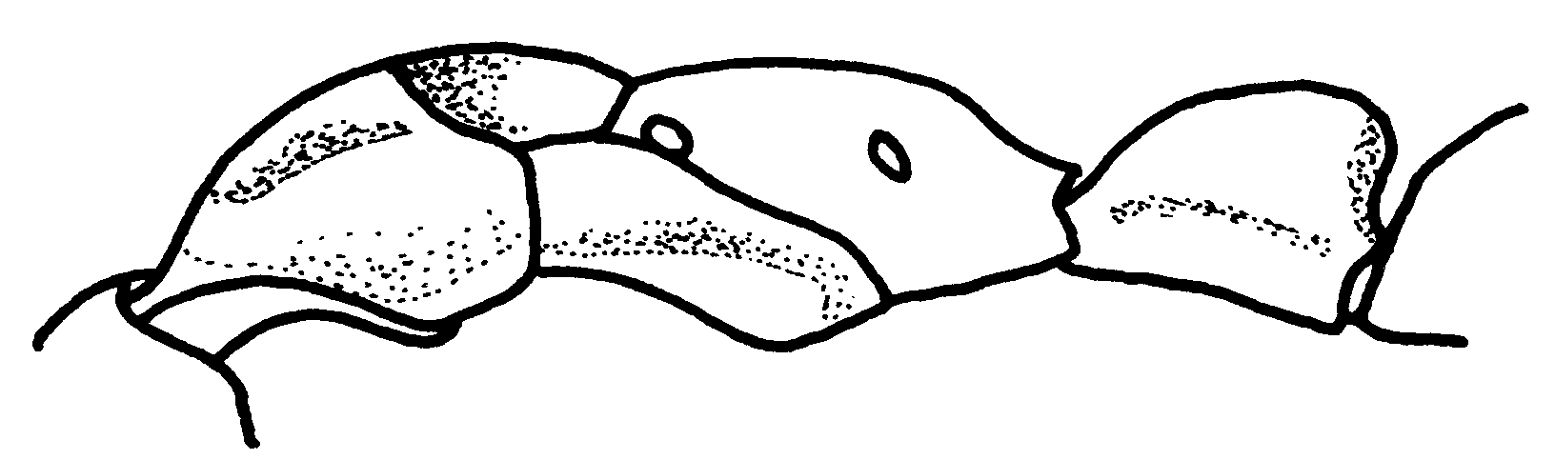
Fig. 35. Mesosoma and petiole of a worker of P. rastrata (Leticia, Colombia).

- Mandibles shorter than head; petiole not longer than high and with steeply rising anterior face ..….......... 19
19(18). Postpetiole (first gastral segment) with anterior face concave and pointed, so that it forms overhanging acute angle with dorsal face (Fig. xx); eyes small; Amazonia, rare and local …………………….... procidua Emery
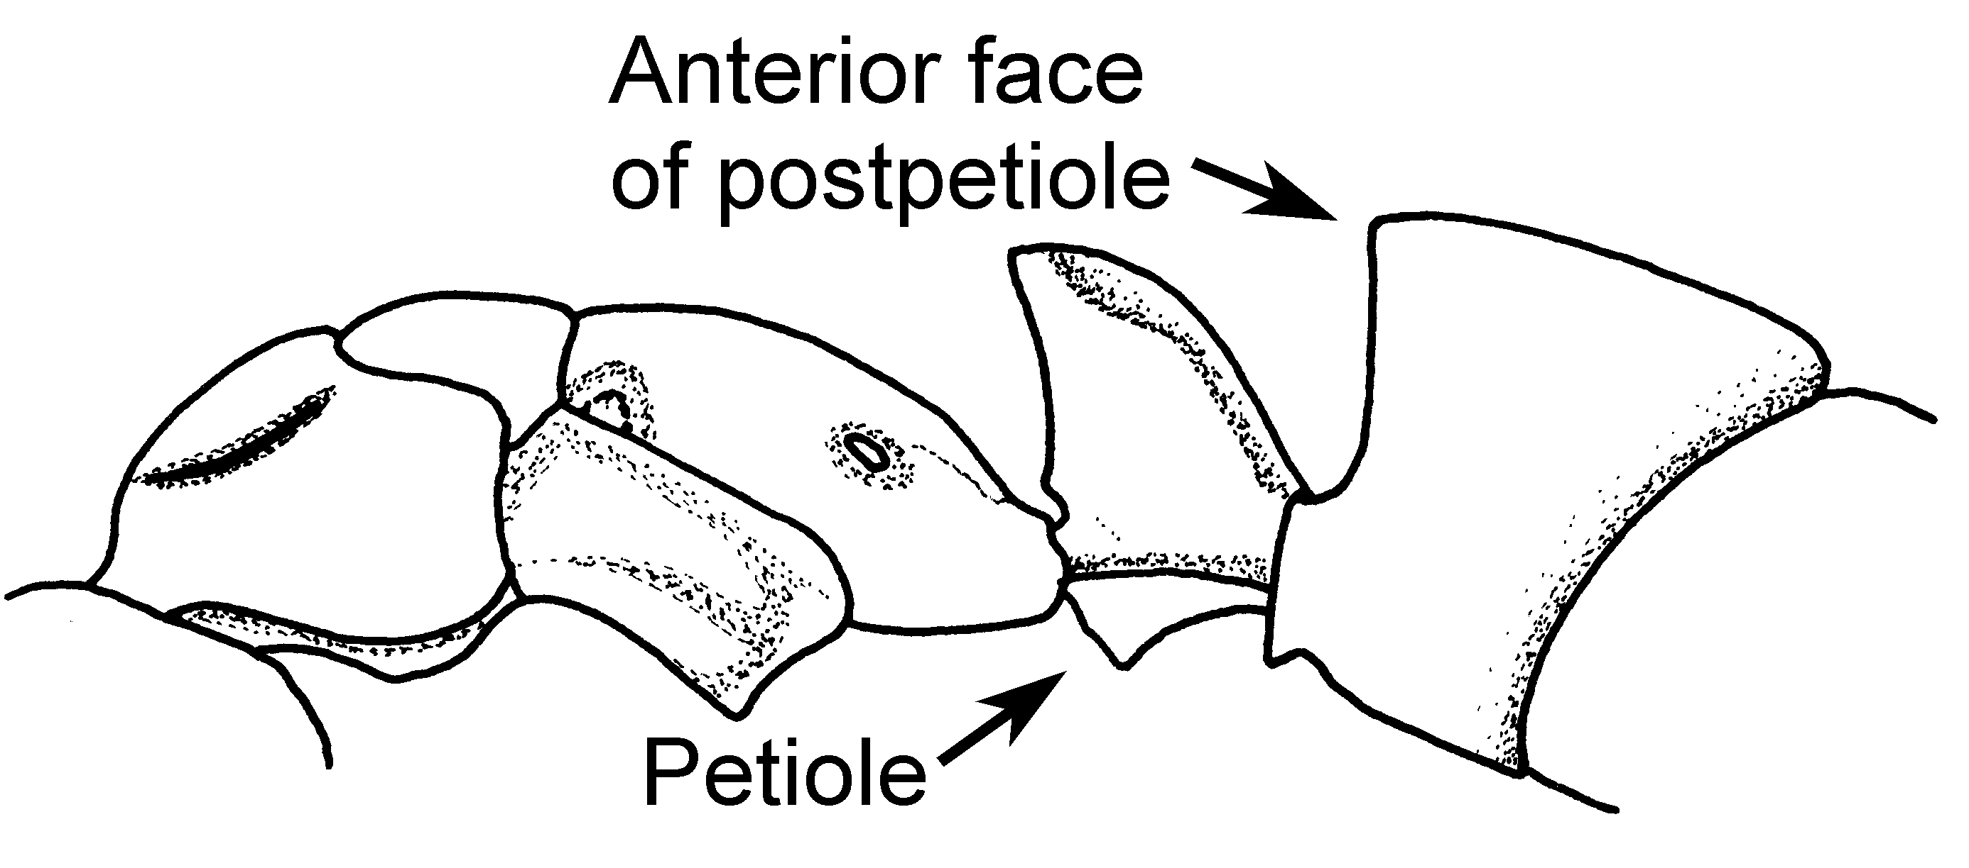Fig. 36. Mesosoma, petiole and first segment of gaster of a worker of P. procidua as seen from the side (King Frederic William IV Falls, Suriname).
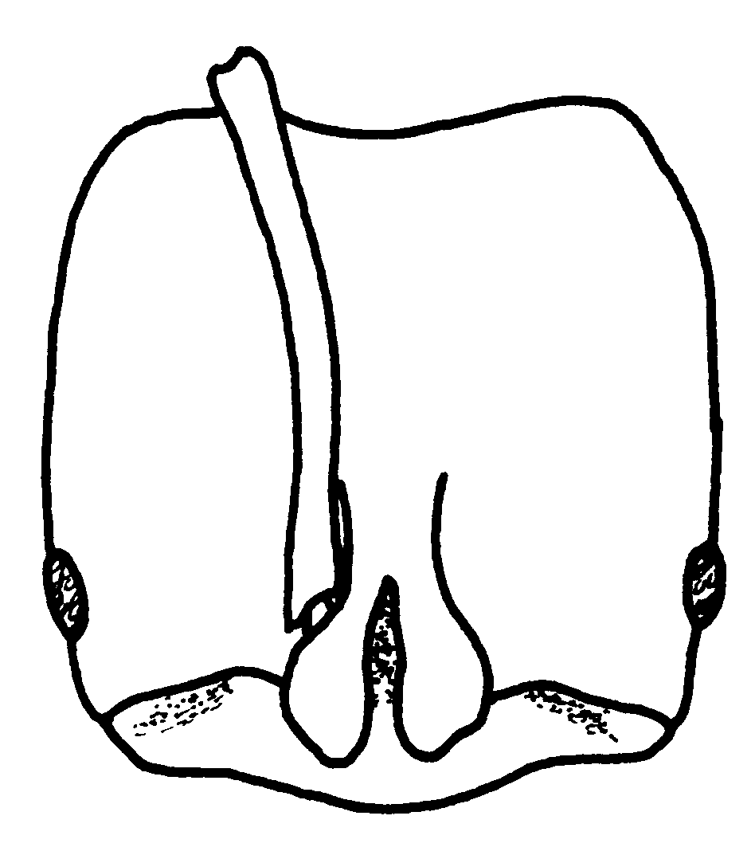
Fig. 37. Head of a worker of P. procidua (King Frederic William IV Falls, Suriname).
- First gastral segment with perpendicular or sloping anterior face that rounds into dorsal face or meets it at approximate right angle (Fig. xx) ………………........ 21
20 doesn’t exist

21(19). Black, very smooth and shining species with striate areas on sides of trunk and sometimes on head; disc of pronotum laterally immarginate or with weak margins and with only few scattered punctures; petiole rectangular when viewed from side (Fig. xx) ............….................................. 22
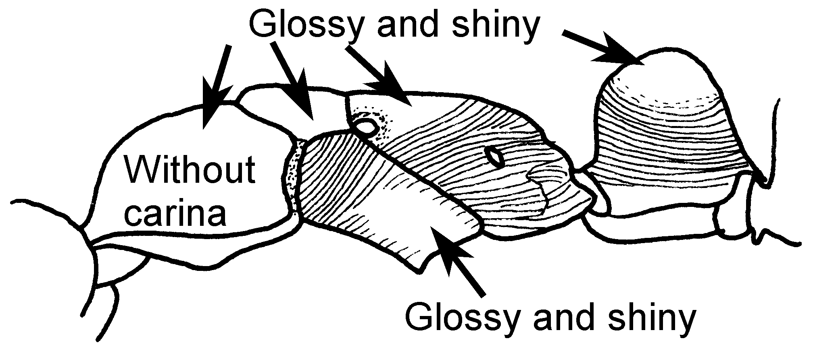Fig. 38. Mesosoma of a worker of P. laevigata (Ecuador).
- Sculpture more extensive; pronotal disc striate or densely and finely punctulate; pronotal margins either sharp or undeveloped; petiole rarely rectangular as seen from side ...…....... 24
22(21). Very large species, head > 3.0 mm wide including eyes; head behind eyes mostly distinctly striate; Amazon-Orinoco Basins …….……….……… ……….......…......... commutata (Roger)

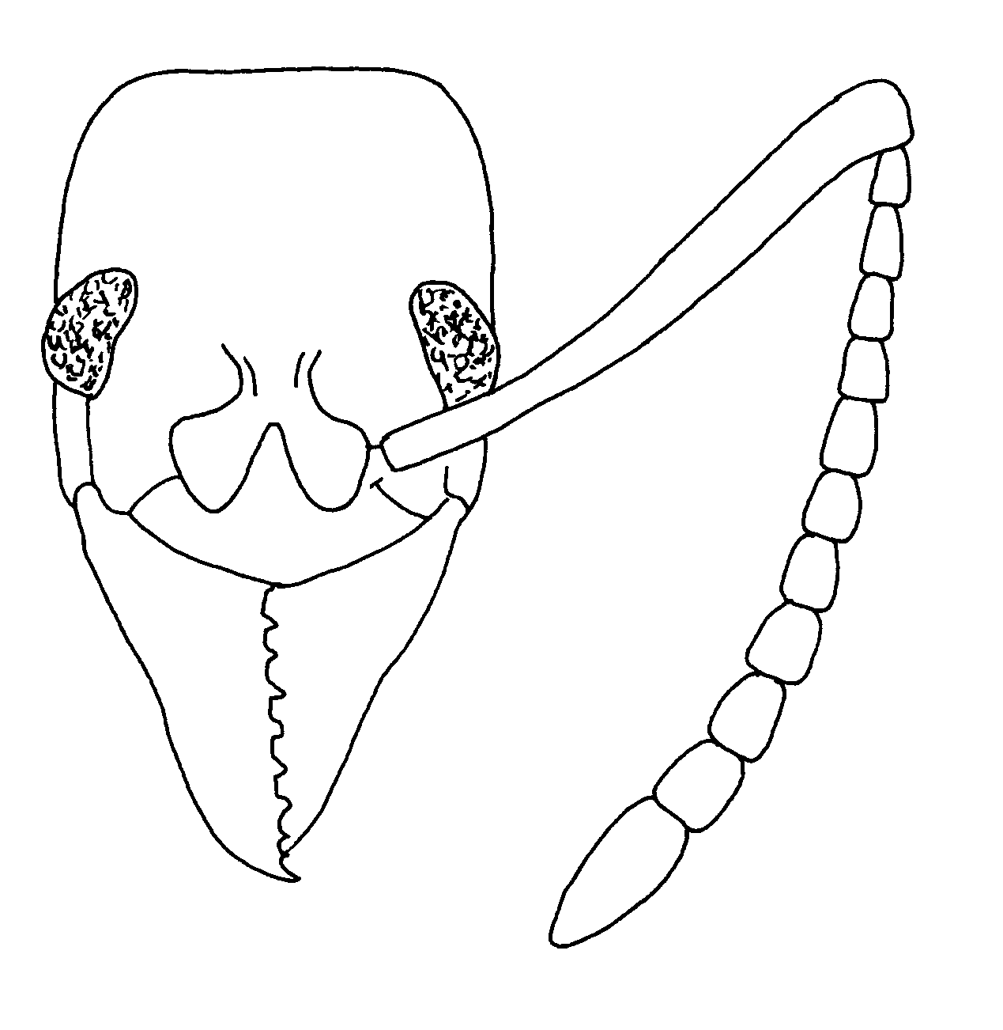
Fig. 39. Head of a worker of P. commutata.
- Smaller species, head width including eves < 2.5 mm; head behind eyes usually mostly smooth and shining .....……......... 23
23(22). Dorsal surface of mandible divided by longitudinal ridge into convex lateral part and broader, concave inner part that extends to dental margin; S Brasil to N Argentina and Bolivia ….… ………....... marginata (Roger)
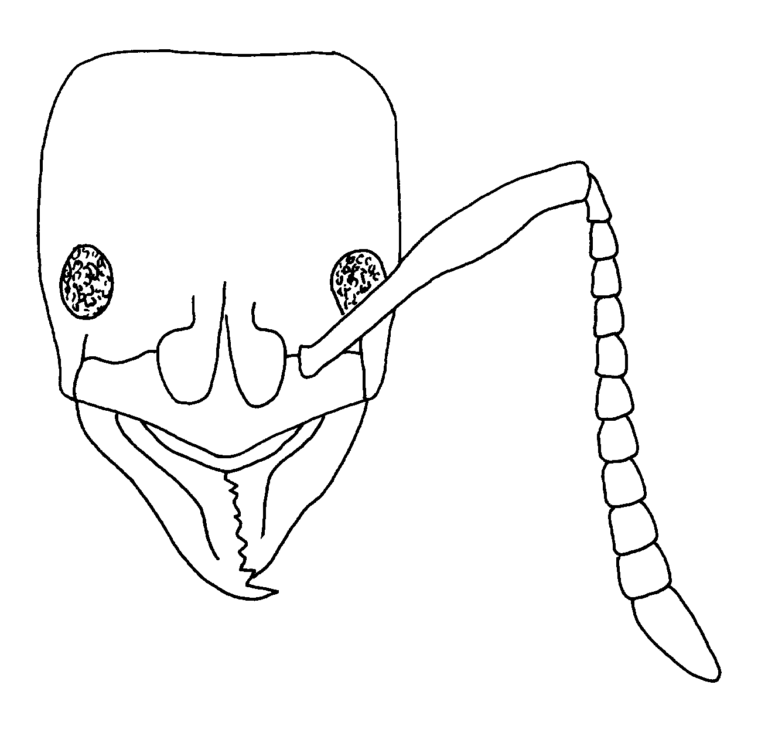
Fig. 40.Head of a worker of P. marginata.

- Each mandible with single convex dorsal surface with series of coarse punctures along dental margin; Central America south into Amazonia and to Espirito Santo State in SE Brasil)…………… laevigata (F. Smith)

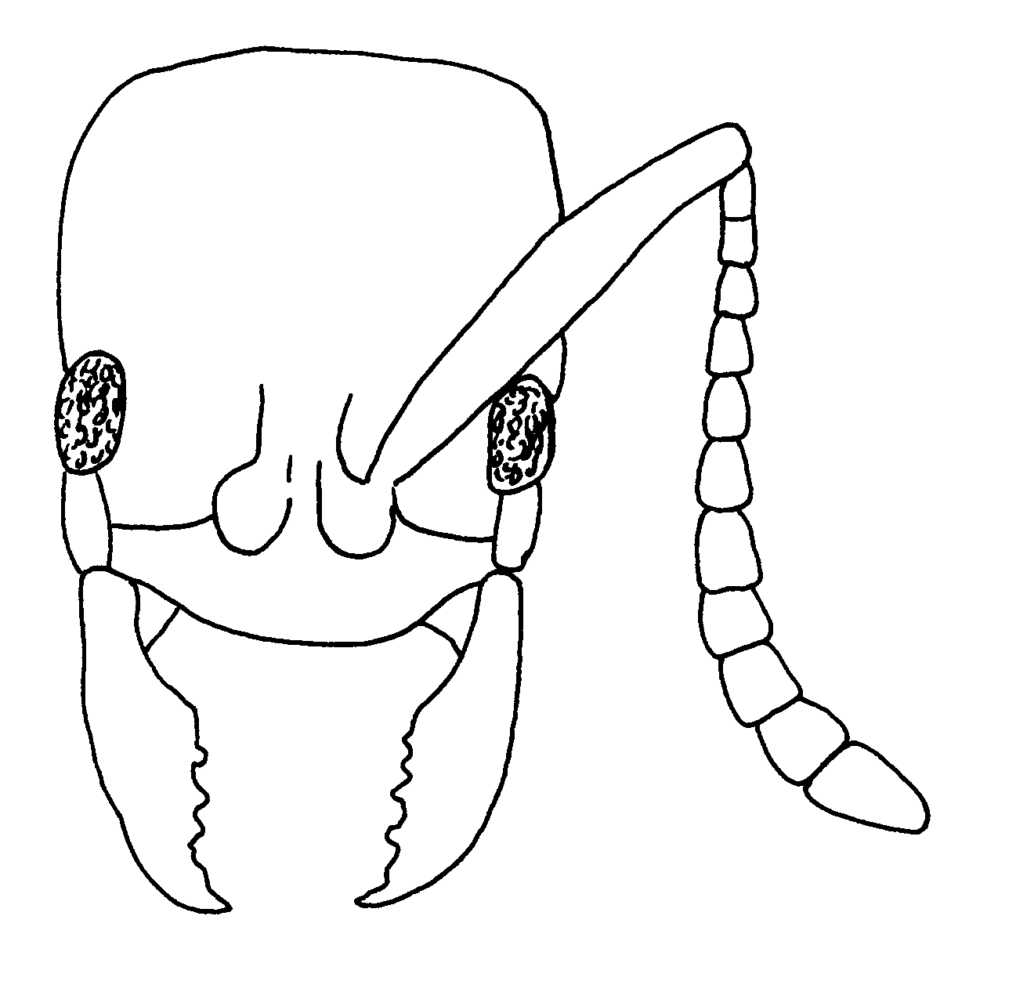
Fig. 41. Head of a worker of P. laevigata.

24(21). In side view, dorsal outline of alitrunk forms continuous (slightly sinuous in P. goeldii) convexity including mesonotum, metanotum and propodeal dorsum; metanotal groove obsolete or nearly so, and not strongly impressed; pronotal disc usually with strong lateral margins ...………………………..... 25
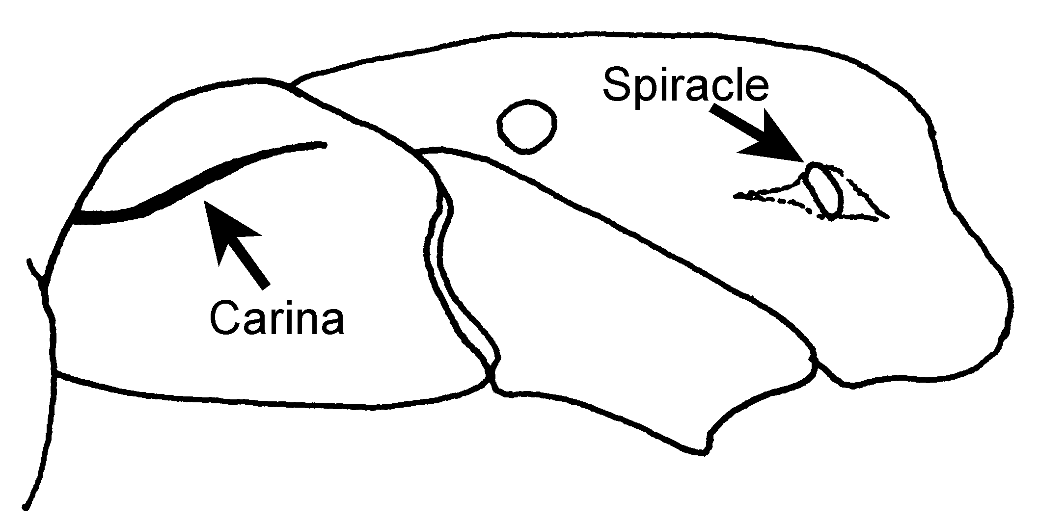 Fig. 42. Mesosoma of a worker of P. striata (Minas Gerais, Brasil).

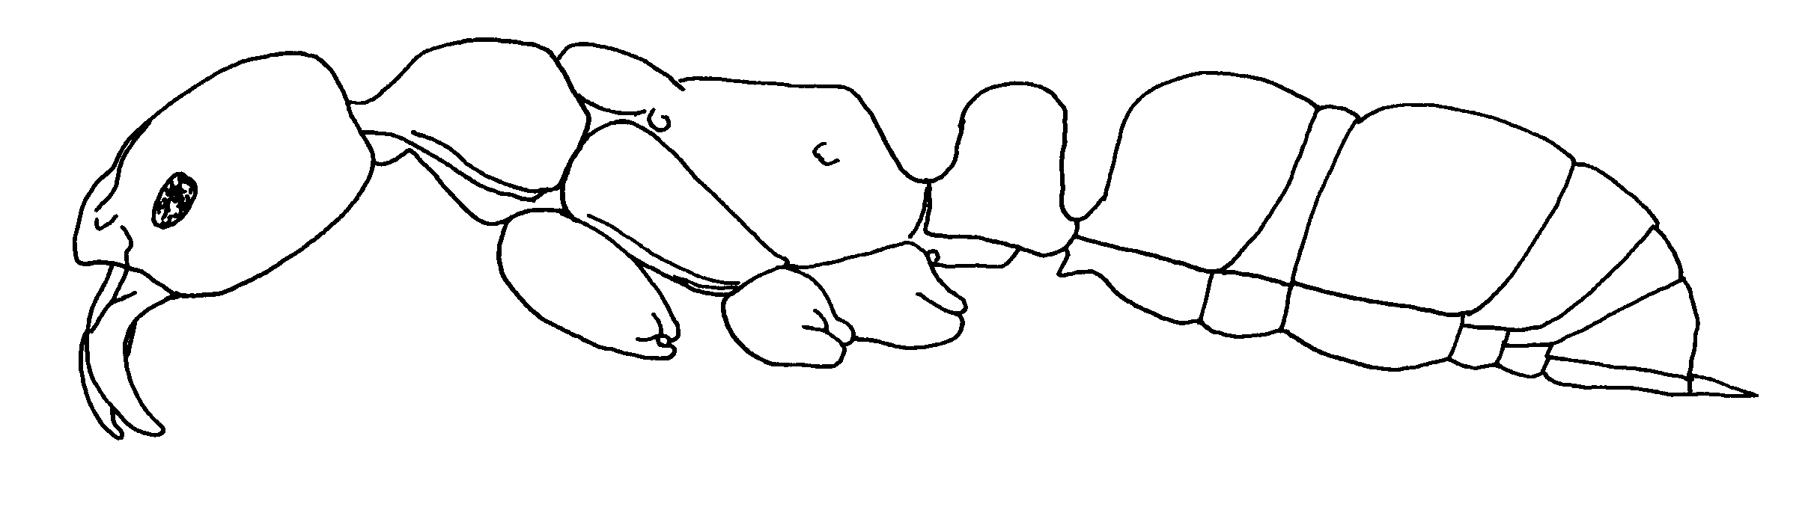
Fig. 43.Side view of a worker of P. marginata (from ). Was fig 102
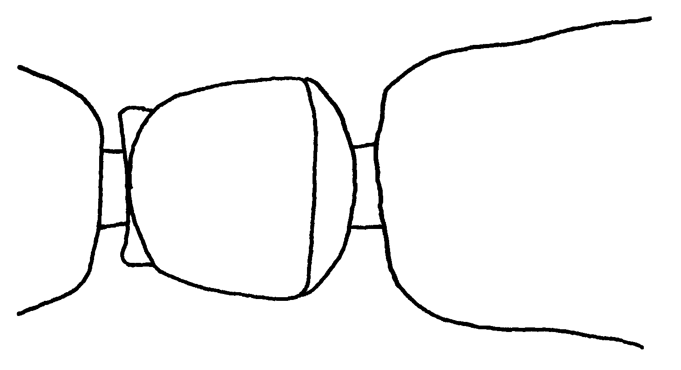
Fig. 44. Dorsal view of the petiole of a worker of P. marginata (from).

- Dorsal outline of trunk interrupted by distinct, impressed metanotal groove, so that mesonotum forms convexity separate from more or less convex propodeal dorsum; lateral margins of pronotal disc distinct, indistinct, or absent ……………………………………..... 35
25(24). Distinct carina runs from lateral wing of clypeus near mandibular insertion to or nearly to anteromesal quarter of margin around eye; eye centers only rarely (in small workers of P. crenata) situated anterior to mid-head length; acrotergite of second gastral tergum (when exposed) with a distinctly differentiated median stridulatory file with bands of rainbow colors (Fig.); arolium present ............……….……………….......... 26

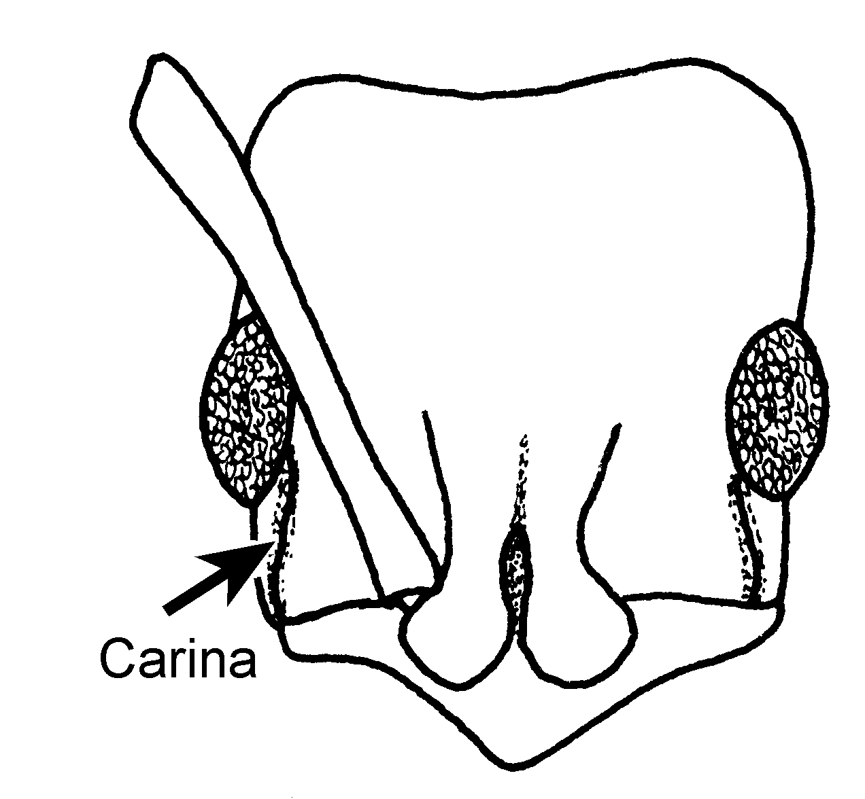
Fig. 45. Head of a worker of P. crenata, showing the carina anterior to eye (Chiapas, México).
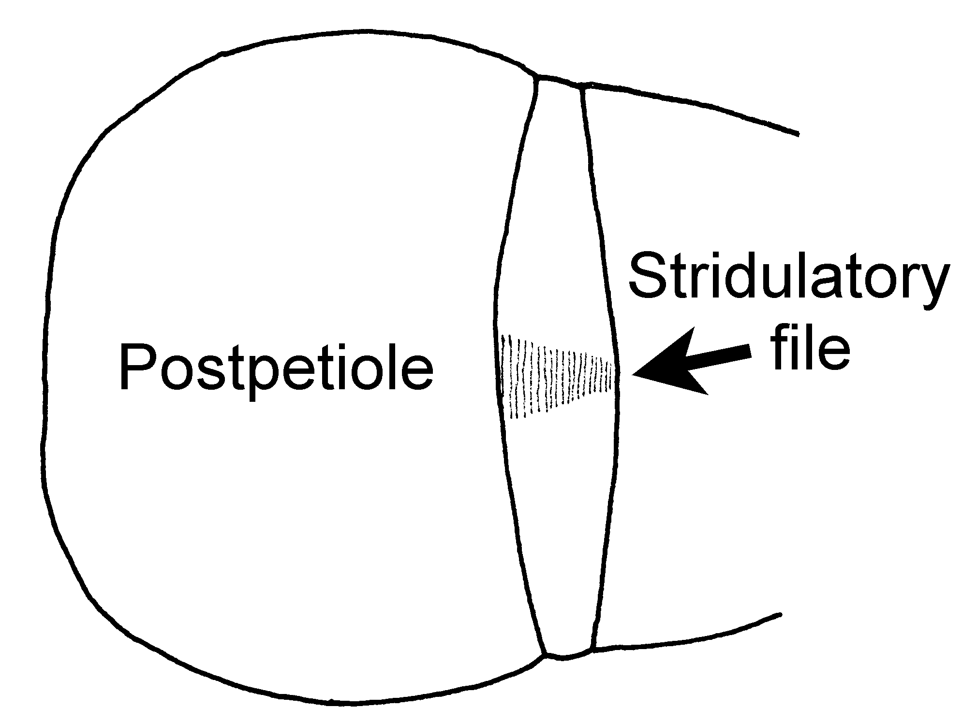
Fig. 46. Dorsum of the gaster of a worker of P. unidentata (Chiapas, México), showing the postpetiole and the stridulatory file on the acrotergite.

- Cheeks without distinct carina reaching more than halfway from clypeal wing to eye margin (a carina indistinct from background sculpture may sometimes occur); eyes anterior- to mid-head length; stridulatrum absent; absent ...........……….…...... 32
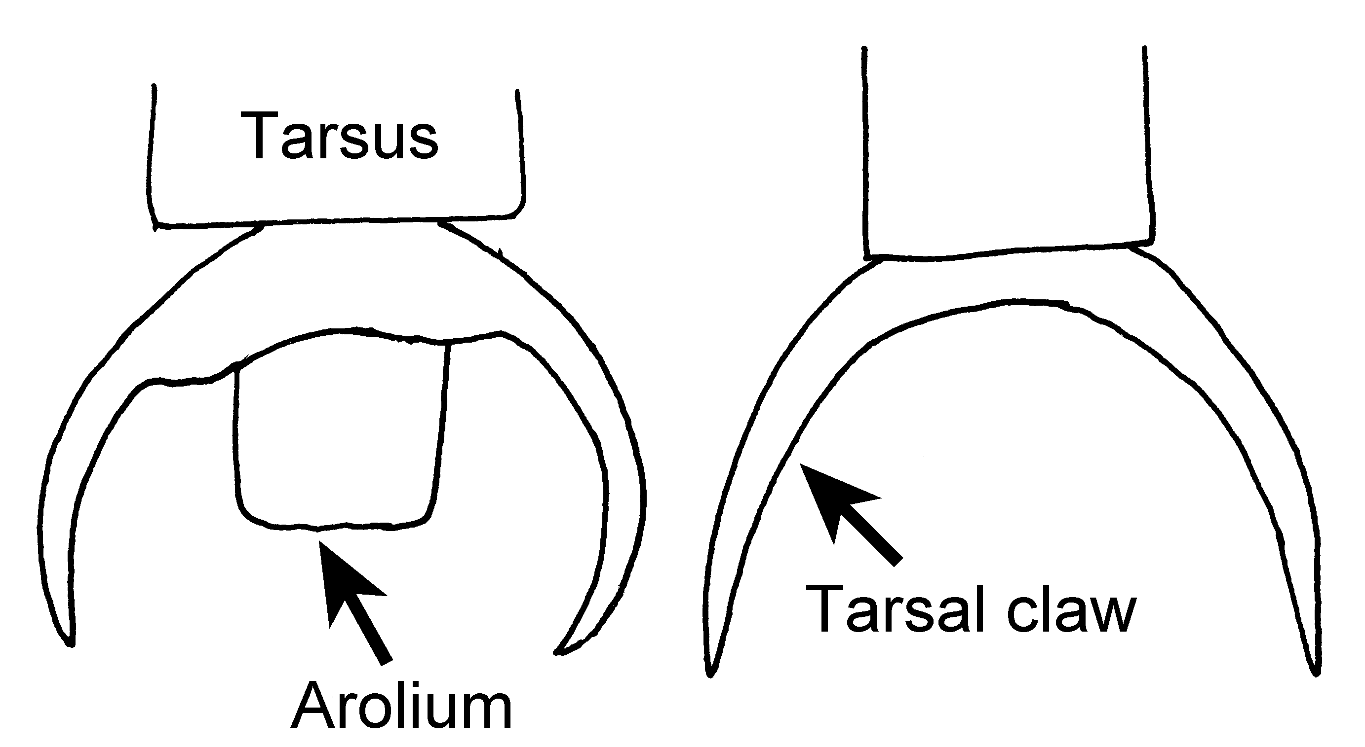
striatidodis harpax
Fig. 47. Middle tarsal claws of a worker of P. striatinodis (left, Frijolito, Panamá), showing the arolium and of a worker of P. harpax (right, Nayarit, México) lacking the arolium.

26(25). Node as seen from side with front face rising abruptly to angular summit at or near front, from which it descends behind through broad curve (Figs.xx) .……………………......... 27
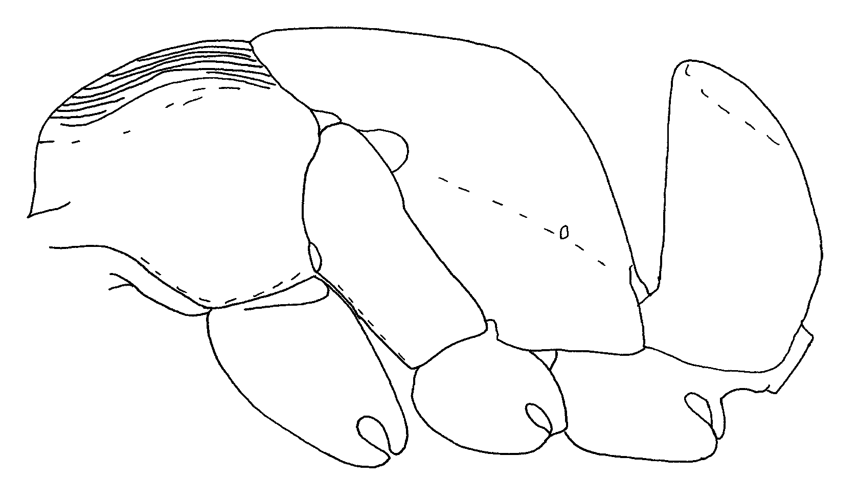
Fig. 48.Mesosoma and petiole of a worker of P. magnifica (from Kempf, 1961).

- Node as seen from side with horizontal or strongly rounded summit with highest point near nodal midlength; or else apex rises well behind midlength (Figs. xx) .....………………………... 28
27(26). Posterior face of node densely and finely punctulate; black, often with satiny blue reflections on side of trunk and node, legs largely yellowish, more rarely brown (Fig. xx); southern Mexico south through Amazonia ………............ ……………………... unidentata Mayr
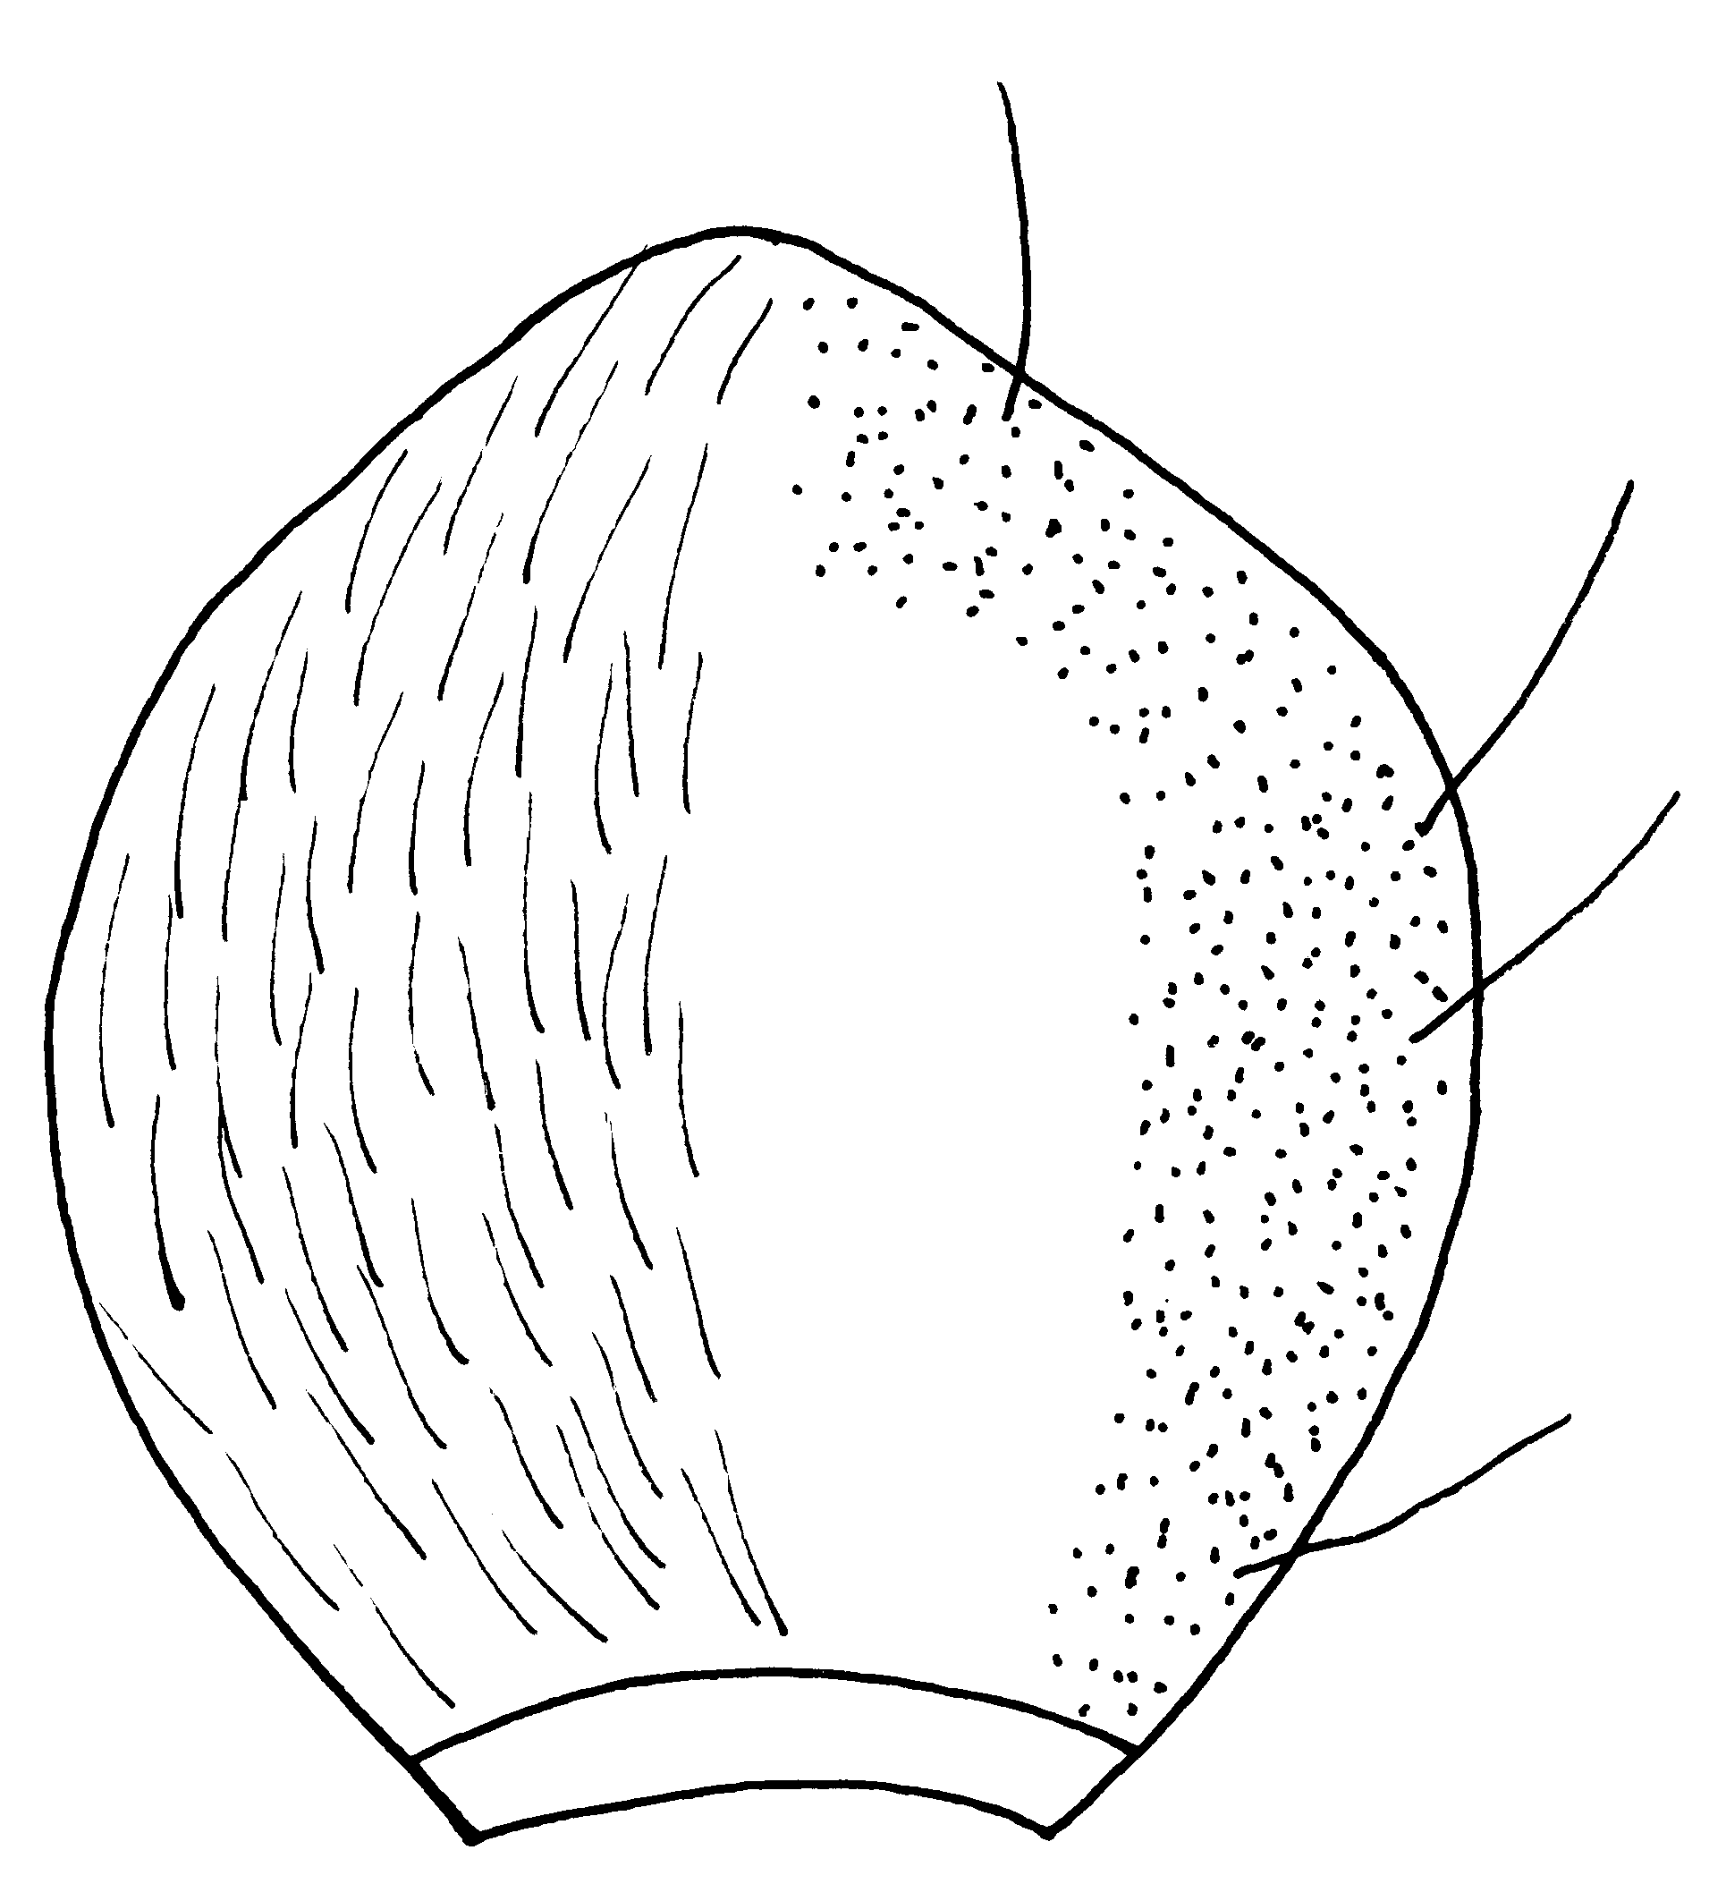
Fig. 49.Posterior face of the petiole of a worker of P. unidentata as seen from behind.

- Posterior face of node completely and coarsely, transversely striate; legs largely yellowish; Central America into Amazonia .......... striatinodis Emery

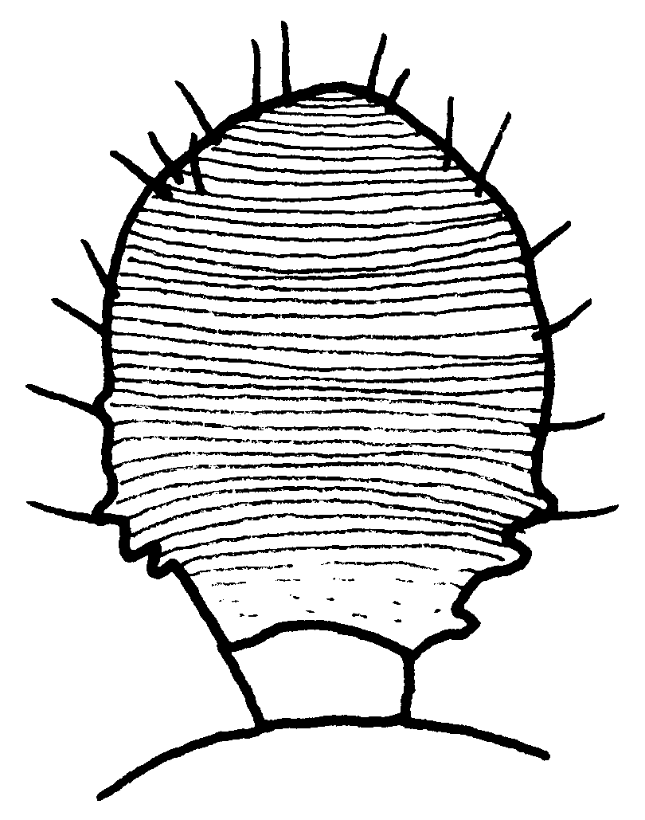
Fig. 50.Posterior face of the petiole of a worker of P. striatinodis (Barro Colorado, Panamá).

28(26). Anterior and dorsal surfaces of petiolar node as seen from side forming even rising curve to narrowly rounded, almost pointed, overhanging apex at rear; posterior face vertical and concave in its upper half (Fig. xx); Panama through Amazonia ………..... cavinodis (Mann)

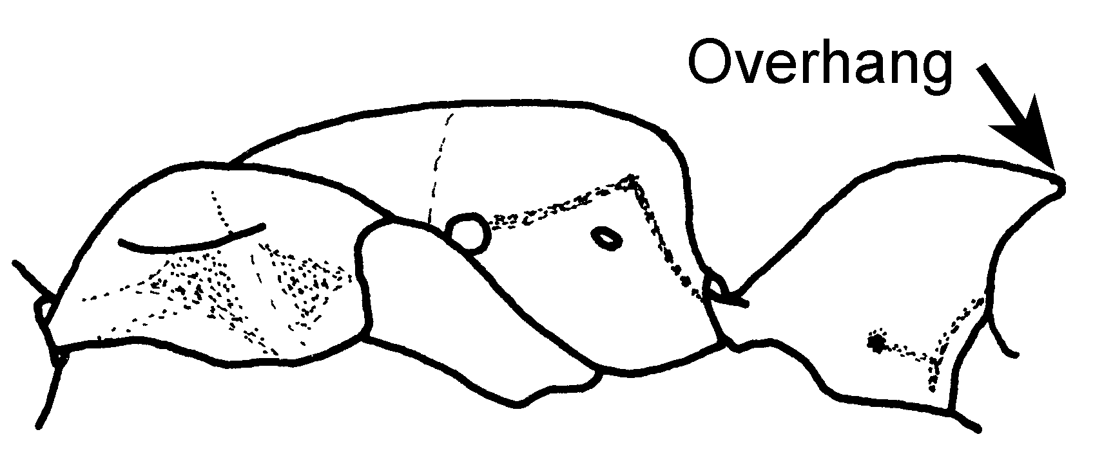
Fig. 51. Petiole of a cotype worker of P. cavinodis.
- Posterior face of node as seen from side convex or flat, only rarely with feeble tendency towards concavity in upper half, but then this surface slopes forward to apex (Figs. xx) ....………………………...... 29
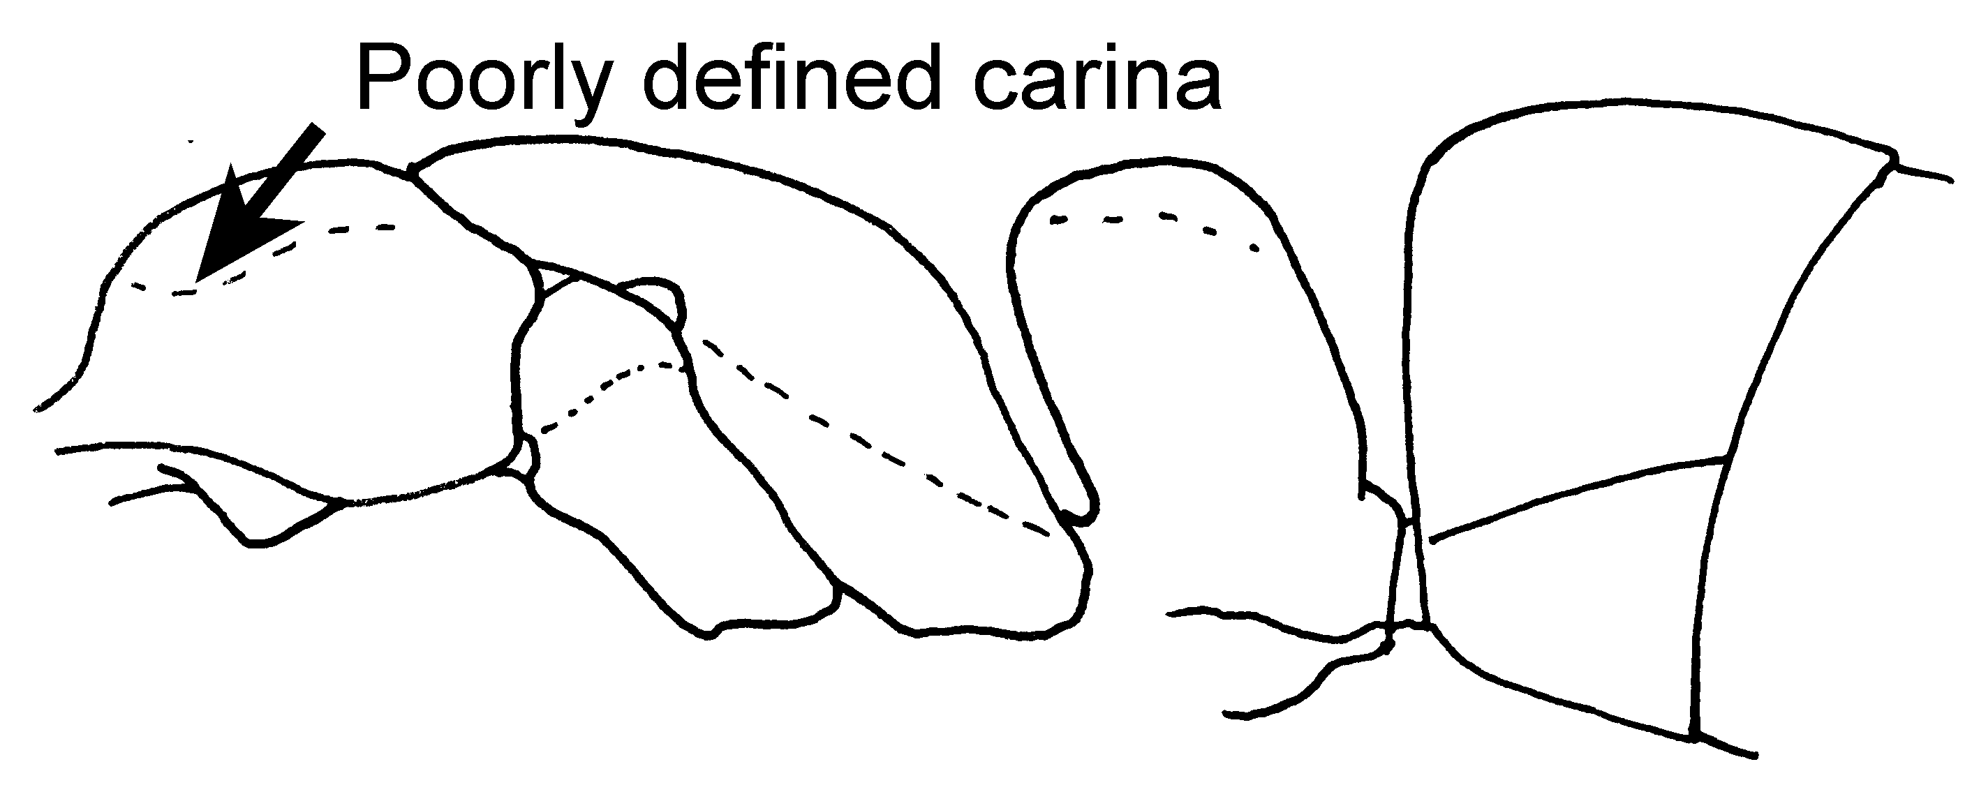Fig. 52.Mesosoma, petiole and first gastral segment of a worker of P. lenis (from Kempf, 1961).
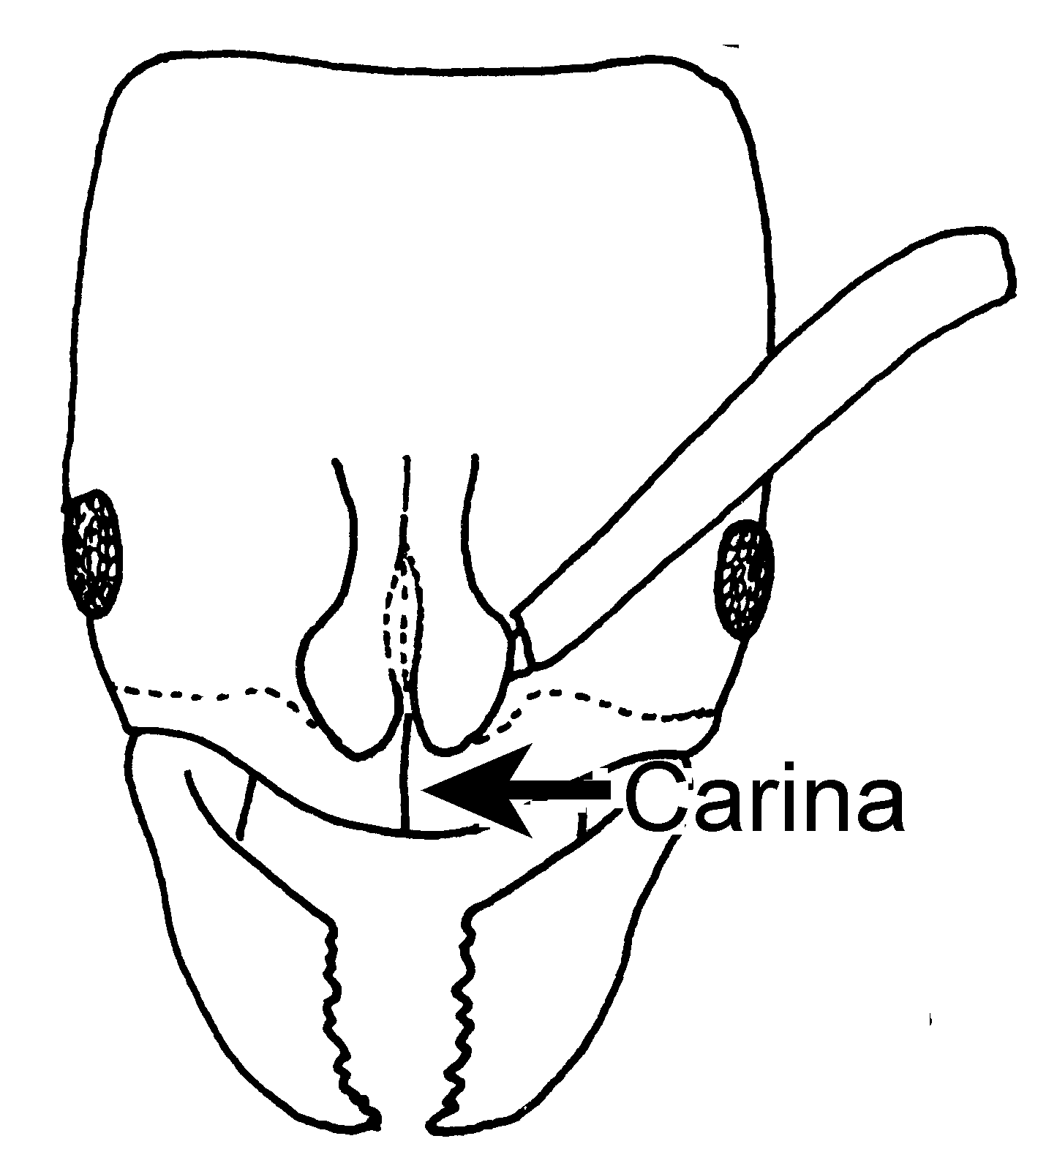
Fig. 53. Head of a worker of P. lenis (from Kempf, 1961).
29(28). Node as seen from side more or less subquadrate, with vertical anterior and posterior faces and horizontal, but convex dorsal face (Fig. ); southern Mexico to northern Argentina ……..….. crenata (Roger)
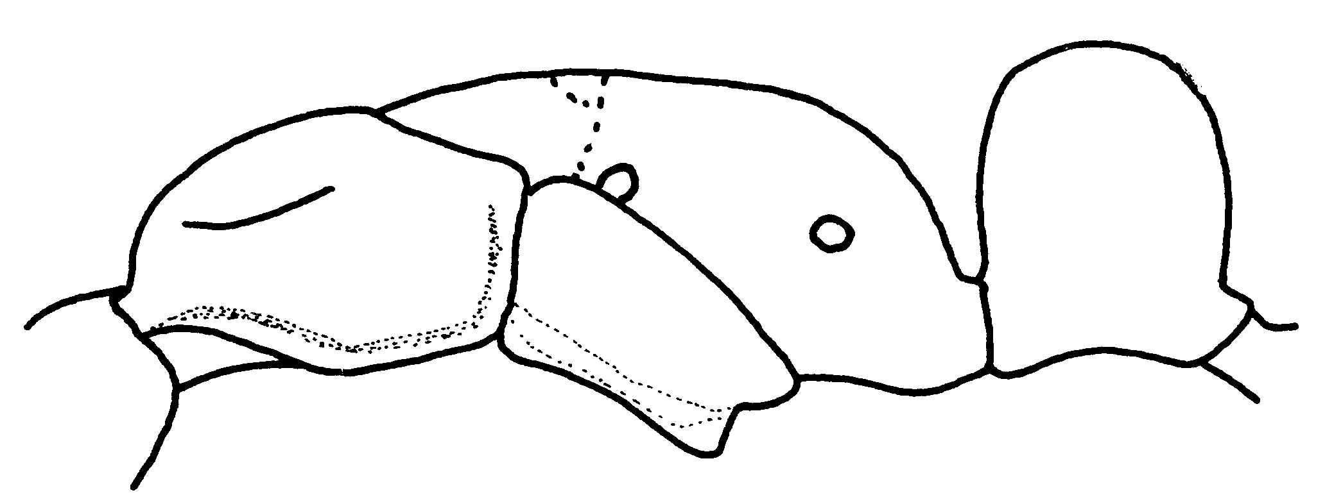
Fig. 54. Mesosoma and petiole of a worker of P. crenata (Oaxaca, México).

- Node as seen from side with anterior or anterodorsal and posterior faces strongly converging above to form sharply rounded or even angular summit near or behind midlength (Figs. xx) ...........…………………….................. 30

30(29). Node as seen from side with posterior face sloping anteriorly from near nodal midlength (Fig. xx); Trinidad through Amazonia .……. goeldii (Forel)
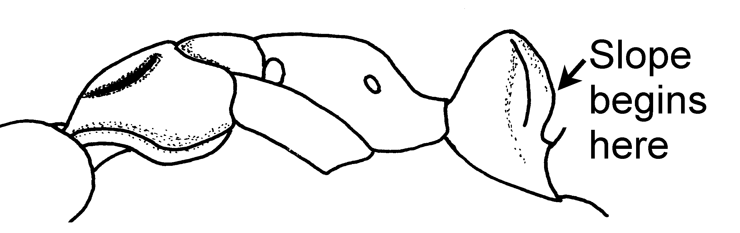
Fig. 55. Mesosoma and petiole of a worker of P. goeldi (Trinidad).

- Node as seen from side with distinct anterior (nearly vertical) and sloping anterodorsal faces; anterodorsal face meets posterior face at subangular, posterior summit (Fig. xx) ...…….... 31
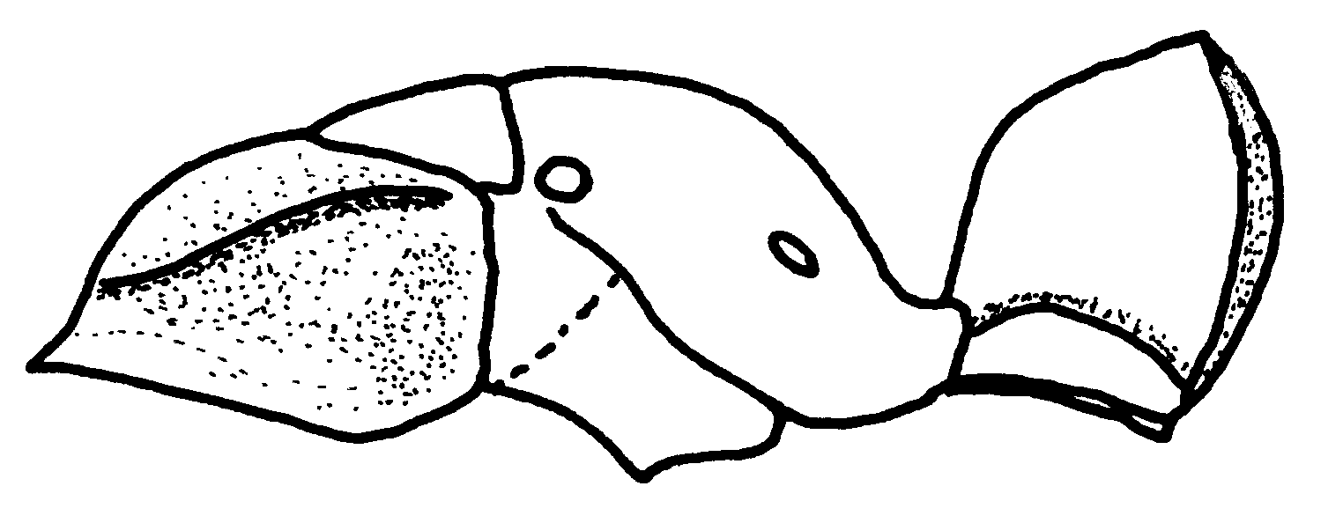Fig. 56. Mesosoma of a worker of P. carinulata (Cuzco Amazónico, Perú).

31(30). Head in full-face view rectangular-shaped posteriorly, with angulate posterior lateral corners; punctures of vertex and pronotum dense, feebly shining to opaque, spaces between punctures of pronotum often so narrow as to form tiny, mostly transverse ridges (Fig. xx); southern México south through Amazonia to Bolivia ………… ……………………. carinulata (Roger)
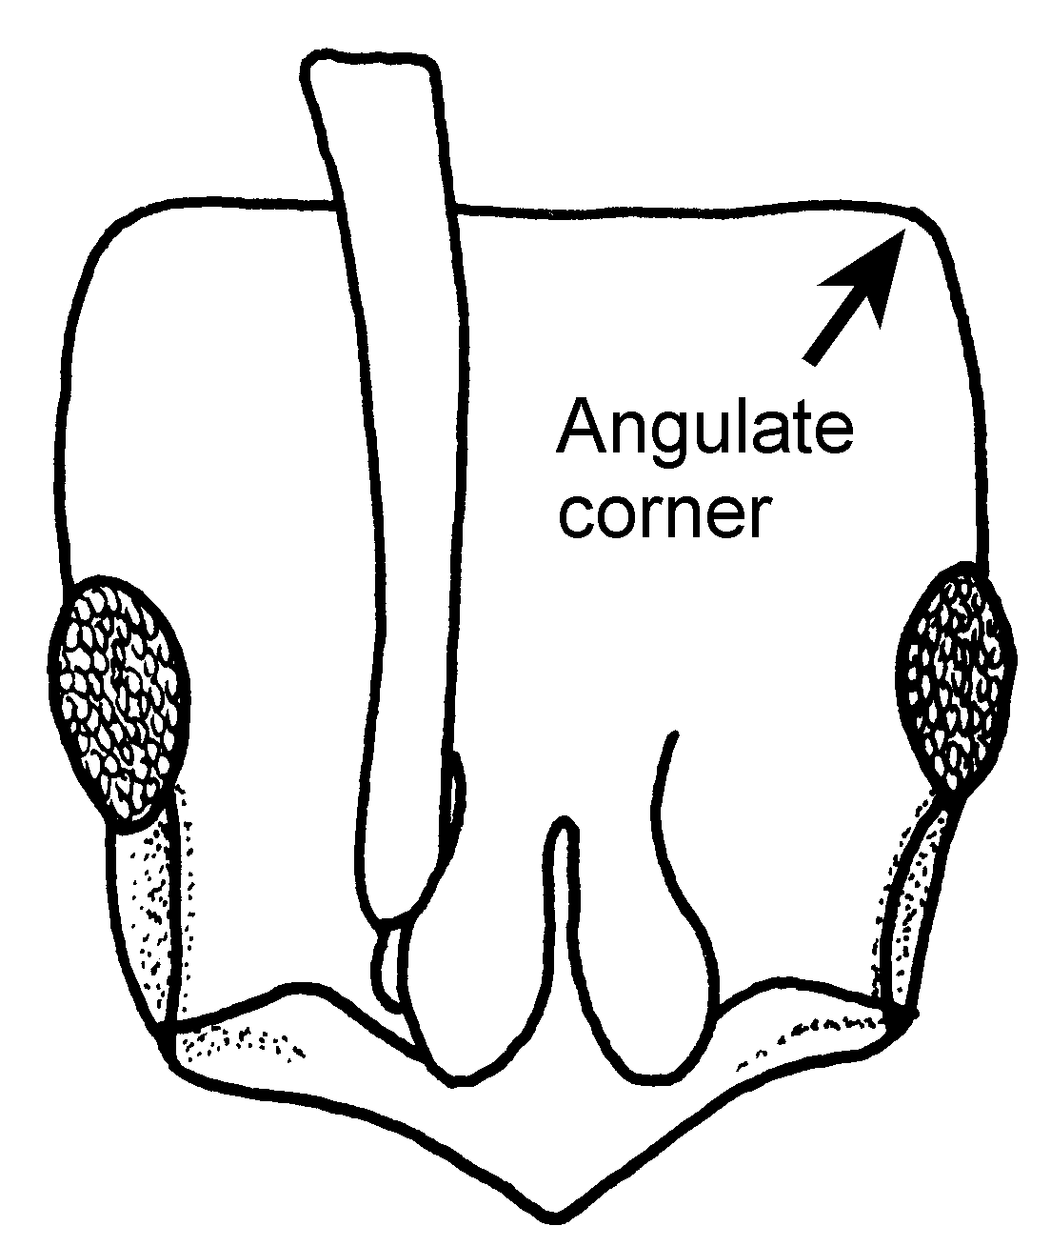
Fig. 57. Head of a worker of P. carinulata (Cuzco Amazónico, Perú).
- Head with broadly rounded posterior corners; punctures near posterior border spaced, surface moderately shining, punctures of pronotal disc spaced, fine, surface strongly shining and usually showing bluish iridescence; Amazonia to Bolivia, Guyana .………........ oberthueri Emery
32(25). Node as seen from side thick, with vertical, subparallel front and rear faces and more or less well differentiated dorsal face; sculpture of dorsa of head and trunk usually fine and dense, prevailingly opaque ........……........... 33
- Node thinner, with posterior face curving evenly into narrowly rounded apex (Figs. xx); sculpture of head and trunk mainly of fine, separated punctulae, surface prevailingly shining; Mato Grosso, rarely collected …………. ………………………….. lenkoi Kempf
33(32). Size smaller, trunk < 3.6 mm long; node thin in side view, < 1.0 mm long just above spiracle; Texas and Louisiana to northern Argentina ........... …………................. 33a
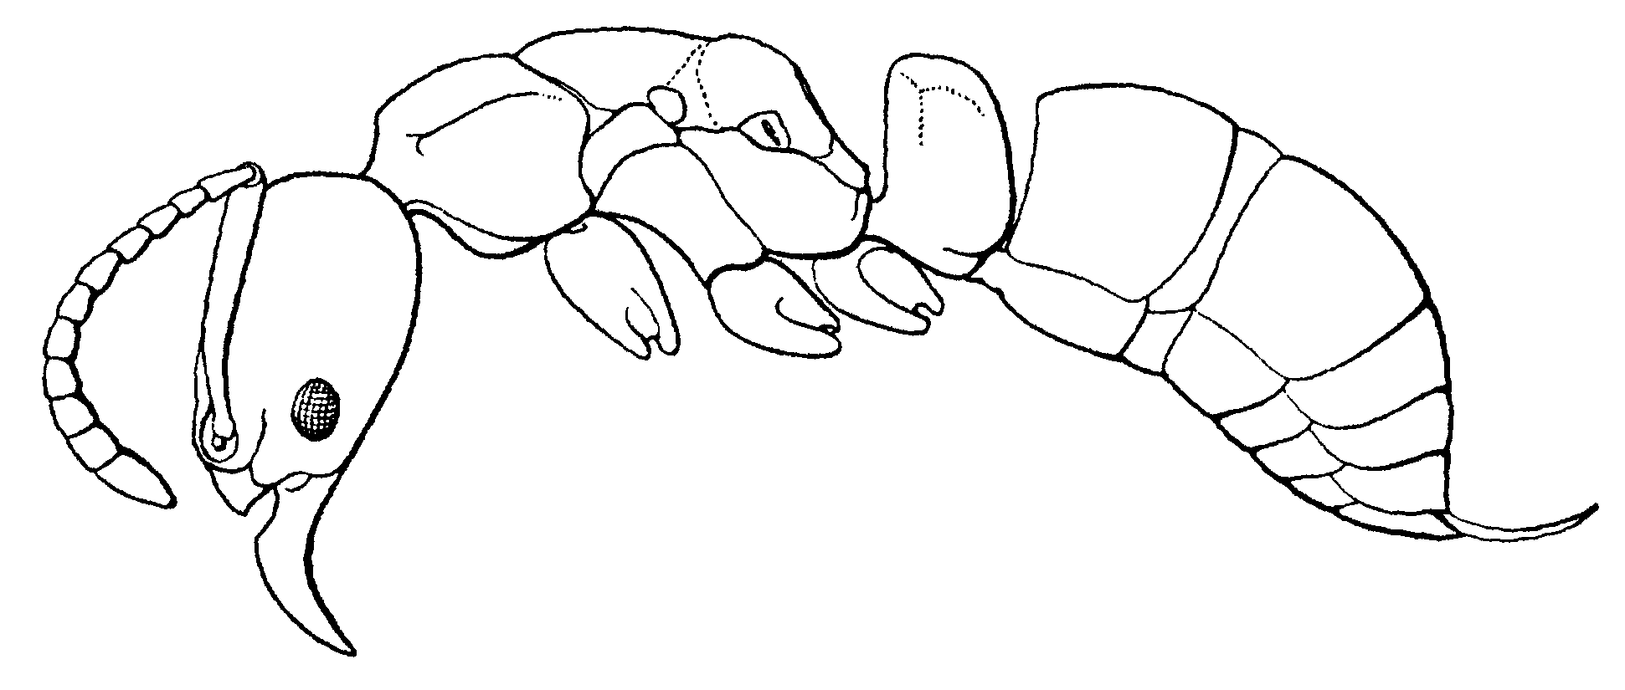
Fig. 58. Side view of a worker of P. harpax (from Creighton, 1950).

- Size larger, trunk > 3.6 mm long; petiolar node in side view 1.0 mm or more long just above spiracle ........... 34

33a(33). Clypeus without carina; pronotal shoulder with well marked carina (Fig. xx); common and widely distributed ….. ……………………. harpax (Fabricius)
- Clypeus with carina (Fig. xx); pronotal shoulder without carina; known only from Brasil ………….. lenis Kempf
Fig. 59. Head of a worker of P. lenis, showing the clypeal carina (From Kempf, 1961).
Fig. 60. Mesosoma, petiole and postpetiole of a worker of P. lenis (from Kempf, 1961).

34(33). Pronotal disc with sharp, shining, carinate lateral margins; anterior clypeal border rounded or straight in middle: pygidium punctate on sides and smooth or nearly so in middle from its acrotergite to sting base (Fig. xx); southern Brasil, Paraguay, Uruguay, northern Argentina ..…....………………... striata F. Smith
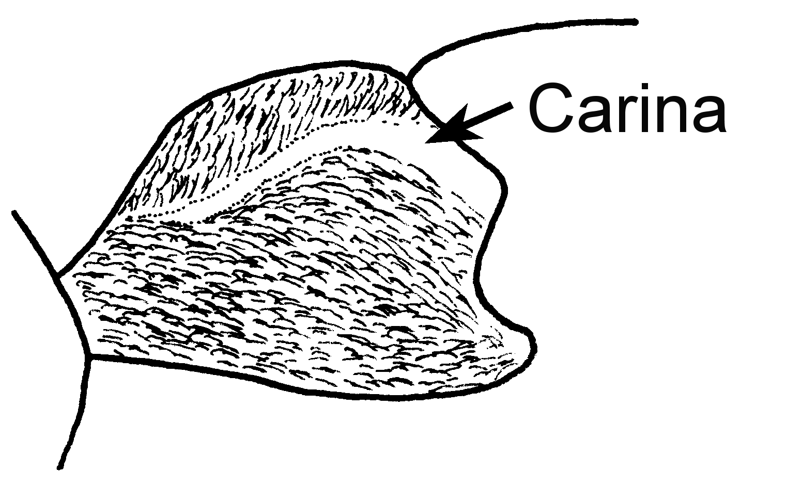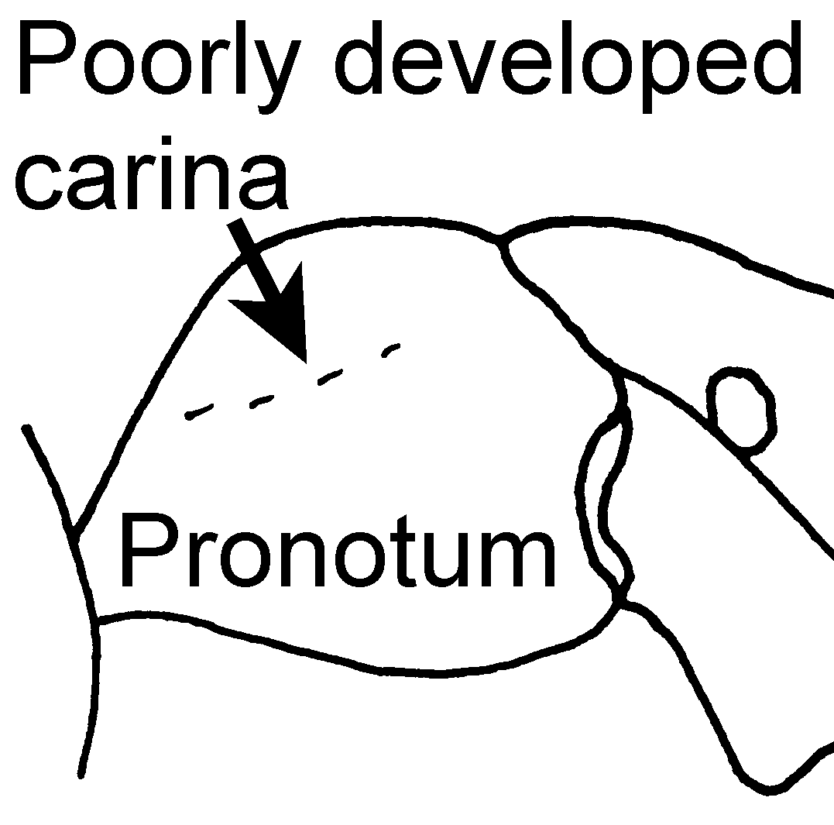
striata impressa
Fig. 61. Pronota of workers of P. striata (left, Minas Gerais, Brasil) and P. impressa (right, Guanacaste, Costa Rica), showing the well developed and poorly developed pronotal carinae.
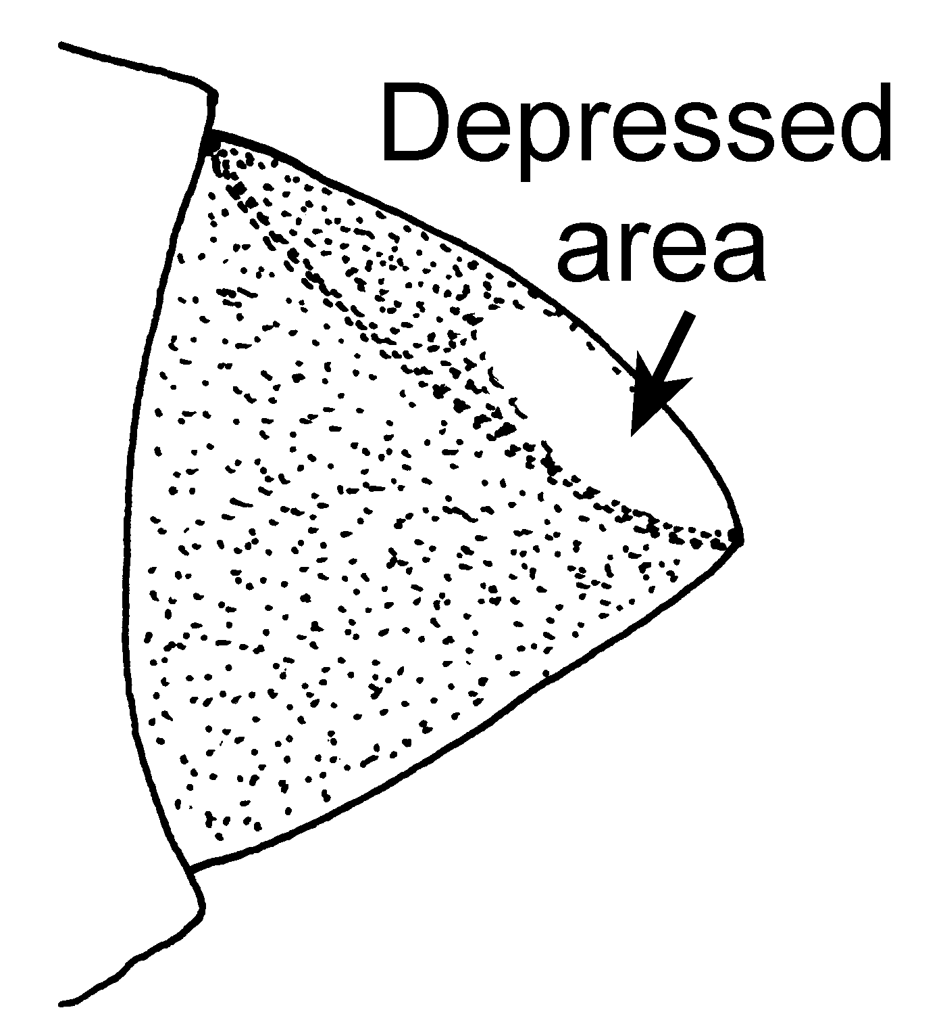
Fig. 62. Pygidium of a worker of P. striata (Minas Gerais, Brasil).
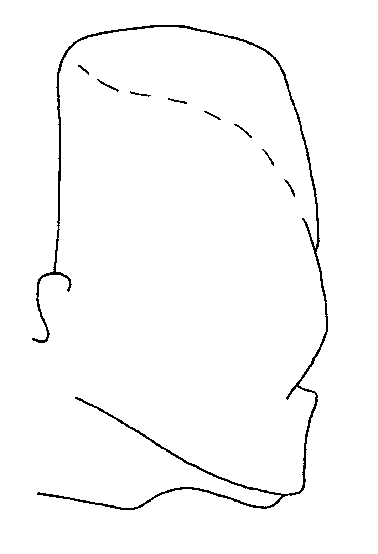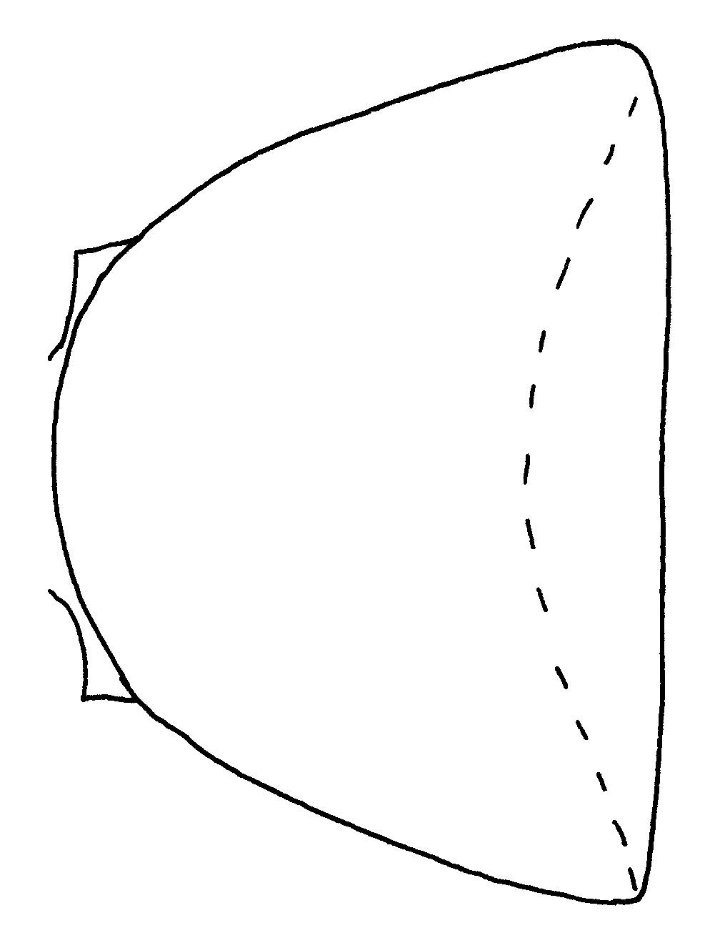
Fig. 63. Side view and top view of the petiole of a female of P. striata (from Kempf, 1961).

- Pronotal disc with indistinct or blunt margins, not carinate; anterior clypeal border feebly to deeply emarginate in middle; pygidium usually with fine, parallel, oblique rugulation on sides, which is often continuous across middle of basal part of tergum, while apical part usually bears elongate, smooth concave area; southern Mexico to mountains. of' Peru and northeastern Brasil rare in southeastern Brasil) …...………… 34a
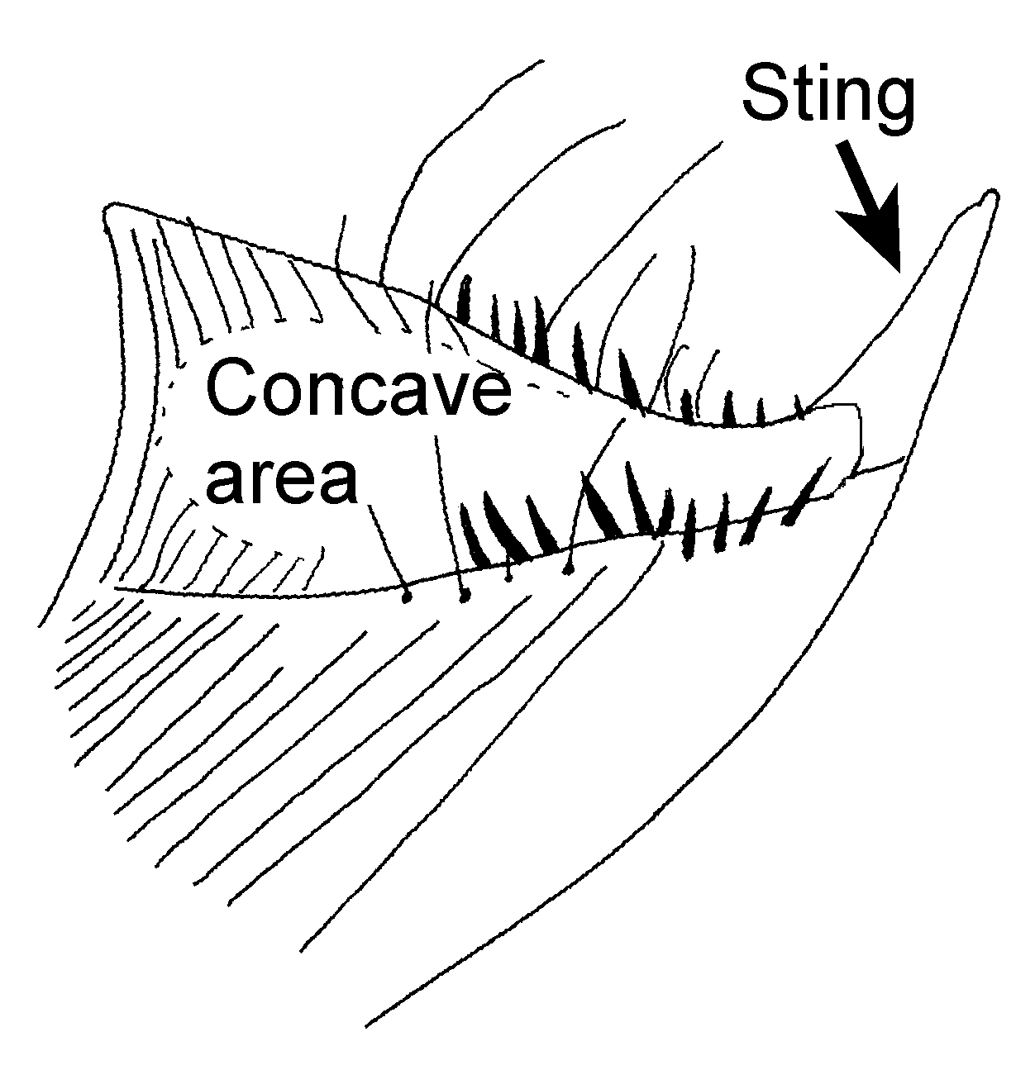
Fig. 64. Pygidium of a worker of P. impressa as seen from the side (modified from Kempf, 1961).

34a(34). Mandible with 8 - 9 teeth; pygidium always with rugae or striae on side, which often extend over dorsum of basal part of tergum, apical part slightly concave; widely distributed and common ………………….… impressa (Roger)
- Mandible with 5 - 6 teeth; pygidium without rugae or striae on side, without smooth, central region; from unknown locality in Colombia ……….….. ………………..….. fuscoatra (Roger)
35(24). In full-face view, line drawn through centers of eyes falls at or behind mid-head length (Fig. xx) …….…..... 36
- Eyes situated more anteriorly on head (Fig. xx) ……......................... 43
36(35). Petiolar node in side-view outline with steep anterior face, apex angular or sharply rounded and situated at or near front of node, followed behind by broad, descending curve of posterodorsal face; dorsolateral margins, when present, reaching to or nearly to anterior apex (Figs. xx) .........………………........................... 37
- Petiolar node in side view with anterior face rounding into dorsal face, which rises caudad to narrowly rounded posterior summit; lateral margins nearly vertical, posterior, separating lateral from posterior faces of node; 4 - 5 apical antennomeres largely or entirely contrasting yellow (Figs. xx) ............ 42
37(36). Apex of node narrowly rounded and dorsal lateral margins absent; slender species with posterior margin of head straight or even feebly convex in full-face view; antennal scapes long, SI >120 (Figs. xx); Costa Rica …….. dismarginata n sp
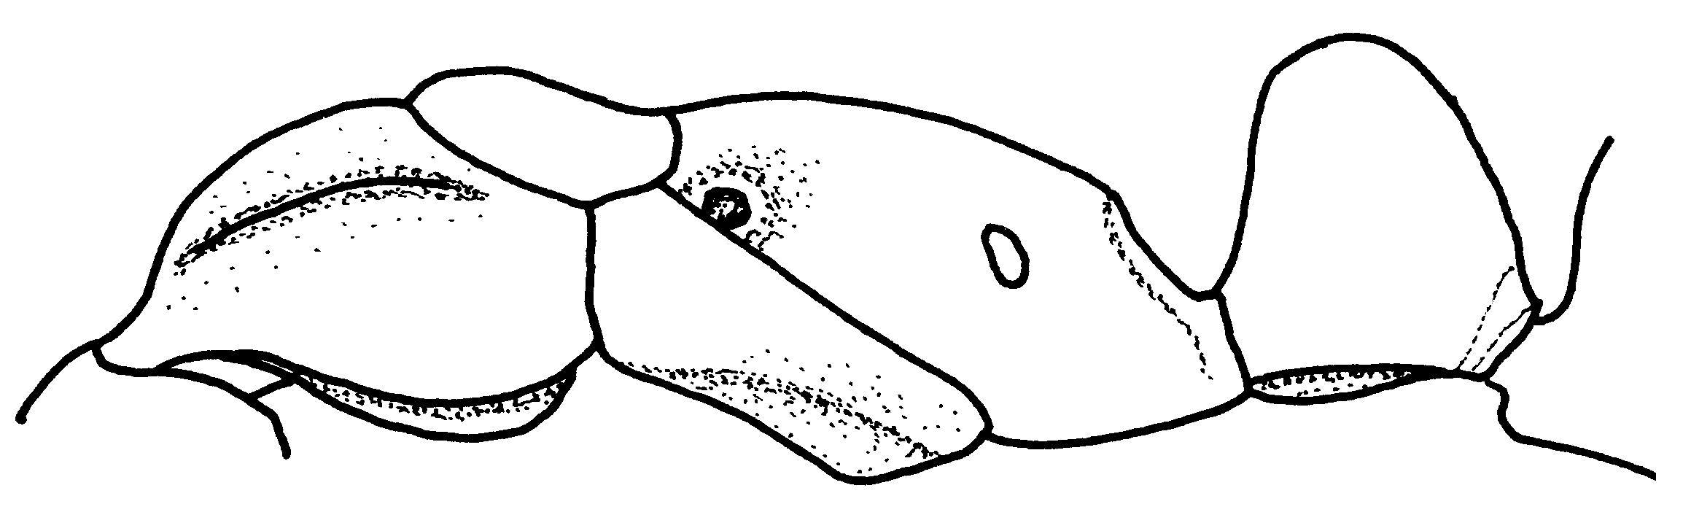Fig. 65. Mesosoma and petiole of a worker of C. dismarginata (Heredia, Costa Rica).
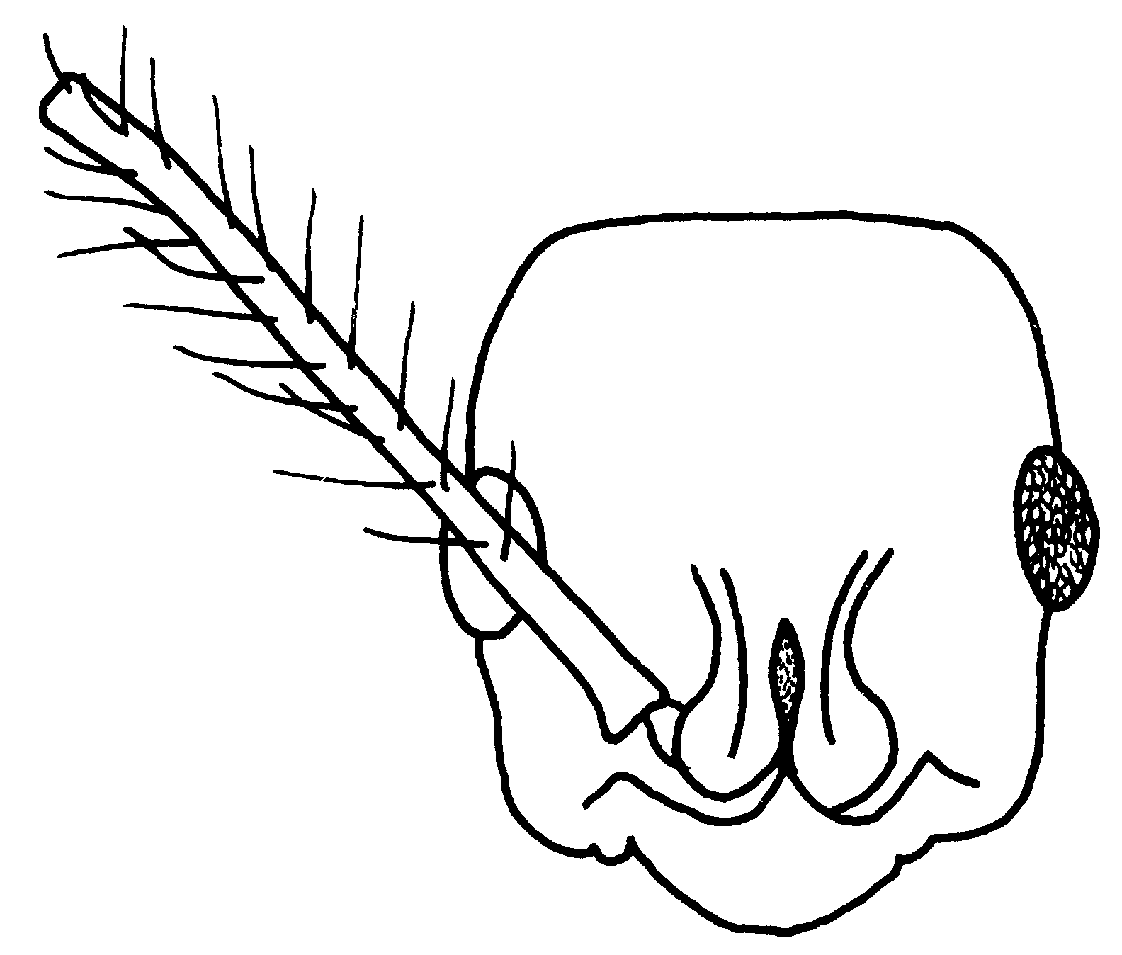
Fig. 66. Head of a worker of C. dismarginata (Heredia, Costa Rica).

- Apex of node rectangular and its dorsolateral margins well marked and complete to apex …………………... 38

38(37). Dorsum of head covered with very coarse, diverging longitudinal striation, free of pubescence, shining and contrasting strongly with surrounding areas of fine sculpture and pubescence; center of posterior face of node usually coarsely vertically rugose (rarely not); tropical Mexico to Panamá ........ lineaticeps Mayr

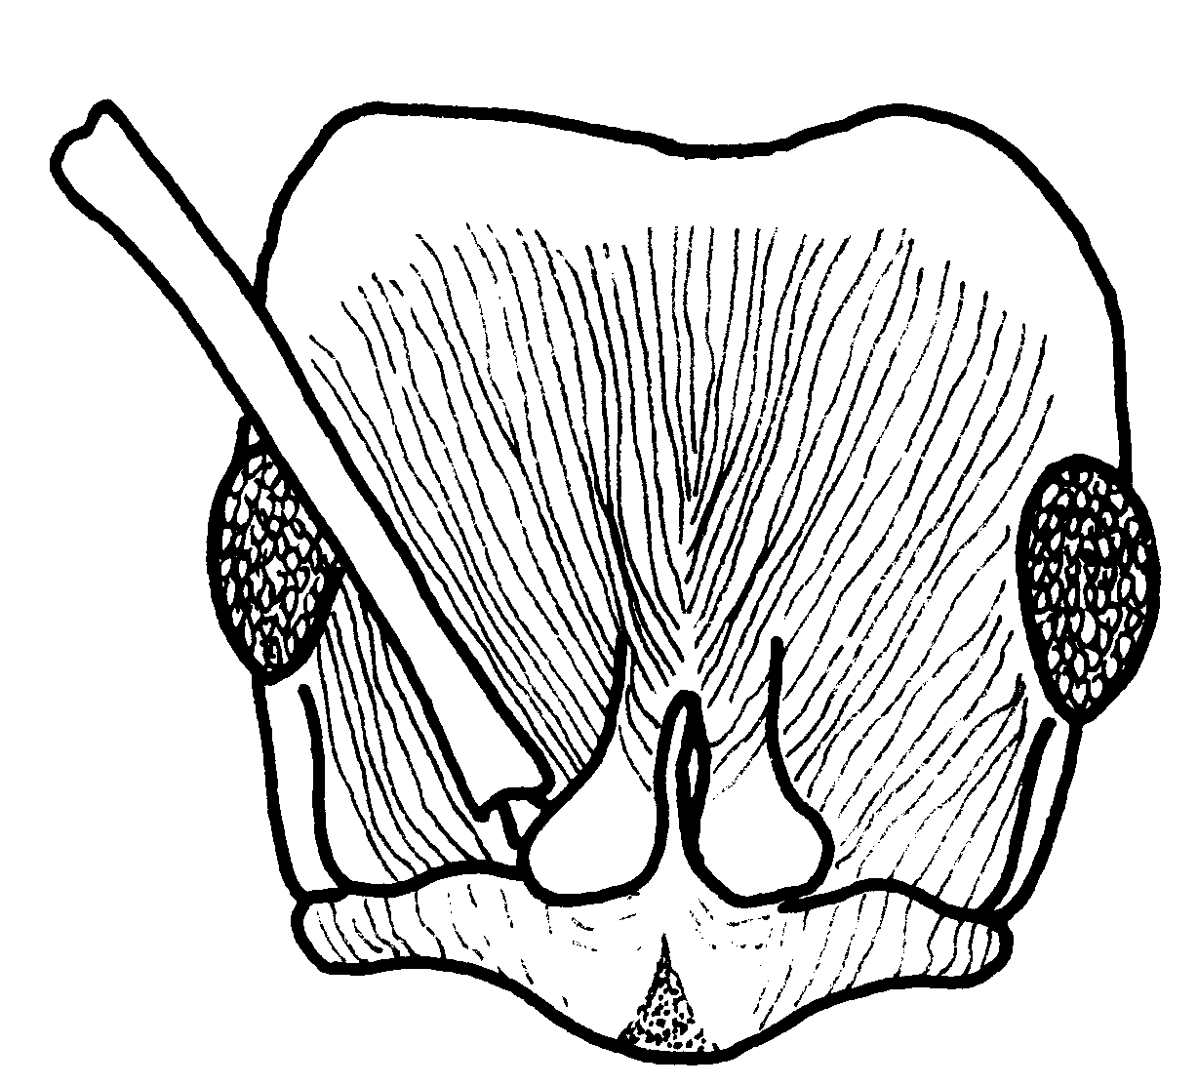
Fig. 67. Head of a worker of P. lineaticeps (Ocosingo, México).
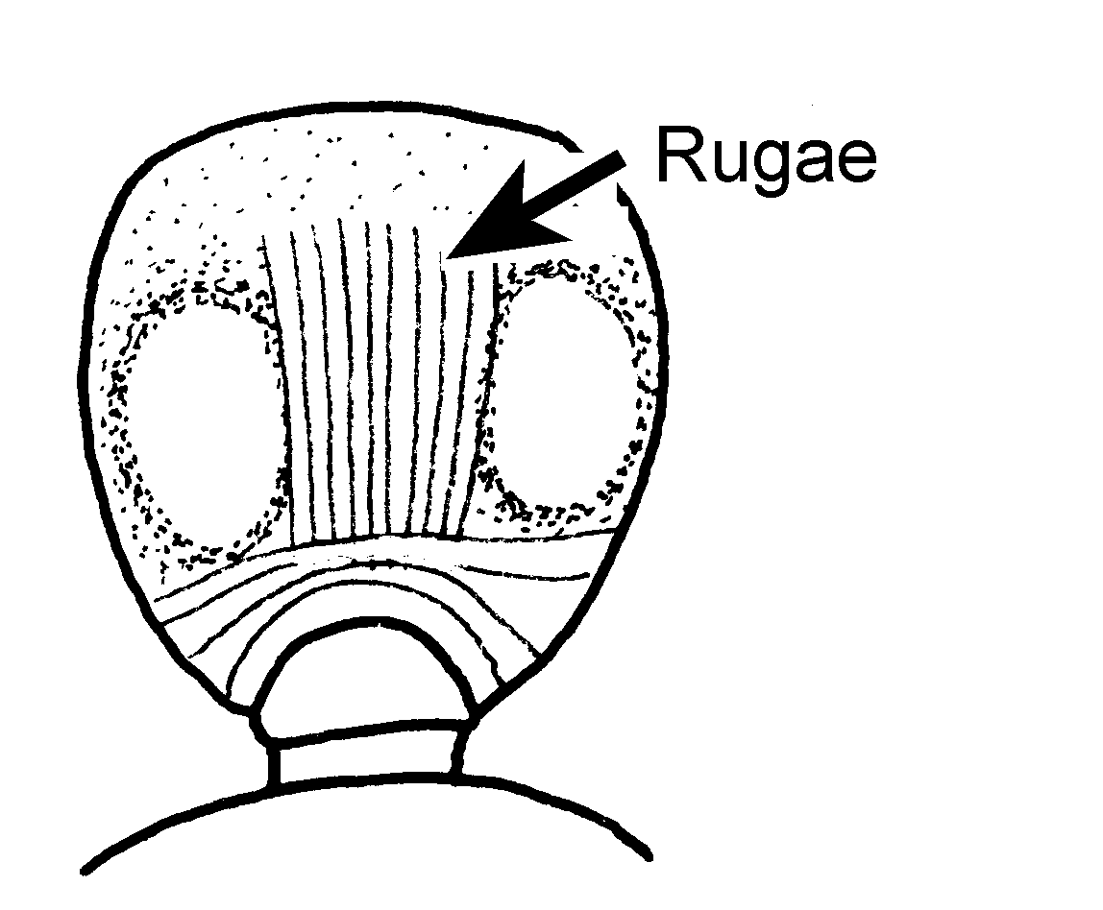
Fig. 68. Posterior face of the petiole of a worker of P. lineaticeps (Ocosingo, México).

- Vertex with sculpture and pubescence like most of remaining dorsum of head, punctulate or finely striate; posterior face of node sculptured differently (transversely striate or with indefinitely oriented rugosity or punctulae) ........ 39
39(38). Posterior face of petiolar node coarsely, tranversely striate to apex; head width including eyes > 2.0 mm; clypeus broad rounded in middle and unarmed; legs black to dark brown; Costa Rica to Bolivia ........ scalaris n. sp.

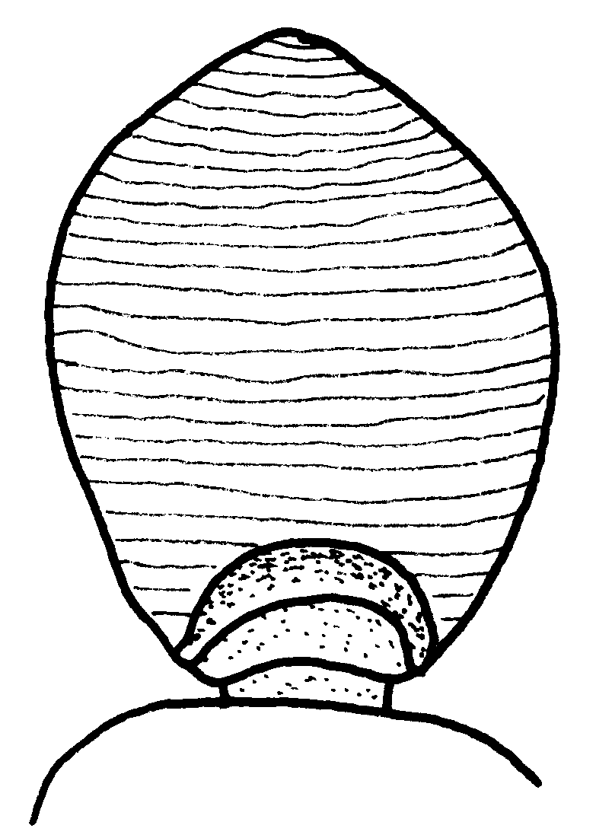
Fig. 69. Posterior face of the petiole of a worker of P. scalaris (Paracou Experimental Forest, French Guiana).
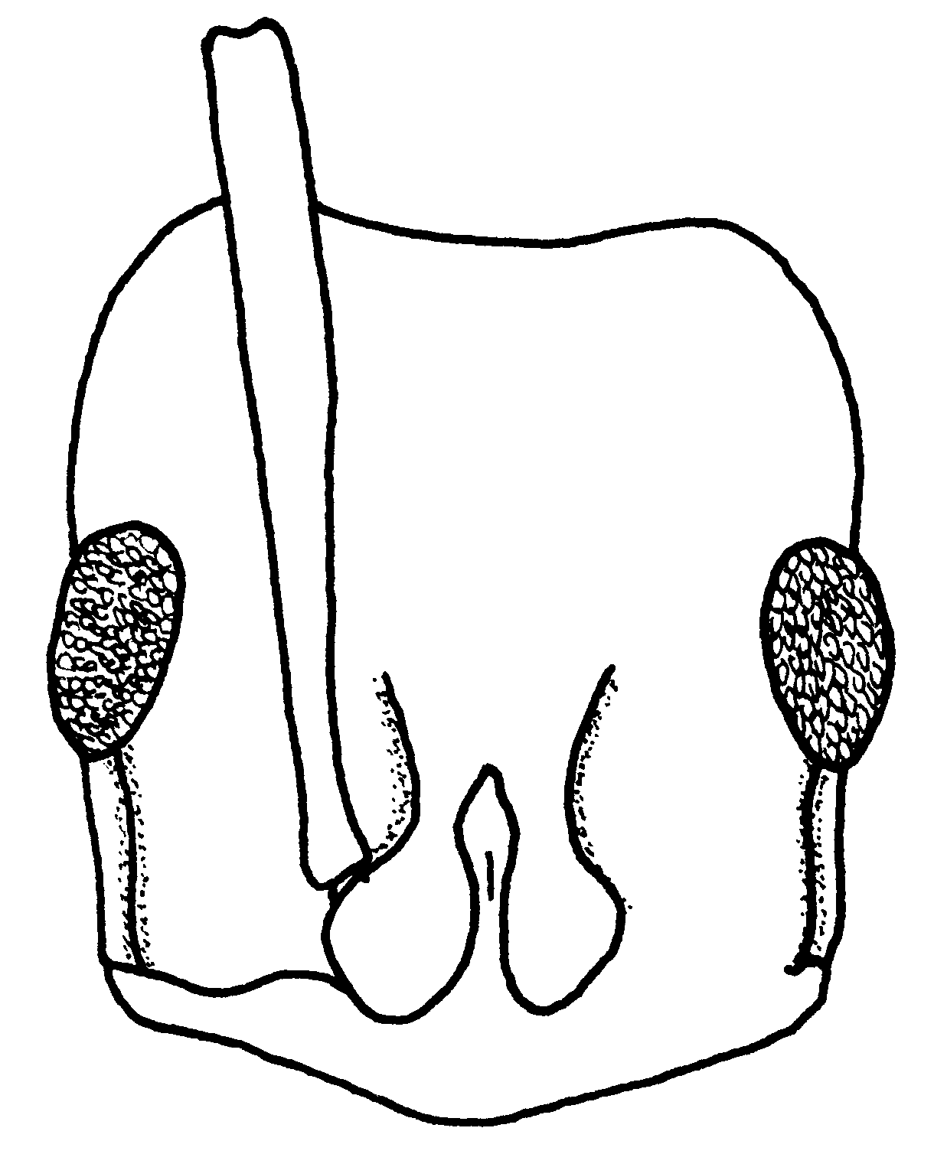
Fig. 70. Head of a worker of P. scalaris (Paracou Experimental Forest, French Guiana).

- Upper third of posterior face of petiolar node finely punctulate or otherwise sculptured, not transversely striate .......….............…………....... . 40

40(39). Sides of node longitudinally striate or rugulose on lower half or more; often irregularly striate or rugulose on lower part of posterior face as well; head width including eyes averaging < 2.2 mm in few specimens available (Fig. xx); Central America to Peru ..……….... ………………………… theresiae Forel
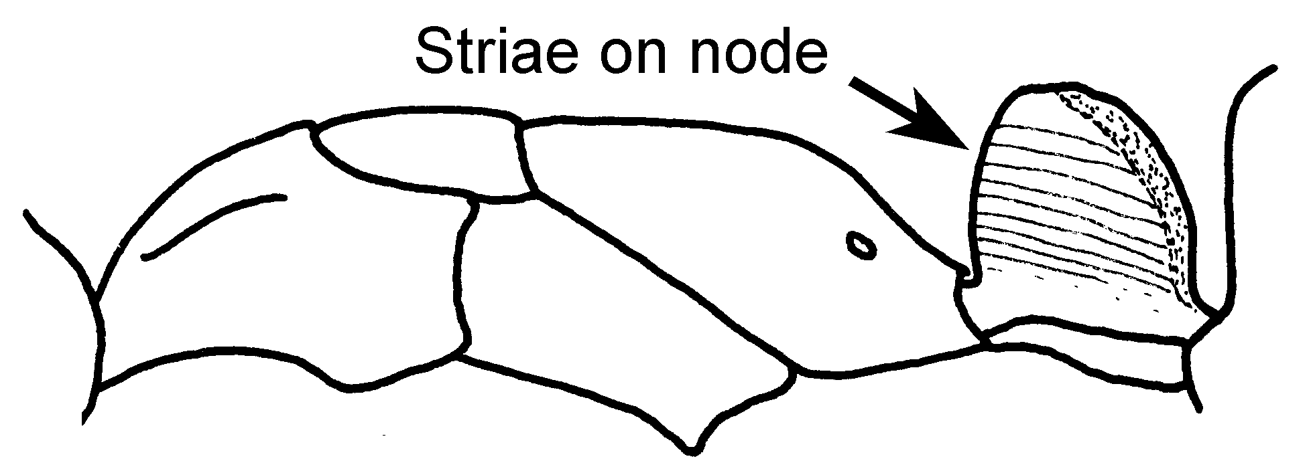Fig. 71. Mesosoma and petiole of a worker of P. theresiae (syntype).

- Sides of node finely punctulate, surface weakly shining ...……............ 41
41(40). Larger, more robust species, head width, including eyes usually > 2.2 mm, width of pronotal disc > 1.55 mm; legs red to black, but if red, then parts of propodeum, base of node and base of gaster also suffused with red (Figs. xx); southern Texas to northern Argentina …………………….. villosa (Fabricius)
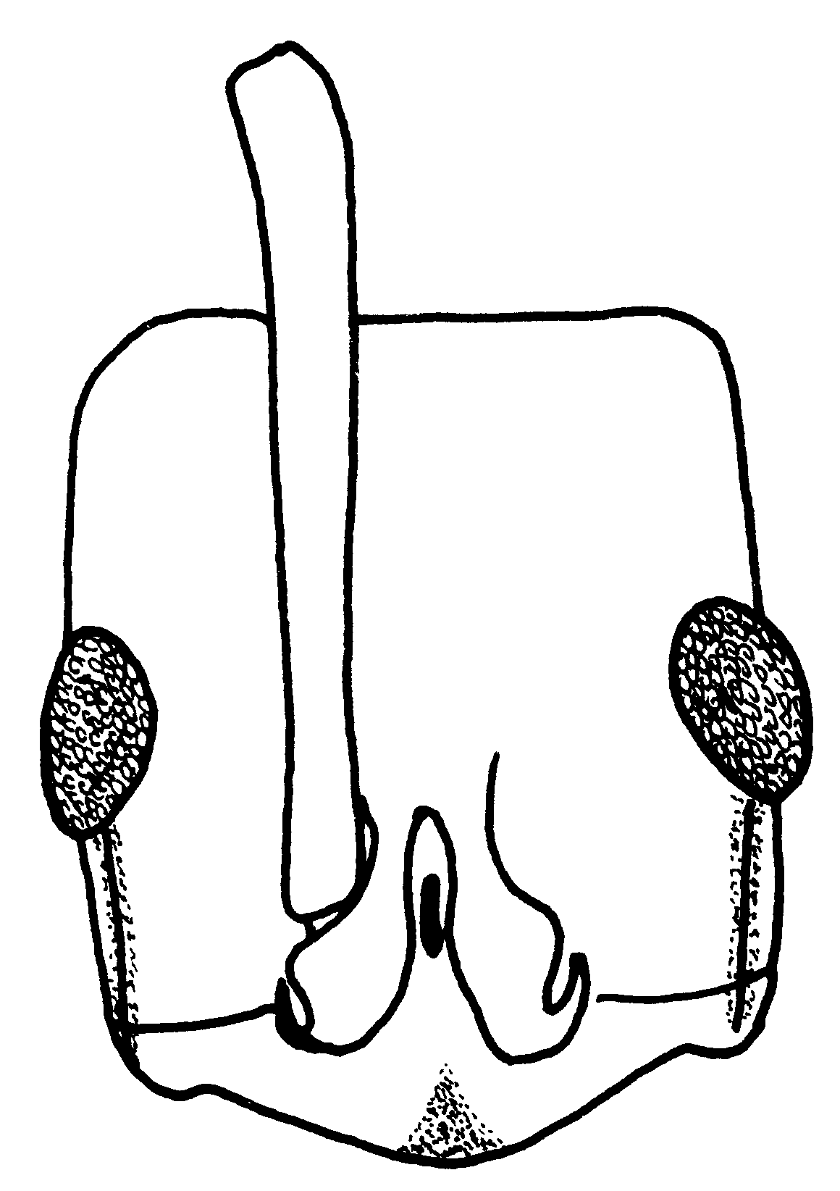
Fig. 72.Head of a worker of P. villosa (Madre de Dios, Perú).

- Smaller and more slender species (Fig. xx), width of worker head including eyes < 2.2 mm; width of pronotal disc < 1.55 mm; body piceous to black, legs clear, bright brownish-red; Central America to Ecuador; problematic species .......…………………. bugabensis Forel
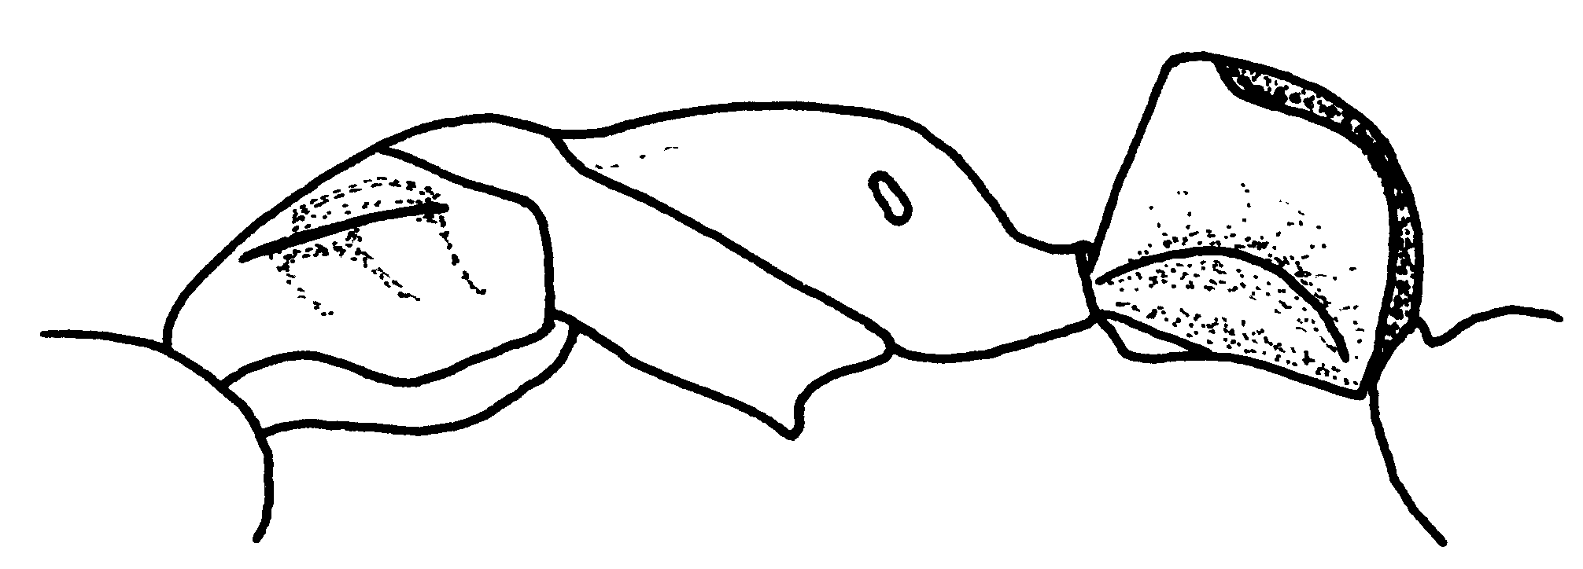Fig. 73. Mesosoma and petiole of a worker of P. bugabensis (Alajuela, Costa Rica).

42(36). Head finely but distinctly striate; mesosoma and petiole with extensive striolate areas; standing hairs abundant and generally distributed on all dorsal surfaces of head and body and all surfaces of scapes and legs (Amazonia) .......... ………………......... eboritacta n. sp.

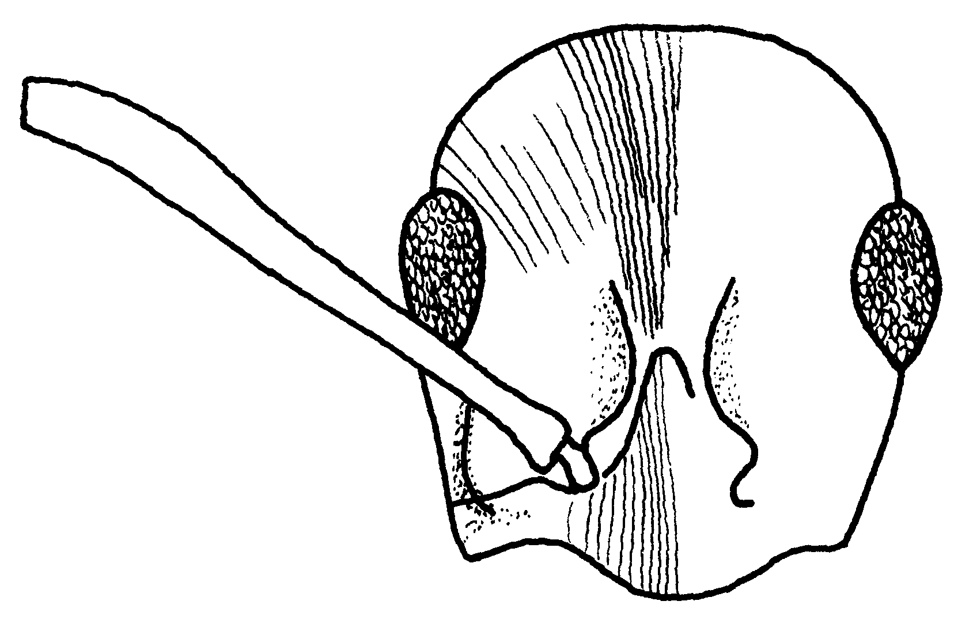
Fig. 74. Head of a worker of P. eboritacta (Amazonas, Brasil).
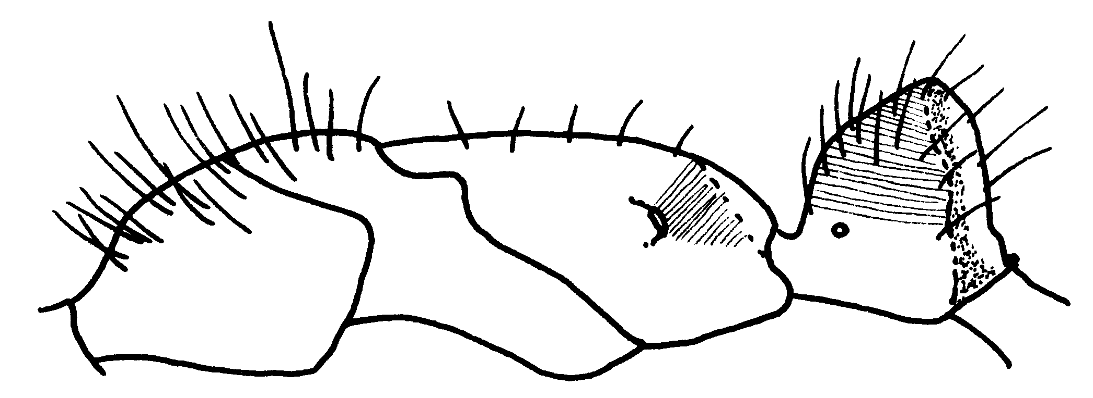Fig. 75. Mesosoma and petiole of a worker of P. eboritacta (Amazonas, Brasil).
- Sculpture overall prevailingly opaque, densely punctulate; standing hairs rare (0 - 10 or so) on promesonotum, usually fewer then 15 on petiolar node; very few on femora and tibiae, where they are usually restricted to flexor surfaces (central and SW Amazonia; see couplet 6) occasional samples of apicalis (Latreille)
43(35). Sides of node covered with coarse longitudinal striation; as seen in side view, dorsal outline of node evenly convex and rising only gently caudad (Fig. xx); Mts. of western Colombia ....................……...…....... holcotyla n. sp.
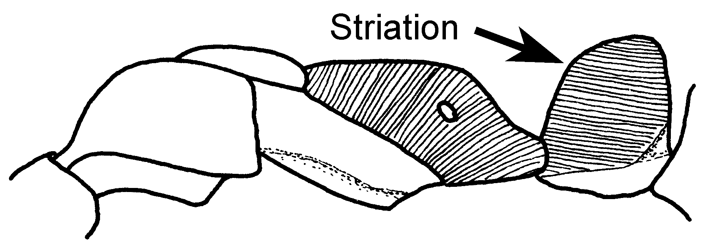Fig. 76. Mesosoma and petiole of the holotype major worker of P. holcotyla (holotype).

- Sides of node finely punctulate or nearly smooth; striation. if present, fine and largely restricted to lower half ..........…………………...................... 44

44(43). Worker node as seen from directly above nearly as long as broad to distinctly longer than broad (but node in queen usually shorter and broader than in corresponding worker) ...……....... 45
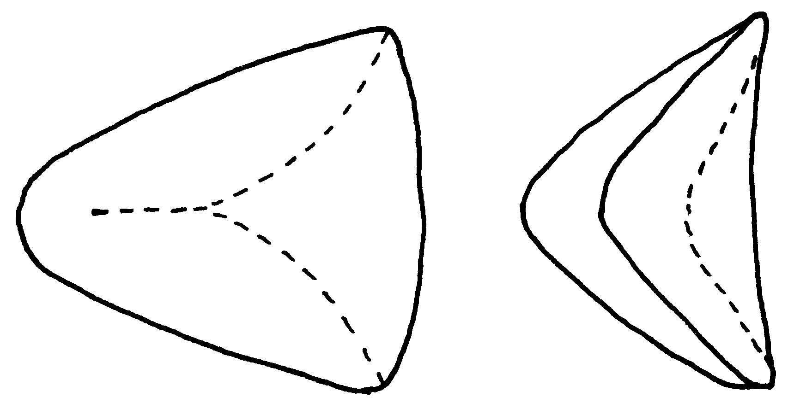
chyzeri carbonaria
Fig. 77. Petiolar node of a worker of P. chyzeri (left, Valle de Cauca, Colombia) and P. carbonaria (right, C32, Colombia) as seen from above.

- Node as seen from above distinctly broader than long .........….. 47
45(44). Size larger, maximum worker head width excluding eyes > 2.4 mm; body and legs black, pubescence bright golden yellow Mts. of SW Colombia to Bolivia) ……………….. chyzeri (Forel)
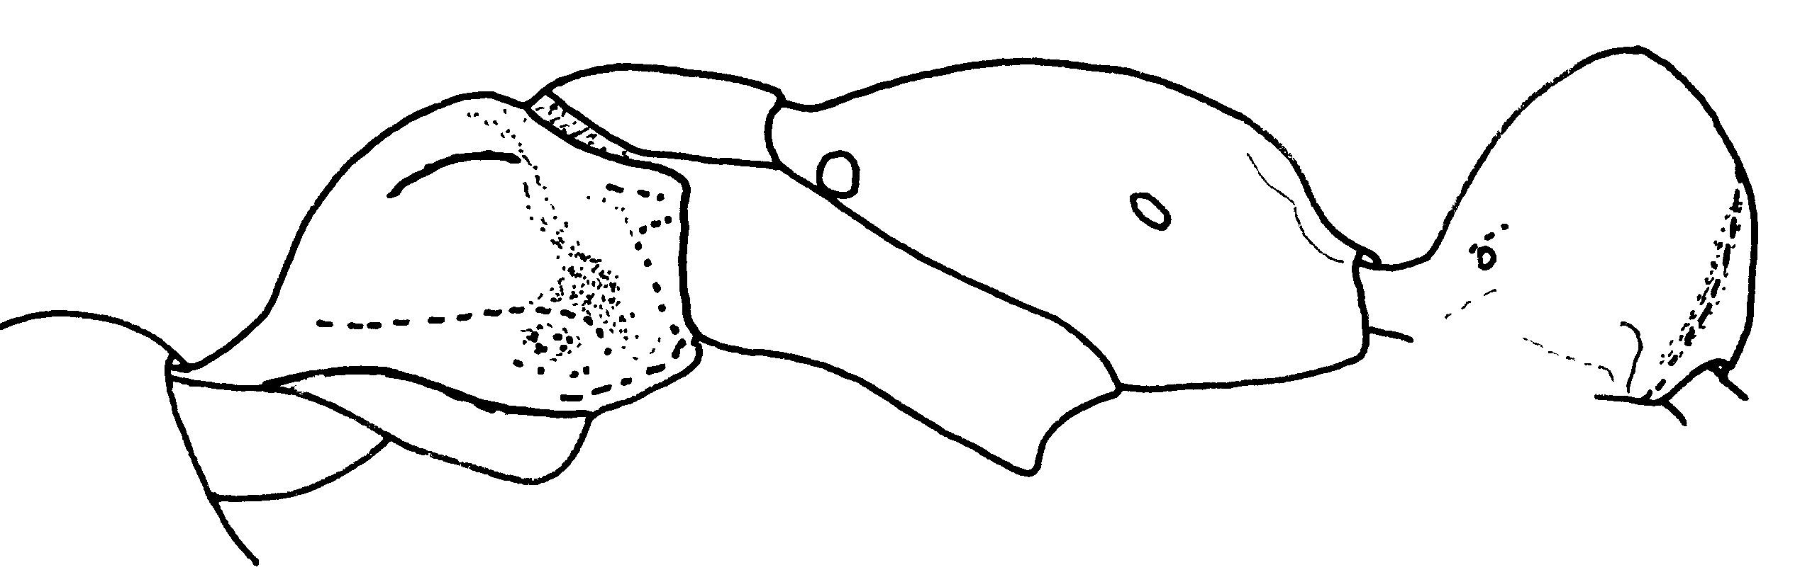Fig. 78. Mesosoma and petiole of a worker of P. chyzeri (Valle, Colombia).
- Size smaller, maximum worker -queen head width excluding eyes < 2.4 mm ....……………………........ 46
46(45). Color black with bronzy reflections, legs and antennae bright brownish-red; pubescence abundant, long and conspicuous, bright reddish-golden; Mts. of Ecuador ……… ……………..………. eleonorae (Forel)
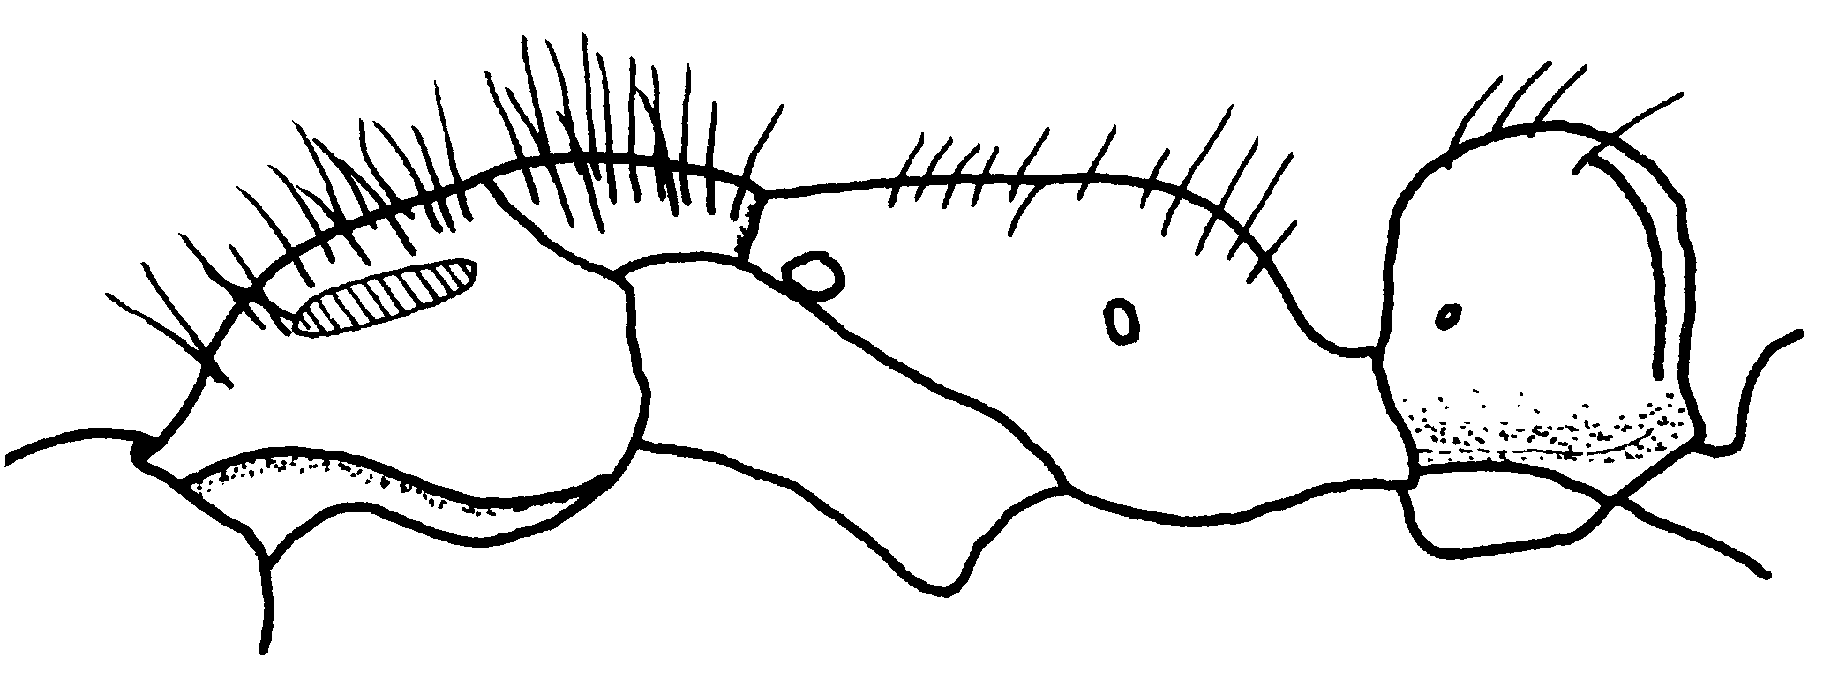Fig. 79. Mesosoma and petiole of a worker of P. elenorae (2 mi W Baños, Ecuador). The hatched area on the pronotum indicates a swollen region.

- Color black, often with blue reflections in clean specimens, legs and antennae black or dark brown (antennae with yellow apices, as in P. apicalis, in some southwestern Colombian samples); pubescence abundant, but short, not especially conspicuous, yellowish-gray to dark reddish in color; Mts. of Colombia to Bolivia ....... fauveli Emery
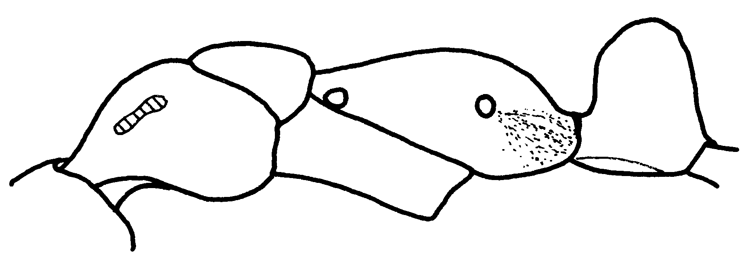
Fig. 80. Mesosoma of a worker of P. fauveli (Machu Picchu. Perú).
47(44). Node as seen from side subcuboidal (Fig. xx), only weakly tapered apicad; apex tending to be horizontal and only gently convex (dwelling in Cecropia trees) .……..... 48
- Node as seen from side higher, strongly tapered apicad with acute or narrowly rounded apex; black, often with colored metallic tints .................. 49
48(47). Anterior clypeal border indented and depressed in middle of anterior border; size larger (HW worker > 0.80, queen > 1.05 mm); petiolar node broader (W worker > 0.50, queen > 0.65 mm); worker basic color black (Figs. xx); Panamá ........ dianae n. Sp.
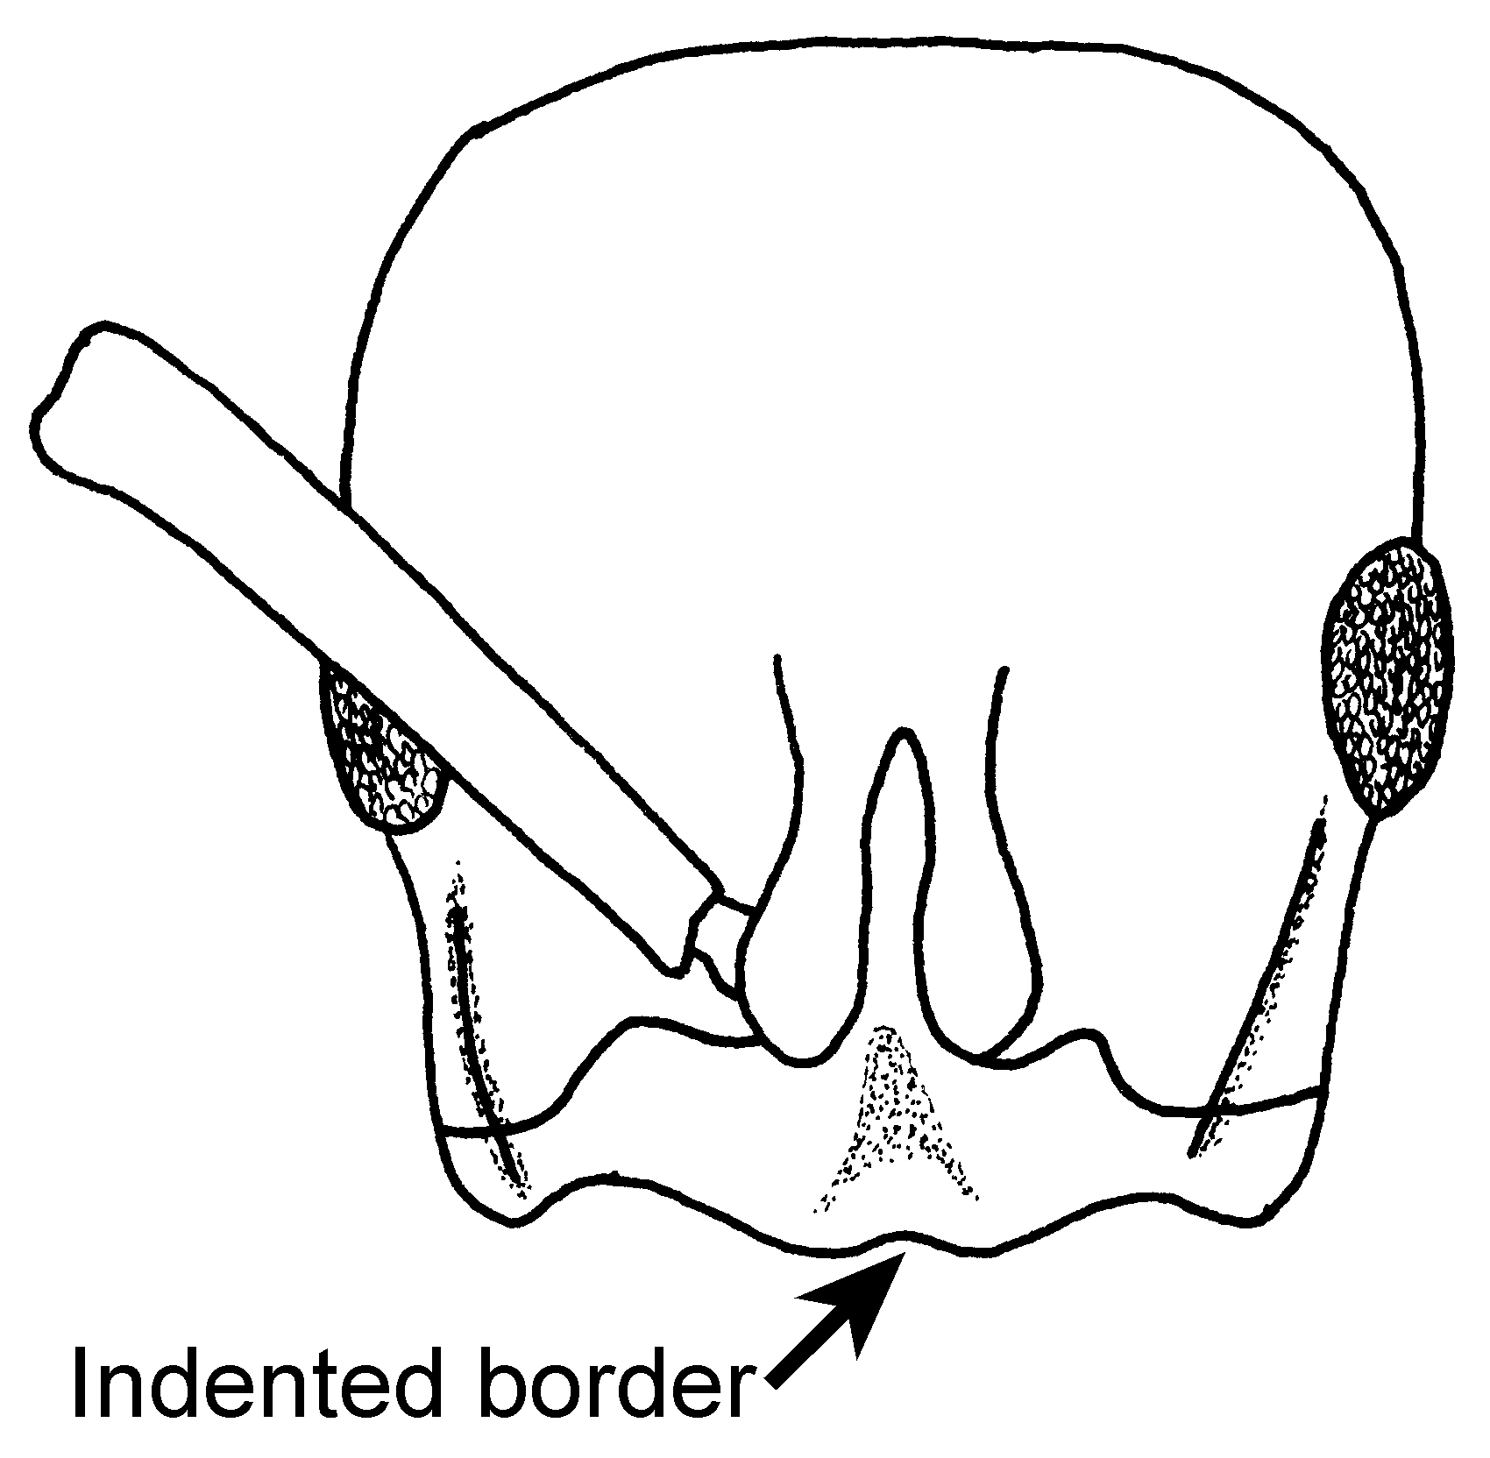
Fig. 81. Head of the “holotype” worker of P. dianae.

- Anterior clypeal border straight to weakly convex in outline mesad; size smaller (HW worker < 0.70, queen < 1.05 mm); petiolar node narrower (W worker < 0.70, queen < 0.56 mm); worker basic color yellowish-brown to dark brown; Amazonian Peru .…........ ………………………... luteola (Roger)
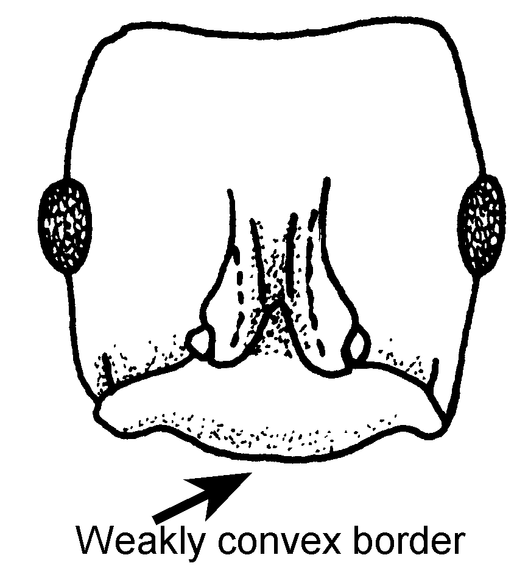
Fig. 82. Head of a cotype worker of P. luteola.
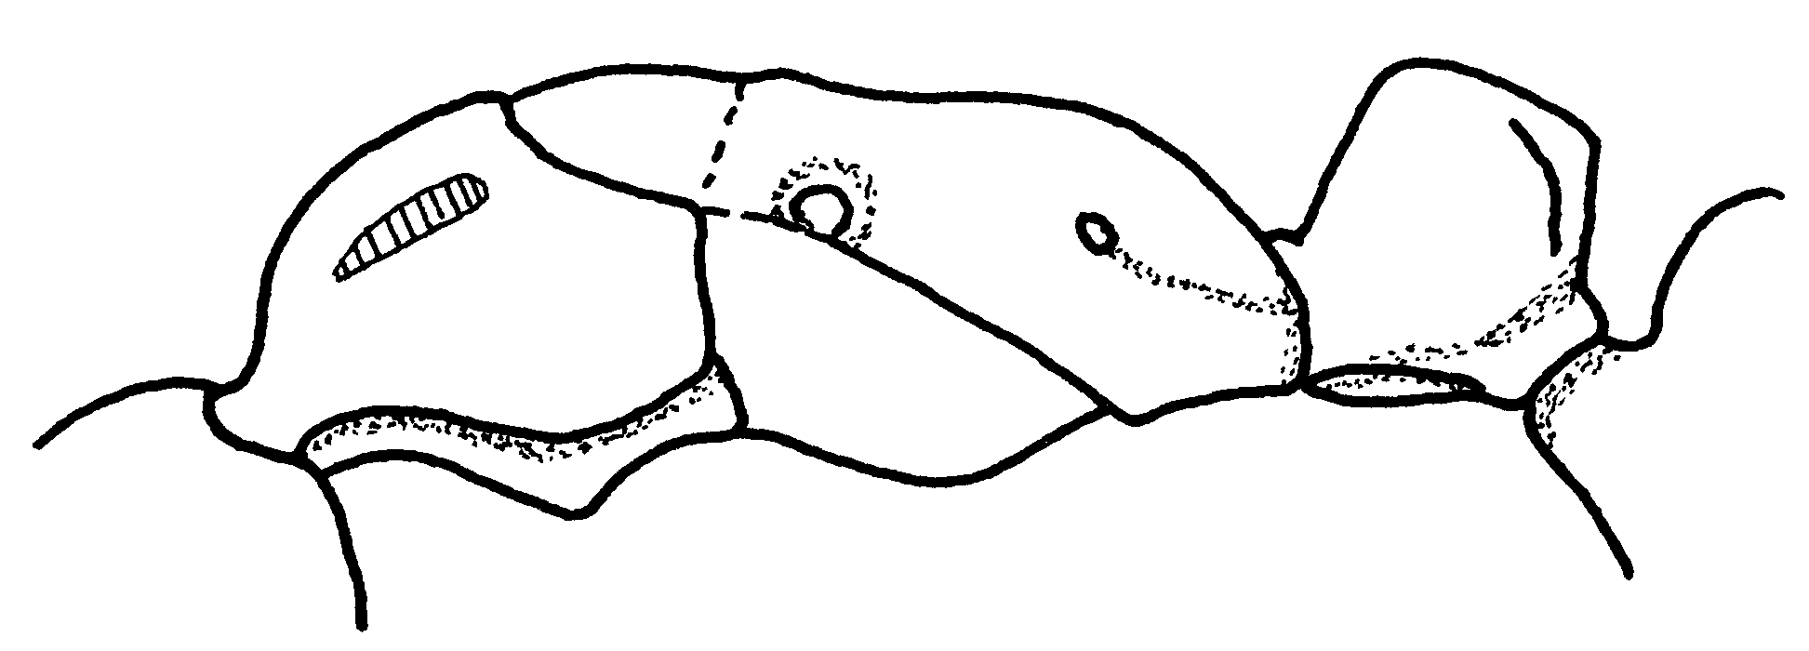Fig. 83. Mesosoma and petiole of a cotype worker of P. luteola. The hatched area on the pronotum indicates a swollen region.
49(47). Body shining nearly throughout, especially dorsum of trunk, which is finely and rather sparsely punctulate; and thus nearly smooth (Fig. ); Nicaragua south to mts. of Ecuador to southwestern Venezuela .........… ………………..… carbonaria (F. Smith)
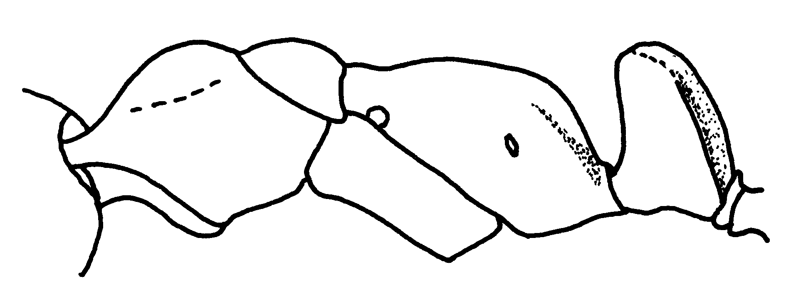Fig. 84. Mesosoma and petiole of a worker of P. carbonaria (Selva Negra, Nicaragua).

- Body densely rugulose- punctulate to punctate and opaque, except for shining, finely punctulate gaster; Mts. of Central America to Colombia ................... aenescens Mayr
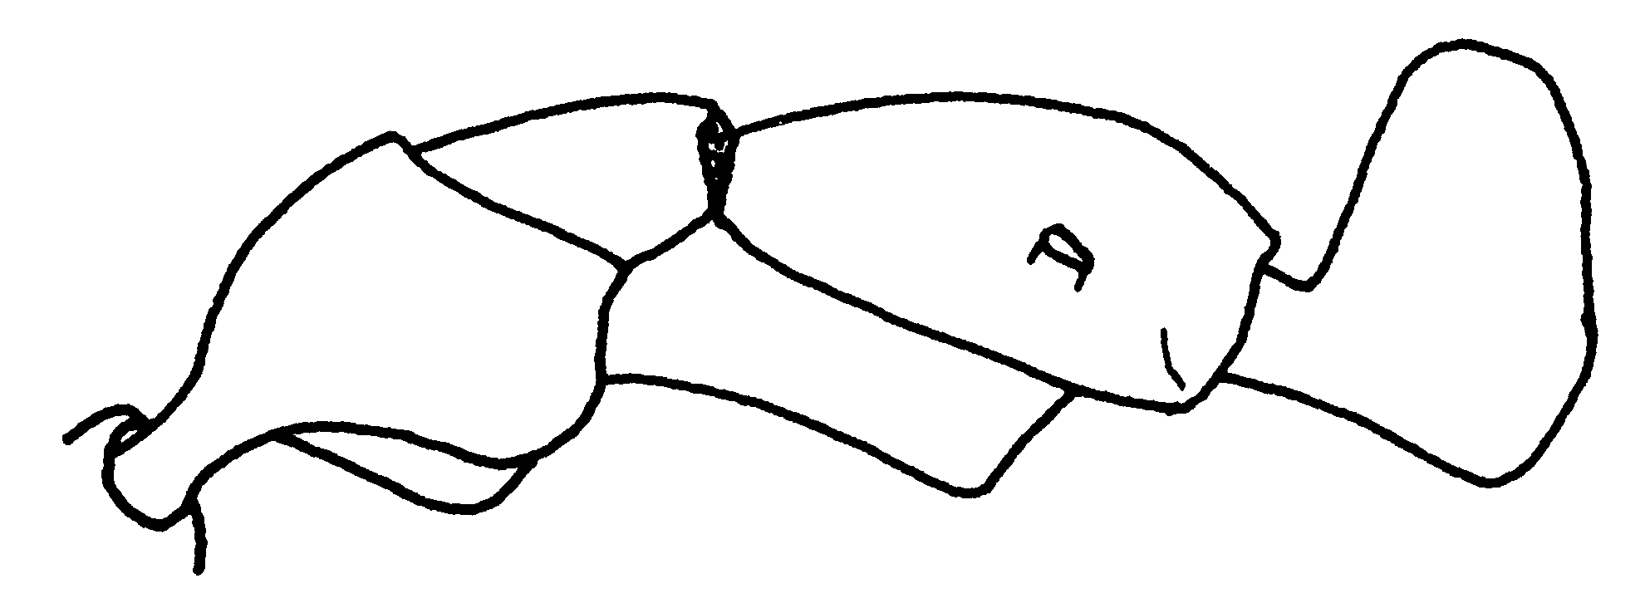
Fig. 85. Mesosoma and petiole of a worker of P. aenescens (Colombia).

List of species

Pachycondyla agilis (Forel) * SA

Pachycondyla aenescens Mayr
Figs.  M76, H 77 ; Map 1

Discussion. The worker is a moderate sized ant (total length about 9 mm). The anterior border of the clypeus is indented medially, the eye is relatively large, and is located about one diameter from the insertion of the mandible. The scape extends about two funicular segments past the posterior lateral corner. The carina is not developed anterior to the eye, but is represented by a swollen region near the base of the mandible The pronotal shoulder is swollen, and nearly forms a carina, the metanotal suture is depressed on the dorsum of the mesosoma, and breaks the integument. The petiole is nearly rectangular shaped, but is noticeably narrowed toward the apex. The stridulatory file is present on the dorsum of the gaster (Fig. xx).
Most of the mandible is roughly sculptured, but it is smooth and shiny near the apex. The head and mesosoma are mostly punctate, with some evidence of striae, especially on the dorsum of the head, the mesopleuron, and the side of the propodeum. The petiole is finely punctate, and some areas, especially the posterior face, partially smooth and shiny. The gaster is very finely sculptured, and mostly shiny.
Erect hairs are moderately abundant on all surfaces, including the dorsum of the mesosoma, and the petiole.
The worker is mostly black, with the appendages being slightly lighter in color.
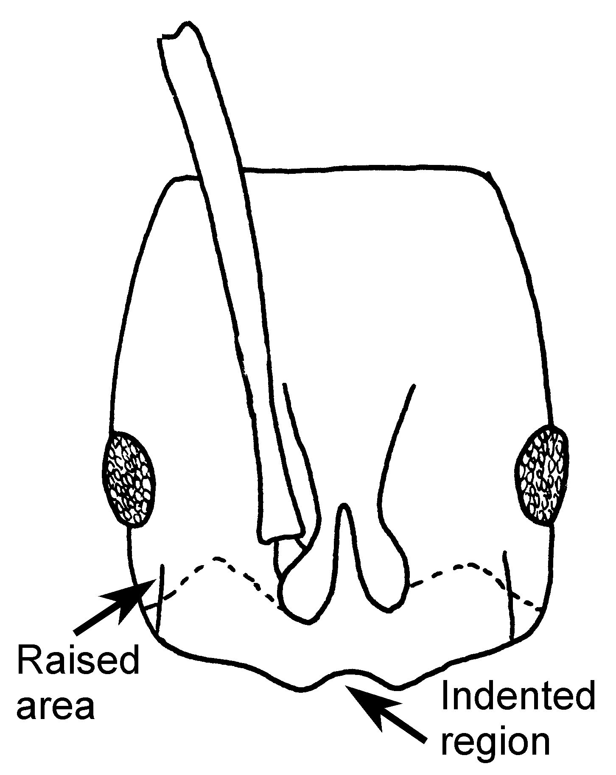
Fig. 86. Head of a worker of P. aenescens (Colombia).
This species could be confused with Pachycondyla harpax, but can be easily separated, as the metanotal suture of P. harpax does not break the integument on the dorsum of the mesosoma. It differs from P. carbonaria in lacking the shiny appearance of the dorsum of the head, and the pronotum. The shape of the petiole would separate it from P. dianae and P. luteola, in which the petiole is not narrowed gradually to the apex.

Distribution.: NICARAGUA (Matagalpa) Hotel Selva Negra, 139 km N Matagalpa), COSTA RICA (San José, Puntarenas, Guanacaste), PANAMA (Chiriquí), COLOMBIA (Valle del Cauca: Bosque Yotoco).
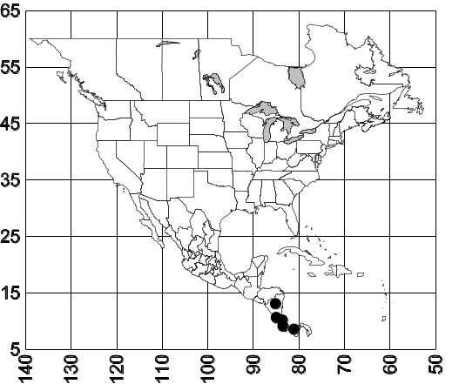
Map 1. Distribution of P. aenescens.
Habitat. Wet, tropical rain forest to dry oak forest.
Biology. Unknown, specimens are often collected in pitfall traps or extracted from litter.

Pachycondyla apicalis (Latreille)
Figs.  M, H 78 ; Map 2

Discussion. This species is easily recognized, even in the field, as being a moderately large ant (total length 15 mm), and by the yellow tip of the funiculus. The eyes are large, with a diameter greater than the distance to the insertion of the mandible, and occupy about one third of the distance of the side of the head. A well defined carina is present between the anterior edge of the eye and the clypeus. The mesosoma is weakly depressed at the metanotal suture, the petiole is thick and cuboidal shaped when viewed in profile. The stridulatory file is present on the dorsum of the gaster, but is poorly defined.
The mandibles are moderately shining, with fine striate, the remainder of the ant is densely, but finely punctate, with all surfaces dull.
Erect hairs are sparse, and restricted to the head and the gaster. The dorsum of the mesosoma, and petiole are without erect hairs (rarely erect hairs are found on promesonotum, and node of the petiole, in samples from the Amazon). There are a few suberect hairs on the flexor surface of the distal half of the tibiae.
This common ant is mostly black, except for the yellow distal half of the funiculus.
There are only two species of North American Pachycondyla that lack erect hairs on the dorsum of the mesosoma: P. apicalis and P. obscuricornis. Pachycondyla apicalis can nearly always be separated, as at least part of the funiculus of the major, female, and even the male is yellow. This characteristic can be easily seen in the field. The funiculus of P. obscuricornis is usually dark brown, but may be reddish-brown near the apex. The posterior lateral edge the petiole is broadly rounded into the posterior face, whereas it is that mostly angulate in the petiole of P. obscuricornis.
Rarely, P. apicalis may have hairs on the dorsum of the mesosoma and petiole, which may cause confusion with the Amazonian P. eboritacta. It can be distinguished, as they head is dull and covered with small punctures, not distinctly striate as it is in P. eboritacta.
Distribution.: MEXICO: Chiapas (10 k S Palenque), Campeche: (10 km e of Campeche), Yucatan: (Chichen Itza, Laguna Ocotal Grande, Ocosindo Chiapas, Veracruz: Cueva de la Sala de Agua, 10 k N Cárdenas, Teoviscocla, nr Cuichapa__________???__________, Huichihuaya S.,L.P.; Park canon 2mi W of Fortin, Hwy 150; Pueblo Nuevo nr. Tetzonapa, Tapalcapan; Las Hamacas, 17 N. of Santiago Tuxtla, Laguna Encantada, El Palmar - 16 k. N of Tetzonapa); Quintana Roo (Reserva Ecológica El Edén) COSTA RICA (__________???__________, Zent, Puntarenas: Palmar, Par. Nat. Corcovado __________???__________, Rio Toro Amarillo, vic. Guapiles; Heredia, La Selva HONDURAS: 14 km S La Ceiba; __________???__________, Lancetillia, Tela; Portilla Grande PANAMA: Canal Zone: Barro Colorado NICARAGUA: Chinandega, Ponta Negra N. of Managua, Tuli Creek; Indio Maiz Res., San Juan and Sarapaqaui Rivers; PERU; ECUADOR; south to BRAZIL; COLOMBIA (Chocó, Valle); SURINAME; VENEZUELA.
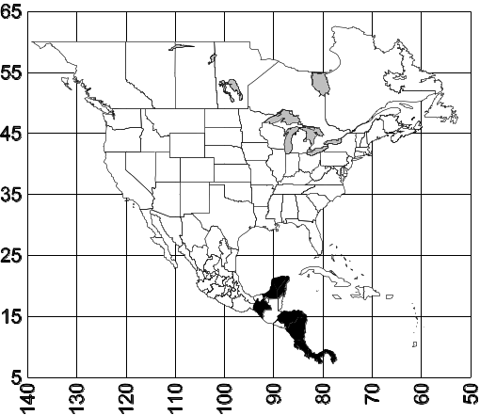
Map 2. Pachycondyla apicalis.
Habitat. This species is common in wet tropical forests, and even in high elevation rain forests.
Biology. Nests are found in logs and stumps. Males were present in a nest at the end of May. They are very active and predators, and are usually captured on the ground, or in pitfall traps. 10531 10605,

Pachycondyla arhuaca (Forel)
Figs.  M, H 79 ; Map 3

Discussion. The workers are relatively small (total length < 5 mm), dark brown ants, with a pale brown appendages. The anterior margin of the clypeus is convex, the eyes are small (maximum diameter about 0.15 mm), and separated from the insertion of the antennae of mandible by slightly less than one maximum diameter. There is no carina between the eye and the insertion of the antenna, although the region is swollen. The antennal scape is relatively short, extending only slightly past the posterior lateral corner. The pronotal shoulder is slightly swollen, but does not formed a shelf or even a well defined carina. Most of the dorsum of the mesosoma is in the same plane, although the metanotal suture breaks the integument on the dorsum of the mesosoma. The propodeal spiracle is circular. The middle tibia is relatively short (0.72 millimeters), only slightly longer than the width of the pronotum (0.66 mm). The petiole is relatively narrow when viewed in profile (maximum width 0.40 mm), the anterior face is convex, the posterior face is concave (viewed from above) with sharp lateral margins.

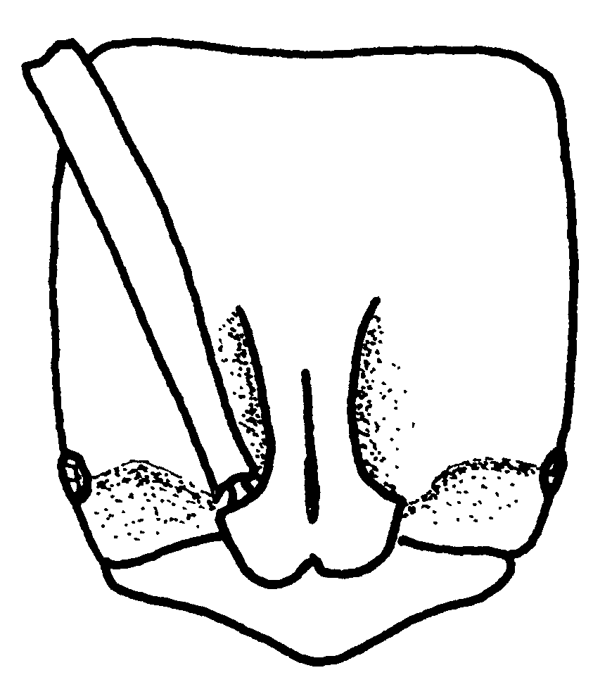
Fig. 87. Head of a worker of P. arhuaca (Antioquia, Colombia).
Erect hairs are scattered on the head, mesosoma, petiole, and gaster, the hairs on the tibiae are mostly appressed, although there are a few short (up to 0.03 mm) erect hairs on the extensor surfaces.
Most surfaces are dull and punctate, the mandibles are finely striate, with regents near the teeth being glossy and shiny, the gaster is moderately shining, with relatively coarse punctures.
The workers of this species could be separated from most of the other North American Pachycondyla by the circular propodeal spiracle. The sharp margin on the pronotal shoulder would distinguish it from other similar, small species, such as P. ferruginea, P. constricta and P. pergandei. It could be confused with the Brazilian P. metanotalis and the Venezuela P. emiliae, but differs in being smaller (the head width of the worker is < 1.2 mm, that of the gyne is about 1.25, the head width of the worker not > 1.4 mm, as it is in P. metanotalis, and P. emiliae ), and the eye is relatively small (maximum diameter of the eye of the worker is about 0.2 mm, not greater than 0.2 mm as in workers of P. metanotalis and P. emiliae).
Distribution.: Panamá (???), Colombia (Antioquia, Huila) south to Brasil.
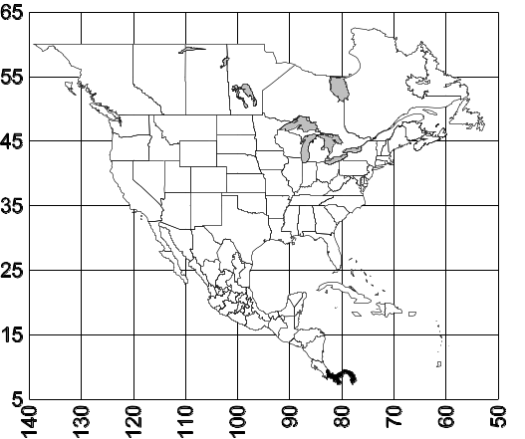
Map 3. Pachycondyla arhuaca.
Habitat. These ants are found in wet, tropical forests.
Biology. Nests are found in rotten wood and the soil under the wood. Brood were present in a nest in January.

Pachycondyla atrovirens Mayr* (+ splendida) SA

Pachycondyla azteca Forel*
Figs.  none; Map

Discussion. ### ???need
Distribution. Panamá (Volcán de Chiriqui)
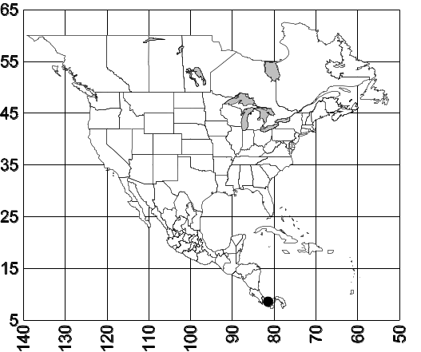
Map 4. Pachycondyla azteca.
Habitat. ^^^
Biology. &&&

Pachycondyla becculata new species
Figs. D M, H ; Map

Discussion. The worker of this species is relatively small (total length < 7 mm), nearly black in color, with medium brown appendages, in reddish-brown mandibles. The anterior edge of the clypeus forms a sharp tooth medially, the eyes are relatively small (maximum length 0.2 mm), which is nearly twice the length of the distance from the eye to the anterior edge of the head. The scape is relatively short, and extends only slightly past the posterior lateral corner. The metanotal suture is deeply impressed on the dorsum of the mesosoma, the propodeal spiracle is circular in shape. The anterior face of the petiole is straight or slightly convex (seen from the side), the posterior face is concave (seen from above) with sharp lateral margins. The stridulatory file is absent on the dorsum of the gaster.
Erect hairs are moderately abundant on nearly all surfaces, including the scapes, head, mesosoma, petiole, and gaster, most hairs on the tibiae are appressed, although short, bristly hairs are present on the extensor and the flexor surfaces of the tibiae.

Fig. 88. Middle left tibia of the holotype worker of P. becculata (xx X) (). needfig 1

The mandible is mostly striate, the remainder of the surfaces are mostly punctate and dull, the posterior face of the petiole is very finely punctate, shiny and glossy.
This species could be easily confused with P. arhuaca. It can be separated by the sharp tooth on the anterior edge of clypeus, which is absent in P. arhuaca.
Distribution. PANAMA: Chiriquí (La Fortuna area, Finca La Suisse). Other countries??? MCZ
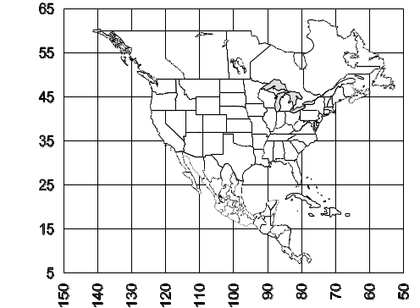
Map 5. Pachycondyla becculata. Need dot???
Habitat. Specimens were collected in a bamboo forest, on an oak ridge.
Biology. Unknown, workers were found in leaf litter.

Pachycondyla bucki (Borgmeier) SA

Pachycondyla bugabensis Forel
Figs.  M64, H 80 ; Map

Discussion. ###

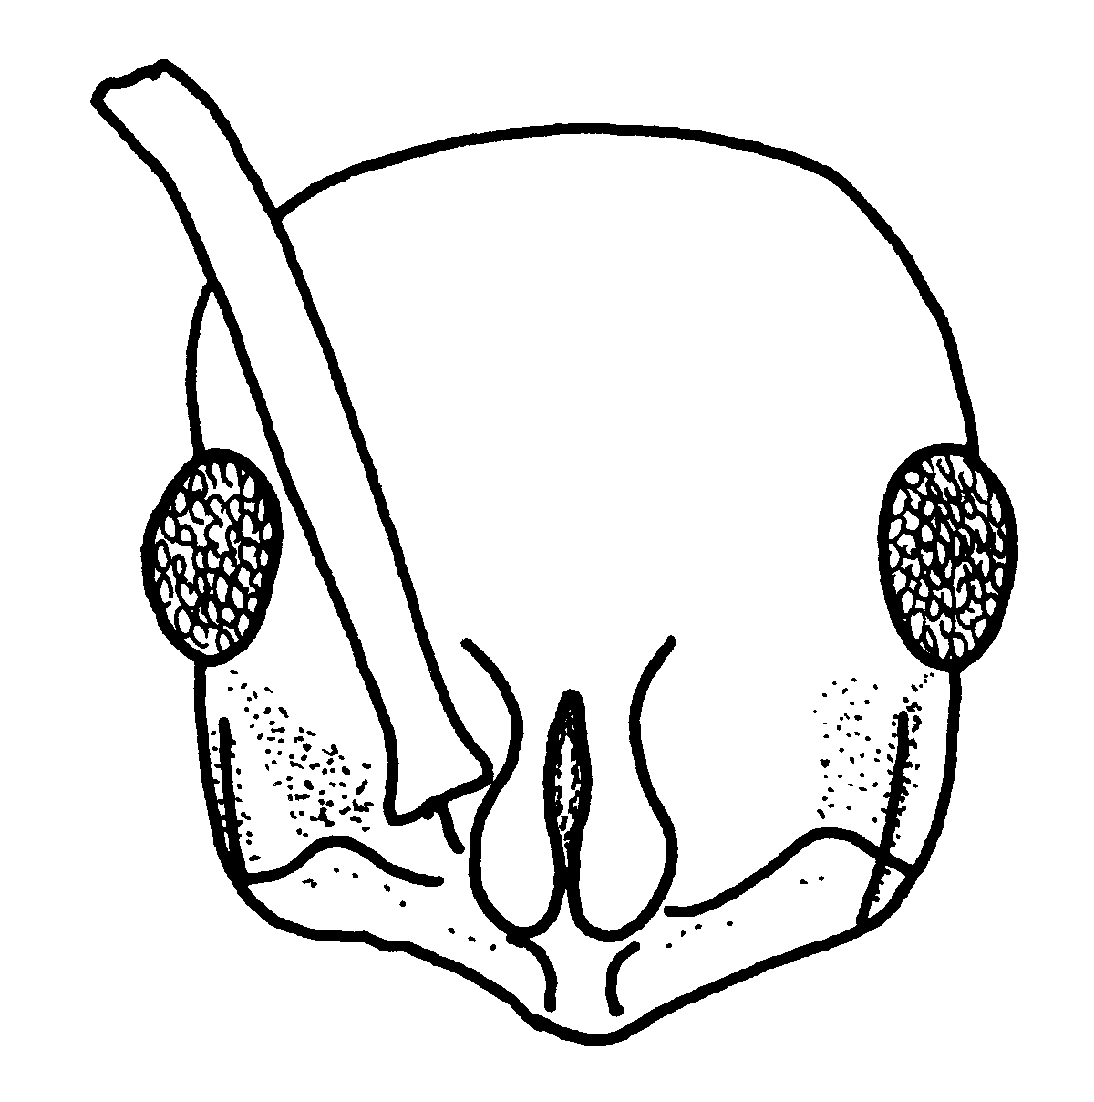
Fig. 89. Head of a worker of P. bugabensis (Alajuela, Costa Rica).
Distribution. COLOMBIA; COSTA RICA: ____________________ Río Toro Amarillo vic. Guapiles; Alajuela, Monteverde Cloud Forest Reserve Esperanza 800m; ECUADOR NICARAGUA: Matagalpa, Hotel Selva Negra, Km 139 N Matagalpa; PANAMA
Map 6. Pachycondyla bugabensis.
Habitat. ^^^
Biology. &&&
Pachycondyla carbonaria (Smith)
Figs.  M75, H; Map

Discussion. These ants are moderately large (total length 10 mm), and appear to be black, with shiny green reflections. The anterior edge of clypeus is indented medially, the eyes are moderately large (maximum diameter 0.43 mm), and separated from the anterior edge of the head by less than one maximum diameter. There is no carina between the eye and the anterior edge of the head. The scape extends about two funicular segments past the posterior lateral corner. The pronotal shoulder is swollen and nearly forms a carina. The metanotal suture is impressed, and breaks the integument of the dorsum of the mesosoma. The propodeal spiracle is elongate, and podium forms carinae laterally. The anterior border face of the petiole is slightly concave, and meets the convex, sloping posterior face at a blunt angle. The stridulatory file is present on the dorsum of the gaster.
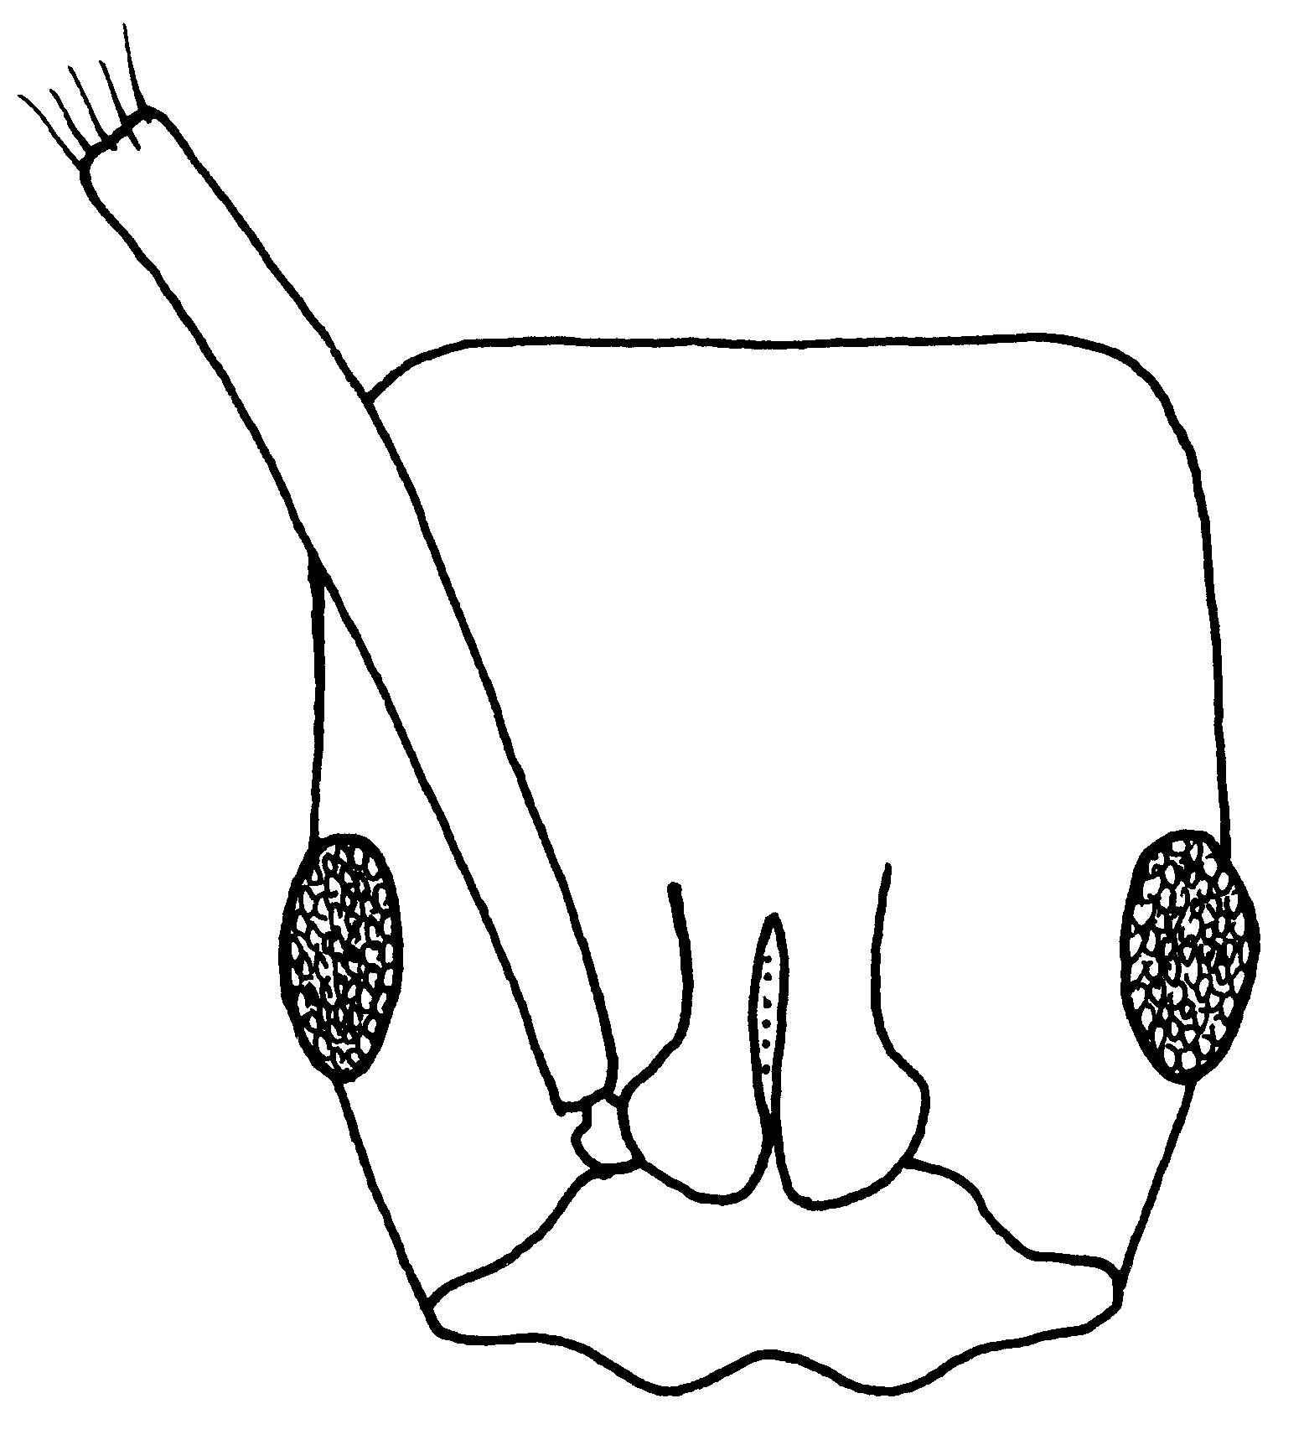
Fig. 90. Head of a worker of P. carbonaria (???).
Erect hairs are moderately abundant on all surfaces of the head, but are lacking on the shaft of the scape. The mesosoma, petiole, and gaster have several, erect hairs, the hairs on the tibiae are appressed, except for a few hairs near the spur. Golden, appressed pubescence is abundant on the head, mesosoma, and gaster.
Most surfaces are moderately smooth, and some are glossy, especially the posterior half of the head, the pronotum, and the gaster. Other surfaces are punctate, or finely striate.
These ants are black, with greenish reflections, the mandibles are reddish-brown, the other appendages may be slightly lighter in color.
This species could be easily confused with P. laevigata, another glossy ant. They can be easily separated, as the side of the propodeum has poorly defined striae, whereas those of P. laevigata are coarsely sculptured, with well defined striae. The appressed, golden pubescence is nearly absent on the head, mesosoma, and gaster of P. laevigata.

Distribution. NICARAGUA: Matagalpa, Hotel Selva Negra, Km 139 N Matagalpa. ECUADOR, COLOMBIA, VENEZUELA.
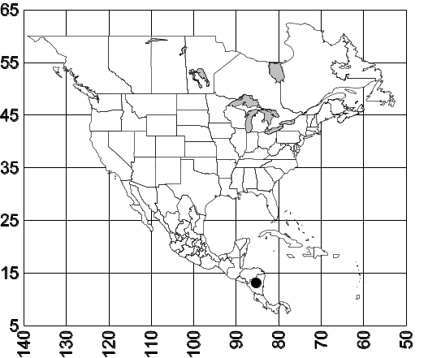
Map 7. Pachycondyla carbonaria.
Habitat. Wet cloud forest
Biology. &&&

Pachycondyla carinulata (Roger) (+ gibbinota)

Pachycondyla carinulata (Roger)
(+ gibbinota)
Figs. D M48, H 49 ; Map

Discussion. The worker is a small (up to 7 mm) dark reddish ant, with reddish-brown mandibles and appendages. The anterior medial edge of the clypeus forms a blunt angle. The carina anterior to the eyes is present, but not greatly developed. The eyes are located slightly less than one maximum diameter from the anterior edge of the head. The scape extends about two funicular segments past the posterior lateral corner. The pronotal shoulder is formed into a sharp carina, which slightly overhangs the side of the pronotum. The metanotal suture is present, but is not depressed, and barely breaks the sculpture on the dorsum of the mesosoma. The propodeal spiracle is elongated. The anterior and posterior faces of the petiole are nearly parallel on the lower half, the anterior face abruptly bends and forms an obliquely sloping dorsal face, which meets the posterior face at an angle. The posterior face is convex and rounded. The stridulatory file on the dorsum of the gaster is present.
Erect hairs are numerous on most surfaces, including the head, the scape, the dorsum of the mesosoma, the petiole, and all surfaces of the gaster, the hairs on the tibiae are abundant, and mostly suberect, all hairs are bright golden-yellow. Appressed pubescence is also abundant, and also golden yellow, and is present on the dorsum of the head, dorsum of the mesosoma, the dorsum of the petiole and dorsum of the gaster. Other surfaces, such as the ventral surface of the head and the side of the mesosoma and petiole also have golden, appressed hairs, which are not is numerous.
The head and the dorsum of the mesosoma are densely and evenly punctate, appearing like a thimble, the side of the mesosoma is weakly sculptured with fine punctures, and is partially smooth and shining. The anterior half of the petiole is mostly punctate and weakly shining, the posterior face is glossy and polished. The gaster is finely punctate, but the sculpture is difficult to see because of the dense, golden, appressed pubescence.
This species could be confused with ???
Distribution: GUAYANA; HONDURAS: Dep. Cortes, Lago Yojoa 680 M: PANAMA: Barro Colorado I., Canal Zone; Cerro Campana Prov. Panama, Bella Vista, C.Z.;; MEXICO: Veracruz, Las Hamacas, 17 km n. Santiago Tuxtla, Tabasco (10 k N Cárdenas); BRAZIL; COSTA RICA: Lalola; Turrialba; R. Toro Amarillo vic. Guapiles; Pen Osa Par, Nat. Corcovado Sirena; Lancetilla nr. Tela; (carinulata gibbinota occurs in Guatemala and Honduras); PERU.
Map 8. Pachycondyla carinulata.
Habitat. These as may be found in disturbed habitats such as a cocoa plantation.
Biology. Unknown.

Pachycondyla cauta (Mann)*
Figs. D M need, H need ; Map

Discussion. ###
Distribution. Honduras,
Map 9. Pachycondyla cauta.
Habitat. ^^^
Biology. &&&

Pachycondyla cavinodis (Mann)
Figs. D M43, H 82 ; Map

Discussion. ###
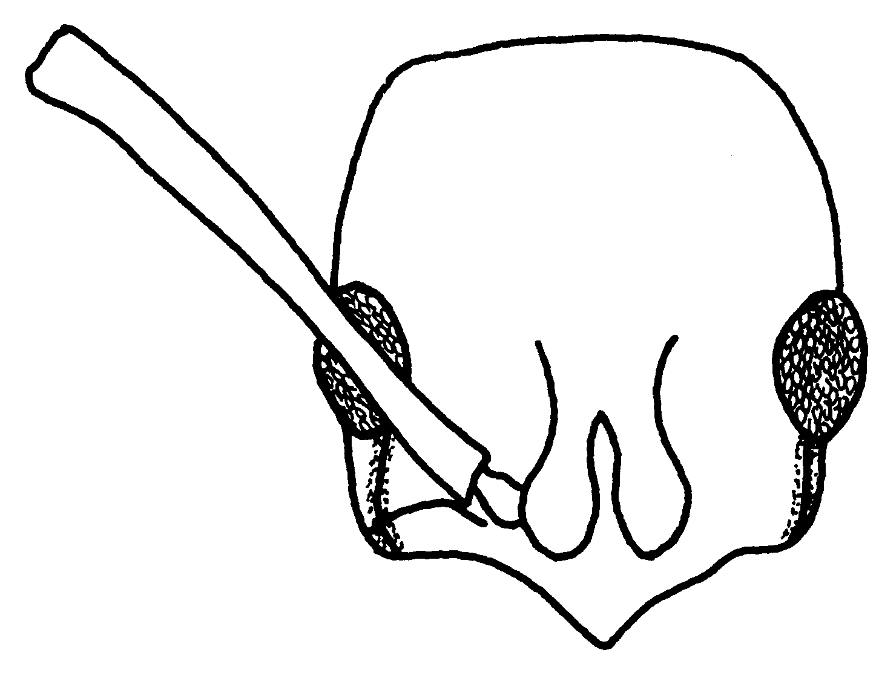
Fig. 91. Head of a cotype worker of P. cavinodis.
Distribution. Panama through Amazonia.
Map 10. Pachycondyla cavinodis.
Habitat. ^^^
Biology. &&&

Pachycondyla chyzeri (Forel) SA
Figs. D M69, H 80 top petiole 68; Map

Distribution. COLOMBIA; PERU.

Pachycondyla cognata (Emery)*
Figs. D M need, H need ; Map

Discussion. ###
Distribution. Costa Rica.
Map 11. Pachycondyla cognata.
Habitat. ^^^
Biology. &&&

Pachycondyla commutata (Roger) SA
Distribution: BRAZIL: COLOMBIA: Meta; ECUADOR: PERU; SURINAME; VENEZUELA: BRIT. GUIANA.

Pachycondyla constricta (Mayr)
Figs. D M29, H 84 ; Map

Discussion. This ant is easily recognized as it is relatively small (about 5 mm total length) with the mesosoma strongly and deeply constricted at the metanotal suture. It is dark reddish brown, with lighter reddish-brown appendages, including the mandibles. Anterior border of clypeus is broadly rounded, the carina is absent between the eye and the anterior edge of the head. The scapes extend the first two funicular segments past the posterior lateral corner, the eyes are close to the anterior edge of the head, located about one diameter from the anterior edge. The propodeal spiracle is circular. The petiole is shaped somewhat is a triangle, with the anterior and posterior faces converging to a bluntly rounded apex. The stridulatory file is present on the dorsum of the gaster.
Erect hairs are present on most surfaces, including the dorsal and ventral surfaces of the head, the dorsum of the mesosoma, the dorsum of the petiole, and all surfaces of the gaster, the hairs on the tibiae are suberect. The scape has a few, scattered, erect hairs. Appressed pubescence is sparse, but is present on the head, especially the dorsum, the dorsum of the mesosoma, and of the gaster.
The head and mesosoma are densely, but finely punctate, as is the anterior face of the petiole, the posterior face is more finely sculptured, but dull, the dorsum of the gaster is mostly finely punctate.

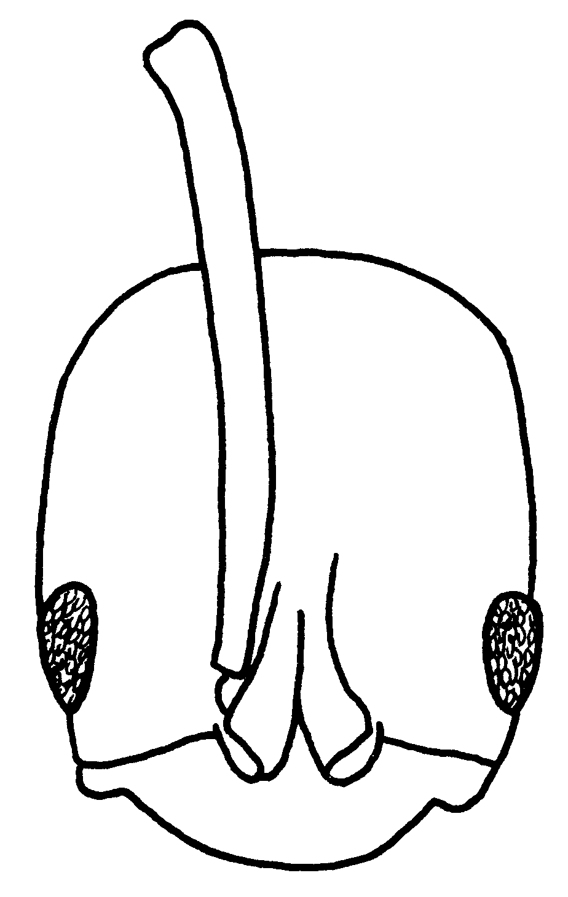
Fig. 92. Head of a worker of P. constricta (Atlántida, Honduras).

Distribution. Honduras south to Brasil and Bolivia.
Map 12. Pachycondyla constricta.
Habitat. Lowland rain forest.
Biology. This species is commonly collected in litter samples.

Pachycondyla crassinoda (Latreille)
SA (Colombia)
Figs. D M, H, pygidium? ; Map

Discussion. This species is easily recognized, as being the largest species in the New World (total length nearly any 20 millimeters). The shape of pygidium (end of the gaster) is unusual, in that it terminates in two lateral, blunt processes, and a central process which covers the dorsum of the sting. The region between the two lateral processes is concave. The sides of the pygidium are covered with longitudinal striae. The form of the pygidium can be easily recognized in the field. Other characters of this species include a the clypeus being concave medially and convex laterally, the eye is located anteriorly on the head, about one diameter from the anterior edge of the head, and the scapes barely extend past the posterior lateral corner. The pronotal shoulder is swollen, but does not form a carina, the mesosoma is not depressed at the metanotal suture, which barely interrupts the sculpture on the dorsum of the mesosoma. The propodeal spiracle is elongated. The petiole is rectangular-shaped, and often slightly wider near the apex as compared to near the base (as seen from the side). There is a definite dorsal surface, which is separated from the anterior and posterior faces by approximately right angles. The anterior face of the postpetiole is nearly vertical, and forms a right angle with the dorsal surface.
Erect hairs are abundant on most surfaces, including the dorsum and ventral surface of the head, the scapes, the dorsum of the mesosoma, the dorsum of the petiole, and all surfaces of the gaster, the hairs on the tibiae are suberect, all hairs are golden yellow in color, contrasting with black background color of the integument. Appressed pubescence is also present and golden yellow in color, and is especially abundant on the dorsum of the head, dorsum of the mesosoma, dorsum of the petiole, and dorsum of the gaster.

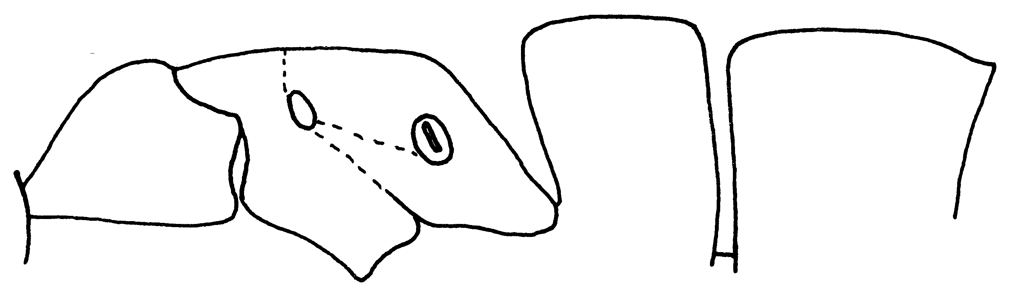Fig. 93. Mesosoma, petiole and first gastral tergite of a worker of P. crassinoda (Bolívar, Venezuela).
Nearly all surfaces are densely, but finely punctate, and dull or weakly shining, the mandibles are polished, with scattered punctures, the posterior face of the petiole is glossy and shiny, the anterior face of the post petiole and is finely sculptured, but not is glossy and shiny as the petiole.
This ant is nearly completely black, the mandibles are dark reddish-brown, and the tarsi are slightly lighter in color.
The female is similar to the worker, except the mesosoma is more massive.
Distribution. This species is widely distributed in South America, including Colombia and Venezuela, and may range into Central America..
Map 13. Pachycondyla crassinoda.
Habitat. Tropical rain forest.
Biology. This species nests under rotten logs.

Pachycondyla crenata (Roger)
Figs. D M 45, H; Map

Discussion. The worker is a relatively small ant (total length about 6 mm), reddish-brown, with pale brown appendages. The anterior medial region of the clypeus is bluntly protuberant, the eyes are very large(maximum diameter 0.36 mm) about three times in diameter as the length between the anterior border, and the anterior margin of the head. A poorly defined carina is located between the eye and the clypeus. The pronotal carina is a present, but poorly developed, the metanotal suture barely breaks the integument on the dorsum of the mesosoma. The propodeal spiracle is elongated, the petiole is thickened when viewed in profile, and somewhat cuboidal-shaped, with the anterior and posterior faces being nearly parallel, and with a definite, dorsal face. The anterior face is straight, the dorsal face and the posterior face are convex and rounded. The stridulatory file is present on the dorsum of the gaster, but is poorly developed.

Erect hairs are abundant on the dorsal and ventral surfaces of the head, the dorsum of the mesosoma, the dorsal and posterior face of the petiole, and all surfaces of the gaster, the hairs on the tibiae are mostly suberect; appressed pubescence is mostly sparse, a few hairs are present on the head, dorsum of the mesosoma, dorsum of the petiole, and dorsum of the gaster, where they are moderately abundant.
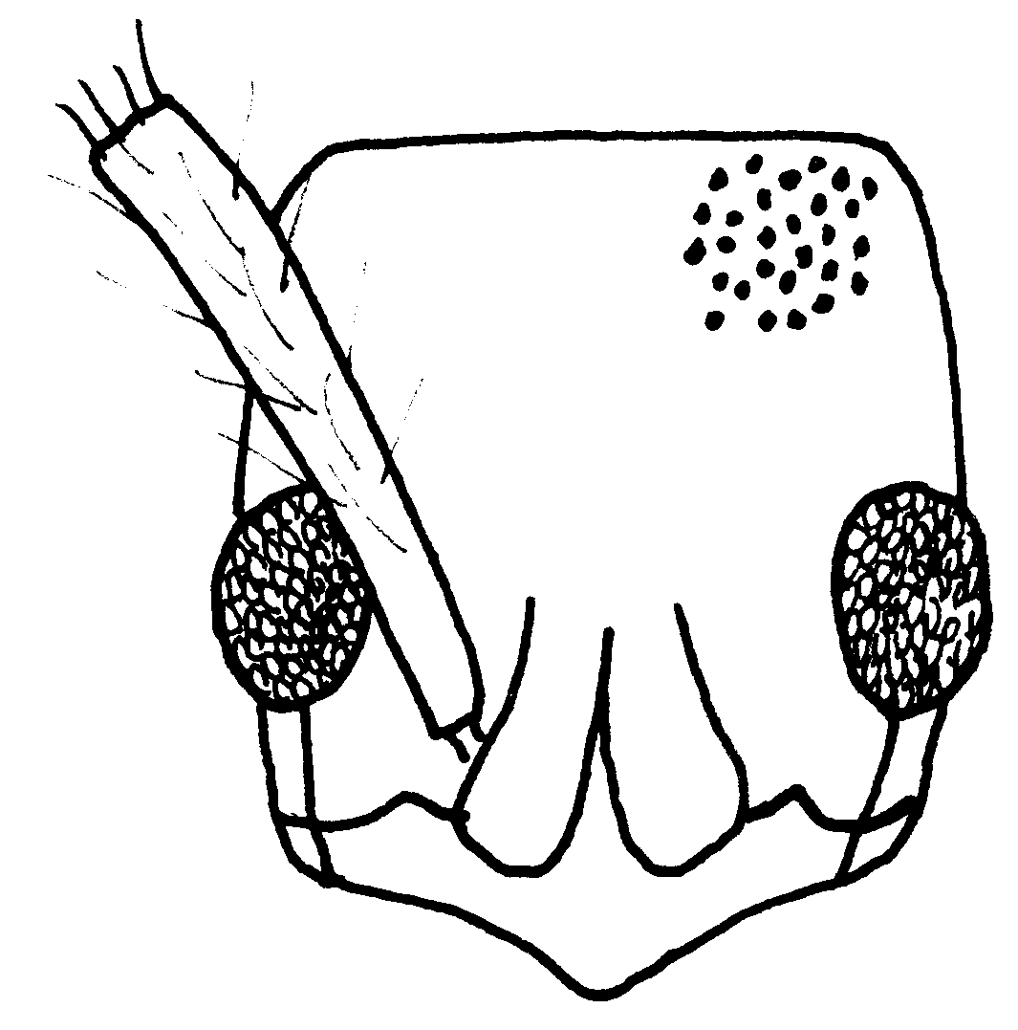
Fig. 94. Head of a worker of P. crenata (Gamboa, Panamá). Only a small part of the sculpture is shown.

The head and the dorsum of the mesosoma are punctate, appearing like the surface of a thimble, the side of the pronotum is weakly punctate, and moderately smooth and glossy, the mesopleuron is mostly smooth and glossy, the side of the propodeum has poorly defined striae and is weakly shining, the petiole is punctate on the sides and the top, the posterior face is mostly smooth and glossy, the dorsum of the gaster is finely punctate, and moderately smooth and glossy.

This species could be confused with ???
Distribution. BRASIL; COLOMBIA Cundinamarca, Meta); COSTA RICA: Heredia, Finca La Selva; R. Toro Amarillo vicinity Guapiles; Sirena Penin. Osa; 8.28 N 83.35 W; BRITISH GUYANA; FRENCH GUIANA, ECUADOR; GUATEMALA; Quirigua; TRINIDAD: nr. Rio Claro; MEXICO: Tabasco (near border with Chiapas); Chiapas (Palenque Ruins, Ocosingo); Veracruz (El Palmar nr. Tetzonapa, Laguna Ocotal Grande, Río Metlac); PANAMA; Barro Colorado I., Canal Zone, Gamboa; PERU; Mexico south to Paraguay (crenata moesta is found from Mexico south to Paraguay).
Map 14. Pachycondyla crenata.
Pachycondyla crenata - ‘robust’ form:
Distribution: BRASIL; BRITISH GUINEA; ECUADOR; FRENCH GUIANA PERU; TRINIDAD.
Habitat. ^^^ ???
Biology. &&&899, 900, 808,17036. 10550, 17236
Pachycondyla dianae new species
Figs. D M 85, H 72 ; Map

Discussion. ###
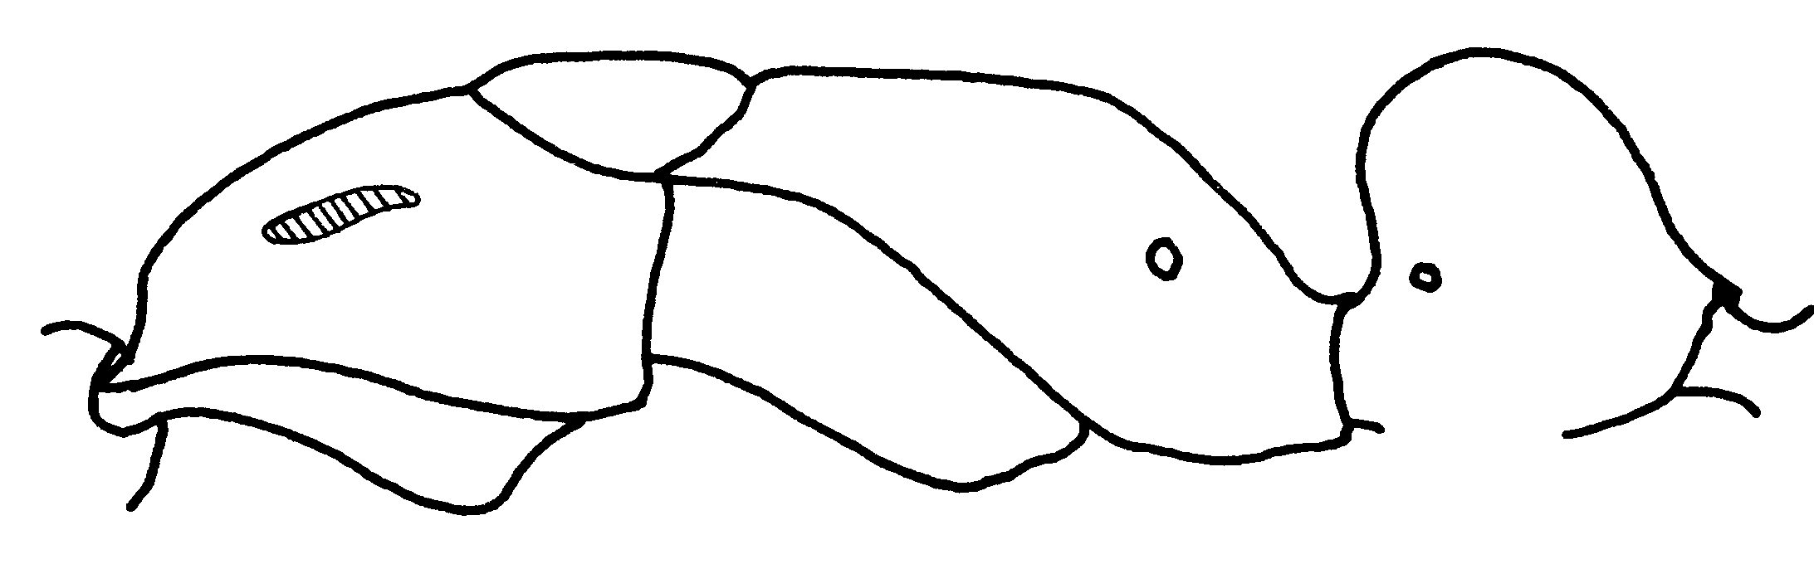Fig. 95. Mesosoma of the “holotype” worker of P. dianae. The hatched area refers to a swollen region.

Distribution. PANAMA: Colon Stat. Rita Ridge, Rd. 4-5 km frm Trans-Isthmian H’way; or Transamerican Hwy; Nusagandi; San Blas
Map 15. Pachycondyla dianae.
Habitat. ^^^
Biology. &&&

Pachycondyla dismarginata new species
Figs. D M 55, H 56; Map

Discussion. ###

Distribution: COSTA RICA: Prov. Heredia, 500m, 10○20’N 84○04’W; 16 km N Vol Barba, 10○17’N84○05’W; Prov. Alajuela, Rio Penas Blancas, 10○19’N 84○43’W
Map 16. Pachycondyla dismarginata.
Habitat. ^^^
Biology. &&&

Pachycondyla eboritacta new species
Distribution:BRAZIL; COLOMBIA.

Pachycondyla eleonorae (Forel) SA
Distribution: ECUADOR.
Pachycondyla emiliae (Forel) SA
Distribution: VENEZUELA.
Pachycondyla evexa (Brown) sp.nov.
Distribution: PERU.
Pachycondyla fauveli Emery SA
Distribution: COLOMBIA;PERU.

Pachycondyla ferruginea (F. Smith)
(+ panamensis)
Figs. D M 27, H ; Map

Discussion. The worker is a relatively small ant (about 6 mm total length), reddish-brown, with the appendages nearly as dark as the remainder of the ant. The middle tibia is very short (0.85 mm), shorter than the maximum width of the pronotum as seen from above (1.1 mm). The medial area of the clypeus is concave, and is surrounded by two convex areas, the area anterior to the eye is without a carina, the eye is very small (0.13 mm maximum diameter), which is less than the distance between the anterior border of the eye and the anterior margin of the head. The scape barely reaches, or slightly surpasses the posterior lateral corner. The pronotal shoulder is completely rounded, the metanotal suture is well marked on the dorsum of the mesosoma, but is only slightly depressed, and the propodeal spiracle is circular. The petiole is rectangular-shaped, with the anterior and posterior faces being nearly parallel, the posterior face forms a rounded angle with the dorsal surface. The stridulatory file is absent on the dorsum of the gaster.
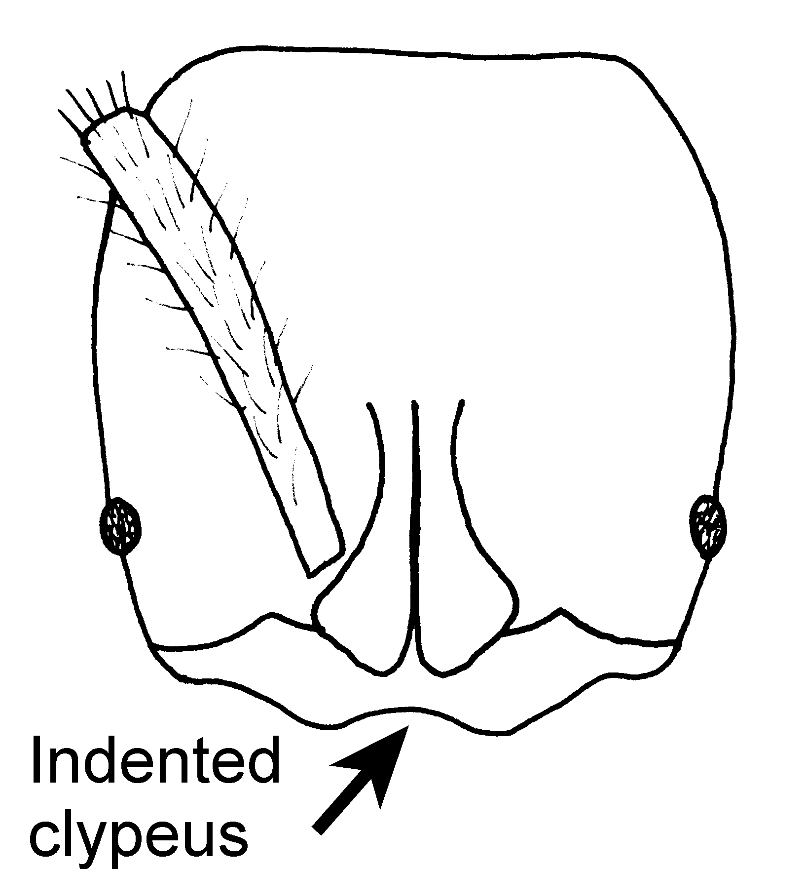
Fig. 96. Head of a worker of P. ferruginea (???).

Erect hairs are abundant on the mandibles, clypeus, shaft of the scape, most of the hairs on the dorsum of the head are erect, but are very short (most less than 0.05 mm), erect hairs are abundant on the ventral surface of the head, the dorsum of the mesosoma, the dorsum of the petiole, and all surfaces of the gaster, most hairs on the tibiae are appressed, although there are a few scattered erect or suberect hairs present; appressed pubescence is sparse on the head, abundant on the dorsum of the mesosoma, dorsum of the petiole, and dorsum of the gaster, golden in color, and may even be matted on some surfaces, especially the gaster.
The mandibles are finely striate, and shining, the head and the mesosoma are mostly finely punctate and dull, the sides of the mesosoma have poorly defined striae, most surfaces of the petiole are punctate and weakly shining, the posterior face is smooth and glossy, except for the central region, which is punctate, the gaster is finely punctate and shining.
This species could be confused with ???
Distribution. México: Veracruz: (Coatepec58 k S Xalapa, Puebla: 17 k NE Tezlutlán, Chiapas: 10 k S Palenque ), poster Rita (Guanacaste: 17 k NE Rincón, Maritza Field Station, E. San Jose: 19 k N San Isidro, Km 117, Pan American Highway, Puntarenas: 5 k SW Estación Biológico Las Cruces, Cartago: Parque Nacional Tapanti); Panamá (Chiriquí: 5.7 k NE Boquete, Volcán, La Fortuna area, Parque Nacional Volcán Baru Boquete); COLOMBIA: Valle de Cauca (Bosque Yotoco).
Map 17. Pachycondyla ferruginea.
Habitat. Mixed dry oak forest, tropical mountain evergreen forest, bamboo forest to wet lowland and cloud forest
Biology. Nests are found under stones. Workers are often collected subterranean traps baited with Vienna sausage. Workers are common in leaf litter extractions. 10852, 10876, 10632 10570, 10632, 10570 10634, 11631, 17812, 11647,

Pachycondyla foetida (Linnaeus)

[lobata is synonym]?yes
Figs. D M need, H need; Map

Discussion. ###
Distribution. BRASIL; PERU; VENEZUELA. Costa Rica south to Brasil.
Map 18. Pachycondyla foetida.
Habitat. ^^^

Biology. &&&

Pachycondyla fuscoatra (Roger)*
Figs. D M need, H need; Map

Discussion. There is considerable uncertainty of the identity of this species, as the types were probably destroyed in World War II. It is apparently closely related to P. impressa. Emery (1890) separated it from P. impressa as having a punctate and rugose sculpturing on the head and the mesosoma, and the surfaces being opaque. The similar surfaces of P. impressa are punctate, but are shiny. Kempf (1961) strongly criticized Emery for the use of such poor characters when a number of good characters were available to separate the two species. Kempf (1961) separated them on the basis of the fewer mandibular teeth (5 - 6) in P. fuscoatra, as compared to numerous teeth (8 - 9) in P. impressa. Additionally the pygidium of P. fuscoatra is without lateral rugae and without a posterior medial dorsal impression, both of which are present in P. impressa (Fig. xx). Kempf (1961) further stated that Emery confused his successors with his poor character, which resulted in the naming of a number of varieties of P. fuscoatra, which Kempf considered to be synonyms of. P. impressa.
We looked at a number of specimens of P. impressa from Colombia and it doesn't appear that this species has been collected again.
Distribution. Unknown, but based on a number of possible misidentifications, it may range from Costa Rica south to Bolivia. The types were collected in Colombia.
Map 19. Pachycondyla fuscoatra.
Habitat. Unknown.
Biology. Unknown.

Pachycondyla carinulata gibbinota (Forel) add???

Pachycondyla gilberti (Kempf)* SA

Pachycondyla gilva (Roger)*
Figs. D M 87, H  m,  m ; Map

Discussion. The worker is a small ant (< 4 mm), ferruginous red, and the with tiny eyes (may be absent). Most surfaces are dull and punctate, the top of the mesosoma, the pronotum, the mesopleuron, the side of the propodeum and petiole, and the dorsum of the gaster are weakly shining. The tibia of the middle leg has a number of very coarse hairs (conical setae) on the extensor surface (Fig XX), which are much thicker than other hairs. The anterior border of the clypeus is broadly convex, the maximum diameter of the eye is about 0.03 mm in length, the distance between the anterior border of the eye and the border of the head is at least three times the maximum eye length. The scapes fail to reach the posterior lateral corner by about the first two funicular segments. The pronotal shoulder is only slightly swollen, the mesosoma is moderately depressed at the metanotal suture, the dorsal face of propodeum is nearly straight, meeting the posterior face at an angle. The petiole is thick when viewed in profile, and is narrowed toward the apex. The petiole spiracle is circular. The dorsum of the gaster is without a stridulatory file.

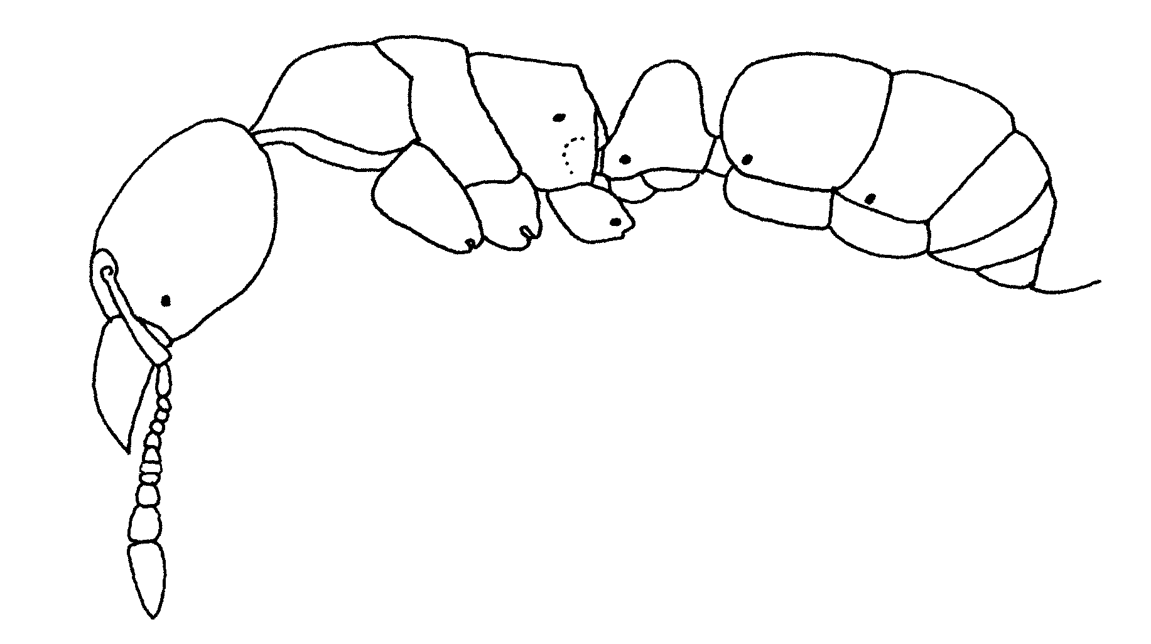
Fig. 97. Side view of a worker of P. gilva (from Creighton, 1950???1930).
Erect hairs are scattered on the dorsal and ventral surfaces of the head, on the scapes, on the dorsum of the mesosoma, dorsum of the petiole and all surfaces of the gaster. Appressed, golden pubescence is abundant on most surfaces.
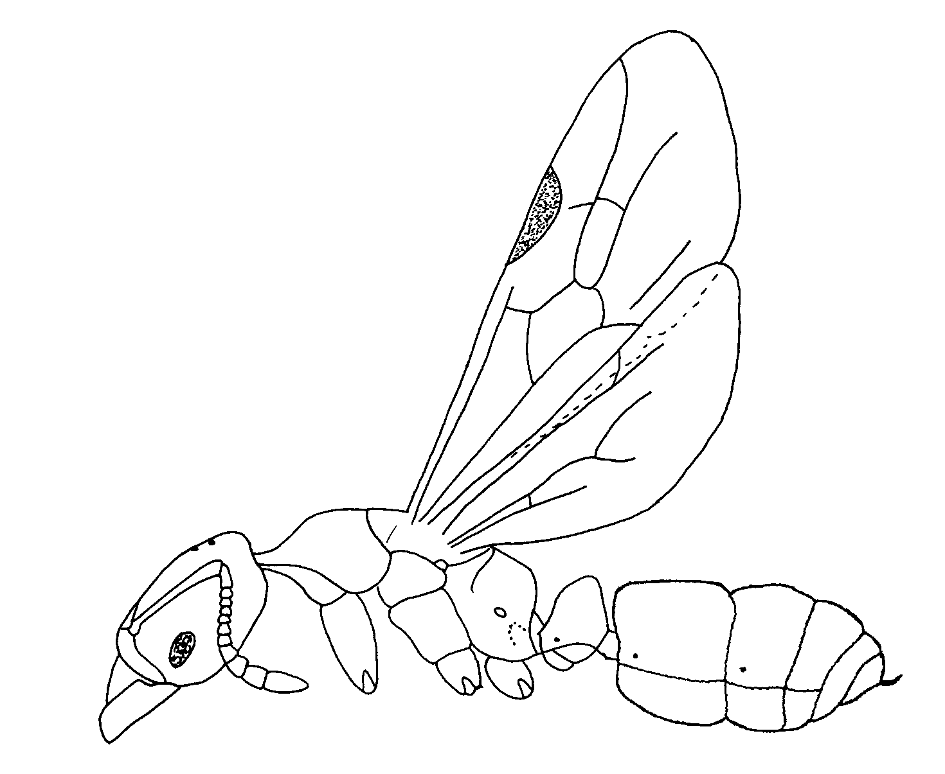
Fig. 98. Side view of a female of P. gilva (from Creighton, 1950).

The female is similar to the worker, and differs primarily in having an enlarged mesosoma, and wings. The male has a 13-segmented antenna (12-segmented in the worker and the female). The mesosoma is also enlarged, and the male has wings.

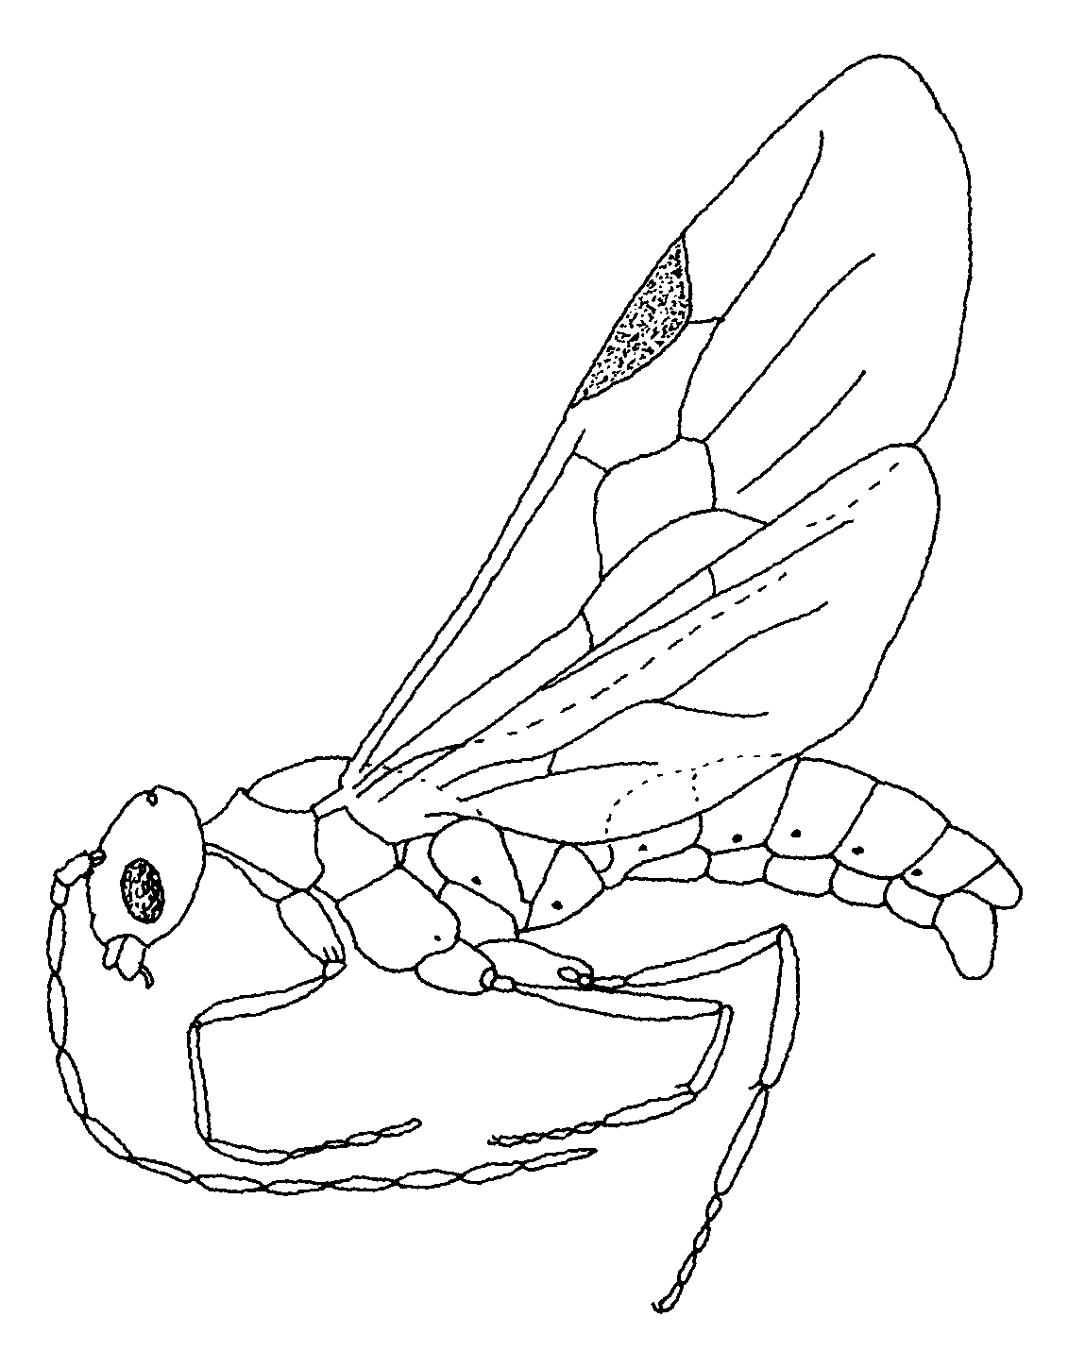
Fig. 99. Side view of a male of P. gilva (from Creighton, 1950).
This species is almost identical to P. guatemalensis. The workers can be distinguished, is the dorsum of the gaster as many erect hairs, which are few in number or absent in P. guatemalensis. The conical setae on the middle tibia would separate these ants from most of the others in the genus.
Check MCZC for males and females.
Distribution.: United States: North Carolina (Clemson), Florida (Gainesville). Add from MCZ???
Map 20. Distribution of C. gilva.
Habitat. Forests and disturbed, urban sites.
Biology. This species nests in rotten, logs.

Pachycondyla goeldii (Forel) SA

Distribution: BRASIL; BRITISH GUIANA; ECUADOR; FRENCH GUIANA; SURINAM; PERU; TRINIDAD.

Pachycondyla goyana (Borgmeier)* SA

Pachycondyla guatemalensis (Forel)
Figs. D M, H ; Map

Discussion. The worker is a small specimen (total length < 4 mm, usually less than three) in which the eyes are very small (maximum diameter 0.04 mm) or even absent. They are yellowish-brown in color. The mandible is elongated, shiny, and has at least five teeth, which are approximately the same size (the apical tooth is slightly larger). The antennal scapes are relatively short, and fail to reach the posterior lateral corner by two or three funicular segments. The dorsum of the mesosoma is broadly rounded, or somewhat flattened, and the anterior part of the side of the propodeum is deeply impressed for the reception of the posterior femur. The metanotal suture is well marked, but only slightly depressed. The petiole is somewhat rectangular shaped, but is distinctly narrowed dorsally, the subpetiolar process is broadly rounded anteriorly, and does not have a fenestra. The middle tibia has a number of coarse, conical setae on the extensor surface, which are lacking on the anterior and the posterior tibiae.
The female is similar to the worker, except larger(total length slightly over 4 mm) and larger eyes (maximum diameter 0.17 mm) the mandibles are similar to that of the minor worker. paused because may not be conspecific, will check at the MCZC. Setae on tibia?
The male is a small (total length about 4 mm), in which the antennae (3.5 mm) are nearly as long as a remainder of the ant. The mandibles are tiny, edentate, and fail to touch by distance equal to at least their length. The eyes are large, and occupy about ½ of the side of the head. The scape is short, about twice the length of the first funicular segment. The petiole is small, and rounded dorsally, the subpetiolar process is little developed. The middle tibia does not have the conical setae that are found in the worker.
This species is almost identical to P. gilva. The workers can be separated, as the dorsum of the gaster as you or no erect hairs, which are abundant on the gaster of C. gilva. The conical setae on the middle tibia would separate these ants from most of the others in the genus.
Distribution. Guatemala, México (Veracruz, Coatepec), Nicaragua.
Map 21. Pachycondyla guatemalensis.
Habitat. Tropical rain forests.
Biology. Specimens are usually collected loose on ground.

Pachycondyla guianensis (Weber)
Figs. D M, H ; Map

Discussion. These are relatively small (total length about 6 mm), orange-brown ants. The mandibles are slender and elongated, with a large, acute apical tooth and a relatively large tooth in the middle of the masticatory border. There is one tiny tooth anterior to this large, medial tooth, and two smaller teeth posterior to it. The eyes are apparently absent, although there is a slightly darker spot where the eyes would be located. The anterior medial border of the clypeus has a tiny tooth. The antennal scape fails to reach the posterior lateral corner by about the length of the first funicular segment. The mesosoma is broadly depressed at the metanotal suture, and the anterior part of the side of the propodeum is depressed for the reception of the middle femur. The petiole is triangular-shaped, distinctly narrowed dorsally, with the top of the node being broadly rounded. The middle tibia has several conical setae on the extensor surface, the anterior and posterior to be tibiae are without these coarse setae.
Most surfaces are dull and punctate, especially the head and dorsum of the mesosoma, the side of the mesosoma is weakly shining, the side of the petiole and gaster are moderately shining.
Erect hairs are abundant on the mandibles, clypeus, ventral surface of the head, shaft of the scape, dorsum of the mesosoma, dorsum of the petiole, and all surfaces of the gaster, the setae on the tibiae legs are mostly suberect or appressed.
This species is obviously a member of the gilva species complex, with the conical setae on the middle tibia, and the lateral, depressed region on the propodeum. The unusual teeth on the mandible separate it from P. holmgreni, P. gilva and P. guatemalensis. It is closely related to P. haskinsi, apparently differing only in that the second funicular segment and is as long not longer than the third.
Distribution. Guatemala, México (Veracruz, Coatepec), Nicaragua.
Map 22. Pachycondyla guatemalensis.
Habitat. Tropical rain forest.
Biology. Unknown.

Pachycondyla harpax (Fabricius)
Figs. D M 82, other, H need,  m, wing,  m ; Map

Discussion. The workers are relatively large (up to 10 mm) black ants with dark brown appendages. The mandibles have nine or 10 teeth, the anterior border of the clypeus is convex, although it may be nearly straight or even slightly concave medially. The central region of the clypeus is swollen, and may even form a carina posteriorly. The region anterior to the eye is without a carina, although it may be slightly raised. The eyes are relatively large (0.34 mm maximum diameter), and are separated from the insertion of the mandibles by less than one maximum diameter. The scape extends only slightly past the posterior lateral corner. The pronotal shoulder is formed into a definite carina, which passes forward on the anterior lateral surface of the pronotum. The metanotal suture is absent on the dorsum of the mesosoma or is only slightly developed. The petiole is rectangular shaped, with the anterior and posterior faces being nearly parallel, the posterior surface forming definite bend with the dorsal surface. Posteriorly, the petiole has a sharp border which defines the posterior face. The anterior face of the post petiole may be slightly concave.
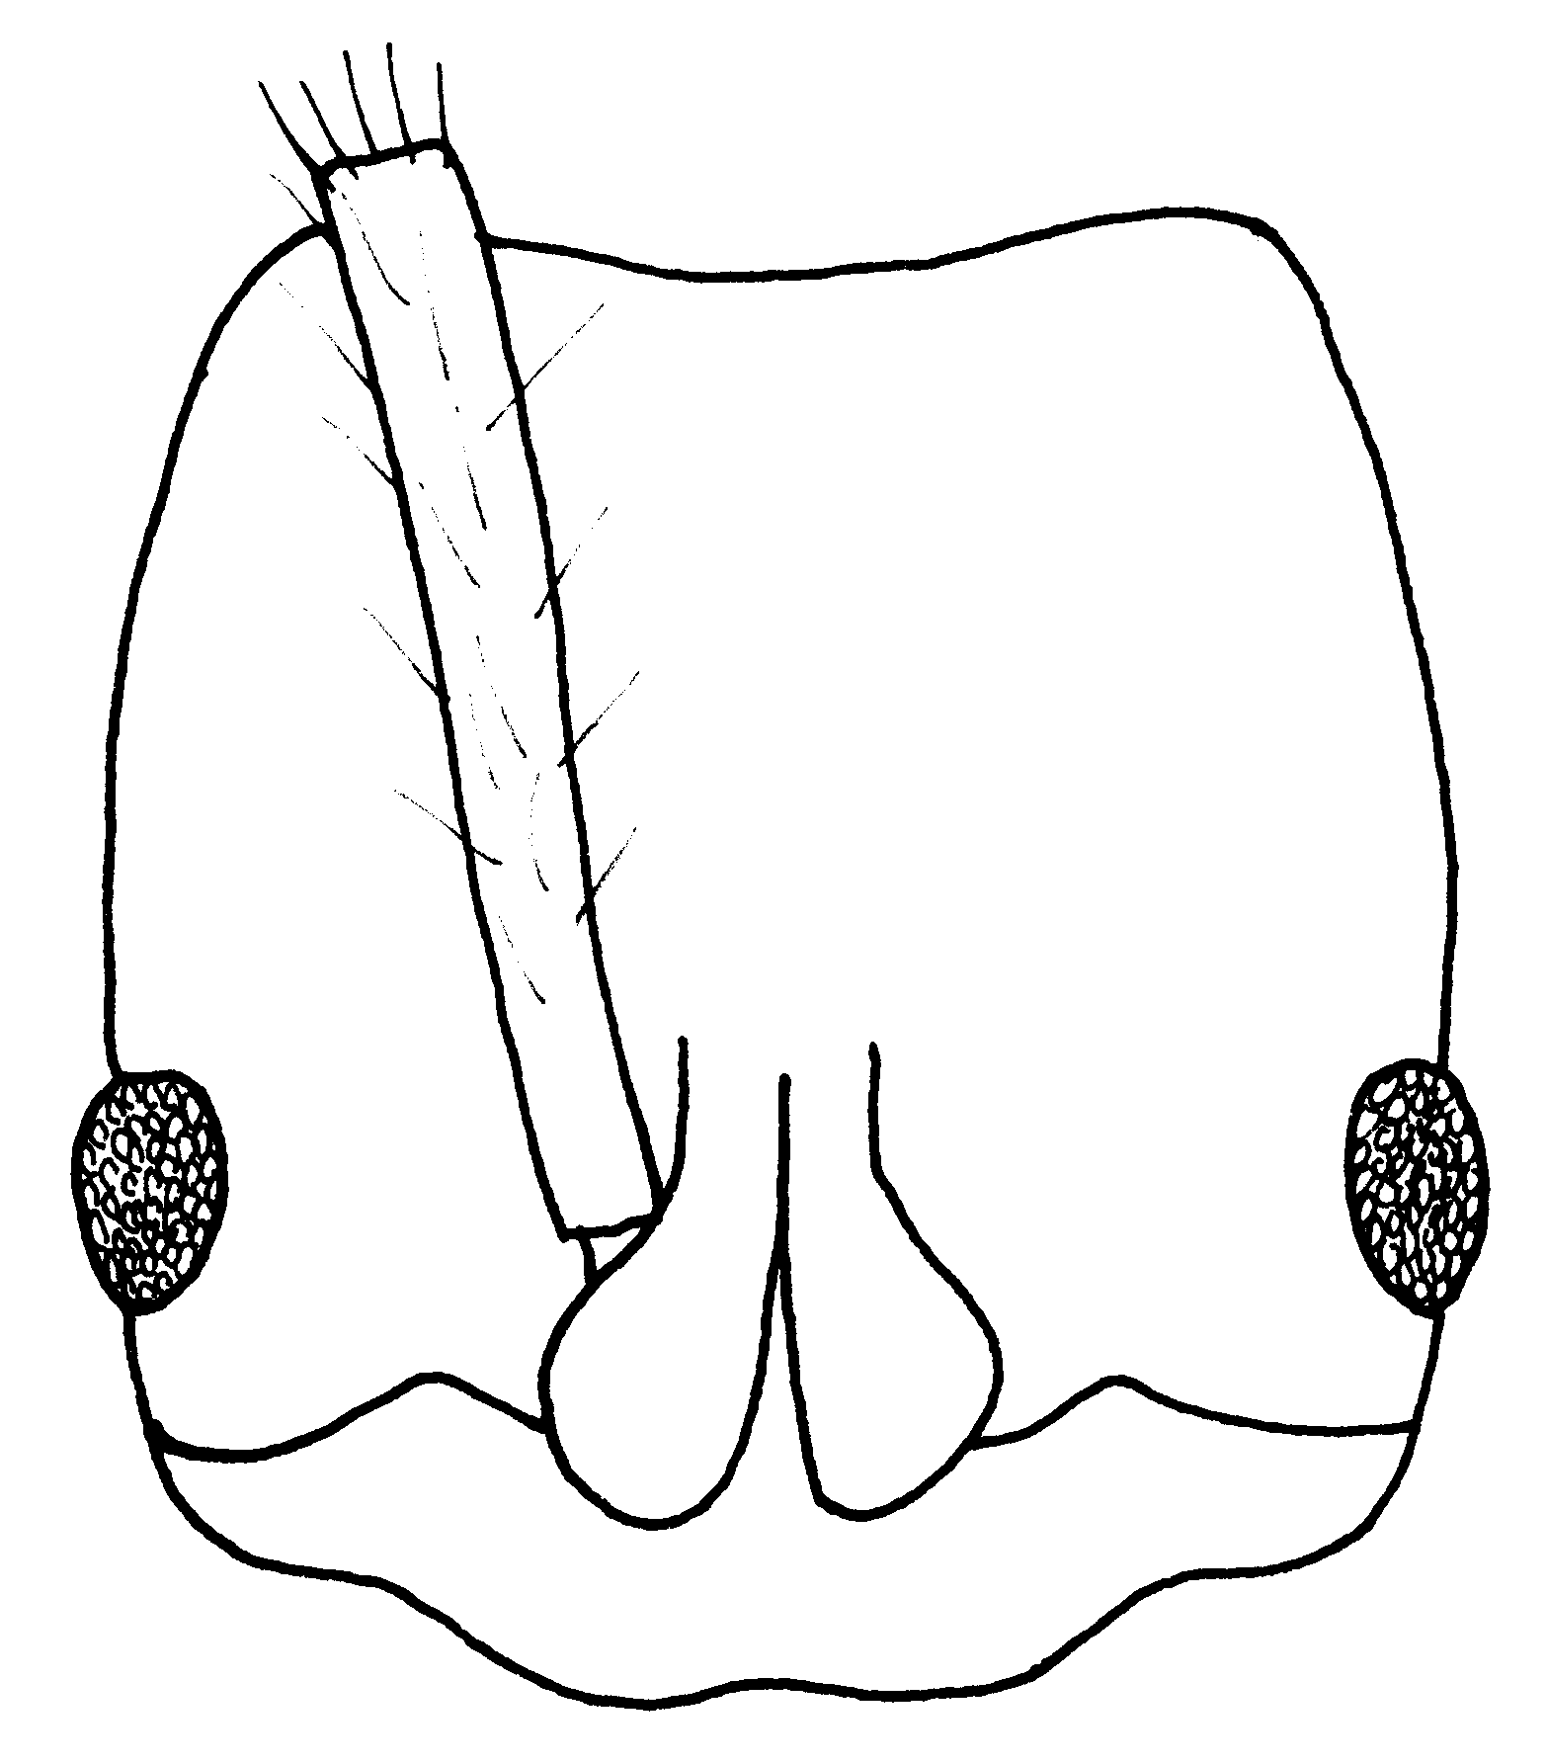
Fig. 100. Head of the a worker of P. harpax (Puntarenas, Costa Rica).
Erect hairs are abundant on most surfaces, including the mandibles, clypeus, scapes, dorsum of the head, region near the eyes, ventral surface of the head, dorsum of the mesosoma, petiole, and all surfaces of the gaster, the hairs on the tibiae are mostly suberect. Appressed, golden pubescence is abundant on most surfaces.
The mandibles are smooth and glossy, with scattered punctures, most of the dorsum of the head is covered with dense punctures, as is the mesosoma and petiole, the punctures on the dorsum of the gaster are more scattered, and much of the gaster is smooth and glossy.
The female is slightly larger (over 10 mm 12 mm, and is similar to the worker, except the mesosoma is more massive, and some structures, especially the side of the pronotum, mesopleuron, and the side of the propodeum is striate. The metanotal suture is well developed, forming a definite metanotum.
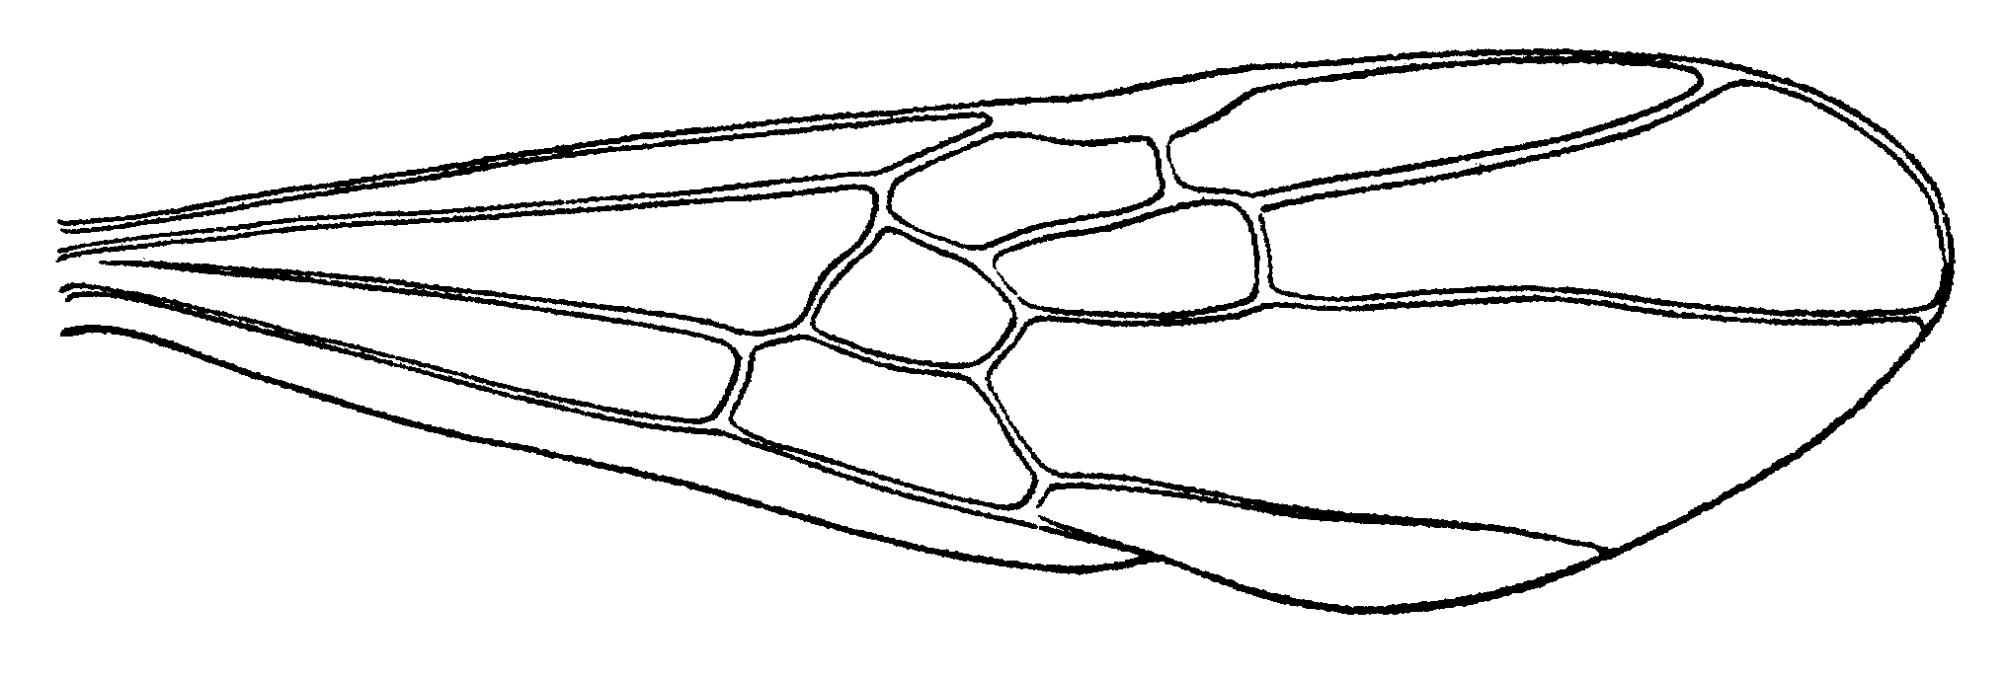
Fig. 101. Forewing of a female of P. harpax (from Creighton, 1950).
The male is also a relatively large specimen (total length about 9 mm), black with brown legs. The eye is large, covering more than half of the side of the head. The pronotal carina, well developed in both the worker and female, is lacking. The metanotal suture is well-developed, as is the metanotum. The petiole is somewhat rectangular shaped, but is definitely narrowed toward the apex, with a rounded node (not developed into a definite dorsal surface). The posterior face of the petiole is not defined by a carina.
Most surfaces are coriaceous, and at least weakly shining, although most of the surface is hidden by appressed, golden pubescence. Erect hairs are abundant and scattered on most surfaces, those hairs on the tibiae are mostly suberect.
Distribution. Louisiana, Texas, south to Paraguay.
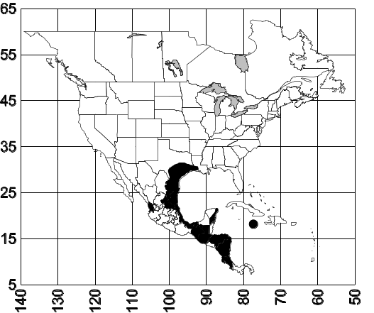
Map 23. Pachycondyla harpax.
Habitat. These ants occur in a wide variety of habitats, ranging from urban environments, grassy areas, coffee, cacao and banana plantations, cypress swamps, to oak forests and arid scrub, tropical deciduous forest, second growth tropical forest, tropical rain forests.
Biology. Nests are found in the soil, often under stones or pieces of wood. A nest gyne was found at a depth of 50 cms. Sexual were found in nests in Texas and Mexico from March to June, dealate females have been collected in May (Mexico), June (Mexico, Costa Rica, Colombia), July (Mexico) August (Mexico), September (Mexico), October (Venezuela), and December (Colombia). Brood were present in nests in August (USA), and November (Colombia). One nest was found in the abandoned nest of Solenopsis geminata. Workers were collected in a trap baited with a mealworm. These ants are found in the same areas as P. apicalis and ???

A269,, 836, 933, , 7161
17753, 17709, 17755, 17833, 17837, 17833, 18685, 18686, 18687, 18633, 18638, 18640, 18644,
***here

Pachycondyla haskinsi (Weber)*
Figs. D M need, H need ; Map

Discussion. ###
Distribution. Panamá and Brasil.
Map 24. Pachycondyla haskinsi.
Habitat. ^^^
Biology. &&&

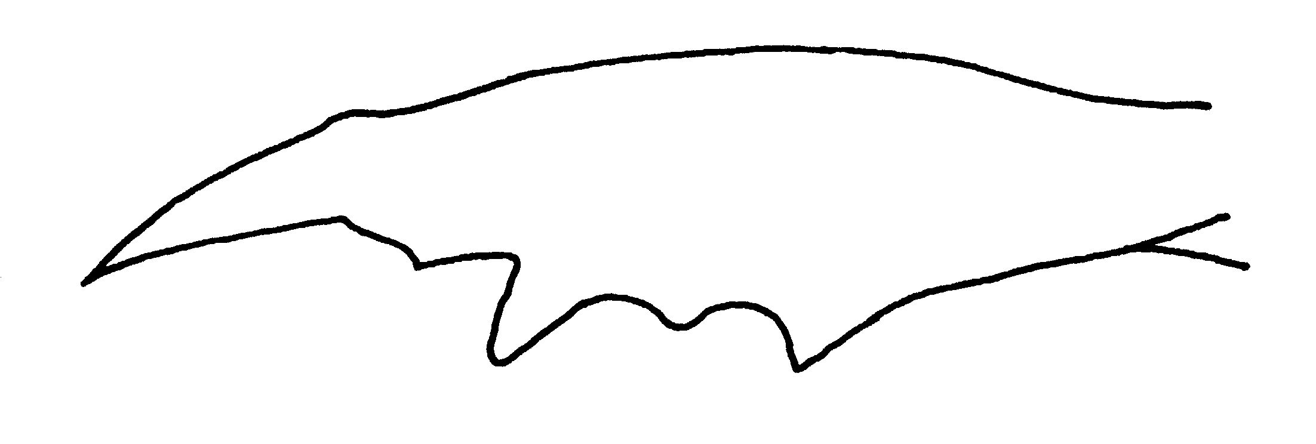
Fig. 102.Mandible of a worker of P. haskinsi (from Weber, 1939).

Pachycondyla holcotyla New species
Figs. D M, H ; Map

Discussion. The worker is a large (total length about 13 mm), black ant. The mandible has 12 or 13 teeth. The anterior border of the clypeus is broadly convex, and slightly indented medially. The preocular carina is well-developed, the eye is located slightly more than one maximum diameter from the anterior head of the head. The scape extends approximately the first funicular segment past the posterior lateral corner of the head. The sides of the head are broadly rounded, the posterior border is concave.
The pronotum has a well-developed carina, which overhangs the side pronotum. The metanotal suture is well-developed, and depressed below the level of the remainder of the mesosoma. The propodeal spiracle is slit-shaped, and the posterior lateral edges of the propodeum form a sharp carina with the posterior face. The petiole is thick when viewed in profile, with a vertical anterior face, and a broadly rounded posterior face, which meets the anterior face at the anterior point of the apex. The anterior face of the postpetiole is vertical, and rounded into the dorsal face. The stridulatory file is well-developed.
Erect hairs are abundant on most surfaces, including the mandibles, the clypeus, scapes, the dorsal and ventral surfaces of the head, the posterior margin of the head, the dorsum of the mesosoma, the dorsum of the petiole, and all surfaces of the gaster, the hairs on the legs are erect or nearly erect. Golden appressed pubescence is found on most surfaces, especially the head, the mesosoma, the post petiole, and first segment of the gaster.
The dorsal surface of the mandible is smooth, and moderately polished, and dorsum of the head is densely punctate, with punctures forming striae, the dorsum of the mesosoma is mostly punctate, with the region between the punctures being smooth and glossy, the side of the pronotum and mesopleuron are finely punctate and shining, the side of the propodeum is striate, and moderately shining. The anterior face of the gaster, as well is the upper half of the side, are covered with coarse striae. Entire posterior face of the gaster has similar, transverse striae. The gaster is mostly finely punctate, and smooth between the punctures.
This species is very similar to P. harpax, but can be recognized by the glossy mandibles (finely striate in P. harpax), and by the coarse striae on nearly all surfaces of the petiole, except for the lower half of the side, which are lacking in P. harpax.
Measurements: HL , HW , SL , EL , CL , CW , WL , FFL , FFW . Indices: CI , SI , CLI , FFI . ***here you
Fig. 103. Head of the holotype worker of P. holcotyla (xx X) (). needfig 2
Fig. 104. Mesosoma and petiole of the holotype worker of P. holcotyla (xx X) (). needfig 3

Etymology: From Greek, holkos, meaning attractive, and tylos, meaning knot or lump, referring to the attractive sculpturing on the petiole of this species. The name was provided by Bill Brown.
Type series: ???
Distribution. COSTA RICA: Guanacaste (Loma Barbudal, 3-vi-1989, S. Vinson # 12307 1  CWEM); COLOMBIA: Meta (75 k E Puerto López, 20-i-1973, W&E Mackay #73-46 1  CWEM)
Map 25. Pachycondyla holcotyla.
Habitat. Seasonal dry forest and grasslands.
Biology. Unknown, specimens have been collected loose on ground.

Pachycondyla holmgreni (Wheeler) SA

Pachycondyla impressa (Roger)
Figs. D M 54, H 93, petiole 94 ; Map

Discussion. The workers are large (total length about 11 mm) black ants, with reddish brown appendages. Most surfaces are dull and punctated, the mandibles are relatively smooth and glossy. The eyes are relatively small (maximum diameter 0.5 mm) and separated from the anterior edge of the head by less than one diameter. The carina is not developed anterior to the eye. The pronotal shoulder is swollen, but does not form a carina, the dorsum of the mesosoma is broadly convex, and the metanotal suture is poorly marked or absent on the dorsal surface of the mesosoma. The propodeal spiracle is slit-shaped. The petiole is large, and thick when viewed in profile, rectangular-shaped, with the apex somewhat sometimes being slightly broader than the region near the base of the peduncle. The anterior face of the postpetiole is slightly concave, and forms a relatively sharp angle with the dorsal surface.
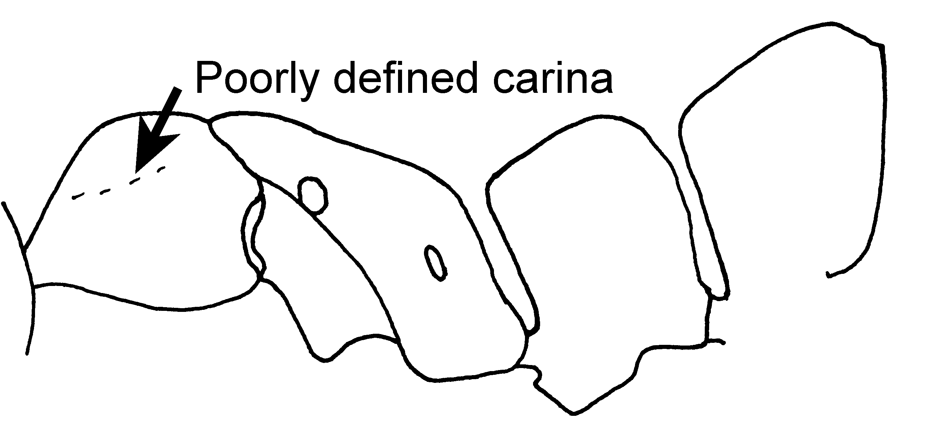
Fig. 105. Mesosoma, petiole and first gastral tergite of a major worker of P. impressa (Guanacaste, Costa Rica).
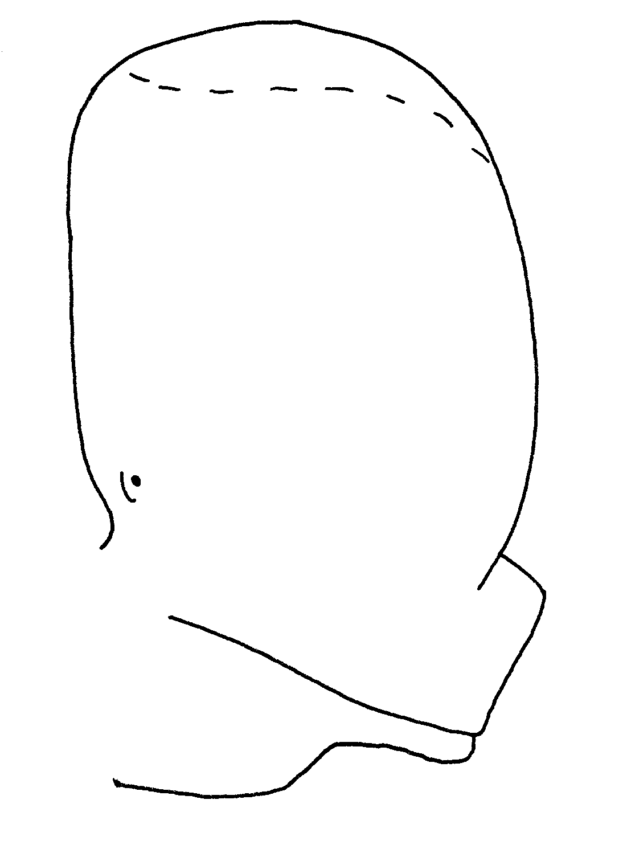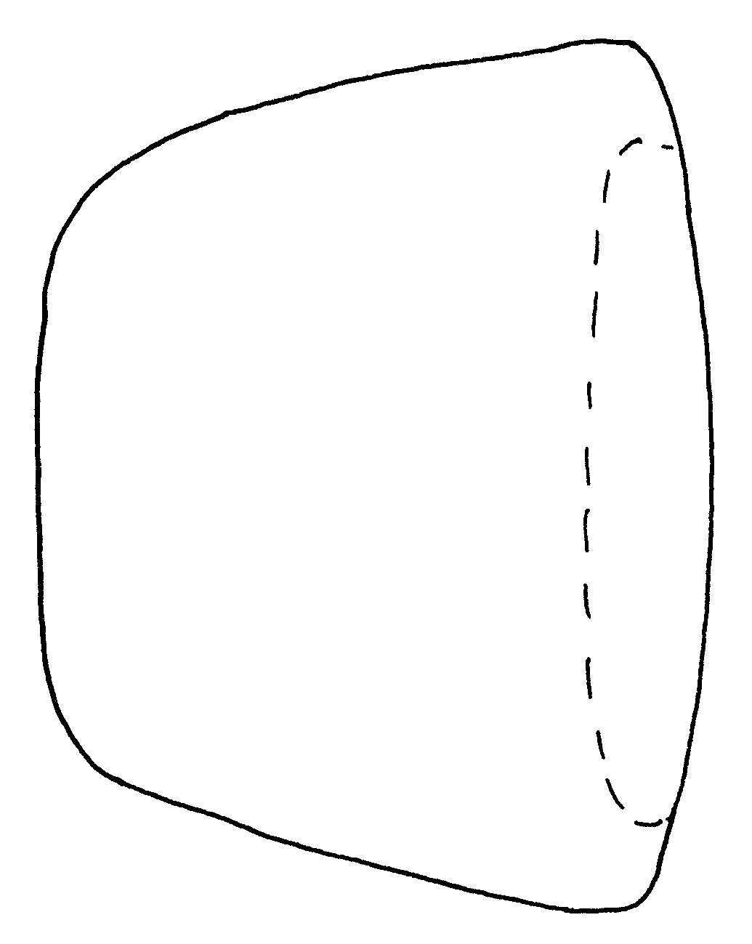
Fig. 106. Side view and top view of a petiole of a female of P. impressa (from Kempf, 1961).
Erect hairs are moderately abundant, including on the malar area, the shaft of the scape, the dorsal and ventral surfaces of the head, the dorsum of the mesosoma, the legs (many hairs are suberect), the dorsum of the petiole, and all surfaces of the gaster.
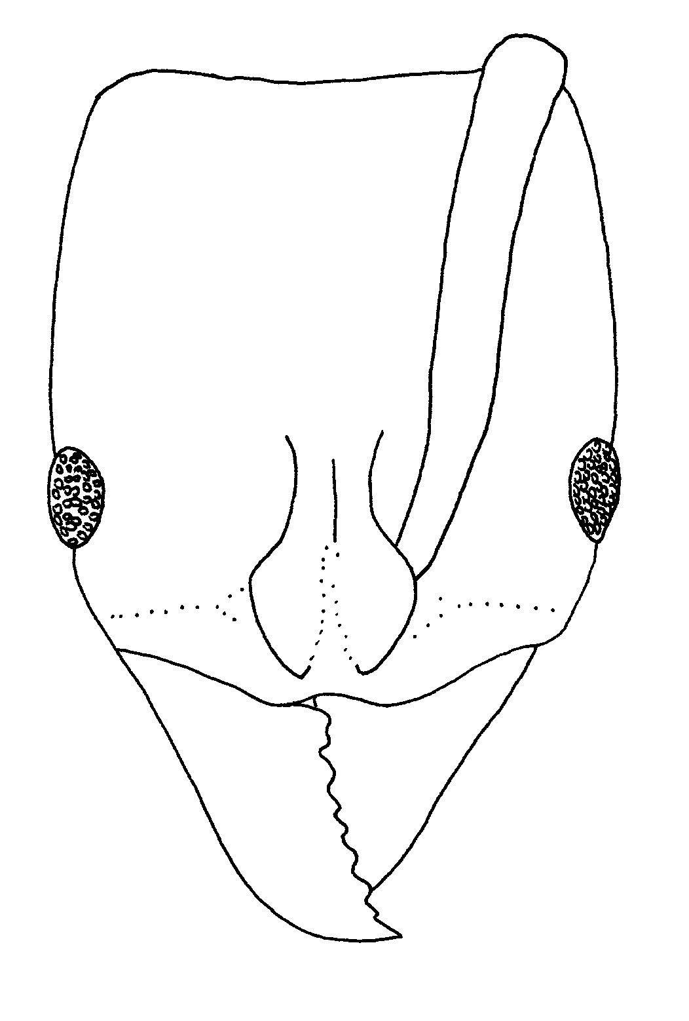
Fig. 107. Head of a worker of P. impressa (from Kempf, 1961).
The female is similar to the worker, but is actually somewhat larger (total length 16 millimeters). The remainder of the ant is nearly identical to that of the major worker, except ocelli are present, the mesosoma is swollen, and the metanotum is well-developed.
The male is also large (total length 16 mm). The petiole is narrowed toward the apex, not rectangular-shaped, and the side of the petiole is covered with coarse, irregular rugae, which gives the surface a hammered appearance.
The large size of this species would separate it from most of the other North American species of Pachycondyla. It could be easily separated from other large species, such as P. commutata by the dull surfaces (P. commutata is mostly shiny), from P. crassinoda by the lack of the three sharp processes on the pygidium (which are present in P. crassinoda), and from P. villosa by the relatively rounded pronotal shoulders (formed into a distinct, sharp carina in P. villosa). The lack of a metanotal suture in the worker could cause confusion with the smaller P. harpax (total length of worker less than 10 mm). It can be separated, as the carina on the pronotal shoulder of P. harpax is relatively sharp.

Distribution. Costa Rica south to Brasil.
Map 26. Pachycondyla impressa.
Habitat. ^^^
Biology. &&&
11526, 18662, 17682, 17739, A 270 or 271, 7168, 7213, 10519, 11113, 11238-2, 11238-7, 11238-1, 11238-8, 11238-4,11238-9, 11539 11238-10 11238-8, 11234-2, 11565 17733, 11238-10, 18636, 17723, 17667, 17666, 18662, 18663. 1

Pachycondyla inversa (Smith) subspecies of villosa

Pachycondyla laevigata (F. Smith)
Figs. D M 34, 95, H 37; Map

Discussion. The worker is a relatively large (total length 10 mm), shiny black ant with dark brown appendages. The eye is relatively large (0.5 mm maximum diameter), which is about twice the distance between the anterior border of the eye and the anterior border of the head. There is no carina anterior to the eye. The scape extends slightly past the posterior lateral corner. The pronotal shoulder is swollen, but does not form a carina. The dorsum of the mesosoma is nearly straight, the metanotal suture is poorly developed, but present on the dorsum of the mesosoma. The propodeal spiracle is slit-shaped, and the posterior face of the propodeum separated from the sides of the propodeum by a sharp edge. The petiole is thick when viewed in profile, with the anterior face being concave, the posterior face being convex, and the dorsal face being well defined. The dorsal face of the petiole is much broader posteriorly than anteriorly. The posterior lateral edges of the petiole are sharp between the sides of the petiole and the posterior face. The anterior face of the postpetiole is slightly concave, and meets the dorsal face at an angle.
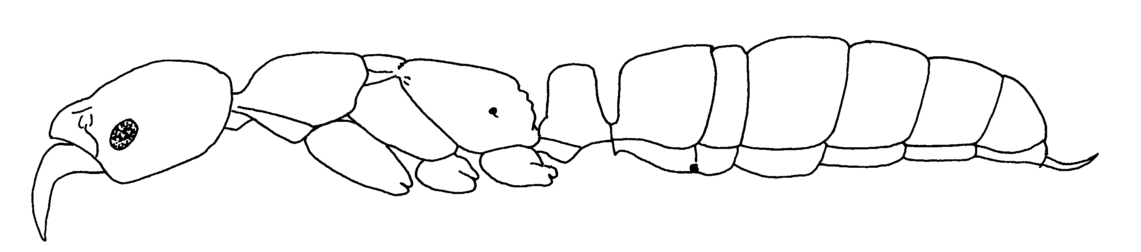
Fig. 108.Side view of a worker of P. laevigata (from wheeler ???).
Erect hairs are abundant on most surfaces, including the sides of the head, the shaft of the scape, the dorsal and ventral surfaces of the head, the dorsum of the mesosoma, the legs (most of the hairs on the tibiae, and many on the remainder is of the legs are suberect), the dorsum of the petiole, and all surfaces of the gaster.
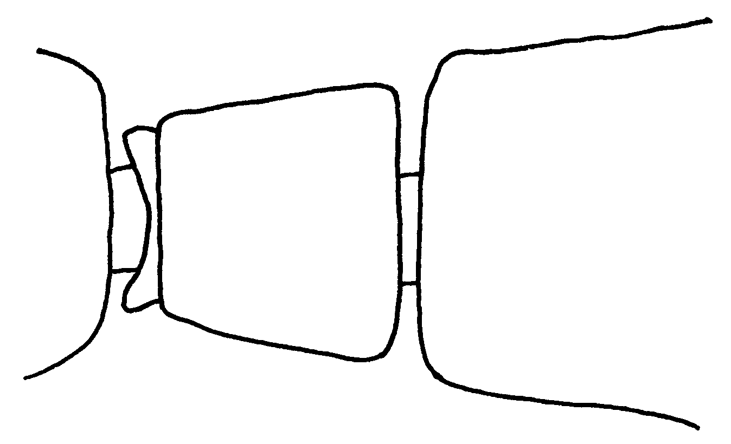
Fig. 109. Top view of the petiole of a worker of P. laevigata (from).
Most of the head is smooth and glossy, but distinct, poorly defined striae are present on the dorsum, the mesosoma is mostly smooth and glossy, but the upper half of the mesopleuron and the side of the propodeum have well-developed, coarse striae. The dorsal face of the propodeum has a few, short (0.3 mm in length), poorly developed striae, the posterior face of the propodeum is smooth and glossy. Most of the petiole and gaster are smooth and glossy.
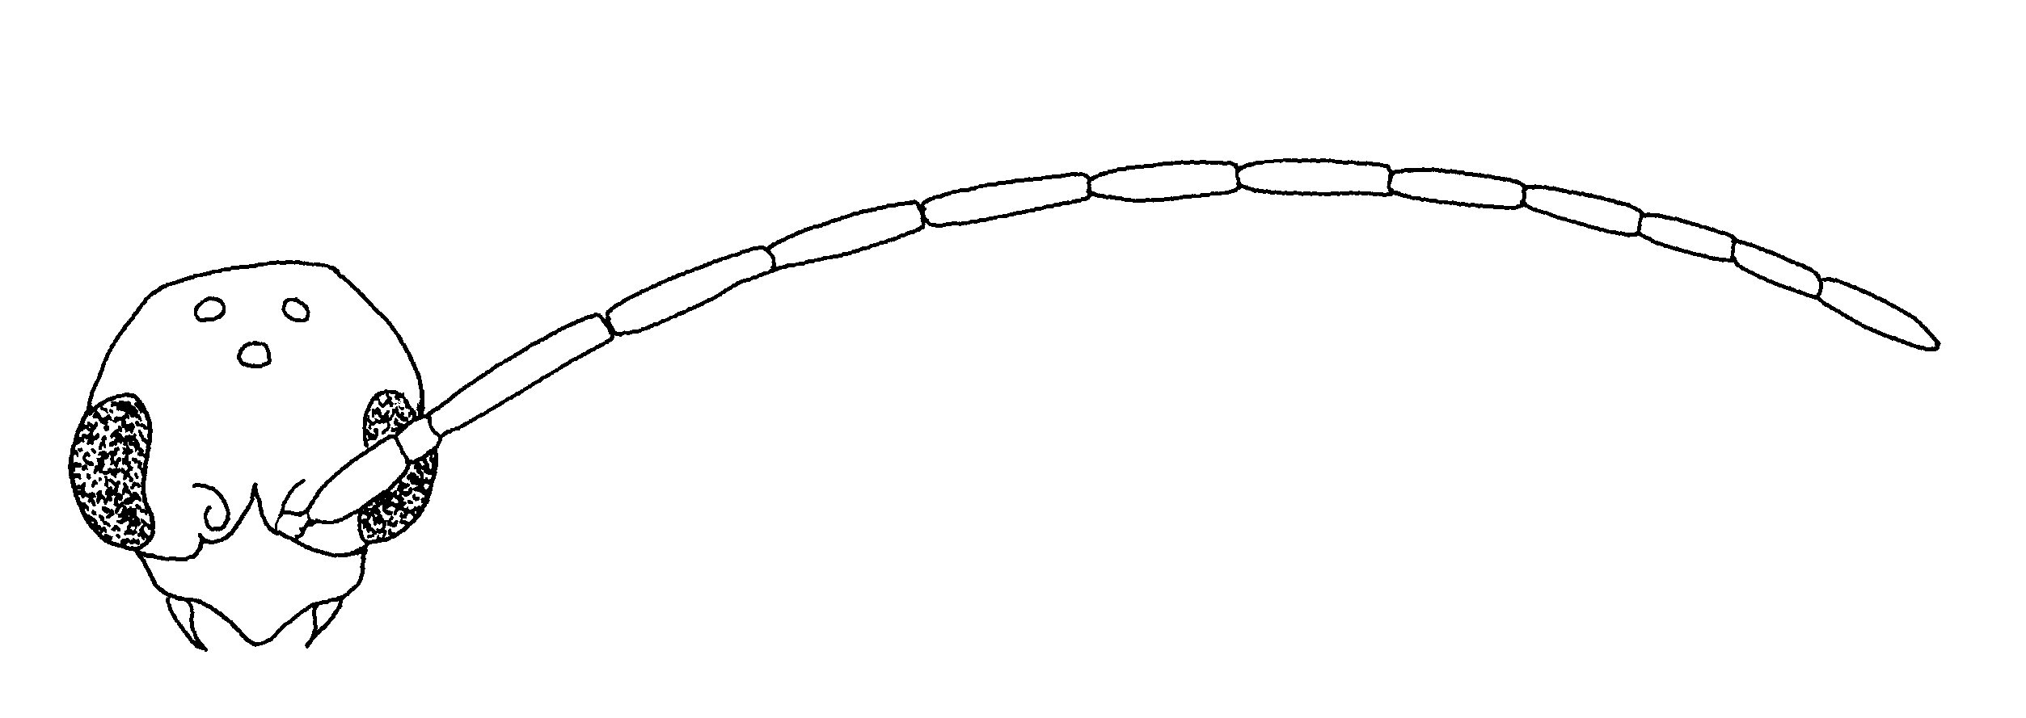
Fig. 110. Head of a male of P. laevigata (from ???).
The male is similar to that of the other species of Pachycondyla, with tiny mandibles.
Pachycondyla laevigata could be confused with two South American species: P. commutata and P. marginata. Only P. commutata could be expected to occur in North America. Pachycondyla laevigata can be easily separated from C. commutata and the moderately shiny North American P. carbonaria by the coarse striae on the side of the propodeum, which are very fine on both of the latter species. The shape of the petiole is very different in P. carbonaria, with the anterior face being nearly vertical, and the posterior face being convex, and meeting the anterior face at an angle, and thus not forming a distinct dorsal face. The mostly shining, black surfaces would separate this species from all of the other North American Pachycondyla.
Distribution: COSTA RICA: ??? (Osa Peninsula, Corcovado, San Pedrillo); PANAMA: Panamá (Canal Zone); COLOMBIA; Valle del Cauca; ECUADOR, TRINIDAD. Costa Rica south to Brasil
Map 27. Pachycondyla laevigata.
Habitat. ^^^
Biology. &&&

Pachycondyla latocciput (Forel) (obscuricornis) Ecuador
Pachycondyla lenis (Kempf)* SA
Pachycondyla lenkoi Kempf SA

Pachycondyla leveillei (Emery)* SA

Pachycondyla lineaticeps Mayr
Figs. D M 100, H 57, petiole 58; Map

Discussion. This is a moderately large (total length 10 mm), black species, with brown mandibles and antennae, and reddish-brown legs. The eye is a relatively large (maximum diameter about 0.5 mm), located about one maximum diameter from the anterior margin of the head. The preocular carina is sharp and well-developed. The pronotal shoulder is developed into a sharp carina, which overhangs the side of the pronotum, the metanotal suture is depressed on the dorsum of the mesosoma, where it breaks the sculpture. The posterior lateral edges of the propodeum form a carina, as does the posterior lateral edges of petiole. The anterior face of the petiole is vertical, the posterior face is broadly rounded and meets the anterior face of the node. There is no distinct dorsal face.
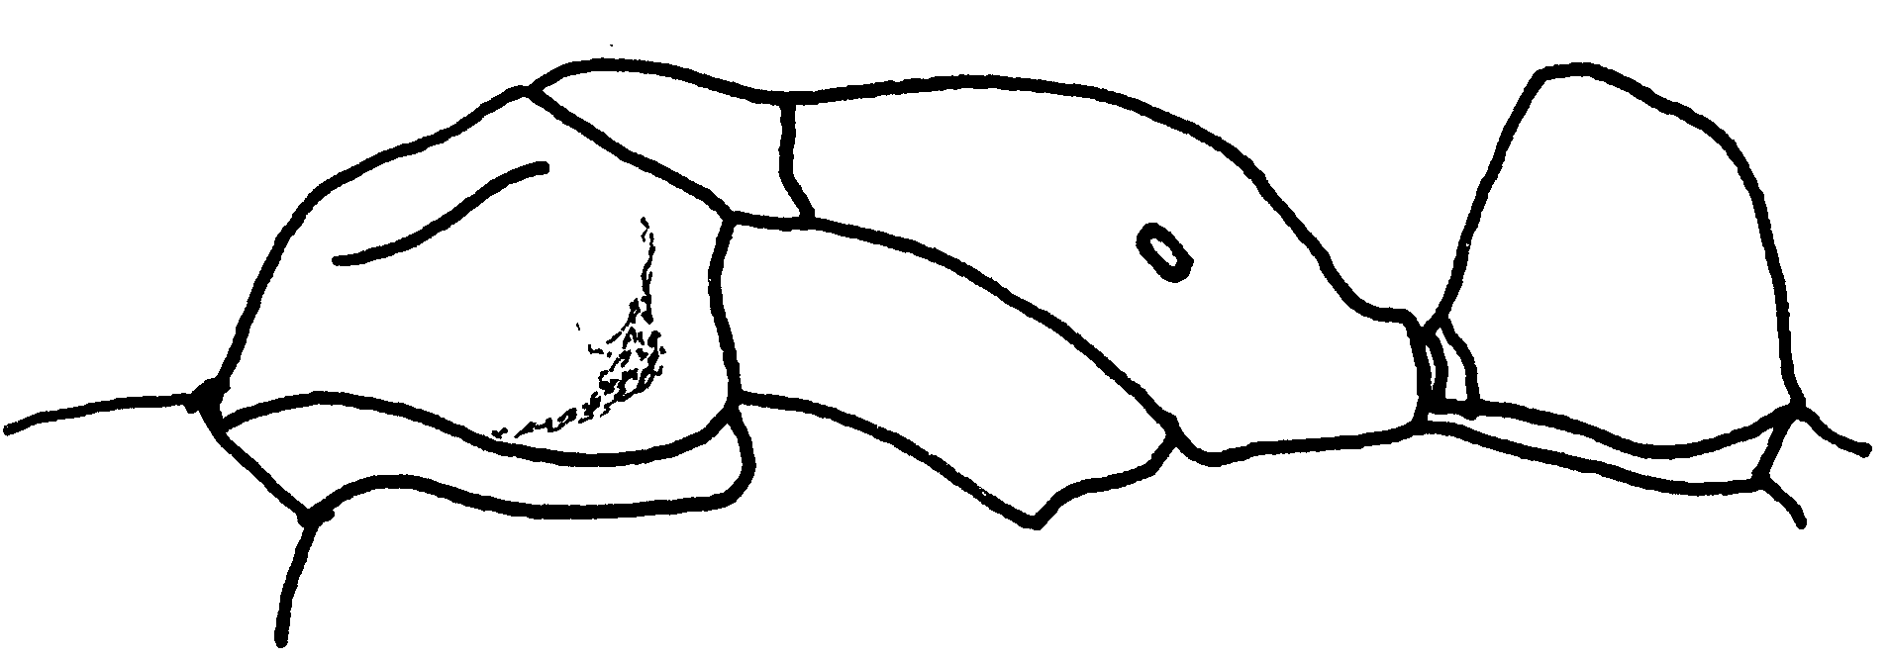Fig. 111. Mesosoma and petiole of a worker of P. lineaticeps (near Guápiles, Costa Rica).
Most surfaces are covered with erect hairs, including the dorsum of the head, the ventral surface of the head, the scapes, the dorsum and sides of the mesosoma, the legs (the hairs on the tibiae are mostly suberect), the petiole, and all surfaces of the gaster. Appressed pubescence is also abundant, and dense on the dorsum of the head, the dorsum of the mesosoma, the side of the mesosoma, the petiole, and the dorsum of the gaster.
Much of the dorsal surface of the head is covered with punctures, some of which are in rows and form striae. The head is slightly swollen on the vertex, with that area covered with coarse, longitudinal striae, which is the characteristic that defines this species. The dorsum of the mesosoma is finely punctate, but the sculpture is covered with golden pubescence which makes much of sculpture hidden. The side of the pronotum is punctate, but moderately shining, the entire mesopleuron is punctate, but moderately shining. The side of the propodeum is covered with coarse, longitudinal rugae. The anterior face and side of the petiole are punctate, and moderately shining, the posterior face of the petiole is punctate and moderately shining, usually with vertical rugae in the central region. The gaster is punctate and moderately shining.
The sculpture of the head would separate this species from all of the others in the genus Pachycondyla. The entire funiculus is brown, which would separate it from P. apicalis and P. eboritacta. The well marked dorsal lateral margins of petiole would distinguish it from the Costa Rican C. dismarginata. The vertical striae or rugae (often poorly developed) on the posterior face of the petiole separate it from P. scalaris (in which the striae are transverse) and from P.theresiae, P. villosa and P. bugabensis, which lacks striae or rugae on the posterior face.
Distribution. MEXICO ; NICARAGUA: Matagalpa (Hotel Selva Negra), south to Panamá. Need distribution???
Map 28. Pachycondyla lineaticeps.
Habitat. ^^^
Biology. &&&
Distribution: COSTA RICA: Osa Peninsula, Corcovado; Santa Clara; Guanacaste Vulcan Cacao. MEXICO: Veracruz: Las Hamacas, 17 km N. Santiago Tuxtla; Chiapas: Laguna Ocotal Grande. PANAMA: Cerro Campana;

Pachycondyla lunaris (Emery)* SA

Pachycondyla luteola (Roger) SA

Distribution: PERU.
Pachycondyla lydiae (Santschi)* SA

Pachycondyla magnifica Borgmeier SA
Pachycondyla marginata (Roger) SA
Distribution: BOLIVIA; BRASIL; PARAGUAY; TRINIDAD.

Pachycondyla mesonotalis (Santschi) SA

Pachycondyla metanotalis Luederwaldt SA
Pachycondyla oberthueri Emery SA

Pachycondyla obscuricornis Emery
(+ latocciput)

Figs. D M have, H 96; Map

Discussion. The workers are relatively large (total length 8 - 9 mm), black ants. The mandibles are mostly smooth and glossy, the remainder of the ant is dull, which forms a strong contrast. The carina between the eye in the clypeus is well-developed and sharp. The eyes are large, occupying more than ⅓ of the length of the side of the head. The scapes extend about ⅓ length past the posterior lateral corner. The dorsum of the mesosoma is nearly straight and, but is slightly depressed at the metanotal suture. The shoulder of the pronotum the swollen, but does not forming a distinct carina. The propodeal spiracle is elongated and slipped-shaped. The petiole is thick when viewed in profile, with both the anterior and posterior faces being convex and rounded, and meeting a rounded apex. The posterior lateral borders of the petiole meet at a sharp angle, which nearly forms a carina.
Erect hairs are sparse, with a few on the mandibles, clypeus, coxae, femora, tibiae (many of the hairs on the legs are suberect), ventral surface of the gaster, and posterior ⅓ of the gaster. Erect and suberect hairs are absent on the side of the head (a few may be present on the cheeks or on the malar area) the dorsum of the mesosoma, the petiole, the first and in most of the second tergum.
The female is similar to the worker, lacking erect hairs on the dorsum of the mesosoma, the petiole, and most of the dorsum of the gaster. The large eyes, and the well-developed carina anterior to the eye would further assist in recognizing this species. The posterior lateral edges of the petiole form a sharp carina.
The male is a small (total length about 12 mm) black specimen, with very tiny, weakly shining mandibles, and the remainder of the body being dull. Most of the bodily surfaces, including the sides of the head, the dorsum of the mesosoma, the dorsum of the petiole, and all surfaces of the gaster are covered with short (most about 0.25 mm in length), golden hairs. The posterior lateral regions of the petiole are broadly rounded, and not sharply bent as they are in the worker and the female. It would be difficult to recognize the male without workers or females.
The lack of erect hairs on the dorsum of the mesosoma, petiole and first tergum of the worker and the female, would separate this species from all of the others of the North American Pachycondyla, except for P. apicalis. The workers and females can be separated from P. apicalis as the apex of the funiculus is usually dark, but may be reddish-brown, but is never yellow as it is in P. apicalis. The sharp posterior lateral edges of the petiole of the worker and female are sharp, and may even formed a carina, whereas in P. apicalis this area is completely rounded. Thus, it is unlikely that this species would be confused with any of the others in North America.
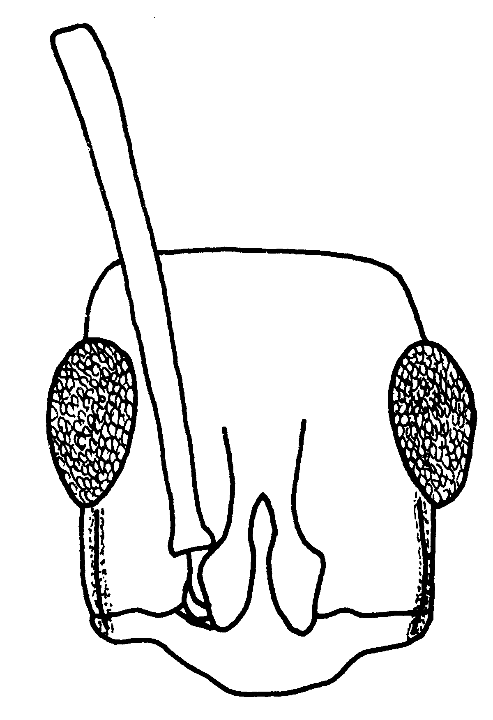
Fig. 112. Head of a worker of P. obscuricornis (Cauca, Colombia).
Distribution: MEXICO: Veracruz (Pueblo Nuevo nr. Tetzonapa, Las Hamacas, 17 km n. Santiago Tuxtla). HONDURAS: ??? (14 km S. La Ceiba, El Buquero, Lancetila nr Tela); COSTA RICA: ??? (Río Toro Amarillo vic. Guapiles; Punta Arenas Prov Par Nat Corcovado; Turrilaba Pocotel Lodge 10° 31’ N 84° 5’ W). COLOMBIA (Valle del Cauca, Huila, Meta); ECUADOR; PERU, VENEZUELA, BRITISH GUYANA; BRASIL, BOLIVIA PARAGUAY.
Map 29. Pachycondyla obscuricornis.
Habitat. ^^^
Biology. &&& 9034, A 242, 496 → 502, 521→525, 150, C39, 7185, 11227, 11226-8, -4, 11222-10, 11778, 11785, 11815, 11818, 11819,11820, 11822, 11508, 12830, 12522, 12824, 12534A, 11814, 12560, 12413, 12326,12440c, 11226-5, 12440 D, 12460,

Pachycondyla obsoleta (Menozzi)*
Figs. D M need, H need; Map

Discussion. ###
Distribution.: Costa Rica.
Map 30. Pachycondyla obsoleta.
Habitat. ^^^
Biology. &&&

Pachycondyla panamensis var ferruginea Forel

Pachycondyla pergandei (Forel)
Figs. D M 28, H ; Map

Discussion. Workers of Pachycondyla pergandei are small (total length about 8 mm), black ants, with reddish-brown appendages. The clypeus nearly forms a medial carina, but the region anterior to the eye is without a carina. The eye is relatively small (0.25 mm maximum diameter) which is longer than the distance between the anterior border of the eye in the anterior border of head. The scape extends to posterior lateral corner of the head. The overall dorsum of the mesosoma is convex, but it is distinctly impressed at the promesonotal suture, and is more deeply impressed at the metanotal suture, and the metanotum is developed, although poorly. The propodeal spiracle is circular and relatively small (diameter of the opening is 0.04 mm). The dorsal face of the propodeum is broadly rounded into the posterior face. The petiole is relatively narrow when viewed in profile, with a vertical anterior face, and a curved, convex posterior face, that meet at a relatively sharp apex. The anterior face of the postpetiole is vertical and straight, and meets the dorsal face at an angle.
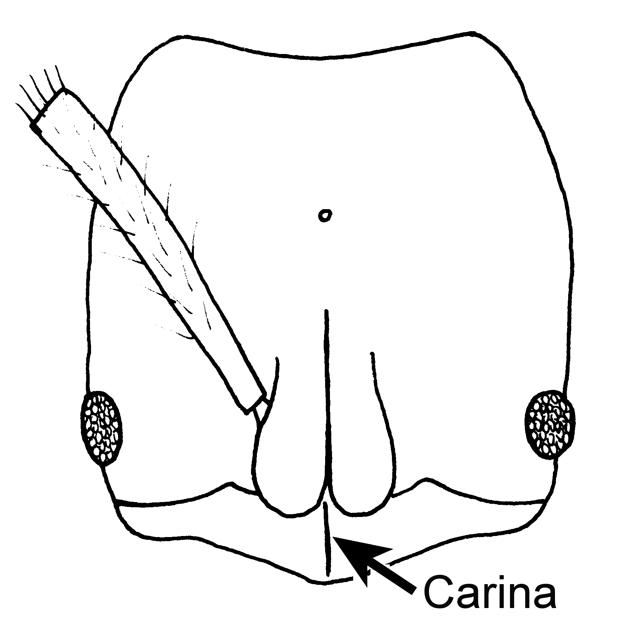
Fig. 113. Head of a worker of P. pergandei (xx X) (Cochabamba, Bolivia).
Erect, mostly short (0.15 - 0.25 mm) hairs are present on most surfaces, including the dorsal and ventral surfaces of the head, the sides of the head, the scapes, the dorsum of the mesosoma, the legs, the dorsum of the petiole, and all surfaces of the gaster. Appressed, golden pubescence is abundant on nearly all surfaces.
Most surfaces are dull and punctate, except for the mandibles which are glossy, but finely striated, and the coxae, which are partially punctate.
The small, round propodeal spiracle would separate this species from most of the other North American species of Pachycondyla. The lateral margins of the pronotum are without a carina, which would distinguish this species from the Panamanian (to the Amazon) P. arhuaca, the Venezuelan P. emiliae and the Brazilian P. metanotalis. It could be easily confused with P. becculata, which is also small, has a clypeal carina, and has a depression at the metanotal suture. It can be separated, as P. becculata has a sharp point on the anterior medial border of the clypeus, not rounded or slightly concave, as it is P. pergandei. The relatively short medial tibia (shorter than the maximum width of the pronotum, about 1 mm in length), would separate this species from other similar species such as P. constricta, P. rostrata, and P. procidua. Finally, it can be separated from the normally dark reddish-brown P. ferruginea by the relatively larger eyes (maximal diameter of eye of P. ferruginea 0.15 mm, much less than the distance between the anterior border of the eye and the anterior border of the head).
Distribution. Guatemala, Bolivia.
Map 31. Pachycondyla pergandei.
Habitat. Transition montane forest.
Biology. Specimens are occasionally collected in leaf litter extractions.

Pachycondyla procidua Emery SA

Distribution: BRASIL; SURINAM.
Pachycondyla rostrata Emery SA
Distribution: COLOMBIA; BRASIL, VENEZUELA.
Pachycondyla stigma var. rufescens Wheeler & Mann, Haiti
P. unidentata var. rugatula Santschi Argentina
P. rugosinodis Andre var. of striatinodis Peru
Pachycondyla rupinicola new species
Distribution: COLOMBIA.

Pachycondyla scalaris new species
Figs. D M 61, H 60, pet 61; Map

Discussion. ###
Distribution. %%%
Map 32. Pachycondyla scalaris.
Habitat. ^^^
Biology. &&&

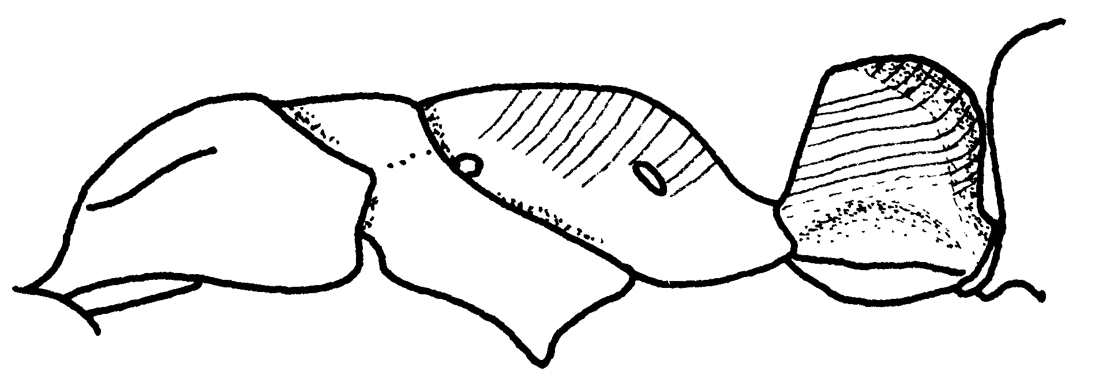Fig. 114. Mesosoma and petiole of a worker of P. scalaris (Paracou Experimental Forest, French Guiana).

splendida race of atrovirens Forel
stipitum Forel ??? in Kempf syn of crenata
Distribution: BRASIL; BRITISH GUIANA; BOLIVIA; COSTA RICA: 6 mi S, 6 mi W of Las Canas; ECUADOR; FRENCH GUIANA; PANAMA; PERU; SURINAM; TRINIDAD.

Pachycondyla stigma (Fabricius)
(+ rufescens)
Figs. D M 97, H have; Map

Discussion. The worker of this species is easily recognized, as the mandible has only six teeth, or rarely with a poorly developed 7th tooth. Workers are small (total length 5 mm), dark reddish-brown, with paler brown appendages. The eyes are tiny (maximum diameter 0.07 mm) and located approximately two diameters from the anterior margin of the head. The scapes extend to posterior lateral corners of the head. The dorsum of the mesosoma is nearly flat, with the promesonotal suture weakly depressed, and the metanotal suture strongly depressed below the level of the mesosoma. The side of the propodeum is depressed near the posterior edge of the mesopleuron, with the side forming a sharp edge with the posterior face of the propodeum. The petiole is narrow when viewed in profile, with a straight anterior face, and a convex posterior face which meet at the apex in a blunt angle. The anterior border of the postpetiole is slightly concave and is abruptly rounded into the dorsal face.
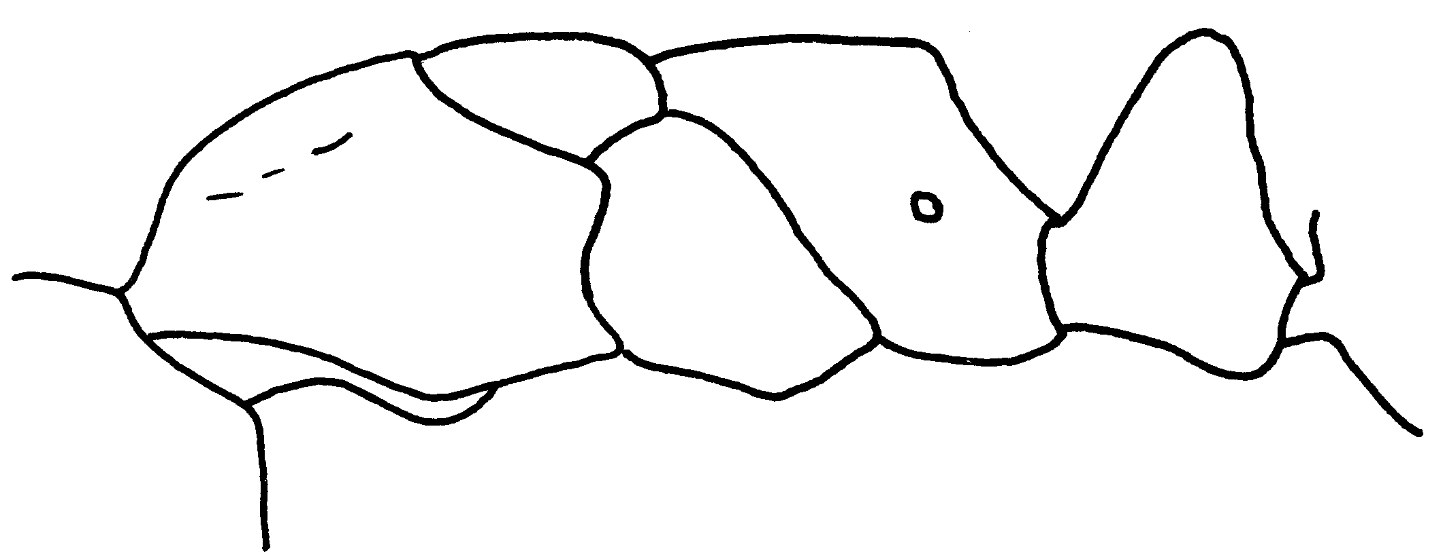Fig. 115. Mesosoma and petiole of a worker of P. stigma (near Tela, Honduras).
Erect hairs are abundant on most surfaces, including the mandibles, the dorsal surface of the head, the scapes, the dorsum of the mesosoma, the legs, the petiole, and all surfaces of the gaster. Golden appressed pubescence is found on most surfaces.
The head, mesosoma, and gaster are mostly dull, and covered with fine punctures, the mandibles are striate and moderately shining.
The female is similar to the worker, except slightly larger (about 7 mm total length), with well-developed ocelli, and the mesosoma adapted for flight.
The male ???
The worker and female of this species would not be confused with any of the others of the North American species in the genus Pachycondyla, based on the small number of mandibular teeth. All other species have more than 10 teeth.
Distribution (New World). UNITED STATES: ??? MEXICO: Chiapas (Tuxtla Chico, 10 k S Palenque), Veracruz (10 k N Cárdenas); COLOMBIA: Valle del Cauca, Antioquia, Tolima; south to ARGENTINA, PUERTO RICO: El Yunque (Campamiento Elisa Goldberg).
Map 33. Pachycondyla stigma.
Habitat. Primary growth rain forest.
Biology. &&& 17120, 11156 alate female, 1079, 1082, 1074, 1067, 75-21, 613, 10532, 11184-1, 17117, 17072,

Pachycondyla striata F. Smith SA

Pachycondyla striatinodis Emery
(+ rugosinodis)
Figs. D M 100, H 101, petiole; Map

Discussion. Workers of this species are moderately sized (total length 9 mm), black ants, with yellowish-brown appendages. The anterior medial border of the clypeus forms a sharp tooth, but the clypeus is without a carina. The eye is moderate sized (maximum diameter 0.46 mm), and is located about one diameter from the anterior border of the head. The carina anterior to the eye is well-developed and sharp. The scapes extend about ⅓ length past the posterior lateral corners. The carina at the pronotal shoulder is very well-developed, sharp, and overhangs the side of the pronotum. The promesonotal suture is well-developed, the metanotal suture is barely indicated. The propodeum is rounded between the two faces, and the spiracle is slit-shaped. The petiole is thick when viewed in profile, with a vertical anterior face, and a convex and rounded posterior face, which meets the vertical face at a blunt angle. The anterior face of the postpetiole is concave, and meets the dorsal face at an angle.

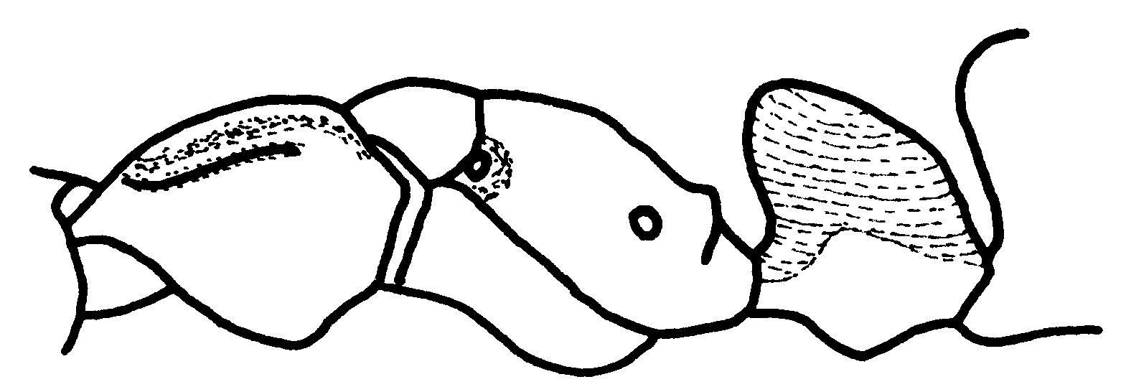Fig. 116. Mesosoma of a worker of P. striatinodis (Barro Colorado Island, Panamá).
Erect hairs are abundant on most surfaces, including the sides of the head, dorsal and ventral surfaces of the head, shaft of the scape, dorsum of the mesosoma, legs, dorsum of the petiole, and all surfaces of the gaster. Appressed, golden pubescence is abundant on most surfaces, and may even be matted on the dorsum of the mesosoma and the dorsum of the gaster.
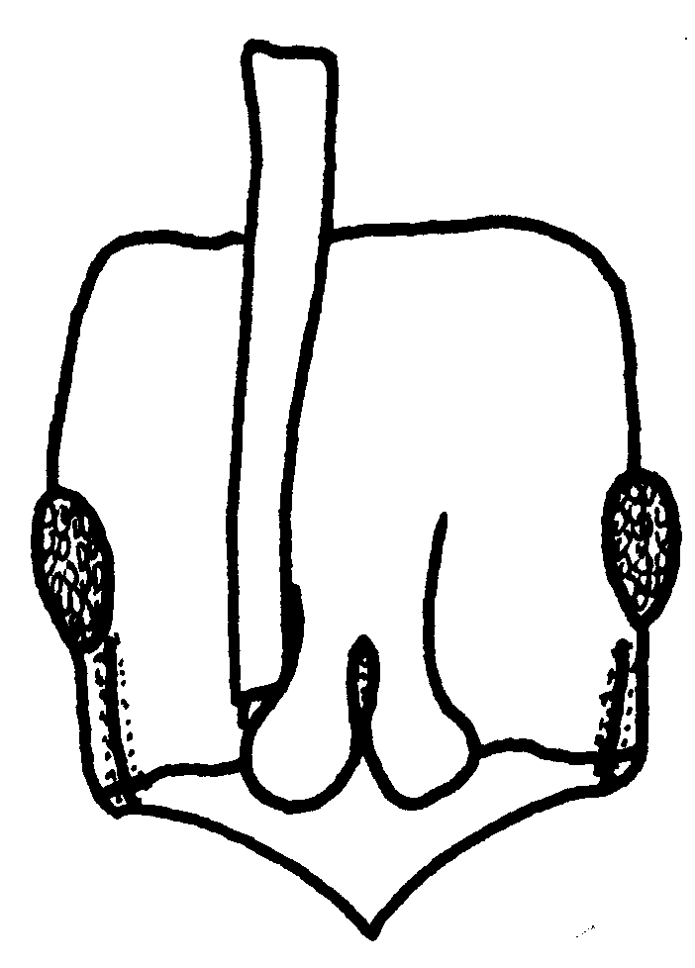
Fig. 117. Head of a worker of A. striatinodis (Tingo Maria, Perú).
The mandibles are finely striate, and moderately shining, the dorsum of the head is covered with striae, with punctures between the striae, the dorsum of the mesosoma is punctate or granulose, the region below the pronotal carina is smooth and shiny, the remainder of the side of the pronotum is weakly punctate and moderately shining. Much of the mesopleuron is shining, except for the uppermost section, which is transversely striate. The side of the propodeum is rugose, the dorsum posterior face shining. The sculpture of the petiole is characteristic of this species, with longitudinal rugae on the sides, which extend and form transverse striae across the anterior face. The posterior face has parallel, transverse striae. The gaster is finely punctate and partially shining. The anterior coxa, femur, and tibia are shining, the other coxae are dull, but the other femora and tibiae are moderately shining.
The striae or rugae covering all surfaces of the petiole, would allow easy recognition of this species. Additionally, the extremely well-developed carina on the pronotal shoulder would separate it from other similar species. Finally, the contrast between the black background color, and the yellowish or reddish-brown legs would allow further separation of this species from most others. This species would be most likely confused with the Mexican, Central America, and South American P. unidentata, which also has a sharp carina on the pronotum, and yellowish or reddish-brown legs. It can be easily separated, as the posterior face of the petiole (as well as the sides) are mostly smooth and shining, with scattered punctures, and is without the transverse striae found in P. striatinodis. Additionally, the anterior medial process on the clypeus of P. unidentata is formed into a blunt angle, not a sharp tooth as in P. striatinodis.
Distribution: GUATEMALA: (???); COSTA RICA: ??? (Osa Peninsula Corcovado); PANAMA: ??? (Río Frijolito); COLOMBIA; PERU; BRITISH GUYANA.
Map 34. Pachycondyla striatinodis.
Habitat. ^^^
Biology. &&& 17848

Pachycondyla succedanea (Roger)*
Figs. D M need, H need; Map

Discussion. ###
Distribution.: Cuba
Map 35. Pachycondyla succedanea.
Habitat. ^^^
Biology. &&&

Pachycondyla theresiae Forel
Figs. D M 62, H need; Map

Discussion. ###
Distribution: COSTA RICA: (Sirena Peninsula Osa, 8.28 N 83.35 W.; Puntarenas (6 km S. San Vito 8° 42’N 83°W); PANAMA: Panamá () south to BRASIL.
Map 36. Pachycondyla theresiae.
Habitat. ^^^
Biology. &&&

Pachycondyla unidentata Mayr
(+ rugatula)
Figs. D M need, H need,  petiole 40; Map

Discussion. The worker is a relatively small (total length about 6 mm), dark reddish-brown ant, with yellowish brown appendages. The anterior medial border of the clypeus forms a bluntly rounded process. The region anterior to the eye forms a moderately well developed carina, the eye is relatively large, occupying nearly one third of the length of the side of the head. The antennal scape extends about the first 2 funicular segments past the posterior lateral corner. The pronotal shoulder forms a very sharp longitudinal carina, which greatly overhangs sides of the pronotum. The metanotal suture is barely evident on the dorsum of the mesosoma. The propodeal spiracle is elongated and oval-shaped. The petiole is thick when viewed in profile, with the anterior face being nearly vertical, straight, the posterior face being convex and rounded, and meeting the anterior face at nearly the anterior edge of the petiole. The posterior lateral margins of the petiole are sharp, and form a crenulated carina.
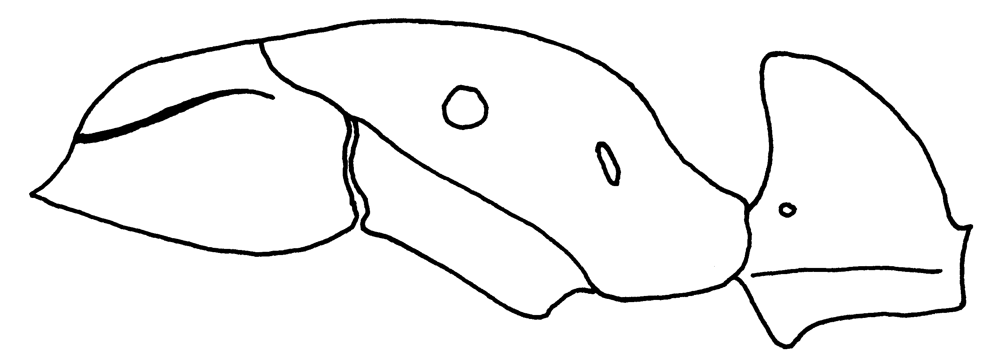 Fig. 118. Mesosoma and petiole of a worker of P. unidentata (Chiapas, México).
Erect hairs are abundant on most surfaces, including the dorsal and ventral surfaces of the head, the scape, dorsum of the mesosoma, the dorsum of the petiole, and all surfaces of the gaster, the hairs on the tibiae are suberect.

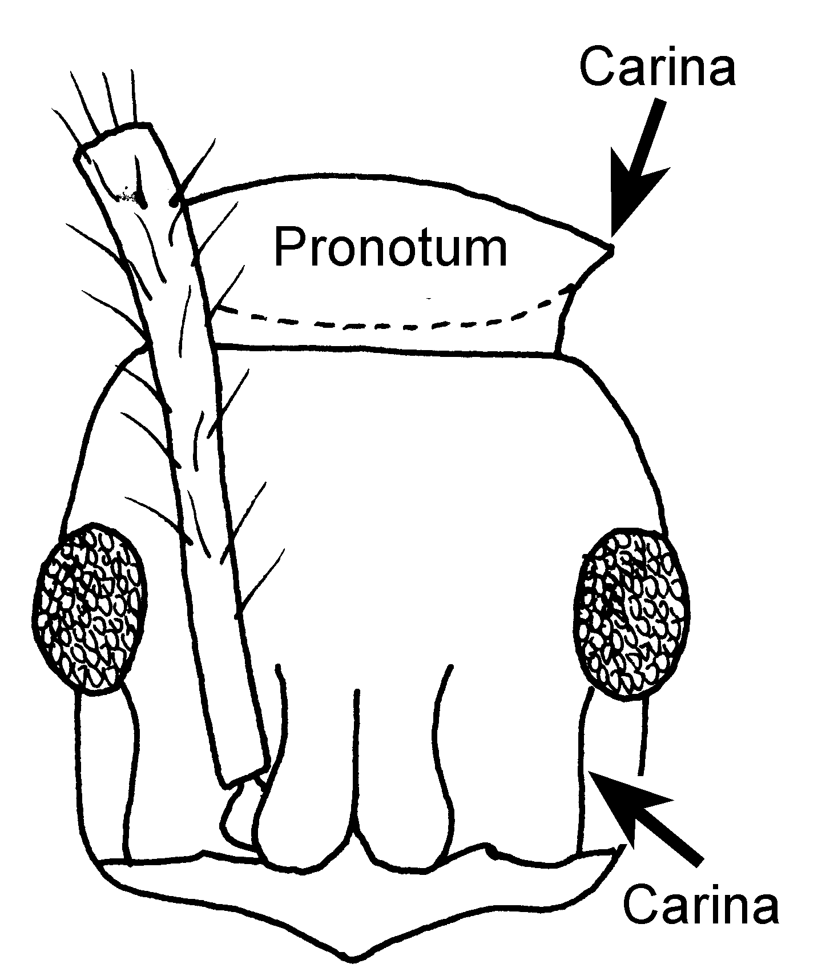
Fig. 119. Head of a worker of P. unidentata (Colombia 7204).
The dorsum of the head is densely and evenly punctate, but shining between the punctures, the dorsum of the mesosoma is more finely punctate and more glossy, the sides of the pronotum are finely punctate and shiny, the remainder of the sides of the mesosoma is slightly more coarsely punctate, but is also shining between the punctures. The anterior face and sides of the petiole are finely punctate and glossy, the posterior face is very finely punctate and very smooth and glossy, the dorsum of postpetiole is finely punctate and moderately glossy, as is most of the remainder of the gaster. The stridulatory file is well-developed.
The female is similar to the major worker, differing in being larger (total length about 9 mm), and is similar in color. The anterior medial border of the clypeus is similar to that of the worker, the preocular carina is well-developed, the pronotal carina is also well-developed and overhangs the side of the pronotum, the spiracle and the petiole are of a similar shape. The pilosity and sculpture are similar to that of the major worker, except the dorsum of the gaster has more abundant, appressed, golden pubescence.
This species can be separated from other members of the crenata species complex, including P. crenata and P. carinulata, as the highest point on the petiole is located near the anterior face (highest area about mid point in the latter two species). It can be separated from the Central and South American P. striatinodis, as it lacks striae on all surfaces of the petiole (which are present in P. striatinodis). Finally, it can be separated from the South American P. goeldii, as the anterior face of the petiole is nearly vertical, not inclined to an approximately 45 degree angle as in P. goeldii.
Distribution: MEXICO: San Luis Potosí (18 mi S Tamazunchale); Chiapas (Ocosingo, Palenque Ruins), Veracruz (Las Hamacas, Pueblo Nuevo nr Tetzonapa, 17 k N Santiago Tuxtla); ____________________, Laguna Ocotal Grande;, Veracruz; Taxoquintela, Yaxiquintela? Chiapas, 16°58’N 91º47’W; GUATEMALA: ____________________ 25.4 Cacao Trece Aguas, ____________________ Alta V. Paz. HONDURAS: ____________________ (Lancetilla nr Tela); ____________________ (Augustine); COSTA RICA: ____________________ (Osa Peninsula Corcovado 8°28’N 83°35’W), ____________________ (Rio Toro Amarillo vic. Guapiles); Heredia (500m 10º20’N 84º04’W); ____________________ Carara Biological Reserve 9º50’N 84º40’W; ; PANAMA, COLOMBIA, ECUADOR; VENEZUELA, BRITISH GUYANA; FRENCH GUIANA PERU; TRINIDAD, BOLIVIA; BRASIL.
Map 37. Pachycondyla unidentata.
Habitat. Primary rain forest.
Biology. # 7204, 11221-2

Pachycondyla venusta Forel SA

Pachycondyla villosa (Fabricius)
(+ inversa)
Figs. D M 102, H 63,  103, wing 105,  104 ; Map

Discussion. Workers of this species are relatively large (total length about 15 mm), black ants, with black or reddish-brown tibiae. The anterior border of the clypeus is convex, but is concave medially. The preocular carina is well-developed and sharp, shining and well marked against a background of golden, appressed pubescence. The maximum diameter the eye is about one fourth the length of the side of the head, and is located more than one maximum diameter from the insertion of the mandible. The scape extends approximately the first two funicular segments past the posterior lateral corner. The carina on the pronotal shoulder is sharp, and slightly overhangs the side of the pronotum. The metanotal suture is well marked on the dorsum of the mesosoma, and depresses the level slightly below the remainder of the mesosoma. The propodeal spiracle is slit-shaped. The posterior face of the propodeum is separated from the side of the propodeum by a definite carina. The petiole is thick when viewed in profile, with a vertical anterior face and a convex, broadly rounded posterior face that meets the anterior face at the anterior point of the apex of the petiole. The posterior lateral edges of the petiole nearly form carinae. The stridulatory file is well-developed.
Erect hairs are abundant on most surfaces, including the dorsal and ventral surfaces of the head, the antennal scapes, the posterior border, the dorsum of the mesosoma, dorsum of the petiole, all surfaces of the gaster, the hairs on the legs are either erect or suberect. Appressed, golden pubescence is abundant on most surfaces, especially the mesosoma petiole, and gaster.
The head is covered with coarse punctures, which are somewhat aligned in rows, the dorsum of the mesosoma has finer punctures, and surfaces which are not hidden by appressed pubescence are glossy and shiny, the side of the mesosoma is mostly punctate, but the surfaces nearly completely hidden with appressed pubescence, the petiole is finely punctate, with surfaces not hidden by appressed pubescence being shining. The dorsum of the gaster is punctate, but most surfaces are densely covered with appressed pubescence.
The female is larger (about 17 mm total length), usually black with reddish-brown femora, and appearing somewhat golden due to the abundant, appressed pubescence. The anterior border of the clypeus is slightly concave medially, and the preocular carina is well-developed. The distance between the insertion of the mandible in the anterior border of the clypeus is greater than the maximum diameter of the eye. The ocelli are well-developed, and the scape extends slightly past posterior lateral corner. The pronotal carina is very well-developed, sharp, and overhangs the side of pronotum. The metanotal suture is well-developed, and forms a well defined metanotum. The petiole is shaped as in the major worker. The pilosity and sculpture are similar to that of the major worker.
This species can be easily confused with P. holcotyla, but can be separated, as the side petiole is without any evidence of striae, which are present in P. holcotyla. What about P. bugabensis, P. theresiae and others, possibly scalaris?
Distribution: UNITED STATES: Texas (Mission; Kingsville; Hidalgo Co. Santa Ana Nat’l Wildlife Refugee; Brooks Co., 13 k S Falfurrias). MEXICO: Nuevo Leon (Horsetails Falls); Tamaulipas (Gomez Farias and vic.); Nayarit (San Blas, Vic. Compostela); Veracruz (El Palmar); Tabasco (10 k N Cárdenas); Hidalgo (Jacala); ____________________ Escuinapa; Chiapas (Tuxtla Chica); Quintana Roo (Reserva Ecológica “El Eden”); Yucatán (Cinco de Mayas Cave, 5 km NE Mérida). GUATEMALA: Sta. Emilia Pochuta; San Jose; HONDURAS: El Zamorano; Augustine Brit.; Lancetilla, Tela; COSTA RICA: Guanacaste (Loma Barbudal), Pen. Osa. Par. Nat. Corcovado, Sirena 8 º 28N 83 º 35W; Rio Toro Amarillo vic. Guapiles; La Lola; Prov. Guanacaste, Had. Palo Verde (Rio Tempisque); Heredia Finca La Selva; San Juan River near Oro Verde Lodge 10 º 41’N 83 º 58’W. PANAMA: ____________________ San Blas Nusagandi; COLOMBIA (Antioquia, Boyacá, Cundinamarca, Guaviare, Meta); ECUADOR; PERU; BRITISH GUIANA; SURINAM; TRINIDAD; VENEZUELA; PARAGUAY; ARGENTINA; BRASIL;
Map 38. Pachycondyla villosa.
Habitat. This species is found in a variety of habitats, ranging from tropical rain forest, to highly disturbed areas such as cacao plantations and even dry scrub forest.
Biology. This species nests in wood, including dead branches, and trunks, and even dead logs on the ground. 7207, 75-21, 13240, 788, 7179, 562, 12321, 988, 13235, 7186, 10071, 9443, 10541, 7198, 75-25, 12276, 12305, 12306, 12316, 13178, 13261
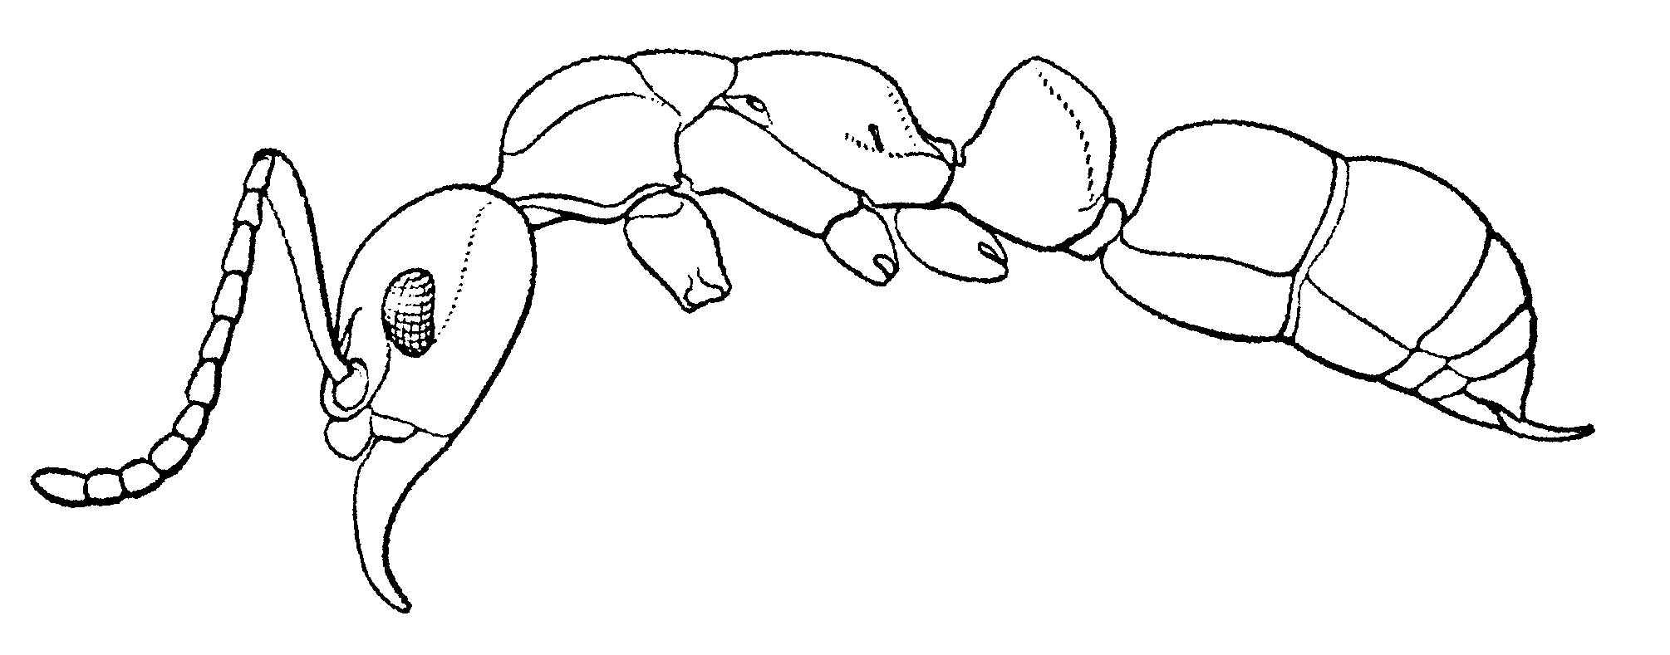
Fig. 120. Side view of a worker of P. villosa (from Creighton, 1950).
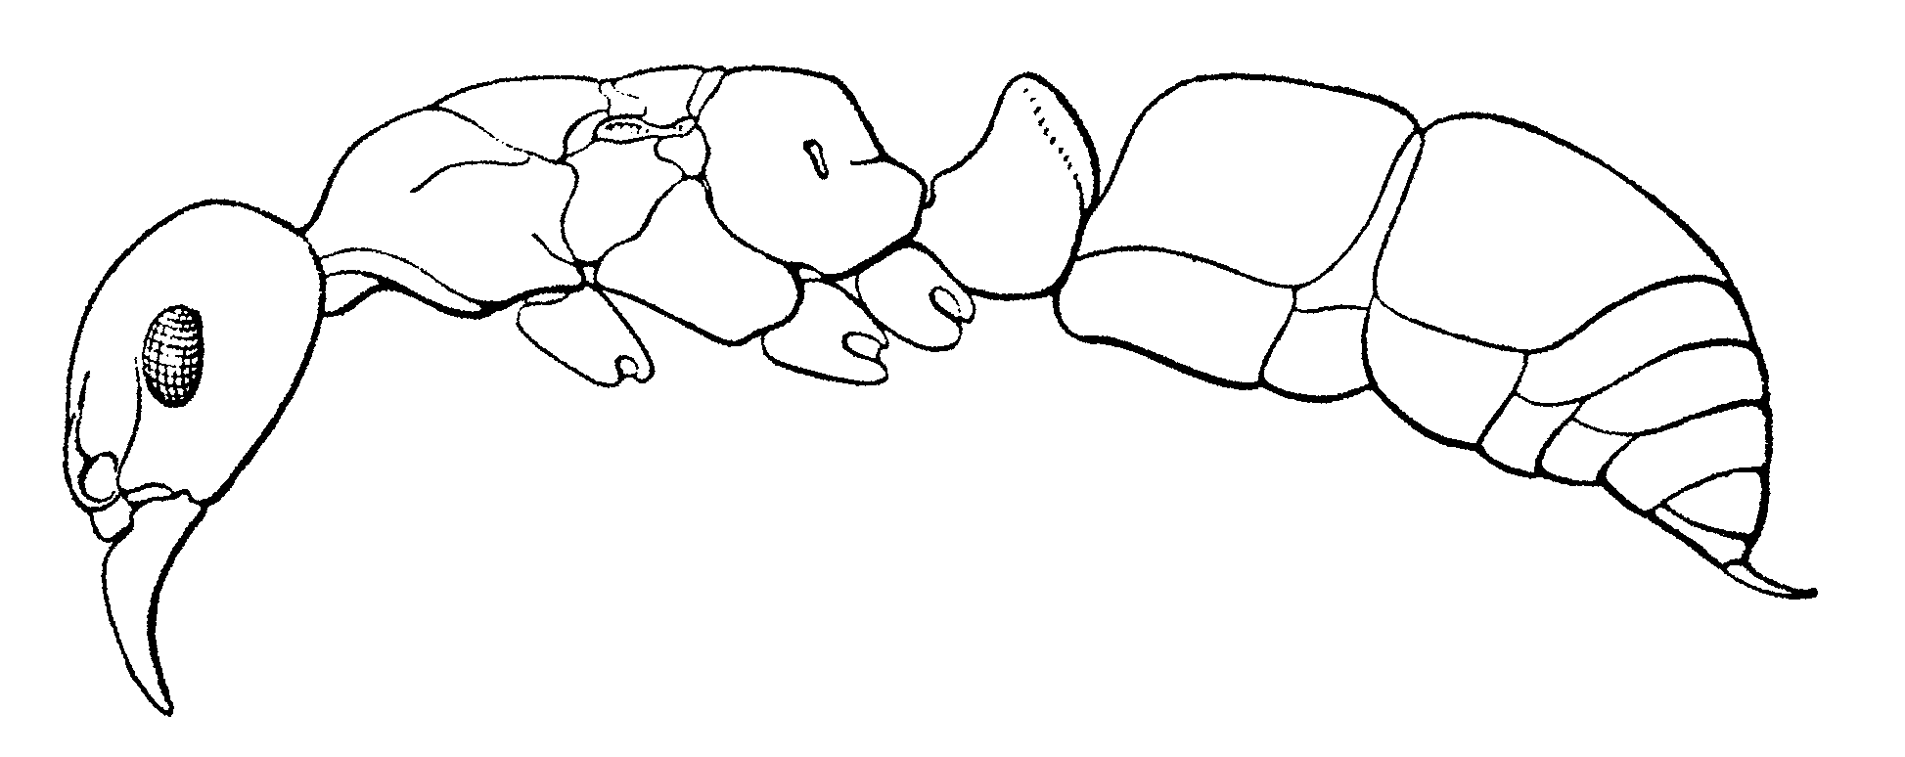
Fig. 121. Side view of a female of P. villosa (from Creighton, 1950).
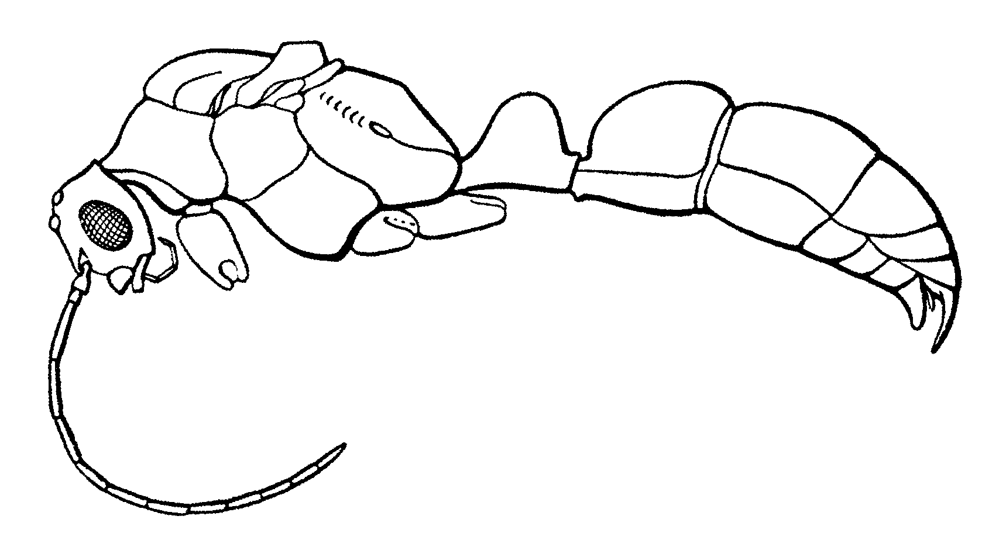
Fig. 122. Side view of a male of P. villosa (from Creighton, 1950).
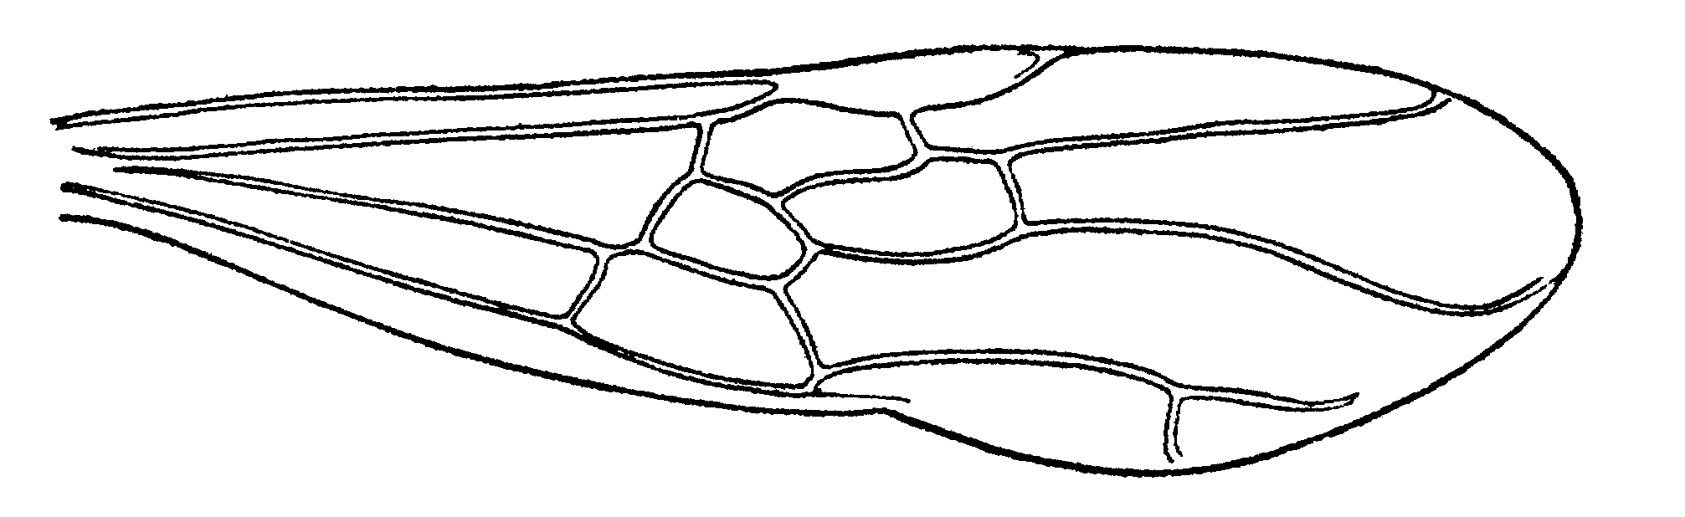
Fig. 123. Forewing of a female of P. villosa (from Creighton, 1950).

Pachycondyla XX XX
Figs. D M, H ; Map

Discussion. ###
Distribution. %%%
Map 39. Pachycondyla xx.
Habitat. ^^^
Biology. &&&

Literature cited
Creighton, W. 1950. The ants of North America. Bull. Mus. Comp. Zool. 104:1-585 + 57 plates.
Serna, F. 1999. Hormigas de la zona de influencia del Proyecto Hidroeléctrico Porec II. Unpublished Master’s Thesis, Universidad Nacional de Colombia, xiv + 250 pp.
Fig. 124 total figs.

All locality data for Neoponera from MCZ entered, Mesoponera and below not done 6/24/03
# | Species | have | discussion | comparison | distribution | map | habitat | biology | comments | Subgenus
1 | aenescens | yes | Yes (cras) | yes | yes | yes | yes | yes | Check id in mcz | Mesop 1870
2 | apicalis | yes | Yes (apic) | no | yes | yes | yes | yes | #’s present | Eupon 1857
3 | arhuaca | yes | Yes (arhu) | yes | yes | no | yes | yes |  | Mesop 1901
4 | azteca Forel | no | no | no | no | no | no | no | none | Neop 1899
5 | becculata | yes | Yes (arhu) | Need more | yes | no | yes | yes | Check mcz
6 | bugabensis | no | no | no | yes | no | no | no | Need desc | Neop 1899
7 | carbonaria | yes | Yes (cras) | yes | yes | yes | yes | no | none | Mesop 1858
8 | carinulata | yes | Yes (cren) | no | yes | no | yes | no | none | Neop 1890
9 | cauta (Mann) | no | no | no | no | no | no | no | none | Trachy 1922
10 | cavinodis (Mann) | no | no | no | no | no | no | no | none | Neop 1916
# | Species | have | discussion | comparison | distribution | map | habitat | biology | comments
11 | cognata (Emery) | no | no | no | no | no | no | no | none | Trachy 1896
12 | constructa (Mayr) | yes | Yes (cons) | no | yes | no | yes | yes | none | Meso 1884
13 | crassinoda | yes | Yes (cras) | no | yes | no | yes | yes | none | Pachy 1802
14 | crenata | yes | Yes (cren) | no | yes | no | no | no | none | Neop 1861
15 | dianae | no | no | no | yes | no | no | no | none
16 | dismarginata | no | no | no | yes | no | no | no | none
17 | ferruginea | yes | Yes (ferr) | no | yes | no | yes | yes | none | Mesop 1858
18 | foetida(Linnaeus) | no | no | no | no | no | no | no | none | Neop 1758
19 | fuscoatra (Roger) | no | Yes (cras) | yes | yes | no | no | no | none | Pach 1861
20 | gilva | yes | Yes (gilv) | yes | no | no | yes | yes | Dist Data mcz | Trac,Cry1863
# | Species | have | discussion | comparison | distribution | map | habitat | biology | comments
21 | guatemalensis | yes | Yes (gilv) | yes | no | no | yes | yes | none | Tra,Cry 1899
22 | guianensis | yes | Yes (gilv) | yes | no | no | yes | no | none | Wadeura 39
23 | harpax | yes | Yes (cras) | no | no | yes | yes | yes | none | Pach 1804
24 | haskinsi | no | No (gilv) | no | no | no | no | no | none | Wadeura 39
25 | impressa | yes | Yes (cras) | yes | no | no | no | no | none | Pachy 1861
26 | laevigata | yes | Yes (laev) | yes | yes | no | no | no | none | Termit 1858
27 | lineaticeps | yes | no | no | no | no | no | no | none | Neop 1901
28 | obscuricornis | yes | Yes (apic) | yes | yes | no | no | no | none | Neop 1890
29 | obsoleta (Menoz) | no | no | no | no | no | no | no | none | Trach 1931
30 | pergandei | yes | Yes (ferr) | yes | yes | no | yes | yes | none | Meso 1909
# | Species | have | discussion | comparison | distribution | map | habitat | biology | comments
31 | scalaris | no | no | no | no | no | no | no | none
32 | stigma | yes | Yes (stig) | yes | yes | no | no | no | none | Meso 1804
33 | striatinodis | yes | Yes (cren) | yes | yes | no | no | no | Check mcz | Neop 1894
34 | succedanea | no | no | no | no | no | no | no | none | Trach 1863
35 | theresiae | no | no | no | yes a | no | no | no | none | Neop 1899
36 | unidentata | yes | yes (cren) | yes | yes | no | yes | no | none | Neop 1862
37 | villosa | yes | yes in (vilo) | yes | yes | no | yes | yes | none | Neop 1804
38 | holcotyla | yes | yes | yes | yes | no | yes | yes | Get at mcz
39
40
41
42
43
44
45
46 | 10/29/03 46 pp
47
48
49
50
51
52
53
54
55
56

Illustrations needed: Pachycondyla
# | Fig.# | Species | Specimen | View | Status | Comments
1 | 5 | guianensis |  | tibia | inked | Mid tibia Showing stiff, conical setae
2 | 15 | crassinoda |  | pyidium | inked | 3 points
3 | 8 | No hairs |  | mesos | inked
4 | 9 | hairs |  | mesos | inked
5 | 17 |  |  |  | inked | 2 forms of propodeal spiracles
6 | 18 |  |  |  | inked | Pronotal disks
7 | 26 | ferruginea |  | mesos | inked | Metanotal groove, petiole
8 | 40 | unidentata |  | petiole | inked | Posterior face punctulate
9 | 52 | striata |  | mesos | inked | Sharp pronotal disk to pygidium
10 | 53 | impressa |  | meso | inked | Lack pronotal disk
11 | 63 | chyzeri |  | petiole | inked | View from top
12 | 80 | carbonaria |  | head | inked
13 | 82 | cauta |  none | head
14 | 83 | cauta |  none | mesos
15 | 84 | crassinoda |  | mesos | inked
16 | 85 | crenata |  | head | inked
17 | 86 | ferruginea |  | head | inked
18 | 86 | foetida |  none | head
19 | 86 | foetida |  none | mesos
20 | 86 | fuscoatra |  none | head
21 | 86 | fuscoatra |  none | mesos
22 | 86 | harpax |  | head | inked
23 | 86 | haskinsi |  none | head
24 | 86 | haskinsi |  none | mesos
25 | 86 | obsoleta |  none | mesos
26 | 86 | obsoleta |  none | head
27 | 86 | pergandei |  | head | inked
28 | 86 | succedanea |  none | head
29 | 86 | succedanea |  none | mesos
30 | 86 | theresiae |  none | head
31 | 86 | unidentata |  none | mesos | inked
32 | 86 | unidentata |  | head | inked
33 | 30 | rupinicola |  none | meso
34 |  | unidentata |  | postpet | inked
35 | 47 | arolia |  |  | inked
36

Based on an unpublished key by W. Brown.
Females differ from workers in having larger eyes, three ocelli, and shorter, broader petiolar nodes.
Note: P. crenata is exceptionally variable in size, eye position, and other characters; furthermore, forms intergradient to carinulata and/or oberthueri, Couplet 31, do occasionally turn up
Kempf (1961) concludes that the other records for P. fuscoatra are probably misidentifications of P. impressa.

