Curriculum Proposal Process Using SharePoint

Transition to SharePoint for Curriculum Proposals
Effective January 1, 2025, we will use SharePoint to manage curriculum proposals instead of email, making it easier to manage proposals in progress. This will ensure that proposal updates are made using the most recent version of the proposal, and also that the full proposals are available to move through the approval process. This change will make the management of proposals more efficient, makes sure that the full proposal is always together, and allows colleges to see where the proposal is in the approval process.

Access and Structure
SharePoint folders have been established for various steps in the proposal process, and access has been granted to those who frequently work with proposals. Access is not restricted, but we were unable to give a blanket access to all with a utep.edu email. If you are not able to access the folders, or have questions about the process, please contact curriculum@utep.edu for assistance.

Folder Structure
The following folders have been created:
- Proposals In Progress
- College Approved Proposals
- Archived Proposals
Each main folder contains subfolders for each college, and within each college folder, there are department-specific folders.

If you encounter any issues accessing the folders, or questions about the process, please contact curriculum@utep.edu for assistance.

Example: These are the folders in the Health Sciences folder
Proposals in Process folder
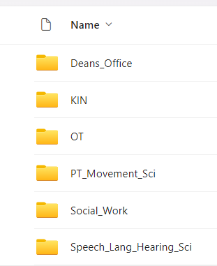

Steps for Submitting a Curriculum Change Proposal
1. Check the Curriculum Change Website
Before you start, visit the Curriculum Change website to identify the necessary forms and steps for your proposed change. If additional forms are required beyond the memo and approval page, navigate to the ‘Individual Forms’ tab to select the extras you need.

2. Create a Proposal Folder on SharePoint
Once you have all the required forms, proceed to SharePoint to create a folder for your new proposal. Follow these steps:
- Go to the Proposals in Progress folder.
- Select your College and then your Department.
- Save your proposal in the department folder with a descriptive name. If there are multiple changes, consider using a general title like “Degree Plan Changes for X.”
- For the approval page you can either use electronic signatures, or if you prefer to get actual signatures the page can be printed and then scanned after signatures are obtained.

3. Folder nomenclature
File name should start with the college acronym
Ex: CLA_BA-History_DegPlanChgs
Keep the proposal name as short as possible

4. Manage Your Proposal
All changes to your proposals should occur within this folder, eliminating the need for email attachments. Please contact the Curriculum Director at curriculum@utep.edu to request a proposal review prior to sending the proposals to the college curriculum committee. Proposals will remain in the Proposals in Progress folder until approved by the college curriculum committee. After receiving approval, the College Committee Chair or designee should move the approved PDF version to the College Approved Proposals folder.

5. College Approved Proposals
For this folder, follow these steps:
- Create a subfolder within your department folder named after your proposal.
- Ensure all documents/forms related to the proposal are combined into a single PDF before moving them.
- Notify the Curriculum Director (curriculum@utep.edu )after placing the proposal in this folder for review. The Curriculum Director will inform you if changes are needed, and when the proposal is ready for the Undergraduate Curriculum Committee (UGCC) and/or Graduate Council.
- If no further changes are needed for the proposal, the Curriculum Director will add the meeting date where the proposal will be presented to the beginning of the file name. For example:
COEN_MS-Aerospace_DegPlanChg
Changed to
GC_04.01.25_ COEN_MS-Aerospace_DegPlanChg

6. Archived Proposals
- The Curriculum Director will move proposals to this folder once they are approved by the UGCC and Faculty Senate, or Graduate Council.
- Proposals will be organized by year, college, and department.
- Access to the Archived Proposals folder will not be restricted.

