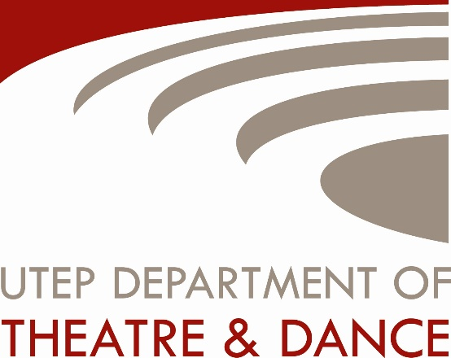

ALL STUDENTS NEED TO ATTACH THE FOLLOWING IN ONE EMAIL to: lisas@utep.edu
DEADLINE: 2/23/19

* See specific requirements for dance performance below. If you would like to submit for an additional discipline in theatre please follow the requirements listed separately on the department website https://www.utep.edu/liberalarts/theatre-dance/resources/scholarships.html

DANCE PERFORMANCE
- Headshot or current photograph
- Resume
- Two letters of recommendation
- Cover Letter (in the body of the email is fine)
- Scholarship Application
- Link to Audition Video OR Link to Current Portfolio
- Prepare a dance solo, no longer than three minutes.
- You may use a solo that you have choreographed or one that has been created for you. Your solo may be improvisation or formal choreography in any genre.
- Include a brief slate introducing yourself and your piece.
- Frame your solo as a “wide shot” or “whole body shot” so we can see your entire body. Avoid unnecessary movement of the camera such as zooming in or panning from side to side.
- Upload your audition solo to youtube, vimeo, dropbox, or google drive, and make sure to include the link in your email.
- You will also need to attend a live scholarship audition class March 30th from 9:00 a.m. to 11:00a.m. in Studio 452 in the Fox Fine Arts Building. This class will include various styles of dance. You will need to wear dance clothes (or clothes that you can move in) and bring ballet slippers (if you have them), sneakers, and socks. *In rare cases we may still be able to consider a student who is unable to attend the audition class. We encourage you to still apply if you are unable to attend the class.

