Conducting a funding search on COS Pivot.
1. Go to the “Funding” option on the top menu.
2. Select “Advance Search” (recommended).
3. Click on each field to see expanded options and select the ones that apply.
4. Click on “Search”.
5. If desired, click on “Refine Search” to modify search parameters.

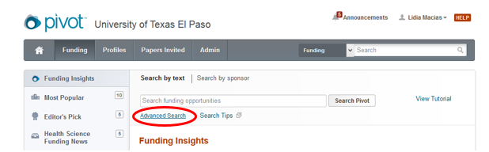

Saving a search on COS Pivot.
COS Pivot automatically provides funding alerts for new opportunities that match a saved search. To save a search:
1. Choose “Save Search” on the results page of your search.
2. Name your search and click “Save”.
3. On the homepage, go to the menu on the left and select “Saved Searches” to view or modify your saved searches.

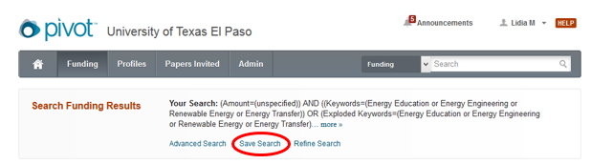

Selecting and modifying keywords on your COS Pivot profile.
Pivot utilizes a large body of keywords to classify funding opportunities. These keywords are used by Pivot’s database system to generate individual and departmental funding matches.
Currently, faculty profiles on COS Pivot share keywords with Expertise Connector.
To view or modify your COS Pivot profile keywords, follow the next steps:
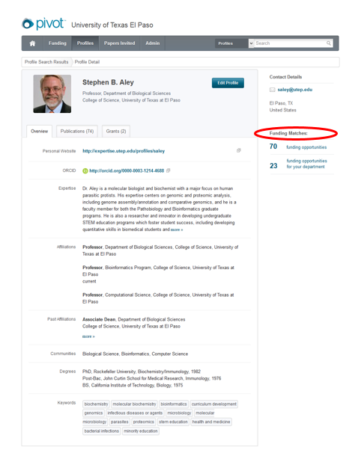
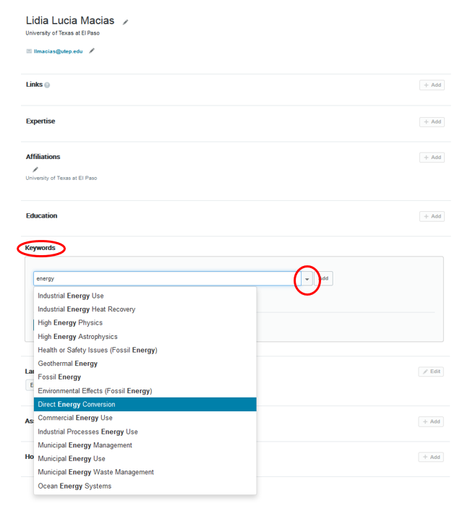
1. Go to “Your Profile” page.
2. Under the “Keywords” section begin typing a term relevant to your area of expertise. A list of all keywords matching your search terms will appear.
2. Choose keywords from the list to add them to your Pivot profile.
3. Click on the arrow to display COS Pivot’s complete keyword tree.
4. If a desired keyword is not included use alternative or broader terms.
Tracking a funding opportunity in COS Pivot.
1. Run a Funding search.
2. Select a funding opportunity.
3. Click “Track” or “Set to Active”
Sharing a funding opportunity in COS Pivot via email notification.
1. Run a Funding search.
2. Select a funding opportunity.
3. Click “Share”.
4. Enter email address of the person to receive the funding opportunity.
5. Click “Send”.
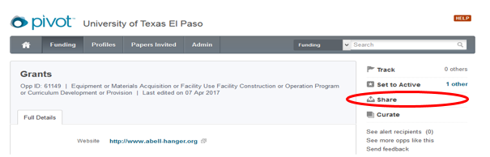

How to look for potential collaborators for a specific funding opportunity in COS Pivot.
1. Run a search.
2. Select a funding opportunity.
3. In the right-hand side of the funding opportunity page, click on “Profile Matches” inside or outside of you institution. Please note that the potential collaborators that COS Pivot identifies will be valid only if your individual profile is updated and accurate.
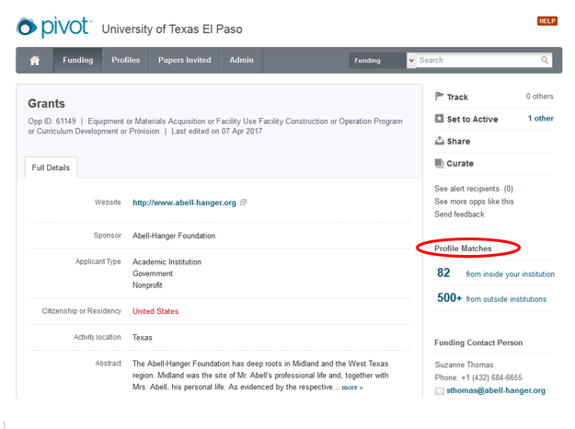

How to create a COS Pivot Account.
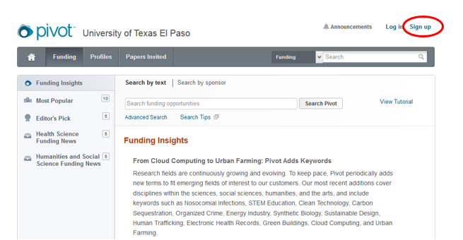
1. Go to http://pivot.cos.com/
2. Click on the “Sing Up” button at the upper right-hand corner.
3. Complete the registration form using your UTEP email address.
4. Click on the link of the verification email to complete the process.
*Note that the email address and the password you entered during the creation of the account will be your Pivot username and password.

How to claim your COS Pivot profile.
1. Log in to COS Pivot.
2. In the upper right-hand corner, click on your name.
3. Select the option “Claim Profile”.
4. If you locate your profile from the results list, click the “This is me” button.
5. If no results are displayed or none of the possible matching profiles is yours, click on “Create a Profile”.
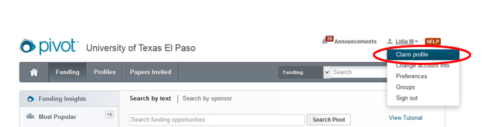
How to update your COS Pivot profile.
1. Log in to COS Pivot
2. Click on your name
3. Select “Your profile”
4. Click on “Edit” button.
