THE UNIVERSITY OF TEXAS AT EL PASO

Registering your bicycle or electric scooter with University Police is a great anti-theft deterrent. This free service allows University Police and surrounding area law enforcement agencies to locate the rightful owner in the event your bicycle or electric scooter is stolen and recovered. This form should be completed and returned to the UTEP Police Department Office of Special Services located at 3118 Sun Bowl Dr.

Hours of Operation: M-F 8:00 a.m. to 5:00 p.m. Phone: (915) 747-6640 or 915-747-6338

BICYCLE / ELECTRIC SCOOTER REGISTRATION
Personal Information
First Name:
Last Name:
State Identification Number:
Date of Birth:
Home Phone Number:
Cell Phone Number:
Address:
City/State:
Zip Code:
Faculty, Staff, or Student (Select one)
E-mail address:
Please check the appropriate box
☐ Bicycle ☐ Electric Scooter
Make:
Model:
Number of Speeds:
Serial Number:
Primary Color:
Description:
Date Registered:
Officer Name & ID Number:
Bike Registration Decal Number:
Remember! When not in use, keep your bicycle or electric scooter secure!

Why should I register my bicycle or electric scooter?

The information you submit will be used to assist in returning your registered bicycle or electric scooter in the event it is stolen and recovered or found by the UTEP Police Department or surrounding law enforcement agencies.
It’s free and easy!

How do I register my bicycle or electric scooter?

You can register your bicycle or electric scooter by completing the registration form at the University Police Department located at 3118 Sun Bowl Drive. You will need to have your bicycle or electric scooter available during the registration process. You may also request this service by contacting any of our patrol officers.

Where can I park my bicycle or electric scooter?

We encourage members of the UTEP community to park their bicycle or electric scooter on any of the designated bike racks. Please be considerate of others and do not park your bicycle or electric scooter in a walkway, sidewalk, hallway, ADA-accessible ramp, or doorway.

Safety Tips:

- Never leave your bicycle or electric scooter unattended or unsecured
- Always secure your bicycle or electric scooter, even if it is for a few minutes
- Keep your bicycle or electric scooter locked with a good “U” type lock
- Always check your lock by pulling on it to ensure it is secure
- Park your bicycle or electric scooter in a high pedestrian traffic area
- Consider engraving your bicycle or electric scooter with a set of identifiable letters to help identify your scooter if it’s stolen
- Write down the model and serial number of your bicycle or electric scooter and keep it in a safe place
- Take a clear photo of your bicycle or scooter
- Consider installing a GPS tracking device
- Report suspicious activities to University Police 747-5611

Pictures (recommended)

Ways to secure your bicycle Ways to secure your electric scooter
Using two U locks, lock frame and both Assess your electric scooter for secure
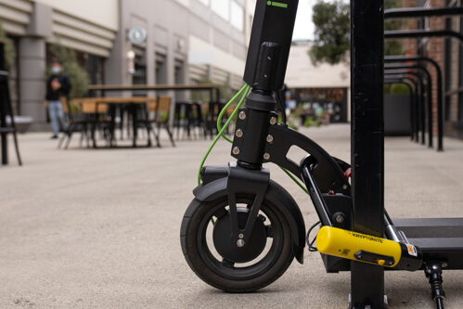
wheels to the bicycle rack locking points

Purchase a high-security U-lock and secure
the rear wheel and frame, with the additional Purchase a high-security U-lock that fits
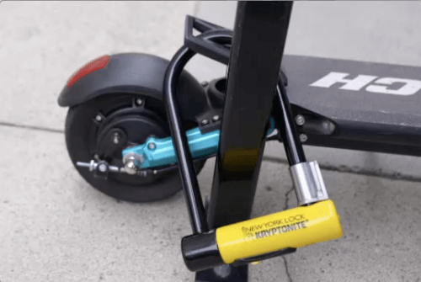
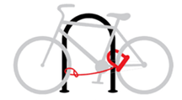
cable lock to secure the front wheel

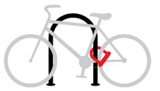
Utilize a U-lock to secure the rear wheel and frame Thread the U-lock through a secure
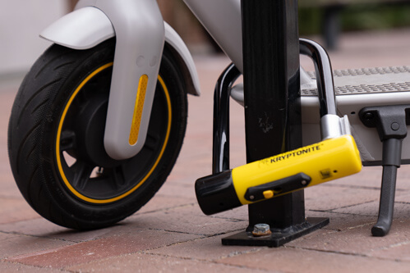
Locking point on your electric scooter

Lock the electric scooter to a permanent
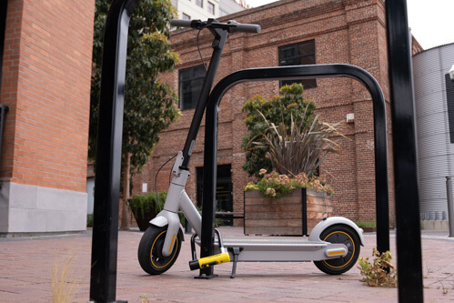
fixture such as a bicycle rack

