The University of Texas at El Paso
Department XXXX
Syllabus
ONLINE COURSE SYLLABUS SAMPLE
WITH THE INTEGRATION OF UTEP EDGE PRACTICES

  - COURSE INFORMATION

* RWS 1302: Rhetoric & Composition II
CRN: 12345
Term: Fall 2024
Delivery Method: Online
Meeting Day and Time: Mondays, 10:30 am-11:50 am
Zoom Link:

  - INSTRUCTOR INFORMATION
Instructor first and last name, Title
Written Communication: Specify your preference of communication (e.g., email and Blackboard)
Phone Number: (915)123-4567
Student Conference Hours:
- Virtual: Days and times (Specify if by appointment only), through (Specify the video conferencing options)

  - Course Information: What this class is about and what we will do
  - * COURSE DESCRIPTION
RWS 1302 is a required 3-credit core course for all majors. The primary goal of RWS 1302 is to develop students’ critical thinking skills in order to facilitate effective communication in all educational, professional, and social contexts. This effective communication is based on an awareness of and appreciation for discourse communities as well as knowledge specific to subject matter, genre, rhetorical strategy, and writing process.

The class presents an approach to communication that helps students determine the most effective strategies, arrangements, and media to use in different rhetorical contexts. It teaches students a systematic approach for analyzing rhetorical situations and then producing a variety of documents and presentations while gaining more confidence and fluency in visual, oral, and written communication. In addition, because communication is central to being an active and engaged member of society, the course also provides a space for informed advocacy.
Students enrolled in RWS 1302 should have successfully completed RWS 1301.
  - *COURSE OBJECTIVES
By the end of the course, students will be able to:
- Draw on existing knowledge bases to create “new” or “transformed” knowledge
- Draw on existing knowledge bases to create “new” or “transformed” knowledge
- Engage as a community of writers who dialogue across texts
- Address the specific, immediate rhetorical situations of individual communicative acts

  - EDGE ADVANTAGES
This course is designed to equip students with essential Edge Advantages that contribute to their professional and personal development. Through the completion of course requirements and assignments, such as team projects, presentations, and essays, students will develop the following Edge Advantages:
 | Problem-Solving | Assignments will challenge students to identify and address complex issues using innovative and analytical approaches.
 | Communication | Class discussions and written assignments will improve students’ skills in articulating ideas clearly and persuasively in both oral and written forms.
 | Social Responsibility | Through community engagement opportunities and course content that encourages ethical considerations, students will foster a sense of responsibility towards their community and society at large.
 | Confidence | By actively participating and successfully completing assignments, students will build self-assurance in their abilities to tackle academic and real-world challenges.
 | Critical Thinking | The course’s emphasis on analysis and synthesis of information will strengthen students’ abilities to think critically and make informed decisions.

  - * REQUIRED MATERIALS
Comer, D. K. (2015). Writing in transit. Fountainhead Press.
ISBN: 978-1-59871-803-4

First-Year Composition Program (2018). The First-Year Composition handbook. (An e-book)
ISBN: 978-0-692-75953-0

  - * ASSIGNMENTS AND GRADING
Assignments for this course are assessed according to rubrics. You can find these rubrics by clicking on the appropriate assignment link in Blackboard and choosing to “View Rubric” from the button beneath the Points Possible for the assignment.
Grade Distribution:
1000-900 = A 899-800 = B 799-700 = C 699-600 = D 599 and Below = F
- 200 points: Genre Analysis
- 200 Points: Literature Review Research/Primary Research Report
- 150 Points: 8 Community Engagement Hours and Reflection Essay
- 200 Points: Documentary Final Project
- 150 Points: E-portfolio
- 100 Points: Participation
Genre Analysis: To deepen our understanding of discourse community concepts, students will be asked to analyze both traditional and multimedia documents as genres.
Literature Review/Primary Research Report: Students will conduct primary and secondary research on a social, political, or ethical issue and will then write a literature review that synthesizes the arguments as they pertain to the questions of inquiry.
Community Engagement: Students will identify and participate a community engagement opportunity (preferably related to their research topic) and write a reflection essay.
Documentary: Students will plan, write, film and edit a documentary film advocating a position on a current issue related to the Literature Review/Primary Research Report.
Website/E-Portfolio: Students will create, design, and maintain a website that presents their work from the semester.
Participation: For this online course, students will be required to participate in weekly discussion boards – both an initial post and responses to your peers. Students will also have a collection of smaller assignments throughout the week that will work to build toward the larger projects. Each of these activities will be given point values that add up to the total 100-point participation grade. These points cannot be made up, so students are expected to stay active in the course by logging in at least three times a week.
  - TECHNOLOGY REQUIREMENTS
Course content is delivered via the Internet through the Blackboard learning management system. Ensure your UTEP e-mail account is working and that you have access to the Web and a stable web browser. Google Chrome and Mozilla Firefox are the best browsers for Blackboard; other browsers may cause complications. When having technical difficulties, update your browser, clear your cache, or try switching to another browser.

You will need to have access to a computer/laptop, scanner, a webcam, and a microphone. You will need to download or update the following software: Microsoft Office, Adobe Acrobat Reader, Windows Media Player, QuickTime, and Java. Check that your computer hardware and software are up-to-date and able to access all parts of the course.

If you do not have a word-processing software, you can download Word and other Microsoft Office programs (including Excel, PowerPoint, Outlook and more) for free via UTEP’s Microsoft Office Portal. Click the following link for more information about Microsoft Office 365 and follow the instructions.

IMPORTANT: If you encounter technical difficulties beyond your scope of troubleshooting, please contact the UTEP Technology Support as they are trained specifically in assisting with technological needs of students. Please do not contact me for this type of assistance. The Help Desk is much better equipped than I am to assist you!

  - Course Communication: How we will stay in contact with each other
Because this is an online class, we won’t see each other in the ways you may be accustomed to: during class time, small group meetings, and office hours. However, there are a number of ways we can keep the communication channels open:
- Student Conference Hours: We will not be able to meet on campus, but I will still have dedicated hours for your questions and comments about the course. Student conference hours will be held during the following times:
  - Mondays: 1-2 p.m. Mountain Time
  - Tuesdays: 10-11 a.m. Mountain Time
  - Thursdays: 4-5 p.m. Mountain Time
    - ZOOM LINK:
- Email: UTEP e-mail is the best way to contact me. I will make every attempt to respond to your e-mail within 24-48 hours of receipt. When e-mailing me, be sure to email from your UTEP student account and please put the course number in the subject line. In the body of your e-mail, clearly state your question. At the end of your e-mail, be sure to put your first and last name, and your university identification number.
- Discussion Board: If you have a question that you believe other students may also have, please post it in the Help Board of the discussion boards inside of Blackboard. Please respond to other students’ questions if you have a helpful response.
- Announcements: Check the Blackboard announcements frequently for any updates, deadlines, or other important messages.

  - NETIQUETTE
As we know, sometimes communication online can be challenging. It’s possible to miscommunicate what we mean or to misunderstand what our classmates mean given the lack of body language and immediate feedback. Therefore, please keep these netiquette (network etiquette) guidelines in mind. Failure to observe them may result in disciplinary action.
- Always consider audience. This is a college-level course; therefore, all communication should reflect polite consideration of other’s ideas.
- Respect and courtesy must be provided to classmates and to the instructor at all times. No harassment or inappropriate postings will be tolerated.
- When reacting to someone else’s message, address the ideas, not the person. Post only what anyone would comfortably state in a face-to-face situation.
- Blackboard is not a public internet venue; all postings to it should be considered private and confidential. Whatever is posted on in these online spaces is intended for classmates and professor only. Please do not copy documents and paste them to a publicly accessible website, blog, or other space.
  - LEARNING COMMUNITY AND RESPECTFUL DISCOURSE
  - Welcome to our community of learners! Our goal as a community is to create an environment where all members of the class can participate, ask questions, test ideas, and learn from each other. Our community members should:
- Engage with the discussion ideas thoughtfully and critically.
- Listen actively and respectfully.
- Critique arguments rather than individuals.
- Lead with questions when they disagree.
  - Differences of opinion are a normal and valuable part of higher education. You are not expected to agree with one another. You are expected to express disagreements in ways that are respectful, evidence-based, and relevant to the course.
  - Personal attacks, harassment, intimidation, disruptive behavior, or actions that interfere with the learning of others are inconsistent with the expectations of this course and the broader UTEP community. Learning occurs most effectively when people feel welcome, respected, and able to engage thoughtfully with challenging ideas.
  - APPROPRIATE CLASSROM BEHAVIOR
  - This class requires participation in discussion to meet course learning outcomes. We are a class composed of individuals. As such, there will be multiple opinions expressed throughout the semester that you may not personally agree with or even understand - as may be expected. My role as an instructor is to facilitate the expression of ideas that are relevant to the course, credible, open, and respectful. Conversations informed by diverse viewpoints contribute to critical thinking and higher-level learning. Even if you don’t agree, listening to different points of view may give you further insight into your own perspectives. If you feel uncomfortable with how content in the course is presented or discussed, please contact me for further conversation or, if you feel comfortable doing so, you may say so in class in a manner that aligns with these expectations.
  - See Appendix for alternate language options
  - CONTROVERSIAL SUBJECTS
  - This course includes topics that could be considered controversial or contested. When discussing these topics, we are expected to adhere to our community standards and observe some additional practices:
- Engage Ideas, Not Individuals: Critique arguments, assumptions, interpretations, and evidence rather than people.
- Use Evidence and Reasoning: Support claims with appropriate evidence, course materials, scholarship, data, or other credible sources whenever possible.
- Listen to Understand: Approach differing viewpoints with curiosity and a willingness to understand the reasoning behind another person's perspective.
- Recognize Complexity: Many issues do not have simple answers. Students are encouraged to consider competing explanations, identify assumptions, and examine their own thinking.
- Practice Intellectual Humility: Be open to revising a position when new evidence, perspectives, or insights emerge.
- Demonstrate Respect: Disagreement is appropriate in an academic setting. Personal attacks, ridicule, intimidation, harassment, or dismissive behavior are not.
  - To do this effectively, we must also recognize that all individuals, including instructors, researchers, authors, and students, bring prior experiences, assumptions, and perspectives to the discussion table. The goal of this course is not to eliminate viewpoints, but to become more aware of how personal experiences, cultural contexts, values, and assumptions influence interpretation and decision-making.
  - This content is necessary to achieve the stated learning objectives, equip students to assess competing theories and claims, and to use reason and appropriate evidence to form their own conclusions about course material. When controversial topics arise, the instructor will strive to present differing views and scholarly evidence on reasonably disputed matters fairly. Students should feel free to voice their questions and beliefs even when those perspectives might conflict with those of the instructor or other students. Discourse is expected to be respectful. The first week of class will include time to discuss this with students to collectively agree on ground rules for discussions.

  - Course Policies: What do you need to do to be successful in the course
  - ATTENDANCE AND PARTICIPATION
Attendance in the course is determined by participation in the learning activities of the course. Your participation in the course is important not only for your learning and success but also to create a community of learners. Participation is determined by completion of the following activities:
- Reading/Viewing all course materials to ensure understanding of assignment requirements
- Participating in engaging discussion with your peers on the discussion boards (grading rubric provided in the “grading information” area of each forum)
- Participating in scheduled Zoom sessions
- Other activities as indicated in the weekly modules
Because these activities are designed to contribute to your learning each week, they cannot be made up after their due date has passed.

  - * EXCUSED ABSENCES AND/OR COURSE DROP POLICY
According to UTEP Catalog, “At the discretion of the instructor, a student can be dropped from a course because of excessive absences or lack of effort. A grade of “W” will be assigned before the course drop deadline and a grade of “F” after the course drop deadline.” See Policies and Regulations in the UTEP Undergraduate Catalog for a list of excuse absences. Therefore, if I find that, due to non-performance in the course, you are at risk of failing, I will drop you from the course. I will provide 24 hours advance notice via email.
OR
I will not drop you from the course. However, if you feel that you are unable to complete the course successfully, please let me know and then contact the Registration and Records Office to initiate the drop process. If you do not, you are at risk of receiving an “F” for the course.

  - ZOOM SESSIONS
This class requires that you participate in scheduled Zoom sessions. The purpose of these sessions are for you to view live demonstrations of the course material and/or to participate in small discussion groups with your classmates. These sessions will be held at the following dates from 10:30 am-11:50 am.

Group A: August 28, September 24, October 15, November 12
Group B: September 3, October 1, October 22, November 19

Students are expected to, at least occasionally, participate in these sessions with a webcam and microphone. The sessions will be recorded and provided so that they can be reviewed by classmates at a later time. Students should not record the sessions and post them to any sites outside of Blackboard.

If you are unable to attend a Zoom session, please let me know as soon as possible so that accommodations can be made when appropriate.

  - DEADLINES, LATE WORK, AND ABSENCE POLICY
Major Writing Assignments
- Major writing assignments will be due on Sundays at midnight (11:59 PM). No late work will be accepted if the reason is not considered excusable.
Quiz and Blog/Discussion Assignments
- All quiz, blog, and discussion board assignments will be due on Sundays at midnight (11:59 PM). No late work will be accepted if the reason is not considered excusable.

  - MAKE-UP WORK
Make-up work will be given only in the case of a documented emergency. Note that make-up work may be in a different format than the original work, may require more intensive preparation, and may be graded with penalty points. If you miss an assignment and the reason is not considered excusable, you will receive a zero. It is therefore important to reach out to me—in advance if at all possible—and explain with proper documentation why you missed a given course requirement. Once a deadline has been established for make-up work, no further extensions or exceptions will be granted.

  - ALTERNATIVE MEANS OF SUBMITTING WORK IN CASE OF TECHNICAL ISSUES
I strongly suggest that you submit your work with plenty of time to spare in the event that you have a technical issue with the course website, network, and/or your computer. I also suggest you save all your work (answers to discussion points, quizzes, exams, and essays) in a separate Word document as a back-up. This way, you will have evidence that you completed the work and will not lose credit. If you are experiencing difficulties submitting your work through the course website, please contact the UTEP Help Desk. You can email me your back-up document as a last resort.

  - INCOMPLETE GRADE POLICY
Incomplete grades may be requested only in exceptional circumstances after you have completed at least half of the course requirements. Talk to me immediately if you believe an incomplete is warranted. If granted, we will establish a contract of work to be completed with deadlines.

* ACCOMMODATIONS POLICY
The University is committed to providing reasonable accommodations to students with documented disabilities. Students who become pregnant may also request reasonable accommodations, in accordance with state and federal laws and regulations and University policy. Accommodations that constitute undue hardship are not reasonable. To make a request, please register with the UTEP Center for Accommodations and Support Services (CASS). Contact CASS at 915-747-5148, email them at cass@utep.edu, or apply for accommodations online via the CASS portal.

ALTERNATIVE ASSIGNMENT OPTION
UTEP recognizes that some students may have concerns about participating in a particular discussion, activity, or assignment involving a controversial topic.
When appropriate and pedagogically feasible, you may request an alternative assignment that:
- Requires comparable time and effort;
- Addresses the same learning objectives;
- Demonstrates achievement of the same student learning outcomes; and
- Meets the same academic standards as the original activity.
If you are seeking an alternative assignment, you should communicate with the instructor as early as possible so that appropriate arrangements can be discussed.
Approval of alternative assignments remains subject to the instructor's determination that equivalent learning objectives can be achieved.
  - * SCHOLASTIC INTEGRITY
Academic dishonesty is prohibited and is considered a violation of the UTEP Handbook of Operating Procedures. It includes, but is not limited to, cheating, plagiarism, and collusion. Cheating may involve copying from or providing information to another student, possessing unauthorized materials during a test, or falsifying research data on laboratory reports. Plagiarism occurs when someone intentionally or knowingly represents the words or ideas of another as ones' own. Collusion involves collaborating with another person to commit any academically dishonest act. Any act of academic dishonesty attempted by a UTEP student is unacceptable and will not be tolerated. All suspected violations of academic integrity at The University of Texas at El Paso must be reported to the Office of Community Standards for possible disciplinary action. To learn more, please visit HOOP: Student Conduct and Discipline.

EVIDENCE-BASED INQUIRY AND INFORMATION LITERACY
College is not simply about expressing opinions. It is about learning how to evaluate information, weigh evidence, and develop informed conclusions.
In this course, claims and arguments should be supported with appropriate evidence whenever possible. Strong academic work demonstrates the ability to examine sources critically, recognize bias and limitations, and distinguish evidence from opinion.
When evaluating information, you should consider:
- Who created the information?
- What evidence supports the claims?
- Whether the source is relevant to the topic.
- Whether the information is current and accurate.
- The purpose and intended audience of the source.
You are encouraged to explore resources provided by the UTEP Library to develop information literacy skills and strengthen their ability to locate, evaluate, and use information effectively.
*GUIDANCE ON ARTIFICIAL INTELLIGENCE
This course intentionally uses AI to explore course content as a learning tool/collaborative partner. We will be using [tool name and version. Provide access link or information if applicable]. In using this tool, you remain responsible for:
- Verifying accuracy and evaluating sources using best practices in critical literacy
- Ensuring compliance with assignment instructions
- Honestly documenting how you used AI when required
- Protecting your personal or research data when using AI
- Ensuring your voice, thoughts, and original ideas are at the core of the work you submit
- Knowing the content of your work well enough to discuss or defend it in live discussion
The goal is not to outsource thinking to AI, but to learn how to apply judgement in when and how to use the tool effectively, ethically, and responsibly.

  - * CLASS RECORDINGS
The use of recordings will enable you to have access to class lectures, group discussions, and so on in the event you miss a synchronous or in-person class meeting due to illness or other extenuating circumstance. Our use of such technology is governed by the Federal Educational Rights and Privacy Act (FERPA) and UTEP’s acceptable-use policy. A recording of class sessions will be kept and stored by UTEP, in accordance with FERPA and UTEP policies. Your instructor will not share the recordings of your class activities outside of course participants, which include your fellow students, teaching assistants, or graduate assistants, and any guest faculty or community-based learning partners with whom we may engage during a class session. You may not share recordings outside of this course. Doing so may result in disciplinary action.

  - TEST PROCTORING SOFTWARE
Two course assessments (the midterm and final exams) will make use of Respondus Lock Down Browser and Respondus Monitor inside of Blackboard to promote academic integrity. You are encouraged to learn more about how to use these programs prior to the first test.
Please review the following guidelines:

- The assessments will only be available at the times identified on the course calendar.
- You may take the test at any time during the 24-hour window.
- A reliable Internet connection is essential to completing the exam. If you must go to a location to take the exam (such as the library), be sure to follow their health and safety requirements.
- You have 2 attempts to take the test. Once the window closes, your answers will be saved, and no changes can be made. The higher score will be recorded.
- Respondus Lockdown Browser will require that all internet tabs are closed prior to the start of the test.
- Respondus Monitor requires a webcam and microphone.
- You will be required to show the webcam your student ID prior to the start of the test.
- Your face should be completely visible during the test. Blocking the camera will disable the test.
- No notes or textbook materials are permitted during the test. Respondus Monitor requires you to take a video of your surrounding area (desk, chair, walls, etc.)
- You should not have conversations with other people and/or leave and return to the area during the test.

  - PLAGIARISM DETECTING SOFTWARE
Some of your course work and assessments may submitted to SafeAssign, a plagiarism detecting software. SafeAssign is used review assignment submissions for originality and will help you learn how to properly attribute sources rather than paraphrase.

  - COPYRIGHT STATEMENT FOR COURSE MATERIALS
All materials used in this course are protected by copyright law. The course materials are only for the use of students currently enrolled in this course and only for the purpose of this course. They may not be further disseminated.

  - *COURSE RESOURCES: Where you can go for assistance
UTEP provides a variety of student services and support. Please refer to the QR code below for a listing of campus resources or visit https://www.utep.edu/advising/student_resources/student-success-resource-hub.html.

Appendices (for instructor use only)
The following appendices are designed to help you make the syllabus your own. They provide additional sample language and guidance for areas where course goals, disciplinary expectations, and teaching approaches may differ. Rather than offering a single “right” way to write these sections, the examples provide options you can adapt to fit your course and your students.
You do not need to use everything included here. Select, revise, or combine language that reflects how your course will actually operate and helps students clearly understand what to expect. As you explore the options, consider how each choice supports your learning outcomes, communicates your intentions, and contributes to the learning environment you want to create.

Alternative Appropriate Behavior Language
Example 2: My role as an instructor is to facilitate academic discussions and promote critical thinking about sometimes challenging and uncomfortable facts and ideas. Your peers and instructor may share diverse ideas and viewpoints, or we may differ in our ideas and viewpoints, but we will always be respectful of other opinions as expected in an academic environment. At times we will need to move on from a discussion without resolving differences.
Example 3: Fundamental to the university’s mission is support for an environment where divergent ideas, theories, and philosophies can be openly exchanged and critically evaluated. Consistent with these principles, this course may involve discussion of ideas that you find uncomfortable, disagreeable, or even offensive. These ideas are intended to be presented in an objective manner and not as an endorsement of what you should personally believe. Objective means that the idea presented can be tested by critical peer review and rigorous debate, and that the idea is supported by credible research. Not all ideas can be supported by objective methods or criteria. Regardless, you may decide that certain ideas are worthy of your personal belief. In this course, however, you may be asked to engage with complex ideas and to demonstrate an understanding of the ideas. Understanding and/or engaging with an idea does not mean that you are required to believe it or agree with it.
Alternate Controversial Subjects Language
Example 2: Due to the nature of the course, some subjects may make you feel embarrassed or uncomfortable. Your continued enrollment in this course indicates that you are aware of the nature of the material and that you consent to its presentation. Continued enrollment in the course also indicates that you will be respectful of others and maintain a mature manner at all times. If, at any time, you are uncomfortable with certain subjects or with the way they are addressed, please inform the professor, either in person, by e-mail, or by putting a note in my mailbox in the department office (anonymous notes are fine).
Example 3: The topics that we're covering in this class are sometimes difficult, not just intellectually but emotionally. While I expect there to be rigorous discussion and even disagreement during our class discussions, I ask that you engage in discussion with care and empathy for other members in the classroom. Aim to disagree without becoming disagreeable. In this class, we will not shy away from the uncomfortable. Critically examining and assessing our most basic assumptions and values is not just one of the tasks of this course but is an activity vital to living an authentic life. I urge you to have the courage to feel uncomfortable in this class. In exchange for your courage, I will work to ensure a classroom environment that supports your taking these intellectual and emotional risks. I (like many people) am still in the process of learning about diverse perspectives and identities. If something is said in class (by anyone) that made you feel uncomfortable, please talk with me about it.

Alternate AI Use Guidance Language
AI-Enabled
The following tools may be used may be used for specified learning activities identified by the instructor on a per-assignment basis:
- [specify tool(s) here]:
You can use AI to explore:
- [Examples of permitted use cases for AI inserted here (e.g. brainstorming ideas, generating outlines, improving organization, checking grammar or readability, exploring alternative approaches to a problem)]
You remain responsible for:
- Verifying accuracy and evaluating sources using best practices in critical literacy
- Ensuring compliance with assignment instructions
- Honestly documenting how you used AI when required
- Protecting your personal or research data when using AI
- Ensuring your voice, thoughts, and original ideas are at the core of the work you submit
- Knowing the content of your work well enough to discuss or defend it in live discussion
Note: Submission of AI-generated content as one's own original work without authorization may constitute academic misconduct.

AI-Restricted (no use permitted)
In this course, assignments are designed to build your personal abilities to [examples: analyze, interpret, defend, synthesize, communicate effectively] in [course topic or discipline]. You will be assessed on your personal learning and skill development in [topic] to ensure your personal [readiness understanding, reasoning, and communication skills] in the absence of AI technology.
Unless specifically authorized, you may not use generative AI tools to create, revise, solve, write, or complete graded work.
If there is suspected use of AI, you may be subject to academic review under UTEP’s academic integrity policies.

Uploading Your Syllabus to Faculty Success

Step 1: Log into your UTEP account from my.utep.edu and open up the Dashboard. Note: Faculty Success login page also available here: Faculty Success Login

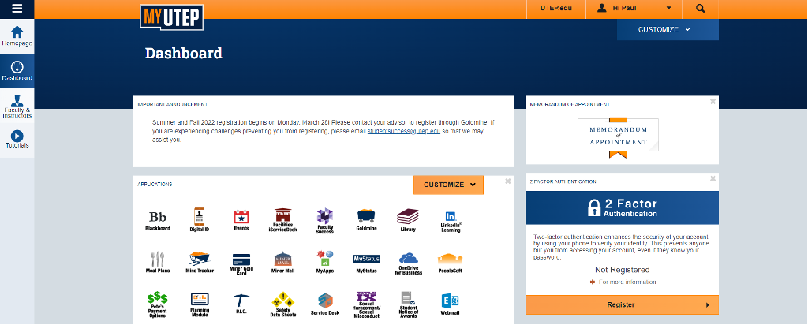

Step 2: Click on “Faculty Success” (center right side of the screen).

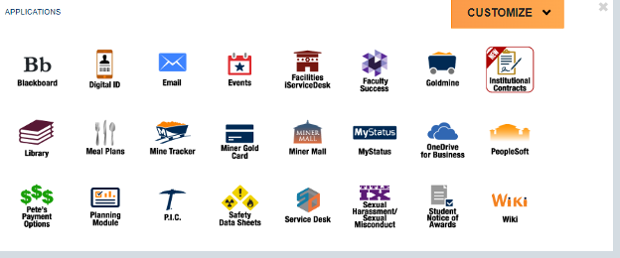

Step 3: Click on “Teaching” > ”Scheduled Teaching” (bottom left).

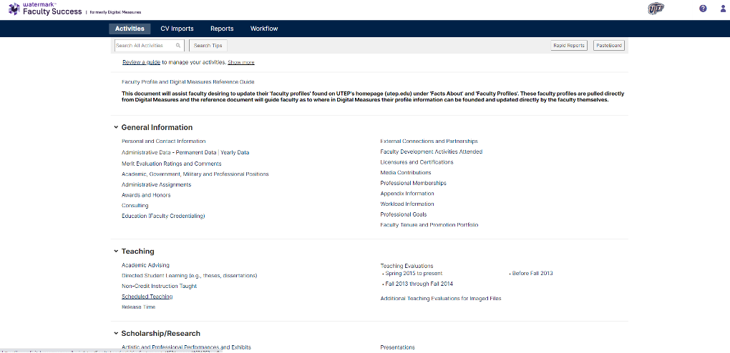

Step 4: Click on the CRN for your course (right side of the screen).

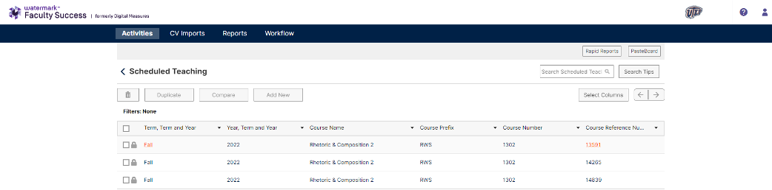

Step 5: Scroll down to “HB2504 Syllabus,” then click on “Drop File Here or Select to Upload.”

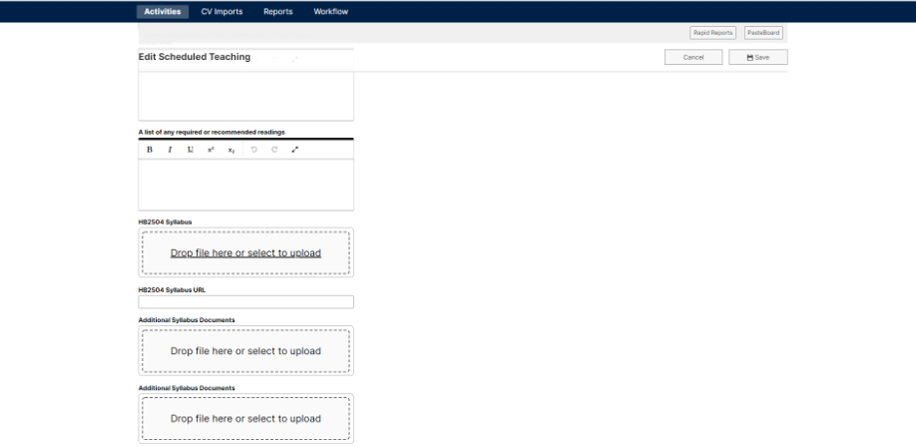

Step 6: Attach your syllabus file and click “Save” (top right).

