CONGRATULATIONS GRADUATE!


CLASS OF 2026

SATURDAY, May 16, 2026
SUNDAY, May 17, 2026
D O N H A S K I N S C E N T E R
UTEP.EDU/COMMENCEMENT

COMMENCEMENT INFORMATION

LOCATION:
DON HASKINS CENTER

TIMES:
SATURDAY

MAY 16,

2026

1:00 PM
- College of Liberal Arts

6:00 PM – College of Education and Miguel A. Loya College of Engineering

SUNDAY MAY 17, 2026

1:00 PM - College of Health Sciences and College of Nursing

6:00 PM -

A NOTE FROM THE TEAM

We know that your graduation from UTEP is an important event in your life and in the lives of those who have
helped you reach this goal. It is important in the life of the University as well, and it should be a meaningful and rewarding experience for everyone. We hope this
information provides the answers to your questions about
the commencement ceremony, and helps to ensure that you, your family, and friends have a memorable experience at this joyous event, marking your transition from student to alumnus.

BEST WISHES AND CONGRATULATIONS!

FROM THE REGISTRATION AND RECORDS OFFICE, THE OFFICE OF UNIVERSITY RELATIONS, AND YOUR UTEP ALUMNI ASSOCIATION

BEFORE COMMENCEMENT

Go to www.utep.edu/commencement for updated information on commencement and college ceremonies.

- RSVP! However, please note that RSVPs are for statistical purposes only. They do not assign you a seat at commencement.

- Purchase your regalia (cap and gown are required to participate in Commencement). You can purchase your regalia during Grad Fair or after Grad Fair in the UTEP Bookstore.

- Undergraduate students: Visit our website, to see if you are eligible for a tuition rebate. On the “Student Forms” menu click, Tuition Rebate Program Application. Turn in the completed application to the Registration & Records Office in the Mike Loya Academic Services Building Room 107 before graduation.

COMMENCEMENT DAY
Please arrive at Memorial Gym at least an hour prior to the ceremony.
Check-in will begin inside of Auxiliary Gym (room 120) at
the following times:

For 1 PM Ceremonies: 11:30 AM - 12:30 PM

For 6 PM Ceremonies: 4:30 PM - 5:30 PM

Leave all personal items (backpacks, mobile devices, purses, coats, etc.)at home or in your automobile. These items (along with food, beverages, beach balls, balloons, confetti, noise makers, silly string, etc.) will not be allowed in the Don Haskins Center.
Don Haskins has a clear bag policy. Only clear/transparent bags will be allowed in Don Haskins for the ceremony. Please ensure you plan ahead and share this information with your family to avoid entry delay.

Though your family and friends are an important part of commencement, childcare services will not be provided, and children may not accompany graduates during the commencement ceremony. Please make appropriate plans for the care of your children.
Wear regalia and comfortable shoes, and out of
courtesy to your fellow graduates, please remain for the duration of the ceremony.

The procession will depart from Memorial Gym to the Don Haskins Center at the following times:

For 1:00 PM Ceremonies: 12:45 PM

For 6:00 PM Ceremonies:
5:45 PM

*Please ensure that you have checked in and picked up your reader card prior to these times.*



REMEMBER

- THE USE OF ALCOHOLIC BEVERAGES ON THE PREMISES IS
PROHIBITED

- ARRIVE ON TIME FOR CHECK-IN WEARING YOUR CAP AND GOWN
- FAMILY MEMBERS ARE NOT ALLOWED AT MEMORIAL GYM

- ARRIVE PROMPTLY TO ALLOW TIME FOR CHECK-IN AND FINDING YOUR ASSIGNED SPOTIN LINE

- CLEAR BAGS ONLY INSIDE OF DON HASKINS

FOR FRIENDS AND FAMILY:
The Don Haskins Center will open one hour prior to the ceremony. Family and friends should plan to arrive at least 60 minutes before the ceremony. Due to the large crowds, choice parking and seating will be limited. Please be mindful of little children. PLEASE NOTE: Baby strollers, balloons, noise makers, glass containers, tripods, and banners are not permitted in the Don Haskins Center. Reserving seats is not allowed.

Visit https://www.utep.edu/commencement/for directions and parking location maps.
Disabled parking areas are located at the north end of the Don Haskins Center.
Wheelchair accessible seating is available in Sections E, I,
R and V. Refer to the ceremony diagrams in this booklet for the location of these sections. Questions concerning services available for individuals with disabilities may be directed to the Center for Accommodations and Support Services at 747-5148.

Only candidates and faculty are allowed to enter through the South Tunnel entrance

- Graduates will be seated in the Don Haskins Center in alphabetical order by college. After the ceremony, graduates
exit the Don Haskins Center through the south tunnel entrance and reunite with family and friends in the “Celebration Plaza”, located south of the Don Haskins Center. College signs will specify the meeting location. Refer to the ceremony diagrams for seating and post-commencement waiting areas.

- Please respect the calling of all graduates’ names by refraining from long and disrupting celebrations, and by remaining seated throughout the entire ceremony, to ensure that each name is heard clearly by the entire audience. Ceremonies are expected to last approximately 2 hours.


LIBERAL ARTS
Saturday, May 16, 2026 • 1:00 p.m.
  - Graduates will check-in at Memorial Gym starting at 11:00 a.m.
  - Don Haskins Center doors will open to the public at 12:00 p.m.

VV
W FACULTY AND STAFF SEATING
V STAGE
UU A
U
GRADUATE SCHOOL
D DD

E
EE
F

T
S
RR
R
Q
QQ P

LMN

LIBERAL ARTS

Z
LIBERAL G

H
LMN HH
I

J
K II

O N M L
PP JJ
OO MM KK

TO MESA ST.

MEMORIAL GYM
GLORY RD.

GRADUATE CHECK IN

LIBERAL ARTS

GRADUATE SCHOOL
OREGON ST.

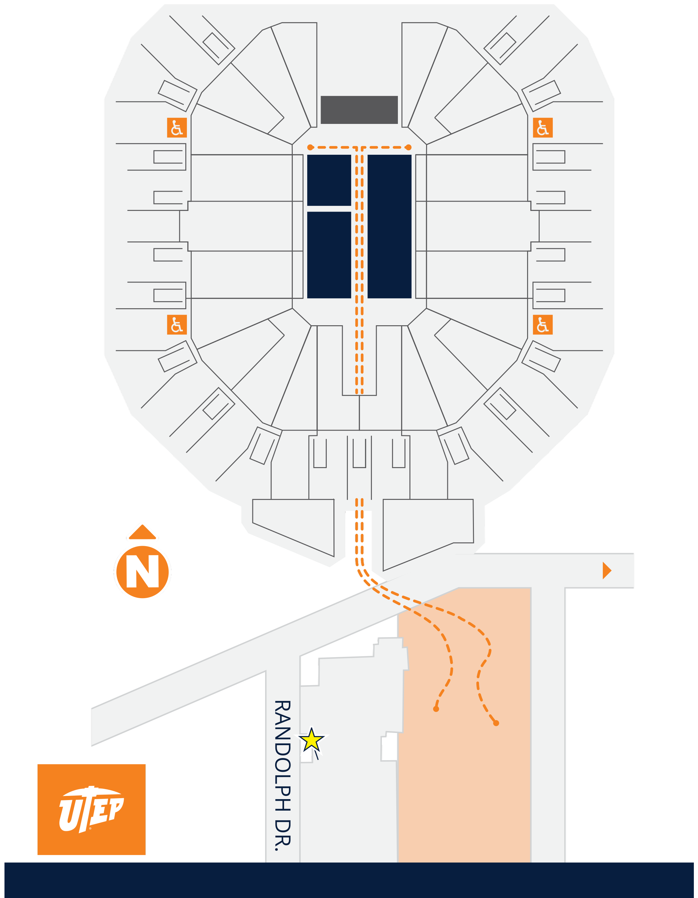
CELEBRATION PLAZA

EDUCATION & ENGINEERING
Saturday, May 16, 2026 • 6:00 p.m.
- Graduates will check-in at Memorial Gym starting at 4:00 p.m.
- Don Haskins Center doors will open to the public at 5:00 p.m.

VV
W
FACULTY AND STAFF SEATING
V STAGE
D DD

E

UU DOCTORAL
U
EDUCATION
MASTER’S
EDUCATION ENGINEERING

T A
DOCTORAL EE
ENGINEERING F

A G

EDUCATION ENGINEERING
S
H

RR Z Z HH
I
R
Q J
QQ P K II
O N M L
PP JJ
OO MM KK

TO MESA ST.

MEMORIAL GYM
GLORY RD.

EDUCATION
ENGINEERING

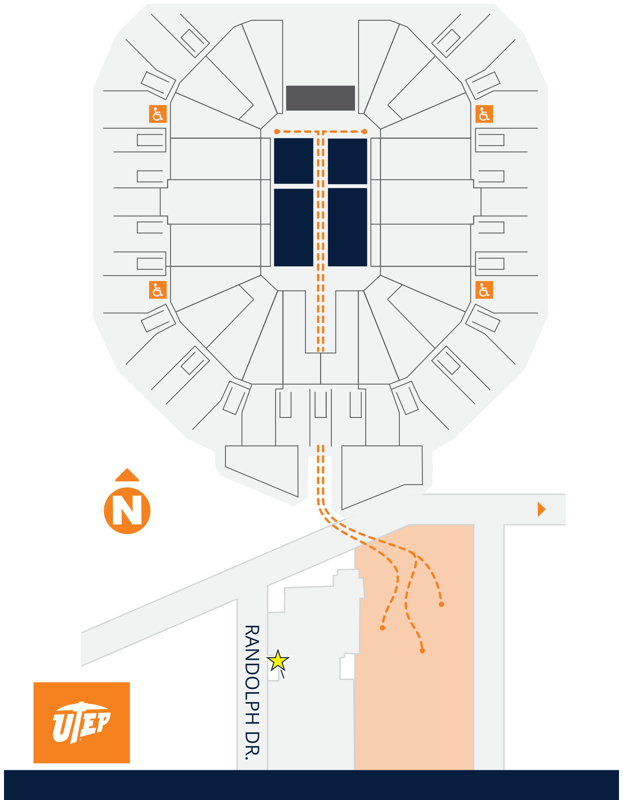

GRADUATE CHECK IN
OREGON ST.

GRADUATE SCHOOL

CELEBRATION PLAZA

HEALTH SCIENCES & NURSING
Sunday, May 17, 2025 • 1:00 p.m.
- Graduates will check-in at Memorial Gym starting at 11:00 a.m.
- Don Haskins Center doors will open to the public at 12:00 p.m.

VV
W FACULTY AND STAFF SEATING
V STAGE
UU
U
D DD

E
EE
F

GRADUATE SCHOOL

T A
GRADUATE SCHOOL

A G

NURSING HEALTH
S SCIENCES H
RR Z HH
Z
I
R
Q J
QQ II
K
P
PP O N M L JJ
OO MM KK

TO MESA ST.

MEMORIAL GYM
GLORY RD.

GRADUATE

NURSING
HEALTH SCIENCES

GRADUATE SCHOOL
OREGON ST.

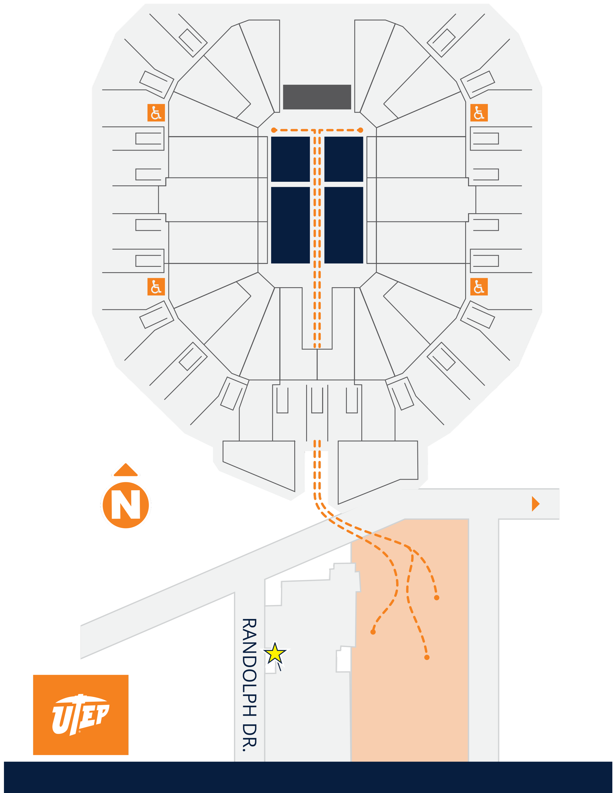
CHECK IN
CELEBRATION PLAZA

SCIENCE, BUSINESS, and PHARMACY
Sunday, May 17, 2026 • 6:00 p.m.
- Graduates will check-in at Memorial Gym starting at 4:00 p.m. • Don Haskins Center doors will open to the public at 5:00 p.m.

VV DD
D
W FACULTY AND STAFF SEATING
V STAGE E
UU EE
U GRADUATE GRADUATE F

T A A G

BUSINESS SCIENCE
H
S
RR Z Z HH
I
R
Q J
QQ P K II
O N M L
PP JJ
OO MM KK

TO MESA ST.
OREGON ST.

MEMORIAL GYM
GLORY RD.

BUSINESS
SCIENCE

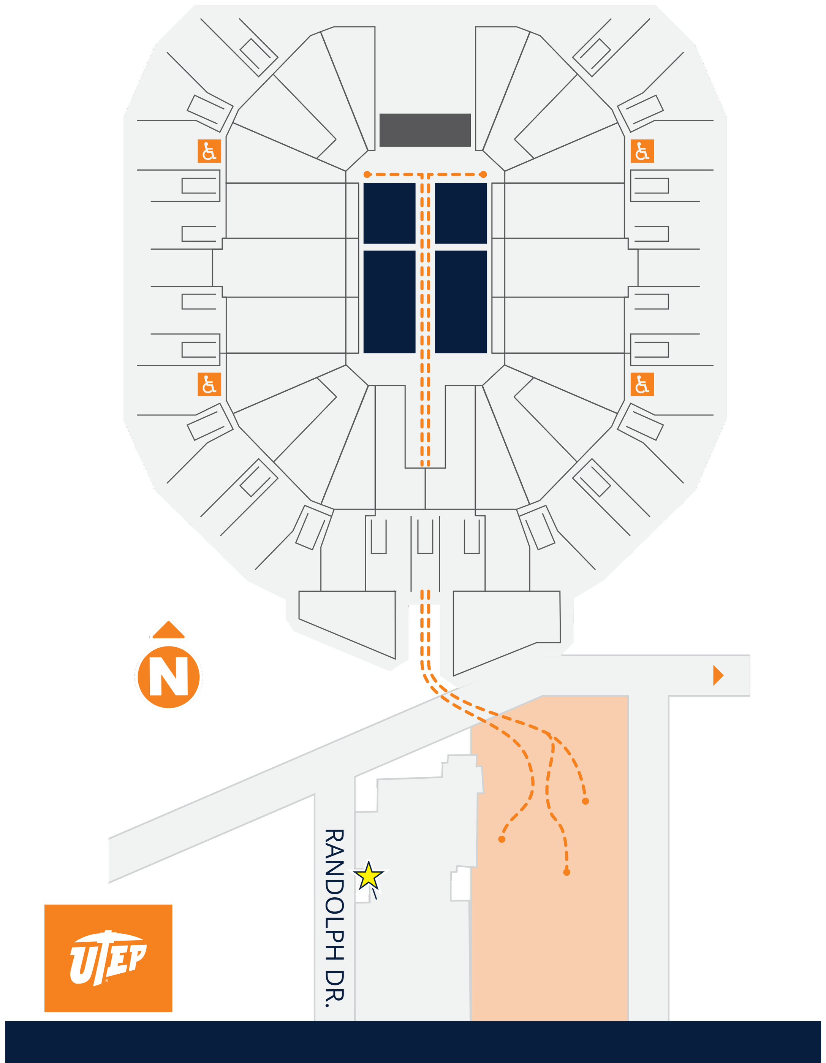

GRADUATE CHECK IN
GRADUATE SCHOOL

CELEBRATION PLAZA


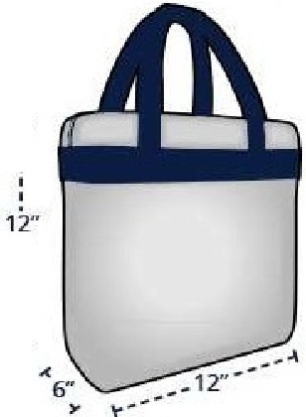

APPROVED BAGS
T Bags that are clear plastic, vinyl or PVC and do not exceed 12'W x 6"D x 12" H.
T One-gallon clear plastic freezer bag (Ziploc™ bag or smaller).
T Small clutch bag approximately the size of a hand (4.5" x 6.5'' or smaller), with or without a handle or strap. This can be carried separately or within a plastic bag.
T Medical bags that contain health necessary items are acceptable after proper inspection and approval from stadium personnel/security.
All other bag! aRJ3ro_bibited whe11 el)terj!1glbe venu_g.
APPROVED BAG EXAMPLES

T
'

.'L
'

C/t11Jrrcfe

.'L
r�����::::ia

Clear Plastic Vinyl or PVC Does not exceed 12" x 6" x 12"

hand, with or without a strap.

No larger than 4.5" x 6.5''






PROHIBITED ITEMS: aerosol cans; animals (service dogs or service dogs in training permitted); artificial noisemakers; balloons; bats, poles and sticks; car seats and baby strollers; coolers/ice chests; camera lenses larger than 4"; e-cigarettes; firearms and fireworks; flags on poles; glass bottles; illegal drugs; laser pointers; lawn chairs; missile-like objects; objects that can be used as projectiles (i.e. balls); outside food and beverages including alcohol (exceptions will be made for those with medical requirements and/or special needs); scooters, strollers, bicycles, roller skates and skateboards; tobacco products; tripods, monopods and selfie sticks; umbrellas; unauthorized video cameras and drones; water bottles {one sealed, plastic water bottle permitted per patron); weapons; any object that might pose a risk to the guest or others.
For more information, please visit


Don’t miss the Spring 2026 Grad Fair, the one-stop shop for all your graduation needs!
Thursday, March 5 : 12 pm – 7 pm
Friday, March 6 : 12 pm – 7 pm
Saturday, March 7 : 10 am – 3 pm

What can you do at Grad Fair?
- Purchase your cap, gown, tassel and graduation regalia
- Order your official UTEP class ring and announcements
- Get a head start on graduation portraits (come camera-ready!)
- Connect with campus partners to support you as a proud UTEP graduate
Want to take graduation headshot photos early? Grad Images, the official Commencement photographer will be on-site taking graduation photos (in regalia) for any students who want to take their photo ahead of time.

Visit our website to learn more:
alumni.utep.edu/gradfair



RESOURCE GUIDE

UTEP.EDU /COMMENCEMENT


DEAN OF STUDENTS
915-747-5648
utep.edu/student-affairs/dean-of-students-office

COLLEGE OF
BUSINESS
GRADUATE SCHOOL
915-747-5491 utep.edu/graduate CENTER FOR ACCOMMODATIONS AND SUPPORT SERVICES
915-747-5148 utep.edu/student-affairs/cass
REGISTRATION AND RECORDS

915-747-5241
utep.edu/business
915-747-7327
affairs/registrar
utep.edu/student-

COLLEGE OF EDUCATION
915-747-5572
utep.edu/education
COLLEGE OF ENGINEERING
915-747-6444
utep.edu/engineering
COLLEGE OF HEALTH SCIENCES
915-747-7280
utep.edu/chs
COLLEGE OF LIBERAL ARTS
915-747-5666
utep.edu/liberalarts COLLEGE OF SCIENCE 915-747-5536
utep.edu/science COLLEGE OF NURSING 915-747- 8337
utep.edu/nursing
SCHOOL OF PHARMACY
915-747-8519
utep.edu/pharmacy
OFFICE OF UNIVERSITY RELATIONS
915-747-8244 relations
OFFICE OF ALUMNI RELATIONS
915-747-8600 alumni.utep.edu
UNIVERSITY BOOKSTORE
915-747-5594
bkstr.com/texaselpasostore/home
GRADIMAGES PHOTOGRAPHY
(800) 261-2576
ecc.giservice@gradimages.net

