Biacore T100
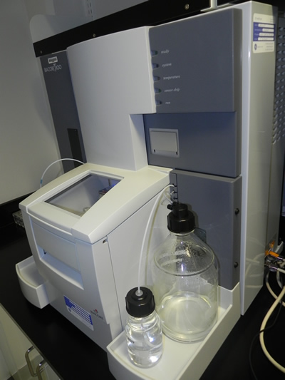The Biacore T100 uses Surface Plasmon Resonance (SPR) technology to detect sensitive and reliable characterization of molecular binding interactions in real-time. The SPR technology monitors the changes of mass bound to the surface of the chip, providing sensitive characterization of biomolecular interactions in terms of specificity, kinetics and affinity.
The Biacore T100 is run exclusively by a dedicated operator. If you would like to make use of the Biacore T100 for your research, please contact Dr. Jeremy Ross :
Jeremy Ross
jross@utep.edu
915-747-5138
Please be aware the users requesting this service are responsible for providing the sensor chips used with the instrument.

Mass Spectrometry LC-MS/MS
Liquid Chromatography-Tandem Mass Spectrometry (LC-MS/MS)
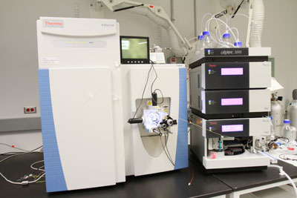 | Description: Thermo Q Exactive mass spectrometer  A Thermo Q Exactive (HR/AM) orbitrap mass spectrometer combines quadrupole precursor selection with high resolution providing high performance and versatility. The quality of data from Q Exactive allows identification and quantification of more compounds with outstanding confidence. The Q Exactive has the capability to be coupled by Dionex UltiMate 3000 quaternary RSLC Nano-UPHLC system (Nano-UHPLC) or the UltiMate 3000 binary Micro-UPHLC system (Micro-UPHLC).
Liquid Chromatography/Mass Spectrometry (LC/MS)
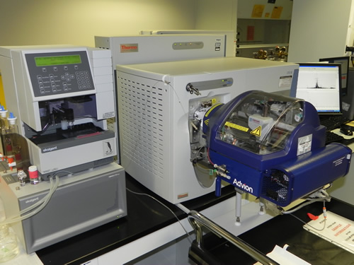 | Description: Thermo LTQXL/ETD mass spectrometer  A Thermo LTQXL/ETD MS ESI-linear ion trap-MS with electron-transfer dissociation (ETD) capability coupled to a nanoLC-1D Plus from Eksigent for analyses of minute amounts (picomoles to femtomoles) of sample.  The instrument is equipped at the front end with a TriVersa NanoMate electrospray ionization nano-source.
Gas Chromatography/Mass Spectrometry (GC/MS)
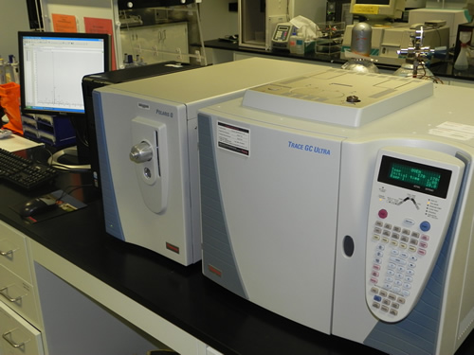 | Description: Thermo Finnigan Polaris Q GC/MSn Benchtop Ion Trap Mass Spetrometer  A Thermo Polaris Q ion-trap mass spectrometer equipped with a Trace GC Ultra gas chromatograph with a split/splitless injector for mass spectrometric identification of the GC components and quantitative composition analyses.

Shared (Open Access)
Thermo Scientific Sorvall RC6+ Centrifuge
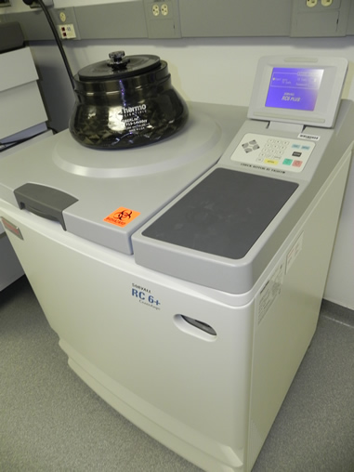- The Sorvall® RC-6 Plus superspeed centrifuge is a compact, user-friendly design that speeds up to 22,000 rpm (55,200 xg). The RC-6 Plus is a high-productivity solution that delivers maximum throughput and minimum maintenance.
- The RC-6 centrifuge is operated on a code basis, which is provided after orientation.
- Available with the following rotors:
- F13S-14x50cy : can spin 14 x 50 ml conical tubes up to 26,727 x g, reducing processing time and eliminating the need for sample transfers. Max.Speed RPM 13000 Max. g-force 28960
- F14S-6x250y : The Fiberlite F14S-6x250y carbon fiber rotor can be paired with Nalgene 250 ml Oak Ridge bottles for quickly and safely processing a wide range of laboratory protocols, from basic separations to cutting edge research. Max. Speed14000 Max. g-force 30100
- F21S-8x50y : The Fiberlite F21-8x50y carbon fiber rotor can be paired with 50 mL Nalgene Oak Ridge Polypropylene or Oak Ridge Polycarbonate bottles with sealing cap. Max. Speed RPM 21000 Max. g-force 52356
Thermo Scientific Sorvall WX Ultra Series Centrifuge
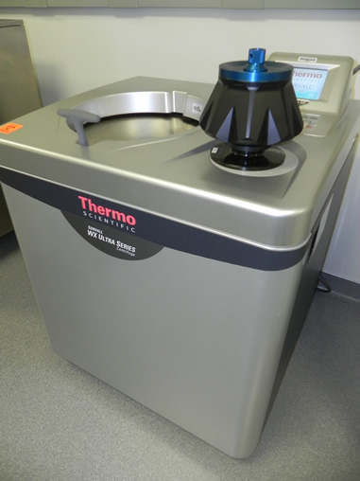- Thermo Scientific* Sorvall WX Ultra Series floor standing laboratory centrifuge combines speed and powerful separation in a quiet compact, energy-efficient design. Available in 80,000 rpm model.
- The RC-6 centrifuge is operated on a code basis, which is provided after orientation.
- Available with the following rotors:
- T-865: Capacity 8 x 36 Max. Speed RPM 65,000 Max g-force 429,460
- AH-650 : Capacity 6 x 5 Max. Speed RPM 50,000 Max g-force 296,010
- TH-641 : Capacity 6 x 13.2 Max. Speed RPM 41,000 Max g-force 287,660

Other Core Facility Instruments
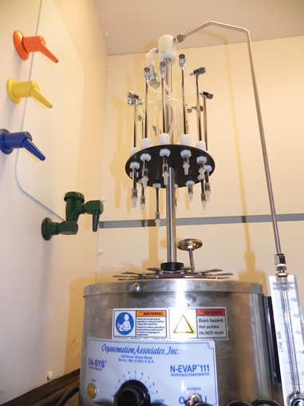
Thermo Scientfic Fluoroskan Ascent-Fluorometer
Thermo Scientific Luminoskan Ascent-Luminometer
Molecular Devices Versa Max Tunable Microplate Reader-Spectrophotometer 96 well plate reader
Beckman DU 640- Spectrophotometer
Beckman Optima Max- Benchtop Ultracentrifuge
Thermo Scientific Multifuge 3SR+ -Low Speed Benchtop Centrifuge
Sonics Vibra Cell VCX 750-Sonicator
VWR Model 150 D-Bath Sonicator
Millipore Milli-Q Gradient- Water System
Denver Instruments Company A-160-Digital Balance
Metler Toledo PL1501-S-Digital Balance
Organomation Associates N-EVAP 111-Nitrogen Drier
Labconco Acid-Resistant Centrivap Concentrator
Labconco Centrivap Console
Labconco Freeze Dry System/Freezone 4.5-Liophilizer
Perkin Elmer Tri-Carb 2900TR-Liquid Scintillation Analyzer
Perkin Elmer Cobra II Auto-Gamma- Gamma Counter

