STEPS TO SUBMIT PROJECT MOVE 2022 PROJECT PROPOSAL

Each project must have its own application, even if the multiple projects will be organized by the same agency. You can follow the steps described below to submit your organization’s project proposal application for Project Move 2022.

Before starting this process make sure that you are signed in into your agency’s account on the CUE. Yu can access the CUE website on the following link: https://utep.givepulse.com/. If you have any problem accessing your account, please contact us for assistance at projectmove@utep.edu.

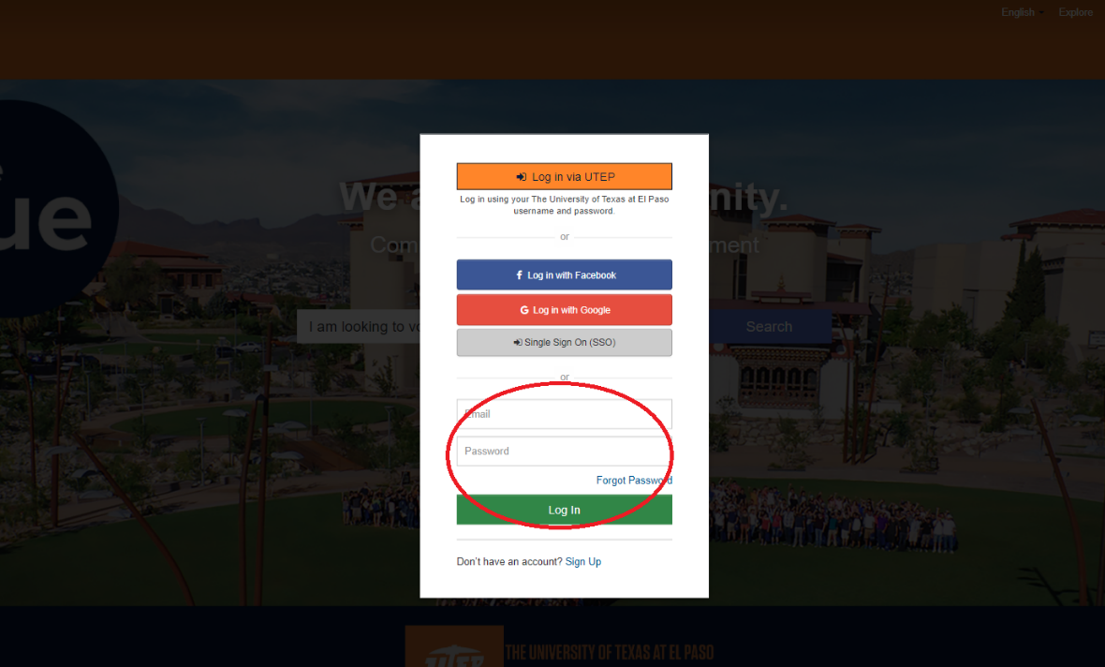
Once you are logged in into your agency’s profile on the CUE, you can follow this link to access the project proposal application for Project Move 2022.
https://utep.givepulse.com/event/create/605804?submission=1&k=da81a80aee0c13ec234fa70ed8851cff
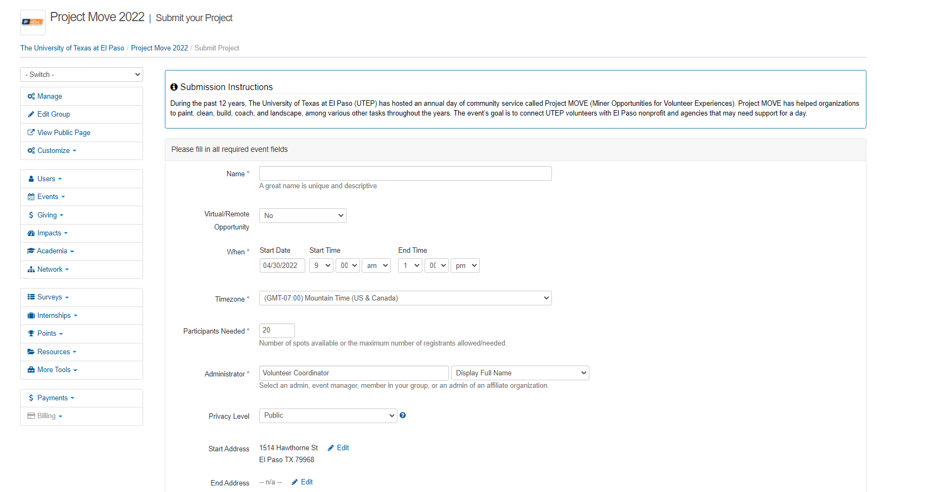

In the application you will proceed to fill out your project’s information, including:
- The name of your project
- If your project will be held remotely
- How many volunteers you will need for this project
- The name of the administrator/point of contact for this project
- The address where your project will take place
- A brief description of the project
- Indicate if the project is a direct response or intends to directly help with COVID-19
Please do NOT modify the following sections on the application as they are predetermined:
- When/Date and Time
- Time zone
- Privacy Level

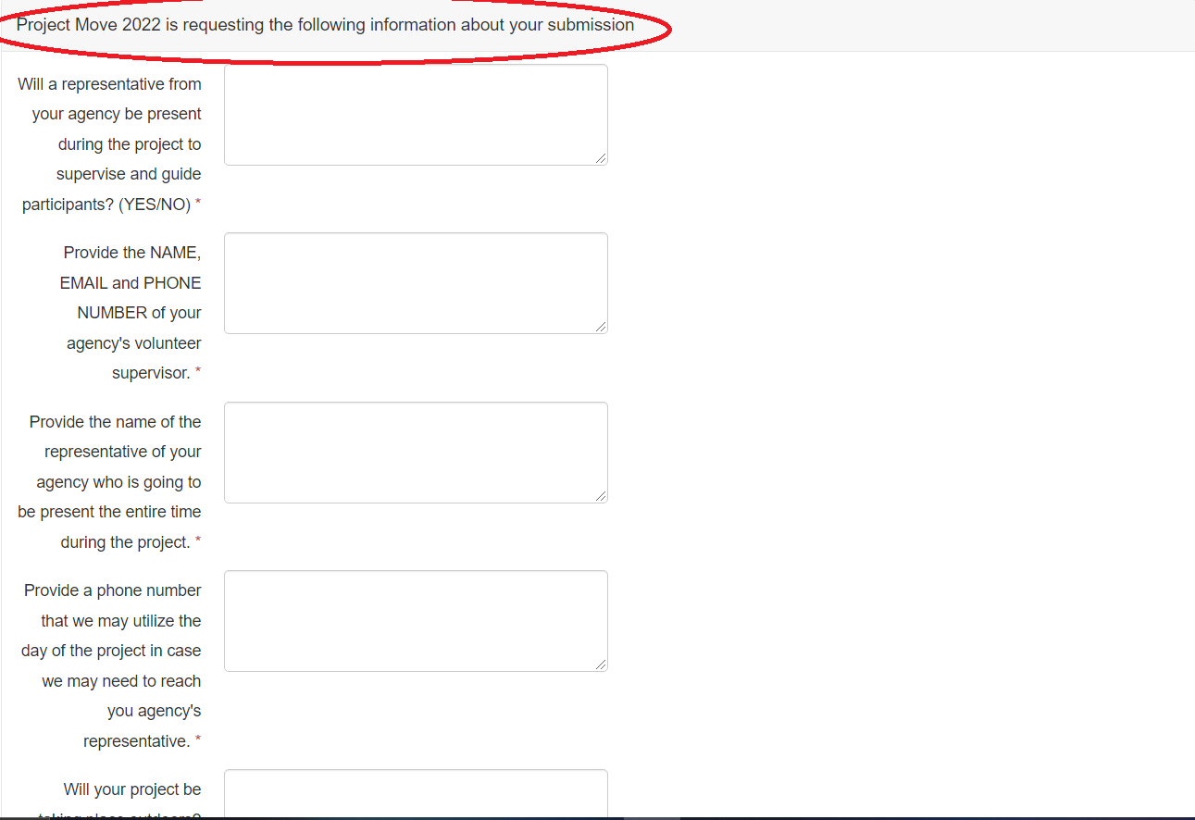
After completing the first section of the application, proceed to answer the questions on the section named “Project Move 2022 is requesting the following information about your submission”

Once you answered all of the required fields click the “Publish” button at the bottom of the page.

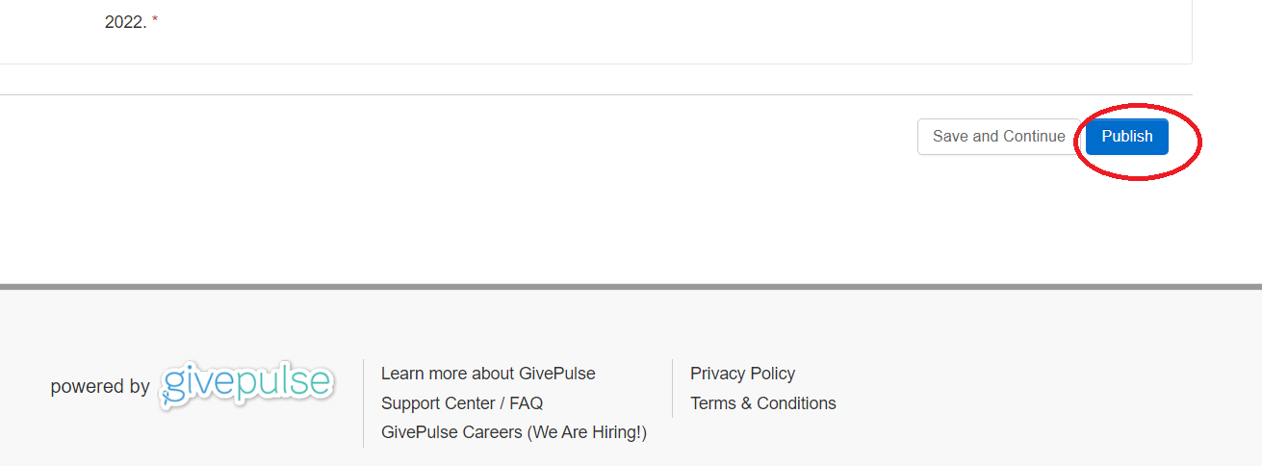

The deadline for submitting a proposal is March 25th and every proposal will be reviewed by Project MOVE’s 2022 committee before approval. If you have any questions regarding the application process, please feel free to contact us at projectmove@utep.edu.

