The CUE Volunteer Sign-In instructions

In order to access your CUE profile, first you need to go into the CUE website https://utep.givepulse.com/. Once you are on the website, click “Log In” on the upper right corner of your screen.

After selecting “Log In”, the system will provide you with several options. You need to select the “Log in via UTEP” option.
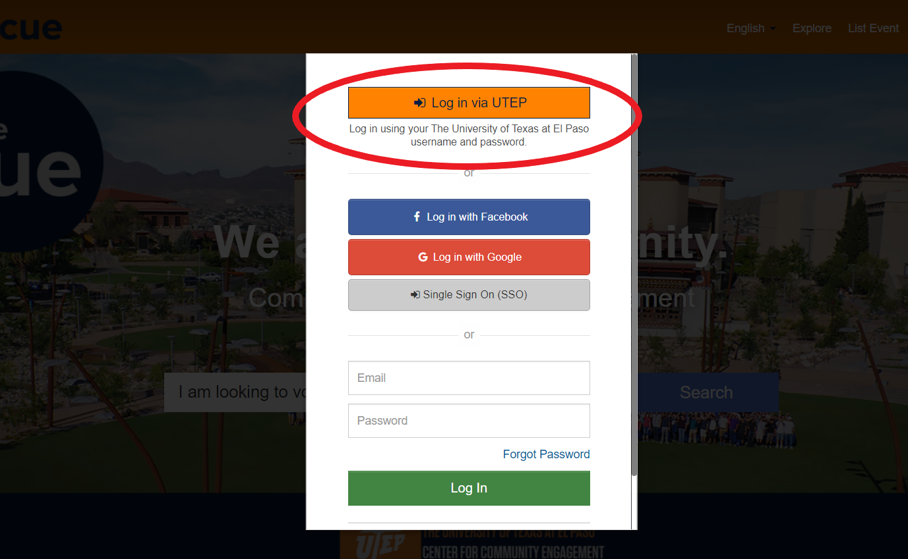

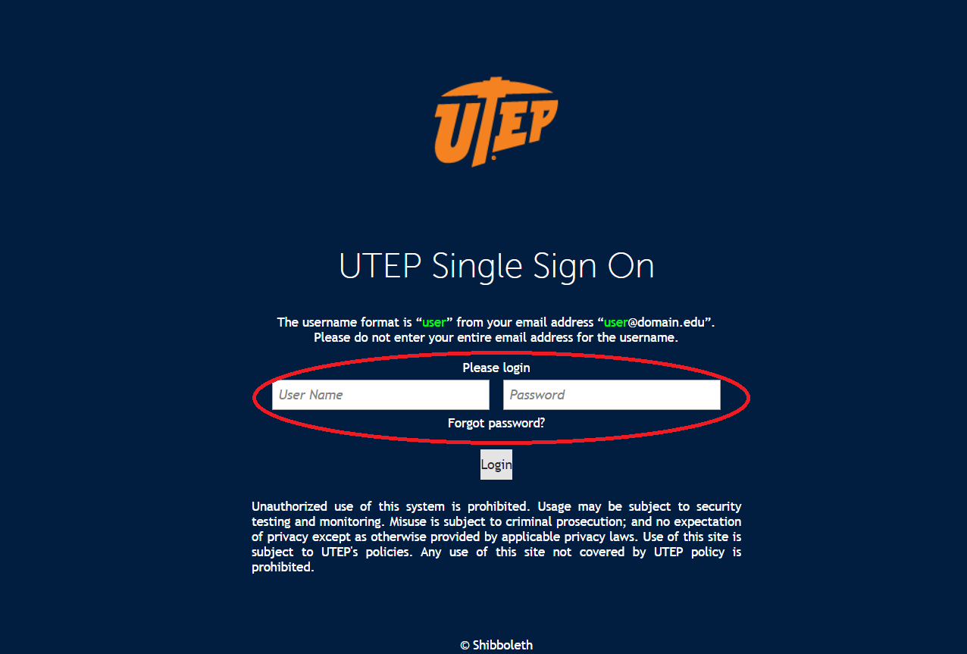
When you select this option, a link will open to allow you to input your UTEP credentials. In this page, fill in your Username and Password and click Log In.

After Logging In, you should be able to access your CUE profile.

If you click on the tab “Explore” on the upper right corner of the page it will open a new page that will allow you to see the volunteering events that are coming up and the groups/organizations that you could volunteer for.

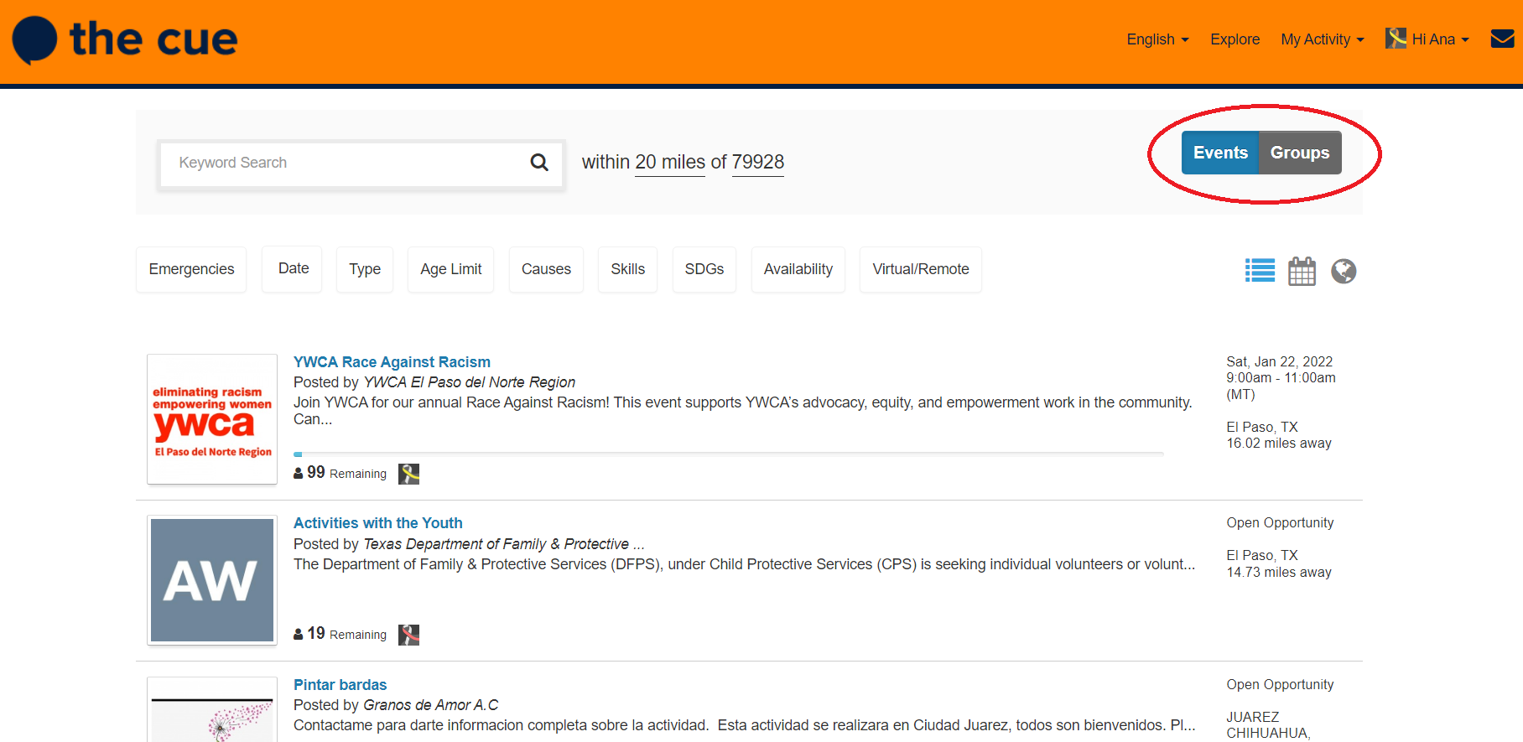

If you click on your name on the upper right side of the page you can access things like your dashboard, profile, and account.
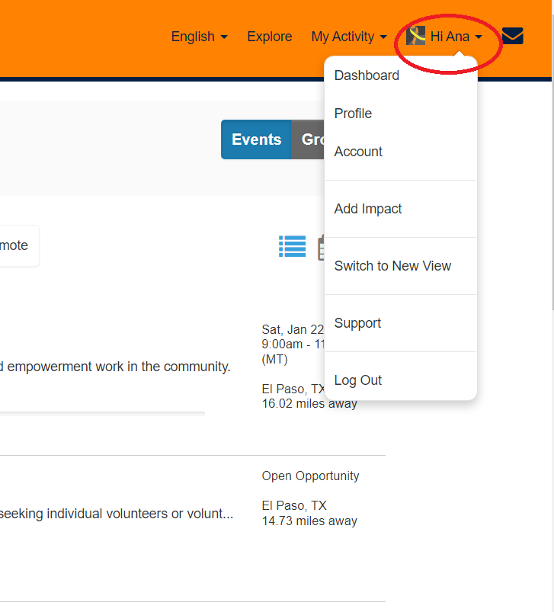

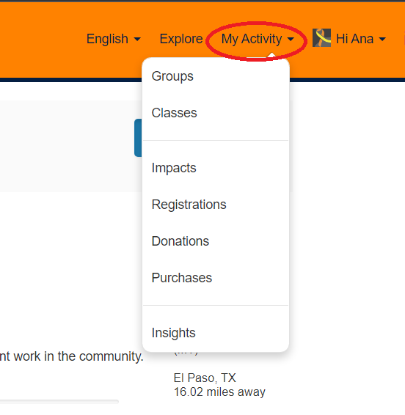
Under “My Activity” you will be able to access some of your actions within the website for example your impacts, registrations and donations.

We recommend you start exploring the website to become more familiar with the different tabs and what you can do within the website. If you have any questions regarding the CUE, please feel free to contact us at cce@utep.edu.

