UNIVERSITY OF TEXAS AT EL PASO
STUDENT REIMBURSEMENT INFORMATION FORM
FOR STUDENTS ONLY
Requestor Requestor
Dept: Name: Phone: Email:

PART I. STUDENT INFORMATION

Legal Name: This field is required - please fill in your Legal Name
University of Texas at El Paso reserves the right to request photo identification to confirm legal name(s)

Social Security #: Student ID #:
Address Line 1:
Address Line 2:
City: State:
Country: Zip Code:
Phone: Fax:
E-Mail:
UTEP is requesting disclosure of your SSN in order to report compensation to the Internal Revenue Service, as required by federal law.
Further disclosure of your SSN will be governed by the Public Information Act (Chapter 552 of the Texas Government Code) and University policies.

PART II: CITIZENSHIP INFORMATION (See IRS Publication 519 – US Tax Guide for Aliens for more information)
Section B. Citizenship Status
Section A. Citizenship Status

I attest, under penalty of perjury, that I am (check one of the following):
1 - A citizen or national of the United States of America Country of Citizenship:
2 - A Lawful Permanent US Resident Alien/Greencard #:
3 - A Non U.S. Resident/Non Resident Alien (If checked, continue to Section B):
Withholding. – Non-employee payments to nonresident aliens are subject to 30% tax withholding unless a tax treaty with their country entitles them to either a lower rate or exemption. To claim any available treaty benefits, the recipient must have either a Social Security Number or IRS assigned Tax Identification Number. In addition, IRS form 8233 must be filed with the payer.

PART III: DIRECT DEPOSIT

New Change Cancel Financial Institution Name:
Routing Number (9-Digits):
Account Type: Checking Savings Account Number (max 17 characters):
Notification: Request must allow for sufficient time for processing and may not be effective for the next check run. Late requests may result in a check being issues or Direct Deposit to an established account. We strongly suggest leaving your old account open until the deposit into your new account has occurred.
Authorization Agreement: I hereby authorize the University of Texas to deposit my payments directly to the account listed above (PART III) by way of Direct Deposit (Automated Clearing House (ACH) credit). This authority will remain in force until I have given advanced written notice, or deposit service has been discontinued by the discretion of the University of Texas. I understand that I must provide advance notice to allow reasonable time for my instructions to be executed. I understand that it is my sole responsibility to verify with my financial institution the receipt of my direct deposit funds. I agree to notify the University of Texas within three (3) business days if the deposit has not been made and/or receipt of an incorrect deposit amount. Furthermore, if an incorrect deposit should be made into my account, I authorize my financial institution and the University of Texas to make appropriate adjustment(s) from my account.

PART IV: AUTHORIZED SIGNATURE
Under penalties of perjury, I certify that the information provided on this form is, to the best of my knowledge, true, correct and complete.
Authorized Signature:
Please send completed form to The University of Texas at El Paso, Disbursement Services-Accounts Payable,
1900 N. Oregon, Suite 602, El Paso, Texas 79902 or sent via Fax to (915) 747-6620
(Due to the sensitive information, fax or deliver this form to the Accounts Payable Office. For your protection, password protect e-mails per the instructions on the next page.)

For Institutional Use Only:
Vendor ID: | Creator: |  |  | Revised 3/25/21

Instructions for Password-Protecting your file:
- Select File from the menu
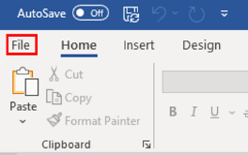
- Click on the Info button
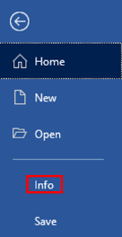
- Click on the Protect Document button
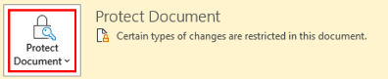
- Select Encrypt with Password
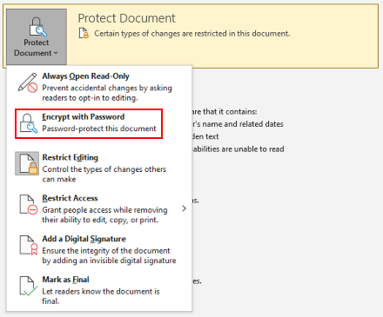
- Type the password into the Password box
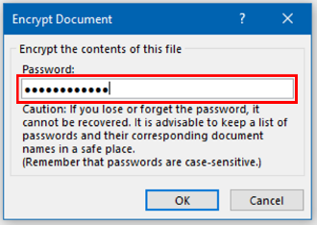
- You will be prompted to confirm the password – type the same password into Reenter password box
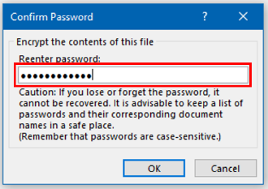
Your file is now password protected – save and close your document.
DO NOT send the password along with your Student Reimbursement Information Form. Send the password in a separate email.

