How to Set Up Direct Deposit

- First you need to be an active employee and have received your credentials to login, i.e. email and password.
- Then go to peoplesoft.utep.edu
- Click on the Launch PeopleSoft button

- Select UTEP from the list of schools
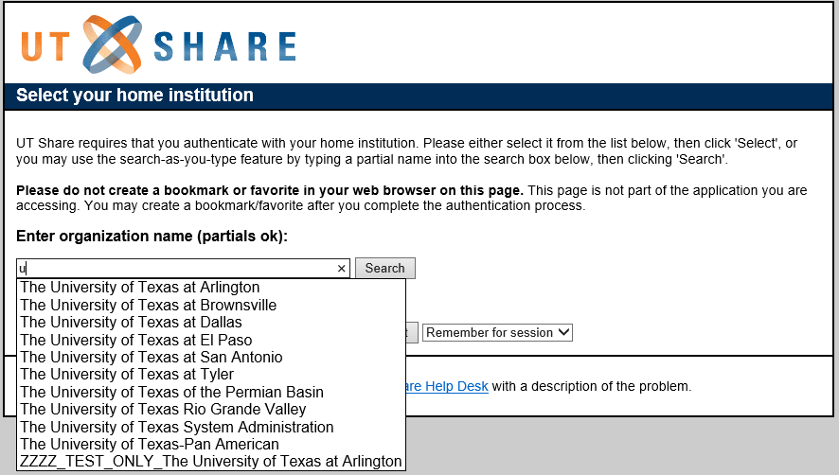
- Login with your credentials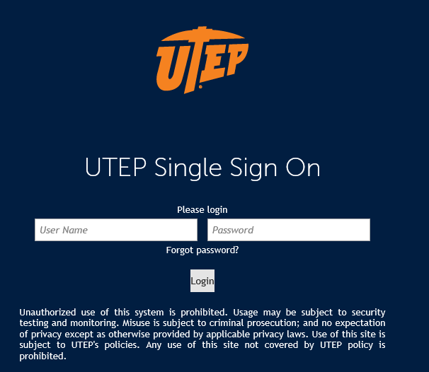

- Locate the Payroll and Compensation Tile in the Employee Self Service Section under Payroll & Compensation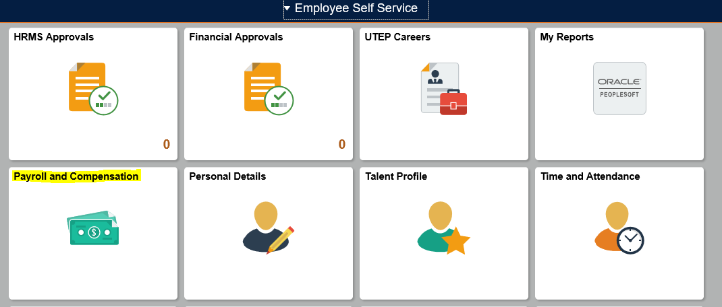

Click on the link Direct Deposit, click on the Add Account button on the next page
- Enter the Routing Number to the bank
- Enter your Account Number
- Select Account Type: Checking or Savings
- For First time set up
  - Deposit Type: Will need to be Balance
  - Deposit Order: Automatically will be set to 999
- For Second or Third Accounts
  - Deposit Type: Choose either Amount or Percent
  - Amount or Percent: Enter the amount or percent you wish to have deposited from your check.
  - Deposit Order: You can enter a number from 1 - 2
    - Here you are telling the system what to deposit 1st, then 2nd, and 999 will be deposited last. Meaning whatever is left over from your check will go into that account.
Please see picture:
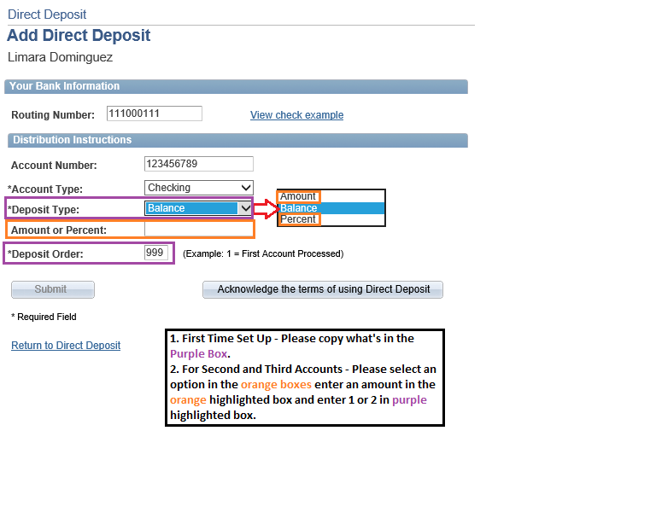

- Click on the Acknowledge the terms of using Direct Deposit button
- Click on Accept and then Ok on the confirmation screen
You have set up your direct deposit or added new accounts to an existing set up.

